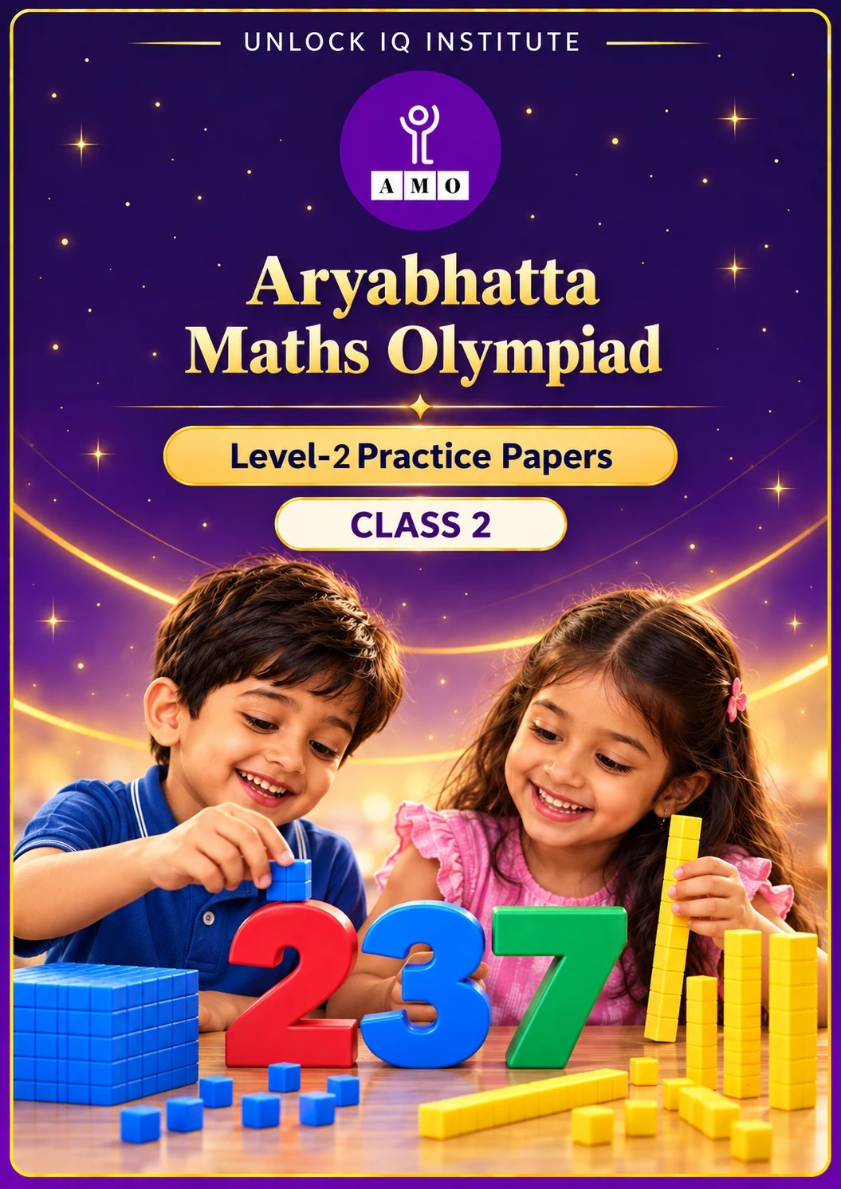
Set 2 · Practice Papers 6–10 · with answer keys & detailed solutions
Name: ____________________ | Class & Section: ________________
Roll No.: ________________ | School: ____________________
City: ____________________ | Date: ____________________

Published by Unlock IQ Institute Pvt. Ltd.
Register for Olympiads: www.aryabhattamathsolympiad.com/student-registration

ARYABHATTA MATHS OLYMPIAD
Level 2
PRACTICE PAPER-6
CLASS 2
Total Questions | 30 multiple-choice questions
Level | Level-2 (final round): every question is Hard
Time | 45 minutes
Section I | 25 questions, each from one chapter
Section II | 5 Star Questions, each joining two chapters
Negative Marking | No negative marking
Calculator | Not allowed
Chapters | Number System · Operations · Geometry · Applied Mathematics · Mathematical Reasoning

👋 Hello, friend! How to do this paper:
⭐ Every question has four answer choices: (A), (B), (C) and (D). Only one is correct.
⭐ Read each question and look at its picture carefully. Then mark your answer on the answer sheet at the end.
⭐ This is a Level-2 paper. Every question needs careful thinking, so take your time and check each step.
⭐ Section I has 25 questions. Section II has 5 Star Questions.
⭐ There is no negative marking, so try every question.
⭐ Do not use a calculator. You may do rough work on a separate sheet.
⭐ All figures are not necessarily drawn to scale unless stated.

For parents and teachers
• Pictures are part of the questions. Every picture also works when printed in black and white.
• You may read a question aloud to the child, exactly as printed. Please do not explain it or point to an answer choice.
• Parts follow the AMO syllabus chapters. Chapters 3, 4, 6, 7 and 8 are not part of the Class 2 syllabus, so the chapter numbers shown in the Part headings have gaps.
• The answer sheet and the answer key are at the end. Remove only the answer key before the child begins.

SECTION I 25 questions · every question is Hard
Part 1 — Number System (Syllabus Chapter 1)
Q1. Gauri has 7 tens and 15 ones. How much more does she need to make 200?
(A) 115 | (B) 125 | (C) 185 | (D) 105

Q2. Kabir writes the largest 3-digit number that has three different digits. He then takes away 900. What number does he get?
(A) 99 | (B) 98 | (C) 78 | (D) 87

Q3. The houses on a lane are numbered from 457 to 464. How many of these house numbers have an odd tens digit?
(A) 4 | (B) 5 | (C) 3 | (D) 8

Q4. Diya starts at 125. She adds 100 two times. Then she takes away 10 three times. Where does she end?
(A) 295 | (B) 305 | (C) 325 | (D) 285

Q5. How many odd 2-digit numbers have digits that add up to 7?
(A) 4 | (B) 7 | (C) 2 | (D) 3

Q6. The seats in a hall are numbered 101 to 150. Yash sits on a seat whose number ends in 5. How many such seats are there?
(A) 6 | (B) 4 | (C) 5 | (D) 10

Part 2 — Operations (Syllabus Chapter 2)
Q7. A tea stall had 850 paper cups. It used 275 cups and then got 160 new cups. How many cups does it have now?
(A) 415 | (B) 735 | (C) 575 | (D) 745

Q8. Ira has 8 boxes with 7 crayons in each box. She uses up all the crayons in 2 boxes. How many crayons are left?
(A) 42 | (B) 54 | (C) 49 | (D) 56

Q9. Om gets half of 70 marbles from his brother and a quarter of 40 marbles from his sister. How many marbles does he get?
(A) 35 | (B) 55 | (C) 25 | (D) 45

Q10. Which pair of numbers has a difference of 199?
(A) 300 and 199 | (B) 400 and 201 | (C) 400 and 211 | (D) 500 and 299

Q11. Rohan has 8 packs of stickers and Kavya has 6 packs. Every pack has 9 stickers. How many more stickers does Rohan have?
(A) 2 | (B) 72 | (C) 54 | (D) 18

Q12. Three numbers come one after the other, like 5, 6 and 7. They add up to 300. What is the largest of the three?
(A) 101 | (B) 100 | (C) 102 | (D) 99

Part 3 — Geometry (Syllabus Chapter 5)
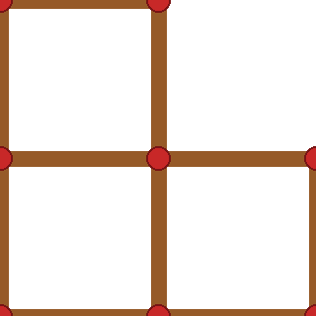
Q13. Neha makes this shape of 3 squares with matchsticks. Each side of a small square is one matchstick. How many matchsticks does she use?
(A) 12 | (B) 9 | (C) 10 | (D) 8

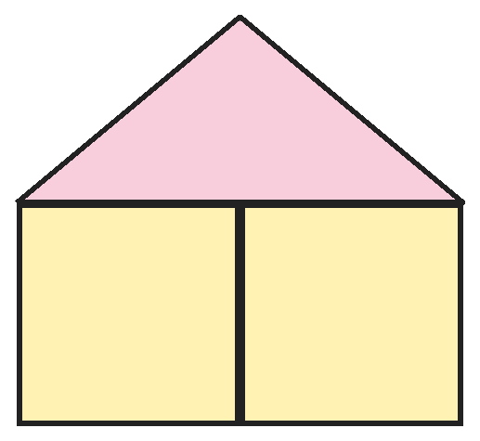
Q14. Vivaan draws this house with two squares and a roof. How many shapes with 4 sides can you find in it?
(A) 2 | (B) 3 | (C) 4 | (D) 5

Q15. Nisha lays an ice-cream cone on its side on a table and rolls it gently. The tip stays in one place. What shape does the round edge trace on the table?
(A) A straight line | (B) A square
(C) A circle | (D) A triangle

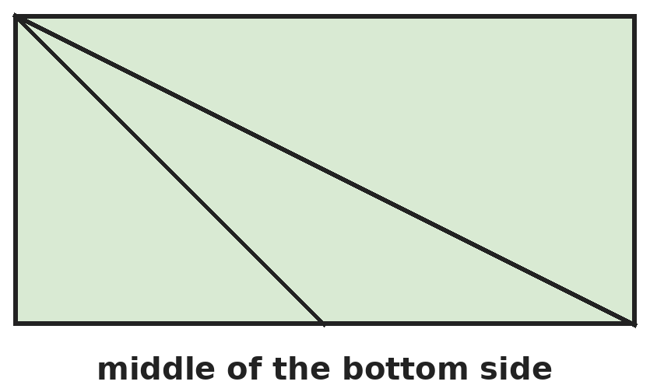
Q16. Manav draws a rectangle. He draws two lines from the top-left corner: one to the bottom-right corner and one to the middle of the bottom side. How many triangles are there?
(A) 3 | (B) 2 | (C) 5 | (D) 4

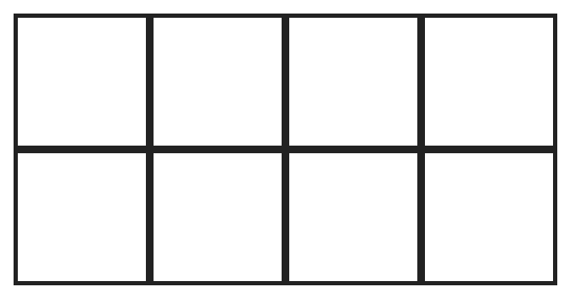
Q17. How many squares of all sizes are in this grid?
(A) 8 | (B) 10 | (C) 12 | (D) 11

Part 4 — Applied Mathematics (Syllabus Chapter 9)
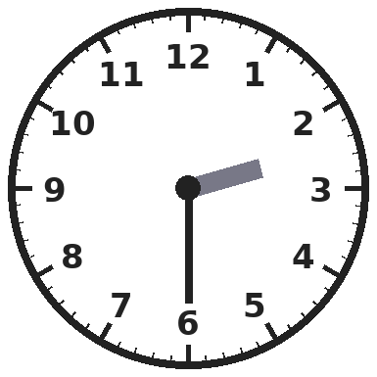
Q18. Aditi's music class starts at the time on this clock. What time does it start?
(A) Half past 6 | (B) Half past 2
(C) Half past 3 | (D) Quarter past 2

Q19. At a shop, Pooja sees that 2 pens cost ₹30. All the pens cost the same. How much will 5 pens cost?
(A) ₹60 | (B) ₹75 | (C) ₹150 | (D) ₹65

Q20. A shop opens at 10 AM and closes at 8 PM. It also shuts for lunch from 1 PM to 2 PM. At which of these times is the shop open?
(A) 1:30 PM | (B) 9:30 AM | (C) 8:30 PM | (D) 2:15 PM

Q21. Harsh saves ₹5 every day for 9 days. Then he buys a toy for ₹18. How much money is left?
(A) ₹45 | (B) ₹27 | (C) ₹63 | (D) ₹23

Part 5 — Mathematical Reasoning (Syllabus Chapter 10)
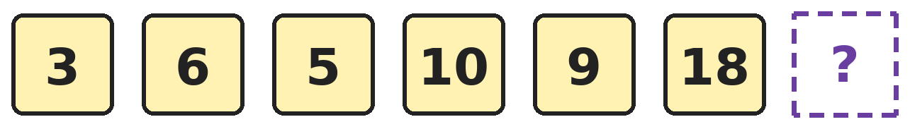
Q22. This pattern uses two steps again and again. Which number comes next?
(A) 36 | (B) 19 | (C) 17 | (D) 27

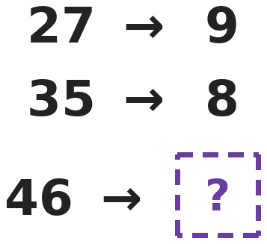
Q23. Each number on the left is changed by the same rule. Which number replaces the question mark?
(A) 12 | (B) 15 | (C) 10 | (D) 23

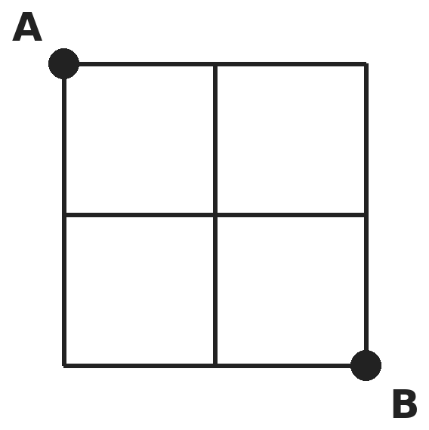
Q24. Sana walks along the lines from A to B. She only moves right or down. How many different paths can she take?
(A) 6 | (B) 4 | (C) 8 | (D) 5

Q25. Three of these numbers are made by multiplying a number by itself, like 3 × 3 = 9. Which number is the odd one out: 16, 25, 36, 48?
(A) 16 | (B) 25 | (C) 36 | (D) 48

SECTION II — Star Questions 5 questions · each joins two chapters
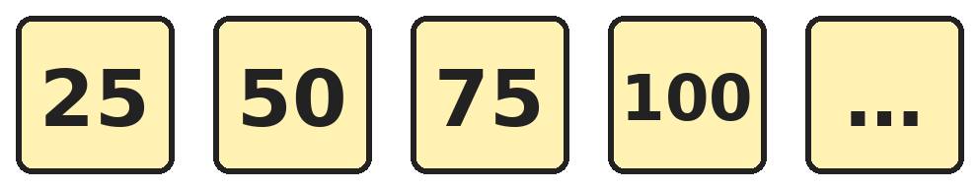
Q26. Riya counts in 25s starting from 25. What is the 10th number she says? [Star]
(A) 250 | (B) 225 | (C) 275 | (D) 200

Q27. Ravi starts at 7 and adds 5 each turn. Asha starts at 47 and takes away 3 each turn. Both of them move once every turn. On which number are they both at the same time? [Star]
(A) 27 | (B) 32 | (C) 35 | (D) 29

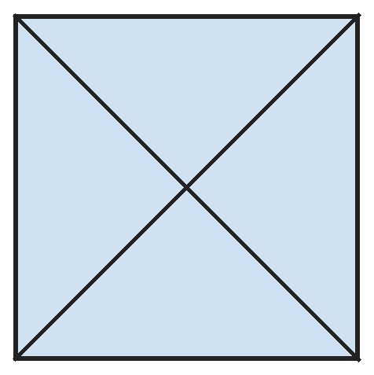
Q28. Kunal draws a square and both of its corner-to-corner lines. How many triangles are there in all? [Star]
(A) 4 | (B) 6 | (C) 8 | (D) 10

Q29. Ananya's birthday is in a month with 30 days. The date is an odd number and its digits add up to 4. On which date is her birthday? [Star]
(A) 22nd | (B) 31st | (C) 13th | (D) 4th

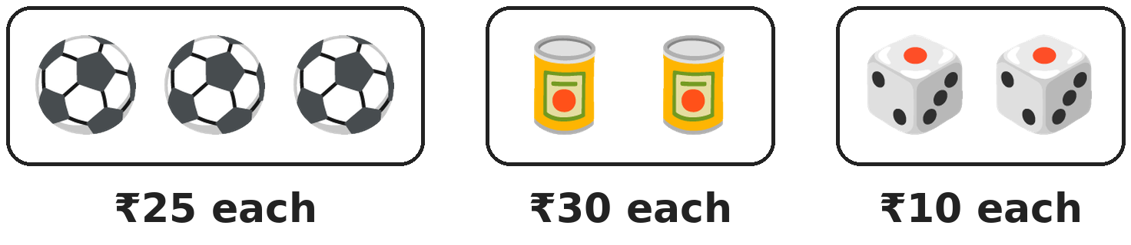
Q30. Parth buys every item in this shop that has the shape of a sphere. How much does he pay? [Star]
(A) ₹75 | (B) ₹60 | (C) ₹25 | (D) ₹95

Answer Sheet AMO Level 2 · Class 2 · Practice Paper 6
Name: | School: | Roll No.:
Shade or tick one circle for each question.
1. | Ⓐ Ⓑ Ⓒ Ⓓ | 11. | Ⓐ Ⓑ Ⓒ Ⓓ | 21. | Ⓐ Ⓑ Ⓒ Ⓓ
2. | Ⓐ Ⓑ Ⓒ Ⓓ | 12. | Ⓐ Ⓑ Ⓒ Ⓓ | 22. | Ⓐ Ⓑ Ⓒ Ⓓ
3. | Ⓐ Ⓑ Ⓒ Ⓓ | 13. | Ⓐ Ⓑ Ⓒ Ⓓ | 23. | Ⓐ Ⓑ Ⓒ Ⓓ
4. | Ⓐ Ⓑ Ⓒ Ⓓ | 14. | Ⓐ Ⓑ Ⓒ Ⓓ | 24. | Ⓐ Ⓑ Ⓒ Ⓓ
5. | Ⓐ Ⓑ Ⓒ Ⓓ | 15. | Ⓐ Ⓑ Ⓒ Ⓓ | 25. | Ⓐ Ⓑ Ⓒ Ⓓ
6. | Ⓐ Ⓑ Ⓒ Ⓓ | 16. | Ⓐ Ⓑ Ⓒ Ⓓ | 26. | Ⓐ Ⓑ Ⓒ Ⓓ
7. | Ⓐ Ⓑ Ⓒ Ⓓ | 17. | Ⓐ Ⓑ Ⓒ Ⓓ | 27. | Ⓐ Ⓑ Ⓒ Ⓓ
8. | Ⓐ Ⓑ Ⓒ Ⓓ | 18. | Ⓐ Ⓑ Ⓒ Ⓓ | 28. | Ⓐ Ⓑ Ⓒ Ⓓ
9. | Ⓐ Ⓑ Ⓒ Ⓓ | 19. | Ⓐ Ⓑ Ⓒ Ⓓ | 29. | Ⓐ Ⓑ Ⓒ Ⓓ
10. | Ⓐ Ⓑ Ⓒ Ⓓ | 20. | Ⓐ Ⓑ Ⓒ Ⓓ | 30. | Ⓐ Ⓑ Ⓒ Ⓓ
Q26–Q30 are Section II Star Questions. Each joins two chapters.
For the parent or teacher
Section I correct: ______ / 25 Section II correct: ______ / 5
Correct: ______ / 30
Answer Key and Solutions AMO Level 2 · Class 2 · Practice Paper 6
Quick answers
1 A | 6 C | 11 D | 16 D | 21 B | 26 A
2 D | 7 B | 12 A | 17 D | 22 C | 27 B
3 C | 8 A | 13 C | 18 B | 23 C | 28 C
4 A | 9 D | 14 B | 19 B | 24 A | 29 C
5 D | 10 B | 15 C | 20 D | 25 D | 30 A
Solutions
Q | Part · level | Answer | Why?
1 | Part 1 · Ch1 · Hard | (A) 115 | Hint: First find the number she has: 15 ones is 1 ten and 5 ones.  7 tens and 15 ones is 70 + 15 = 85. To make 200 she needs 200 − 85 = 115.
2 | Part 1 · Ch1 · Hard | (D) 87 | Hint: The largest 3-digit number with different digits is not 999.  The largest number with three different digits is 987. 987 − 900 = 87.
3 | Part 1 · Ch1 · Hard | (C) 3 | Hint: Look at the tens digit of each number.  457, 458 and 459 have tens digit 5, which is odd. 460 to 464 have tens digit 6, which is even. So 3 numbers.
4 | Part 1 · Ch1 · Hard | (A) 295 | Hint: Adding 100 twice adds 200 in all.  125 + 200 = 325. Taking away 10 three times takes away 30: 325 − 30 = 295.
5 | Part 1 · Ch1 · Hard | (D) 3 | Hint: List all 2-digit numbers with digit sum 7, then keep the odd ones.  Numbers with digit sum 7: 16, 25, 34, 43, 52, 61, 70. The odd ones are 25, 43 and 61. That is 3.
6 | Part 1 · Ch1 · Hard | (C) 5 | Hint: Seat numbers ending in 5 go up by 10.  The seats are 105, 115, 125, 135 and 145. 155 is past 150. That is 5 seats.
7 | Part 2 · Ch2 · Hard | (B) 735 | Hint: Take away first, then add.  850 − 275 = 575. 575 + 160 = 735.
8 | Part 2 · Ch2 · Hard | (A) 42 | Hint: How many full boxes are left?  8 − 2 = 6 boxes are left. 6 × 7 = 42 crayons.
9 | Part 2 · Ch2 · Hard | (D) 45 | Hint: Find each part separately.  Half of 70 is 35. A quarter of 40 is 10. 35 + 10 = 45.
10 | Part 2 · Ch2 · Hard | (B) 400 and 201 | Hint: Think of 199 as 200 − 1.  400 − 201 = 199. The others: 300 − 199 = 101, 400 − 211 = 189, 500 − 299 = 201.
11 | Part 2 · Ch2 · Hard | (D) 18 | Hint: How many more packs does Rohan have?  Rohan has 2 more packs. 2 × 9 = 18 more stickers. (Check: 72 − 54 = 18.)
12 | Part 2 · Ch2 · Hard | (A) 101 | Hint: The middle number is about a third of 300.  99 + 100 + 101 = 300. The largest is 101.
13 | Part 3 · Ch5 · Hard | (C) 10 | Hint: Squares that touch share a matchstick.  3 squares on their own would need 12 matchsticks. Two sides are shared, so 12 − 2 = 10 matchsticks.
14 | Part 3 · Ch5 · Hard | (B) 3 | Hint: Two squares side by side also make a bigger shape.  There are 2 squares. Together they make a rectangle, which also has 4 sides. That is 3. The roof has 3 sides.
15 | Part 3 · Ch5 · Hard | (C) A circle | Hint: The tip does not move, so the cone turns around it.  A cone lying on its side turns around its tip. The round edge stays the same distance from the tip, so it traces a circle.
16 | Part 3 · Ch5 · Hard | (D) 4 | Hint: Do not forget the triangle above the long line.  Below the long line there are 3 triangles: the left one, the middle one and both together. Above the long line there is 1 more triangle. 3 + 1 = 4.
17 | Part 3 · Ch5 · Hard | (D) 11 | Hint: Count small squares, then squares made of 4 small ones.  There are 8 small squares. A 2 by 2 square can start in 3 places along the row. 8 + 3 = 11.
18 | Part 4 · Ch9 · Hard | (B) Half past 2 | Hint: At half past, the hour hand is between two numbers.  The minute hand points at 6, so it is half past. The hour hand is between 2 and 3, so it is half past 2.
19 | Part 4 · Ch9 · Hard | (B) ₹75 | Hint: First find the cost of 1 pen.  Half of ₹30 is ₹15, so 1 pen costs ₹15. 5 pens cost 15 + 15 + 15 + 15 + 15 = ₹75.
20 | Part 4 · Ch9 · Hard | (D) 2:15 PM | Hint: Check each time against the opening time, the lunch break and the closing time.  9:30 AM is before it opens. 1:30 PM is in the lunch break. 8:30 PM is after it closes. 2:15 PM is after lunch and before 8 PM, so the shop is open.
21 | Part 4 · Ch9 · Hard | (B) ₹27 | Hint: First find how much he saved.  He saves 5 × 9 = ₹45. After the toy: ₹45 − ₹18 = ₹27.
22 | Part 5 · Ch10 · Hard | (C) 17 | Hint: Look at 3 to 6, then 6 to 5.  The steps are: double, then take away 1. 3 → 6 → 5 → 10 → 9 → 18 → 17.
23 | Part 5 · Ch10 · Hard | (C) 10 | Hint: Look at the two digits of each number.  2 + 7 = 9 and 3 + 5 = 8, so the rule adds the two digits. 4 + 6 = 10.
24 | Part 5 · Ch10 · Hard | (A) 6 | Hint: Every path has 2 steps right and 2 steps down.  Write R for right and D for down. The paths are RRDD, RDRD, RDDR, DRRD, DRDR, DDRR. That is 6 paths.
25 | Part 5 · Ch10 · Hard | (D) 48 | Hint: Try 4 × 4, 5 × 5 and 6 × 6.  16 = 4 × 4, 25 = 5 × 5 and 36 = 6 × 6. 48 is not a number times itself (6 × 6 = 36 and 7 × 7 = 49), so 48 is the odd one out.
26 | Section II · Ch1 + Ch10 · Hard | (A) 250 | Hint: Every 4 numbers she reaches the next hundred.  The 4th number is 100 and the 8th is 200. The 9th is 225 and the 10th is 250.
27 | Section II · Ch2 + Ch10 · Hard | (B) 32 | Hint: Write both lists side by side.  Ravi: 7, 12, 17, 22, 27, 32. Asha: 47, 44, 41, 38, 35, 32. After 5 turns both are at 32.
28 | Section II · Ch5 + Ch10 · Hard | (C) 8 | Hint: Count the small ones and then those made of two small ones.  There are 4 small triangles. Each corner-to-corner line cuts the square into 2 big triangles, so there are 4 big triangles. 4 + 4 = 8.
29 | Section II · Ch1 + Ch9 · Hard | (C) 13th | Hint: The date must be from 1 to 30.  Dates whose digits add up to 4: 4, 13, 22, 31. 4 and 22 are even. 31 is not in a 30-day month. So the date is the 13th.
30 | Section II · Ch5 + Ch9 · Hard | (A) ₹75 | Hint: Only the balls are spheres. A can is a cylinder and a dice is a cube.  The 3 balls are spheres. They cost 25 + 25 + 25 = ₹75.

ARYABHATTA MATHS OLYMPIAD
Level 2
PRACTICE PAPER-7
CLASS 2
Total Questions | 30 multiple-choice questions
Level | Level-2 (final round): every question is Hard
Time | 45 minutes
Section I | 25 questions, each from one chapter
Section II | 5 Star Questions, each joining two chapters
Negative Marking | No negative marking
Calculator | Not allowed
Chapters | Number System · Operations · Geometry · Applied Mathematics · Mathematical Reasoning

👋 Hello, friend! How to do this paper:
⭐ Every question has four answer choices: (A), (B), (C) and (D). Only one is correct.
⭐ Read each question and look at its picture carefully. Then mark your answer on the answer sheet at the end.
⭐ This is a Level-2 paper. Every question needs careful thinking, so take your time and check each step.
⭐ Section I has 25 questions. Section II has 5 Star Questions.
⭐ There is no negative marking, so try every question.
⭐ Do not use a calculator. You may do rough work on a separate sheet.
⭐ All figures are not necessarily drawn to scale unless stated.

For parents and teachers
• Pictures are part of the questions. Every picture also works when printed in black and white.
• You may read a question aloud to the child, exactly as printed. Please do not explain it or point to an answer choice.
• Parts follow the AMO syllabus chapters. Chapters 3, 4, 6, 7 and 8 are not part of the Class 2 syllabus, so the chapter numbers shown in the Part headings have gaps.
• The answer sheet and the answer key are at the end. Remove only the answer key before the child begins.

SECTION I 25 questions · every question is Hard
Part 1 — Number System (Syllabus Chapter 1)
Q1. In the number 437, what is the value of the digit 3 added to the value of the digit 4?
(A) 7 | (B) 430 | (C) 43 | (D) 340

Q2. Which number is 1 hundred more and 1 ten less than 345?
(A) 455 | (B) 335 | (C) 435 | (D) 446

Q3. How many numbers from 601 to 699 have the same tens digit and ones digit, like 633?
(A) 10 | (B) 11 | (C) 9 | (D) 8

Q4. Mohini stands at the point halfway between A and B. She then moves 2 tens forward. Where is she now?
(A) 350 | (B) 370 | (C) 360 | (D) 380

Q5. Lata makes 3-digit numbers using each of the digits 2, 5 and 8 once. Which of her numbers is closest to 500?
(A) 582 | (B) 528 | (C) 285 | (D) 258

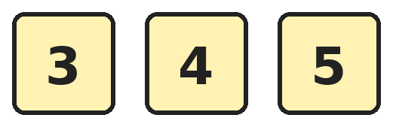
Q6. Aarav makes 3-digit numbers using all three cards once each. How many of his numbers are odd?
(A) 2 | (B) 6 | (C) 4 | (D) 3

Part 2 — Operations (Syllabus Chapter 2)
Q7. Lalit gave away 125 stamps. Later he got 210 new stamps. Now he has 500 stamps. How many stamps did he have at the start?
(A) 585 | (B) 375 | (C) 835 | (D) 415

Q8. In the school hall there are 7 rows of chairs with 6 chairs in each row. There are 4 extra chairs at the side. How many chairs are there in all?
(A) 42 | (B) 38 | (C) 17 | (D) 46

Q9. Siya has 32 balloons. A quarter of them burst. She gives half of the balloons that are left to her friend. How many balloons does she have now?
(A) 12 | (B) 8 | (C) 16 | (D) 24

Q10. Varun adds three odd numbers, like 3 + 5 + 7. What can you say about his answer?
(A) It is always even | (B) It can be odd or even
(C) It is always odd | (D) It always ends in 5

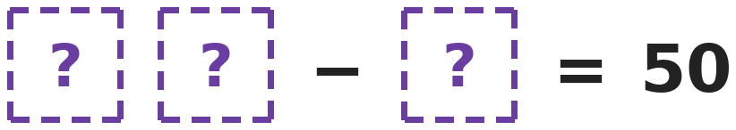
Q11. Every box hides the same digit. Which digit is it?
(A) 0 | (B) 5 | (C) 1 | (D) 6

Q12. Dev buys 4 packs of juice with 6 boxes in each, and 3 packs with 5 boxes in each. How many juice boxes does he buy?
(A) 39 | (B) 35 | (C) 42 | (D) 18

Part 3 — Geometry (Syllabus Chapter 5)
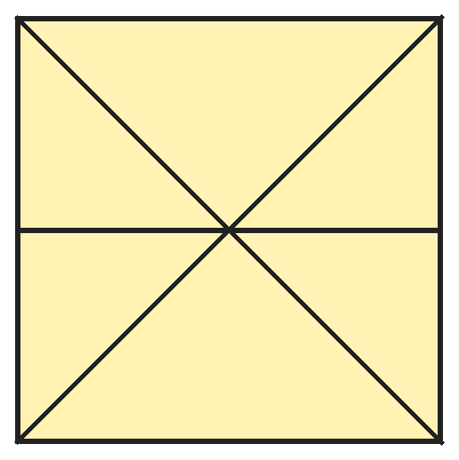
Q13. Juhi draws a square, both corner-to-corner lines and one line across the middle. How many triangles are there in all?
(A) 8 | (B) 6 | (C) 10 | (D) 12

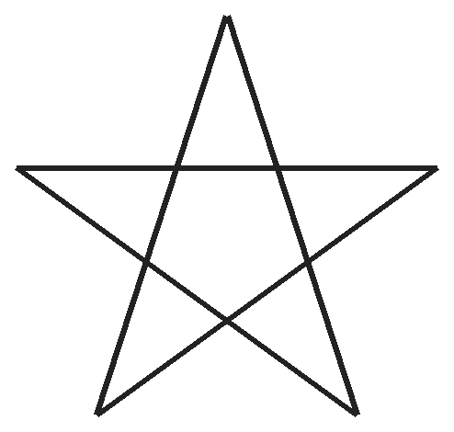
Q14. Mahi draws this star without lifting her pencil. How many straight lines does she draw?
(A) 10 | (B) 5 | (C) 6 | (D) 4

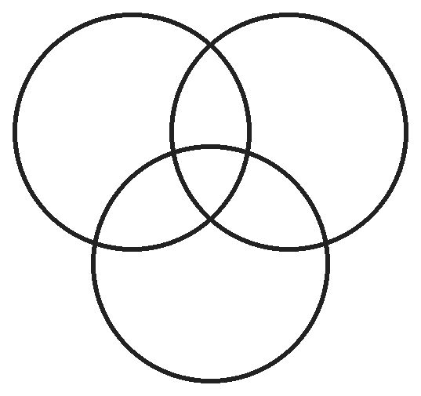
Q15. Three circles overlap like this. Into how many parts do they cut the space inside them?
(A) 6 | (B) 8 | (C) 7 | (D) 3

Q16. Leena has a sharpened round pencil, a birthday cap and a tin. Count every part shaped like a cone or a cylinder. What does she find?
(A) 2 cones and 2 cylinders | (B) 1 cone and 2 cylinders
(C) 2 cones and 1 cylinder | (D) 1 cone and 1 cylinder

Q17. Prachi folds a paper in half. She cuts out a triangle with no square corner, so that one side of the triangle lies along the fold. When she opens the paper, what shape is the hole?
(A) A triangle | (B) Two triangles
(C) A circle | (D) A shape with 4 sides

Part 4 — Applied Mathematics (Syllabus Chapter 9)
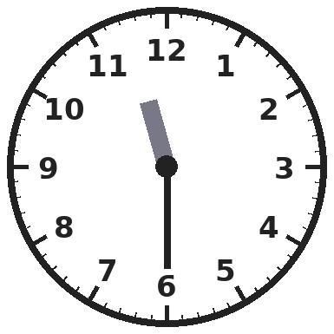
Q18. Yamini's train leaves at the time on this clock. What time does it leave?
(A) Half past 12 | (B) Half past 6 | (C) Quarter to 12 | (D) Half past 11

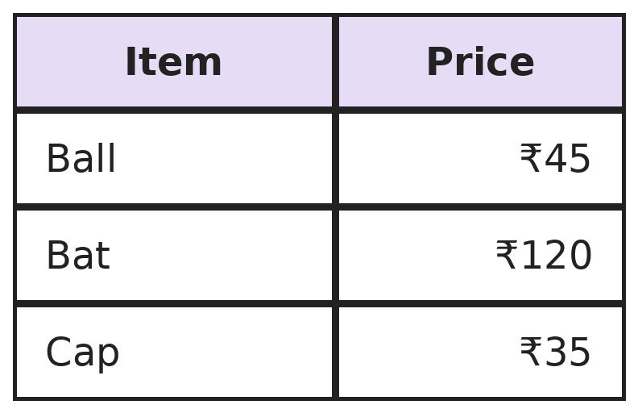
Q19. Aditya buys two of these items and pays ₹155. Which two items does he buy?
(A) Ball and bat | (B) Bat and cap
(C) Ball and cap | (D) All three items

Q20. Kiara says the AM part of a day, from midnight to noon, is longer than the PM part, from noon to midnight. What is true?
(A) The AM part is longer | (B) The PM part is longer
(C) It changes every day | (D) Both parts are equally long

Q21. Samar has ₹500 in 6 notes. Each note is either ₹50 or ₹100. How many ₹100 notes does he have?
(A) 2 | (B) 3 | (C) 4 | (D) 5

Part 5 — Mathematical Reasoning (Syllabus Chapter 10)
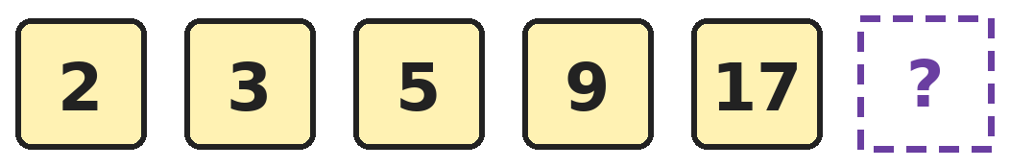
Q22. Look at how much is added each time. Which number comes next?
(A) 33 | (B) 25 | (C) 34 | (D) 31

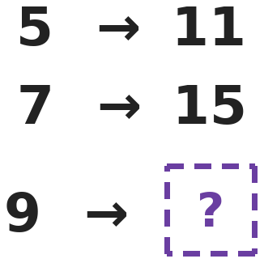
Q23. Bhavna's number machine uses the same rule for every number. What does it give for 9?
(A) 19 | (B) 18 | (C) 17 | (D) 15

Q24. Ishaan lists every 2-digit number whose digits add up to 10. How many numbers are on his list?
(A) 10 | (B) 8 | (C) 9 | (D) 5

Q25. Three of these numbers are made from the same three digits. Which is the odd one out: 203, 302, 230, 233?
(A) 233 | (B) 203 | (C) 302 | (D) 230

SECTION II — Star Questions 5 questions · each joins two chapters
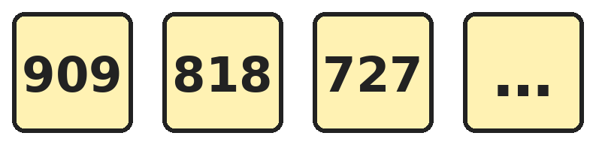
Q26. The numbers keep going down in the same way. What is the 6th number? [Star]
(A) 545 | (B) 363 | (C) 464 | (D) 454

Q27. Rani adds all the even numbers from 2 to 20: 2 + 4 + 6 + … + 20. What total does she get? [Star]
(A) 110 | (B) 100 | (C) 120 | (D) 90

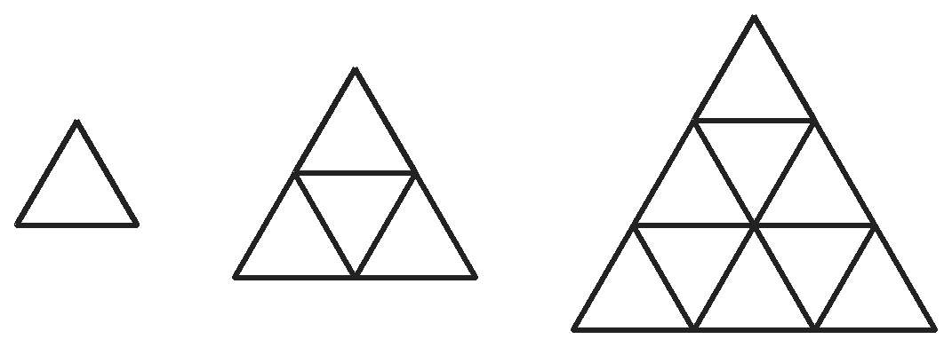
Q28. Naina makes these triangle patterns with matchsticks. 1 row uses 3 sticks, 2 rows use 9 sticks and 3 rows use 18 sticks. How many sticks does a pattern with 4 rows use? [Star]
(A) 30 | (B) 27 | (C) 24 | (D) 36

Q29. Tushar must pay ₹999. He can use ₹500, ₹200, ₹100, ₹50, ₹20 and ₹10 notes and ₹5, ₹2 and ₹1 coins. What is the fewest number of notes and coins he can use? [Star]
(A) 6 | (B) 27 | (C) 9 | (D) 10

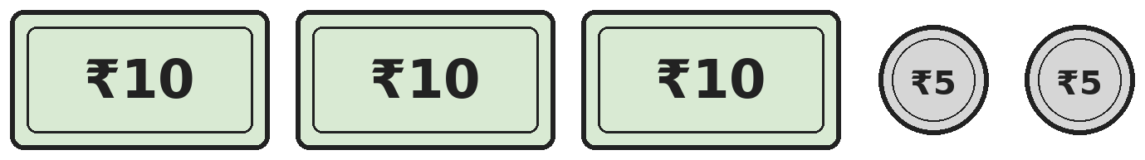
Q30. Ekta puts three ₹10 notes and two ₹5 coins on the table. How many square corners do they have altogether? [Star]
(A) 20 | (B) 12 | (C) 14 | (D) 10

Answer Sheet AMO Level 2 · Class 2 · Practice Paper 7
Name: | School: | Roll No.:
Shade or tick one circle for each question.
1. | Ⓐ Ⓑ Ⓒ Ⓓ | 11. | Ⓐ Ⓑ Ⓒ Ⓓ | 21. | Ⓐ Ⓑ Ⓒ Ⓓ
2. | Ⓐ Ⓑ Ⓒ Ⓓ | 12. | Ⓐ Ⓑ Ⓒ Ⓓ | 22. | Ⓐ Ⓑ Ⓒ Ⓓ
3. | Ⓐ Ⓑ Ⓒ Ⓓ | 13. | Ⓐ Ⓑ Ⓒ Ⓓ | 23. | Ⓐ Ⓑ Ⓒ Ⓓ
4. | Ⓐ Ⓑ Ⓒ Ⓓ | 14. | Ⓐ Ⓑ Ⓒ Ⓓ | 24. | Ⓐ Ⓑ Ⓒ Ⓓ
5. | Ⓐ Ⓑ Ⓒ Ⓓ | 15. | Ⓐ Ⓑ Ⓒ Ⓓ | 25. | Ⓐ Ⓑ Ⓒ Ⓓ
6. | Ⓐ Ⓑ Ⓒ Ⓓ | 16. | Ⓐ Ⓑ Ⓒ Ⓓ | 26. | Ⓐ Ⓑ Ⓒ Ⓓ
7. | Ⓐ Ⓑ Ⓒ Ⓓ | 17. | Ⓐ Ⓑ Ⓒ Ⓓ | 27. | Ⓐ Ⓑ Ⓒ Ⓓ
8. | Ⓐ Ⓑ Ⓒ Ⓓ | 18. | Ⓐ Ⓑ Ⓒ Ⓓ | 28. | Ⓐ Ⓑ Ⓒ Ⓓ
9. | Ⓐ Ⓑ Ⓒ Ⓓ | 19. | Ⓐ Ⓑ Ⓒ Ⓓ | 29. | Ⓐ Ⓑ Ⓒ Ⓓ
10. | Ⓐ Ⓑ Ⓒ Ⓓ | 20. | Ⓐ Ⓑ Ⓒ Ⓓ | 30. | Ⓐ Ⓑ Ⓒ Ⓓ
Q26–Q30 are Section II Star Questions. Each joins two chapters.
For the parent or teacher
Section I correct: ______ / 25 Section II correct: ______ / 5
Correct: ______ / 30
Answer Key and Solutions AMO Level 2 · Class 2 · Practice Paper 7
Quick answers
1 B | 6 C | 11 B | 16 A | 21 C | 26 D
2 C | 7 D | 12 A | 17 D | 22 A | 27 A
3 C | 8 D | 13 D | 18 D | 23 A | 28 A
4 B | 9 A | 14 B | 19 B | 24 C | 29 C
5 B | 10 C | 15 C | 20 D | 25 A | 30 B
Solutions
Q | Part · level | Answer | Why?
1 | Part 1 · Ch1 · Hard | (B) 430 | Hint: The value of a digit depends on its place.  In 437 the 4 is in the hundreds place, so its value is 400. The 3 is in the tens place, so its value is 30. 400 + 30 = 430.
2 | Part 1 · Ch1 · Hard | (C) 435 | Hint: Change the hundreds digit, then the tens digit.  1 hundred more than 345 is 445. 1 ten less than 445 is 435.
3 | Part 1 · Ch1 · Hard | (C) 9 | Hint: 600 is not in the list.  The numbers are 611, 622, 633, 644, 655, 666, 677, 688 and 699. 600 is not from 601 to 699. That is 9.
4 | Part 1 · Ch1 · Hard | (B) 370 | Hint: Find the number halfway between 320 and 380 first.  Halfway between 320 and 380 is 350. 2 tens forward from 350 is 370.
5 | Part 1 · Ch1 · Hard | (B) 528 | Hint: Start with 5 in the hundreds place.  528 is 28 more than 500. 582 is 82 more. 285 and 258 are more than 200 less than 500. So 528 is the closest.
6 | Part 1 · Ch1 · Hard | (C) 4 | Hint: An odd number must end in 3 or 5.  Ending in 3: 453 and 543. Ending in 5: 345 and 435. That is 4 odd numbers.
7 | Part 2 · Ch2 · Hard | (D) 415 | Hint: Work backwards: undo each step.  Before getting 210, he had 500 − 210 = 290. Before giving away 125, he had 290 + 125 = 415.
8 | Part 2 · Ch2 · Hard | (D) 46 | Hint: Multiply first, then add.  7 × 6 = 42 chairs in rows. 42 + 4 = 46 chairs.
9 | Part 2 · Ch2 · Hard | (A) 12 | Hint: First find a quarter of 32.  A quarter of 32 is 8, so 32 − 8 = 24 are left. Half of 24 is 12. She keeps 12 balloons.
10 | Part 2 · Ch2 · Hard | (C) It is always odd | Hint: Odd + odd is even. Now add one more odd number.  Odd + odd gives an even number. Even + odd gives an odd number. So the sum of three odd numbers is always odd. Example: 3 + 5 + 7 = 15.
11 | Part 2 · Ch2 · Hard | (B) 5 | Hint: Try each digit in a 2-digit number like 44 − 4.  With 5: 55 − 5 = 50. With 6: 66 − 6 = 60. With 1: 11 − 1 = 10. So the digit is 5.
12 | Part 2 · Ch2 · Hard | (A) 39 | Hint: Find each kind of pack separately.  4 × 6 = 24 boxes. 3 × 5 = 15 boxes. 24 + 15 = 39 juice boxes.
13 | Part 3 · Ch5 · Hard | (D) 12 | Hint: Count the 6 small ones first, then look for bigger ones.  There are 6 small triangles. 2 more are made of two small ones: the left part and the right part. Each corner-to-corner line also cuts the square into 2 big triangles, which gives 4 more. 6 + 2 + 4 = 12.
14 | Part 3 · Ch5 · Hard | (B) 5 | Hint: Follow each line from one point to another point.  Each line goes from one point of the star straight to another. Starting at the top, she draws 5 lines and is back at the top.
15 | Part 3 · Ch5 · Hard | (C) 7 | Hint: Look for the part that is inside all three circles.  There is 1 part inside all three circles. There are 3 parts inside exactly two circles. Each circle also has 1 part of its own, which makes 3. 1 + 3 + 3 = 7.
16 | Part 3 · Ch5 · Hard | (A) 2 cones and 2 cylinders | Hint: A sharpened pencil is made of two solids joined together.  The pencil is a cylinder with a cone at the sharpened end. The cap is a cone and the tin is a cylinder. That makes 2 cones and 2 cylinders.
17 | Part 3 · Ch5 · Hard | (D) A shape with 4 sides | Hint: The same triangle appears on both sides of the fold, joined along the fold.  Opening the paper gives the triangle and its copy on the other side of the fold. They are joined along the side on the fold, so that side disappears. The hole has 2 + 2 = 4 sides.
18 | Part 4 · Ch9 · Hard | (D) Half past 11 | Hint: The hour hand is between 11 and 12.  The minute hand points at 6, so it is half past. The hour hand is between 11 and 12, so it is half past 11.
19 | Part 4 · Ch9 · Hard | (B) Bat and cap | Hint: Add the prices of each pair.  Bat and cap: 120 + 35 = 155. Ball and bat: 165. Ball and cap: 80. All three: 200. So he buys the bat and the cap.
20 | Part 4 · Ch9 · Hard | (D) Both parts are equally long | Hint: The clock goes round once in each part.  From midnight to noon the hour hand goes once round the clock: 12 hours. From noon to midnight it also goes once round: 12 hours. Both parts are equally long.
21 | Part 4 · Ch9 · Hard | (C) 4 | Hint: Try different numbers of ₹100 notes and fill up with ₹50 notes.  With 4 notes of ₹100 (₹400) and 2 notes of ₹50 (₹100) he has 6 notes and ₹500. With 3 notes of ₹100 he would need 4 notes of ₹50, which is 7 notes.
22 | Part 5 · Ch10 · Hard | (A) 33 | Hint: The amount added doubles each time.  The pattern adds 1, 2, 4 and 8. Next it adds 16: 17 + 16 = 33.
23 | Part 5 · Ch10 · Hard | (A) 19 | Hint: Adding 6 works for 5 but not for 7.  5 doubled is 10, add 1 to get 11. 7 doubled is 14, add 1 to get 15. 9 doubled is 18, add 1 to get 19.
24 | Part 5 · Ch10 · Hard | (C) 9 | Hint: The tens digit can be 1, 2, 3, … Check which ones work.  The numbers are 19, 28, 37, 46, 55, 64, 73, 82 and 91. That is 9 numbers.
25 | Part 5 · Ch10 · Hard | (A) 233 | Hint: Look at which digits each number uses.  203, 302 and 230 each use the digits 2, 0 and 3. 233 uses 2, 3 and 3, so it is the odd one out.
26 | Section II · Ch1 + Ch10 · Hard | (D) 454 | Hint: Each number is 91 less than the one before. Look at each digit.  The hundreds and ones digits go down by 1 and the tens digit goes up by 1. 909, 818, 727, 636, 545, 454. The 6th is 454.
27 | Section II · Ch2 + Ch10 · Hard | (A) 110 | Hint: Pair the numbers: 2 + 20, 4 + 18, …  Make pairs: 2 + 20, 4 + 18, 6 + 16, 8 + 14 and 10 + 12. Each pair makes 22, and there are 5 pairs. 22 + 22 + 22 + 22 + 22 = 110.
28 | Section II · Ch5 + Ch10 · Hard | (A) 30 | Hint: Look at how many sticks are added each time: 6, then 9.  The sticks added go 6, then 9, so next 12 are added. 18 + 12 = 30. (Each row has 3 more sticks than the row above: 3 + 6 + 9 + 12 = 30.)
29 | Section II · Ch1 + Ch9 · Hard | (C) 9 | Hint: Make 900, then 90, then 9.  900 = 500 + 200 + 200 (3 notes). 90 = 50 + 20 + 20 (3 notes). 9 = 5 + 2 + 2 (3 coins). That is 3 + 3 + 3 = 9.
30 | Section II · Ch5 + Ch9 · Hard | (B) 12 | Hint: A note is a rectangle. A coin is a circle.  Each note is a rectangle with 4 square corners: 4 + 4 + 4 = 12. The coins are circles with no corners. Total 12.

ARYABHATTA MATHS OLYMPIAD
Level 2
PRACTICE PAPER-8
CLASS 2
Total Questions | 30 multiple-choice questions
Level | Level-2 (final round): every question is Hard
Time | 45 minutes
Section I | 25 questions, each from one chapter
Section II | 5 Star Questions, each joining two chapters
Negative Marking | No negative marking
Calculator | Not allowed
Chapters | Number System · Operations · Geometry · Applied Mathematics · Mathematical Reasoning

👋 Hello, friend! How to do this paper:
⭐ Every question has four answer choices: (A), (B), (C) and (D). Only one is correct.
⭐ Read each question and look at its picture carefully. Then mark your answer on the answer sheet at the end.
⭐ This is a Level-2 paper. Every question needs careful thinking, so take your time and check each step.
⭐ Section I has 25 questions. Section II has 5 Star Questions.
⭐ There is no negative marking, so try every question.
⭐ Do not use a calculator. You may do rough work on a separate sheet.
⭐ All figures are not necessarily drawn to scale unless stated.

For parents and teachers
• Pictures are part of the questions. Every picture also works when printed in black and white.
• You may read a question aloud to the child, exactly as printed. Please do not explain it or point to an answer choice.
• Parts follow the AMO syllabus chapters. Chapters 3, 4, 6, 7 and 8 are not part of the Class 2 syllabus, so the chapter numbers shown in the Part headings have gaps.
• The answer sheet and the answer key are at the end. Remove only the answer key before the child begins.

SECTION I 25 questions · every question is Hard
Part 1 — Number System (Syllabus Chapter 1)
Q1. What is the smallest odd 3-digit number whose digits add up to 5?
(A) 104 | (B) 113 | (C) 131 | (D) 311

Q2. Rakesh has 8 hundreds and 5 tens. If he changes everything into tens, how many tens will he have?
(A) 13 | (B) 850 | (C) 58 | (D) 85

Q3. Kirti takes the smallest 3-digit number away from the largest 3-digit number. What does she get?
(A) 900 | (B) 899 | (C) 989 | (D) 999

Q4. Suresh adds six hundred six, sixteen and sixty. Which number does he get?
(A) 676 | (B) 682 | (C) 622 | (D) 766

Q5. Madhu counts back in 50s, starting at 900. What is the 6th number she says?
(A) 600 | (B) 700 | (C) 550 | (D) 650

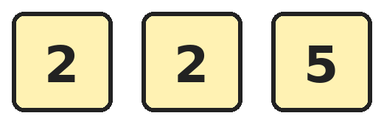
Q6. Hemant uses all three cards to make 3-digit numbers. How many different numbers can he make?
(A) 6 | (B) 2 | (C) 4 | (D) 3

Part 2 — Operations (Syllabus Chapter 2)
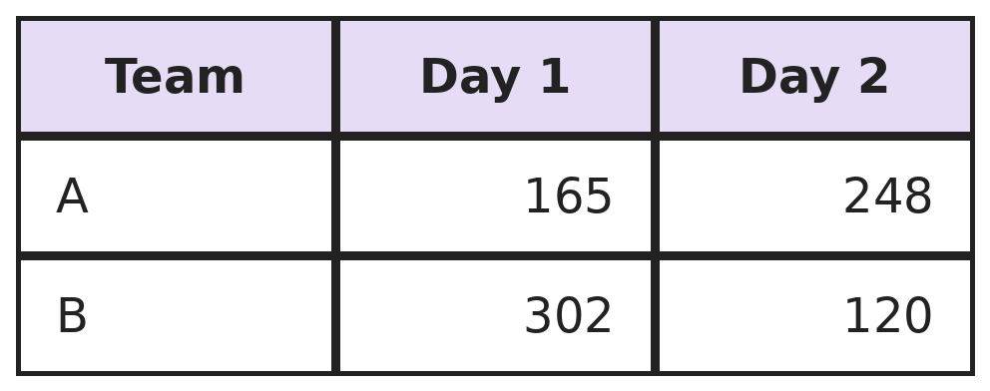
Q7. Two teams collect cans for two days. Which team collects more cans in all, and by how many?
(A) Team B, by 9 | (B) Team A, by 9 | (C) Team B, by 19 | (D) Both the same

Q8. Jaya has 8 bags with 9 beads in each. Komal has 9 bags with 8 beads in each. Who has more beads?
(A) Jaya, by 1 bead | (B) Komal, by 1 bead
(C) Both have the same | (D) Jaya, by 8 beads

Q9. Half of the mangoes in a basket is 24. How many mangoes are a quarter of the basket?
(A) 48 | (B) 12 | (C) 6 | (D) 96

Q10. Pallavi adds 456 + 298 by first adding 300. What is the answer?
(A) 756 | (B) 744 | (C) 754 | (D) 654

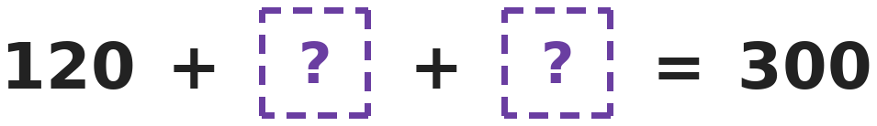
Q11. Both boxes hide the same number. Which number is it?
(A) 180 | (B) 60 | (C) 90 | (D) 80

Q12. A tray has 6 rows of oranges with 9 oranges in each row. Shalini finds that 4 oranges are rotten. How many good oranges are there?
(A) 54 | (B) 50 | (C) 58 | (D) 46

Part 3 — Geometry (Syllabus Chapter 5)
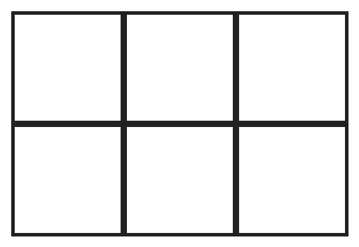
Q13. How many rectangles in this grid are NOT squares?
(A) 10 | (B) 8 | (C) 18 | (D) 12

Q14. Vidya folds a paper in half, then in half again, then in half once more. When she opens it, how many equal parts do the folds make?
(A) 6 | (B) 3 | (C) 8 | (D) 9

Q15. Girish builds a big cube using small cubes. The big cube is 2 small cubes long, 2 wide and 2 tall. How many small cubes does he use?
(A) 6 | (B) 8 | (C) 4 | (D) 12

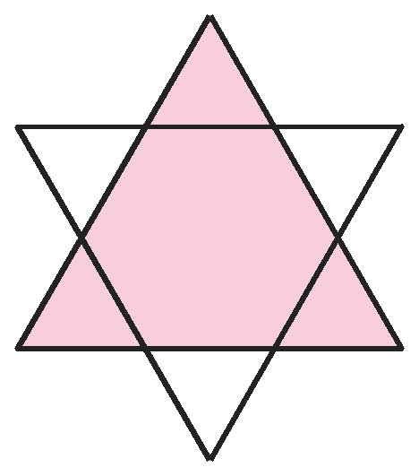
Q16. Kishore draws two big triangles, one pointing up and one pointing down, to make this star. How many triangles can you find in it?
(A) 8 | (B) 2 | (C) 6 | (D) 7

Q17. Rupa stands a solid on the table and traces round its bottom: she gets a circle. Laid on its side, it rolls in a straight line. Which solid is it?
(A) Cone | (B) Sphere | (C) Cube | (D) Cylinder

Part 4 — Applied Mathematics (Syllabus Chapter 9)
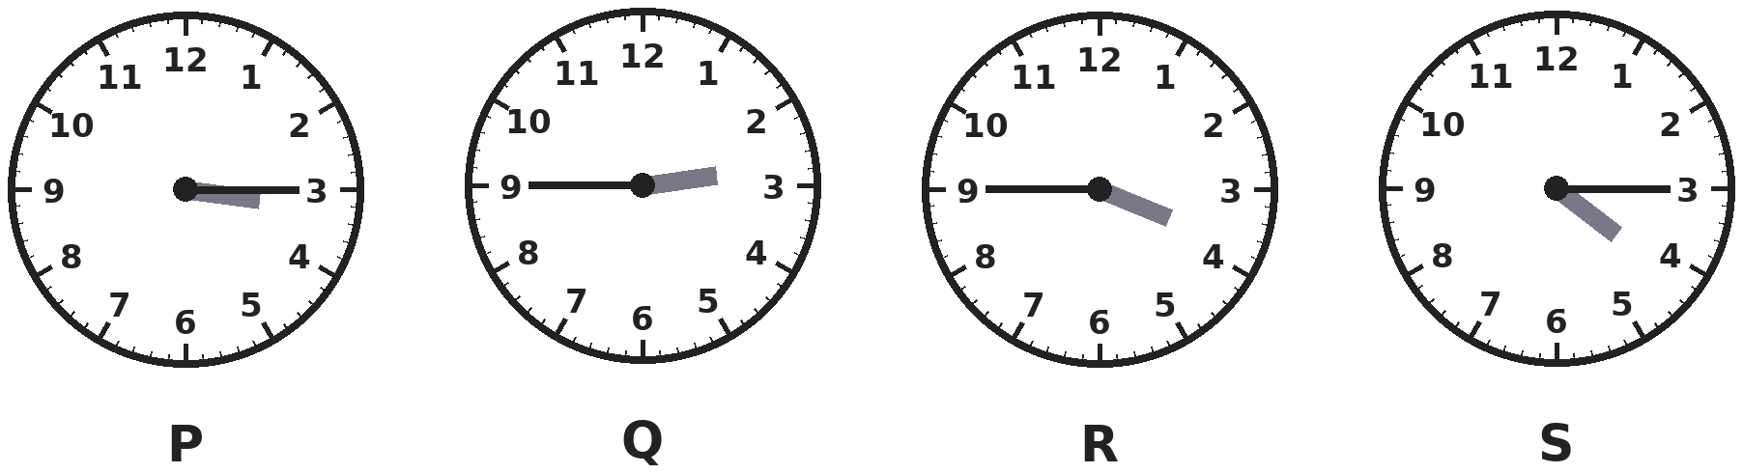
Q18. Which clock shows a time between 3 o'clock and half past 3?
(A) P | (B) Q | (C) R | (D) S

Q19. A zoo ticket costs ₹28 for an adult and ₹14 for a child. How much do tickets cost for 2 adults and 3 children?
(A) ₹84 | (B) ₹98 | (C) ₹70 | (D) ₹112

Q20. Which of these times comes first in a day?
(A) Half past 8 AM | (B) Quarter to 9 AM
(C) Quarter past 8 PM | (D) 9 o'clock AM

Q21. A pen costs ₹12. Nandini has ₹50. What is the largest number of pens she can buy?
(A) 4 | (B) 5 | (C) 3 | (D) 2

Part 5 — Mathematical Reasoning (Syllabus Chapter 10)

Q22. Jiya adds beads to a jar each day. The totals grow in this pattern. What total comes next?
(A) 20 | (B) 25 | (C) 19 | (D) 21

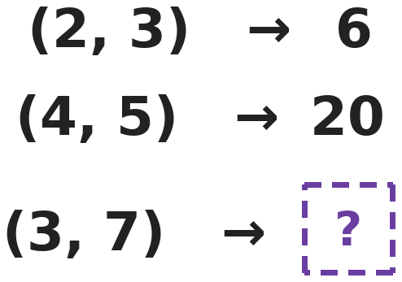
Q23. Each pair of numbers is changed into one number by the same rule. What does (3, 7) give?
(A) 10 | (B) 37 | (C) 4 | (D) 21

Q24. How many even 2-digit numbers have digits that add up to 8?
(A) 8 | (B) 5 | (C) 4 | (D) 3

Q25. Three of these numbers are in the same times table. Which is the odd one out: 21, 35, 49, 55?
(A) 21 | (B) 35 | (C) 49 | (D) 55

SECTION II — Star Questions 5 questions · each joins two chapters
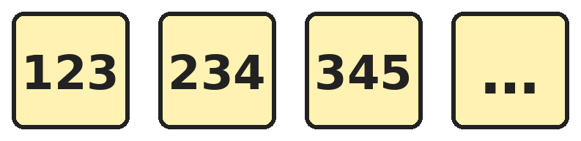
Q26. The pattern keeps going in the same way. Which number in it has digits that add up to 21? [Star]
(A) 789 | (B) 567 | (C) 678 | (D) 777

Q27. Two numbers add up to 50. One is 10 more than the other. What is the larger number? [Star]
(A) 40 | (B) 25 | (C) 20 | (D) 30

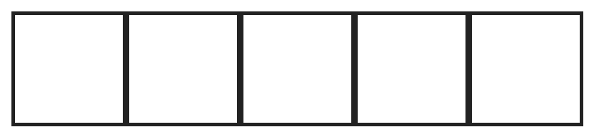
Q28. How many rectangles of all sizes are in this strip of 5 squares? (A square is also a rectangle.) [Star]
(A) 15 | (B) 5 | (C) 10 | (D) 14

Q29. Kartik pays ₹305 using only ₹100 notes and ₹1 coins. He uses as few as he can. How many notes and coins does he use in all? [Star]
(A) 35 | (B) 305 | (C) 8 | (D) 6

Q30. At a craft fair, a paper shape costs ₹3 for every corner it has, and a circle costs ₹5. Garima buys 2 triangles, 1 square and 3 circles. How much does she pay? [Star]
(A) ₹45 | (B) ₹30 | (C) ₹42 | (D) ₹50

Answer Sheet AMO Level 2 · Class 2 · Practice Paper 8
Name: | School: | Roll No.:
Shade or tick one circle for each question.
1. | Ⓐ Ⓑ Ⓒ Ⓓ | 11. | Ⓐ Ⓑ Ⓒ Ⓓ | 21. | Ⓐ Ⓑ Ⓒ Ⓓ
2. | Ⓐ Ⓑ Ⓒ Ⓓ | 12. | Ⓐ Ⓑ Ⓒ Ⓓ | 22. | Ⓐ Ⓑ Ⓒ Ⓓ
3. | Ⓐ Ⓑ Ⓒ Ⓓ | 13. | Ⓐ Ⓑ Ⓒ Ⓓ | 23. | Ⓐ Ⓑ Ⓒ Ⓓ
4. | Ⓐ Ⓑ Ⓒ Ⓓ | 14. | Ⓐ Ⓑ Ⓒ Ⓓ | 24. | Ⓐ Ⓑ Ⓒ Ⓓ
5. | Ⓐ Ⓑ Ⓒ Ⓓ | 15. | Ⓐ Ⓑ Ⓒ Ⓓ | 25. | Ⓐ Ⓑ Ⓒ Ⓓ
6. | Ⓐ Ⓑ Ⓒ Ⓓ | 16. | Ⓐ Ⓑ Ⓒ Ⓓ | 26. | Ⓐ Ⓑ Ⓒ Ⓓ
7. | Ⓐ Ⓑ Ⓒ Ⓓ | 17. | Ⓐ Ⓑ Ⓒ Ⓓ | 27. | Ⓐ Ⓑ Ⓒ Ⓓ
8. | Ⓐ Ⓑ Ⓒ Ⓓ | 18. | Ⓐ Ⓑ Ⓒ Ⓓ | 28. | Ⓐ Ⓑ Ⓒ Ⓓ
9. | Ⓐ Ⓑ Ⓒ Ⓓ | 19. | Ⓐ Ⓑ Ⓒ Ⓓ | 29. | Ⓐ Ⓑ Ⓒ Ⓓ
10. | Ⓐ Ⓑ Ⓒ Ⓓ | 20. | Ⓐ Ⓑ Ⓒ Ⓓ | 30. | Ⓐ Ⓑ Ⓒ Ⓓ
Q26–Q30 are Section II Star Questions. Each joins two chapters.
For the parent or teacher
Section I correct: ______ / 25 Section II correct: ______ / 5
Correct: ______ / 30
Answer Key and Solutions AMO Level 2 · Class 2 · Practice Paper 8
Quick answers
1 B | 6 D | 11 C | 16 A | 21 A | 26 C
2 D | 7 A | 12 B | 17 D | 22 D | 27 D
3 B | 8 C | 13 A | 18 A | 23 D | 28 A
4 B | 9 B | 14 C | 19 B | 24 C | 29 C
5 D | 10 C | 15 B | 20 A | 25 D | 30 A
Solutions
Q | Part · level | Answer | Why?
1 | Part 1 · Ch1 · Hard | (B) 113 | Hint: Start with hundreds digit 1 and keep the tens digit small.  With hundreds digit 1, the other two digits add up to 4. The smallest is 104, but it is even. The next is 113, which is odd.
2 | Part 1 · Ch1 · Hard | (D) 85 | Hint: 1 hundred is 10 tens.  8 hundreds is 80 tens. 80 tens + 5 tens = 85 tens.
3 | Part 1 · Ch1 · Hard | (B) 899 | Hint: The smallest 3-digit number is 100.  The largest 3-digit number is 999 and the smallest is 100. 999 − 100 = 899.
4 | Part 1 · Ch1 · Hard | (B) 682 | Hint: Write each number name as digits first.  Six hundred six is 606. 606 + 16 = 622. 622 + 60 = 682.
5 | Part 1 · Ch1 · Hard | (D) 650 | Hint: The 1st number is 900.  900, 850, 800, 750, 700, 650. The 6th number is 650.
6 | Part 1 · Ch1 · Hard | (D) 3 | Hint: The two 2s look the same, so swapping them does not make a new number.  The 5 can be in the hundreds, tens or ones place: 522, 252 and 225. That is 3 numbers.
7 | Part 2 · Ch2 · Hard | (A) Team B, by 9 | Hint: Add each team's two days.  Team A: 165 + 248 = 413. Team B: 302 + 120 = 422. Team B has 422 − 413 = 9 more.
8 | Part 2 · Ch2 · Hard | (C) Both have the same | Hint: Is 8 × 9 the same as 9 × 8?  Jaya: 8 × 9 = 72. Komal: 9 × 8 = 72. They have the same number of beads.
9 | Part 2 · Ch2 · Hard | (B) 12 | Hint: A quarter is half of a half.  Half is 24, and a quarter is half of a half. Half of 24 is 12.
10 | Part 2 · Ch2 · Hard | (C) 754 | Hint: 298 is 2 less than 300.  456 + 300 = 756. She added 2 too many, so 756 − 2 = 754.
11 | Part 2 · Ch2 · Hard | (C) 90 | Hint: The two boxes together must make 300 − 120.  300 − 120 = 180. The two equal numbers add up to 180, so each is half of 180, which is 90.
12 | Part 2 · Ch2 · Hard | (B) 50 | Hint: Find all the oranges first.  6 × 9 = 54 oranges. 54 − 4 = 50 good oranges.
13 | Part 3 · Ch5 · Hard | (A) 10 | Hint: Count all the rectangles, then take away the squares.  Rectangles 2 across: 2 in each row, so 4. 3 across: 1 in each row, so 2. 1 across, 2 down: 3. 2 across, 2 down is a square. 3 across, 2 down: 1. Not squares: 4 + 2 + 3 + 1 = 10.
14 | Part 3 · Ch5 · Hard | (C) 8 | Hint: Each fold doubles the number of parts.  One fold makes 2 parts. Two folds make 4. Three folds make 8.
15 | Part 3 · Ch5 · Hard | (B) 8 | Hint: Count the bottom layer first.  The bottom layer is 2 by 2, which is 4 cubes. The top layer also has 4. 4 + 4 = 8 cubes.
16 | Part 3 · Ch5 · Hard | (A) 8 | Hint: Each point of the star is a small triangle.  The star has 6 points, and each point is a small triangle. There are also the 2 big triangles. 6 + 2 = 8.
17 | Part 3 · Ch5 · Hard | (D) Cylinder | Hint: A cone on its side rolls round in a circle.  A cylinder has a flat circle at the bottom and rolls in a straight line on its side. A cone also has a flat circle, but it rolls round in a circle. A sphere has no flat bottom and a cube does not roll.
18 | Part 4 · Ch9 · Hard | (A) P | Hint: Read each clock first.  P shows quarter past 3, which is between 3 o'clock and half past 3. Q shows quarter to 3, R shows quarter to 4 and S shows quarter past 4.
19 | Part 4 · Ch9 · Hard | (B) ₹98 | Hint: Add the adult tickets and the child tickets separately.  2 adults: 28 + 28 = ₹56. 3 children: 14 + 14 + 14 = ₹42. Total ₹56 + ₹42 = ₹98.
20 | Part 4 · Ch9 · Hard | (A) Half past 8 AM | Hint: AM times come before PM times.  Quarter past 8 PM is in the evening, so it is last. Of the AM times, half past 8 comes before quarter to 9 and 9 o'clock.
21 | Part 4 · Ch9 · Hard | (A) 4 | Hint: Keep adding ₹12 until you pass ₹50.  12, 24, 36, 48: 4 pens cost ₹48. 5 pens would cost ₹60, which is more than ₹50. She can buy 4 pens.
22 | Part 5 · Ch10 · Hard | (D) 21 | Hint: The amount added goes up by 1 each time.  The pattern adds 2, 3, 4 and 5. Next it adds 6: 15 + 6 = 21.
23 | Part 5 · Ch10 · Hard | (D) 21 | Hint: Adding works for (2, 3)? Check (4, 5).  2 × 3 = 6 and 4 × 5 = 20, so the rule multiplies. 3 × 7 = 21.
24 | Part 5 · Ch10 · Hard | (C) 4 | Hint: List the numbers with digit sum 8, then keep the even ones.  Numbers with digit sum 8: 17, 26, 35, 44, 53, 62, 71, 80. The even ones are 26, 44, 62 and 80. That is 4.
25 | Part 5 · Ch10 · Hard | (D) 55 | Hint: Think of the 7 times table.  21 = 7 × 3, 35 = 7 × 5 and 49 = 7 × 7. 55 is not in the 7 times table, so it is the odd one out.
26 | Section II · Ch1 + Ch10 · Hard | (C) 678 | Hint: Each number has three digits next to each other, like 4, 5, 6.  The numbers are 123, 234, 345, 456, 567, 678, 789. 6 + 7 + 8 = 21, so the number is 678. (777 is not in the pattern.)
27 | Section II · Ch2 + Ch10 · Hard | (D) 30 | Hint: Try two numbers that are 10 apart near the middle of 50.  Take away the extra 10: 50 − 10 = 40. Half of 40 is 20, so the smaller number is 20 and the larger is 30. Check: 20 + 30 = 50.
28 | Section II · Ch5 + Ch10 · Hard | (A) 15 | Hint: Count rectangles 1 square long, 2 squares long, and so on.  1 long: 5. 2 long: 4. 3 long: 3. 4 long: 2. 5 long: 1. 5 + 4 + 3 + 2 + 1 = 15.
29 | Section II · Ch1 + Ch9 · Hard | (C) 8 | Hint: Look at the hundreds digit and the ones digit of 305.  305 is 3 hundreds and 5 ones. He uses 3 notes of ₹100 and 5 coins of ₹1. 3 + 5 = 8.
30 | Section II · Ch5 + Ch9 · Hard | (A) ₹45 | Hint: A triangle has 3 corners and a square has 4.  Each triangle has 3 corners, so it costs 3 × 3 = ₹9, and 2 triangles cost ₹18. The square has 4 corners: 4 × 3 = ₹12. 3 circles cost 5 + 5 + 5 = ₹15. Total ₹45.

ARYABHATTA MATHS OLYMPIAD
Level 2
PRACTICE PAPER-9
CLASS 2
Total Questions | 30 multiple-choice questions
Level | Level-2 (final round): every question is Hard
Time | 45 minutes
Section I | 25 questions, each from one chapter
Section II | 5 Star Questions, each joining two chapters
Negative Marking | No negative marking
Calculator | Not allowed
Chapters | Number System · Operations · Geometry · Applied Mathematics · Mathematical Reasoning

👋 Hello, friend! How to do this paper:
⭐ Every question has four answer choices: (A), (B), (C) and (D). Only one is correct.
⭐ Read each question and look at its picture carefully. Then mark your answer on the answer sheet at the end.
⭐ This is a Level-2 paper. Every question needs careful thinking, so take your time and check each step.
⭐ Section I has 25 questions. Section II has 5 Star Questions.
⭐ There is no negative marking, so try every question.
⭐ Do not use a calculator. You may do rough work on a separate sheet.
⭐ All figures are not necessarily drawn to scale unless stated.

For parents and teachers
• Pictures are part of the questions. Every picture also works when printed in black and white.
• You may read a question aloud to the child, exactly as printed. Please do not explain it or point to an answer choice.
• Parts follow the AMO syllabus chapters. Chapters 3, 4, 6, 7 and 8 are not part of the Class 2 syllabus, so the chapter numbers shown in the Part headings have gaps.
• The answer sheet and the answer key are at the end. Remove only the answer key before the child begins.

SECTION I 25 questions · every question is Hard
Part 1 — Number System (Syllabus Chapter 1)
Q1. How many even numbers have 9 as their hundreds digit, like 914?
(A) 100 | (B) 45 | (C) 10 | (D) 50

Q2. What is the greatest odd number less than 500 that has three different digits?
(A) 499 | (B) 497 | (C) 489 | (D) 498

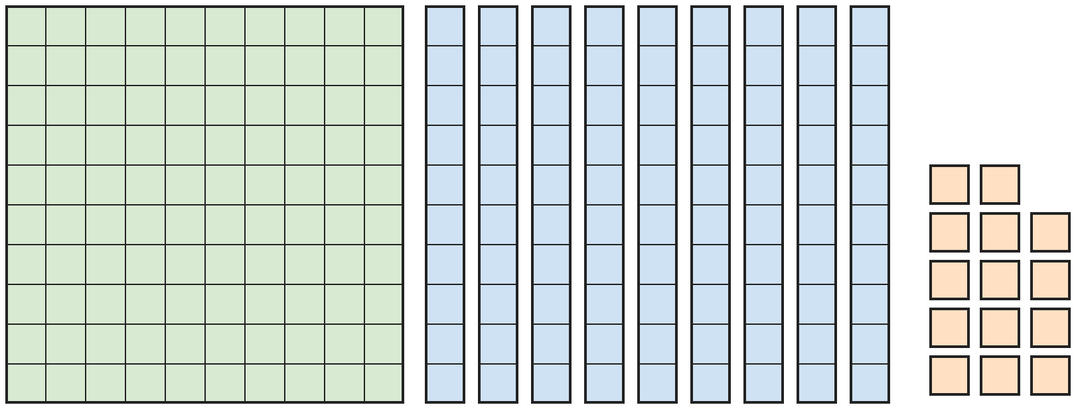
Q3. Kriti puts out these blocks. What number do they show?
(A) 194 | (B) 214 | (C) 204 | (D) 184

Q4. Bharat adds 3 tens and then 2 hundreds to 482. Which number does he get?
(A) 712 | (B) 512 | (C) 785 | (D) 702

Q5. Which number is 5 hundreds, 4 ones and 12 tens?
(A) 612 | (B) 542 | (C) 624 | (D) 534

Q6. In which number is the tens digit equal to the sum of the other two digits?
(A) 381 | (B) 253 | (C) 472 | (D) 615

Part 2 — Operations (Syllabus Chapter 2)
Q7. A train had 320 passengers. At a station, 145 people got on and 210 got off. How many passengers are on the train now?
(A) 385 | (B) 675 | (C) 255 | (D) 245

Q8. Both sides are equal. Which number goes in the box?
(A) 16 | (B) 50 | (C) 6 | (D) 10

Q9. There are 60 children in a sports camp. A quarter play cricket, half play football and the rest play tennis. How many play tennis?
(A) 30 | (B) 15 | (C) 45 | (D) 20

Q10. Which subtraction gives the largest answer?
(A) 400 − 150 | (B) 512 − 260 | (C) 391 − 125 | (D) 300 − 45

Q11. Ojas thinks of a number. He doubles it and adds 15. He gets 55. What was his number?
(A) 40 | (B) 35 | (C) 25 | (D) 20

Q12. Indu's holiday was 6 weeks long. She was ill for 5 days of it. For how many days of the holiday was she well?
(A) 47 | (B) 1 | (C) 37 | (D) 42

Part 3 — Geometry (Syllabus Chapter 5)
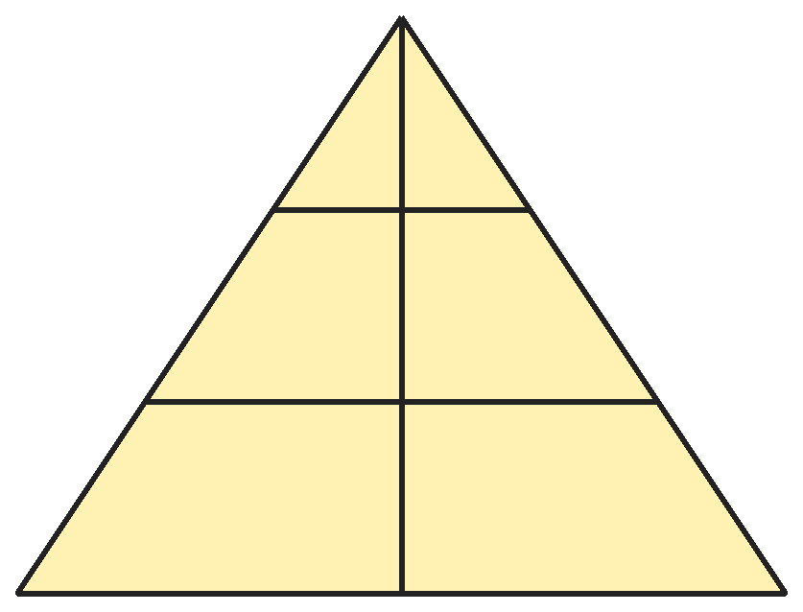
Q13. How many triangles of all sizes are in this picture?
(A) 6 | (B) 9 | (C) 3 | (D) 8

Q14. Ruhi has a clay cone standing on its flat face. She cuts it straight across, halfway up, like slicing a carrot. What shape is the top piece?
(A) A cylinder | (B) A triangle
(C) A sphere | (D) A smaller cone

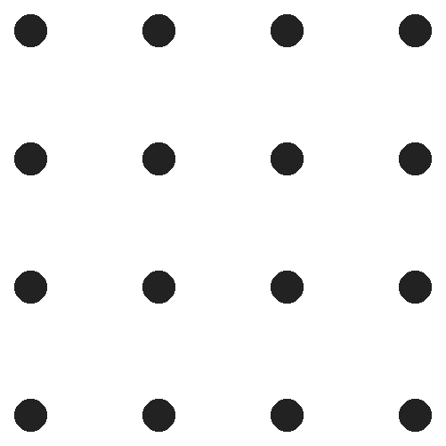
Q15. Ajay joins the dots on the outside of this grid to make a square. How many dots lie on his square?
(A) 16 | (B) 8 | (C) 12 | (D) 4

Q16. Disha covers this board with 3 dominoes. Each domino covers 2 squares next to each other. In how many different ways can she do it?
(A) 3 | (B) 2 | (C) 4 | (D) 6

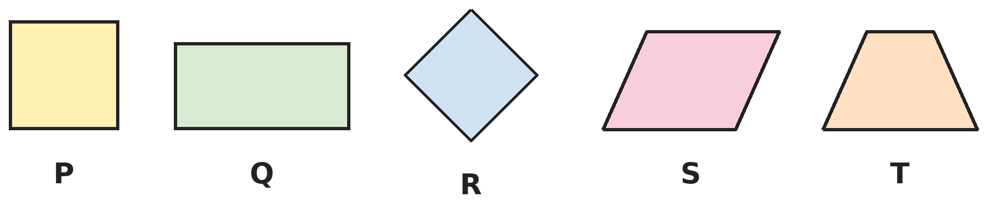
Q17. How many of these shapes have 4 square corners?
(A) 2 | (B) 4 | (C) 3 | (D) 5

Part 4 — Applied Mathematics (Syllabus Chapter 9)
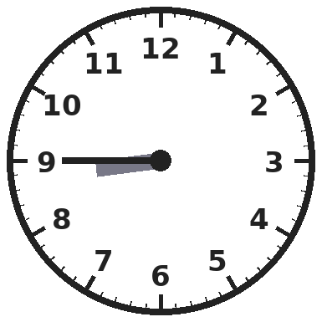
Q18. Charvi goes to bed in the evening at the time on this clock. What time does she go to bed?
(A) Quarter to 8 PM | (B) Quarter past 9 PM
(C) Quarter to 9 AM | (D) Quarter to 9 PM

Q19. Shoes cost ₹185 and a cap costs ₹130. Raghav has ₹300. How much more money does he need to buy both?
(A) ₹5 | (B) ₹115 | (C) ₹25 | (D) ₹15

Q20. Apples cost ₹8 each and bananas cost ₹5 each. Rekha buys 4 apples and 6 bananas and pays with a ₹100 note. How much change does she get?
(A) ₹38 | (B) ₹62 | (C) ₹48 | (D) ₹42

Q21. Akash has ₹100. He buys 2 notebooks for ₹25 each and one pencil box. He gets ₹15 back. How much does the pencil box cost?
(A) ₹60 | (B) ₹35 | (C) ₹50 | (D) ₹85

Part 5 — Mathematical Reasoning (Syllabus Chapter 10)
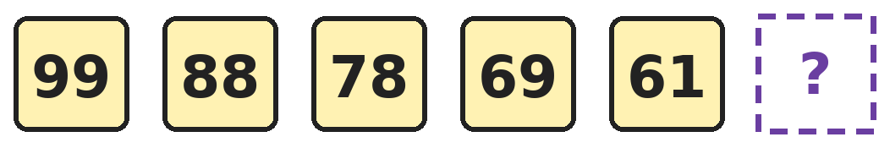
Q22. Look at how much is taken away each time. Which number comes next?
(A) 54 | (B) 53 | (C) 55 | (D) 52

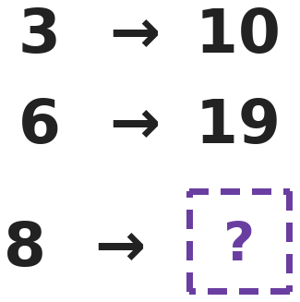
Q23. Mohit's number machine uses the same rule for every number. What does it give for 8?
(A) 25 | (B) 24 | (C) 21 | (D) 15

Q24. How many 3-digit numbers start with 5 and end with 5, like 575?
(A) 9 | (B) 11 | (C) 10 | (D) 5

Q25. Three of these are equal. Which is the odd one out: half of 40, a quarter of 80, 2 × 10, 5 × 5?
(A) Half of 40 | (B) 5 × 5
(C) A quarter of 80 | (D) 2 × 10

SECTION II — Star Questions 5 questions · each joins two chapters
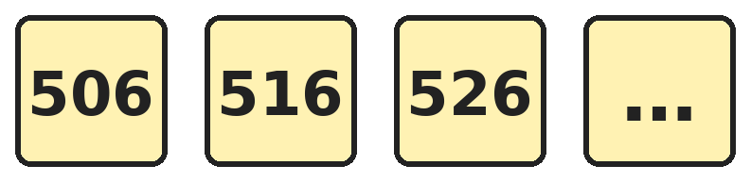
Q26. The numbers go up in the same way. What is the 8th number? [Star]
(A) 576 | (B) 586 | (C) 566 | (D) 580

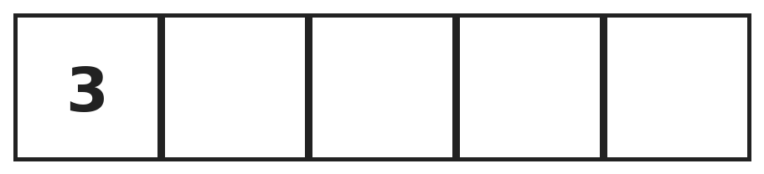
Q27. Nitya fills the boxes so that any two boxes next to each other add up to 10. What is the total of all five boxes? [Star]
(A) 25 | (B) 23 | (C) 27 | (D) 20

Q28. A cube looks like a square from every side. Which word makes this true? Cube is to square as sphere is to ___. [Star]
(A) Cylinder | (B) Cone | (C) Triangle | (D) Circle

Q29. A book costs ₹457. Vinay pays with four ₹100 notes, four ₹10 notes and seventeen ₹1 coins. What is true? [Star]
(A) He paid ₹10 too little | (B) He paid ₹10 too much
(C) He paid ₹1 too little | (D) He paid exactly ₹457

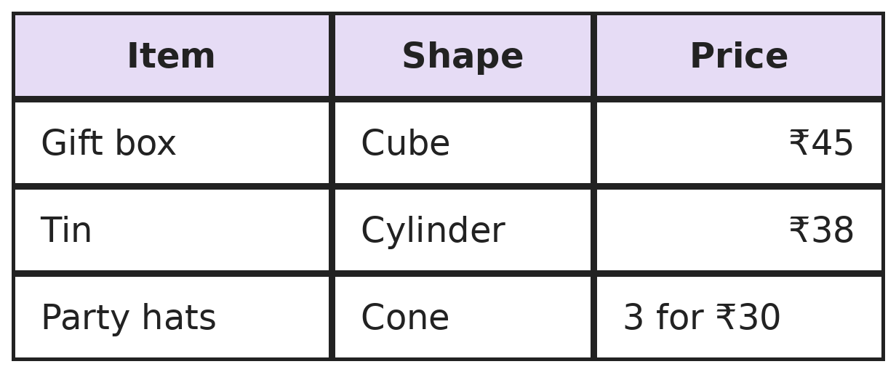
Q30. Swati buys the cube-shaped item, the cylinder-shaped item and 6 of the cone-shaped items. How much does she pay? [Star]
(A) ₹143 | (B) ₹113 | (C) ₹263 | (D) ₹123

Answer Sheet AMO Level 2 · Class 2 · Practice Paper 9
Name: | School: | Roll No.:
Shade or tick one circle for each question.
1. | Ⓐ Ⓑ Ⓒ Ⓓ | 11. | Ⓐ Ⓑ Ⓒ Ⓓ | 21. | Ⓐ Ⓑ Ⓒ Ⓓ
2. | Ⓐ Ⓑ Ⓒ Ⓓ | 12. | Ⓐ Ⓑ Ⓒ Ⓓ | 22. | Ⓐ Ⓑ Ⓒ Ⓓ
3. | Ⓐ Ⓑ Ⓒ Ⓓ | 13. | Ⓐ Ⓑ Ⓒ Ⓓ | 23. | Ⓐ Ⓑ Ⓒ Ⓓ
4. | Ⓐ Ⓑ Ⓒ Ⓓ | 14. | Ⓐ Ⓑ Ⓒ Ⓓ | 24. | Ⓐ Ⓑ Ⓒ Ⓓ
5. | Ⓐ Ⓑ Ⓒ Ⓓ | 15. | Ⓐ Ⓑ Ⓒ Ⓓ | 25. | Ⓐ Ⓑ Ⓒ Ⓓ
6. | Ⓐ Ⓑ Ⓒ Ⓓ | 16. | Ⓐ Ⓑ Ⓒ Ⓓ | 26. | Ⓐ Ⓑ Ⓒ Ⓓ
7. | Ⓐ Ⓑ Ⓒ Ⓓ | 17. | Ⓐ Ⓑ Ⓒ Ⓓ | 27. | Ⓐ Ⓑ Ⓒ Ⓓ
8. | Ⓐ Ⓑ Ⓒ Ⓓ | 18. | Ⓐ Ⓑ Ⓒ Ⓓ | 28. | Ⓐ Ⓑ Ⓒ Ⓓ
9. | Ⓐ Ⓑ Ⓒ Ⓓ | 19. | Ⓐ Ⓑ Ⓒ Ⓓ | 29. | Ⓐ Ⓑ Ⓒ Ⓓ
10. | Ⓐ Ⓑ Ⓒ Ⓓ | 20. | Ⓐ Ⓑ Ⓒ Ⓓ | 30. | Ⓐ Ⓑ Ⓒ Ⓓ
Q26–Q30 are Section II Star Questions. Each joins two chapters.
For the parent or teacher
Section I correct: ______ / 25 Section II correct: ______ / 5
Correct: ______ / 30
Answer Key and Solutions AMO Level 2 · Class 2 · Practice Paper 9
Quick answers
1 D | 6 B | 11 D | 16 A | 21 B | 26 A
2 B | 7 C | 12 C | 17 C | 22 A | 27 B
3 C | 8 D | 13 B | 18 D | 23 A | 28 D
4 A | 9 B | 14 D | 19 D | 24 C | 29 D
5 C | 10 C | 15 C | 20 A | 25 B | 30 A
Solutions
Q | Part · level | Answer | Why?
1 | Part 1 · Ch1 · Hard | (D) 50 | Hint: These are the numbers from 900 to 999.  From 900 to 999 there are 100 numbers. Half of them are even: 900, 902, …, 998. That is 50.
2 | Part 1 · Ch1 · Hard | (B) 497 | Hint: 499 has two 9s.  499 has the digit 9 twice. 498 is even. 497 is odd and its digits 4, 9 and 7 are all different.
3 | Part 1 · Ch1 · Hard | (C) 204 | Hint: 14 ones is 1 ten and 4 ones.  1 hundred is 100, 9 tens is 90 and 14 ones is 14. 100 + 90 + 14 = 204.
4 | Part 1 · Ch1 · Hard | (A) 712 | Hint: 8 tens and 3 tens make 11 tens.  482 + 30 = 512, because 8 tens and 3 tens make 11 tens, which is 1 hundred and 1 ten. Then 512 + 200 = 712.
5 | Part 1 · Ch1 · Hard | (C) 624 | Hint: 12 tens is 120.  500 + 120 + 4 = 624.
6 | Part 1 · Ch1 · Hard | (B) 253 | Hint: Add the hundreds and ones digits and compare with the tens digit.  253: 2 + 3 = 5, the tens digit. 381: 3 + 1 = 4, not 8. 472: 4 + 2 = 6, not 7. 615: 6 + 5 = 11, not 1.
7 | Part 2 · Ch2 · Hard | (C) 255 | Hint: Add those who got on, then take away those who got off.  320 + 145 = 465. 465 − 210 = 255.
8 | Part 2 · Ch2 · Hard | (D) 10 | Hint: Work out the left side first.  5 × 8 = 40 and 5 × 2 = 10, so the left side is 50. 5 × 10 = 50, so the box is 10. (It is 8 + 2.)
9 | Part 2 · Ch2 · Hard | (B) 15 | Hint: Find a quarter and a half of 60.  A quarter of 60 is 15 and half of 60 is 30. 15 + 30 = 45. The rest is 60 − 45 = 15.
10 | Part 2 · Ch2 · Hard | (C) 391 − 125 | Hint: Work out each one.  391 − 125 = 266. 400 − 150 = 250. 512 − 260 = 252. 300 − 45 = 255. The largest is 266.
11 | Part 2 · Ch2 · Hard | (D) 20 | Hint: Work backwards from 55.  Before adding 15 he had 55 − 15 = 40. Before doubling he had half of 40, which is 20.
12 | Part 2 · Ch2 · Hard | (C) 37 | Hint: There are 7 days in a week.  6 weeks is 6 × 7 = 42 days. 42 − 5 = 37 days.
13 | Part 3 · Ch5 · Hard | (B) 9 | Hint: Every triangle has its top corner at the top. Count by its bottom side.  Each line across, and the bottom side, can be the bottom of 3 triangles: the left one, the right one and both together. 3 + 3 + 3 = 9.
14 | Part 3 · Ch5 · Hard | (D) A smaller cone | Hint: The top piece still has the pointed tip.  The top piece keeps the pointed tip and has a new flat circle at the bottom. It is a smaller cone. A triangle is flat, not a solid.
15 | Part 3 · Ch5 · Hard | (C) 12 | Hint: Do not count the corner dots twice.  There are 16 dots in all. The 4 dots in the middle are not on the square. 16 − 4 = 12.
16 | Part 3 · Ch5 · Hard | (A) 3 | Hint: Try all 3 dominoes standing up, then try lying some down.  All 3 standing up: 1 way. Two lying down on the left with one standing on the right: 1 way. One standing on the left with two lying down on the right: 1 way. That is 3 ways.
17 | Part 3 · Ch5 · Hard | (C) 3 | Hint: A square that is turned still has square corners.  P is a square and Q is a rectangle. R is a square turned on its corner, so its corners are still square. S and T have slanting sides and no square corners. That is 3.
18 | Part 4 · Ch9 · Hard | (D) Quarter to 9 PM | Hint: The hour hand is close to 9 but not there yet.  The minute hand points at 9, so it is quarter to. The hour hand is nearly at 9, so it is quarter to 9. It is evening, so PM.
19 | Part 4 · Ch9 · Hard | (D) ₹15 | Hint: Find the total cost first.  185 + 130 = ₹315. He needs ₹315 − ₹300 = ₹15 more.
20 | Part 4 · Ch9 · Hard | (A) ₹38 | Hint: Find the cost of the apples and the bananas separately.  4 apples: 8 × 4 = ₹32. 6 bananas: 5 × 6 = ₹30. Total ₹62. Change: ₹100 − ₹62 = ₹38.
21 | Part 4 · Ch9 · Hard | (B) ₹35 | Hint: First find how much he spent in all.  He spent ₹100 − ₹15 = ₹85. The notebooks cost 25 + 25 = ₹50. The pencil box costs ₹85 − ₹50 = ₹35.
22 | Part 5 · Ch10 · Hard | (A) 54 | Hint: The amount taken away goes down by 1 each time.  The pattern takes away 11, 10, 9 and 8. Next it takes away 7: 61 − 7 = 54.
23 | Part 5 · Ch10 · Hard | (A) 25 | Hint: Adding 7 works for 3 but not for 6.  3 × 3 = 9 and 9 + 1 = 10. 6 × 3 = 18 and 18 + 1 = 19. So 8 × 3 = 24 and 24 + 1 = 25.
24 | Part 5 · Ch10 · Hard | (C) 10 | Hint: Only the middle digit can change.  The middle digit can be any of 0, 1, 2, …, 9. That gives 505, 515, …, 595: 10 numbers.
25 | Part 5 · Ch10 · Hard | (B) 5 × 5 | Hint: Work out each one.  Half of 40 is 20, a quarter of 80 is 20 and 2 × 10 is 20. 5 × 5 is 25, so it is the odd one out.
26 | Section II · Ch1 + Ch10 · Hard | (A) 576 | Hint: Only the tens digit changes.  The tens digit goes 0, 1, 2, … so the 8th number has tens digit 7. It is 576.
27 | Section II · Ch2 + Ch10 · Hard | (B) 23 | Hint: Fill the second box first.  The boxes are 3, 7, 3, 7, 3. Their total is 3 + 7 + 3 + 7 + 3 = 23.
28 | Section II · Ch5 + Ch10 · Hard | (D) Circle | Hint: What flat shape do you see when you look at a sphere?  A cube looks like a square from any side. A sphere looks like a circle from any side. So sphere is to circle.
29 | Section II · Ch1 + Ch9 · Hard | (D) He paid exactly ₹457 | Hint: 17 ones is 1 ten and 7 ones.  400 + 40 + 17 = 457. He paid exactly ₹457.
30 | Section II · Ch5 + Ch9 · Hard | (A) ₹143 | Hint: 6 party hats are two lots of 3.  6 hats cost ₹30 + ₹30 = ₹60. Total: ₹45 + ₹38 + ₹60 = ₹143.

ARYABHATTA MATHS OLYMPIAD
Level 2
PRACTICE PAPER-10
CLASS 2
Total Questions | 30 multiple-choice questions
Level | Level-2 (final round): every question is Hard
Time | 45 minutes
Section I | 25 questions, each from one chapter
Section II | 5 Star Questions, each joining two chapters
Negative Marking | No negative marking
Calculator | Not allowed
Chapters | Number System · Operations · Geometry · Applied Mathematics · Mathematical Reasoning

👋 Hello, friend! How to do this paper:
⭐ Every question has four answer choices: (A), (B), (C) and (D). Only one is correct.
⭐ Read each question and look at its picture carefully. Then mark your answer on the answer sheet at the end.
⭐ This is a Level-2 paper. Every question needs careful thinking, so take your time and check each step.
⭐ Section I has 25 questions. Section II has 5 Star Questions.
⭐ There is no negative marking, so try every question.
⭐ Do not use a calculator. You may do rough work on a separate sheet.
⭐ All figures are not necessarily drawn to scale unless stated.

For parents and teachers
• Pictures are part of the questions. Every picture also works when printed in black and white.
• You may read a question aloud to the child, exactly as printed. Please do not explain it or point to an answer choice.
• Parts follow the AMO syllabus chapters. Chapters 3, 4, 6, 7 and 8 are not part of the Class 2 syllabus, so the chapter numbers shown in the Part headings have gaps.
• The answer sheet and the answer key are at the end. Remove only the answer key before the child begins.

SECTION I 25 questions · every question is Hard
Part 1 — Number System (Syllabus Chapter 1)
Q1. Raffle tickets are numbered from 200 to 299. Each ticket has a different number. How many tickets are there?
(A) 99 | (B) 98 | (C) 101 | (D) 100

Q2. Upasana writes these numbers in order: 789, 798, 879, 897, 978. Which number is in the middle?
(A) 897 | (B) 879 | (C) 798 | (D) 978

Q3. Which number is 8 hundreds, 19 tens and 5 ones?
(A) 905 | (B) 895 | (C) 985 | (D) 995

Q4. How many 3-digit numbers have digits that add up to 3?
(A) 6 | (B) 5 | (C) 4 | (D) 3

Q5. Atul's number is between 300 and 400. Its tens digit is 4 more than its hundreds digit. Its ones digit is 2 less than its tens digit. What is the number?
(A) 357 | (B) 379 | (C) 375 | (D) 475

Q6. Suhani reads a book from page 101 to page 120. How many of these pages have odd page numbers?
(A) 10 | (B) 9 | (C) 11 | (D) 20

Part 2 — Operations (Syllabus Chapter 2)
Q7. A hall has 600 seats. 389 tickets were sold online and 127 at the gate. How many seats are still empty?
(A) 211 | (B) 516 | (C) 94 | (D) 84

Q8. In a parking lot there are 7 cars and 6 bicycles. How many wheels are there altogether?
(A) 40 | (B) 26 | (C) 52 | (D) 13

Q9. Sameer has 84 marbles. He gives half of them to Rahul and a quarter of them to Pratik. How many marbles does Sameer keep?
(A) 42 | (B) 63 | (C) 21 | (D) 28

Q10. Anjali has saved ₹263. She wants to save ₹500. How much more does she need to save?
(A) ₹237 | (B) ₹247 | (C) ₹337 | (D) ₹763

Q11. Rishi thinks of a number. He doubles it and then adds 6. He gets 48. What was his number?
(A) 21 | (B) 24 | (C) 27 | (D) 42

Q12. Three odd numbers come one after the other, like 3, 5 and 7. They add up to 27. What is the largest of the three?
(A) 9 | (B) 13 | (C) 11 | (D) 10

Part 3 — Geometry (Syllabus Chapter 5)
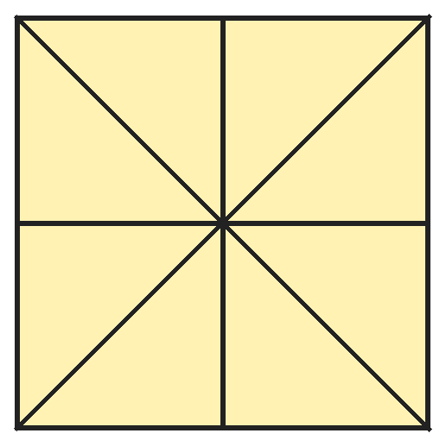
Q13. Mansi draws a square, both corner-to-corner lines and both middle lines. How many triangles are there in all?
(A) 8 | (B) 16 | (C) 12 | (D) 20

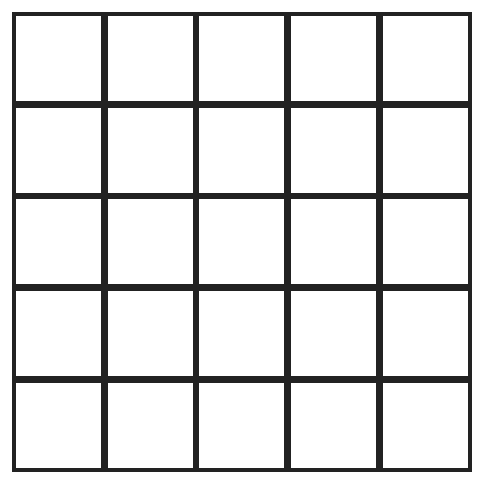
Q14. Jai colours every small square that touches the outside edge of this grid. How many squares does he colour?
(A) 20 | (B) 16 | (C) 25 | (D) 9

Q15. Jaya puts a cone on top of a cylinder of the same width, like a toy rocket. What does she see when she looks at it from the side?
(A) A rectangle with a triangle on top | (B) A rectangle with a circle on top
(C) A square with a circle on top | (D) Two triangles

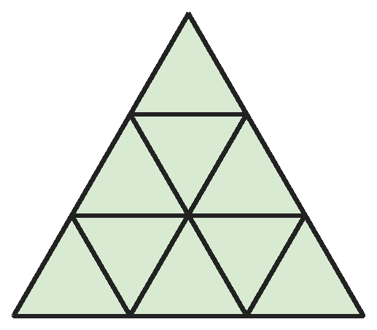
Q16. This big triangle is made of small triangles in 3 rows. How many small triangles point down?
(A) 6 | (B) 9 | (C) 3 | (D) 4

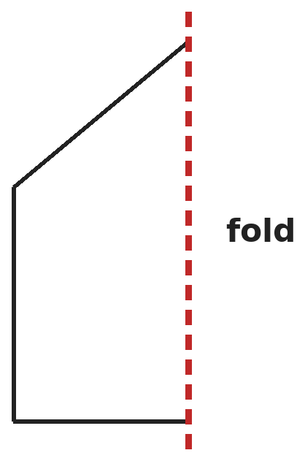
Q17. Ishita draws half of a house shape next to a fold line. She folds the paper, cuts along her line and opens it. How many corners does the whole house shape have?
(A) 6 | (B) 5 | (C) 4 | (D) 3

Part 4 — Applied Mathematics (Syllabus Chapter 9)
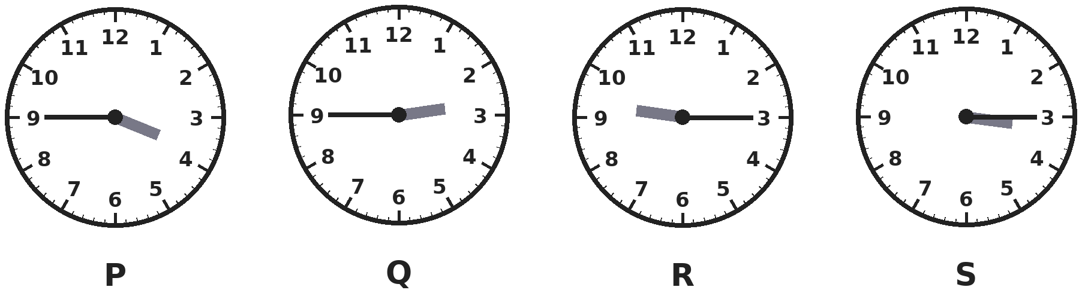
Q18. Which clock shows quarter to 3?
(A) P | (B) Q | (C) R | (D) S

Q19. Vijay buys 3 notebooks at ₹45 each. He pays with a ₹200 note. How much change does he get?
(A) ₹155 | (B) ₹135 | (C) ₹75 | (D) ₹65

Q20. Which of these times is closest to midnight?
(A) 11:15 PM | (B) 1:00 AM | (C) 11:45 AM | (D) 11:45 PM

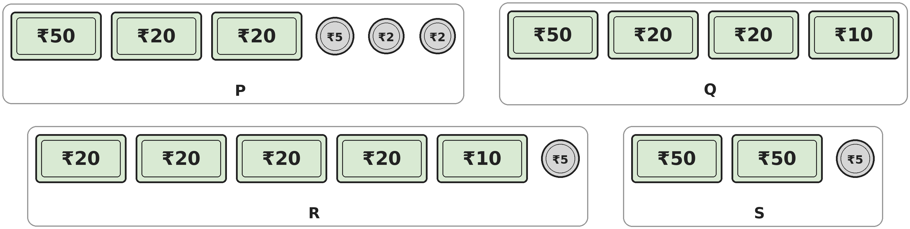
Q21. Which group is worth exactly ₹100?
(A) P | (B) Q | (C) R | (D) S

Part 5 — Mathematical Reasoning (Syllabus Chapter 10)
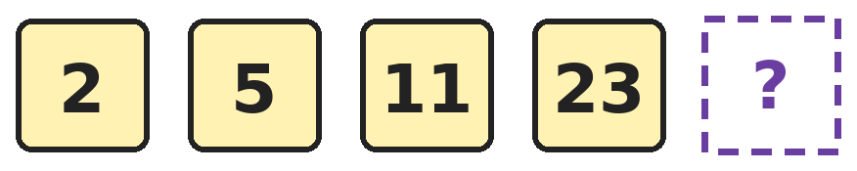
Q22. Each number is made from the one before by the same two steps. Which number comes next?
(A) 47 | (B) 46 | (C) 35 | (D) 45

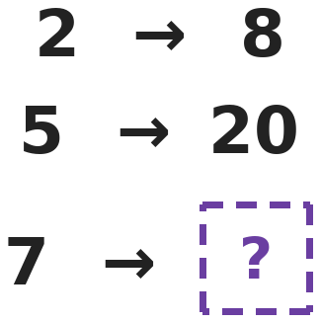
Q23. Mayank's number machine uses the same rule for every number. What does it give for 7?
(A) 25 | (B) 23 | (C) 28 | (D) 21

Q24. Pratik has many ₹2 coins and ₹5 coins. He may use only one kind of coin, or both. In how many different ways can he make exactly ₹20?
(A) 2 | (B) 4 | (C) 5 | (D) 3

Q25. Three of these sums give the same total. Which sum is the odd one out?
(A) 1 + 6 + 9 | (B) 4 + 5 + 6 | (C) 3 + 5 + 7 | (D) 2 + 6 + 7

SECTION II — Star Questions 5 questions · each joins two chapters
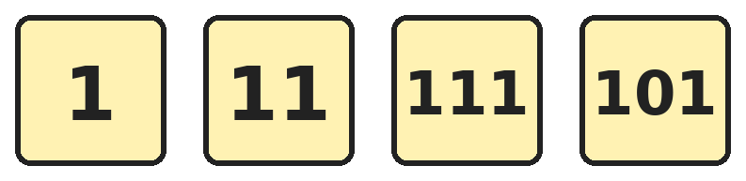
Q26. Seema writes these four numbers. How many times does she write the digit 1? [Star]
(A) 4 | (B) 8 | (C) 7 | (D) 9

Q27. Ankit writes 3. Then he keeps doubling: each new number is double the one before. What is the 6th number he writes? [Star]
(A) 48 | (B) 192 | (C) 18 | (D) 96

Q28. Pari builds a tower of cubes in 3 layers. The top layer is 1 cube. The middle layer is 2 by 2 cubes. The bottom layer is 3 by 3 cubes. How many cubes does she use? [Star]
(A) 6 | (B) 9 | (C) 14 | (D) 12

Q29. Sakshi has 12 pieces of money: some ₹10 notes and some ₹1 coins. They are worth ₹75 in all. How many ₹10 notes does she have? [Star]
(A) 5 | (B) 6 | (C) 7 | (D) 8

Q30. Hari cuts a paper clock face in half along the straight line from 12 to 6. How many of the numbers 1 to 12 are on the half that has 3 on it, not counting 12 and 6? [Star]
(A) 6 | (B) 4 | (C) 7 | (D) 5

Answer Sheet AMO Level 2 · Class 2 · Practice Paper 10
Name: | School: | Roll No.:
Shade or tick one circle for each question.
1. | Ⓐ Ⓑ Ⓒ Ⓓ | 11. | Ⓐ Ⓑ Ⓒ Ⓓ | 21. | Ⓐ Ⓑ Ⓒ Ⓓ
2. | Ⓐ Ⓑ Ⓒ Ⓓ | 12. | Ⓐ Ⓑ Ⓒ Ⓓ | 22. | Ⓐ Ⓑ Ⓒ Ⓓ
3. | Ⓐ Ⓑ Ⓒ Ⓓ | 13. | Ⓐ Ⓑ Ⓒ Ⓓ | 23. | Ⓐ Ⓑ Ⓒ Ⓓ
4. | Ⓐ Ⓑ Ⓒ Ⓓ | 14. | Ⓐ Ⓑ Ⓒ Ⓓ | 24. | Ⓐ Ⓑ Ⓒ Ⓓ
5. | Ⓐ Ⓑ Ⓒ Ⓓ | 15. | Ⓐ Ⓑ Ⓒ Ⓓ | 25. | Ⓐ Ⓑ Ⓒ Ⓓ
6. | Ⓐ Ⓑ Ⓒ Ⓓ | 16. | Ⓐ Ⓑ Ⓒ Ⓓ | 26. | Ⓐ Ⓑ Ⓒ Ⓓ
7. | Ⓐ Ⓑ Ⓒ Ⓓ | 17. | Ⓐ Ⓑ Ⓒ Ⓓ | 27. | Ⓐ Ⓑ Ⓒ Ⓓ
8. | Ⓐ Ⓑ Ⓒ Ⓓ | 18. | Ⓐ Ⓑ Ⓒ Ⓓ | 28. | Ⓐ Ⓑ Ⓒ Ⓓ
9. | Ⓐ Ⓑ Ⓒ Ⓓ | 19. | Ⓐ Ⓑ Ⓒ Ⓓ | 29. | Ⓐ Ⓑ Ⓒ Ⓓ
10. | Ⓐ Ⓑ Ⓒ Ⓓ | 20. | Ⓐ Ⓑ Ⓒ Ⓓ | 30. | Ⓐ Ⓑ Ⓒ Ⓓ
Q26–Q30 are Section II Star Questions. Each joins two chapters.
For the parent or teacher
Section I correct: ______ / 25 Section II correct: ______ / 5
Correct: ______ / 30
Answer Key and Solutions AMO Level 2 · Class 2 · Practice Paper 10
Quick answers
1 D | 6 A | 11 A | 16 C | 21 B | 26 B
2 B | 7 D | 12 C | 17 B | 22 A | 27 D
3 D | 8 A | 13 B | 18 B | 23 C | 28 C
4 A | 9 C | 14 B | 19 D | 24 D | 29 C
5 C | 10 A | 15 A | 20 D | 25 A | 30 D
Solutions
Q | Part · level | Answer | Why?
1 | Part 1 · Ch1 · Hard | (D) 100 | Hint: Count both 200 and 299.  The hundreds digit is always 2 and the last two digits go from 00 to 99. That is 100 tickets.
2 | Part 1 · Ch1 · Hard | (B) 879 | Hint: Five numbers in order: the middle one is the 3rd.  In order: 789, 798, 879, 897, 978. The 3rd one is 879.
3 | Part 1 · Ch1 · Hard | (D) 995 | Hint: 19 tens is 190.  800 + 190 + 5 = 995.
4 | Part 1 · Ch1 · Hard | (A) 6 | Hint: The hundreds digit can be 1, 2 or 3.  Hundreds 1: 102, 111, 120. Hundreds 2: 201, 210. Hundreds 3: 300. That is 6 numbers.
5 | Part 1 · Ch1 · Hard | (C) 375 | Hint: The hundreds digit is 3.  The hundreds digit is 3, so the tens digit is 3 + 4 = 7 and the ones digit is 7 − 2 = 5. The number is 375.
6 | Part 1 · Ch1 · Hard | (A) 10 | Hint: Odd and even pages take turns.  There are 20 pages from 101 to 120. They take turns odd and even, starting with 101 (odd) and ending with 120 (even). Half are odd: 10.
7 | Part 2 · Ch2 · Hard | (D) 84 | Hint: Find the total tickets sold first.  Tickets sold: 389 + 127 = 516. Empty seats: 600 − 516 = 84.
8 | Part 2 · Ch2 · Hard | (A) 40 | Hint: A car has 4 wheels and a bicycle has 2.  Cars: 4 × 7 = 28 wheels. Bicycles: 2 × 6 = 12 wheels. 28 + 12 = 40.
9 | Part 2 · Ch2 · Hard | (C) 21 | Hint: A quarter is half of a half.  Half of 84 is 42. A quarter of 84 is half of 42, which is 21. He gives away 42 + 21 = 63 and keeps 84 − 63 = 21.
10 | Part 2 · Ch2 · Hard | (A) ₹237 | Hint: Count up from 263 to 300, then to 500.  From 263 to 300 is 37. From 300 to 500 is 200. 37 + 200 = ₹237.
11 | Part 2 · Ch2 · Hard | (A) 21 | Hint: Work backwards: take away 6 first, then halve.  48 − 6 = 42. Before doubling, the number was half of 42, which is 21. Check: 21 + 21 = 42 and 42 + 6 = 48.
12 | Part 2 · Ch2 · Hard | (C) 11 | Hint: The middle number is close to a third of 27.  7 + 9 + 11 = 27. The largest is 11.
13 | Part 3 · Ch5 · Hard | (B) 16 | Hint: Count the 8 small triangles, then bigger ones made of 2 and of 4 small ones.  There are 8 small triangles. Two small ones next to each other along a side make 4 bigger triangles that meet at the centre. Each corner-to-corner line cuts the square into 2 halves, which gives 4 more. 8 + 4 + 4 = 16.
14 | Part 3 · Ch5 · Hard | (B) 16 | Hint: Take the inside squares away from all the squares.  There are 25 squares in all. The inside part is 3 by 3, which is 9 squares. 25 − 9 = 16.
15 | Part 3 · Ch5 · Hard | (A) A rectangle with a triangle on top | Hint: Think of how each solid looks from the side.  A cylinder looks like a rectangle from the side and a cone looks like a triangle. So she sees a rectangle with a triangle on top, like a house.
16 | Part 3 · Ch5 · Hard | (C) 3 | Hint: Look between the triangles that point up.  The top row has none. The middle row has 1 pointing down. The bottom row has 2 pointing down. 0 + 1 + 2 = 3.
17 | Part 3 · Ch5 · Hard | (B) 5 | Hint: The top point is on the fold. The bottom corner on the fold disappears.  The top point on the fold is 1 corner. Each half has 2 more corners (where the roof meets the wall and at the bottom), so 2 + 2 = 4. The point at the bottom of the fold is on a straight line, so it is not a corner. 1 + 4 = 5.
18 | Part 4 · Ch9 · Hard | (B) Q | Hint: At quarter to 3, the hour hand is just before 3.  Q shows quarter to 3: the minute hand is at 9 and the hour hand is just before 3. P shows quarter to 4, R shows quarter past 9 and S shows quarter past 3.
19 | Part 4 · Ch9 · Hard | (D) ₹65 | Hint: First find the cost of 3 notebooks.  45 + 45 + 45 = ₹135. Change: ₹200 − ₹135 = ₹65.
20 | Part 4 · Ch9 · Hard | (D) 11:45 PM | Hint: Midnight is 12 o'clock at night.  11:45 PM is a quarter of an hour before midnight. 11:15 PM is three quarters of an hour before. 1:00 AM is one hour after. 11:45 AM is in the morning, almost half a day away.
21 | Part 4 · Ch9 · Hard | (B) Q | Hint: Add each group carefully.  P: 50 + 20 + 20 + 5 + 2 + 2 = ₹99. Q: 50 + 20 + 20 + 10 = ₹100. R: 80 + 10 + 5 = ₹95. S: 50 + 50 + 5 = ₹105.
22 | Part 5 · Ch10 · Hard | (A) 47 | Hint: Double the number and then add something.  2 doubled is 4, add 1 to get 5. 5 doubled is 10, add 1 to get 11. 11 → 23. 23 doubled is 46, add 1 to get 47.
23 | Part 5 · Ch10 · Hard | (C) 28 | Hint: Adding 6 works for 2 but not for 5.  2 × 4 = 8 and 5 × 4 = 20, so the rule multiplies by 4. 7 × 4 = 28.
24 | Part 5 · Ch10 · Hard | (D) 3 | Hint: Try using 0, 2 or 4 coins of ₹5.  No ₹5 coins: ten ₹2 coins. Two ₹5 coins (₹10): five ₹2 coins. Four ₹5 coins: ₹20. An odd number of ₹5 coins leaves an odd amount, which ₹2 coins cannot make. That is 3 ways.
25 | Part 5 · Ch10 · Hard | (A) 1 + 6 + 9 | Hint: Work out each total.  4 + 5 + 6 = 15, 3 + 5 + 7 = 15 and 2 + 6 + 7 = 15. 1 + 6 + 9 = 16, so it is the odd one out.
26 | Section II · Ch1 + Ch10 · Hard | (B) 8 | Hint: Count the 1s in each number.  1 has one 1, 11 has two, 111 has three and 101 has two. 1 + 2 + 3 + 2 = 8.
27 | Section II · Ch2 + Ch10 · Hard | (D) 96 | Hint: The 1st number is 3.  3, 6, 12, 24, 48, 96. The 6th number is 96.
28 | Section II · Ch5 + Ch10 · Hard | (C) 14 | Hint: Count the cubes in each layer.  Top: 1. Middle: 2 × 2 = 4. Bottom: 3 × 3 = 9. 1 + 4 + 9 = 14.
29 | Section II · Ch1 + Ch9 · Hard | (C) 7 | Hint: ₹75 is 7 tens and 5 ones. Count the pieces.  7 notes of ₹10 and 5 coins of ₹1 make ₹75 with 7 + 5 = 12 pieces. With 6 notes she would need 15 coins, which is 21 pieces.
30 | Section II · Ch5 + Ch9 · Hard | (D) 5 | Hint: 12 and 6 are on the cut line.  The cut goes through 12 and 6. On the half with 3 are 1, 2, 3, 4 and 5. That is 5 numbers.

