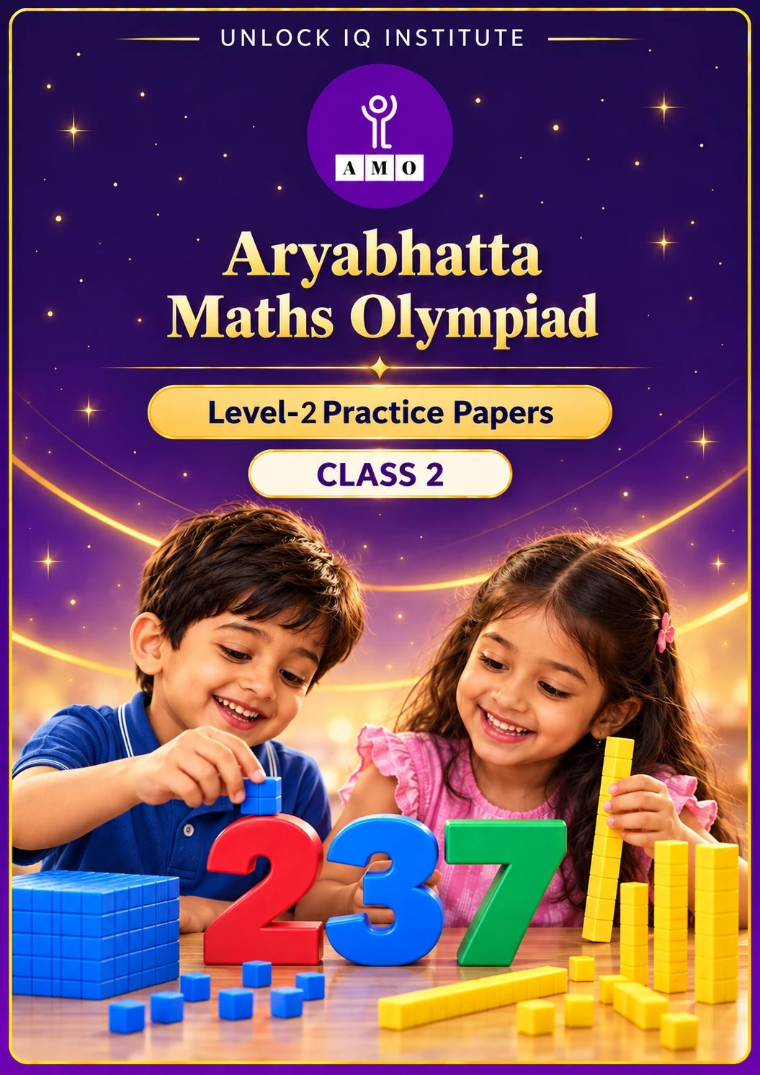
Set 1 · Practice Papers 1–5 · with answer keys & detailed solutions
Name: ____________________ | Class & Section: ________________
Roll No.: ________________ | School: ____________________
City: ____________________ | Date: ____________________

Published by Unlock IQ Institute Pvt. Ltd.
Register for Olympiads: www.aryabhattamathsolympiad.com/student-registration

ARYABHATTA MATHS OLYMPIAD
Level 2
PRACTICE PAPER-1
CLASS 2
Total Questions | 30 multiple-choice questions
Level | Level-2 (final round): every question is Hard
Time | 45 minutes
Arrangement | Parts by chapter; the last Part has mixed problems joining two chapters
Negative Marking | No negative marking
Calculator | Not allowed
Chapters | Number System · Operations · Geometry · Applied Mathematics · Mathematical Reasoning

👋 Hello, friend! How to do this paper:
⭐ Every question has four answer choices: (A), (B), (C) and (D). Only one is correct.
⭐ Read each question and look at its picture carefully. Then mark your answer on the answer sheet at the end.
⭐ This is a Level-2 paper. Every question needs careful thinking, so take your time and check each step.
⭐ The questions are in Parts by chapter. The last Part has mixed problems that join two chapters.
⭐ There is no negative marking, so try every question.
⭐ Do not use a calculator. You may do rough work on a separate sheet.
⭐ All figures are not necessarily drawn to scale unless stated.

For parents and teachers
• Pictures are part of the questions. Every picture also works when printed in black and white.
• You may read a question aloud to the child, exactly as printed. Please do not explain it or point to an answer choice.
• Parts follow the AMO syllabus chapters. Chapters 3, 4, 6, 7 and 8 are not part of the Class 2 syllabus, so the chapter numbers shown in the Part headings have gaps.
• The answer sheet and the answer key are at the end. Remove only the answer key before the child begins.

Part 1 — Number System (Syllabus Chapter 1)
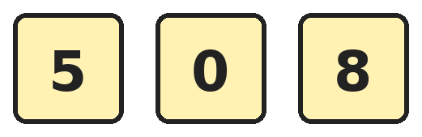
Q1. Anita uses each of these cards once to make the largest 3-digit number and the smallest 3-digit number. What is the largest number minus the smallest number?
(A) 358 | (B) 350 | (C) 342 | (D) 800

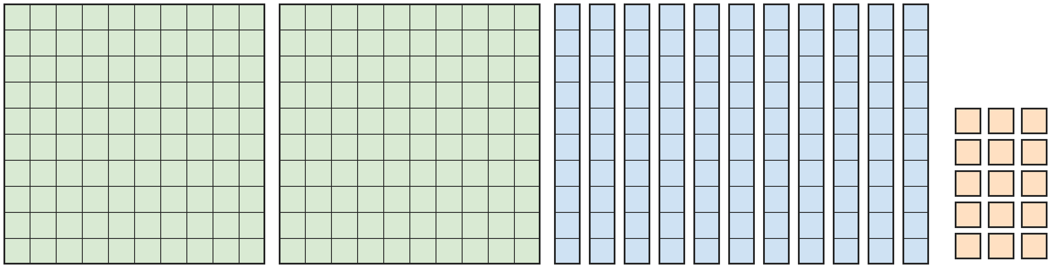
Q2. Rohan shows a number with hundreds flats, tens rods and ones cubes. Which number does he show?
(A) 325 | (B) 2115 | (C) 235 | (D) 315

Q3. How many even numbers are there between 345 and 361?
(A) 7 | (B) 8 | (C) 9 | (D) 16

Q4. Which point on the number line shows the number made of 3 hundreds and 14 tens?
(A) Point P | (B) Point Q | (C) Point R | (D) Point S

Q5. In the number 747, what is the difference between the values of the two 7s?
(A) 693 | (B) 0 | (C) 700 | (D) 690

Q6. Which number is 1 hundred and 1 ten more than four hundred and nine?
(A) 510 | (B) 429 | (C) 519 | (D) 609

Part 2 — Operations (Syllabus Chapter 2)
Q7. A school has 268 girls and 195 boys. On Monday, 147 children go on a trip. How many children stay back at school?
(A) 326 | (B) 316 | (C) 463 | (D) 216

Q8. Kavya has 6 boxes with 7 pencils in each box. She finds that 9 pencils are broken. How many pencils are not broken?
(A) 42 | (B) 33 | (C) 51 | (D) 13

Q9. Ravi has 48 stickers. He gives half of them to Asha. Then he gives half of the stickers he has left to Dev. How many stickers does Ravi have now?
(A) 12 | (B) 24 | (C) 36 | (D) 6

Q10. One digit is hidden by the question mark. Which digit is it?
(A) 6 | (B) 8 | (C) 9 | (D) 3

Q11. Which of these gives the greatest total?
(A) 7 groups of 8 | (B) 9 groups of 6
(C) 5 groups of 10 | (D) 8 groups of 6

Q12. Each bus has 45 seats. Three full-size buses carry 128 children, one child to a seat. How many seats are empty?
(A) 17 | (B) 135 | (C) 13 | (D) 7

Part 3 — Geometry (Syllabus Chapter 5)
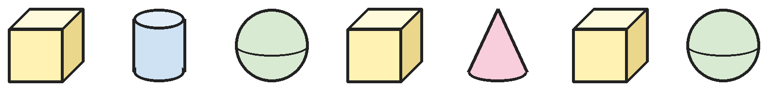
Q13. Kabir has these solids in a row. How many of them can roll?
(A) 3 | (B) 2 | (C) 4 | (D) 7

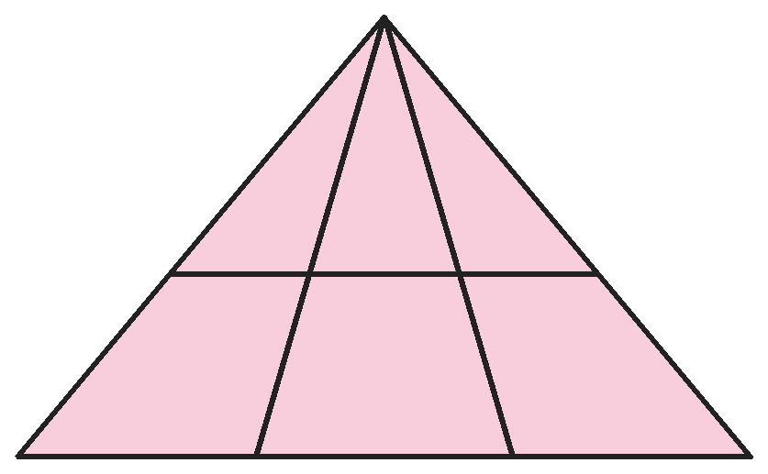
Q14. Priya draws a big triangle, two lines from its top corner and one line across. How many triangles of all sizes are in her drawing?
(A) 12 | (B) 6 | (C) 9 | (D) 10

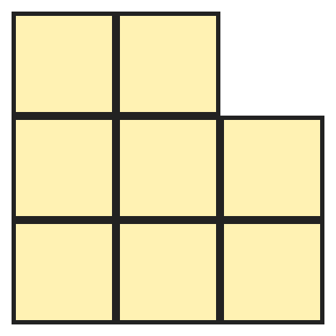
Q15. A 3 by 3 grid of small squares has one corner square cut away, as shown. How many squares of all sizes can you find?
(A) 12 | (B) 11 | (C) 14 | (D) 8

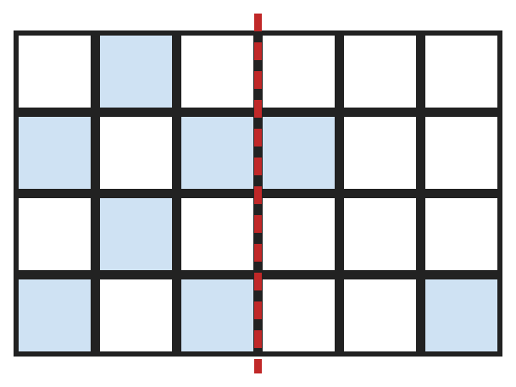
Q16. Neha wants the shaded squares to look the same on both sides of the dotted line, like a mirror. Two squares on the right are already shaded correctly. How many more squares must she shade?
(A) 6 | (B) 2 | (C) 12 | (D) 4

Q17. Kunal lays a solid on its side and pushes it. It rolls round in a circle and stays in one place. From the side it looks like a triangle. Which solid is it?
(A) Cone | (B) Cylinder | (C) Sphere | (D) Cube

Part 4 — Applied Mathematics (Syllabus Chapter 9)
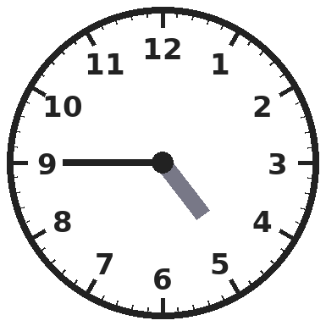
Q18. Look at the clock. What time will it show when the minute hand next points at 12?
(A) 4 o'clock | (B) 6 o'clock | (C) 5 o'clock | (D) Half past 5

Q19. Om's school bell rings in the morning when the minute hand points at 3 and the hour hand is just past 8. How is this time written?
(A) 8:45 AM | (B) 8:15 AM | (C) 8:15 PM | (D) 7:45 AM

Q20. A notebook costs ₹38 and a pencil costs ₹15. Neha buys 2 notebooks and 1 pencil. She pays with a ₹100 note. How much change does she get?
(A) ₹19 | (B) ₹47 | (C) ₹91 | (D) ₹9

Q21. Raju has three ₹50 notes, two ₹20 notes and four ₹5 coins. How much money does he have?
(A) ₹200 | (B) ₹190 | (C) ₹75 | (D) ₹210

Part 5 — Mathematical Reasoning (Syllabus Chapter 10)
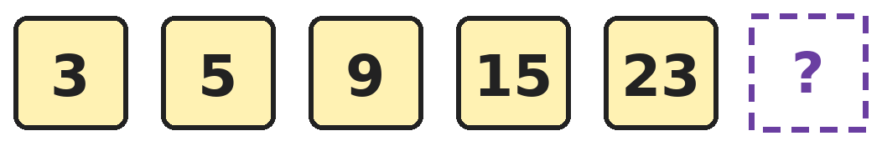
Q22. Sakshi writes this number pattern. Which number should she write next?
(A) 33 | (B) 31 | (C) 30 | (D) 35

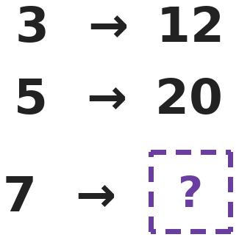
Q23. Each pair of numbers follows the same rule. Which number goes in the box?
(A) 21 | (B) 14 | (C) 24 | (D) 28

Q24. Asha has 3 tops, 2 skirts and 2 pairs of shoes. An outfit is one top, one skirt and one pair of shoes. How many different outfits can she make?
(A) 7 | (B) 6 | (C) 10 | (D) 12

Q25. Four tickets are numbered 24, 36, 42 and 56. Three numbers belong to the same times table. Which ticket number is the odd one out?
(A) 56 | (B) 24 | (C) 36 | (D) 42

Part 6 — Mixed Problems (each joins two chapters)
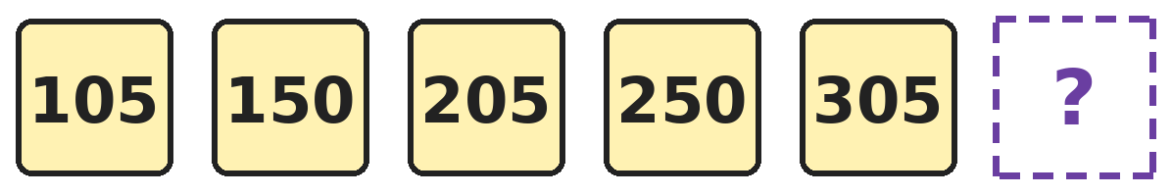
Q26. Look at how this pattern is built. Which number comes next?
(A) 310 | (B) 355 | (C) 350 | (D) 405

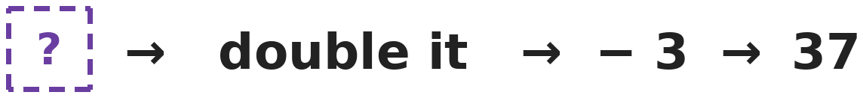
Q27. A number goes into this machine. It is doubled and then 3 is taken away. The number 37 comes out. Which number went in?
(A) 17 | (B) 40 | (C) 34 | (D) 20

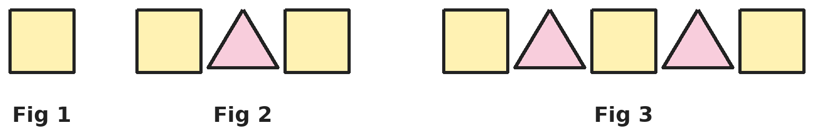
Q28. Each figure has one more square and one more triangle than the one before. How many corners do all the shapes in Figure 4 have?
(A) 18 | (B) 28 | (C) 25 | (D) 32

Q29. Diya has four ₹100 notes, thirteen ₹10 notes and six ₹1 coins. How much money does she have?
(A) ₹436 | (B) ₹4136 | (C) ₹536 | (D) ₹23

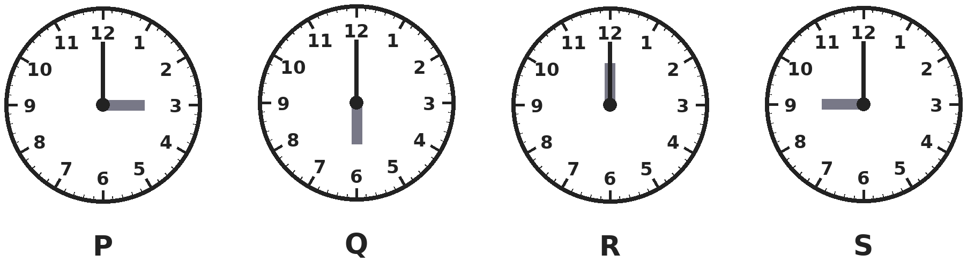
Q30. On which clock do the two hands make one straight line across the clock face?
(A) Clock P | (B) Clock Q | (C) Clock R | (D) Clock S

Answer Sheet AMO Level 2 · Class 2 · Practice Paper 1
Name: | School: | Roll No.:
Shade or tick one circle for each question.
1. | Ⓐ Ⓑ Ⓒ Ⓓ | 11. | Ⓐ Ⓑ Ⓒ Ⓓ | 21. | Ⓐ Ⓑ Ⓒ Ⓓ
2. | Ⓐ Ⓑ Ⓒ Ⓓ | 12. | Ⓐ Ⓑ Ⓒ Ⓓ | 22. | Ⓐ Ⓑ Ⓒ Ⓓ
3. | Ⓐ Ⓑ Ⓒ Ⓓ | 13. | Ⓐ Ⓑ Ⓒ Ⓓ | 23. | Ⓐ Ⓑ Ⓒ Ⓓ
4. | Ⓐ Ⓑ Ⓒ Ⓓ | 14. | Ⓐ Ⓑ Ⓒ Ⓓ | 24. | Ⓐ Ⓑ Ⓒ Ⓓ
5. | Ⓐ Ⓑ Ⓒ Ⓓ | 15. | Ⓐ Ⓑ Ⓒ Ⓓ | 25. | Ⓐ Ⓑ Ⓒ Ⓓ
6. | Ⓐ Ⓑ Ⓒ Ⓓ | 16. | Ⓐ Ⓑ Ⓒ Ⓓ | 26. | Ⓐ Ⓑ Ⓒ Ⓓ
7. | Ⓐ Ⓑ Ⓒ Ⓓ | 17. | Ⓐ Ⓑ Ⓒ Ⓓ | 27. | Ⓐ Ⓑ Ⓒ Ⓓ
8. | Ⓐ Ⓑ Ⓒ Ⓓ | 18. | Ⓐ Ⓑ Ⓒ Ⓓ | 28. | Ⓐ Ⓑ Ⓒ Ⓓ
9. | Ⓐ Ⓑ Ⓒ Ⓓ | 19. | Ⓐ Ⓑ Ⓒ Ⓓ | 29. | Ⓐ Ⓑ Ⓒ Ⓓ
10. | Ⓐ Ⓑ Ⓒ Ⓓ | 20. | Ⓐ Ⓑ Ⓒ Ⓓ | 30. | Ⓐ Ⓑ Ⓒ Ⓓ

For the parent or teacher
Correct: ______ / 30
Answer Key and Solutions AMO Level 2 · Class 2 · Practice Paper 1
Quick answers
1 C | 6 C | 11 A | 16 D | 21 D | 26 C
2 A | 7 B | 12 D | 17 A | 22 A | 27 D
3 B | 8 B | 13 C | 18 C | 23 D | 28 C
4 B | 9 A | 14 A | 19 B | 24 D | 29 C
5 A | 10 B | 15 B | 20 D | 25 A | 30 B
Solutions
Q | Part · level | Answer | Why?
1 | Part 1 · Ch1 · Hard | (C) 342 | Hint: The smallest 3-digit number cannot start with 0.  The largest number is 850. The smallest cannot start with 0, so it is 508. 850 − 508 = 342.
2 | Part 1 · Ch1 · Hard | (A) 325 | Hint: Ten rods make a hundred and ten cubes make a ten.  There are 2 hundreds, 11 tens and 15 ones. 11 tens are 1 hundred and 1 ten. 15 ones are 1 ten and 5 ones. So there are 3 hundreds, 2 tens and 5 ones: 325.
3 | Part 1 · Ch1 · Hard | (B) 8 | Hint: The first even number after 345 is 346.  The even numbers are 346, 348, 350, 352, 354, 356, 358 and 360. That is 8 numbers.
4 | Part 1 · Ch1 · Hard | (B) Point Q | Hint: 14 tens are 1 hundred and 4 tens.  14 tens are 1 hundred and 4 tens. So 3 hundreds and 14 tens make 4 hundreds and 4 tens, which is 440. Point Q is at 440.
5 | Part 1 · Ch1 · Hard | (A) 693 | Hint: One 7 is in the hundreds place and the other is in the ones place.  The first 7 stands for 700 and the last 7 stands for 7. 700 − 7 = 693.
6 | Part 1 · Ch1 · Hard | (C) 519 | Hint: Write four hundred and nine as a number first.  Four hundred and nine is 409: 4 hundreds, 0 tens and 9 ones. 1 hundred more gives 509. 1 ten more gives 5 hundreds, 1 ten and 9 ones: 519.
7 | Part 2 · Ch2 · Hard | (B) 316 | Hint: First find the total number of children.  Total children: 268 + 195 = 463. Children who stay back: 463 − 147 = 316.
8 | Part 2 · Ch2 · Hard | (B) 33 | Hint: First find how many pencils there are in all.  6 boxes of 7 pencils: 7 × 6 = 42 pencils. Not broken: 42 − 9 = 33.
9 | Part 2 · Ch2 · Hard | (A) 12 | Hint: Find half of 48 first, then half again.  Half of 48 is 24, so Ravi keeps 24. Half of 24 is 12, so he gives 12 to Dev and keeps 12.
10 | Part 2 · Ch2 · Hard | (B) 8 | Hint: 634 − 248 gives the first number.  The first number is 634 − 248 = 386. So the hidden digit is 8. Check: 386 + 248 = 634.
11 | Part 2 · Ch2 · Hard | (A) 7 groups of 8 | Hint: Work out each one using times tables.  7 × 8 = 56, 9 × 6 = 54, 5 × 10 = 50 and 8 × 6 = 48. The greatest is 7 groups of 8.
12 | Part 2 · Ch2 · Hard | (D) 7 | Hint: First find the number of seats in three buses.  Three buses have 45 + 45 + 45 = 135 seats. 135 − 128 = 7 seats are empty.
13 | Part 3 · Ch5 · Hard | (C) 4 | Hint: A solid with a curved surface can roll.  The cylinder, the cone and the two spheres have curved surfaces, so they can roll: that is 4. The three cubes have only flat faces, so they cannot roll.
14 | Part 3 · Ch5 · Hard | (A) 12 | Hint: Count the triangles in the top part first. Then count the ones that reach the bottom side.  Above the line across, there are 3 small triangles, 2 made of two parts and 1 made of all three: 6. Triangles that reach the bottom side follow the same pattern: 6 more. 6 + 6 = 12.
15 | Part 3 · Ch5 · Hard | (B) 11 | Hint: Count small squares, then squares made of 2 by 2 small squares.  There are 8 small squares. A 2 by 2 square can sit in 4 places, but one of them uses the missing corner, so there are 3. The big 3 by 3 square is broken. 8 + 3 = 11.
16 | Part 3 · Ch5 · Hard | (D) 4 | Hint: Each shaded square on the left needs a partner on the right.  There are 6 shaded squares on the left, so the right side needs 6 partners. Two of them are already shaded. So she must shade 6 − 2 = 4 more.
17 | Part 3 · Ch5 · Hard | (A) Cone | Hint: Which solid has a pointed top and a round base?  A cone on its side turns round its tip, so it rolls in a circle. From the side it looks like a triangle. A cylinder rolls away in a straight line, a sphere looks like a circle from every side, and a cube does not roll.
18 | Part 4 · Ch9 · Hard | (C) 5 o'clock | Hint: First read the time. The hour hand is between 4 and 5.  The minute hand is at 9 and the hour hand is between 4 and 5, so it is quarter to 5. When the minute hand next reaches 12, the time is 5 o'clock.
19 | Part 4 · Ch9 · Hard | (B) 8:15 AM | Hint: Quarter past means 15 minutes after the hour. Morning times are AM.  The minute hand at 3 means quarter past. The hour hand just past 8 means quarter past 8, written 8:15. Morning times are AM, so it is 8:15 AM. 7:45 is quarter to 8.
20 | Part 4 · Ch9 · Hard | (D) ₹9 | Hint: Find the total cost first.  Two notebooks cost ₹38 + ₹38 = ₹76. With the pencil: ₹76 + ₹15 = ₹91. Change: ₹100 − ₹91 = ₹9.
21 | Part 4 · Ch9 · Hard | (D) ₹210 | Hint: Add each kind of money separately.  Three ₹50 notes: ₹150. Two ₹20 notes: ₹40. Four ₹5 coins: ₹20. Total ₹150 + ₹40 + ₹20 = ₹210.
22 | Part 5 · Ch10 · Hard | (A) 33 | Hint: Look at how much is added each time.  The pattern adds 2, 4, 6 and 8. Next it adds 10: 23 + 10 = 33.
23 | Part 5 · Ch10 · Hard | (D) 28 | Hint: Look at both pairs. Adding the same number does not work for both.  3 → 12 and 5 → 20: each number is multiplied by 4 (3 × 4 = 12, 5 × 4 = 20). So 7 → 7 × 4 = 28.
24 | Part 5 · Ch10 · Hard | (D) 12 | Hint: Count top-and-skirt pairs first.  Each of the 3 tops can go with 2 skirts: 3 × 2 = 6 top-and-skirt pairs. Each pair can go with 2 pairs of shoes: 6 × 2 = 12 outfits.
25 | Part 5 · Ch10 · Hard | (A) 56 | Hint: Try the 6 times table.  24 = 6 × 4, 36 = 6 × 6 and 42 = 6 × 7 are in the 6 times table. 56 is not (6 × 9 = 54 and 6 × 10 = 60), so it is the odd one out.
26 | Part 6 · Mixed · Ch1 + Ch10 · Hard | (C) 350 | Hint: Look at the numbers in pairs.  The pairs are 105 and 150, 205 and 250, then 305 and 350. In each pair the last two digits swap, and each pair is 1 hundred more than the last.
27 | Part 6 · Mixed · Ch2 + Ch10 · Hard | (D) 20 | Hint: Undo the steps in the opposite order.  Undo taking away 3: 37 + 3 = 40. Undo doubling: half of 40 is 20. Check: 20 doubled is 40, and 40 − 3 = 37.
28 | Part 6 · Mixed · Ch5 + Ch10 · Hard | (C) 25 | Hint: Count the corners in Figures 1, 2 and 3.  Figure 1 has 4 corners. Figure 2 has 4 + 3 + 4 = 11. Figure 3 has 3 squares and 2 triangles: 12 + 6 = 18. Each figure adds 7 corners, so Figure 4 has 18 + 7 = 25.
29 | Part 6 · Mixed · Ch1 + Ch9 · Hard | (C) ₹536 | Hint: Ten ₹10 notes make ₹100.  Thirteen ₹10 notes are ₹130, which is 1 hundred and 3 tens. With four ₹100 notes there are 5 hundreds, 3 tens and 6 ones: ₹536.
30 | Part 6 · Mixed · Ch5 + Ch9 · Hard | (B) Clock Q | Hint: The hands must point in opposite directions.  At 6 o'clock (Q) the hour hand points at 6 and the minute hand at 12, so together they make one straight line. At 3 and 9 o'clock the hands make a square corner, and at 12 o'clock they lie on top of each other.

ARYABHATTA MATHS OLYMPIAD
Level 2
PRACTICE PAPER-2
CLASS 2
Total Questions | 30 multiple-choice questions
Level | Level-2 (final round): every question is Hard
Time | 45 minutes
Arrangement | Parts by chapter; the last Part has mixed problems joining two chapters
Negative Marking | No negative marking
Calculator | Not allowed
Chapters | Number System · Operations · Geometry · Applied Mathematics · Mathematical Reasoning

👋 Hello, friend! How to do this paper:
⭐ Every question has four answer choices: (A), (B), (C) and (D). Only one is correct.
⭐ Read each question and look at its picture carefully. Then mark your answer on the answer sheet at the end.
⭐ This is a Level-2 paper. Every question needs careful thinking, so take your time and check each step.
⭐ The questions are in Parts by chapter. The last Part has mixed problems that join two chapters.
⭐ There is no negative marking, so try every question.
⭐ Do not use a calculator. You may do rough work on a separate sheet.
⭐ All figures are not necessarily drawn to scale unless stated.

For parents and teachers
• Pictures are part of the questions. Every picture also works when printed in black and white.
• You may read a question aloud to the child, exactly as printed. Please do not explain it or point to an answer choice.
• Parts follow the AMO syllabus chapters. Chapters 3, 4, 6, 7 and 8 are not part of the Class 2 syllabus, so the chapter numbers shown in the Part headings have gaps.
• The answer sheet and the answer key are at the end. Remove only the answer key before the child begins.

Part 1 — Number System (Syllabus Chapter 1)
Q1. I am a 3-digit number. My tens digit is 0. My hundreds digit is 2 more than my ones digit. My digits add up to 8. Which number am I?
(A) 305 | (B) 530 | (C) 503 | (D) 602

Q2. Mihir puts these numbers in order from smallest to largest: 409, 490, 94, 940, 449. Which number is 4th?
(A) 449 | (B) 940 | (C) 490 | (D) 409

Q3. Arjun starts at 237. He jumps back by 1 hundred. Then he jumps forward by 3 tens. On which number does he land?
(A) 307 | (B) 107 | (C) 140 | (D) 167

Q4. How many 3-digit numbers have all three digits the same, like 444?
(A) 10 | (B) 3 | (C) 8 | (D) 9

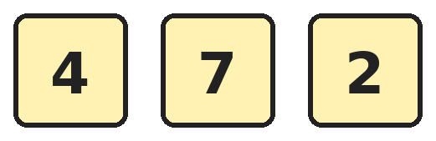
Q5. Tanvi makes 3-digit numbers using each of these cards once. How many of her numbers are odd?
(A) 6 | (B) 3 | (C) 2 | (D) 1

Q6. Which of these is NOT the same as 506?
(A) 5 hundreds and 6 ones | (B) 4 hundreds, 10 tens and 6 ones
(C) 5 hundreds and 6 tens | (D) 50 tens and 6 ones

Part 2 — Operations (Syllabus Chapter 2)
Q7. A library had 437 books. It bought 286 new books. Then it gave 158 books to a village school. How many books does the library have now?
(A) 565 | (B) 723 | (C) 595 | (D) 475

Q8. In a hall there are 5 rows with 8 chairs in each row. 13 children sit on the chairs, one on each chair. How many chairs are empty?
(A) 40 | (B) 27 | (C) 13 | (D) 35

Q9. Sneha has 36 apples. She gives a quarter of them to her neighbour. How many apples does she have left?
(A) 27 | (B) 9 | (C) 18 | (D) 32

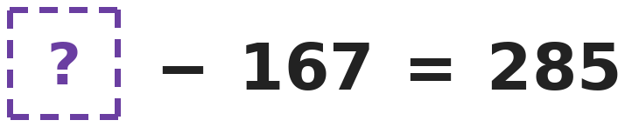
Q10. Which number goes in the box?
(A) 118 | (B) 442 | (C) 452 | (D) 352

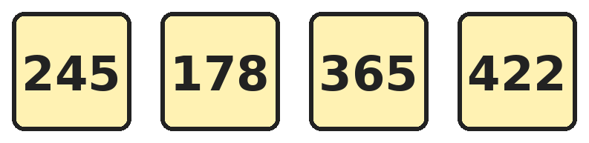
Q11. Which two of these cards add up to exactly 600?
(A) 245 and 365 | (B) 178 and 422 | (C) 245 and 422 | (D) 178 and 365

Q12. Ravi has 8 marbles. Raju has 3 times as many marbles as Ravi. How many marbles do they have together?
(A) 24 | (B) 32 | (C) 11 | (D) 16

Part 3 — Geometry (Syllabus Chapter 5)
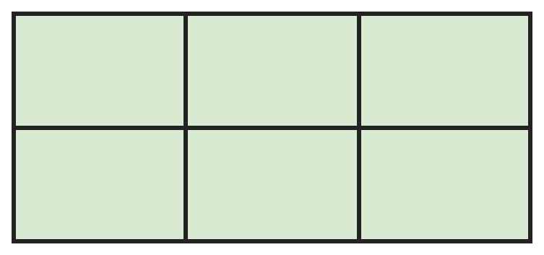
Q13. A window has 2 rows and 3 columns of panes. How many rectangles of all sizes can you find in it?
(A) 6 | (B) 9 | (C) 12 | (D) 18

Q14. Which solid can roll along the floor and can also be stacked one on top of another?
(A) Cylinder | (B) Sphere | (C) Cube | (D) Cone

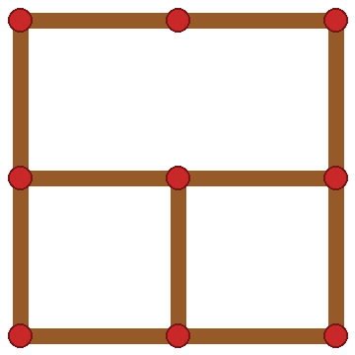
Q15. Raju made a big square with 4 small squares inside using 12 sticks. He took away one stick from the middle, as shown. How many squares of all sizes are there now?
(A) 4 | (B) 5 | (C) 3 | (D) 2

Q16. Ruhi marks the middle point of each side of a square. She joins these 4 points in order with straight lines. What shape is formed inside the square?
(A) A rectangle that is not a square | (B) A smaller square
(C) A triangle | (D) A circle

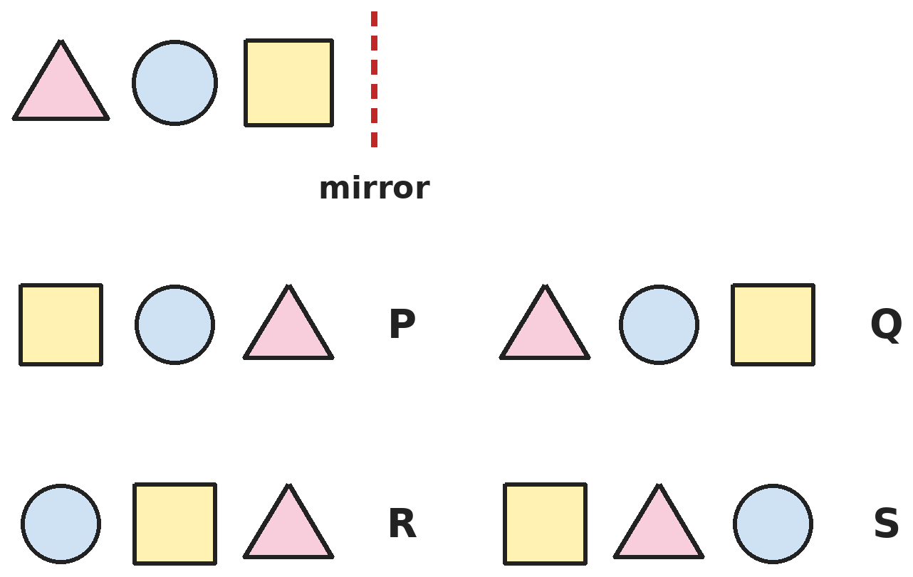
Q17. The top row of shapes is reflected in the mirror. Which row shows how it looks in the mirror?
(A) Row P | (B) Row Q | (C) Row R | (D) Row S

Part 4 — Applied Mathematics (Syllabus Chapter 9)
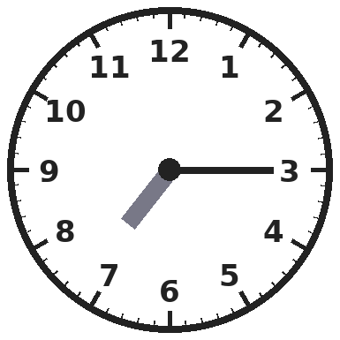
Q18. What time does this clock show?
(A) Quarter past 3 | (B) Quarter past 7
(C) Quarter to 7 | (D) Half past 3

Q19. A pen costs ₹12 and a notebook costs ₹19. Which costs more, 3 pens or 2 notebooks, and by how much?
(A) 2 notebooks, by ₹2 | (B) 3 pens, by ₹2
(C) 2 notebooks, by ₹7 | (D) 3 pens, by ₹7

Q20. Put these times in order from the earliest in the day to the latest: 11:00 AM, 9:30 PM, 12:15 PM, 6:45 AM. Which time is 3rd?
(A) 12:15 PM | (B) 11:00 AM | (C) 9:30 PM | (D) 6:45 AM

Q21. Tanvi has ₹200. She buys a bag for ₹125 and a pencil box for ₹48. How much money does she have left?
(A) ₹173 | (B) ₹75 | (C) ₹37 | (D) ₹27

Part 5 — Mathematical Reasoning (Syllabus Chapter 10)
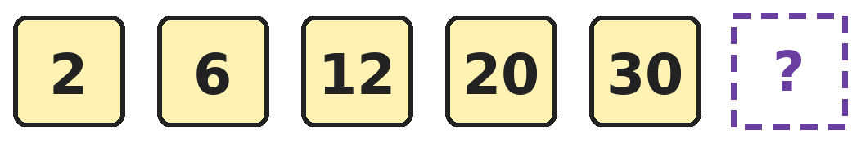
Q22. Ishaan writes this number pattern. Which number comes next?
(A) 40 | (B) 36 | (C) 42 | (D) 44

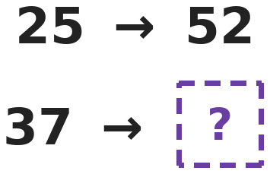
Q23. The second pair follows the same rule as the first pair. Which number goes in the box?
(A) 74 | (B) 40 | (C) 59 | (D) 73

Q24. Four friends meet. Each friend shakes hands once with every other friend. How many handshakes are there in all?
(A) 6 | (B) 4 | (C) 8 | (D) 12

Q25. Four buses have the numbers 121, 343, 565 and 789. Three numbers belong together. Which bus number is the odd one out?
(A) 789 | (B) 121 | (C) 343 | (D) 565

Part 6 — Mixed Problems (each joins two chapters)
Q26. How many numbers between 100 and 200 read the same forwards and backwards, like 151?
(A) 9 | (B) 11 | (C) 20 | (D) 10

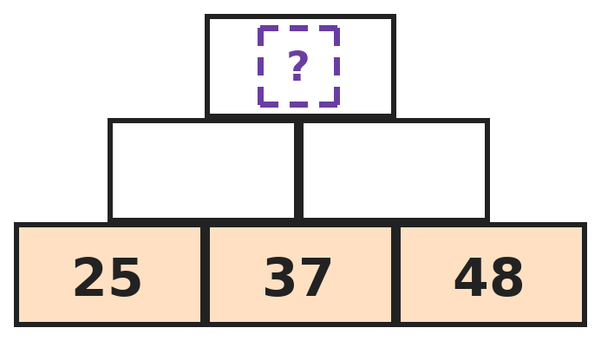
Q27. In this number wall, each brick is the sum of the two bricks just below it. Which number goes in the top brick?
(A) 110 | (B) 157 | (C) 147 | (D) 137

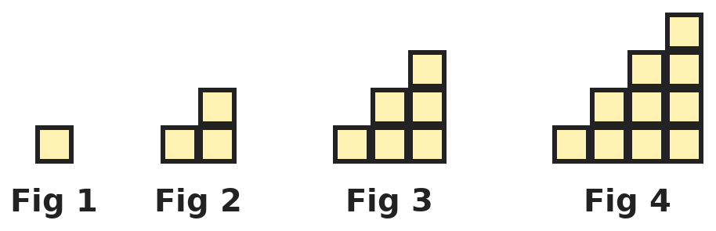
Q28. Each figure is a staircase of small squares. How many small squares will Figure 6 have?
(A) 15 | (B) 21 | (C) 18 | (D) 28

Q29. Shreya must pay ₹786 using only ₹100 notes, ₹10 notes and ₹1 coins. She uses as few notes and coins as she can. How many does she use in all?
(A) 786 | (B) 21 | (C) 3 | (D) 78

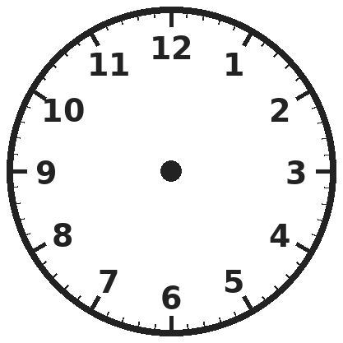
Q30. On a clock face, Om draws straight lines joining the numbers 12, 3, 6 and 9 in order, and then back to 12. What shape does he draw?
(A) Triangle | (B) Circle
(C) Rectangle that is not a square | (D) Square

Answer Sheet AMO Level 2 · Class 2 · Practice Paper 2
Name: | School: | Roll No.:
Shade or tick one circle for each question.
1. | Ⓐ Ⓑ Ⓒ Ⓓ | 11. | Ⓐ Ⓑ Ⓒ Ⓓ | 21. | Ⓐ Ⓑ Ⓒ Ⓓ
2. | Ⓐ Ⓑ Ⓒ Ⓓ | 12. | Ⓐ Ⓑ Ⓒ Ⓓ | 22. | Ⓐ Ⓑ Ⓒ Ⓓ
3. | Ⓐ Ⓑ Ⓒ Ⓓ | 13. | Ⓐ Ⓑ Ⓒ Ⓓ | 23. | Ⓐ Ⓑ Ⓒ Ⓓ
4. | Ⓐ Ⓑ Ⓒ Ⓓ | 14. | Ⓐ Ⓑ Ⓒ Ⓓ | 24. | Ⓐ Ⓑ Ⓒ Ⓓ
5. | Ⓐ Ⓑ Ⓒ Ⓓ | 15. | Ⓐ Ⓑ Ⓒ Ⓓ | 25. | Ⓐ Ⓑ Ⓒ Ⓓ
6. | Ⓐ Ⓑ Ⓒ Ⓓ | 16. | Ⓐ Ⓑ Ⓒ Ⓓ | 26. | Ⓐ Ⓑ Ⓒ Ⓓ
7. | Ⓐ Ⓑ Ⓒ Ⓓ | 17. | Ⓐ Ⓑ Ⓒ Ⓓ | 27. | Ⓐ Ⓑ Ⓒ Ⓓ
8. | Ⓐ Ⓑ Ⓒ Ⓓ | 18. | Ⓐ Ⓑ Ⓒ Ⓓ | 28. | Ⓐ Ⓑ Ⓒ Ⓓ
9. | Ⓐ Ⓑ Ⓒ Ⓓ | 19. | Ⓐ Ⓑ Ⓒ Ⓓ | 29. | Ⓐ Ⓑ Ⓒ Ⓓ
10. | Ⓐ Ⓑ Ⓒ Ⓓ | 20. | Ⓐ Ⓑ Ⓒ Ⓓ | 30. | Ⓐ Ⓑ Ⓒ Ⓓ

For the parent or teacher
Correct: ______ / 30
Answer Key and Solutions AMO Level 2 · Class 2 · Practice Paper 2
Quick answers
1 C | 6 C | 11 B | 16 B | 21 D | 26 D
2 C | 7 A | 12 B | 17 A | 22 C | 27 C
3 D | 8 B | 13 D | 18 B | 23 D | 28 B
4 D | 9 A | 14 A | 19 A | 24 A | 29 B
5 C | 10 C | 15 C | 20 A | 25 A | 30 D
Solutions
Q | Part · level | Answer | Why?
1 | Part 1 · Ch1 · Hard | (C) 503 | Hint: The hundreds and ones digits add up to 8.  The tens digit is 0, so the hundreds and ones digits add up to 8. Two numbers that add to 8 and differ by 2 are 5 and 3. The hundreds digit is the bigger one, so the number is 503.
2 | Part 1 · Ch1 · Hard | (C) 490 | Hint: A 2-digit number is smaller than every 3-digit number.  In order: 94, 409, 449, 490, 940. The 4th number is 490.
3 | Part 1 · Ch1 · Hard | (D) 167 | Hint: Change the hundreds digit first, then the tens digit.  Back 1 hundred from 237 is 137. Forward 3 tens from 137 is 167.
4 | Part 1 · Ch1 · Hard | (D) 9 | Hint: The hundreds digit cannot be 0.  The numbers are 111, 222, 333, 444, 555, 666, 777, 888 and 999. 000 is not a 3-digit number. That is 9 numbers.
5 | Part 1 · Ch1 · Hard | (C) 2 | Hint: An odd number must end in an odd digit.  The only odd digit is 7, so the number must end in 7. The other two cards can be in either order: 427 and 247. That is 2 odd numbers.
6 | Part 1 · Ch1 · Hard | (C) 5 hundreds and 6 tens | Hint: Change each one into a number.  5 hundreds and 6 ones is 506. 4 hundreds and 10 tens make 5 hundreds, so with 6 ones that is 506. 50 tens are 500, so with 6 ones that is 506. But 5 hundreds and 6 tens is 560.
7 | Part 2 · Ch2 · Hard | (A) 565 | Hint: Add first, then take away.  437 + 286 = 723 books. Then 723 − 158 = 565 books.
8 | Part 2 · Ch2 · Hard | (B) 27 | Hint: First find how many chairs there are in all.  There are 8 × 5 = 40 chairs. 40 − 13 = 27 chairs are empty.
9 | Part 2 · Ch2 · Hard | (A) 27 | Hint: A quarter means 1 of 4 equal parts.  Sharing 36 into 4 equal parts gives 9 in each part (9 + 9 + 9 + 9 = 36). She gives away 9 apples, so 36 − 9 = 27 are left.
10 | Part 2 · Ch2 · Hard | (C) 452 | Hint: Undo the subtraction by adding.  If ? − 167 = 285, then ? = 285 + 167 = 452. Check: 452 − 167 = 285.
11 | Part 2 · Ch2 · Hard | (B) 178 and 422 | Hint: Look at the ones digits first: they must make 10 or 0.  178 + 422 = 600. The other pairs make 610, 667 and 543.
12 | Part 2 · Ch2 · Hard | (B) 32 | Hint: First find how many Raju has.  Raju has 8 × 3 = 24 marbles. Together they have 8 + 24 = 32.
13 | Part 3 · Ch5 · Hard | (D) 18 | Hint: Count rectangles in one row, then in both rows together.  In each row there are 3 + 2 + 1 = 6 rectangles, so the two rows give 12. Rectangles that use both rows give 6 more. 12 + 6 = 18.
14 | Part 3 · Ch5 · Hard | (A) Cylinder | Hint: It needs a curved surface and two flat faces.  A cylinder has a curved surface, so it rolls, and flat faces on top and bottom, so cylinders stack. A sphere rolls but cannot be stacked, and a cube stacks but does not roll. A cone has a point on top, so it does not stack steadily.
15 | Part 3 · Ch5 · Hard | (C) 3 | Hint: Which small squares are now broken? Is the big square still there?  The missing stick breaks the top two small squares, which join to make a rectangle. The 2 bottom small squares are still there. The big outside square is still complete. 2 + 1 = 3 squares.
16 | Part 3 · Ch5 · Hard | (B) A smaller square | Hint: Each new line cuts off a corner triangle of the same size.  Each line cuts off one corner of the square, and all 4 corners are the same size. So the 4 new sides are equal and the corners are square corners. The shape inside is a smaller square, turned on its side.
17 | Part 3 · Ch5 · Hard | (A) Row P | Hint: In a mirror, the shape nearest the mirror stays nearest the mirror.  The square is nearest the mirror, so in the mirror it comes first, then the circle, then the triangle. Row P shows square, circle, triangle. Row Q is just the same row again.
18 | Part 4 · Ch9 · Hard | (B) Quarter past 7 | Hint: The short hand shows the hour. The long hand shows the minutes.  The long (minute) hand points at 3, which means quarter past. The short (hour) hand is just after 7. So it is quarter past 7. Quarter past 3 mixes up the two hands.
19 | Part 4 · Ch9 · Hard | (A) 2 notebooks, by ₹2 | Hint: Find both totals first.  3 pens cost ₹12 + ₹12 + ₹12 = ₹36. 2 notebooks cost ₹19 + ₹19 = ₹38. The notebooks cost ₹38 − ₹36 = ₹2 more.
20 | Part 4 · Ch9 · Hard | (A) 12:15 PM | Hint: AM times come before noon. PM times come after noon.  The morning times are 6:45 AM and then 11:00 AM. 12:15 PM is just after noon, and 9:30 PM is at night. The order is 6:45 AM, 11:00 AM, 12:15 PM, 9:30 PM, so the 3rd is 12:15 PM.
21 | Part 4 · Ch9 · Hard | (D) ₹27 | Hint: Find the total she spends first.  She spends ₹125 + ₹48 = ₹173. She has ₹200 − ₹173 = ₹27 left.
22 | Part 5 · Ch10 · Hard | (C) 42 | Hint: Look at how much is added each time.  The pattern adds 4, 6, 8 and 10. Next it adds 12: 30 + 12 = 42.
23 | Part 5 · Ch10 · Hard | (D) 73 | Hint: Look at the digits of 25 and 52.  25 becomes 52 when its two digits swap places. So 37 becomes 73.
24 | Part 5 · Ch10 · Hard | (A) 6 | Hint: Count the new handshakes for each friend, one at a time.  The 1st friend shakes 3 hands. The 2nd has already shaken with the 1st, so 2 new. The 3rd has 1 new, and the 4th has none. 3 + 2 + 1 = 6.
25 | Part 5 · Ch10 · Hard | (A) 789 | Hint: Read each number backwards.  121, 343 and 565 read the same forwards and backwards. 789 backwards is 987, so it is the odd one out.
26 | Part 6 · Mixed · Ch1 + Ch10 · Hard | (D) 10 | Hint: Such a number must start and end with 1.  The number must be 1?1. The middle digit can be any of 0 to 9: 101, 111, 121, … , 191. That is 10 numbers.
27 | Part 6 · Mixed · Ch2 + Ch10 · Hard | (C) 147 | Hint: Fill in the middle row first.  The middle bricks are 25 + 37 = 62 and 37 + 48 = 85. The top brick is 62 + 85 = 147.
28 | Part 6 · Mixed · Ch5 + Ch10 · Hard | (B) 21 | Hint: Each new figure adds a column that is one square taller.  The figures have 1, 3, 6 and 10 squares. Figure 5 adds 5 squares to make 15, and Figure 6 adds 6 to make 21.
29 | Part 6 · Mixed · Ch1 + Ch9 · Hard | (B) 21 | Hint: Think of 786 as hundreds, tens and ones.  786 is 7 hundreds, 8 tens and 6 ones. She uses 7 notes of ₹100, 8 notes of ₹10 and 6 coins of ₹1: 7 + 8 + 6 = 21.
30 | Part 6 · Mixed · Ch5 + Ch9 · Hard | (D) Square | Hint: These four numbers are equally spaced around the clock.  12, 3, 6 and 9 are equally spaced round the circle, a quarter of the way apart. Joining them gives 4 equal sides with square corners, which is a square.

ARYABHATTA MATHS OLYMPIAD
Level 2
PRACTICE PAPER-3
CLASS 2
Total Questions | 30 multiple-choice questions
Level | Level-2 (final round): every question is Hard
Time | 45 minutes
Arrangement | Parts by chapter; the last Part has mixed problems joining two chapters
Negative Marking | No negative marking
Calculator | Not allowed
Chapters | Number System · Operations · Geometry · Applied Mathematics · Mathematical Reasoning

👋 Hello, friend! How to do this paper:
⭐ Every question has four answer choices: (A), (B), (C) and (D). Only one is correct.
⭐ Read each question and look at its picture carefully. Then mark your answer on the answer sheet at the end.
⭐ This is a Level-2 paper. Every question needs careful thinking, so take your time and check each step.
⭐ The questions are in Parts by chapter. The last Part has mixed problems that join two chapters.
⭐ There is no negative marking, so try every question.
⭐ Do not use a calculator. You may do rough work on a separate sheet.
⭐ All figures are not necessarily drawn to scale unless stated.

For parents and teachers
• Pictures are part of the questions. Every picture also works when printed in black and white.
• You may read a question aloud to the child, exactly as printed. Please do not explain it or point to an answer choice.
• Parts follow the AMO syllabus chapters. Chapters 3, 4, 6, 7 and 8 are not part of the Class 2 syllabus, so the chapter numbers shown in the Part headings have gaps.
• The answer sheet and the answer key are at the end. Remove only the answer key before the child begins.

Part 1 — Number System (Syllabus Chapter 1)
Q1. What is the smallest 3-digit number whose three digits add up to 20?
(A) 389 | (B) 299 | (C) 992 | (D) 479

Q2. Ravi adds 2 tens to 389. Which number does he get?
(A) 391 | (B) 589 | (C) 399 | (D) 409

Q3. How many numbers from 100 to 199 have 5 as their tens digit?
(A) 1 | (B) 10 | (C) 9 | (D) 20

Q4. Kavya thinks of an odd number between 120 and 130. Its digits add up to 10. What is her number?
(A) 125 | (B) 136 | (C) 127 | (D) 128

Q5. How many tens are there in 470 altogether?
(A) 47 | (B) 7 | (C) 4 | (D) 470

Q6. Which number is exactly halfway between 480 and 520?
(A) 490 | (B) 500 | (C) 510 | (D) 505

Part 2 — Operations (Syllabus Chapter 2)
Q7. A farmer has 156 hens and 98 ducks. He sells 75 hens. How many birds does he have now?
(A) 254 | (B) 81 | (C) 179 | (D) 169

Q8. Tarun has 9 bags with 6 mangoes in each bag. The mangoes in 2 of the bags are spoilt. How many good mangoes does he have?
(A) 54 | (B) 52 | (C) 12 | (D) 42

Q9. Diya has 80 beads. She uses half of them for a necklace. Then she uses a quarter of the beads left for a ring. How many beads does she have now?
(A) 20 | (B) 40 | (C) 30 | (D) 10

Q10. Which number must be added to 368 to make 500?
(A) 142 | (B) 232 | (C) 868 | (D) 132

Q11. Which is bigger, 7 × 6 or 8 × 5, and by how much?
(A) 8 × 5, by 2 | (B) 7 × 6, by 2
(C) 7 × 6, by 1 | (D) They are equal

Q12. Om adds 199 to a number by adding 200 and then taking away 1. He starts with 345. What answer does he get?
(A) 544 | (B) 545 | (C) 546 | (D) 444

Part 3 — Geometry (Syllabus Chapter 5)

Q13. How many of these objects have the shape of a cylinder?
(A) 4 | (B) 3 | (C) 5 | (D) 2

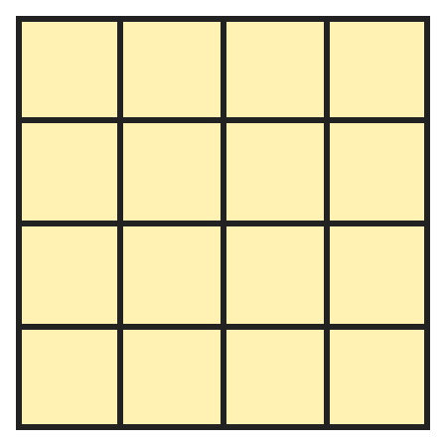
Q14. This board has 4 rows of 4 small squares. How many squares of all sizes are there on it?
(A) 16 | (B) 20 | (C) 30 | (D) 25

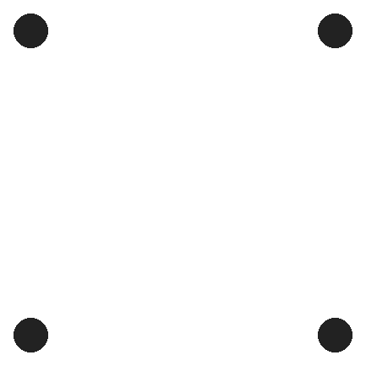
Q15. The four dots are at the corners of a square. Kunal joins any 3 of the dots to make a triangle. How many different triangles can he make?
(A) 4 | (B) 3 | (C) 6 | (D) 8

Q16. Diya puts a cube, a cone, a cylinder and a sphere on a sloping board. She stands each one on a flat face if it has one. How many roll down?
(A) 2 | (B) 1 | (C) 3 | (D) 0

Q17. Riya stacks 3 tins of the same size, one on top of another. Each tin is a cylinder. What does the stack look like from the top?
(A) Three circles | (B) A rectangle | (C) One circle | (D) A square

Part 4 — Applied Mathematics (Syllabus Chapter 9)
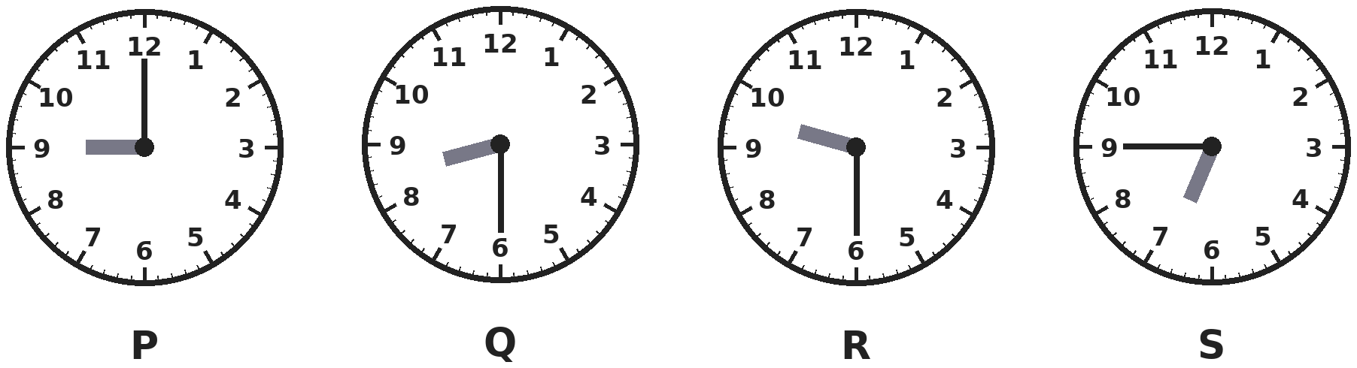
Q18. Which clock shows half past 9?
(A) Clock P | (B) Clock Q | (C) Clock R | (D) Clock S

Q19. Gopal changes one ₹50 note and one ₹20 note into ₹5 coins. How many ₹5 coins does he get?
(A) 10 | (B) 7 | (C) 70 | (D) 14

Q20. A shop opens in the morning when the minute hand points at 9 and the hour hand is nearly at 10. How is this time written?
(A) 9:45 AM | (B) 10:45 AM | (C) 9:15 AM | (D) 9:45 PM

Q21. Four pencils cost ₹28 together. All the pencils cost the same. How much do 7 such pencils cost?
(A) ₹49 | (B) ₹35 | (C) ₹56 | (D) ₹42

Part 5 — Mathematical Reasoning (Syllabus Chapter 10)
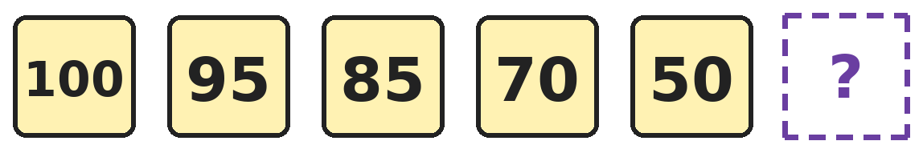
Q22. A pattern starts at 100. Which number comes next?
(A) 30 | (B) 20 | (C) 35 | (D) 25

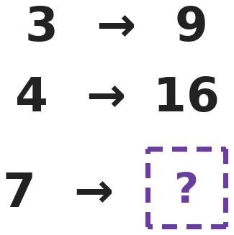
Q23. All three pairs follow the same rule. Which number goes in the box?
(A) 49 | (B) 21 | (C) 28 | (D) 14

Q24. Leela makes 2-digit numbers using only the digits 1, 2 and 3. She may use a digit twice, as in 33. How many different numbers can she make?
(A) 6 | (B) 9 | (C) 3 | (D) 12

Q25. Four lockers are numbered 18, 27, 36 and 35. Three of these numbers are in the same times table. Which locker number is the odd one out?
(A) 18 | (B) 27 | (C) 36 | (D) 35

Part 6 — Mixed Problems (each joins two chapters)
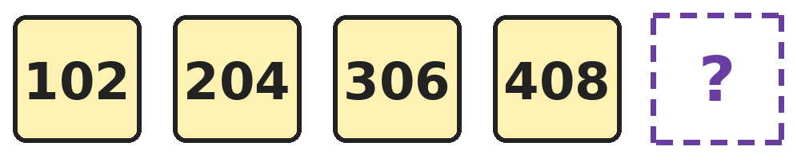
Q26. Each number is the same amount more than the one before. Which number comes next?
(A) 500 | (B) 510 | (C) 410 | (D) 512

Q27. Ankit knows that 1 + 2 + 3 + … + 10 = 55. What is 11 + 12 + 13 + … + 20?
(A) 65 | (B) 110 | (C) 155 | (D) 165

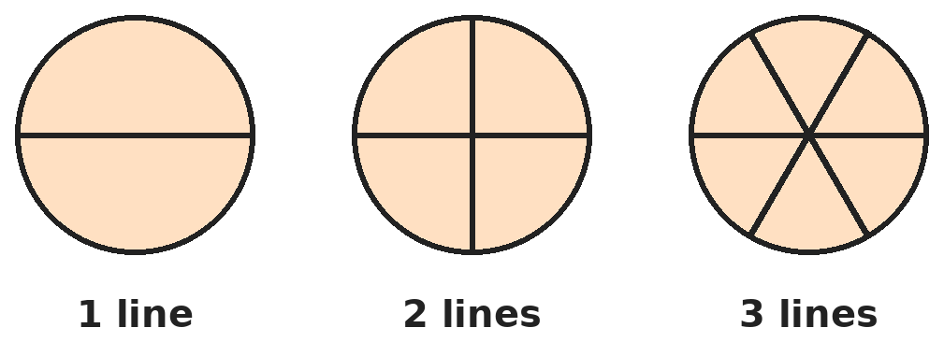
Q28. A round pizza is cut with straight lines that all pass through its centre. How many pieces will there be with 5 such lines?
(A) 6 | (B) 8 | (C) 5 | (D) 10

Q29. A toy costs ₹385. The shopkeeper wrote the price with the last two digits swapped by mistake. How much less is the wrong price than the right price?
(A) ₹17 | (B) ₹33 | (C) ₹27 | (D) ₹73

Q30. The minute hand turns from 12 to 3 in a quarter turn. Going round the usual way, how many quarter turns does it make from 12 to 9?
(A) 1 | (B) 9 | (C) 2 | (D) 3

Answer Sheet AMO Level 2 · Class 2 · Practice Paper 3
Name: | School: | Roll No.:
Shade or tick one circle for each question.
1. | Ⓐ Ⓑ Ⓒ Ⓓ | 11. | Ⓐ Ⓑ Ⓒ Ⓓ | 21. | Ⓐ Ⓑ Ⓒ Ⓓ
2. | Ⓐ Ⓑ Ⓒ Ⓓ | 12. | Ⓐ Ⓑ Ⓒ Ⓓ | 22. | Ⓐ Ⓑ Ⓒ Ⓓ
3. | Ⓐ Ⓑ Ⓒ Ⓓ | 13. | Ⓐ Ⓑ Ⓒ Ⓓ | 23. | Ⓐ Ⓑ Ⓒ Ⓓ
4. | Ⓐ Ⓑ Ⓒ Ⓓ | 14. | Ⓐ Ⓑ Ⓒ Ⓓ | 24. | Ⓐ Ⓑ Ⓒ Ⓓ
5. | Ⓐ Ⓑ Ⓒ Ⓓ | 15. | Ⓐ Ⓑ Ⓒ Ⓓ | 25. | Ⓐ Ⓑ Ⓒ Ⓓ
6. | Ⓐ Ⓑ Ⓒ Ⓓ | 16. | Ⓐ Ⓑ Ⓒ Ⓓ | 26. | Ⓐ Ⓑ Ⓒ Ⓓ
7. | Ⓐ Ⓑ Ⓒ Ⓓ | 17. | Ⓐ Ⓑ Ⓒ Ⓓ | 27. | Ⓐ Ⓑ Ⓒ Ⓓ
8. | Ⓐ Ⓑ Ⓒ Ⓓ | 18. | Ⓐ Ⓑ Ⓒ Ⓓ | 28. | Ⓐ Ⓑ Ⓒ Ⓓ
9. | Ⓐ Ⓑ Ⓒ Ⓓ | 19. | Ⓐ Ⓑ Ⓒ Ⓓ | 29. | Ⓐ Ⓑ Ⓒ Ⓓ
10. | Ⓐ Ⓑ Ⓒ Ⓓ | 20. | Ⓐ Ⓑ Ⓒ Ⓓ | 30. | Ⓐ Ⓑ Ⓒ Ⓓ

For the parent or teacher
Correct: ______ / 30
Answer Key and Solutions AMO Level 2 · Class 2 · Practice Paper 3
Quick answers
1 B | 6 B | 11 B | 16 B | 21 A | 26 B
2 D | 7 C | 12 A | 17 C | 22 D | 27 C
3 B | 8 D | 13 A | 18 C | 23 A | 28 D
4 C | 9 C | 14 C | 19 D | 24 B | 29 C
5 A | 10 D | 15 A | 20 A | 25 D | 30 D
Solutions
Q | Part · level | Answer | Why?
1 | Part 1 · Ch1 · Hard | (B) 299 | Hint: Make the ones and tens digits as big as possible so the hundreds digit can be small.  The tens and ones digits can each be at most 9, which gives 18. So the hundreds digit must be at least 2, since 2 + 9 + 9 = 20. The smallest number is 299.
2 | Part 1 · Ch1 · Hard | (D) 409 | Hint: Adding 2 tens is the same as adding 20.  389 + 20: the 8 tens become 10 tens, which is 1 more hundred. So 389 + 20 = 409.
3 | Part 1 · Ch1 · Hard | (B) 10 | Hint: The tens digit is fixed. What can the ones digit be?  The numbers are 150, 151, 152, … , 159. The ones digit can be any of 0 to 9, so there are 10 numbers.
4 | Part 1 · Ch1 · Hard | (C) 127 | Hint: The hundreds and tens digits are 1 and 2.  The number is 12?, so the ones digit must make 1 + 2 + ? = 10. That gives 7, and 127 is odd. 128 is even and 136 is not between 120 and 130.
5 | Part 1 · Ch1 · Hard | (A) 47 | Hint: Each hundred is 10 tens.  470 has 4 hundreds and 7 tens. 4 hundreds are 40 tens, so there are 40 + 7 = 47 tens in all. The tens digit alone is 7.
6 | Part 1 · Ch1 · Hard | (B) 500 | Hint: Count in tens from both ends towards the middle.  From 480 to 520 is 4 tens. Halfway is 2 tens from each end: 480 + 20 = 500 and 520 − 20 = 500.
7 | Part 2 · Ch2 · Hard | (C) 179 | Hint: Find the hens left, then add the ducks.  Hens left: 156 − 75 = 81. Birds now: 81 + 98 = 179.
8 | Part 2 · Ch2 · Hard | (D) 42 | Hint: How many bags are still good?  9 − 2 = 7 bags are good. 7 bags of 6 mangoes: 6 × 7 = 42 good mangoes.
9 | Part 2 · Ch2 · Hard | (C) 30 | Hint: Find what is left after the necklace first.  Half of 80 is 40, so 40 beads are left. A quarter of 40 is 10, used for the ring. 40 − 10 = 30 beads are left.
10 | Part 2 · Ch2 · Hard | (D) 132 | Hint: Count up: 368 to 370, then to 400, then to 500.  368 + 2 = 370, 370 + 30 = 400 and 400 + 100 = 500. So 2 + 30 + 100 = 132 must be added.
11 | Part 2 · Ch2 · Hard | (B) 7 × 6, by 2 | Hint: Use your times tables.  7 × 6 = 42 and 8 × 5 = 40. So 7 × 6 is bigger by 42 − 40 = 2.
12 | Part 2 · Ch2 · Hard | (A) 544 | Hint: Do his two steps in order.  345 + 200 = 545. Then 545 − 1 = 544. Adding 200 adds 1 too many, so he takes 1 away.
13 | Part 3 · Ch5 · Hard | (A) 4 | Hint: A cylinder has two round flat ends and a curved side.  The can, the candle, the drum and the paper roll are cylinders: 4. The ball is a sphere, the dice is a cube and the ice-cream cone is a cone.
14 | Part 3 · Ch5 · Hard | (C) 30 | Hint: Count 1 by 1 squares, then 2 by 2, 3 by 3 and 4 by 4.  1 by 1 squares: 16. 2 by 2 squares: 9. 3 by 3 squares: 4. The whole board: 1. 16 + 9 + 4 + 1 = 30.
15 | Part 3 · Ch5 · Hard | (A) 4 | Hint: Each triangle leaves out exactly one dot.  Each triangle uses 3 dots, so it leaves out 1 dot. There are 4 dots to leave out, so there are 4 different triangles.
16 | Part 3 · Ch5 · Hard | (B) 1 | Hint: A solid standing on a flat face does not roll.  The cube, the cone and the cylinder can each stand on a flat face, so they stay. The sphere has no flat face, so it rolls down. Only 1 rolls.
17 | Part 3 · Ch5 · Hard | (C) One circle | Hint: From the top you only see the top tin.  From the top you see only the lid of the top tin, which hides the others. A cylinder looks like a circle from the top, so the stack looks like one circle. From the side it would look like a rectangle.
18 | Part 4 · Ch9 · Hard | (C) Clock R | Hint: At half past 9 the minute hand points at 6 and the hour hand is halfway between 9 and 10.  Clock R has the minute hand at 6 and the hour hand halfway between 9 and 10, so it shows half past 9. Clock P shows 9 o'clock, Clock Q shows half past 8 and Clock S shows quarter to 7.
19 | Part 4 · Ch9 · Hard | (D) 14 | Hint: Find the total first, then count in fives.  ₹50 + ₹20 = ₹70. Counting in fives: ₹50 is 10 coins and ₹20 is 4 more coins. 10 + 4 = 14 coins.
20 | Part 4 · Ch9 · Hard | (A) 9:45 AM | Hint: The minute hand at 9 means quarter to.  The minute hand at 9 means quarter to. The hour hand nearly at 10 means quarter to 10, which is 9:45. It is morning, so 9:45 AM. 10:45 is quarter to 11.
21 | Part 4 · Ch9 · Hard | (A) ₹49 | Hint: First find the cost of one pencil by sharing ₹28 into 4 equal parts.  A quarter of ₹28 is ₹7, so one pencil costs ₹7. Seven pencils cost ₹7 × 7 = ₹49.
22 | Part 5 · Ch10 · Hard | (D) 25 | Hint: Look at how much is taken away each time.  The pattern takes away 5, 10, 15 and 20. Next it takes away 25: 50 − 25 = 25.
23 | Part 5 · Ch10 · Hard | (A) 49 | Hint: Multiplying by 3 works for the first pair but not the second.  3 × 3 = 9 and 4 × 4 = 16: each number is multiplied by itself. So 7 → 7 × 7 = 49.
24 | Part 5 · Ch10 · Hard | (B) 9 | Hint: The tens digit has 3 choices and so does the ones digit.  For each tens digit (1, 2 or 3) there are 3 choices of ones digit. That gives 3 + 3 + 3 = 9 numbers: 11, 12, 13, 21, 22, 23, 31, 32 and 33.
25 | Part 5 · Ch10 · Hard | (D) 35 | Hint: Try the 9 times table.  18 = 9 × 2, 27 = 9 × 3 and 36 = 9 × 4 are in the 9 times table. 35 is not, so it is the odd one out.
26 | Part 6 · Mixed · Ch1 + Ch10 · Hard | (B) 510 | Hint: Find how much is added each time. Watch the ones digit after 8.  Each number is 102 more than the one before: 102 + 102 = 204, 204 + 102 = 306, 306 + 102 = 408. Next: 408 + 102 = 510. The ones digits 8 + 2 make 10, so the tens digit becomes 1 and the ones digit 0.
27 | Part 6 · Mixed · Ch2 + Ch10 · Hard | (C) 155 | Hint: Each number from 11 to 20 is 10 more than a number from 1 to 10.  There are 10 numbers, and each is 10 more than a number in 1 to 10. That adds 10 + 10 + … (10 times) = 100 more. 55 + 100 = 155.
28 | Part 6 · Mixed · Ch5 + Ch10 · Hard | (D) 10 | Hint: Count the pieces for 1, 2 and 3 lines.  1 line gives 2 pieces, 2 lines give 4 and 3 lines give 6. Each line through the centre adds 2 pieces. 5 lines give 10 pieces.
29 | Part 6 · Mixed · Ch1 + Ch9 · Hard | (C) ₹27 | Hint: First write the wrong price.  With the last two digits swapped, the wrong price is ₹358. ₹385 − ₹358 = ₹27.
30 | Part 6 · Mixed · Ch5 + Ch9 · Hard | (D) 3 | Hint: 12 to 3 is one quarter turn. Where is the next quarter turn?  12 to 3 is 1 quarter turn, 3 to 6 is 2, and 6 to 9 is 3. So from 12 to 9 it makes 3 quarter turns.

ARYABHATTA MATHS OLYMPIAD
Level 2
PRACTICE PAPER-4
CLASS 2
Total Questions | 30 multiple-choice questions
Level | Level-2 (final round): every question is Hard
Time | 45 minutes
Arrangement | Parts by chapter; the last Part has mixed problems joining two chapters
Negative Marking | No negative marking
Calculator | Not allowed
Chapters | Number System · Operations · Geometry · Applied Mathematics · Mathematical Reasoning

👋 Hello, friend! How to do this paper:
⭐ Every question has four answer choices: (A), (B), (C) and (D). Only one is correct.
⭐ Read each question and look at its picture carefully. Then mark your answer on the answer sheet at the end.
⭐ This is a Level-2 paper. Every question needs careful thinking, so take your time and check each step.
⭐ The questions are in Parts by chapter. The last Part has mixed problems that join two chapters.
⭐ There is no negative marking, so try every question.
⭐ Do not use a calculator. You may do rough work on a separate sheet.
⭐ All figures are not necessarily drawn to scale unless stated.

For parents and teachers
• Pictures are part of the questions. Every picture also works when printed in black and white.
• You may read a question aloud to the child, exactly as printed. Please do not explain it or point to an answer choice.
• Parts follow the AMO syllabus chapters. Chapters 3, 4, 6, 7 and 8 are not part of the Class 2 syllabus, so the chapter numbers shown in the Part headings have gaps.
• The answer sheet and the answer key are at the end. Remove only the answer key before the child begins.

Part 1 — Number System (Syllabus Chapter 1)
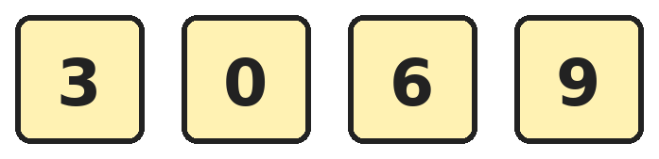
Q1. Neel makes 3-digit numbers using three different cards from these. What is the smallest even number he can make?
(A) 360 | (B) 306 | (C) 309 | (D) 036

Q2. Asha counts in fives from 355 to 400, saying both 355 and 400. How many numbers does she say?
(A) 9 | (B) 45 | (C) 11 | (D) 10

Q3. Which number has 6 hundreds, 0 tens and 12 ones?
(A) 6012 | (B) 620 | (C) 612 | (D) 602

Q4. Which of these is the greatest number?
(A) 5 hundreds and 9 tens | (B) 58 tens and 9 ones
(C) 5 hundreds, 8 tens and 12 ones | (D) 591

Q5. Riya adds 347 and 128. Without adding, which statement about the answer is correct?
(A) It is even, because 128 is even | (B) It is odd, because 347 is bigger
(C) It is even, because both have 3 digits | (D) It is odd, because odd + even is odd

Q6. Which number is 3 hundreds and 5 tens less than 700?
(A) 400 | (B) 350 | (C) 450 | (D) 345

Part 2 — Operations (Syllabus Chapter 2)
Q7. Three friends scored 600 points in all in a game. Vivaan scored 128 and Meera scored 245. How many points did Kabir score?
(A) 373 | (B) 237 | (C) 227 | (D) 327

Q8. Mother puts 9 idlis on each of 4 plates. The children eat 7 idlis. How many idlis are left?
(A) 36 | (B) 43 | (C) 27 | (D) 29

Q9. Raju eats a quarter of 48 grapes. His sister eats half of 20 cherries. How many fruits do they eat in all?
(A) 22 | (B) 34 | (C) 12 | (D) 24

Q10. Arjun's subtraction got a drop of ink on one digit. Which digit is under the ink?
(A) 5 | (B) 4 | (C) 3 | (D) 7

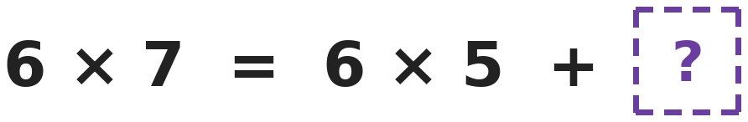
Q11. Meena's teacher wrote this on the board. Both sides are equal. What number is in the box?
(A) 12 | (B) 2 | (C) 6 | (D) 42

Q12. A train has 245 passengers. At a station, 78 passengers get off and 136 get on. How many passengers are on the train now?
(A) 303 | (B) 459 | (C) 167 | (D) 313

Part 3 — Geometry (Syllabus Chapter 5)
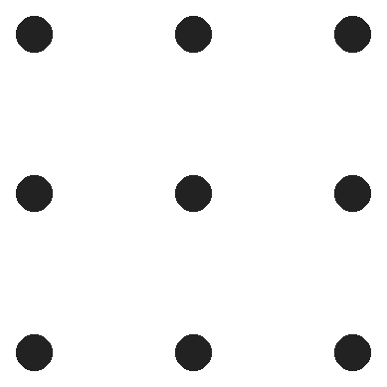
Q13. These 9 dots are in 3 equal rows. Sana joins 4 dots to make squares whose sides go straight across or straight down. How many such squares can she make?
(A) 4 | (B) 5 | (C) 9 | (D) 6

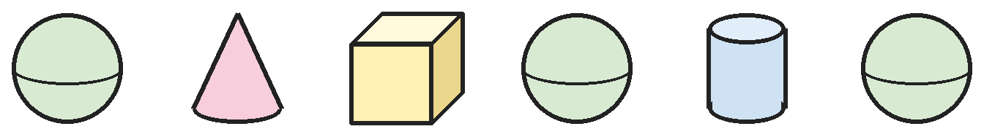
Q14. How many of these solids have at least one flat face?
(A) 3 | (B) 6 | (C) 2 | (D) 4

Q15. Mansi folds a square paper along a line from one corner to the opposite corner. Then she folds it again so the two sharp corners meet. What shape is the folded paper now?
(A) A smaller triangle | (B) A square
(C) A rectangle | (D) A circle

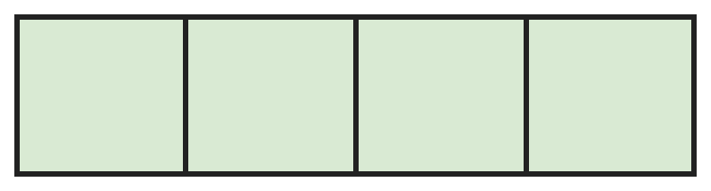
Q16. A long strip is divided into 4 equal panels, as shown. How many rectangles of all sizes are in the strip?
(A) 4 | (B) 10 | (C) 7 | (D) 8

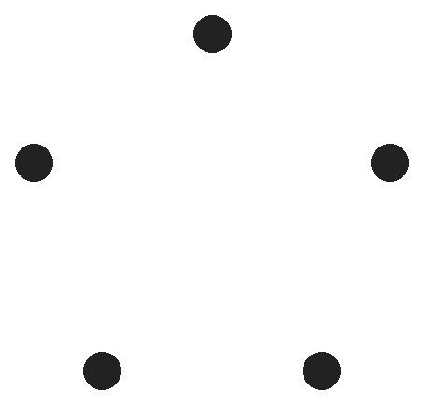
Q17. Five dots are drawn, and no three of them are on one straight line. Vikram joins every pair of dots with a straight line. How many lines does he draw?
(A) 5 | (B) 20 | (C) 15 | (D) 10

Part 4 — Applied Mathematics (Syllabus Chapter 9)
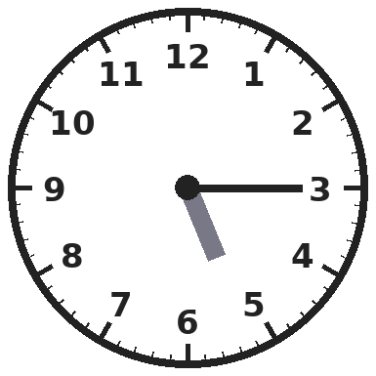
Q18. Rohit's tuition starts at the time shown on this clock. What time is it?
(A) Quarter past 3 | (B) Quarter to 5
(C) Quarter past 6 | (D) Quarter past 5

Q19. Ruhi pays ₹500 for shoes that cost ₹349. The shopkeeper gives her change using the fewest notes and coins. How many notes and coins does she get?
(A) 3 | (B) 2 | (C) 4 | (D) 151

Q20. Kavya's music class starts in the evening when the minute hand points at 6 and the hour hand is halfway between 5 and 6. How is this time written?
(A) 6:30 PM | (B) 5:30 AM | (C) 5:15 PM | (D) 5:30 PM

Q21. Raju buys 3 toffees at ₹2 each and 2 chocolates at ₹10 each. He pays with a ₹50 note. How much change does he get?
(A) ₹26 | (B) ₹36 | (C) ₹24 | (D) ₹38

Part 5 — Mathematical Reasoning (Syllabus Chapter 10)

Q22. A frog jumps along a number track and lands on these numbers. If it keeps jumping the same way, where does it land next?
(A) 22 | (B) 21 | (C) 20 | (D) 23

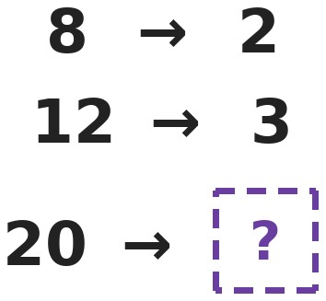
Q23. A number machine changes each number on the left into the one on the right using one rule. What does it give for the last number?
(A) 17 | (B) 5 | (C) 10 | (D) 4

Q24. Asha, Ved and Pari stand in a line for a photo. In how many different orders can they stand?
(A) 6 | (B) 3 | (C) 9 | (D) 4

Q25. Three of these give the same answer. Which one is the odd one out?
(A) 3 × 8 | (B) Half of 50 | (C) 4 × 6 | (D) 30 − 6

Part 6 — Mixed Problems (each joins two chapters)
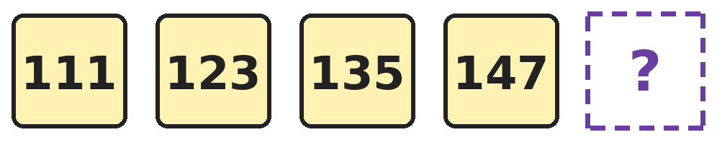
Q26. The numbers grow in the same way each time. Which number comes next?
(A) 157 | (B) 160 | (C) 159 | (D) 1510

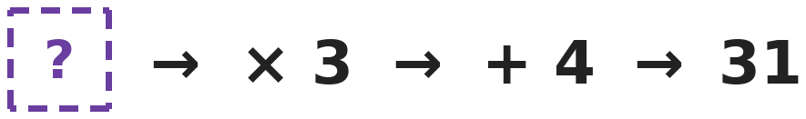
Q27. A number goes into this machine. It is multiplied by 3 and then 4 is added. The number 31 comes out. Which number went in?
(A) 35 | (B) 11 | (C) 9 | (D) 27

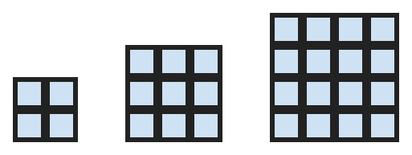
Q28. Square floors are made of square tiles: 2 by 2, then 3 by 3, then 4 by 4, and so on. How many more tiles does a 6 by 6 floor need than a 5 by 5 floor?
(A) 36 | (B) 11 | (C) 6 | (D) 12

Q29. Om writes down the number the minute hand points at for quarter past, half past and quarter to. What is the total of the three numbers?
(A) 15 | (B) 12 | (C) 18 | (D) 45

Q30. Gita makes a tall stack of 20 coins of ₹5. Which describes the stack?
(A) A cylinder worth ₹25 | (B) A cube worth ₹100
(C) A cone worth ₹20 | (D) A cylinder worth ₹100

Answer Sheet AMO Level 2 · Class 2 · Practice Paper 4
Name: | School: | Roll No.:
Shade or tick one circle for each question.
1. | Ⓐ Ⓑ Ⓒ Ⓓ | 11. | Ⓐ Ⓑ Ⓒ Ⓓ | 21. | Ⓐ Ⓑ Ⓒ Ⓓ
2. | Ⓐ Ⓑ Ⓒ Ⓓ | 12. | Ⓐ Ⓑ Ⓒ Ⓓ | 22. | Ⓐ Ⓑ Ⓒ Ⓓ
3. | Ⓐ Ⓑ Ⓒ Ⓓ | 13. | Ⓐ Ⓑ Ⓒ Ⓓ | 23. | Ⓐ Ⓑ Ⓒ Ⓓ
4. | Ⓐ Ⓑ Ⓒ Ⓓ | 14. | Ⓐ Ⓑ Ⓒ Ⓓ | 24. | Ⓐ Ⓑ Ⓒ Ⓓ
5. | Ⓐ Ⓑ Ⓒ Ⓓ | 15. | Ⓐ Ⓑ Ⓒ Ⓓ | 25. | Ⓐ Ⓑ Ⓒ Ⓓ
6. | Ⓐ Ⓑ Ⓒ Ⓓ | 16. | Ⓐ Ⓑ Ⓒ Ⓓ | 26. | Ⓐ Ⓑ Ⓒ Ⓓ
7. | Ⓐ Ⓑ Ⓒ Ⓓ | 17. | Ⓐ Ⓑ Ⓒ Ⓓ | 27. | Ⓐ Ⓑ Ⓒ Ⓓ
8. | Ⓐ Ⓑ Ⓒ Ⓓ | 18. | Ⓐ Ⓑ Ⓒ Ⓓ | 28. | Ⓐ Ⓑ Ⓒ Ⓓ
9. | Ⓐ Ⓑ Ⓒ Ⓓ | 19. | Ⓐ Ⓑ Ⓒ Ⓓ | 29. | Ⓐ Ⓑ Ⓒ Ⓓ
10. | Ⓐ Ⓑ Ⓒ Ⓓ | 20. | Ⓐ Ⓑ Ⓒ Ⓓ | 30. | Ⓐ Ⓑ Ⓒ Ⓓ

For the parent or teacher
Correct: ______ / 30
Answer Key and Solutions AMO Level 2 · Class 2 · Practice Paper 4
Quick answers
1 B | 6 B | 11 A | 16 B | 21 C | 26 C
2 D | 7 C | 12 A | 17 D | 22 A | 27 C
3 C | 8 D | 13 B | 18 D | 23 B | 28 B
4 C | 9 A | 14 A | 19 A | 24 A | 29 C
5 D | 10 B | 15 A | 20 D | 25 B | 30 D
Solutions
Q | Part · level | Answer | Why?
1 | Part 1 · Ch1 · Hard | (B) 306 | Hint: The number cannot start with 0, and an even number must end in 0 or 6.  The smallest hundreds digit allowed is 3. Then use the smallest tens digit, 0. The ones digit must be even, so it is 6 (0 is already used). The number is 306. 309 is odd, and 036 is not a 3-digit number.
2 | Part 1 · Ch1 · Hard | (D) 10 | Hint: Count the jumps of 5, then add 1 for the starting number.  She says 355, 360, 365, 370, 375, 380, 385, 390, 395, 400. That is 10 numbers.
3 | Part 1 · Ch1 · Hard | (C) 612 | Hint: 12 ones are 1 ten and 2 ones.  12 ones are 1 ten and 2 ones. So the number has 6 hundreds, 1 ten and 2 ones, which is 612.
4 | Part 1 · Ch1 · Hard | (C) 5 hundreds, 8 tens and 12 ones | Hint: Change extra ones into tens and extra tens into hundreds.  5 hundreds, 8 tens and 12 ones make 592. 5 hundreds and 9 tens make 590. 58 tens and 9 ones make 589. So 592 is the greatest.
5 | Part 1 · Ch1 · Hard | (D) It is odd, because odd + even is odd | Hint: Only the ones digits decide whether the answer is odd or even.  347 is odd and 128 is even. An odd number plus an even number is always odd. Check: 347 + 128 = 475, which is odd.
6 | Part 1 · Ch1 · Hard | (B) 350 | Hint: Take away 3 hundreds first, then 5 tens.  700 − 300 = 400. Then 400 − 50 = 350.
7 | Part 2 · Ch2 · Hard | (C) 227 | Hint: Add the two scores you know first.  Vivaan and Meera scored 128 + 245 = 373. Kabir scored 600 − 373 = 227.
8 | Part 2 · Ch2 · Hard | (D) 29 | Hint: First find how many idlis there were.  4 plates of 9 idlis: 9 × 4 = 36. After 7 are eaten: 36 − 7 = 29.
9 | Part 2 · Ch2 · Hard | (A) 22 | Hint: Find each part separately.  A quarter of 48 is 12 (12 + 12 + 12 + 12 = 48). Half of 20 is 10. In all 12 + 10 = 22 fruits.
10 | Part 2 · Ch2 · Hard | (B) 4 | Hint: Add 357 and 287 to find the first number.  The first number is 357 + 287 = 644. So the hidden digit is 4. Check: 644 − 287 = 357.
11 | Part 2 · Ch2 · Hard | (A) 12 | Hint: Six sevens are six fives and six twos.  6 × 7 = 42 and 6 × 5 = 30. So 30 + ? = 42, and ? = 12. This is the same as 6 × 2.
12 | Part 2 · Ch2 · Hard | (A) 303 | Hint: Take away first, then add.  245 − 78 = 167. Then 167 + 136 = 303 passengers.
13 | Part 3 · Ch5 · Hard | (B) 5 | Hint: Look for small squares and one big square.  There are 4 small squares, one in each corner. The 4 corner dots make 1 big square. 4 + 1 = 5.
14 | Part 3 · Ch5 · Hard | (A) 3 | Hint: A sphere is the only solid here with no flat face.  The cone, the cube and the cylinder each have flat faces. The three spheres are curved all over. So 3 solids have at least one flat face.
15 | Part 3 · Ch5 · Hard | (A) A smaller triangle | Hint: The first fold makes a triangle.  The first fold makes a big triangle. Folding again so its two sharp corners meet folds the triangle in half, which makes a smaller triangle.
16 | Part 3 · Ch5 · Hard | (B) 10 | Hint: Count rectangles of 1, 2, 3 and 4 panels.  1 panel: 4. 2 panels side by side: 3. 3 panels: 2. All 4 panels: 1. 4 + 3 + 2 + 1 = 10.
17 | Part 3 · Ch5 · Hard | (D) 10 | Hint: Count the new lines from each dot in turn.  The 1st dot joins to 4 others. The 2nd joins to 3 new ones, the 3rd to 2 and the 4th to 1. 4 + 3 + 2 + 1 = 10 lines.
18 | Part 4 · Ch9 · Hard | (D) Quarter past 5 | Hint: The hour hand has only just passed the 5.  The minute hand points at 3, which means quarter past. The hour hand is just after 5. So the time is quarter past 5.
19 | Part 4 · Ch9 · Hard | (A) 3 | Hint: First find the change. Then use the biggest notes and coins you can.  The change is ₹500 − ₹349 = ₹151. That is a ₹100 note, a ₹50 note and a ₹1 coin: 3 pieces.
20 | Part 4 · Ch9 · Hard | (D) 5:30 PM | Hint: The minute hand at 6 means half past.  The minute hand at 6 means half past. The hour hand between 5 and 6 means half past 5, written 5:30. Evening times are PM, so 5:30 PM. 6:30 is half past 6.
21 | Part 4 · Ch9 · Hard | (C) ₹24 | Hint: Find the cost of the toffees and the chocolates first.  Toffees: ₹2 × 3 = ₹6. Chocolates: ₹10 × 2 = ₹20. Total ₹26. Change: ₹50 − ₹26 = ₹24.
22 | Part 5 · Ch10 · Hard | (A) 22 | Hint: Look at how much each jump grows.  The jumps are 1, 2, 3, 4 and 5. The next jump is 6: 16 + 6 = 22.
23 | Part 5 · Ch10 · Hard | (B) 5 | Hint: Taking away 6 works for the first pair but not the second.  8 → 2 and 12 → 3: each number is shared into 4 equal parts (a quarter). A quarter of 20 is 5.
24 | Part 5 · Ch10 · Hard | (A) 6 | Hint: Choose who stands first, then who stands second.  Any of the 3 can stand first. Then either of the other 2 can stand second, and the last one stands third. That is 3 × 2 = 6 orders.
25 | Part 5 · Ch10 · Hard | (B) Half of 50 | Hint: Work out each one.  3 × 8 = 24, 4 × 6 = 24 and 30 − 6 = 24. Half of 50 is 25, so it is the odd one out.
26 | Part 6 · Mixed · Ch1 + Ch10 · Hard | (C) 159 | Hint: Find how much is added each time.  Each number is 12 more than the one before: 111, 123, 135, 147. Next is 147 + 12 = 159.
27 | Part 6 · Mixed · Ch2 + Ch10 · Hard | (C) 9 | Hint: Undo the steps in the opposite order.  Undo adding 4: 31 − 4 = 27. Undo multiplying by 3: 3 × 9 = 27, so the number is 9.
28 | Part 6 · Mixed · Ch5 + Ch10 · Hard | (B) 11 | Hint: Look at how many tiles are added each time: 4 to 9, 9 to 16.  2 by 2 has 4 tiles, 3 by 3 has 9 and 4 by 4 has 16. The extra tiles go 5, 7, 9, then 11. So 6 by 6 needs 11 more tiles than 5 by 5 (36 − 25 = 11).
29 | Part 6 · Mixed · Ch1 + Ch9 · Hard | (C) 18 | Hint: Quarter past means the minute hand is at 3.  Quarter past: 3. Half past: 6. Quarter to: 9. The total is 3 + 6 + 9 = 18.
30 | Part 6 · Mixed · Ch5 + Ch9 · Hard | (D) A cylinder worth ₹100 | Hint: Think of the shape of one coin, then many piled up.  Each coin is a flat circle, so a pile of coins is a cylinder. Counting in fives 20 times gives ₹100.

ARYABHATTA MATHS OLYMPIAD
Level 2
PRACTICE PAPER-5
CLASS 2
Total Questions | 30 multiple-choice questions
Level | Level-2 (final round): every question is Hard
Time | 45 minutes
Arrangement | Parts by chapter; the last Part has mixed problems joining two chapters
Negative Marking | No negative marking
Calculator | Not allowed
Chapters | Number System · Operations · Geometry · Applied Mathematics · Mathematical Reasoning

👋 Hello, friend! How to do this paper:
⭐ Every question has four answer choices: (A), (B), (C) and (D). Only one is correct.
⭐ Read each question and look at its picture carefully. Then mark your answer on the answer sheet at the end.
⭐ This is a Level-2 paper. Every question needs careful thinking, so take your time and check each step.
⭐ The questions are in Parts by chapter. The last Part has mixed problems that join two chapters.
⭐ There is no negative marking, so try every question.
⭐ Do not use a calculator. You may do rough work on a separate sheet.
⭐ All figures are not necessarily drawn to scale unless stated.

For parents and teachers
• Pictures are part of the questions. Every picture also works when printed in black and white.
• You may read a question aloud to the child, exactly as printed. Please do not explain it or point to an answer choice.
• Parts follow the AMO syllabus chapters. Chapters 3, 4, 6, 7 and 8 are not part of the Class 2 syllabus, so the chapter numbers shown in the Part headings have gaps.
• The answer sheet and the answer key are at the end. Remove only the answer key before the child begins.

Part 1 — Number System (Syllabus Chapter 1)
Q1. Shreya makes 3-digit numbers using each of the digits 1, 2 and 3 once. How many of her numbers are greater than 200?
(A) 4 | (B) 6 | (C) 2 | (D) 3

Q2. Which number is 10 less than the number that is 100 more than 495?
(A) 595 | (B) 605 | (C) 585 | (D) 485

Q3. Kunal writes all the numbers from 100 to 110. How many times does he write the digit 0?
(A) 11 | (B) 12 | (C) 10 | (D) 20

Q4. In Sita's 3-digit number, the ones digit is 4. The tens digit is double the ones digit. The hundreds digit is half of the tens digit. What is the number?
(A) 448 | (B) 844 | (C) 424 | (D) 484

Q5. Which of these number names is the 2nd largest: four hundred four, four hundred forty, forty-four, four hundred fourteen?
(A) four hundred forty | (B) four hundred fourteen
(C) four hundred four | (D) forty-four

Q6. How many odd numbers are there between 90 and 110?
(A) 9 | (B) 20 | (C) 11 | (D) 10

Part 2 — Operations (Syllabus Chapter 2)
Q7. A shop had 500 pens. It sold 237 pens on Monday and 158 pens on Tuesday. How many pens are left?
(A) 395 | (B) 263 | (C) 105 | (D) 115

Q8. A spider has 8 legs and an ant has 6 legs. How many legs do 6 spiders and 5 ants have altogether?
(A) 66 | (B) 84 | (C) 78 | (D) 48

Q9. There are 40 students in a class. A quarter of them are absent today. How many students are present?
(A) 10 | (B) 20 | (C) 36 | (D) 30

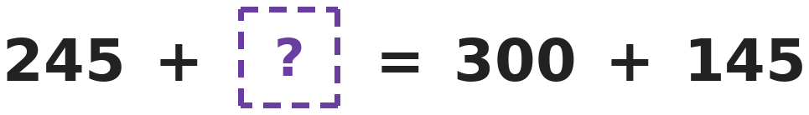
Q10. Tara balances a number sentence so that both sides are equal. Which number should she write in the box?
(A) 200 | (B) 100 | (C) 445 | (D) 55

Q11. Two numbers multiply to give 24 and add up to 10. Which are the two numbers?
(A) 3 and 8 | (B) 2 and 12 | (C) 5 and 5 | (D) 4 and 6

Q12. A book has 100 pages. Pari reads 9 pages every day for 7 days. How many pages are still left to read?
(A) 37 | (B) 63 | (C) 27 | (D) 47

Part 3 — Geometry (Syllabus Chapter 5)
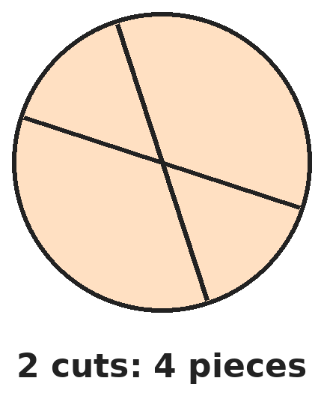
Q13. With 2 cuts, Mother can cut a roti into 4 pieces, as shown. Now she makes 3 straight cuts. The cuts do not have to go through the middle. What is the largest number of pieces she can get?
(A) 6 | (B) 8 | (C) 7 | (D) 9

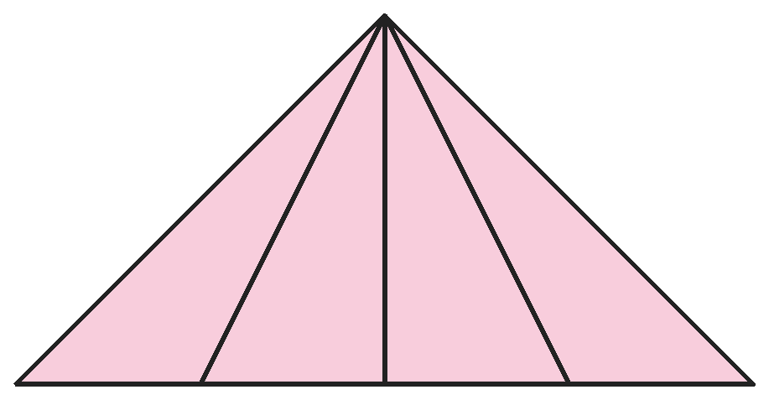
Q14. Vani draws a triangle and three lines from its top corner to the bottom side. How many triangles of all sizes are in her drawing?
(A) 4 | (B) 7 | (C) 10 | (D) 6

Q15. Leela looks at a solid from the top, from the front and from the side. Every time it looks like a circle. Which solid is it?
(A) Cylinder | (B) Cone | (C) Cube | (D) Sphere

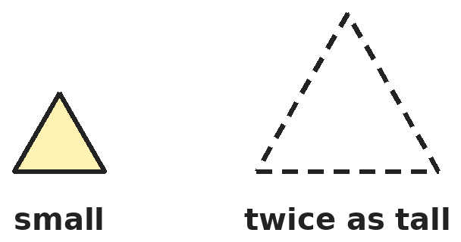
Q16. Kush has many small triangles that are all the same. He puts some together, with no gaps, to make a bigger triangle of the same shape that is twice as tall. How many small triangles does he use?
(A) 4 | (B) 2 | (C) 3 | (D) 6

Q17. Isha has 5 sticks of the same length. She can let triangles share a stick. What is the largest number of triangles she can make using all 5 sticks?
(A) 1 | (B) 3 | (C) 2 | (D) 5

Part 4 — Applied Mathematics (Syllabus Chapter 9)
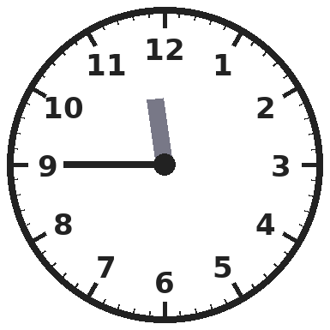
Q18. Lunch at Devika's school starts at the time on this clock. What time is it?
(A) Quarter to 12 | (B) Quarter to 11
(C) Quarter past 9 | (D) Quarter past 11

Q19. Ravi changes a ₹100 note into three ₹20 notes and some ₹10 notes. How many ₹10 notes does he get?
(A) 3 | (B) 7 | (C) 2 | (D) 4

Q20. Yash wakes up at half past 6 in the morning. Which of these times is after he wakes up but before noon?
(A) 5:15 AM | (B) 11:45 AM | (C) 12:30 PM | (D) 6:15 AM

Q21. Sana has three ₹20 notes and five ₹2 coins. She spends ₹45. How much money does she have left?
(A) ₹15 | (B) ₹70 | (C) ₹35 | (D) ₹25

Part 5 — Mathematical Reasoning (Syllabus Chapter 10)
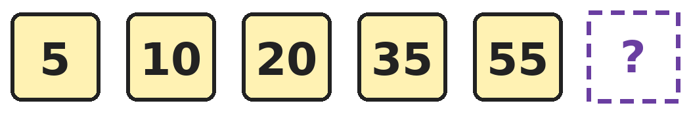
Q22. Look at how much is added each time in this pattern. Which number comes next?
(A) 75 | (B) 80 | (C) 85 | (D) 90

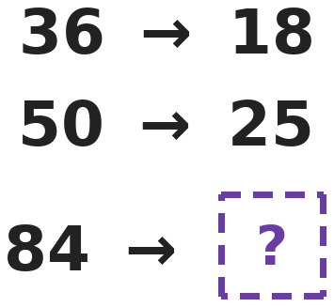
Q23. Each arrow in Nikhil's puzzle uses the same rule. Which number replaces the question mark?
(A) 66 | (B) 42 | (C) 21 | (D) 48

Q24. Ayaan has one each of ₹1, ₹2, ₹5 and ₹10 coins. He picks two different coins. How many different totals can he get?
(A) 4 | (B) 8 | (C) 12 | (D) 6

Q25. Four lockers are numbered 234, 345, 456 and 579. Three numbers belong together. Which locker number is the odd one out?
(A) 234 | (B) 579 | (C) 345 | (D) 456

Part 6 — Mixed Problems (each joins two chapters)
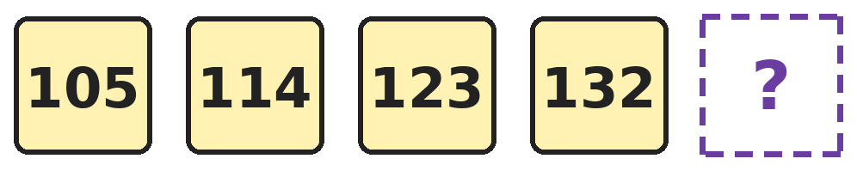
Q26. These are 3-digit numbers whose digits add up to 6, written in order from smallest. Which number comes next?
(A) 141 | (B) 150 | (C) 133 | (D) 204

Q27. Two numbers that come one after the other, like 3 and 4, multiply to give 56. What do the two numbers add up to?
(A) 13 | (B) 15 | (C) 17 | (D) 56


Q28. The shapes keep repeating in this order. How many corners do the first 10 shapes have altogether?
(A) 24 | (B) 28 | (C) 21 | (D) 18

Q29. Vikram has ₹340, all in ₹10 notes. How many notes does he have?
(A) 340 | (B) 34 | (C) 43 | (D) 30

Q30. At 9 o'clock, the two hands of a clock make a square corner, like the corner of a square. At which of these times do the hands also make a square corner?
(A) 3 o'clock | (B) 6 o'clock | (C) 12 o'clock | (D) Half past 6

Answer Sheet AMO Level 2 · Class 2 · Practice Paper 5
Name: | School: | Roll No.:
Shade or tick one circle for each question.
1. | Ⓐ Ⓑ Ⓒ Ⓓ | 11. | Ⓐ Ⓑ Ⓒ Ⓓ | 21. | Ⓐ Ⓑ Ⓒ Ⓓ
2. | Ⓐ Ⓑ Ⓒ Ⓓ | 12. | Ⓐ Ⓑ Ⓒ Ⓓ | 22. | Ⓐ Ⓑ Ⓒ Ⓓ
3. | Ⓐ Ⓑ Ⓒ Ⓓ | 13. | Ⓐ Ⓑ Ⓒ Ⓓ | 23. | Ⓐ Ⓑ Ⓒ Ⓓ
4. | Ⓐ Ⓑ Ⓒ Ⓓ | 14. | Ⓐ Ⓑ Ⓒ Ⓓ | 24. | Ⓐ Ⓑ Ⓒ Ⓓ
5. | Ⓐ Ⓑ Ⓒ Ⓓ | 15. | Ⓐ Ⓑ Ⓒ Ⓓ | 25. | Ⓐ Ⓑ Ⓒ Ⓓ
6. | Ⓐ Ⓑ Ⓒ Ⓓ | 16. | Ⓐ Ⓑ Ⓒ Ⓓ | 26. | Ⓐ Ⓑ Ⓒ Ⓓ
7. | Ⓐ Ⓑ Ⓒ Ⓓ | 17. | Ⓐ Ⓑ Ⓒ Ⓓ | 27. | Ⓐ Ⓑ Ⓒ Ⓓ
8. | Ⓐ Ⓑ Ⓒ Ⓓ | 18. | Ⓐ Ⓑ Ⓒ Ⓓ | 28. | Ⓐ Ⓑ Ⓒ Ⓓ
9. | Ⓐ Ⓑ Ⓒ Ⓓ | 19. | Ⓐ Ⓑ Ⓒ Ⓓ | 29. | Ⓐ Ⓑ Ⓒ Ⓓ
10. | Ⓐ Ⓑ Ⓒ Ⓓ | 20. | Ⓐ Ⓑ Ⓒ Ⓓ | 30. | Ⓐ Ⓑ Ⓒ Ⓓ

For the parent or teacher
Correct: ______ / 30
Answer Key and Solutions AMO Level 2 · Class 2 · Practice Paper 5
Quick answers
1 A | 6 D | 11 D | 16 A | 21 D | 26 A
2 C | 7 C | 12 A | 17 C | 22 B | 27 B
3 B | 8 C | 13 C | 18 A | 23 B | 28 C
4 D | 9 D | 14 C | 19 D | 24 D | 29 B
5 B | 10 A | 15 D | 20 B | 25 B | 30 A
Solutions
Q | Part · level | Answer | Why?
1 | Part 1 · Ch1 · Hard | (A) 4 | Hint: A number greater than 200 must start with 2 or 3.  Starting with 2: 213 and 231. Starting with 3: 312 and 321. Numbers starting with 1 are less than 200. That is 4 numbers.
2 | Part 1 · Ch1 · Hard | (C) 585 | Hint: First add 100 to 495.  100 more than 495 is 595. 10 less than 595 is 585.
3 | Part 1 · Ch1 · Hard | (B) 12 | Hint: 100 has two zeros.  100 has two 0s. Each of 101 to 109 has one 0, which is 9 more. 110 has one 0. 2 + 9 + 1 = 12.
4 | Part 1 · Ch1 · Hard | (D) 484 | Hint: Find the tens digit first, then the hundreds digit.  Double 4 is 8, so the tens digit is 8. Half of 8 is 4, so the hundreds digit is 4. The number is 484.
5 | Part 1 · Ch1 · Hard | (B) four hundred fourteen | Hint: Write each name as a number first.  The numbers are 404, 440, 44 and 414. From largest: 440, 414, 404, 44. The 2nd largest is 414, four hundred fourteen.
6 | Part 1 · Ch1 · Hard | (D) 10 | Hint: The first odd number after 90 is 91.  The odd numbers are 91, 93, 95, 97, 99, 101, 103, 105, 107 and 109. That is 10 numbers.
7 | Part 2 · Ch2 · Hard | (C) 105 | Hint: Find the total sold first.  Pens sold: 237 + 158 = 395. Pens left: 500 − 395 = 105.
8 | Part 2 · Ch2 · Hard | (C) 78 | Hint: Use the 8 times table and the 6 times table.  6 spiders: 8 × 6 = 48 legs. 5 ants: 6 × 5 = 30 legs. Altogether 48 + 30 = 78 legs.
9 | Part 2 · Ch2 · Hard | (D) 30 | Hint: First find a quarter of 40.  A quarter of 40 is 10 (10 + 10 + 10 + 10 = 40). So 10 are absent and 40 − 10 = 30 are present.
10 | Part 2 · Ch2 · Hard | (A) 200 | Hint: Work out the right side first.  300 + 145 = 445. So 245 + ? = 445, and ? = 445 − 245 = 200.
11 | Part 2 · Ch2 · Hard | (D) 4 and 6 | Hint: List pairs that multiply to 24, then check which add to 10.  Pairs that make 24: 3 and 8 (they add to 11), 4 and 6 (they add to 10). 5 and 5 add to 10 but make 25. So the numbers are 4 and 6.
12 | Part 2 · Ch2 · Hard | (A) 37 | Hint: First find how many pages she has read.  She reads 9 × 7 = 63 pages. Pages left: 100 − 63 = 37.
13 | Part 3 · Ch5 · Hard | (C) 7 | Hint: Each new cut should cross every cut before it, at different places.  One cut gives 2 pieces. A second cut crossing the first gives 4. A third cut that crosses both earlier cuts at two different points goes through 3 pieces and splits each, giving 4 + 3 = 7.
14 | Part 3 · Ch5 · Hard | (C) 10 | Hint: Count triangles made of 1, 2, 3 and 4 parts.  There are 4 small triangles. Triangles made of 2 parts: 3. Of 3 parts: 2. The whole shape: 1. 4 + 3 + 2 + 1 = 10.
15 | Part 3 · Ch5 · Hard | (D) Sphere | Hint: Only one of these is round in every direction.  A sphere looks like a circle from every side. A cylinder looks like a rectangle from the side, a cone like a triangle, and a cube like a square.
16 | Part 3 · Ch5 · Hard | (A) 4 | Hint: Try 1 triangle on top and a row of triangles below it.  One triangle goes on top. The row below has 2 triangles pointing up and 1 pointing down between them. That is 1 + 3 = 4 small triangles.
17 | Part 3 · Ch5 · Hard | (C) 2 | Hint: One triangle uses 3 sticks. Can a second triangle share one of them?  One triangle uses 3 sticks. A second triangle can share one side, so it needs only 2 more sticks. That uses 3 + 2 = 5 sticks for 2 triangles.
18 | Part 4 · Ch9 · Hard | (A) Quarter to 12 | Hint: The hour hand has not reached 12 yet.  The minute hand points at 9, which means quarter to. The hour hand is just before 12. So it is quarter to 12.
19 | Part 4 · Ch9 · Hard | (D) 4 | Hint: First find how much the ₹20 notes make.  Three ₹20 notes make ₹60. The rest is ₹100 − ₹60 = ₹40, which is four ₹10 notes.
20 | Part 4 · Ch9 · Hard | (B) 11:45 AM | Hint: Half past 6 in the morning is 6:30 AM. Noon is 12 o'clock in the day.  He wakes at 6:30 AM. 5:15 AM and 6:15 AM are before that. 12:30 PM is after noon. Only 11:45 AM is between 6:30 AM and noon.
21 | Part 4 · Ch9 · Hard | (D) ₹25 | Hint: First find how much money she has.  Three ₹20 notes: ₹60. Five ₹2 coins: ₹10. In all ₹70. After spending ₹45: ₹70 − ₹45 = ₹25.
22 | Part 5 · Ch10 · Hard | (B) 80 | Hint: The amount added goes up by 5 each time.  The pattern adds 5, 10, 15 and 20. Next it adds 25: 55 + 25 = 80.
23 | Part 5 · Ch10 · Hard | (B) 42 | Hint: Taking away 18 works for the first pair but not the second.  36 → 18 and 50 → 25: each number is halved. Half of 84 is 42, since 42 + 42 = 84.
24 | Part 5 · Ch10 · Hard | (D) 6 | Hint: List every pair of coins.  The pairs are ₹1 + ₹2 = ₹3, ₹1 + ₹5 = ₹6, ₹1 + ₹10 = ₹11, ₹2 + ₹5 = ₹7, ₹2 + ₹10 = ₹12 and ₹5 + ₹10 = ₹15. All 6 totals are different.
25 | Part 5 · Ch10 · Hard | (B) 579 | Hint: Look at the digits of each number from left to right.  In 234, 345 and 456 the digits go up by 1 each time. In 579 the digits go up by 2, so it is the odd one out.
26 | Part 6 · Mixed · Ch1 + Ch10 · Hard | (A) 141 | Hint: Keep the hundreds digit 1 and see how the tens and ones change.  Each time the tens digit goes up by 1 and the ones digit goes down by 1, keeping the digit total 6. After 132 comes 141, and 1 + 4 + 1 = 6. (150 comes after 141.)
27 | Part 6 · Mixed · Ch2 + Ch10 · Hard | (B) 15 | Hint: Use the times tables near 56.  7 × 8 = 56, and 7 and 8 come one after the other. Their sum is 7 + 8 = 15.
28 | Part 6 · Mixed · Ch5 + Ch10 · Hard | (C) 21 | Hint: Each group of circle, triangle and square has 0 + 3 + 4 corners.  Each group of 3 shapes has 0 + 3 + 4 = 7 corners. 9 shapes make 3 groups: 7 + 7 + 7 = 21. The 10th shape is a circle with 0 corners. Total 21.
29 | Part 6 · Mixed · Ch1 + Ch9 · Hard | (B) 34 | Hint: How many tens are there in 340?  340 is 3 hundreds and 4 tens. Each hundred is 10 tens, so 340 is 30 + 4 = 34 tens. He has 34 notes of ₹10.
30 | Part 6 · Mixed · Ch5 + Ch9 · Hard | (A) 3 o'clock | Hint: The hands must point a quarter of the way round from each other.  At 3 o'clock the minute hand points at 12 and the hour hand at 3, a quarter turn apart: a square corner. At 6 o'clock they make a straight line, at 12 o'clock they overlap, and at half past 6 they are close together.

