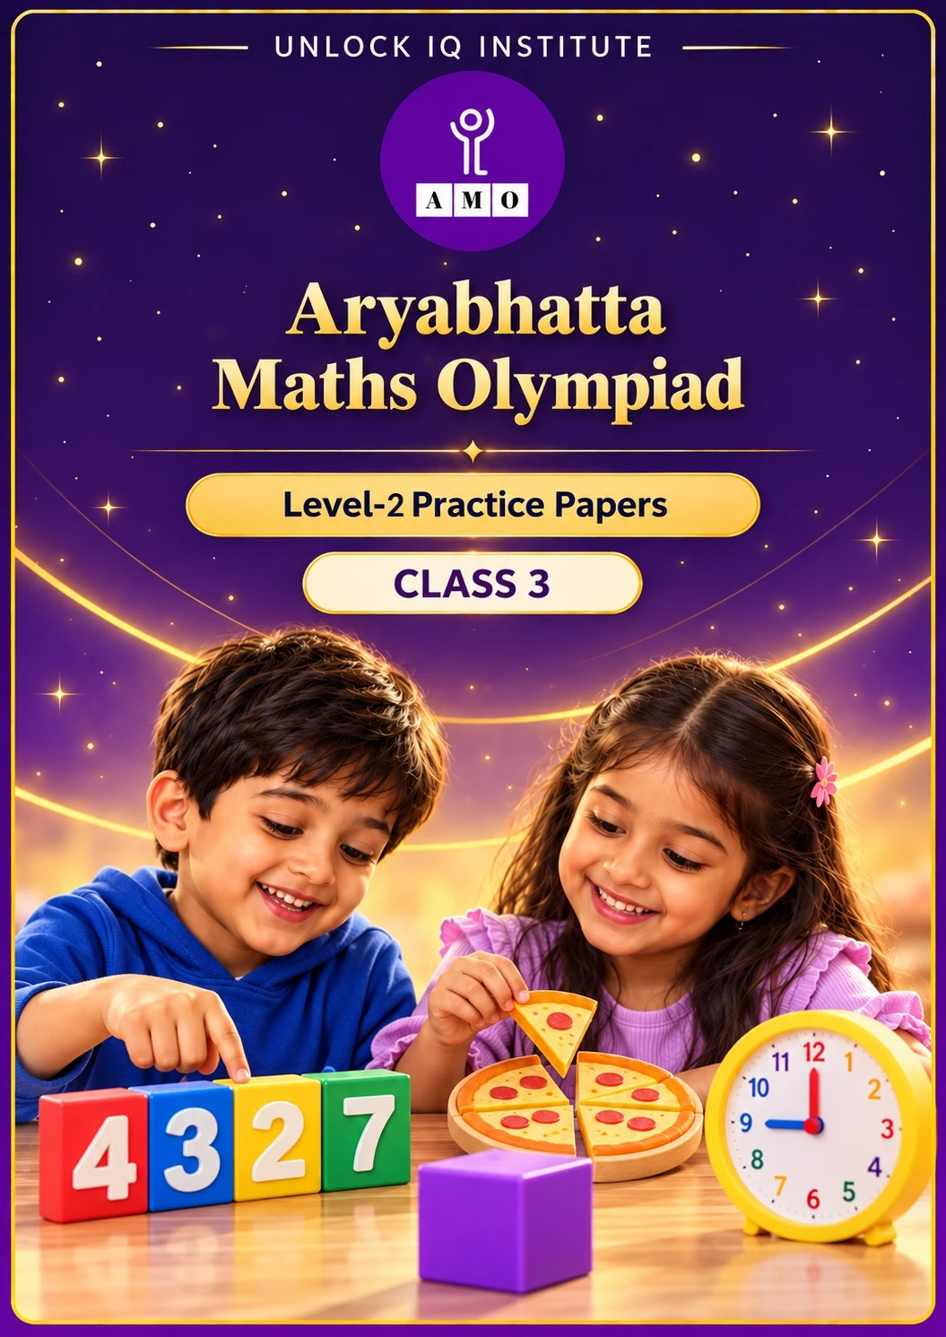
Set 1 · Practice Papers 1–5 · with answer keys & detailed solutions
Name: ____________________ | Class & Section: ________________
Roll No.: ________________ | School: ____________________
City: ____________________ | Date: ____________________

Published by Unlock IQ Institute Pvt. Ltd.
Register for Olympiads: www.aryabhattamathsolympiad.com/student-registration

ARYABHATTA MATHS OLYMPIAD
Level 2
PRACTICE PAPER-1
CLASS 3
Total Questions | 30 multiple-choice questions
Level | Level-2 (final round): every question is Hard
Time | 45 minutes
Arrangement | Parts by chapter; the last Part has mixed problems joining two chapters
Negative Marking | No negative marking
Calculator | Not allowed
Chapters | Number System · Operations · Fractions · Geometry · Mensuration · Applied Mathematics · Mathematical Reasoning

👋 Hello, friend! How to do this paper:
⭐ Every question has four answer choices: (A), (B), (C) and (D). Only one is correct.
⭐ Read each question and look at its picture carefully. Then mark your answer on the answer sheet at the end.
⭐ This is a Level-2 paper. Every question needs careful thinking, so take your time and check each step.
⭐ The questions are in Parts by chapter. The last Part has mixed problems that join two chapters.
⭐ There is no negative marking, so try every question.
⭐ Do not use a calculator. You may do rough work on a separate sheet.
⭐ All figures are not necessarily drawn to scale unless stated.

For parents and teachers
• Pictures are part of the questions. Every picture also works when printed in black and white.
• You may read a question aloud to the child, exactly as printed. Please do not explain it or point to an answer choice.
• Parts follow the AMO syllabus chapters. Chapters 4, 7 and 8 are not part of the Class 3 syllabus, so the chapter numbers shown in the Part headings have gaps.
• The answer sheet and the answer key are at the end. Remove only the answer key before the child begins.

Part 1 — Number System (Syllabus Chapter 1)
Q1. Kavya wants the smallest 4-digit number whose four digits are all different and add up to 10. Which number is it?
(A) 1009 | (B) 1027 | (C) 1036 | (D) 1234

Q2. In the number 7474, what is the difference between the place values of the two 7s?
(A) 0 | (B) 7070 | (C) 6930 | (D) 6993

Q3. Arjun adds XXIX and XIV. How is his answer written in Roman numerals?
(A) XXXXIII | (B) XLII | (C) LXIII | (D) XLIII

Q4. Rohan's number is between 4000 and 5000. Its tens digit is 0. Its hundreds digit is double its ones digit. Its digits add up to 13. What is the number?
(A) 4306 | (B) 4630 | (C) 4603 | (D) 4036

Part 2 — Operations (Syllabus Chapter 2)
Q5. A library had 5230 books. It lent out 1875 books and got back 948 of them. Then it bought 600 new books. How many books are in the library now?
(A) 4303 | (B) 4903 | (C) 5003 | (D) 4803

Q6. A shop has 12 boxes with 8 erasers in each. It sells 9 packets with 7 erasers in each. How many erasers are left?
(A) 43 | (B) 23 | (C) 37 | (D) 33

Q7. A sweet shop packs 744 laddoos in boxes of 6. Then it puts the boxes in cartons, 4 boxes to a carton. How many cartons does it fill?
(A) 124 | (B) 31 | (C) 30 | (D) 32

Q8. At a sports day, 50 children make teams of 7 for a game. How many more children must join so that every team is full?
(A) 1 | (B) 7 | (C) 8 | (D) 6

Part 3 — Fractions (Syllabus Chapter 3)
Q9. Ira has 40 marbles. 3/8 of them are red, 2/8 are blue and the rest are green. How many marbles are green?
(A) 25 | (B) 15 | (C) 10 | (D) 5

Q10. Meena eats 2/9 of a cake and Rahul eats 4/9 of it. Their mother eats 1/9 of the cake. What fraction of the cake is left?
(A) 3/9 | (B) 1/9 | (C) 7/9 | (D) 2/9

Q11. Each pizza is cut into 6 equal slices. Kabir's family eats 17 slices, opening as few pizzas as they can. What fraction of a pizza is left over?
(A) 1/6 | (B) 5/6 | (C) 17/6 | (D) 2/6

Part 4 — Geometry (Syllabus Chapter 5)
Q12. Ishaan glues two equal cubes face to face to make a cuboid. He adds the number of faces, edges and vertices of the cuboid. What total does he get?
(A) 52 | (B) 26 | (C) 44 | (D) 40

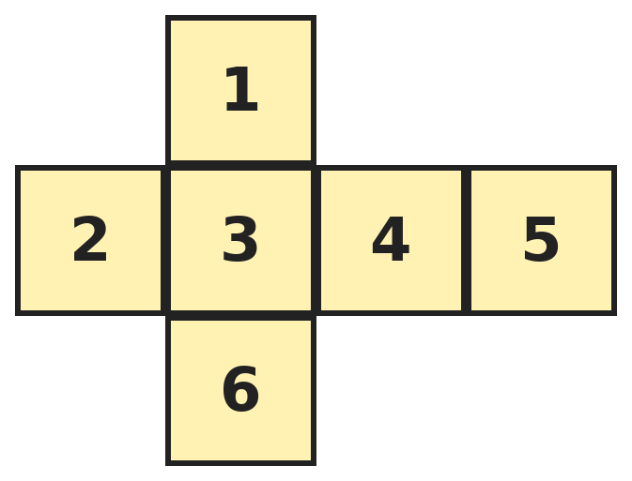
Q13. Diya folds this net into a cube. Which number is on the face opposite the face with 2?
(A) 3 | (B) 5 | (C) 4 | (D) 6

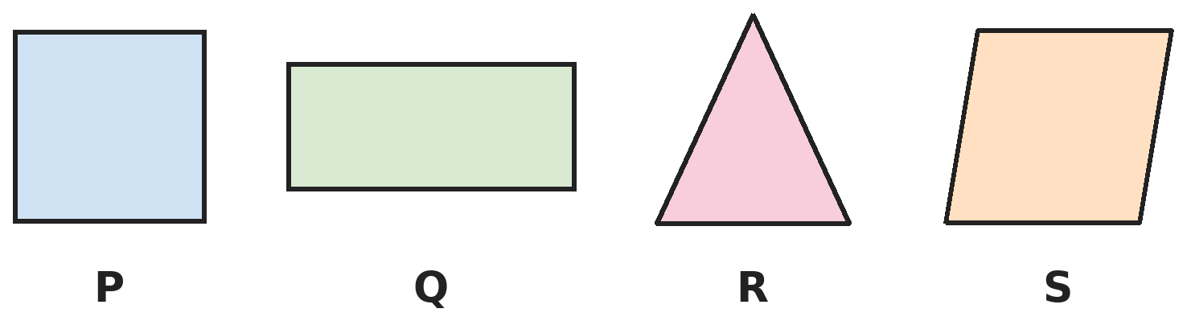
Q14. Sana folds each shape to find its lines of symmetry. Which shape has exactly one line of symmetry?
(A) P | (B) Q | (C) R | (D) S

Part 5 — Mensuration (Syllabus Chapter 6)
Q15. A garden is a rectangle 12 m long and 8 m wide. Vivaan puts wire 3 times all the way round it. How much wire does he use?
(A) 40 m | (B) 96 m | (C) 60 m | (D) 120 m

Q16. One bag has 3 kg 250 g of rice and another has 1 kg 900 g. A cook uses 2 kg 400 g from them. How many grams of rice are left?
(A) 2650 g | (B) 3750 g | (C) 2075 g | (D) 2750 g

Q17. Gauri has 3 jugs of juice. Each jug holds 2 L. She fills glasses that hold 250 mL each. How many glasses can she fill?
(A) 24 | (B) 12 | (C) 6 | (D) 30

Part 6 — Applied Mathematics (Syllabus Chapter 9)
Q18. A train leaves at 9:45 AM. The journey takes 3 hours 35 minutes. At what time does the train arrive?
(A) 12:20 PM | (B) 1:20 AM | (C) 1:20 PM | (D) 2:20 PM

Q19. In one year, 15 August is a Friday. August has 31 days. What day of the week is 2 September?
(A) Tuesday | (B) Wednesday | (C) Monday | (D) Thursday

Q20. Lata buys 4 notebooks at ₹35 each and 3 pens at ₹12 each. She pays with a ₹200 note. How much change does she get?
(A) ₹34 | (B) ₹176 | (C) ₹24 | (D) ₹14

Q21. Om's uncle reaches their house at 8 PM on Monday and leaves at 6 AM on Wednesday. How many hours does he stay?
(A) 34 hours | (B) 10 hours | (C) 22 hours | (D) 32 hours

Part 7 — Mathematical Reasoning (Syllabus Chapter 10)

Q22. Find the rule in this pattern. Which number comes next?
(A) 40 | (B) 36 | (C) 44 | (D) 42

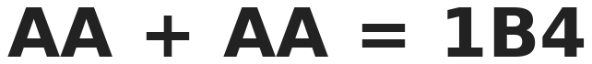
Q23. In this sum, each letter stands for one digit. What digit is B?
(A) 5 | (B) 4 | (C) 7 | (D) 1

Q24. Priya thinks of a number. She multiplies it by 4, takes away 9 and then divides by 3. She gets 13. What was her number?
(A) 13 | (B) 12 | (C) 9 | (D) 15

Q25. How many 3-digit numbers have all odd digits that go up from left to right, like 159?
(A) 10 | (B) 6 | (C) 15 | (D) 125

Part 8 — Mixed Problems (each joins two chapters)
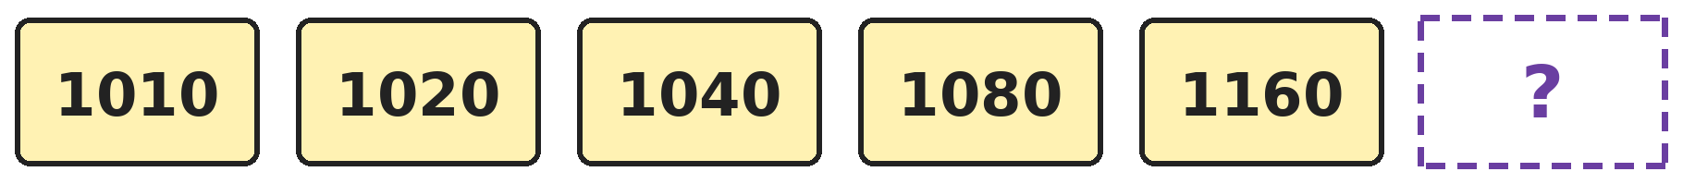
Q26. Look at how much is added each time. Which number comes next?
(A) 1320 | (B) 1240 | (C) 1280 | (D) 1640

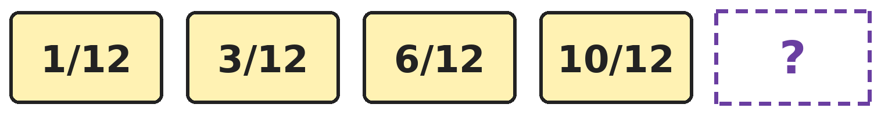
Q27. The fractions follow a pattern. Which fraction comes next?
(A) 14/12 | (B) 11/12 | (C) 15/12 | (D) 15/24

Q28. A month has 31 days. It has five Mondays and five Tuesdays but only four Sundays. On what day is the 1st of the month?
(A) Sunday | (B) Tuesday | (C) Monday | (D) Saturday

Q29. Yash must pay ₹3450 using only ₹500, ₹100 and ₹10 notes. He uses as few notes as he can. How many notes does he use?
(A) 12 | (B) 15 | (C) 345 | (D) 13

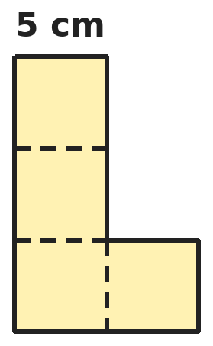
Q30. Nisha joins 4 squares, each with sides of 5 cm, to make this L shape. What is the perimeter of the L shape?
(A) 80 cm | (B) 50 cm | (C) 40 cm | (D) 60 cm

Answer Sheet AMO Level 2 · Class 3 · Practice Paper 1
Name: | School: | Roll No.:
Shade or tick one circle for each question.
1. | Ⓐ Ⓑ Ⓒ Ⓓ | 11. | Ⓐ Ⓑ Ⓒ Ⓓ | 21. | Ⓐ Ⓑ Ⓒ Ⓓ
2. | Ⓐ Ⓑ Ⓒ Ⓓ | 12. | Ⓐ Ⓑ Ⓒ Ⓓ | 22. | Ⓐ Ⓑ Ⓒ Ⓓ
3. | Ⓐ Ⓑ Ⓒ Ⓓ | 13. | Ⓐ Ⓑ Ⓒ Ⓓ | 23. | Ⓐ Ⓑ Ⓒ Ⓓ
4. | Ⓐ Ⓑ Ⓒ Ⓓ | 14. | Ⓐ Ⓑ Ⓒ Ⓓ | 24. | Ⓐ Ⓑ Ⓒ Ⓓ
5. | Ⓐ Ⓑ Ⓒ Ⓓ | 15. | Ⓐ Ⓑ Ⓒ Ⓓ | 25. | Ⓐ Ⓑ Ⓒ Ⓓ
6. | Ⓐ Ⓑ Ⓒ Ⓓ | 16. | Ⓐ Ⓑ Ⓒ Ⓓ | 26. | Ⓐ Ⓑ Ⓒ Ⓓ
7. | Ⓐ Ⓑ Ⓒ Ⓓ | 17. | Ⓐ Ⓑ Ⓒ Ⓓ | 27. | Ⓐ Ⓑ Ⓒ Ⓓ
8. | Ⓐ Ⓑ Ⓒ Ⓓ | 18. | Ⓐ Ⓑ Ⓒ Ⓓ | 28. | Ⓐ Ⓑ Ⓒ Ⓓ
9. | Ⓐ Ⓑ Ⓒ Ⓓ | 19. | Ⓐ Ⓑ Ⓒ Ⓓ | 29. | Ⓐ Ⓑ Ⓒ Ⓓ
10. | Ⓐ Ⓑ Ⓒ Ⓓ | 20. | Ⓐ Ⓑ Ⓒ Ⓓ | 30. | Ⓐ Ⓑ Ⓒ Ⓓ

For the parent or teacher
Correct: ______ / 30
Answer Key and Solutions AMO Level 2 · Class 3 · Practice Paper 1
Quick answers
1 B | 6 D | 11 A | 16 D | 21 A | 26 A
2 C | 7 B | 12 B | 17 A | 22 D | 27 C
3 D | 8 D | 13 C | 18 C | 23 A | 28 C
4 C | 9 B | 14 C | 19 A | 24 B | 29 B
5 B | 10 D | 15 D | 20 C | 25 A | 30 B
Solutions
Q | Part · level | Answer | Why?
1 | Part 1 · Ch1 · Hard | (B) 1027 | Hint: Keep the first digits as small as possible, but no digit may repeat.  Start with 1 and 0. The last two digits must add up to 9 and be different from 1 and 0, and from each other. The smallest tens digit allowed is 2, so the ones digit is 7. The number is 1027. (1009 repeats 0; 1036 and 1234 are bigger.)
2 | Part 1 · Ch1 · Hard | (C) 6930 | Hint: Place value depends on the position of the digit; face value does not.  The first 7 is in the thousands place: 7000. The second 7 is in the tens place: 70. The difference is 7000 − 70 = 6930. (0 is the difference of their face values.)
3 | Part 1 · Ch1 · Hard | (D) XLIII | Hint: Change both to our numbers first, then change the answer back.  XXIX = 29 and XIV = 14. 29 + 14 = 43. 40 is written XL (10 before 50), so 43 is XLIII. A Roman numeral never repeats X four times, so XXXXIII is wrong.
4 | Part 1 · Ch1 · Hard | (C) 4603 | Hint: The thousands digit is 4, so the other digits add up to 9.  The thousands digit is 4, so hundreds + ones = 13 − 4 − 0 = 9. The hundreds digit is double the ones digit, so ones = 3 and hundreds = 6. The number is 4603.
5 | Part 2 · Ch2 · Hard | (B) 4903 | Hint: Take away the books lent, then add the books returned and bought.  5230 − 1875 = 3355. 3355 + 948 = 4303. 4303 + 600 = 4903.
6 | Part 2 · Ch2 · Hard | (D) 33 | Hint: Use the 12 times table and the 9 times table.  12 × 8 = 96 erasers. 9 × 7 = 63 erasers sold. 96 − 63 = 33 left.
7 | Part 2 · Ch2 · Hard | (B) 31 | Hint: First find the number of boxes.  744 ÷ 6 = 124 boxes. 124 ÷ 4 = 31 cartons.
8 | Part 2 · Ch2 · Hard | (D) 6 | Hint: Divide 50 by 7 and look at the remainder.  50 ÷ 7 = 7 teams, remainder 1. The 1 child starts an 8th team, which needs 7 children. So 7 − 1 = 6 more must join. (Check: 8 × 7 = 56 = 50 + 6.)
9 | Part 3 · Ch3 · Hard | (B) 15 | Hint: First find 1/8 of 40.  1/8 of 40 is 5. Red and blue together are 3/8 + 2/8 = 5/8, so green is 3/8. 3 × 5 = 15 green marbles.
10 | Part 3 · Ch3 · Hard | (D) 2/9 | Hint: The whole cake is 9/9.  Together they eat 2/9 + 4/9 + 1/9 = 7/9. The whole cake is 9/9, so 9/9 − 7/9 = 2/9 is left. Only the top numbers are added; the bottom stays 9.
11 | Part 3 · Ch3 · Hard | (A) 1/6 | Hint: How many pizzas are needed for 17 slices?  2 pizzas give only 12 slices, so they open 3 pizzas: 18 slices. 18 − 17 = 1 slice is left, which is 1/6 of a pizza.
12 | Part 4 · Ch5 · Hard | (B) 26 | Hint: The new solid is one cuboid, not two cubes.  The glued faces are hidden and the new solid is a cuboid. A cuboid has 6 faces, 12 edges and 8 vertices, like a cube. 6 + 12 + 8 = 26. (52 counts two separate cubes.)
13 | Part 4 · Ch5 · Hard | (C) 4 | Hint: In a row of four squares, faces with one square between them are opposite.  In the row 2, 3, 4, 5, the faces 2 and 4 have one square between them, so they become opposite. (3 is opposite 5, and 1 is opposite 6.)
14 | Part 4 · Ch5 · Hard | (C) R | Hint: Try folding each shape along every possible line.  P is a square: 4 lines. Q is a rectangle: 2 lines. R is a triangle with two equal sides: only the up-down fold through its top works, so 1 line. S leans to one side, so no fold makes its two halves match: 0 lines. So R.
15 | Part 5 · Ch6 · Hard | (D) 120 m | Hint: Find the distance round the garden once.  Once round: 12 + 8 + 12 + 8 = 40 m. Three times round: 40 + 40 + 40 = 120 m.
16 | Part 5 · Ch6 · Hard | (D) 2750 g | Hint: Change everything to grams: 1 kg = 1000 g.  3 kg 250 g = 3250 g and 1 kg 900 g = 1900 g, so there are 3250 + 1900 = 5150 g. 2 kg 400 g = 2400 g. Left: 5150 − 2400 = 2750 g.
17 | Part 5 · Ch6 · Hard | (A) 24 | Hint: How many 250 mL glasses make 1 L?  1 L = 1000 mL = 4 glasses of 250 mL. The jugs hold 3 × 2 = 6 L. 6 × 4 = 24 glasses.
18 | Part 6 · Ch9 · Hard | (C) 1:20 PM | Hint: Add the hours first, then the minutes.  9:45 AM + 3 hours = 12:45 PM. 12:45 PM + 35 minutes: 15 minutes takes it to 1:00 PM, and 20 more makes 1:20 PM.
19 | Part 6 · Ch9 · Hard | (A) Tuesday | Hint: Add 7 days at a time from 15 August.  15, 22 and 29 August are Fridays. 29 August + 7 days = 5 September, also a Friday. 2 September is 3 days before that: Thursday, Wednesday, Tuesday. So it is a Tuesday.
20 | Part 6 · Ch9 · Hard | (C) ₹24 | Hint: Find each cost, add them, then subtract from ₹200.  Notebooks: 35 × 4 = ₹140. Pens: 12 × 3 = ₹36. Total ₹176. Change: 200 − 176 = ₹24.
21 | Part 6 · Ch9 · Hard | (A) 34 hours | Hint: Break the time into: Monday night, all of Tuesday, Wednesday morning.  8 PM to midnight on Monday: 4 hours. All of Tuesday: 24 hours. Midnight to 6 AM on Wednesday: 6 hours. 4 + 24 + 6 = 34 hours.
22 | Part 7 · Ch10 · Hard | (D) 42 | Hint: Look at the differences between neighbours.  The differences are 4, 6, 8 and 10, going up by 2. The next difference is 12: 30 + 12 = 42.
23 | Part 7 · Ch10 · Hard | (A) 5 | Hint: The ones digits give A + A, which must end in 4.  A + A ends in 4, so A is 2 or 7. 22 + 22 = 44 is too small. 77 + 77 = 154, which fits 1B4. So B = 5.
24 | Part 7 · Ch10 · Hard | (B) 12 | Hint: Undo each step, starting from the last one.  Undo ÷ 3: 13 × 3 = 39. Undo − 9: 39 + 9 = 48. Undo × 4: 48 ÷ 4 = 12. Check: 12 × 4 = 48, 48 − 9 = 39, 39 ÷ 3 = 13.
25 | Part 7 · Ch10 · Hard | (A) 10 | Hint: The digits come from 1, 3, 5, 7, 9. List them by the first digit.  Starting with 1: 135, 137, 139, 157, 159, 179 (6). Starting with 3: 357, 359, 379 (3). Starting with 5: 579 (1). Total 6 + 3 + 1 = 10.
26 | Part 8 · Mixed · Ch1 + Ch10 · Hard | (A) 1320 | Hint: The amount added doubles each time.  The pattern adds 10, 20, 40 and 80. Next it adds 160: 1160 + 160 = 1320.
27 | Part 8 · Mixed · Ch3 + Ch10 · Hard | (C) 15/12 | Hint: Look at how many twelfths are added each time.  The pattern adds 2/12, 3/12 and 4/12. Next it adds 5/12: 10/12 + 5/12 = 15/12.
28 | Part 8 · Mixed · Ch9 + Ch10 · Hard | (C) Monday | Hint: 31 days = 4 weeks and 3 extra days. The first 3 days of the month happen five times.  4 weeks is 28 days, so the days of the 1st, 2nd and 3rd happen five times. These must include Monday and Tuesday but not Sunday. If the 1st is Monday, the three days are Monday, Tuesday, Wednesday. If the 1st were Sunday, there would be five Sundays.
29 | Part 8 · Mixed · Ch1 + Ch9 · Hard | (B) 15 | Hint: Use as many ₹500 notes as possible first.  ₹3450 = 6 notes of ₹500 (₹3000) + 4 notes of ₹100 (₹400) + 5 notes of ₹10 (₹50). 6 + 4 + 5 = 15 notes.
30 | Part 8 · Mixed · Ch5 + Ch6 · Hard | (B) 50 cm | Hint: Count how many 5 cm sides are on the outside.  Going round the outside there are 10 sides of 5 cm: 3 on the left, 1 on the top, 2 down the right of the tall part, 1 on the right of the bottom square, 2 along the bottom and 1 step across. 10 × 5 = 50 cm. (80 cm counts all 16 sides, including the ones inside.)

ARYABHATTA MATHS OLYMPIAD
Level 2
PRACTICE PAPER-2
CLASS 3
Total Questions | 30 multiple-choice questions
Level | Level-2 (final round): every question is Hard
Time | 45 minutes
Arrangement | Parts by chapter; the last Part has mixed problems joining two chapters
Negative Marking | No negative marking
Calculator | Not allowed
Chapters | Number System · Operations · Fractions · Geometry · Mensuration · Applied Mathematics · Mathematical Reasoning

👋 Hello, friend! How to do this paper:
⭐ Every question has four answer choices: (A), (B), (C) and (D). Only one is correct.
⭐ Read each question and look at its picture carefully. Then mark your answer on the answer sheet at the end.
⭐ This is a Level-2 paper. Every question needs careful thinking, so take your time and check each step.
⭐ The questions are in Parts by chapter. The last Part has mixed problems that join two chapters.
⭐ There is no negative marking, so try every question.
⭐ Do not use a calculator. You may do rough work on a separate sheet.
⭐ All figures are not necessarily drawn to scale unless stated.

For parents and teachers
• Pictures are part of the questions. Every picture also works when printed in black and white.
• You may read a question aloud to the child, exactly as printed. Please do not explain it or point to an answer choice.
• Parts follow the AMO syllabus chapters. Chapters 4, 7 and 8 are not part of the Class 3 syllabus, so the chapter numbers shown in the Part headings have gaps.
• The answer sheet and the answer key are at the end. Remove only the answer key before the child begins.

Part 1 — Number System (Syllabus Chapter 1)
Q1. What is the largest 4-digit number whose digits are all different and add up to 12?
(A) 9210 | (B) 9300 | (C) 9201 | (D) 8310

Q2. Which number is 6 thousands, 15 hundreds, 4 tens and 23 ones?
(A) 6543 | (B) 6563 | (C) 7543 | (D) 7563

Q3. Which of these Roman numerals stands for the largest number?
(A) XLVIII | (B) XLIX | (C) XLVI | (D) XXXIX

Q4. Asha uses each of the digits 3, 0, 7 and 5 once to make 4-digit numbers. How many of her numbers are between 3000 and 4000?
(A) 6 | (B) 24 | (C) 4 | (D) 3

Part 2 — Operations (Syllabus Chapter 2)
Q5. A factory must make 6000 toys. It made 2465 toys on Monday and 1879 on Tuesday. How many more toys must it make?
(A) 1756 | (B) 4344 | (C) 1656 | (D) 1666

Q6. Hall A has 48 rows of 7 chairs. Hall B has 39 rows of 9 chairs. Which hall has more chairs, and how many more?
(A) Hall A, 15 more | (B) Hall B, 25 more
(C) They are equal | (D) Hall B, 15 more

Q7. At a camp, 936 stickers are shared equally among 8 children. Then each child gives 9 stickers to a friend. How many stickers does each child have now?
(A) 117 | (B) 126 | (C) 108 | (D) 99

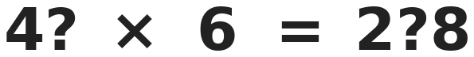
Q8. Both boxes hide the same digit. Which digit is it?
(A) 3 | (B) 5 | (C) 8 | (D) 6

Part 3 — Fractions (Syllabus Chapter 3)
Q9. Raj eats 7/10 of 50 grapes. Asha eats 4/10 of 80 grapes. Who eats more, and by how many grapes?
(A) Asha, by 3 | (B) Raj, by 30
(C) Both eat the same | (D) Raj, by 3

Q10. How many of these fractions are more than one whole: 9/8, 7/8, 8/8, 12/8, 3/8?
(A) 3 | (B) 1 | (C) 2 | (D) 4

Q11. A tank is 11/12 full. Kunal uses 5/12 of the tank for the garden. Then rain adds 3/12. How full is the tank now?
(A) 3/12 | (B) 9/12 | (C) 19/12 | (D) 9/24

Part 4 — Geometry (Syllabus Chapter 5)
Q12. Which solid has 5 faces, 8 edges and 5 vertices?
(A) Square pyramid | (B) Cube
(C) Triangular prism | (D) Cone

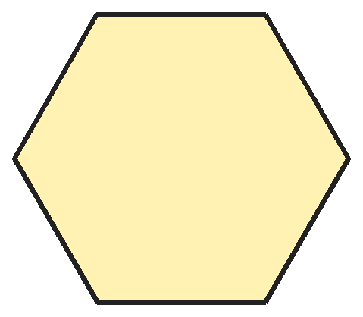
Q13. All six sides of this hexagon are equal and all its corners are the same. In how many ways can Riya fold it so the two halves match exactly?
(A) 6 | (B) 3 | (C) 2 | (D) 12

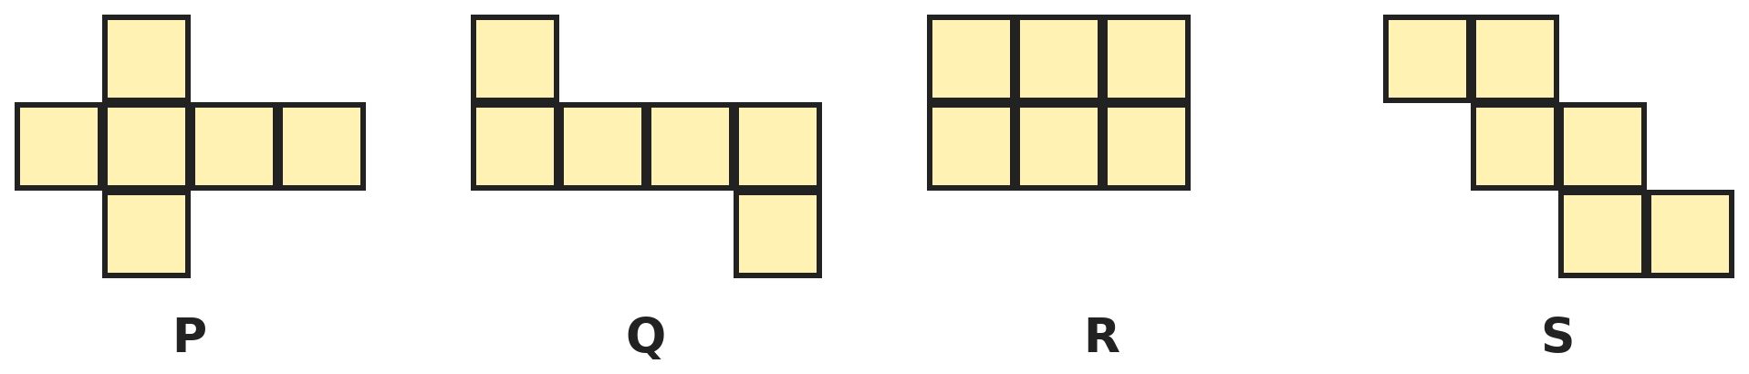
Q14. Each shape is made of 6 squares. Which one can NOT be folded into a cube?
(A) P | (B) Q | (C) R | (D) S

Part 5 — Mensuration (Syllabus Chapter 6)
Q15. A triangle has 3 equal sides of 12 cm. A square has the same perimeter as the triangle. How long is one side of the square?
(A) 12 cm | (B) 9 cm | (C) 36 cm | (D) 8 cm

Q16. Tara has a ribbon 3 m 20 cm long. She cuts 4 pieces, each 65 cm long. How much ribbon is left?
(A) 2 m 60 cm | (B) 55 cm | (C) 1 m 60 cm | (D) 60 cm

Q17. A basket with 6 equal apples weighs 2 kg 100 g. The empty basket weighs 300 g. How much does one apple weigh?
(A) 300 g | (B) 350 g | (C) 400 g | (D) 1800 g

Part 6 — Applied Mathematics (Syllabus Chapter 9)
Q18. School runs from 8:40 AM to 2:10 PM. Lunch break is 35 minutes. How much time is spent in class?
(A) 5 h 30 min | (B) 4 h 55 min | (C) 6 h 5 min | (D) 5 h 5 min

Q19. Siya's school play practice runs every day from 20 March to 10 April, both days included. On how many days does she practise?
(A) 21 | (B) 20 | (C) 22 | (D) 23

Q20. A bus ticket costs ₹35 for an adult and ₹18 for a child, each way. A family of 2 adults and 3 children go and come back. How much do they pay?
(A) ₹124 | (B) ₹106 | (C) ₹212 | (D) ₹248

Q21. Neel's clock gains 5 minutes every hour. He sets it right at 6 AM. What time does his clock show at 2 PM the same day?
(A) 2:05 PM | (B) 2:40 PM | (C) 2:45 PM | (D) 1:20 PM

Part 7 — Mathematical Reasoning (Syllabus Chapter 10)

Q22. Ananya writes this pattern. Which number should she write next?
(A) 47 | (B) 40 | (C) 45 | (D) 58

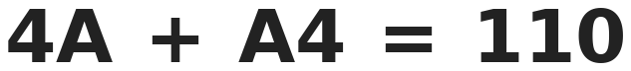
Q23. The letter A stands for the same digit in both numbers. What is A?
(A) 6 | (B) 5 | (C) 7 | (D) 4

Q24. Mahi gives half her sweets to her sister and then 6 to a friend. Next she gives half of what is left to her brother. She has 9 left. How many did she start with?
(A) 30 | (B) 36 | (C) 42 | (D) 48

Q25. At a party, 6 friends meet. Each friend shakes hands once with every other friend. How many handshakes are there?
(A) 30 | (B) 15 | (C) 36 | (D) 12

Part 8 — Mixed Problems (each joins two chapters)
Q26. Karan writes all the numbers from 1 to 100. How many times does he write the digit 7?
(A) 19 | (B) 11 | (C) 20 | (D) 10

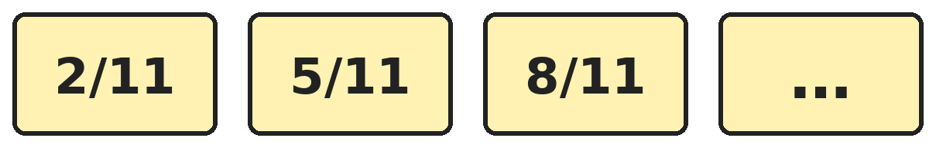
Q27. The fractions keep growing by the same amount. Which is the first fraction in the pattern that is more than one whole?
(A) 11/11 | (B) 12/11 | (C) 13/11 | (D) 14/11

Q28. A 12-hour digital clock shows times like 2:22 and 11:11, where all the digits are the same. How many such times are there in one whole day?
(A) 6 | (B) 12 | (C) 10 | (D) 9

Q29. Ravi has 25 coins. Some are ₹10 coins and the rest are ₹1 coins. Together they are worth ₹142. How many ₹10 coins does he have?
(A) 14 | (B) 12 | (C) 11 | (D) 13

Q30. Pooja makes the frame of a box with straws. The box is 6 cm long, 4 cm wide and 2 cm tall. What total length of straw does she use for all the edges?
(A) 48 cm | (B) 12 cm | (C) 24 cm | (D) 96 cm

Answer Sheet AMO Level 2 · Class 3 · Practice Paper 2
Name: | School: | Roll No.:
Shade or tick one circle for each question.
1. | Ⓐ Ⓑ Ⓒ Ⓓ | 11. | Ⓐ Ⓑ Ⓒ Ⓓ | 21. | Ⓐ Ⓑ Ⓒ Ⓓ
2. | Ⓐ Ⓑ Ⓒ Ⓓ | 12. | Ⓐ Ⓑ Ⓒ Ⓓ | 22. | Ⓐ Ⓑ Ⓒ Ⓓ
3. | Ⓐ Ⓑ Ⓒ Ⓓ | 13. | Ⓐ Ⓑ Ⓒ Ⓓ | 23. | Ⓐ Ⓑ Ⓒ Ⓓ
4. | Ⓐ Ⓑ Ⓒ Ⓓ | 14. | Ⓐ Ⓑ Ⓒ Ⓓ | 24. | Ⓐ Ⓑ Ⓒ Ⓓ
5. | Ⓐ Ⓑ Ⓒ Ⓓ | 15. | Ⓐ Ⓑ Ⓒ Ⓓ | 25. | Ⓐ Ⓑ Ⓒ Ⓓ
6. | Ⓐ Ⓑ Ⓒ Ⓓ | 16. | Ⓐ Ⓑ Ⓒ Ⓓ | 26. | Ⓐ Ⓑ Ⓒ Ⓓ
7. | Ⓐ Ⓑ Ⓒ Ⓓ | 17. | Ⓐ Ⓑ Ⓒ Ⓓ | 27. | Ⓐ Ⓑ Ⓒ Ⓓ
8. | Ⓐ Ⓑ Ⓒ Ⓓ | 18. | Ⓐ Ⓑ Ⓒ Ⓓ | 28. | Ⓐ Ⓑ Ⓒ Ⓓ
9. | Ⓐ Ⓑ Ⓒ Ⓓ | 19. | Ⓐ Ⓑ Ⓒ Ⓓ | 29. | Ⓐ Ⓑ Ⓒ Ⓓ
10. | Ⓐ Ⓑ Ⓒ Ⓓ | 20. | Ⓐ Ⓑ Ⓒ Ⓓ | 30. | Ⓐ Ⓑ Ⓒ Ⓓ

For the parent or teacher
Correct: ______ / 30
Answer Key and Solutions AMO Level 2 · Class 3 · Practice Paper 2
Quick answers
1 A | 6 D | 11 B | 16 D | 21 B | 26 C
2 D | 7 C | 12 A | 17 A | 22 A | 27 D
3 B | 8 C | 13 A | 18 B | 23 A | 28 B
4 A | 9 D | 14 C | 19 C | 24 D | 29 D
5 C | 10 C | 15 B | 20 D | 25 B | 30 A
Solutions
Q | Part · level | Answer | Why?
1 | Part 1 · Ch1 · Hard | (A) 9210 | Hint: Put 9 first. Then the other three digits must add up to 3.  Start with 9. The other three different digits must add up to 3, so they are 2, 1 and 0. Largest order: 9210. (9300 repeats 0.)
2 | Part 1 · Ch1 · Hard | (D) 7563 | Hint: 15 hundreds is 1500 and 23 ones is 23.  6000 + 1500 + 40 + 23 = 7563.
3 | Part 1 · Ch1 · Hard | (B) XLIX | Hint: The longest numeral is not always the largest.  XLIX = 40 + 9 = 49. XLVIII = 48. XLVI = 46. XXXIX = 39. The largest is XLIX.
4 | Part 1 · Ch1 · Hard | (A) 6 | Hint: The thousands digit must be 3.  The thousands digit must be 3. The other three digits 0, 7, 5 can be arranged in 6 ways: 3057, 3075, 3507, 3570, 3705, 3750.
5 | Part 2 · Ch2 · Hard | (C) 1656 | Hint: Add the two days, then subtract from 6000.  2465 + 1879 = 4344. 6000 − 4344 = 1656.
6 | Part 2 · Ch2 · Hard | (D) Hall B, 15 more | Hint: Work out 48 × 7 and 39 × 9.  48 × 7 = 336. 39 × 9 = 351. Hall B has 351 − 336 = 15 more chairs.
7 | Part 2 · Ch2 · Hard | (C) 108 | Hint: First share the stickers.  936 ÷ 8 = 117 stickers each. After giving away 9: 117 − 9 = 108.
8 | Part 2 · Ch2 · Hard | (C) 8 | Hint: ? × 6 must end in 8.  ? × 6 ends in 8 when ? is 3 or 8. 43 × 6 = 258: the middle digit is 5, not 3. 48 × 6 = 288: the middle digit is 8. So the digit is 8.
9 | Part 3 · Ch3 · Hard | (D) Raj, by 3 | Hint: Find 1/10 of each number first.  1/10 of 50 is 5, so Raj eats 7 × 5 = 35. 1/10 of 80 is 8, so Asha eats 4 × 8 = 32. Raj eats 3 more.
10 | Part 3 · Ch3 · Hard | (C) 2 | Hint: 8/8 is exactly one whole.  One whole is 8/8. Only fractions with a top number bigger than 8 are more than one whole: 9/8 and 12/8. 8/8 is equal to one whole, not more. So 2.
11 | Part 3 · Ch3 · Hard | (B) 9/12 | Hint: Take away first, then add.  11/12 − 5/12 = 6/12. 6/12 + 3/12 = 9/12.
12 | Part 4 · Ch5 · Hard | (A) Square pyramid | Hint: Think of a solid with a square base and four triangles meeting at the top.  A square pyramid has 1 square + 4 triangles = 5 faces, 4 base edges + 4 slanting edges = 8 edges, and 4 base corners + 1 top = 5 vertices. A triangular prism has 5 faces but 9 edges and 6 vertices.
13 | Part 4 · Ch5 · Hard | (A) 6 | Hint: Fold from corner to opposite corner, and from side to opposite side.  Folding corner to opposite corner gives 3 lines. Folding from the middle of a side to the middle of the opposite side gives 3 more. 3 + 3 = 6 lines of symmetry.
14 | Part 4 · Ch5 · Hard | (C) R | Hint: Imagine one square as the bottom of the box and fold the others up around it.  R is 2 rows of 3. When you fold it, two squares end up on top of each other and two faces of the cube are left open. P, Q and S each fold into a cube.
15 | Part 5 · Ch6 · Hard | (B) 9 cm | Hint: Find the perimeter of the triangle first.  Triangle perimeter: 12 + 12 + 12 = 36 cm. A square has 4 equal sides, so each side is 36 ÷ 4 = 9 cm.
16 | Part 5 · Ch6 · Hard | (D) 60 cm | Hint: Change 3 m 20 cm into centimetres.  3 m 20 cm = 320 cm. 4 pieces use 65 × 4 = 260 cm. 320 − 260 = 60 cm left.
17 | Part 5 · Ch6 · Hard | (A) 300 g | Hint: Take away the basket first.  2 kg 100 g = 2100 g. Apples alone: 2100 − 300 = 1800 g. One apple: 1800 ÷ 6 = 300 g.
18 | Part 6 · Ch9 · Hard | (B) 4 h 55 min | Hint: Find the whole school time first.  8:40 AM to 1:40 PM is 5 hours, and 1:40 to 2:10 PM is 30 minutes: 5 h 30 min. Taking away 35 minutes lunch: 5 h 30 min − 35 min = 4 h 55 min.
19 | Part 6 · Ch9 · Hard | (C) 22 | Hint: March has 31 days.  20 March to 31 March, both included: 31 − 20 + 1 = 12 days. 1 April to 10 April: 10 days. 12 + 10 = 22 days.
20 | Part 6 · Ch9 · Hard | (D) ₹248 | Hint: Find the cost one way, then double it.  One way: 2 × 35 = ₹70 and 3 × 18 = ₹54, total ₹124. There and back: 124 + 124 = ₹248.
21 | Part 6 · Ch9 · Hard | (B) 2:40 PM | Hint: Count the hours from 6 AM to 2 PM.  From 6 AM to 2 PM is 8 hours. The clock gains 8 × 5 = 40 minutes, so it shows 2:40 PM.
22 | Part 7 · Ch10 · Hard | (A) 47 | Hint: Look at the two numbers just before each number.  Each number is the sum of the two before it: 3 + 4 = 7, 4 + 7 = 11, 7 + 11 = 18, 11 + 18 = 29. Next: 18 + 29 = 47.
23 | Part 7 · Ch10 · Hard | (A) 6 | Hint: Try the ones column: A + 4 must end in 0.  A + 4 ends in 0, so A = 6. Check: 46 + 64 = 110.
24 | Part 7 · Ch10 · Hard | (D) 48 | Hint: Undo the steps from the end.  Before the brother: 9 + 9 = 18. Before the friend: 18 + 6 = 24. Before the sister: 24 + 24 = 48.
25 | Part 7 · Ch10 · Hard | (B) 15 | Hint: The first friend shakes 5 hands, the next shakes 4 new hands, and so on.  5 + 4 + 3 + 2 + 1 = 15 handshakes. (30 counts each handshake twice.)
26 | Part 8 · Mixed · Ch1 + Ch10 · Hard | (C) 20 | Hint: Count 7 in the ones place and 7 in the tens place separately.  7 in the ones place: 7, 17, 27, …, 97 makes 10. 7 in the tens place: 70 to 79 makes 10. 77 is counted in both, and it really has two 7s. Total 20.
27 | Part 8 · Mixed · Ch3 + Ch10 · Hard | (D) 14/11 | Hint: Find how much is added each time.  Each step adds 3/11: 2/11, 5/11, 8/11, 11/11, 14/11. 11/11 is exactly one whole, not more. The first one more than a whole is 14/11.
28 | Part 8 · Mixed · Ch9 + Ch10 · Hard | (B) 12 | Hint: List them in 12 hours, then remember AM and PM.  In 12 hours: 1:11, 2:22, 3:33, 4:44, 5:55 and 11:11, which is 6 times. (6:66 and higher are not real times.) A day has AM and PM, so 6 + 6 = 12.
29 | Part 8 · Mixed · Ch1 + Ch9 · Hard | (D) 13 | Hint: If all 25 were ₹1 coins, the total would be ₹25.  If all 25 were ₹1 coins, they would make ₹25. Changing one ₹1 coin into a ₹10 coin adds ₹9. ₹142 − ₹25 = ₹117, and 117 ÷ 9 = 13. Check: 13 coins of ₹10 and 12 coins of ₹1 make 130 + 12 = ₹142.
30 | Part 8 · Mixed · Ch5 + Ch6 · Hard | (A) 48 cm | Hint: A box has 12 edges: 4 of each length.  A cuboid has 4 edges of each length. 4 × 6 = 24, 4 × 4 = 16, 4 × 2 = 8. 24 + 16 + 8 = 48 cm.

ARYABHATTA MATHS OLYMPIAD
Level 2
PRACTICE PAPER-3
CLASS 3
Total Questions | 30 multiple-choice questions
Level | Level-2 (final round): every question is Hard
Time | 45 minutes
Arrangement | Parts by chapter; the last Part has mixed problems joining two chapters
Negative Marking | No negative marking
Calculator | Not allowed
Chapters | Number System · Operations · Fractions · Geometry · Mensuration · Applied Mathematics · Mathematical Reasoning

👋 Hello, friend! How to do this paper:
⭐ Every question has four answer choices: (A), (B), (C) and (D). Only one is correct.
⭐ Read each question and look at its picture carefully. Then mark your answer on the answer sheet at the end.
⭐ This is a Level-2 paper. Every question needs careful thinking, so take your time and check each step.
⭐ The questions are in Parts by chapter. The last Part has mixed problems that join two chapters.
⭐ There is no negative marking, so try every question.
⭐ Do not use a calculator. You may do rough work on a separate sheet.
⭐ All figures are not necessarily drawn to scale unless stated.

For parents and teachers
• Pictures are part of the questions. Every picture also works when printed in black and white.
• You may read a question aloud to the child, exactly as printed. Please do not explain it or point to an answer choice.
• Parts follow the AMO syllabus chapters. Chapters 4, 7 and 8 are not part of the Class 3 syllabus, so the chapter numbers shown in the Part headings have gaps.
• The answer sheet and the answer key are at the end. Remove only the answer key before the child begins.

Part 1 — Number System (Syllabus Chapter 1)
Q1. Sahil makes the largest and the smallest 4-digit numbers using each of 0, 2, 5 and 8 once. What is their difference?
(A) 6562 | (B) 6468 | (C) 8520 | (D) 6462

Q2. In which number is the place value of 6 exactly 100 times its face value?
(A) 2615 | (B) 6215 | (C) 2165 | (D) 2156

Q3. Nandini works out XXXVI − XIX. How should she write the answer in Roman numerals?
(A) XVII | (B) XXVII | (C) XV | (D) XIII

Q4. Bharat writes 4089, 4809, 4098, 4890 and 4908 in order from smallest to largest. Which number is in the middle?
(A) 4890 | (B) 4098 | (C) 4809 | (D) 4908

Part 2 — Operations (Syllabus Chapter 2)
Q5. A shop had 4500 cups. It sold 1275 cups. Then two deliveries of 860 cups each arrived. How many cups does the shop have now?
(A) 4085 | (B) 3225 | (C) 4955 | (D) 4945

Q6. A cinema has 12 rows of 9 seats upstairs and 11 rows of 9 seats downstairs. 150 tickets are sold for a show. How many seats are empty?
(A) 207 | (B) 67 | (C) 47 | (D) 57

Q7. A rope 945 cm long is cut into 7 equal pieces. Each piece is then cut into 5 equal parts. How long is each part?
(A) 135 cm | (B) 27 cm | (C) 35 cm | (D) 189 cm

Q8. Leela's book has 85 pages. She reads 9 pages every day, and fewer only on the last day. On which day does she finish, and how many pages does she read that day?
(A) Day 9, 4 pages | (B) Day 10, 9 pages
(C) Day 10, 4 pages | (D) Day 9, 5 pages

Part 3 — Fractions (Syllabus Chapter 3)
Q9. In a class of 36, 5/12 of the students like cricket best, 4/12 like football and the rest like hockey. How many more like cricket than hockey?
(A) 3 | (B) 9 | (C) 15 | (D) 6

Q10. Ruhi puts 7/9, 2/9, 1 whole, 11/9 and 5/9 in order from smallest to largest. Which is 4th?
(A) 1 whole | (B) 7/9 | (C) 11/9 | (D) 5/9


Q11. Both sides are equal. Which fraction goes in the box?
(A) 8/10 | (B) 5/10 | (C) 1/10 | (D) 5/20

Part 4 — Geometry (Syllabus Chapter 5)
Q12. Kush glues two equal cubes face to face to make a longer box shape. How many flat faces does the new solid have?
(A) 12 | (B) 6 | (C) 10 | (D) 11

Q13. Gita folds a square paper in half, then in half again to make a smaller square. She cuts a small half-circle on the edge made by the first fold, away from the corners. How many holes does she see when she opens it?
(A) 2 | (B) 4 | (C) 1 | (D) 8

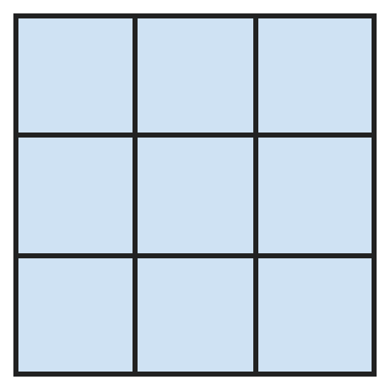
Q14. How many squares of all sizes are in this picture?
(A) 9 | (B) 14 | (C) 13 | (D) 10

Part 5 — Mensuration (Syllabus Chapter 6)
Q15. A rectangle is twice as long as it is wide. Its perimeter is 36 cm. How long is it?
(A) 6 cm | (B) 18 cm | (C) 12 cm | (D) 9 cm

Q16. Arnav walks 2 km 400 m to school and the same way back every school day. How far does he walk in 5 school days?
(A) 12 km | (B) 24 km | (C) 20 km 400 m | (D) 24 km 400 m

Q17. Uma has a 5 L can of oil. She fills 3 bottles of 750 mL and 4 bottles of 500 mL. How much oil is left in the can?
(A) 1 L 750 mL | (B) 750 mL | (C) 250 mL | (D) 1 L 250 mL

Part 6 — Applied Mathematics (Syllabus Chapter 9)
Q18. A film starts at 6:50 PM and lasts 2 hours 25 minutes. Then Jatin drives home for 20 minutes. When does he reach home?
(A) 9:15 PM | (B) 8:35 PM | (C) 9:35 PM | (D) 9:45 PM

Q19. In a year when February has 28 days, 1 January is a Monday. What day is 1 March?
(A) Wednesday | (B) Friday | (C) Monday | (D) Thursday

Q20. A shop sells pencils only in packs of 3 for ₹10. Manav needs at least 20 pencils. What is the least he must pay?
(A) ₹60 | (B) ₹67 | (C) ₹66 | (D) ₹70

Q21. Hema's mother works from quarter past 7 in the morning to quarter to 1 in the afternoon. How long does she work?
(A) 5 h 30 min | (B) 6 h 30 min | (C) 5 h 45 min | (D) 6 h

Part 7 — Mathematical Reasoning (Syllabus Chapter 10)

Q22. Vansh makes each number from the one before it. Which number comes next in his pattern?
(A) 120 | (B) 48 | (C) 96 | (D) 30

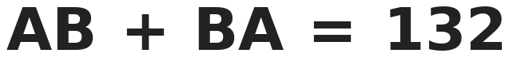
Q23. A and B are digits, and A is 2 more than B. What is the number AB?
(A) 57 | (B) 84 | (C) 66 | (D) 75

Q24. A frog is at the bottom of a well 20 m deep. Each day it climbs up 5 m, and each night it slips down 3 m. On which day does it get out?
(A) Day 10 | (B) Day 8 | (C) Day 9 | (D) Day 7

Q25. How many 2-digit numbers have a tens digit greater than the ones digit, like 52?
(A) 36 | (B) 50 | (C) 45 | (D) 90

Part 8 — Mixed Problems (each joins two chapters)
Q26. A palindrome reads the same forwards and backwards, like 1331. How many 4-digit palindromes are between 1000 and 2000?
(A) 9 | (B) 100 | (C) 11 | (D) 10

Q27. Rani eats 1/12 of a jar of jam on day 1, 2/12 on day 2, 3/12 on day 3, and so on. On which day does she finish the jar?
(A) Day 4 | (B) Day 5 | (C) Day 6 | (D) Day 12

Q28. Aryan swims every 3rd day: on the 1st, 4th, 7th and so on. The 1st of the month is a Monday. On which date does he next swim on a Monday?
(A) 22nd | (B) 21st | (C) 15th | (D) 8th

Q29. Mansi has ₹5000. She spends ₹1275 and then ₹2350. She changes as much as she can of the rest into ₹100 notes. How many notes does she get?
(A) 14 | (B) 1375 | (C) 13 | (D) 12

Q30. Shalini cuts a square of side 8 cm into two equal rectangles. What is the perimeter of one rectangle?
(A) 32 cm | (B) 16 cm | (C) 24 cm | (D) 20 cm

Answer Sheet AMO Level 2 · Class 3 · Practice Paper 3
Name: | School: | Roll No.:
Shade or tick one circle for each question.
1. | Ⓐ Ⓑ Ⓒ Ⓓ | 11. | Ⓐ Ⓑ Ⓒ Ⓓ | 21. | Ⓐ Ⓑ Ⓒ Ⓓ
2. | Ⓐ Ⓑ Ⓒ Ⓓ | 12. | Ⓐ Ⓑ Ⓒ Ⓓ | 22. | Ⓐ Ⓑ Ⓒ Ⓓ
3. | Ⓐ Ⓑ Ⓒ Ⓓ | 13. | Ⓐ Ⓑ Ⓒ Ⓓ | 23. | Ⓐ Ⓑ Ⓒ Ⓓ
4. | Ⓐ Ⓑ Ⓒ Ⓓ | 14. | Ⓐ Ⓑ Ⓒ Ⓓ | 24. | Ⓐ Ⓑ Ⓒ Ⓓ
5. | Ⓐ Ⓑ Ⓒ Ⓓ | 15. | Ⓐ Ⓑ Ⓒ Ⓓ | 25. | Ⓐ Ⓑ Ⓒ Ⓓ
6. | Ⓐ Ⓑ Ⓒ Ⓓ | 16. | Ⓐ Ⓑ Ⓒ Ⓓ | 26. | Ⓐ Ⓑ Ⓒ Ⓓ
7. | Ⓐ Ⓑ Ⓒ Ⓓ | 17. | Ⓐ Ⓑ Ⓒ Ⓓ | 27. | Ⓐ Ⓑ Ⓒ Ⓓ
8. | Ⓐ Ⓑ Ⓒ Ⓓ | 18. | Ⓐ Ⓑ Ⓒ Ⓓ | 28. | Ⓐ Ⓑ Ⓒ Ⓓ
9. | Ⓐ Ⓑ Ⓒ Ⓓ | 19. | Ⓐ Ⓑ Ⓒ Ⓓ | 29. | Ⓐ Ⓑ Ⓒ Ⓓ
10. | Ⓐ Ⓑ Ⓒ Ⓓ | 20. | Ⓐ Ⓑ Ⓒ Ⓓ | 30. | Ⓐ Ⓑ Ⓒ Ⓓ

For the parent or teacher
Correct: ______ / 30
Answer Key and Solutions AMO Level 2 · Class 3 · Practice Paper 3
Quick answers
1 D | 6 D | 11 B | 16 B | 21 A | 26 D
2 A | 7 B | 12 B | 17 B | 22 A | 27 B
3 A | 8 C | 13 A | 18 C | 23 D | 28 A
4 C | 9 D | 14 B | 19 D | 24 C | 29 C
5 D | 10 A | 15 C | 20 D | 25 C | 30 C
Solutions
Q | Part · level | Answer | Why?
1 | Part 1 · Ch1 · Hard | (D) 6462 | Hint: A 4-digit number cannot start with 0.  Largest: 8520. Smallest: 2058 (0 cannot come first, so 2 comes first and 0 next). 8520 − 2058 = 6462.
2 | Part 1 · Ch1 · Hard | (A) 2615 | Hint: Face value of 6 is 6. What is 100 × 6?  100 × 6 = 600, so the 6 must be in the hundreds place. In 2615 it is. (In 6215 it is 6000, in 2165 it is 60, in 2156 it is 6.)
3 | Part 1 · Ch1 · Hard | (A) XVII | Hint: IX means 9, not 11.  XXXVI = 36 and XIX = 19. 36 − 19 = 17, which is XVII.
4 | Part 1 · Ch1 · Hard | (C) 4809 | Hint: All start with 4. Compare the hundreds digits next.  In order: 4089, 4098, 4809, 4890, 4908. The middle (3rd) number is 4809.
5 | Part 2 · Ch2 · Hard | (D) 4945 | Hint: Two deliveries of 860 is 860 + 860.  4500 − 1275 = 3225. Two deliveries: 860 + 860 = 1720. 3225 + 1720 = 4945.
6 | Part 2 · Ch2 · Hard | (D) 57 | Hint: 12 rows and 11 rows make 23 rows of 9.  Seats: 12 × 9 = 108 and 11 × 9 = 99, total 207. Empty: 207 − 150 = 57.
7 | Part 2 · Ch2 · Hard | (B) 27 cm | Hint: First divide by 7, then by 5.  945 ÷ 7 = 135 cm. 135 ÷ 5 = 27 cm.
8 | Part 2 · Ch2 · Hard | (C) Day 10, 4 pages | Hint: Divide 85 by 9 and look at the remainder.  85 ÷ 9 = 9 remainder 4. In 9 days she reads 81 pages. The last 4 pages are read on day 10.
9 | Part 3 · Ch3 · Hard | (D) 6 | Hint: First find 1/12 of 36.  1/12 of 36 is 3. Cricket: 5 × 3 = 15. Hockey is 12/12 − 5/12 − 4/12 = 3/12, so 3 × 3 = 9. 15 − 9 = 6 more.
10 | Part 3 · Ch3 · Hard | (A) 1 whole | Hint: Write 1 whole as ninths first.  1 whole = 9/9. With the same bottom number, order the tops: 2, 5, 7, 9, 11. The 4th is 9/9, which is 1 whole.
11 | Part 3 · Ch3 · Hard | (B) 5/10 | Hint: 1 whole is 10/10.  Right side: 10/10 − 2/10 = 8/10. So ? + 3/10 = 8/10, and ? = 5/10.
12 | Part 4 · Ch5 · Hard | (B) 6 | Hint: The new solid is a cuboid.  The two glued faces are hidden, and the side faces join into longer faces. The new solid is a cuboid, which has 6 faces. (12 counts all faces of both cubes; 10 forgets that pairs of side faces join into one.)
13 | Part 4 · Ch5 · Hard | (A) 2 | Hint: A half-circle cut on a fold opens into a full circle.  After the second fold, the first fold is folded in half, so the cut goes through two layers of it. Opening the second fold gives 2 half-circles on the first fold. Opening the first fold makes each one a full circle: 2 holes.
14 | Part 4 · Ch5 · Hard | (B) 14 | Hint: Count 1 by 1, 2 by 2 and 3 by 3 squares.  1 by 1 squares: 9. 2 by 2 squares: 4. 3 by 3 squares: 1. 9 + 4 + 1 = 14.
15 | Part 5 · Ch6 · Hard | (C) 12 cm | Hint: Going round, you pass 2 lengths and 2 breadths: that is 6 breadths.  Each length equals 2 breadths, so the perimeter is 2 + 1 + 2 + 1 = 6 breadths. 36 ÷ 6 = 6 cm breadth. Length = 12 cm.
16 | Part 5 · Ch6 · Hard | (B) 24 km | Hint: First find one day: there and back.  One day: 2 km 400 m + 2 km 400 m = 4 km 800 m. 5 days: 4 km × 5 = 20 km and 800 m × 5 = 4000 m = 4 km. Total 20 km + 4 km = 24 km.
17 | Part 5 · Ch6 · Hard | (B) 750 mL | Hint: 1 L = 1000 mL, so 5 L = 5000 mL.  750 + 750 + 750 = 2250 mL. 4 × 500 = 2000 mL. Used 4250 mL. Left: 5000 − 4250 = 750 mL.
18 | Part 6 · Ch9 · Hard | (C) 9:35 PM | Hint: Add the film time first.  6:50 PM + 2 h = 8:50 PM. + 25 min = 9:15 PM (film ends). + 20 min = 9:35 PM.
19 | Part 6 · Ch9 · Hard | (D) Thursday | Hint: Count the days from 1 January to 1 March, then take away full weeks.  January has 31 days and February 28, so 1 March is 59 days after 1 January. 59 = 8 weeks (56 days) + 3 days. Monday + 3 days = Thursday.
20 | Part 6 · Ch9 · Hard | (D) ₹70 | Hint: Packs cannot be opened. How many packs give 20 or more pencils?  6 packs give only 18 pencils. 7 packs give 21 pencils, enough. 7 × ₹10 = ₹70.
21 | Part 6 · Ch9 · Hard | (A) 5 h 30 min | Hint: Quarter past 7 is 7:15 and quarter to 1 is 12:45.  7:15 AM to 12:15 PM is 5 hours. 12:15 to 12:45 PM is 30 minutes. Total 5 h 30 min.
22 | Part 7 · Ch10 · Hard | (A) 120 | Hint: Look at what each number is multiplied by.  1 × 2 = 2, 2 × 3 = 6, 6 × 4 = 24. Next: 24 × 5 = 120.
23 | Part 7 · Ch10 · Hard | (D) 75 | Hint: AB + BA is always 11 × (A + B).  AB + BA = 11 × (A + B) = 132, so A + B = 12. A is 2 more than B, so A = 7 and B = 5. AB = 75. Check: 75 + 57 = 132.
24 | Part 7 · Ch10 · Hard | (C) Day 9 | Hint: Once it reaches the top in the day, it does not slip back.  Each full day and night it goes up 2 m. After 8 nights it is at 16 m. On day 9 it climbs 5 m to 21 m, which is out of the well. (Day 10 forgets it gets out before slipping.)
25 | Part 7 · Ch10 · Hard | (C) 45 | Hint: With tens digit 1, only 10 works. With tens digit 2, 20 and 21 work.  Tens digit 1: 1 number. Tens digit 2: 2 numbers. … Tens digit 9: 9 numbers. 1 + 2 + … + 9 = 45.
26 | Part 8 · Mixed · Ch1 + Ch10 · Hard | (D) 10 | Hint: The number must look like 1 ? ? 1, with the two middle digits the same.  It starts and ends with 1, and the middle two digits are the same: 1001, 1111, 1221, …, 1991. The middle digit can be 0 to 9, so there are 10.
27 | Part 8 · Mixed · Ch3 + Ch10 · Hard | (B) Day 5 | Hint: Add up how much she has eaten after each day.  After day 4 she has eaten 1/12 + 2/12 + 3/12 + 4/12 = 10/12. Only 2/12 is left, so she finishes it on day 5.
28 | Part 8 · Mixed · Ch9 + Ch10 · Hard | (A) 22nd | Hint: List the Mondays and check which one is a swimming day.  Mondays are 1, 8, 15, 22, 29. Swimming days are 1, 4, 7, 10, 13, 16, 19, 22, … The next Monday that is a swimming day is the 22nd.
29 | Part 8 · Mixed · Ch1 + Ch9 · Hard | (C) 13 | Hint: Find what is left, then count the hundreds.  1275 + 2350 = 3625. Left: 5000 − 3625 = ₹1375. ₹1375 has 13 hundreds, so 13 notes of ₹100 and ₹75 is left over.
30 | Part 8 · Mixed · Ch5 + Ch6 · Hard | (C) 24 cm | Hint: Each rectangle is 8 cm long and half as wide.  Each rectangle is 8 cm by 4 cm. Perimeter: 8 + 4 + 8 + 4 = 24 cm. (32 cm is the square; 16 cm is half of it, which forgets the new cut side.)

ARYABHATTA MATHS OLYMPIAD
Level 2
PRACTICE PAPER-4
CLASS 3
Total Questions | 30 multiple-choice questions
Level | Level-2 (final round): every question is Hard
Time | 45 minutes
Arrangement | Parts by chapter; the last Part has mixed problems joining two chapters
Negative Marking | No negative marking
Calculator | Not allowed
Chapters | Number System · Operations · Fractions · Geometry · Mensuration · Applied Mathematics · Mathematical Reasoning

👋 Hello, friend! How to do this paper:
⭐ Every question has four answer choices: (A), (B), (C) and (D). Only one is correct.
⭐ Read each question and look at its picture carefully. Then mark your answer on the answer sheet at the end.
⭐ This is a Level-2 paper. Every question needs careful thinking, so take your time and check each step.
⭐ The questions are in Parts by chapter. The last Part has mixed problems that join two chapters.
⭐ There is no negative marking, so try every question.
⭐ Do not use a calculator. You may do rough work on a separate sheet.
⭐ All figures are not necessarily drawn to scale unless stated.

For parents and teachers
• Pictures are part of the questions. Every picture also works when printed in black and white.
• You may read a question aloud to the child, exactly as printed. Please do not explain it or point to an answer choice.
• Parts follow the AMO syllabus chapters. Chapters 4, 7 and 8 are not part of the Class 3 syllabus, so the chapter numbers shown in the Part headings have gaps.
• The answer sheet and the answer key are at the end. Remove only the answer key before the child begins.

Part 1 — Number System (Syllabus Chapter 1)
Q1. How many 4-digit numbers have digits that add up to 2?
(A) 3 | (B) 4 | (C) 5 | (D) 2

Q2. Rudra subtracts the largest 3-digit number from the smallest 4-digit number that ends in 5. What answer does he get?
(A) 1 | (B) 106 | (C) 6 | (D) 16

Q3. Lakshya writes the Roman numerals from I to L. In how many of them does the symbol X appear exactly twice?
(A) 10 | (B) 9 | (C) 11 | (D) 12

Q4. Which number is 300 less than the number that is 1000 more than 6845?
(A) 7845 | (B) 7545 | (C) 7145 | (D) 8145

Part 2 — Operations (Syllabus Chapter 2)
Q5. Three classes collected 3465 cans. Class 3 brought 978 and Class 4 brought 1206. Class 5 brought the rest. Which class brought the most, and by how many more than the next?
(A) Class 5, by 75 | (B) Class 4, by 75
(C) Class 5, by 303 | (D) Class 4, by 228

Q6. A shop has 11 trays with 12 eggs on each. It sells 9 dozen eggs. How many eggs are left?
(A) 36 | (B) 12 | (C) 22 | (D) 24

Q7. Seven friends share ₹868 equally. Sunil then gives half of his share to his sister. How much does Sunil have now?
(A) ₹124 | (B) ₹62 | (C) ₹434 | (D) ₹56

Q8. For a school trip, 94 children travel in vans. Each van holds 8 children. How many vans are needed, and how many seats stay empty?
(A) 11 vans, 6 empty seats | (B) 12 vans, 6 empty seats
(C) 12 vans, 2 empty seats | (D) 11 vans, 2 empty seats

Part 3 — Fractions (Syllabus Chapter 3)
Q9. A rope is cut into 8 equal parts. Neel takes 3 parts and Tara takes 2 parts. The parts left measure 12 m in all. How long was the rope?
(A) 24 m | (B) 96 m | (C) 20 m | (D) 32 m

Q10. Nakul works out four fraction problems. Which one gives the largest answer?
(A) 9/7 − 3/7 | (B) 3/7 + 2/7
(C) 6/7 − 2/7 | (D) 1/7 + 1/7 + 1/7 + 1/7

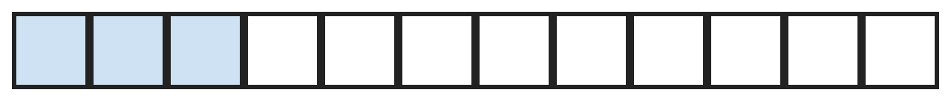
Q11. In this strip, 3 of the 12 parts are shaded. Kirti wants the shaded part to be 4/12 more than the unshaded part. What fraction must she still shade?
(A) 4/12 | (B) 5/12 | (C) 8/12 | (D) 1/12

Part 4 — Geometry (Syllabus Chapter 5)
Q12. Tejas has 3 cylinders, 2 cones and 4 spheres. How many flat faces do all of them have together?
(A) 9 | (B) 5 | (C) 12 | (D) 8

Q13. A square sheet has 4 lines of symmetry. Kiran cuts straight across one corner, taking the same length off both sides. How many lines of symmetry does the sheet have now?
(A) 2 | (B) 1 | (C) 4 | (D) 0

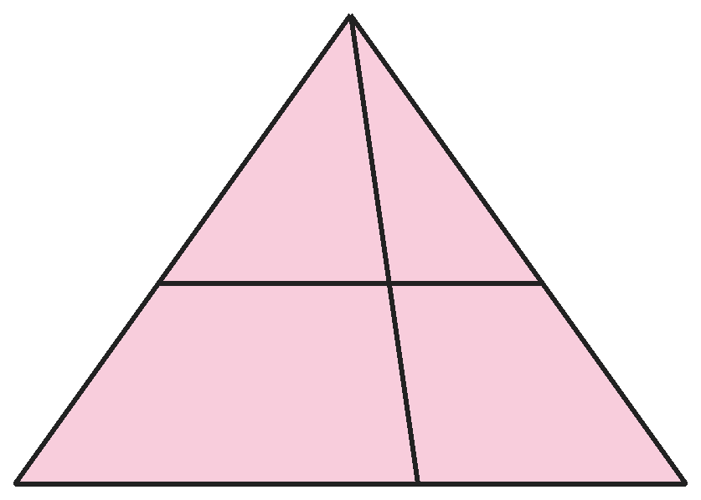
Q14. How many triangles are in this picture?
(A) 5 | (B) 4 | (C) 8 | (D) 6

Part 5 — Mensuration (Syllabus Chapter 6)
Q15. A tile is a hexagon with 6 sides of 7 cm. Harini puts lace all round the edge of 3 such tiles. How much lace does she use?
(A) 42 cm | (B) 63 cm | (C) 126 cm | (D) 84 cm

Q16. Which of these is the second heaviest: 2 kg 50 g, 2005 g, 2 kg 500 g, 2055 g?
(A) 2 kg 500 g | (B) 2055 g | (C) 2 kg 50 g | (D) 2005 g

Q17. A tap fills a 12 L bucket in 4 minutes. How long will it take to fill a 45 L drum?
(A) 15 min | (B) 12 min | (C) 9 min | (D) 16 min

Part 6 — Applied Mathematics (Syllabus Chapter 9)
Q18. A night bus leaves Pune at 10:35 PM and reaches Goa at 7:15 AM the next morning. How long is the journey?
(A) 3 h 20 min | (B) 9 h 20 min | (C) 8 h 40 min | (D) 8 h 20 min

Q19. In one year, 14 November is a Thursday. November has 30 days. What day of the week is 25 December that year?
(A) Thursday | (B) Wednesday | (C) Tuesday | (D) Friday

Q20. At a fruit stall, apples cost ₹48 for 1 kg. Charu buys 2 kg 500 g and pays with a ₹200 note. How much change does she get?
(A) ₹80 | (B) ₹104 | (C) ₹120 | (D) ₹56

Q21. A school has 6 periods of 40 minutes, with a 15-minute break after the 3rd period. School starts at 8:30 AM. When does it end?
(A) 12:30 PM | (B) 12:15 PM | (C) 1:00 PM | (D) 12:45 PM

Part 7 — Mathematical Reasoning (Syllabus Chapter 10)

Q22. Disha builds this pattern by adding a bigger number each time. Which number comes next?
(A) 35 | (B) 37 | (C) 36 | (D) 39

Q23. A and B are different digits, and neither is 0. What is A + B?
(A) 5 | (B) 15 | (C) 6 | (D) 10

Q24. At the first stop, half the bus passengers get off and 5 get on. At the second stop, 10 get off and 3 get on. Now 18 are on the bus. How many were on at the start?
(A) 40 | (B) 30 | (C) 50 | (D) 36

Q25. In a race, Amit is ahead of Bela but behind Chirag. Disha is behind Bela. Ekta finishes between Chirag and Amit. Who finishes 3rd?
(A) Amit | (B) Ekta | (C) Bela | (D) Chirag

Part 8 — Mixed Problems (each joins two chapters)
Q26. How many 4-digit numbers have all even digits that get bigger from left to right?
(A) 5 | (B) 4 | (C) 1 | (D) 0

Q27. A is twice as big as B. What is A?
(A) 6 | (B) 3 | (C) 9 | (D) 4

Q28. Three days after the day before yesterday will be a Sunday. What day is today?
(A) Friday | (B) Sunday | (C) Saturday | (D) Thursday

Q29. A cycle costs ₹4850. A toy car costs ₹1375 less than the cycle. How much do both cost together?
(A) ₹6225 | (B) ₹3475 | (C) ₹9675 | (D) ₹8325

Q30. One face of a cube has a perimeter of 20 cm. What is the total length of all the edges of the cube?
(A) 20 cm | (B) 80 cm | (C) 40 cm | (D) 60 cm

Answer Sheet AMO Level 2 · Class 3 · Practice Paper 4
Name: | School: | Roll No.:
Shade or tick one circle for each question.
1. | Ⓐ Ⓑ Ⓒ Ⓓ | 11. | Ⓐ Ⓑ Ⓒ Ⓓ | 21. | Ⓐ Ⓑ Ⓒ Ⓓ
2. | Ⓐ Ⓑ Ⓒ Ⓓ | 12. | Ⓐ Ⓑ Ⓒ Ⓓ | 22. | Ⓐ Ⓑ Ⓒ Ⓓ
3. | Ⓐ Ⓑ Ⓒ Ⓓ | 13. | Ⓐ Ⓑ Ⓒ Ⓓ | 23. | Ⓐ Ⓑ Ⓒ Ⓓ
4. | Ⓐ Ⓑ Ⓒ Ⓓ | 14. | Ⓐ Ⓑ Ⓒ Ⓓ | 24. | Ⓐ Ⓑ Ⓒ Ⓓ
5. | Ⓐ Ⓑ Ⓒ Ⓓ | 15. | Ⓐ Ⓑ Ⓒ Ⓓ | 25. | Ⓐ Ⓑ Ⓒ Ⓓ
6. | Ⓐ Ⓑ Ⓒ Ⓓ | 16. | Ⓐ Ⓑ Ⓒ Ⓓ | 26. | Ⓐ Ⓑ Ⓒ Ⓓ
7. | Ⓐ Ⓑ Ⓒ Ⓓ | 17. | Ⓐ Ⓑ Ⓒ Ⓓ | 27. | Ⓐ Ⓑ Ⓒ Ⓓ
8. | Ⓐ Ⓑ Ⓒ Ⓓ | 18. | Ⓐ Ⓑ Ⓒ Ⓓ | 28. | Ⓐ Ⓑ Ⓒ Ⓓ
9. | Ⓐ Ⓑ Ⓒ Ⓓ | 19. | Ⓐ Ⓑ Ⓒ Ⓓ | 29. | Ⓐ Ⓑ Ⓒ Ⓓ
10. | Ⓐ Ⓑ Ⓒ Ⓓ | 20. | Ⓐ Ⓑ Ⓒ Ⓓ | 30. | Ⓐ Ⓑ Ⓒ Ⓓ

For the parent or teacher
Correct: ______ / 30
Answer Key and Solutions AMO Level 2 · Class 3 · Practice Paper 4
Quick answers
1 B | 6 D | 11 B | 16 B | 21 D | 26 C
2 C | 7 B | 12 D | 17 A | 22 B | 27 A
3 C | 8 C | 13 B | 18 C | 23 C | 28 C
4 B | 9 D | 14 D | 19 B | 24 A | 29 D
5 A | 10 A | 15 C | 20 A | 25 A | 30 D
Solutions
Q | Part · level | Answer | Why?
1 | Part 1 · Ch1 · Hard | (B) 4 | Hint: The first digit must be 1 or 2.  First digit 2: 2000. First digit 1: the other 1 can be in the hundreds, tens or ones place: 1100, 1010, 1001. Total 4.
2 | Part 1 · Ch1 · Hard | (C) 6 | Hint: The smallest 4-digit number ending in 5 is not 1000.  The smallest 4-digit number is 1000, so the smallest ending in 5 is 1005. The largest 3-digit number is 999. 1005 − 999 = 6.
3 | Part 1 · Ch1 · Hard | (C) 11 | Hint: Do not forget XIX and XLIX. Check XXIX carefully.  XX to XXVIII (20 to 28) have two Xs: 9 numerals. XXIX has three. XIX (19) and XLIX (49) also have two Xs. 9 + 2 = 11.
4 | Part 1 · Ch1 · Hard | (B) 7545 | Hint: Add 1000 first, then take away 300.  1000 more than 6845 is 7845. 300 less than 7845 is 7545.
5 | Part 2 · Ch2 · Hard | (A) Class 5, by 75 | Hint: Find how many Class 5 brought.  Class 3 and 4: 978 + 1206 = 2184. Class 5: 3465 − 2184 = 1281. The most is Class 5 (1281), and the next is Class 4 (1206). 1281 − 1206 = 75.
6 | Part 2 · Ch2 · Hard | (D) 24 | Hint: A dozen is 12.  Each tray holds a dozen eggs, so selling 9 dozen empties 9 trays. 11 − 9 = 2 trays are left: 12 + 12 = 24 eggs.
7 | Part 2 · Ch2 · Hard | (B) ₹62 | Hint: Divide by 7 first.  868 ÷ 7 = ₹124 each. Half of 124 is ₹62.
8 | Part 2 · Ch2 · Hard | (C) 12 vans, 2 empty seats | Hint: Divide 94 by 8. What happens to the children left over?  94 ÷ 8 = 11 remainder 6. The 6 extra children need a 12th van, which has 8 − 6 = 2 empty seats.
9 | Part 3 · Ch3 · Hard | (D) 32 m | Hint: What fraction of the rope is left?  Left: 8 − 3 − 2 = 3 parts, which is 12 m. So 1 part is 4 m, and 8 parts are 32 m.
10 | Part 3 · Ch3 · Hard | (A) 9/7 − 3/7 | Hint: Work each one out. They all have sevenths.  9/7 − 3/7 = 6/7. 3/7 + 2/7 = 5/7. 6/7 − 2/7 = 4/7. Four sevenths is 4/7. The largest is 6/7.
11 | Part 3 · Ch3 · Hard | (B) 5/12 | Hint: Try 8 shaded and 4 unshaded.  Shaded and unshaded add up to 12 parts and differ by 4: that is 8 and 4. She has 3 shaded, so she must shade 8 − 3 = 5 more parts: 5/12.
12 | Part 4 · Ch5 · Hard | (D) 8 | Hint: A sphere has no flat face.  Each cylinder has 2 flat faces: 3 × 2 = 6. Each cone has 1: 2. Spheres have none. 6 + 2 + 0 = 8.
13 | Part 4 · Ch5 · Hard | (B) 1 | Hint: Which fold still puts the cut corner on itself?  Only the fold along the diagonal through the cut corner still makes both halves match. The other three folds would put the cut corner on top of a whole corner. So 1.
14 | Part 4 · Ch5 · Hard | (D) 6 | Hint: Every triangle has its top at the top corner. Count by its bottom side.  The line across and the bottom side can each be the bottom of 3 triangles: left, right, and both together. 3 + 3 = 6. The part between the two lines has 4 sides, so it is not a triangle.
15 | Part 5 · Ch6 · Hard | (C) 126 cm | Hint: Find the perimeter of one tile.  One tile: 6 × 7 = 42 cm. Three tiles: 42 × 3 = 126 cm.
16 | Part 5 · Ch6 · Hard | (B) 2055 g | Hint: Change all of them to grams.  2 kg 50 g = 2050 g and 2 kg 500 g = 2500 g. From heaviest: 2500 g, 2055 g, 2050 g, 2005 g. The second heaviest is 2055 g.
17 | Part 5 · Ch6 · Hard | (A) 15 min | Hint: How many litres does the tap fill in 1 minute?  12 L in 4 minutes is 3 L each minute. 45 L ÷ 3 = 15 minutes.
18 | Part 6 · Ch9 · Hard | (C) 8 h 40 min | Hint: Count to midnight first.  10:35 PM to midnight is 1 h 25 min. Midnight to 7:15 AM is 7 h 15 min. Total 8 h 40 min.
19 | Part 6 · Ch9 · Hard | (B) Wednesday | Hint: Jump 7 days at a time.  Thursdays: 14, 21, 28 November, then 5, 12, 19, 26 December. 25 December is the day before 26: Wednesday.
20 | Part 6 · Ch9 · Hard | (A) ₹80 | Hint: 500 g is half a kilogram.  2 kg cost 48 × 2 = ₹96. 500 g costs half of 48 = ₹24. Total ₹120. Change: 200 − 120 = ₹80.
21 | Part 6 · Ch9 · Hard | (D) 12:45 PM | Hint: Add up the time in minutes, then change it into hours.  6 × 40 = 240 minutes, plus 15 minutes = 255 minutes = 4 h 15 min. 8:30 AM + 4 h 15 min = 12:45 PM.
22 | Part 7 · Ch10 · Hard | (B) 37 | Hint: The amounts added are odd numbers.  She adds 3, 5, 7, 9. Next she adds 11: 26 + 11 = 37.
23 | Part 7 · Ch10 · Hard | (C) 6 | Hint: Three A's must end in the digit A.  3 × A ends in A. Try A = 5: 5 + 5 + 5 = 15, which is BA with B = 1. So A + B = 5 + 1 = 6.
24 | Part 7 · Ch10 · Hard | (A) 40 | Hint: Undo the second stop first.  Before the second stop: 18 − 3 + 10 = 25. Before the 5 got on: 25 − 5 = 20. That was half, so at the start there were 40.
25 | Part 7 · Ch10 · Hard | (A) Amit | Hint: Write the names in a line from first to last.  Chirag is ahead of Amit, with Ekta between them: Chirag, Ekta, Amit. Bela is behind Amit and Disha behind Bela. Order: Chirag, Ekta, Amit, Bela, Disha. Amit is 3rd.
26 | Part 8 · Mixed · Ch1 + Ch10 · Hard | (C) 1 | Hint: The even digits are 0, 2, 4, 6, 8. Can 0 be used?  If 0 were used, it would have to be first, which is not allowed. So the digits are four of 2, 4, 6, 8, which means all of them: 2468. There is only 1 such number.
27 | Part 8 · Mixed · Ch3 + Ch10 · Hard | (A) 6 | Hint: A + B = 9.  The tops add up: A + B = 9. A is twice B, so B + B + B = 9 and B = 3. A = 6.
28 | Part 8 · Mixed · Ch9 + Ch10 · Hard | (C) Saturday | Hint: Three days after the day before yesterday is one day after today.  The day before yesterday is 2 days before today. Three days after it is 1 day after today, which is Sunday. So today is Saturday.
29 | Part 8 · Mixed · Ch1 + Ch9 · Hard | (D) ₹8325 | Hint: Find the price of the toy car first.  Toy car: 4850 − 1375 = ₹3475. Both: 4850 + 3475 = ₹8325.
30 | Part 8 · Mixed · Ch5 + Ch6 · Hard | (D) 60 cm | Hint: Find the length of one edge first. A cube has 12 edges.  A face is a square with perimeter 20 cm, so each edge is 5 cm. A cube has 12 edges: 12 × 5 = 60 cm.

ARYABHATTA MATHS OLYMPIAD
Level 2
PRACTICE PAPER-5
CLASS 3
Total Questions | 30 multiple-choice questions
Level | Level-2 (final round): every question is Hard
Time | 45 minutes
Arrangement | Parts by chapter; the last Part has mixed problems joining two chapters
Negative Marking | No negative marking
Calculator | Not allowed
Chapters | Number System · Operations · Fractions · Geometry · Mensuration · Applied Mathematics · Mathematical Reasoning

👋 Hello, friend! How to do this paper:
⭐ Every question has four answer choices: (A), (B), (C) and (D). Only one is correct.
⭐ Read each question and look at its picture carefully. Then mark your answer on the answer sheet at the end.
⭐ This is a Level-2 paper. Every question needs careful thinking, so take your time and check each step.
⭐ The questions are in Parts by chapter. The last Part has mixed problems that join two chapters.
⭐ There is no negative marking, so try every question.
⭐ Do not use a calculator. You may do rough work on a separate sheet.
⭐ All figures are not necessarily drawn to scale unless stated.

For parents and teachers
• Pictures are part of the questions. Every picture also works when printed in black and white.
• You may read a question aloud to the child, exactly as printed. Please do not explain it or point to an answer choice.
• Parts follow the AMO syllabus chapters. Chapters 4, 7 and 8 are not part of the Class 3 syllabus, so the chapter numbers shown in the Part headings have gaps.
• The answer sheet and the answer key are at the end. Remove only the answer key before the child begins.

Part 1 — Number System (Syllabus Chapter 1)
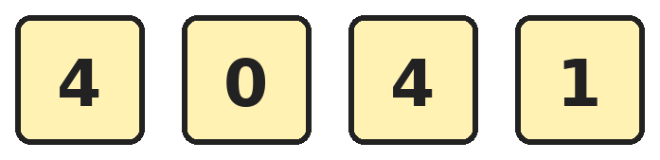
Q1. Komal uses all four cards to make 4-digit numbers. How many different numbers can she make?
(A) 12 | (B) 24 | (C) 9 | (D) 6

Q2. Madhav's number is greater than 5000. Its thousands digit is 3 times its ones digit. Its hundreds digit is 1 more than its thousands digit. Its tens digit is 1 more than double the ones digit. What is the number?
(A) 3431 | (B) 6572 | (C) 6752 | (D) 7652

Q3. A clock face shows the Roman numerals I to XII. How many of these 12 numerals use the symbol I at least once?
(A) 10 | (B) 8 | (C) 12 | (D) 9

Q4. Juhi looks for numbers between 2000 and 3000. The ones digit must be 4 more than the thousands digit. The hundreds and tens digits must be equal. How many such numbers are there?
(A) 9 | (B) 1 | (C) 100 | (D) 10

Part 2 — Operations (Syllabus Chapter 2)
Q5. Three books have 3000 pages in all. The first has 1248 pages and the second has 976. How many pages does the third book have?
(A) 876 | (B) 776 | (C) 786 | (D) 2224

Q6. Sapna adds all the numbers in the 9 times table from 9 × 1 to 9 × 10. What total does she get?
(A) 450 | (B) 90 | (C) 505 | (D) 495

Q7. Naveen divides a number by 7 and gets 108. What does he get if he divides the same number by 4?
(A) 27 | (B) 189 | (C) 756 | (D) 216

Q8. A number between 20 and 50 leaves remainder 5 when divided by 6, and remainder 4 when divided by 5. What is the number?
(A) 35 | (B) 41 | (C) 29 | (D) 24

Part 3 — Fractions (Syllabus Chapter 3)
Q9. Vidya has 24 crayons. 5/12 of them are broken. She gives half of the unbroken crayons to her brother. How many unbroken crayons does she keep?
(A) 14 | (B) 7 | (C) 10 | (D) 5

Q10. Lata walks from the 2/12 mark to the 11/12 mark on a number line. She stops one third of the way along. Which fraction does she stop at?
(A) 5/12 | (B) 3/12 | (C) 6/12 | (D) 4/12

Q11. A cat drinks 2/8 L of milk every morning and 3/8 L every evening. For how many days will 5 L of milk last?
(A) 5 | (B) 8 | (C) 40 | (D) 10

Part 4 — Geometry (Syllabus Chapter 5)
Q12. On a dice, opposite faces always add up to 7. Krish can see three faces showing 1, 2 and 3. What is the total of the three faces he cannot see?
(A) 6 | (B) 21 | (C) 15 | (D) 12

Q13. A square pyramid sits exactly on top of a cube, so its square base covers the top of the cube. How many vertices does the new solid have?
(A) 13 | (B) 8 | (C) 12 | (D) 9

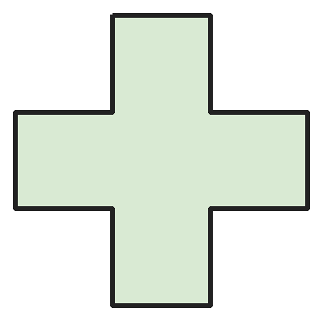
Q14. This plus shape has four equal arms. How many lines of symmetry does it have?
(A) 2 | (B) 4 | (C) 8 | (D) 1

Part 5 — Mensuration (Syllabus Chapter 6)
Q15. A square park has sides of 45 m. Rohit runs 4 times round the park. How far does he run?
(A) 180 m | (B) 360 m | (C) 720 m | (D) 540 m

Q16. Each pencil is 25 cm long. How many pencils must Parth lay end to end to make a line 3 m long?
(A) 75 | (B) 120 | (C) 12 | (D) 4

Q17. Bucket A holds 3 L 400 mL of water and bucket B holds 2 L 750 mL. Both are poured into an empty 7 L tub. How much more water fills the tub?
(A) 1 L 850 mL | (B) 950 mL | (C) 1 L 150 mL | (D) 850 mL

Part 6 — Applied Mathematics (Syllabus Chapter 9)
Q18. A film ended at 1:10 PM. It ran for 2 hours 45 minutes. At what time did it start?
(A) 11:25 AM | (B) 10:25 AM | (C) 10:35 AM | (D) 3:55 PM

Q19. A month has 30 days and starts on a Wednesday. Which two days of the week come five times in that month?
(A) Wednesday and Thursday | (B) Tuesday and Wednesday
(C) Wednesday and Sunday | (D) Thursday and Friday

Q20. At a market, 6 bananas cost the same as 2 mangoes. One mango costs ₹21. How much do 10 bananas cost?
(A) ₹70 | (B) ₹63 | (C) ₹210 | (D) ₹35

Q21. Akash's train journey takes half a day, plus a quarter of an hour, plus 90 minutes. How long is that?
(A) 12 h 45 min | (B) 13 h 45 min | (C) 14 h 15 min | (D) 13 h 15 min

Part 7 — Mathematical Reasoning (Syllabus Chapter 10)

Q22. Prachi takes away a bigger even number each time. Which number comes next?
(A) 72 | (B) 68 | (C) 60 | (D) 70


Q23. A and B are digits and A + B = 11. What is the number AB?
(A) 74 | (B) 47 | (C) 83 | (D) 65

Q24. Uncle asks Gautam his age. Gautam says, "Add 7 to my age, double it and take away 10. You get 40." How old is Gautam?
(A) 18 | (B) 25 | (C) 13 | (D) 20

Q25. Nakul has 4 flags of different patterns. He hangs 2 of them on a pole, one above the other. How many different ways can he do this?
(A) 6 | (B) 16 | (C) 8 | (D) 12

Part 8 — Mixed Problems (each joins two chapters)
Q26. Bhavin writes the numbers from 1 to 20. He adds up all the digits he wrote. What total does he get?
(A) 210 | (B) 100 | (C) 102 | (D) 57

Q27. Three fractions are 1/12 apart, like 2/12, 3/12, 4/12. They add up to one whole. What is the largest of them?
(A) 5/12 | (B) 4/12 | (C) 6/12 | (D) 3/12

Q28. A clock strikes once at 1 o'clock, twice at 2 o'clock, and so on. It also strikes once at every half past. How many times does it strike from 1 PM to 6 PM, both included?
(A) 21 | (B) 27 | (C) 26 | (D) 32

Q29. Indu pays ₹48 using only ₹1, ₹2, ₹5 and ₹10 coins. What is the fewest number of coins she can use?
(A) 6 | (B) 7 | (C) 8 | (D) 9

Q30. Three equal squares are put in a row to make a rectangle. The perimeter of the rectangle is 48 cm. How long is a side of one square?
(A) 4 cm | (B) 16 cm | (C) 12 cm | (D) 6 cm

Answer Sheet AMO Level 2 · Class 3 · Practice Paper 5
Name: | School: | Roll No.:
Shade or tick one circle for each question.
1. | Ⓐ Ⓑ Ⓒ Ⓓ | 11. | Ⓐ Ⓑ Ⓒ Ⓓ | 21. | Ⓐ Ⓑ Ⓒ Ⓓ
2. | Ⓐ Ⓑ Ⓒ Ⓓ | 12. | Ⓐ Ⓑ Ⓒ Ⓓ | 22. | Ⓐ Ⓑ Ⓒ Ⓓ
3. | Ⓐ Ⓑ Ⓒ Ⓓ | 13. | Ⓐ Ⓑ Ⓒ Ⓓ | 23. | Ⓐ Ⓑ Ⓒ Ⓓ
4. | Ⓐ Ⓑ Ⓒ Ⓓ | 14. | Ⓐ Ⓑ Ⓒ Ⓓ | 24. | Ⓐ Ⓑ Ⓒ Ⓓ
5. | Ⓐ Ⓑ Ⓒ Ⓓ | 15. | Ⓐ Ⓑ Ⓒ Ⓓ | 25. | Ⓐ Ⓑ Ⓒ Ⓓ
6. | Ⓐ Ⓑ Ⓒ Ⓓ | 16. | Ⓐ Ⓑ Ⓒ Ⓓ | 26. | Ⓐ Ⓑ Ⓒ Ⓓ
7. | Ⓐ Ⓑ Ⓒ Ⓓ | 17. | Ⓐ Ⓑ Ⓒ Ⓓ | 27. | Ⓐ Ⓑ Ⓒ Ⓓ
8. | Ⓐ Ⓑ Ⓒ Ⓓ | 18. | Ⓐ Ⓑ Ⓒ Ⓓ | 28. | Ⓐ Ⓑ Ⓒ Ⓓ
9. | Ⓐ Ⓑ Ⓒ Ⓓ | 19. | Ⓐ Ⓑ Ⓒ Ⓓ | 29. | Ⓐ Ⓑ Ⓒ Ⓓ
10. | Ⓐ Ⓑ Ⓒ Ⓓ | 20. | Ⓐ Ⓑ Ⓒ Ⓓ | 30. | Ⓐ Ⓑ Ⓒ Ⓓ

For the parent or teacher
Correct: ______ / 30
Answer Key and Solutions AMO Level 2 · Class 3 · Practice Paper 5
Quick answers
1 C | 6 D | 11 B | 16 C | 21 B | 26 C
2 C | 7 B | 12 C | 17 D | 22 D | 27 A
3 A | 8 C | 13 D | 18 B | 23 A | 28 C
4 D | 9 B | 14 B | 19 A | 24 A | 29 B
5 B | 10 A | 15 C | 20 A | 25 D | 30 D
Solutions
Q | Part · level | Answer | Why?
1 | Part 1 · Ch1 · Hard | (C) 9 | Hint: The number cannot start with 0. The two 4s look the same.  Start with 1: the rest 4, 4, 0 can be 440, 404, 044, so 3 numbers. Start with 4: the rest 4, 0, 1 can be arranged in 6 ways. 3 + 6 = 9.
2 | Part 1 · Ch1 · Hard | (C) 6752 | Hint: The thousands digit is 6 or more.  Thousands = 3 × ones. If ones = 1, the number starts with 3, which is less than 5000. If ones = 2: thousands 6, hundreds 7, tens 2 × 2 + 1 = 5. The number is 6752. (Ones = 3 would need hundreds 10.)
3 | Part 1 · Ch1 · Hard | (A) 10 | Hint: Find the numerals with no I at all.  Only V (5) and X (10) have no I. The other 12 − 2 = 10 numerals all use I: I, II, III, IV, VI, VII, VIII, IX, XI, XII.
4 | Part 1 · Ch1 · Hard | (D) 10 | Hint: The thousands digit is 2. What is the ones digit?  The thousands digit is 2, so the ones digit is 6. The hundreds and tens digits are the same: 00, 11, 22, …, 99. That gives 2006, 2116, …, 2996: 10 numbers.
5 | Part 2 · Ch2 · Hard | (B) 776 | Hint: Add the first two, then subtract from 3000.  1248 + 976 = 2224. 3000 − 2224 = 776.
6 | Part 2 · Ch2 · Hard | (D) 495 | Hint: 9 + 18 + … + 90 is 9 × (1 + 2 + … + 10).  1 + 2 + … + 10 = 55. So the total is 9 × 55 = 495.
7 | Part 2 · Ch2 · Hard | (B) 189 | Hint: Find the number first.  The number is 7 groups of 108. Dividing by 4 instead: 108 ÷ 4 = 27, so the answer is 7 groups of 27 = 27 × 7 = 189. (The number is 756.)
8 | Part 2 · Ch2 · Hard | (C) 29 | Hint: Try numbers that are 1 less than a multiple of 6.  Remainder 5 on dividing by 6: 23, 29, 35, 41, 47. Remainder 4 on dividing by 5 means the number ends in 4 or 9. Only 29 fits.
9 | Part 3 · Ch3 · Hard | (B) 7 | Hint: First find 1/12 of 24.  1/12 of 24 is 2. Broken: 5 × 2 = 10. Unbroken: 24 − 10 = 14. Half of 14 is 7.
10 | Part 3 · Ch3 · Hard | (A) 5/12 | Hint: First find the distance from 2/12 to 11/12.  The distance is 11/12 − 2/12 = 9/12. One third of 9 twelfths is 3 twelfths. 2/12 + 3/12 = 5/12.
11 | Part 3 · Ch3 · Hard | (B) 8 | Hint: How many eighths of a litre are in 5 L?  Each day: 2/8 + 3/8 = 5/8 L. 5 L = 40/8 L. 40 ÷ 5 = 8 days.
12 | Part 4 · Ch5 · Hard | (C) 15 | Hint: Each hidden face is opposite a face he can see.  The hidden faces are opposite 1, 2 and 3, so they show 6, 5 and 4. 6 + 5 + 4 = 15. (All six faces add to 21, and 21 − 6 = 15.)
13 | Part 4 · Ch5 · Hard | (D) 9 | Hint: The corners of the pyramid base sit on the corners of the cube.  The cube has 8 vertices. The pyramid's 4 base corners are the same as the cube's top corners, so only its tip is new. 8 + 1 = 9.
14 | Part 4 · Ch5 · Hard | (B) 4 | Hint: Try folding up-down, across, and corner to corner.  Folding down the middle and across the middle both work: 2 lines. Folding along the two slanting lines through the centre also works: 2 more. Total 4.
15 | Part 5 · Ch6 · Hard | (C) 720 m | Hint: First find one round.  One round: 4 × 45 = 180 m. Four rounds: 180 + 180 + 180 + 180 = 720 m.
16 | Part 5 · Ch6 · Hard | (C) 12 | Hint: How many 25 cm pencils make 1 m?  1 m = 100 cm = 4 pencils of 25 cm. 3 m needs 3 × 4 = 12 pencils.
17 | Part 5 · Ch6 · Hard | (D) 850 mL | Hint: Change everything into millilitres.  3400 + 2750 = 6150 mL. 7 L = 7000 mL. 7000 − 6150 = 850 mL.
18 | Part 6 · Ch9 · Hard | (B) 10:25 AM | Hint: Count back 2 hours, then 45 minutes.  2 hours before 1:10 PM is 11:10 AM. 45 minutes before 11:10 AM is 10:25 AM.
19 | Part 6 · Ch9 · Hard | (A) Wednesday and Thursday | Hint: 30 days is 4 weeks and 2 days.  28 days make 4 full weeks. The 29th and 30th are the extra days: they are the same days as the 1st and 2nd, Wednesday and Thursday. So these two come five times.
20 | Part 6 · Ch9 · Hard | (A) ₹70 | Hint: Find the cost of 1 banana.  2 mangoes cost ₹42, so 6 bananas cost ₹42. 1 banana costs 42 ÷ 6 = ₹7. 10 bananas cost ₹70.
21 | Part 6 · Ch9 · Hard | (B) 13 h 45 min | Hint: Half a day is 12 hours and 90 minutes is 1 h 30 min.  12 h + 15 min + 1 h 30 min = 13 h 45 min.
22 | Part 7 · Ch10 · Hard | (D) 70 | Hint: She takes away 2, then 4, then 6, …  She takes away 2, 4, 6 and 8. Next she takes away 10: 80 − 10 = 70.
23 | Part 7 · Ch10 · Hard | (A) 74 | Hint: AB − BA is always 9 × (A − B).  9 × (A − B) = 27, so A − B = 3. With A + B = 11, A = 7 and B = 4. Check: 74 − 47 = 27.
24 | Part 7 · Ch10 · Hard | (A) 18 | Hint: Undo the steps from the end.  Undo − 10: 40 + 10 = 50. Undo doubling: 25. Undo + 7: 25 − 7 = 18.
25 | Part 7 · Ch10 · Hard | (D) 12 | Hint: Choose the top flag first, then the bottom flag.  The top flag can be any of 4. The bottom can be any of the other 3. 4 × 3 = 12 ways. (6 forgets that swapping top and bottom makes a new way.)
26 | Part 8 · Mixed · Ch1 + Ch10 · Hard | (C) 102 | Hint: Do 1–9, then 10–19, then 20.  1 to 9: 45. 10 to 19: ten 1s in the tens place (10) and 0 to 9 in the ones (45), so 55. 20: 2. Total 45 + 55 + 2 = 102. (210 adds the numbers, not the digits.)
27 | Part 8 · Mixed · Ch3 + Ch10 · Hard | (A) 5/12 | Hint: One whole is 12/12. The middle top number is a third of 12.  The tops are three numbers in a row that add to 12: 3 + 4 + 5 = 12. The fractions are 3/12, 4/12, 5/12. The largest is 5/12.
28 | Part 8 · Mixed · Ch9 + Ch10 · Hard | (C) 26 | Hint: Add the hour strikes, then count the half-hour strikes.  Hour strikes: 1 + 2 + 3 + 4 + 5 + 6 = 21. Half pasts between 1 PM and 6 PM: 1:30, 2:30, 3:30, 4:30, 5:30, which is 5 more. 21 + 5 = 26.
29 | Part 8 · Mixed · Ch1 + Ch9 · Hard | (B) 7 | Hint: Use as many ₹10 coins as possible, then make 8.  4 coins of ₹10 make ₹40. ₹8 needs ₹5 + ₹2 + ₹1, which is 3 coins. 4 + 3 = 7 coins.
30 | Part 8 · Mixed · Ch5 + Ch6 · Hard | (D) 6 cm | Hint: Count the square sides on the outside of the rectangle.  The rectangle has 3 sides on top, 3 on the bottom and 1 at each end: 8 square sides. 48 ÷ 8 = 6 cm. (4 cm wrongly uses all 12 sides.)

