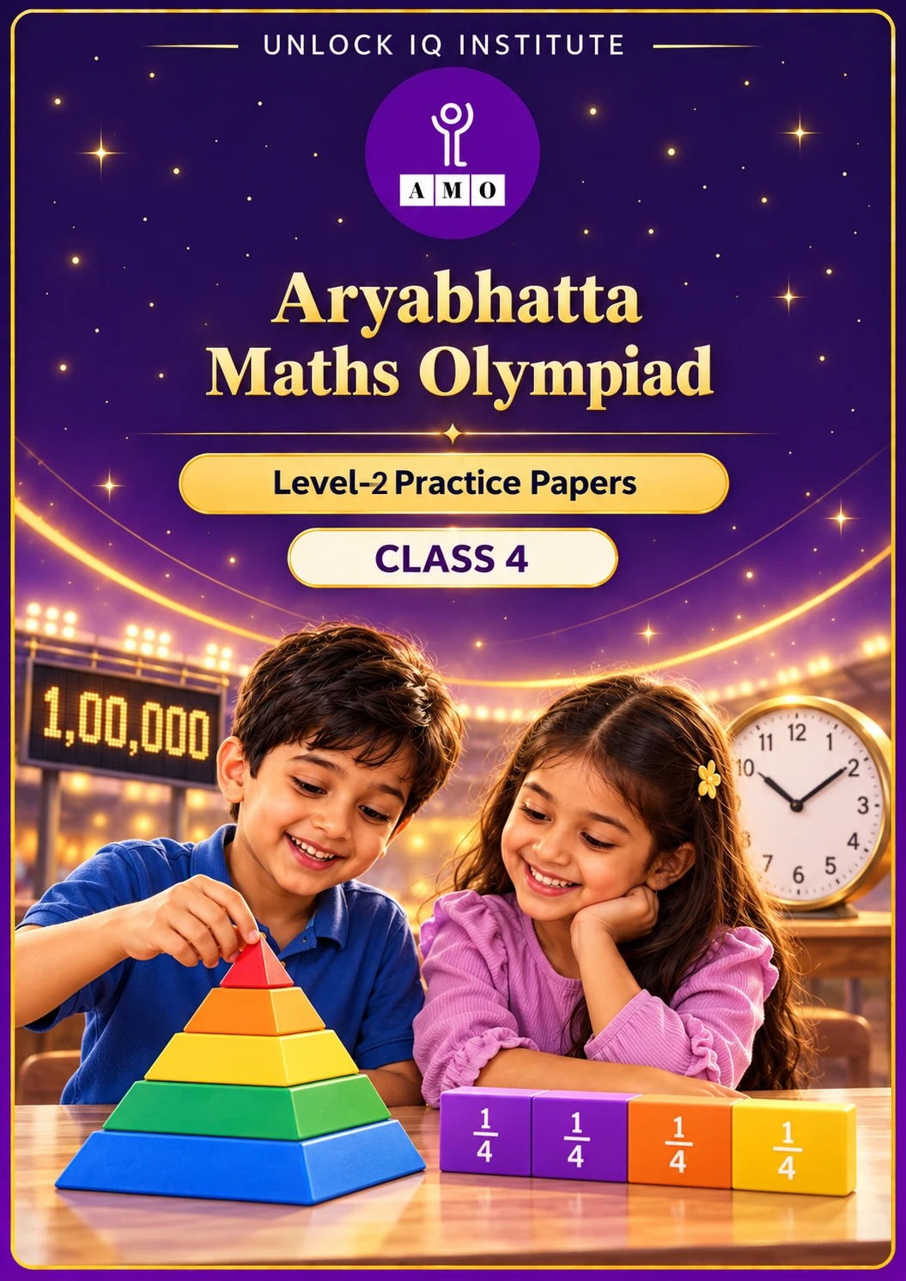
Set 2 · Practice Papers 6–10 · with answer keys & detailed solutions
Name: ____________________ | Class & Section: ________________
Roll No.: ________________ | School: ____________________
City: ____________________ | Date: ____________________

Published by Unlock IQ Institute Pvt. Ltd.
Register for Olympiads: www.aryabhattamathsolympiad.com/student-registration

ARYABHATTA MATHS OLYMPIAD
Level 2
PRACTICE PAPER-6
CLASS 4
Total Questions | 30 multiple-choice questions
Level | Level-2 (final round): every question is Hard
Time | 45 minutes
Arrangement | Parts by chapter; the last Part has mixed problems joining two chapters
Negative Marking | No negative marking
Calculator | Not allowed
Chapters | Number System · Operations · Fractions & Decimals · Geometry · Mensuration · Data Handling · Applied Mathematics · Mathematical Reasoning

👋 Hello, friend! How to do this paper:
⭐ Every question has four answer choices: (A), (B), (C) and (D). Only one is correct.
⭐ Read each question and look at its picture carefully. Then mark your answer on the answer sheet at the end.
⭐ This is a Level-2 paper. Every question needs careful thinking, so take your time and check each step.
⭐ The questions are in Parts by chapter. The last Part has mixed problems that join two chapters.
⭐ There is no negative marking, so try every question.
⭐ Do not use a calculator. You may do rough work on a separate sheet.
⭐ All figures are not necessarily drawn to scale unless stated.

For parents and teachers
• Pictures are part of the questions. Every picture also works when printed in black and white.
• You may read a question aloud to the child, exactly as printed. Please do not explain it or point to an answer choice.
• Parts follow the AMO syllabus chapters. Chapters 4 and 7 are not part of the Class 4 syllabus, so the chapter numbers shown in the Part headings have gaps.
• The answer sheet and the answer key are at the end. Remove only the answer key before the child begins.

Part 1 — Number System (Syllabus Chapter 1)
Q1. Upasana writes all the numbers from 1 to 100. How many times does she write the digit 9?
(A) 19 | (B) 20 | (C) 11 | (D) 10

Q2. What is the difference between sixty thousand six hundred six and six thousand sixty-six?
(A) 54,000 | (B) 66,672 | (C) 54,540 | (D) 54,450

Q3. Which of these Roman numerals is the 2nd largest: XLIV, LIV, XCIV, LXIV?
(A) LIV | (B) LXIV | (C) XCIV | (D) XLIV

Part 2 — Operations (Syllabus Chapter 2)
Q4. Rohan finds 125 × 37 × 8 quickly by changing the order of multiplying. What is the answer?
(A) 37,000 | (B) 3,700 | (C) 36,000 | (D) 37,800

Q5. Naina splits 46 into two parts to make this true. Which number replaces the question mark?
(A) 46 | (B) 52 | (C) 6 | (D) 40

Q6. What is the largest 4-digit number that can be divided by 8 with no remainder?
(A) 9,996 | (B) 9,999 | (C) 9,984 | (D) 9,992

Part 3 — Fractions & Decimals (Syllabus Chapter 3)
Q7. For a big batch of laddoos, Devika uses 1 1/2 cups of flour, then 2 3/4 cups, then 3/4 of a cup. How many cups of flour does she use in all?
(A) 5 cups | (B) 4 1/2 cups | (C) 4 3/4 cups | (D) 5 1/4 cups

Q8. Ribbon P is 3/5 of a metre long and ribbon Q is 1/4 of a metre long. How many centimetres longer is ribbon P?
(A) 2 cm | (B) 35 cm | (C) 25 cm | (D) 60 cm

Q9. A can holds 10 L of paint. Girish uses 3.7 L on a door and 2.5 L on a gate. How much paint is left?
(A) 4.8 L | (B) 6.2 L | (C) 3.2 L | (D) 3.8 L

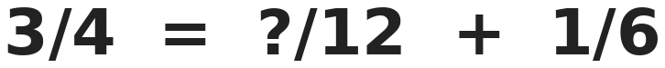
Q10. Arjun wants both sides to be equal. Which numerator replaces the question mark?
(A) 7 | (B) 9 | (C) 2 | (D) 5

Part 4 — Geometry (Syllabus Chapter 5)
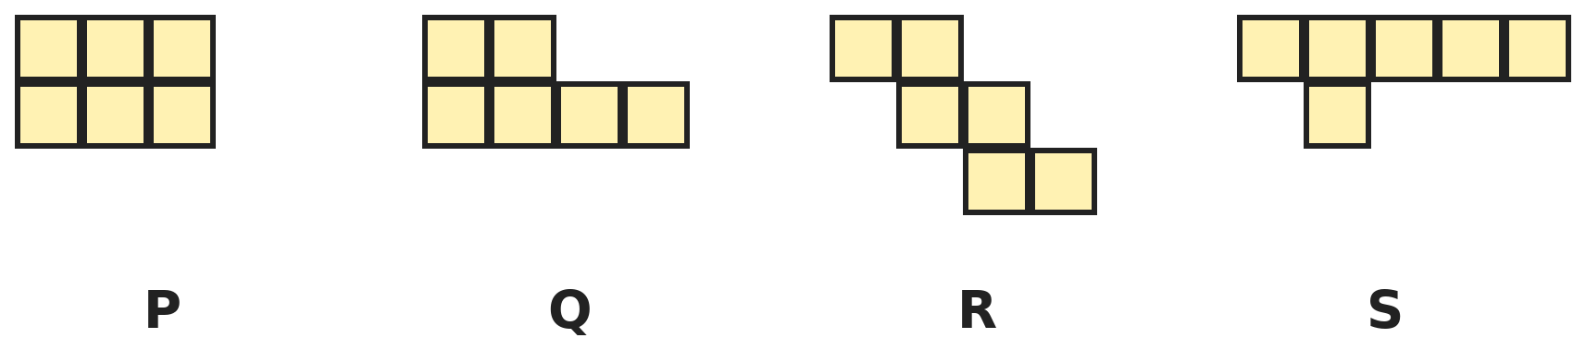
Q11. Each shape is made of 6 equal squares. Which shape can be folded to make a cube?
(A) P | (B) Q | (C) R | (D) S

Q12. A robot is on a grid at row 4, column 3. Rows are numbered from top to bottom. It moves 3 columns right, 2 rows up, 1 column left and then 4 rows down. Where is it now?
(A) Row 6, column 5 | (B) Row 2, column 5
(C) Row 6, column 7 | (D) Row 4, column 5

Q13. Seen from the front a solid looks like a triangle. From the side it also looks like a triangle. From the top it looks like a square. Which solid is it?
(A) Cone | (B) Triangular prism
(C) Square pyramid | (D) Cube

Part 5 — Mensuration (Syllabus Chapter 6)
Q14. A square has the same perimeter as a rectangle 14 cm long and 10 cm wide. How much bigger is the area of the square than the area of the rectangle?
(A) 0 cm² | (B) 2 cm² | (C) 44 cm² | (D) 4 cm²

Q15. A rectangle has an area of 48 cm² and a perimeter of 28 cm. How much longer is its length than its width?
(A) 4 cm | (B) 8 cm | (C) 2 cm | (D) 20 cm

Q16. When each side of a square is made 2 cm longer, its area grows by 36 cm². What was the perimeter of the square at first?
(A) 36 cm | (B) 40 cm | (C) 28 cm | (D) 32 cm

Q17. A table top is 2 m long and 1 m wide. Payal covers it with square tiles of side 10 cm. How many tiles does she use?
(A) 200 | (B) 20 | (C) 30 | (D) 2,000

Part 6 — Data Handling (Syllabus Chapter 8)
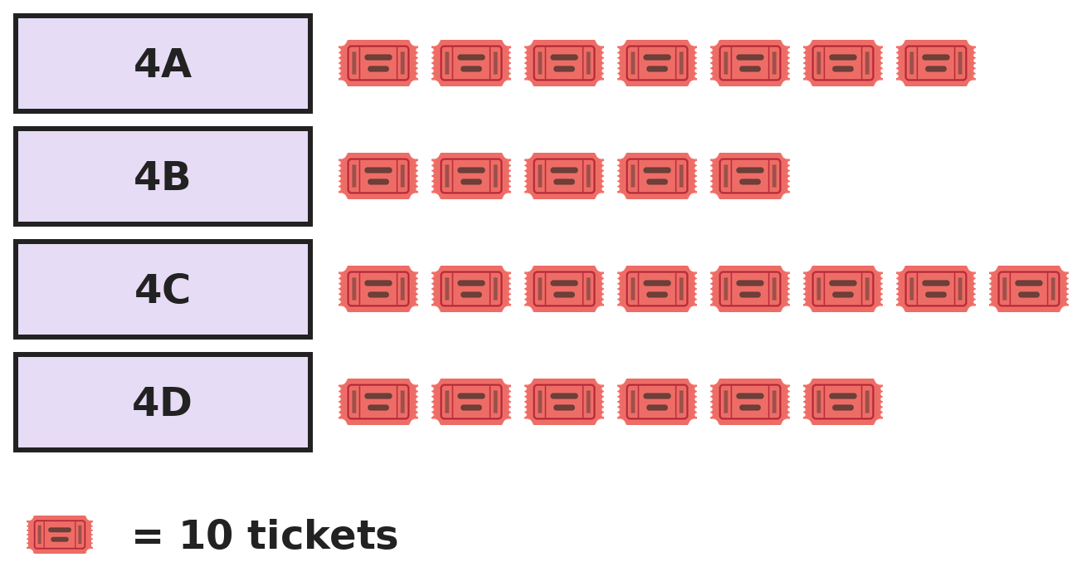
Q18. The pictograph shows tickets sold by four sections for a school fair. Each ticket costs ₹15. How much more money did 4C collect than 4B?
(A) ₹30 | (B) ₹450 | (C) ₹45 | (D) ₹1,200

Part 7 — Applied Mathematics (Syllabus Chapter 9)
Q19. A cricket match starts at 9:47 AM and stops for lunch at 1:15 PM. For how many minutes has it been played?
(A) 328 minutes | (B) 212 minutes | (C) 208 minutes | (D) 188 minutes

Q20. Kirti's birthday is on the 29th of a month whose 1st day is a Friday. Her party is 3 days after her birthday. On which day of the week is the party?
(A) Friday | (B) Sunday | (C) Tuesday | (D) Monday

Q21. Manju buys a toy for ₹137 and a game for ₹248. She pays with a ₹500 note. The shop gives change in the fewest notes and coins. How many notes and coins does she get?
(A) 2 | (B) 3 | (C) 4 | (D) 5

Part 8 — Mathematical Reasoning (Syllabus Chapter 10)

Q22. Charvi mixed two series together. Which number comes next?
(A) 9 | (B) 37 | (C) 40 | (D) 35

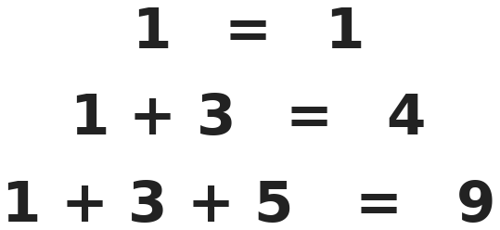
Q23. Follow the pattern. What is 1 + 3 + 5 + … + 19?
(A) 81 | (B) 100 | (C) 121 | (D) 190

Q24. Ishaan has plenty of ₹1, ₹2 and ₹5 coins. In how many different ways can he pay exactly ₹10?
(A) 10 | (B) 8 | (C) 6 | (D) 12

Q25. Ravi, Sita and Om each have one pet: a cat, a dog or a parrot. Ravi does not have the cat or the dog. Sita does not have the dog. Who has the dog?
(A) Ravi | (B) Om | (C) Sita | (D) Cannot tell

Part 9 — Mixed Problems (each joins two chapters)
Q26. How many fractions with denominator 12 lie between 1/3 and 3/4? Do not count 1/3 and 3/4.
(A) 4 | (B) 5 | (C) 6 | (D) 3

Q27. A leap year has 366 days. In one leap year, 1 January is a Wednesday. How many Wednesdays are there in that year?
(A) 52 | (B) 54 | (C) 53 | (D) 51

Q28. What is the smallest 5-digit number whose digits add up to 40?
(A) 58,999 | (B) 99,994 | (C) 39,999 | (D) 49,999

Q29. A shopkeeper has 120 eggs. He sells 3/4 of them at ₹6 each and the rest at ₹5 each. How much money does he get?
(A) ₹690 | (B) ₹720 | (C) ₹660 | (D) ₹540

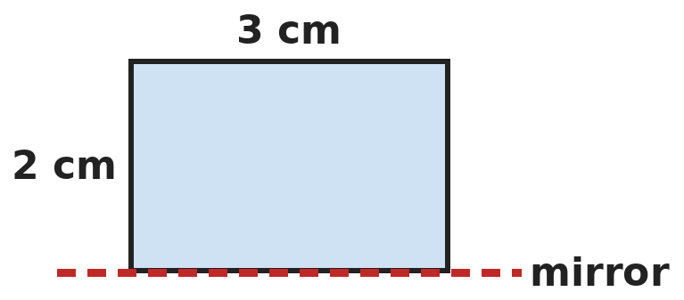
Q30. A 3 cm by 2 cm rectangle sits on a mirror line along its 3 cm side. The rectangle and its reflection together make one shape. What is the perimeter of that shape?
(A) 20 cm | (B) 10 cm | (C) 12 cm | (D) 14 cm

Answer Sheet AMO Level 2 · Class 4 · Practice Paper 6
Name: | School: | Roll No.:
Shade or tick one circle for each question.
1. | Ⓐ Ⓑ Ⓒ Ⓓ | 11. | Ⓐ Ⓑ Ⓒ Ⓓ | 21. | Ⓐ Ⓑ Ⓒ Ⓓ
2. | Ⓐ Ⓑ Ⓒ Ⓓ | 12. | Ⓐ Ⓑ Ⓒ Ⓓ | 22. | Ⓐ Ⓑ Ⓒ Ⓓ
3. | Ⓐ Ⓑ Ⓒ Ⓓ | 13. | Ⓐ Ⓑ Ⓒ Ⓓ | 23. | Ⓐ Ⓑ Ⓒ Ⓓ
4. | Ⓐ Ⓑ Ⓒ Ⓓ | 14. | Ⓐ Ⓑ Ⓒ Ⓓ | 24. | Ⓐ Ⓑ Ⓒ Ⓓ
5. | Ⓐ Ⓑ Ⓒ Ⓓ | 15. | Ⓐ Ⓑ Ⓒ Ⓓ | 25. | Ⓐ Ⓑ Ⓒ Ⓓ
6. | Ⓐ Ⓑ Ⓒ Ⓓ | 16. | Ⓐ Ⓑ Ⓒ Ⓓ | 26. | Ⓐ Ⓑ Ⓒ Ⓓ
7. | Ⓐ Ⓑ Ⓒ Ⓓ | 17. | Ⓐ Ⓑ Ⓒ Ⓓ | 27. | Ⓐ Ⓑ Ⓒ Ⓓ
8. | Ⓐ Ⓑ Ⓒ Ⓓ | 18. | Ⓐ Ⓑ Ⓒ Ⓓ | 28. | Ⓐ Ⓑ Ⓒ Ⓓ
9. | Ⓐ Ⓑ Ⓒ Ⓓ | 19. | Ⓐ Ⓑ Ⓒ Ⓓ | 29. | Ⓐ Ⓑ Ⓒ Ⓓ
10. | Ⓐ Ⓑ Ⓒ Ⓓ | 20. | Ⓐ Ⓑ Ⓒ Ⓓ | 30. | Ⓐ Ⓑ Ⓒ Ⓓ

For the parent or teacher
Correct: ______ / 30
Answer Key and Solutions AMO Level 2 · Class 4 · Practice Paper 6
Quick answers
1 B | 6 D | 11 C | 16 D | 21 B | 26 A
2 C | 7 A | 12 A | 17 A | 22 C | 27 C
3 B | 8 B | 13 C | 18 B | 23 B | 28 D
4 A | 9 D | 14 D | 19 C | 24 A | 29 A
5 D | 10 A | 15 C | 20 D | 25 B | 30 D
Solutions
Q | Part · level | Answer | Why?
1 | Part 1 · Ch1 · Hard | (B) 20 | Hint: Count 9 in the ones place and 9 in the tens place separately.  9 in the ones place: 9, 19, 29, …, 99, which is 10 times. 9 in the tens place: 90 to 99, which is 10 more times. 99 has two 9s and is counted in both lists, which is correct, as she writes 9 twice there. 10 + 10 = 20.
2 | Part 1 · Ch1 · Hard | (C) 54,540 | Hint: Write both numbers in digits first.  Sixty thousand six hundred six = 60,606. Six thousand sixty-six = 6,066. 60,606 − 6,066 = 54,540.
3 | Part 1 · Ch1 · Hard | (B) LXIV | Hint: XL is 40 and XC is 90.  XLIV = 44, LIV = 54, XCIV = 94 and LXIV = 64. From largest: 94, 64, 54, 44. The 2nd largest is LXIV.
4 | Part 2 · Ch2 · Hard | (A) 37,000 | Hint: 125 × 8 is a round number.  125 × 8 = 1,000. 1,000 × 37 = 37,000.
5 | Part 2 · Ch2 · Hard | (D) 40 | Hint: 46 × 25 is the same as 25 × 46. Split 46 into two parts.  46 × 25 = 25 × 46 = 25 × (40 + 6) = 25 × 40 + 25 × 6. So the box is 40.
6 | Part 2 · Ch2 · Hard | (D) 9,992 | Hint: Divide 9,999 by 8 and look at the remainder.  9,999 ÷ 8 = 1,249 remainder 7. So 9,999 − 7 = 9,992 = 8 × 1,249.
7 | Part 3 · Ch3 · Hard | (A) 5 cups | Hint: Add the whole numbers, then the fractions.  Whole cups: 1 + 2 = 3. Fractions: 1/2 + 3/4 + 3/4 = 2/4 + 3/4 + 3/4 = 8/4 = 2. Total 3 + 2 = 5 cups.
8 | Part 3 · Ch3 · Hard | (B) 35 cm | Hint: 1 m = 100 cm.  3/5 of 100 cm = 60 cm. 1/4 of 100 cm = 25 cm. 60 − 25 = 35 cm.
9 | Part 3 · Ch3 · Hard | (D) 3.8 L | Hint: Add the paint used, then subtract from 10.  Paint used: 3.7 + 2.5 = 6.2 L. Left: 10.0 − 6.2 = 3.8 L.
10 | Part 3 · Ch3 · Hard | (A) 7 | Hint: Write 3/4 and 1/6 as twelfths.  3/4 = 9/12 and 1/6 = 2/12. 9/12 − 2/12 = 7/12, so the box is 7.
11 | Part 4 · Ch5 · Hard | (C) R | Hint: A cube net cannot have 5 squares in a row or a 2 by 2 block of squares.  P is a 2 by 3 block and Q has a 2 by 2 block, so faces would overlap. S has 5 squares in a row, which wrap round past 4 sides. R is a staircase net: it folds into a cube.
12 | Part 4 · Ch5 · Hard | (A) Row 6, column 5 | Hint: Moving up makes the row number smaller.  Columns: 3 + 3 − 1 = 5. Rows: 4 − 2 + 4 = 6. The robot is at row 6, column 5.
13 | Part 4 · Ch5 · Hard | (C) Square pyramid | Hint: Which of these has a square base and a point at the top?  A square pyramid has a square base, so the top view is a square, and it rises to a point, so the front and side views are triangles. A cone looks like a circle from the top, and a triangular prism looks like a rectangle from one side.
14 | Part 5 · Ch6 · Hard | (D) 4 cm² | Hint: Find the perimeter, then the side of the square.  Perimeter = 2 × (14 + 10) = 48 cm, so the square has side 12 cm. Square: 144 cm². Rectangle: 140 cm². 144 − 140 = 4 cm².
15 | Part 5 · Ch6 · Hard | (C) 2 cm | Hint: Length + width = 14 cm. Which pair also multiplies to 48?  Length + width = 28 ÷ 2 = 14. Pairs adding to 14: 8 and 6 give 8 × 6 = 48. So the length is 8 cm and the width 6 cm. 8 − 6 = 2 cm.
16 | Part 5 · Ch6 · Hard | (D) 32 cm | Hint: Try a few squares: from 5 cm to 7 cm the area grows from 25 to 49.  Try side 8 cm: area 64. With side 10 cm: area 100. 100 − 64 = 36. So the side was 8 cm and the perimeter 4 × 8 = 32 cm.
17 | Part 5 · Ch6 · Hard | (A) 200 | Hint: How many 10 cm tiles fit along 1 m?  10 tiles fit along 1 m. Along 2 m: 20 tiles. Along 1 m: 10 tiles. 20 × 10 = 200 tiles.
18 | Part 6 · Ch8 · Hard | (B) ₹450 | Hint: Find how many more tickets 4C sold.  4C sold 8 − 5 = 3 more symbols = 30 more tickets. 30 × 15 = ₹450.
19 | Part 7 · Ch9 · Hard | (C) 208 minutes | Hint: Count to 10:00 AM first, then to 1:00 PM, then to 1:15 PM.  9:47 to 10:00 is 13 minutes. 10:00 to 1:00 is 3 hours = 180 minutes. 1:00 to 1:15 is 15 minutes. 13 + 180 + 15 = 208 minutes.
20 | Part 7 · Ch9 · Hard | (D) Monday | Hint: The 29th is exactly 4 weeks after the 1st.  The 29th is 28 days after the 1st, which is exactly 4 weeks, so it is a Friday. 3 days later is Monday.
21 | Part 7 · Ch9 · Hard | (B) 3 | Hint: Find the change first.  She spends 137 + 248 = ₹385. Change: 500 − 385 = ₹115 = ₹100 + ₹10 + ₹5. That is 3 notes and coins.
22 | Part 8 · Ch10 · Hard | (C) 40 | Hint: Look at every other number.  Odd places: 1, 3, 5, 7. Even places: 10, 20, 30, so next comes 40.
23 | Part 8 · Ch10 · Hard | (B) 100 | Hint: How many odd numbers are added each time? 1 number gives 1 × 1, 2 numbers give 2 × 2.  Adding the first n odd numbers gives n × n. From 1 to 19 there are 10 odd numbers, so the sum is 10 × 10 = 100.
24 | Part 8 · Ch10 · Hard | (A) 10 | Hint: Sort the ways by the number of ₹5 coins: 0, 1 or 2.  Two ₹5 coins: 1 way. One ₹5 coin: the other ₹5 uses 0, 1 or 2 coins of ₹2, which is 3 ways. No ₹5 coin: ₹10 uses 0 to 5 coins of ₹2, which is 6 ways. 1 + 3 + 6 = 10.
25 | Part 8 · Ch10 · Hard | (B) Om | Hint: Start with Ravi.  Ravi has neither the cat nor the dog, so he has the parrot. Sita does not have the dog, so she has the cat. Om has the dog.
26 | Part 9 · Mixed · Ch3 + Ch10 · Hard | (A) 4 | Hint: Write 1/3 and 3/4 as twelfths.  1/3 = 4/12 and 3/4 = 9/12. Between them: 5/12, 6/12, 7/12 and 8/12. That is 4 fractions.
27 | Part 9 · Mixed · Ch9 + Ch10 · Hard | (C) 53 | Hint: 366 days is 52 weeks and 2 days.  52 weeks give 52 Wednesdays. The 2 extra days at the end of the year are a Wednesday and a Thursday, because the year began on a Wednesday. So there are 53 Wednesdays.
28 | Part 9 · Mixed · Ch1 + Ch10 · Hard | (D) 49,999 | Hint: Make the last digits as big as possible so the first digit can be small.  The last four digits can be at most 9 each, which makes 36. So the first digit must be at least 4. The smallest number is 49,999. (39,999 has digit sum 39.)
29 | Part 9 · Mixed · Ch3 + Ch9 · Hard | (A) ₹690 | Hint: Find 3/4 of 120 first.  3/4 of 120 = 90 eggs at ₹6: ₹540. The other 30 eggs at ₹5: ₹150. Total ₹690.
30 | Part 9 · Mixed · Ch5 + Ch6 · Hard | (D) 14 cm | Hint: The reflection is below the line. What shape do they make together?  The reflection is another 3 cm by 2 cm rectangle just below the mirror. Together they make a 3 cm by 4 cm rectangle. Perimeter = 2 × (3 + 4) = 14 cm.

ARYABHATTA MATHS OLYMPIAD
Level 2
PRACTICE PAPER-7
CLASS 4
Total Questions | 30 multiple-choice questions
Level | Level-2 (final round): every question is Hard
Time | 45 minutes
Arrangement | Parts by chapter; the last Part has mixed problems joining two chapters
Negative Marking | No negative marking
Calculator | Not allowed
Chapters | Number System · Operations · Fractions & Decimals · Geometry · Mensuration · Data Handling · Applied Mathematics · Mathematical Reasoning

👋 Hello, friend! How to do this paper:
⭐ Every question has four answer choices: (A), (B), (C) and (D). Only one is correct.
⭐ Read each question and look at its picture carefully. Then mark your answer on the answer sheet at the end.
⭐ This is a Level-2 paper. Every question needs careful thinking, so take your time and check each step.
⭐ The questions are in Parts by chapter. The last Part has mixed problems that join two chapters.
⭐ There is no negative marking, so try every question.
⭐ Do not use a calculator. You may do rough work on a separate sheet.
⭐ All figures are not necessarily drawn to scale unless stated.

For parents and teachers
• Pictures are part of the questions. Every picture also works when printed in black and white.
• You may read a question aloud to the child, exactly as printed. Please do not explain it or point to an answer choice.
• Parts follow the AMO syllabus chapters. Chapters 4 and 7 are not part of the Class 4 syllabus, so the chapter numbers shown in the Part headings have gaps.
• The answer sheet and the answer key are at the end. Remove only the answer key before the child begins.

Part 1 — Number System (Syllabus Chapter 1)
Q1. Ashwin's number is between 40,000 and 50,000. Its first digit is twice its last digit. Its hundreds digit is 5 more than its last digit. Its tens digit is the sum of its first and last digits. Its thousands digit is its hundreds digit minus its tens digit. What is the number?
(A) 41,726 | (B) 42,762 | (C) 41,672 | (D) 41,762

Q2. Tara counts on in steps of 2,500, starting at 37,500. Which of these numbers will she say?
(A) 49,500 | (B) 52,500 | (C) 51,000 | (D) 53,750

Q3. Nandini writes the numbers 1 to 10 in Roman numerals. How many letters does she write in all?
(A) 21 | (B) 20 | (C) 10 | (D) 18

Part 2 — Operations (Syllabus Chapter 2)
Q4. Kavya estimates 98 × 21 as 100 × 20. How much bigger is the exact answer than her estimate?
(A) 42 | (B) 98 | (C) 58 | (D) 0

Q5. A shop sells pens in packs of 4 for ₹27. Arun needs 36 pens. How much does he pay?
(A) ₹972 | (B) ₹270 | (C) ₹216 | (D) ₹243

Q6. Which of these gives the largest answer: 25 × 36, 30 × 30, 45 × 20 or 18 × 50?
(A) All four are equal | (B) 30 × 30
(C) 25 × 36 | (D) 18 × 50

Part 3 — Fractions & Decimals (Syllabus Chapter 3)
Q7. Ravi walks 3/10 km to the shop and 7/10 km to the park. Asha walks 4/5 km. Who walks farther, and by how much?
(A) Asha, by 1/5 km | (B) Ravi, by 1/10 km
(C) Both the same | (D) Ravi, by 1/5 km

Q8. A tank is empty. On Monday 1/2 of it is filled, on Tuesday 1/4 of it and on Wednesday 1/8 of it. What fraction of the tank is still empty?
(A) 1/14 | (B) 3/8 | (C) 1/4 | (D) 1/8

Q9. Ritu has a fever of 38.4 °C. After medicine it falls by 1.9 °C. In the evening it rises by 0.7 °C. What is her temperature in the evening?
(A) 36.8 °C | (B) 37.2 °C | (C) 35.8 °C | (D) 37.6 °C

Q10. A farmer plants 5/6 of his field. 1/4 of the whole field is wheat and the rest of the planted part is rice. What fraction of the field is rice?
(A) 3/12 | (B) 1/12 | (C) 7/12 | (D) 13/12

Part 4 — Geometry (Syllabus Chapter 5)
Q11. Lavanya adds the number of edges of a pentagonal pyramid to the number of vertices of a hexagonal prism. What does she get?
(A) 22 | (B) 20 | (C) 27 | (D) 17

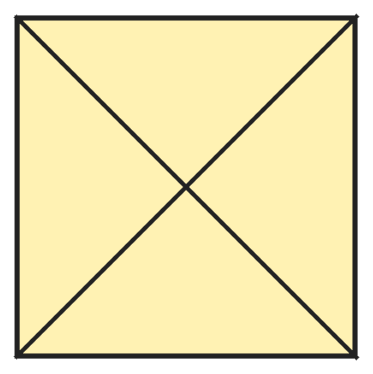
Q12. Kush draws a square and both of its diagonals. How many pairs of these six line segments are perpendicular to each other?
(A) 4 | (B) 5 | (C) 6 | (D) 2

Q13. Three corners of a square are at (row 1, column 2), (row 1, column 6) and (row 5, column 6). Where is the fourth corner?
(A) Row 6, column 2 | (B) Row 5, column 1
(C) Row 1, column 5 | (D) Row 5, column 2

Part 5 — Mensuration (Syllabus Chapter 6)
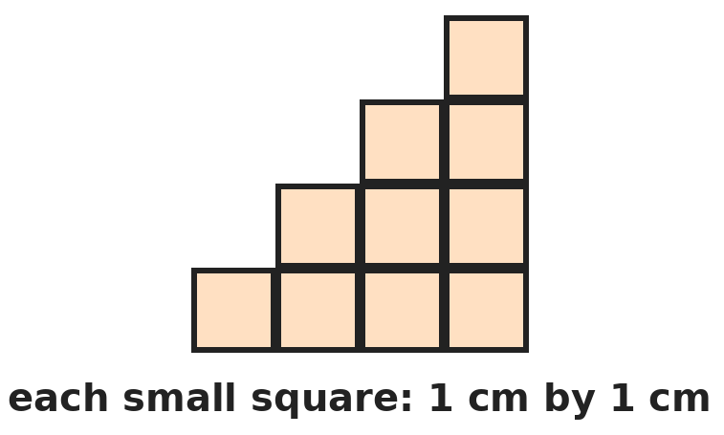
Q14. This staircase is made of 1 cm squares. What is its perimeter?
(A) 16 cm | (B) 20 cm | (C) 10 cm | (D) 40 cm

Q15. A room is 6 m long and 5 m wide. A skirting board runs along the bottom of all the walls, except at the door, which is 1 m wide. It costs ₹25 per metre. What does it cost?
(A) ₹550 | (B) ₹525 | (C) ₹750 | (D) ₹275

Q16. A cake weighs 2 kg. Mother cuts it into 8 equal pieces. Rohan eats 3 pieces. What is the weight of cake that Rohan eats?
(A) 250 g | (B) 600 g | (C) 1 kg 250 g | (D) 750 g

Q17. A tank has 50 L of water. Each day 2 L 750 mL is used in the morning and 3 L 250 mL in the evening. For how many full days will the water last?
(A) 8 | (B) 9 | (C) 6 | (D) 10

Part 6 — Data Handling (Syllabus Chapter 8)
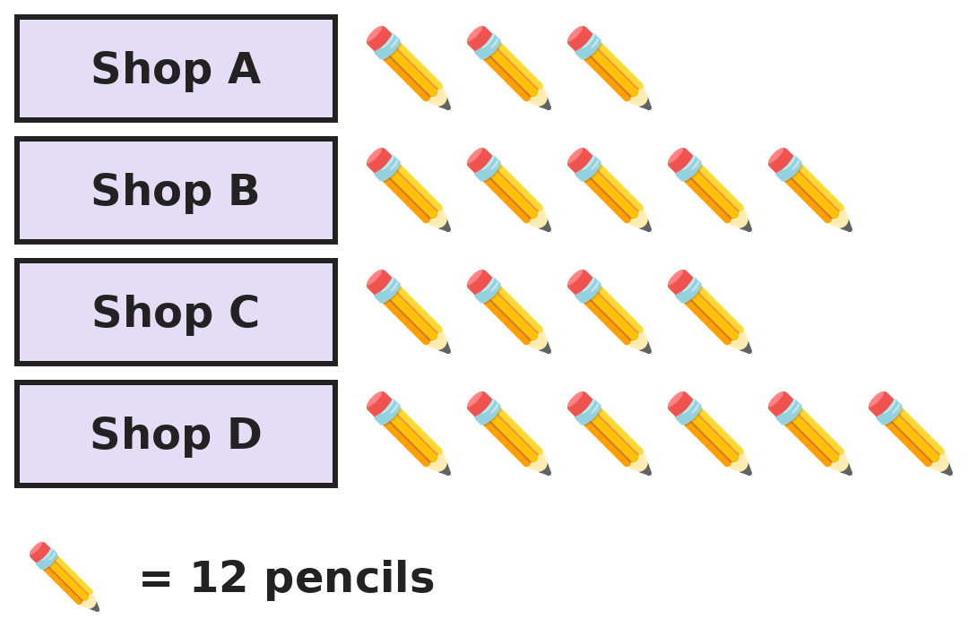
Q18. The pictograph shows the pencils sold by four shops in a day. Each pencil costs ₹5. How much money did the four shops get in all?
(A) ₹216 | (B) ₹90 | (C) ₹1,080 | (D) ₹1,200

Part 7 — Applied Mathematics (Syllabus Chapter 9)
Q19. Rekha's cake needs 1 hour 35 minutes of baking and then 50 minutes of cooling. She wants it ready at 4:15 PM. When must she start baking?
(A) 2:40 PM | (B) 2:00 PM | (C) 1:50 PM | (D) 1:40 PM

Q20. In a certain year, 12 November is a Sunday. What day of the week was 2 October in the same year?
(A) Monday | (B) Saturday | (C) Tuesday | (D) Sunday

Q21. Shalini has ₹220 in ₹5 and ₹10 coins. She has 4 more ₹10 coins than ₹5 coins. How many coins does she have in all?
(A) 28 | (B) 24 | (C) 16 | (D) 32

Part 8 — Mathematical Reasoning (Syllabus Chapter 10)

Q22. Vinay's series uses the same rule each time. Which number comes next?
(A) 158 | (B) 159 | (C) 119 | (D) 160

Q23. Yamini makes 3-digit numbers from the digits 1, 2, 3, 4 and 5. Each digit is bigger than the one before, like 135. How many such numbers can she make?
(A) 6 | (B) 10 | (C) 12 | (D) 60

Q24. Pratik has 9 coins that look the same. One is a little heavier. With a two-pan balance, what is the least number of weighings that will always find the heavy coin?
(A) 3 | (B) 4 | (C) 8 | (D) 2

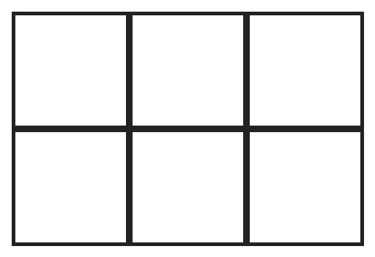
Q25. How many rectangles of all sizes are there in this grid? (Squares count as rectangles.)
(A) 6 | (B) 12 | (C) 18 | (D) 17

Part 9 — Mixed Problems (each joins two chapters)
Q26. Bhavna has a 1 L bottle of juice. Each day she drinks half of what is left in the bottle. After how many days is 1/8 L left?
(A) 4 | (B) 8 | (C) 3 | (D) 2

Q27. In a year that is not a leap year, 1 January is a Sunday. In how many months of that year are there five Sundays?
(A) 4 | (B) 5 | (C) 6 | (D) 1

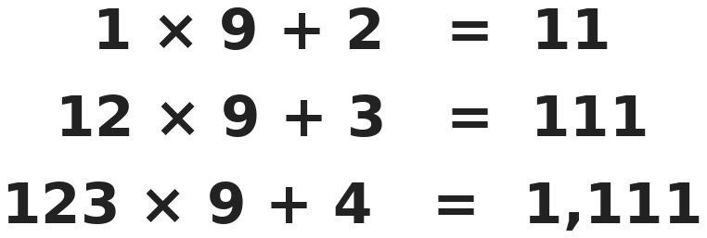
Q28. Look at the pattern. What is 1,234 × 9 + 5?
(A) 11,011 | (B) 11,106 | (C) 11,111 | (D) 10,111

Q29. A school bag costs ₹840. Mother pays 3/4 of the price. Om pays the rest from his savings of ₹500. How much does Om have left?
(A) ₹210 | (B) ₹130 | (C) ₹340 | (D) ₹290

Q30. Eight 1 cm cubes are put together to make a 2 cm cube. What is the total area of the small cube faces that are hidden inside the big cube?
(A) 48 cm² | (B) 24 cm² | (C) 12 cm² | (D) 6 cm²

Answer Sheet AMO Level 2 · Class 4 · Practice Paper 7
Name: | School: | Roll No.:
Shade or tick one circle for each question.
1. | Ⓐ Ⓑ Ⓒ Ⓓ | 11. | Ⓐ Ⓑ Ⓒ Ⓓ | 21. | Ⓐ Ⓑ Ⓒ Ⓓ
2. | Ⓐ Ⓑ Ⓒ Ⓓ | 12. | Ⓐ Ⓑ Ⓒ Ⓓ | 22. | Ⓐ Ⓑ Ⓒ Ⓓ
3. | Ⓐ Ⓑ Ⓒ Ⓓ | 13. | Ⓐ Ⓑ Ⓒ Ⓓ | 23. | Ⓐ Ⓑ Ⓒ Ⓓ
4. | Ⓐ Ⓑ Ⓒ Ⓓ | 14. | Ⓐ Ⓑ Ⓒ Ⓓ | 24. | Ⓐ Ⓑ Ⓒ Ⓓ
5. | Ⓐ Ⓑ Ⓒ Ⓓ | 15. | Ⓐ Ⓑ Ⓒ Ⓓ | 25. | Ⓐ Ⓑ Ⓒ Ⓓ
6. | Ⓐ Ⓑ Ⓒ Ⓓ | 16. | Ⓐ Ⓑ Ⓒ Ⓓ | 26. | Ⓐ Ⓑ Ⓒ Ⓓ
7. | Ⓐ Ⓑ Ⓒ Ⓓ | 17. | Ⓐ Ⓑ Ⓒ Ⓓ | 27. | Ⓐ Ⓑ Ⓒ Ⓓ
8. | Ⓐ Ⓑ Ⓒ Ⓓ | 18. | Ⓐ Ⓑ Ⓒ Ⓓ | 28. | Ⓐ Ⓑ Ⓒ Ⓓ
9. | Ⓐ Ⓑ Ⓒ Ⓓ | 19. | Ⓐ Ⓑ Ⓒ Ⓓ | 29. | Ⓐ Ⓑ Ⓒ Ⓓ
10. | Ⓐ Ⓑ Ⓒ Ⓓ | 20. | Ⓐ Ⓑ Ⓒ Ⓓ | 30. | Ⓐ Ⓑ Ⓒ Ⓓ

For the parent or teacher
Correct: ______ / 30
Answer Key and Solutions AMO Level 2 · Class 4 · Practice Paper 7
Quick answers
1 D | 6 A | 11 A | 16 D | 21 A | 26 C
2 B | 7 D | 12 B | 17 A | 22 B | 27 B
3 A | 8 D | 13 D | 18 C | 23 B | 28 C
4 C | 9 B | 14 A | 19 C | 24 D | 29 D
5 D | 10 C | 15 B | 20 A | 25 C | 30 B
Solutions
Q | Part · level | Answer | Why?
1 | Part 1 · Ch1 · Hard | (D) 41,762 | Hint: The first digit is 4, so the last digit is 2.  First digit 4, so the ones digit is 2. Hundreds: 2 + 5 = 7. Tens: 4 + 2 = 6. Thousands: 7 − 6 = 1. The number is 41,762.
2 | Part 1 · Ch1 · Hard | (B) 52,500 | Hint: The numbers she says always end in 000 or 500, and go 40,000, 42,500, …  She says 37,500, 40,000, 42,500, 45,000, 47,500, 50,000, 52,500, 55,000, … So 52,500 is said. 49,500 is between 47,500 and 50,000, 51,000 is between 50,000 and 52,500, and 53,750 is between 52,500 and 55,000, so she never says them.
3 | Part 1 · Ch1 · Hard | (A) 21 | Hint: VIII has 4 letters.  I (1), II (2), III (3), IV (2), V (1), VI (2), VII (3), VIII (4), IX (2), X (1). 1 + 2 + 3 + 2 + 1 + 2 + 3 + 4 + 2 + 1 = 21.
4 | Part 2 · Ch2 · Hard | (C) 58 | Hint: Work out 98 × 21 exactly: 98 × 20 + 98.  Estimate: 100 × 20 = 2,000. Exact: 98 × 21 = 98 × 20 + 98 = 1,960 + 98 = 2,058. 2,058 − 2,000 = 58.
5 | Part 2 · Ch2 · Hard | (D) ₹243 | Hint: How many packs make 36 pens?  36 ÷ 4 = 9 packs. 9 × 27 = ₹243.
6 | Part 2 · Ch2 · Hard | (A) All four are equal | Hint: Work each one out, or look for ways to regroup.  25 × 36 = 900. 30 × 30 = 900. 45 × 20 = 900. 18 × 50 = 900. All four are equal.
7 | Part 3 · Ch3 · Hard | (D) Ravi, by 1/5 km | Hint: Write 4/5 as tenths.  Ravi walks 3/10 + 7/10 = 10/10 = 1 km. Asha walks 4/5 = 8/10 km. Ravi walks 2/10 = 1/5 km farther.
8 | Part 3 · Ch3 · Hard | (D) 1/8 | Hint: Write all three fractions as eighths.  1/2 + 1/4 + 1/8 = 4/8 + 2/8 + 1/8 = 7/8. Still empty: 8/8 − 7/8 = 1/8.
9 | Part 3 · Ch3 · Hard | (B) 37.2 °C | Hint: Subtract first, then add.  38.4 − 1.9 = 36.5. 36.5 + 0.7 = 37.2 °C.
10 | Part 3 · Ch3 · Hard | (C) 7/12 | Hint: Write 5/6 and 1/4 as twelfths.  5/6 = 10/12 and 1/4 = 3/12. Rice: 10/12 − 3/12 = 7/12 of the field.
11 | Part 4 · Ch5 · Hard | (A) 22 | Hint: A pentagonal pyramid has 5 base edges and 5 slanting edges.  Pentagonal pyramid: 5 + 5 = 10 edges. Hexagonal prism: 6 vertices on each base, so 12 vertices. 10 + 12 = 22.
12 | Part 4 · Ch5 · Hard | (B) 5 | Hint: The two diagonals of a square also cross at a square corner.  Each side is perpendicular to the 2 sides next to it, which gives 4 pairs (one at each corner). The two diagonals are also perpendicular. 4 + 1 = 5.
13 | Part 4 · Ch5 · Hard | (D) Row 5, column 2 | Hint: Opposite sides of a square line up with each other.  The top side goes from column 2 to column 6 on row 1. The right side goes from row 1 to row 5 on column 6. So the bottom-left corner is at row 5, column 2.
14 | Part 5 · Ch6 · Hard | (A) 16 cm | Hint: Push the small steps out to make a rectangle. Does the perimeter change?  The steps going up add up to 4 cm and the steps going across add up to 4 cm. With the bottom (4 cm) and left side (4 cm), the perimeter is 4 + 4 + 4 + 4 = 16 cm.
15 | Part 5 · Ch6 · Hard | (B) ₹525 | Hint: Find the perimeter of the room first.  Perimeter = 2 × (6 + 5) = 22 m. Without the door: 21 m. Cost: 21 × 25 = ₹525.
16 | Part 5 · Ch6 · Hard | (D) 750 g | Hint: Change 2 kg into grams.  2 kg = 2,000 g. One piece: 2,000 ÷ 8 = 250 g. Three pieces: 750 g.
17 | Part 5 · Ch6 · Hard | (A) 8 | Hint: Find the water used in one whole day.  Each day: 2 L 750 mL + 3 L 250 mL = 6 L. 50 ÷ 6 = 8 remainder 2, so the water lasts 8 full days (2 L is left).
18 | Part 6 · Ch8 · Hard | (C) ₹1,080 | Hint: Count all the symbols first.  Symbols: 3 + 5 + 4 + 6 = 18. Pencils: 18 × 12 = 216. Money: 216 × 5 = ₹1,080.
19 | Part 7 · Ch9 · Hard | (C) 1:50 PM | Hint: Add the two times, then count back from 4:15 PM.  1 h 35 min + 50 min = 2 h 25 min. 4:15 PM − 2 h = 2:15 PM. 2:15 PM − 25 min = 1:50 PM.
20 | Part 7 · Ch9 · Hard | (A) Monday | Hint: October has 31 days. Count the days from 2 October to 12 November.  From 2 October to 31 October: 29 days. Then 12 more days to 12 November: 41 days. 41 = 5 weeks + 6 days. 6 days before Sunday is Monday.
21 | Part 7 · Ch9 · Hard | (A) 28 | Hint: Put the 4 extra ₹10 coins aside first.  The 4 extra ₹10 coins make ₹40, leaving ₹180. Each pair of one ₹5 and one ₹10 coin makes ₹15. 180 ÷ 15 = 12 pairs. So 12 coins of ₹5 and 16 of ₹10: 28 coins.
22 | Part 8 · Ch10 · Hard | (B) 159 | Hint: Double each number and then add something.  Each number is double the one before plus 1: 4 × 2 + 1 = 9, 9 × 2 + 1 = 19, … 79 × 2 + 1 = 159.
23 | Part 8 · Ch10 · Hard | (B) 10 | Hint: Once you choose three digits, there is only one way to put them in increasing order.  List them: 123, 124, 125, 134, 135, 145, 234, 235, 245, 345. That is 10.
24 | Part 8 · Ch10 · Hard | (D) 2 | Hint: Put the coins in 3 groups of 3.  Weigh 3 coins against 3. If one side is heavier, the coin is there; if they balance, it is in the other 3. Then weigh 1 coin against 1 of those 3 in the same way. So 2 weighings are enough. One weighing cannot decide among 9 coins.
25 | Part 8 · Ch10 · Hard | (C) 18 | Hint: Choose 2 of the 4 upright lines and 2 of the 3 flat lines.  There are 4 upright lines, so 6 ways to choose a left and right side. There are 3 flat lines, so 3 ways to choose a top and bottom. 6 × 3 = 18 rectangles.
26 | Part 9 · Mixed · Ch3 + Ch10 · Hard | (C) 3 | Hint: Write the amount left after each day.  After day 1: 1/2 L. After day 2: 1/4 L. After day 3: 1/8 L. So after 3 days.
27 | Part 9 · Mixed · Ch9 + Ch10 · Hard | (B) 5 | Hint: A month has five Sundays if its first Sunday is on the 1st, 2nd or 3rd, depending on its length.  The year has 365 = 52 weeks + 1 day, so there are 53 Sundays. 12 months × 4 = 48, so 5 months have a 5th Sunday. (They are January, April, July, October and December.)
28 | Part 9 · Mixed · Ch1 + Ch10 · Hard | (C) 11,111 | Hint: Each answer has one more 1 than the line before.  The answers are 11, 111, 1,111, so the next is 11,111.
29 | Part 9 · Mixed · Ch3 + Ch9 · Hard | (D) ₹290 | Hint: Om pays 1/4 of the price.  Om pays 1/4 of ₹840 = ₹210. He has 500 − 210 = ₹290 left.
30 | Part 9 · Mixed · Ch5 + Ch6 · Hard | (B) 24 cm² | Hint: Find the area of all the small faces, then the area of the outside of the big cube.  All small faces: 8 × 6 = 48 faces of 1 cm², which is 48 cm². The outside of the big cube: 6 faces of 2 × 2 = 4 cm², which is 24 cm². Hidden: 48 − 24 = 24 cm².

ARYABHATTA MATHS OLYMPIAD
Level 2
PRACTICE PAPER-8
CLASS 4
Total Questions | 30 multiple-choice questions
Level | Level-2 (final round): every question is Hard
Time | 45 minutes
Arrangement | Parts by chapter; the last Part has mixed problems joining two chapters
Negative Marking | No negative marking
Calculator | Not allowed
Chapters | Number System · Operations · Fractions & Decimals · Geometry · Mensuration · Data Handling · Applied Mathematics · Mathematical Reasoning

👋 Hello, friend! How to do this paper:
⭐ Every question has four answer choices: (A), (B), (C) and (D). Only one is correct.
⭐ Read each question and look at its picture carefully. Then mark your answer on the answer sheet at the end.
⭐ This is a Level-2 paper. Every question needs careful thinking, so take your time and check each step.
⭐ The questions are in Parts by chapter. The last Part has mixed problems that join two chapters.
⭐ There is no negative marking, so try every question.
⭐ Do not use a calculator. You may do rough work on a separate sheet.
⭐ All figures are not necessarily drawn to scale unless stated.

For parents and teachers
• Pictures are part of the questions. Every picture also works when printed in black and white.
• You may read a question aloud to the child, exactly as printed. Please do not explain it or point to an answer choice.
• Parts follow the AMO syllabus chapters. Chapters 4 and 7 are not part of the Class 4 syllabus, so the chapter numbers shown in the Part headings have gaps.
• The answer sheet and the answer key are at the end. Remove only the answer key before the child begins.

Part 1 — Number System (Syllabus Chapter 1)
Q1. Sneha makes the largest and the smallest 5-digit numbers using each of the digits 2, 4, 6, 8 and 0 once. What is the difference between them?
(A) 61,740 | (B) 64,952 | (C) 66,952 | (D) 65,952

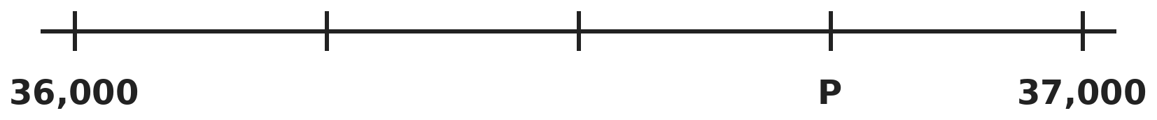
Q2. The marks on this number line are equally spaced. What number is 1,250 more than the number at P?
(A) 37,750 | (B) 38,000 | (C) 37,500 | (D) 38,250

Q3. Mohit's grandfather writes his age as XLVIII. In how many years will his age first be written with just one Roman letter?
(A) 2 | (B) 12 | (C) 52 | (D) 1

Part 2 — Operations (Syllabus Chapter 2)
Q4. At a sports meet, 1,248 students are put into 8 equal groups. Each group is then split into 4 equal teams. How many students are in each team?
(A) 156 | (B) 312 | (C) 39 | (D) 49

Q5. Raj makes all the 3-digit numbers that use each of the digits 1, 2 and 3 once. What is the sum of all his numbers?
(A) 666 | (B) 1,233 | (C) 1,332 | (D) 1,998

Q6. Kriti makes both sides equal. Which number replaces the question mark?
(A) 80 | (B) 85 | (C) 75 | (D) 1,020

Part 3 — Fractions & Decimals (Syllabus Chapter 3)
Q7. In Vani's class, 1/3 of the students like cricket best and 1/4 like football best. The other 20 students like hockey best. How many students are in the class?
(A) 40 | (B) 60 | (C) 35 | (D) 48

Q8. Which pair of fractions are equal to each other?
(A) 3/4 and 4/5 | (B) 5/10 and 6/11 | (C) 4/6 and 6/9 | (D) 2/3 and 3/4

Q9. Sahil picks two of these numbers: 2.7, 4.6, 3.9, 1.8. He wants their sum to be as close to 6 as possible. Which two should he pick?
(A) 3.9 and 1.8 | (B) 4.6 and 1.8 | (C) 2.7 and 3.9 | (D) 2.7 and 4.6

Q10. A bucket has 6 1/3 L of water. Gopal uses 2 3/4 L to water plants. How much water is left?
(A) 4 7/12 L | (B) 3 5/12 L | (C) 3 7/12 L | (D) 4 1/12 L

Part 4 — Geometry (Syllabus Chapter 5)
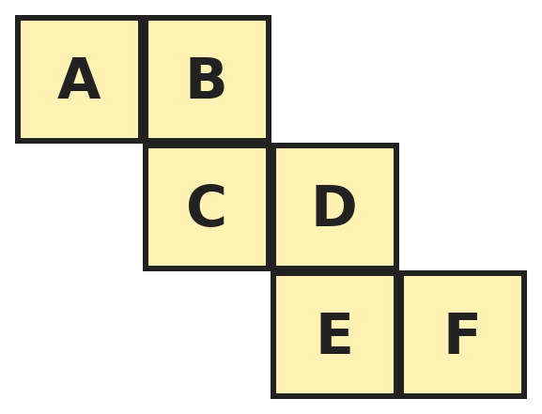
Q11. This net is folded to make a cube. Which letter is on the face opposite A?
(A) B | (B) D | (C) C | (D) F

Q12. A cube has 12 edges. How many pairs of edges are parallel to each other?
(A) 18 | (B) 12 | (C) 6 | (D) 24

Q13. Malti looks at a cylinder from different directions. Which of these shapes can she NEVER see as a view?
(A) A circle | (B) A triangle | (C) A rectangle | (D) A square

Part 5 — Mensuration (Syllabus Chapter 6)
Q14. A rectangle is 5 cm long and 3 cm wide. Esha doubles both its length and its width. By how much does the area grow?
(A) 15 cm² | (B) 30 cm² | (C) 45 cm² | (D) 60 cm²

Q15. A garden is 30 m long and 20 m wide. Two paths, each 2 m wide, cross in the middle: one runs the whole length and one the whole width. What is the area of the paths?
(A) 96 m² | (B) 100 m² | (C) 104 m² | (D) 92 m²

Q16. A shopkeeper fills packets with 400 g of sugar each, using 3 kg 200 g of sugar. He sells each packet for ₹28. How much does he get for all the packets?
(A) ₹2,240 | (B) ₹196 | (C) ₹252 | (D) ₹224

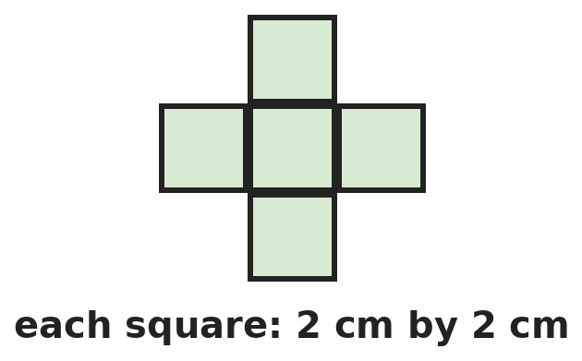
Q17. This plus shape is made of 5 squares, each 2 cm by 2 cm. What is its perimeter?
(A) 20 cm | (B) 40 cm | (C) 12 cm | (D) 24 cm

Part 6 — Data Handling (Syllabus Chapter 8)
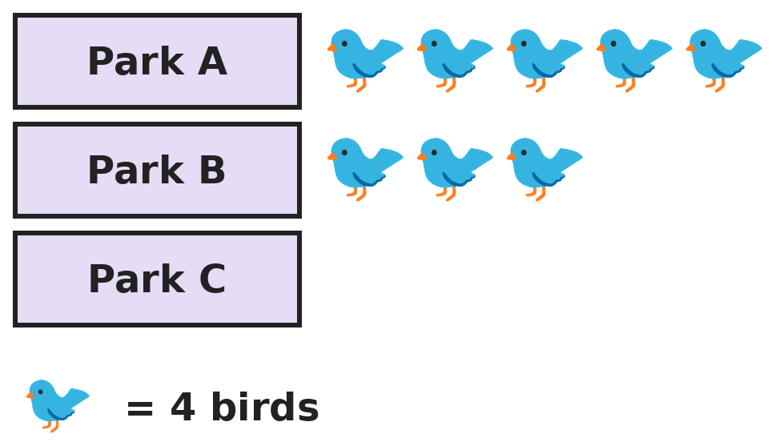
Q18. Children counted 52 birds in three parks. The row for Park C is still empty. How many symbols should be drawn for Park C?
(A) 8 | (B) 5 | (C) 13 | (D) 20

Part 7 — Applied Mathematics (Syllabus Chapter 9)
Q19. A shop is open from 9:35 AM to 1:10 PM and again from 3:45 PM to 8:20 PM. For how long is it open in all?
(A) 8 h 10 min | (B) 7 h 10 min | (C) 8 h 50 min | (D) 9 h 10 min

Q20. In a year that is not a leap year, 1 January is a Thursday. On which date is the first Sunday in March?
(A) 4 March | (B) 2 March | (C) 7 March | (D) 1 March

Q21. A shop sells notebooks at 3 for ₹40. Another shop sells the same notebooks at 5 for ₹65. Lata needs 15 notebooks. Which shop is cheaper, and by how much?
(A) The first shop, by ₹5 | (B) The second shop, by ₹15
(C) The second shop, by ₹5 | (D) Both cost the same

Part 8 — Mathematical Reasoning (Syllabus Chapter 10)

Q22. Raghav's series adds a different odd number each time. Which number comes next?
(A) 35 | (B) 37 | (C) 36 | (D) 39


Q23. A and B are different digits, and BA is a 2-digit number. For how many digits A is this true?
(A) 1 | (B) 3 | (C) 2 | (D) 4

Q24. How many numbers from 1 to 100 have digits that add up to 9?
(A) 10 | (B) 9 | (C) 11 | (D) 8

Q25. In 5 years, Meera will be twice as old as she was 5 years ago. How old is Meera now?
(A) 10 | (B) 15 | (C) 20 | (D) 25

Part 9 — Mixed Problems (each joins two chapters)
Q26. Ananya writes the fractions 1/12, 2/12, 3/12, …, 11/12. How many of them can be written with a smaller denominator?
(A) 4 | (B) 6 | (C) 5 | (D) 7

Q27. The day after tomorrow is a Sunday. What day of the week will it be 100 days from today?
(A) Friday | (B) Sunday | (C) Tuesday | (D) Saturday

Q28. A palindrome reads the same both ways, like 12,321. How many 5-digit palindromes have digits that add up to 9?
(A) 10 | (B) 9 | (C) 8 | (D) 12

Q29. Cloth costs ₹120 per metre. Sita buys 2 1/2 m of blue cloth and 1 3/4 m of red cloth. How much does she pay?
(A) ₹480 | (B) ₹540 | (C) ₹420 | (D) ₹510

Q30. A sheet of paper is 12 cm long and 8 cm wide. Rupa folds it in half so that the two 8 cm sides meet. How much smaller is the perimeter of the folded shape than that of the sheet?
(A) 8 cm | (B) 20 cm | (C) 12 cm | (D) 16 cm

Answer Sheet AMO Level 2 · Class 4 · Practice Paper 8
Name: | School: | Roll No.:
Shade or tick one circle for each question.
1. | Ⓐ Ⓑ Ⓒ Ⓓ | 11. | Ⓐ Ⓑ Ⓒ Ⓓ | 21. | Ⓐ Ⓑ Ⓒ Ⓓ
2. | Ⓐ Ⓑ Ⓒ Ⓓ | 12. | Ⓐ Ⓑ Ⓒ Ⓓ | 22. | Ⓐ Ⓑ Ⓒ Ⓓ
3. | Ⓐ Ⓑ Ⓒ Ⓓ | 13. | Ⓐ Ⓑ Ⓒ Ⓓ | 23. | Ⓐ Ⓑ Ⓒ Ⓓ
4. | Ⓐ Ⓑ Ⓒ Ⓓ | 14. | Ⓐ Ⓑ Ⓒ Ⓓ | 24. | Ⓐ Ⓑ Ⓒ Ⓓ
5. | Ⓐ Ⓑ Ⓒ Ⓓ | 15. | Ⓐ Ⓑ Ⓒ Ⓓ | 25. | Ⓐ Ⓑ Ⓒ Ⓓ
6. | Ⓐ Ⓑ Ⓒ Ⓓ | 16. | Ⓐ Ⓑ Ⓒ Ⓓ | 26. | Ⓐ Ⓑ Ⓒ Ⓓ
7. | Ⓐ Ⓑ Ⓒ Ⓓ | 17. | Ⓐ Ⓑ Ⓒ Ⓓ | 27. | Ⓐ Ⓑ Ⓒ Ⓓ
8. | Ⓐ Ⓑ Ⓒ Ⓓ | 18. | Ⓐ Ⓑ Ⓒ Ⓓ | 28. | Ⓐ Ⓑ Ⓒ Ⓓ
9. | Ⓐ Ⓑ Ⓒ Ⓓ | 19. | Ⓐ Ⓑ Ⓒ Ⓓ | 29. | Ⓐ Ⓑ Ⓒ Ⓓ
10. | Ⓐ Ⓑ Ⓒ Ⓓ | 20. | Ⓐ Ⓑ Ⓒ Ⓓ | 30. | Ⓐ Ⓑ Ⓒ Ⓓ

For the parent or teacher
Correct: ______ / 30
Answer Key and Solutions AMO Level 2 · Class 4 · Practice Paper 8
Quick answers
1 D | 6 B | 11 B | 16 D | 21 C | 26 D
2 B | 7 D | 12 A | 17 D | 22 B | 27 B
3 A | 8 C | 13 B | 18 B | 23 C | 28 A
4 C | 9 A | 14 C | 19 A | 24 A | 29 D
5 C | 10 C | 15 A | 20 D | 25 B | 30 C
Solutions
Q | Part · level | Answer | Why?
1 | Part 1 · Ch1 · Hard | (D) 65,952 | Hint: The smallest number cannot start with 0.  Largest: 86,420. Smallest: 20,468 (0 goes second). 86,420 − 20,468 = 65,952.
2 | Part 1 · Ch1 · Hard | (B) 38,000 | Hint: There are 4 equal gaps between 36,000 and 37,000.  Each gap is 1,000 ÷ 4 = 250. P is 3 gaps after 36,000: 36,750. 36,750 + 1,250 = 38,000.
3 | Part 1 · Ch1 · Hard | (A) 2 | Hint: Which Roman letters stand for numbers bigger than 48?  XLVIII = 48. The one-letter numerals above 48 are L (50) and C (100). He reaches 50 first, in 2 years.
4 | Part 2 · Ch2 · Hard | (C) 39 | Hint: Divide by 8, then by 4.  1,248 ÷ 8 = 156 students in each group. 156 ÷ 4 = 39 students in each team.
5 | Part 2 · Ch2 · Hard | (C) 1,332 | Hint: Each digit appears twice in the hundreds place, twice in the tens place and twice in the ones place.  The numbers are 123, 132, 213, 231, 312, 321. Each place has each digit twice, so each place adds to 2 × (1 + 2 + 3) = 12. Sum = 1,200 + 120 + 12 = 1,332.
6 | Part 2 · Ch2 · Hard | (B) 85 | Hint: 960 = 12 × 80.  960 = 12 × 80, so the right side is 12 × 80 + 12 × 5 = 12 × 85. The box is 85. (Check: 960 + 60 = 1,020 = 85 × 12.)
7 | Part 3 · Ch3 · Hard | (D) 48 | Hint: What fraction of the class likes hockey?  Cricket and football: 1/3 + 1/4 = 4/12 + 3/12 = 7/12. Hockey: 5/12 of the class = 20, so 1/12 = 4 students. The class has 12 × 4 = 48 students.
8 | Part 3 · Ch3 · Hard | (C) 4/6 and 6/9 | Hint: Write each fraction in its simplest form.  4/6 = 2/3 and 6/9 = 2/3, so they are equal. 3/4 is less than 4/5. 5/10 is exactly 1/2 but 6/11 is more than 1/2. 2/3 is less than 3/4.
9 | Part 3 · Ch3 · Hard | (A) 3.9 and 1.8 | Hint: Work out each sum and how far it is from 6.  3.9 + 1.8 = 5.7 (0.3 away). 4.6 + 1.8 = 6.4 (0.4 away). 2.7 + 3.9 = 6.6 (0.6 away). 2.7 + 4.6 = 7.3. The closest is 3.9 and 1.8.
10 | Part 3 · Ch3 · Hard | (C) 3 7/12 L | Hint: Write the fractions as twelfths. 1/3 is less than 3/4, so you need to borrow 1.  6 1/3 = 6 4/12 = 5 16/12. 2 3/4 = 2 9/12. 5 16/12 − 2 9/12 = 3 7/12 L.
11 | Part 4 · Ch5 · Hard | (B) D | Hint: Fold with C on the bottom. Where do B, A and D go?  With C on the bottom, B folds up as the back, A as the left side and D as the right side. E becomes the front and F the top. So A (left) is opposite D (right). Also B is opposite E and C is opposite F.
12 | Part 4 · Ch5 · Hard | (A) 18 | Hint: The edges go in 3 directions, with 4 edges in each direction.  There are 4 upright edges, 4 left-right edges and 4 front-back edges. In each set of 4 parallel edges there are 6 pairs (4 × 3 ÷ 2). 3 × 6 = 18 pairs.
13 | Part 4 · Ch5 · Hard | (B) A triangle | Hint: A cylinder can be short and wide or tall and thin.  From the top a cylinder looks like a circle. From the side it looks like a rectangle, and if its height equals its width that rectangle is a square. It has no pointed parts, so it never looks like a triangle.
14 | Part 5 · Ch6 · Hard | (C) 45 cm² | Hint: Find the new area. It is not just double the old one.  Old area: 5 × 3 = 15 cm². New rectangle: 10 cm by 6 cm, area 60 cm². Growth: 60 − 15 = 45 cm². (The area becomes 4 times as big.)
15 | Part 5 · Ch6 · Hard | (A) 96 m² | Hint: The square where the paths cross must be counted only once.  Long path: 30 × 2 = 60 m². Short path: 20 × 2 = 40 m². The crossing square of 2 × 2 = 4 m² is in both. 60 + 40 − 4 = 96 m².
16 | Part 5 · Ch6 · Hard | (D) ₹224 | Hint: Change 3 kg 200 g to grams and find the number of packets.  3 kg 200 g = 3,200 g. 400 g × 8 = 3,200 g, so 8 packets. 8 × ₹28 = ₹224.
17 | Part 5 · Ch6 · Hard | (D) 24 cm | Hint: Count the square sides on the outside.  Each of the 4 arms shows 3 outside sides, and the middle square shows none. 4 × 3 = 12 sides of 2 cm. 12 × 2 = 24 cm.
18 | Part 6 · Ch8 · Hard | (B) 5 | Hint: How many symbols stand for 52 birds?  52 birds = 52 ÷ 4 = 13 symbols. Parks A and B have 5 + 3 = 8 symbols. Park C needs 13 − 8 = 5 symbols.
19 | Part 7 · Ch9 · Hard | (A) 8 h 10 min | Hint: Find each part separately.  9:35 AM to 1:10 PM: 3 h 35 min. 3:45 PM to 8:20 PM: 4 h 35 min. Total: 7 h 70 min = 8 h 10 min.
20 | Part 7 · Ch9 · Hard | (D) 1 March | Hint: Find the day of the week of 1 March.  1 March is 31 + 28 = 59 days after 1 January. 59 = 8 weeks + 3 days. 3 days after Thursday is Sunday, so 1 March is itself a Sunday.
21 | Part 7 · Ch9 · Hard | (C) The second shop, by ₹5 | Hint: 15 notebooks are 5 packs of 3 or 3 packs of 5.  First shop: 5 × 40 = ₹200. Second shop: 3 × 65 = ₹195. The second shop is cheaper by ₹5.
22 | Part 8 · Ch10 · Hard | (B) 37 | Hint: The numbers added are 3, 5, 7, …  The series adds 3, 5, 7, 9. Next it adds 11: 26 + 11 = 37.
23 | Part 8 · Ch10 · Hard | (C) 2 | Hint: Look for a digit whose square ends in the same digit.  Squares that are 2-digit numbers: 16, 25, 36, 49, 64, 81. Only 25 (A = 5) and 36 (A = 6) end in A. So 2 digits work.
24 | Part 8 · Ch10 · Hard | (A) 10 | Hint: Start with 9, then 18, 27, …  They are 9, 18, 27, 36, 45, 54, 63, 72, 81 and 90. That is 10 numbers.
25 | Part 8 · Ch10 · Hard | (B) 15 | Hint: Try some ages. For age 12: in 5 years 17, 5 years ago 7.  Try 15: in 5 years she will be 20, and 5 years ago she was 10. 20 is twice 10. So Meera is 15.
26 | Part 9 · Mixed · Ch3 + Ch10 · Hard | (D) 7 | Hint: Which tops share a factor with 12, like 2/12 = 1/6?  2/12 = 1/6, 3/12 = 1/4, 4/12 = 1/3, 6/12 = 1/2, 8/12 = 2/3, 9/12 = 3/4, 10/12 = 5/6. That is 7. 1/12, 5/12, 7/12 and 11/12 cannot be simplified.
27 | Part 9 · Mixed · Ch9 + Ch10 · Hard | (B) Sunday | Hint: First find today.  The day after tomorrow is Sunday, so today is Friday. 100 = 14 weeks + 2 days. 2 days after Friday is Sunday.
28 | Part 9 · Mixed · Ch1 + Ch10 · Hard | (A) 10 | Hint: In a palindrome ABCBA, the digit sum is 2A + 2B + C. Try A = 1, 2, 3, 4.  2A + 2B + C = 9. A = 1: 2B + C = 7, so B = 0, 1, 2 or 3 (4 ways). A = 2: 2B + C = 5, B = 0, 1, 2 (3 ways). A = 3: 2B + C = 3, B = 0 or 1 (2 ways). A = 4: B = 0, C = 1 (1 way). 4 + 3 + 2 + 1 = 10.
29 | Part 9 · Mixed · Ch3 + Ch9 · Hard | (D) ₹510 | Hint: Add the lengths first.  2 1/2 + 1 3/4 = 2 2/4 + 1 3/4 = 4 1/4 m. 4 m cost 4 × 120 = ₹480. 1/4 m costs 1/4 of 120 = ₹30. Total ₹510.
30 | Part 9 · Mixed · Ch5 + Ch6 · Hard | (C) 12 cm | Hint: After folding, the shape is 6 cm long and 8 cm wide.  Sheet: 2 × (12 + 8) = 40 cm. Folded: 6 cm by 8 cm, so 2 × (6 + 8) = 28 cm. 40 − 28 = 12 cm.

ARYABHATTA MATHS OLYMPIAD
Level 2
PRACTICE PAPER-9
CLASS 4
Total Questions | 30 multiple-choice questions
Level | Level-2 (final round): every question is Hard
Time | 45 minutes
Arrangement | Parts by chapter; the last Part has mixed problems joining two chapters
Negative Marking | No negative marking
Calculator | Not allowed
Chapters | Number System · Operations · Fractions & Decimals · Geometry · Mensuration · Data Handling · Applied Mathematics · Mathematical Reasoning

👋 Hello, friend! How to do this paper:
⭐ Every question has four answer choices: (A), (B), (C) and (D). Only one is correct.
⭐ Read each question and look at its picture carefully. Then mark your answer on the answer sheet at the end.
⭐ This is a Level-2 paper. Every question needs careful thinking, so take your time and check each step.
⭐ The questions are in Parts by chapter. The last Part has mixed problems that join two chapters.
⭐ There is no negative marking, so try every question.
⭐ Do not use a calculator. You may do rough work on a separate sheet.
⭐ All figures are not necessarily drawn to scale unless stated.

For parents and teachers
• Pictures are part of the questions. Every picture also works when printed in black and white.
• You may read a question aloud to the child, exactly as printed. Please do not explain it or point to an answer choice.
• Parts follow the AMO syllabus chapters. Chapters 4 and 7 are not part of the Class 4 syllabus, so the chapter numbers shown in the Part headings have gaps.
• The answer sheet and the answer key are at the end. Remove only the answer key before the child begins.

Part 1 — Number System (Syllabus Chapter 1)
Q1. How many whole numbers become 50,000 when they are rounded to the nearest thousand?
(A) 1,000 | (B) 999 | (C) 500 | (D) 1,001

Q2. Kiara swaps the first and last digits of 72,519. How much bigger is her new number than 72,519?
(A) 20,000 | (B) 19,998 | (C) 19,989 | (D) 20,002

Q3. Which Roman numeral is half of XCVI?
(A) XLVI | (B) LXVIII | (C) XXXVIII | (D) XLVIII

Part 2 — Operations (Syllabus Chapter 2)
Q4. A school shares 3,600 sweets equally among 8 classes. Each class shares its sweets equally among its 9 sections. How many sweets does each section get?
(A) 450 | (B) 50 | (C) 400 | (D) 45

Q5. Jaya adds 2,987 + 4,015 + 1,998 in her head by first rounding each number to the nearest thousand. What is the exact sum?
(A) 8,900 | (B) 9,000 | (C) 9,100 | (D) 9,010

Q6. Kunal should have added 6 to a number. By mistake, he multiplied the number by 6 and got 492. What is the correct answer?
(A) 88 | (B) 498 | (C) 82 | (D) 486

Part 3 — Fractions & Decimals (Syllabus Chapter 3)
Q7. Which fraction is equal to 2/3 and has a numerator and denominator that add up to 20?
(A) 9/11 | (B) 6/9 | (C) 8/12 | (D) 4/6

Q8. Rani paints 1/4 of a wall on Monday, 1/3 of it on Tuesday and 1/6 of it on Wednesday. What fraction of the wall is still not painted?
(A) 3/4 | (B) 1/12 | (C) 5/12 | (D) 1/4

Q9. A new pencil is 12.5 cm long. Arnav uses 3.8 cm of it in the first week and 2.9 cm in the second week. How long is it now?
(A) 6.7 cm | (B) 6.2 cm | (C) 5.8 cm | (D) 5.2 cm

Q10. Which of these is NOT equal to 2 3/4?
(A) 11/4 | (B) 2 6/8 | (C) 2 9/12 | (D) 2 3/8

Part 4 — Geometry (Syllabus Chapter 5)
Q11. A pyramid has 10 faces. How many edges does it have?
(A) 18 | (B) 20 | (C) 10 | (D) 16

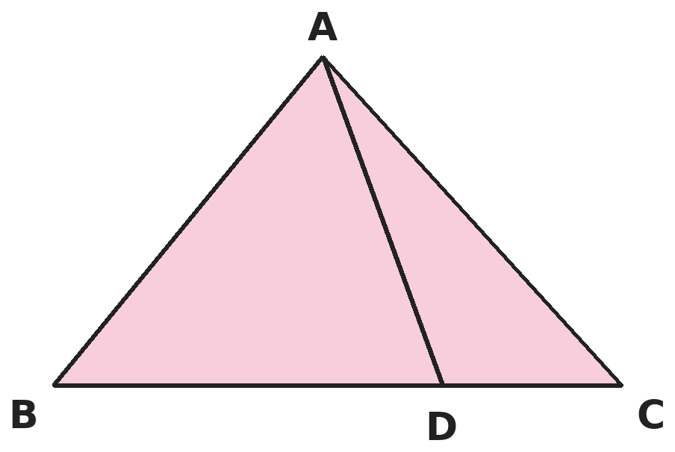
Q12. Point D is on side BC. How many different line segments are there in this picture?
(A) 6 | (B) 4 | (C) 5 | (D) 7

Q13. At each vertex of a square pyramid, Om counts how many edges meet there. Then he adds up all his counts. What total does he get?
(A) 8 | (B) 13 | (C) 20 | (D) 16

Part 5 — Mensuration (Syllabus Chapter 6)
Q14. A square garden has sides of 20 m. A path 1 m wide runs along the inside of all four sides. What is the area of the path?
(A) 80 m² | (B) 84 m² | (C) 76 m² | (D) 324 m²

Q15. A square has the same area as a rectangle 9 cm long and 4 cm wide. How much shorter is the perimeter of the square?
(A) 2 cm | (B) 0 cm | (C) 4 cm | (D) 10 cm

Q16. Lalit pours 4 L 500 mL of juice into bottles that each hold 750 mL. How many bottles can he fill completely?
(A) 6 | (B) 5 | (C) 7 | (D) 60

Q17. A field is 20 m long and 12 m wide. Posts are put all round its edge, 4 m apart, with a post at each corner. How many posts are there?
(A) 17 | (B) 18 | (C) 20 | (D) 16

Part 6 — Data Handling (Syllabus Chapter 8)
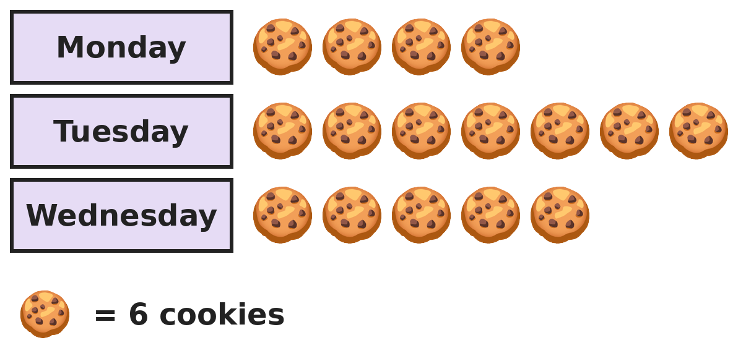
Q18. The pictograph shows cookies sold by a bakery. The cookies were sold in packets of 3. How many packets were sold on the three days?
(A) 16 | (B) 32 | (C) 96 | (D) 48

Part 7 — Applied Mathematics (Syllabus Chapter 9)
Q19. A night train leaves Pune at 9:48 PM. The journey takes 7 hours 35 minutes. At what time does it arrive?
(A) 4:23 AM | (B) 5:23 PM | (C) 5:23 AM | (D) 6:23 AM

Q20. The 1st of a month is a Wednesday. On which date is the third Friday of that month?
(A) 15th | (B) 24th | (C) 17th | (D) 10th

Q21. Rice costs ₹48 per kg and dal costs ₹115 per kg. Neelam buys 3 kg of rice and 2 kg of dal and pays with ₹500. How much change does she get?
(A) ₹337 | (B) ₹126 | (C) ₹374 | (D) ₹226

Part 8 — Mathematical Reasoning (Syllabus Chapter 10)

Q22. Pari's series adds a little more each time. Which number comes next?
(A) 25 | (B) 26 | (C) 27 | (D) 30

Q23. Akash makes 3-digit numbers from the digits 1, 2, 3 and 4, using no digit twice in a number. How many of his numbers are even?
(A) 24 | (B) 6 | (C) 12 | (D) 8

Q24. Five children ran a race. Isha finished ahead of Kabir but behind Tara. Neel finished just after Kabir. Om finished last. Who finished 3rd?
(A) Kabir | (B) Isha | (C) Neel | (D) Tara

Q25. Suresh gives half of his mangoes and 1 more to his first friend. Then he gives half of the rest and 1 more to his second friend. He has 2 mangoes left. How many did he have at the start?
(A) 10 | (B) 14 | (C) 12 | (D) 16

Part 9 — Mixed Problems (each joins two chapters)
Q26. Two fractions with denominator 12 add up to 1. Their difference is 1/6. What is the larger fraction?
(A) 5/12 | (B) 2/3 | (C) 1/2 | (D) 7/12

Q27. Holi is on Wednesday, 8 March. Ravi's birthday is 47 days after Holi. On which date and day is his birthday?
(A) 24 April, Tuesday | (B) 25 April, Monday
(C) 24 April, Monday | (D) 23 April, Sunday

Q28. How many numbers from 1 to 1,000 are written using only even digits (0, 2, 4, 6, 8)?
(A) 124 | (B) 125 | (C) 100 | (D) 120

Q29. A film runs for 2 1/4 hours, plus a 15-minute interval. The show starts at 5:50 PM. At what time does it end?
(A) 8:05 PM | (B) 8:15 PM | (C) 7:55 PM | (D) 8:20 PM

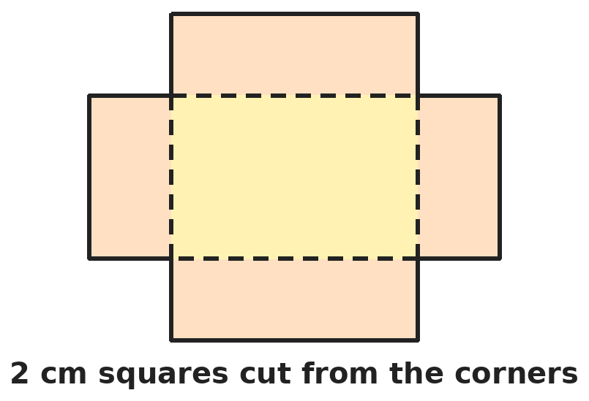
Q30. A 10 cm by 8 cm sheet has a 2 cm square cut from each corner. The flaps are folded up to make an open box. What is the total area of the four side walls?
(A) 64 cm² | (B) 24 cm² | (C) 80 cm² | (D) 40 cm²

Answer Sheet AMO Level 2 · Class 4 · Practice Paper 9
Name: | School: | Roll No.:
Shade or tick one circle for each question.
1. | Ⓐ Ⓑ Ⓒ Ⓓ | 11. | Ⓐ Ⓑ Ⓒ Ⓓ | 21. | Ⓐ Ⓑ Ⓒ Ⓓ
2. | Ⓐ Ⓑ Ⓒ Ⓓ | 12. | Ⓐ Ⓑ Ⓒ Ⓓ | 22. | Ⓐ Ⓑ Ⓒ Ⓓ
3. | Ⓐ Ⓑ Ⓒ Ⓓ | 13. | Ⓐ Ⓑ Ⓒ Ⓓ | 23. | Ⓐ Ⓑ Ⓒ Ⓓ
4. | Ⓐ Ⓑ Ⓒ Ⓓ | 14. | Ⓐ Ⓑ Ⓒ Ⓓ | 24. | Ⓐ Ⓑ Ⓒ Ⓓ
5. | Ⓐ Ⓑ Ⓒ Ⓓ | 15. | Ⓐ Ⓑ Ⓒ Ⓓ | 25. | Ⓐ Ⓑ Ⓒ Ⓓ
6. | Ⓐ Ⓑ Ⓒ Ⓓ | 16. | Ⓐ Ⓑ Ⓒ Ⓓ | 26. | Ⓐ Ⓑ Ⓒ Ⓓ
7. | Ⓐ Ⓑ Ⓒ Ⓓ | 17. | Ⓐ Ⓑ Ⓒ Ⓓ | 27. | Ⓐ Ⓑ Ⓒ Ⓓ
8. | Ⓐ Ⓑ Ⓒ Ⓓ | 18. | Ⓐ Ⓑ Ⓒ Ⓓ | 28. | Ⓐ Ⓑ Ⓒ Ⓓ
9. | Ⓐ Ⓑ Ⓒ Ⓓ | 19. | Ⓐ Ⓑ Ⓒ Ⓓ | 29. | Ⓐ Ⓑ Ⓒ Ⓓ
10. | Ⓐ Ⓑ Ⓒ Ⓓ | 20. | Ⓐ Ⓑ Ⓒ Ⓓ | 30. | Ⓐ Ⓑ Ⓒ Ⓓ

For the parent or teacher
Correct: ______ / 30
Answer Key and Solutions AMO Level 2 · Class 4 · Practice Paper 9
Quick answers
1 A | 6 A | 11 A | 16 A | 21 B | 26 D
2 B | 7 C | 12 A | 17 D | 22 B | 27 C
3 D | 8 D | 13 D | 18 B | 23 C | 28 A
4 B | 9 C | 14 C | 19 C | 24 A | 29 D
5 B | 10 D | 15 A | 20 C | 25 B | 30 D
Solutions
Q | Part · level | Answer | Why?
1 | Part 1 · Ch1 · Hard | (A) 1,000 | Hint: Find the smallest and the largest such number.  The smallest is 49,500 and the largest is 50,499. From 49,500 to 50,499 there are 50,499 − 49,500 + 1 = 1,000 numbers.
2 | Part 1 · Ch1 · Hard | (B) 19,998 | Hint: The new number is 92,517.  Swapping 7 and 9 gives 92,517. 92,517 − 72,519 = 19,998.
3 | Part 1 · Ch1 · Hard | (D) XLVIII | Hint: Change XCVI to a number first.  XCVI = 90 + 6 = 96. Half of 96 is 48. 48 = 40 + 8 = XLVIII.
4 | Part 2 · Ch2 · Hard | (B) 50 | Hint: Divide by 8 first, then by 9.  3,600 ÷ 8 = 450 sweets for each class. 450 ÷ 9 = 50 sweets for each section.
5 | Part 2 · Ch2 · Hard | (B) 9,000 | Hint: Round each number and keep track of the change.  2,987 is 13 less than 3,000, 4,015 is 15 more than 4,000, and 1,998 is 2 less than 2,000. 3,000 + 4,000 + 2,000 = 9,000. The changes: −13 + 15 − 2 = 0. So the sum is exactly 9,000.
6 | Part 2 · Ch2 · Hard | (A) 88 | Hint: First find the number.  The number × 6 = 492, so the number is 492 ÷ 6 = 82. The correct answer is 82 + 6 = 88.
7 | Part 3 · Ch3 · Hard | (C) 8/12 | Hint: Fractions equal to 2/3: 2/3, 4/6, 6/9, 8/12, … Check the sums.  2/3 has sum 5. 4/6 has sum 10. 6/9 has sum 15. 8/12 has sum 20. 9/11 adds to 20 but is not equal to 2/3.
8 | Part 3 · Ch3 · Hard | (D) 1/4 | Hint: Change all three fractions to twelfths.  1/4 + 1/3 + 1/6 = 3/12 + 4/12 + 2/12 = 9/12. Not painted: 12/12 − 9/12 = 3/12 = 1/4.
9 | Part 3 · Ch3 · Hard | (C) 5.8 cm | Hint: Add the two lengths used.  Used: 3.8 + 2.9 = 6.7 cm. Left: 12.5 − 6.7 = 5.8 cm.
10 | Part 3 · Ch3 · Hard | (D) 2 3/8 | Hint: Write each one as a mixed number with quarters.  11/4 = 2 3/4. 2 6/8 = 2 3/4. 2 9/12 = 2 3/4. But 2 3/8 is less than 2 3/4, because 3/8 is less than 6/8.
11 | Part 4 · Ch5 · Hard | (A) 18 | Hint: One face is the base. The others are triangles, one for each side of the base.  10 faces = 1 base + 9 triangles, so the base has 9 sides. Edges: 9 on the base + 9 slanting = 18.
12 | Part 4 · Ch5 · Hard | (A) 6 | Hint: Do not forget BD, DC and the whole of BC.  From A: AB, AD, AC (3). On the base: BD, DC and BC (3). 3 + 3 = 6.
13 | Part 4 · Ch5 · Hard | (D) 16 | Hint: Count at the top point and at each corner of the base.  At the top point 4 edges meet. At each of the 4 base corners 3 edges meet. 4 + 4 × 3 = 16. This is twice the 8 edges, because each edge has two ends.
14 | Part 5 · Ch6 · Hard | (C) 76 m² | Hint: The part inside the path is a square with sides of 18 m.  Whole garden: 20 × 20 = 400 m². Inside the path: 18 × 18 = 324 m². Path: 400 − 324 = 76 m².
15 | Part 5 · Ch6 · Hard | (A) 2 cm | Hint: Which square has an area of 36 cm²?  Area = 9 × 4 = 36 cm², so the square has side 6 cm and perimeter 24 cm. The rectangle's perimeter is 2 × (9 + 4) = 26 cm. 26 − 24 = 2 cm.
16 | Part 5 · Ch6 · Hard | (A) 6 | Hint: Add 750 mL again and again: 750, 1,500, …  4 L 500 mL = 4,500 mL. 750 × 6 = 4,500 mL. So 6 bottles.
17 | Part 5 · Ch6 · Hard | (D) 16 | Hint: Going all the way round, the last gap ends at the first post.  Perimeter = 2 × (20 + 12) = 64 m. There are 64 ÷ 4 = 16 gaps. On a closed path the number of posts equals the number of gaps, so 16 posts.
18 | Part 6 · Ch8 · Hard | (B) 32 | Hint: Find the number of cookies first.  Symbols: 4 + 7 + 5 = 16. Cookies: 16 × 6 = 96. Packets: 96 ÷ 3 = 32.
19 | Part 7 · Ch9 · Hard | (C) 5:23 AM | Hint: Add the hours first, then the minutes. Watch for midnight.  9:48 PM + 7 hours = 4:48 AM the next day. 4:48 + 35 minutes: 12 minutes take it to 5:00, and 23 more give 5:23 AM.
20 | Part 7 · Ch9 · Hard | (C) 17th | Hint: Find the date of the first Friday.  The first Friday is the 3rd. The others come every 7 days: 10th, 17th. So the third Friday is the 17th.
21 | Part 7 · Ch9 · Hard | (B) ₹126 | Hint: Find the cost of rice and of dal separately.  Rice: 3 × 48 = ₹144. Dal: 2 × 115 = ₹230. Total: ₹374. Change: 500 − 374 = ₹126.
22 | Part 8 · Ch10 · Hard | (B) 26 | Hint: The amounts added are 1, 2, 3, …  The series adds 1, 2, 3, 4, 5. Next it adds 6: 20 + 6 = 26.
23 | Part 8 · Ch10 · Hard | (C) 12 | Hint: The last digit must be 2 or 4.  Last digit: 2 choices (2 or 4). Hundreds digit: 3 choices left. Tens digit: 2 choices left. 2 × 3 × 2 = 12.
24 | Part 8 · Ch10 · Hard | (A) Kabir | Hint: Start with Tara, Isha and Kabir in order.  Tara, then Isha, then Kabir. Neel is just after Kabir and Om is last: Tara, Isha, Kabir, Neel, Om. Kabir is 3rd.
25 | Part 8 · Ch10 · Hard | (B) 14 | Hint: Work backwards. Before the second friend he had (2 + 1) × 2.  Before the second friend: (2 + 1) × 2 = 6. Before the first friend: (6 + 1) × 2 = 14. Check: 14 → gives 7 + 1 = 8, leaving 6 → gives 3 + 1 = 4, leaving 2.
26 | Part 9 · Mixed · Ch3 + Ch10 · Hard | (D) 7/12 | Hint: Their numerators add up to 12 and differ by 2.  1 = 12/12 and 1/6 = 2/12. Two numbers that add to 12 and differ by 2 are 7 and 5. The larger fraction is 7/12.
27 | Part 9 · Mixed · Ch9 + Ch10 · Hard | (C) 24 April, Monday | Hint: March has 31 days. 47 days is 6 weeks and 5 days.  8 March + 23 days = 31 March. 24 more days reach 24 April. 47 = 6 × 7 + 5, and 5 days after Wednesday is Monday. So 24 April, Monday.
28 | Part 9 · Mixed · Ch1 + Ch10 · Hard | (A) 124 | Hint: Count 1-digit, 2-digit and 3-digit numbers separately. The first digit cannot be 0.  1-digit: 2, 4, 6, 8 (4). 2-digit: 4 choices for tens × 5 for ones = 20. 3-digit: 4 × 5 × 5 = 100. 1,000 has a 1. 4 + 20 + 100 = 124.
29 | Part 9 · Mixed · Ch3 + Ch9 · Hard | (D) 8:20 PM | Hint: 2 1/4 hours is 2 hours 15 minutes.  2 1/4 hours = 2 h 15 min. With the interval: 2 h 30 min. 5:50 PM + 2 h 30 min = 8:20 PM.
30 | Part 9 · Mixed · Ch5 + Ch6 · Hard | (D) 40 cm² | Hint: Find the area left after cutting, then take away the base.  Sheet: 10 × 8 = 80 cm². Corners cut: 4 × 4 = 16 cm², leaving 64 cm². The base is (10 − 4) × (8 − 4) = 6 × 4 = 24 cm². Side walls: 64 − 24 = 40 cm².

ARYABHATTA MATHS OLYMPIAD
Level 2
PRACTICE PAPER-10
CLASS 4
Total Questions | 30 multiple-choice questions
Level | Level-2 (final round): every question is Hard
Time | 45 minutes
Arrangement | Parts by chapter; the last Part has mixed problems joining two chapters
Negative Marking | No negative marking
Calculator | Not allowed
Chapters | Number System · Operations · Fractions & Decimals · Geometry · Mensuration · Data Handling · Applied Mathematics · Mathematical Reasoning

👋 Hello, friend! How to do this paper:
⭐ Every question has four answer choices: (A), (B), (C) and (D). Only one is correct.
⭐ Read each question and look at its picture carefully. Then mark your answer on the answer sheet at the end.
⭐ This is a Level-2 paper. Every question needs careful thinking, so take your time and check each step.
⭐ The questions are in Parts by chapter. The last Part has mixed problems that join two chapters.
⭐ There is no negative marking, so try every question.
⭐ Do not use a calculator. You may do rough work on a separate sheet.
⭐ All figures are not necessarily drawn to scale unless stated.

For parents and teachers
• Pictures are part of the questions. Every picture also works when printed in black and white.
• You may read a question aloud to the child, exactly as printed. Please do not explain it or point to an answer choice.
• Parts follow the AMO syllabus chapters. Chapters 4 and 7 are not part of the Class 4 syllabus, so the chapter numbers shown in the Part headings have gaps.
• The answer sheet and the answer key are at the end. Remove only the answer key before the child begins.

Part 1 — Number System (Syllabus Chapter 1)
Q1. How many 5-digit numbers have digits that add up to 44?
(A) 5 | (B) 1 | (C) 4 | (D) 9

Q2. Gita's number is 63,4?8, with the tens digit hidden. The number is as close to 63,500 as it can be. What is the hidden digit?
(A) 5 | (B) 0 | (C) 8 | (D) 9

Q3. Bharat works out LXXIV − XXIX. Which Roman numeral is his answer?
(A) LV | (B) XLIV | (C) XLV | (D) XXXV

Part 2 — Operations (Syllabus Chapter 2)
Q4. A factory packs 2,016 bottles into crates of 6. A truck can carry 9 crates. How many trucks are needed to carry all the crates?
(A) 37 | (B) 336 | (C) 224 | (D) 38

Q5. Leena works out 37 × 99 + 37 in her head. What is the answer?
(A) 3,663 | (B) 3,737 | (C) 3,700 | (D) 3,600

Q6. Three numbers that come one after another multiply to give 120. What is their sum?
(A) 15 | (B) 12 | (C) 18 | (D) 120

Part 3 — Fractions & Decimals (Syllabus Chapter 3)
Q7. Which of these is the largest: 7/4, 5/3, 11/6, 3/2?
(A) 7/4 | (B) 5/3 | (C) 11/6 | (D) 3/2

Q8. Riya gets 3/8 of ₹960 and Sohan gets 5/12 of it. The rest is given to a school. How much does the school get?
(A) ₹760 | (B) ₹360 | (C) ₹200 | (D) ₹240

Q9. A pole is 6.4 m long. 1.5 m of it is in the ground and the bottom 0.8 m above the ground is covered by snow. How much of the pole can be seen above the snow?
(A) 4.1 m | (B) 4.9 m | (C) 5.6 m | (D) 3.1 m

Q10. Pallavi pours 2/3 L and then 3/4 L of milk into an empty jug. Then she pours out 5/6 L. How much milk is in the jug?
(A) 5/12 L | (B) 0 L | (C) 7/12 L | (D) 1 5/12 L

Part 4 — Geometry (Syllabus Chapter 5)
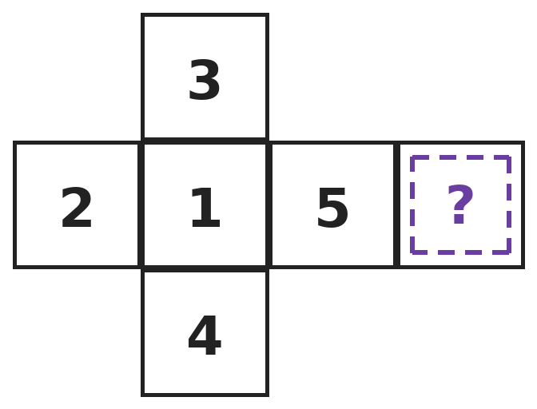
Q11. This net folds into a dice. On a dice, opposite faces add up to 7. Which number goes in the square with the question mark?
(A) 4 | (B) 6 | (C) 3 | (D) 2

Q12. Two equal cubes are glued face to face to make a cuboid. How many edges does the cuboid have?
(A) 24 | (B) 12 | (C) 20 | (D) 16

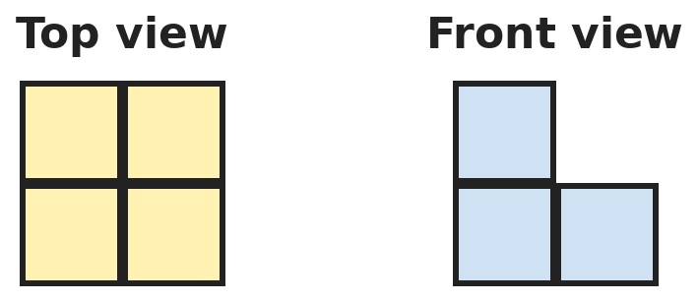
Q13. Ajay builds a solid with cubes. These are its top view and front view. What is the smallest number of cubes he could have used?
(A) 4 | (B) 6 | (C) 5 | (D) 3

Part 5 — Mensuration (Syllabus Chapter 6)
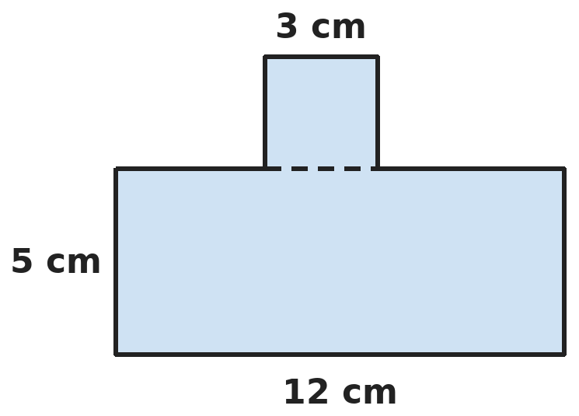
Q14. A 3 cm square is joined to the top of a rectangle 12 cm long and 5 cm wide. What is the perimeter of the new shape?
(A) 34 cm | (B) 46 cm | (C) 43 cm | (D) 40 cm

Q15. Tarun cuts cards 25 cm by 20 cm from a square sheet with sides of 1 m. What is the largest number of cards he can cut?
(A) 25 | (B) 20 | (C) 4 | (D) 200

Q16. A sack holds 5 kg 40 g of potatoes. Prakash takes out 2 kg 875 g. How much is left in the sack?
(A) 3 kg 165 g | (B) 2 kg 165 g | (C) 2 kg 835 g | (D) 3 kg 835 g

Q17. A park is 150 m long and 100 m wide. Swati jogs 5 rounds along its edge. How far does she jog?
(A) 1 km 250 m | (B) 2 km 50 m | (C) 75 km | (D) 2 km 500 m

Part 6 — Data Handling (Syllabus Chapter 8)
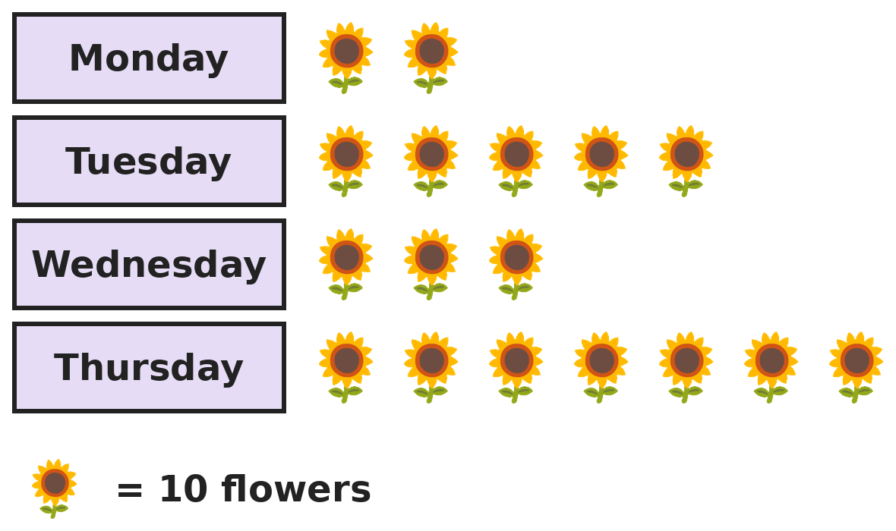
Q18. The pictograph shows flowers picked each day. On Friday, 15 more flowers were picked than on Wednesday. How many symbols should be drawn for Friday?
(A) 4 | (B) 4 1/2 | (C) 5 | (D) 1 1/2

Part 7 — Applied Mathematics (Syllabus Chapter 9)
Q19. Train A leaves at 7:45 AM and takes 2 h 50 min. Train B leaves at 8:20 AM and takes 2 h 10 min. Which train arrives first, and by how much?
(A) Train A, by 5 min | (B) Train B, by 35 min
(C) They arrive together | (D) Train B, by 5 min

Q20. In a leap year, 28 February is a Monday. What day of the week is 31 March?
(A) Thursday | (B) Saturday | (C) Wednesday | (D) Friday

Q21. A bus ticket costs ₹24 for an adult and half of that for a child. Two adults and three children make a return trip. They pay with ₹200. How much change do they get?
(A) ₹116 | (B) ₹56 | (C) ₹32 | (D) ₹20

Part 8 — Mathematical Reasoning (Syllabus Chapter 10)

Q22. Nitya writes this series. Every number comes from the one before by the same rule. Which number comes next?
(A) 33 | (B) 34 | (C) 25 | (D) 31

Q23. How many 2-digit numbers have digits that differ by 3, like 52 or 14?
(A) 13 | (B) 12 | (C) 14 | (D) 7

Q24. In Ira's balance puzzle, 2 mangoes weigh the same as 3 apples. 4 apples weigh the same as 6 bananas. How many bananas weigh the same as 8 mangoes?
(A) 12 | (B) 18 | (C) 16 | (D) 24

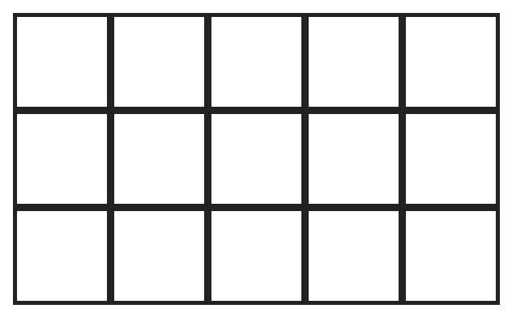
Q25. How many squares of all sizes are there in this 3 by 5 grid?
(A) 15 | (B) 26 | (C) 23 | (D) 30

Part 9 — Mixed Problems (each joins two chapters)
Q26. Madhav has a rope 12 m long. He cuts off half of it. Then he cuts off 1/3 of what is left. Then he cuts off 1/4 of what is left. How long is the rope now?
(A) 3 m | (B) 1 m | (C) 4 m | (D) 6 m

Q27. In a year that is not a leap year, 1 March is a Monday. What day of the week was 1 January of that year?
(A) Thursday | (B) Saturday | (C) Monday | (D) Friday

Q28. Prachi adds all the numbers from 1 to 100. She pairs 1 with 100, 2 with 99, and so on. What total does she get?
(A) 5,050 | (B) 5,000 | (C) 10,100 | (D) 5,100

Q29. At a tea shop, 3/4 kg of tea costs ₹360. How much does 1 1/2 kg of the same tea cost?
(A) ₹540 | (B) ₹480 | (C) ₹720 | (D) ₹600

Q30. A bathroom floor is 2.4 m long and 1.5 m wide. It is covered with square tiles with sides of 30 cm. How many tiles are needed?
(A) 36 | (B) 40 | (C) 50 | (D) 24

Answer Sheet AMO Level 2 · Class 4 · Practice Paper 10
Name: | School: | Roll No.:
Shade or tick one circle for each question.
1. | Ⓐ Ⓑ Ⓒ Ⓓ | 11. | Ⓐ Ⓑ Ⓒ Ⓓ | 21. | Ⓐ Ⓑ Ⓒ Ⓓ
2. | Ⓐ Ⓑ Ⓒ Ⓓ | 12. | Ⓐ Ⓑ Ⓒ Ⓓ | 22. | Ⓐ Ⓑ Ⓒ Ⓓ
3. | Ⓐ Ⓑ Ⓒ Ⓓ | 13. | Ⓐ Ⓑ Ⓒ Ⓓ | 23. | Ⓐ Ⓑ Ⓒ Ⓓ
4. | Ⓐ Ⓑ Ⓒ Ⓓ | 14. | Ⓐ Ⓑ Ⓒ Ⓓ | 24. | Ⓐ Ⓑ Ⓒ Ⓓ
5. | Ⓐ Ⓑ Ⓒ Ⓓ | 15. | Ⓐ Ⓑ Ⓒ Ⓓ | 25. | Ⓐ Ⓑ Ⓒ Ⓓ
6. | Ⓐ Ⓑ Ⓒ Ⓓ | 16. | Ⓐ Ⓑ Ⓒ Ⓓ | 26. | Ⓐ Ⓑ Ⓒ Ⓓ
7. | Ⓐ Ⓑ Ⓒ Ⓓ | 17. | Ⓐ Ⓑ Ⓒ Ⓓ | 27. | Ⓐ Ⓑ Ⓒ Ⓓ
8. | Ⓐ Ⓑ Ⓒ Ⓓ | 18. | Ⓐ Ⓑ Ⓒ Ⓓ | 28. | Ⓐ Ⓑ Ⓒ Ⓓ
9. | Ⓐ Ⓑ Ⓒ Ⓓ | 19. | Ⓐ Ⓑ Ⓒ Ⓓ | 29. | Ⓐ Ⓑ Ⓒ Ⓓ
10. | Ⓐ Ⓑ Ⓒ Ⓓ | 20. | Ⓐ Ⓑ Ⓒ Ⓓ | 30. | Ⓐ Ⓑ Ⓒ Ⓓ

For the parent or teacher
Correct: ______ / 30
Answer Key and Solutions AMO Level 2 · Class 4 · Practice Paper 10
Quick answers
1 A | 6 A | 11 B | 16 B | 21 C | 26 A
2 D | 7 C | 12 B | 17 D | 22 A | 27 D
3 C | 8 C | 13 C | 18 B | 23 A | 28 A
4 D | 9 A | 14 D | 19 D | 24 B | 29 C
5 C | 10 C | 15 B | 20 D | 25 B | 30 B
Solutions
Q | Part · level | Answer | Why?
1 | Part 1 · Ch1 · Hard | (A) 5 | Hint: The largest possible digit sum is 45. Which digit must be one less than 9?  Five 9s make 45, so exactly one digit is 8 and the others are 9. The 8 can be in any of the 5 places: 89,999, 98,999, 99,899, 99,989, 99,998. That is 5 numbers.
2 | Part 1 · Ch1 · Hard | (D) 9 | Hint: The number is always less than 63,500. Make it as big as possible.  63,4?8 is at most 63,498, which is less than 63,500. The biggest choice is 63,498, just 2 away from 63,500. So the hidden digit is 9.
3 | Part 1 · Ch1 · Hard | (C) XLV | Hint: LXXIV = 74 and XXIX = 29.  74 − 29 = 45. 45 = 40 + 5 = XLV.
4 | Part 2 · Ch2 · Hard | (D) 38 | Hint: Find the number of crates first.  2,016 ÷ 6 = 336 crates. 336 ÷ 9 = 37 remainder 3. 37 trucks carry 333 crates and 3 crates need one more truck: 38 trucks.
5 | Part 2 · Ch2 · Hard | (C) 3,700 | Hint: 37 × 99 + 37 × 1 = 37 × (99 + 1).  37 × 99 + 37 = 37 × 99 + 37 × 1 = 37 × 100 = 3,700.
6 | Part 2 · Ch2 · Hard | (A) 15 | Hint: Try 3 × 4 × 5 and then the next three numbers.  3 × 4 × 5 = 60 is too small. 4 × 5 × 6 = 120. Their sum is 4 + 5 + 6 = 15.
7 | Part 3 · Ch3 · Hard | (C) 11/6 | Hint: Each is 1 and a bit. Compare how far each is from 2.  7/4 is 1/4 less than 2. 5/3 is 1/3 less than 2. 11/6 is 1/6 less than 2. 3/2 is 1/2 less than 2. The smallest gap is 1/6, so 11/6 is the largest.
8 | Part 3 · Ch3 · Hard | (C) ₹200 | Hint: Find 3/8 of 960 and 5/12 of 960.  1/8 of 960 = 120, so 3/8 = ₹360. 1/12 of 960 = 80, so 5/12 = ₹400. 360 + 400 = 760. The school gets 960 − 760 = ₹200.
9 | Part 3 · Ch3 · Hard | (A) 4.1 m | Hint: Take away both parts that cannot be seen.  Hidden: 1.5 + 0.8 = 2.3 m. Seen: 6.4 − 2.3 = 4.1 m.
10 | Part 3 · Ch3 · Hard | (C) 7/12 L | Hint: Write all three fractions as twelfths.  2/3 = 8/12, 3/4 = 9/12 and 5/6 = 10/12. 8/12 + 9/12 − 10/12 = 7/12 L.
11 | Part 4 · Ch5 · Hard | (B) 6 | Hint: Find which face is opposite the question mark.  In the row 2, 1, 5, ?, faces with one square between them are opposite: 2 and 5, and 1 and ?. 3 and 4 are opposite as well. 1 + ? = 7, so the missing number is 6.
12 | Part 4 · Ch5 · Hard | (B) 12 | Hint: Look at the new solid, not the two cubes.  The two cubes have 24 edges. The 4 edges round each glued face (8 in all) now lie flat inside the side faces, so they are not edges. The other edges running away from the glued face join end to end in pairs: 8 become 4. 24 − 8 − 4 = 12, as for any cuboid.
13 | Part 4 · Ch5 · Hard | (C) 5 | Hint: The top view shows 4 towers. The front view shows that one tower on the left is 2 cubes tall.  The top view needs 4 towers of at least 1 cube. The front view shows the left side is 2 cubes tall, so at least one left tower has 2 cubes. The smallest total is 4 + 1 = 5.
14 | Part 5 · Ch6 · Hard | (D) 40 cm | Hint: The square adds two upright sides. Its top side replaces the part of the rectangle it covers.  The rectangle has perimeter 2 × (12 + 5) = 34 cm. The square adds 3 cm on each side going up and down. Its top replaces the 3 cm it covers. 34 + 3 + 3 = 40 cm.
15 | Part 5 · Ch6 · Hard | (B) 20 | Hint: 1 m = 100 cm. How many cards fit along each side?  Along one side: 100 ÷ 25 = 4 cards. Along the other: 100 ÷ 20 = 5 cards. 4 × 5 = 20 cards, with nothing wasted (20 × 500 cm² = 10,000 cm² = 1 m²).
16 | Part 5 · Ch6 · Hard | (B) 2 kg 165 g | Hint: Change both to grams first.  5 kg 40 g = 5,040 g. 2 kg 875 g = 2,875 g. 5,040 − 2,875 = 2,165 g = 2 kg 165 g.
17 | Part 5 · Ch6 · Hard | (D) 2 km 500 m | Hint: Find the perimeter first.  One round: 2 × (150 + 100) = 500 m. Five rounds: 2,500 m = 2 km 500 m.
18 | Part 6 · Ch8 · Hard | (B) 4 1/2 | Hint: A half symbol stands for 5 flowers.  Wednesday: 3 × 10 = 30 flowers. Friday: 30 + 15 = 45 flowers. 45 = 4 full symbols (40) and half a symbol (5). So 4 1/2 symbols.
19 | Part 7 · Ch9 · Hard | (D) Train B, by 5 min | Hint: Find each arrival time.  Train A: 7:45 + 2 h 50 min = 10:35 AM. Train B: 8:20 + 2 h 10 min = 10:30 AM. Train B arrives 5 minutes earlier.
20 | Part 7 · Ch9 · Hard | (D) Friday | Hint: A leap year has 29 days in February. Find 1 March first.  29 February is a Tuesday, so 1 March is a Wednesday. 31 March is 30 days later. 30 = 4 weeks + 2 days, so it is 2 days after Wednesday: Friday.
21 | Part 7 · Ch9 · Hard | (C) ₹32 | Hint: Find the cost of one way first.  Child ticket: ₹12. One way: 2 × 24 + 3 × 12 = 48 + 36 = ₹84. Return trip: 84 × 2 = ₹168. Change: 200 − 168 = ₹32.
22 | Part 8 · Ch10 · Hard | (A) 33 | Hint: Try doubling each number. What do you have to change?  Each number is double the one before minus 1: 2 × 2 − 1 = 3, 3 × 2 − 1 = 5, 5 × 2 − 1 = 9, 9 × 2 − 1 = 17. Next: 17 × 2 − 1 = 33.
23 | Part 8 · Ch10 · Hard | (A) 13 | Hint: Count those with the bigger digit in the tens place and those with it in the ones place.  Tens digit 3 more: 30, 41, 52, 63, 74, 85, 96 (7). Ones digit 3 more: 14, 25, 36, 47, 58, 69 (6). 03 is not a 2-digit number. 7 + 6 = 13.
24 | Part 8 · Ch10 · Hard | (B) 18 | Hint: First change mangoes into apples.  8 mangoes = 4 groups of 2 mangoes = 4 × 3 = 12 apples. 12 apples = 3 groups of 4 apples = 3 × 6 = 18 bananas.
25 | Part 8 · Ch10 · Hard | (B) 26 | Hint: Count 1 by 1, 2 by 2 and 3 by 3 squares.  1 by 1: 3 × 5 = 15. 2 by 2: 2 × 4 = 8. 3 by 3: 1 × 3 = 3. 15 + 8 + 3 = 26.
26 | Part 9 · Mixed · Ch3 + Ch10 · Hard | (A) 3 m | Hint: Find the length after each cut.  After the first cut: 6 m. 1/3 of 6 is 2, leaving 4 m. 1/4 of 4 is 1, leaving 3 m.
27 | Part 9 · Mixed · Ch9 + Ch10 · Hard | (D) Friday | Hint: Count back the days of January and February.  1 March is 31 + 28 = 59 days after 1 January. 59 = 8 weeks + 3 days. 3 days before Monday is Friday.
28 | Part 9 · Mixed · Ch1 + Ch10 · Hard | (A) 5,050 | Hint: How many pairs are there, and what does each pair add up to?  Each pair adds up to 101: 1 + 100, 2 + 99, …, 50 + 51. There are 50 pairs. 50 × 101 = 5,050.
29 | Part 9 · Mixed · Ch3 + Ch9 · Hard | (C) ₹720 | Hint: 1 1/2 kg is double 3/4 kg.  3/4 + 3/4 = 6/4 = 1 1/2. So 1 1/2 kg costs double: 2 × 360 = ₹720.
30 | Part 9 · Mixed · Ch5 + Ch6 · Hard | (B) 40 | Hint: Change the lengths to centimetres.  2.4 m = 240 cm and 1.5 m = 150 cm. Along the length: 240 ÷ 30 = 8 tiles. Along the width: 150 ÷ 30 = 5 tiles. 8 × 5 = 40 tiles.

