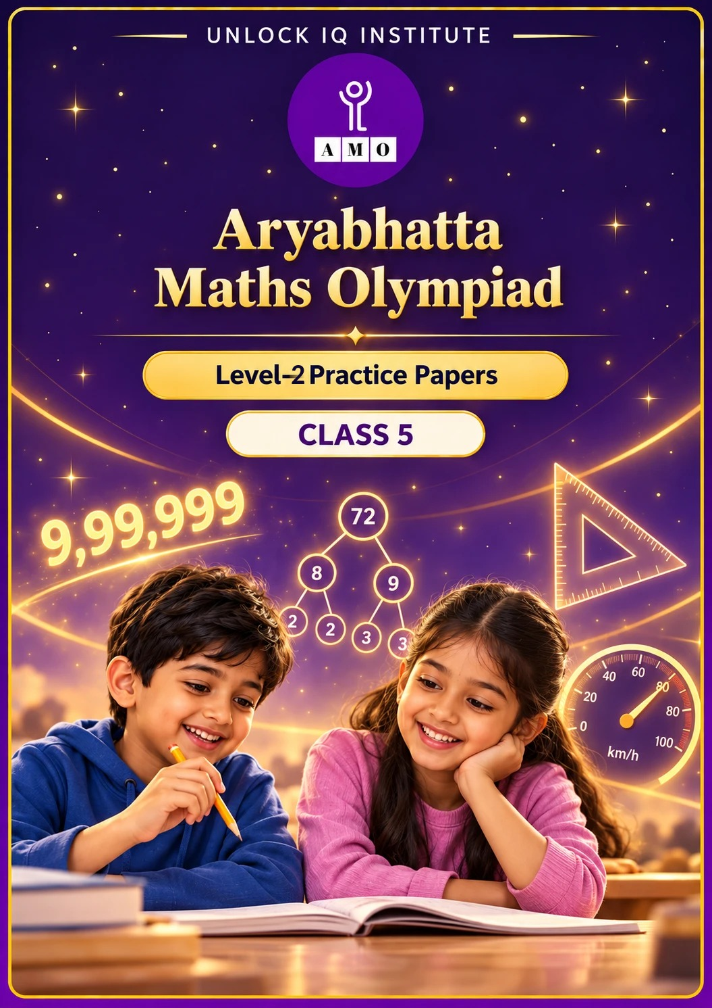
Set 1 · Practice Papers 1–5 · with answer keys & detailed solutions
Name: ____________________ | Class & Section: ________________
Roll No.: ________________ | School: ____________________
City: ____________________ | Date: ____________________

Published by Unlock IQ Institute Pvt. Ltd.
Register for Olympiads: www.aryabhattamathsolympiad.com/student-registration

ARYABHATTA MATHS OLYMPIAD
Level 2
PRACTICE PAPER-1
CLASS 5
Total Questions | 30 multiple-choice questions
Level | Level-2 (final round): every question is Hard
Time | 45 minutes
Arrangement | Parts by chapter; the last Part has mixed problems joining two chapters
Negative Marking | No negative marking
Calculator | Not allowed
Chapters | Number System · Operations · Fractions, Decimals & Percentages · Geometry · Mensuration · Data Handling, Statistics & Probability · Applied Mathematics · Mathematical Reasoning

👋 Hello, friend! How to do this paper:
⭐ Every question has four answer choices: (A), (B), (C) and (D). Only one is correct.
⭐ Read each question and look at its picture carefully. Then mark your answer on the answer sheet at the end.
⭐ This is a Level-2 paper. Every question needs careful thinking, so take your time and check each step.
⭐ The questions are in Parts by chapter. The last Part has mixed problems that join two chapters.
⭐ There is no negative marking, so try every question.
⭐ Do not use a calculator. You may do rough work on a separate sheet.
⭐ All figures are not necessarily drawn to scale unless stated.

For parents and teachers
• Pictures are part of the questions. Every picture also works when printed in black and white.
• You may read a question aloud to the child, exactly as printed. Please do not explain it or point to an answer choice.
• Parts follow the AMO syllabus chapters. Chapters 4 and 7 are not part of the Class 5 syllabus, so the chapter numbers shown in the Part headings have gaps.
• The answer sheet and the answer key are at the end. Remove only the answer key before the child begins.

Part 1 — Number System (Syllabus Chapter 1)
Q1. Vikram writes the smallest 6-digit number whose digits are all different. Sana writes the largest 5-digit number whose digits are all different. What is the difference between their numbers?
(A) 3,480 | (B) 3,590 | (C) 4,580 | (D) 3,580

Q2. Laddoos can be packed in boxes of 12 or in boxes of 18. Either way, exactly 3 laddoos are left over. There are between 100 and 120 laddoos. How many are there?
(A) 108 | (B) 105 | (C) 111 | (D) 117

Q3. Ayaan subtracts CDXCIX from MCMXLIV. Which Roman numeral is the answer?
(A) MCDLXV | (B) MCDXXXV | (C) MDXLV | (D) MCDXLV

Part 2 — Operations (Syllabus Chapter 2)
Q4. Pallavi works out this expression using the correct order of operations. What answer does she get?
(A) 82 | (B) 123 | (C) 98 | (D) 114

Q5. Mohan estimates 487 × 31 by rounding both numbers to the nearest ten. By how much is his estimate less than the exact answer?
(A) 403 | (B) 297 | (C) 497 | (D) 397

Q6. Without long multiplication, Divya works out 125 × 37 × 8 − 25 × 37 × 4. What is the answer?
(A) 33,300 | (B) 33,700 | (C) 29,600 | (D) 37,000

Part 3 — Fractions, Decimals & Percentages (Syllabus Chapter 3)
Q7. A school has 840 students. 25% of them walk to school and 1/3 of them come by bus. The rest come by van. How many come by van?
(A) 490 | (B) 350 | (C) 280 | (D) 420

Q8. Which is the 2nd largest of these: 3/8, 0.4, 7/20, 0.38?
(A) 0.4 | (B) 3/8 | (C) 0.38 | (D) 7/20

Q9. Kavya cuts a ribbon 7.5 m long into pieces of 0.25 m each. 4 pieces get spoiled. How many good pieces does she have?
(A) 30 | (B) 34 | (C) 26 | (D) 186

Q10. A water tank can hold 1,200 L. It is 75% full. Ravi then uses an amount equal to 20% of the full tank. How many litres are left in the tank?
(A) 660 | (B) 720 | (C) 540 | (D) 700

Part 4 — Geometry (Syllabus Chapter 5)
Q11. A triangle has one right angle. One of its other angles is twice the third angle. What is the smallest angle of the triangle?
(A) 45° | (B) 60° | (C) 15° | (D) 30°

Q12. Ishita adds the orders of rotational symmetry of a square, an equilateral triangle, a rectangle that is not a square and a regular hexagon. What total does she get?
(A) 13 | (B) 15 | (C) 17 | (D) 11

Q13. Arjun faces North. He turns 90° clockwise, then 180° clockwise, then 270° anticlockwise. Which direction does he face now?
(A) South | (B) East | (C) North | (D) West

Part 5 — Mensuration (Syllabus Chapter 6)
Q14. A fish tank is a cuboid 50 cm long, 40 cm wide and 30 cm high. It is half full of water. How many 1-litre bottles of water are in it? (1 L = 1,000 cm³)
(A) 60 | (B) 600 | (C) 30 | (D) 300

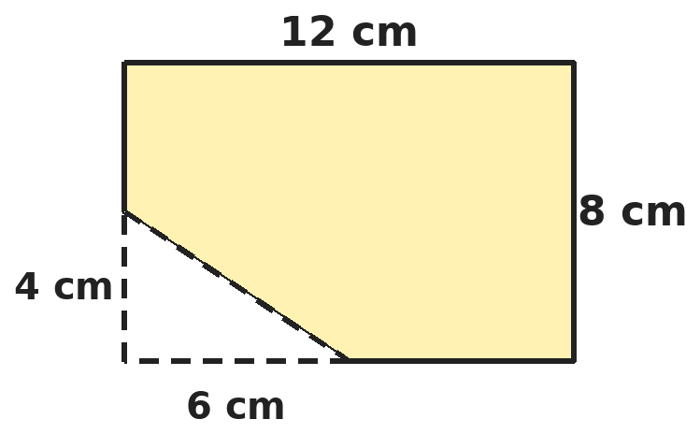
Q15. Riya cuts a right-angled triangle with sides 6 cm and 4 cm from a corner of a 12 cm by 8 cm card, as shown. What is the area of the card left?
(A) 72 cm² | (B) 84 cm² | (C) 90 cm² | (D) 60 cm²

Q16. A square garden has sides of 20 m. A path 2 m wide runs inside the garden along all four sides. What is the area of the path?
(A) 144 m² | (B) 160 m² | (C) 80 m² | (D) 156 m²

Part 6 — Data Handling, Statistics & Probability (Syllabus Chapter 8)
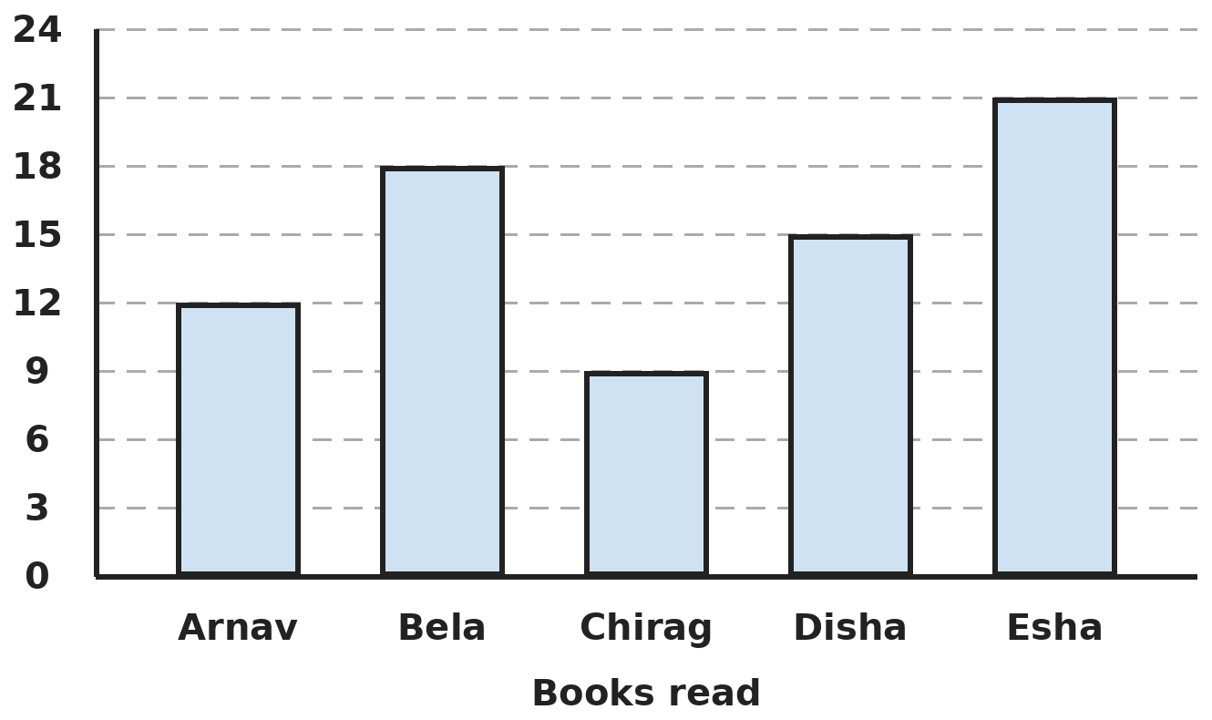
Q17. The bar graph shows the books read by five children. How many more books did the two top readers read than the two children who read the least?
(A) 12 | (B) 21 | (C) 15 | (D) 18

Part 7 — Applied Mathematics (Syllabus Chapter 9)
Q18. A train covers 180 km in 2 hours 30 minutes at a steady speed. How far does it go in 4 hours at the same speed?
(A) 360 km | (B) 300 km | (C) 288 km | (D) 270 km

Q19. Neha cycles 12 km at 12 km/h and then another 12 km at 6 km/h. What is her average speed for the whole ride?
(A) 9 km/h | (B) 18 km/h | (C) 6 km/h | (D) 8 km/h

Q20. A film starts at 6:50 PM and lasts 2.75 hours. At what time does it end?
(A) 9:15 PM | (B) 9:35 PM | (C) 9:25 PM | (D) 8:35 PM

Q21. A pen costs ₹18.50 and a notebook costs ₹42.75. Simran buys 2 pens and 3 notebooks and pays with ₹200. How much change does she get?
(A) ₹34.75 | (B) ₹35.25 | (C) ₹38.75 | (D) ₹44.75

Part 8 — Mathematical Reasoning (Syllabus Chapter 10)

Q22. Each number in Rohit's series comes from the one before by the same two steps. Which number comes next?
(A) 121 | (B) 120 | (C) 124 | (D) 160

Q23. Independence Day, 15 August, falls on a Friday in 2025. 2026 is not a leap year. On which day of the week does it fall in 2026?
(A) Friday | (B) Sunday | (C) Thursday | (D) Saturday

Q24. Kunal adds 9 different positive odd numbers. Priya adds 6 different positive even numbers. Which of these could be the total of both their sums together?
(A) 150 | (B) 175 | (C) 200 | (D) 64

Q25. How many 3-digit numbers have digits that add up to 5?
(A) 21 | (B) 10 | (C) 12 | (D) 15

Part 9 — Mixed Problems (each joins two chapters)
Q26. Gaurav lists all the prime numbers between 40 and 60 and adds them. What total does he get?
(A) 243 | (B) 196 | (C) 290 | (D) 236


Q27. The series goes up by the same amount each time. What is the 10th number in the series?
(A) 14.2 | (B) 12.9 | (C) 13.0 | (D) 11.6

Q28. A big cube is painted on all its faces and then cut into 64 equal small cubes, 4 along each edge. How many small cubes have exactly one painted face?
(A) 8 | (B) 16 | (C) 24 | (D) 36

Q29. Two buses leave a depot together at 6:00 AM. One returns to the depot every 40 minutes, the other every 60 minutes. How many times are they at the depot together from 6:00 AM to 6:00 PM, counting both?
(A) 6 | (B) 7 | (C) 12 | (D) 13

Q30. A car goes 15 km on 1 litre of petrol. Petrol costs ₹104.50 per litre. How much does the petrol cost for a 255 km trip?
(A) ₹1,776.50 | (B) ₹1,672.00 | (C) ₹1,766.50 | (D) ₹1,881.00

Answer Sheet AMO Level 2 · Class 5 · Practice Paper 1
Name: | School: | Roll No.:
Shade or tick one circle for each question.
1. | Ⓐ Ⓑ Ⓒ Ⓓ | 11. | Ⓐ Ⓑ Ⓒ Ⓓ | 21. | Ⓐ Ⓑ Ⓒ Ⓓ
2. | Ⓐ Ⓑ Ⓒ Ⓓ | 12. | Ⓐ Ⓑ Ⓒ Ⓓ | 22. | Ⓐ Ⓑ Ⓒ Ⓓ
3. | Ⓐ Ⓑ Ⓒ Ⓓ | 13. | Ⓐ Ⓑ Ⓒ Ⓓ | 23. | Ⓐ Ⓑ Ⓒ Ⓓ
4. | Ⓐ Ⓑ Ⓒ Ⓓ | 14. | Ⓐ Ⓑ Ⓒ Ⓓ | 24. | Ⓐ Ⓑ Ⓒ Ⓓ
5. | Ⓐ Ⓑ Ⓒ Ⓓ | 15. | Ⓐ Ⓑ Ⓒ Ⓓ | 25. | Ⓐ Ⓑ Ⓒ Ⓓ
6. | Ⓐ Ⓑ Ⓒ Ⓓ | 16. | Ⓐ Ⓑ Ⓒ Ⓓ | 26. | Ⓐ Ⓑ Ⓒ Ⓓ
7. | Ⓐ Ⓑ Ⓒ Ⓓ | 17. | Ⓐ Ⓑ Ⓒ Ⓓ | 27. | Ⓐ Ⓑ Ⓒ Ⓓ
8. | Ⓐ Ⓑ Ⓒ Ⓓ | 18. | Ⓐ Ⓑ Ⓒ Ⓓ | 28. | Ⓐ Ⓑ Ⓒ Ⓓ
9. | Ⓐ Ⓑ Ⓒ Ⓓ | 19. | Ⓐ Ⓑ Ⓒ Ⓓ | 29. | Ⓐ Ⓑ Ⓒ Ⓓ
10. | Ⓐ Ⓑ Ⓒ Ⓓ | 20. | Ⓐ Ⓑ Ⓒ Ⓓ | 30. | Ⓐ Ⓑ Ⓒ Ⓓ

For the parent or teacher
Correct: ______ / 30
Answer Key and Solutions AMO Level 2 · Class 5 · Practice Paper 1
Quick answers
1 D | 6 A | 11 D | 16 A | 21 A | 26 A
2 C | 7 B | 12 B | 17 D | 22 A | 27 B
3 D | 8 C | 13 C | 18 C | 23 D | 28 C
4 C | 9 C | 14 C | 19 D | 24 B | 29 B
5 D | 10 A | 15 B | 20 B | 25 D | 30 A
Solutions
Q | Part · level | Answer | Why?
1 | Part 1 · Ch1 · Hard | (D) 3,580 | Hint: The smallest 6-digit number with different digits starts 1, 0, 2, …  Smallest 6-digit number with different digits: 1,02,345. Largest 5-digit number with different digits: 98,765. 1,02,345 − 98,765 = 3,580.
2 | Part 1 · Ch1 · Hard | (C) 111 | Hint: Without the 3 extra, the number is a common multiple of 12 and 18.  LCM of 12 and 18 is 36. Common multiples: 36, 72, 108, 144, … Adding the 3 left over: 39, 75, 111, 147. Only 111 is between 100 and 120.
3 | Part 1 · Ch1 · Hard | (D) MCDXLV | Hint: Change both numerals into ordinary numbers first.  MCMXLIV = 1000 + 900 + 40 + 4 = 1944. CDXCIX = 400 + 90 + 9 = 499. 1944 − 499 = 1445 = M + CD + XL + V = MCDXLV.
4 | Part 2 · Ch2 · Hard | (C) 98 | Hint: Work out the small bracket first, then the square bracket.  4 + 2 = 6. Inside the square bracket: 36 ÷ 6 = 6 and 6 × 5 = 30. Then 120 − 30 + 8 = 98. (82 wrongly takes away 30 + 8.)
5 | Part 2 · Ch2 · Hard | (D) 397 | Hint: Estimate: 490 × 30. Exact: 487 × 30 + 487.  Estimate: 490 × 30 = 14,700. Exact: 487 × 31 = 487 × 30 + 487 = 14,610 + 487 = 15,097. Difference: 15,097 − 14,700 = 397.
6 | Part 2 · Ch2 · Hard | (A) 33,300 | Hint: Group 125 × 8 and 25 × 4 first.  125 × 8 = 1,000, so the first part is 37 × 1,000 = 37,000. 25 × 4 = 100, so the second part is 3,700. 37,000 − 3,700 = 33,300.
7 | Part 3 · Ch3 · Hard | (B) 350 | Hint: 25% is the same as 1/4.  25% of 840 = 840 ÷ 4 = 210. 1/3 of 840 = 280. 210 + 280 = 490. By van: 840 − 490 = 350.
8 | Part 3 · Ch3 · Hard | (C) 0.38 | Hint: Change the fractions into decimals.  3/8 = 0.375 and 7/20 = 0.35. In order from largest: 0.4, 0.38, 0.375, 0.35. The 2nd largest is 0.38.
9 | Part 3 · Ch3 · Hard | (C) 26 | Hint: 0.25 m is a quarter of a metre.  Each metre gives 4 pieces of 0.25 m, so 7.5 m gives 7.5 × 4 = 30 pieces. 30 − 4 = 26 good pieces.
10 | Part 3 · Ch3 · Hard | (A) 660 | Hint: Find 75% of 1,200 and 20% of 1,200.  75% of 1,200 = 3/4 × 1,200 = 900 L. 20% of 1,200 = 1/5 × 1,200 = 240 L. Left: 900 − 240 = 660 L.
11 | Part 4 · Ch5 · Hard | (D) 30° | Hint: The angles of a triangle add up to 180°.  The other two angles add up to 180° − 90° = 90°. One is twice the other, so together they are 3 equal parts: 90° ÷ 3 = 30°. The angles are 90°, 60° and 30°.
12 | Part 4 · Ch5 · Hard | (B) 15 | Hint: Count how many times each shape looks the same in one full turn.  Square: 4. Equilateral triangle: 3. Rectangle (not a square): 2. Regular hexagon: 6. 4 + 3 + 2 + 6 = 15.
13 | Part 4 · Ch5 · Hard | (C) North | Hint: Follow each turn one at a time.  90° clockwise from North: East. 180° more: West. 270° anticlockwise from West: South (90°), East (180°), North (270°). He faces North.
14 | Part 5 · Ch6 · Hard | (C) 30 | Hint: Find the volume of the full tank first.  Full tank: 50 × 40 × 30 = 60,000 cm³ = 60 L. Half full: 30 L, which is 30 bottles.
15 | Part 5 · Ch6 · Hard | (B) 84 cm² | Hint: The area of a right-angled triangle is half of the rectangle around it.  Card: 12 × 8 = 96 cm². Triangle: half of 6 × 4 = 12 cm². Left: 96 − 12 = 84 cm².
16 | Part 5 · Ch6 · Hard | (A) 144 m² | Hint: Take the inner square away from the whole garden.  Whole garden: 20 × 20 = 400 m². The inner square has side 20 − 2 − 2 = 16 m: 16 × 16 = 256 m². Path: 400 − 256 = 144 m². (160 counts the 4 corner squares twice.)
17 | Part 6 · Ch8 · Hard | (D) 18 | Hint: Read each bar against the scale.  Esha 21 and Bela 18 read the most: 39. Chirag 9 and Arnav 12 read the least: 21. 39 − 21 = 18.
18 | Part 7 · Ch9 · Hard | (C) 288 km | Hint: Find the distance covered in 30 minutes first.  2 h 30 min is 5 half-hours, so it covers 180 ÷ 5 = 36 km each half-hour, which is 72 km/h. In 4 hours: 72 × 4 = 288 km.
19 | Part 7 · Ch9 · Hard | (D) 8 km/h | Hint: Average speed = total distance ÷ total time.  First part: 1 hour. Second part: 12 ÷ 6 = 2 hours. Total: 24 km in 3 hours, so 24 ÷ 3 = 8 km/h. (9 km/h wrongly averages the two speeds.)
20 | Part 7 · Ch9 · Hard | (B) 9:35 PM | Hint: 0.75 hour is three quarters of an hour.  2.75 hours = 2 hours 45 minutes. 6:50 PM + 2 hours = 8:50 PM. 8:50 + 45 minutes = 9:35 PM.
21 | Part 7 · Ch9 · Hard | (A) ₹34.75 | Hint: Find the cost of the pens and the notebooks separately.  Pens: 2 × 18.50 = ₹37.00. Notebooks: 3 × 42.75 = ₹128.25. Total: ₹165.25. Change: 200 − 165.25 = ₹34.75.
22 | Part 8 · Ch10 · Hard | (A) 121 | Hint: Multiply by something, then add something.  1 × 3 + 1 = 4, 4 × 3 + 1 = 13, 13 × 3 + 1 = 40. Next: 40 × 3 + 1 = 121.
23 | Part 8 · Ch10 · Hard | (D) Saturday | Hint: Is there a 29 February between the two dates?  From 15 August 2025 to 15 August 2026 there are 365 days, because February 2026 has 28 days. 365 = 52 weeks + 1 day, so the day moves on by 1: Saturday.
24 | Part 8 · Ch10 · Hard | (B) 175 | Hint: Is the sum of 9 odd numbers odd or even?  9 odd numbers make an odd total; 6 even numbers make an even total. Odd + even is odd, so the total must be odd. Only 175 is odd. (It is also large enough: the smallest possible total is 81 + 42 = 123.)
25 | Part 8 · Ch10 · Hard | (D) 15 | Hint: Fix the hundreds digit and count the choices for the other two digits.  Hundreds digit 1: the other two add to 4, giving 5 numbers (104, 113, 122, 131, 140). Hundreds 2: 4 numbers. 3: 3. 4: 2. 5: 1 (500). 5 + 4 + 3 + 2 + 1 = 15.
26 | Part 9 · Mixed · Ch1 + Ch10 · Hard | (A) 243 | Hint: Test each odd number from 41 to 59 for factors 3 and 7.  The primes are 41, 43, 47, 53 and 59 (45, 49, 51, 55 and 57 have other factors). 41 + 43 + 47 + 53 + 59 = 243.
27 | Part 9 · Mixed · Ch3 + Ch10 · Hard | (B) 12.9 | Hint: From the 1st to the 10th number there are 9 steps.  Each step adds 1.3. From the 1st number to the 10th there are 9 steps: 9 × 1.3 = 11.7. 1.2 + 11.7 = 12.9.
28 | Part 9 · Mixed · Ch6 + Ch10 · Hard | (C) 24 | Hint: Look at the middle part of each face of the big cube.  On each face, the small cubes not on an edge form a 2 by 2 square: 4 cubes with one painted face. 6 faces × 4 = 24.
29 | Part 9 · Mixed · Ch1 + Ch9 · Hard | (B) 7 | Hint: Find the LCM of 40 and 60 minutes.  LCM of 40 and 60 is 120 minutes = 2 hours. They meet at 6, 8, 10, 12, 2, 4 and 6 o'clock: 7 times.
30 | Part 9 · Mixed · Ch3 + Ch9 · Hard | (A) ₹1,776.50 | Hint: First find how many litres the trip needs.  Litres: 255 ÷ 15 = 17. Cost: 17 × 104.50. 17 × 100 = 1,700 and 17 × 4.50 = 76.50, so the cost is ₹1,776.50.

ARYABHATTA MATHS OLYMPIAD
Level 2
PRACTICE PAPER-2
CLASS 5
Total Questions | 30 multiple-choice questions
Level | Level-2 (final round): every question is Hard
Time | 45 minutes
Arrangement | Parts by chapter; the last Part has mixed problems joining two chapters
Negative Marking | No negative marking
Calculator | Not allowed
Chapters | Number System · Operations · Fractions, Decimals & Percentages · Geometry · Mensuration · Data Handling, Statistics & Probability · Applied Mathematics · Mathematical Reasoning

👋 Hello, friend! How to do this paper:
⭐ Every question has four answer choices: (A), (B), (C) and (D). Only one is correct.
⭐ Read each question and look at its picture carefully. Then mark your answer on the answer sheet at the end.
⭐ This is a Level-2 paper. Every question needs careful thinking, so take your time and check each step.
⭐ The questions are in Parts by chapter. The last Part has mixed problems that join two chapters.
⭐ There is no negative marking, so try every question.
⭐ Do not use a calculator. You may do rough work on a separate sheet.
⭐ All figures are not necessarily drawn to scale unless stated.

For parents and teachers
• Pictures are part of the questions. Every picture also works when printed in black and white.
• You may read a question aloud to the child, exactly as printed. Please do not explain it or point to an answer choice.
• Parts follow the AMO syllabus chapters. Chapters 4 and 7 are not part of the Class 5 syllabus, so the chapter numbers shown in the Part headings have gaps.
• The answer sheet and the answer key are at the end. Remove only the answer key before the child begins.

Part 1 — Number System (Syllabus Chapter 1)
Q1. How many numbers from 1 to 100 are multiples of 4 or of 6 (or of both)?
(A) 41 | (B) 25 | (C) 33 | (D) 29

Q2. Tara swaps the lakhs digit and the tens digit of 7,48,592. By how much does the number increase?
(A) 2,00,020 | (B) 1,99,980 | (C) 1,99,800 | (D) 2,00,000

Q3. Which of these numbers has the most factors: 36, 48, 40 or 45?
(A) 36 | (B) 40 | (C) 45 | (D) 48

Part 2 — Operations (Syllabus Chapter 2)
Q4. Which sign should replace the question mark to make this true?
(A) + | (B) − | (C) × | (D) ÷

Q5. Nitin rounds each of these prices to the nearest ₹10 and adds them: ₹347, ₹582, ₹119 and ₹265. By how much is his estimate more than the exact total?
(A) ₹7 | (B) ₹3 | (C) ₹13 | (D) ₹17

Q6. A box holds 24 packets and each packet has 36 biscuits. Shalini fills 25 such boxes. How many biscuits is that?
(A) 2,160 | (B) 21,000 | (C) 21,600 | (D) 22,600

Part 3 — Fractions, Decimals & Percentages (Syllabus Chapter 3)
Q7. A class has 60 students and 40% of them are girls. Half of the girls and 25% of the boys wear glasses. How many students wear glasses?
(A) 30 | (B) 15 | (C) 21 | (D) 24

Q8. Mehul adds 3/4, 0.6 and 7/20. What is the total as a decimal?
(A) 1.07 | (B) 1.65 | (C) 1.8 | (D) 1.7

Q9. Ankit buys 3.5 kg of rice at ₹48.40 per kg and pays with a ₹200 note. How much change does he get?
(A) ₹31.40 | (B) ₹30.40 | (C) ₹30.60 | (D) ₹40.60

Q10. Seema spends 2/5 of her pocket money on books and 1/4 of it on snacks. She has ₹140 left. How much pocket money did she have?
(A) ₹350 | (B) ₹560 | (C) ₹200 | (D) ₹400

Part 4 — Geometry (Syllabus Chapter 5)
Q11. Three angles make a straight line. The second is 20° more than the first, and the third is 20° more than the second. What is the largest angle?
(A) 60° | (B) 100° | (C) 70° | (D) 80°

Q12. A triangle has two sides of 7 cm with an angle of 60° between them. What type of triangle is it?
(A) Equilateral | (B) Isosceles but not equilateral
(C) Scalene | (D) Right-angled

Q13. Tiles of only one shape must cover a floor with no gaps or overlaps. A regular pentagon has corners of 108°. Which of these regular shapes can NOT do it?
(A) Equilateral triangle | (B) Regular pentagon
(C) Square | (D) Regular hexagon

Part 5 — Mensuration (Syllabus Chapter 6)
Q14. How many cubes with 2 cm edges can be packed into a box that is 10 cm long, 8 cm wide and 6 cm high?
(A) 480 | (B) 60 | (C) 120 | (D) 40

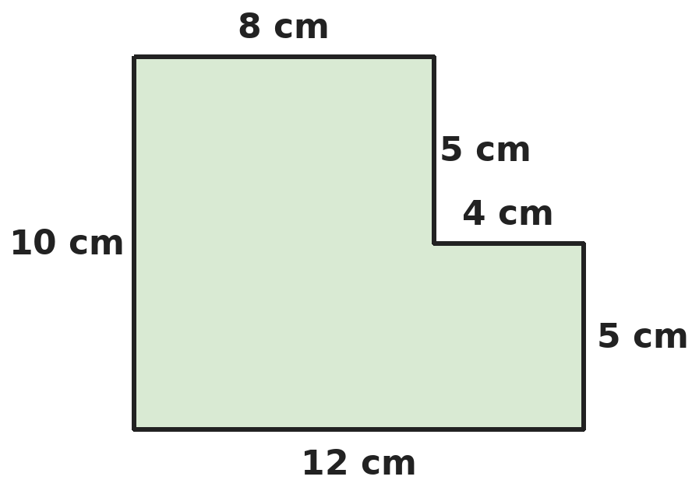
Q15. What is the area of this shape? All corners are right angles.
(A) 120 cm² | (B) 80 cm² | (C) 100 cm² | (D) 110 cm²

Q16. A right-angled triangle has an area of 54 cm². One of the sides that make the right angle is 9 cm. Its longest side is 15 cm. What is its perimeter?
(A) 36 cm | (B) 33 cm | (C) 42 cm | (D) 30 cm

Part 6 — Data Handling, Statistics & Probability (Syllabus Chapter 8)
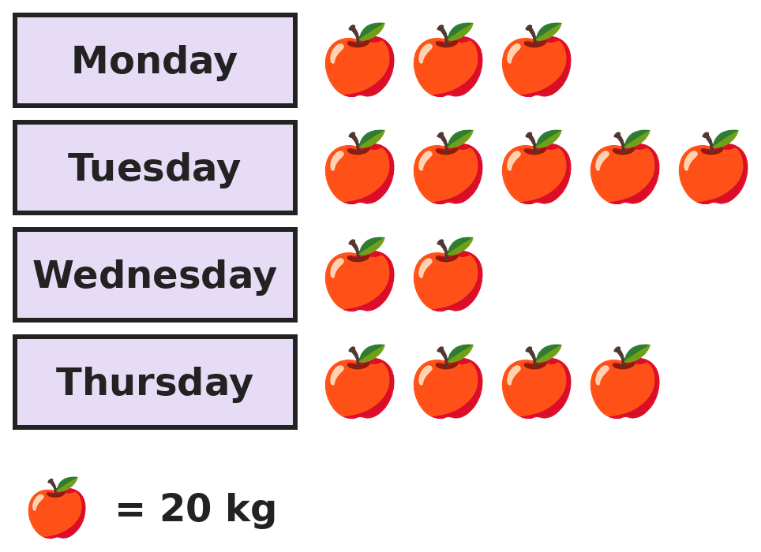
Q17. The pictograph shows apples sold by a shop. Its target was 300 kg for the four days. What happened?
(A) It beat it by 20 kg | (B) It beat it by 40 kg
(C) It beat it by 80 kg | (D) It missed by 20 kg

Part 7 — Applied Mathematics (Syllabus Chapter 9)
Q18. Raghav walks from home to a lake at 5 km/h. The lake is 6 km away. He cycles back at 15 km/h. How long does the whole trip take?
(A) 1 h 24 min | (B) 2 h | (C) 1 h 36 min | (D) 1 h 32 min

Q19. A bus travels 120 km in 3 hours, stops for 30 minutes, then travels 90 km in 1.5 hours. What is its average speed for the whole journey, including the stop?
(A) 52.5 km/h | (B) 42 km/h | (C) 40 km/h | (D) 45 km/h

Q20. How many seconds are there in 2.5 hours minus 75 minutes?
(A) 5,400 | (B) 4,200 | (C) 2,700 | (D) 4,500

Q21. Rani buys 12 bananas at ₹4.50 each and 2.5 kg of apples at ₹160 per kg. She pays with a ₹500 note. How much change does she get?
(A) ₹54 | (B) ₹96 | (C) ₹36 | (D) ₹46

Part 8 — Mathematical Reasoning (Syllabus Chapter 10)

Q22. Each number in this series is double the one before. What is the 8th number?
(A) 192 | (B) 384 | (C) 768 | (D) 48

Q23. In a year that is not a leap year, 1 January is a Wednesday. What day of the week is 1 March?
(A) Friday | (B) Sunday | (C) Wednesday | (D) Saturday

Q24. Tejas puts a + or − sign in place of each question mark. Which of these results can he NEVER get?
(A) 9 | (B) 2 | (C) 0 | (D) 14

Q25. Bhavna has many ₹5 coins, ₹10 notes and ₹20 notes. In how many different ways can she make exactly ₹50?
(A) 10 | (B) 12 | (C) 9 | (D) 15

Part 9 — Mixed Problems (each joins two chapters)
Q26. Two numbers have HCF 6 and LCM 36. One of them is 12. What is the other number?
(A) 18 | (B) 24 | (C) 36 | (D) 30


Q27. The pattern continues in the same way. Which is the first fraction in the pattern that is greater than 0.9?
(A) 9/10 | (B) 11/12 | (C) 10/11 | (D) 8/9

Q28. Lavanya builds a staircase from 1 cm cubes. The 1st step is 1 cube high, the 2nd is 2 cubes high, and so on. Each step is 1 cube wide and 1 cube deep. What is the volume of a staircase with 8 steps?
(A) 36 cm³ | (B) 28 cm³ | (C) 45 cm³ | (D) 64 cm³

Q29. A school building has MCMXCVIII carved above its door, the year it was built. How many years old is the building in 2026?
(A) 38 | (B) 28 | (C) 32 | (D) 18

Q30. A cyclist covers 0.75 km every 3 minutes. How far does she go in 1 hour 12 minutes at the same speed?
(A) 24 km | (B) 18 km | (C) 16.5 km | (D) 21.6 km

Answer Sheet AMO Level 2 · Class 5 · Practice Paper 2
Name: | School: | Roll No.:
Shade or tick one circle for each question.
1. | Ⓐ Ⓑ Ⓒ Ⓓ | 11. | Ⓐ Ⓑ Ⓒ Ⓓ | 21. | Ⓐ Ⓑ Ⓒ Ⓓ
2. | Ⓐ Ⓑ Ⓒ Ⓓ | 12. | Ⓐ Ⓑ Ⓒ Ⓓ | 22. | Ⓐ Ⓑ Ⓒ Ⓓ
3. | Ⓐ Ⓑ Ⓒ Ⓓ | 13. | Ⓐ Ⓑ Ⓒ Ⓓ | 23. | Ⓐ Ⓑ Ⓒ Ⓓ
4. | Ⓐ Ⓑ Ⓒ Ⓓ | 14. | Ⓐ Ⓑ Ⓒ Ⓓ | 24. | Ⓐ Ⓑ Ⓒ Ⓓ
5. | Ⓐ Ⓑ Ⓒ Ⓓ | 15. | Ⓐ Ⓑ Ⓒ Ⓓ | 25. | Ⓐ Ⓑ Ⓒ Ⓓ
6. | Ⓐ Ⓑ Ⓒ Ⓓ | 16. | Ⓐ Ⓑ Ⓒ Ⓓ | 26. | Ⓐ Ⓑ Ⓒ Ⓓ
7. | Ⓐ Ⓑ Ⓒ Ⓓ | 17. | Ⓐ Ⓑ Ⓒ Ⓓ | 27. | Ⓐ Ⓑ Ⓒ Ⓓ
8. | Ⓐ Ⓑ Ⓒ Ⓓ | 18. | Ⓐ Ⓑ Ⓒ Ⓓ | 28. | Ⓐ Ⓑ Ⓒ Ⓓ
9. | Ⓐ Ⓑ Ⓒ Ⓓ | 19. | Ⓐ Ⓑ Ⓒ Ⓓ | 29. | Ⓐ Ⓑ Ⓒ Ⓓ
10. | Ⓐ Ⓑ Ⓒ Ⓓ | 20. | Ⓐ Ⓑ Ⓒ Ⓓ | 30. | Ⓐ Ⓑ Ⓒ Ⓓ

For the parent or teacher
Correct: ______ / 30
Answer Key and Solutions AMO Level 2 · Class 5 · Practice Paper 2
Quick answers
1 C | 6 C | 11 D | 16 A | 21 D | 26 A
2 B | 7 C | 12 A | 17 D | 22 B | 27 C
3 D | 8 D | 13 B | 18 C | 23 D | 28 A
4 A | 9 C | 14 B | 19 B | 24 A | 29 B
5 A | 10 D | 15 C | 20 D | 25 B | 30 B
Solutions
Q | Part · level | Answer | Why?
1 | Part 1 · Ch1 · Hard | (C) 33 | Hint: Numbers that are multiples of both 4 and 6 are multiples of 12. Do not count them twice.  Multiples of 4: 25 (4 to 100). Multiples of 6: 16 (6 to 96). Multiples of 12 are in both lists: 8 (12 to 96). 25 + 16 − 8 = 33. (41 counts the multiples of 12 twice.)
2 | Part 1 · Ch1 · Hard | (B) 1,99,980 | Hint: Write the new number first.  The lakhs digit is 7 and the tens digit is 9. After swapping: 9,48,572. 9,48,572 − 7,48,592 = 1,99,980.
3 | Part 1 · Ch1 · Hard | (D) 48 | Hint: List the factors in pairs.  36: 1, 2, 3, 4, 6, 9, 12, 18, 36 (9 factors). 48: 1, 2, 3, 4, 6, 8, 12, 16, 24, 48 (10). 40: 1, 2, 4, 5, 8, 10, 20, 40 (8). 45: 1, 3, 5, 9, 15, 45 (6). So 48.
4 | Part 2 · Ch2 · Hard | (A) + | Hint: 5 × 3 = 15, so 48 ÷ (6 ? 2) must be 6.  5 × 3 = 15, so 48 ÷ (6 ? 2) must be 21 − 15 = 6. 48 ÷ 8 = 6, and 6 + 2 = 8. The sign is +. (− gives 27, × gives 19, ÷ gives 31.)
5 | Part 2 · Ch2 · Hard | (A) ₹7 | Hint: Compare each rounded price with the real price.  Rounded: 350 + 580 + 120 + 270 = ₹1,320. Exact: 347 + 582 + 119 + 265 = ₹1,313. The estimate is ₹7 more. (The changes are +3, −2, +1, +5.)
6 | Part 2 · Ch2 · Hard | (C) 21,600 | Hint: Multiply 24 × 25 first.  Biscuits = 25 × 24 × 36. 25 × 24 = 600, and 600 × 36 = 21,600.
7 | Part 3 · Ch3 · Hard | (C) 21 | Hint: First find the number of girls and boys.  Girls: 40% of 60 = 24, so boys = 36. Girls with glasses: 12. Boys with glasses: 25% of 36 = 9. Total 12 + 9 = 21.
8 | Part 3 · Ch3 · Hard | (D) 1.7 | Hint: Change each fraction into hundredths.  3/4 = 0.75 and 7/20 = 0.35. 0.75 + 0.6 + 0.35 = 1.7.
9 | Part 3 · Ch3 · Hard | (C) ₹30.60 | Hint: 3.5 kg is 3 kg and half a kilogram.  3 kg cost 3 × 48.40 = ₹145.20. Half a kg costs ₹24.20. Total ₹169.40. Change: 200 − 169.40 = ₹30.60.
10 | Part 3 · Ch3 · Hard | (D) ₹400 | Hint: Write both fractions in twentieths.  2/5 + 1/4 = 8/20 + 5/20 = 13/20 is spent, so 7/20 is left. 7/20 is ₹140, so 1/20 is ₹20 and the whole is 20 × 20 = ₹400.
11 | Part 4 · Ch5 · Hard | (D) 80° | Hint: Angles on a straight line add up to 180°.  Take the first angle away from each: the extras are 0°, 20° and 40°, which is 60°. 180° − 60° = 120°, so each base part is 40°. The angles are 40°, 60° and 80°.
12 | Part 4 · Ch5 · Hard | (A) Equilateral | Hint: In a triangle with two equal sides, the two other angles are equal.  The other two angles are equal and add up to 180° − 60° = 120°, so each is 60°. All three angles are 60°, so all sides are equal: equilateral.
13 | Part 4 · Ch5 · Hard | (B) Regular pentagon | Hint: At each corner the angles must add up to 360°.  Corner angles: triangle 60° (6 make 360°), square 90° (4 make 360°), hexagon 120° (3 make 360°). A regular pentagon has 108° corners; 3 make 324° and 4 make 432°, so they never fit exactly.
14 | Part 5 · Ch6 · Hard | (B) 60 | Hint: Count how many cubes fit along each edge.  Along the length: 10 ÷ 2 = 5. Width: 4. Height: 3. 5 × 4 × 3 = 60 cubes. (480 is the volume divided by 1, not by 8.)
15 | Part 5 · Ch6 · Hard | (C) 100 cm² | Hint: Think of a 12 cm by 10 cm rectangle with a piece missing.  The full rectangle is 12 × 10 = 120 cm². The missing corner is 4 cm by 5 cm = 20 cm². 120 − 20 = 100 cm².
16 | Part 5 · Ch6 · Hard | (A) 36 cm | Hint: Area = half of (one side × the other side) at the right angle.  Half of 9 × (other side) = 54, so 9 × (other side) = 108 and the other side is 12 cm. Perimeter: 9 + 12 + 15 = 36 cm.
17 | Part 6 · Ch8 · Hard | (D) It missed by 20 kg | Hint: Each symbol stands for 20 kg.  Symbols: 3 + 5 + 2 + 4 = 14. 14 × 20 = 280 kg. 300 − 280 = 20, so it missed the target by 20 kg.
18 | Part 7 · Ch9 · Hard | (C) 1 h 36 min | Hint: Find each time in minutes.  Walking: 6 km at 5 km/h takes 6/5 h = 72 minutes. Cycling: 6 km at 15 km/h takes 6/15 h = 24 minutes. Total 96 minutes = 1 h 36 min.
19 | Part 7 · Ch9 · Hard | (B) 42 km/h | Hint: Average speed = total distance ÷ total time.  Distance: 120 + 90 = 210 km. Time: 3 + 0.5 + 1.5 = 5 hours. 210 ÷ 5 = 42 km/h. (52.5 forgets the stop: 210 ÷ 4.)
20 | Part 7 · Ch9 · Hard | (D) 4,500 | Hint: Change both to minutes first.  2.5 hours = 150 minutes. 150 − 75 = 75 minutes. 75 × 60 = 4,500 seconds.
21 | Part 7 · Ch9 · Hard | (D) ₹46 | Hint: 2.5 kg is 2 kg and half a kg.  Bananas: 12 × 4.50 = ₹54. Apples: 2 × 160 + 80 = ₹400. Total ₹454. Change: 500 − 454 = ₹46.
22 | Part 8 · Ch10 · Hard | (B) 384 | Hint: Keep doubling and count carefully.  3, 6, 12, 24, 48, 96, 192, 384. The 8th number is 384.
23 | Part 8 · Ch10 · Hard | (D) Saturday | Hint: Count the days from 1 January to 1 March.  January has 31 days and February 28, so 1 March is 59 days after 1 January. 59 = 8 weeks + 3 days. 3 days after Wednesday is Saturday.
24 | Part 8 · Ch10 · Hard | (A) 9 | Hint: What is 1 + 2 + … + 7? Does changing a + into a − change odd or even?  With all + signs the total is 28, which is even. Changing a + into a − takes away twice that number, which keeps the total even. So an odd result like 9 is impossible. (2: subtract 6 and 7. 0: subtract 2, 5 and 7. 14: subtract 2 and 5.)
25 | Part 8 · Ch10 · Hard | (B) 12 | Hint: Count the ways with no ₹20 note, with one, and with two.  No ₹20: make ₹50 from ₹5 and ₹10 with 0 to 5 tens: 6 ways. One ₹20: make ₹30: 4 ways. Two ₹20: make ₹10: 2 ways. 6 + 4 + 2 = 12.
26 | Part 9 · Mixed · Ch1 + Ch10 · Hard | (A) 18 | Hint: The other number is a multiple of 6 and a factor of 36. Test them.  The other number must be a multiple of 6 that divides 36: 6, 12, 18 or 36. With 12: 6 gives LCM 12; 12 gives HCF 12; 36 gives HCF 12. Only 18 works: HCF(12, 18) = 6 and LCM(12, 18) = 36.
27 | Part 9 · Mixed · Ch3 + Ch10 · Hard | (C) 10/11 | Hint: Each fraction is 1 minus a unit fraction: 1/2 = 1 − 1/2, 2/3 = 1 − 1/3, …  The fractions are 1 − 1/2, 1 − 1/3, 1 − 1/4, … To be more than 0.9, the part taken away must be less than 1/10. 9/10 = 0.9 exactly, not more. The next, 10/11 = 1 − 1/11, is the first one greater than 0.9.
28 | Part 9 · Mixed · Ch6 + Ch10 · Hard | (A) 36 cm³ | Hint: Add 1 + 2 + 3 + … + 8.  Cubes: 1 + 2 + … + 8. Pair 1 with 8, 2 with 7, 3 with 6, 4 with 5: 4 pairs of 9 = 36. Each cube is 1 cm³, so 36 cm³.
29 | Part 9 · Mixed · Ch1 + Ch9 · Hard | (B) 28 | Hint: MCM is 1900.  MCMXCVIII = 1000 + 900 + 90 + 8 = 1998. 2026 − 1998 = 28 years.
30 | Part 9 · Mixed · Ch3 + Ch9 · Hard | (B) 18 km | Hint: How many 3-minute blocks are in 1 hour 12 minutes?  1 h 12 min = 72 minutes = 24 blocks of 3 minutes. 24 × 0.75 = 18 km.

ARYABHATTA MATHS OLYMPIAD
Level 2
PRACTICE PAPER-3
CLASS 5
Total Questions | 30 multiple-choice questions
Level | Level-2 (final round): every question is Hard
Time | 45 minutes
Arrangement | Parts by chapter; the last Part has mixed problems joining two chapters
Negative Marking | No negative marking
Calculator | Not allowed
Chapters | Number System · Operations · Fractions, Decimals & Percentages · Geometry · Mensuration · Data Handling, Statistics & Probability · Applied Mathematics · Mathematical Reasoning

👋 Hello, friend! How to do this paper:
⭐ Every question has four answer choices: (A), (B), (C) and (D). Only one is correct.
⭐ Read each question and look at its picture carefully. Then mark your answer on the answer sheet at the end.
⭐ This is a Level-2 paper. Every question needs careful thinking, so take your time and check each step.
⭐ The questions are in Parts by chapter. The last Part has mixed problems that join two chapters.
⭐ There is no negative marking, so try every question.
⭐ Do not use a calculator. You may do rough work on a separate sheet.
⭐ All figures are not necessarily drawn to scale unless stated.

For parents and teachers
• Pictures are part of the questions. Every picture also works when printed in black and white.
• You may read a question aloud to the child, exactly as printed. Please do not explain it or point to an answer choice.
• Parts follow the AMO syllabus chapters. Chapters 4 and 7 are not part of the Class 5 syllabus, so the chapter numbers shown in the Part headings have gaps.
• The answer sheet and the answer key are at the end. Remove only the answer key before the child begins.

Part 1 — Number System (Syllabus Chapter 1)
Q1. How many 2-digit prime numbers have digits that add up to 10?
(A) 4 | (B) 2 | (C) 3 | (D) 5

Q2. Uma has two ribbons, 84 cm and 63 cm long. She cuts both into pieces of the same length, as long as possible, with nothing left over. How many pieces does she get in all?
(A) 7 | (B) 21 | (C) 12 | (D) 4

Q3. Kishore writes "six lakh four thousand seventy" in figures. What is the sum of the digits he writes?
(A) 16 | (B) 13 | (C) 17 | (D) 19

Part 2 — Operations (Syllabus Chapter 2)
Q4. Kajal can put brackets into 6 + 4 × 8 − 2 in different ways. Which way gives the largest value?
(A) (6 + 4) × 8 − 2 | (B) (6 + 4) × (8 − 2)
(C) 6 + 4 × (8 − 2) | (D) 6 + (4 × 8) − 2

Q5. A hall has 48 rows of 52 seats. Kartik estimates the number of seats as 50 × 50. By how much is his estimate more than the exact number?
(A) 104 | (B) 96 | (C) 0 | (D) 4

Q6. Without long multiplication, Megha works out 999 × 47 + 47. What does she get?
(A) 46,953 | (B) 47,000 | (C) 47,047 | (D) 46,000

Part 3 — Fractions, Decimals & Percentages (Syllabus Chapter 3)
Q7. Lakshya scored 36 out of 45 in Maths and 42 out of 60 in Science. How many percentage points higher is his Maths score?
(A) 6 | (B) 8 | (C) 10 | (D) 12

Q8. Which two of these are equal: 0.45, 9/20, 4/9, 0.405?
(A) 4/9 and 0.45 | (B) 0.405 and 4/9
(C) 9/20 and 0.405 | (D) 0.45 and 9/20

Q9. Tara pours juice from a 1.25 L jug into glasses that hold 0.15 L each. She fills as many glasses as she can. What is the result?
(A) 8 glasses, 50 mL left | (B) 8 glasses, 5 mL left
(C) 9 glasses, nothing left | (D) 7 glasses, 200 mL left

Q10. Three quarters of a number is 45. What is two fifths of the same number?
(A) 24 | (B) 18 | (C) 27 | (D) 36

Part 4 — Geometry (Syllabus Chapter 5)
Q11. Four angles meet at a point. One is a right angle, one is 70°, and the other two are equal. What is each of the equal angles?
(A) 110° | (B) 90° | (C) 200° | (D) 100°

Q12. How many of these are ALWAYS true? Every square is a rhombus. Every rhombus is a parallelogram. Every rectangle is a parallelogram. Every rhombus is a rectangle.
(A) 3 | (B) 2 | (C) 4 | (D) 1

Q13. Om adds the numbers of lines of symmetry of a regular hexagon, a rectangle that is not a square and an isosceles triangle that is not equilateral. What total does he get?
(A) 8 | (B) 9 | (C) 10 | (D) 12

Part 5 — Mensuration (Syllabus Chapter 6)
Q14. A tank is 1.2 m long, 50 cm wide and 40 cm deep. How many litres of water does it hold when full? (1 L = 1,000 cm³)
(A) 2,400 L | (B) 240 L | (C) 24 L | (D) 480 L

Q15. Prachi cuts a 4 cm square from each corner of a 15 cm by 9 cm rectangle. What is the perimeter of the shape that is left?
(A) 48 cm | (B) 32 cm | (C) 64 cm | (D) 40 cm

Q16. A right-angled triangular plot has its two shorter sides 24 m and 18 m. Grass costs ₹15 per square metre. How much does it cost to grass the whole plot?
(A) ₹6,480 | (B) ₹2,160 | (C) ₹3,600 | (D) ₹3,240

Part 6 — Data Handling, Statistics & Probability (Syllabus Chapter 8)
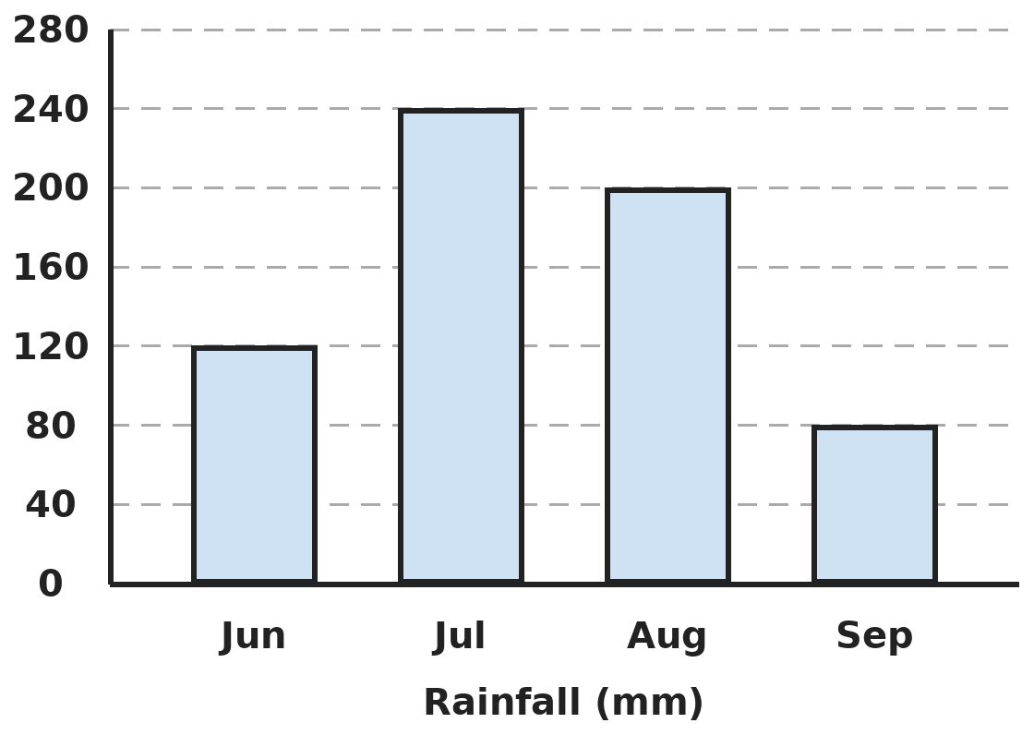
Q17. The bar graph shows the rainfall in a town. How many more millimetres fell in July and August together than in June and September together?
(A) 200 | (B) 280 | (C) 240 | (D) 160

Part 7 — Applied Mathematics (Syllabus Chapter 9)
Q18. Two trains are 330 km apart. They start at the same time and move towards each other at 60 km/h and 50 km/h. After how long do they meet?
(A) 6 h | (B) 3 h | (C) 3 h 30 min | (D) 2 h 30 min

Q19. Mihir drives for 2 hours at 60 km/h and then for 3 hours at 40 km/h. What is his average speed for the whole drive?
(A) 48 km/h | (B) 50 km/h | (C) 45 km/h | (D) 52 km/h

Q20. A leaking tap drips 25 mL of water every 2 minutes. How many litres does it waste in one whole day?
(A) 18 L | (B) 36 L | (C) 1.8 L | (D) 180 L

Q21. Notebooks cost ₹19 each, or ₹105 for a pack of 6. Ishaan needs exactly 20 notebooks and wants to pay as little as possible. How much does he pay?
(A) ₹380 | (B) ₹420 | (C) ₹350 | (D) ₹353

Part 8 — Mathematical Reasoning (Syllabus Chapter 10)

Q22. The series keeps going up by the same amount. Which of these numbers is in the series: 100, 103, 108, 115?
(A) 100 | (B) 108 | (C) 115 | (D) 103

Q23. In a leap year, 1 February is a Thursday. On which day of the week is 31 March?
(A) Saturday | (B) Sunday | (C) Monday | (D) Friday

Q24. Seven cards lie face up. In each move Nitin must turn over exactly two cards. What is the fewest number of moves he needs to make all seven cards face down?
(A) 4 | (B) 3
(C) It is impossible | (D) 7

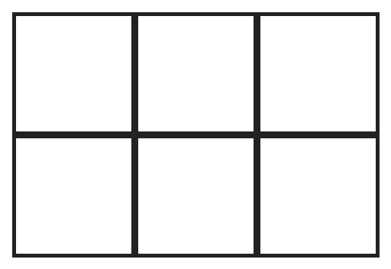
Q25. How many rectangles of all sizes are there in this grid? (Squares count as rectangles.)
(A) 17 | (B) 18 | (C) 12 | (D) 24

Part 9 — Mixed Problems (each joins two chapters)
Q26. How many numbers from 1 to 50 have exactly three factors?
(A) 3 | (B) 5 | (C) 7 | (D) 4


Q27. Each number in the series is found from the one before in the same way. Which number comes next?
(A) 10.8 | (B) 15.4 | (C) 16.8 | (D) 16.2

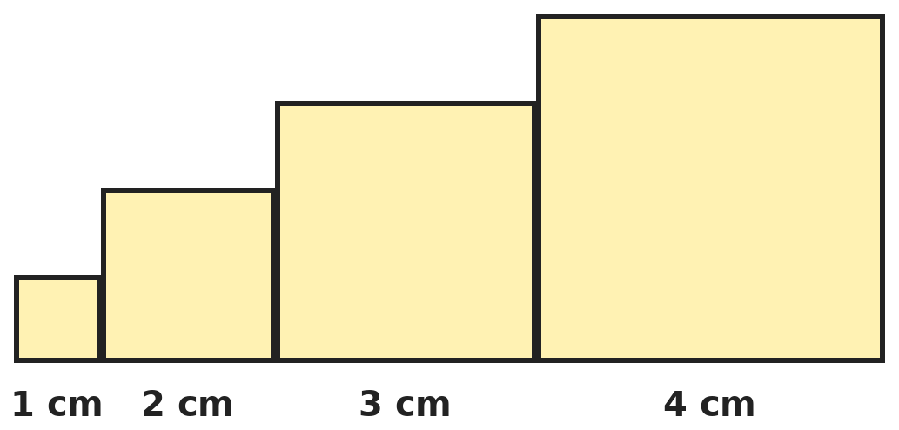
Q28. Squares of side 1 cm, 2 cm, 3 cm and 4 cm stand side by side on a line, as shown. What is the perimeter of the whole shape?
(A) 40 cm | (B) 30 cm | (C) 28 cm | (D) 36 cm

Q29. At a cinema, shows on Screen 1 start every 45 minutes and on Screen 2 every 60 minutes. Both start a show at 10:00 AM. How many shows start on Screen 1 from 10:00 AM until both next start together, counting both ends?
(A) 4 | (B) 5 | (C) 3 | (D) 6

Q30. Juice costs ₹48 per litre. Kirti buys one 750 mL pack and one 1.25 L pack and pays with ₹200. How much change does she get?
(A) ₹96 | (B) ₹114 | (C) ₹104 | (D) ₹86

Answer Sheet AMO Level 2 · Class 5 · Practice Paper 3
Name: | School: | Roll No.:
Shade or tick one circle for each question.
1. | Ⓐ Ⓑ Ⓒ Ⓓ | 11. | Ⓐ Ⓑ Ⓒ Ⓓ | 21. | Ⓐ Ⓑ Ⓒ Ⓓ
2. | Ⓐ Ⓑ Ⓒ Ⓓ | 12. | Ⓐ Ⓑ Ⓒ Ⓓ | 22. | Ⓐ Ⓑ Ⓒ Ⓓ
3. | Ⓐ Ⓑ Ⓒ Ⓓ | 13. | Ⓐ Ⓑ Ⓒ Ⓓ | 23. | Ⓐ Ⓑ Ⓒ Ⓓ
4. | Ⓐ Ⓑ Ⓒ Ⓓ | 14. | Ⓐ Ⓑ Ⓒ Ⓓ | 24. | Ⓐ Ⓑ Ⓒ Ⓓ
5. | Ⓐ Ⓑ Ⓒ Ⓓ | 15. | Ⓐ Ⓑ Ⓒ Ⓓ | 25. | Ⓐ Ⓑ Ⓒ Ⓓ
6. | Ⓐ Ⓑ Ⓒ Ⓓ | 16. | Ⓐ Ⓑ Ⓒ Ⓓ | 26. | Ⓐ Ⓑ Ⓒ Ⓓ
7. | Ⓐ Ⓑ Ⓒ Ⓓ | 17. | Ⓐ Ⓑ Ⓒ Ⓓ | 27. | Ⓐ Ⓑ Ⓒ Ⓓ
8. | Ⓐ Ⓑ Ⓒ Ⓓ | 18. | Ⓐ Ⓑ Ⓒ Ⓓ | 28. | Ⓐ Ⓑ Ⓒ Ⓓ
9. | Ⓐ Ⓑ Ⓒ Ⓓ | 19. | Ⓐ Ⓑ Ⓒ Ⓓ | 29. | Ⓐ Ⓑ Ⓒ Ⓓ
10. | Ⓐ Ⓑ Ⓒ Ⓓ | 20. | Ⓐ Ⓑ Ⓒ Ⓓ | 30. | Ⓐ Ⓑ Ⓒ Ⓓ

For the parent or teacher
Correct: ______ / 30
Answer Key and Solutions AMO Level 2 · Class 5 · Practice Paper 3
Quick answers
1 C | 6 B | 11 D | 16 D | 21 D | 26 D
2 A | 7 C | 12 A | 17 C | 22 D | 27 D
3 C | 8 D | 13 B | 18 B | 23 B | 28 C
4 A | 9 A | 14 B | 19 A | 24 C | 29 B
5 D | 10 A | 15 A | 20 A | 25 B | 30 C
Solutions
Q | Part · level | Answer | Why?
1 | Part 1 · Ch1 · Hard | (C) 3 | Hint: List the 2-digit numbers with digit sum 10 and test each one.  Digit sum 10: 19, 28, 37, 46, 55, 64, 73, 82, 91. Even numbers and 55 are not prime, and 91 = 7 × 13. The primes are 19, 37 and 73: 3.
2 | Part 1 · Ch1 · Hard | (A) 7 | Hint: The longest piece that fits both is the HCF.  HCF of 84 and 63 is 21, so each piece is 21 cm. 84 ÷ 21 = 4 and 63 ÷ 21 = 3. 4 + 3 = 7 pieces.
3 | Part 1 · Ch1 · Hard | (C) 17 | Hint: Be careful with the zeros in the thousands and hundreds places.  Six lakh four thousand seventy = 6,04,070. Digit sum: 6 + 0 + 4 + 0 + 7 + 0 = 17.
4 | Part 2 · Ch2 · Hard | (A) (6 + 4) × 8 − 2 | Hint: Work out each one.  (6 + 4) × 8 − 2 = 80 − 2 = 78. (6 + 4) × (8 − 2) = 60. 6 + 4 × (8 − 2) = 30. 6 + 32 − 2 = 36. The largest is 78.
5 | Part 2 · Ch2 · Hard | (D) 4 | Hint: Work out 48 × 52 exactly.  48 × 52 = 48 × 50 + 48 × 2 = 2,400 + 96 = 2,496. 50 × 50 = 2,500. 2,500 − 2,496 = 4.
6 | Part 2 · Ch2 · Hard | (B) 47,000 | Hint: 47 is 1 × 47.  999 × 47 + 1 × 47 = (999 + 1) × 47 = 1,000 × 47 = 47,000.
7 | Part 3 · Ch3 · Hard | (C) 10 | Hint: Change each score into a percentage.  36/45 = 4/5 = 80%. 42/60 = 7/10 = 70%. 80 − 70 = 10 percentage points.
8 | Part 3 · Ch3 · Hard | (D) 0.45 and 9/20 | Hint: Change each fraction into a decimal.  9/20 = 45/100 = 0.45. 4/9 = 0.444…, which is neither 0.45 nor 0.405. So 0.45 and 9/20 are equal.
9 | Part 3 · Ch3 · Hard | (A) 8 glasses, 50 mL left | Hint: Work in millilitres: 1.25 L = 1,250 mL.  1,250 mL ÷ 150 mL: 8 glasses use 1,200 mL. 1,250 − 1,200 = 50 mL left.
10 | Part 3 · Ch3 · Hard | (A) 24 | Hint: Find the whole number first.  3/4 of the number is 45, so 1/4 is 15 and the number is 60. 2/5 of 60 = 24.
11 | Part 4 · Ch5 · Hard | (D) 100° | Hint: Angles round a point add up to 360°.  360° − 90° − 70° = 200°. The two equal angles share it: 200° ÷ 2 = 100°.
12 | Part 4 · Ch5 · Hard | (A) 3 | Hint: Check each one: does the second shape need anything the first might not have?  A square has four equal sides, so it is a rhombus. A rhombus and a rectangle both have two pairs of parallel sides, so both are parallelograms. A rhombus need not have square corners, so it need not be a rectangle. 3 are always true.
13 | Part 4 · Ch5 · Hard | (B) 9 | Hint: The diagonals of a rectangle are not lines of symmetry.  Regular hexagon: 6. Rectangle (not a square): 2. Isosceles triangle (not equilateral): 1. 6 + 2 + 1 = 9.
14 | Part 5 · Ch6 · Hard | (B) 240 L | Hint: Change 1.2 m into centimetres first.  1.2 m = 120 cm. Volume: 120 × 50 × 40 = 2,40,000 cm³. 2,40,000 ÷ 1,000 = 240 L.
15 | Part 5 · Ch6 · Hard | (A) 48 cm | Hint: Look at what each cut takes away and what it adds to the boundary.  Each cut removes 4 + 4 cm of the old edge but adds 4 + 4 cm of new edge, so the perimeter does not change. It is 2 × (15 + 9) = 48 cm.
16 | Part 5 · Ch6 · Hard | (D) ₹3,240 | Hint: Area of a right-angled triangle = half of (base × height).  Area: half of 24 × 18 = 216 m². Cost: 216 × 15 = ₹3,240. (₹6,480 forgets to halve.)
17 | Part 6 · Ch8 · Hard | (C) 240 | Hint: Read each bar against the scale, which goes up in 40s.  July 240 + August 200 = 440 mm. June 120 + September 80 = 200 mm. 440 − 200 = 240 mm.
18 | Part 7 · Ch9 · Hard | (B) 3 h | Hint: Together they close the gap by 60 + 50 km every hour.  Each hour the gap gets 60 + 50 = 110 km smaller. 330 ÷ 110 = 3 hours.
19 | Part 7 · Ch9 · Hard | (A) 48 km/h | Hint: Find the total distance and the total time.  Distance: 2 × 60 + 3 × 40 = 120 + 120 = 240 km. Time: 5 h. 240 ÷ 5 = 48 km/h. (50 is the plain average of the speeds.)
20 | Part 7 · Ch9 · Hard | (A) 18 L | Hint: How many 2-minute blocks are there in 24 hours?  One day = 24 × 60 = 1,440 minutes = 720 blocks of 2 minutes. 720 × 25 = 18,000 mL = 18 L.
21 | Part 7 · Ch9 · Hard | (D) ₹353 | Hint: Compare 3 packs plus some single notebooks with 4 packs.  3 packs give 18 notebooks for ₹315; 2 more cost ₹38: total ₹353. 4 packs (24 notebooks) cost ₹420. 20 singles cost ₹380. The least is ₹353.
22 | Part 8 · Ch10 · Hard | (D) 103 | Hint: Every number in the series is 5 more than a multiple of 7.  The series adds 7 each time, so each number is 5 + a multiple of 7. 103 − 5 = 98 = 7 × 14. 100 − 5 = 95, 108 − 5 = 103 and 115 − 5 = 110 are not multiples of 7.
23 | Part 8 · Ch10 · Hard | (B) Sunday | Hint: A leap year February has 29 days.  1 March is 29 days after 1 February: 4 weeks + 1 day, so Friday. 31 March is 30 days after 1 March: 4 weeks + 2 days, so Sunday.
24 | Part 8 · Ch10 · Hard | (C) It is impossible | Hint: Think about whether the number of face-up cards is odd or even after each move.  Each move changes the number of face-up cards by 2 or 0, so it stays odd: 7, 5, 3, 1, … It can never become 0. So it is impossible.
25 | Part 8 · Ch10 · Hard | (B) 18 | Hint: A rectangle is fixed by choosing 2 of the vertical lines and 2 of the horizontal lines.  There are 4 vertical lines and 3 horizontal lines. Pairs of vertical lines: 6. Pairs of horizontal lines: 3. Rectangles: 6 × 3 = 18.
26 | Part 9 · Mixed · Ch1 + Ch10 · Hard | (D) 4 | Hint: Try 4: its factors are 1, 2 and 4. What kind of number is 4?  A number with exactly 3 factors is a prime times itself: 4, 9, 25 and 49 (factors 1, p and p × p). The next, 121, is over 50. So 4 numbers.
27 | Part 9 · Mixed · Ch3 + Ch10 · Hard | (D) 16.2 | Hint: Compare 0.6 with 0.2.  Each number is 3 times the one before: 0.2 × 3 = 0.6, 0.6 × 3 = 1.8, 1.8 × 3 = 5.4. Next: 5.4 × 3 = 16.2.
28 | Part 9 · Mixed · Ch6 + Ch10 · Hard | (C) 28 cm | Hint: Slide the steps of the top edge up and across: they make a simple rectangle outline.  The shape is 1 + 2 + 3 + 4 = 10 cm wide and 4 cm tall. The steps on the top and left add up to 10 cm across and 4 cm up, so the perimeter is the same as a 10 cm by 4 cm rectangle: 2 × (10 + 4) = 28 cm. (40 adds all four square perimeters.)
29 | Part 9 · Mixed · Ch1 + Ch9 · Hard | (B) 5 | Hint: Find when both screens next start at the same time.  LCM of 45 and 60 is 180 minutes, so both next start at 1:00 PM. Screen 1 starts at 10:00, 10:45, 11:30, 12:15 and 1:00: 5 shows.
30 | Part 9 · Mixed · Ch3 + Ch9 · Hard | (C) ₹104 | Hint: Add the two amounts in litres first.  750 mL = 0.75 L. 0.75 + 1.25 = 2 L. Cost: 2 × 48 = ₹96. Change: 200 − 96 = ₹104.

ARYABHATTA MATHS OLYMPIAD
Level 2
PRACTICE PAPER-4
CLASS 5
Total Questions | 30 multiple-choice questions
Level | Level-2 (final round): every question is Hard
Time | 45 minutes
Arrangement | Parts by chapter; the last Part has mixed problems joining two chapters
Negative Marking | No negative marking
Calculator | Not allowed
Chapters | Number System · Operations · Fractions, Decimals & Percentages · Geometry · Mensuration · Data Handling, Statistics & Probability · Applied Mathematics · Mathematical Reasoning

👋 Hello, friend! How to do this paper:
⭐ Every question has four answer choices: (A), (B), (C) and (D). Only one is correct.
⭐ Read each question and look at its picture carefully. Then mark your answer on the answer sheet at the end.
⭐ This is a Level-2 paper. Every question needs careful thinking, so take your time and check each step.
⭐ The questions are in Parts by chapter. The last Part has mixed problems that join two chapters.
⭐ There is no negative marking, so try every question.
⭐ Do not use a calculator. You may do rough work on a separate sheet.
⭐ All figures are not necessarily drawn to scale unless stated.

For parents and teachers
• Pictures are part of the questions. Every picture also works when printed in black and white.
• You may read a question aloud to the child, exactly as printed. Please do not explain it or point to an answer choice.
• Parts follow the AMO syllabus chapters. Chapters 4 and 7 are not part of the Class 5 syllabus, so the chapter numbers shown in the Part headings have gaps.
• The answer sheet and the answer key are at the end. Remove only the answer key before the child begins.

Part 1 — Number System (Syllabus Chapter 1)
Q1. Which is the smallest number greater than 1 that leaves a remainder of 1 when divided by 2, by 3, by 4, by 5 and by 6?
(A) 31 | (B) 121 | (C) 59 | (D) 61

Q2. Jayesh writes the Roman numerals from I to C. How many of them use the letter L?
(A) 50 | (B) 49 | (C) 40 | (D) 39

Q3. Three prime numbers that come one after another (like 2, 3, 5) multiply to give 1,001. What is their sum?
(A) 29 | (B) 35 | (C) 31 | (D) 23

Part 2 — Operations (Syllabus Chapter 2)
Q4. Tanmay works out this expression in the correct order. What is the answer?
(A) 0.6 | (B) 15 | (C) 90 | (D) 3

Q5. Anjali rounds 6,48,372 to the nearest thousand. Mayank rounds it to the nearest lakh. What is the difference between their answers?
(A) 48,000 | (B) 52,000 | (C) 48,372 | (D) 1,48,000

Q6. Which number should replace the question mark?
(A) 100 | (B) 64 | (C) 54 | (D) 63

Part 3 — Fractions, Decimals & Percentages (Syllabus Chapter 3)
Q7. A library had 1,500 books. 20% of them were damaged and removed. Then 300 new books were added. What percentage of the books in the library are now new?
(A) 25% | (B) 30% | (C) 15% | (D) 20%

Q8. What is 0.36 × 25 ÷ 0.9?
(A) 10 | (B) 1 | (C) 100 | (D) 0.1

Q9. Sahil ate 7/10 of a pizza. Isha ate 3/4 of a pizza of the same size. Who ate more, and by how much?
(A) Sahil, by 1/20 | (B) Isha, by 1/10
(C) Isha, by 1/20 | (D) They ate the same

Q10. Payal gets ₹2,400. She saves 15% of it and gives 1/8 of it to charity. How much does she have left to spend?
(A) ₹1,800 | (B) ₹2,040 | (C) ₹1,740 | (D) ₹1,640

Part 4 — Geometry (Syllabus Chapter 5)
Q11. An isosceles triangle has one angle of 40°. Which of these can NOT be one of its other angles?
(A) 100° | (B) 80° | (C) 70° | (D) 40°

Q12. A regular octagon is turned about its centre. Which of these turns does NOT make it look exactly the same as before?
(A) 100° | (B) 90° | (C) 135° | (D) 225°

Q13. Kirti walks 5 km North. She turns right and walks 3 km, turns right again and walks 9 km, then turns left and walks 3 km. Where is she now from her starting point?
(A) 6 km East, 4 km North | (B) 3 km East, 4 km South
(C) 6 km East, 4 km South | (D) 0 km East, 4 km South

Part 5 — Mensuration (Syllabus Chapter 6)
Q14. A wooden block is 6 cm by 9 cm by 12 cm. How many cubes with 3 cm edges can be cut from it with nothing left over?
(A) 72 | (B) 24 | (C) 48 | (D) 18

Q15. A hall floor is 12 m long and 8.5 m wide. It is covered with square tiles of side 50 cm. How many tiles are needed?
(A) 204 | (B) 408 | (C) 102 | (D) 816

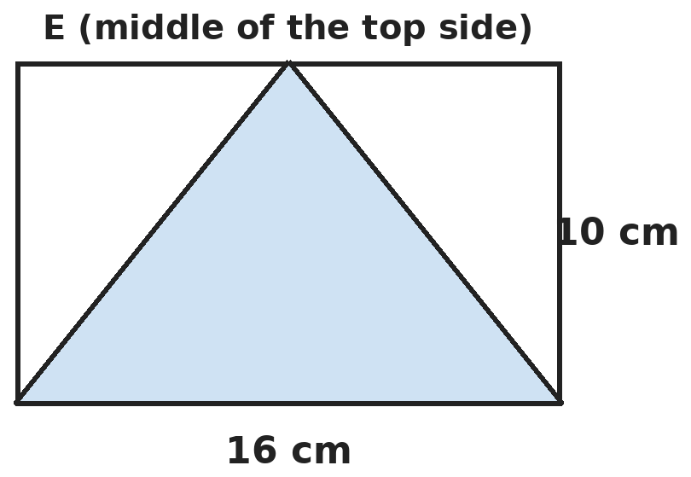
Q16. E is the middle of the top side of a 16 cm by 10 cm rectangle. E is joined to the two bottom corners. What is the area of the shaded triangle?
(A) 40 cm² | (B) 120 cm² | (C) 80 cm² | (D) 60 cm²

Part 6 — Data Handling, Statistics & Probability (Syllabus Chapter 8)
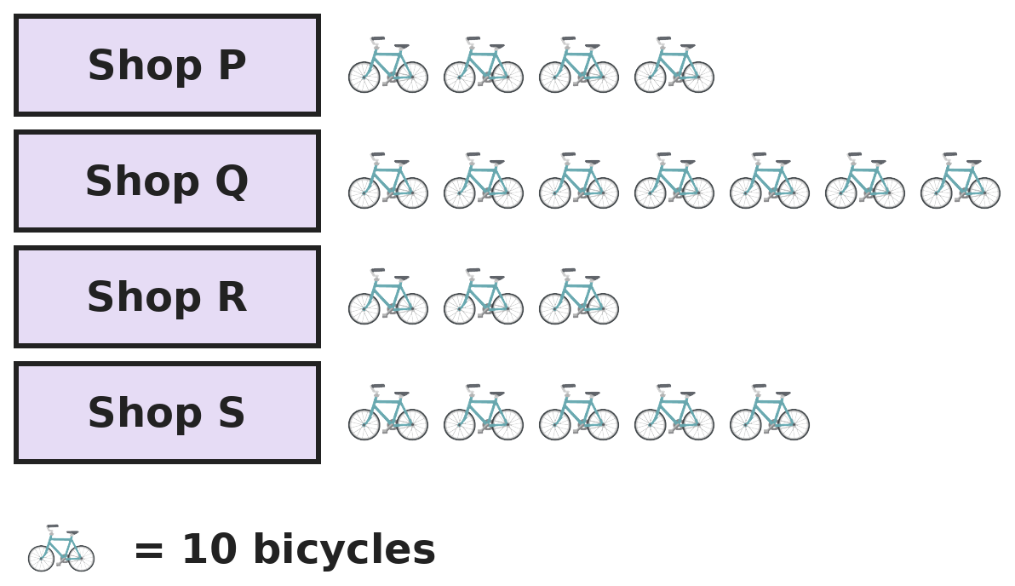
Q17. The pictograph shows bicycles sold by four shops in a month. Which two shops together sold exactly 110 bicycles?
(A) Q and R | (B) P and Q | (C) P and S | (D) Q and S

Part 7 — Applied Mathematics (Syllabus Chapter 9)
Q18. A car leaves at 7:40 AM and arrives at 10:10 AM. It drives at a steady 54 km/h. How far does it travel?
(A) 162 km | (B) 126 km | (C) 135 km | (D) 140 km

Q19. Sumit walks 6 km up a hill at 3 km/h and comes back down the same path at 6 km/h. What is his average speed for the whole walk?
(A) 4 km/h | (B) 4.5 km/h | (C) 5 km/h | (D) 9 km/h

Q20. The winner of a race took 1 hour 4 minutes 30 seconds. Raju took 245 seconds longer. What was Raju's time?
(A) 1 h 6 min 55 s | (B) 1 h 9 min 15 s
(C) 1 h 8 min 35 s | (D) 1 h 8 min 15 s

Q21. Gauri buys 3 kg of sugar at ₹46.50 per kg and 2 litres of oil at ₹138.75 per litre. She had ₹500. How much money is left?
(A) ₹83 | (B) ₹93 | (C) ₹73 | (D) ₹83.50

Part 8 — Mathematical Reasoning (Syllabus Chapter 10)

Q22. Find the rule in this series. Which number comes next?
(A) 29 | (B) 31 | (C) 42 | (D) 34

Q23. Riya was born on Saturday, 29 February 2020. The next 29 February was in 2024. On which day of the week did it fall?
(A) Saturday | (B) Wednesday | (C) Friday | (D) Thursday

Q24. Kavya adds five numbers that come one after another, like 3, 4, 5, 6, 7. Which of these could be her total?
(A) 115 | (B) 102 | (C) 98 | (D) 121

Q25. Rhea makes 3-digit numbers using three different digits from 0, 2, 5 and 7. How many of her numbers are divisible by 5?
(A) 12 | (B) 6 | (C) 8 | (D) 10

Part 9 — Mixed Problems (each joins two chapters)
Q26. How many numbers from 1 to 200 are divisible by both 6 and 8?
(A) 8 | (B) 4 | (C) 33 | (D) 25

Q27. A ball is dropped from a height of 12.8 m. Each time it bounces, it rises to half the height it fell from. How high does it rise after the 4th bounce?
(A) 1.6 m | (B) 0.8 m | (C) 0.4 m | (D) 3.2 m

Q28. Equal squares of side 2 cm are placed side by side in a row to make a long rectangle. How many squares are needed to make a rectangle with a perimeter of 84 cm?
(A) 21 | (B) 20 | (C) 10 | (D) 42

Q29. A shopkeeper has ₹1,000 in ₹20 and ₹50 notes. There are 32 notes in all. How many ₹50 notes are there?
(A) 20 | (B) 10 | (C) 14 | (D) 12

Q30. A motorbike uses 1.5 litres of petrol for every 60 km. Petrol costs ₹102 per litre. How much does the petrol cost for a 340 km trip?
(A) ₹850 | (B) ₹918 | (C) ₹765 | (D) ₹867

Answer Sheet AMO Level 2 · Class 5 · Practice Paper 4
Name: | School: | Roll No.:
Shade or tick one circle for each question.
1. | Ⓐ Ⓑ Ⓒ Ⓓ | 11. | Ⓐ Ⓑ Ⓒ Ⓓ | 21. | Ⓐ Ⓑ Ⓒ Ⓓ
2. | Ⓐ Ⓑ Ⓒ Ⓓ | 12. | Ⓐ Ⓑ Ⓒ Ⓓ | 22. | Ⓐ Ⓑ Ⓒ Ⓓ
3. | Ⓐ Ⓑ Ⓒ Ⓓ | 13. | Ⓐ Ⓑ Ⓒ Ⓓ | 23. | Ⓐ Ⓑ Ⓒ Ⓓ
4. | Ⓐ Ⓑ Ⓒ Ⓓ | 14. | Ⓐ Ⓑ Ⓒ Ⓓ | 24. | Ⓐ Ⓑ Ⓒ Ⓓ
5. | Ⓐ Ⓑ Ⓒ Ⓓ | 15. | Ⓐ Ⓑ Ⓒ Ⓓ | 25. | Ⓐ Ⓑ Ⓒ Ⓓ
6. | Ⓐ Ⓑ Ⓒ Ⓓ | 16. | Ⓐ Ⓑ Ⓒ Ⓓ | 26. | Ⓐ Ⓑ Ⓒ Ⓓ
7. | Ⓐ Ⓑ Ⓒ Ⓓ | 17. | Ⓐ Ⓑ Ⓒ Ⓓ | 27. | Ⓐ Ⓑ Ⓒ Ⓓ
8. | Ⓐ Ⓑ Ⓒ Ⓓ | 18. | Ⓐ Ⓑ Ⓒ Ⓓ | 28. | Ⓐ Ⓑ Ⓒ Ⓓ
9. | Ⓐ Ⓑ Ⓒ Ⓓ | 19. | Ⓐ Ⓑ Ⓒ Ⓓ | 29. | Ⓐ Ⓑ Ⓒ Ⓓ
10. | Ⓐ Ⓑ Ⓒ Ⓓ | 20. | Ⓐ Ⓑ Ⓒ Ⓓ | 30. | Ⓐ Ⓑ Ⓒ Ⓓ

For the parent or teacher
Correct: ______ / 30
Answer Key and Solutions AMO Level 2 · Class 5 · Practice Paper 4
Quick answers
1 D | 6 C | 11 B | 16 C | 21 A | 26 A
2 A | 7 D | 12 A | 17 B | 22 D | 27 B
3 C | 8 A | 13 C | 18 C | 23 D | 28 B
4 B | 9 C | 14 B | 19 A | 24 A | 29 D
5 A | 10 C | 15 B | 20 C | 25 D | 30 D
Solutions
Q | Part · level | Answer | Why?
1 | Part 1 · Ch1 · Hard | (D) 61 | Hint: One less than the number is divisible by all of 2, 3, 4, 5 and 6.  The number minus 1 must be a common multiple of 2, 3, 4, 5 and 6. Their LCM is 60. So the number is 60 + 1 = 61.
2 | Part 1 · Ch1 · Hard | (A) 50 | Hint: L means 50. Which numbers need it?  40 to 49 are XL to XLIX: 10 numerals. 50 to 89 all start with L: 40 numerals. 90 to 99 use XC and 100 is C, with no L. 10 + 40 = 50.
3 | Part 1 · Ch1 · Hard | (C) 31 | Hint: Try dividing 1,001 by 7.  1,001 ÷ 7 = 143 and 143 = 11 × 13. So 1,001 = 7 × 11 × 13, which are consecutive primes. 7 + 11 + 13 = 31.
4 | Part 2 · Ch2 · Hard | (B) 15 | Hint: Inside the round bracket, multiply before adding.  6 × 3 = 18 and 12 + 18 = 30. 48 − 30 = 18. Then from left to right: 18 ÷ 6 = 3 and 3 × 5 = 15. (0.6 wrongly does 6 × 5 first.)
5 | Part 2 · Ch2 · Hard | (A) 48,000 | Hint: To the nearest lakh, look at the ten-thousands digit.  Nearest thousand: 6,48,000. Nearest lakh: 6,00,000, because 48,372 is less than 50,000. Difference: 48,000.
6 | Part 2 · Ch2 · Hard | (C) 54 | Hint: 3,700 = 37 × 100.  37 × 46 + 37 × ? = 37 × (46 + ?). This must be 37 × 100, so 46 + ? = 100 and ? = 54.
7 | Part 3 · Ch3 · Hard | (D) 20% | Hint: First find how many books are in the library now.  20% of 1,500 = 300 removed, leaving 1,200. Adding 300 new books gives 1,500. New books: 300 out of 1,500 = 1/5 = 20%.
8 | Part 3 · Ch3 · Hard | (A) 10 | Hint: 0.36 × 25 is the same as 36 × 25 ÷ 100.  0.36 × 25 = 9. 9 ÷ 0.9 = 90 ÷ 9 = 10.
9 | Part 3 · Ch3 · Hard | (C) Isha, by 1/20 | Hint: Write both fractions in twentieths.  7/10 = 14/20 and 3/4 = 15/20. Isha ate 15/20 − 14/20 = 1/20 of a pizza more.
10 | Part 3 · Ch3 · Hard | (C) ₹1,740 | Hint: 15% is 10% + 5%.  10% of 2,400 = 240 and 5% = 120, so 15% = ₹360. 1/8 of 2,400 = ₹300. Left: 2,400 − 360 − 300 = ₹1,740.
11 | Part 4 · Ch5 · Hard | (B) 80° | Hint: The 40° angle could be one of the two equal angles, or the odd one.  If 40° is one of the equal angles, the angles are 40°, 40° and 100°. If 40° is the odd angle, the other two share 140°: 70° and 70°. So the other angles can be 40°, 100° or 70°, but never 80°.
12 | Part 4 · Ch5 · Hard | (A) 100° | Hint: Its order of rotational symmetry is 8. Find the smallest turn first.  A regular octagon looks the same 8 times in a full turn, so every turn that is a multiple of 360° ÷ 8 = 45° works. 90° = 2 × 45°, 135° = 3 × 45° and 225° = 5 × 45°. 100° is not a multiple of 45°.
13 | Part 4 · Ch5 · Hard | (C) 6 km East, 4 km South | Hint: Turning right from North faces East; right again faces South.  5 km North, then right: 3 km East. Right again: 9 km South, so she is 4 km south of the start. Left from South faces East: 3 km more East. Total 6 km East, 4 km South.
14 | Part 5 · Ch6 · Hard | (B) 24 | Hint: Count along each edge.  6 ÷ 3 = 2, 9 ÷ 3 = 3, 12 ÷ 3 = 4. 2 × 3 × 4 = 24 cubes. (Check: 648 ÷ 27 = 24.)
15 | Part 5 · Ch6 · Hard | (B) 408 | Hint: How many tiles fit along each side?  Along 12 m: 24 tiles. Along 8.5 m: 17 tiles. 24 × 17 = 408 tiles.
16 | Part 5 · Ch6 · Hard | (C) 80 cm² | Hint: The two white parts are right-angled triangles.  Rectangle: 16 × 10 = 160 cm². Each white right-angled triangle has sides 8 cm and 10 cm: half of 80 = 40 cm². Shaded: 160 − 40 − 40 = 80 cm².
17 | Part 6 · Ch8 · Hard | (B) P and Q | Hint: Each symbol stands for 10 bicycles, so 110 needs 11 symbols.  P 4, Q 7, R 3, S 5 symbols. 11 symbols: P + Q = 4 + 7. (Q + R = 10, P + S = 9, Q + S = 12.)
18 | Part 7 · Ch9 · Hard | (C) 135 km | Hint: Find the time taken first.  7:40 to 10:10 is 2 hours 30 minutes = 2.5 hours. 54 × 2.5 = 108 + 27 = 135 km.
19 | Part 7 · Ch9 · Hard | (A) 4 km/h | Hint: Average speed is not the average of the two speeds.  Up: 6 ÷ 3 = 2 hours. Down: 6 ÷ 6 = 1 hour. Total: 12 km in 3 hours, so 12 ÷ 3 = 4 km/h.
20 | Part 7 · Ch9 · Hard | (C) 1 h 8 min 35 s | Hint: Change 245 seconds into minutes and seconds.  245 s = 4 min 5 s (4 × 60 = 240). 1 h 4 min 30 s + 4 min 5 s = 1 h 8 min 35 s.
21 | Part 7 · Ch9 · Hard | (A) ₹83 | Hint: Work out each item, then add.  Sugar: 3 × 46.50 = ₹139.50. Oil: 2 × 138.75 = ₹277.50. Total ₹417.00. Left: 500 − 417 = ₹83.
22 | Part 8 · Ch10 · Hard | (D) 34 | Hint: Look at 2 + 3 and 3 + 5.  Each number is the sum of the two before it: 2 + 3 = 5, 3 + 5 = 8, 5 + 8 = 13, 8 + 13 = 21. Next: 13 + 21 = 34.
23 | Part 8 · Ch10 · Hard | (D) Thursday | Hint: The next 29 February is in 2024. Count the days in between.  The next 29 February is in 2024. The four years in between have 365 × 4 = 1,460 days plus 1 extra day for 29 February 2024: 1,461 days. 1,461 = 208 weeks + 5 days. 5 days after Saturday is Thursday.
24 | Part 8 · Ch10 · Hard | (A) 115 | Hint: The total is 5 times the middle number.  The five numbers are spread evenly around the middle one, so the total is 5 × the middle number: a multiple of 5. Only 115 is a multiple of 5: 21 + 22 + 23 + 24 + 25 = 115.
25 | Part 8 · Ch10 · Hard | (D) 10 | Hint: The number must end in 0 or 5. The first digit cannot be 0.  Ending in 0: the first two digits are chosen from 2, 5, 7: 3 × 2 = 6 numbers. Ending in 5: the first digit is 2 or 7 (not 0), then the middle digit has 2 choices: 2 × 2 = 4. 6 + 4 = 10.
26 | Part 9 · Mixed · Ch1 + Ch10 · Hard | (A) 8 | Hint: A number divisible by both is a multiple of their LCM, which is not 48.  LCM of 6 and 8 is 24. Multiples of 24 up to 200: 24, 48, 72, 96, 120, 144, 168, 192. That is 8. (Using 48 would give only 4.)
27 | Part 9 · Mixed · Ch3 + Ch10 · Hard | (B) 0.8 m | Hint: Halve the height four times.  After the bounces it rises to 6.4 m, 3.2 m, 1.6 m and then 0.8 m.
28 | Part 9 · Mixed · Ch6 + Ch10 · Hard | (B) 20 | Hint: With 1 square the perimeter is 8 cm, with 2 squares 12 cm, with 3 squares 16 cm, …  Each new square adds 4 cm to the perimeter (2 cm on top and 2 cm below). The perimeter is 4 × (number of squares) + 4. 84 − 4 = 80, and 80 ÷ 4 = 20 squares. Check: 40 cm by 2 cm has perimeter 84 cm.
29 | Part 9 · Mixed · Ch1 + Ch9 · Hard | (D) 12 | Hint: Suppose all 32 notes were ₹20 notes.  32 notes of ₹20 make ₹640. The rest, ₹360, comes from changing ₹20 notes into ₹50 notes, each adding ₹30. 360 ÷ 30 = 12 notes of ₹50. Check: 12 × 50 + 20 × 20 = 600 + 400 = 1,000.
30 | Part 9 · Mixed · Ch3 + Ch9 · Hard | (D) ₹867 | Hint: Find the petrol used for 20 km first.  60 km uses 1.5 L, so 20 km uses 0.5 L. 340 km is 17 lots of 20 km: 17 × 0.5 = 8.5 L. Cost: 8.5 × 102 = 816 + 51 = ₹867.

ARYABHATTA MATHS OLYMPIAD
Level 2
PRACTICE PAPER-5
CLASS 5
Total Questions | 30 multiple-choice questions
Level | Level-2 (final round): every question is Hard
Time | 45 minutes
Arrangement | Parts by chapter; the last Part has mixed problems joining two chapters
Negative Marking | No negative marking
Calculator | Not allowed
Chapters | Number System · Operations · Fractions, Decimals & Percentages · Geometry · Mensuration · Data Handling, Statistics & Probability · Applied Mathematics · Mathematical Reasoning

👋 Hello, friend! How to do this paper:
⭐ Every question has four answer choices: (A), (B), (C) and (D). Only one is correct.
⭐ Read each question and look at its picture carefully. Then mark your answer on the answer sheet at the end.
⭐ This is a Level-2 paper. Every question needs careful thinking, so take your time and check each step.
⭐ The questions are in Parts by chapter. The last Part has mixed problems that join two chapters.
⭐ There is no negative marking, so try every question.
⭐ Do not use a calculator. You may do rough work on a separate sheet.
⭐ All figures are not necessarily drawn to scale unless stated.

For parents and teachers
• Pictures are part of the questions. Every picture also works when printed in black and white.
• You may read a question aloud to the child, exactly as printed. Please do not explain it or point to an answer choice.
• Parts follow the AMO syllabus chapters. Chapters 4 and 7 are not part of the Class 5 syllabus, so the chapter numbers shown in the Part headings have gaps.
• The answer sheet and the answer key are at the end. Remove only the answer key before the child begins.

Part 1 — Number System (Syllabus Chapter 1)
Q1. Which of these numbers is equal to the sum of all its factors other than itself: 12, 28, 18 or 20?
(A) 12 | (B) 28 | (C) 18 | (D) 20

Q2. What is the greatest number that divides both 75 and 99 and leaves a remainder of 3 each time?
(A) 12 | (B) 8 | (C) 3 | (D) 24

Q3. In the number 8,05,326, how many times the value of the digit 5 is the value of the digit 8?
(A) 16 | (B) 1,600 | (C) 40 | (D) 160

Part 2 — Operations (Syllabus Chapter 2)
Q4. Ravi wrote 18 + 6 ÷ 3 × 4 − 2 = 30. He did not follow the order of operations. What is the correct value?
(A) 30 | (B) 16 | (C) 24 | (D) 34

Q5. A farm packs 4,982 eggs into trays of 49 eggs each. Rohit estimates "about 100 trays". How many trays can actually be filled completely?
(A) 100 | (B) 101 | (C) 102 | (D) 99

Q6. Which of these is NOT equal to 36 × 25?
(A) 9 × 100 | (B) 18 × 50 | (C) 6 × 125 | (D) 12 × 75

Part 3 — Fractions, Decimals & Percentages (Syllabus Chapter 3)
Q7. A jar has 80 marbles. 35% are red, 25% are blue and the rest are green. Rina adds 20 more green marbles. What percentage of the marbles are green now?
(A) 52% | (B) 40% | (C) 60% | (D) 45%

Q8. Which of these is closest to 1: 9/10, 1.05, 21/20 or 0.97?
(A) 0.97 | (B) 1.05 | (C) 21/20 | (D) 9/10

Q9. Raju finds that 0.6 of a number is 4.8. What is 1.5 times the same number?
(A) 7.2 | (B) 12 | (C) 8 | (D) 2.88

Q10. Of 360 students, 5/12 like cricket best and 1/4 like football best. The rest like kabaddi best. How many more students like cricket than kabaddi?
(A) 60 | (B) 150 | (C) 120 | (D) 30

Part 4 — Geometry (Syllabus Chapter 5)
Q11. Four angles meet at a point. Two of them are 100° and 70°. The other two are equal. What is the size of each equal angle, and what type of angle is it?
(A) 95°, acute | (B) 85°, acute | (C) 95°, obtuse | (D) 190°, reflex

Q12. The angles of a triangle go up in steps: the second is 30° more than the first, and the third is 30° more than the second. What type of triangle is it?
(A) Right-angled | (B) Acute-angled | (C) Obtuse-angled | (D) Equilateral

Q13. At one point on a tiled floor, 2 squares and some equilateral triangles meet with no gaps. How many triangles meet there?
(A) 2 | (B) 4 | (C) 6 | (D) 3

Part 5 — Mensuration (Syllabus Chapter 6)
Q14. A tank has a base 80 cm by 50 cm. Shruti drops a stone in and the water rises by 2 cm without overflowing. What is the volume of the stone?
(A) 1,20,000 cm³ | (B) 4,000 cm³ | (C) 8,000 cm³ | (D) 800 cm³

Q15. Two squares have perimeters of 40 cm and 24 cm. What is the difference between their areas?
(A) 16 cm² | (B) 4 cm² | (C) 256 cm² | (D) 64 cm²

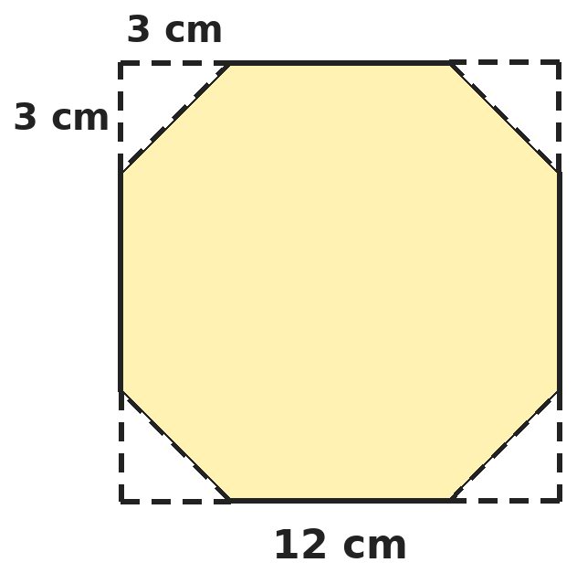
Q16. From each corner of a 12 cm square, Gita cuts off a right-angled triangle with two 3 cm sides, as shown. What is the area of the shape left?
(A) 135 cm² | (B) 126 cm² | (C) 108 cm² | (D) 132 cm²

Part 6 — Data Handling, Statistics & Probability (Syllabus Chapter 8)
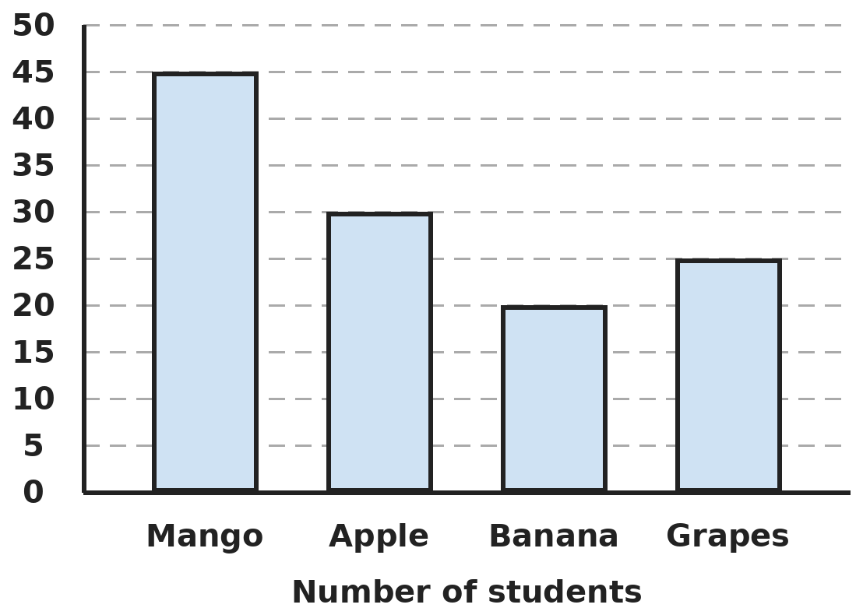
Q17. The bar graph shows the favourite fruit of every student in a school year. What fraction of these students chose mango?
(A) 3/5 | (B) 9/20 | (C) 1/3 | (D) 3/8

Part 7 — Applied Mathematics (Syllabus Chapter 9)
Q18. Arun runs round a 400 m track at a steady 5 metres per second. How many full laps does he complete in 10 minutes?
(A) 8 | (B) 75 | (C) 6 | (D) 7

Q19. Ishani cycles for 30 minutes at 16 km/h and then for 45 minutes at 12 km/h. What is her average speed?
(A) 13.6 km/h | (B) 14 km/h | (C) 13 km/h | (D) 14.4 km/h

Q20. A machine makes one toy every 45 seconds. How many toys does it make in 3 hours 30 minutes?
(A) 280 | (B) 210 | (C) 480 | (D) 300

Q21. A bus ticket costs ₹37.50 for an adult and ₹18.75 for a child. A family of 2 adults and 3 children pays with ₹200. How much change do they get?
(A) ₹70.25 | (B) ₹68.75 | (C) ₹78.75 | (D) ₹56.25

Part 8 — Mathematical Reasoning (Syllabus Chapter 10)

Q22. Nandini's series follows a pattern. Which number comes next?
(A) 720 | (B) 620 | (C) 500 | (D) 144

Q23. A month has 31 days. It has five Fridays, five Saturdays and five Sundays. On which day of the week does the month begin?
(A) Saturday | (B) Friday | (C) Thursday | (D) Sunday

Q24. Seven friends meet. Each person shakes hands with some of the others. Which of these is impossible?
(A) Each shakes hands with exactly 2 others | (B) Each shakes hands with exactly 3 others
(C) Each shakes hands with exactly 4 others | (D) Each shakes hands with exactly 6 others

Q25. How many even numbers between 100 and 200 have three different digits?
(A) 45 | (B) 36 | (C) 40 | (D) 50

Part 9 — Mixed Problems (each joins two chapters)
Q26. A square number is a number times itself, like 9 = 3 × 3. How many square numbers from 1 to 100 are even?
(A) 10 | (B) 4 | (C) 5 | (D) 6


Q27. The series goes up by the same amount each time. Which number in the series (1st, 2nd, …) is 5?
(A) 18th | (B) 19th | (C) 20th | (D) 10th

Q28. Siddharth builds a pyramid of 1 cm cubes. The top layer is 1 by 1, the next 2 by 2, then 3 by 3, and so on. What is the volume of a pyramid with 5 layers?
(A) 30 cm³ | (B) 25 cm³ | (C) 55 cm³ | (D) 125 cm³

Q29. Two lighthouses flash together at 8:00:00 PM. One flashes every 15 seconds and the other every 20 seconds. How many more times do they flash together up to 8:05:00 PM?
(A) 5 | (B) 6 | (C) 4 | (D) 20

Q30. Workers build a road 3.6 km long. They build 0.45 km each working day and rest on Sundays. They start on Monday the 1st. On which day do they finish?
(A) Monday the 8th | (B) Wednesday the 10th
(C) Thursday the 11th | (D) Tuesday the 9th

Answer Sheet AMO Level 2 · Class 5 · Practice Paper 5
Name: | School: | Roll No.:
Shade or tick one circle for each question.
1. | Ⓐ Ⓑ Ⓒ Ⓓ | 11. | Ⓐ Ⓑ Ⓒ Ⓓ | 21. | Ⓐ Ⓑ Ⓒ Ⓓ
2. | Ⓐ Ⓑ Ⓒ Ⓓ | 12. | Ⓐ Ⓑ Ⓒ Ⓓ | 22. | Ⓐ Ⓑ Ⓒ Ⓓ
3. | Ⓐ Ⓑ Ⓒ Ⓓ | 13. | Ⓐ Ⓑ Ⓒ Ⓓ | 23. | Ⓐ Ⓑ Ⓒ Ⓓ
4. | Ⓐ Ⓑ Ⓒ Ⓓ | 14. | Ⓐ Ⓑ Ⓒ Ⓓ | 24. | Ⓐ Ⓑ Ⓒ Ⓓ
5. | Ⓐ Ⓑ Ⓒ Ⓓ | 15. | Ⓐ Ⓑ Ⓒ Ⓓ | 25. | Ⓐ Ⓑ Ⓒ Ⓓ
6. | Ⓐ Ⓑ Ⓒ Ⓓ | 16. | Ⓐ Ⓑ Ⓒ Ⓓ | 26. | Ⓐ Ⓑ Ⓒ Ⓓ
7. | Ⓐ Ⓑ Ⓒ Ⓓ | 17. | Ⓐ Ⓑ Ⓒ Ⓓ | 27. | Ⓐ Ⓑ Ⓒ Ⓓ
8. | Ⓐ Ⓑ Ⓒ Ⓓ | 18. | Ⓐ Ⓑ Ⓒ Ⓓ | 28. | Ⓐ Ⓑ Ⓒ Ⓓ
9. | Ⓐ Ⓑ Ⓒ Ⓓ | 19. | Ⓐ Ⓑ Ⓒ Ⓓ | 29. | Ⓐ Ⓑ Ⓒ Ⓓ
10. | Ⓐ Ⓑ Ⓒ Ⓓ | 20. | Ⓐ Ⓑ Ⓒ Ⓓ | 30. | Ⓐ Ⓑ Ⓒ Ⓓ

For the parent or teacher
Correct: ______ / 30
Answer Key and Solutions AMO Level 2 · Class 5 · Practice Paper 5
Quick answers
1 B | 6 C | 11 C | 16 B | 21 B | 26 C
2 D | 7 A | 12 A | 17 D | 22 A | 27 B
3 D | 8 A | 13 D | 18 D | 23 B | 28 C
4 C | 9 B | 14 C | 19 A | 24 B | 29 A
5 B | 10 D | 15 D | 20 A | 25 C | 30 D
Solutions
Q | Part · level | Answer | Why?
1 | Part 1 · Ch1 · Hard | (B) 28 | Hint: For 12, add 1, 2, 3, 4 and 6.  12: 1 + 2 + 3 + 4 + 6 = 16. 28: 1 + 2 + 4 + 7 + 14 = 28. 18: 1 + 2 + 3 + 6 + 9 = 21. 20: 1 + 2 + 4 + 5 + 10 = 22. Only 28 works.
2 | Part 1 · Ch1 · Hard | (D) 24 | Hint: Take away the remainder first.  The number must divide 75 − 3 = 72 and 99 − 3 = 96 exactly. HCF of 72 and 96 is 24. Check: 75 = 3 × 24 + 3 and 99 = 4 × 24 + 3.
3 | Part 1 · Ch1 · Hard | (D) 160 | Hint: Find the place of each digit.  8 is in the lakhs place: 8,00,000. 5 is in the thousands place: 5,000. 8,00,000 ÷ 5,000 = 800 ÷ 5 = 160.
4 | Part 2 · Ch2 · Hard | (C) 24 | Hint: Divide and multiply before you add and subtract.  6 ÷ 3 = 2 and 2 × 4 = 8. Then 18 + 8 − 2 = 24. (Ravi added 18 + 6 first.)
5 | Part 2 · Ch2 · Hard | (B) 101 | Hint: 49 × 100 = 4,900. How many eggs are left over?  49 × 100 = 4,900, leaving 82 eggs. 82 eggs fill 1 more tray (49) with 33 left. So 101 full trays.
6 | Part 2 · Ch2 · Hard | (C) 6 × 125 | Hint: Move factors from one number to the other.  36 × 25 = 900. 9 × 100 = 900, 18 × 50 = 900, 12 × 75 = 900, but 6 × 125 = 750.
7 | Part 3 · Ch3 · Hard | (A) 52% | Hint: Find the green marbles at the start.  Green at first: 100% − 35% − 25% = 40% of 80 = 32. After adding 20: 52 green out of 100 marbles = 52%.
8 | Part 3 · Ch3 · Hard | (A) 0.97 | Hint: Find how far each is from 1.  9/10 = 0.9 is 0.1 away. 1.05 is 0.05 away. 21/20 = 1.05 is also 0.05 away. 0.97 is only 0.03 away, so it is closest.
9 | Part 3 · Ch3 · Hard | (B) 12 | Hint: Find the number first.  0.6 of the number is 4.8, so the number is 4.8 ÷ 0.6 = 8. 1.5 × 8 = 12.
10 | Part 3 · Ch3 · Hard | (D) 30 | Hint: Find each group in turn.  Cricket: 5/12 of 360 = 150. Football: 1/4 of 360 = 90. Kabaddi: 360 − 150 − 90 = 120. 150 − 120 = 30.
11 | Part 4 · Ch5 · Hard | (C) 95°, obtuse | Hint: Angles around a point add up to 360°.  360° − 100° − 70° = 190° for the two equal angles together. Each is 190° ÷ 2 = 95°. It is more than 90° and less than 180°, so it is obtuse.
12 | Part 4 · Ch5 · Hard | (A) Right-angled | Hint: The angles add up to 180°.  Take away the extras 0°, 30° and 60° (90° in all): 180° − 90° = 90°, so the smallest angle is 30°. The angles are 30°, 60° and 90°, so it is right-angled.
13 | Part 4 · Ch5 · Hard | (D) 3 | Hint: The angles round a point add up to 360°.  Two squares give 2 × 90° = 180°. The rest, 180°, is filled by 60° triangle corners: 180 ÷ 60 = 3 triangles.
14 | Part 5 · Ch6 · Hard | (C) 8,000 cm³ | Hint: The stone takes the place of the water that has risen.  The extra water height is 2 cm over the whole base: 80 × 50 × 2 = 8,000 cm³. That equals the volume of the stone.
15 | Part 5 · Ch6 · Hard | (D) 64 cm² | Hint: Find the side of each square first.  Sides: 40 ÷ 4 = 10 cm and 24 ÷ 4 = 6 cm. Areas: 100 cm² and 36 cm². Difference: 64 cm². (16 is the difference of the perimeters.)
16 | Part 5 · Ch6 · Hard | (B) 126 cm² | Hint: Each corner triangle is half of a 3 cm square.  Square: 144 cm². Each triangle: half of 3 × 3 = 4.5 cm². Four triangles: 18 cm². Left: 144 − 18 = 126 cm².
17 | Part 6 · Ch8 · Hard | (D) 3/8 | Hint: First find the total number of students.  Total: 45 + 30 + 20 + 25 = 120. Mango: 45/120 = 3/8.
18 | Part 7 · Ch9 · Hard | (D) 7 | Hint: Find the distance he runs in 10 minutes.  10 minutes = 600 seconds. Distance: 600 × 5 = 3,000 m. 3,000 ÷ 400 = 7.5, so 7 full laps.
19 | Part 7 · Ch9 · Hard | (A) 13.6 km/h | Hint: Find each distance, then divide the total by the total time.  First part: half an hour at 16 km/h = 8 km. Second: three quarters of an hour at 12 km/h = 9 km. Total 17 km in 1.25 h. 17 ÷ 1.25 = 68 ÷ 5 = 13.6 km/h.
20 | Part 7 · Ch9 · Hard | (A) 280 | Hint: How many toys does it make in 3 minutes?  In 3 minutes (180 s) it makes 4 toys. 3 h 30 min = 210 minutes = 70 lots of 3 minutes. 70 × 4 = 280 toys.
21 | Part 7 · Ch9 · Hard | (B) ₹68.75 | Hint: Work out the adult and child tickets separately.  Adults: 2 × 37.50 = ₹75. Children: 3 × 18.75 = ₹56.25. Total ₹131.25. Change: 200 − 131.25 = ₹68.75.
22 | Part 8 · Ch10 · Hard | (A) 720 | Hint: Look at what each number is multiplied by.  The multipliers are 2, 3, 4 and 5: 1 × 2 = 2, 2 × 3 = 6, 6 × 4 = 24, 24 × 5 = 120. Next: 120 × 6 = 720.
23 | Part 8 · Ch10 · Hard | (B) Friday | Hint: 31 days = 4 weeks + 3 extra days.  4 full weeks give every day four times. The 3 extra days are the first three days of the month, so they must be Friday, Saturday and Sunday. The month begins on a Friday.
24 | Part 8 · Ch10 · Hard | (B) Each shakes hands with exactly 3 others | Hint: Each handshake is counted by two people.  Adding up everyone's handshakes counts each handshake twice, so the total must be even. With 3 each: 7 × 3 = 21, which is odd, so it is impossible. 7 × 2 = 14, 7 × 4 = 28 and 7 × 6 = 42 are even, and those patterns can be made.
25 | Part 8 · Ch10 · Hard | (C) 40 | Hint: The number is 1 _ _. The last digit must be even and not 1.  The hundreds digit is 1. The ones digit is even: 0, 2, 4, 6 or 8 (5 choices). The tens digit can be any digit except 1 and the ones digit: 8 choices. 5 × 8 = 40.
26 | Part 9 · Mixed · Ch1 + Ch10 · Hard | (C) 5 | Hint: An even number times itself is even; an odd number times itself is odd.  The square numbers up to 100 are 1, 4, 9, …, 100 (from 1 × 1 to 10 × 10). The even ones come from 2, 4, 6, 8 and 10: 4, 16, 36, 64 and 100. That is 5.
27 | Part 9 · Mixed · Ch3 + Ch10 · Hard | (B) 19th | Hint: How many steps of 0.25 take you from 0.5 to 5?  From 0.5 to 5 is 4.5. Each step is 0.25, so there are 4.5 ÷ 0.25 = 18 steps. The 1st number plus 18 steps is the 19th number.
28 | Part 9 · Mixed · Ch6 + Ch10 · Hard | (C) 55 cm³ | Hint: Add the cubes in each layer.  Layers: 1 + 4 + 9 + 16 + 25 = 55 cubes. Each is 1 cm³, so 55 cm³.
29 | Part 9 · Mixed · Ch1 + Ch9 · Hard | (A) 5 | Hint: Find the LCM of 15 and 20 seconds.  LCM of 15 and 20 is 60 seconds. They flash together at the end of every minute: 8:01, 8:02, 8:03, 8:04 and 8:05. That is 5 more times.
30 | Part 9 · Mixed · Ch3 + Ch9 · Hard | (D) Tuesday the 9th | Hint: First find how many working days they need.  3.6 ÷ 0.45 = 360 ÷ 45 = 8 working days. Monday 1st to Saturday 6th is 6 days. Sunday 7th is a rest day. Monday 8th and Tuesday 9th are days 7 and 8. They finish on Tuesday the 9th.

