UNLOCK IQ INSTITUTE
Realize Your True Potential
Aryabhatta Maths Olympiad (AMO)
Level 1 — Practice Paper 1
CLASS 10

Questions | 45 multiple-choice questions
Marks | 100
Time | 60 minutes
Section I | 40 questions × 2 marks = 80 marks
Section II | 5 Star Questions × 4 marks = 20 marks
Negative marking | No negative marking
Calculator | Not allowed
Chapters | Number System · Fractions, Decimals & Percentages · Algebra · Geometry · Mensuration · Trigonometry · Data Handling · Applied Mathematics · Mathematical Reasoning

Instructions to candidates
• This paper has 45 multiple-choice questions. Each question has four answer choices, of which exactly one is correct.
• Section I (Q1–Q40) carries 2 marks per question. Section II (Q41–Q45) carries 4 marks per question.
• There is no negative marking. Unanswered questions score zero.
• Calculators are not permitted. Rough work may be done on a separate sheet.
• Mark your answers on the answer sheet at the end of the paper.
• All figures are not necessarily drawn to scale unless stated.

For parents and teachers
Print or view this paper in colour. Pictures are part of the questions.
Parts follow the AMO syllabus chapters. Chapter 2 is not part of the Class 10 syllabus, so the chapter numbers shown in the Part headings have gaps.
The answer sheet and the answer key are at the end. Remove only the answer key before the student begins.

Name: | School: | Roll No.:

SECTION I 40 questions × 2 marks each
Part 1 — Number System (Syllabus Chapter 1)
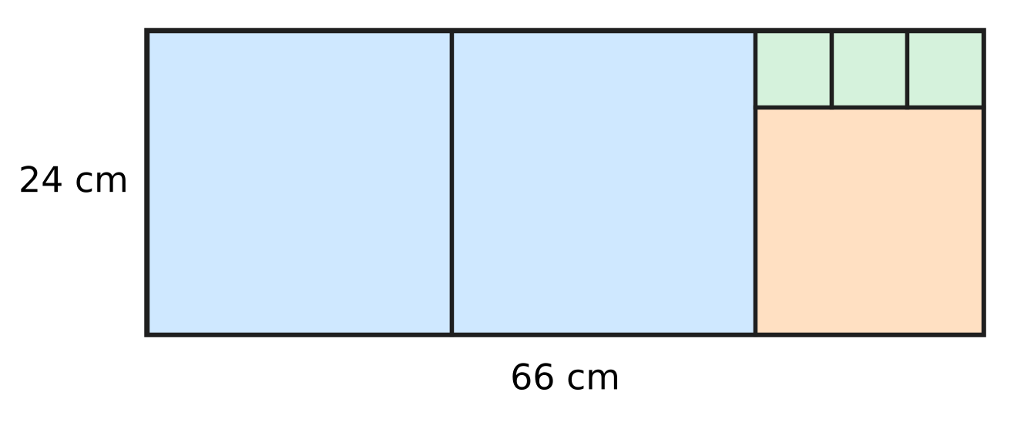
Q1. A card measures 66 cm by 24 cm. Each time, the largest possible square is cut from the part that is left, as shown in the figure, until nothing is left. What is the side of the smallest square?
(A) 3 cm | (B) 24 cm | (C) 6 cm | (D) 18 cm

Q2. Which of these fractions has a decimal expansion that ends after exactly three decimal places?
(A) $\frac{21}{40}$ | (B) $\frac{13}{16}$ | (C) $\frac{7}{24}$ | (D) $\frac{27}{150}$

Q3. What is the smallest natural number k for which 360 × k is a perfect cube?
(A) 10 | (B) 15 | (C) 30 | (D) 75

Part 2 — Fractions, Decimals & Percentages (Syllabus Chapter 3)
Q4. Swati and Chirag run a school bus service. At the start of a year, each of them puts in ₹55,000. Chirag takes all his money out after 8 months, and Swati keeps hers in for the whole year. The year's profit of ₹42,000 is shared in the ratio of capital × time. What is Swati's share?
(A) ₹31,500 | (B) ₹16,800 | (C) ₹21,000 | (D) ₹25,200

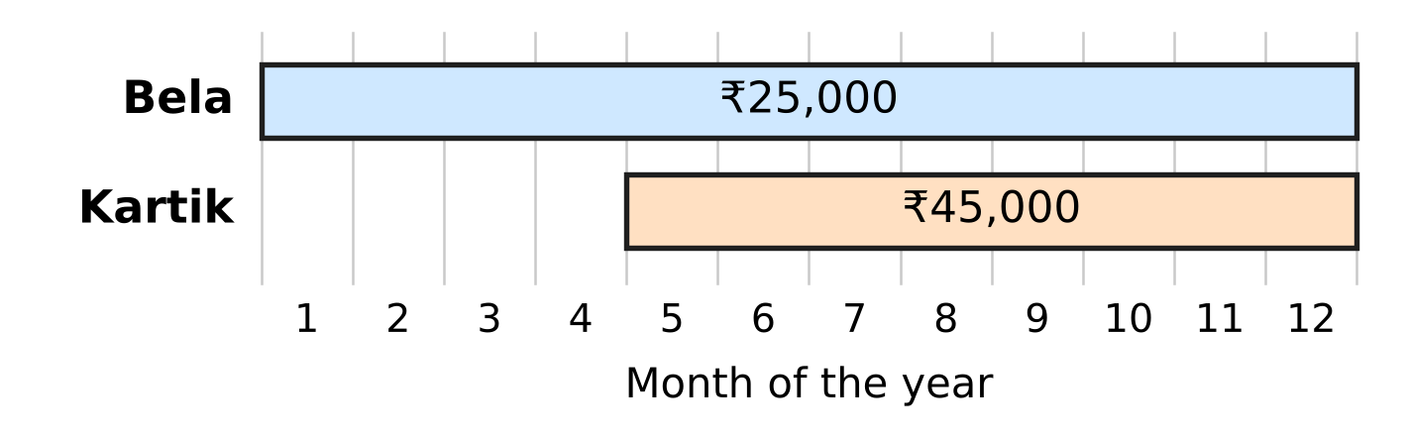
Q5. Bela and Kartik run a farm with cows and hens. The chart shows how much money each of them put into the farm and for which months of the year it was there. In what ratio should the year's profit be shared between Bela and Kartik?
(A) 20 : 21 | (B) 6 : 5 | (C) 5 : 6 | (D) 5 : 9

Q6. A deposit earns 20% per year, compounded half-yearly. By what percentage does the deposit grow in one full year?
(A) 40% | (B) 21% | (C) 20% | (D) 44%

Passbook of a deposit compounded half-yearly
Half-year | Balance at start | Interest | Balance at end
1st | ₹30,000 | ₹1,200 | ₹31,200
2nd | ₹31,200 | ? | ?

Q7. The table shows a deposit that earns compound interest, added every half-year at the same rate. What is the balance at the end of the 2nd half-year?
(A) ₹32,448 | (B) ₹32,480 | (C) ₹32,400 | (D) ₹33,696

Q8. Ruhi opens a stationery shop with ₹48,000 at the start of the year. Arun joins some months later and puts in ₹72,000. At the end of the year they share the profit equally. After how many months from the start did Arun join?
(A) 8 months | (B) 3 months | (C) 4 months | (D) 6 months

Part 3 — Algebra (Syllabus Chapter 4)
Q9. The figure shows the graph of $y=x^{2}+bx+c$. It cuts the x-axis at the two marked points. What is the value of b? | 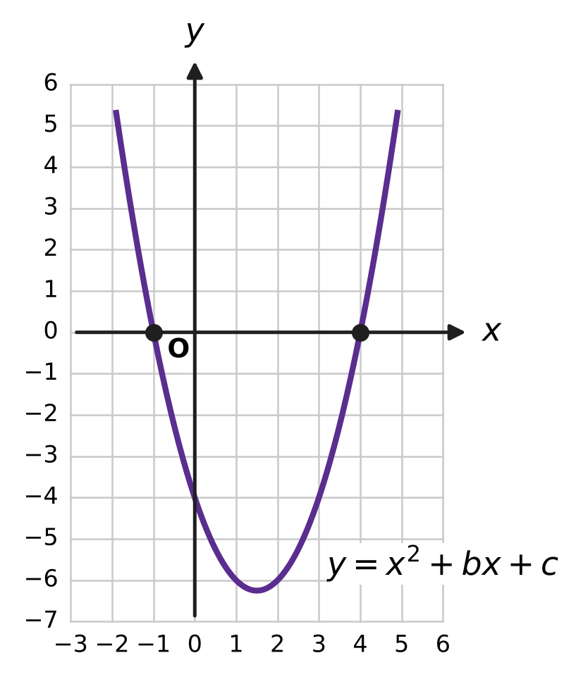
  (A) −3 | (B) 5 | (C) 3 | (D) −4

Q10. For which value of k does the pair of equations $3x+ky=7$ and $6x+10y=11$ have no solution?
(A) −5 | (B) 5 | (C) 20 | (D) 10

Q11. When a polynomial p(x) is divided by $x^{2}−1$, the quotient is $2x+3$ and the remainder is $x−4$. What is p(2)?
(A) 17 | (B) 23 | (C) 21 | (D) 19

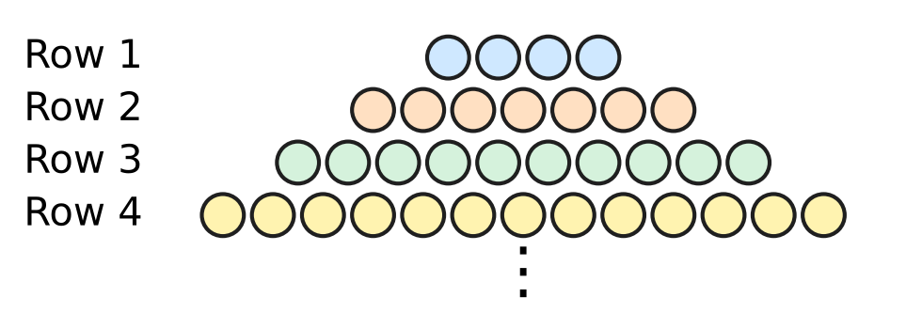
Q12. Esha lays marbles in rows on a table. The figure shows the first four rows, and the pattern continues in the same way. How many marbles are there in the first 12 rows altogether?
(A) 246 | (B) 209 | (C) 264 | (D) 37

Q13. For how many integer values of k does the equation $2x^{2}+kx+8=0$ have no real roots?
(A) 7 | (B) 17 | (C) 15 | (D) 14

Q14. The two zeroes of the polynomial $x^{2}−10x+k$ differ by 4. What is the value of k?
(A) 16 | (B) 25 | (C) 24 | (D) 21

Part 4 — Geometry (Syllabus Chapter 5)
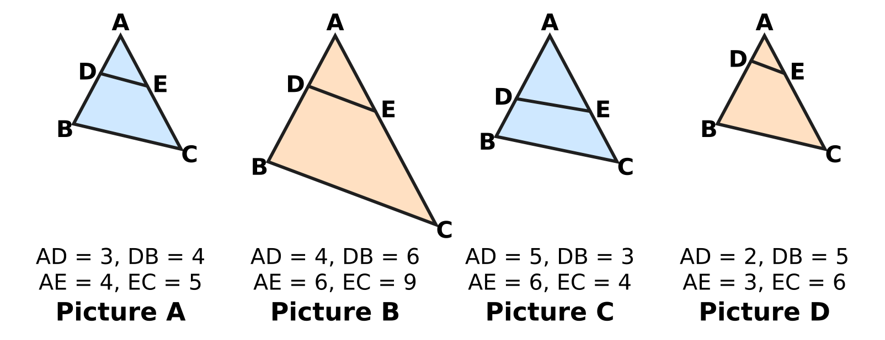
Q15. In each triangle ABC in the figure, D lies on AB and E lies on AC, and the lengths are in cm. In which picture is DE parallel to BC?
(A) Picture A | (B) Picture B
(C) Picture C | (D) Picture D

Q16. The figure shows the points R and S on a square grid. The point M lies on RS and RM : MS = 3 : 1. What are the coordinates of M? | 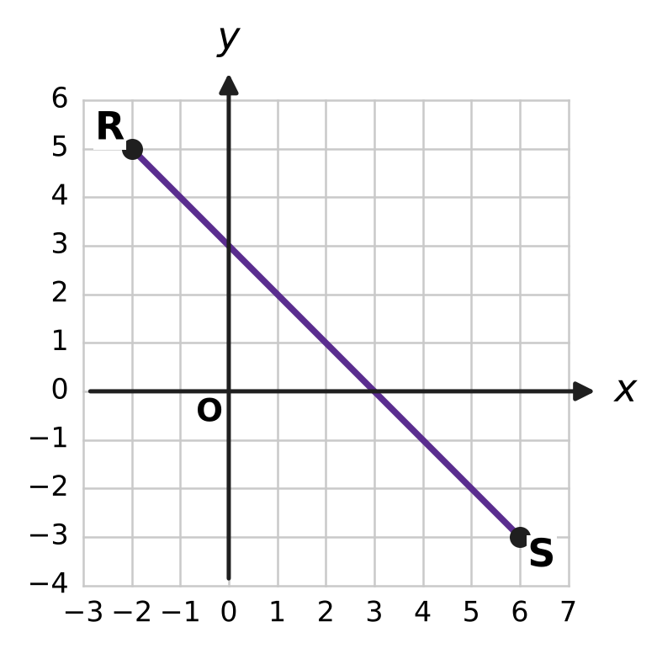
  (A) (4, 1) | (B) (4, −1) | (C) (2, 1) | (D) (0, 3)

Q17. In the figure, PA and PB are tangents from P to the circle with centre O. In cm, PA = $3x−2$ and PB = $x+6$, as marked. What is the length of PA? | 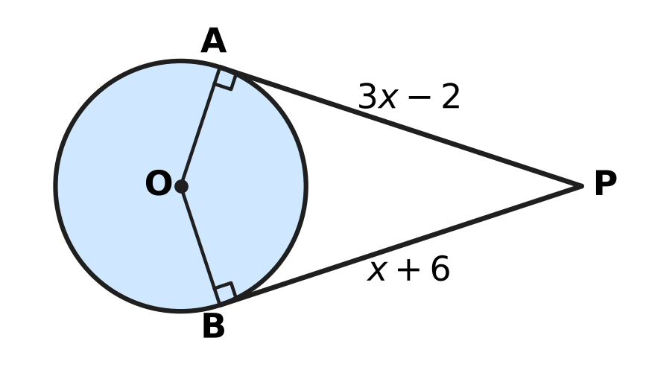
  (A) 10 cm | (B) 4 cm | (C) 8 cm | (D) 20 cm

Q18. In the figure, ABCD is a trapezium with AB ∥ DC, AB = 12 cm and DC = 8 cm. The diagonals meet at O. If AC = 15 cm, what is the length of AO? | 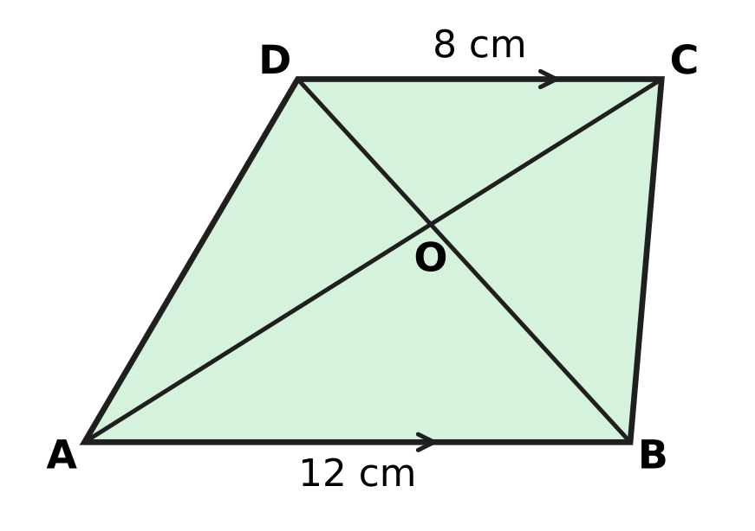
  (A) 10 cm | (B) 7.5 cm | (C) 9 cm | (D) 6 cm

Q19. The figure shows a right triangle ABC with ∠B = 90°, AB = 8 cm and BC = 15 cm. A circle touches all three sides. What is its radius r? | 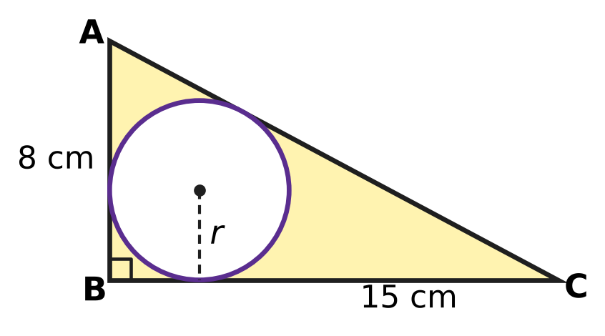
  (A) 8.5 cm | (B) 4 cm | (C) 6 cm | (D) 3 cm

Part 5 — Mensuration (Syllabus Chapter 6)
Q20. Ishan's vegetable bed is a sector of a circle with radius 14 m and angle 135°, as shown. How long is its curved edge? (Use π = 22/7.) | 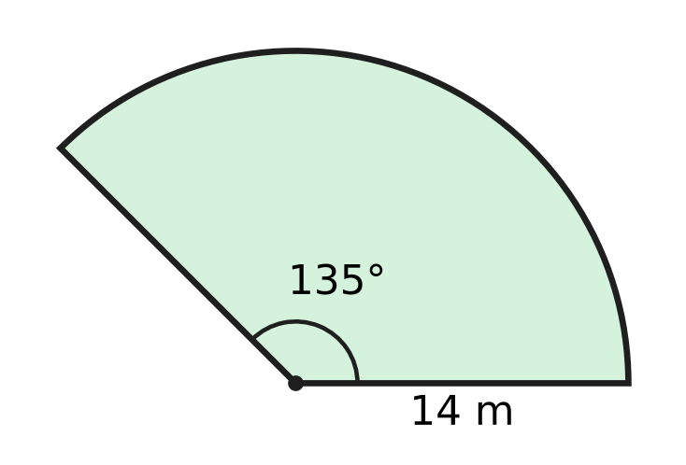
  (A) 61 m | (B) 33 m | (C) 16.5 m | (D) 66 m

Q21. A lampshade is the curved part of a frustum, open at both ends. Its end radii are 10.5 cm and 7 cm and its slant height is 12 cm, as shown. What is the area of cloth on it? (Use π = 22/7.) | 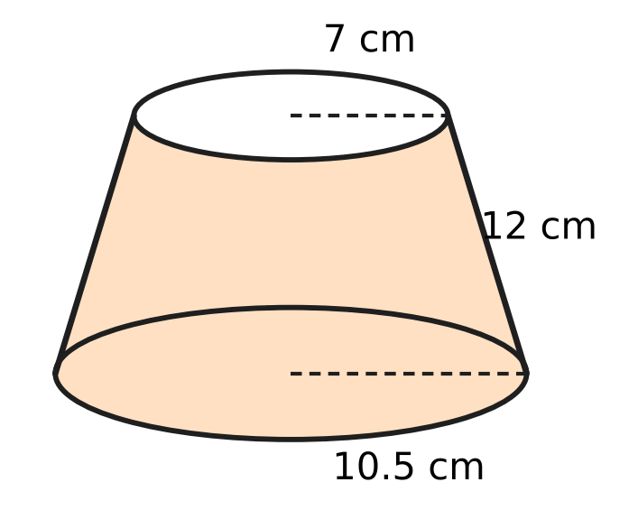
  (A) 330 cm² | (B) 814 cm²
  (C) 1,320 cm² | (D) 660 cm²

Q22. A solid is made of a cylinder of radius 7 cm and height 9 cm, with a cone of the same radius and height 6 cm on top, as shown. What is its volume? (Use π = 22/7.) | 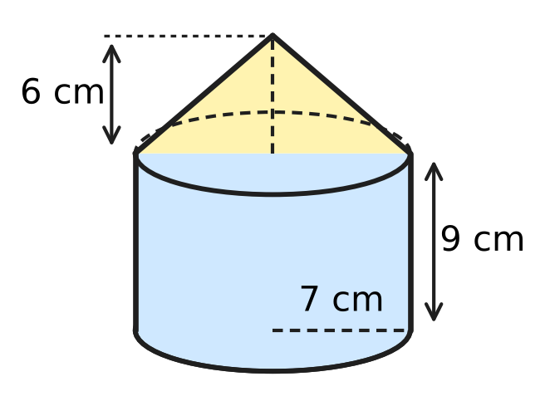
  (A) 2,310 cm³ | (B) 1,848 cm³
  (C) 1,694 cm³ | (D) 1,386 cm³

Q23. ABCD is a square of side 21 cm. Two quarter circles of radius 21 cm are drawn with centres A and C, as shown. What is the area of the shaded leaf shape? (Use π = 22/7.) | 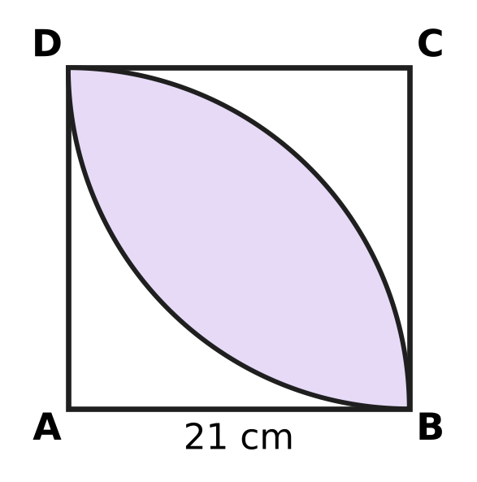
  (A) 189 cm² | (B) 252 cm² | (C) 693 cm² | (D) 126 cm²

Q24. A flat roof measures 22 m by 20 m. Rain falls on it to a depth of 2 cm, and all the water drains into an empty cylindrical rainwater tank of radius 1 m. How high does the water rise in the tank? (Use π = 22/7.)
(A) 2.8 m | (B) 28 m | (C) 8.8 m | (D) 11.2 m

Part 6 — Trigonometry & Heights and Distances (Syllabus Chapter 7)
Q25. The figure shows a right triangle KLM with ∠L = 90°, KL = 21 cm and LM = 20 cm, and ∠MKL = θ. What is the value of cosec θ? | 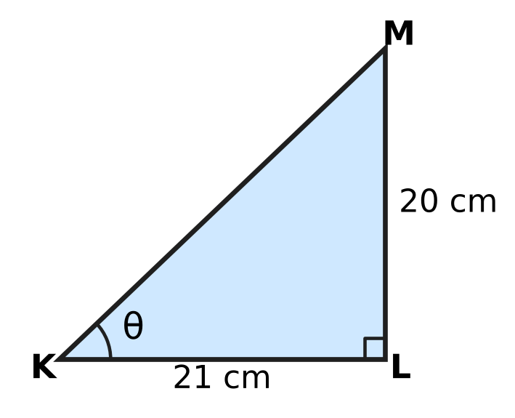
  (A) $\frac{20}{29}$ | (B) $\frac{29}{21}$ | (C) $\frac{29}{20}$ | (D) $\frac{21}{20}$

Q26. The angle θ is acute and cos θ = $\frac{1}{2}$. What is the value of sin θ × tan θ?
(A) $\frac{\sqrt{3}}{6}$ | (B) $\frac{3}{2}$
(C) $\frac{3}{4}$ | (D) $\frac{1}{2}$

Q27. From the top of a 30 m tall school building, the angle of depression of the bottom G of a tree is 60° and that of its top T is 30°, as shown in the figure. The building and the tree stand on the same level ground. How tall is the tree? | 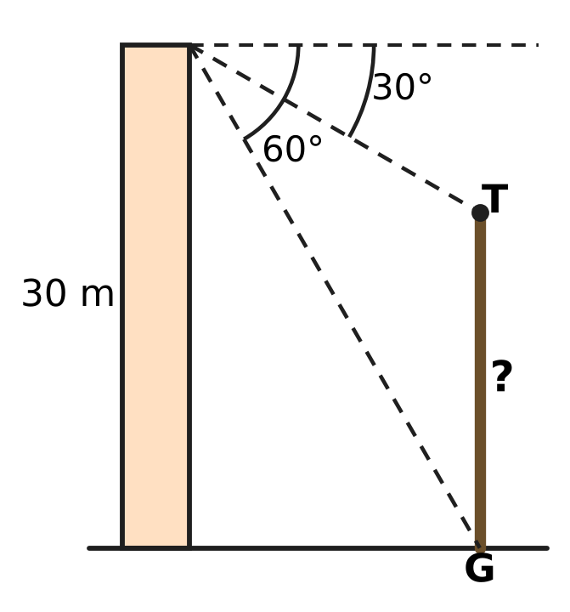
  (A) 20 m | (B) 10 m
  (C) 40 m | (D) $10\sqrt{3}$ m

Part 7 — Data Handling, Statistics & Probability (Syllabus Chapter 8)
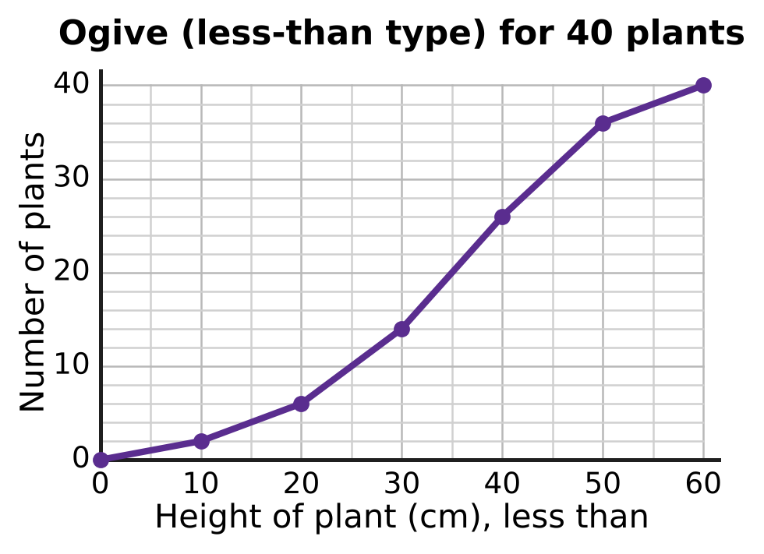
Q28. The less-than ogive shows the heights of 40 plants. The thin grid lines are every 5 cm across and every 2 plants up. What is the median height?
(A) 40 cm | (B) 20 cm | (C) 30 cm | (D) 35 cm

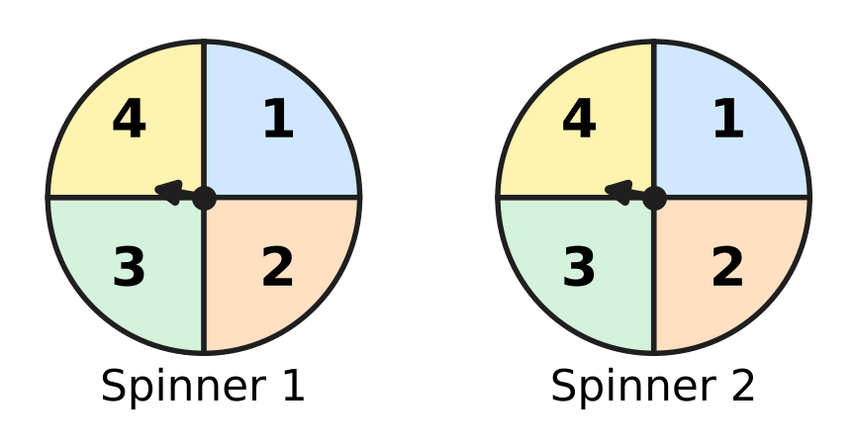
Q29. Each fair spinner in the figure has four equal parts numbered 1 to 4. Both are spun once and the two numbers are added. What is the probability that the sum is at least 3?
(A) $\frac{15}{16}$ | (B) $\frac{6}{7}$ | (C) $\frac{1}{16}$ | (D) $\frac{13}{16}$

Times of 30 swimmers in a swimming pool
Time for one length (seconds) | 20–30 | 30–40 | 40–50 | 50–60 | 60–70
Number of swimmers | 2 | 4 | 13 | 7 | 4

Q30. The table shows the time 30 swimmers took to swim one length of a pool. What is the mode of these times?
(A) 45 seconds | (B) 44 seconds
(C) 40 seconds | (D) 46 seconds

Part 8 — Applied Mathematics (Syllabus Chapter 9)
Bill from an electronics shop (sale within the state)
Item | Quantity | Price (₹)
Headphones | 1 | 900
Charging cable | 2 | 150 each
CGST |  | 9%
SGST |  | 9%

Q31. The table shows a shop bill. CGST and SGST are each charged on the total price of the items. How much does the customer pay in all?
(A) ₹1,308 | (B) ₹1,362 | (C) ₹1,416 | (D) ₹1,632

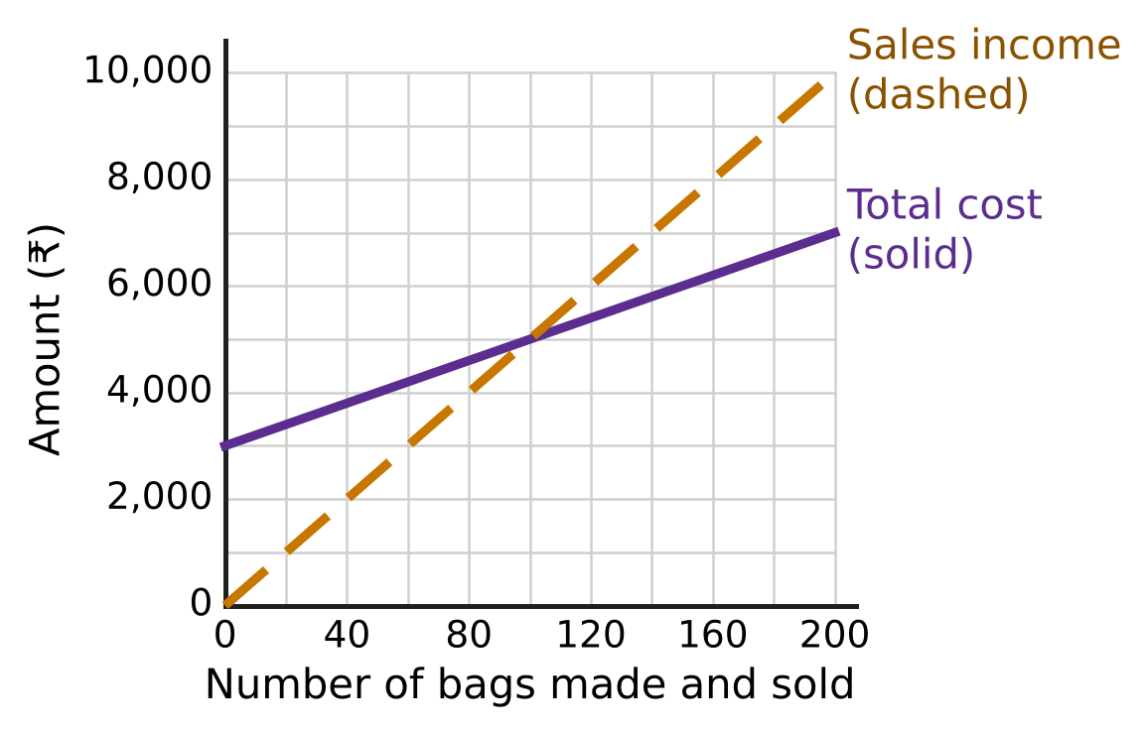
Q32. The graph shows the total cost (solid line) and the sales income (dashed line) of a small workshop that makes school bags. What is the profit when 200 bags are made and sold?
(A) ₹10,000 | (B) ₹3,000 | (C) ₹6,000 | (D) ₹7,000

Q33. Naveen's motorboat moves at 13 km/h in still water. The river flows at 3 km/h. He goes 40 km upstream and then comes back to his starting point. How long does the whole trip take?
(A) 6.5 hours | (B) 4 hours
(C) 8 hours | (D) 5 hours

Repayment of a bicycle loan
Month | Loan at start of month | Loan paid back | Interest for the month | Payment
1 | ₹14,000 | ₹5,000 | ₹210 | ₹5,210
2 | ₹9,000 | ₹4,000 | ? | ?
3 | ? | ₹3,000 | ? | ?
4 | ? | ₹2,000 | ? | ?

Q34. A ₹14,000 bicycle loan is repaid in 4 months, as shown in the table. Each month, the part of the loan shown is paid back together with that month's interest on the loan still unpaid, at the same monthly rate. What is the total interest paid over the 4 months?
(A) ₹420 | (B) ₹840 | (C) ₹240 | (D) ₹450

Q35. Leela can cover all the new books of the school library in 7 days, and Advait can do the same job in 35 days. Leela works alone for 2 days and then stops. Advait finishes the rest alone. For how many days does Advait work?
(A) 33 days | (B) 5 days | (C) 25 days | (D) 27 days

Part 9 — Mathematical Reasoning & Problem-Solving (Syllabus Chapter 10)
Q36. Some points are marked on a circle. Every pair of points is joined by a straight line, and 28 lines are drawn in all. How many points are marked?
(A) 14 | (B) 8 | (C) 7 | (D) 9

Q37. Seven whole numbers add up to 50. Some of them may be equal. What is the smallest possible value of the largest of them?
(A) 8 | (B) 6 | (C) 44 | (D) 7

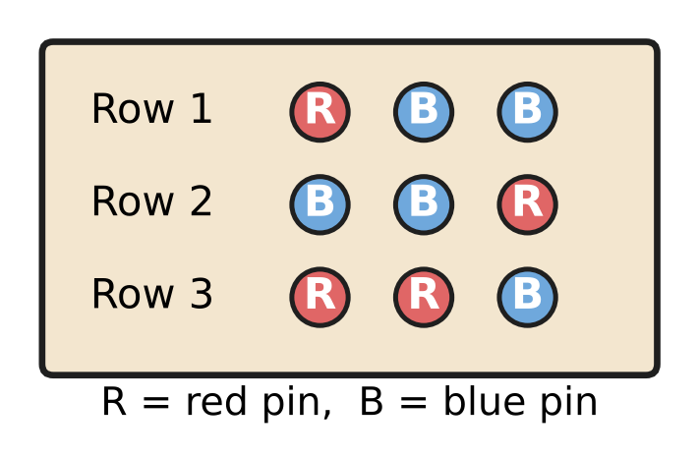
Q38. On the classroom notice board, each row has 3 pins in a line, and each pin is red or blue. The figure shows three such rows. What is the least number of rows that makes sure two rows have exactly the same colours in the same order?
(A) 8 | (B) 5 | (C) 7 | (D) 9

Q39. Uday's counter shows 7. Each press of button A adds 6 to the number shown, and each press of button B subtracts 9. Which of these numbers can the counter show after some presses?
(A) 77 | (B) 100 | (C) 50 | (D) 63

Q40. A path goes along the lines of the grid from S to F, moving only right or up at each step. The crossing marked ⊗ is closed and no path may pass through it. How many paths are there? | 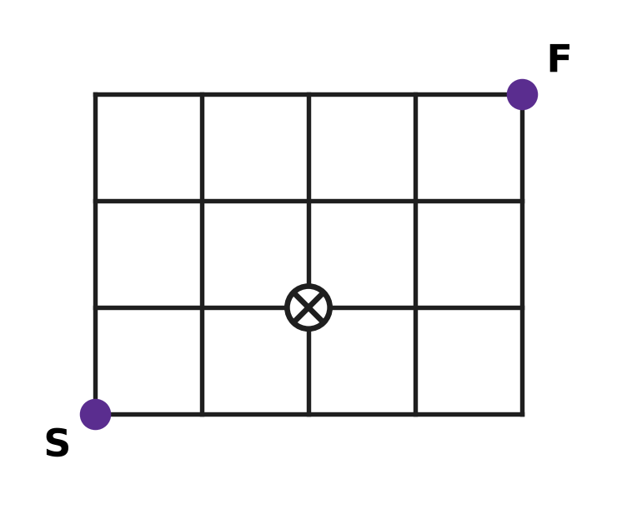
  (A) 15 | (B) 18 | (C) 17 | (D) 35

SECTION II — Star Questions 5 questions × 4 marks each
Q41. Mona puts all 100 stamps of her stamp collection into an album. Every page she uses holds at least one stamp, and no two pages hold the same number of stamps. What is the greatest number of pages she can use? [4 marks]
(A) 13 | (B) 10 | (C) 14 | (D) 9

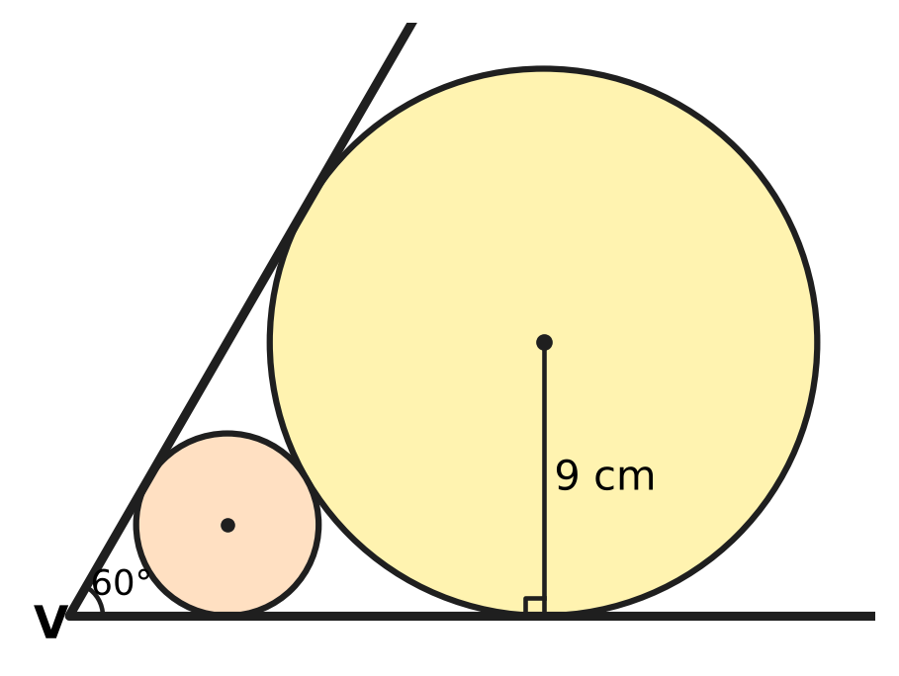
Q42. Two straight edges meet at V at an angle of 60°, as shown. A large round disc of radius 9 cm touches both edges. A smaller round disc lies between V and the large disc; it touches both edges and also the large disc. What is the radius of the smaller disc? [4 marks]
(A) 4.5 cm | (B) 3 cm
(C) 6 cm | (D) $3\sqrt{3}$ cm

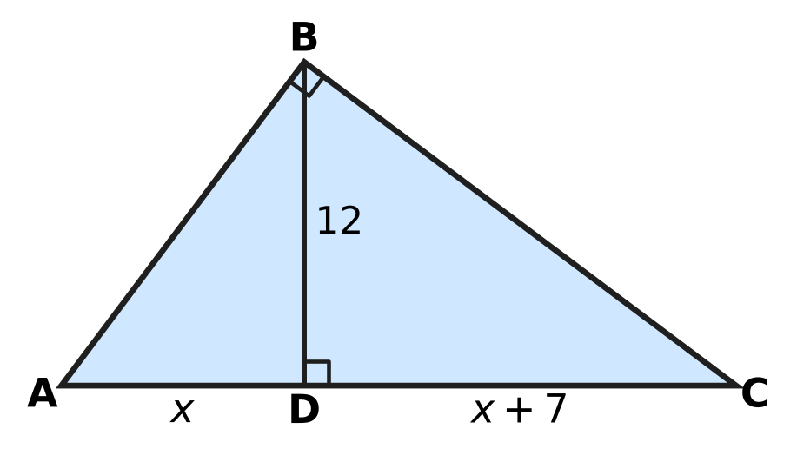
Q43. In the triangle ABC, ∠ABC = 90° and BD ⊥ AC, as shown. All lengths are in cm: BD = 12, AD = x and DC = x + 7. What is the length of AB? [4 marks]
(A) 9 cm | (B) 20 cm | (C) 25 cm | (D) 15 cm

Q44. Farhan and Mia run a workshop that makes kites for windy days. Farhan puts in ₹60,000 for the whole year, and Mia puts in ₹90,000 for the last 4 months of the year. In the year, the fixed costs are ₹30,000, each kite costs ₹40 to make and sells for ₹70, and 2,500 kites are sold. The profit is shared in the ratio of capital × time. What is Mia's share? [4 marks]
(A) ₹27,000 | (B) ₹30,000 | (C) ₹15,000 | (D) ₹25,000

Q45. A circular apple orchard has a fence 132 m long around it. It is divided into equal sectors, each of area 77 m². Saplings are planted so that each one lies inside exactly one sector. What is the least number of saplings that makes sure some sector has at least 3 saplings? (Use π = 22/7.) [4 marks]
(A) 54 | (B) 36 | (C) 37 | (D) 19

Answer Sheet AMO Level 1 · Class 10 · Practice Paper 1
Name: | School: | Roll No.:
Shade or tick one circle for each question.
1. Ⓐ Ⓑ Ⓒ Ⓓ | 16. Ⓐ Ⓑ Ⓒ Ⓓ | 31. Ⓐ Ⓑ Ⓒ Ⓓ
2. Ⓐ Ⓑ Ⓒ Ⓓ | 17. Ⓐ Ⓑ Ⓒ Ⓓ | 32. Ⓐ Ⓑ Ⓒ Ⓓ
3. Ⓐ Ⓑ Ⓒ Ⓓ | 18. Ⓐ Ⓑ Ⓒ Ⓓ | 33. Ⓐ Ⓑ Ⓒ Ⓓ
4. Ⓐ Ⓑ Ⓒ Ⓓ | 19. Ⓐ Ⓑ Ⓒ Ⓓ | 34. Ⓐ Ⓑ Ⓒ Ⓓ
5. Ⓐ Ⓑ Ⓒ Ⓓ | 20. Ⓐ Ⓑ Ⓒ Ⓓ | 35. Ⓐ Ⓑ Ⓒ Ⓓ
6. Ⓐ Ⓑ Ⓒ Ⓓ | 21. Ⓐ Ⓑ Ⓒ Ⓓ | 36. Ⓐ Ⓑ Ⓒ Ⓓ
7. Ⓐ Ⓑ Ⓒ Ⓓ | 22. Ⓐ Ⓑ Ⓒ Ⓓ | 37. Ⓐ Ⓑ Ⓒ Ⓓ
8. Ⓐ Ⓑ Ⓒ Ⓓ | 23. Ⓐ Ⓑ Ⓒ Ⓓ | 38. Ⓐ Ⓑ Ⓒ Ⓓ
9. Ⓐ Ⓑ Ⓒ Ⓓ | 24. Ⓐ Ⓑ Ⓒ Ⓓ | 39. Ⓐ Ⓑ Ⓒ Ⓓ
10. Ⓐ Ⓑ Ⓒ Ⓓ | 25. Ⓐ Ⓑ Ⓒ Ⓓ | 40. Ⓐ Ⓑ Ⓒ Ⓓ
11. Ⓐ Ⓑ Ⓒ Ⓓ | 26. Ⓐ Ⓑ Ⓒ Ⓓ | 41. Ⓐ Ⓑ Ⓒ Ⓓ
12. Ⓐ Ⓑ Ⓒ Ⓓ | 27. Ⓐ Ⓑ Ⓒ Ⓓ | 42. Ⓐ Ⓑ Ⓒ Ⓓ
13. Ⓐ Ⓑ Ⓒ Ⓓ | 28. Ⓐ Ⓑ Ⓒ Ⓓ | 43. Ⓐ Ⓑ Ⓒ Ⓓ
14. Ⓐ Ⓑ Ⓒ Ⓓ | 29. Ⓐ Ⓑ Ⓒ Ⓓ | 44. Ⓐ Ⓑ Ⓒ Ⓓ
15. Ⓐ Ⓑ Ⓒ Ⓓ | 30. Ⓐ Ⓑ Ⓒ Ⓓ | 45. Ⓐ Ⓑ Ⓒ Ⓓ
Q41–Q45 are Section II Star Questions (4 marks each).
For the parent or teacher
Section I correct: ______ / 40 × 2 = ______ marks Section II correct: ______ / 5 × 4 = ______ marks
Correct: ______ / 45 Score: ______ / 100
Answer Key and Solutions AMO Level 1 · Class 10 · Practice Paper 1
Quick answers
1 C | 6 B | 11 D | 16 B | 21 D | 26 B | 31 C | 36 B | 41 A
2 A | 7 A | 12 A | 17 A | 22 C | 27 A | 32 B | 37 A | 42 B
3 D | 8 C | 13 C | 18 C | 23 B | 28 D | 33 A | 38 D | 43 D
4 D | 9 A | 14 D | 19 D | 24 A | 29 A | 34 D | 39 B | 44 C
5 C | 10 B | 15 B | 20 B | 25 C | 30 D | 35 C | 40 C | 45 C
Solutions
Q | Part · level | Answer | Why?
1 | Part 1 · Ch1 · Easy | (C) 6 cm | The cuts follow Euclid's algorithm: 66 = 2 × 24 + 18, 24 = 1 × 18 + 6, 18 = 3 × 6. The last square has side HCF(66, 24) = 6 cm.
2 | Part 1 · Ch1 · Easy | (A) $\frac{21}{40}$ | Since 40 = 2³ × 5, 21/40 ends after 3 places: 21/40 = 0.525. Also, 13/16 has 4 places, 27/150 = 9/50 has 2 places and 7/24 does not end.
3 | Part 1 · Ch1 · Medium | (D) 75 | Here 360 = 2³ × 3² × 5. Each power must become a multiple of 3, so k = 3 × 5² = 75 (360 × 75 = 27,000 = 30³).
4 | Part 2 · Ch3 · Easy | (D) ₹25,200 | The amounts are equal, so the shares follow the months: 12 : 8 = 3 : 2. Swati gets 3/5 of ₹42,000 = ₹25,200.
5 | Part 2 · Ch3 · Easy | (C) 5 : 6 | Bela: 25,000 × 12 = 300,000. Kartik (months 5 to 12): 45,000 × 8 = 360,000. The ratio is 300,000 : 360,000 = 5 : 6.
6 | Part 2 · Ch3 · Easy | (B) 21% | The rate is 10% for each half-year, so 1.1 × 1.1 = 1.21: the deposit grows by 21% in a year.
7 | Part 2 · Ch3 · Medium | (A) ₹32,448 | The half-yearly rate is 1,200 ÷ 30,000 = 4%. Interest for the 2nd half-year = 4% of 31,200 = ₹1,248, so the balance is ₹32,448.
8 | Part 2 · Ch3 · Medium | (C) 4 months | Equal shares need 48,000 × 12 = 72,000 × t, so t = 8 months. Arun joined 12 − 8 = 4 months after the start.
9 | Part 3 · Ch4 · Easy | (A) −3 | The zeroes are −1 and 4. Their sum is 3 and the sum of the zeroes equals −b, so b = −3.
10 | Part 3 · Ch4 · Easy | (B) 5 | No solution needs 3/6 = k/10 ≠ 7/11. So k/10 = 1/2 and k = 5.
11 | Part 3 · Ch4 · Easy | (D) 19 | p(x) = (x² − 1)(2x + 3) + (x − 4). So p(2) = 3 × 7 + (2 − 4) = 21 − 2 = 19.
12 | Part 3 · Ch4 · Medium | (A) 246 | The rows form an AP with a = 4 and d = 3. S = 12/2 × (2 × 4 + 11 × 3) = 6 × 41 = 246.
13 | Part 3 · Ch4 · Medium | (C) 15 | No real roots needs k² − 4 × 2 × 8 < 0, so k² < 64 and −8 < k < 8. The integers −7 to 7 give 15 values.
14 | Part 3 · Ch4 · Medium | (D) 21 | The zeroes add up to 10 and differ by 4, so they are 7 and 3. Their product is k = 21.
15 | Part 4 · Ch5 · Easy | (B) Picture B | DE ∥ BC exactly when AD/DB = AE/EC. Only 4/6 = 6/9 (both 2/3) is a match; 3/4 ≠ 4/5, 5/3 ≠ 6/4 and 2/5 ≠ 3/6.
16 | Part 4 · Ch5 · Easy | (B) (4, −1) | R(−2, 5) and S(6, −3). M = ((3 × 6 + 1 × (−2))/4, (3 × (−3) + 1 × 5)/4) = (16/4, −4/4) = (4, −1).
17 | Part 4 · Ch5 · Easy | (A) 10 cm | Tangents from an outside point are equal: 3x − 2 = x + 6, so x = 4 and PA = 3 × 4 − 2 = 10 cm.
18 | Part 4 · Ch5 · Medium | (C) 9 cm | Triangles AOB and COD are similar (AB ∥ DC), so AO : OC = 12 : 8 = 3 : 2. AO = 3/5 × 15 = 9 cm.
19 | Part 4 · Ch5 · Medium | (D) 3 cm | AC = √(64 + 225) = 17 cm. Tangents from each vertex are equal, so AB + BC − AC = 2r: 8 + 15 − 17 = 6 and r = 3 cm.
20 | Part 5 · Ch6 · Easy | (B) 33 m | Arc = 135/360 × 2 × 22/7 × 14 = 3/8 × 88 = 33 m.
21 | Part 5 · Ch6 · Easy | (D) 660 cm² | Curved surface area = π(R + r)l = 22/7 × 17.5 × 12 = 660 cm².
22 | Part 5 · Ch6 · Easy | (C) 1,694 cm³ | Volume = πr²(9) + (1/3)πr²(6) = 154 × 9 + 154 × 2 = 154 × 11 = 1,694 cm³.
23 | Part 5 · Ch6 · Medium | (B) 252 cm² | Each half of the leaf is a quarter circle minus a right triangle: 346.5 − 220.5 = 126 cm². The leaf is 2 × 126 = 252 cm².
24 | Part 5 · Ch6 · Medium | (A) 2.8 m | Water = 22 × 20 × 0.02 = 8.8 m³. Height = 8.8 ÷ (22/7 × 1²) = 8.8 × 7/22 = 2.8 m.
25 | Part 6 · Ch7 · Easy | (C) $\frac{29}{20}$ | KM = √(21² + 20²) = √841 = 29 cm. cosec θ = hypotenuse/opposite = 29/20.
26 | Part 6 · Ch7 · Easy | (B) $\frac{3}{2}$ | cos θ = 1/2 gives θ = 60°. sin 60° × tan 60° = (√3/2) × √3 = 3/2.
27 | Part 6 · Ch7 · Medium | (A) 20 m | Distance = 30/tan 60° = 10√3 m. The drop to the top of the tree is 10√3 × tan 30° = 10 m, so the tree is 30 − 10 = 20 m tall.
28 | Part 7 · Ch8 · Easy | (D) 35 cm | N/2 = 20. On the ogive, 20 plants is reached at a height of 35 cm (halfway from 14 at 30 cm to 26 at 40 cm), so the median is 35 cm.
29 | Part 7 · Ch8 · Easy | (A) $\frac{15}{16}$ | There are 4 × 4 = 16 equally likely outcomes. Only (1, 1) gives a sum less than 3, so P = 1 − 1/16 = 15/16.
30 | Part 7 · Ch8 · Medium | (D) 46 seconds | The modal class is 40–50. Mode = 40 + (13 − 4)/(2 × 13 − 4 − 7) × 10 = 40 + 9/15 × 10 = 46 seconds.
31 | Part 8 · Ch9 · Easy | (C) ₹1,416 | Items: 900 + 2 × 150 = ₹1,200. CGST + SGST = 9% + 9% = 18% of 1,200 = ₹216. Total = ₹1,416.
32 | Part 8 · Ch9 · Easy | (B) ₹3,000 | At 200 bags the sales income is ₹10,000 and the total cost is ₹7,000, so the profit is ₹3,000.
33 | Part 8 · Ch9 · Easy | (A) 6.5 hours | Upstream speed = 13 − 3 = 10 km/h and downstream speed = 13 + 3 = 16 km/h. Time = 40/10 + 40/16 = 4 + 2.5 = 6.5 hours.
34 | Part 8 · Ch9 · Medium | (D) ₹450 | The monthly rate is 210 ÷ 14,000 = 1.5%. The loan still unpaid is ₹14,000, ₹9,000, ₹5,000 and ₹2,000, so the interest is 210 + 135 + 75 + 30 = ₹450.
35 | Part 8 · Ch9 · Medium | (C) 25 days | In 2 days Leela does 2/7 of the work, leaving 5/7. Advait does 1/35 a day, so he needs 5/7 × 35 = 25 days.
36 | Part 9 · Ch10 · Easy | (B) 8 | With n points there are n(n − 1)/2 lines. Since 8 × 7 ÷ 2 = 28, there are 8 points.
37 | Part 9 · Ch10 · Easy | (A) 8 | If every number were 7 or less, the total would be at most 49. So the largest is at least 8, and 8 + 7 + 7 + 7 + 7 + 7 + 7 = 50 shows 8 is possible.
38 | Part 9 · Ch10 · Easy | (D) 9 | Each pin has 2 colours, so a row can look 2 × 2 × 2 = 8 ways. With 8 rows all could differ; the 9th row must repeat one (pigeonhole), so 9 rows.
39 | Part 9 · Ch10 · Medium | (B) 100 | Each press changes the number by a multiple of 3, so the remainder on division by 3 stays 1 (as for 7). Only 100 leaves remainder 1; for example 17 presses of A and 1 of B give 100.
40 | Part 9 · Ch10 · Medium | (C) 17 | Write at each crossing the number of ways to reach it (left + below), with 0 at the closed crossing. The top row then reads 1, 4, 7, 11, 17, so there are 17 paths.
41 | Section II · Ch4 + Ch10 · Hard | (A) 13 | With n pages all different, the fewest stamps needed is 1 + 2 + … + n = n(n + 1)/2. This is 91 for 13 pages but 105 for 14 pages. So 14 or more pages cannot all differ (pigeonhole); 1, 2, …, 12 and 22 stamps shows 13 works.
42 | Section II · Ch5 + Ch7 · Hard | (B) 3 cm | Each centre lies on the bisector of the 60° angle, and the radius to an edge is ⊥ to it, so the centre is at distance radius ÷ sin 30° = 2 × radius from V. The centres are 18 and 2r from V and 9 + r apart: 18 − 2r = 9 + r, so r = 3 cm.
43 | Section II · Ch4 + Ch5 · Hard | (D) 15 cm | Triangles ADB and BDC are similar, so BD² = AD × DC: x(x + 7) = 144, so x² + 7x − 144 = (x + 16)(x − 9) = 0 and x = 9. Then AC = 25 and AB² = AD × AC = 225, so AB = 15 cm.
44 | Section II · Ch3 + Ch9 · Hard | (C) ₹15,000 | Profit = 2,500 × (70 − 40) − 30,000 = ₹45,000. Ratio = 60,000 × 12 : 90,000 × 4 = 2 : 1, so Mia gets 1/3 of 45,000 = ₹15,000.
45 | Section II · Ch6 + Ch10 · Hard | (C) 37 | Here 2πr = 132 gives r = 21 m and area = 22/7 × 21 × 21 = 1,386 m², so there are 1,386 ÷ 77 = 18 sectors. With 36 saplings there could be 2 in every sector, so 2 × 18 + 1 = 37 saplings are needed.

