UNLOCK IQ INSTITUTE
Realize Your True Potential
Aryabhatta Maths Olympiad (AMO)
Level 1 — Practice Paper 2
CLASS 10

Questions | 45 multiple-choice questions
Marks | 100
Time | 60 minutes
Section I | 40 questions × 2 marks = 80 marks
Section II | 5 Star Questions × 4 marks = 20 marks
Negative marking | No negative marking
Calculator | Not allowed
Chapters | Number System · Fractions, Decimals & Percentages · Algebra · Geometry · Mensuration · Trigonometry · Data Handling · Applied Mathematics · Mathematical Reasoning

Instructions to candidates
• This paper has 45 multiple-choice questions. Each question has four answer choices, of which exactly one is correct.
• Section I (Q1–Q40) carries 2 marks per question. Section II (Q41–Q45) carries 4 marks per question.
• There is no negative marking. Unanswered questions score zero.
• Calculators are not permitted. Rough work may be done on a separate sheet.
• Mark your answers on the answer sheet at the end of the paper.
• All figures are not necessarily drawn to scale unless stated.

For parents and teachers
Print or view this paper in colour. Pictures are part of the questions.
Parts follow the AMO syllabus chapters. Chapter 2 is not part of the Class 10 syllabus, so the chapter numbers shown in the Part headings have gaps.
The answer sheet and the answer key are at the end. Remove only the answer key before the student begins.

Name: | School: | Roll No.:

SECTION I 40 questions × 2 marks each
Part 1 — Number System (Syllabus Chapter 1)
Q1. Two numbers are written as products of primes: a = 2⁴ × 3 × 5² and b = 2² × 3³ × 7. Which of these is the HCF of a and b?
(A) 2⁴ × 3³ | (B) 2² × 3 × 5² × 7
(C) 2⁴ × 3³ × 5² × 7 | (D) 2² × 3

Q2. For which of these values of k does $\frac{k}{150}$ have a terminating decimal expansion?
(A) 21 | (B) 35 | (C) 40 | (D) 25

Q3. Euclid's algorithm is used to find the HCF of two numbers a and b, where a > b. The steps are a = 3 × b + r, then b = 2 × r + s, then r = 4 × s + 0. The HCF of a and b is 7. What is the value of a?
(A) 189 | (B) 217 | (C) 266 | (D) 63

Part 2 — Fractions, Decimals & Percentages (Syllabus Chapter 3)
Q4. A machine bought for ₹80,000 loses value at 10% per year. The loss is worked out every half-year on the value at that time. What is the value of the machine after one year?
(A) ₹64,800 | (B) ₹72,000 | (C) ₹72,200 | (D) ₹76,000

Q5. Jai and Gita run a toy shop for one year. The profit is shared in the ratio of capital × time. Which of these plans gives them equal shares of the profit?
(A) Jai ₹35,000 for 12 months; Gita ₹35,000 for 9 months
(B) Jai ₹25,000 for 12 months; Gita ₹35,000 for 8 months
(C) Jai ₹45,000 for 8 months; Gita ₹36,000 for 10 months
(D) Jai ₹60,000 for 6 months; Gita ₹40,000 for 8 months

Q6. Pavan, Lena and Vijay start a business. Their capitals are in the ratio 2 : 3 : 5. They keep their money in the business for times in the ratio 5 : 4 : 2. In what ratio should the profit be shared?
(A) 5 : 6 : 5 | (B) 1 : 1 : 1
(C) 2 : 3 : 5 | (D) 5 : 4 : 2

Q7. Atharv and Nitya run a juice stall for a year. Atharv puts in ₹40,000 at the start, and after 4 months he adds ₹30,000 more. Nitya puts in ₹50,000 for the whole year. The year's profit is ₹15,840, shared in the ratio of capital × time. What is Atharv's share?
(A) ₹7,200 | (B) ₹7,040 | (C) ₹9,240 | (D) ₹8,640

Q8. ₹60,000 is deposited for one year. Which of these schemes gives the greatest amount at the end of the year?
(A) 8% per year for the first half-year and 12% per year for the second half-year, compounded half-yearly
(B) 10% per year, compounded half-yearly
(C) 8% per year, compounded half-yearly
(D) 10% per year, compounded yearly

Part 3 — Algebra (Syllabus Chapter 4)
Q9. Which of these quadratic equations has two equal roots?
(A) $9x^{2}+30x−25=0$ | (B) $x^{2}−6x+18=0$
(C) $9x^{2}−30x+25=0$ | (D) $4x^{2}−8x+16=0$

Q10. Which of these numbers is a term of the arithmetic progression −4, 3, 10, 17, …?
(A) 188 | (B) 196 | (C) 200 | (D) 192

Q11. At a fruit market, 1 kg of apples, 1 kg of bananas and 1 kg of grapes together cost ₹310. Apples and bananas, 1 kg each, cost ₹190. Bananas and grapes, 1 kg each, cost ₹170. What is the price of 1 kg of bananas?
(A) ₹50 | (B) ₹140 | (C) ₹120 | (D) ₹85

Q12. The numbers 2 and −3 are zeroes of the polynomial $x^{3}+ax^{2}+bx−30$. What is its third zero?
(A) 5 | (B) −5 | (C) 6 | (D) 1

Q13. The desks in an examination hall are set out in equal rows. Each row has 4 more desks than the number of rows. There are 117 desks in all. How many rows are there?
(A) 11 | (B) 13 | (C) 10 | (D) 9

Q14. An arithmetic progression has first term 48. The sum of its first 10 terms is equal to the sum of its first 15 terms. What is the sum of its first 25 terms?
(A) 300 | (B) 2,400 | (C) 0 | (D) 1,200

Part 4 — Geometry (Syllabus Chapter 5)
Q15. Which of these points is at a distance of 13 units from the point (2, −1)?
(A) (11, 3) | (B) (7, 11) | (C) (−6, 4) | (D) (7, 13)

Q16. A triangle has sides 4 cm, 6 cm and 8 cm. A second triangle is similar to it. Which of these could be the sides of the second triangle?
(A) 6 cm, 9 cm and 12 cm | (B) 5 cm, 7 cm and 9 cm
(C) 6 cm, 8 cm and 10 cm | (D) 8 cm, 12 cm and 14 cm

Q17. The point M(1, 2) lies on the segment AB, where A is (−1, 4) and AM : MB = 1 : 2. What are the coordinates of B?
(A) (3, 0) | (B) (7, −4) | (C) (2, 1) | (D) (5, −2)

Q18. In the figure, PA and PB are tangents from P to the circle with centre O, and ∠APB = 50°. The chord AB is drawn. What is the measure of ∠OAB? | 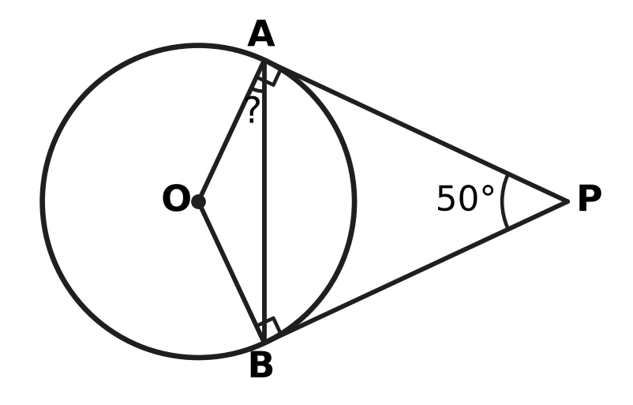
  (A) 65° | (B) 40° | (C) 25° | (D) 130°

Q19. In the figure, D lies on AB and E lies on AC, and ∠ADE = ∠ACB (marked). AD = 6 cm, DB = 6 cm and AE = 4 cm. What is the length of AC? | 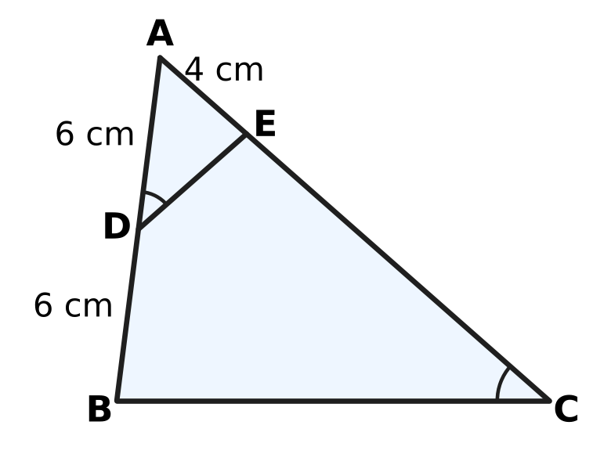
  (A) 18 cm | (B) 13 cm | (C) 8 cm | (D) 12 cm

Part 5 — Mensuration (Syllabus Chapter 6)
Q20. Which of these sectors of a circle has the largest area?
(A) radius 28 cm, angle 20° | (B) radius 21 cm, angle 45°
(C) radius 7 cm, angle 300° | (D) radius 14 cm, angle 90°

Q21. A paper cup used at a picnic is shaped like a frustum of a cone. Its top radius is 5 cm, its bottom radius is 3 cm and its height is 6 cm, as shown. How much water can it hold when full? (Use π = $\frac{22}{7}$.) | 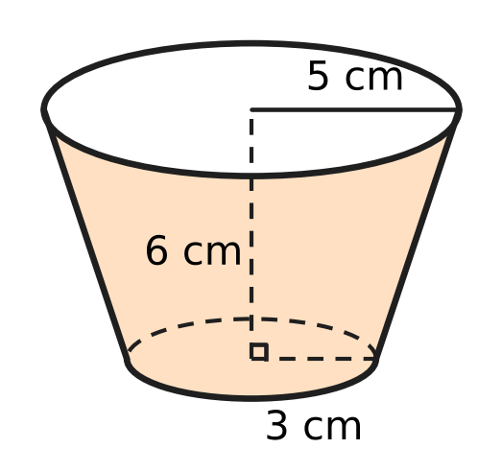
  (A) 462 cm³ | (B) 308 cm³ | (C) 924 cm³ | (D) 616 cm³

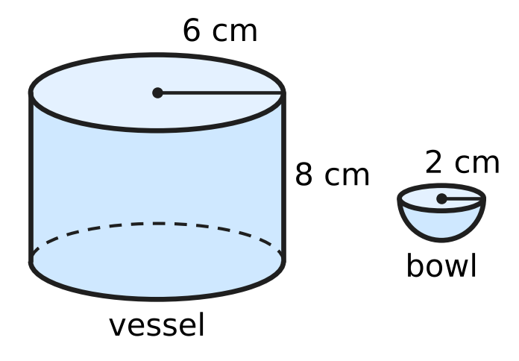
Q22. A cylindrical vessel of radius 6 cm and height 8 cm is full of water. All the water is poured into hemispherical bowls of radius 2 cm, shown in the figure, and each bowl is filled to the brim. How many bowls are filled?
(A) 27 | (B) 36 | (C) 108 | (D) 54

Q23. A sector of a circle has an arc of length 18 cm and an area of 81 cm², as shown. What is the radius r of the circle? | 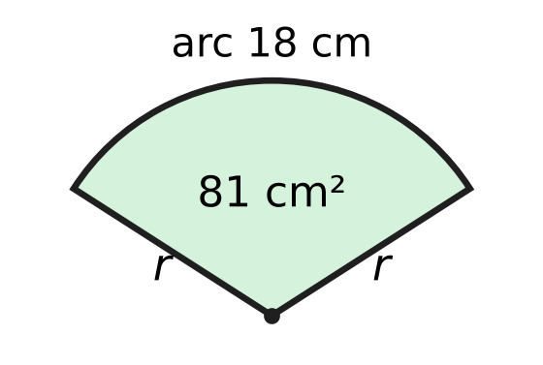
  (A) 9 cm | (B) 12 cm | (C) 4.5 cm | (D) 18 cm

Q24. A solid is made of a cube of edge 14 cm with a hemisphere of radius 7 cm fixed on its top face, as shown. What is the total surface area of the solid? (Use π = $\frac{22}{7}$.) | 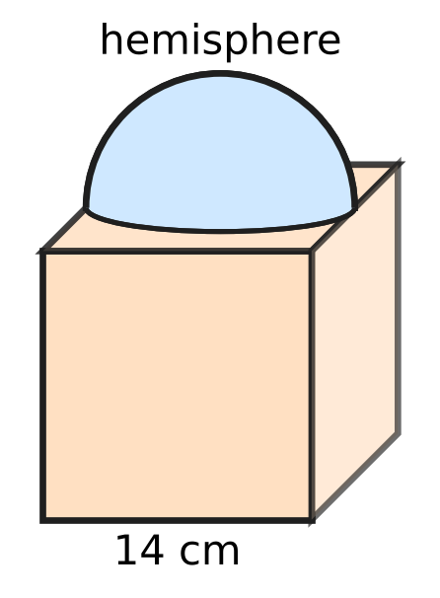
  (A) 1,022 cm² | (B) 1,484 cm²
  (C) 1,330 cm² | (D) 1,176 cm²

Part 6 — Trigonometry & Heights and Distances (Syllabus Chapter 7)
Q25. Which of these has the greatest value?
(A) sin 60° + cos 60° | (B) sec 45°
(C) tan 60° | (D) cosec 30°

Q26. Which of these is equal to $\sin^{4}θ−\cos^{4}θ$ for every angle θ?
(A) $2\sin^{2}θ−1$ | (B) ${(sinθ−cosθ)}^{2}$
(C) $1−2\sin^{2}θ$ | (D) $1$

Q27. A ladder 10 m long stands with its bottom end at one point of a level lane between two vertical walls. Leaning on one wall, it makes an angle of 60° with the ground. Turned about its bottom end to lean on the other wall, it makes 30° with the ground, as shown. How far apart are the two walls? | 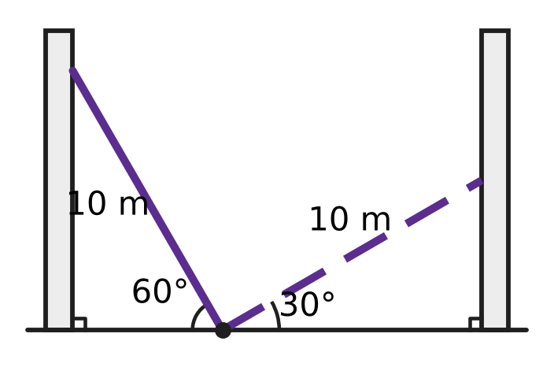
  (A) 20 m | (B) $5(\sqrt{3}−1)$ m
  (C) $5(\sqrt{3}+1)$ m | (D) $5\sqrt{3}$ m

Part 7 — Data Handling, Statistics & Probability (Syllabus Chapter 8)
Lengths of the fish in an aquarium
Length (cm) | 2–6 | 6–10 | 10–14 | 14–18 | 18–22
Number of fish | 3 | 7 | 6 | 3 | 1

Q28. The table shows the lengths of the 20 fish in an aquarium. What is the mean length of a fish, using the class marks?
(A) 8 cm | (B) 10.4 cm | (C) 8.4 cm | (D) 12 cm

Q29. Bowl X has 1 red bead and 3 white beads. Bowl Y has 1 red bead and 4 white beads. One bead is taken at random from each bowl. What is the probability that both beads are white?
(A) $\frac{2}{5}$ | (B) $\frac{3}{5}$ | (C) $\frac{7}{9}$ | (D) $\frac{1}{20}$

Q30. A fair coin is tossed and a fair die is thrown at the same time. Which of these events has the greatest probability?
(A) a head, or a number from 3 to 6 | (B) a number greater than 2
(C) a head, or a number greater than 3 | (D) a tail and a number less than 6

Part 8 — Applied Mathematics (Syllabus Chapter 9)
Q31. A shoe rack is marked ₹2,400. Which of these offers gives the lowest price?
(A) a single discount of 30% | (B) 20% off, then a further 15% off
(C) 10% off, then a further 25% off | (D) 15% off, then a further 15% off

Q32. Akash paints twice as fast as Rekha. Working together, they paint a fence in 6 days. How many days would Rekha take to paint the fence alone?
(A) 3 days | (B) 12 days | (C) 9 days | (D) 18 days

Q33. A bill for goods sold within a state shows SGST of ₹63, charged at 9%. CGST is charged at the same rate. What is the price of the goods before GST?
(A) ₹1,400 | (B) ₹826 | (C) ₹700 | (D) ₹350

Q34. A tap fills an empty water tank in 3 hours. Because of a leak at the bottom, the tank takes 3 hours 30 minutes to fill. If the tank is full and the tap is closed, how long will the leak take to empty it?
(A) 21 hours | (B) 0.5 hours
(C) 10.5 hours | (D) 6.5 hours

Q35. Two towns stand 80 km apart on the bank of a river that flows at 4 km/h. Two boats, each with a speed of 16 km/h in still water, start at the same time from the two towns towards each other. How long after starting do they meet?
(A) 2 hours | (B) 5 hours
(C) 3 hours 20 minutes | (D) 2 hours 30 minutes

Part 9 — Mathematical Reasoning & Problem-Solving (Syllabus Chapter 10)
Q36. A tree has 8 nests. Birds settle in them, and every bird is in some nest. What is the least number of birds that makes sure that some nest has at least 5 birds?
(A) 32 | (B) 33 | (C) 40 | (D) 41

Q37. How many of the whole numbers from 1 to 100 are divisible by 2 or by 5 (or by both)?
(A) 40 | (B) 60 | (C) 70 | (D) 50

Q38. Two players take turns to remove 1, 2, 3 or 4 matchsticks from a pile of 38. The player who removes the last matchstick wins. How many matchsticks should the first player remove at the start to be sure of winning?
(A) 3 | (B) 1 | (C) 4 | (D) 2

Q39. On sports day, 6 teams play a tug-of-war league. Each team plays every other team once, and every match has a winner (no draws). What is the greatest number of teams that can each win at least 4 matches?
(A) 5 | (B) 4 | (C) 2 | (D) 3

Q40. How many different triangles have sides that are whole numbers of centimetres and a perimeter of 15 cm? Triangles with the same three side lengths count as the same triangle.
(A) 6 | (B) 3 | (C) 7 | (D) 19

SECTION II — Star Questions 5 questions × 4 marks each
Q41. The berths in a train coach are numbered so that the numbers form an arithmetic progression. The first berth is numbered 2 and the 24th (last) berth is numbered 71. Passengers each take a different berth of this coach. What is the least number of passengers that makes sure that four of them have berth numbers with the same tens digit, where 2, 5 and 8 count as having tens digit 0? [4 marks]
(A) 25 | (B) 31 | (C) 22 | (D) 23

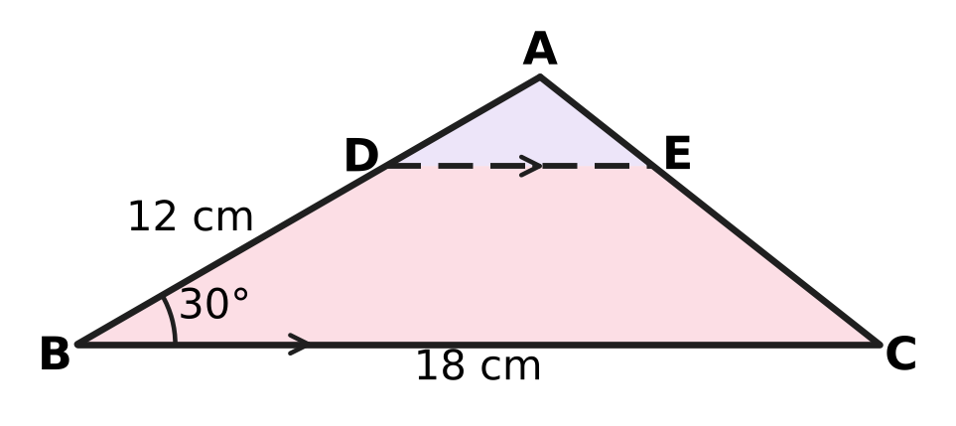
Q42. A triangular piece of cloth ABC has AB = 12 cm, BC = 18 cm and ∠ABC = 30°, as shown. It is cut along DE, where D is on AB, E is on AC, DE ∥ BC and AD : DB = 1 : 2. What is the area of the piece DBCE? [4 marks]
(A) 72 cm² | (B) 36 cm² | (C) 48 cm² | (D) 54 cm²

Q43. The three sides of a right triangle, in cm, form an arithmetic progression, and its perimeter is 48 cm. A perpendicular is drawn from the vertex of the right angle to the longest side. How long is this perpendicular? [4 marks]
(A) 9.6 cm | (B) 7.2 cm | (C) 10 cm | (D) 12 cm

Q44. Mira has ₹50,000 in a bank that pays interest at 12% per year, compounded half-yearly. She wants a laptop priced ₹50,000. The shop lets her either pay now with a 10% discount, or pay the full ₹50,000 one year from now with no extra charge. Any money left unspent stays in the bank. Which way leaves her with more money one year from now, and by how much? [4 marks]
(A) Paying later, by ₹1,180 | (B) Paying later, by ₹562
(C) Paying now, by ₹562 | (D) Paying later, by ₹400

Q45. A solid clay cone of radius 7 cm and height 12 cm, shown in the figure, is reshaped, with no clay lost, into a cuboid. Each edge of the cuboid is a whole number of centimetres. What is the least possible total surface area of the cuboid? (Use π = $\frac{22}{7}$.) [4 marks] | 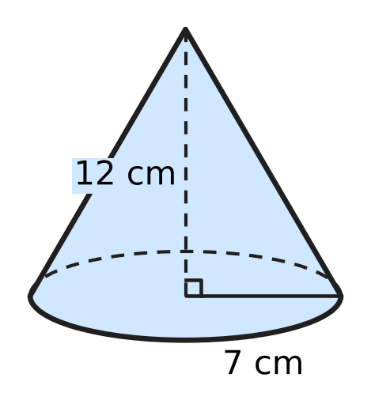
  (A) 221 cm² | (B) 540 cm² | (C) 508 cm² | (D) 442 cm²
Answer Sheet AMO Level 1 · Class 10 · Practice Paper 2
Name: | School: | Roll No.:
Shade or tick one circle for each question.
1. Ⓐ Ⓑ Ⓒ Ⓓ | 16. Ⓐ Ⓑ Ⓒ Ⓓ | 31. Ⓐ Ⓑ Ⓒ Ⓓ
2. Ⓐ Ⓑ Ⓒ Ⓓ | 17. Ⓐ Ⓑ Ⓒ Ⓓ | 32. Ⓐ Ⓑ Ⓒ Ⓓ
3. Ⓐ Ⓑ Ⓒ Ⓓ | 18. Ⓐ Ⓑ Ⓒ Ⓓ | 33. Ⓐ Ⓑ Ⓒ Ⓓ
4. Ⓐ Ⓑ Ⓒ Ⓓ | 19. Ⓐ Ⓑ Ⓒ Ⓓ | 34. Ⓐ Ⓑ Ⓒ Ⓓ
5. Ⓐ Ⓑ Ⓒ Ⓓ | 20. Ⓐ Ⓑ Ⓒ Ⓓ | 35. Ⓐ Ⓑ Ⓒ Ⓓ
6. Ⓐ Ⓑ Ⓒ Ⓓ | 21. Ⓐ Ⓑ Ⓒ Ⓓ | 36. Ⓐ Ⓑ Ⓒ Ⓓ
7. Ⓐ Ⓑ Ⓒ Ⓓ | 22. Ⓐ Ⓑ Ⓒ Ⓓ | 37. Ⓐ Ⓑ Ⓒ Ⓓ
8. Ⓐ Ⓑ Ⓒ Ⓓ | 23. Ⓐ Ⓑ Ⓒ Ⓓ | 38. Ⓐ Ⓑ Ⓒ Ⓓ
9. Ⓐ Ⓑ Ⓒ Ⓓ | 24. Ⓐ Ⓑ Ⓒ Ⓓ | 39. Ⓐ Ⓑ Ⓒ Ⓓ
10. Ⓐ Ⓑ Ⓒ Ⓓ | 25. Ⓐ Ⓑ Ⓒ Ⓓ | 40. Ⓐ Ⓑ Ⓒ Ⓓ
11. Ⓐ Ⓑ Ⓒ Ⓓ | 26. Ⓐ Ⓑ Ⓒ Ⓓ | 41. Ⓐ Ⓑ Ⓒ Ⓓ
12. Ⓐ Ⓑ Ⓒ Ⓓ | 27. Ⓐ Ⓑ Ⓒ Ⓓ | 42. Ⓐ Ⓑ Ⓒ Ⓓ
13. Ⓐ Ⓑ Ⓒ Ⓓ | 28. Ⓐ Ⓑ Ⓒ Ⓓ | 43. Ⓐ Ⓑ Ⓒ Ⓓ
14. Ⓐ Ⓑ Ⓒ Ⓓ | 29. Ⓐ Ⓑ Ⓒ Ⓓ | 44. Ⓐ Ⓑ Ⓒ Ⓓ
15. Ⓐ Ⓑ Ⓒ Ⓓ | 30. Ⓐ Ⓑ Ⓒ Ⓓ | 45. Ⓐ Ⓑ Ⓒ Ⓓ
Q41–Q45 are Section II Star Questions (4 marks each).
For the parent or teacher
Section I correct: ______ / 40 × 2 = ______ marks Section II correct: ______ / 5 × 4 = ______ marks
Correct: ______ / 45 Score: ______ / 100
Answer Key and Solutions AMO Level 1 · Class 10 · Practice Paper 2
Quick answers
1 D | 6 A | 11 A | 16 A | 21 B | 26 A | 31 C | 36 B | 41 D
2 A | 7 D | 12 B | 17 D | 22 D | 27 C | 32 D | 37 B | 42 C
3 B | 8 B | 13 D | 18 C | 23 A | 28 B | 33 C | 38 A | 43 A
4 C | 9 C | 14 C | 19 A | 24 C | 29 B | 34 A | 39 D | 44 B
5 C | 10 D | 15 B | 20 B | 25 D | 30 A | 35 D | 40 C | 45 D
Solutions
Q | Part · level | Answer | Why?
1 | Part 1 · Ch1 · Easy | (D) 2² × 3 | The HCF takes only the common primes 2 and 3, each to its smaller power: 2² × 3 = 12.
2 | Part 1 · Ch1 · Easy | (A) 21 | Here 150 = 2 × 3 × 5². The factor 3 must cancel, so k must be a multiple of 3: $\frac{21}{150}=\frac{7}{50}$ = 0.14.
3 | Part 1 · Ch1 · Medium | (B) 217 | The HCF is the last non-zero remainder, so s = 7. Then r = 4 × 7 = 28, b = 2 × 28 + 7 = 63 and a = 3 × 63 + 28 = 217.
4 | Part 2 · Ch3 · Easy | (C) ₹72,200 | The rate is 5% per half-year for 2 half-years: 80,000 × 0.95 × 0.95 = ₹72,200.
5 | Part 2 · Ch3 · Easy | (C) Jai ₹45,000 for 8 months; Gita ₹36,000 for 10 months | Capital × months: 45,000 × 8 = 360,000 and 36,000 × 10 = 360,000, which are equal.
6 | Part 2 · Ch3 · Easy | (A) 5 : 6 : 5 | Multiply term by term: 2 × 5 : 3 × 4 : 5 × 2 = 10 : 12 : 10 = 5 : 6 : 5.
7 | Part 2 · Ch3 · Medium | (D) ₹8,640 | Atharv: 40,000 × 4 + 70,000 × 8 = 720,000. Nitya: 50,000 × 12 = 600,000. Ratio 6 : 5, so Atharv gets 15,840 × 6/11 = ₹8,640.
8 | Part 2 · Ch3 · Medium | (B) 10% per year, compounded half-yearly | Amounts: (A) 60,000 × 1.04 × 1.06 = ₹66,144; (B) 60,000 × 1.05 × 1.05 = ₹66,150; (C) 60,000 × 1.04 × 1.04 = ₹64,896; (D) ₹66,000. Scheme (B) gives the most.
9 | Part 3 · Ch4 · Easy | (C) 9x² − 30x + 25 = 0 | Equal roots need b² − 4ac = 0: for 9x² − 30x + 25 = 0, 900 − 4 × 9 × 25 = 0. It is (3x − 5)² = 0.
10 | Part 3 · Ch4 · Easy | (D) 192 | A term is −4 + 7(n − 1), so 192 + 4 = 196 must be a multiple of 7: 196 = 7 × 28, so 192 is the 29th term.
11 | Part 3 · Ch4 · Easy | (A) ₹50 | Adding the two pair totals counts bananas twice: 190 + 170 = 360, and 360 − 310 = ₹50.
12 | Part 3 · Ch4 · Medium | (B) −5 | For x³ + ax² + bx + d, the product of the zeroes is −d = 30. So 2 × (−3) × k = 30, giving k = −5.
13 | Part 3 · Ch4 · Medium | (D) 9 | If there are x rows, x(x + 4) = 117, so x² + 4x − 117 = 0, which is (x + 13)(x − 9) = 0. So x = 9.
14 | Part 3 · Ch4 · Medium | (C) 0 | S₁₀ = S₁₅ gives 5(96 + 9d) = 7.5(96 + 14d), so d = −4. Then S₂₅ = 12.5 × (96 + 24 × (−4)) = 0.
15 | Part 4 · Ch5 · Easy | (B) (7, 11) | From (2, −1) to (7, 11): √(5² + 12²) = √169 = 13.
16 | Part 4 · Ch5 · Easy | (A) 6 cm, 9 cm and 12 cm | The ratios 6/4 = 9/6 = 12/8 = 1.5 are equal, so the triangles are similar (SSS similarity).
17 | Part 4 · Ch5 · Easy | (D) (5, −2) | By the section formula, M = (2A + B) ÷ 3, so B = 3M − 2A = (3 + 2, 6 − 8) = (5, −2).
18 | Part 4 · Ch5 · Medium | (C) 25° | PA = PB, so ∠PAB = (180° − 50°) ÷ 2 = 65°. OA ⊥ PA, so ∠OAB = 90° − 65° = 25°.
19 | Part 4 · Ch5 · Medium | (A) 18 cm | Triangles ADE and ACB share ∠A and have ∠ADE = ∠ACB, so they are similar: AD/AC = AE/AB, so AC = 6 × 12 ÷ 4 = 18 cm.
20 | Part 5 · Ch6 · Easy | (B) radius 21 cm, angle 45° | The area is proportional to r² × angle: 441 × 45 = 19,845, more than 196 × 90 = 17,640, 784 × 20 = 15,680 and 49 × 300 = 14,700.
21 | Part 5 · Ch6 · Easy | (B) 308 cm³ | V = ⅓πh(R² + r² + Rr) = ⅓ × 22/7 × 6 × (25 + 9 + 15) = 44/7 × 49 = 308 cm³.
22 | Part 5 · Ch6 · Easy | (D) 54 | Water: π × 36 × 8 = 288π cm³. One bowl: ⅔π × 8 = 16π/3 cm³. 288π ÷ 16π/3 = 54 bowls.
23 | Part 5 · Ch6 · Medium | (A) 9 cm | Area of a sector = ½ × r × (arc length), because θ/360 × πr² = ½ × r × (θ/360 × 2πr). So 81 = ½ × r × 18 and r = 9 cm.
24 | Part 5 · Ch6 · Medium | (C) 1,330 cm² | The cube gives 6 × 196 = 1,176. Subtract the hidden circle 154 and add the curved surface 2 × 154 = 308: 1,176 − 154 + 308 = 1,330 cm².
25 | Part 6 · Ch7 · Easy | (D) cosec 30° | cosec 30° = 1 ÷ sin 30° = 2, while tan 60° ≈ 1.73, sec 45° ≈ 1.41 and sin 60° + cos 60° ≈ 1.37.
26 | Part 6 · Ch7 · Easy | (A) $2\sin^{2}θ−1$ | sin⁴θ − cos⁴θ = (sin²θ + cos²θ)(sin²θ − cos²θ) = sin²θ − (1 − sin²θ) = 2sin²θ − 1.
27 | Part 6 · Ch7 · Medium | (C) $5(\sqrt{3}+1)$ m | Distances from the bottom end: 10 × cos 60° = 5 m and 10 × cos 30° = 5√3 m. Width = 5 + 5√3 = 5(√3 + 1) m.
28 | Part 7 · Ch8 · Easy | (B) 10.4 cm | Σfx = 3 × 4 + 7 × 8 + 6 × 12 + 3 × 16 + 1 × 20 = 208, and 208 ÷ 20 = 10.4 cm.
29 | Part 7 · Ch8 · Easy | (B) $\frac{3}{5}$ | P(white from X) = 3/4 and P(white from Y) = 4/5. Both: 3/4 × 4/5 = 3/5.
30 | Part 7 · Ch8 · Medium | (A) a head, or a number from 3 to 6 | There are 12 equally likely outcomes. Only a tail with a 1 or 2 fails "a head, or a number from 3 to 6", so it has 10/12 = 5/6, more than 3/4, 2/3 and 5/12.
31 | Part 8 · Ch9 · Easy | (C) 10% off, then a further 25% off | Prices: 2,400 × 0.9 × 0.75 = ₹1,620; × 0.8 × 0.85 = ₹1,632; × 0.7 = ₹1,680; × 0.85 × 0.85 = ₹1,734.
32 | Part 8 · Ch9 · Easy | (D) 18 days | Rekha does 1 part and Akash 2 parts a day, so together they do 3 times Rekha's rate. Rekha alone takes 3 × 6 = 18 days.
33 | Part 8 · Ch9 · Easy | (C) ₹700 | ₹63 is 9% of the price, so the price is 63 × 100 ÷ 9 = ₹700.
34 | Part 8 · Ch9 · Medium | (A) 21 hours | Per hour: tap 1/3, tap with leak 2/7. Leak = 1/3 − 2/7 = 1/21 of the tank per hour, so 21 hours.
35 | Part 8 · Ch9 · Medium | (D) 2 hours 30 minutes | They close the gap at (16 + 4) + (16 − 4) = 32 km/h: the stream helps one boat and slows the other equally. 80 ÷ 32 = 2.5 hours, which is 2 hours 30 minutes.
36 | Part 9 · Ch10 · Easy | (B) 33 | With 32 birds, each nest can hold 4, so 32 is not enough. With 33 birds, 4 or fewer in each nest would hold at most 32, so some nest has at least 5.
37 | Part 9 · Ch10 · Easy | (B) 60 | There are 50 multiples of 2 and 20 multiples of 5, but the 10 multiples of 10 are counted twice: 50 + 20 − 10 = 60.
38 | Part 9 · Ch10 · Easy | (A) 3 | Taking 3 leaves 35, a multiple of 5. After that, whatever the other player takes (1 to 4), the first player takes enough to make 5 in that round, so the pile stays a multiple of 5 until the first player takes the last matchstick.
39 | Part 9 · Ch10 · Medium | (D) 3 | There are 15 matches, so 15 wins in all. Four teams with 4 wins would need 16 wins. Three is possible: three teams beat the other three and beat each other in a cycle, 3 + 1 = 4 wins each.
40 | Part 9 · Ch10 · Medium | (C) 7 | The longest side must be less than half of 15, so it is 5, 6 or 7: (5, 5, 5), (4, 5, 6), (3, 6, 6), (1, 7, 7), (2, 6, 7), (3, 5, 7), (4, 4, 7).
41 | Section II · Ch4 + Ch10 · Hard | (D) 23 | d = (71 − 2) ÷ 23 = 3, so the berths are 2, 5, 8, 11, …, 71. Tens digits 0 to 6 have 3, 3, 4, 3, 3, 4, 3 berths and 7 has only 71. Taking at most 3 from each group gives 3 × 7 + 1 = 22 passengers with no four alike, so 23 make sure of it.
42 | Section II · Ch5 + Ch7 · Hard | (C) 48 cm² | The height of A above BC is 12 × sin 30° = 6 cm, so ABC has area 54 cm². By BPT, DE = 18 ÷ 3 = 6 cm and D is 4 cm above BC. DBCE = ½ × (6 + 18) × 4 = 48 cm².
43 | Section II · Ch4 + Ch5 · Hard | (A) 9.6 cm | Sides a − d, a, a + d: 3a = 48, so a = 16. (16 − d)² + 16² = (16 + d)² gives d = 4: sides 12, 16, 20. The perpendicular is 12 × 16 ÷ 20 = 9.6 cm.
44 | Section II · Ch3 + Ch9 · Hard | (B) Paying later, by ₹562 | Paying now: the ₹5,000 saved grows to 5,000 × 1.06 × 1.06 = ₹5,618. Paying later: ₹50,000 grows to ₹56,180, and ₹6,180 is left after paying. Paying later is ahead by 6,180 − 5,618 = ₹562.
45 | Section II · Ch6 + Ch10 · Hard | (D) 442 cm² | Volume = ⅓ × 22/7 × 49 × 12 = 616 = 2³ × 7 × 11. The surface is least when the edges are as close as possible: 7 × 8 × 11, with area 2(56 + 88 + 77) = 442 cm². Checking every way of writing 616 as a product of three whole numbers confirms this; the next best, 4 × 11 × 14, gives 508 cm².

