UNLOCK IQ INSTITUTE
Realize Your True Potential
Aryabhatta Maths Olympiad (AMO)
Level 1 — Practice Paper 3
CLASS 10

Questions | 45 multiple-choice questions
Marks | 100
Time | 60 minutes
Section I | 40 questions × 2 marks = 80 marks
Section II | 5 Star Questions × 4 marks = 20 marks
Negative marking | No negative marking
Calculator | Not allowed
Chapters | Number System · Fractions, Decimals & Percentages · Algebra · Geometry · Mensuration · Trigonometry · Data Handling · Applied Mathematics · Mathematical Reasoning

Instructions to candidates
• This paper has 45 multiple-choice questions. Each question has four answer choices, of which exactly one is correct.
• Section I (Q1–Q40) carries 2 marks per question. Section II (Q41–Q45) carries 4 marks per question.
• There is no negative marking. Unanswered questions score zero.
• Calculators are not permitted. Rough work may be done on a separate sheet.
• Mark your answers on the answer sheet at the end of the paper.
• All figures are not necessarily drawn to scale unless stated.

For parents and teachers
Print or view this paper in colour. Pictures are part of the questions.
Parts follow the AMO syllabus chapters. Chapter 2 is not part of the Class 10 syllabus, so the chapter numbers shown in the Part headings have gaps.
The answer sheet and the answer key are at the end. Remove only the answer key before the student begins.

Name: | School: | Roll No.:

SECTION I 40 questions × 2 marks each
Part 1 — Number System (Syllabus Chapter 1)
Q1. What is the smallest natural number that is divisible by every whole number from 1 to 10?
(A) 1,260 | (B) 2,520
(C) 3,628,800 | (D) 5,040

Q2. The number 3 × 5 × 7 × 11 + 11 is composite. It can be written as 11 × $□$. Which number goes in the box?
(A) 106 | (B) 1,155 | (C) 105 | (D) 116

Q3. A natural number n leaves a remainder of 5 when it is divided by 9. What remainder does n² leave when it is divided by 9?
(A) 1 | (B) 4 | (C) 5 | (D) 7

Part 2 — Fractions, Decimals & Percentages (Syllabus Chapter 3)
Q4. Charu and Bharat run the school canteen as partners for a year. Charu puts in ₹24,000 and Bharat puts in ₹40,000. The year's profit is shared in the ratio of their capitals, and Charu's share is ₹4,500. What is the total profit?
(A) ₹9,000 | (B) ₹7,200 | (C) ₹12,000 | (D) ₹7,500

Q5. A deposit earns compound interest at 10% per year, added once a year. The interest for the 2nd year is ₹2,200. The interest for the 3rd year is $□$. Which amount completes the statement?
(A) ₹2,640 | (B) ₹2,200 | (C) ₹2,662 | (D) ₹2,420

Q6. Vidya deposits her savings of ₹26,000 for 2 years at 5% per year, compounded yearly. The interest she earns is $□$. Which amount completes the statement?
(A) ₹2,600 | (B) ₹2,665 | (C) ₹28,665 | (D) ₹1,365

Q7. A sum of money is lent at 24% per year, compounded half-yearly. After one year, ₹78,400 is due. What sum was lent?
(A) ₹59,584 | (B) ₹68,992 | (C) ₹62,500 | (D) ₹70,000

Q8. Sneha starts a beekeeping business with ₹50,000. After 5 months, Vikram joins with ₹80,000. The profit at the end of the year is shared in the ratio of capital × time, and Sneha gets ₹1,000 more than Vikram. What is the total profit?
(A) ₹29,000 | (B) ₹15,000 | (C) ₹5,000 | (D) ₹14,000

Part 3 — Algebra (Syllabus Chapter 4)
Q9. One zero of the polynomial $3x^{2}−8x+k$ is 2. Its other zero is $□$. Which number goes in the box?
(A) 6 | (B) $\frac{14}{3}$ | (C) $\frac{2}{3}$ | (D) $\frac{4}{3}$

Q10. The numbers x + 2, 3x and 4x + 1 are consecutive terms of an arithmetic progression. Then x = $□$. Which number goes in the box?
(A) 5 | (B) 3 | (C) −3 | (D) 9

Q11. Look at the equations:
x + 2y + 3z = 14; 2x + 3y + z = 11; 3x + y + 2z = 11.
From these, x + y + z = $□$. Which number goes in the box?
(A) 6 | (B) 18 | (C) 36 | (D) 12

Q12. When $p(x)=x^{3}+ax+b$ is divided by $x−1$, the remainder is 3. When it is divided by $x+2$, the remainder is 6. Then a = $□$. Which number goes in the box?
(A) 4 | (B) 2 | (C) 6 | (D) −4

Q13. Three numbers are in an arithmetic progression with a positive common difference. Their sum is 27 and their product is 648. The largest of the three numbers is $□$. Which number goes in the box?
(A) 12 | (B) 15 | (C) 6 | (D) 9

Q14. As x takes all real values, the least value of $x^{2}−8x+21$ is $□$. Which number goes in the box?
(A) 4 | (B) 5 | (C) 37 | (D) 21

Part 4 — Geometry (Syllabus Chapter 5)
Q15. △ABC is similar to △DEF, with A matching D and B matching E. AB = 6 cm, DE = 9 cm and the perimeter of △ABC is 24 cm. The perimeter of △DEF is $□$. Which length goes in the box?
(A) 16 cm | (B) 27 cm | (C) 36 cm | (D) 54 cm

Q16. The points A(−3, 2) and B(5, k) are 10 units apart, and k is positive. Then k = $□$. Which number goes in the box?
(A) 10 | (B) 4 | (C) 6 | (D) 8

Q17. In the figure, two straight lines through P touch a circle of radius 5 cm, centre O, at A and B. The two lines meet at right angles at P. How far is P from A? | 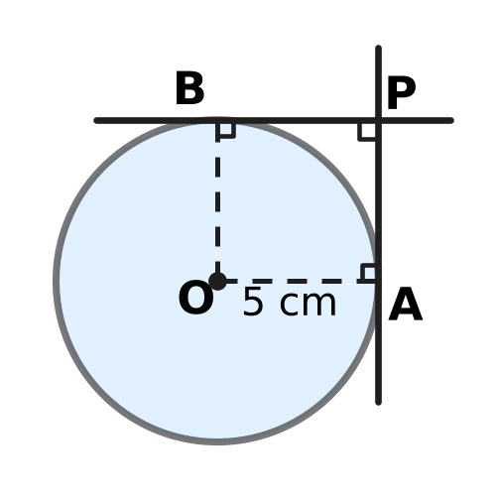
  (A) 5√2 cm | (B) 10 cm | (C) 5 cm | (D) 2.5 cm

Q18. R is (−2, −1) and S is (10, 8). The point M($□$, 5) lies on the segment RS. Which number goes in the box?
(A) 6 | (B) 2 | (C) 5.5 | (D) 4

Q19. Two vertical poles, 10 m and 15 m tall, stand 20 m apart on level ground. A straight wire runs from the top of each pole to the bottom of the other, as shown. At what height h above the ground do the wires cross? | 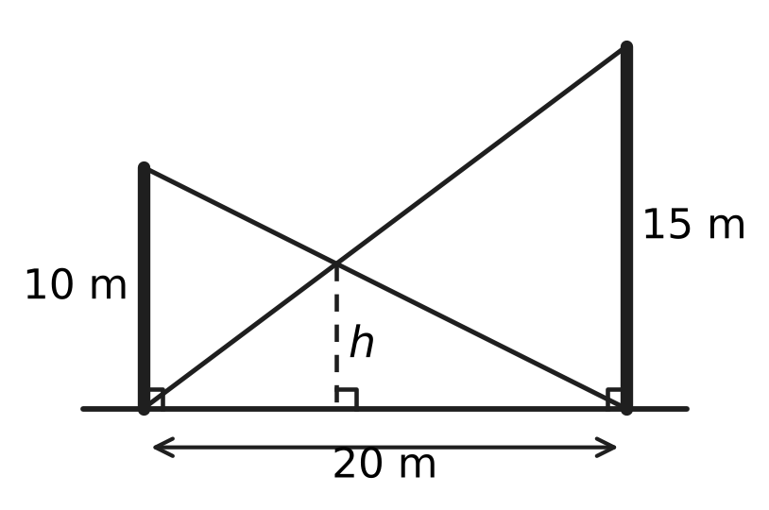
  (A) 7.5 m | (B) 5 m | (C) 12.5 m | (D) 6 m

Part 5 — Mensuration (Syllabus Chapter 6)
Q20. A glass window is a rectangle 14 cm wide and 10 cm tall with a semicircle on its top side, as shown. What is the area of the glass? (Use π = 22/7.) | 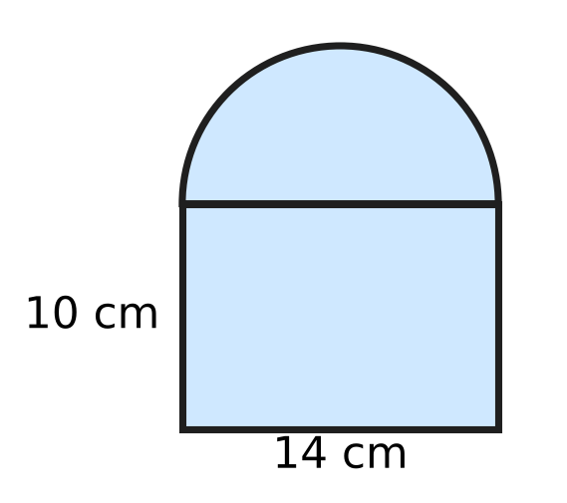
  (A) 448 cm² | (B) 217 cm² | (C) 294 cm² | (D) 162 cm²

Q21. Three solid metal cubes with edges 3 cm, 4 cm and 5 cm are melted and recast into one solid cube, with no metal lost. The edge of the new cube is $□$. Which length goes in the box?
(A) 216 cm | (B) 12 cm | (C) 6 cm | (D) 4 cm

Q22. A bucket is shaped like a frustum of a cone. The circumference of its top rim is 110 cm, the circumference of its bottom is 66 cm, and its slant height is 16 cm, as shown. What is its curved surface area? | 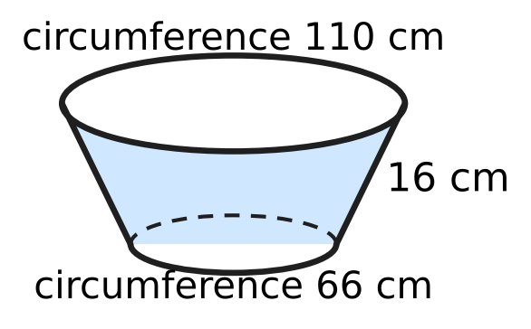
  (A) 2,816 cm² | (B) 880 cm²
  (C) 528 cm² | (D) 1,408 cm²

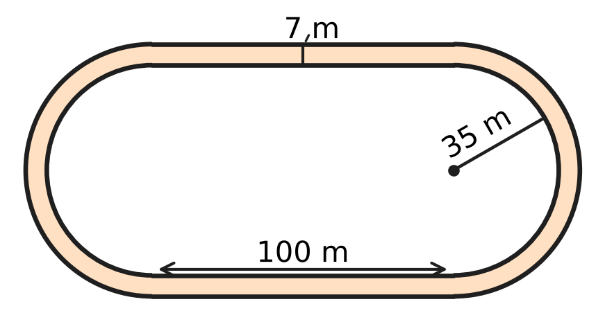
Q23. The running track in the figure has two straight parts of 100 m and two semicircular ends. The inner edge of each end has radius 35 m, and the track is 7 m wide. Kavin runs one lap along the outer edge. How much farther does he run than a runner who goes along the inner edge? (Use π = 22/7.)
(A) 14 m | (B) 44 m | (C) 22 m | (D) 88 m

Q24. A solid wooden cylinder has radius 21 cm and height 20 cm. A cone of the same radius and height is hollowed out of it from the top face, as shown (the dashed lines). What is the total surface area of the remaining solid? (Use π = 22/7.) | 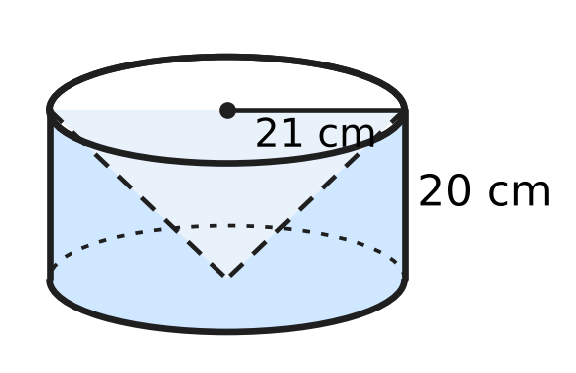
  (A) 5,940 cm² | (B) 5,346 cm²
  (C) 4,026 cm² | (D) 7,326 cm²

Part 6 — Trigonometry & Heights and Distances (Syllabus Chapter 7)
Q25. For every acute angle θ, $1−\frac{\sin^{2}θ}{1+cosθ}$ = $□$. Which expression goes in the box?
(A) $1+cosθ$ | (B) $cosθ$
(C) $1−cosθ$ | (D) $sinθ$

Q26. The angle 3θ − 15° is acute and tan(3θ − 15°) = 1. Then θ = $□$. Which angle goes in the box?
(A) 20° | (B) 15° | (C) 25° | (D) 10°

Q27. A flagpole BT stands on the flat roof of a building, at its front edge B. From a point P on level ground, 24 m from the building, the angle of elevation of B is 30° and that of the top T is 60°, as shown. How tall is the flagpole? | 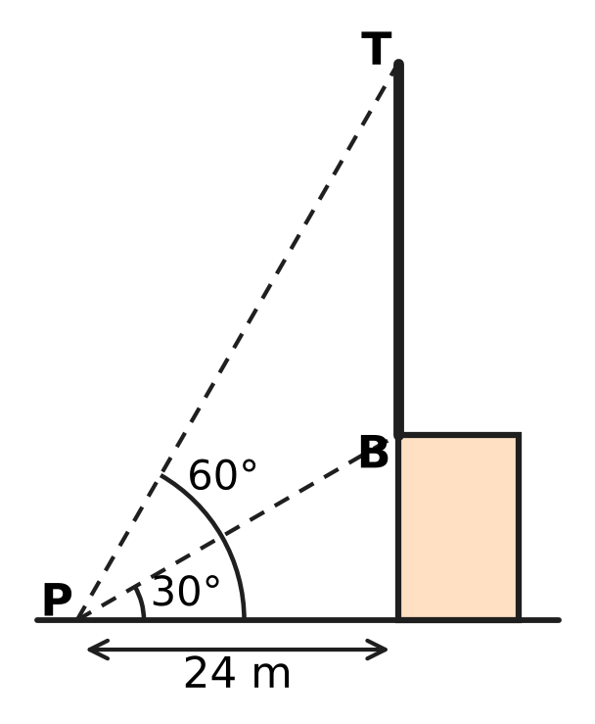
  (A) $8\sqrt{3}$ m | (B) 16 m
  (C) $16\sqrt{3}$ m | (D) $24\sqrt{3}$ m

Part 7 — Data Handling, Statistics & Probability (Syllabus Chapter 8)
Q28. A post office has three postboxes. Two letters are posted, one at a time. Each letter is equally likely to go into any of the three boxes, whatever happened to the other letter. What is the probability that both letters go into the same box?
(A) $\frac{1}{6}$ | (B) $\frac{2}{3}$ | (C) $\frac{1}{9}$ | (D) $\frac{1}{3}$

Q29. In a board game, a player throws two fair dice and multiplies the two numbers. What is the probability that the product is even?
(A) $\frac{3}{4}$ | (B) $\frac{1}{2}$ | (C) $\frac{1}{4}$ | (D) $\frac{2}{3}$

Time taken by 40 students to finish a puzzle
Time (minutes) | 10–20 | 20–30 | 30–40 | 40–50 | 50–60
Number of students | 6 | 12 | 10 | 7 | 5

Q30. The table shows how long 40 students took to finish a puzzle. What is the median time, found by the formula for grouped data?
(A) 35 minutes | (B) 22 minutes
(C) 32 minutes | (D) 52 minutes

Part 8 — Applied Mathematics (Syllabus Chapter 9)
Q31. At a flour mill, 75% of the mass of grain becomes flour. Grain comes in sacks of 50 kg each. How many sacks of grain are needed to make 600 kg of flour?
(A) 12 sacks | (B) 16 sacks | (C) 9 sacks | (D) 15 sacks

Q32. Juhi's club sells paper-plane kits. Its fixed costs are ₹9,000, and each kit costs ₹45 to make. To break even by selling exactly 600 kits, the selling price of a kit must be $□$. Which amount completes the statement?
(A) ₹15 | (B) ₹30 | (C) ₹75 | (D) ₹60

Q33. Three identical pipes, working together, fill an empty tank in 12 hours. Four such pipes, working together, fill it in $□$ hours. Which number goes in the box?
(A) 16 | (B) 36 | (C) 9 | (D) 3

Q34. A wall clock shop sells a clock within the state for ₹5,900. This price includes GST at 18%, which is split equally into CGST and SGST. How much CGST is included in the price?
(A) ₹1,062 | (B) ₹900 | (C) ₹531 | (D) ₹450

Q35. Ankit's motorboat leaves the harbour and goes up a river to a jetty, then comes back the same way. Going upstream takes 3 times as long as coming back downstream. What is the ratio of the speed of the boat in still water to the speed of the stream?
(A) 2 : 1 | (B) 4 : 3 | (C) 1 : 2 | (D) 3 : 1

Part 9 — Mathematical Reasoning & Problem-Solving (Syllabus Chapter 10)
Q36. Bus tickets carry the numbers 1,000 to 9,999. A ticket is lucky if its number reads the same forwards and backwards, such as 3,883. How many lucky tickets are there?
(A) 900 | (B) 90 | (C) 100 | (D) 81

Q37. On a museum visit, each of 35 students saw the science gallery, the art gallery, both or neither. Of them, 28 saw the science gallery and 25 saw the art gallery. What is the least possible number of students who saw both galleries?
(A) 25 | (B) 3 | (C) 7 | (D) 18

Q38. Each of 9 friends sends one message to every other friend in the group. How many messages are sent in all?
(A) 81 | (B) 36 | (C) 72 | (D) 18

Q39. What is the least number n such that among ANY n different whole numbers, there are always two whose sum or whose difference is divisible by 10?
(A) 7 | (B) 11 | (C) 6 | (D) 5

Q40. Twelve cards lie on a table, all face up. In one move you must turn over exactly 5 of the cards (any 5, face up or face down). What is the least number of moves needed to have all 12 cards face down?
(A) 3 | (B) 4 | (C) 5 | (D) 6

SECTION II — Star Questions 5 questions × 4 marks each
Q41. Three different numbers are chosen from the whole numbers 1 to 30 so that, written in increasing order, they form an arithmetic progression. For example, 4, 11, 18 is one such choice. How many such choices are there? [4 marks]
(A) 392 | (B) 420 | (C) 435 | (D) 210

Q42. A straight wire 24 m long runs from the top A of a vertical mast OA to a point B on the level ground, as shown. The angle of elevation of A from B is 30°. A lamp is fixed on the wire at M, where AM : MB = 1 : 3. How far is the lamp from the point O at the bottom of the mast? [4 marks] | 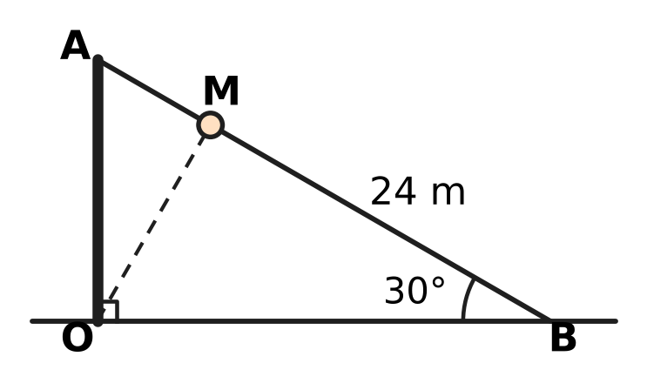
  (A) $6\sqrt{7}$ m | (B) $6\sqrt{3}$ m
  (C) 6 m | (D) 12 m

Q43. The figure shows the points A(0, 4) and B(6, 2). A point C is to be chosen on the x-axis so that ∠ACB = 90°. Which of these gives ALL the possible positions of C? [4 marks] | 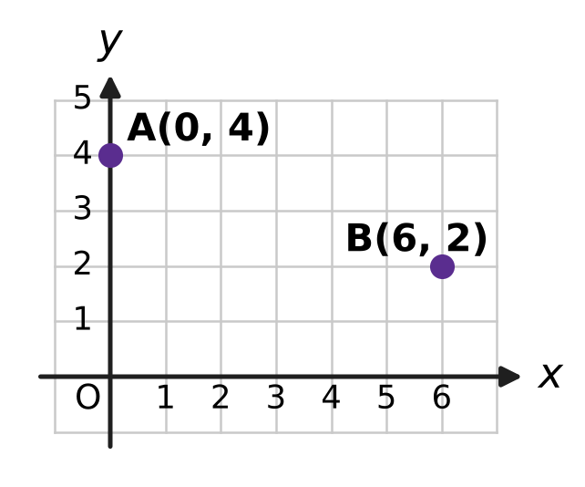
  (A) (2, 0) and (4, 0) | (B) (2, 0) only
  (C) (−2, 0) and (−4, 0) | (D) (3, 0) only

Q44. Hema borrows ₹40,000 to buy a kiln for clay pots, at 10% per year compounded half-yearly. She repays the whole amount at the end of one year. During the year she also spends ₹5,900 on fuel. Each pot costs ₹30 in clay and paint and sells for ₹80. What is the least number of pots she must sell in the year to cover the loan repayment and the fuel? [4 marks]
(A) 1,086 | (B) 998 | (C) 1,000 | (D) 882

Q45. Nirav melts a solid metal cylinder of radius 6 cm and height 7 cm. He recasts ALL the metal into solid spheres of radius 3 cm and solid cones of radius 3 cm and height 4 cm, with no metal lost. He makes at least one sphere and at least one cone. What is the greatest possible total number of solids? [4 marks]
(A) 7 | (B) 21 | (C) 9 | (D) 19

Answer Sheet AMO Level 1 · Class 10 · Practice Paper 3
Name: | School: | Roll No.:
Shade or tick one circle for each question.
1. Ⓐ Ⓑ Ⓒ Ⓓ | 16. Ⓐ Ⓑ Ⓒ Ⓓ | 31. Ⓐ Ⓑ Ⓒ Ⓓ
2. Ⓐ Ⓑ Ⓒ Ⓓ | 17. Ⓐ Ⓑ Ⓒ Ⓓ | 32. Ⓐ Ⓑ Ⓒ Ⓓ
3. Ⓐ Ⓑ Ⓒ Ⓓ | 18. Ⓐ Ⓑ Ⓒ Ⓓ | 33. Ⓐ Ⓑ Ⓒ Ⓓ
4. Ⓐ Ⓑ Ⓒ Ⓓ | 19. Ⓐ Ⓑ Ⓒ Ⓓ | 34. Ⓐ Ⓑ Ⓒ Ⓓ
5. Ⓐ Ⓑ Ⓒ Ⓓ | 20. Ⓐ Ⓑ Ⓒ Ⓓ | 35. Ⓐ Ⓑ Ⓒ Ⓓ
6. Ⓐ Ⓑ Ⓒ Ⓓ | 21. Ⓐ Ⓑ Ⓒ Ⓓ | 36. Ⓐ Ⓑ Ⓒ Ⓓ
7. Ⓐ Ⓑ Ⓒ Ⓓ | 22. Ⓐ Ⓑ Ⓒ Ⓓ | 37. Ⓐ Ⓑ Ⓒ Ⓓ
8. Ⓐ Ⓑ Ⓒ Ⓓ | 23. Ⓐ Ⓑ Ⓒ Ⓓ | 38. Ⓐ Ⓑ Ⓒ Ⓓ
9. Ⓐ Ⓑ Ⓒ Ⓓ | 24. Ⓐ Ⓑ Ⓒ Ⓓ | 39. Ⓐ Ⓑ Ⓒ Ⓓ
10. Ⓐ Ⓑ Ⓒ Ⓓ | 25. Ⓐ Ⓑ Ⓒ Ⓓ | 40. Ⓐ Ⓑ Ⓒ Ⓓ
11. Ⓐ Ⓑ Ⓒ Ⓓ | 26. Ⓐ Ⓑ Ⓒ Ⓓ | 41. Ⓐ Ⓑ Ⓒ Ⓓ
12. Ⓐ Ⓑ Ⓒ Ⓓ | 27. Ⓐ Ⓑ Ⓒ Ⓓ | 42. Ⓐ Ⓑ Ⓒ Ⓓ
13. Ⓐ Ⓑ Ⓒ Ⓓ | 28. Ⓐ Ⓑ Ⓒ Ⓓ | 43. Ⓐ Ⓑ Ⓒ Ⓓ
14. Ⓐ Ⓑ Ⓒ Ⓓ | 29. Ⓐ Ⓑ Ⓒ Ⓓ | 44. Ⓐ Ⓑ Ⓒ Ⓓ
15. Ⓐ Ⓑ Ⓒ Ⓓ | 30. Ⓐ Ⓑ Ⓒ Ⓓ | 45. Ⓐ Ⓑ Ⓒ Ⓓ
Q41–Q45 are Section II Star Questions (4 marks each).
For the parent or teacher
Section I correct: ______ / 40 × 2 = ______ marks Section II correct: ______ / 5 × 4 = ______ marks
Correct: ______ / 45 Score: ______ / 100
Answer Key and Solutions AMO Level 1 · Class 10 · Practice Paper 3
Quick answers
1 B | 6 B | 11 A | 16 D | 21 C | 26 A | 31 B | 36 B | 41 D
2 A | 7 C | 12 D | 17 C | 22 D | 27 C | 32 D | 37 D | 42 B
3 D | 8 A | 13 A | 18 A | 23 B | 28 D | 33 C | 38 C | 43 A
4 C | 9 C | 14 B | 19 D | 24 A | 29 A | 34 D | 39 A | 44 C
5 D | 10 B | 15 C | 20 B | 25 B | 30 C | 35 A | 40 B | 45 D
Solutions
Q | Part · level | Answer | Why?
1 | Part 1 · Ch1 · Easy | (B) 2,520 | Take the highest power of each prime up to 10: 2³ × 3² × 5 × 7 = 2,520.
2 | Part 1 · Ch1 · Easy | (A) 106 | 3 × 5 × 7 × 11 + 11 = 11 × (3 × 5 × 7 + 1) = 11 × 106, so it has the factor 11 and is composite.
3 | Part 1 · Ch1 · Medium | (D) 7 | Write n = 9q + 5. Then n² = 81q² + 90q + 25 = 9(9q² + 10q + 2) + 7, so the remainder is 7.
4 | Part 2 · Ch3 · Easy | (C) ₹12,000 | The ratio is 24,000 : 40,000 = 3 : 5. Charu has 3 of the 8 parts, so one part is ₹1,500 and the profit is 8 × 1,500 = ₹12,000.
5 | Part 2 · Ch3 · Easy | (D) ₹2,420 | Each year's interest is 10% more than the year before, because the balance has grown by 10%: 2,200 × 1.1 = ₹2,420.
6 | Part 2 · Ch3 · Easy | (B) ₹2,665 | Amount = 26,000 × 1.05 × 1.05 = ₹28,665, so the interest is 28,665 − 26,000 = ₹2,665 (₹65 more than simple interest).
7 | Part 2 · Ch3 · Medium | (C) ₹62,500 | The rate is 12% per half-year for 2 half-years, so the sum × 1.12 × 1.12 = 78,400. The sum is 78,400 ÷ 1.2544 = ₹62,500.
8 | Part 2 · Ch3 · Medium | (A) ₹29,000 | Sneha: 50,000 × 12 = 600,000. Vikram: 80,000 × 7 = 560,000. The ratio is 15 : 14, so 1 part = ₹1,000 and the profit is 29 × 1,000 = ₹29,000.
9 | Part 3 · Ch4 · Easy | (C) $\frac{2}{3}$ | The sum of the zeroes is 8/3. So the other zero is 8/3 − 2 = 2/3. (Also k = 4 and 2 × 2/3 = 4/3.)
10 | Part 3 · Ch4 · Easy | (B) 3 | For an AP, twice the middle term equals the sum of the other two: 6x = 5x + 3, so x = 3 (terms 5, 9, 13).
11 | Part 3 · Ch4 · Easy | (A) 6 | Adding the three equations gives 6x + 6y + 6z = 36, so x + y + z = 6.
12 | Part 3 · Ch4 · Medium | (D) −4 | p(1) = 1 + a + b = 3 and p(−2) = −8 − 2a + b = 6. So a + b = 2 and b − 2a = 14; subtracting, 3a = −12 and a = −4.
13 | Part 3 · Ch4 · Medium | (A) 12 | Take the numbers as 9 − d, 9, 9 + d. Then 9(81 − d²) = 648, so d² = 9 and d = 3. The numbers are 6, 9, 12.
14 | Part 3 · Ch4 · Medium | (B) 5 | x² − 8x + 21 = (x − 4)² + 5. A square is never negative, so the least value is 5, at x = 4.
15 | Part 4 · Ch5 · Easy | (C) 36 cm | In similar triangles the perimeters are in the ratio of matching sides, 9 : 6 = 3 : 2. So the perimeter is 24 × 3/2 = 36 cm.
16 | Part 4 · Ch5 · Easy | (D) 8 | 8² + (k − 2)² = 10², so (k − 2)² = 36 and k − 2 = 6 or −6. As k is positive, k = 8.
17 | Part 4 · Ch5 · Easy | (C) 5 cm | ∠OAP = ∠OBP = 90° and ∠APB = 90°, so OAPB is a rectangle with OA = OB; it is a square. Hence PA = OB = 5 cm.
18 | Part 4 · Ch5 · Medium | (A) 6 | From R to S, y rises by 9; from R to M it rises by 6. So RM : MS = 6 : 3 = 2 : 1 and x = −2 + (2/3) × 12 = 6.
19 | Part 4 · Ch5 · Medium | (D) 6 m | Let the crossing be x m from the 10 m pole. By similar triangles, h/10 = (20 − x)/20 and h/15 = x/20. Adding, h/10 + h/15 = 1, so h = 6 m.
20 | Part 5 · Ch6 · Easy | (B) 217 cm² | Rectangle 14 × 10 = 140 cm². Semicircle of radius 7 cm: ½ × 22/7 × 49 = 77 cm². Total 217 cm².
21 | Part 5 · Ch6 · Easy | (C) 6 cm | Volume = 27 + 64 + 125 = 216 cm³ = 6³, so the edge is 6 cm.
22 | Part 5 · Ch6 · Easy | (D) 1,408 cm² | CSA = π(R + r)l = ½(2πR + 2πr) × l = ½ × (110 + 66) × 16 = 1,408 cm².
23 | Part 5 · Ch6 · Medium | (B) 44 m | The straight parts are the same. The two semicircles make a full circle, so the extra distance is 2π × 42 − 2π × 35 = 2π × 7 = 44 m.
24 | Part 5 · Ch6 · Medium | (A) 5,940 cm² | Slant height = √(21² + 20²) = 29 cm. Area = curved surface 2πrh (2,640) + base πr² (1,386) + cone inside πrl (1,914) = 5,940 cm².
25 | Part 6 · Ch7 · Easy | (B) $cosθ$ | sin²θ = 1 − cos²θ = (1 − cos θ)(1 + cos θ), so the fraction is 1 − cos θ and the expression is 1 − (1 − cos θ) = cos θ.
26 | Part 6 · Ch7 · Easy | (A) 20° | tan 45° = 1, so 3θ − 15° = 45°. Then 3θ = 60° and θ = 20°.
27 | Part 6 · Ch7 · Medium | (C) $16\sqrt{3}$ m | Building = 24 tan 30° = 8√3 m. Top T = 24 tan 60° = 24√3 m above the ground. Flagpole = 24√3 − 8√3 = 16√3 m.
28 | Part 7 · Ch8 · Easy | (D) $\frac{1}{3}$ | There are 3 × 3 = 9 equally likely outcomes, and 3 of them put both letters in the same box: 3/9 = 1/3.
29 | Part 7 · Ch8 · Easy | (A) $\frac{3}{4}$ | The product is odd only when both numbers are odd: 3/6 × 3/6 = 1/4. So P(even) = 1 − 1/4 = 3/4.
30 | Part 7 · Ch8 · Medium | (C) 32 minutes | N/2 = 20, so the median class is 30–40, with cf before it 18 and f = 10. Median = 30 + (20 − 18)/10 × 10 = 32 minutes.
31 | Part 8 · Ch9 · Easy | (B) 16 sacks | Grain needed = 600 ÷ 0.75 = 800 kg, which is 800 ÷ 50 = 16 sacks.
32 | Part 8 · Ch9 · Easy | (D) ₹60 | At break-even, income = total cost: 600 × price = 9,000 + 600 × 45. So price = 45 + 15 = ₹60.
33 | Part 8 · Ch9 · Easy | (C) 9 | One pipe alone takes 3 × 12 = 36 hours. Four pipes take 36 ÷ 4 = 9 hours.
34 | Part 8 · Ch9 · Medium | (D) ₹450 | Price before GST = 5,900 ÷ 1.18 = ₹5,000, so GST = ₹900. CGST is half of it: ₹450.
35 | Part 8 · Ch9 · Medium | (A) 2 : 1 | For the same distance, downstream speed = 3 × upstream speed: b + s = 3(b − s), so 2b = 4s and b : s = 2 : 1.
36 | Part 9 · Ch10 · Easy | (B) 90 | The first digit (1–9) and the second digit (0–9) fix the number, since the last two digits repeat them: 9 × 10 = 90.
37 | Part 9 · Ch10 · Easy | (D) 18 | At most 35 students saw at least one gallery, so at least 28 + 25 − 35 = 18 saw both. This is possible when every student saw a gallery.
38 | Part 9 · Ch10 · Easy | (C) 72 | Each of the 9 friends sends 8 messages, so 9 × 8 = 72 messages. (A message from A to B and one from B to A are different.)
39 | Part 9 · Ch10 · Medium | (A) 7 | Use 6 boxes of remainders: {0}, {5}, {1, 9}, {2, 8}, {3, 7}, {4, 6}. Two numbers in one box have a sum or difference divisible by 10, so 7 numbers are enough. The numbers 0, 1, 2, 3, 4, 5 show that 6 are not.
40 | Part 9 · Ch10 · Medium | (B) 4 | Each move changes the number of face-up cards by an odd amount, so the number of moves must be even; two moves turn at most 10 cards. Four moves work: 12 → 7 → 2 → 5 → 0 face-up cards.
41 | Section II · Ch4 + Ch10 · Hard | (D) 210 | For common difference d, the first term can be 1 to 30 − 2d, giving 28, 26, …, 2 choices for d = 1 to 14. This is an AP with 14 terms, so the total is 14 × (28 + 2)/2 = 210.
42 | Section II · Ch5 + Ch7 · Hard | (B) $6\sqrt{3}$ m | OA = 24 sin 30° = 12 m and OB = 24 cos 30° = 12√3 m. M is 1/4 of the way from A to B, so it is 3/4 × 12 = 9 m high and 1/4 × 12√3 = 3√3 m from the mast. OM = √(27 + 81) = √108 = 6√3 m.
43 | Section II · Ch4 + Ch5 · Hard | (A) (2, 0) and (4, 0) | For C(k, 0): CA² + CB² = AB² gives (k² + 16) + ((k − 6)² + 4) = 40, so k² − 6k + 8 = 0 and k = 2 or 4. Both give a right angle.
44 | Section II · Ch3 + Ch9 · Hard | (C) 1,000 | Amount = 40,000 × 1.05² = ₹44,100. With fuel, she needs ₹50,000. Each pot gives 80 − 30 = ₹50, so she must sell 50,000 ÷ 50 = 1,000 pots.
45 | Section II · Ch6 + Ch10 · Hard | (D) 19 | In units of π cm³: cylinder 252, sphere 36, cone 12. So 36a + 12b = 252, i.e. 3a + b = 21, and the total a + b = 21 − 2a is greatest when a = 1: 1 + 18 = 19.

