UNLOCK IQ INSTITUTE
Realize Your True Potential
Aryabhatta Maths Olympiad (AMO)
Level 1 — Practice Paper 4
CLASS 10

Questions | 45 multiple-choice questions
Marks | 100
Time | 60 minutes
Section I | 40 questions × 2 marks = 80 marks
Section II | 5 Star Questions × 4 marks = 20 marks
Negative marking | No negative marking
Calculator | Not allowed
Chapters | Number System · Fractions, Decimals & Percentages · Algebra · Geometry · Mensuration · Trigonometry · Data Handling · Applied Mathematics · Mathematical Reasoning

Instructions to candidates
• This paper has 45 multiple-choice questions. Each question has four answer choices, of which exactly one is correct.
• Section I (Q1–Q40) carries 2 marks per question. Section II (Q41–Q45) carries 4 marks per question.
• There is no negative marking. Unanswered questions score zero.
• Calculators are not permitted. Rough work may be done on a separate sheet.
• Mark your answers on the answer sheet at the end of the paper.
• All figures are not necessarily drawn to scale unless stated.

For parents and teachers
Print or view this paper in colour. Pictures are part of the questions.
Parts follow the AMO syllabus chapters. Chapter 2 is not part of the Class 10 syllabus, so the chapter numbers shown in the Part headings have gaps.
The answer sheet and the answer key are at the end. Remove only the answer key before the student begins.

Name: | School: | Roll No.:

SECTION I 40 questions × 2 marks each
Part 1 — Number System (Syllabus Chapter 1)
Q1. Dividing 1,001 by 455 gives 1,001 = 2 × 455 + 91. Taking this as the first step of Euclid's algorithm, what is the HCF of 1,001 and 455?
(A) 455 | (B) 7 | (C) 2 | (D) 91

Q2. For every natural number n greater than 1, the number n³ − n is divisible by which of these?
(A) 24 | (B) 6 | (C) 4 | (D) 12

Q3. The HCF of two different natural numbers is 18, and their sum is 216. How many such pairs of numbers are there? A pair is counted once, whichever number is written first.
(A) 2 | (B) 6 | (C) 4 | (D) 5

Part 2 — Fractions, Decimals & Percentages (Syllabus Chapter 3)
Q4. A savings deposit of ₹40,000 grows at 12% per year, with the interest added every three months. How many months does it take to grow to ₹42,436?
(A) 12 months | (B) 3 months
(C) 6 months | (D) 2 months

Q5. Garima and Omar start a cycle repair shop. Garima puts in ₹39,000 and Omar puts in ₹65,000, both for the whole year. Garima also runs the shop. Out of the year's profit of ₹56,000, Garima is first paid ₹12,000 for running it. The rest is shared in the ratio of their capitals. What is Omar's share?
(A) ₹35,000 | (B) ₹16,500 | (C) ₹22,000 | (D) ₹27,500

Tailoring unit — first year
Partner | Capital (₹) | Months in the business
Chitra | 40,000 | 12
Ayaan | 60,000 | 6
Zara | 20,000 | 6

Q6. Chitra, Ayaan and Zara start a tailoring unit. The table shows the money each put in and for how many months. The first year's profit of ₹32,000 is shared in the ratio of capital × time. What is Ayaan's share?
(A) ₹8,000 | (B) ₹12,000 | (C) ₹4,000 | (D) ₹16,000

Q7. Sonal and Vivek run a milk dairy. Sonal's money stays in the dairy for 10 months and Vivek's for 12 months. They share the profit in the ratio of capital × time, and their shares are in the ratio 5 : 3. In what ratio did they put in money?
(A) 2 : 1 | (B) 25 : 18 | (C) 1 : 2 | (D) 5 : 3

Q8. Eva opens a savings account with ₹25,000. It earns interest at 8% per year, compounded half-yearly. Six months later, just after the first interest is added, she puts in ₹15,000 more. What is her balance at the end of the year, just after the second interest is added?
(A) ₹42,040 | (B) ₹42,640 | (C) ₹43,264 | (D) ₹42,600

Part 3 — Algebra (Syllabus Chapter 4)
Q9. The polynomial $(k+2)x^{2}−13x+6$ has two zeroes, and one zero is the reciprocal of the other. What is the value of k?
(A) 4 | (B) −8 | (C) 11 | (D) 6

Q10. Neel packs 312 eggs into 20 containers. Some are small boxes that hold 6 eggs each, and the rest are large trays that hold 30 eggs each. Every container is full, and no egg is left over. How many large trays does he use?
(A) 12 | (B) 13 | (C) 8 | (D) 10

Q11. On a mountain hike, Rehan climbs 300 m in the first hour. In each later hour he climbs 20 m less than in the hour before. In which hour does he climb exactly 160 m?
(A) the 6th hour | (B) the 9th hour
(C) the 7th hour | (D) the 8th hour

Q12. What is the sum of the positive roots of the equation $x^{4}−13x^{2}+36=0$?
(A) 6 | (B) 13 | (C) 5 | (D) 0

Q13. The three zeroes of the polynomial $x^{3}−12x^{2}+kx−28$ form an arithmetic progression. What is the value of k?
(A) 48 | (B) 28 | (C) 4 | (D) 39

Q14. The first ten terms of an arithmetic progression add up to 155. The ten terms after them, the 11th to the 20th, add up to 455. Find the first term of the progression.
(A) 2 | (B) 3 | (C) 15.5 | (D) 3.5

Part 4 — Geometry (Syllabus Chapter 5)
Q15. The points A(1, 2), B(4, 3) and C(6, 6) are three vertices of a parallelogram ABCD, taken in that order. What are the coordinates of D?
(A) (−1, −1) | (B) (3, 5) | (C) (3.5, 4) | (D) (9, 7)

Q16. Kiara's eyes are 1.5 m above level ground. A small mirror M lies flat on the ground 2 m in front of her, and a tree stands 12 m beyond the mirror, as shown. Looking into the mirror, she sees the top of the tree. Light leaves the mirror at the same angle to the ground as it arrives. How tall is the tree? | 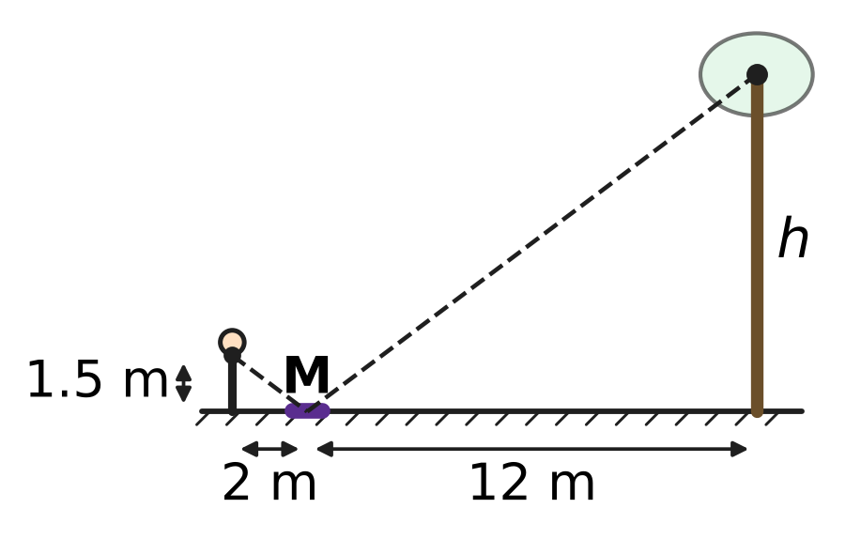
  (A) 16 m | (B) 10.5 m | (C) 9 m | (D) 18 m

Q17. In the figure, O is the centre of a circle of radius 6 cm. The line from P to O meets the circle at A, and PA = 4 cm. PT touches the circle at T. What is the length of PT? | 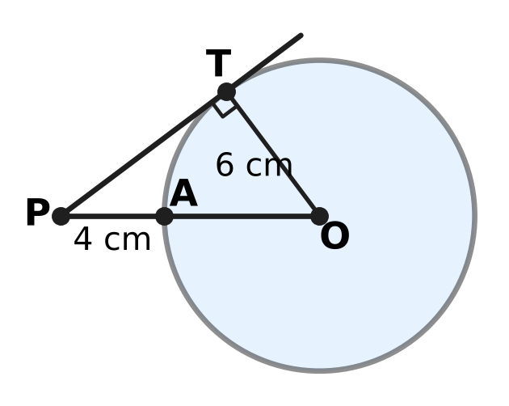
  (A) 8 cm | (B) 10 cm
  (C) $2\sqrt{13}$ cm | (D) 6 cm

Q18. The points A(1, 1), B(7, 1) and C(1, 9) are given. Which point is at the same distance from A, from B and from C?
(A) (4, 1) | (B) (5, 4) | (C) (1, 5) | (D) (4, 5)

Q19. Two circles with centres M and N have radii 9 cm and 4 cm, and they touch each other externally, as shown. A straight line touches the larger circle at A and the smaller circle at B. What is the length of AB? | 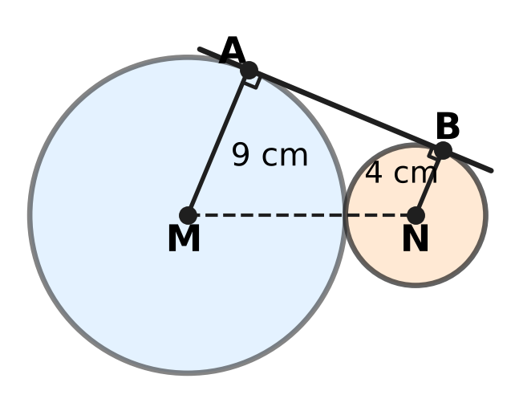
  (A) 5 cm | (B) 12 cm
  (C) 13 cm | (D) $\sqrt{194}$ cm

Part 5 — Mensuration (Syllabus Chapter 6)
Q20. A lawn sprinkler turns to and fro through a fixed angle and waters a sector of radius 21 m. The watered area is 462 m². Take π = 22/7. Through what angle does the sprinkler turn?
(A) 240° | (B) 30° | (C) 120° | (D) 60°

Q21. A ball fits exactly inside a closed cylindrical box: it touches the top, the bottom and the curved side, as shown. What fraction of the space inside the box is NOT filled by the ball? | 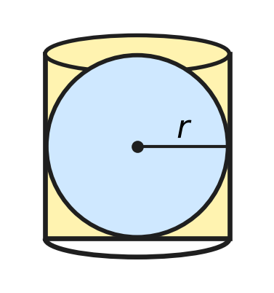
  (A) $\frac{2}{3}$ | (B) $\frac{1}{3}$ | (C) $\frac{1}{4}$ | (D) $\frac{1}{2}$

Q22. A cylindrical jar of radius 6 cm contains some water. Sixteen metal balls, each of radius 1.5 cm, are dropped into it, and the water still covers them all. By how much does the water level rise?
(A) 2 cm | (B) 0.5 cm | (C) 16 cm | (D) 1.5 cm

Q23. A bucket is a frustum of a cone with top radius 12 cm, bottom radius 8 cm and height 15 cm, as shown. Vihaan estimates its capacity as the volume of a cylinder of height 15 cm whose radius is the average of the two radii. By how much is his estimate less than the true capacity? | 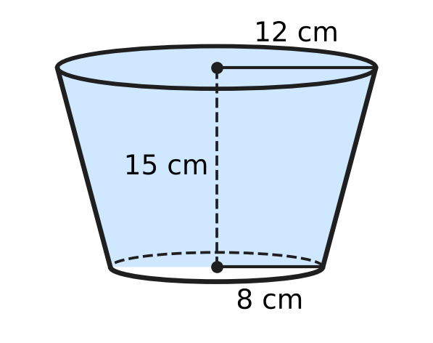
  (A) $40π$ cm³ | (B) $460π$ cm³
  (C) $80π$ cm³ | (D) $20π$ cm³

Q24. In the figure, ABC is a triangle with ∠C = 90°, CA = 6 cm and CB = 8 cm. Semicircles are drawn outwards on CA and on CB. A third semicircle, on AB, passes through C. What is the total area of the two shaded crescents? | 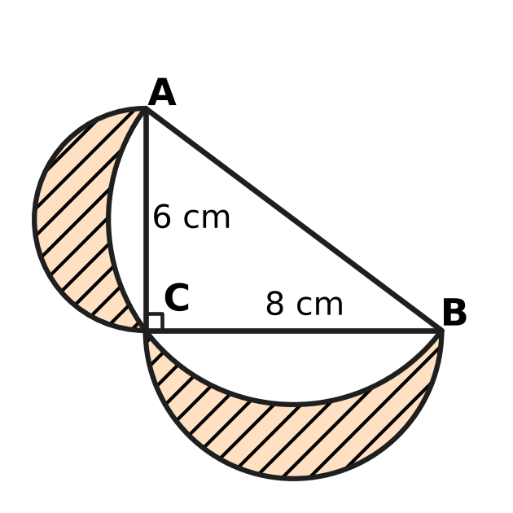
  (A) $\frac{25π}{2}$ cm² | (B) 24 cm²
  (C) 48 cm² | (D) $\frac{25π−48}{2}$ cm²

Part 6 — Trigonometry & Heights and Distances (Syllabus Chapter 7)
Q25. What is the value of $\frac{1−\tan^{2}{30}^{∘}}{1+\tan^{2}{30}^{∘}}$?
(A) $−\frac{1}{2}$ | (B) $\frac{3}{4}$ | (C) $\frac{1}{2}$ | (D) $\frac{2}{3}$

Q26. For every acute angle θ, tan θ + cot θ is equal to which of these?
(A) sec θ + cosec θ | (B) sin θ × cos θ
(C) 1 | (D) sec θ × cosec θ

Q27. Vinay stands at P on a jetty, 8 m above a still lake. A bird hovers above the lake. From P, the angle of elevation of the bird is 30° and the angle of depression of its reflection is 60°, as shown. The reflection is as far below the water as the bird is above it. How high above the water is the bird? | 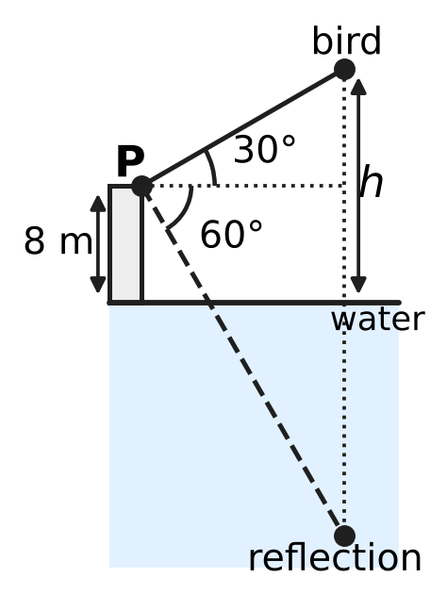
  (A) 16 m | (B) 12 m
  (C) $8\sqrt{3}$ m | (D) 24 m

Part 7 — Data Handling, Statistics & Probability (Syllabus Chapter 8)
Saplings in a plant nursery (none is shorter than 20 cm or taller than 70 cm)
Height of sapling | 20 cm or more | 30 cm or more | 40 cm or more | 50 cm or more | 60 cm or more
Number of saplings | 60 | 52 | 37 | 15 | 4

Q28. The table shows the heights of the 60 saplings in a plant nursery. How many saplings are at least 40 cm tall but less than 50 cm tall?
(A) 15 | (B) 37 | (C) 22 | (D) 33

Q29. An umbrella stand holds 4 black and 6 blue umbrellas, alike apart from colour. Tia takes one at random; it is black, and she keeps it. Then Noor takes one of the remaining umbrellas at random. What is the probability that Noor's umbrella is blue?
(A) $\frac{3}{5}$ | (B) $\frac{2}{3}$ | (C) $\frac{4}{15}$ | (D) $\frac{1}{3}$

Q30. A fair die is thrown twice. What is the probability that the second number is greater than the first?
(A) $\frac{5}{12}$ | (B) $\frac{7}{12}$ | (C) $\frac{1}{6}$ | (D) $\frac{1}{2}$

Part 8 — Applied Mathematics (Syllabus Chapter 9)
Q31. A bookshop sale offers "buy 3 books, get 1 more free" on books of the same price. Eshan takes 4 books and pays for 3. What is the effective discount on the 4 books?
(A) $33\frac{1}{3}$% | (B) 75% | (C) 20% | (D) 25%

Q32. Komal makes candles at home. Her fixed costs are ₹6,000 a month. Each candle costs ₹25 to make and sells for ₹40. How many candles must she sell in a month to make a profit of ₹3,000?
(A) 225 | (B) 400 | (C) 200 | (D) 600

Q33. In a school kitchen, 6 cooks make 240 sandwiches in 2 hours. All the cooks work at the same steady rate. How many sandwiches can 9 cooks make in 3 hours?
(A) 360 | (B) 540 | (C) 160 | (D) 1,080

Q34. A river ferry goes downstream from jetty X to jetty Y in 2 hours. With the same engine speed, it comes back upstream in 3 hours. How long would a raft, carried only by the current, take to drift from X to Y?
(A) 6 hours | (B) 2.5 hours
(C) 12 hours | (D) 5 hours

Q35. Ojas can paint a wall alone in 5 days, and Kriti can paint it alone in 10 days. They work on alternate days, with only one of them working each day, and Ojas works on the first day. In how many days is the wall painted?
(A) $6\frac{1}{2}$ days | (B) $3\frac{1}{3}$ days
(C) 7 days | (D) 6 days

Part 9 — Mathematical Reasoning & Problem-Solving (Syllabus Chapter 10)
Q36. There are 37 players in a badminton singles knockout. In each match two players play, the loser is out, and there are no draws. In some rounds a player may get a free pass to the next round. How many matches are played to find the champion?
(A) 36 | (B) 18 | (C) 666 | (D) 37

Q37. The figure is a grid of 5 × 3 small squares. How many squares of all sizes can be traced along its lines? | 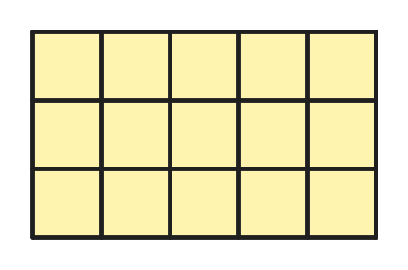
  (A) 23 | (B) 18 | (C) 26 | (D) 15

Q38. Rupa colours flags with 3 horizontal stripes, using crayons of 6 different colours. Each stripe is one colour, and stripes that touch must be different colours. How many different flags can she make?
(A) 180 | (B) 150 | (C) 120 | (D) 216

Q39. Some whole numbers are chosen from 1 to 20 so that no chosen number is double another chosen number. What is the greatest number of whole numbers that can be chosen?
(A) 10 | (B) 15 | (C) 13 | (D) 14

Q40. A box has 12 red, 15 green and 17 blue counters. In one move, you take out one counter of each of two different colours and put in two counters of the third colour. After some moves, all 44 counters are of one colour. What is that colour?
(A) red | (B) green
(C) blue | (D) it could be any of the three colours

SECTION II — Star Questions 5 questions × 4 marks each
Q41. A group buys 12 tickets for a zoo visit and pays ₹400 in all. A child ticket costs ₹20, a senior ticket ₹30 and an adult ticket ₹50. The group has at least one child, at least one senior and at least one adult. In how many different ways could the 12 tickets be made up of these three kinds? [4 marks]
(A) 6 | (B) 3 | (C) 1 | (D) 4

Q42. A large hoop of radius 1.5 m stands upright on level ground and touches the ground at T. K is the highest point of the hoop. From a point P on the ground, the angle of elevation of K is 60°. A straight rod rests with one end at P and touches the hoop at A, where A is a different point from T, as shown. How long is PA? [4 marks] | 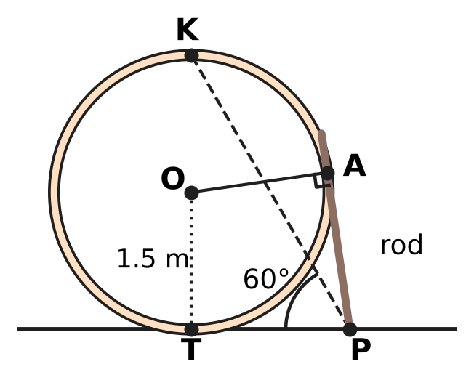
  (A) $3\sqrt{3}$ m | (B) $\frac{\sqrt{3}}{2}$ m
  (C) $2\sqrt{3}$ m | (D) $\sqrt{3}$ m

Q43. Jayesh has a flat wooden plank shaped like a right triangle whose two shorter sides are 60 cm and 80 cm. He cuts a rectangular shelf from it. Two sides of the shelf lie along the two shorter sides of the plank, and the fourth corner of the shelf lies on the longest side, as shown. What is the greatest possible area of the shelf? [4 marks] | 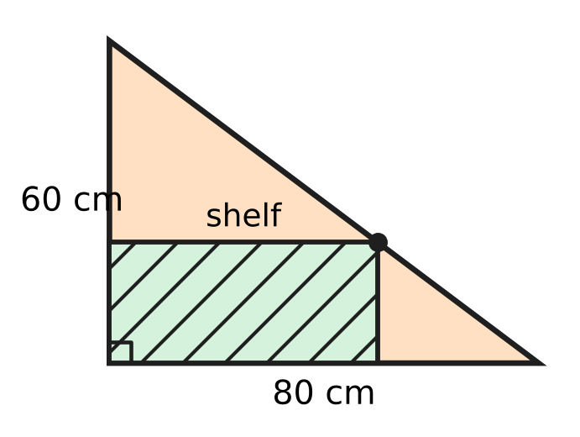
  (A) 1,200 cm² | (B) 4,800 cm²
  (C) 1,600 cm² | (D) 2,400 cm²

Q44. Trisha and Manu take a contract to lay a stone path. Trisha alone could finish it in 30 days and Manu alone in 20 days. Trisha starts alone and puts ₹30,000 into the job on the first day. After 10 days, Manu joins with ₹60,000, and they finish the path together. The profit of ₹51,000 is shared in the ratio of capital × number of days that capital was in the job. What is Manu's share? [4 marks]
(A) ₹34,000 | (B) ₹25,500 | (C) ₹24,000 | (D) ₹20,400

Q45. Imran has one solid metal ball of radius 8 cm. In each round, he melts every ball he has and recasts each one into 8 equal smaller balls, with no metal lost. After how many rounds is the total surface area of all his balls 16 times the surface area of the first ball? [4 marks]
(A) 4 | (B) 3 | (C) 8 | (D) 2

Answer Sheet AMO Level 1 · Class 10 · Practice Paper 4
Name: | School: | Roll No.:
Shade or tick one circle for each question.
1. Ⓐ Ⓑ Ⓒ Ⓓ | 16. Ⓐ Ⓑ Ⓒ Ⓓ | 31. Ⓐ Ⓑ Ⓒ Ⓓ
2. Ⓐ Ⓑ Ⓒ Ⓓ | 17. Ⓐ Ⓑ Ⓒ Ⓓ | 32. Ⓐ Ⓑ Ⓒ Ⓓ
3. Ⓐ Ⓑ Ⓒ Ⓓ | 18. Ⓐ Ⓑ Ⓒ Ⓓ | 33. Ⓐ Ⓑ Ⓒ Ⓓ
4. Ⓐ Ⓑ Ⓒ Ⓓ | 19. Ⓐ Ⓑ Ⓒ Ⓓ | 34. Ⓐ Ⓑ Ⓒ Ⓓ
5. Ⓐ Ⓑ Ⓒ Ⓓ | 20. Ⓐ Ⓑ Ⓒ Ⓓ | 35. Ⓐ Ⓑ Ⓒ Ⓓ
6. Ⓐ Ⓑ Ⓒ Ⓓ | 21. Ⓐ Ⓑ Ⓒ Ⓓ | 36. Ⓐ Ⓑ Ⓒ Ⓓ
7. Ⓐ Ⓑ Ⓒ Ⓓ | 22. Ⓐ Ⓑ Ⓒ Ⓓ | 37. Ⓐ Ⓑ Ⓒ Ⓓ
8. Ⓐ Ⓑ Ⓒ Ⓓ | 23. Ⓐ Ⓑ Ⓒ Ⓓ | 38. Ⓐ Ⓑ Ⓒ Ⓓ
9. Ⓐ Ⓑ Ⓒ Ⓓ | 24. Ⓐ Ⓑ Ⓒ Ⓓ | 39. Ⓐ Ⓑ Ⓒ Ⓓ
10. Ⓐ Ⓑ Ⓒ Ⓓ | 25. Ⓐ Ⓑ Ⓒ Ⓓ | 40. Ⓐ Ⓑ Ⓒ Ⓓ
11. Ⓐ Ⓑ Ⓒ Ⓓ | 26. Ⓐ Ⓑ Ⓒ Ⓓ | 41. Ⓐ Ⓑ Ⓒ Ⓓ
12. Ⓐ Ⓑ Ⓒ Ⓓ | 27. Ⓐ Ⓑ Ⓒ Ⓓ | 42. Ⓐ Ⓑ Ⓒ Ⓓ
13. Ⓐ Ⓑ Ⓒ Ⓓ | 28. Ⓐ Ⓑ Ⓒ Ⓓ | 43. Ⓐ Ⓑ Ⓒ Ⓓ
14. Ⓐ Ⓑ Ⓒ Ⓓ | 29. Ⓐ Ⓑ Ⓒ Ⓓ | 44. Ⓐ Ⓑ Ⓒ Ⓓ
15. Ⓐ Ⓑ Ⓒ Ⓓ | 30. Ⓐ Ⓑ Ⓒ Ⓓ | 45. Ⓐ Ⓑ Ⓒ Ⓓ
Q41–Q45 are Section II Star Questions (4 marks each).
For the parent or teacher
Section I correct: ______ / 40 × 2 = ______ marks Section II correct: ______ / 5 × 4 = ______ marks
Correct: ______ / 45 Score: ______ / 100
Answer Key and Solutions AMO Level 1 · Class 10 · Practice Paper 4
Quick answers
1 D | 6 B | 11 D | 16 C | 21 B | 26 D | 31 D | 36 A | 41 B
2 B | 7 A | 12 C | 17 A | 22 A | 27 A | 32 D | 37 C | 42 D
3 A | 8 B | 13 D | 18 D | 23 D | 28 C | 33 B | 38 B | 43 A
4 C | 9 A | 14 A | 19 B | 24 B | 29 B | 34 C | 39 D | 44 C
5 D | 10 C | 15 B | 20 C | 25 C | 30 A | 35 A | 40 C | 45 A
Solutions
Q | Part · level | Answer | Why?
1 | Part 1 · Ch1 · Easy | (D) 91 | Next step: 455 = 5 × 91 + 0. The remainder is 0, so the HCF is the last divisor, 91.
2 | Part 1 · Ch1 · Easy | (B) 6 | n³ − n = (n − 1) × n × (n + 1) is a product of three consecutive numbers, so it always has a factor 2 and a factor 3. For n = 2 it is exactly 6.
3 | Part 1 · Ch1 · Medium | (A) 2 | Write the numbers as 18m and 18n with m + n = 12 and HCF(m, n) = 1. Only 1 + 11 and 5 + 7 work, giving 18, 198 and 90, 126: two pairs.
4 | Part 2 · Ch3 · Easy | (C) 6 months | The rate is 3% per quarter. Then 40,000 × 1.03 = 41,200 and 41,200 × 1.03 = 42,436, so it takes 2 quarters, which is 6 months.
5 | Part 2 · Ch3 · Easy | (D) ₹27,500 | The rest is 56,000 − 12,000 = 44,000. The capitals are in the ratio 3 : 5, so Omar gets 5/8 of 44,000 = ₹27,500.
6 | Part 2 · Ch3 · Easy | (B) ₹12,000 | Capital × months: 480,000 : 360,000 : 120,000 = 4 : 3 : 1. Ayaan gets 3/8 of 32,000 = ₹12,000.
7 | Part 2 · Ch3 · Medium | (A) 2 : 1 | Each capital is in proportion to share ÷ time: 5/10 : 3/12 = 1/2 : 1/4 = 2 : 1.
8 | Part 2 · Ch3 · Medium | (B) ₹42,640 | The rate is 4% per half-year. After 6 months: 25,000 × 1.04 = 26,000, plus 15,000 gives 41,000. At the end of the year: 41,000 × 1.04 = ₹42,640.
9 | Part 3 · Ch4 · Easy | (A) 4 | If the zeroes are α and 1/α, their product is 1. The product is 6 ÷ (k + 2), so k + 2 = 6 and k = 4.
10 | Part 3 · Ch4 · Easy | (C) 8 | Let there be s boxes and l trays: s + l = 20 and 6s + 30l = 312. Taking 6 × 20 = 120 away leaves 24l = 192, so l = 8.
11 | Part 3 · Ch4 · Easy | (D) the 8th hour | The amounts form an AP: aₙ = 300 − 20(n − 1). Setting 300 − 20(n − 1) = 160 gives n − 1 = 7, so n = 8.
12 | Part 3 · Ch4 · Medium | (C) 5 | Put y = x²: y² − 13y + 36 = 0 gives y = 4 or 9. So x = ±2 or ±3, and the positive roots add up to 2 + 3 = 5.
13 | Part 3 · Ch4 · Medium | (D) 39 | Let the zeroes be a − d, a, a + d. Their sum is 3a = 12, so a = 4. Product: 4(16 − d²) = 28 gives d = 3, so the zeroes are 1, 4, 7 and k = 1 × 4 + 4 × 7 + 1 × 7 = 39.
14 | Part 3 · Ch4 · Medium | (A) 2 | Each of the next 10 terms is 10d more than the matching earlier term, so 100d = 455 − 155 = 300 and d = 3. Then 5(2a + 27) = 155, so 2a = 4 and a = 2.
15 | Part 4 · Ch5 · Easy | (B) (3, 5) | The diagonals of a parallelogram bisect each other, so the midpoint of BD is the midpoint of AC, (3.5, 4). Then D = (7 − 4, 8 − 3) = (3, 5).
16 | Part 4 · Ch5 · Easy | (C) 9 m | The two right triangles have equal angles at the mirror, so they are similar: h ÷ 12 = 1.5 ÷ 2, giving h = 9 m.
17 | Part 4 · Ch5 · Easy | (A) 8 cm | OP = 4 + 6 = 10 cm. The radius OT is perpendicular to the tangent, so PT² = 10² − 6² = 64 and PT = 8 cm.
18 | Part 4 · Ch5 · Medium | (D) (4, 5) | AB is horizontal and AC is vertical, so ∠A = 90° and BC = 10 is the longest side. The midpoint of BC, (4, 5), is 5 units from each of A, B and C.
19 | Part 4 · Ch5 · Medium | (B) 12 cm | MN = 9 + 4 = 13 cm. MA and NB are both perpendicular to AB, so AB² = 13² − (9 − 4)² = 144 and AB = 12 cm.
20 | Part 5 · Ch6 · Easy | (C) 120° | The whole circle has area 22/7 × 21 × 21 = 1,386 m². The area 462 m² is one-third of this, so the angle is 360° ÷ 3 = 120°.
21 | Part 5 · Ch6 · Easy | (B) $\frac{1}{3}$ | With radius r, the box has height 2r and volume πr² × 2r = 2πr³. The ball has volume (4/3)πr³, which is 2/3 of it, so 1/3 is empty.
22 | Part 5 · Ch6 · Easy | (A) 2 cm | The balls push up a volume of 16 × (4/3)π × 1.5³ = 72π cm³. The jar has base area 36π cm², so the level rises 72π ÷ 36π = 2 cm.
23 | Part 5 · Ch6 · Medium | (D) $20π$ cm³ | True capacity: (1/3)π × 15 × (144 + 96 + 64) = 1,520π cm³. Estimate: π × 10² × 15 = 1,500π cm³. The estimate is 20π cm³ less.
24 | Part 5 · Ch6 · Medium | (B) 24 cm² | Small semicircles: (π/2)(3² + 4²) = 25π/2. By Pythagoras AB = 10 cm, so the semicircle on AB is (π/2)(5²) = 25π/2. Crescents = 25π/2 + 24 − 25π/2 = 24 cm², the area of the triangle.
25 | Part 6 · Ch7 · Easy | (C) $\frac{1}{2}$ | tan²30° = 1/3. So the value is (1 − 1/3) ÷ (1 + 1/3) = (2/3) ÷ (4/3) = 1/2.
26 | Part 6 · Ch7 · Easy | (D) sec θ × cosec θ | tan θ + cot θ = sin θ/cos θ + cos θ/sin θ = (sin²θ + cos²θ)/(sin θ cos θ) = 1/(sin θ cos θ) = sec θ cosec θ.
27 | Part 6 · Ch7 · Medium | (A) 16 m | Let the horizontal distance be d. Then h − 8 = d tan 30° and h + 8 = d tan 60°, so h + 8 = 3(h − 8), which gives h = 16 m.
28 | Part 7 · Ch8 · Easy | (C) 22 | Saplings of 40 cm or more: 37. Saplings of 50 cm or more: 15. So 37 − 15 = 22 are at least 40 cm but less than 50 cm.
29 | Part 7 · Ch8 · Easy | (B) $\frac{2}{3}$ | After Tia keeps a black one, 3 black and 6 blue are left. The probability of blue is 6/9 = 2/3.
30 | Part 7 · Ch8 · Medium | (A) $\frac{5}{12}$ | Of the 36 equally likely outcomes, 6 have equal numbers. The other 30 split evenly, so 15 have the second number greater: 15/36 = 5/12.
31 | Part 8 · Ch9 · Easy | (D) 25% | He gets 4 books for the price of 3, so he saves 1 book's price out of 4: 1/4 = 25%.
32 | Part 8 · Ch9 · Easy | (D) 600 | Each candle adds 40 − 25 = ₹15. To cover ₹6,000 and earn ₹3,000 she needs 9,000 ÷ 15 = 600 candles.
33 | Part 8 · Ch9 · Easy | (B) 540 | One cook makes 240 ÷ (6 × 2) = 20 sandwiches an hour. So 9 cooks make 9 × 3 × 20 = 540 in 3 hours.
34 | Part 8 · Ch9 · Medium | (C) 12 hours | Let XY = d. Downstream speed d/2, upstream speed d/3. Stream speed = (d/2 − d/3) ÷ 2 = d/12, so the raft takes 12 hours.
35 | Part 8 · Ch9 · Medium | (A) $6\frac{1}{2}$ days | Each pair of days paints 1/5 + 1/10 = 3/10. After 6 days 9/10 is done; on day 7 Ojas needs (1/10) ÷ (1/5) = half a day. Total 6½ days.
36 | Part 9 · Ch10 · Easy | (A) 36 | Each match puts exactly one player out. To leave one champion, 36 players must be put out, so 36 matches are played.
37 | Part 9 · Ch10 · Easy | (C) 26 | Squares of size 1 × 1: 5 × 3 = 15. Size 2 × 2: 4 × 2 = 8. Size 3 × 3: 3 × 1 = 3. Total 15 + 8 + 3 = 26.
38 | Part 9 · Ch10 · Easy | (B) 150 | The top stripe has 6 choices, the middle 5 (unlike the top), and the bottom 5 (unlike the middle): 6 × 5 × 5 = 150.
39 | Part 9 · Ch10 · Medium | (D) 14 | Split 1–20 into chains 1, 2, 4, 8, 16; 3, 6, 12; 5, 10, 20; 7, 14; 9, 18; and the single odd numbers 11–19. At most 3, 2, 2, 1, 1 and 5 can be taken from them: 14 in all, for example the odd numbers with 4, 12, 16, 20.
40 | Part 9 · Ch10 · Medium | (C) blue | Each move changes the difference of any two counts by 0 or 3. Red − green = −3 is a multiple of 3, so red and green can both reach 0 together; green − blue = −2 and red − blue = −5 are not, so all blue is the only possibility.
41 | Section II · Ch4 + Ch10 · Hard | (B) 3 | With c, s, a tickets: c + s + a = 12 and 2c + 3s + 5a = 40. Subtracting twice the first gives s + 3a = 16, so s = 16 − 3a and c = 2a − 4. With each at least 1, a = 3, 4 or 5: three ways.
42 | Section II · Ch5 + Ch7 · Hard | (D) $\sqrt{3}$ m | OT is perpendicular to the ground, so T, O and K lie on one vertical line and TK = 3 m. Then PT = 3 ÷ tan 60° = √3 m. PT and PA are both tangents from P, so PA = PT = √3 m.
43 | Section II · Ch4 + Ch5 · Hard | (A) 1,200 cm² | If the shelf is x cm along the 80 cm side, similar triangles give its height as 60 − 3x/4. Area = 60x − 3x²/4 = 1,200 − (3/4)(x − 40)², greatest when x = 40: 40 × 30 = 1,200 cm².
44 | Section II · Ch3 + Ch9 · Hard | (C) ₹24,000 | Trisha does 10/30 = 1/3 alone. Together they do 1/30 + 1/20 = 1/12 a day, so the other 2/3 takes 8 days; the job lasts 18 days. Capital × days: 30,000 × 18 : 60,000 × 8 = 9 : 8, so Manu gets 8/17 of 51,000 = ₹24,000.
45 | Section II · Ch6 + Ch10 · Hard | (A) 4 | One ball of radius r gives 8 balls of radius r/2 (same volume). Each has 1/4 of the surface area, so the total is 8 × 1/4 = 2 times as much. After n rounds the total is 2ⁿ times, and 2⁴ = 16: 4 rounds.

