UNLOCK IQ INSTITUTE
Realize Your True Potential
Aryabhatta Maths Olympiad (AMO)
Level 1 — Practice Paper 5
CLASS 10

Questions | 45 multiple-choice questions
Marks | 100
Time | 60 minutes
Section I | 40 questions × 2 marks = 80 marks
Section II | 5 Star Questions × 4 marks = 20 marks
Negative marking | No negative marking
Calculator | Not allowed
Chapters | Number System · Fractions, Decimals & Percentages · Algebra · Geometry · Mensuration · Trigonometry · Data Handling · Applied Mathematics · Mathematical Reasoning

Instructions to candidates
• This paper has 45 multiple-choice questions. Each question has four answer choices, of which exactly one is correct.
• Section I (Q1–Q40) carries 2 marks per question. Section II (Q41–Q45) carries 4 marks per question.
• There is no negative marking. Unanswered questions score zero.
• Calculators are not permitted. Rough work may be done on a separate sheet.
• Mark your answers on the answer sheet at the end of the paper.
• All figures are not necessarily drawn to scale unless stated.

For parents and teachers
Print or view this paper in colour. Pictures are part of the questions.
Parts follow the AMO syllabus chapters. Chapter 2 is not part of the Class 10 syllabus, so the chapter numbers shown in the Part headings have gaps.
The answer sheet and the answer key are at the end. Remove only the answer key before the student begins.

Name: | School: | Roll No.:

SECTION I 40 questions × 2 marks each
Part 1 — Number System (Syllabus Chapter 1)
Q1. I am a two-digit number. My HCF with 70 is 14, and my LCM with 70 is 420. Who am I?
(A) 42 | (B) 60 | (C) 30 | (D) 84

Q2. Written as a decimal, $\frac{7}{2^{a}×5^{2}}$ (where a is a whole number) stops after exactly 5 digits past the decimal point. Find a.
(A) 3 | (B) 10 | (C) 5 | (D) 7

Q3. How many factors of 360 are multiples of 6?
(A) 12 | (B) 6 | (C) 24 | (D) 10

Part 2 — Fractions, Decimals & Percentages (Syllabus Chapter 3)
Q4. Lata, Tarun and Usha start a flower shop that makes bouquets. The money they put in is in the ratio $\frac{1}{2}:\frac{1}{3}:\frac{1}{5}$, and it stays in the shop for the whole year. The year's profit of ₹62,000 is shared in the ratio of the money put in. What is Usha's share?
(A) ₹12,400 | (B) ₹31,000 | (C) ₹12,000 | (D) ₹20,000

Q5. Ana and Kian run an ice-cream stall for a whole year. The profit is shared in the ratio of their capitals. The year's profit is ₹36,000, and Ana's share is ₹20,000. Ana put in ₹50,000. How much did Kian put in?
(A) ₹16,000 | (B) ₹40,000 | (C) ₹90,000 | (D) ₹62,500

Q6. Dhruv's deposit of ₹20,000 earns 5% in the first year. In the second year it earns interest at a different rate, on the amount at the end of the first year. After two years the amount is ₹23,520. What was the rate in the second year?
(A) 12.6% | (B) 5% | (C) 17.6% | (D) 12%

Q7. Myra splits ₹22,000 into two deposits, both at 20% per year, compounded annually. She takes one deposit out after 1 year and the other after 2 years, and both give her the same amount. How much did she put in the 2-year deposit?
(A) ₹10,000 | (B) ₹14,400 | (C) ₹12,000 | (D) ₹11,000

Q8. Hana puts ₹60,000 into a workshop that makes fishing nets. After 3 months, Ivan joins with ₹40,000. After 8 months from the start, Hana takes out ₹20,000. The year's profit is ₹50,000, shared in the ratio of capital × time. What is Ivan's share?
(A) ₹32,000 | (B) ₹20,000 | (C) ₹18,000 | (D) ₹25,000

Part 3 — Algebra (Syllabus Chapter 4)
Q9. For the school play, 3 front-row tickets and 5 back-row tickets cost ₹550 in all. Also, 5 front-row tickets and 3 back-row tickets cost ₹650 in all. What is the price of one front-row ticket?
(A) ₹50 | (B) ₹150 | (C) ₹75 | (D) ₹100

Q10. The terms of an arithmetic progression start at 4 and end at 64, and together they add up to 340. How many terms are there?
(A) 10 | (B) 20 | (C) 11 | (D) 5

Q11. What are the roots of the equation (x − 2)(x + 5) = 18?
(A) 7 and −4 | (B) 4 and −7
(C) 2 and −5 | (D) 20 and 13

Q12. What must be subtracted from $x^{3}+3x^{2}−5x+2$ so that the result is exactly divisible by $x^{2}+2x−3$?
(A) $−4x+5$ | (B) $−4x−1$ | (C) $4x−5$ | (D) $x+1$

Q13. The number $3+\sqrt{2}$ is a zero of the polynomial $x^{2}−6x+c$, where c is a number. What is the value of c?
(A) −7 | (B) 7 | (C) 9 | (D) 11

Q14. The fourth term of an arithmetic progression is 11. Whatever the common difference is, the first seven terms always add up to the same total. What is that total?
(A) 88 | (B) 44 | (C) 38.5 | (D) 77

Part 4 — Geometry (Syllabus Chapter 5)
Q15. In the figure, a playground ladder AB stands upright on level ground and a straight slide AC runs from its top to the ground. AB = 2.4 m and BC = 3.2 m. A bar DE, parallel to the ground, joins the ladder to the slide 0.9 m above the ground. How long is the bar DE? | 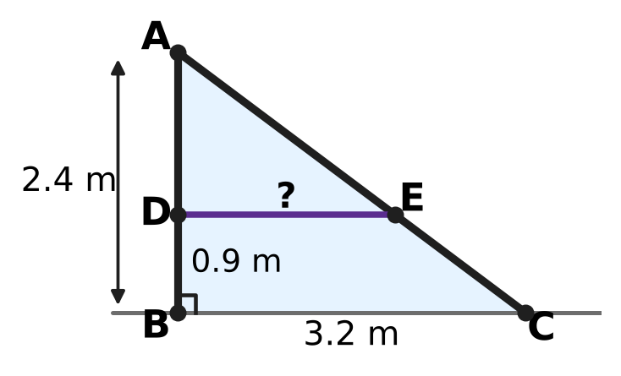
  (A) 1.2 m | (B) 1.5 m | (C) 2 m | (D) 1.6 m

Q16. The points A(−3, 1) and C(1, 7) are opposite corners of a square ABCD. What is the area of the square?
(A) 26 square units | (B) 13 square units
(C) 104 square units | (D) 52 square units

Q17. In the figure, each side of quadrilateral PQRS touches the circle. The perimeter of PQRS is 50 cm and PQ = 11 cm. What is the length of RS? | 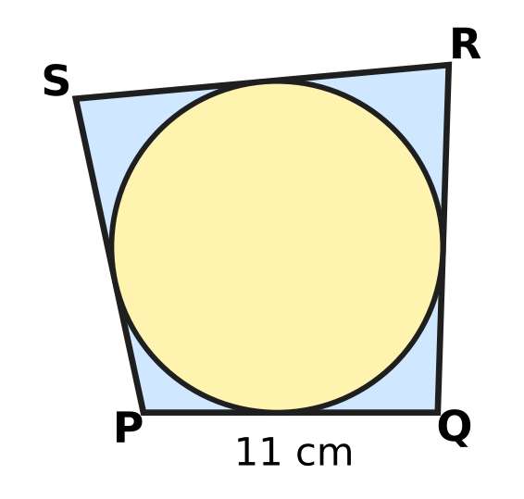
  (A) 13 cm | (B) 39 cm | (C) 28 cm | (D) 14 cm

Q18. Start at A(−2, 1) and move exactly 5 units along the straight line towards B(10, 10). At which point do you stop?
(A) (4, 5.5) | (B) (6, 7) | (C) (2, 4) | (D) (3, 6)

Q19. In the figure, AB is a diameter of a circle with centre O. The tangents at A and B meet the tangent at C at the points P and Q. AP = 3 cm and BQ = 12 cm. What is the radius of the circle? | 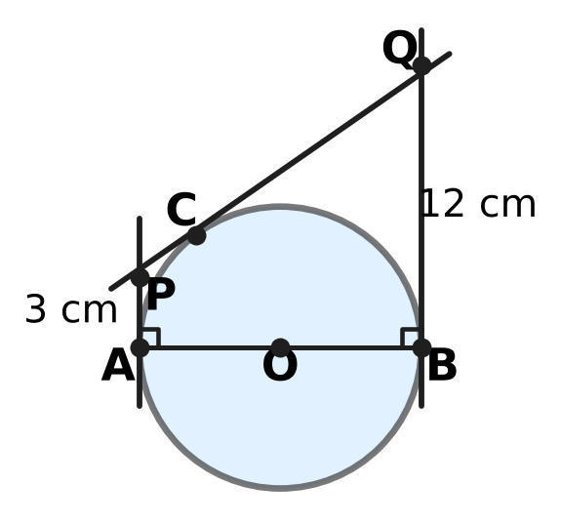
  (A) 7.5 cm | (B) 6 cm | (C) 12 cm | (D) 9 cm

Part 5 — Mensuration (Syllabus Chapter 6)
Q20. An open paper fan has the shape of a sector of a circle of radius 35 cm with an angle of 72°, as shown. What is the length of the boundary of the sector? (Use π = 22/7.) | 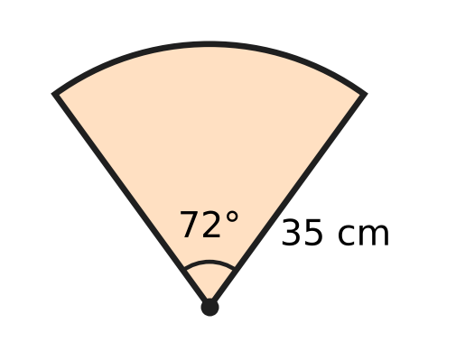
  (A) 44 cm | (B) 158 cm | (C) 114 cm | (D) 79 cm

Q21. A frustum-shaped flower vase has a top radius of 6 cm and a base radius of 3 cm, as shown. It takes exactly 660 cm³ of water to fill it. Find its height h. (Use π = 22/7.) | 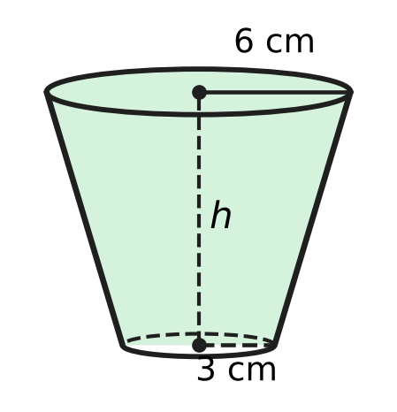
  (A) 2.5 cm | (B) 14 cm | (C) 17.5 cm | (D) 10 cm

Q22. A wiper arm turns about O through 120°. Its rubber blade is 21 cm long and starts 7 cm from O, so it cleans the shaded region shown. What is the area of the shaded region? (Use π = 22/7.) | 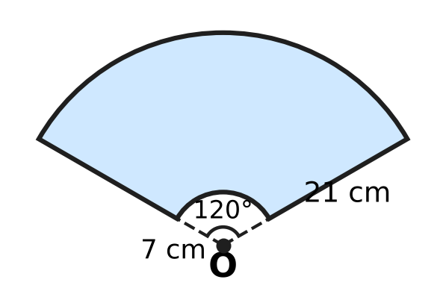
  (A) 770 cm² | (B) 385 cm²
  (C) 2,310 cm² | (D) 462 cm²

Q23. A cylindrical well 6 m wide (diameter) is dug 6 m deep. All the earth taken out is spread evenly around the well to form an embankment in the shape of a ring 3 m wide, as shown in the cross-section. How high is the embankment? | 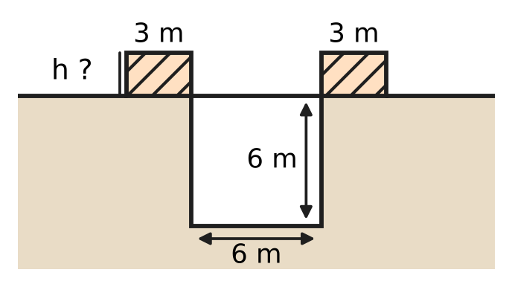
  (A) 8 m | (B) 2 m | (C) 1.5 m | (D) 6 m

Q24. The cloth of a hot-air balloon is a hemisphere of radius 10.5 m on top of a frustum of a cone. The frustum has radii 10.5 m and 3.5 m and height 24 m, as shown, and it is open at the bottom. What is the area of the cloth? (Use π = 22/7.) | 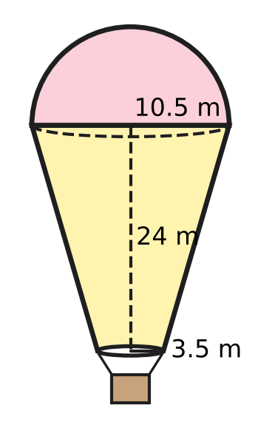
  (A) 1,793 m² | (B) 1,749 m² | (C) 2,486 m² | (D) 1,100 m²

Part 6 — Trigonometry & Heights and Distances (Syllabus Chapter 7)
Q25. Write $\frac{sinθ}{1+cosθ}+\frac{sinθ}{1−cosθ}$, where θ is acute, as a single term. What do you get?
(A) 2 sec θ | (B) 2 cosec θ
(C) 2 sin θ | (D) 2

Q26. The angle θ is acute, so 0° < θ < 90°. Which of these could be the value of sec θ?
(A) $\frac{\sqrt{3}}{2}$ | (B) 1
(C) $\frac{1}{2}$ | (D) $\frac{2}{\sqrt{3}}$

Q27. Isha stands at O on level ground near an airport. An aeroplane flies in a straight line at a fixed height of $600\sqrt{3}$ m, away from her. Its angle of elevation is 60° at A and 30° at B, ten seconds later, as shown. How far does the aeroplane fly from A to B? | 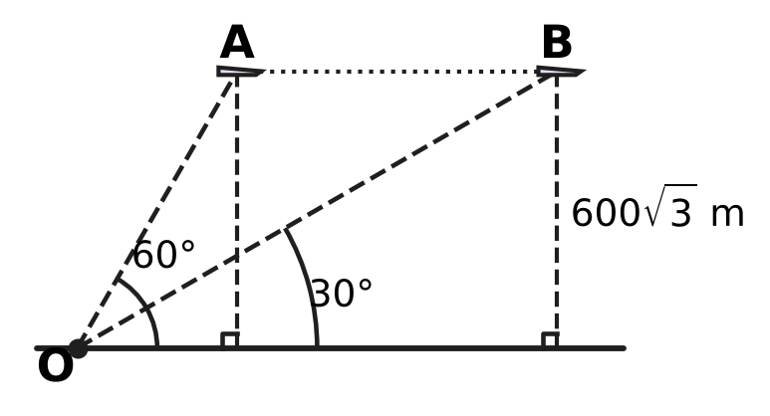
  (A) $1,200\sqrt{3}$ m | (B) 1,800 m
  (C) 1,200 m | (D) 600 m

Part 7 — Data Handling, Statistics & Probability (Syllabus Chapter 8)
Q28. The less-than ogive shows the marks of 60 students in a test. The thin grid lines are every 2 students up. How many students scored at least 20 marks but less than 40 marks? | 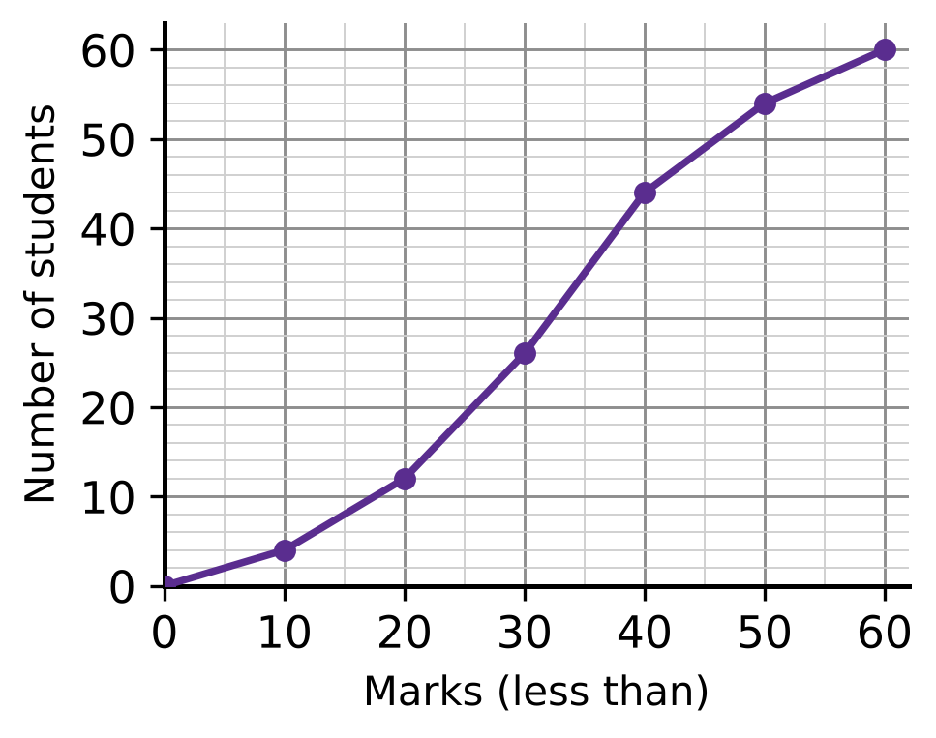
  (A) 14 | (B) 32 | (C) 44 | (D) 18

Q29. In the rainy season in a town, the probability that it rains on any given day is $\frac{2}{5}$, whatever happens on other days. What is the probability that it rains on exactly one of two given days?
(A) $\frac{6}{25}$ | (B) $\frac{4}{25}$ | (C) $\frac{16}{25}$ | (D) $\frac{12}{25}$

Q30. Six cards are numbered 1 to 6. One card is drawn at random and kept aside. Then a second card is drawn at random from the other five. What is the probability that the sum of the two numbers is even?
(A) $\frac{2}{5}$ | (B) $\frac{3}{5}$ | (C) $\frac{1}{2}$ | (D) $\frac{1}{5}$

Part 8 — Applied Mathematics (Syllabus Chapter 9)
Q31. A car park charges ₹40 for each hour, or ₹250 for a day pass. Parth parks for a whole number of hours. What is the least number of hours for which the day pass costs less than paying by the hour?
(A) 8 hours | (B) 5 hours | (C) 7 hours | (D) 6 hours

Q32. A keyboard for Urvi's music class is marked ₹2,500. The shop gives 20% off and then a further discount on the reduced price. Urvi pays ₹1,700. What is the second discount?
(A) 32% | (B) 15% | (C) 20% | (D) 12%

Q33. A team of 25 gardeners can plant all the saplings in a park in 12 days. How many days would 20 gardeners take, all working at the same rate?
(A) 17 days | (B) 9.6 days | (C) 12 days | (D) 15 days

Q34. Heena, a furniture dealer, buys a table for ₹8,000 plus GST at 18%. She sells it for ₹10,000 plus GST at 18%. She may subtract the GST she paid from the GST she collected. How much GST must she pay to the government on this table?
(A) ₹360 | (B) ₹3,240 | (C) ₹1,440 | (D) ₹1,800

Q35. Nakul's motorboat moves at 15 km/h in still water. On a river, a 20 km trip against the current takes 1 hour longer than the same 20 km trip with the current. What is the speed of the current?
(A) 20 km/h | (B) 4 km/h | (C) 5 km/h | (D) 10 km/h

Part 9 — Mathematical Reasoning & Problem-Solving (Syllabus Chapter 10)
Q36. Deepa and Jatin get into an empty lift on the ground floor of a building. Each of them gets out at one of the floors 1 to 6, and they get out at different floors. In how many different ways can this happen?
(A) 36 | (B) 11 | (C) 15 | (D) 30

Q37. A counter starts on square S of the board shown. In each move it goes to a square that shares a side with the square it is on. After exactly 9 moves, on which of the lettered squares could the counter be? | 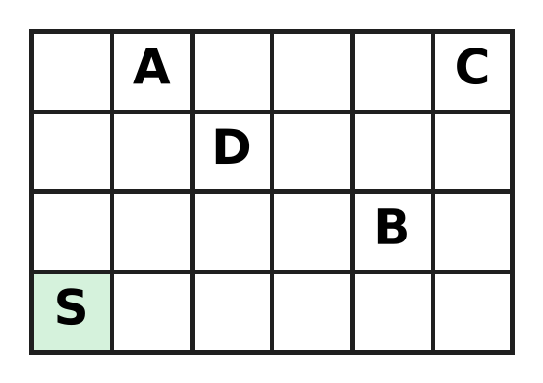
  (A) square A | (B) square B | (C) square C | (D) square D

Q38. How many three-digit numbers have digits that add up to 3?
(A) 5 | (B) 6 | (C) 3 | (D) 10

Q39. A suitcase lock can be set to any 3-digit code from 000 to 999. How many of these codes have at least one digit 7?
(A) 300 | (B) 729 | (C) 271 | (D) 243

Q40. A floor is covered with 5 rows of 5 square tiles. Some tiles are painted so that no two painted tiles share a side. What is the greatest number of tiles that can be painted?
(A) 13 | (B) 15 | (C) 12 | (D) 10

SECTION II — Star Questions 5 questions × 4 marks each
Q41. Each student in a class writes one quadratic equation $x^{2}−bx+c=0$, where b and c are whole numbers and c is at most 12. Both roots of each equation are positive whole numbers; the two roots may be equal. What is the least number of students in the class that makes sure that two of them write the same equation? [4 marks]
(A) 19 | (B) 13 | (C) 36 | (D) 20

Q42. On a ground plan with axes marked in metres, a vertical tower stands at the point T(2, −1). From the point P(8, 7) on the level ground, the angle of elevation of the top of the tower is 60°. From which of these points on the ground is the angle of elevation of the top 30°? [4 marks]
(A) (−6, 5) | (B) (18, 11) | (C) (20, 23) | (D) (20, 11)

Q43. In the figure, the incircle of right-angled △ABC (∠C = 90°) touches the longest side AB at T, splitting it into AT = 14 cm and TB = 15 cm. How long is the radius r of the incircle? [4 marks] | 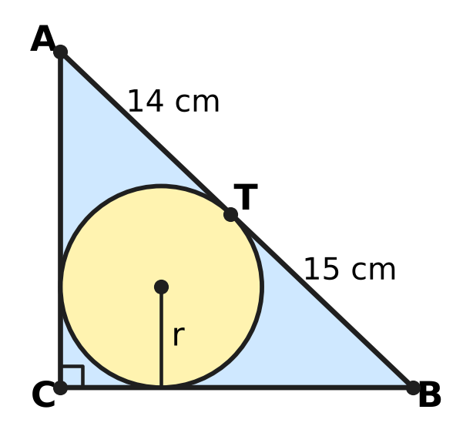
  (A) 14.5 cm | (B) 6 cm | (C) 12 cm | (D) 35 cm

Q44. Rani and Yash run a tea stall for a whole year. Rani puts in ₹80,000 and Yash puts in ₹120,000. The year's sales are ₹295,000, and this amount includes GST at 18%, which is all paid to the government. The other costs for the year, without GST, are ₹190,000. From the profit, each partner is first paid 10% of the money he or she put in. The rest of the profit is shared equally. How much does Yash get in all? [4 marks]
(A) ₹32,000 | (B) ₹36,000 | (C) ₹54,500 | (D) ₹20,000

Q45. At a science exhibition, Zubin has a cylinder of radius 3.5 cm and height 16 cm, and a cone of radius 10.5 cm and height 12 cm held point down, as shown. In one move he may fill a vessel to the brim from a tap, empty a vessel, or pour from one vessel into the other until the first is empty or the second is full. Which amount of water can he NOT end up with in the cone? (Use π = 22/7.) [4 marks] | 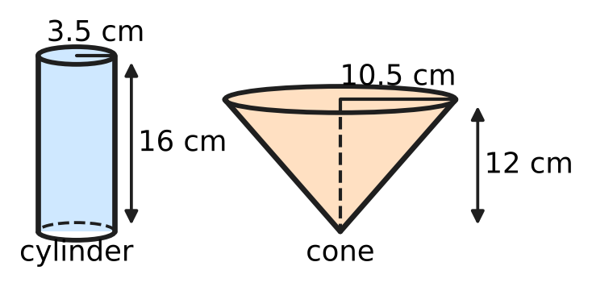
  (A) 1,232 cm³ | (B) 462 cm³
  (C) 770 cm³ | (D) 693 cm³
Answer Sheet AMO Level 1 · Class 10 · Practice Paper 5
Name: | School: | Roll No.:
Shade or tick one circle for each question.
1. Ⓐ Ⓑ Ⓒ Ⓓ | 16. Ⓐ Ⓑ Ⓒ Ⓓ | 31. Ⓐ Ⓑ Ⓒ Ⓓ
2. Ⓐ Ⓑ Ⓒ Ⓓ | 17. Ⓐ Ⓑ Ⓒ Ⓓ | 32. Ⓐ Ⓑ Ⓒ Ⓓ
3. Ⓐ Ⓑ Ⓒ Ⓓ | 18. Ⓐ Ⓑ Ⓒ Ⓓ | 33. Ⓐ Ⓑ Ⓒ Ⓓ
4. Ⓐ Ⓑ Ⓒ Ⓓ | 19. Ⓐ Ⓑ Ⓒ Ⓓ | 34. Ⓐ Ⓑ Ⓒ Ⓓ
5. Ⓐ Ⓑ Ⓒ Ⓓ | 20. Ⓐ Ⓑ Ⓒ Ⓓ | 35. Ⓐ Ⓑ Ⓒ Ⓓ
6. Ⓐ Ⓑ Ⓒ Ⓓ | 21. Ⓐ Ⓑ Ⓒ Ⓓ | 36. Ⓐ Ⓑ Ⓒ Ⓓ
7. Ⓐ Ⓑ Ⓒ Ⓓ | 22. Ⓐ Ⓑ Ⓒ Ⓓ | 37. Ⓐ Ⓑ Ⓒ Ⓓ
8. Ⓐ Ⓑ Ⓒ Ⓓ | 23. Ⓐ Ⓑ Ⓒ Ⓓ | 38. Ⓐ Ⓑ Ⓒ Ⓓ
9. Ⓐ Ⓑ Ⓒ Ⓓ | 24. Ⓐ Ⓑ Ⓒ Ⓓ | 39. Ⓐ Ⓑ Ⓒ Ⓓ
10. Ⓐ Ⓑ Ⓒ Ⓓ | 25. Ⓐ Ⓑ Ⓒ Ⓓ | 40. Ⓐ Ⓑ Ⓒ Ⓓ
11. Ⓐ Ⓑ Ⓒ Ⓓ | 26. Ⓐ Ⓑ Ⓒ Ⓓ | 41. Ⓐ Ⓑ Ⓒ Ⓓ
12. Ⓐ Ⓑ Ⓒ Ⓓ | 27. Ⓐ Ⓑ Ⓒ Ⓓ | 42. Ⓐ Ⓑ Ⓒ Ⓓ
13. Ⓐ Ⓑ Ⓒ Ⓓ | 28. Ⓐ Ⓑ Ⓒ Ⓓ | 43. Ⓐ Ⓑ Ⓒ Ⓓ
14. Ⓐ Ⓑ Ⓒ Ⓓ | 29. Ⓐ Ⓑ Ⓒ Ⓓ | 44. Ⓐ Ⓑ Ⓒ Ⓓ
15. Ⓐ Ⓑ Ⓒ Ⓓ | 30. Ⓐ Ⓑ Ⓒ Ⓓ | 45. Ⓐ Ⓑ Ⓒ Ⓓ
Q41–Q45 are Section II Star Questions (4 marks each).
For the parent or teacher
Section I correct: ______ / 40 × 2 = ______ marks Section II correct: ______ / 5 × 4 = ______ marks
Correct: ______ / 45 Score: ______ / 100
Answer Key and Solutions AMO Level 1 · Class 10 · Practice Paper 5
Quick answers
1 D | 6 D | 11 B | 16 A | 21 D | 26 D | 31 C | 36 D | 41 D
2 C | 7 A | 12 A | 17 D | 22 A | 27 C | 32 B | 37 B | 42 C
3 A | 8 C | 13 B | 18 C | 23 B | 28 B | 33 D | 38 B | 43 B
4 C | 9 D | 14 D | 19 B | 24 A | 29 D | 34 A | 39 C | 44 A
5 B | 10 A | 15 C | 20 C | 25 B | 30 A | 35 C | 40 A | 45 D
Solutions
Q | Part · level | Answer | Why?
1 | Part 1 · Ch1 · Easy | (D) 84 | HCF × LCM = product of the two numbers, so the number is 14 × 420 ÷ 70 = 84. Check: HCF(84, 70) = 14 and LCM = 420.
2 | Part 1 · Ch1 · Easy | (C) 5 | A fraction 7/(2ᵃ × 5²) in lowest terms ends after the larger of a and 2 decimal places. For 5 places, a = 5: 7/800 = 0.00875.
3 | Part 1 · Ch1 · Medium | (A) 12 | 360 = 2³ × 3² × 5. A factor that is a multiple of 6 is 6 × (a factor of 60), and 60 = 2² × 3 × 5 has 3 × 2 × 2 = 12 factors.
4 | Part 2 · Ch3 · Easy | (C) ₹12,000 | Multiply each fraction by 30: the ratio is 15 : 10 : 6, which adds up to 31. Usha gets 6/31 of 62,000 = ₹12,000.
5 | Part 2 · Ch3 · Easy | (B) ₹40,000 | Kian's share is 36,000 − 20,000 = 16,000, so capitals are in the ratio 20 : 16 = 5 : 4. Kian put in 4/5 of 50,000 = ₹40,000.
6 | Part 2 · Ch3 · Easy | (D) 12% | After year 1 the amount is 21,000. In year 2 it grows by 2,520, and 2,520 ÷ 21,000 = 12%.
7 | Part 2 · Ch3 · Medium | (A) ₹10,000 | The 1-year part × 1.2 = the 2-year part × 1.44, so the parts are in the ratio 1.2 : 1 = 6 : 5. The 2-year part is 5/11 of 22,000 = ₹10,000 (both grow to 14,400).
8 | Part 2 · Ch3 · Medium | (C) ₹18,000 | Hana: 60,000 × 8 + 40,000 × 4 = 640,000. Ivan: 40,000 × 9 = 360,000. Ratio 16 : 9, so Ivan gets 9/25 of 50,000 = ₹18,000.
9 | Part 3 · Ch4 · Easy | (D) ₹100 | Adding: 8 front + 8 back = 1,200, so front + back = 150. Subtracting: 2 front − 2 back = 100, so front − back = 50. Front = ₹100.
10 | Part 3 · Ch4 · Easy | (A) 10 | Sₙ = n(a + l)/2, so 340 = n × 68 ÷ 2 = 34n and n = 10.
11 | Part 3 · Ch4 · Easy | (B) 4 and −7 | Expand: x² + 3x − 10 = 18, so x² + 3x − 28 = 0, which is (x − 4)(x + 7) = 0. The roots are 4 and −7.
12 | Part 3 · Ch4 · Medium | (A) $−4x+5$ | Dividing gives quotient x + 1 and remainder −4x + 5. Taking away the remainder leaves (x + 1)(x² + 2x − 3) = x³ + 3x² − x − 3.
13 | Part 3 · Ch4 · Medium | (B) 7 | The sum of the zeroes is 6, so the other zero is 3 − √2. Their product is c = (3 + √2)(3 − √2) = 9 − 2 = 7.
14 | Part 3 · Ch4 · Medium | (D) 77 | S₇ = 7 × (a₁ + a₇)/2, and a₁ + a₇ = 2a₄ = 22. So S₇ = 7 × 11 = 77, whatever the common difference is.
15 | Part 4 · Ch5 · Easy | (C) 2 m | AD = 2.4 − 0.9 = 1.5 m. △ADE is similar to △ABC, so DE = 3.2 × 1.5 ÷ 2.4 = 2 m.
16 | Part 4 · Ch5 · Easy | (A) 26 square units | AC² = 4² + 6² = 52. The diagonal of a square of side s has d² = 2s², so the area s² = 52 ÷ 2 = 26 square units.
17 | Part 4 · Ch5 · Easy | (D) 14 cm | Equal tangents from each corner give PQ + RS = QR + SP, so each pair is half the perimeter, 25 cm. RS = 25 − 11 = 14 cm.
18 | Part 4 · Ch5 · Medium | (C) (2, 4) | AB = √(12² + 9²) = 15, so AP : PB = 5 : 10 = 1 : 2. P = ((1 × 10 + 2 × (−2))/3, (1 × 10 + 2 × 1)/3) = (2, 4).
19 | Part 4 · Ch5 · Medium | (B) 6 cm | PC = PA = 3 and QC = QB = 12, so PQ = 15. AP and BQ are both ⊥ AB, so PQ² = (12 − 3)² + AB²: 225 = 81 + AB², AB = 12, radius 6 cm.
20 | Part 5 · Ch6 · Easy | (C) 114 cm | Arc = (72/360) × 2 × (22/7) × 35 = 44 cm. Boundary = 44 + 35 + 35 = 114 cm.
21 | Part 5 · Ch6 · Easy | (D) 10 cm | V = (1/3) × (22/7) × h × (6² + 6 × 3 + 3²) = (22/21) × 63 × h = 66h. So 66h = 660 and h = 10 cm.
22 | Part 5 · Ch6 · Easy | (A) 770 cm² | Area = (120/360) × (22/7) × (28² − 7²) = (1/3) × (22/7) × 735 = 770 cm².
23 | Part 5 · Ch6 · Medium | (B) 2 m | Earth = π × 3² × 6 = 54π m³. Ring area = π(6² − 3²) = 27π m². Height = 54π ÷ 27π = 2 m.
24 | Part 5 · Ch6 · Medium | (A) 1,793 m² | Slant height = √(24² + 7²) = 25 m. Hemisphere: 2 × (22/7) × 10.5² = 693. Frustum: (22/7) × 25 × (10.5 + 3.5) = 1,100. Total 1,793 m².
25 | Part 6 · Ch7 · Easy | (B) 2 cosec θ | Over a common denominator: sin θ(1 − cos θ + 1 + cos θ)/(1 − cos²θ) = 2 sin θ/sin²θ = 2/sin θ = 2 cosec θ.
26 | Part 6 · Ch7 · Easy | (D) $\frac{2}{\sqrt{3}}$ | For an acute angle, 0 < cos θ < 1, so sec θ = 1/cos θ is greater than 1. Only 2/√3 (= sec 30°) is greater than 1.
27 | Part 6 · Ch7 · Medium | (C) 1,200 m | Below A the ground distance is 600√3 ÷ tan 60° = 600 m; below B it is 600√3 ÷ tan 30° = 1,800 m. The plane flies 1,800 − 600 = 1,200 m.
28 | Part 7 · Ch8 · Easy | (B) 32 | From the ogive, 44 students scored less than 40 and 12 scored less than 20. So 44 − 12 = 32 students scored from 20 up to 40.
29 | Part 7 · Ch8 · Easy | (D) $\frac{12}{25}$ | Rain then dry: 2/5 × 3/5 = 6/25. Dry then rain: 6/25. Exactly one rainy day: 6/25 + 6/25 = 12/25.
30 | Part 7 · Ch8 · Medium | (A) $\frac{2}{5}$ | The sum is even when both are odd or both are even. Both odd: 3/6 × 2/5 = 1/5. Both even: 1/5. Total 2/5.
31 | Part 8 · Ch9 · Easy | (C) 7 hours | By the hour, 6 hours cost ₹240 (less than ₹250) and 7 hours cost ₹280 (more than ₹250). So the pass is cheaper from 7 hours.
32 | Part 8 · Ch9 · Easy | (B) 15% | After 20% off, the price is ₹2,000. The second discount is ₹300, and 300 ÷ 2,000 = 15%.
33 | Part 8 · Ch9 · Easy | (D) 15 days | The job needs 25 × 12 = 300 gardener-days. With 20 gardeners it takes 300 ÷ 20 = 15 days.
34 | Part 8 · Ch9 · Medium | (A) ₹360 | GST collected = 18% of 10,000 = 1,800. GST paid = 18% of 8,000 = 1,440. She pays 1,800 − 1,440 = ₹360 (18% of the ₹2,000 added value).
35 | Part 8 · Ch9 · Medium | (C) 5 km/h | Let the current be c. Then 20/(15 − c) − 20/(15 + c) = 1, so c² + 40c − 225 = 0 = (c − 5)(c + 45) and c = 5 km/h. Check: 20 ÷ 10 = 2 hours, 20 ÷ 20 = 1 hour.
36 | Part 9 · Ch10 · Easy | (D) 30 | Deepa has 6 choices of floor, and then Jatin has 5 different floors left: 6 × 5 = 30 ways.
37 | Part 9 · Ch10 · Easy | (B) square B | Colour the board like a chessboard. Each move changes the colour, so after 9 moves (an odd number) the counter is on the other colour from S. Only B is that colour (it is 4 + 1 = 5 steps from S, an odd number).
38 | Part 9 · Ch10 · Easy | (B) 6 | The first digit is 1, 2 or 3. First digit 3: 300. First digit 2: 210, 201. First digit 1: 120, 102, 111. That makes 6.
39 | Part 9 · Ch10 · Medium | (C) 271 | There are 1,000 codes. Codes with no 7 have 9 choices for each digit: 9 × 9 × 9 = 729. So 1,000 − 729 = 271 codes have at least one 7.
40 | Part 9 · Ch10 · Medium | (A) 13 | Painting like the dark squares of a chessboard, with the corners painted, gives 13. More is impossible: split the floor into 12 pairs of side-by-side tiles and 1 single tile; each pair holds at most one painted tile, so at most 12 + 1 = 13.
41 | Section II · Ch4 + Ch10 · Hard | (D) 20 | An equation is fixed by its roots p ≤ q, with p + q = b and pq = c ≤ 12. p = 1: q = 1 to 12 (12 pairs); p = 2: q = 2 to 6 (5); p = 3: q = 3 or 4 (2). That is 19 equations, so 20 students make a repeat certain.
42 | Section II · Ch5 + Ch7 · Hard | (C) (20, 23) | TP = √(6² + 8²) = 10 m, so the tower is 10 × tan 60° = 10√3 m tall. For 30°, the distance must be 10√3 ÷ tan 30° = 30 m. Only (20, 23) is 30 m from T: √(18² + 24²) = 30.
43 | Section II · Ch4 + Ch5 · Hard | (B) 6 cm | Equal tangents: AC = r + 14 and BC = r + 15 (from C both tangents equal r, as the radii make a square). Pythagoras: (r + 14)² + (r + 15)² = 29², so r² + 29r − 210 = 0 = (r − 6)(r + 35), and r = 6 cm.
44 | Section II · Ch3 + Ch9 · Hard | (A) ₹32,000 | Sales without GST = 295,000 × 100/118 = 250,000, so the profit is 250,000 − 190,000 = 60,000. Rani gets 8,000 and Yash 12,000 first; the remaining 40,000 is split 20,000 each, so Yash gets 12,000 + 20,000 = ₹32,000.
45 | Section II · Ch6 + Ch10 · Hard | (D) 693 cm³ | Cylinder: (22/7) × 3.5² × 16 = 616 cm³. Cone: (1/3) × (22/7) × 10.5² × 12 = 1,386 cm³. HCF(616, 1,386) = 154. Every move keeps both amounts multiples of 154, and 693 is not a multiple of 154 (it is half the cone). The other three can be reached. 770: fill the cone and pour into the cylinder; 770 stays in the cone. 1,232: fill the cylinder and pour it into the cone, twice. 462: with 1,232 in the cone, fill the cylinder and top up the cone, leaving 462 in the cylinder; empty the cone and pour the 462 into it.

