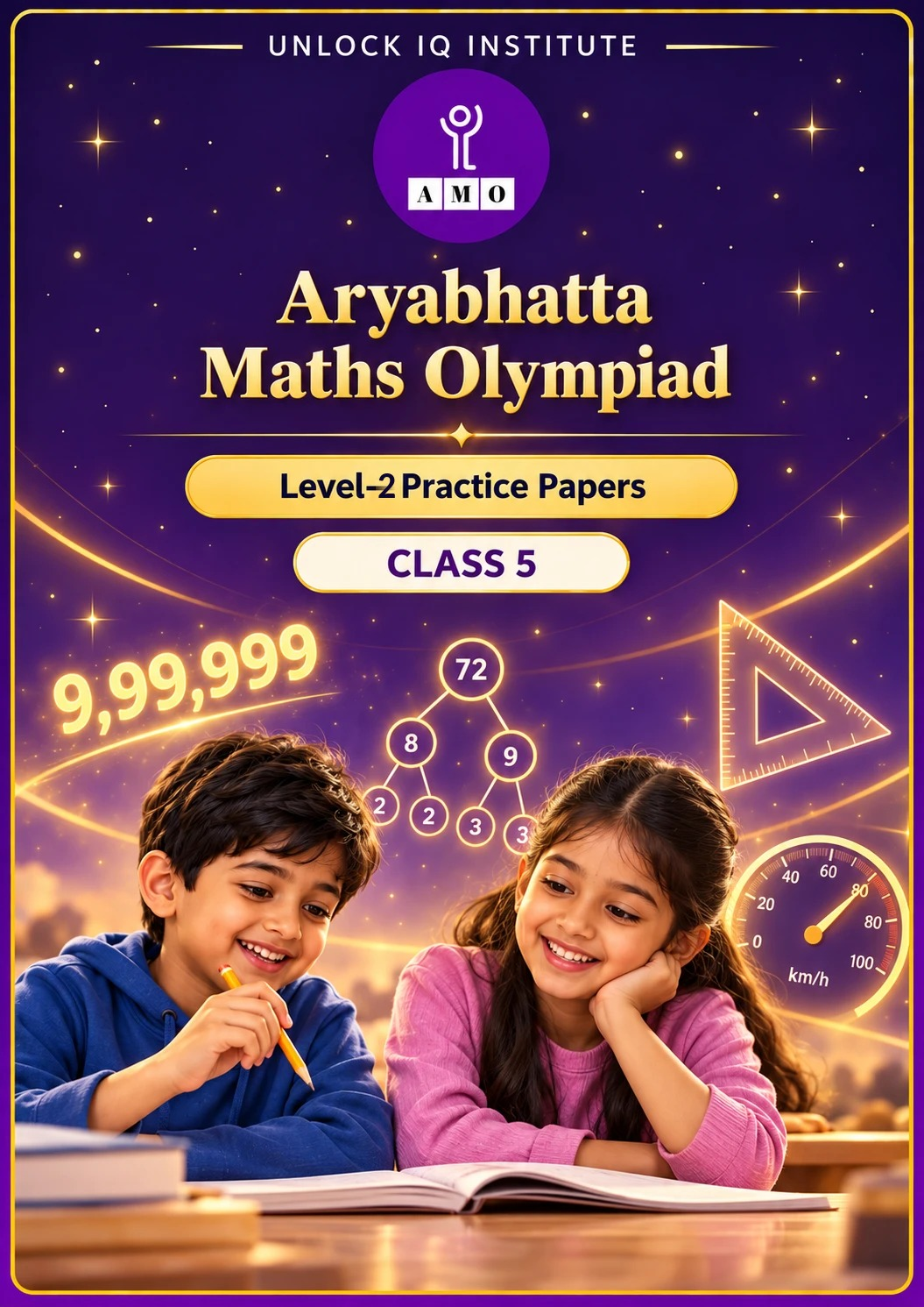
Set 2 · Practice Papers 6–10 · with answer keys & detailed solutions
Name: ____________________ | Class & Section: ________________
Roll No.: ________________ | School: ____________________
City: ____________________ | Date: ____________________

Published by Unlock IQ Institute Pvt. Ltd.
Register for Olympiads: www.aryabhattamathsolympiad.com/student-registration

ARYABHATTA MATHS OLYMPIAD
Level 2
PRACTICE PAPER-6
CLASS 5
Total Questions | 30 multiple-choice questions
Level | Level-2 (final round): every question is Hard
Time | 45 minutes
Section I | 25 questions, each from one chapter
Section II | 5 Star Questions, each joining two chapters
Negative Marking | No negative marking
Calculator | Not allowed
Chapters | Number System · Operations · Fractions, Decimals & Percentages · Geometry · Mensuration · Data Handling, Statistics & Probability · Applied Mathematics · Mathematical Reasoning

👋 Hello, friend! How to do this paper:
⭐ Every question has four answer choices: (A), (B), (C) and (D). Only one is correct.
⭐ Read each question and look at its picture carefully. Then mark your answer on the answer sheet at the end.
⭐ This is a Level-2 paper. Every question needs careful thinking, so take your time and check each step.
⭐ Section I has 25 questions. Section II has 5 Star Questions.
⭐ There is no negative marking, so try every question.
⭐ Do not use a calculator. You may do rough work on a separate sheet.
⭐ All figures are not necessarily drawn to scale unless stated.

For parents and teachers
• Pictures are part of the questions. Every picture also works when printed in black and white.
• You may read a question aloud to the child, exactly as printed. Please do not explain it or point to an answer choice.
• Parts follow the AMO syllabus chapters. Chapters 4 and 7 are not part of the Class 5 syllabus, so the chapter numbers shown in the Part headings have gaps.
• The answer sheet and the answer key are at the end. Remove only the answer key before the child begins.

SECTION I 25 questions · every question is Hard
Part 1 — Number System (Syllabus Chapter 1)
Q1. What is the smallest 5-digit number that is divisible by 6, by 8 and by 12?
(A) 10,008 | (B) 10,024 | (C) 10,000 | (D) 10,080

Q2. How many prime numbers are there between 60 and 80?
(A) 4 | (B) 5 | (C) 6 | (D) 3

Q3. Which is the 2nd largest of these Roman numerals: CDXC, CCCXCIX, CDLIX, CDXLIV?
(A) CDLIX | (B) CDXC | (C) CDXLIV | (D) CCCXCIX

Part 2 — Operations (Syllabus Chapter 2)
Q4. What is the value of this expression?
(A) 14 | (B) 94 | (C) 30 | (D) 88

Q5. A trip costs ₹28 per person and 196 people go. Sapna estimates the total as 30 × 200. How much more is her estimate than the real total?
(A) ₹488 | (B) ₹512 | (C) ₹600 | (D) ₹412

Q6. Without long multiplication, Vipul works out 125 × 72 − 125 × 8. What is the answer?
(A) 9,000 | (B) 7,000 | (C) 8,000 | (D) 8,125

Part 3 — Fractions, Decimals & Percentages (Syllabus Chapter 3)
Q7. ₹1,600 is shared among three children. Aman gets 30% and Bela gets 45%. Chirag gets the rest. How much more does Bela get than Chirag?
(A) ₹240 | (B) ₹480 | (C) ₹320 | (D) ₹400

Q8. Which of these fractions lies between 0.6 and 0.65 (and is equal to neither)?
(A) 3/5 | (B) 2/3 | (C) 13/20 | (D) 5/8

Q9. What is 2.4 × 1.5 + 0.6 ÷ 0.2?
(A) 6.6 | (B) 3.9 | (C) 5.4 | (D) 0.75

Q10. A tank is 3/5 full of water. After 48 L is used, it is 1/3 full. How many litres does the full tank hold?
(A) 144 L | (B) 180 L | (C) 240 L | (D) 120 L

Part 4 — Geometry (Syllabus Chapter 5)
Q11. Two straight lines cross, making four angles. One of the angles is 65°. What is the sum of the two angles that are NOT equal to 65°?
(A) 115° | (B) 295° | (C) 230° | (D) 250°

Q12. A four-sided shape has opposite sides parallel. Three of its angles, in order, are 80°, 100° and 80°. What is the fourth angle, and what is the shape?
(A) 80°, rectangle | (B) 100°, kite
(C) 120°, trapezium | (D) 100°, parallelogram

Q13. Which of these shapes has rotational symmetry (of order 2 or more) but NO line of symmetry?
(A) A rectangle | (B) An isosceles triangle
(C) A kite | (D) A parallelogram that is not a rectangle or a rhombus

Part 5 — Mensuration (Syllabus Chapter 6)
Q14. A wall is 2 m long, 20 cm thick and 1 m high. How many bricks of size 25 cm × 10 cm × 8 cm are needed to build it? (Ignore the cement.)
(A) 400 | (B) 200 | (C) 100 | (D) 2,000

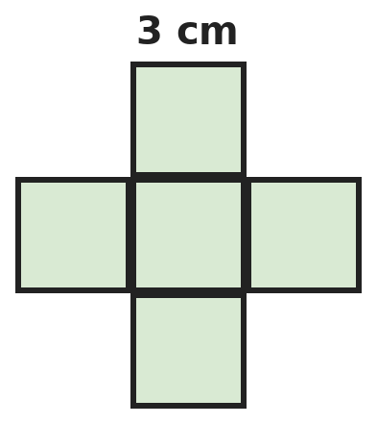
Q15. Five squares of side 3 cm make this plus shape. What is its perimeter?
(A) 36 cm | (B) 60 cm | (C) 45 cm | (D) 30 cm

Q16. A park is 1.2 km long and 400 m wide. Fertiliser costs ₹5 for every 100 m². How much does it cost to fertilise the whole park?
(A) ₹2,400 | (B) ₹2,40,000 | (C) ₹24,000 | (D) ₹9,600

Part 6 — Data Handling, Statistics & Probability (Syllabus Chapter 8)
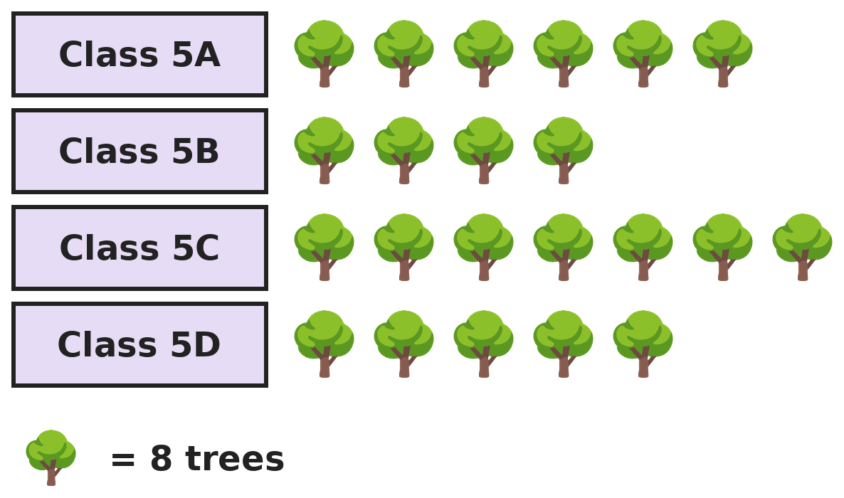
Q17. The pictograph shows trees planted by four classes. If Class 5B had planted 50% more trees, how many symbols would its row show?
(A) 5 | (B) 7 | (C) 6 | (D) 4

Part 7 — Applied Mathematics (Syllabus Chapter 9)
Q18. A plane leaves at 10:35 PM and flies 2,100 km at 700 km/h. At what time does it land? (Ignore time zones.)
(A) 1:35 PM | (B) 12:35 AM | (C) 2:05 AM | (D) 1:35 AM

Q19. A car covers the first 100 km at 50 km/h and the next 150 km at 75 km/h. What is its average speed for the whole 250 km?
(A) 62 km/h | (B) 65 km/h | (C) 60 km/h | (D) 62.5 km/h

Q20. 2028 is a leap year. How many hours are there in February and March 2028 together?
(A) 1,440 | (B) 1,416 | (C) 1,464 | (D) 1,488

Q21. Mangoes cost ₹360 a dozen and grapes cost ₹96 per kg. Gopal buys 18 mangoes and 1.5 kg of grapes and pays with ₹1,000. How much change does he get?
(A) ₹304 | (B) ₹316 | (C) ₹416 | (D) ₹346

Part 8 — Mathematical Reasoning (Syllabus Chapter 10)

Q22. Each number in this series comes from the one before by the same two steps. Which number comes next?
(A) 65 | (B) 49 | (C) 66 | (D) 64

Q23. Today is Wednesday. Which day of the week will it be 100 days from today?
(A) Friday | (B) Thursday | (C) Saturday | (D) Wednesday

Q24. Ekta multiplies 25 whole numbers and the answer is odd. What can you say about the sum of the same 25 numbers?
(A) It is even | (B) It can be odd or even
(C) It is odd | (D) It is a multiple of 25

Q25. Hrithik climbs a staircase of 6 steps. Each time he goes up either 1 step or 2 steps. In how many different ways can he reach the top?
(A) 12 | (B) 8 | (C) 13 | (D) 21

SECTION II — Star Questions 5 questions · each joins two chapters

Q26. These are the numbers that leave a remainder of 2 when divided by 3 and also when divided by 5, in order. What is the 10th number? [Star]
(A) 152 | (B) 137 | (C) 150 | (D) 122


Q27. Each fraction is double the one before. What is the first fraction in the pattern that is more than 1, written as a decimal? [Star]
(A) 0.8 | (B) 3.2 | (C) 1.2 | (D) 1.6

Q28. Kajal draws rectangles that are 1 cm by 2 cm, 2 cm by 3 cm, 3 cm by 4 cm, and so on. What is the perimeter of the first rectangle whose area is more than 100 cm²? [Star]
(A) 42 cm | (B) 38 cm | (C) 110 cm | (D) 44 cm

Q29. A clock tower has Roman numerals. In the morning, its hour hand is halfway between IX and X and its minute hand points at VI. What time will it be 2 hours 45 minutes later? [Star]
(A) 11:15 AM | (B) 12:45 PM | (C) 12:15 PM | (D) 12:30 PM

Q30. A train travels at 0.8 km per minute. How long does it take to travel 240 km? [Star]
(A) 3 h 12 min | (B) 30 h | (C) 4 h 48 min | (D) 5 h

Answer Sheet AMO Level 2 · Class 5 · Practice Paper 6
Name: | School: | Roll No.:
Shade or tick one circle for each question.
1. | Ⓐ Ⓑ Ⓒ Ⓓ | 11. | Ⓐ Ⓑ Ⓒ Ⓓ | 21. | Ⓐ Ⓑ Ⓒ Ⓓ
2. | Ⓐ Ⓑ Ⓒ Ⓓ | 12. | Ⓐ Ⓑ Ⓒ Ⓓ | 22. | Ⓐ Ⓑ Ⓒ Ⓓ
3. | Ⓐ Ⓑ Ⓒ Ⓓ | 13. | Ⓐ Ⓑ Ⓒ Ⓓ | 23. | Ⓐ Ⓑ Ⓒ Ⓓ
4. | Ⓐ Ⓑ Ⓒ Ⓓ | 14. | Ⓐ Ⓑ Ⓒ Ⓓ | 24. | Ⓐ Ⓑ Ⓒ Ⓓ
5. | Ⓐ Ⓑ Ⓒ Ⓓ | 15. | Ⓐ Ⓑ Ⓒ Ⓓ | 25. | Ⓐ Ⓑ Ⓒ Ⓓ
6. | Ⓐ Ⓑ Ⓒ Ⓓ | 16. | Ⓐ Ⓑ Ⓒ Ⓓ | 26. | Ⓐ Ⓑ Ⓒ Ⓓ
7. | Ⓐ Ⓑ Ⓒ Ⓓ | 17. | Ⓐ Ⓑ Ⓒ Ⓓ | 27. | Ⓐ Ⓑ Ⓒ Ⓓ
8. | Ⓐ Ⓑ Ⓒ Ⓓ | 18. | Ⓐ Ⓑ Ⓒ Ⓓ | 28. | Ⓐ Ⓑ Ⓒ Ⓓ
9. | Ⓐ Ⓑ Ⓒ Ⓓ | 19. | Ⓐ Ⓑ Ⓒ Ⓓ | 29. | Ⓐ Ⓑ Ⓒ Ⓓ
10. | Ⓐ Ⓑ Ⓒ Ⓓ | 20. | Ⓐ Ⓑ Ⓒ Ⓓ | 30. | Ⓐ Ⓑ Ⓒ Ⓓ
Q26–Q30 are Section II Star Questions. Each joins two chapters.
For the parent or teacher
Section I correct: ______ / 25 Section II correct: ______ / 5
Correct: ______ / 30
Answer Key and Solutions AMO Level 2 · Class 5 · Practice Paper 6
Quick answers
1 A | 6 C | 11 C | 16 C | 21 B | 26 B
2 B | 7 C | 12 D | 17 C | 22 A | 27 D
3 A | 8 D | 13 D | 18 D | 23 A | 28 A
4 B | 9 A | 14 B | 19 D | 24 C | 29 C
5 B | 10 B | 15 A | 20 A | 25 C | 30 D
Solutions
Q | Part · level | Answer | Why?
1 | Part 1 · Ch1 · Hard | (A) 10,008 | Hint: Find the LCM of 6, 8 and 12 first.  LCM of 6, 8 and 12 is 24. 10,000 ÷ 24 = 416 remainder 16, so 24 × 416 = 9,984 is a 4-digit number. The next multiple, 9,984 + 24 = 10,008, is the smallest 5-digit one.
2 | Part 1 · Ch1 · Hard | (B) 5 | Hint: Only odd numbers not ending in 5 need checking.  Check 61, 63, 67, 69, 71, 73, 77, 79. 63 = 7 × 9, 69 = 3 × 23 and 77 = 7 × 11. The primes are 61, 67, 71, 73 and 79: 5.
3 | Part 1 · Ch1 · Hard | (A) CDLIX | Hint: Change each one into an ordinary number.  CDXC = 490, CCCXCIX = 399, CDLIX = 459, CDXLIV = 444. In order from largest: 490, 459, 444, 399. The 2nd largest is CDLIX.
4 | Part 2 · Ch2 · Hard | (B) 94 | Hint: Work out each round bracket, then the square bracket, then divide.  15 − 3 = 12, 8 − 5 = 3, 4 + 2 = 6. Square bracket: 12 × 3 = 36. 36 ÷ 6 = 6. 100 − 6 = 94.
5 | Part 2 · Ch2 · Hard | (B) ₹512 | Hint: Work out 28 × 196 as 28 × 200 − 28 × 4.  Real total: 28 × 196 = 28 × 200 − 28 × 4 = 5,600 − 112 = ₹5,488. Estimate: ₹6,000. Difference: ₹512.
6 | Part 2 · Ch2 · Hard | (C) 8,000 | Hint: Both parts have 125 × something.  125 × 72 − 125 × 8 = 125 × (72 − 8) = 125 × 64. 125 × 8 = 1,000, so 125 × 64 = 1,000 × 8 = 8,000.
7 | Part 3 · Ch3 · Hard | (C) ₹320 | Hint: Chirag gets 100% − 30% − 45%.  Chirag gets 25% = ₹400. Bela gets 45% = 45 × 16 = ₹720. 720 − 400 = ₹320.
8 | Part 3 · Ch3 · Hard | (D) 5/8 | Hint: Change each fraction into a decimal.  5/8 = 0.625, which is between them. 3/5 = 0.6 and 13/20 = 0.65 are the end values themselves. 2/3 = 0.666… is more than 0.65.
9 | Part 3 · Ch3 · Hard | (A) 6.6 | Hint: Multiply and divide before you add.  2.4 × 1.5 = 3.6. 0.6 ÷ 0.2 = 3. 3.6 + 3 = 6.6.
10 | Part 3 · Ch3 · Hard | (B) 180 L | Hint: Write 3/5 and 1/3 in fifteenths.  3/5 = 9/15 and 1/3 = 5/15. The 48 L used is 4/15 of the tank, so 1/15 is 12 L and the full tank is 15 × 12 = 180 L.
11 | Part 4 · Ch5 · Hard | (C) 230° | Hint: Angles next to each other on a straight line add up to 180°.  The angle opposite the 65° angle is also 65°. Each of the other two angles is 180° − 65° = 115°. Their sum is 230°.
12 | Part 4 · Ch5 · Hard | (D) 100°, parallelogram | Hint: The angles of a four-sided shape add up to 360°.  360° − 80° − 100° − 80° = 100°. Both pairs of opposite sides are parallel, so it is a parallelogram. It is not a rectangle because its angles are not 90°.
13 | Part 4 · Ch5 · Hard | (D) A parallelogram that is not a rectangle or a rhombus | Hint: Try folding each shape, then try turning it half way round.  A parallelogram (not a rectangle or rhombus) looks the same after a half turn, but no fold makes its halves match. A rectangle has 2 lines of symmetry; the isosceles triangle and the kite each have 1 line but no rotational symmetry.
14 | Part 5 · Ch6 · Hard | (B) 200 | Hint: Change all lengths to centimetres and find both volumes.  Wall: 200 × 20 × 100 = 4,00,000 cm³. Brick: 25 × 10 × 8 = 2,000 cm³. 4,00,000 ÷ 2,000 = 200 bricks.
15 | Part 5 · Ch6 · Hard | (A) 36 cm | Hint: Count the outside edges.  The outline has 12 edges, each 3 cm long: 12 × 3 = 36 cm. (60 cm adds all five squares' perimeters.)
16 | Part 5 · Ch6 · Hard | (C) ₹24,000 | Hint: Change 1.2 km into metres first.  1.2 km = 1,200 m. Area: 1,200 × 400 = 4,80,000 m². That is 4,800 lots of 100 m². Cost: 4,800 × 5 = ₹24,000.
17 | Part 6 · Ch8 · Hard | (C) 6 | Hint: 50% more means half as many again.  5B planted 4 × 8 = 32 trees. 50% more: 32 + 16 = 48 trees. 48 ÷ 8 = 6 symbols.
18 | Part 7 · Ch9 · Hard | (D) 1:35 AM | Hint: Find the flying time first.  2,100 ÷ 700 = 3 hours. 10:35 PM + 3 hours = 1:35 AM the next day.
19 | Part 7 · Ch9 · Hard | (D) 62.5 km/h | Hint: Find the time for each part.  First part: 100 ÷ 50 = 2 h. Second: 150 ÷ 75 = 2 h. 250 km in 4 h: 250 ÷ 4 = 62.5 km/h.
20 | Part 7 · Ch9 · Hard | (A) 1,440 | Hint: Count the days in the two months first.  February 2028 has 29 days and March has 31: 29 + 31 = 60 days. 60 × 24 = 1,440 hours.
21 | Part 7 · Ch9 · Hard | (B) ₹316 | Hint: 18 mangoes is one and a half dozen.  18 mangoes: 360 + 180 = ₹540. Grapes: 96 + 48 = ₹144. Total ₹684. Change: 1,000 − 684 = ₹316.
22 | Part 8 · Ch10 · Hard | (A) 65 | Hint: Double the number and then adjust.  3 × 2 − 1 = 5, 5 × 2 − 1 = 9, 9 × 2 − 1 = 17, 17 × 2 − 1 = 33. Next: 33 × 2 − 1 = 65.
23 | Part 8 · Ch10 · Hard | (A) Friday | Hint: Every 7 days it is Wednesday again.  100 = 14 × 7 + 2. After 98 days it is Wednesday again; 2 more days gives Friday.
24 | Part 8 · Ch10 · Hard | (C) It is odd | Hint: If even one of the numbers were even, the product would be even.  An odd product means all 25 numbers are odd. Odd + odd is even, so 24 odd numbers add to an even total, and the 25th odd number makes it odd.
25 | Part 8 · Ch10 · Hard | (C) 13 | Hint: Count the ways for 1, 2, 3, … steps and look for a pattern.  Ways for 1 step: 1. 2 steps: 2. Each later number is the sum of the two before (the last move is 1 step or 2 steps): 3 steps 3, 4 steps 5, 5 steps 8, 6 steps 13.
26 | Section II · Ch1 + Ch10 · Hard | (B) 137 | Hint: The numbers go up by the LCM of 3 and 5.  They go up by 15 each time. The 10th number is 2 + 9 × 15 = 2 + 135 = 137.
27 | Section II · Ch3 + Ch10 · Hard | (D) 1.6 | Hint: 1 whole is 20/20.  Next come 16/20 (less than 1) and then 32/20, which is more than 20/20. 32/20 = 1.6.
28 | Section II · Ch6 + Ch10 · Hard | (A) 42 cm | Hint: The areas are 2, 6, 12, 20, …  9 cm by 10 cm has area 90 cm². The next, 10 cm by 11 cm, has area 110 cm², the first over 100. Its perimeter: 2 × (10 + 11) = 42 cm.
29 | Section II · Ch1 + Ch9 · Hard | (C) 12:15 PM | Hint: First read the time. VI on the minute hand means 30 minutes.  Hour hand halfway between IX (9) and X (10), minute hand at VI: 9:30 AM. 9:30 + 2 h 45 min = 12:15 PM.
30 | Section II · Ch3 + Ch9 · Hard | (D) 5 h | Hint: How many minutes does it take to cover 4 km?  0.8 km per minute means 4 km every 5 minutes. 240 km is 60 lots of 4 km: 60 × 5 = 300 minutes = 5 hours.

ARYABHATTA MATHS OLYMPIAD
Level 2
PRACTICE PAPER-7
CLASS 5
Total Questions | 30 multiple-choice questions
Level | Level-2 (final round): every question is Hard
Time | 45 minutes
Section I | 25 questions, each from one chapter
Section II | 5 Star Questions, each joining two chapters
Negative Marking | No negative marking
Calculator | Not allowed
Chapters | Number System · Operations · Fractions, Decimals & Percentages · Geometry · Mensuration · Data Handling, Statistics & Probability · Applied Mathematics · Mathematical Reasoning

👋 Hello, friend! How to do this paper:
⭐ Every question has four answer choices: (A), (B), (C) and (D). Only one is correct.
⭐ Read each question and look at its picture carefully. Then mark your answer on the answer sheet at the end.
⭐ This is a Level-2 paper. Every question needs careful thinking, so take your time and check each step.
⭐ Section I has 25 questions. Section II has 5 Star Questions.
⭐ There is no negative marking, so try every question.
⭐ Do not use a calculator. You may do rough work on a separate sheet.
⭐ All figures are not necessarily drawn to scale unless stated.

For parents and teachers
• Pictures are part of the questions. Every picture also works when printed in black and white.
• You may read a question aloud to the child, exactly as printed. Please do not explain it or point to an answer choice.
• Parts follow the AMO syllabus chapters. Chapters 4 and 7 are not part of the Class 5 syllabus, so the chapter numbers shown in the Part headings have gaps.
• The answer sheet and the answer key are at the end. Remove only the answer key before the child begins.

SECTION I 25 questions · every question is Hard
Part 1 — Number System (Syllabus Chapter 1)
Q1. How many prime numbers less than 60 end in the digit 3?
(A) 6 | (B) 5 | (C) 4 | (D) 3

Q2. Three runners go round a track. One takes 4 minutes per lap, one 6 minutes and one 9 minutes. They start together. When they are next all together at the start, how many laps has the fastest runner done?
(A) 36 | (B) 6 | (C) 4 | (D) 9

Q3. Navya uses each of the digits 0, 3, 5, 7, 8 and 9 exactly once to make 6-digit numbers. What is the difference between the largest and the smallest number she can make?
(A) 6,81,751 | (B) 5,81,741 | (C) 6,81,741 | (D) 6,82,741

Part 2 — Operations (Syllabus Chapter 2)
Q4. Which of these expressions has the value 20?
(A) 4 × 6 − 2 + 4 | (B) (4 × 6 − 2) + 4
(C) 4 × (6 − 2 + 4) | (D) 4 × (6 − 2) + 4

Q5. Harini rounds 3,987, 5,012 and 2,995 to the nearest thousand and adds them. How much more is her answer than the exact total?
(A) 6 | (B) 4 | (C) 14 | (D) 16

Q6. What is the value of 1,000 − 999 + 998 − 997 + 996 − 995 + … + 2 − 1?
(A) 0 | (B) 1,000 | (C) 500 | (D) 499

Part 3 — Fractions, Decimals & Percentages (Syllabus Chapter 3)
Q7. A cricket team has won 18 of its 24 matches. It will play 6 more. How many of those 6 must it win so that it has won 80% of all its matches?
(A) 5 | (B) 4 | (C) 3 | (D) 6

Q8. Which fraction is equal to 0.35 + 2/5?
(A) 37/100 | (B) 7/10 | (C) 2/3 | (D) 3/4

Q9. Together, 7 pens and 3 erasers cost ₹63.50. One pen costs ₹7.25. What does one eraser cost?
(A) ₹4.50 | (B) ₹12.75 | (C) ₹4.25 | (D) ₹3.75

Q10. Rekha reads 1/4 of a book on Monday. On Tuesday she reads 1/3 of the pages that are left. She still has 60 pages to read. How many pages does the book have?
(A) 180 | (B) 240 | (C) 120 | (D) 96

Part 4 — Geometry (Syllabus Chapter 5)
Q11. A triangle has one angle of 52° and its other two angles are equal. What is each equal angle, and what type of triangle is it by its angles?
(A) 64°, acute-angled | (B) 64°, obtuse-angled
(C) 128°, obtuse-angled | (D) 76°, acute-angled

Q12. How many of these shapes ALWAYS have diagonals of equal length: square, rectangle, rhombus, parallelogram?
(A) 1 | (B) 2 | (C) 3 | (D) 4

Q13. Kunwar faces West. He turns right, then right again, then left, then right. Which direction does he face now?
(A) North | (B) East | (C) West | (D) South

Part 5 — Mensuration (Syllabus Chapter 6)
Q14. A cube-shaped box is packed exactly with 1,000 cubes of edge 1 cm, in 10 equal layers. How much cloth is needed to cover all the faces of the box exactly?
(A) 100 cm² | (B) 400 cm² | (C) 600 cm² | (D) 1,000 cm²

Q15. A rectangular garden is 25 m long and 15 m wide. It is fenced with 4 rounds of wire. Wire costs ₹12 per metre. What is the cost of the wire?
(A) ₹960 | (B) ₹4,500 | (C) ₹1,920 | (D) ₹3,840

Q16. Two identical right-angled triangles, each with shorter sides 5 cm and 12 cm, are joined along their 12 cm sides to make one big triangle. What is its area?
(A) 30 cm² | (B) 120 cm² | (C) 65 cm² | (D) 60 cm²

Part 6 — Data Handling, Statistics & Probability (Syllabus Chapter 8)
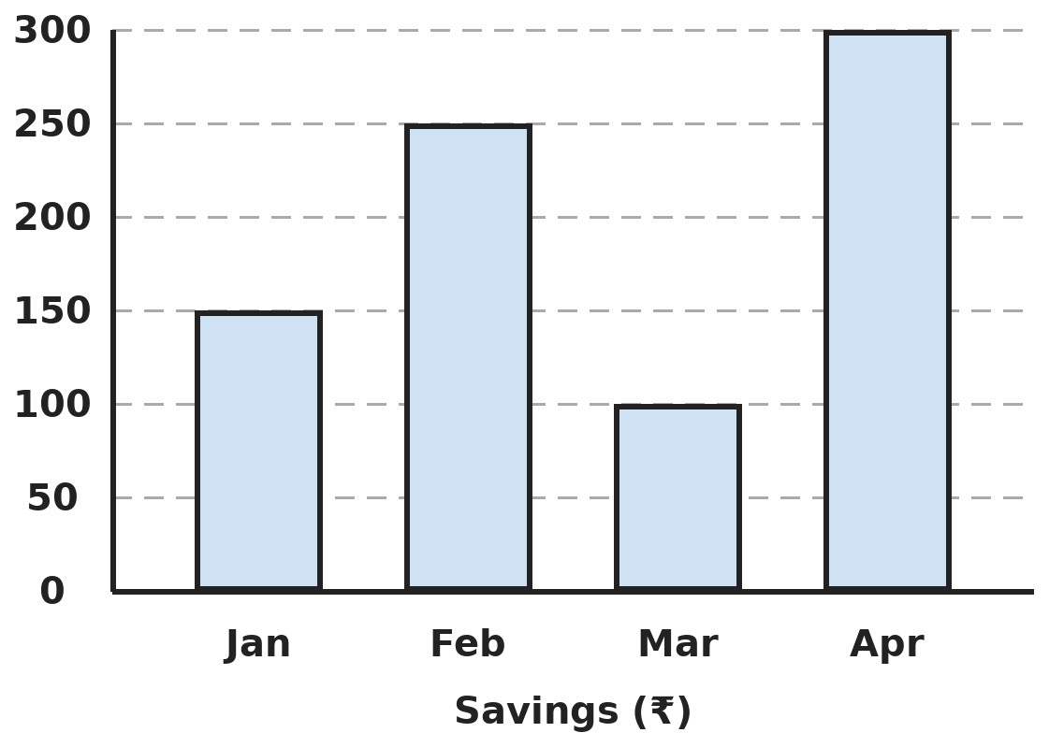
Q17. The bar graph shows Payal's savings each month. In which month did her savings go up the most compared with the month before?
(A) February | (B) April | (C) March | (D) January

Part 7 — Applied Mathematics (Syllabus Chapter 9)
Q18. Sound travels about 0.34 km every second. Tushar hears thunder 6 seconds after he sees the lightning. About how far away is the storm?
(A) 2.4 km | (B) 20.4 km | (C) 1.7 km | (D) 2.04 km

Q19. A trip of 180 km has an average speed of 45 km/h. The first 90 km took 1.5 hours. At what speed was the rest of the trip driven?
(A) 45 km/h | (B) 60 km/h | (C) 36 km/h | (D) 40 km/h

Q20. A train leaves at 14:45 and reaches its station at 06:20 the next morning (24-hour times). How long is the journey?
(A) 8 h 25 min | (B) 16 h 35 min | (C) 15 h 35 min | (D) 15 h 25 min

Q21. A school trip costs ₹1,250 per student for 36 students. A parent gives ₹4,500 towards the trip. The rest is shared equally by the students. How much does each student pay?
(A) ₹1,125 | (B) ₹1,250 | (C) ₹1,100 | (D) ₹1,025

Part 8 — Mathematical Reasoning (Syllabus Chapter 10)

Q22. Two patterns are mixed together in this series. Which number comes next?
(A) 16 | (B) 80 | (C) 10 | (D) 32

Q23. Republic Day, 26 January, was a Sunday in 2025. 2024 was a leap year. On which day of the week was Republic Day in 2024?
(A) Saturday | (B) Friday | (C) Monday | (D) Thursday

Q24. Seema picks 3 different cards from cards numbered 1 to 9. Their numbers add up to 20. Which of these is possible?
(A) Exactly 2 odd cards | (B) All 3 even cards
(C) Exactly 1 odd card | (D) All 3 odd cards

Q25. How many 2-digit numbers have a tens digit that is greater than the ones digit, like 52?
(A) 45 | (B) 36 | (C) 54 | (D) 50

SECTION II — Star Questions 5 questions · each joins two chapters
Q26. How many multiples of 6 that are less than 100 are NOT multiples of 9? [Star]
(A) 16 | (B) 11 | (C) 10 | (D) 5


Q27. Each number in this series is found from the one before in the same way. Which number comes next? [Star]
(A) 20.25 | (B) 18 | (C) 20.5 | (D) 19.5

Q28. Kirti makes cuboid boxes. The 1st is 1 × 2 × 3 cm, the 2nd is 2 × 3 × 4 cm, the 3rd is 3 × 4 × 5 cm, and so on. Which is the first box with a volume of more than 500 cm³? [Star]
(A) 6th | (B) 8th | (C) 7th | (D) 5th

Q29. A shop shows prices in Roman numerals. A bag costs ₹CDXL and a pair of shoes costs ₹DCCL. Rahul buys both and pays with three ₹500 notes. How much change does he get? [Star]
(A) ₹410 | (B) ₹310 | (C) ₹290 | (D) ₹1,190

Q30. A scooter goes 48.5 km on 1 litre of petrol. Its tank holds 6 litres. How far can it go on 3/4 of a full tank? [Star]
(A) 291 km | (B) 218.25 km | (C) 194 km | (D) 220.25 km

Answer Sheet AMO Level 2 · Class 5 · Practice Paper 7
Name: | School: | Roll No.:
Shade or tick one circle for each question.
1. | Ⓐ Ⓑ Ⓒ Ⓓ | 11. | Ⓐ Ⓑ Ⓒ Ⓓ | 21. | Ⓐ Ⓑ Ⓒ Ⓓ
2. | Ⓐ Ⓑ Ⓒ Ⓓ | 12. | Ⓐ Ⓑ Ⓒ Ⓓ | 22. | Ⓐ Ⓑ Ⓒ Ⓓ
3. | Ⓐ Ⓑ Ⓒ Ⓓ | 13. | Ⓐ Ⓑ Ⓒ Ⓓ | 23. | Ⓐ Ⓑ Ⓒ Ⓓ
4. | Ⓐ Ⓑ Ⓒ Ⓓ | 14. | Ⓐ Ⓑ Ⓒ Ⓓ | 24. | Ⓐ Ⓑ Ⓒ Ⓓ
5. | Ⓐ Ⓑ Ⓒ Ⓓ | 15. | Ⓐ Ⓑ Ⓒ Ⓓ | 25. | Ⓐ Ⓑ Ⓒ Ⓓ
6. | Ⓐ Ⓑ Ⓒ Ⓓ | 16. | Ⓐ Ⓑ Ⓒ Ⓓ | 26. | Ⓐ Ⓑ Ⓒ Ⓓ
7. | Ⓐ Ⓑ Ⓒ Ⓓ | 17. | Ⓐ Ⓑ Ⓒ Ⓓ | 27. | Ⓐ Ⓑ Ⓒ Ⓓ
8. | Ⓐ Ⓑ Ⓒ Ⓓ | 18. | Ⓐ Ⓑ Ⓒ Ⓓ | 28. | Ⓐ Ⓑ Ⓒ Ⓓ
9. | Ⓐ Ⓑ Ⓒ Ⓓ | 19. | Ⓐ Ⓑ Ⓒ Ⓓ | 29. | Ⓐ Ⓑ Ⓒ Ⓓ
10. | Ⓐ Ⓑ Ⓒ Ⓓ | 20. | Ⓐ Ⓑ Ⓒ Ⓓ | 30. | Ⓐ Ⓑ Ⓒ Ⓓ
Q26–Q30 are Section II Star Questions. Each joins two chapters.
For the parent or teacher
Section I correct: ______ / 25 Section II correct: ______ / 5
Correct: ______ / 30
Answer Key and Solutions AMO Level 2 · Class 5 · Practice Paper 7
Quick answers
1 B | 6 C | 11 A | 16 D | 21 A | 26 B
2 D | 7 D | 12 B | 17 B | 22 A | 27 A
3 C | 8 D | 13 B | 18 D | 23 B | 28 C
4 D | 9 C | 14 C | 19 C | 24 A | 29 B
5 A | 10 C | 15 D | 20 C | 25 A | 30 B
Solutions
Q | Part · level | Answer | Why?
1 | Part 1 · Ch1 · Hard | (B) 5 | Hint: Check 3, 13, 23, 33, 43 and 53.  3, 13, 23, 43 and 53 are prime. 33 = 3 × 11 is not. So 5.
2 | Part 1 · Ch1 · Hard | (D) 9 | Hint: Find the LCM of 4, 6 and 9.  LCM of 4, 6 and 9 is 36 minutes. The fastest runner takes 4 minutes per lap: 36 ÷ 4 = 9 laps.
3 | Part 1 · Ch1 · Hard | (C) 6,81,741 | Hint: The smallest number cannot start with 0.  Largest: 9,87,530. Smallest: 3,05,789 (0 goes second). 9,87,530 − 3,05,789 = 6,81,741.
4 | Part 2 · Ch2 · Hard | (D) 4 × (6 − 2) + 4 | Hint: Work out each one carefully.  4 × (6 − 2) + 4 = 16 + 4 = 20. 4 × 6 − 2 + 4 = 26. (4 × 6 − 2) + 4 = 26. 4 × (6 − 2 + 4) = 4 × 8 = 32.
5 | Part 2 · Ch2 · Hard | (A) 6 | Hint: Look at how much each number changed when it was rounded.  Rounded: 4,000 + 5,000 + 3,000 = 12,000. Changes: +13, −12, +5, so the estimate is 6 more. Exact total: 11,994.
6 | Part 2 · Ch2 · Hard | (C) 500 | Hint: Group the numbers in pairs: (1,000 − 999), (998 − 997), …  Each pair like (1,000 − 999) equals 1. The numbers 1 to 1,000 make 500 pairs, so the total is 500.
7 | Part 3 · Ch3 · Hard | (D) 6 | Hint: Find 80% of the total number of matches.  Total matches: 30. 80% of 30 = 24 wins. It has 18, so it needs 6 more: it must win all 6.
8 | Part 3 · Ch3 · Hard | (D) 3/4 | Hint: Change 2/5 into a decimal.  2/5 = 0.4. 0.35 + 0.4 = 0.75 = 3/4. (37/100 wrongly adds 35 and 2.)
9 | Part 3 · Ch3 · Hard | (C) ₹4.25 | Hint: Find the cost of the 7 pens first.  7 pens: 7 × 7.25 = ₹50.75. 3 erasers: 63.50 − 50.75 = ₹12.75. One eraser: 12.75 ÷ 3 = ₹4.25.
10 | Part 3 · Ch3 · Hard | (C) 120 | Hint: After Monday, 3/4 of the book is left.  After Monday, 3/4 is left. Tuesday: 1/3 of 3/4 = 1/4 of the book. Left: 1 − 1/4 − 1/4 = 1/2 of the book = 60 pages. The book has 120 pages.
11 | Part 4 · Ch5 · Hard | (A) 64°, acute-angled | Hint: The angles add up to 180°.  180° − 52° = 128°, shared equally: 64° each. All angles (52°, 64°, 64°) are less than 90°, so it is acute-angled.
12 | Part 4 · Ch5 · Hard | (B) 2 | Hint: Think of a tall thin rhombus.  The square and the rectangle always have equal diagonals. A rhombus and a parallelogram that are not rectangles have one long and one short diagonal. So 2.
13 | Part 4 · Ch5 · Hard | (B) East | Hint: Turning right from West faces North.  West → right → North → right → East → left → North → right → East.
14 | Part 5 · Ch6 · Hard | (C) 600 cm² | Hint: How many cubes are in one layer? What square does one layer make?  One layer has 1,000 ÷ 10 = 100 cubes, which is a 10 × 10 square. With 10 layers the box is 10 cm tall, so each edge is 10 cm. Each face is 10 × 10 = 100 cm². 6 faces: 600 cm².
15 | Part 5 · Ch6 · Hard | (D) ₹3,840 | Hint: One round of wire is the perimeter.  Perimeter: 2 × (25 + 15) = 80 m. 4 rounds: 320 m. Cost: 320 × 12 = ₹3,840.
16 | Part 5 · Ch6 · Hard | (D) 60 cm² | Hint: Find the area of one small triangle first.  One triangle: half of 5 × 12 = 30 cm². Two of them: 60 cm². Joining does not change the total area.
17 | Part 6 · Ch8 · Hard | (B) April | Hint: Find the change from each month to the next.  Jan → Feb: +₹100. Feb → Mar: −₹150 (it went down). Mar → Apr: +₹200. The biggest rise was in April.
18 | Part 7 · Ch9 · Hard | (D) 2.04 km | Hint: The light reaches him almost at once.  Distance = speed × time = 0.34 × 6 = 2.04 km.
19 | Part 7 · Ch9 · Hard | (C) 36 km/h | Hint: Find the total time of the trip first.  Total time: 180 ÷ 45 = 4 h. The rest took 4 − 1.5 = 2.5 h for 90 km. 90 ÷ 2.5 = 36 km/h.
20 | Part 7 · Ch9 · Hard | (C) 15 h 35 min | Hint: Count to midnight first.  14:45 to midnight is 9 h 15 min. Midnight to 06:20 is 6 h 20 min. Total: 15 h 35 min.
21 | Part 7 · Ch9 · Hard | (A) ₹1,125 | Hint: Share the gift among the 36 students first.  The gift saves each student 4,500 ÷ 36 = ₹125. Each pays 1,250 − 125 = ₹1,125.
22 | Part 8 · Ch10 · Hard | (A) 16 | Hint: Look at the 1st, 3rd and 5th numbers.  The 1st, 3rd, 5th numbers are 2, 4, 8 (doubling). The 2nd, 4th, 6th are 10, 20, 40 (doubling). The 7th number continues the first pattern: 16.
23 | Part 8 · Ch10 · Hard | (B) Friday | Hint: Between the two dates is a 29 February.  From 26 January 2024 to 26 January 2025 there are 366 days, because February 2024 had 29 days. 366 = 52 weeks + 2 days. Going back 2 days from Sunday gives Friday.
24 | Part 8 · Ch10 · Hard | (A) Exactly 2 odd cards | Hint: Is 20 odd or even? Also, what is the largest total of three even cards?  An even total needs an even number of odd cards: 0 or 2. Three even cards give at most 4 + 6 + 8 = 18, which is less than 20. So she must have exactly 2 odd cards, for example 9 + 7 + 4 = 20.
25 | Part 8 · Ch10 · Hard | (A) 45 | Hint: Count by the tens digit: 1 _, 2 _, 3 _, …  Tens 1: ones 0 (1 number). Tens 2: 2 numbers. … Tens 9: 9 numbers. 1 + 2 + … + 9 = 45.
26 | Section II · Ch1 + Ch10 · Hard | (B) 11 | Hint: A multiple of 6 that is also a multiple of 9 is a multiple of 18.  Multiples of 6 below 100: 6, 12, …, 96, which is 16. Multiples of 18 among them: 18, 36, 54, 72, 90, which is 5. 16 − 5 = 11.
27 | Section II · Ch3 + Ch10 · Hard | (A) 20.25 | Hint: Compare 6 with 4, and 9 with 6.  Each number is 1.5 times the one before: 4 × 1.5 = 6, 6 × 1.5 = 9, 9 × 1.5 = 13.5. Next: 13.5 × 1.5 = 13.5 + 6.75 = 20.25.
28 | Section II · Ch6 + Ch10 · Hard | (C) 7th | Hint: Write the volumes of the 5th, 6th and 7th boxes.  5th: 5 × 6 × 7 = 210 cm³. 6th: 6 × 7 × 8 = 336 cm³. 7th: 7 × 8 × 9 = 504 cm³. The 7th box is the first over 500 cm³.
29 | Section II · Ch1 + Ch9 · Hard | (B) ₹310 | Hint: CD = 400 and DCC = 700.  CDXL = 440 and DCCL = 750. Total: ₹1,190. He pays ₹1,500. Change: 1,500 − 1,190 = ₹310.
30 | Section II · Ch3 + Ch9 · Hard | (B) 218.25 km | Hint: Find 3/4 of 6 litres first.  3/4 of 6 L = 4.5 L. Distance: 4.5 × 48.5 = 194 + 24.25 = 218.25 km.

ARYABHATTA MATHS OLYMPIAD
Level 2
PRACTICE PAPER-8
CLASS 5
Total Questions | 30 multiple-choice questions
Level | Level-2 (final round): every question is Hard
Time | 45 minutes
Section I | 25 questions, each from one chapter
Section II | 5 Star Questions, each joining two chapters
Negative Marking | No negative marking
Calculator | Not allowed
Chapters | Number System · Operations · Fractions, Decimals & Percentages · Geometry · Mensuration · Data Handling, Statistics & Probability · Applied Mathematics · Mathematical Reasoning

👋 Hello, friend! How to do this paper:
⭐ Every question has four answer choices: (A), (B), (C) and (D). Only one is correct.
⭐ Read each question and look at its picture carefully. Then mark your answer on the answer sheet at the end.
⭐ This is a Level-2 paper. Every question needs careful thinking, so take your time and check each step.
⭐ Section I has 25 questions. Section II has 5 Star Questions.
⭐ There is no negative marking, so try every question.
⭐ Do not use a calculator. You may do rough work on a separate sheet.
⭐ All figures are not necessarily drawn to scale unless stated.

For parents and teachers
• Pictures are part of the questions. Every picture also works when printed in black and white.
• You may read a question aloud to the child, exactly as printed. Please do not explain it or point to an answer choice.
• Parts follow the AMO syllabus chapters. Chapters 4 and 7 are not part of the Class 5 syllabus, so the chapter numbers shown in the Part headings have gaps.
• The answer sheet and the answer key are at the end. Remove only the answer key before the child begins.

SECTION I 25 questions · every question is Hard
Part 1 — Number System (Syllabus Chapter 1)
Q1. How many of the factors of 60 are even numbers?
(A) 8 | (B) 12 | (C) 6 | (D) 4

Q2. A sweet shop packs 120 laddoos, 168 barfis and 216 jalebis into boxes. Each box has only one kind of sweet, and every box has the same number of sweets. What is the fewest number of boxes needed?
(A) 24 | (B) 18 | (C) 36 | (D) 21

Q3. What is the greatest 6-digit number whose digits add up to 10?
(A) 9,10,000 | (B) 9,01,000 | (C) 1,00,009 | (D) 9,00,001

Part 2 — Operations (Syllabus Chapter 2)
Q4. Lokesh wants this number sentence to be true. Which number should replace the question mark?
(A) 7 | (B) 11 | (C) 4 | (D) 14

Q5. Kunal estimates 7,890 ÷ 39 as 8,000 ÷ 40 = 200. What is the exact whole-number quotient of 7,890 ÷ 39?
(A) 200 | (B) 198 | (C) 202 | (D) 203

Q6. Three of these products have the same value. Which is the odd one out?
(A) 25 × 16 × 7 | (B) 50 × 8 × 7 | (C) 70 × 60 | (D) 100 × 28

Part 3 — Fractions, Decimals & Percentages (Syllabus Chapter 3)
Q7. Of 500 students, 64% passed English, 72% passed Maths and 48% passed both. How many students failed both subjects?
(A) 40 | (B) 60 | (C) 80 | (D) 140

Q8. Which of these has the largest value?
(A) 0.5 | (B) 0.7 × 0.7 | (C) 0.25 × 2.2 | (D) 3/5 − 0.1

Q9. Ankita cuts a rope 2.5 m long into 4 equal pieces. Then she cuts each piece in half. How long is each small piece?
(A) 62.5 cm | (B) 3.125 cm | (C) 32 cm | (D) 31.25 cm

Q10. Kusum buys 2 1/4 kg of potatoes and 1 3/5 kg of onions. What is the total weight, written as a decimal?
(A) 3.45 kg | (B) 3.85 kg | (C) 3.8 kg | (D) 4.85 kg

Part 4 — Geometry (Syllabus Chapter 5)
Q11. Three angles of a four-sided shape are 75°, 105° and 110°. What is the fourth angle, and what type of angle is it?
(A) 80°, acute | (B) 70°, acute | (C) 110°, obtuse | (D) 70°, obtuse

Q12. Which of these triangles can NOT exist?
(A) A right-angled isosceles triangle | (B) An obtuse-angled scalene triangle
(C) An acute-angled isosceles triangle | (D) A right-angled equilateral triangle

Q13. Leena folds a square sheet along one diagonal, then folds it in half again along the other diagonal. She punches one hole through all the layers, away from the folds. How many holes are there when she opens it?
(A) 2 | (B) 4 | (C) 8 | (D) 1

Part 5 — Mensuration (Syllabus Chapter 6)
Q14. A cuboid water tank holds 3,600 litres when full. Its base is 2 m long and 1.2 m wide. How deep is it? (1 m³ = 1,000 L)
(A) 15 m | (B) 1.5 m | (C) 1.2 m | (D) 3 m

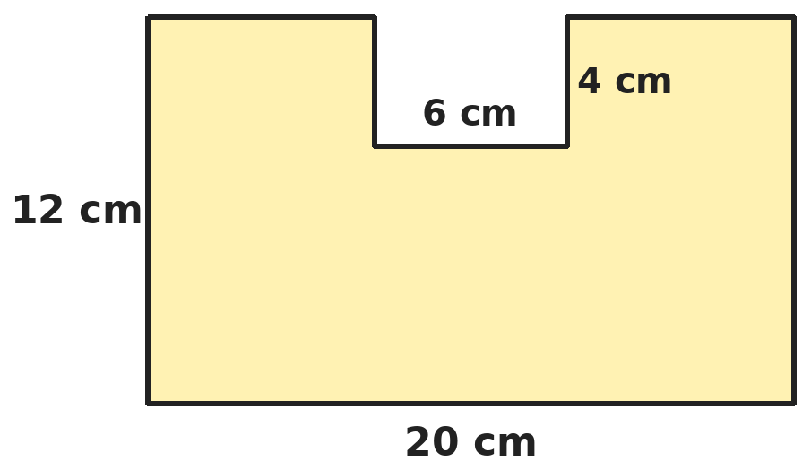
Q15. A 6 cm by 4 cm piece is cut from the middle of the top of a 20 cm by 12 cm rectangle, as shown. What is the perimeter of the shape?
(A) 64 cm | (B) 76 cm | (C) 68 cm | (D) 72 cm

Q16. A right-angled triangular plot has an area of 1,200 m². One of the sides at the right angle is 60 m. A fence along the two sides at the right angle costs ₹25 per metre. What is the cost?
(A) ₹1,500 | (B) ₹30,000 | (C) ₹5,000 | (D) ₹2,500

Part 6 — Data Handling, Statistics & Probability (Syllabus Chapter 8)
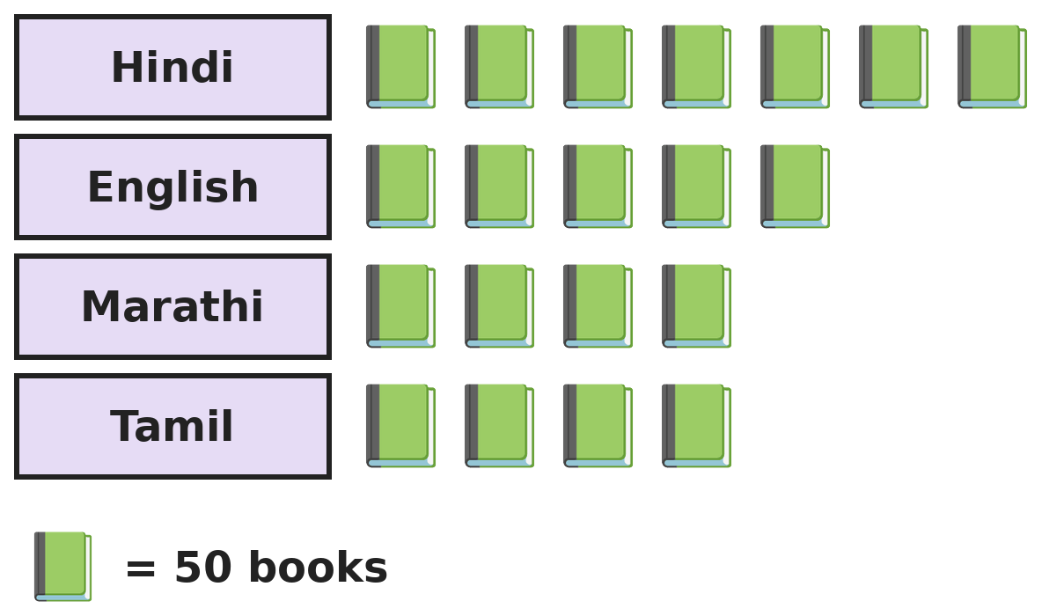
Q17. The pictograph shows the books in a library by language. What percentage of all the books are in English?
(A) 25% | (B) 20% | (C) 50% | (D) 5%

Part 7 — Applied Mathematics (Syllabus Chapter 9)
Q18. Two cyclists start from the same place and ride in opposite directions at 12 km/h and 18 km/h. How far apart are they after 40 minutes?
(A) 20 km | (B) 30 km | (C) 4 km | (D) 12 km

Q19. A car travels for 3 hours at an average of 50 km/h and then for 2 hours at 60 km/h. What is its average speed for the 5 hours?
(A) 55 km/h | (B) 52 km/h | (C) 54 km/h | (D) 56 km/h

Q20. A garden light is on from 6:45 PM to 5:30 AM every night. For how long is it on in one week?
(A) 75 h 15 min | (B) 74 h 15 min | (C) 76 h 45 min | (D) 73 h 45 min

Q21. Four friends go to a film. Each ticket costs ₹180 and they buy 2 tubs of popcorn at ₹95.50 each. They share the total cost equally. How much does each pay?
(A) ₹275.50 | (B) ₹227.75 | (C) ₹223.75 | (D) ₹227.50

Part 8 — Mathematical Reasoning (Syllabus Chapter 10)

Q22. Look at the differences between the numbers. Which number comes next?
(A) 49 | (B) 55 | (C) 52 | (D) 50

Q23. In 2027, 1 January is a Friday. 2027 is not a leap year. On which day of the week is Ayaan's birthday, 5 March 2027?
(A) Thursday | (B) Saturday | (C) Monday | (D) Friday

Q24. Each sheet of a book has an odd page number on one side and the next even number on the other, like 7 and 8. Mohan tears out 5 sheets and adds all their page numbers. Which could be his total?
(A) 210 | (B) 300 | (C) 203 | (D) 196

Q25. Four friends, including Ravi and Sita, sit in a row of 4 chairs. Ravi and Sita must sit next to each other. In how many different ways can they sit?
(A) 24 | (B) 12 | (C) 6 | (D) 8

SECTION II — Star Questions 5 questions · each joins two chapters
Q26. Numbers that are multiples of both 4 and 6 are listed in order, starting from the first one greater than 50. What is the 5th number in the list? [Star]
(A) 108 | (B) 96 | (C) 120 | (D) 84


Q27. Ronak builds this decimal series using the same two steps each time. Which number comes next? [Star]
(A) 6.2 | (B) 4.7 | (C) 6.3 | (D) 6.1

Q28. One-metre square tiles are laid in a single ring around square ponds. A 1 m by 1 m pond needs 8 tiles, a 2 m by 2 m pond needs 12 tiles and a 3 m by 3 m pond needs 16 tiles. How many tiles does a 10 m by 10 m pond need? [Star]
(A) 40 | (B) 48 | (C) 44 | (D) 100

Q29. A fruit seller packs 84 apples and 120 oranges into bags. Each bag has only one kind of fruit, all bags hold the same number, and each bag holds as many as possible. Bags cost ₹4.50 each. How much do the bags cost? [Star]
(A) ₹54.00 | (B) ₹90.00 | (C) ₹72.50 | (D) ₹76.50

Q30. Malti runs 2.4 km in 12 minutes. At the same speed, how long will she take to run a 15 km race? [Star]
(A) 1 h 12 min | (B) 1 h 30 min | (C) 1 h 2 min | (D) 1 h 15 min

Answer Sheet AMO Level 2 · Class 5 · Practice Paper 8
Name: | School: | Roll No.:
Shade or tick one circle for each question.
1. | Ⓐ Ⓑ Ⓒ Ⓓ | 11. | Ⓐ Ⓑ Ⓒ Ⓓ | 21. | Ⓐ Ⓑ Ⓒ Ⓓ
2. | Ⓐ Ⓑ Ⓒ Ⓓ | 12. | Ⓐ Ⓑ Ⓒ Ⓓ | 22. | Ⓐ Ⓑ Ⓒ Ⓓ
3. | Ⓐ Ⓑ Ⓒ Ⓓ | 13. | Ⓐ Ⓑ Ⓒ Ⓓ | 23. | Ⓐ Ⓑ Ⓒ Ⓓ
4. | Ⓐ Ⓑ Ⓒ Ⓓ | 14. | Ⓐ Ⓑ Ⓒ Ⓓ | 24. | Ⓐ Ⓑ Ⓒ Ⓓ
5. | Ⓐ Ⓑ Ⓒ Ⓓ | 15. | Ⓐ Ⓑ Ⓒ Ⓓ | 25. | Ⓐ Ⓑ Ⓒ Ⓓ
6. | Ⓐ Ⓑ Ⓒ Ⓓ | 16. | Ⓐ Ⓑ Ⓒ Ⓓ | 26. | Ⓐ Ⓑ Ⓒ Ⓓ
7. | Ⓐ Ⓑ Ⓒ Ⓓ | 17. | Ⓐ Ⓑ Ⓒ Ⓓ | 27. | Ⓐ Ⓑ Ⓒ Ⓓ
8. | Ⓐ Ⓑ Ⓒ Ⓓ | 18. | Ⓐ Ⓑ Ⓒ Ⓓ | 28. | Ⓐ Ⓑ Ⓒ Ⓓ
9. | Ⓐ Ⓑ Ⓒ Ⓓ | 19. | Ⓐ Ⓑ Ⓒ Ⓓ | 29. | Ⓐ Ⓑ Ⓒ Ⓓ
10. | Ⓐ Ⓑ Ⓒ Ⓓ | 20. | Ⓐ Ⓑ Ⓒ Ⓓ | 30. | Ⓐ Ⓑ Ⓒ Ⓓ
Q26–Q30 are Section II Star Questions. Each joins two chapters.
For the parent or teacher
Section I correct: ______ / 25 Section II correct: ______ / 5
Correct: ______ / 30
Answer Key and Solutions AMO Level 2 · Class 5 · Practice Paper 8
Quick answers
1 A | 6 C | 11 B | 16 D | 21 B | 26 A
2 D | 7 B | 12 D | 17 A | 22 C | 27 C
3 A | 8 C | 13 B | 18 A | 23 D | 28 C
4 A | 9 D | 14 B | 19 C | 24 C | 29 D
5 C | 10 B | 15 D | 20 A | 25 B | 30 D
Solutions
Q | Part · level | Answer | Why?
1 | Part 1 · Ch1 · Hard | (A) 8 | Hint: List all the factors of 60 in pairs.  Factors of 60: 1, 2, 3, 4, 5, 6, 10, 12, 15, 20, 30, 60. The even ones are 2, 4, 6, 10, 12, 20, 30, 60: 8 of them.
2 | Part 1 · Ch1 · Hard | (D) 21 | Hint: Put as many sweets as possible in each box: use the HCF.  HCF of 120, 168 and 216 is 24, so each box holds 24 sweets. Boxes: 120 ÷ 24 = 5, 168 ÷ 24 = 7, 216 ÷ 24 = 9. 5 + 7 + 9 = 21.
3 | Part 1 · Ch1 · Hard | (A) 9,10,000 | Hint: Make the lakhs digit as big as possible, then the next digit.  Put 9 in the lakhs place. The remaining digits must add up to 1, and the 1 should be as far left as possible: 9,10,000.
4 | Part 2 · Ch2 · Hard | (A) 7 | Hint: Work backwards: undo the + 6, then the × 4.  50 − 6 = 44. 44 ÷ 4 = 11, so 18 − ? = 11 and ? = 7.
5 | Part 2 · Ch2 · Hard | (C) 202 | Hint: 39 × 200 = 7,800. How much is left?  39 × 200 = 7,800, leaving 90. 90 contains 39 two times (78), leaving 12. So 7,890 ÷ 39 = 202 remainder 12.
6 | Part 2 · Ch2 · Hard | (C) 70 × 60 | Hint: Work out each product, using easy pairs like 25 × 4.  25 × 16 × 7 = 400 × 7 = 2,800. 50 × 8 × 7 = 400 × 7 = 2,800. 100 × 28 = 2,800. 70 × 60 = 4,200.
7 | Part 3 · Ch3 · Hard | (B) 60 | Hint: Students who passed both are counted in both 64% and 72%.  Passed at least one: 64% + 72% − 48% = 88%. Failed both: 12% of 500 = 60.
8 | Part 3 · Ch3 · Hard | (C) 0.25 × 2.2 | Hint: Work out each one as a decimal.  0.25 × 2.2 = 0.55. 0.7 × 0.7 = 0.49. 3/5 − 0.1 = 0.6 − 0.1 = 0.5. The largest is 0.55.
9 | Part 3 · Ch3 · Hard | (D) 31.25 cm | Hint: The rope is cut into 8 equal pieces in all. 2.5 m = 250 cm.  4 pieces each cut in half makes 8 equal pieces. 250 cm ÷ 8 = 31.25 cm.
10 | Part 3 · Ch3 · Hard | (B) 3.85 kg | Hint: 1/4 = 0.25 and 3/5 = 0.6.  2 1/4 = 2.25 and 1 3/5 = 1.6. 2.25 + 1.6 = 3.85 kg.
11 | Part 4 · Ch5 · Hard | (B) 70°, acute | Hint: The angles of a four-sided shape add up to 360°.  75 + 105 + 110 = 290. 360° − 290° = 70°, which is less than 90°: acute.
12 | Part 4 · Ch5 · Hard | (D) A right-angled equilateral triangle | Hint: What are the angles of an equilateral triangle?  An equilateral triangle has three 60° angles, so it can never have a 90° angle. The others exist: 90°, 45°, 45°; 120°, 40°, 20°; 70°, 70°, 40°.
13 | Part 4 · Ch5 · Hard | (B) 4 | Hint: Count how many layers of paper there are after the two folds.  The first fold makes 2 layers; the second makes 4 layers. One punch goes through all 4 layers, so there are 4 holes.
14 | Part 5 · Ch6 · Hard | (B) 1.5 m | Hint: Change 3,600 L into cubic metres first.  3,600 L = 3.6 m³. Base area: 2 × 1.2 = 2.4 m². Depth: 3.6 ÷ 2.4 = 1.5 m.
15 | Part 5 · Ch6 · Hard | (D) 72 cm | Hint: Compare the outline with the outline of the full rectangle.  The full rectangle has perimeter 2 × (20 + 12) = 64 cm. The notch removes 6 cm of top edge but adds 4 + 6 + 4 = 14 cm. 64 − 6 + 14 = 72 cm.
16 | Part 5 · Ch6 · Hard | (D) ₹2,500 | Hint: Find the other side at the right angle first.  Half of 60 × (other side) = 1,200, so 60 × (other side) = 2,400 and the other side is 40 m. Fence: 60 + 40 = 100 m. Cost: 100 × 25 = ₹2,500.
17 | Part 6 · Ch8 · Hard | (A) 25% | Hint: Count all the symbols.  Total symbols: 7 + 5 + 4 + 4 = 20. English: 5 out of 20 = 1/4 = 25%. (In books: 250 out of 1,000.)
18 | Part 7 · Ch9 · Hard | (A) 20 km | Hint: Each hour they move 12 + 18 km further apart.  They separate at 30 km per hour. 40 minutes is 2/3 of an hour: 2/3 × 30 = 20 km.
19 | Part 7 · Ch9 · Hard | (C) 54 km/h | Hint: Find the total distance first.  Distance: 3 × 50 + 2 × 60 = 150 + 120 = 270 km. 270 ÷ 5 = 54 km/h. (55 is the plain average of 50 and 60.)
20 | Part 7 · Ch9 · Hard | (A) 75 h 15 min | Hint: Find the time for one night first.  6:45 PM to 5:30 AM is 10 h 45 min. For 7 nights: 70 h + 7 × 45 min = 70 h + 315 min = 70 h + 5 h 15 min = 75 h 15 min.
21 | Part 7 · Ch9 · Hard | (B) ₹227.75 | Hint: Find the total cost first.  Tickets: 4 × 180 = ₹720. Popcorn: 2 × 95.50 = ₹191. Total ₹911. Each: 911 ÷ 4 = ₹227.75.
22 | Part 8 · Ch10 · Hard | (C) 52 | Hint: The differences are 3, 6, 9, 12, …  The differences go up by 3 each time: 3, 6, 9, 12. The next difference is 15: 37 + 15 = 52.
23 | Part 8 · Ch10 · Hard | (D) Friday | Hint: Is 2027 a leap year? Count the days after 1 January.  2027 is not a leap year. 5 March is 30 (rest of January) + 28 (February) + 5 = 63 days after 1 January. 63 = 9 weeks exactly, so it is also a Friday.
24 | Part 8 · Ch10 · Hard | (C) 203 | Hint: Is the sum of the two page numbers on one sheet odd or even?  Each sheet's two numbers add to odd + even = odd. Five odd totals add up to an odd number. Only 203 is odd. (Sheets with pages 15–16, 17–18, 19–20, 23–24 and 25–26 give 203.)
25 | Part 8 · Ch10 · Hard | (B) 12 | Hint: Treat Ravi and Sita as one block first.  Ravi and Sita as one block plus the other 2 friends make 3 items: 3 × 2 × 1 = 6 orders. Inside the block, Ravi and Sita can swap: 6 × 2 = 12 ways.
26 | Section II · Ch1 + Ch10 · Hard | (A) 108 | Hint: Common multiples of 4 and 6 are multiples of 12, not of 24.  Common multiples of 4 and 6 are multiples of 12. Those above 50: 60, 72, 84, 96, 108. The 5th is 108.
27 | Section II · Ch3 + Ch10 · Hard | (C) 6.3 | Hint: Double the number and then add something.  0.1 × 2 + 0.1 = 0.3, 0.3 × 2 + 0.1 = 0.7, 0.7 × 2 + 0.1 = 1.5, 1.5 × 2 + 0.1 = 3.1. Next: 3.1 × 2 + 0.1 = 6.3.
28 | Section II · Ch6 + Ch10 · Hard | (C) 44 | Hint: Each bigger pond needs 4 more tiles.  The tiles go up by 4 each time: 4 × (side) + 4 (one row of side tiles on each side, plus 4 corner tiles). For side 10: 40 + 4 = 44 tiles.
29 | Section II · Ch1 + Ch9 · Hard | (D) ₹76.50 | Hint: The number in each bag is the HCF of 84 and 120.  HCF of 84 and 120 is 12. Bags: 84 ÷ 12 = 7 and 120 ÷ 12 = 10, so 17 bags. Cost: 17 × 4.50 = ₹76.50.
30 | Section II · Ch3 + Ch9 · Hard | (D) 1 h 15 min | Hint: Find how long she takes for 1 km.  12 minutes for 2.4 km means 5 minutes per km (2.4 × 5 = 12). 15 km takes 15 × 5 = 75 minutes = 1 h 15 min.

ARYABHATTA MATHS OLYMPIAD
Level 2
PRACTICE PAPER-9
CLASS 5
Total Questions | 30 multiple-choice questions
Level | Level-2 (final round): every question is Hard
Time | 45 minutes
Section I | 25 questions, each from one chapter
Section II | 5 Star Questions, each joining two chapters
Negative Marking | No negative marking
Calculator | Not allowed
Chapters | Number System · Operations · Fractions, Decimals & Percentages · Geometry · Mensuration · Data Handling, Statistics & Probability · Applied Mathematics · Mathematical Reasoning

👋 Hello, friend! How to do this paper:
⭐ Every question has four answer choices: (A), (B), (C) and (D). Only one is correct.
⭐ Read each question and look at its picture carefully. Then mark your answer on the answer sheet at the end.
⭐ This is a Level-2 paper. Every question needs careful thinking, so take your time and check each step.
⭐ Section I has 25 questions. Section II has 5 Star Questions.
⭐ There is no negative marking, so try every question.
⭐ Do not use a calculator. You may do rough work on a separate sheet.
⭐ All figures are not necessarily drawn to scale unless stated.

For parents and teachers
• Pictures are part of the questions. Every picture also works when printed in black and white.
• You may read a question aloud to the child, exactly as printed. Please do not explain it or point to an answer choice.
• Parts follow the AMO syllabus chapters. Chapters 4 and 7 are not part of the Class 5 syllabus, so the chapter numbers shown in the Part headings have gaps.
• The answer sheet and the answer key are at the end. Remove only the answer key before the child begins.

SECTION I 25 questions · every question is Hard
Part 1 — Number System (Syllabus Chapter 1)
Q1. How many numbers from 1 to 100 are multiples of 3 but are NOT divisible by 2 and NOT divisible by 5?
(A) 14 | (B) 17 | (C) 11 | (D) 20

Q2. A group of children can stand in rows of 4, in rows of 6 or in rows of 9, with nobody left over each time. There are between 200 and 230 children. How many are there?
(A) 180 | (B) 204 | (C) 216 | (D) 228

Q3. A school started in MCMXLVII. How old is it in MMXXVI, written as a Roman numeral?
(A) LXXXI | (B) LXIX | (C) LXXIX | (D) LXXIV

Part 2 — Operations (Syllabus Chapter 2)
Q4. Ravi says 60 ÷ 5 × 3 = 4. Uma says it is 36. Who is right?
(A) Ravi, 4 | (B) Uma, 36
(C) Neither: it is 12 | (D) Both, it depends on the order

Q5. Sakshi rounds 2,346, 1,478 and 3,952 to the nearest hundred and then adds. Mohit adds the exact numbers and then rounds the total to the nearest hundred. What is the difference between their answers?
(A) 100 | (B) 24 | (C) 76 | (D) 0

Q6. What is 999 × 999 + 999?
(A) 9,98,001 | (B) 9,99,999 | (C) 10,00,000 | (D) 9,99,000

Part 3 — Fractions, Decimals & Percentages (Syllabus Chapter 3)
Q7. A book costs ₹240. Kriti has 75% of this amount. Her brother gives her money equal to 20% of the price. How much more does she need?
(A) ₹60 | (B) ₹48 | (C) ₹12 | (D) ₹0

Q8. Which of these has the same value as 3.2 ÷ 0.08?
(A) 32 ÷ 8 | (B) 3.2 ÷ 8 | (C) 0.32 ÷ 0.8 | (D) 320 ÷ 8

Q9. Neel buys 12.5 litres of petrol at ₹96.40 per litre and pays with ₹2,000. How much change does he get?
(A) ₹805 | (B) ₹795 | (C) ₹1,205 | (D) ₹785

Q10. A jug holds 1,200 mL when full. It is 2/3 full of milk. Juhi pours out 3/4 of the milk in it. How much milk is left in the jug?
(A) 400 mL | (B) 200 mL | (C) 600 mL | (D) 300 mL

Part 4 — Geometry (Syllabus Chapter 5)
Q11. Through how many degrees does the minute hand of a clock turn from 3:10 to 3:55?
(A) 270° | (B) 45° | (C) 225° | (D) 300°

Q12. A four-sided shape has exactly one pair of parallel sides, and its other two sides are equal in length. What is it called?
(A) Parallelogram | (B) Kite
(C) Rhombus | (D) Isosceles trapezium

Q13. Kiran draws an equilateral triangle on top of a square, with the triangle's bottom side on the top of the square, like a house. How many lines of symmetry does the shape have, and what is its order of rotational symmetry?
(A) 1 line, order 2 | (B) 1 line, order 1
(C) 2 lines, order 2 | (D) 5 lines, order 1

Part 5 — Mensuration (Syllabus Chapter 6)
Q14. A cuboid 12 cm × 8 cm × 5 cm is built from 1 cm cubes. The outside is painted. How many small cubes have no paint at all?
(A) 180 | (B) 480 | (C) 300 | (D) 240

Q15. A square and a rectangle both have a perimeter of 36 cm. The rectangle is 12 cm long. Which has the greater area, and by how much?
(A) The rectangle, by 9 cm² | (B) They are equal
(C) The square, by 18 cm² | (D) The square, by 9 cm²

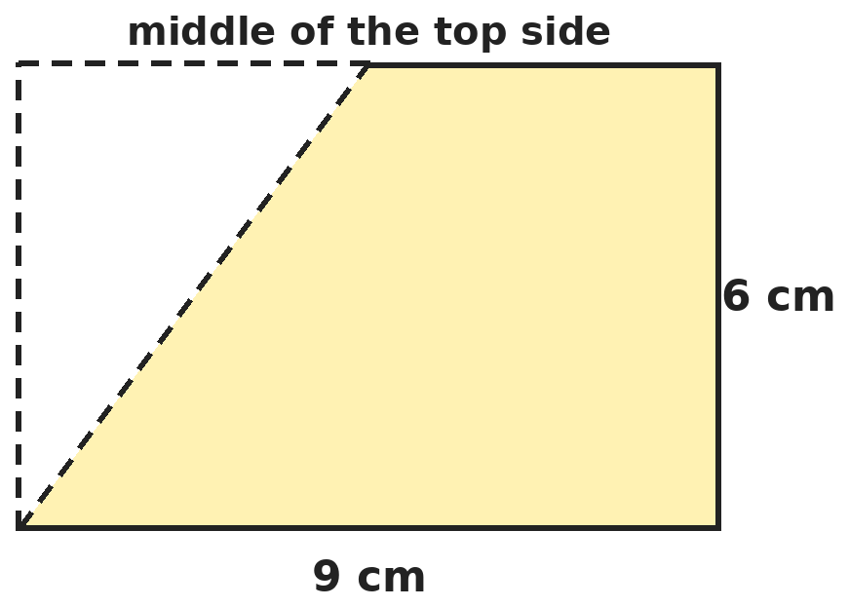
Q16. A line is drawn from the bottom-left corner of a 9 cm by 6 cm rectangle to the middle of its top side. What is the area of the shaded part?
(A) 27 cm² | (B) 40.5 cm² | (C) 13.5 cm² | (D) 45 cm²

Part 6 — Data Handling, Statistics & Probability (Syllabus Chapter 8)
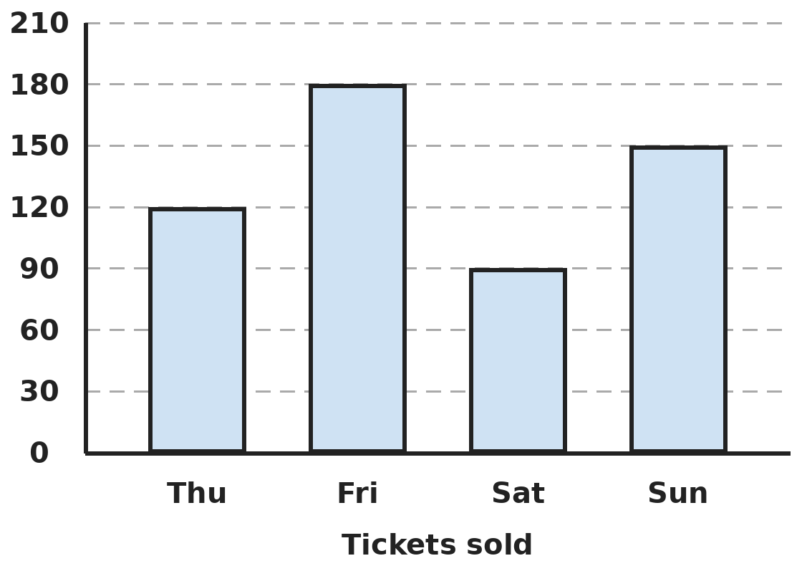
Q17. The bar graph shows tickets sold at a fair. Each ticket costs ₹15. How much more money was collected on the best day than on the worst day?
(A) ₹1,350 | (B) ₹90 | (C) ₹1,800 | (D) ₹2,700

Part 7 — Applied Mathematics (Syllabus Chapter 9)
Q18. A bus leaves a town at 9:00 AM at 45 km/h. A car leaves the same town at 10:00 AM on the same road at 60 km/h. At what time does the car catch up with the bus?
(A) 12:00 noon | (B) 2:00 PM | (C) 1:00 PM | (D) 12:30 PM

Q19. Devika walks 4 km in 50 minutes and then runs 6 km in 25 minutes. What is her average speed for the whole 10 km?
(A) 7.5 km/h | (B) 9.6 km/h | (C) 8 km/h | (D) 10 km/h

Q20. A meeting starts at 13:50 and lasts 155 minutes. At what time does it end, on the 24-hour clock?
(A) 16:25 | (B) 15:45 | (C) 16:05 | (D) 04:25

Q21. Mukesh changes a ₹500 note into ₹20 notes and ₹5 coins. He gets the same number of notes as coins. How many notes and coins does he get altogether?
(A) 20 | (B) 25 | (C) 50 | (D) 40

Part 8 — Mathematical Reasoning (Syllabus Chapter 10)

Q22. What number comes next in Rashmi's series?
(A) 42 | (B) 40 | (C) 36 | (D) 44

Q23. The year 2025 is not a leap year. Which month of 2025 begins on the same day of the week as January?
(A) April | (B) July | (C) September | (D) October

Q24. Diya writes the numbers 1 to 20. Again and again she rubs out any two numbers and writes their difference instead. In the end one number is left. What can you say about it?
(A) It is always odd | (B) It is always 0
(C) It is always even | (D) It can be odd or even

Q25. How many 3-digit odd numbers can be made from the digits 1, 2, 3 and 4 if digits may be used more than once?
(A) 24 | (B) 32 | (C) 64 | (D) 12

SECTION II — Star Questions 5 questions · each joins two chapters
Q26. Prime numbers are written in order: 2, 3, 5, 7, … What is the 10th prime number? [Star]
(A) 23 | (B) 29 | (C) 31 | (D) 27


Q27. Each number in Smita's series is the same fraction of the one before. Which number comes next? [Star]
(A) 63.9 | (B) 64.8 | (C) 65.61 | (D) 65.6

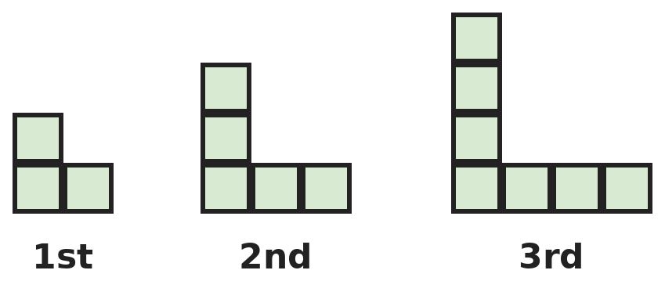
Q28. Each L shape is made of 1 cm squares, with both arms one square longer than in the shape before. What is the area of the 10th L shape? [Star]
(A) 20 cm² | (B) 21 cm² | (C) 44 cm² | (D) 22 cm²

Q29. A clock chimes every 20 minutes and a buzzer sounds every 30 minutes. Both sound together at 12:00 noon. When do they next sound together? [Star]
(A) 1:00 PM | (B) 12:50 PM | (C) 12:30 PM | (D) 2:00 PM

Q30. Ravi has ₹1,500 saved. He spends 0.4 of it on a bicycle and 3/20 of it on a helmet. How much does he have left? [Star]
(A) ₹825 | (B) ₹900 | (C) ₹750 | (D) ₹675

Answer Sheet AMO Level 2 · Class 5 · Practice Paper 9
Name: | School: | Roll No.:
Shade or tick one circle for each question.
1. | Ⓐ Ⓑ Ⓒ Ⓓ | 11. | Ⓐ Ⓑ Ⓒ Ⓓ | 21. | Ⓐ Ⓑ Ⓒ Ⓓ
2. | Ⓐ Ⓑ Ⓒ Ⓓ | 12. | Ⓐ Ⓑ Ⓒ Ⓓ | 22. | Ⓐ Ⓑ Ⓒ Ⓓ
3. | Ⓐ Ⓑ Ⓒ Ⓓ | 13. | Ⓐ Ⓑ Ⓒ Ⓓ | 23. | Ⓐ Ⓑ Ⓒ Ⓓ
4. | Ⓐ Ⓑ Ⓒ Ⓓ | 14. | Ⓐ Ⓑ Ⓒ Ⓓ | 24. | Ⓐ Ⓑ Ⓒ Ⓓ
5. | Ⓐ Ⓑ Ⓒ Ⓓ | 15. | Ⓐ Ⓑ Ⓒ Ⓓ | 25. | Ⓐ Ⓑ Ⓒ Ⓓ
6. | Ⓐ Ⓑ Ⓒ Ⓓ | 16. | Ⓐ Ⓑ Ⓒ Ⓓ | 26. | Ⓐ Ⓑ Ⓒ Ⓓ
7. | Ⓐ Ⓑ Ⓒ Ⓓ | 17. | Ⓐ Ⓑ Ⓒ Ⓓ | 27. | Ⓐ Ⓑ Ⓒ Ⓓ
8. | Ⓐ Ⓑ Ⓒ Ⓓ | 18. | Ⓐ Ⓑ Ⓒ Ⓓ | 28. | Ⓐ Ⓑ Ⓒ Ⓓ
9. | Ⓐ Ⓑ Ⓒ Ⓓ | 19. | Ⓐ Ⓑ Ⓒ Ⓓ | 29. | Ⓐ Ⓑ Ⓒ Ⓓ
10. | Ⓐ Ⓑ Ⓒ Ⓓ | 20. | Ⓐ Ⓑ Ⓒ Ⓓ | 30. | Ⓐ Ⓑ Ⓒ Ⓓ
Q26–Q30 are Section II Star Questions. Each joins two chapters.
For the parent or teacher
Section I correct: ______ / 25 Section II correct: ______ / 5
Correct: ______ / 30
Answer Key and Solutions AMO Level 2 · Class 5 · Practice Paper 9
Quick answers
1 A | 6 D | 11 A | 16 B | 21 D | 26 B
2 C | 7 C | 12 D | 17 A | 22 A | 27 C
3 C | 8 D | 13 B | 18 C | 23 D | 28 B
4 B | 9 B | 14 A | 19 C | 24 C | 29 A
5 D | 10 B | 15 D | 20 A | 25 B | 30 D
Solutions
Q | Part · level | Answer | Why?
1 | Part 1 · Ch1 · Hard | (A) 14 | Hint: The numbers you want are odd multiples of 3 that do not end in 5.  Odd multiples of 3 up to 100: 3, 9, 15, …, 99, which is 17. Remove those ending in 5 (odd multiples of 15): 15, 45, 75, which is 3. 17 − 3 = 14.
2 | Part 1 · Ch1 · Hard | (C) 216 | Hint: The number is a common multiple of 4, 6 and 9.  LCM of 4, 6 and 9 is 36. Its multiples are 180, 216, 252, … Only 216 is between 200 and 230. (204 and 228 are multiples of 4 and 6 but not of 9.)
3 | Part 1 · Ch1 · Hard | (C) LXXIX | Hint: MCMXLVII = 1947 and MMXXVI = 2026.  2026 − 1947 = 79 years. 79 = 50 + 10 + 10 + 9 = LXXIX.
4 | Part 2 · Ch2 · Hard | (B) Uma, 36 | Hint: Division and multiplication are done from left to right.  Working left to right: 60 ÷ 5 = 12, then 12 × 3 = 36. Uma is right. Ravi wrongly did 5 × 3 first.
5 | Part 2 · Ch2 · Hard | (D) 0 | Hint: Work out both answers.  Sakshi: 2,300 + 1,500 + 4,000 = 7,800. Mohit: 2,346 + 1,478 + 3,952 = 7,776, which rounds to 7,800. The difference is 0.
6 | Part 2 · Ch2 · Hard | (D) 9,99,000 | Hint: 999 = 999 × 1.  999 × 999 + 999 × 1 = 999 × (999 + 1) = 999 × 1,000 = 9,99,000.
7 | Part 3 · Ch3 · Hard | (C) ₹12 | Hint: Find 75% and 20% of ₹240.  75% of 240 = ₹180. 20% of 240 = ₹48. She has 180 + 48 = ₹228. She needs 240 − 228 = ₹12 more.
8 | Part 3 · Ch3 · Hard | (D) 320 ÷ 8 | Hint: Multiply both numbers by 100.  Multiplying both numbers by 100 does not change a division: 3.2 ÷ 0.08 = 320 ÷ 8 = 40. The others give 4, 0.4 and 0.4.
9 | Part 3 · Ch3 · Hard | (B) ₹795 | Hint: 12.5 = 100 ÷ 8, so 12.5 × 96.40 = 9,640 ÷ 8.  12.5 × 96.40 = 1,205 (12 × 96.40 = 1,156.80 and 0.5 × 96.40 = 48.20). Change: 2,000 − 1,205 = ₹795.
10 | Part 3 · Ch3 · Hard | (B) 200 mL | Hint: Find how much milk is in the jug first.  2/3 of 1,200 = 800 mL in the jug. 3/4 of 800 = 600 mL poured out. Left: 800 − 600 = 200 mL.
11 | Part 4 · Ch5 · Hard | (A) 270° | Hint: The minute hand turns 360° in 60 minutes.  It turns 6° every minute (360 ÷ 60). From 3:10 to 3:55 is 45 minutes: 45 × 6 = 270°.
12 | Part 4 · Ch5 · Hard | (D) Isosceles trapezium | Hint: Exactly one pair of parallel sides means a trapezium.  A shape with exactly one pair of parallel sides is a trapezium. When the other two sides are equal it is an isosceles trapezium. A parallelogram and a rhombus have two pairs of parallel sides; a kite has none.
13 | Part 4 · Ch5 · Hard | (B) 1 line, order 1 | Hint: Turning it upside down puts the point at the bottom.  Only the vertical line through the top point is a line of symmetry. It looks the same only after a full turn, so its order of rotational symmetry is 1.
14 | Part 5 · Ch6 · Hard | (A) 180 | Hint: Remove one layer of cubes from every face.  The unpainted cubes form an inner cuboid that is 2 cm shorter in each direction: 10 × 6 × 3 = 180.
15 | Part 5 · Ch6 · Hard | (D) The square, by 9 cm² | Hint: Find the side of the square and the width of the rectangle.  Square: side 9 cm, area 81 cm². Rectangle: 12 + width = 18, so width 6 cm and area 72 cm². The square is bigger by 9 cm².
16 | Part 5 · Ch6 · Hard | (B) 40.5 cm² | Hint: The white part is a right-angled triangle.  Rectangle: 9 × 6 = 54 cm². White triangle: sides 6 cm and 4.5 cm at the right angle, so half of 27 = 13.5 cm². Shaded: 54 − 13.5 = 40.5 cm².
17 | Part 6 · Ch8 · Hard | (A) ₹1,350 | Hint: Find the difference in tickets first.  Best day: Friday, 180. Worst: Saturday, 90. Difference: 90 tickets. 90 × 15 = ₹1,350.
18 | Part 7 · Ch9 · Hard | (C) 1:00 PM | Hint: How far ahead is the bus at 10:00 AM?  At 10:00 the bus is 45 km ahead. The car gains 60 − 45 = 15 km every hour. 45 ÷ 15 = 3 hours, so at 1:00 PM.
19 | Part 7 · Ch9 · Hard | (C) 8 km/h | Hint: Total time is 75 minutes.  10 km in 75 minutes. 75 minutes = 1.25 hours. 10 ÷ 1.25 = 8 km/h.
20 | Part 7 · Ch9 · Hard | (A) 16:25 | Hint: 155 minutes = 2 hours 35 minutes.  155 minutes = 2 h 35 min. 13:50 + 2 h = 15:50. 15:50 + 35 min = 16:25.
21 | Part 7 · Ch9 · Hard | (D) 40 | Hint: One note and one coin together make ₹25.  Each pair of one ₹20 note and one ₹5 coin is ₹25. 500 ÷ 25 = 20 pairs. That is 20 notes and 20 coins: 40 in all.
22 | Part 8 · Ch10 · Hard | (A) 42 | Hint: Look at the differences: 4, 6, 8, 10, …  The differences are 4, 6, 8, 10, so the next is 12: 30 + 12 = 42. (Also 1 × 2, 2 × 3, 3 × 4, 4 × 5, 5 × 6, 6 × 7.)
23 | Part 8 · Ch10 · Hard | (D) October | Hint: Count the days from 1 January to the 1st of each month.  Days before each 1st: April 90, July 181, September 243, October 273. 273 = 39 weeks exactly, so 1 October is the same weekday as 1 January. (90, 181 and 243 are not multiples of 7.)
24 | Part 8 · Ch10 · Hard | (C) It is always even | Hint: What happens to whether the total is odd or even at each step?  The total starts at 1 + 2 + … + 20 = 210, which is even. Replacing a and b by their difference changes the total by an even amount (2 × the smaller number), so the total stays even. The last number is always even.
25 | Part 8 · Ch10 · Hard | (B) 32 | Hint: The ones digit must be 1 or 3.  Hundreds digit: 4 choices. Tens digit: 4 choices. Ones digit: 1 or 3, so 2 choices. 4 × 4 × 2 = 32.
26 | Section II · Ch1 + Ch10 · Hard | (B) 29 | Hint: Keep listing and check each number for factors.  2, 3, 5, 7, 11, 13, 17, 19, 23, 29. The 10th is 29. (27 = 3 × 9 is not prime.)
27 | Section II · Ch3 + Ch10 · Hard | (C) 65.61 | Hint: Each number is 9/10 of the one before.  100 × 0.9 = 90, 90 × 0.9 = 81, 81 × 0.9 = 72.9. Next: 72.9 × 0.9 = 72.9 − 7.29 = 65.61.
28 | Section II · Ch6 + Ch10 · Hard | (B) 21 cm² | Hint: The 1st shape has 3 squares, the 2nd 5, the 3rd 7.  The number of squares goes up by 2 each time: 3, 5, 7, … The 10th has 3 + 9 × 2 = 21 squares, so its area is 21 cm².
29 | Section II · Ch1 + Ch9 · Hard | (A) 1:00 PM | Hint: Find the LCM of 20 and 30.  LCM of 20 and 30 is 60 minutes. 12:00 noon + 60 minutes = 1:00 PM. (12:50 adds 20 and 30, and 2:00 PM is a later common time.)
30 | Section II · Ch3 + Ch9 · Hard | (D) ₹675 | Hint: 0.4 of 1,500 and 3/20 of 1,500.  0.4 of 1,500 = ₹600. 3/20 of 1,500 = ₹225. Left: 1,500 − 600 − 225 = ₹675.

ARYABHATTA MATHS OLYMPIAD
Level 2
PRACTICE PAPER-10
CLASS 5
Total Questions | 30 multiple-choice questions
Level | Level-2 (final round): every question is Hard
Time | 45 minutes
Section I | 25 questions, each from one chapter
Section II | 5 Star Questions, each joining two chapters
Negative Marking | No negative marking
Calculator | Not allowed
Chapters | Number System · Operations · Fractions, Decimals & Percentages · Geometry · Mensuration · Data Handling, Statistics & Probability · Applied Mathematics · Mathematical Reasoning

👋 Hello, friend! How to do this paper:
⭐ Every question has four answer choices: (A), (B), (C) and (D). Only one is correct.
⭐ Read each question and look at its picture carefully. Then mark your answer on the answer sheet at the end.
⭐ This is a Level-2 paper. Every question needs careful thinking, so take your time and check each step.
⭐ Section I has 25 questions. Section II has 5 Star Questions.
⭐ There is no negative marking, so try every question.
⭐ Do not use a calculator. You may do rough work on a separate sheet.
⭐ All figures are not necessarily drawn to scale unless stated.

For parents and teachers
• Pictures are part of the questions. Every picture also works when printed in black and white.
• You may read a question aloud to the child, exactly as printed. Please do not explain it or point to an answer choice.
• Parts follow the AMO syllabus chapters. Chapters 4 and 7 are not part of the Class 5 syllabus, so the chapter numbers shown in the Part headings have gaps.
• The answer sheet and the answer key are at the end. Remove only the answer key before the child begins.

SECTION I 25 questions · every question is Hard
Part 1 — Number System (Syllabus Chapter 1)
Q1. Which is the smallest of these numbers that has exactly 6 factors: 12, 18, 20 or 24?
(A) 18 | (B) 12 | (C) 20 | (D) 24

Q2. Two numbers multiply to give 720. Their HCF is 12. What is their LCM?
(A) 708 | (B) 120 | (C) 36 | (D) 60

Q3. Which number is made of 7 lakhs, 15 thousands, 12 hundreds and 9 ones?
(A) 7,15,129 | (B) 7,16,290 | (C) 7,16,209 | (D) 8,52,109

Part 2 — Operations (Syllabus Chapter 2)
Q4. Vrinda works out this expression in the correct order. What answer does she get?
(A) 11 | (B) 16 | (C) 10 | (D) 20

Q5. A shop sells 198 toys at ₹49 each. Shalini estimates the takings as 200 × 50. By how much is her estimate too high?
(A) ₹300 | (B) ₹202 | (C) ₹98 | (D) ₹298

Q6. The value of 24 ÷ 4 × 3 + 6 is 24. Which way of adding brackets keeps the value 24?
(A) (24 ÷ 4) × 3 + 6 | (B) 24 ÷ (4 × 3) + 6
(C) 24 ÷ 4 × (3 + 6) | (D) 24 ÷ (4 × 3 + 6)

Part 3 — Fractions, Decimals & Percentages (Syllabus Chapter 3)
Q7. A village has 1,200 voters. 85% of them voted. The winner got 60% of the votes cast. How many votes did the winner get?
(A) 720 | (B) 510 | (C) 612 | (D) 680

Q8. How many of these are equal to 0.8: 4/5, 16/20, 8/100, 12/15?
(A) 3 | (B) 2 | (C) 4 | (D) 1

Q9. A 250 g packet of biscuits costs ₹42.50. At the same rate, how much do 1.5 kg of these biscuits cost?
(A) ₹63.75 | (B) ₹170 | (C) ₹637.50 | (D) ₹255

Q10. A class has 36 students and 2/3 of them are girls. 3/8 of the girls and 1/4 of the boys come by bus. How many students come by bus?
(A) 12 | (B) 9 | (C) 15 | (D) 18

Part 4 — Geometry (Syllabus Chapter 5)
Q11. A straight angle is split into three angles. One is 47°. The second is 21° more than the first. What is the third angle, and what type is it?
(A) 65°, acute | (B) 65°, obtuse | (C) 112°, obtuse | (D) 86°, acute

Q12. Two angles of a triangle are 35° and 55°. How is the triangle best described?
(A) Acute-angled isosceles | (B) Right-angled scalene
(C) Right-angled isosceles | (D) Obtuse-angled scalene

Q13. A wheel has 5 equally spaced spokes and nothing else marked on it. What is the smallest turn that makes it look exactly the same?
(A) 60° | (B) 90° | (C) 72° | (D) 36°

Part 5 — Mensuration (Syllabus Chapter 6)
Q14. A cube-shaped water tank has edges 2 m long. How many litres does it hold when full? (1 m³ = 1,000 L)
(A) 6,000 L | (B) 800 L | (C) 80,000 L | (D) 8,000 L

Q15. Suhani cuts a 16 cm by 10 cm card into two pieces 16 cm by 5 cm and puts them end to end to make one long rectangle. What is its perimeter?
(A) 52 cm | (B) 74 cm | (C) 84 cm | (D) 64 cm

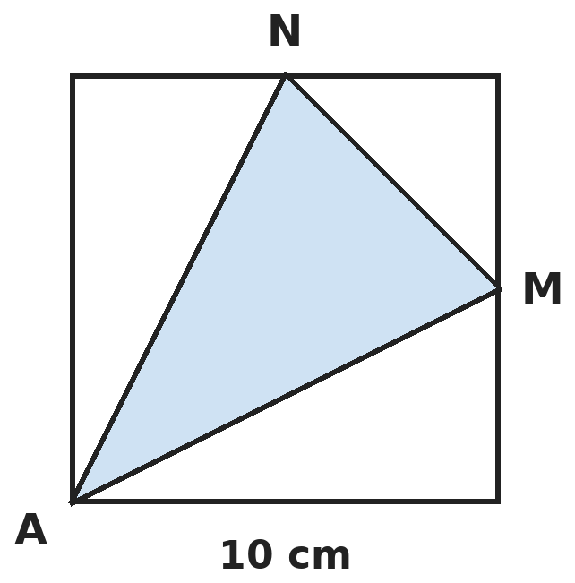
Q16. M and N are the middle points of two sides of a 10 cm square, as shown. Corner A is joined to M and N. What is the area of the shaded triangle AMN?
(A) 37.5 cm² | (B) 50 cm² | (C) 25 cm² | (D) 62.5 cm²

Part 6 — Data Handling, Statistics & Probability (Syllabus Chapter 8)
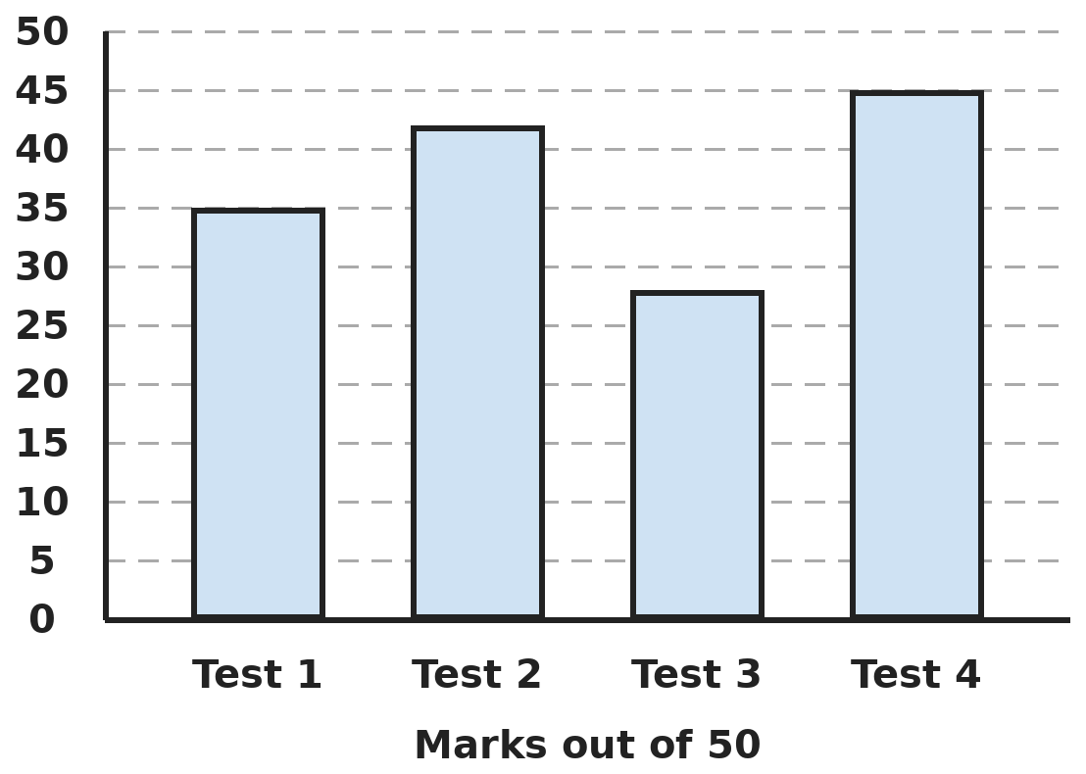
Q17. The bar graph shows Riya's marks out of 50 in four tests. In how many tests did she score more than 70%?
(A) 3 | (B) 1 | (C) 2 | (D) 4

Part 7 — Applied Mathematics (Syllabus Chapter 9)
Q18. A train 150 m long passes a pole in 10 seconds. What is its speed in km/h?
(A) 15 km/h | (B) 54 km/h | (C) 90 km/h | (D) 36 km/h

Q19. Arjun drives 90 km to a town at 45 km/h and comes back the same way at 30 km/h. What is his average speed for the whole trip?
(A) 37.5 km/h | (B) 36 km/h | (C) 40 km/h | (D) 35 km/h

Q20. Jaya goes to sleep at 10:40 PM on Tuesday and wakes at 7:15 AM on Wednesday. For how many minutes does she sleep?
(A) 475 | (B) 535 | (C) 515 | (D) 495

Q21. A shop gives 2 free pens for every 10 pens you buy. Each pen costs ₹7.50. Kiran needs 36 pens. What is the least he must pay?
(A) ₹225 | (B) ₹270 | (C) ₹240 | (D) ₹232.50

Part 8 — Mathematical Reasoning (Syllabus Chapter 10)

Q22. In this series, the 2nd number is 2 × 2 × 2. Which number comes next?
(A) 100 | (B) 125 | (C) 81 | (D) 216

Q23. Today is Monday, 10 June. What is the date of the third Saturday after today?
(A) 22 June | (B) 29 June | (C) 30 June | (D) 6 July

Q24. Gaurav multiplies two whole numbers that come one after the other, like 4 × 5. Which of these could be his answer?
(A) 45 | (B) 91 | (C) 63 | (D) 56

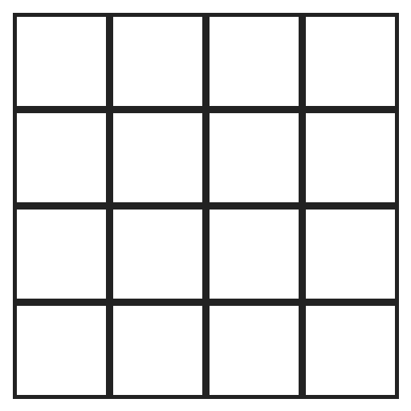
Q25. How many squares of all sizes are there in this 4 by 4 grid?
(A) 16 | (B) 30 | (C) 20 | (D) 25

SECTION II — Star Questions 5 questions · each joins two chapters

Q26. The series goes up by 4 each time and stops before 100. How many numbers in the series are prime? [Star]
(A) 12 | (B) 14 | (C) 11 | (D) 13


Q27. The series goes down by the same amount each time. Which number in the series (1st, 2nd, …) is the first one less than 1? [Star]
(A) 7th | (B) 6th | (C) 8th | (D) 10th

Q28. Om builds cuboids from 1 cm cubes: 1 × 1 × 2, then 2 × 2 × 3, then 3 × 3 × 4, and so on. Which is the first cuboid with a volume of more than 300 cm³? [Star]
(A) 6th | (B) 8th | (C) 7th | (D) 5th

Q29. Mohan has ₹1,100. He buys as many ₹45 notebooks as he can, and then spends the money left on ₹5 pencils. How many pencils does he buy? [Star]
(A) 1 | (B) 2 | (C) 0 | (D) 4

Q30. Anand has ₹2,560. He spends 25% of it on clothes and then 0.3 of the money left on books. How much does he have now? [Star]
(A) ₹1,152 | (B) ₹1,408 | (C) ₹1,344 | (D) ₹1,216

Answer Sheet AMO Level 2 · Class 5 · Practice Paper 10
Name: | School: | Roll No.:
Shade or tick one circle for each question.
1. | Ⓐ Ⓑ Ⓒ Ⓓ | 11. | Ⓐ Ⓑ Ⓒ Ⓓ | 21. | Ⓐ Ⓑ Ⓒ Ⓓ
2. | Ⓐ Ⓑ Ⓒ Ⓓ | 12. | Ⓐ Ⓑ Ⓒ Ⓓ | 22. | Ⓐ Ⓑ Ⓒ Ⓓ
3. | Ⓐ Ⓑ Ⓒ Ⓓ | 13. | Ⓐ Ⓑ Ⓒ Ⓓ | 23. | Ⓐ Ⓑ Ⓒ Ⓓ
4. | Ⓐ Ⓑ Ⓒ Ⓓ | 14. | Ⓐ Ⓑ Ⓒ Ⓓ | 24. | Ⓐ Ⓑ Ⓒ Ⓓ
5. | Ⓐ Ⓑ Ⓒ Ⓓ | 15. | Ⓐ Ⓑ Ⓒ Ⓓ | 25. | Ⓐ Ⓑ Ⓒ Ⓓ
6. | Ⓐ Ⓑ Ⓒ Ⓓ | 16. | Ⓐ Ⓑ Ⓒ Ⓓ | 26. | Ⓐ Ⓑ Ⓒ Ⓓ
7. | Ⓐ Ⓑ Ⓒ Ⓓ | 17. | Ⓐ Ⓑ Ⓒ Ⓓ | 27. | Ⓐ Ⓑ Ⓒ Ⓓ
8. | Ⓐ Ⓑ Ⓒ Ⓓ | 18. | Ⓐ Ⓑ Ⓒ Ⓓ | 28. | Ⓐ Ⓑ Ⓒ Ⓓ
9. | Ⓐ Ⓑ Ⓒ Ⓓ | 19. | Ⓐ Ⓑ Ⓒ Ⓓ | 29. | Ⓐ Ⓑ Ⓒ Ⓓ
10. | Ⓐ Ⓑ Ⓒ Ⓓ | 20. | Ⓐ Ⓑ Ⓒ Ⓓ | 30. | Ⓐ Ⓑ Ⓒ Ⓓ
Q26–Q30 are Section II Star Questions. Each joins two chapters.
For the parent or teacher
Section I correct: ______ / 25 Section II correct: ______ / 5
Correct: ______ / 30
Answer Key and Solutions AMO Level 2 · Class 5 · Practice Paper 10
Quick answers
1 B | 6 A | 11 A | 16 A | 21 A | 26 D
2 D | 7 C | 12 B | 17 C | 22 B | 27 C
3 C | 8 A | 13 C | 18 B | 23 B | 28 C
4 A | 9 D | 14 D | 19 B | 24 D | 29 D
5 D | 10 A | 15 B | 20 C | 25 B | 30 C
Solutions
Q | Part · level | Answer | Why?
1 | Part 1 · Ch1 · Hard | (B) 12 | Hint: List the factors of each number.  12: 1, 2, 3, 4, 6, 12 (6 factors). 18: 1, 2, 3, 6, 9, 18 (6). 20: 1, 2, 4, 5, 10, 20 (6). 24 has 8 factors. The smallest with exactly 6 is 12.
2 | Part 1 · Ch1 · Hard | (D) 60 | Hint: For any two numbers, HCF × LCM = the product of the numbers.  HCF × LCM = 720, so LCM = 720 ÷ 12 = 60. Check: 12 and 60 multiply to 720, their HCF is 12 and their LCM is 60.
3 | Part 1 · Ch1 · Hard | (C) 7,16,209 | Hint: 12 hundreds is 1 thousand and 2 hundreds.  7,00,000 + 15,000 + 1,200 + 9 = 7,16,209.
4 | Part 2 · Ch2 · Hard | (A) 11 | Hint: Start with the round bracket, then finish the square bracket.  6 − 4 = 2. Square bracket: 8 − 2 × 2 = 8 − 4 = 4. Then 3 × 4 = 12, 12 ÷ 2 = 6 and 5 + 6 = 11. (16 adds 5 + 3 first.)
5 | Part 2 · Ch2 · Hard | (D) ₹298 | Hint: Work out 198 × 49 exactly as 198 × 50 − 198.  198 × 49 = 198 × 50 − 198 = 9,900 − 198 = ₹9,702. Estimate: ₹10,000. Too high by 10,000 − 9,702 = ₹298.
6 | Part 2 · Ch2 · Hard | (A) (24 ÷ 4) × 3 + 6 | Hint: Work out each one.  (24 ÷ 4) × 3 + 6 = 18 + 6 = 24, the same as working left to right. 24 ÷ 12 + 6 = 8. 6 × 9 = 54. 24 ÷ 18 is not even a whole number.
7 | Part 3 · Ch3 · Hard | (C) 612 | Hint: Find the number of votes cast first.  Votes cast: 85% of 1,200 = 1,020. Winner: 60% of 1,020 = 6 × 102 = 612. (720 is 60% of all 1,200 voters.)
8 | Part 3 · Ch3 · Hard | (A) 3 | Hint: Simplify each fraction.  4/5 = 0.8, 16/20 = 4/5 = 0.8, 12/15 = 4/5 = 0.8. But 8/100 = 0.08. So 3 of them.
9 | Part 3 · Ch3 · Hard | (D) ₹255 | Hint: How many 250 g packets make 1.5 kg?  1.5 kg = 1,500 g = 6 packets of 250 g. 6 × 42.50 = ₹255.
10 | Part 3 · Ch3 · Hard | (A) 12 | Hint: Find the number of girls and boys first.  Girls: 2/3 of 36 = 24. Boys: 12. By bus: 3/8 of 24 = 9 girls and 1/4 of 12 = 3 boys. 9 + 3 = 12.
11 | Part 4 · Ch5 · Hard | (A) 65°, acute | Hint: Find the second angle first. A straight angle is 180°.  The second angle is 47° + 21° = 68°. The third is 180° − 47° − 68° = 65°. It is less than 90°, so it is acute.
12 | Part 4 · Ch5 · Hard | (B) Right-angled scalene | Hint: Find the third angle first.  Third angle: 180° − 35° − 55° = 90°, so it is right-angled. All three angles are different, so all three sides are different: scalene.
13 | Part 4 · Ch5 · Hard | (C) 72° | Hint: It looks the same 5 times in one full turn.  Its order of rotational symmetry is 5, so the smallest turn is 360° ÷ 5 = 72°.
14 | Part 5 · Ch6 · Hard | (D) 8,000 L | Hint: Find the volume in m³ first.  Volume = 2 × 2 × 2 = 8 m³. 8 × 1,000 = 8,000 L. (6,000 comes from adding 2 + 2 + 2.)
15 | Part 5 · Ch6 · Hard | (B) 74 cm | Hint: The new rectangle is 32 cm long.  The new rectangle is 32 cm by 5 cm. Perimeter: 2 × (32 + 5) = 74 cm. (The old card had perimeter 52 cm.)
16 | Part 5 · Ch6 · Hard | (A) 37.5 cm² | Hint: The three white parts are right-angled triangles.  White triangles: half of 10 × 5 = 25, another 25, and half of 5 × 5 = 12.5. Total 62.5 cm². Shaded: 100 − 62.5 = 37.5 cm².
17 | Part 6 · Ch8 · Hard | (C) 2 | Hint: 70% of 50 is 35. Is 35 itself more than 70%?  70% of 50 = 35. Marks more than 35: 42 and 45. Test 1 is exactly 35, which is not more than 70%. So 2 tests.
18 | Part 7 · Ch9 · Hard | (B) 54 km/h | Hint: Its front must travel its own length to pass the pole.  It travels 150 m in 10 s, which is 15 m every second. In one hour (3,600 s): 15 × 3,600 = 54,000 m = 54 km. So 54 km/h.
19 | Part 7 · Ch9 · Hard | (B) 36 km/h | Hint: Find the time for each way.  Going: 90 ÷ 45 = 2 h. Returning: 90 ÷ 30 = 3 h. 180 km in 5 h: 180 ÷ 5 = 36 km/h. (37.5 is the plain average of the speeds.)
20 | Part 7 · Ch9 · Hard | (C) 515 | Hint: Count to midnight first.  10:40 PM to midnight: 1 h 20 min. Midnight to 7:15 AM: 7 h 15 min. Total 8 h 35 min = 480 + 35 = 515 minutes.
21 | Part 7 · Ch9 · Hard | (A) ₹225 | Hint: Every 10 pens bought gives 12 pens.  30 pens bought give 6 free pens: 36 pens. Cost: 30 × 7.50 = ₹225. (Buying 29 pens gives only 2 × 2 = 4 free, 33 in all.)
22 | Part 8 · Ch10 · Hard | (B) 125 | Hint: The 3rd number is 3 × 3 × 3.  1 = 1 × 1 × 1, 8 = 2 × 2 × 2, 27 = 3 × 3 × 3, 64 = 4 × 4 × 4. Next: 5 × 5 × 5 = 125.
23 | Part 8 · Ch10 · Hard | (B) 29 June | Hint: The first Saturday after Monday 10 June is 5 days later.  The Saturdays after today are 15 June, 22 June and 29 June. The third is 29 June.
24 | Part 8 · Ch10 · Hard | (D) 56 | Hint: One of two numbers next to each other is always even.  Of two numbers next to each other, one is even, so the product is even. Only 56 is even, and 56 = 7 × 8.
25 | Part 8 · Ch10 · Hard | (B) 30 | Hint: Count 1 by 1, 2 by 2, 3 by 3 and 4 by 4 squares.  1 by 1: 16. 2 by 2: 9. 3 by 3: 4. 4 by 4: 1. 16 + 9 + 4 + 1 = 30.
26 | Section II · Ch1 + Ch10 · Hard | (D) 13 | Hint: The series is 3, 7, 11, 15, 19, …, 99. Cross out multiples of 3, 5 and 7.  The numbers are 3, 7, 11, 15, 19, 23, 27, 31, 35, 39, 43, 47, 51, 55, 59, 63, 67, 71, 75, 79, 83, 87, 91, 95, 99. The primes are 3, 7, 11, 19, 23, 31, 43, 47, 59, 67, 71, 79, 83: 13. (91 = 7 × 13 and 51 = 3 × 17 are not prime.)
27 | Section II · Ch3 + Ch10 · Hard | (C) 8th | Hint: List the numbers until you go below 1.  2.5, 2.25, 2, 1.75, 1.5, 1.25, 1, 0.75. The 7th number is exactly 1, which is not less than 1. The 8th, 0.75, is the first below 1.
28 | Section II · Ch6 + Ch10 · Hard | (C) 7th | Hint: Write the volumes of the 5th, 6th and 7th cuboids.  5th: 5 × 5 × 6 = 150 cm³. 6th: 6 × 6 × 7 = 252 cm³. 7th: 7 × 7 × 8 = 392 cm³. The 7th is the first over 300 cm³.
29 | Section II · Ch1 + Ch9 · Hard | (D) 4 | Hint: Find how many notebooks he can buy and how much is left.  45 × 24 = 1,080 and 45 × 25 = 1,125, which is too much. So 24 notebooks, leaving 1,100 − 1,080 = ₹20. 20 ÷ 5 = 4 pencils.
30 | Section II · Ch3 + Ch9 · Hard | (C) ₹1,344 | Hint: Find the money left after the clothes first.  25% of 2,560 = ₹640, leaving ₹1,920. 0.3 of 1,920 = ₹576. Left: 1,920 − 576 = ₹1,344. (₹1,152 wrongly takes 0.3 of 2,560.)

