UNLOCK IQ INSTITUTE
Realize Your True Potential
Aryabhatta Maths Olympiad (AMO)
Level 1 — Practice Paper 1
CLASS 1

Questions | 45 multiple-choice questions
Marks | 100
Time | 60 minutes
Section I | 40 questions × 2 marks = 80 marks
Section II | 5 Star Questions × 4 marks = 20 marks
Negative marking | No negative marking
Calculator | Not allowed
Chapters | Number System · Operations · Geometry · Applied Mathematics · Mathematical Reasoning

Hello, friend!
• Every question has four answer choices: (A), (B), (C) and (D). Only one is correct.
• Read each question and look at its picture carefully. Then mark your answer on the answer sheet at the end.
• Section I has 40 questions of 2 marks each. Section II has 5 Star Questions of 4 marks each.
• There is no negative marking, so try every question.
• Do not use a calculator. You may do rough work on a separate sheet.

For parents and teachers
Print or view this paper in colour. Pictures are part of the questions.
You may read a question aloud to the child, exactly as printed. Please do not explain it or point to an answer choice.
Parts follow the AMO syllabus chapters. Chapters 3, 4, 6, 7 and 8 are not part of the Class 1 syllabus, so the chapter numbers shown in the Part headings have gaps.
The answer sheet and the answer key with solutions are at the end. Give the child the answer sheet. Remove the answer key and solutions before the child begins.

Name: | School: | Roll No.:

SECTION I 40 questions × 2 marks each
Part 1 — Number System (Syllabus Chapter 1)
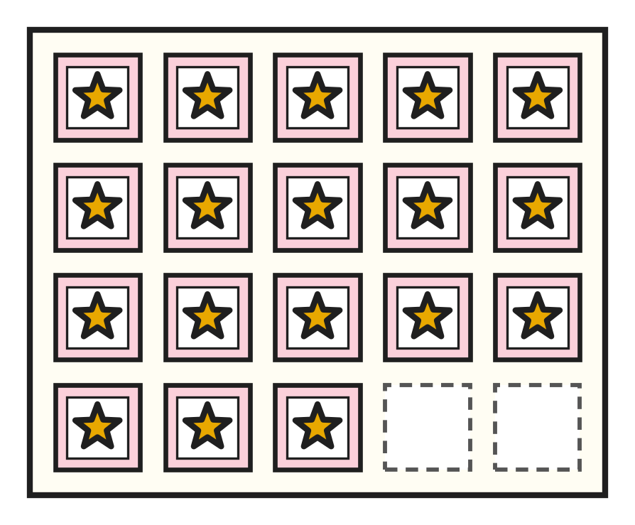
Q1. Look at the stamp page. How many stamps are on it?
(A) 17 | (B) 20 | (C) 81 | (D) 18

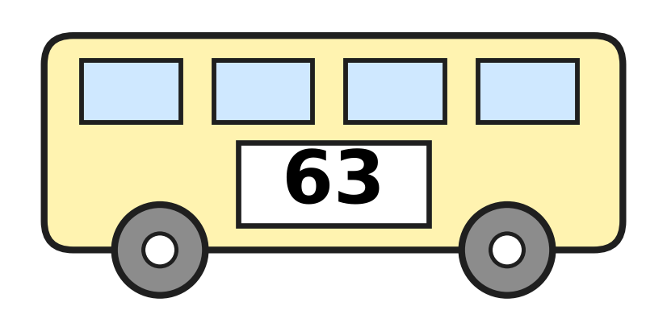
Q2. Look at the number on the school bus. What is its number name?
(A) sixty-three | (B) sixteen
(C) sixty | (D) thirty-six

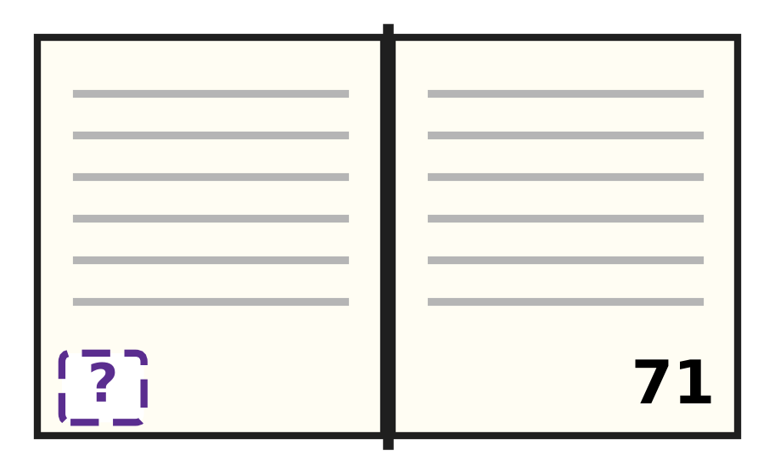
Q3. Look at Reena's open book. The right page is page 71. What is the number of the left page?
(A) 69 | (B) 61 | (C) 72 | (D) 70

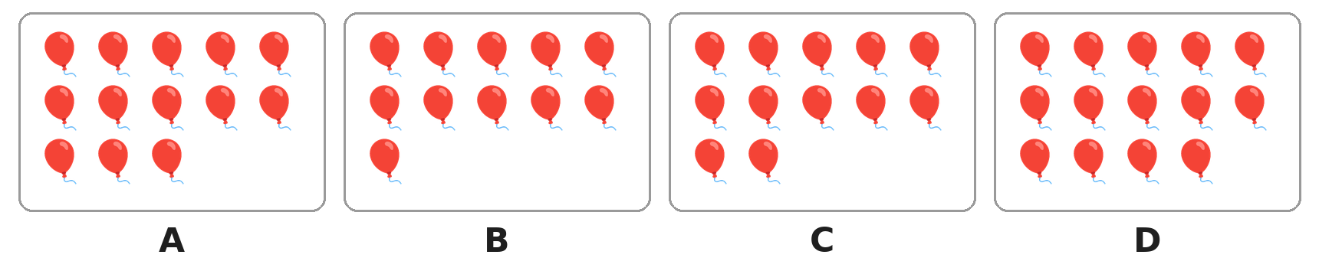
Q4. Look at the four pictures. Which picture has the smallest number of balloons?
(A) Picture A | (B) Picture B
(C) Picture C | (D) Picture D

Q5. Which number has 6 as its ones digit?
(A) 65 | (B) 61 | (C) 60 | (D) 16

Q6. Shreya counts in tens: 10, 20, 30, and so on. Which number does she say just after 70?
(A) 80 | (B) 90 | (C) 60 | (D) 71

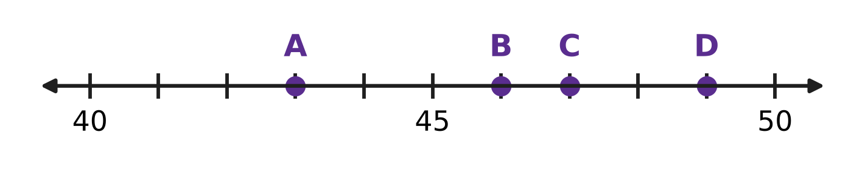
Q7. Look at the number line. Which dot shows the number 47?
(A) Dot A | (B) Dot B | (C) Dot C | (D) Dot D

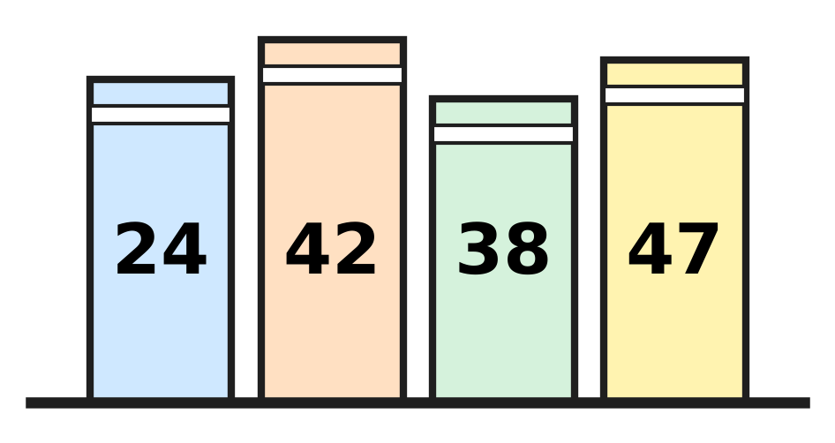
Q8. Look at the books. Which two books should swap places so that the numbers are in order, smallest first?
(A) 42 and 47 | (B) 24 and 38
(C) 42 and 38 | (D) 24 and 47

Q9. Which number has more tens than ones?
(A) 38 | (B) 52 | (C) 66 | (D) 47

Q10. The sign > means "is greater than". The sign < means "is smaller than". Which one is correct?
(A) 58 > 85 | (B) 70 < 17 | (C) 46 > 64 | (D) 39 < 93

Q11. Navya has 58 marbles. She puts 10 marbles in each jar. How many jars will be full?
(A) 13 | (B) 8 | (C) 5 | (D) 6

Q12. A number has the same ones digit as 46. It has one more ten than 46. Which number is it?
(A) 56 | (B) 47 | (C) 36 | (D) 57

Part 2 — Operations & Number Properties (Syllabus Chapter 2)
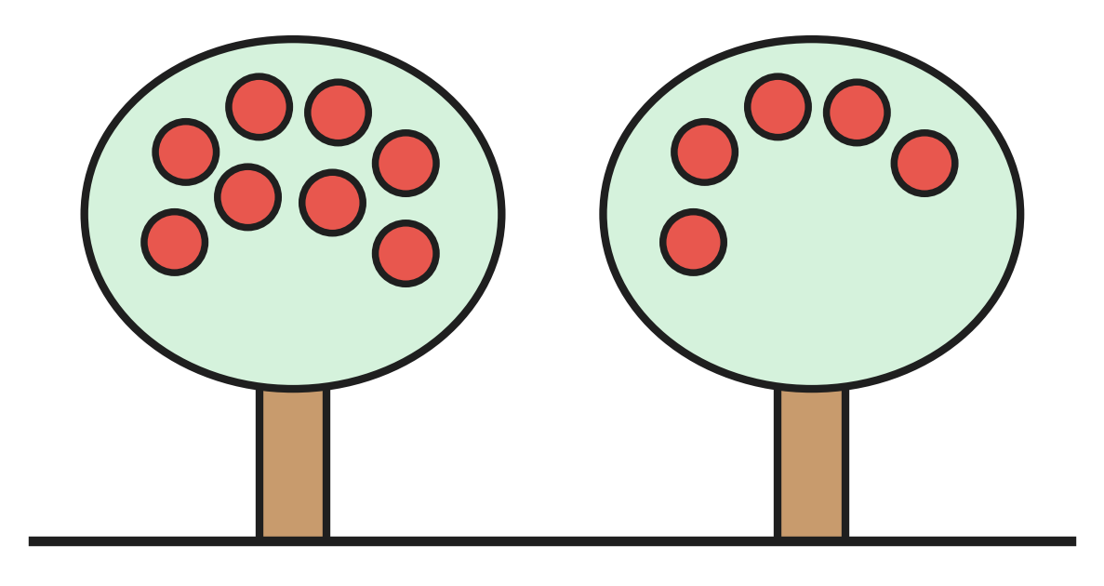
Q13. Look at the two apple trees. How many apples are on the trees in all?
(A) 3 | (B) 13 | (C) 8 | (D) 12

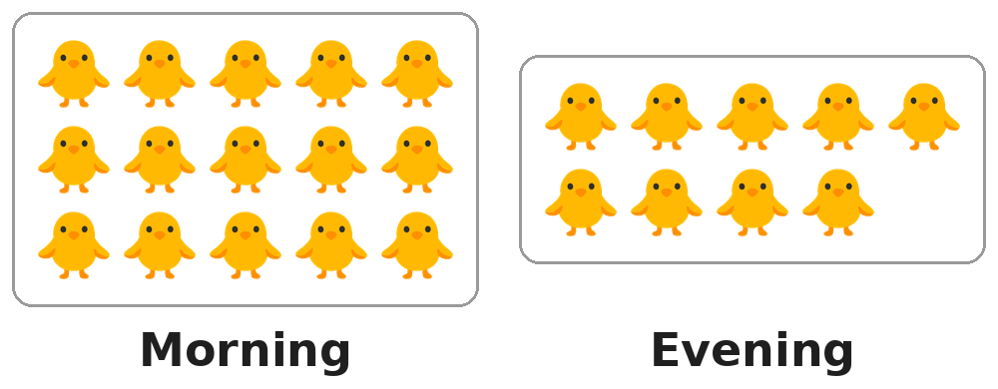
Q14. Look at the two pictures of a farm. In the morning there are 15 chicks. In the evening there are 9. How many chicks have gone away?
(A) 6 | (B) 7 | (C) 9 | (D) 5

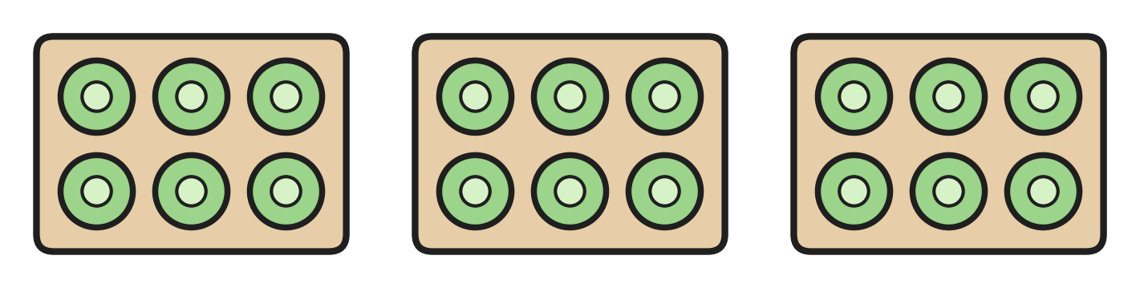
Q15. Look at the vegetable garden. Each bed has 6 cabbages. How many cabbages are there in all?
(A) 9 | (B) 12 | (C) 16 | (D) 18

Q16. There are 6 children in the swimming pool. Then 8 more children jump in. How many children are in the pool now?
(A) 2 | (B) 13 | (C) 14 | (D) 16

Q17. There are 18 children on a bicycle trip. Then 5 of them stop to rest. How many children are still riding?
(A) 5 | (B) 13 | (C) 23 | (D) 12

Q18. Which number is 2 less than 20?
(A) 19 | (B) 18 | (C) 12 | (D) 22

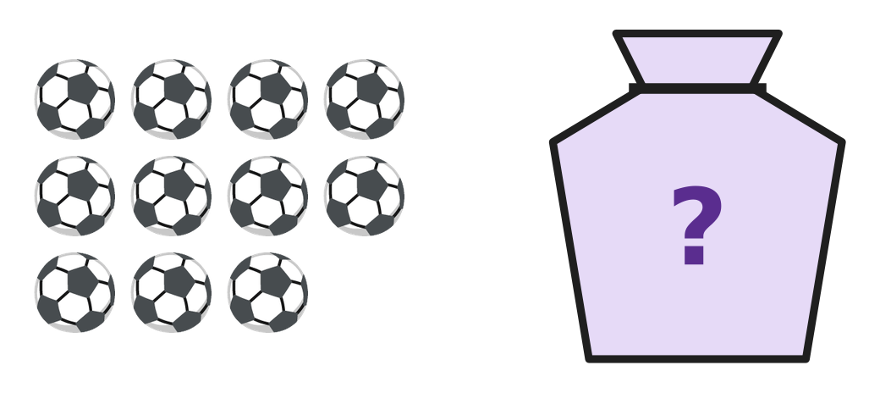
Q19. Jack has 17 balls. The picture shows 11 of them. The other balls are in the bag. How many balls are in the bag?
(A) 6 | (B) 11 | (C) 7 | (D) 5

Q20. Madhu knows that 7 + 8 = 15. What is 15 − 8?
(A) 23 | (B) 6 | (C) 7 | (D) 8

Q21. Arun ties 6 red bows, 4 blue bows and 3 yellow bows on the tail of his kite. How many bows does he tie in all?
(A) 7 | (B) 14 | (C) 10 | (D) 13

Q22. A rainwater tank holds 20 buckets of water. Amma uses 6 buckets for the garden and 5 buckets for washing. How many buckets of water are left in the tank?
(A) 14 | (B) 9 | (C) 11 | (D) 15

Part 3 — Geometry (Syllabus Chapter 5)
Q23. Kai looks at the wheel of his bicycle from the side. Which shape does he see?
(A) Circle | (B) Square
(C) Triangle | (D) Rectangle

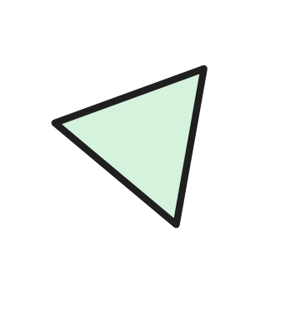
Q24. Look at the shape. How many straight sides does it have?
(A) 0 | (B) 2 | (C) 4 | (D) 3

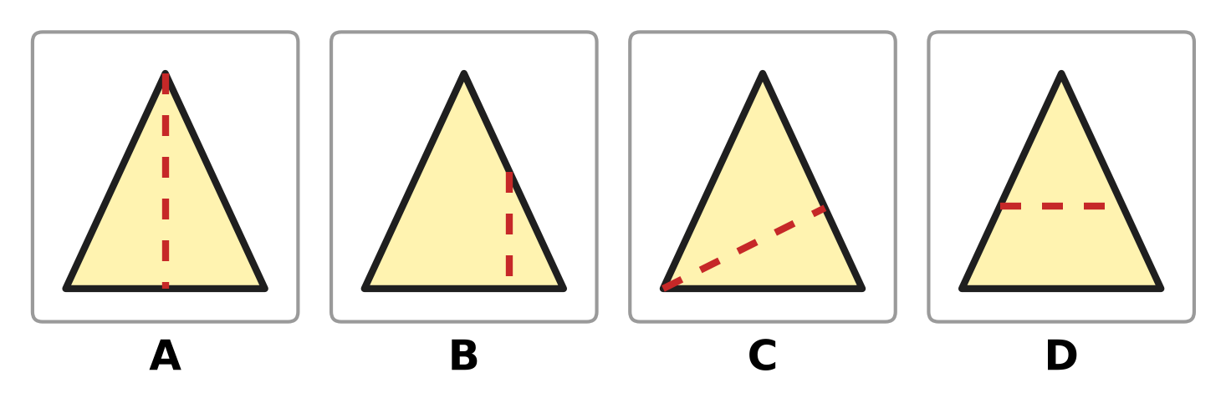
Q25. Look at the four paper triangles. In which picture does the dotted line cut the triangle into two parts of the same size and shape?
(A) Picture A | (B) Picture B
(C) Picture C | (D) Picture D

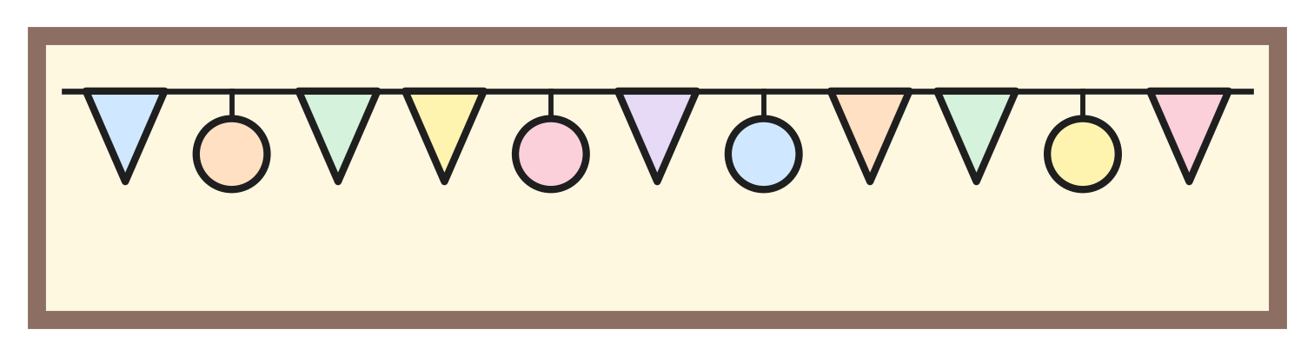
Q26. Look at the string of shapes on the notice board. How many of the shapes have no corners?
(A) 7 | (B) 3 | (C) 4 | (D) 11

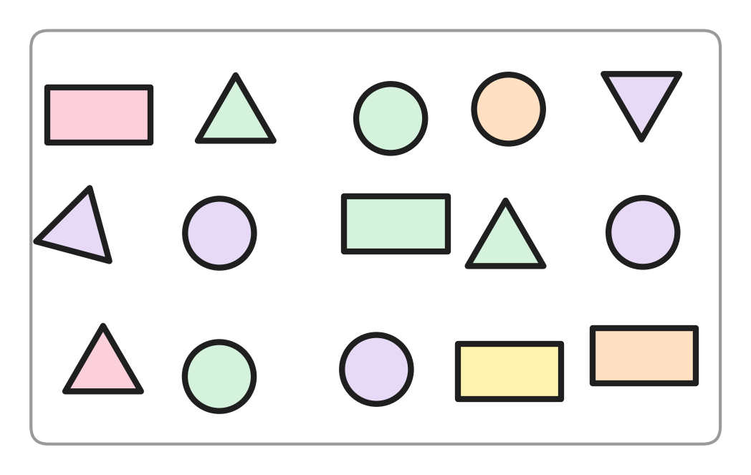
Q27. Look at the shapes in the box. How many more circles than rectangles are there?
(A) 6 | (B) 1 | (C) 4 | (D) 2

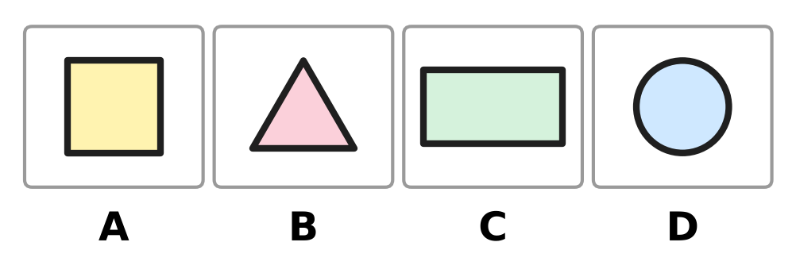
Q28. Look at the four shapes. My shape has 4 corners. Two of its sides are long and two are short. Which picture shows my shape?
(A) Picture A | (B) Picture B
(C) Picture C | (D) Picture D

Part 4 — Applied Mathematics (Syllabus Chapter 9)
Q29. Which of these is NOT a month of the year?
(A) Monday | (B) March | (C) June | (D) May

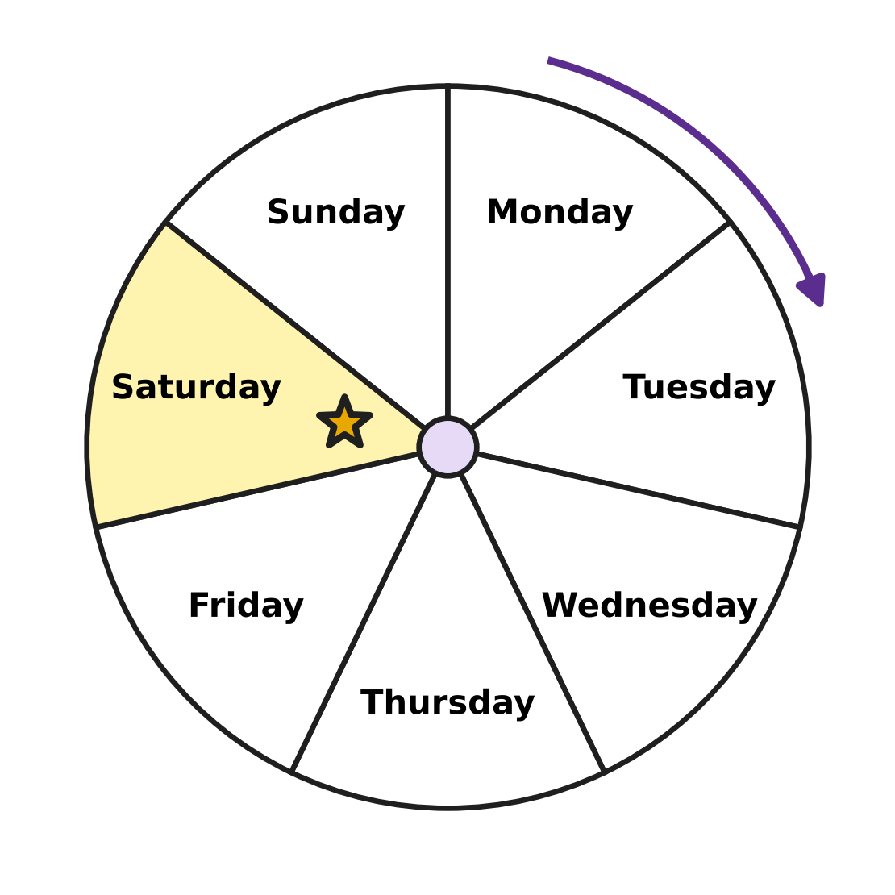
Q30. Look at the week wheel. The days go round the way the arrow shows. Which day comes just after the day with the star?
(A) Friday | (B) Monday
(C) Sunday | (D) Saturday

Q31. Which of these is worth less than a ₹5 coin?
(A) ₹10 note | (B) ₹2 coin
(C) ₹10 coin | (D) ₹20 note

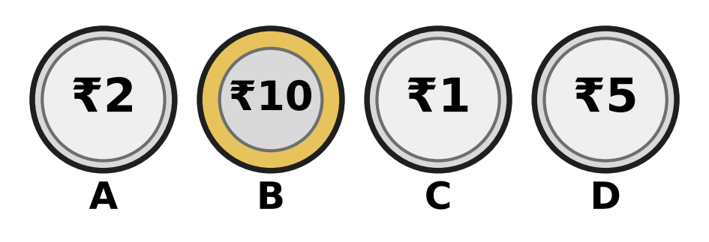
Q32. Look at the coins. Which coin is worth the same as a ₹10 note?
(A) Picture A | (B) Picture B
(C) Picture C | (D) Picture D

Q33. Farah reads a library book on 3 days, one after the other. The first day is Tuesday. Which is the last day?
(A) Sunday | (B) Wednesday
(C) Thursday | (D) Friday

Q34. Which list shows three months in the order they come in the year?
(A) January, March, February | (B) September, October, November
(C) May, April, June | (D) June, August, July

Part 5 — Mathematical Reasoning & Problem-Solving (Syllabus Chapter 10)

Q35. Look at the pictures. Star, balloon, car and fish repeat again and again in the same order. Which picture goes in the box?
(A) Car | (B) Balloon | (C) Fish | (D) Star

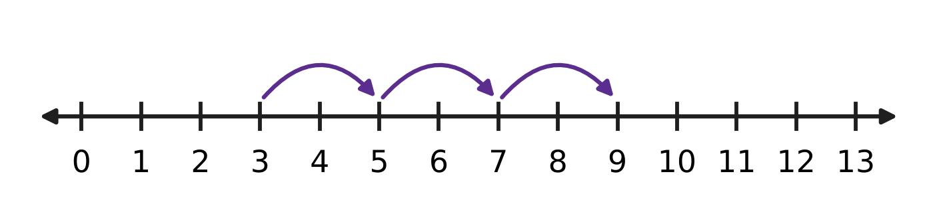
Q36. Look at the hops on the number line. Each hop is the same size. Where will the next hop land?
(A) 10 | (B) 13 | (C) 12 | (D) 11

Q37. Three of these numbers come one after the other. Which number does NOT belong with them?
(A) 19 | (B) 15 | (C) 16 | (D) 14

Q38. Look at the pattern of triangles and circles. It goes on in the same way. How many circles come next, before the next triangle?
(A) 6 | (B) 5 | (C) 1 | (D) 4

Q39. Vani makes a number pattern. It starts at 9. Each new number is 2 more. What is the fourth number in her pattern?
(A) 13 | (B) 11 | (C) 15 | (D) 17

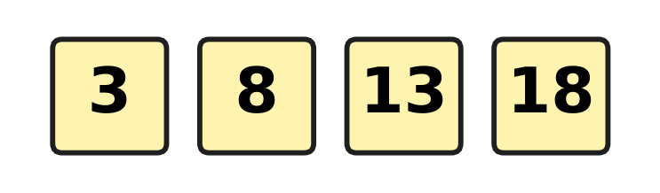
Q40. Look at the number pattern. What is added each time?
(A) 6 | (B) 4 | (C) 10 | (D) 5

SECTION II — Star Questions 5 questions × 4 marks each
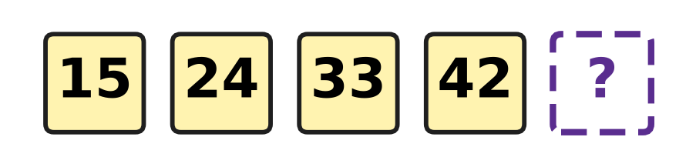
Q41. Look at the number pattern. See how the tens digit and the ones digit change each time. Which number comes next? [4 marks]
(A) 51 | (B) 43 | (C) 41 | (D) 52

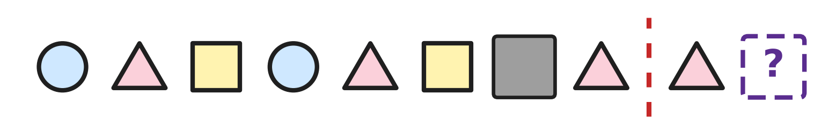
Q42. The shapes on the left of the red line make a pattern. A grey card hides one shape. If you fold the paper on the red line, each shape on the right lands on a matching shape on the left. Which shape goes in the box? [4 marks]
(A) Rectangle | (B) Triangle
(C) Circle | (D) Square

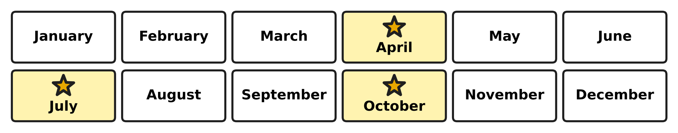
Q43. A water tank is cleaned in the starred months on the chart. The gap between cleanings is always the same. After October, in which month will the tank be cleaned next? [4 marks]
(A) December | (B) March
(C) February | (D) January

Q44. From Monday to Saturday, Samar saves a ₹10 note each day. He also saves a ₹2 coin on Wednesday and another ₹2 coin on Friday. How much money does he save in all? [4 marks]
(A) ₹54 | (B) ₹64 | (C) ₹74 | (D) ₹62

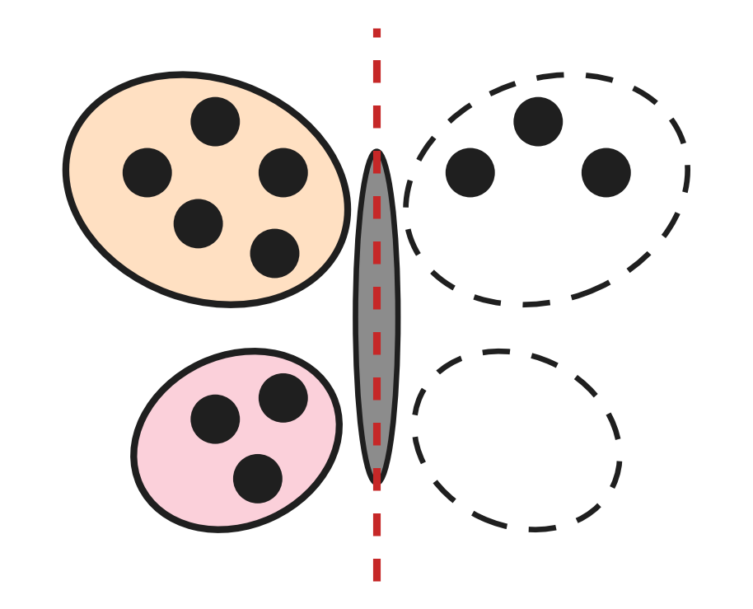
Q45. The butterfly must look the same on both sides of its body. How many more spots must be drawn on it? [4 marks]
(A) 2 | (B) 5 | (C) 8 | (D) 16

Answer Sheet AMO Level 1 · Class 1 · Practice Paper 1
Name: | School: | Roll No.:
Shade or tick one circle for each question.
1. Ⓐ Ⓑ Ⓒ Ⓓ | 16. Ⓐ Ⓑ Ⓒ Ⓓ | 31. Ⓐ Ⓑ Ⓒ Ⓓ
2. Ⓐ Ⓑ Ⓒ Ⓓ | 17. Ⓐ Ⓑ Ⓒ Ⓓ | 32. Ⓐ Ⓑ Ⓒ Ⓓ
3. Ⓐ Ⓑ Ⓒ Ⓓ | 18. Ⓐ Ⓑ Ⓒ Ⓓ | 33. Ⓐ Ⓑ Ⓒ Ⓓ
4. Ⓐ Ⓑ Ⓒ Ⓓ | 19. Ⓐ Ⓑ Ⓒ Ⓓ | 34. Ⓐ Ⓑ Ⓒ Ⓓ
5. Ⓐ Ⓑ Ⓒ Ⓓ | 20. Ⓐ Ⓑ Ⓒ Ⓓ | 35. Ⓐ Ⓑ Ⓒ Ⓓ
6. Ⓐ Ⓑ Ⓒ Ⓓ | 21. Ⓐ Ⓑ Ⓒ Ⓓ | 36. Ⓐ Ⓑ Ⓒ Ⓓ
7. Ⓐ Ⓑ Ⓒ Ⓓ | 22. Ⓐ Ⓑ Ⓒ Ⓓ | 37. Ⓐ Ⓑ Ⓒ Ⓓ
8. Ⓐ Ⓑ Ⓒ Ⓓ | 23. Ⓐ Ⓑ Ⓒ Ⓓ | 38. Ⓐ Ⓑ Ⓒ Ⓓ
9. Ⓐ Ⓑ Ⓒ Ⓓ | 24. Ⓐ Ⓑ Ⓒ Ⓓ | 39. Ⓐ Ⓑ Ⓒ Ⓓ
10. Ⓐ Ⓑ Ⓒ Ⓓ | 25. Ⓐ Ⓑ Ⓒ Ⓓ | 40. Ⓐ Ⓑ Ⓒ Ⓓ
11. Ⓐ Ⓑ Ⓒ Ⓓ | 26. Ⓐ Ⓑ Ⓒ Ⓓ | 41. Ⓐ Ⓑ Ⓒ Ⓓ
12. Ⓐ Ⓑ Ⓒ Ⓓ | 27. Ⓐ Ⓑ Ⓒ Ⓓ | 42. Ⓐ Ⓑ Ⓒ Ⓓ
13. Ⓐ Ⓑ Ⓒ Ⓓ | 28. Ⓐ Ⓑ Ⓒ Ⓓ | 43. Ⓐ Ⓑ Ⓒ Ⓓ
14. Ⓐ Ⓑ Ⓒ Ⓓ | 29. Ⓐ Ⓑ Ⓒ Ⓓ | 44. Ⓐ Ⓑ Ⓒ Ⓓ
15. Ⓐ Ⓑ Ⓒ Ⓓ | 30. Ⓐ Ⓑ Ⓒ Ⓓ | 45. Ⓐ Ⓑ Ⓒ Ⓓ
Q41–Q45 are Section II Star Questions (4 marks each).
For the parent or teacher
Section I correct: ______ / 40 × 2 = ______ marks Section II correct: ______ / 5 × 4 = ______ marks
Correct: ______ / 45 Score: ______ / 100
Answer Key and Solutions AMO Level 1 · Class 1 · Practice Paper 1
Quick answers
1 D | 6 A | 11 C | 16 C | 21 D | 26 C | 31 B | 36 D | 41 A
2 A | 7 C | 12 A | 17 B | 22 B | 27 D | 32 B | 37 A | 42 C
3 D | 8 C | 13 B | 18 B | 23 A | 28 C | 33 C | 38 B | 43 D
4 B | 9 B | 14 A | 19 A | 24 D | 29 A | 34 B | 39 C | 44 B
5 D | 10 D | 15 D | 20 C | 25 A | 30 C | 35 A | 40 D | 45 B
Solutions
Q | Part · level | Answer | Why?
1 | Part 1 · Ch1 · Easy | (D) 18 | There are 3 full rows of 5 stamps and 3 more: 5, 10, 15, then 16, 17, 18.
2 | Part 1 · Ch1 · Easy | (A) sixty-three | 63 has 6 tens and 3 ones. It is read as sixty-three.
3 | Part 1 · Ch1 · Easy | (D) 70 | The left page comes just before the right page. The number just before 71 is 70.
4 | Part 1 · Ch1 · Easy | (B) Picture B | The pictures have 13, 11, 12 and 14 balloons. 11 is the smallest number, so Picture B has the fewest.
5 | Part 1 · Ch1 · Easy | (D) 16 | 16 is 1 ten and 6 ones. In 61, 60 and 65 the 6 is the tens digit.
6 | Part 1 · Ch1 · Easy | (A) 80 | 70 is 7 tens. One more ten makes 8 tens, which is 80. So after 70 she says 80.
7 | Part 1 · Ch1 · Easy | (C) Dot C | Count on from 45: the next marks are 46 and 47. Dot C is 2 steps after 45, so it shows 47.
8 | Part 1 · Ch1 · Medium | (C) 42 and 38 | The order should be 24, 38, 42, 47. Only 42 and 38 are in the wrong places, so they swap.
9 | Part 1 · Ch1 · Medium | (B) 52 | 52 has 5 tens and 2 ones, and 5 is more than 2. The other numbers do not have more tens than ones.
10 | Part 1 · Ch1 · Medium | (D) 39 < 93 | 39 has 3 tens and 93 has 9 tens, so 39 is smaller than 93. The other three are wrong.
11 | Part 1 · Ch1 · Medium | (C) 5 | 58 is 5 tens and 8 ones. So 5 jars are full and 8 marbles are left over.
12 | Part 1 · Ch1 · Medium | (A) 56 | 46 has 4 tens and 6 ones. One more ten makes 5 tens and 6 ones, which is 56.
13 | Part 2 · Ch2 · Easy | (B) 13 | One tree has 8 apples and the other has 5. 8 + 5 = 13.
14 | Part 2 · Ch2 · Easy | (A) 6 | 15 − 9 = 6, so 6 chicks have gone away.
15 | Part 2 · Ch2 · Easy | (D) 18 | 3 beds of 6 cabbages: 6 + 6 + 6 = 18.
16 | Part 2 · Ch2 · Easy | (C) 14 | 6 + 8 = 14 children.
17 | Part 2 · Ch2 · Easy | (B) 13 | 18 − 5 = 13 children are still riding.
18 | Part 2 · Ch2 · Easy | (B) 18 | 2 less than 20 means 20 − 2, which is 18.
19 | Part 2 · Ch2 · Medium | (A) 6 | 11 and how many more make 17? 17 − 11 = 6, so 6 balls are in the bag.
20 | Part 2 · Ch2 · Medium | (C) 7 | 7 and 8 make 15. So when 8 is taken from 15, 7 is left.
21 | Part 2 · Ch2 · Medium | (D) 13 | 6 + 4 = 10, and 10 + 3 = 13 bows.
22 | Part 2 · Ch2 · Medium | (B) 9 | 20 − 6 = 14. Then 14 − 5 = 9 buckets are left.
23 | Part 3 · Ch5 · Easy | (A) Circle | A wheel is round with no corners, so its shape is a circle.
24 | Part 3 · Ch5 · Easy | (D) 3 | The shape is a triangle. It has 3 straight sides.
25 | Part 3 · Ch5 · Easy | (A) Picture A | In Picture A the dotted line goes down the middle, so the two parts have the same size and shape. In the other pictures the parts do not match.
26 | Part 3 · Ch5 · Easy | (C) 4 | A circle has no corners. There are 4 circles on the string. The 7 triangles have 3 corners each.
27 | Part 3 · Ch5 · Medium | (D) 2 | There are 6 circles and 4 rectangles. 6 is 2 more than 4.
28 | Part 3 · Ch5 · Medium | (C) Picture C | The square and the rectangle have 4 corners. The square has 4 equal sides, so the shape with two long and two short sides is the rectangle.
29 | Part 4 · Ch9 · Easy | (A) Monday | Monday is a day of the week. March, May and June are months.
30 | Part 4 · Ch9 · Easy | (C) Sunday | The star is on Saturday. The day just after Saturday is Sunday.
31 | Part 4 · Ch9 · Easy | (B) ₹2 coin | 2 is less than 5, so a ₹2 coin is worth less than a ₹5 coin. The others are worth ₹10 or ₹20.
32 | Part 4 · Ch9 · Easy | (B) Picture B | The coin in Picture B is a ₹10 coin. It is worth the same as a ₹10 note.
33 | Part 4 · Ch9 · Medium | (C) Thursday | The three days are Tuesday, Wednesday and Thursday. The last day is Thursday.
34 | Part 4 · Ch9 · Medium | (B) Sep, Oct, Nov | September, October and November come one after another. In each other list two months are swapped.
35 | Part 5 · Ch10 · Easy | (A) Car | The order is star, balloon, car, fish, again and again. After a balloon comes a car.
36 | Part 5 · Ch10 · Easy | (D) 11 | The hops land on 5, 7 and 9, going up by 2 each time. The next hop lands on 11.
37 | Part 5 · Ch10 · Easy | (A) 19 | 14, 15, 16 come one after the other. After 16 come 17 and 18, so 19 is the odd one out.
38 | Part 5 · Ch10 · Medium | (B) 5 | Between the triangles there are 1, 2, 3 and then 4 circles. Each group has one more, so 5 circles come next.
39 | Part 5 · Ch10 · Medium | (C) 15 | The pattern is 9, 11, 13, 15. The fourth number is 15.
40 | Part 5 · Ch10 · Medium | (D) 5 | From 3 to 8 is 5 more, from 8 to 13 is 5 more, and from 13 to 18 is 5 more.
41 | Section II · Ch1 + Ch10 · Hard | (A) 51 | The tens digit goes up by one: 1, 2, 3, 4, then 5. The ones digit goes down by one: 5, 4, 3, 2, then 1. The next number is 51.
42 | Section II · Ch5 + Ch10 · Hard | (C) Circle | The pattern is circle, triangle, square, again and again, so a circle is under the grey card. Folding on the dotted line puts the box on that card, so the box has a circle.
43 | Section II · Ch9 + Ch10 · Hard | (D) January | From April to July is 3 months, and from July to October is 3 months. Three months after October is January.
44 | Section II · Ch1 + Ch9 · Hard | (B) ₹64 | Monday to Saturday is 6 days: 10, 20, 30, 40, 50, 60. The two ₹2 coins make ₹4. 6 tens and 4 ones make ₹64.
45 | Section II · Ch2 + Ch5 · Hard | (B) 5 | Top wings: 5 spots on the left and 3 on the right, so 2 more. Bottom wings: 3 on the left and none on the right, so 3 more. 2 + 3 = 5.

