UNLOCK IQ INSTITUTE
Realize Your True Potential
Aryabhatta Maths Olympiad (AMO)
Level 1 — Practice Paper 2
CLASS 1

Questions | 45 multiple-choice questions
Marks | 100
Time | 60 minutes
Section I | 40 questions × 2 marks = 80 marks
Section II | 5 Star Questions × 4 marks = 20 marks
Negative marking | No negative marking
Calculator | Not allowed
Chapters | Number System · Operations · Geometry · Applied Mathematics · Mathematical Reasoning

Hello, friend!
• Every question has four answer choices: (A), (B), (C) and (D). Only one is correct.
• Read each question and look at its picture carefully. Then mark your answer on the answer sheet at the end.
• Section I has 40 questions of 2 marks each. Section II has 5 Star Questions of 4 marks each.
• There is no negative marking, so try every question.
• Do not use a calculator. You may do rough work on a separate sheet.

For parents and teachers
Print or view this paper in colour. Pictures are part of the questions.
You may read a question aloud to the child, exactly as printed. Please do not explain it or point to an answer choice.
Parts follow the AMO syllabus chapters. Chapters 3, 4, 6, 7 and 8 are not part of the Class 1 syllabus, so the chapter numbers shown in the Part headings have gaps.
The answer sheet and the answer key with solutions are at the end. Give the child the answer sheet. Remove the answer key and solutions before the child begins.

Name: | School: | Roll No.:

SECTION I 40 questions × 2 marks each
Part 1 — Number System (Syllabus Chapter 1)
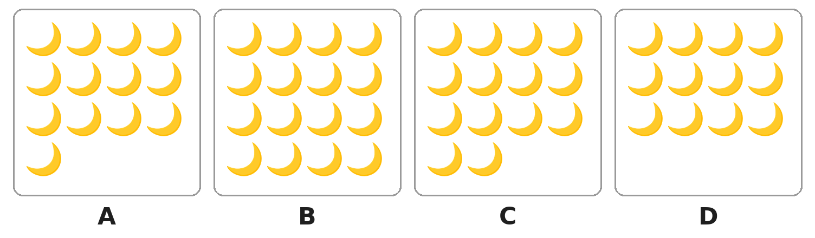
Q1. Look at the boxes. Which box has exactly 14 moons?
(A) Box A | (B) Box B | (C) Box C | (D) Box D

Q2. A toy shop packs balls in bags of 10. Which number of balls fills the bags with no balls left over?
(A) 16 | (B) 26 | (C) 60 | (D) 61

Q3. Which number name matches its number correctly?
(A) forty-seven = 74 | (B) seventy = 17
(C) seventeen = 70 | (D) seventy-four = 74

Q4. Which of these numbers has the same tens digit as 47?
(A) 27 | (B) 43 | (C) 57 | (D) 74

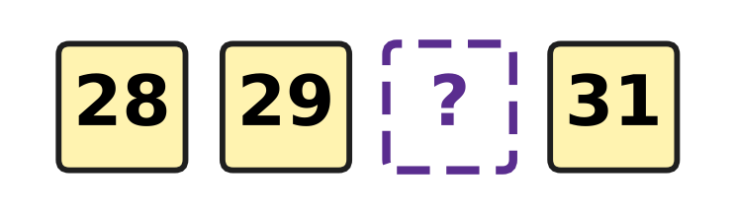
Q5. Look at the number cards. They are in order. Which number is hidden?
(A) 20 | (B) 30 | (C) 39 | (D) 40

Q6. One fish tank has 53 fish. Another tank has 35 fish. Which of these shows this correctly?
(A) 53 > 35 | (B) 53 < 35 | (C) 53 = 35 | (D) 35 > 53

Q7. Which of these numbers is greater than 70?
(A) 71 | (B) 17 | (C) 69 | (D) 67

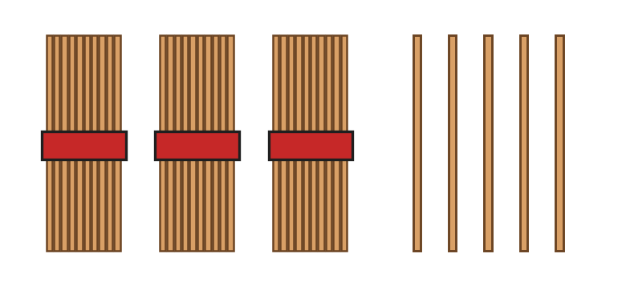
Q8. Look at the picture. Each bundle has 10 sticks. Veena adds 2 more bundles. How many sticks are there now?
(A) 35 | (B) 37 | (C) 45 | (D) 55

Q9. Which of these numbers stays the same when its two digits swap places?
(A) 34 | (B) 40 | (C) 43 | (D) 44

Q10. Three of these are the number 52. Which one is NOT 52?
(A) 5 tens and 2 ones | (B) 2 tens and 5 ones
(C) fifty-two | (D) 50 and 2 more

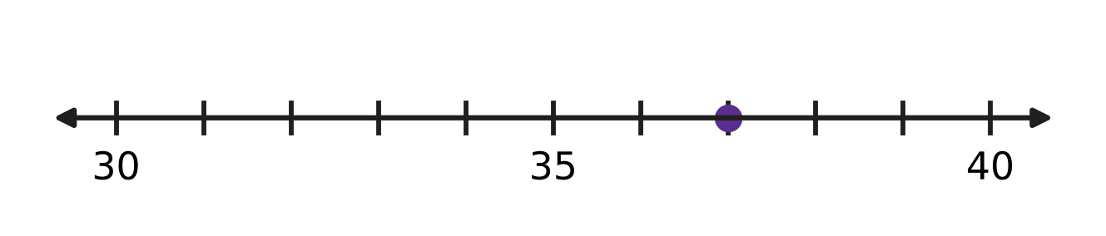
Q11. Look at the number line. Which number is at the dot?
(A) 32 | (B) 36 | (C) 37 | (D) 38

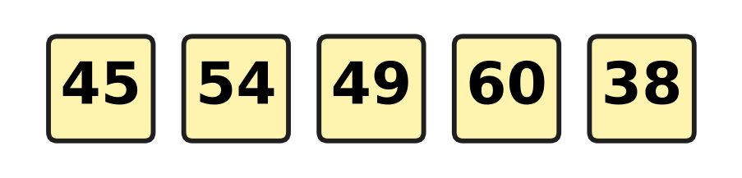
Q12. Look at the five number cards. How many of the numbers are less than 50?
(A) 2 | (B) 3 | (C) 4 | (D) 5

Part 2 — Operations & Number Properties (Syllabus Chapter 2)
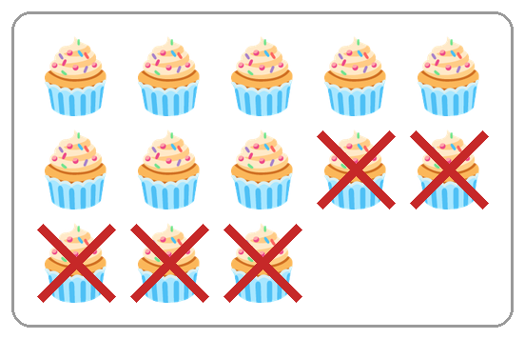
Q13. Look at the cupcakes. The crossed-out ones were eaten. Which take-away matches the picture?
(A) 8 − 5 | (B) 13 + 5 | (C) 13 − 4 | (D) 13 − 5

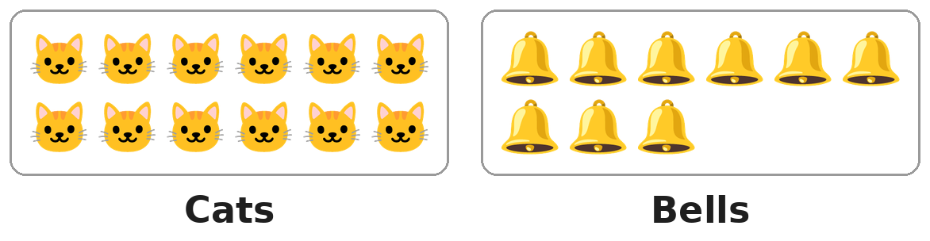
Q14. Look at the picture. Each cat needs one bell. How many more bells are needed?
(A) 3 | (B) 4 | (C) 9 | (D) 21

Q15. Which number goes in the blank?
13 + ___ = 13
(A) 0 | (B) 1 | (C) 13 | (D) 26

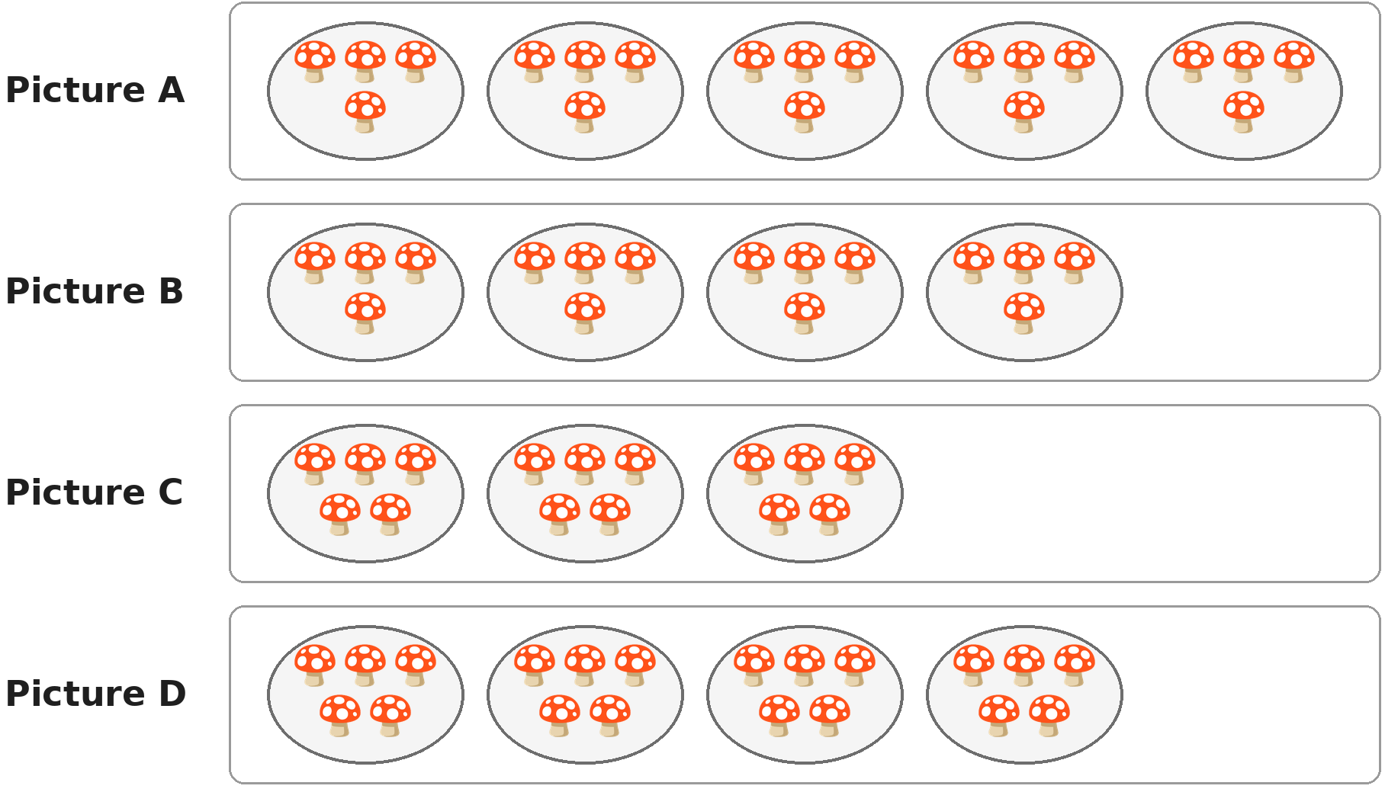
Q16. Look at the plates of mushrooms. Which picture shows 4 plates with 5 mushrooms on each plate?
(A) Picture A | (B) Picture B
(C) Picture C | (D) Picture D

Q17. A fence has 16 boards. Girish has painted 9 of them. How many boards are left to paint?
(A) 7 | (B) 8 | (C) 9 | (D) 25

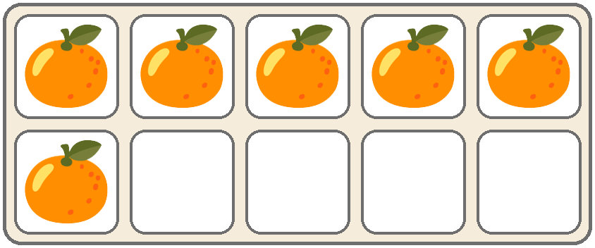
Q18. Look at the tray at a fruit market. A full tray holds 10 oranges. How many more oranges will fill it?
(A) 4 | (B) 5 | (C) 6 | (D) 16

Q19. We know that 9 + 5 = 14. Which of these number sentences is also true?
(A) 14 + 9 = 5 | (B) 5 + 14 = 9
(C) 9 − 5 = 14 | (D) 14 − 5 = 9

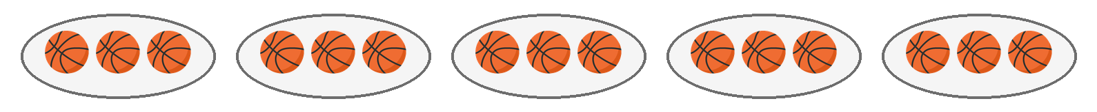
Q20. Look at the picture. Each tray has 3 balls. Jai takes away one full tray. How many balls are left?
(A) 9 | (B) 12 | (C) 14 | (D) 15

Q21. Geeta needs 13 beads for a necklace. She has 4 red beads and 5 blue beads. How many more beads does she need?
(A) 4 | (B) 8 | (C) 9 | (D) 22

Q22. Only one of these is right. Which one?
(A) 17 − 4 = 12 | (B) 9 + 6 = 14
(C) 8 + 7 = 15 | (D) 14 − 6 = 9

Part 3 — Geometry (Syllabus Chapter 5)
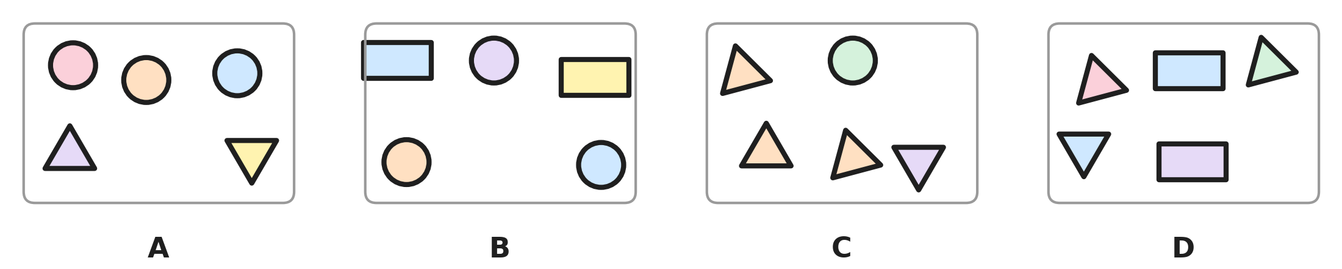
Q23. Look at the four pictures. Which picture has exactly 3 triangles?
(A) Picture A | (B) Picture B
(C) Picture C | (D) Picture D

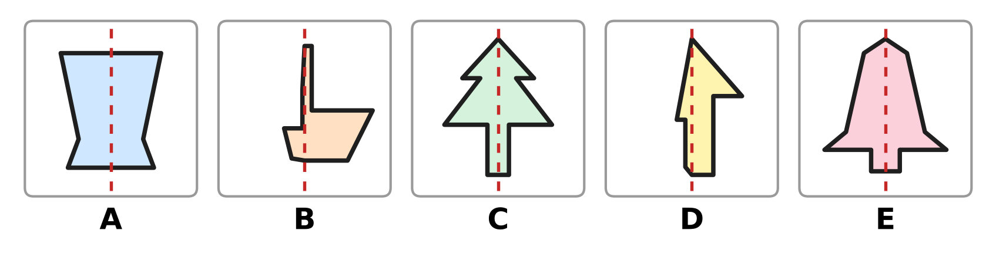
Q24. Look at the five pictures. How many of them are the same on both sides of the dotted line?
(A) 2 | (B) 3 | (C) 4 | (D) 5

Q25. Which of these is true for a rectangle?
(A) It has 4 corners. | (B) It is round.
(C) It has 3 sides. | (D) It has no corners.

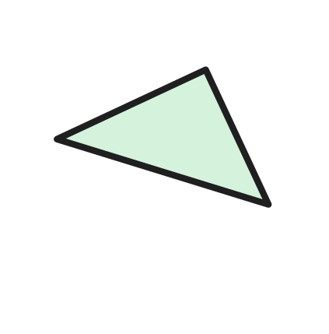
Q26. A shape card is turned, as in the picture. What is the name of the shape?
(A) Rectangle | (B) Circle
(C) Square | (D) Triangle

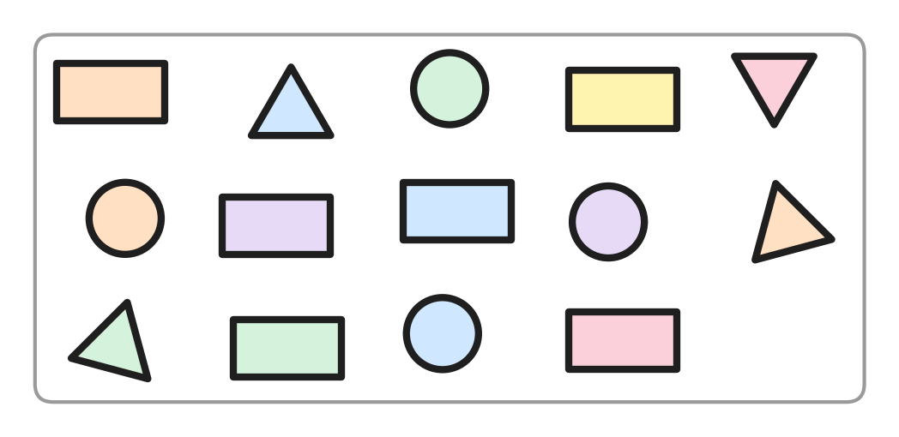
Q27. Look at the picture. Count each kind of shape. Which two kinds of shapes have the same count?
(A) Triangles and rectangles | (B) Circles and rectangles
(C) Circles and triangles | (D) Squares and circles

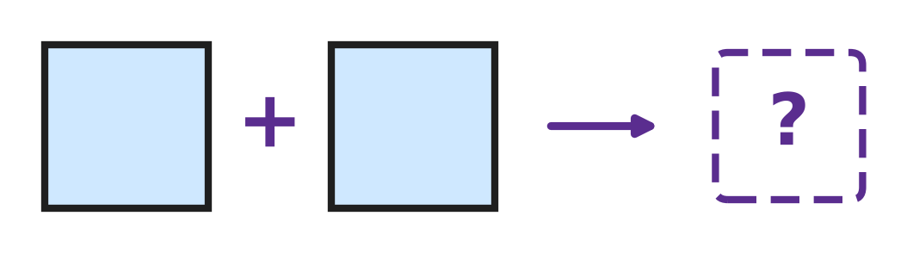
Q28. Look at the picture. Sumit joins two squares of the same size along one full side. Which shape does he make?
(A) A bigger square | (B) A rectangle
(C) A triangle | (D) A circle

Part 4 — Applied Mathematics (Syllabus Chapter 9)
Q29. Which of these shows two days that come one after the other?
(A) Thursday and Saturday | (B) Friday and Saturday
(C) Sunday and Tuesday | (D) Monday and Wednesday

Q30. Tanya says the months in order: January, February, April, May. Which month did she leave out?
(A) March | (B) December
(C) July | (D) June

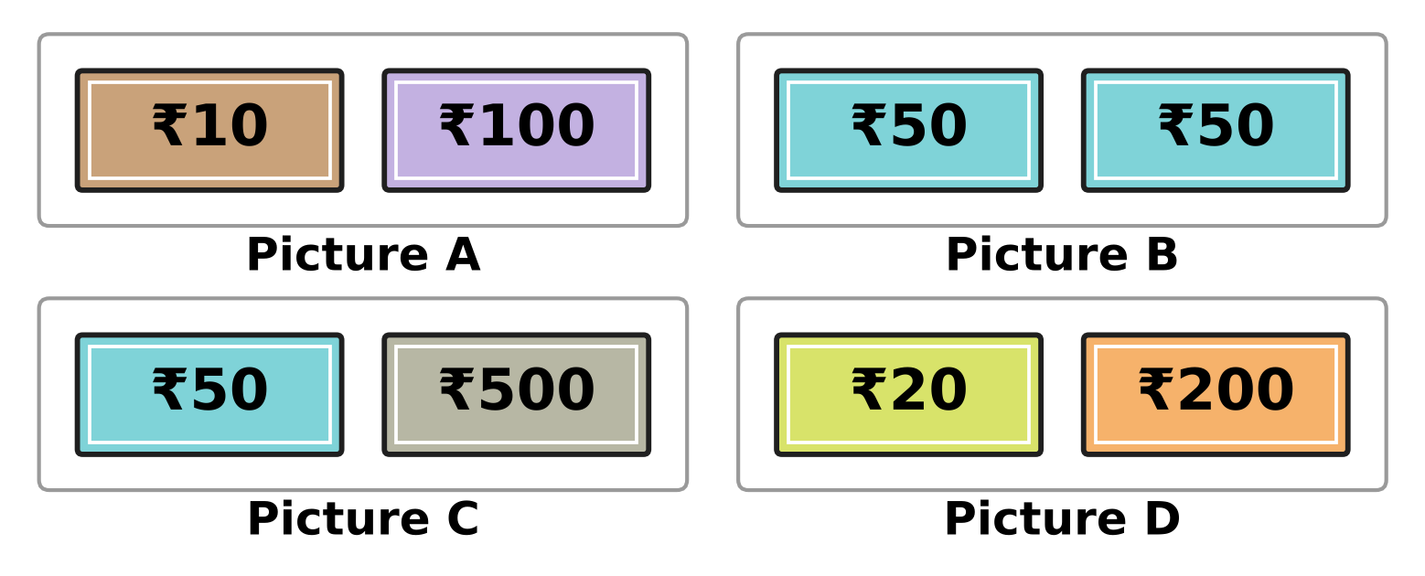
Q31. Look at the notes. Which picture shows two notes of the same value?
(A) Picture A | (B) Picture B
(C) Picture C | (D) Picture D

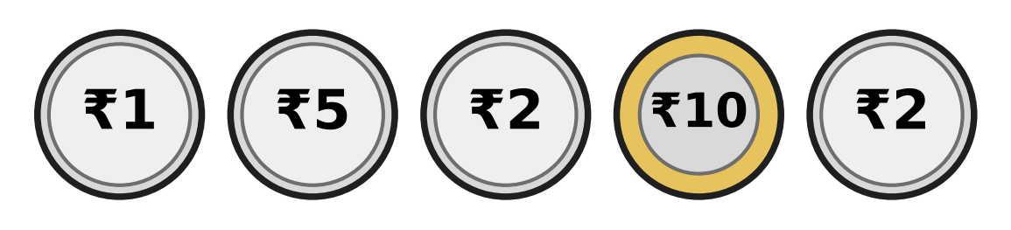
Q32. Look at the five coins. Kush keeps the two coins that are worth the most. Which coins does he keep?
(A) ₹2 and ₹2 | (B) ₹2 and ₹10
(C) ₹5 and ₹10 | (D) ₹1 and ₹5

Q33. Which of these months comes first in the year?
(A) November | (B) August
(C) May | (D) March

Q34. An aquarium is open every day from Tuesday to Sunday. On which day of the week is it closed?
(A) Monday | (B) Tuesday
(C) Saturday | (D) Sunday

Part 5 — Mathematical Reasoning & Problem-Solving (Syllabus Chapter 10)

Q35. Look at the pattern of big and small shapes. Which shape goes in the box?
(A) A big square | (B) A small square
(C) A big circle | (D) A small circle

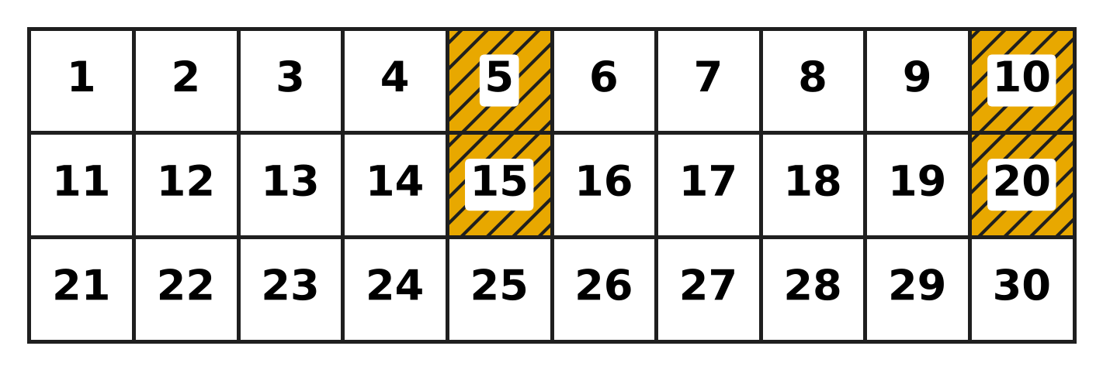
Q36. Look at the number chart. The shaded numbers follow a pattern. Which number will be shaded next?
(A) 21 | (B) 24 | (C) 25 | (D) 30

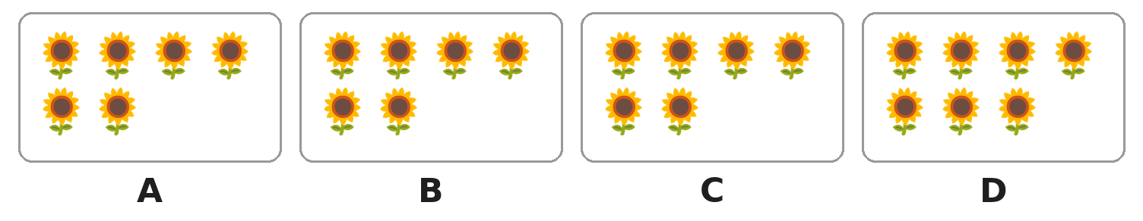
Q37. Look at the boxes of sunflowers. One box has a different number from the other three. Which box is it?
(A) Box A | (B) Box B | (C) Box C | (D) Box D

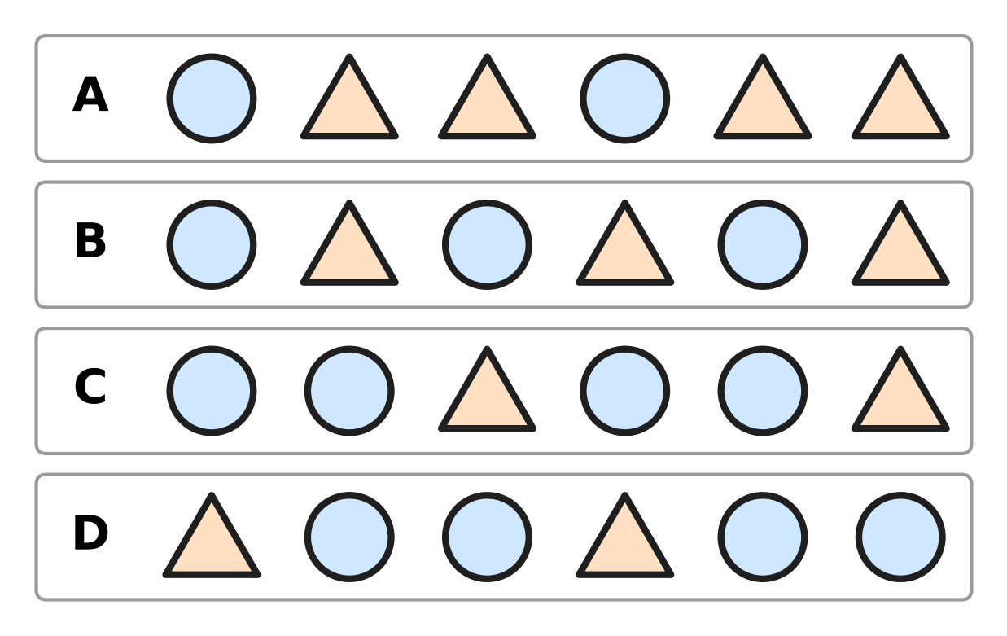
Q38. Look at the four rows. Which row repeats circle, triangle, triangle?
(A) Row A | (B) Row B
(C) Row C | (D) Row D

Q39. Which of these patterns counts back by 2 each time?
(A) 12, 9, 6, 3 | (B) 12, 10, 8, 6
(C) 12, 11, 10, 9 | (D) 6, 8, 10, 12

Q40. Mahi counts by twos from 2. Tejas counts by fives from 5. Which of these numbers do both of them say?
(A) 12 | (B) 15 | (C) 20 | (D) 25

SECTION II — Star Questions 5 questions × 4 marks each
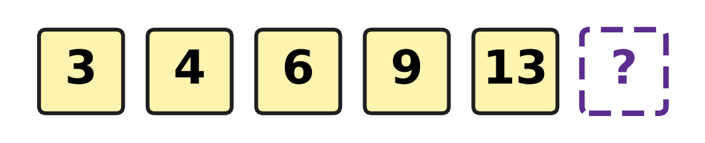
Q41. Look at the number pattern. Each jump is 1 more than the jump before. How many tens and ones does the next number have? [4 marks]
(A) 1 ten and 4 ones | (B) 8 tens and 1 one
(C) 1 ten and 7 ones | (D) 1 ten and 8 ones

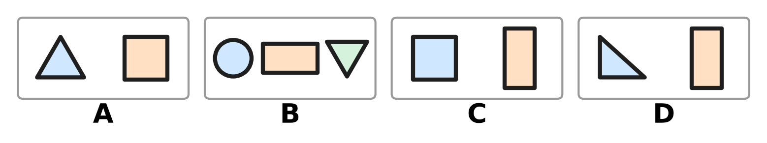
Q42. Look at the four pictures. Count all the corners in each picture. Which picture has a different number of corners from the other three? [4 marks]
(A) Picture A | (B) Picture B
(C) Picture C | (D) Picture D

Q43. Yuvan counts by tens: 10, 20, 30, and so on up to 100. For how many of these numbers is there an Indian rupee note? [4 marks]
(A) 3 | (B) 4 | (C) 6 | (D) 10

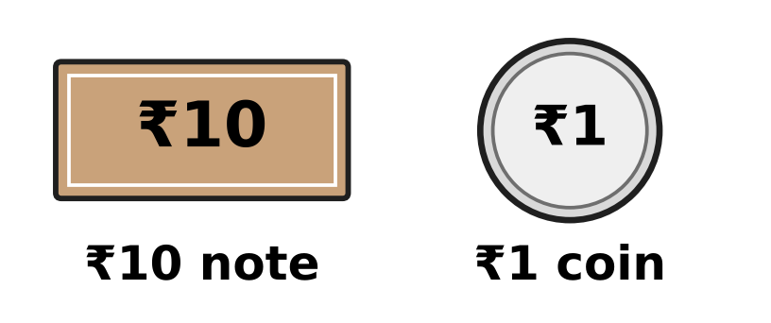
Q44. Look at the picture. Pihu pays the exact amount using only these two kinds of money. Which amount needs the smallest number of notes and coins in all? [4 marks]
(A) ₹19 | (B) ₹27 | (C) ₹31 | (D) ₹50

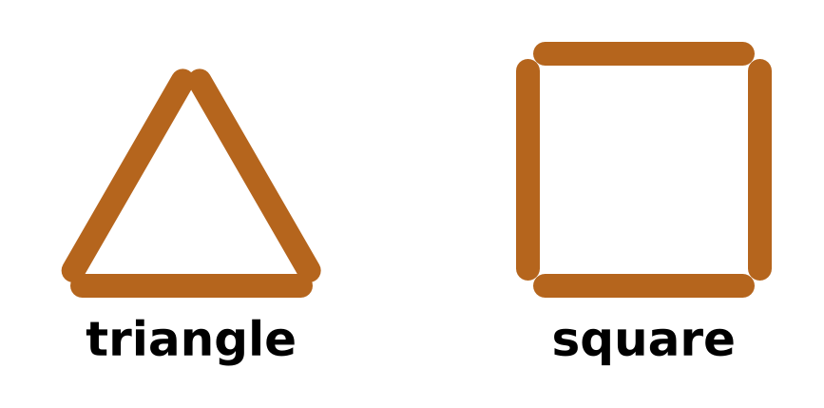
Q45. Look at the picture. Akash makes shapes like these, with one stick for each side. Which of these uses exactly 10 sticks? [4 marks]
(A) 3 triangles | (B) 2 squares
(C) 2 triangles and 1 square | (D) 1 triangle and 2 squares

Answer Sheet AMO Level 1 · Class 1 · Practice Paper 2
Name: | School: | Roll No.:
Shade or tick one circle for each question.
1. Ⓐ Ⓑ Ⓒ Ⓓ | 16. Ⓐ Ⓑ Ⓒ Ⓓ | 31. Ⓐ Ⓑ Ⓒ Ⓓ
2. Ⓐ Ⓑ Ⓒ Ⓓ | 17. Ⓐ Ⓑ Ⓒ Ⓓ | 32. Ⓐ Ⓑ Ⓒ Ⓓ
3. Ⓐ Ⓑ Ⓒ Ⓓ | 18. Ⓐ Ⓑ Ⓒ Ⓓ | 33. Ⓐ Ⓑ Ⓒ Ⓓ
4. Ⓐ Ⓑ Ⓒ Ⓓ | 19. Ⓐ Ⓑ Ⓒ Ⓓ | 34. Ⓐ Ⓑ Ⓒ Ⓓ
5. Ⓐ Ⓑ Ⓒ Ⓓ | 20. Ⓐ Ⓑ Ⓒ Ⓓ | 35. Ⓐ Ⓑ Ⓒ Ⓓ
6. Ⓐ Ⓑ Ⓒ Ⓓ | 21. Ⓐ Ⓑ Ⓒ Ⓓ | 36. Ⓐ Ⓑ Ⓒ Ⓓ
7. Ⓐ Ⓑ Ⓒ Ⓓ | 22. Ⓐ Ⓑ Ⓒ Ⓓ | 37. Ⓐ Ⓑ Ⓒ Ⓓ
8. Ⓐ Ⓑ Ⓒ Ⓓ | 23. Ⓐ Ⓑ Ⓒ Ⓓ | 38. Ⓐ Ⓑ Ⓒ Ⓓ
9. Ⓐ Ⓑ Ⓒ Ⓓ | 24. Ⓐ Ⓑ Ⓒ Ⓓ | 39. Ⓐ Ⓑ Ⓒ Ⓓ
10. Ⓐ Ⓑ Ⓒ Ⓓ | 25. Ⓐ Ⓑ Ⓒ Ⓓ | 40. Ⓐ Ⓑ Ⓒ Ⓓ
11. Ⓐ Ⓑ Ⓒ Ⓓ | 26. Ⓐ Ⓑ Ⓒ Ⓓ | 41. Ⓐ Ⓑ Ⓒ Ⓓ
12. Ⓐ Ⓑ Ⓒ Ⓓ | 27. Ⓐ Ⓑ Ⓒ Ⓓ | 42. Ⓐ Ⓑ Ⓒ Ⓓ
13. Ⓐ Ⓑ Ⓒ Ⓓ | 28. Ⓐ Ⓑ Ⓒ Ⓓ | 43. Ⓐ Ⓑ Ⓒ Ⓓ
14. Ⓐ Ⓑ Ⓒ Ⓓ | 29. Ⓐ Ⓑ Ⓒ Ⓓ | 44. Ⓐ Ⓑ Ⓒ Ⓓ
15. Ⓐ Ⓑ Ⓒ Ⓓ | 30. Ⓐ Ⓑ Ⓒ Ⓓ | 45. Ⓐ Ⓑ Ⓒ Ⓓ
Q41–Q45 are Section II Star Questions (4 marks each).
For the parent or teacher
Section I correct: ______ / 40 × 2 = ______ marks Section II correct: ______ / 5 × 4 = ______ marks
Correct: ______ / 45 Score: ______ / 100
Answer Key and Solutions AMO Level 1 · Class 1 · Practice Paper 2
Quick answers
1 C | 6 A | 11 C | 16 D | 21 A | 26 D | 31 B | 36 C | 41 D
2 C | 7 A | 12 B | 17 A | 22 C | 27 C | 32 C | 37 D | 42 C
3 D | 8 D | 13 D | 18 A | 23 D | 28 B | 33 D | 38 A | 43 B
4 B | 9 D | 14 A | 19 D | 24 B | 29 B | 34 A | 39 B | 44 C
5 B | 10 B | 15 A | 20 B | 25 A | 30 A | 35 D | 40 C | 45 C
Solutions
Q | Part · level | Answer | Why?
1 | Part 1 · Ch1 · Easy | (C) Box C | Box C has three rows of 4 moons and 2 more moons. Counting on from 12 gives 13, 14. So Box C has 14 moons.
2 | Part 1 · Ch1 · Easy | (C) 60 | 60 is 6 tens and 0 ones, so it fills 6 bags with no ball left. The numbers 16, 26 and 61 have 6, 6 and 1 loose ones.
3 | Part 1 · Ch1 · Easy | (D) seventy-four = 74 | Seventy-four is 7 tens and 4 ones, which is 74. Forty-seven is 47, seventeen is 17 and seventy is 70.
4 | Part 1 · Ch1 · Easy | (B) 43 | The tens digit of 47 is 4. The number 43 also has 4 tens. The numbers 27, 57 and 74 have 2, 5 and 7 tens.
5 | Part 1 · Ch1 · Easy | (B) 30 | The number just after 29 is 30, and 30 is just before 31. The hidden number is 30.
6 | Part 1 · Ch1 · Easy | (A) 53 > 35 | 53 has 5 tens and 35 has only 3 tens. So 53 is greater than 35, written 53 > 35.
7 | Part 1 · Ch1 · Easy | (A) 71 | 70 has 7 tens and 0 ones. 71 has 7 tens and 1 one, so it is greater. The numbers 67, 69 and 17 have fewer tens.
8 | Part 1 · Ch1 · Medium | (D) 55 | The picture shows 3 bundles and 5 sticks, which is 35. Two more bundles make 5 tens. 5 tens and 5 ones is 55.
9 | Part 1 · Ch1 · Medium | (D) 44 | 44 has 4 tens and 4 ones, so swapping the digits gives 44 again. The others change: 34 becomes 43, 43 becomes 34 and 40 becomes 4.
10 | Part 1 · Ch1 · Medium | (B) 2 tens and 5 ones | 2 tens and 5 ones make 25, not 52. The other three all mean 52.
11 | Part 1 · Ch1 · Medium | (C) 37 | The dot is two steps after 35. Counting on from 35 gives 36, then 37. The dot is at 37.
12 | Part 1 · Ch1 · Medium | (B) 3 | 45, 49 and 38 have fewer than 5 tens, so they are less than 50. The numbers 54 and 60 are greater. That makes 3 numbers.
13 | Part 2 · Ch2 · Easy | (D) 13 − 5 | There are 13 cupcakes in all and 5 are crossed out. The take-away is 13 − 5, which leaves 8.
14 | Part 2 · Ch2 · Easy | (A) 3 | There are 12 cats and 9 bells. 12 − 9 = 3, so 3 more bells are needed.
15 | Part 2 · Ch2 · Easy | (A) 0 | Adding 0 keeps a number the same. 13 + 0 = 13, so the blank is 0.
16 | Part 2 · Ch2 · Easy | (D) Picture D | Picture D has 4 plates, and every plate has 5 mushrooms. Picture A has 5 plates of 4, Picture B has 4 plates of 4 and Picture C has 3 plates of 5.
17 | Part 2 · Ch2 · Easy | (A) 7 | 16 − 9 = 7. So 7 boards are left to paint.
18 | Part 2 · Ch2 · Easy | (A) 4 | The tray has 6 oranges and 4 empty boxes. 6 + 4 = 10, so 4 more oranges will fill it.
19 | Part 2 · Ch2 · Medium | (D) 14 − 5 = 9 | The three numbers are 9, 5 and 14. Taking 5 away from 14 leaves 9, so 14 − 5 = 9 is true.
20 | Part 2 · Ch2 · Medium | (B) 12 | 5 trays of 3 make 3, 6, 9, 12, 15 balls. One tray of 3 goes away, so 15 − 3 = 12 balls are left.
21 | Part 2 · Ch2 · Medium | (A) 4 | She has 4 + 5 = 9 beads. She needs 13 − 9 = 4 more beads.
22 | Part 2 · Ch2 · Medium | (C) 8 + 7 = 15 | 8 + 7 = 15 is right. The others should be 9 + 6 = 15, 17 − 4 = 13 and 14 − 6 = 8.
23 | Part 3 · Ch5 · Easy | (D) Picture D | Picture D has 3 triangles and 2 rectangles. Picture A has 2 triangles, Picture B has none and Picture C has 4.
24 | Part 3 · Ch5 · Easy | (B) 3 | Pictures A, C and E match when folded along the dotted line. In Pictures B and D the left half is smaller. So 3 pictures are the same on both sides.
25 | Part 3 · Ch5 · Easy | (A) It has 4 corners. | A rectangle has 4 straight sides and 4 corners. A triangle has 3 sides, and a circle is round with no corners.
26 | Part 3 · Ch5 · Easy | (D) Triangle | The shape has 3 straight sides and 3 corners. It is a triangle, even when it is turned.
27 | Part 3 · Ch5 · Medium | (C) Circles and triangles | There are 4 circles, 4 triangles and 6 rectangles. The circles and the triangles are equal in number.
28 | Part 3 · Ch5 · Medium | (B) A rectangle | The new shape has 4 corners, with 2 long sides and 2 short sides. That is a rectangle.
29 | Part 4 · Ch9 · Easy | (B) Friday and Saturday | Saturday comes just after Friday. Each of the other pairs has one day in between.
30 | Part 4 · Ch9 · Easy | (A) March | The order is January, February, March, April, May. She left out March.
31 | Part 4 · Ch9 · Easy | (B) Picture B | Picture B has two ₹50 notes. The other pictures have ₹10 and ₹100, ₹50 and ₹500, and ₹20 and ₹200, which are different.
32 | Part 4 · Ch9 · Easy | (C) ₹5 and ₹10 | From least to most the coins are ₹1, ₹2, ₹2, ₹5, ₹10. The two worth the most are ₹5 and ₹10.
33 | Part 4 · Ch9 · Medium | (D) March | In the year the order is March, May, August, November. March comes earliest.
34 | Part 4 · Ch9 · Medium | (A) Monday | Tuesday, Wednesday, Thursday, Friday, Saturday and Sunday are six days. The only day left in the week is Monday.
35 | Part 5 · Ch10 · Easy | (D) A small circle | The pattern repeats big circle, small circle, big square, small square. After a big circle comes a small circle.
36 | Part 5 · Ch10 · Easy | (C) 25 | The shaded numbers are 5, 10, 15, 20. Each is 5 more than the one before, so the next is 25.
37 | Part 5 · Ch10 · Easy | (D) Box D | Boxes A, B and C have 6 sunflowers each. Box D has 7 sunflowers, so it is the odd one out.
38 | Part 5 · Ch10 · Medium | (A) Picture A | Row A goes circle, triangle, triangle, and then the same three shapes again. Row B repeats two shapes, and Rows C and D have two circles together.
39 | Part 5 · Ch10 · Medium | (B) 12, 10, 8, 6 | 12, 10, 8, 6 goes down by 2 each time. The others go back by 1, forward by 2 and back by 3.
40 | Part 5 · Ch10 · Medium | (C) 20 | Mahi says 2, 4, 6, and so on up to 20. Tejas says 5, 10, 15, 20. Both say 20. Only Mahi says 12, and only Tejas says 15 and 25.
41 | Section II · Ch1 + Ch10 · Hard | (D) 1 ten and 8 ones | The jumps are 1, 2, 3, 4, so the next jump is 5. 13 + 5 = 18, and 18 is 1 ten and 8 ones.
42 | Section II · Ch5 + Ch10 · Hard | (C) Picture C | Picture A has 3 + 4 = 7 corners. Picture B has 0 + 4 + 3 = 7. Picture C has 4 + 4 = 8. Picture D has 3 + 4 = 7. Only Picture C has a different number.
43 | Section II · Ch9 + Ch10 · Hard | (B) 4 | He says 10, 20, 30, 40, 50, 60, 70, 80, 90, 100. There are notes of ₹10, ₹20, ₹50 and ₹100 only. That is 4 numbers.
44 | Section II · Ch1 + Ch9 · Hard | (C) ₹31 | ₹19 needs 1 note and 9 coins (10 in all). ₹27 needs 2 notes and 7 coins (9). ₹31 needs 3 notes and 1 coin (4). ₹50 needs 5 notes. The fewest is 4, for ₹31.
45 | Section II · Ch2 + Ch5 · Hard | (C) 2 triangles and 1 square | A triangle needs 3 sticks and a square needs 4. 3 + 3 + 4 = 10 sticks. 3 triangles need 9 sticks, 2 squares need 8, and 1 triangle and 2 squares need 11.

