UNLOCK IQ INSTITUTE
Realize Your True Potential
Aryabhatta Maths Olympiad (AMO)
Level 1 — Practice Paper 3
CLASS 1

Questions | 45 multiple-choice questions
Marks | 100
Time | 60 minutes
Section I | 40 questions × 2 marks = 80 marks
Section II | 5 Star Questions × 4 marks = 20 marks
Negative marking | No negative marking
Calculator | Not allowed
Chapters | Number System · Operations · Geometry · Applied Mathematics · Mathematical Reasoning

Hello, friend!
• Every question has four answer choices: (A), (B), (C) and (D). Only one is correct.
• Read each question and look at its picture carefully. Then mark your answer on the answer sheet at the end.
• Section I has 40 questions of 2 marks each. Section II has 5 Star Questions of 4 marks each.
• There is no negative marking, so try every question.
• Do not use a calculator. You may do rough work on a separate sheet.

For parents and teachers
Print or view this paper in colour. Pictures are part of the questions.
You may read a question aloud to the child, exactly as printed. Please do not explain it or point to an answer choice.
Parts follow the AMO syllabus chapters. Chapters 3, 4, 6, 7 and 8 are not part of the Class 1 syllabus, so the chapter numbers shown in the Part headings have gaps.
The answer sheet and the answer key with solutions are at the end. Give the child the answer sheet. Remove the answer key and solutions before the child begins.

Name: | School: | Roll No.:

SECTION I 40 questions × 2 marks each
Part 1 — Number System (Syllabus Chapter 1)
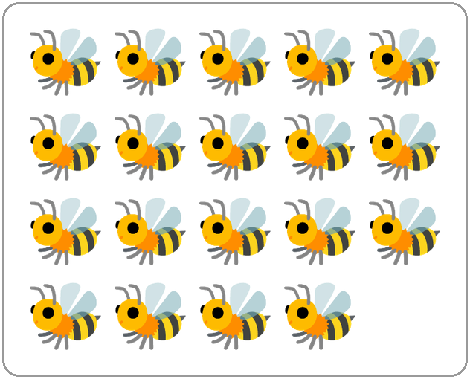
Q1. Look at the picture. Which number name tells how many bees there are?
(A) nineteen | (B) eighteen
(C) fifteen | (D) ninety

Q2. Which word fills the blank?
The number name of 73 is seventy-___.
(A) ten | (B) thirty | (C) seven | (D) three

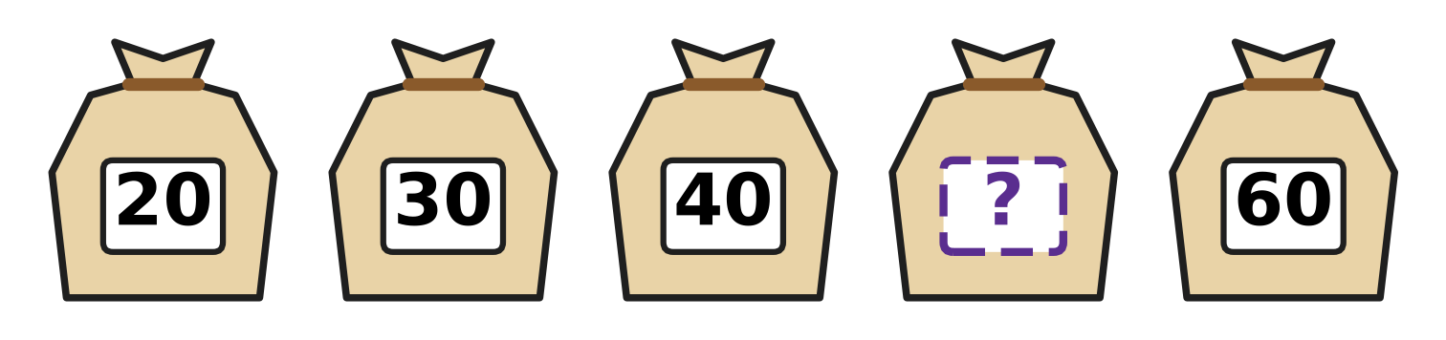
Q3. The sacks of grain in the picture are numbered in tens. Which number is hidden?
(A) 50 | (B) 70 | (C) 41 | (D) 45

Q4. Which number fills the blank?
The number that is 1 more than 79 is ___.
(A) 78 | (B) 80 | (C) 89 | (D) 90

Q5. Which number fills the blank?
The number 67 is 6 tens and ___ ones.
(A) 1 | (B) 6 | (C) 13 | (D) 7

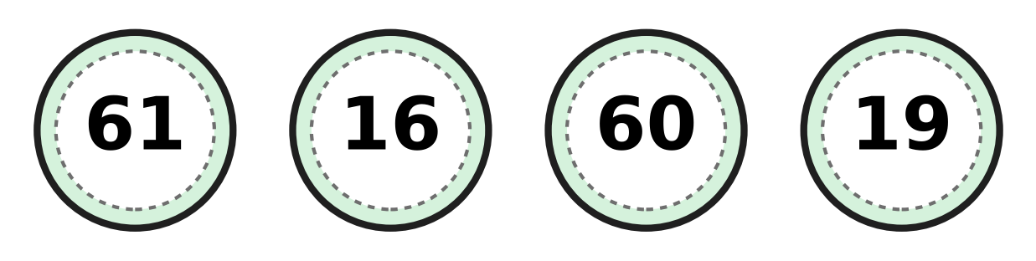
Q6. Look at the four canteen tokens. Which token has the smallest number?
(A) 16 | (B) 61 | (C) 19 | (D) 60

Q7. In 74, what does the digit 7 stand for?
(A) 74 tens | (B) 4 tens | (C) 7 ones | (D) 7 tens

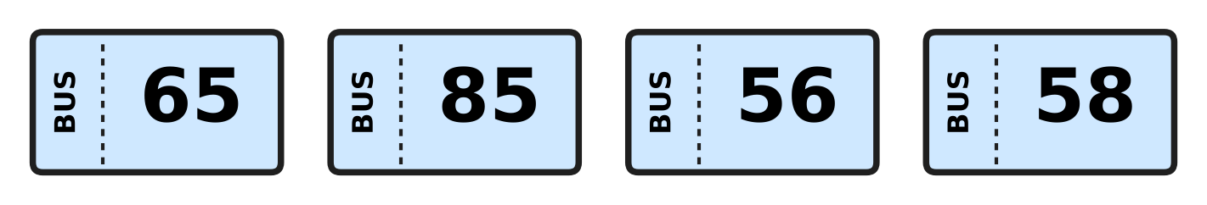
Q8. Look at the four bus tickets. Daksh puts their numbers in order, smallest first. Which number comes third?
(A) 65 | (B) 85 | (C) 56 | (D) 58

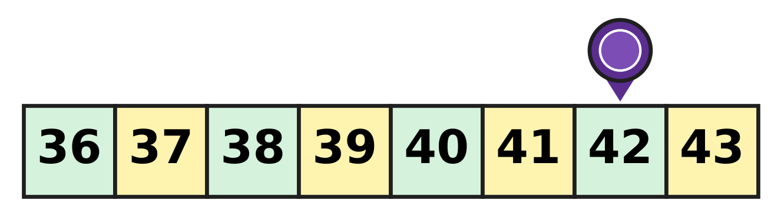
Q9. Look at the game track. The counter is on 42. It moves back 4 squares, to a smaller number. On which number does it stop?
(A) 37 | (B) 38 | (C) 39 | (D) 46

Q10. Sakshi writes the number with 5 tens and 2 ones. Then she swaps its two digits. Which number does she get?
(A) 25 | (B) 52 | (C) 20 | (D) 7

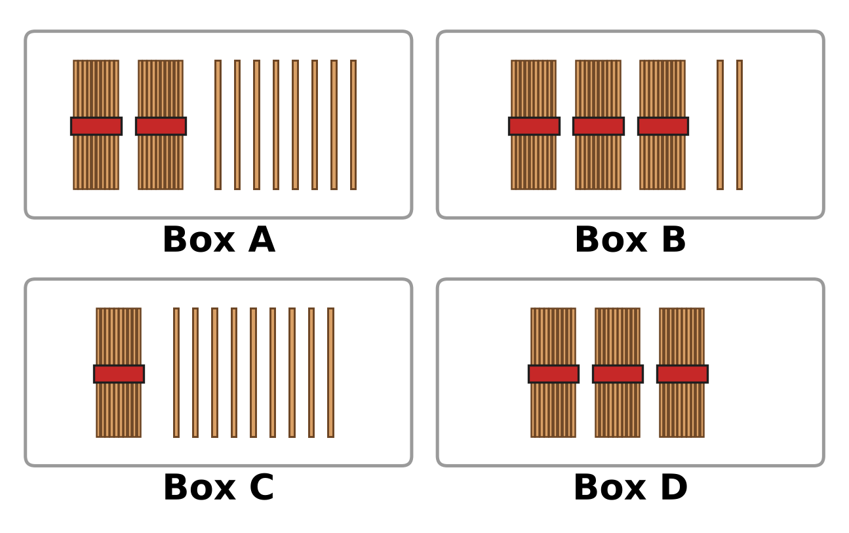
Q11. Each box shows bundles of ten sticks. Some boxes also have loose sticks. Which box shows the greatest number?
(A) Box A | (B) Box B | (C) Box C | (D) Box D

Q12. Which of these is greater than 78?
(A) 6 tens and 9 ones | (B) 7 tens
(C) 7 tens and 7 ones | (D) 8 tens

Part 2 — Operations & Number Properties (Syllabus Chapter 2)
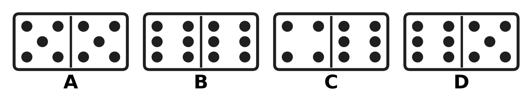
Q13. Look at the dominoes. Which domino has 11 dots in all?
(A) Picture A | (B) Picture B
(C) Picture C | (D) Picture D

Q14. Juhi folds 8 paper planes. Sahil also folds 8. How many paper planes do they fold in all?
(A) 16 | (B) 88 | (C) 18 | (D) 8

Q15. Hemant the postman has 19 letters in his bag. He delivers 7 letters. How many letters are left in the bag?
(A) 11 | (B) 12 | (C) 13 | (D) 26

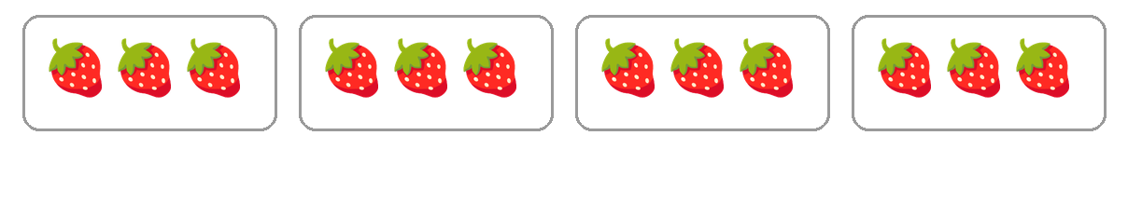
Q16. Look at the boxes of strawberries. Which number fills the blank?
There are ___ groups of 3 strawberries.
(A) 7 | (B) 3 | (C) 12 | (D) 4

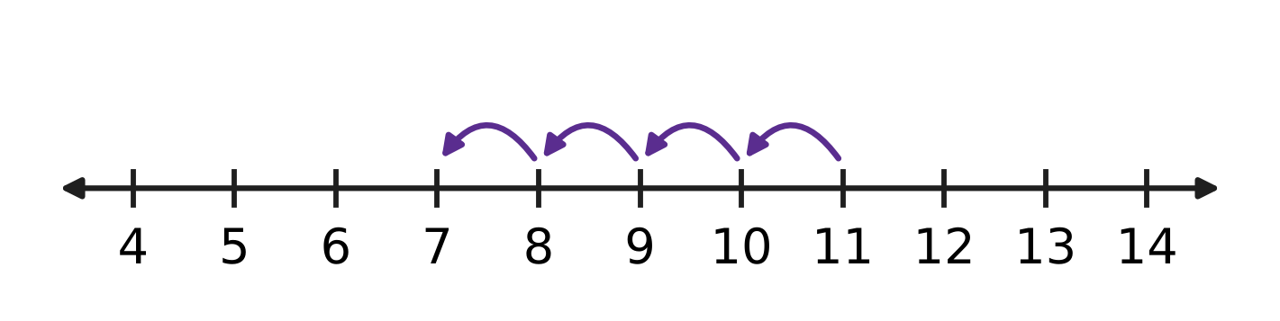
Q17. The hops on the number line show a take-away. Which number fills the blank?
11 − ___ = 7
(A) 3 | (B) 4 | (C) 5 | (D) 18

Q18. Which number fills the blank?
10 + ___ = 17
(A) 17 | (B) 27 | (C) 1 | (D) 7

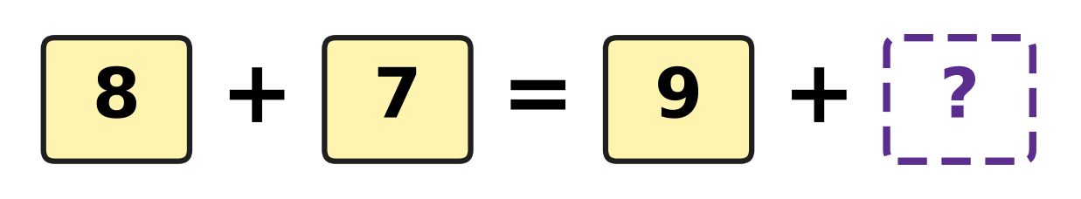
Q19. Look at the number cards. The two sides of the = sign must be equal. Which number goes in the box with the question mark?
(A) 6 | (B) 7 | (C) 15 | (D) 24

Q20. Which take-away gives 9?
(A) 18 − 9 | (B) 16 − 6 | (C) 19 − 9 | (D) 17 − 9

Q21. Some mangoes hang on a tree. Then 5 mangoes fall down. Now 11 mangoes are on the tree. How many mangoes were on the tree at first?
(A) 6 | (B) 11 | (C) 15 | (D) 16

Q22. Bharat makes 15 clay pots. Nina makes 11 clay pots. How many more pots does Bharat make than Nina?
(A) 4 | (B) 5 | (C) 15 | (D) 26

Part 3 — Geometry (Syllabus Chapter 5)
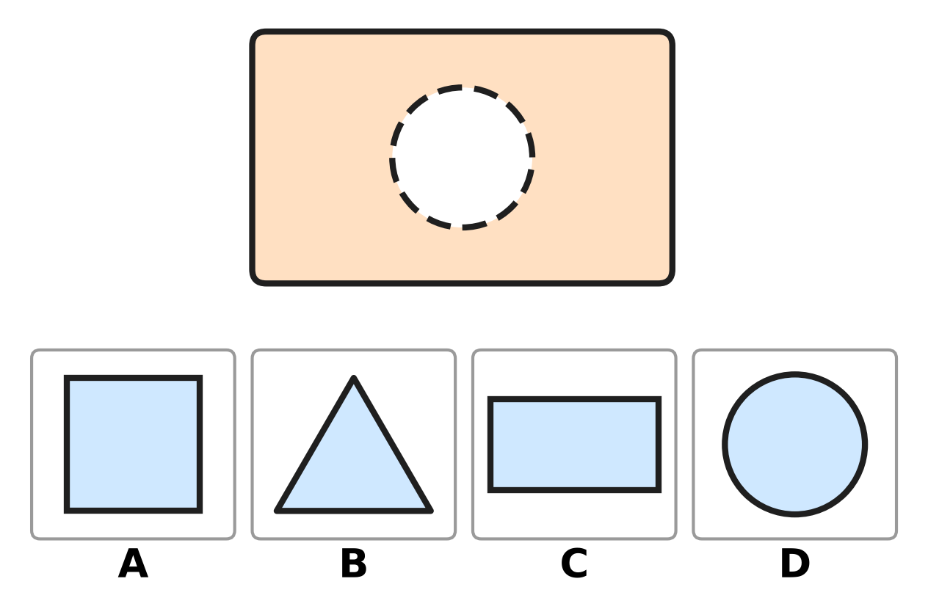
Q23. A piece is missing from the board at the top. Which picture shows the piece that fits the hole?
(A) Picture A | (B) Picture B
(C) Picture C | (D) Picture D

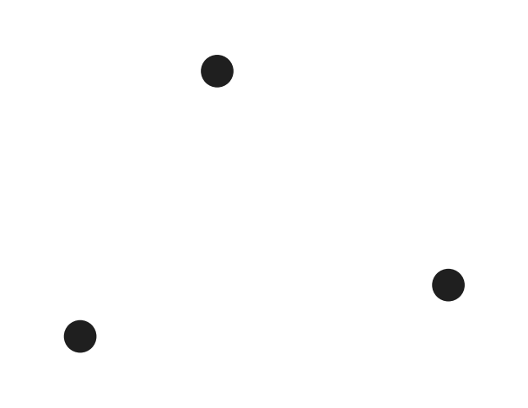
Q24. Sneha joins the three dots in the picture with straight lines to make a shape. How many sides does her shape have?
(A) 0 | (B) 3 | (C) 4 | (D) 6

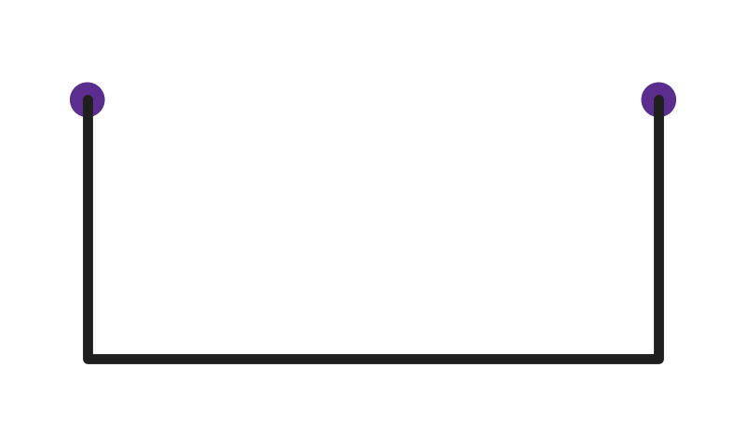
Q25. Three sides of a shape are drawn. Tushar joins the two dots with a straight line to close the shape. Which shape does he get?
(A) triangle | (B) circle
(C) square | (D) rectangle

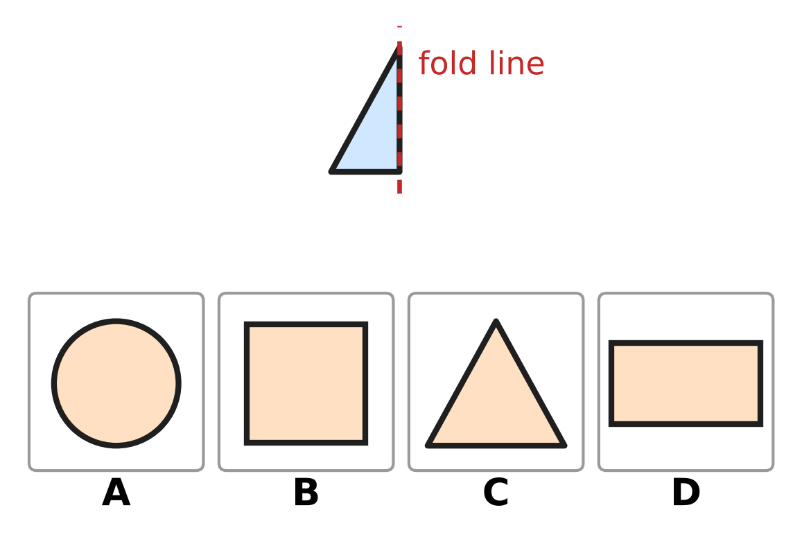
Q26. Half of a shape is drawn next to a fold line. The other half is the same, on the other side of the fold line. Which picture shows the whole shape?
(A) Picture A | (B) Picture B
(C) Picture C | (D) Picture D

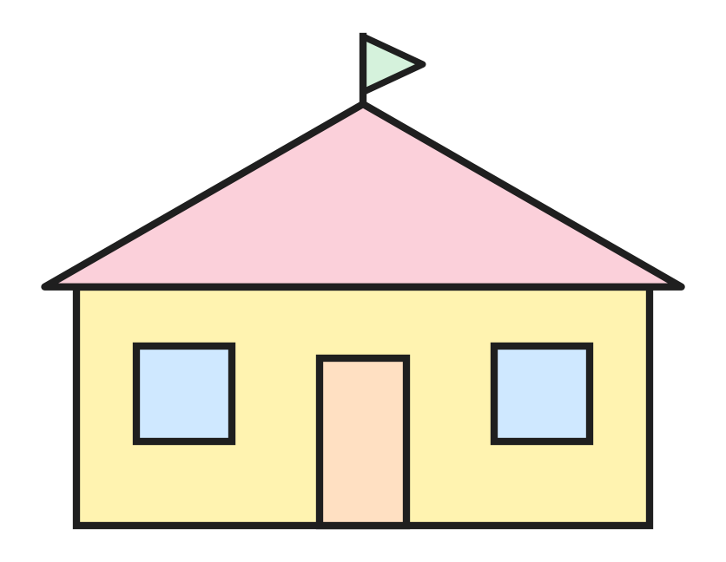
Q27. This picture of a house is made of shapes. Which shape is NOT in the picture?
(A) circle | (B) rectangle
(C) triangle | (D) square

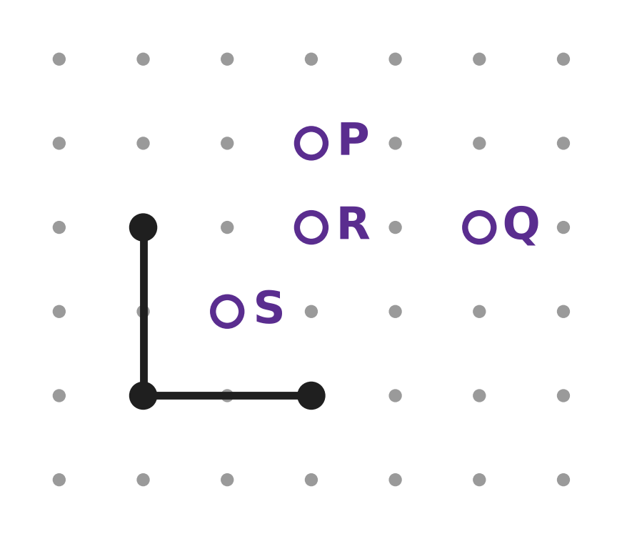
Q28. Two sides of a square are drawn on dot paper. Which letter marks the fourth corner of the square?
(A) P | (B) Q | (C) R | (D) S

Part 4 — Applied Mathematics (Syllabus Chapter 9)
Q29. Tomorrow is Saturday. Which day is today?
(A) Sunday | (B) Thursday
(C) Monday | (D) Friday

Q30. Which number fills the blank?
One year has ___ months.
(A) 7 | (B) 10 | (C) 12 | (D) 30

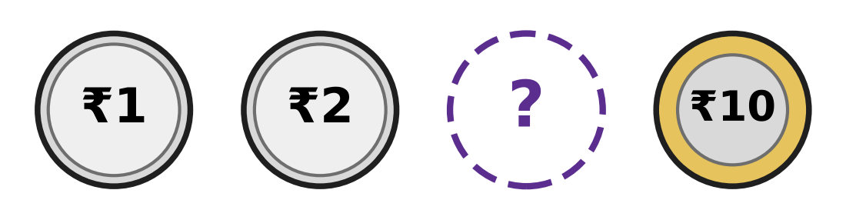
Q31. The coins in the picture are in order, from the least value to the greatest. Which coin is hidden?
(A) ₹1 | (B) ₹2 | (C) ₹5 | (D) ₹20

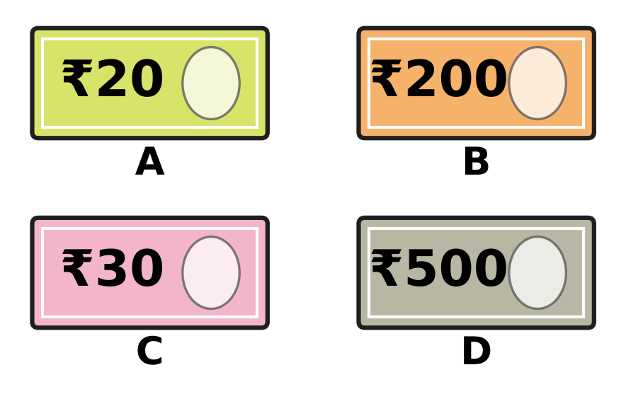
Q32. Look at the four pictures. Three of them show Indian notes. Which picture is NOT an Indian note?
(A) Picture A | (B) Picture B
(C) Picture C | (D) Picture D

Q33. Vinita goes to school every day from Monday to Friday. Which is the middle day of these school days?
(A) Wednesday | (B) Tuesday
(C) Friday | (D) Thursday

Q34. How many months of the year come after September?
(A) 2 | (B) 3 | (C) 4 | (D) 9

Part 5 — Mathematical Reasoning & Problem-Solving (Syllabus Chapter 10)
Q35. Ken counts back in fives: 40, 35, 30, 25. Which number does he say next?
(A) 15 | (B) 20 | (C) 24 | (D) 30


Q36. The pictures make a pattern. Which two pictures come next, in this order?
(A)  | (B)  | (C)  | (D) 

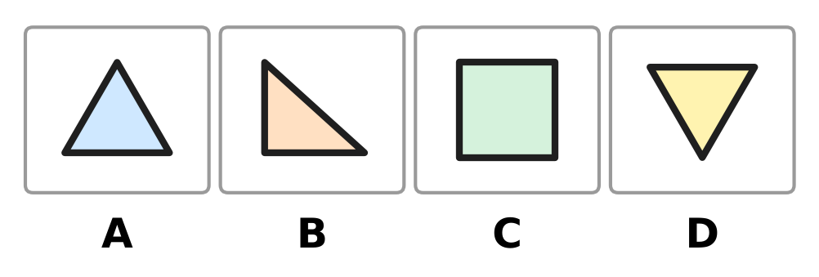
Q37. Three of the four shapes are alike. Each of them has 3 corners. Which picture does NOT belong with them?
(A) Picture A | (B) Picture B
(C) Picture C | (D) Picture D

Q38. Look at the pattern: 7, 17, 27, 37.
It goes on in the same way. Which of these numbers will also be in the pattern?
(A) 40 | (B) 57 | (C) 70 | (D) 73

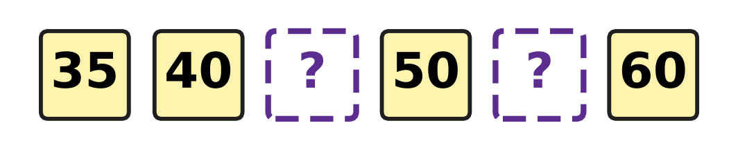
Q39. The numbers in the picture make a pattern. Which two numbers are hidden?
(A) 42 and 52 | (B) 45 and 55
(C) 41 and 51 | (D) 45 and 65

Q40. Look at the tens in these numbers. Three of them have the same number of tens. Which number does NOT belong with them?
(A) 62 | (B) 64 | (C) 46 | (D) 68

SECTION II — Star Questions 5 questions × 4 marks each
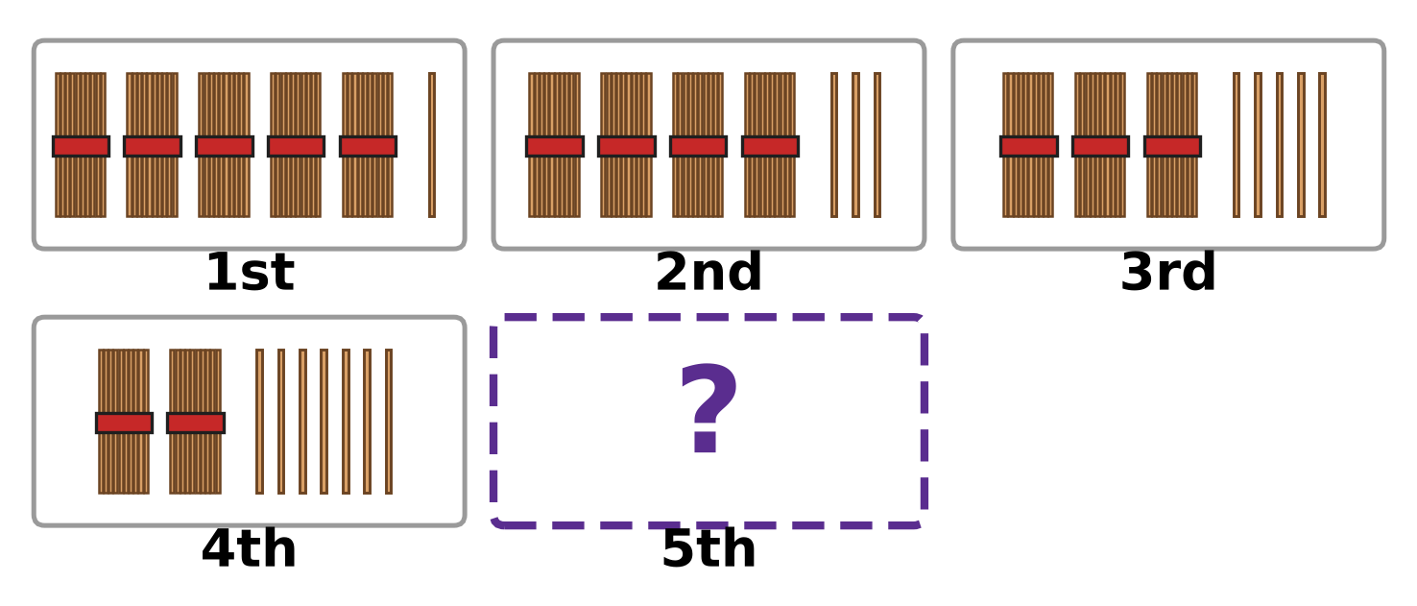
Q41. Each box shows a number as bundles of ten and loose sticks. The boxes follow a pattern. Which number does the 5th box show? [4 marks]
(A) 17 | (B) 19 | (C) 29 | (D) 91

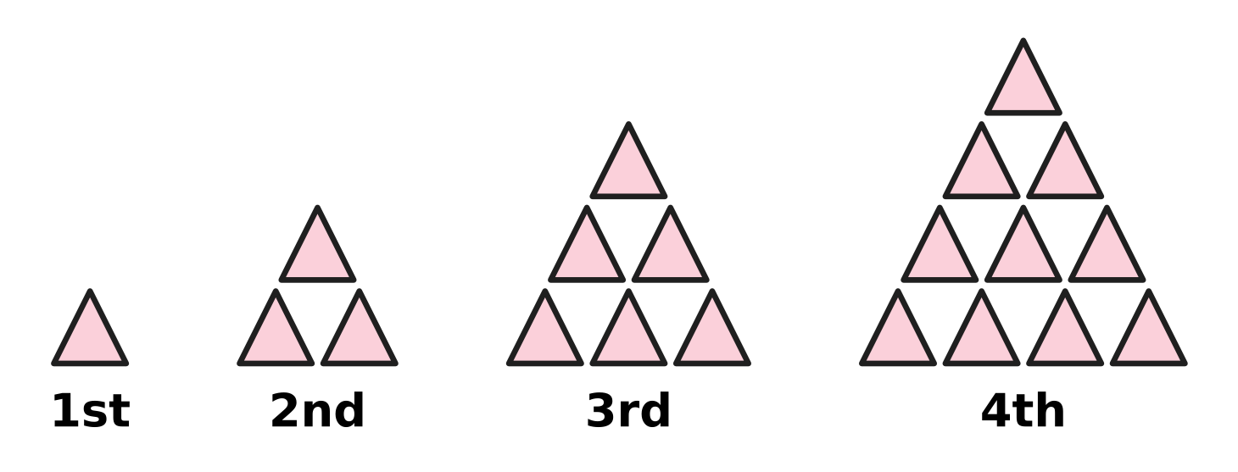
Q42. Look at the stacks of triangles. Each new stack has one more row at the bottom. How many triangles will the 5th stack have? [4 marks]
(A) 5 | (B) 14 | (C) 15 | (D) 20

Q43. Nora saves ₹10 in January, ₹20 in February, ₹30 in March and ₹40 in April. The pattern goes on. In which month does she save ₹70? [4 marks]
(A) June | (B) July | (C) August | (D) May

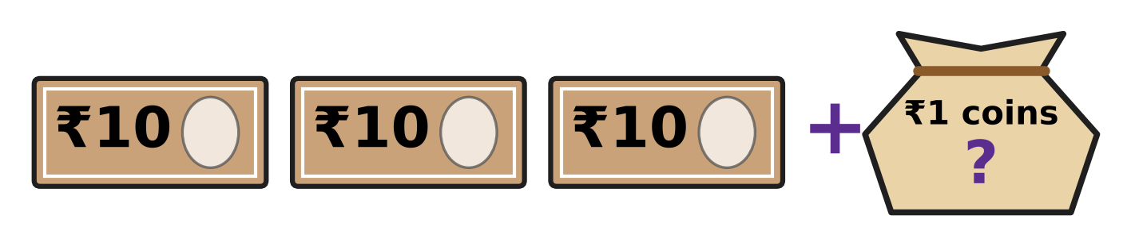
Q44. Saira has ₹42 in all. She has the 3 notes in the picture, and the rest is in ₹1 coins. How many ₹1 coins does she have? [4 marks]
(A) 2 | (B) 4 | (C) 12 | (D) 39

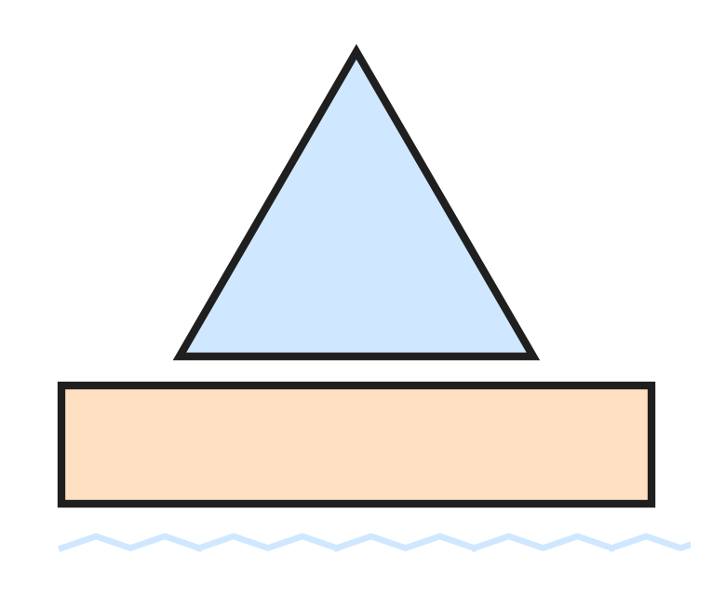
Q45. Look at the toy boat. Lalit counts all the sides and all the corners of its two shapes. What total does he get? [4 marks]
(A) 7 | (B) 8 | (C) 14 | (D) 16

Answer Sheet AMO Level 1 · Class 1 · Practice Paper 3
Name: | School: | Roll No.:
Shade or tick one circle for each question.
1. Ⓐ Ⓑ Ⓒ Ⓓ | 16. Ⓐ Ⓑ Ⓒ Ⓓ | 31. Ⓐ Ⓑ Ⓒ Ⓓ
2. Ⓐ Ⓑ Ⓒ Ⓓ | 17. Ⓐ Ⓑ Ⓒ Ⓓ | 32. Ⓐ Ⓑ Ⓒ Ⓓ
3. Ⓐ Ⓑ Ⓒ Ⓓ | 18. Ⓐ Ⓑ Ⓒ Ⓓ | 33. Ⓐ Ⓑ Ⓒ Ⓓ
4. Ⓐ Ⓑ Ⓒ Ⓓ | 19. Ⓐ Ⓑ Ⓒ Ⓓ | 34. Ⓐ Ⓑ Ⓒ Ⓓ
5. Ⓐ Ⓑ Ⓒ Ⓓ | 20. Ⓐ Ⓑ Ⓒ Ⓓ | 35. Ⓐ Ⓑ Ⓒ Ⓓ
6. Ⓐ Ⓑ Ⓒ Ⓓ | 21. Ⓐ Ⓑ Ⓒ Ⓓ | 36. Ⓐ Ⓑ Ⓒ Ⓓ
7. Ⓐ Ⓑ Ⓒ Ⓓ | 22. Ⓐ Ⓑ Ⓒ Ⓓ | 37. Ⓐ Ⓑ Ⓒ Ⓓ
8. Ⓐ Ⓑ Ⓒ Ⓓ | 23. Ⓐ Ⓑ Ⓒ Ⓓ | 38. Ⓐ Ⓑ Ⓒ Ⓓ
9. Ⓐ Ⓑ Ⓒ Ⓓ | 24. Ⓐ Ⓑ Ⓒ Ⓓ | 39. Ⓐ Ⓑ Ⓒ Ⓓ
10. Ⓐ Ⓑ Ⓒ Ⓓ | 25. Ⓐ Ⓑ Ⓒ Ⓓ | 40. Ⓐ Ⓑ Ⓒ Ⓓ
11. Ⓐ Ⓑ Ⓒ Ⓓ | 26. Ⓐ Ⓑ Ⓒ Ⓓ | 41. Ⓐ Ⓑ Ⓒ Ⓓ
12. Ⓐ Ⓑ Ⓒ Ⓓ | 27. Ⓐ Ⓑ Ⓒ Ⓓ | 42. Ⓐ Ⓑ Ⓒ Ⓓ
13. Ⓐ Ⓑ Ⓒ Ⓓ | 28. Ⓐ Ⓑ Ⓒ Ⓓ | 43. Ⓐ Ⓑ Ⓒ Ⓓ
14. Ⓐ Ⓑ Ⓒ Ⓓ | 29. Ⓐ Ⓑ Ⓒ Ⓓ | 44. Ⓐ Ⓑ Ⓒ Ⓓ
15. Ⓐ Ⓑ Ⓒ Ⓓ | 30. Ⓐ Ⓑ Ⓒ Ⓓ | 45. Ⓐ Ⓑ Ⓒ Ⓓ
Q41–Q45 are Section II Star Questions (4 marks each).
For the parent or teacher
Section I correct: ______ / 40 × 2 = ______ marks Section II correct: ______ / 5 × 4 = ______ marks
Correct: ______ / 45 Score: ______ / 100
Answer Key and Solutions AMO Level 1 · Class 1 · Practice Paper 3
Quick answers
1 A | 6 A | 11 B | 16 D | 21 D | 26 C | 31 C | 36 C | 41 B
2 D | 7 D | 12 D | 17 B | 22 A | 27 A | 32 C | 37 C | 42 C
3 A | 8 A | 13 D | 18 D | 23 D | 28 C | 33 A | 38 B | 43 B
4 B | 9 B | 14 A | 19 A | 24 B | 29 D | 34 B | 39 B | 44 C
5 D | 10 A | 15 B | 20 A | 25 D | 30 C | 35 B | 40 C | 45 C
Solutions
Q | Part · level | Answer | Why?
1 | Part 1 · Ch1 · Easy | (A) nineteen | There are three rows of 5 and 4 more: 5, 10, 15, then 16, 17, 18, 19. The number 19 is nineteen.
2 | Part 1 · Ch1 · Easy | (D) three | 73 is 7 tens and 3 ones. We say seventy for 7 tens and three for 3 ones: seventy-three.
3 | Part 1 · Ch1 · Easy | (A) 50 | Counting in tens: 20, 30, 40, 50, 60. The hidden number is 50.
4 | Part 1 · Ch1 · Easy | (B) 80 | The number just after 79 is 80. So 1 more than 79 is 80.
5 | Part 1 · Ch1 · Easy | (D) 7 | 67 has 6 in the tens place and 7 in the ones place. So it is 6 tens and 7 ones.
6 | Part 1 · Ch1 · Easy | (A) 16 | 16 and 19 have 1 ten, and 60 and 61 have 6 tens. Of 16 and 19, the number 16 has fewer ones. So 16 is the smallest.
7 | Part 1 · Ch1 · Easy | (D) 7 tens | In 74, the digit 7 is on the left, in the tens place. It stands for 7 tens.
8 | Part 1 · Ch1 · Medium | (A) 65 | In order, smallest first, the numbers are 56, 58, 65, 85. The third number is 65.
9 | Part 1 · Ch1 · Medium | (B) 38 | Count back 4 squares from 42: 41, 40, 39, 38. The counter stops on 38.
10 | Part 1 · Ch1 · Medium | (A) 25 | 5 tens and 2 ones make 52. With the digits swapped, the number is 25.
11 | Part 1 · Ch1 · Medium | (B) Box B | Box A shows 28, Box B shows 32, Box C shows 19 and Box D shows 30. The greatest number is 32, in Box B.
12 | Part 1 · Ch1 · Medium | (D) 8 tens | 8 tens make 80, and 80 is greater than 78. The others are 70, 77 and 69, which are all less than 78.
13 | Part 2 · Ch2 · Easy | (D) Picture D | Picture D has 6 dots and 5 dots. 6 + 5 = 11.
14 | Part 2 · Ch2 · Easy | (A) 16 | 8 + 8 = 16. They fold 16 paper planes in all.
15 | Part 2 · Ch2 · Easy | (B) 12 | Letters are taken out of the bag, so we take away. 19 − 7 = 12.
16 | Part 2 · Ch2 · Easy | (D) 4 | Each box is one group of 3 strawberries. There are 4 boxes, so there are 4 groups of 3.
17 | Part 2 · Ch2 · Easy | (B) 4 | The hops start at 11 and end at 7. There are 4 hops, so 11 − 4 = 7.
18 | Part 2 · Ch2 · Easy | (D) 7 | 17 is 1 ten and 7 ones. So 10 + 7 = 17.
19 | Part 2 · Ch2 · Medium | (A) 6 | 8 + 7 = 15. To make 15 from 9, add 6. So 9 + 6 = 15.
20 | Part 2 · Ch2 · Medium | (A) 18 − 9 | 18 − 9 = 9. The other sums give 8, 10 and 10.
21 | Part 2 · Ch2 · Medium | (D) 16 | Put the fallen mangoes back: 11 + 5 = 16. There were 16 mangoes at first.
22 | Part 2 · Ch2 · Medium | (A) 4 | Count on from 11 to 15: that takes 4 steps. 15 − 11 = 4.
23 | Part 3 · Ch5 · Easy | (D) Picture D | The hole is round with no corners, so it is a circle. The circle is in Picture D.
24 | Part 3 · Ch5 · Easy | (B) 3 | Each dot is a corner. Three corners joined by straight lines make a triangle, which has 3 sides.
25 | Part 3 · Ch5 · Easy | (D) rectangle | The new line makes a fourth side. The shape has 2 long sides and 2 short sides, so it is a rectangle.
26 | Part 3 · Ch5 · Easy | (C) Picture C | The half has one slanting side. With the same half on the other side, the two slanting sides meet at the top and make a triangle.
27 | Part 3 · Ch5 · Medium | (A) circle | The roof and the flag are triangles, the windows are squares, and the wall and the door are rectangles. There is no circle.
28 | Part 3 · Ch5 · Medium | (C) R | All 4 sides of a square have the same length. Each drawn side goes 2 spaces from dot to dot. So the last corner is 2 spaces straight up from the right end of the bottom side. That is the dot marked R.
29 | Part 4 · Ch9 · Easy | (D) Friday | Tomorrow is the day after today. The day just before Saturday is Friday.
30 | Part 4 · Ch9 · Easy | (C) 12 | The months run from January to December. Count them: there are 12 months in one year.
31 | Part 4 · Ch9 · Easy | (C) ₹5 | Our coins are ₹1, ₹2, ₹5, ₹10 and ₹20. The coin between ₹2 and ₹10 is the ₹5 coin.
32 | Part 4 · Ch9 · Easy | (C) Picture C | Our notes are ₹10, ₹20, ₹50, ₹100, ₹200 and ₹500. There is no ₹30 note, so Picture C is not an Indian note.
33 | Part 4 · Ch9 · Medium | (A) Wednesday | The school days are Monday, Tuesday, Wednesday, Thursday and Friday. Wednesday has two days before it and two days after it.
34 | Part 4 · Ch9 · Medium | (B) 3 | After September come October, November and December. That is 3 months.
35 | Part 5 · Ch10 · Easy | (B) 20 | Each number is 5 less than the one before: 40, 35, 30, 25. Then 5 less than 25 is 20.
36 | Part 5 · Ch10 · Easy | (C) | The part that repeats is cactus, sun, sun. After the last cactus come two suns.
37 | Part 5 · Ch10 · Easy | (C) Picture C | The shapes in Pictures A, B and D each have 3 corners. The shape in Picture C has 4 corners, so it is the odd one out.
38 | Part 5 · Ch10 · Medium | (B) 57 | Each number is 10 more than the one before, so every number ends in 7: 47, 57, 67 and so on. Of the four numbers, only 57 ends in 7.
39 | Part 5 · Ch10 · Medium | (B) 45 and 55 | The numbers go up by 5 each time: 35, 40, 45, 50, 55, 60. The hidden numbers are 45 and 55.
40 | Part 5 · Ch10 · Medium | (C) 46 | 62, 64 and 68 all have 6 tens. 46 has 4 tens, so it is the odd one out.
41 | Section II · Ch1 + Ch10 · Hard | (B) 19 | The boxes show 51, 43, 35 and 27. Each time there is 1 bundle fewer and 2 more loose sticks. The 5th box has 1 ten and 9 ones, which is 19.
42 | Section II · Ch5 + Ch10 · Hard | (C) 15 | The stacks have 1, 3, 6 and 10 triangles. The 5th stack gets a new row of 5 triangles, so it has 10 + 5 = 15.
43 | Section II · Ch9 + Ch10 · Hard | (B) July | The money goes up by ₹10 each month: May ₹50, June ₹60, July ₹70. She saves ₹70 in July.
44 | Section II · Ch1 + Ch9 · Hard | (C) 12 | The 3 notes of ₹10 make ₹30. From 30 to 42 is 1 ten and 2 ones, which is 12. She has 12 coins of ₹1.
45 | Section II · Ch2 + Ch5 · Hard | (C) 14 | The triangle has 3 sides and 3 corners. The rectangle has 4 sides and 4 corners. 3 + 3 + 4 + 4 = 14.

