UNLOCK IQ INSTITUTE
Realize Your True Potential
Aryabhatta Maths Olympiad (AMO)
Level 1 — Practice Paper 5
CLASS 1

Questions | 45 multiple-choice questions
Marks | 100
Time | 60 minutes
Section I | 40 questions × 2 marks = 80 marks
Section II | 5 Star Questions × 4 marks = 20 marks
Negative marking | No negative marking
Calculator | Not allowed
Chapters | Number System · Operations · Geometry · Applied Mathematics · Mathematical Reasoning

Hello, friend!
• Every question has four answer choices: (A), (B), (C) and (D). Only one is correct.
• Read each question and look at its picture carefully. Then mark your answer on the answer sheet at the end.
• Section I has 40 questions of 2 marks each. Section II has 5 Star Questions of 4 marks each.
• There is no negative marking, so try every question.
• Do not use a calculator. You may do rough work on a separate sheet.

For parents and teachers
Print or view this paper in colour. Pictures are part of the questions.
You may read a question aloud to the child, exactly as printed. Please do not explain it or point to an answer choice.
Parts follow the AMO syllabus chapters. Chapters 3, 4, 6, 7 and 8 are not part of the Class 1 syllabus, so the chapter numbers shown in the Part headings have gaps.
The answer sheet and the answer key with solutions are at the end. Give the child the answer sheet. Remove the answer key and solutions before the child begins.

Name: | School: | Roll No.:

SECTION I 40 questions × 2 marks each
Part 1 — Number System (Syllabus Chapter 1)
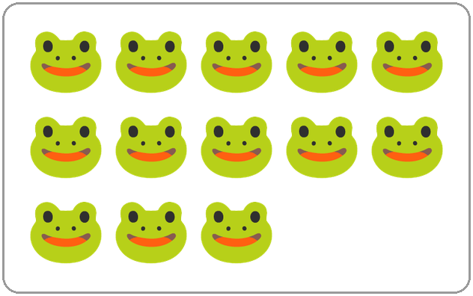
Q1. Tarun says there are 15 frogs in the picture. He is wrong. Count the frogs. How many are there?
(A) 13 | (B) 14 | (C) 15 | (D) 16

Q2. Which number name comes just after twenty-nine?
(A) twenty-eight | (B) forty
(C) thirty-one | (D) thirty

Q3. Lavina lives in house number 72. What is the ones digit of her house number?
(A) 2 | (B) 7 | (C) 9 | (D) 70

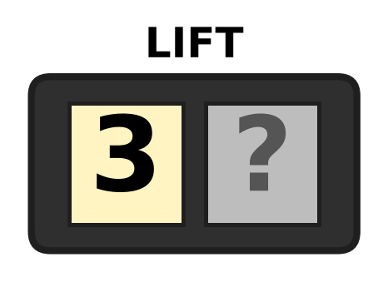
Q4. Look at the lift display. One digit cannot be seen. The floor number is greater than 38. Which digit is hidden?
(A) 6 | (B) 7 | (C) 8 | (D) 9

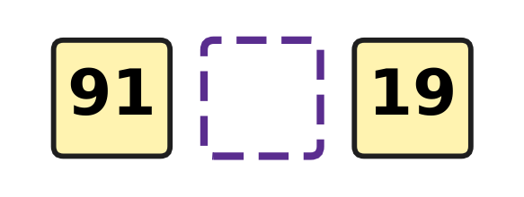
Q5. Look at the two number cards. Which sign goes in the empty box between them?
(A) + | (B) = | (C) < | (D) >

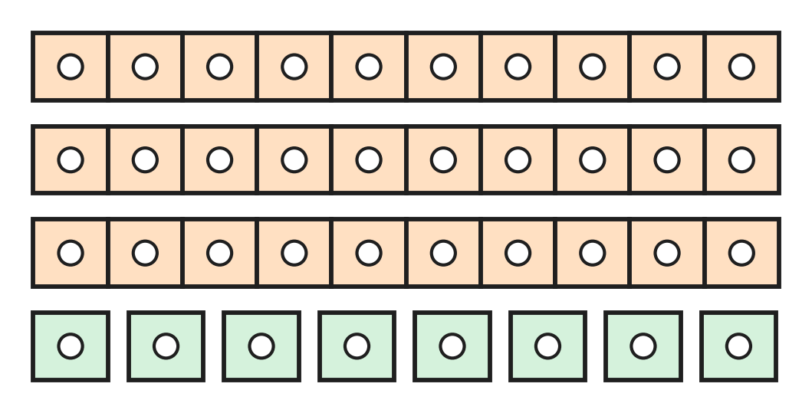
Q6. Look at the tickets for the school play. Each long strip has 10 tickets. How many tickets are there in all?
(A) 11 | (B) 30 | (C) 38 | (D) 83

Q7. How many tens are there in 90?
(A) 10 | (B) 19 | (C) 0 | (D) 9

Q8. Sohan thinks of a number. It has 4 ones. It has 2 more tens than ones. What is Sohan's number?
(A) 24 | (B) 46 | (C) 64 | (D) 66

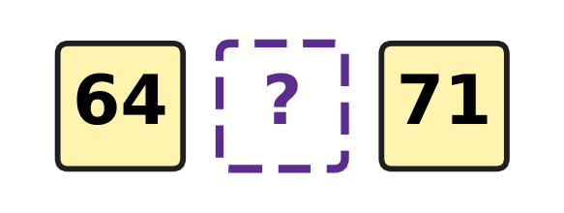
Q9. Look at the three cards. They are in order from smallest to greatest. Which number can be on the middle card?
(A) 46 | (B) 63 | (C) 72 | (D) 68

Q10. Car park spaces are numbered in order: 27, 28, 92, 30, 31. One number is painted wrongly. Which number should it be?
(A) 26 | (B) 29 | (C) 32 | (D) 39

Q11. Kian hears the number fifteen and writes 50. Which number should he write?
(A) 55 | (B) 51 | (C) 5 | (D) 15

Q12. How many numbers come between 37 and 42?
(A) 3 | (B) 4 | (C) 5 | (D) 6

Part 2 — Operations & Number Properties (Syllabus Chapter 2)
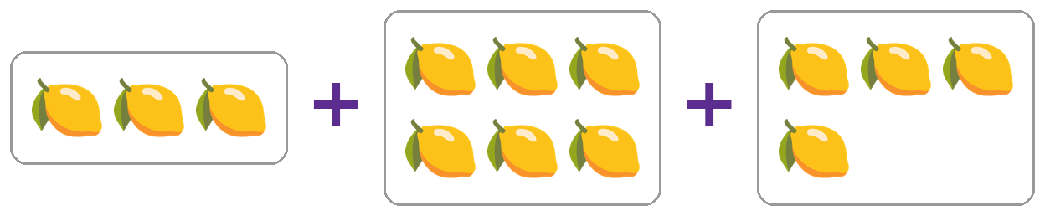
Q13. Look at the three trays of lemons. How many lemons are there in all?
(A) 9 | (B) 12 | (C) 13 | (D) 14

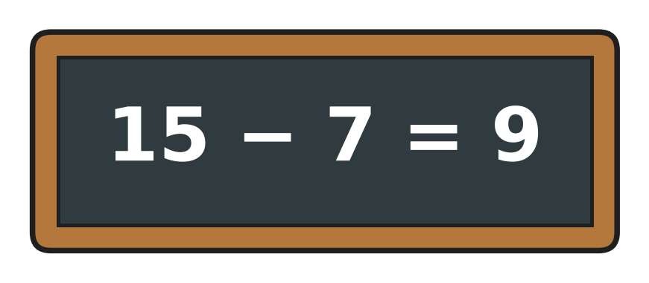
Q14. Look at the slate. The answer Ivan wrote is wrong. What is the correct answer?
(A) 8 | (B) 7 | (C) 9 | (D) 22

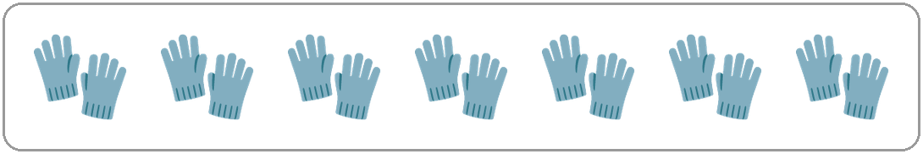
Q15. Look at the picture. Each pair has 2 gloves. How many gloves are there in all?
(A) 7 | (B) 9 | (C) 14 | (D) 16

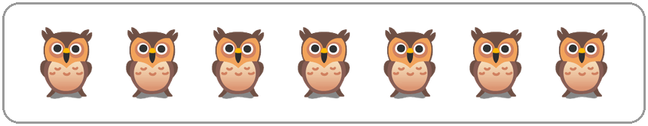
Q16. Look at the owls in the picture. All of them fly away. How many owls are left?
(A) 0 | (B) 1 | (C) 7 | (D) 14

Q17. There are 7 planes at the airport. Then 5 more planes land. How many planes are at the airport now?
(A) 2 | (B) 11 | (C) 12 | (D) 13

Q18. A tea stall has 15 clean cups. People use 6 of the cups. How many clean cups are left?
(A) 8 | (B) 9 | (C) 10 | (D) 21

Q19. There are 18 children in the playground. Some children go home. Now 11 children are still playing. How many children went home?
(A) 29 | (B) 6 | (C) 8 | (D) 7

Q20. Rani thought of a number. She took away 6 and got 7. What was her number?
(A) 1 | (B) 12 | (C) 13 | (D) 14

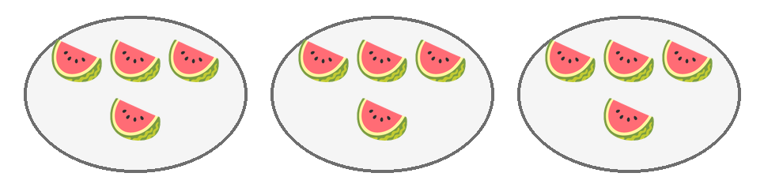
Q21. Look at the plates of watermelon slices. Mum puts one more plate with the same number of slices on the table. How many slices are there now?
(A) 12 | (B) 13 | (C) 16 | (D) 20

Q22. I am a number. Add me to myself and you get 14. Which number am I?
(A) 7 | (B) 8 | (C) 12 | (D) 14

Part 3 — Geometry (Syllabus Chapter 5)
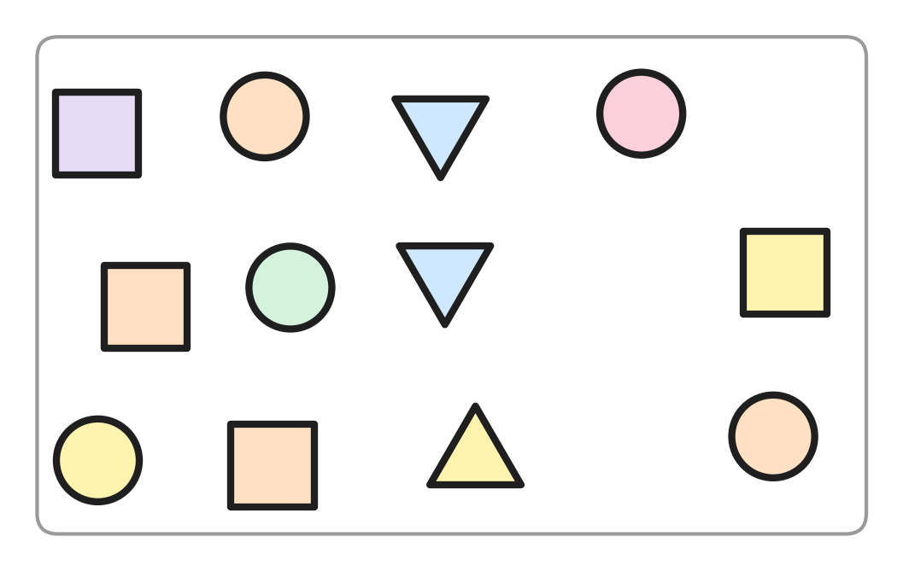
Q23. Look at the picture. How many squares are there?
(A) 4 | (B) 5 | (C) 9 | (D) 12

Q24. I have no corners and no straight sides. Which shape am I?
(A) triangle | (B) circle
(C) rectangle | (D) square

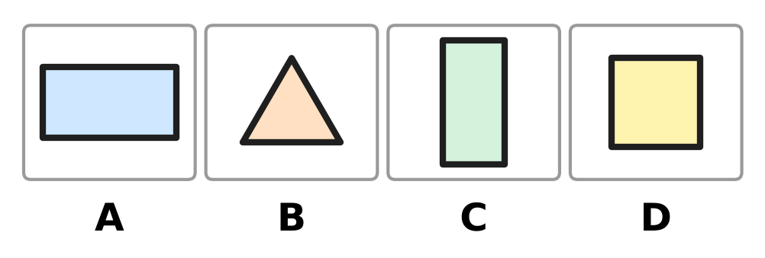
Q25. Look at the shapes. Which picture shows a square?
(A) Picture A | (B) Picture B
(C) Picture C | (D) Picture D

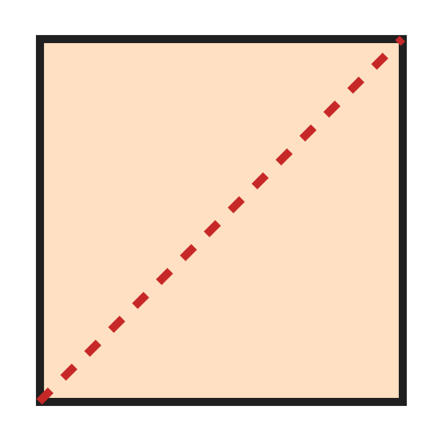
Q26. Look at the picture. A square floor tile is cut along the dotted line. What are the two pieces?
(A) two triangles | (B) two squares
(C) two circles | (D) two rectangles

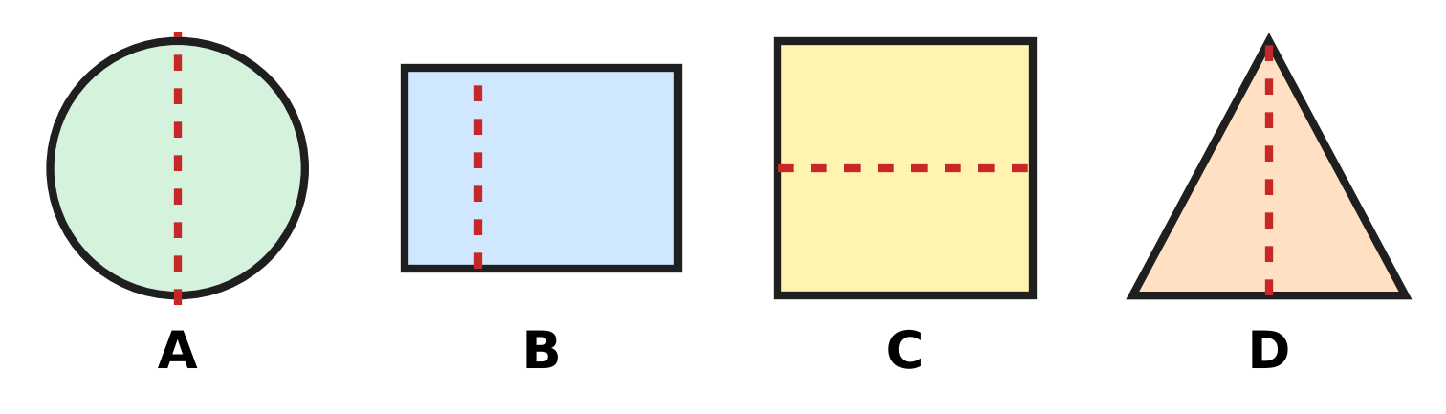
Q27. Look at the four shapes. Each has a dotted line. In which picture does the dotted line NOT cut the shape into two halves that match?
(A) Picture A | (B) Picture B
(C) Picture C | (D) Picture D

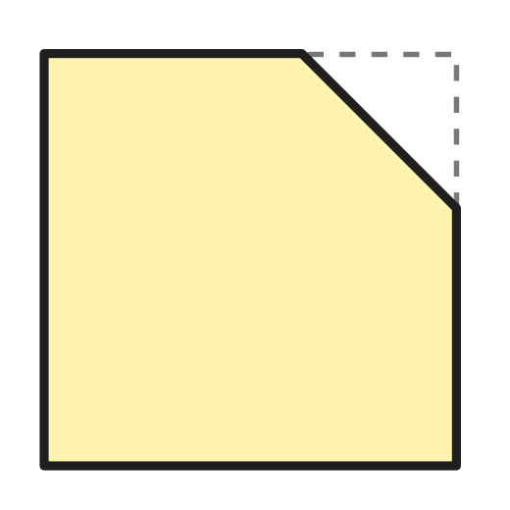
Q28. Jatin cuts one corner off a square paper with one straight cut. Look at the picture. How many corners does the paper have now?
(A) 3 | (B) 4 | (C) 5 | (D) 7

Part 4 — Applied Mathematics (Syllabus Chapter 9)
Q29. A hot-air balloon show is two days after Friday. On which day is the show?
(A) Saturday | (B) Monday
(C) Wednesday | (D) Sunday

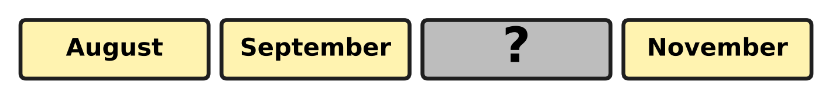
Q30. Look at the month cards. They are in order. One card is turned over. Which month is on it?
(A) October | (B) December
(C) June | (D) July

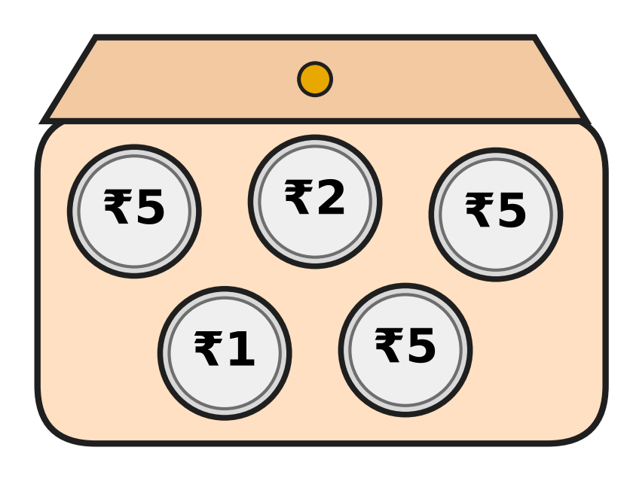
Q31. Look at the coins in Pari's purse. Which of these coins does Pari NOT have?
(A) ₹1 | (B) ₹2 | (C) ₹5 | (D) ₹10

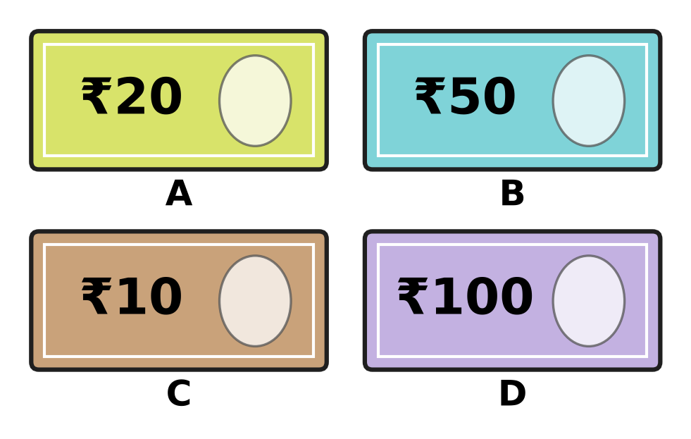
Q32. Hana has a fifty-rupee note. Which picture shows her note?
(A) Picture A | (B) Picture B
(C) Picture C | (D) Picture D

Q33. Myra writes down the rainfall every month from June to September. For how many months does she write it down?
(A) 3 | (B) 4 | (C) 5 | (D) 9

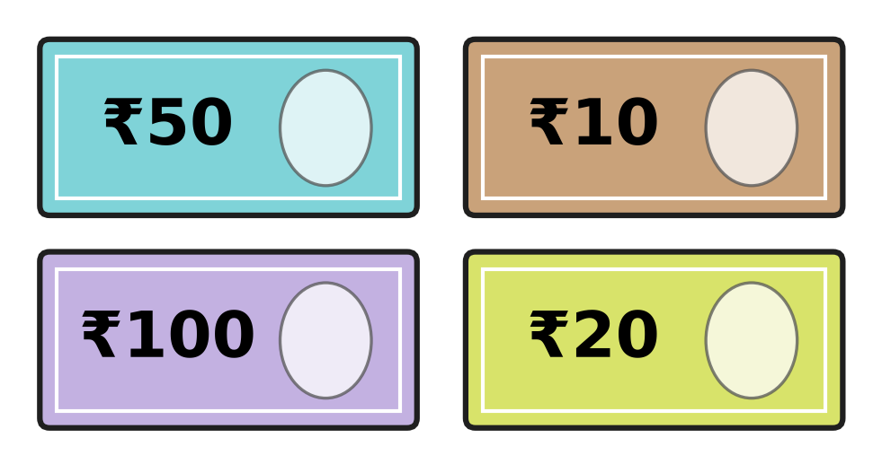
Q34. Look at the notes. Dhruv puts them in order from the smallest amount to the biggest. Which note comes second?
(A) ₹10 | (B) ₹20 | (C) ₹50 | (D) ₹100

Part 5 — Mathematical Reasoning & Problem-Solving (Syllabus Chapter 10)
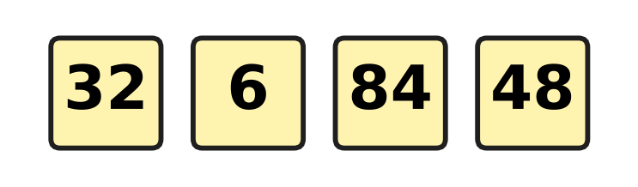
Q35. Look at the four number cards. Count the digits in each number. Which number has a different number of digits from the others?
(A) 6 | (B) 32 | (C) 48 | (D) 84

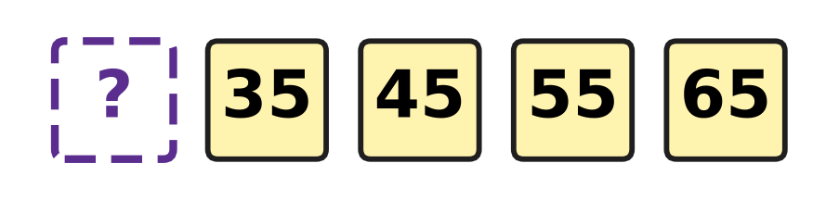
Q36. Look at the number pattern. The numbers grow by the same amount each time. Which number is hidden at the start?
(A) 25 | (B) 30 | (C) 34 | (D) 75

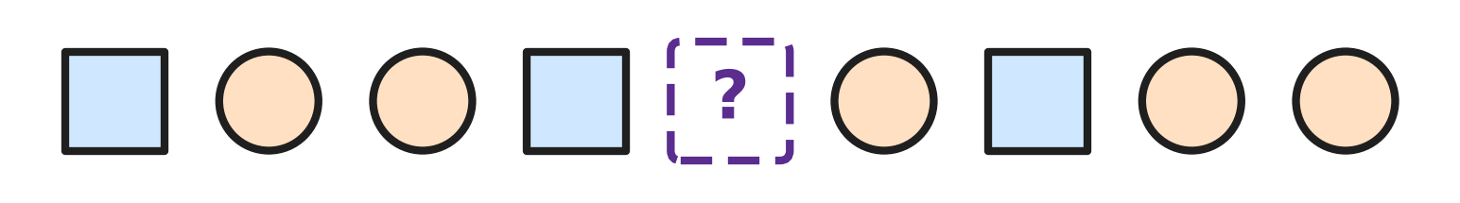
Q37. Look at the shape pattern. One shape is covered by the box. Which shape is under the box?
(A) triangle | (B) circle
(C) square | (D) rectangle

Q38. Nakul counts back in twos: 19, 17, 15, 13, and so on. He stops at 1. Which of these numbers does he NOT say?
(A) 3 | (B) 5 | (C) 6 | (D) 9

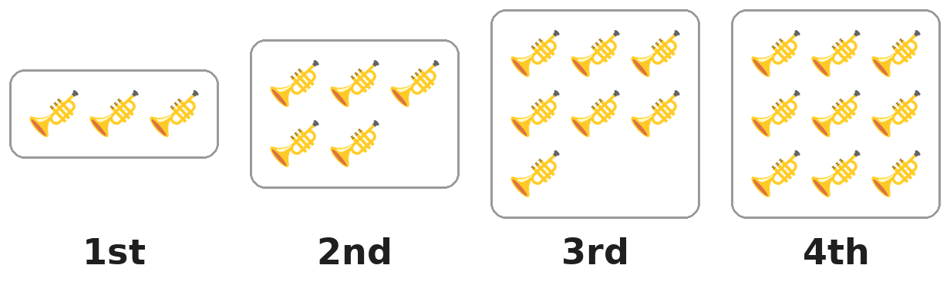
Q39. The groups of trumpets grow in a pattern. Which group will have 13 trumpets?
(A) the 13th group | (B) the 7th group
(C) the 5th group | (D) the 6th group

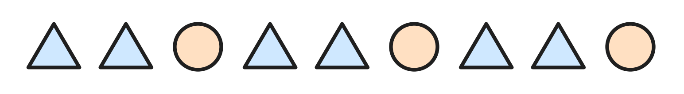
Q40. Look at the shape pattern. It is made by repeating one small group of shapes, starting from the left. Which group is it?
(A) 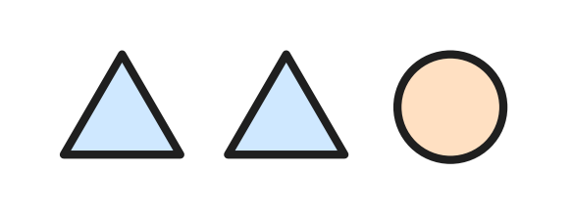 | (B) 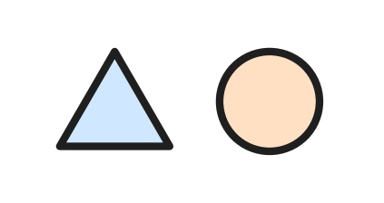
(C) 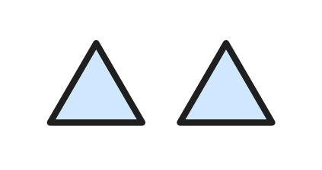 | (D) 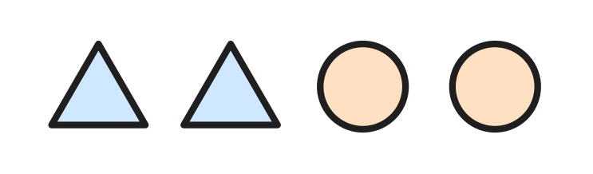

SECTION II — Star Questions 5 questions × 4 marks each
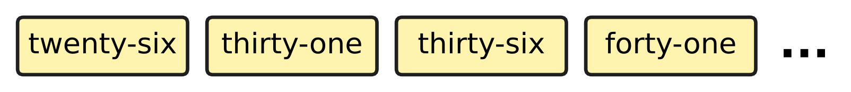
Q41. Look at the number cards. Ryan goes on with this pattern. He stops at the first number that is more than 60. At which number does he stop? [4 marks]
(A) 56 | (B) 60 | (C) 61 | (D) 66

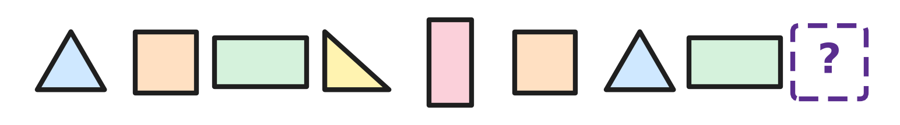
Q42. Look at the shapes. Count the corners of each shape. The numbers of corners repeat in a pattern. How many corners must the next shape have? [4 marks]
(A) 0 | (B) 3 | (C) 4 | (D) 7

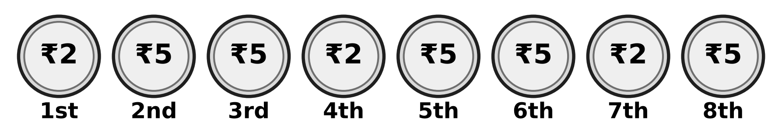
Q43. Look at the row of coins. The pattern goes on in the same way. How much is the 10th coin worth? [4 marks]
(A) ₹1 | (B) ₹2 | (C) ₹5 | (D) ₹10

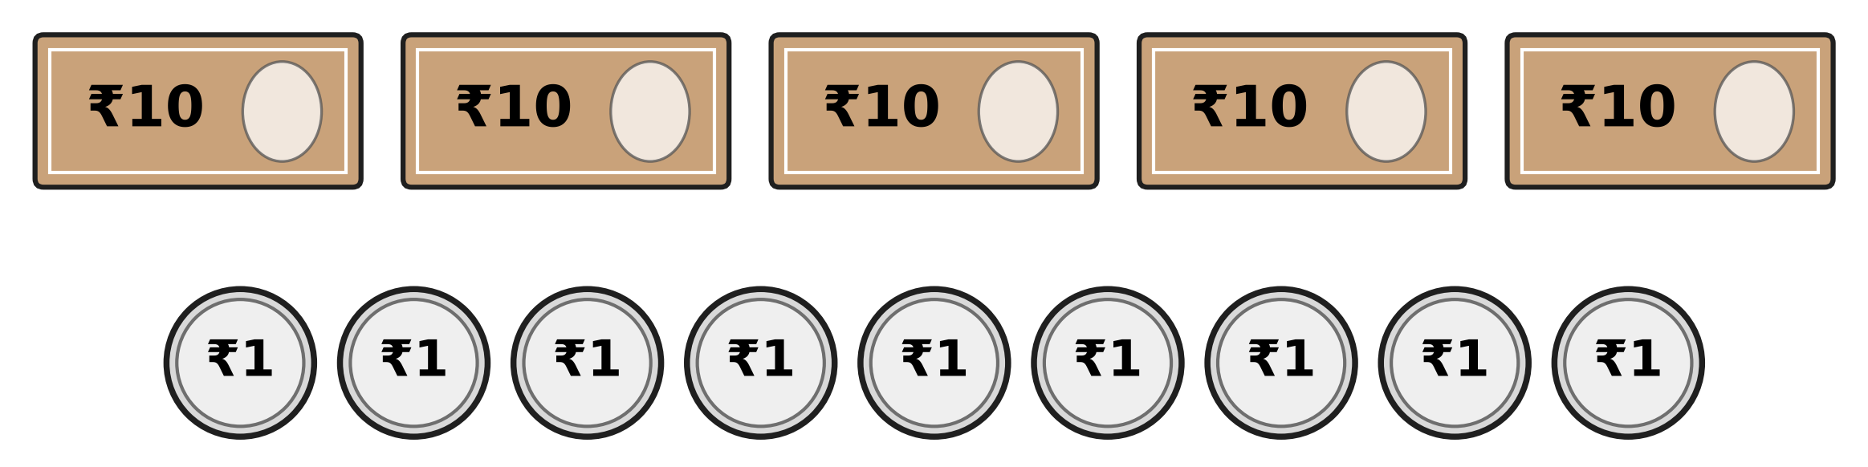
Q44. Look at the money on the table. Zubin puts 2 notes of ₹10 and 4 coins of ₹1 in his pocket. How much money is still on the table? [4 marks]
(A) ₹24 | (B) ₹35 | (C) ₹53 | (D) ₹59

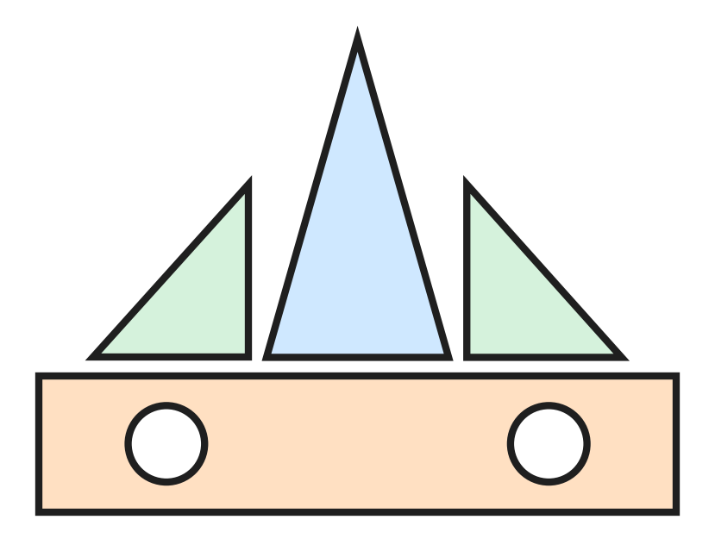
Q45. Look at the boat made of shape blocks. Varsha has 11 triangle blocks. She makes 2 boats like this one. How many triangle blocks are left? [4 marks]
(A) 5 | (B) 6 | (C) 7 | (D) 8

Answer Sheet AMO Level 1 · Class 1 · Practice Paper 5
Name: | School: | Roll No.:
Shade or tick one circle for each question.
1. Ⓐ Ⓑ Ⓒ Ⓓ | 16. Ⓐ Ⓑ Ⓒ Ⓓ | 31. Ⓐ Ⓑ Ⓒ Ⓓ
2. Ⓐ Ⓑ Ⓒ Ⓓ | 17. Ⓐ Ⓑ Ⓒ Ⓓ | 32. Ⓐ Ⓑ Ⓒ Ⓓ
3. Ⓐ Ⓑ Ⓒ Ⓓ | 18. Ⓐ Ⓑ Ⓒ Ⓓ | 33. Ⓐ Ⓑ Ⓒ Ⓓ
4. Ⓐ Ⓑ Ⓒ Ⓓ | 19. Ⓐ Ⓑ Ⓒ Ⓓ | 34. Ⓐ Ⓑ Ⓒ Ⓓ
5. Ⓐ Ⓑ Ⓒ Ⓓ | 20. Ⓐ Ⓑ Ⓒ Ⓓ | 35. Ⓐ Ⓑ Ⓒ Ⓓ
6. Ⓐ Ⓑ Ⓒ Ⓓ | 21. Ⓐ Ⓑ Ⓒ Ⓓ | 36. Ⓐ Ⓑ Ⓒ Ⓓ
7. Ⓐ Ⓑ Ⓒ Ⓓ | 22. Ⓐ Ⓑ Ⓒ Ⓓ | 37. Ⓐ Ⓑ Ⓒ Ⓓ
8. Ⓐ Ⓑ Ⓒ Ⓓ | 23. Ⓐ Ⓑ Ⓒ Ⓓ | 38. Ⓐ Ⓑ Ⓒ Ⓓ
9. Ⓐ Ⓑ Ⓒ Ⓓ | 24. Ⓐ Ⓑ Ⓒ Ⓓ | 39. Ⓐ Ⓑ Ⓒ Ⓓ
10. Ⓐ Ⓑ Ⓒ Ⓓ | 25. Ⓐ Ⓑ Ⓒ Ⓓ | 40. Ⓐ Ⓑ Ⓒ Ⓓ
11. Ⓐ Ⓑ Ⓒ Ⓓ | 26. Ⓐ Ⓑ Ⓒ Ⓓ | 41. Ⓐ Ⓑ Ⓒ Ⓓ
12. Ⓐ Ⓑ Ⓒ Ⓓ | 27. Ⓐ Ⓑ Ⓒ Ⓓ | 42. Ⓐ Ⓑ Ⓒ Ⓓ
13. Ⓐ Ⓑ Ⓒ Ⓓ | 28. Ⓐ Ⓑ Ⓒ Ⓓ | 43. Ⓐ Ⓑ Ⓒ Ⓓ
14. Ⓐ Ⓑ Ⓒ Ⓓ | 29. Ⓐ Ⓑ Ⓒ Ⓓ | 44. Ⓐ Ⓑ Ⓒ Ⓓ
15. Ⓐ Ⓑ Ⓒ Ⓓ | 30. Ⓐ Ⓑ Ⓒ Ⓓ | 45. Ⓐ Ⓑ Ⓒ Ⓓ
Q41–Q45 are Section II Star Questions (4 marks each).
For the parent or teacher
Section I correct: ______ / 40 × 2 = ______ marks Section II correct: ______ / 5 × 4 = ______ marks
Correct: ______ / 45 Score: ______ / 100
Answer Key and Solutions AMO Level 1 · Class 1 · Practice Paper 5
Quick answers
1 A | 6 C | 11 D | 16 A | 21 C | 26 A | 31 D | 36 A | 41 C
2 D | 7 D | 12 B | 17 C | 22 A | 27 B | 32 B | 37 B | 42 C
3 A | 8 C | 13 C | 18 B | 23 A | 28 C | 33 B | 38 C | 43 B
4 D | 9 D | 14 A | 19 D | 24 B | 29 D | 34 B | 39 D | 44 B
5 D | 10 B | 15 C | 20 C | 25 D | 30 A | 35 A | 40 A | 45 A
Solutions
Q | Part · level | Answer | Why?
1 | Part 1 · Ch1 · Easy | (A) 13 | There are two rows of 5 frogs and 3 more frogs. 5 and 5 make 10, and 3 more make 13.
2 | Part 1 · Ch1 · Easy | (D) thirty | Twenty-nine is 29. The number just after 29 is 30, which is thirty.
3 | Part 1 · Ch1 · Easy | (A) 2 | 72 has 7 tens and 2 ones. The ones digit is 2.
4 | Part 1 · Ch1 · Easy | (D) 9 | The tens digit is 3, so the ones digit must be more than 8. Only 9 works: 39 is greater than 38.
5 | Part 1 · Ch1 · Easy | (D) > | 91 has 9 tens and 19 has only 1 ten, so 91 is greater than 19. The sign is >.
6 | Part 1 · Ch1 · Easy | (C) 38 | There are 3 strips of ten and 8 single tickets. 3 tens and 8 ones make 38.
7 | Part 1 · Ch1 · Easy | (D) 9 | Count in tens: 10, 20, 30, 40, 50, 60, 70, 80, 90. That is 9 tens.
8 | Part 1 · Ch1 · Medium | (C) 64 | The number has 4 ones and 4 + 2 = 6 tens. 6 tens and 4 ones make 64.
9 | Part 1 · Ch1 · Medium | (D) 68 | The middle number must be greater than 64 and less than 71. Only 68 fits.
10 | Part 1 · Ch1 · Medium | (B) 29 | In order the numbers go 27, 28, 29, 30, 31. The space painted 92 should be 29: its two digits were swapped.
11 | Part 1 · Ch1 · Medium | (D) 15 | Fifteen is 1 ten and 5 ones, which is 15. The number 50 is fifty.
12 | Part 1 · Ch1 · Medium | (B) 4 | The numbers are 38, 39, 40 and 41. That is 4 numbers.
13 | Part 2 · Ch2 · Easy | (C) 13 | 3 + 6 = 9, and 9 + 4 = 13.
14 | Part 2 · Ch2 · Easy | (A) 8 | 15 − 7: take away 5 to reach 10, then 2 more to reach 8.
15 | Part 2 · Ch2 · Easy | (C) 14 | Count in twos, once for each pair: 2, 4, 6, 8, 10, 12, 14.
16 | Part 2 · Ch2 · Easy | (A) 0 | There are 7 owls. When all 7 fly away, 7 − 7 = 0 owls are left.
17 | Part 2 · Ch2 · Easy | (C) 12 | 7 + 5: 7 and 3 make 10, and 2 more make 12.
18 | Part 2 · Ch2 · Easy | (B) 9 | 15 − 6 = 9.
19 | Part 2 · Ch2 · Medium | (D) 7 | 18 take away how many leaves 11? 18 − 11 = 7, so 7 children went home.
20 | Part 2 · Ch2 · Medium | (C) 13 | Put the 6 back: 7 + 6 = 13.
21 | Part 2 · Ch2 · Medium | (C) 16 | Each plate has 4 slices. 3 plates have 4 + 4 + 4 = 12 slices, and one more plate makes 12 + 4 = 16.
22 | Part 2 · Ch2 · Medium | (A) 7 | 7 + 7 = 14, so the number is 7.
23 | Part 3 · Ch5 · Easy | (A) 4 | Count only the shapes with 4 equal sides and 4 corners. There are 4 squares.
24 | Part 3 · Ch5 · Easy | (B) circle | A circle is round and has no corners.
25 | Part 3 · Ch5 · Easy | (D) Picture D | A square has 4 sides that are all the same length. Picture D is the square.
26 | Part 3 · Ch5 · Easy | (A) two triangles | Each piece has 3 straight sides and 3 corners, so the pieces are two triangles.
27 | Part 3 · Ch5 · Medium | (B) Picture B | The circle, the square and the triangle are cut through the middle, so their two sides are the same. In Picture B the line is near one end of the rectangle, so the two sides are not the same.
28 | Part 3 · Ch5 · Medium | (C) 5 | The cut removes 1 corner and makes 2 new corners. Count the corners in the picture: there are 5.
29 | Part 4 · Ch9 · Easy | (D) Sunday | The day after Friday is Saturday. The day after Saturday is Sunday.
30 | Part 4 · Ch9 · Easy | (A) October | The months go August, September, October, November. The turned card is October.
31 | Part 4 · Ch9 · Easy | (D) ₹10 | Pari has ₹5, ₹2 and ₹1 coins. She has no ₹10 coin.
32 | Part 4 · Ch9 · Easy | (B) Picture B | Fifty is written as 50. The note in Picture B is the ₹50 note.
33 | Part 4 · Ch9 · Medium | (B) 4 | The months are June, July, August and September. That is 4 months.
34 | Part 4 · Ch9 · Medium | (B) ₹20 | From least to most the notes are ₹10, ₹20, ₹50, ₹100. The second note is ₹20.
35 | Part 5 · Ch10 · Easy | (A) 6 | 32, 84 and 48 are written with two digits. 6 has only one digit, so it is the odd one out.
36 | Part 5 · Ch10 · Easy | (A) 25 | Each number is 10 more than the one before. 10 less than 35 is 25.
37 | Part 5 · Ch10 · Easy | (B) circle | The pattern repeats square, circle, circle. After a square comes a circle, so the covered shape is a circle.
38 | Part 5 · Ch10 · Medium | (C) 6 | Nakul says 19, 17, 15, 13, 11, 9, 7, 5, 3, 1. He never says 6.
39 | Part 5 · Ch10 · Medium | (D) the 6th group | The groups have 3, 5, 7, 9 trumpets, 2 more each time. The 5th group has 11 and the 6th group has 13.
40 | Part 5 · Ch10 · Medium | (A) | The row is triangle, triangle, circle, then triangle, triangle, circle again. The group that repeats is triangle, triangle, circle.
41 | Section II · Ch1 + Ch10 · Hard | (C) 61 | The numbers are 26, 31, 36, 41, so each is 5 more. Next come 46, 51, 56 and 61. 61 is the first number more than 60.
42 | Section II · Ch5 + Ch10 · Hard | (C) 4 | The corners go 3, 4, 4, then 3, 4, 4, then 3, 4. The group 3, 4, 4 repeats, so the next shape must have 4 corners.
43 | Section II · Ch9 + Ch10 · Hard | (B) ₹2 | The coins repeat ₹2, ₹5, ₹5. The 9th coin is ₹5 and the 10th coin starts the group again, so it is ₹2.
44 | Section II · Ch1 + Ch9 · Hard | (B) ₹35 | 3 notes of ₹10 and 5 coins of ₹1 are still on the table. 3 tens and 5 ones make ₹35.
45 | Section II · Ch2 + Ch5 · Hard | (A) 5 | One boat has 3 triangles: 1 big and 2 small. 2 boats use 3 + 3 = 6, and 11 − 6 = 5 are left.

