UNLOCK IQ INSTITUTE
Realize Your True Potential
Aryabhatta Maths Olympiad (AMO)
Level 1 — Practice Paper 4
CLASS 1

Questions | 45 multiple-choice questions
Marks | 100
Time | 60 minutes
Section I | 40 questions × 2 marks = 80 marks
Section II | 5 Star Questions × 4 marks = 20 marks
Negative marking | No negative marking
Calculator | Not allowed
Chapters | Number System · Operations · Geometry · Applied Mathematics · Mathematical Reasoning

Hello, friend!
• Every question has four answer choices: (A), (B), (C) and (D). Only one is correct.
• Read each question and look at its picture carefully. Then mark your answer on the answer sheet at the end.
• Section I has 40 questions of 2 marks each. Section II has 5 Star Questions of 4 marks each.
• There is no negative marking, so try every question.
• Do not use a calculator. You may do rough work on a separate sheet.
• All figures are not necessarily drawn to scale unless stated.

For parents and teachers
Print or view this paper in colour. Pictures are part of the questions.
You may read a question aloud to the child, exactly as printed. Please do not explain it or point to an answer choice.
Parts follow the AMO syllabus chapters. Chapters 3, 4, 6, 7 and 8 are not part of the Class 1 syllabus, so the chapter numbers shown in the Part headings have gaps.
The answer sheet and the answer key are at the end. Remove only the answer key before the child begins.

Name: | School: | Roll No.:

SECTION I 40 questions × 2 marks each
Part 1 — Number System (Syllabus Chapter 1)
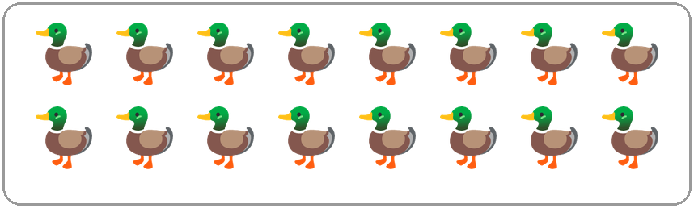
Q1. Look at the picture. How many ducks are there?
(A) 8 | (B) 16 | (C) 18 | (D) 14

Q2. The pages of a book are numbered 1, 2, 3 and so on. Which is the first page number that has two digits?
(A) 9 | (B) 10 | (C) 11 | (D) 20

Q3. Candles come in packs of 10. Chetan buys 7 packs. How many candles does he buy?
(A) 60 | (B) 17 | (C) 7 | (D) 70

Q4. Imran climbed 73 steps on a hike. Zara climbed more steps than Imran. How many steps could Zara have climbed?
(A) 78 | (B) 63 | (C) 70 | (D) 37

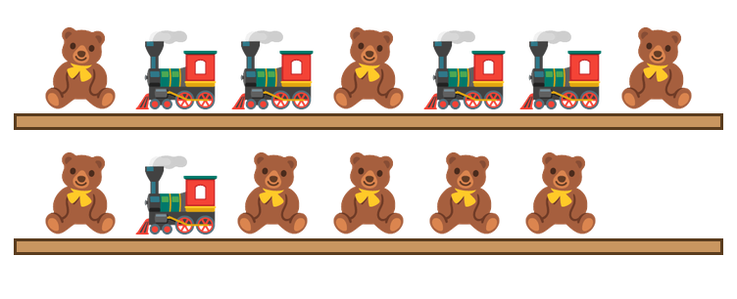
Q5. Look at the toys on the wooden shelves. How many teddy bears are there?
(A) 13 | (B) 7 | (C) 5 | (D) 8

Q6. Zoo cages are numbered in order. The parrots live in the cage between cage 59 and cage 61. What is the number of their cage?
(A) 62 | (B) 60 | (C) 50 | (D) 58

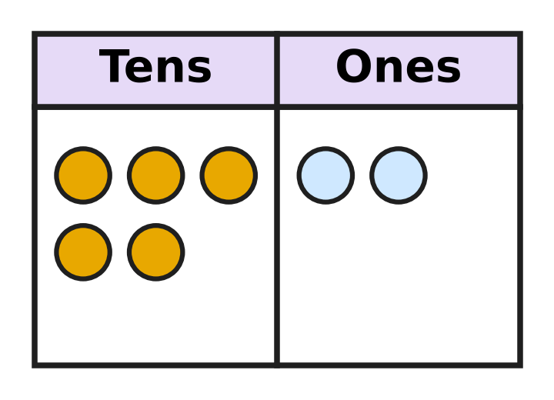
Q7. Look at the counters on the board. Each counter in the tens column is one ten. Which number does the board show?
(A) 7 | (B) 52 | (C) 25 | (D) 50

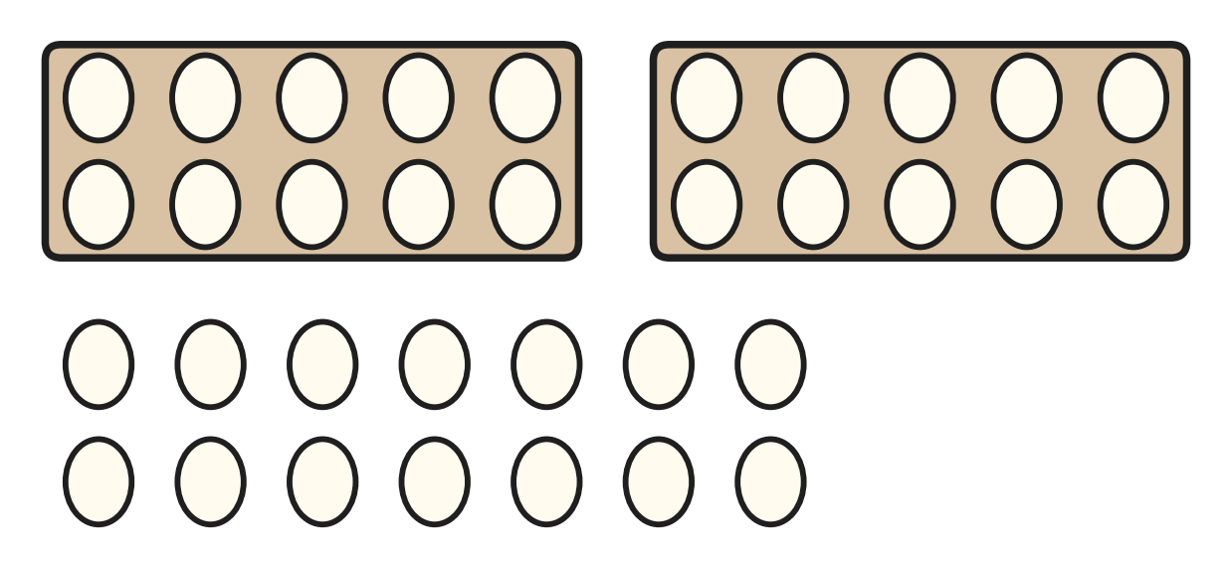
Q8. A full tray holds 10 eggs. Look at the full trays and the loose eggs in the picture. How many eggs are there in all?
(A) 44 | (B) 16 | (C) 24 | (D) 34

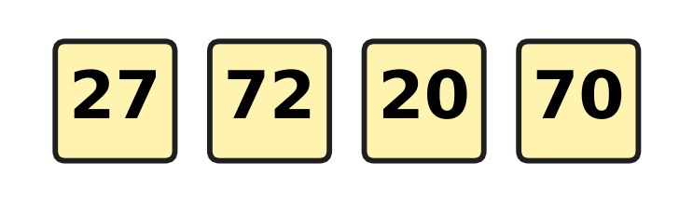
Q9. Four children wear these number cards. They stand in a row from the greatest number to the smallest. Which row is correct?
(A) 70, 72, 27, 20 | (B) 27, 72, 70, 20
(C) 72, 70, 27, 20 | (D) 20, 27, 70, 72

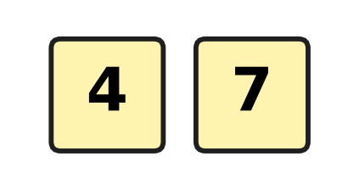
Q10. Kiara has two digit cards. She uses both cards to make a number. What is the greatest number she can make?
(A) 74 | (B) 77 | (C) 47 | (D) 11

Q11. Which number can go in the blank to make this true?
67 > ___
(A) 76 | (B) 59 | (C) 68 | (D) 70

Q12. Which number has 8 tens?
(A) eight | (B) twenty-eight
(C) eighteen | (D) eighty-one

Part 2 — Operations & Number Properties (Syllabus Chapter 2)
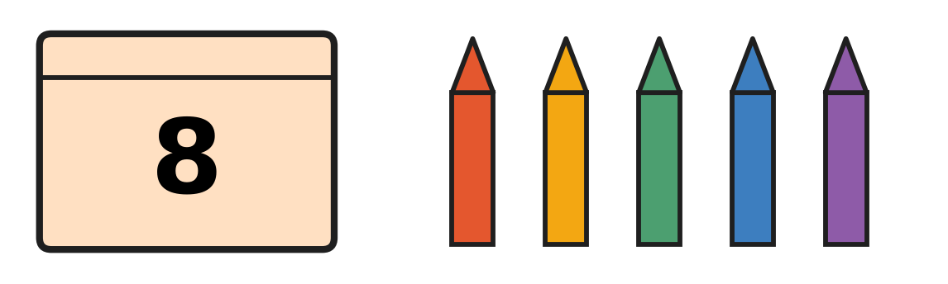
Q13. The closed box has 8 crayons inside. Look at the crayons outside the box. How many crayons are there in all?
(A) 13 | (B) 5 | (C) 14 | (D) 12

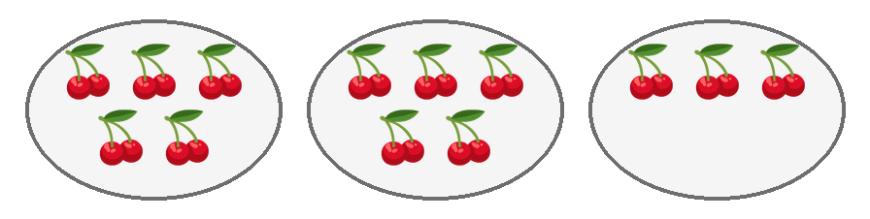
Q14. Look at the plates. Each picture shows a bunch of cherries. Komal wants 5 bunches on every plate. How many more bunches does she need?
(A) 3 | (B) 5 | (C) 2 | (D) 13

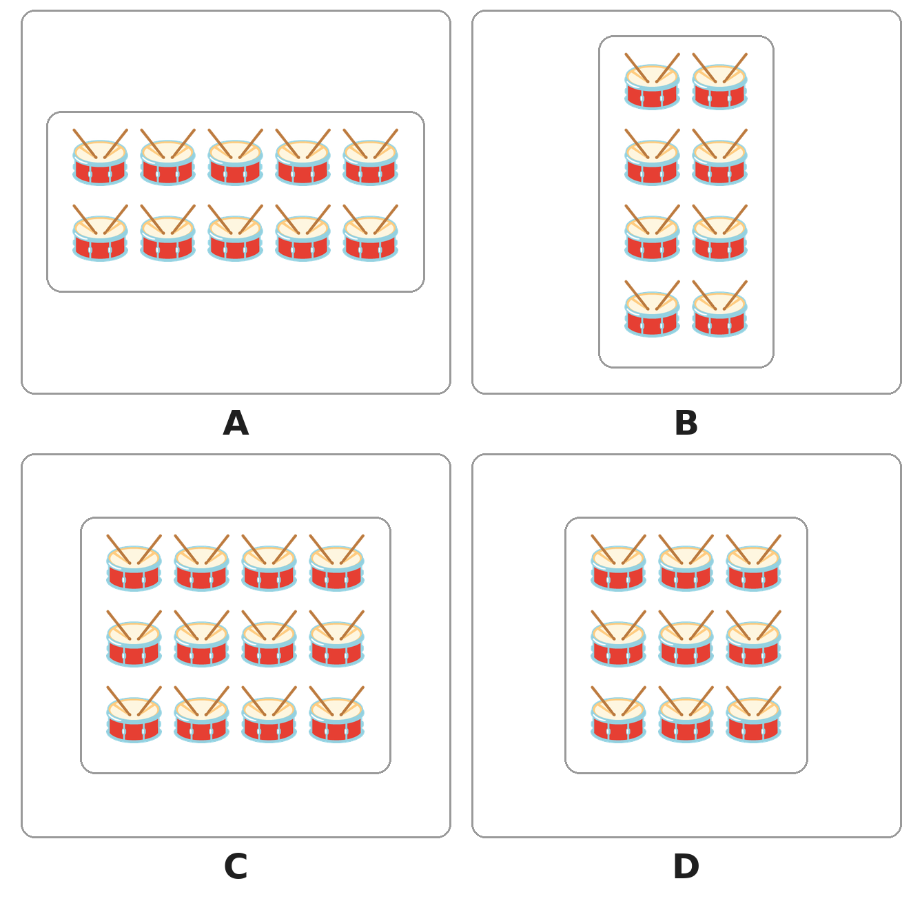
Q15. Look at the four boxes of drums. The drums in each box are in equal rows. Which box has the most drums?
(A) Box A | (B) Box B | (C) Box C | (D) Box D

Q16. Ojas adds 6 + 9 and gets 15. Rima adds 9 + 6. What answer does Rima get?
(A) 14 | (B) 3 | (C) 16 | (D) 15

Q17. Sonal bakes 12 buns. Her friends eat 5 of them. Which of these tells how many buns are left?
(A) 12 − 5 | (B) 12 + 5 | (C) 5 + 5 | (D) 12 − 12

Q18. A dairy van carries 19 milk cans. It leaves 13 cans at a shop. How many cans are still in the van?
(A) 5 | (B) 6 | (C) 32 | (D) 13

Q19. A plant shop has 12 small plants. Then 7 more plants arrive. After that, 5 plants are sold. How many plants does the shop have now?
(A) 19 | (B) 12 | (C) 14 | (D) 7

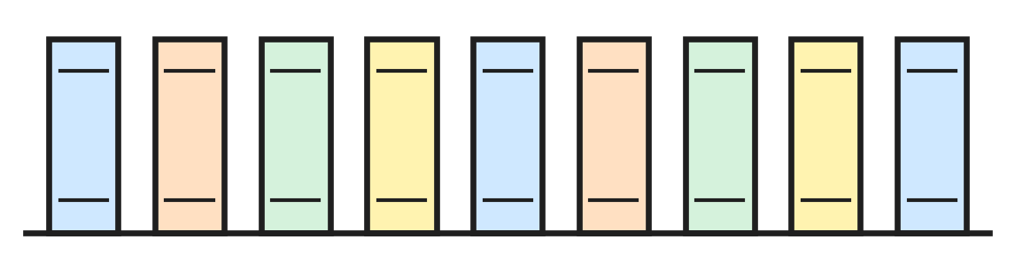
Q20. A bookshop had 13 copies of a story book. Some copies were sold. The picture shows the copies left. How many copies were sold?
(A) 4 | (B) 5 | (C) 9 | (D) 22

Q21. Which of these gives the greatest answer?
(A) 6 + 6 | (B) 7 + 8 | (C) 9 + 5 | (D) 20 − 4

Q22. A soup needs 6 tomatoes. It needs 3 more potatoes than tomatoes. How many tomatoes and potatoes does it need in all?
(A) 18 | (B) 12 | (C) 15 | (D) 9

Part 3 — Geometry (Syllabus Chapter 5)
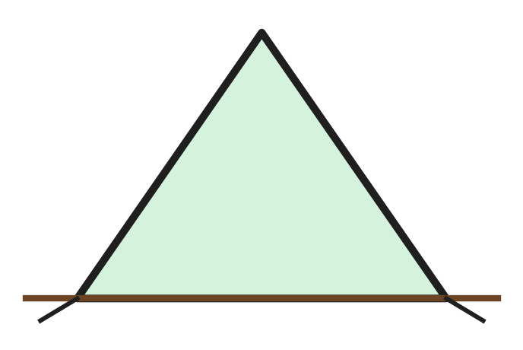
Q23. Ayaan puts up a tent on a mountain hike. Look at the front of his tent. Which shape is it?
(A) a square | (B) a triangle
(C) a circle | (D) a rectangle

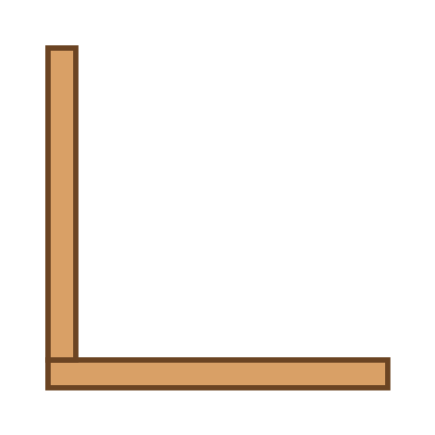
Q24. Neel has joined 2 planks, as in the picture. He wants a closed square frame, one plank for each side. How many more planks does he need?
(A) 3 | (B) 4 | (C) 2 | (D) 6

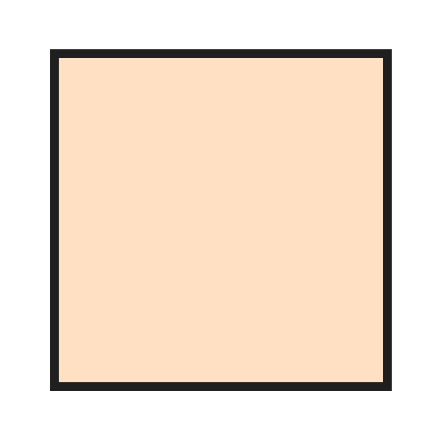
Q25. Look at the top of a square table. One lamp is put at each corner. How many lamps are on the table?
(A) 4 | (B) 5 | (C) 8 | (D) 3

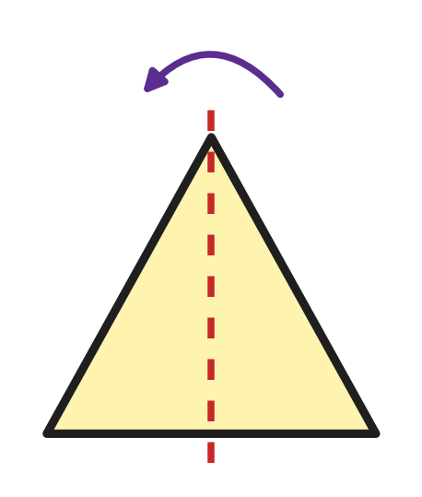
Q26. Leah folds this paper triangle along the dotted line. One half lies exactly on the other. Which shape is the folded paper?
(A)  | (B) 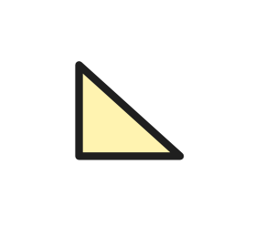 | (C)  | (D) 

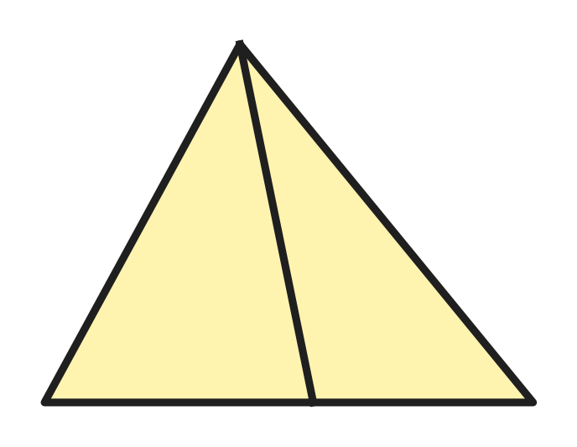
Q27. Look at the picture. How many triangles are there in all? Count triangles of every size.
(A) 5 | (B) 6 | (C) 2 | (D) 3

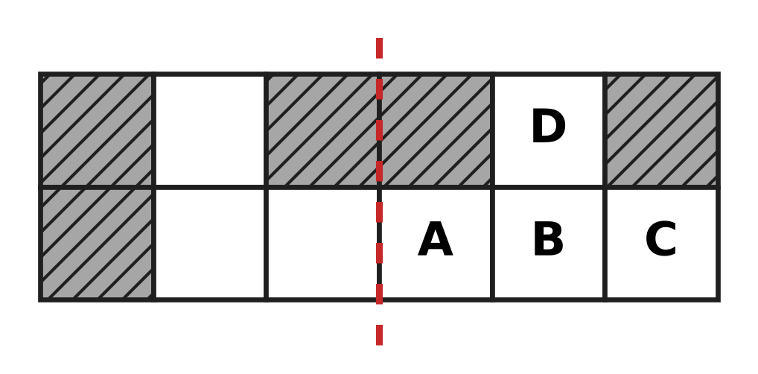
Q28. Look at the picture. One more box must be coloured so that both sides of the dotted line are the same. Which box is it?
(A) A | (B) B | (C) C | (D) D

Part 4 — Applied Mathematics (Syllabus Chapter 9)
Q29. An elephant at the zoo gets a bath on Tuesday and on Thursday. Which day comes between these two days?
(A) Wednesday | (B) Monday
(C) Saturday | (D) Friday

Q30. A new year begins with January. Which month comes just before January?
(A) February | (B) March
(C) December | (D) November

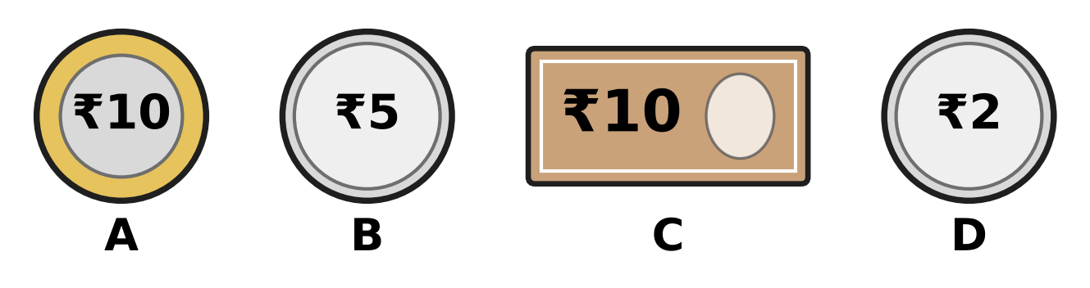
Q31. Look at the pictures of money. Three of them are coins. Which picture shows a note?
(A) Picture A | (B) Picture B
(C) Picture C | (D) Picture D

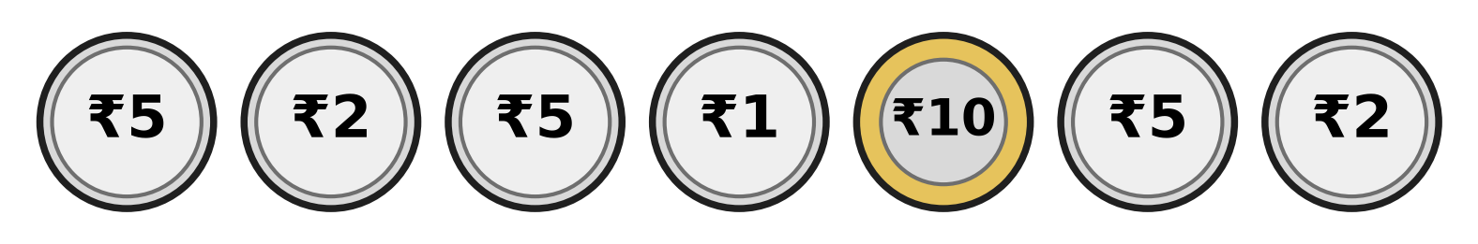
Q32. Look at the coins. How many ₹5 coins are there?
(A) 5 | (B) 3 | (C) 7 | (D) 2

Q33. Chitra feeds her small plant on a Tuesday. She feeds it again 7 days later. On which day is that?
(A) Wednesday | (B) Saturday
(C) Monday | (D) Tuesday

Q34. Vinay says the months of the year in order. Which month does he say fifth?
(A) May | (B) April | (C) June | (D) March

Part 5 — Mathematical Reasoning & Problem-Solving (Syllabus Chapter 10)
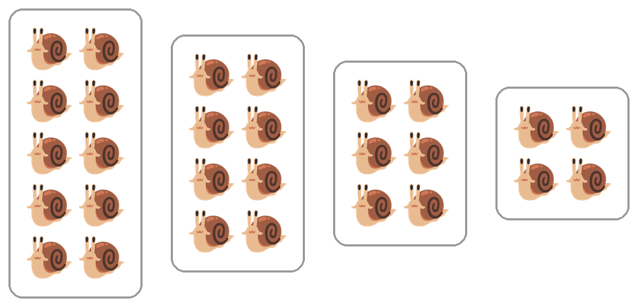
Q35. Look at the boxes of snails. The number of snails changes in a pattern. How many snails will the next box have?
(A) 4 | (B) 2 | (C) 3 | (D) 6

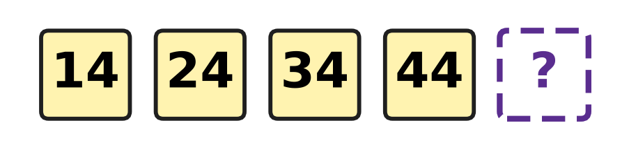
Q36. Look at the numbers on the cards. They make a pattern. Which number comes next?
(A) 64 | (B) 45 | (C) 54 | (D) 49

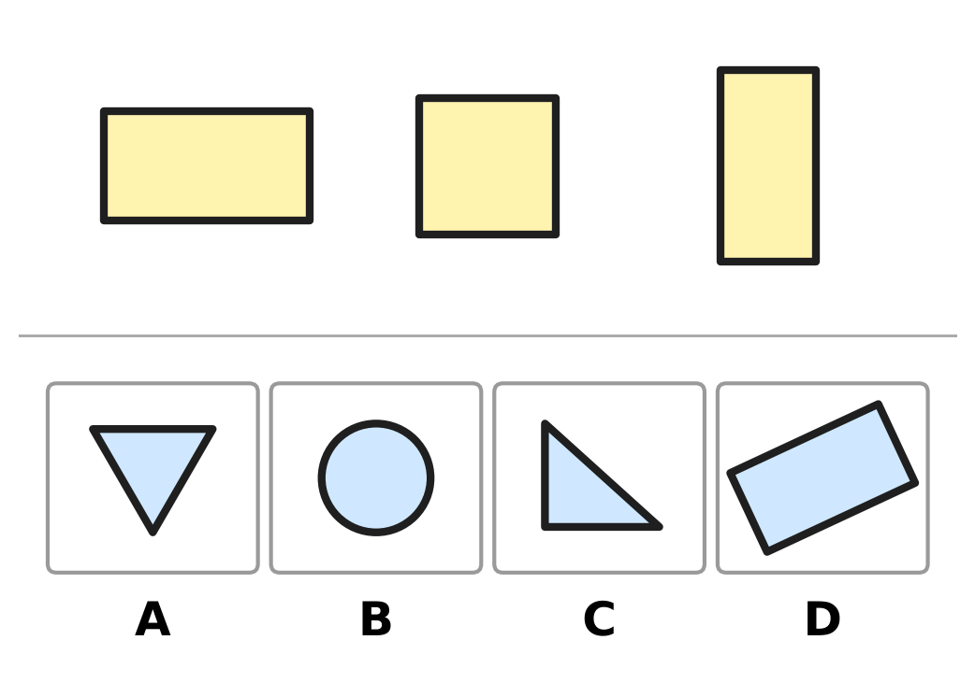
Q37. The three shapes at the top belong together: they have the same number of corners. Which picture shows one more shape that belongs with them?
(A) Picture A | (B) Picture B
(C) Picture C | (D) Picture D

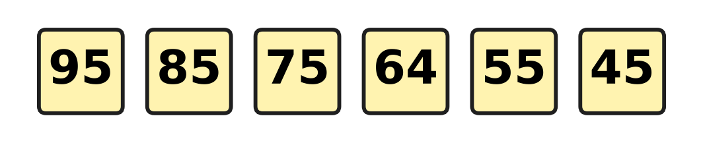
Q38. Look at the number cards. They count back in the same way each time. One card has a wrong number. Which number is wrong?
(A) 85 | (B) 75 | (C) 55 | (D) 64

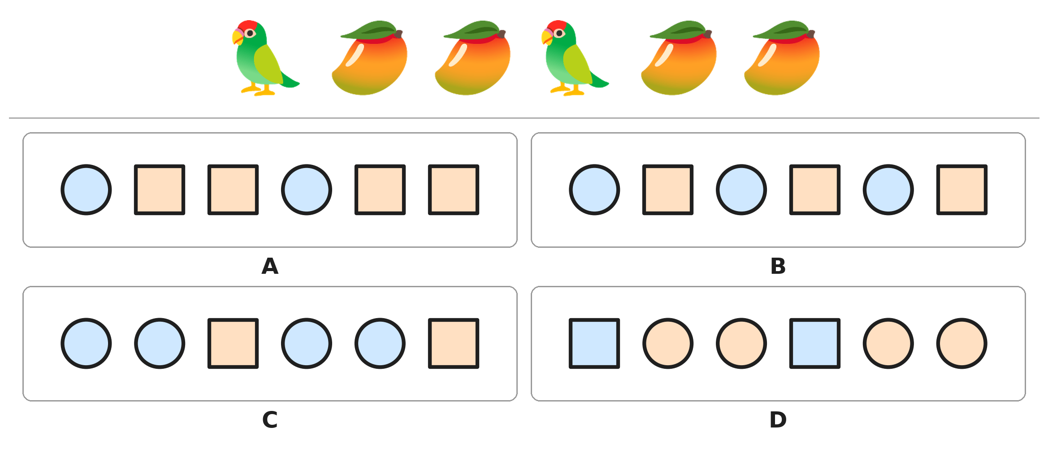
Q39. Look at the pattern of parrots and mangoes. Circles stand for parrots and squares stand for mangoes. Which picture shows the same pattern?
(A) Picture A | (B) Picture B
(C) Picture C | (D) Picture D

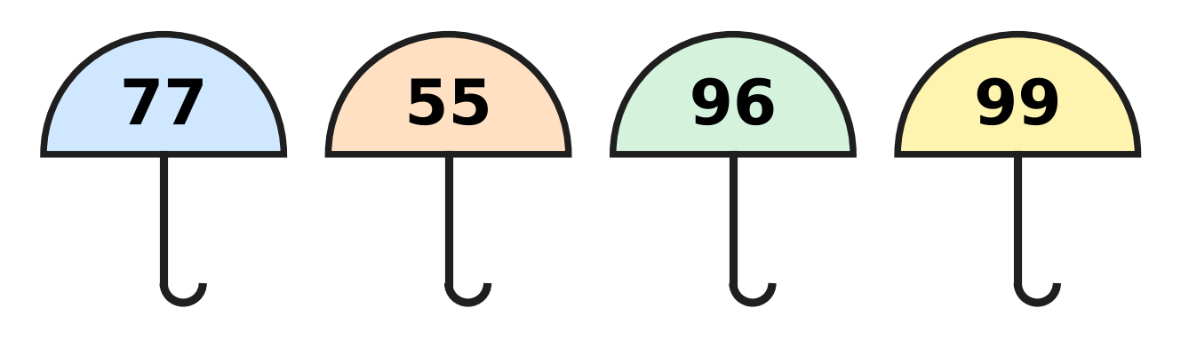
Q40. Look at the numbers on the umbrellas. In three numbers, the tens digit and the ones digit are the same. Which number does NOT belong with them?
(A) 77 | (B) 55 | (C) 96 | (D) 99

SECTION II — Star Questions 5 questions × 4 marks each
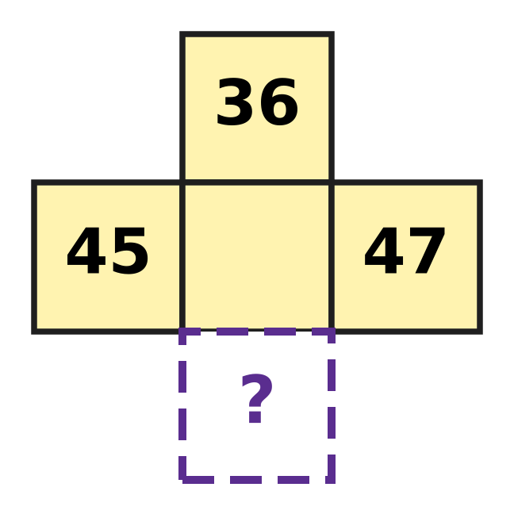
Q41. This piece is cut from a 1 to 100 number chart. The middle number has rubbed off. First find it. Then find the number in the ? box below it. [4 marks]
(A) 55 | (B) 56 | (C) 46 | (D) 57

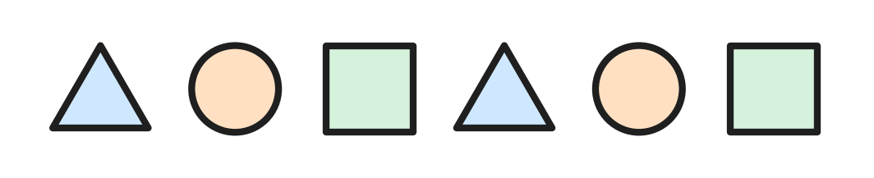
Q42. Eva prints shapes in a pattern, as in the picture. She goes on until the row has 11 shapes. How many triangles are in the row then? [4 marks]
(A) 4 | (B) 5 | (C) 3 | (D) 2

Q43. Rosa plays badminton on Monday, Tuesday, Thursday and Sunday. She plays 1 day later, then 2 days later, then 3 days later. Each time she waits one more day. On which day does she play next? [4 marks]
(A) Friday | (B) Wednesday
(C) Monday | (D) Thursday

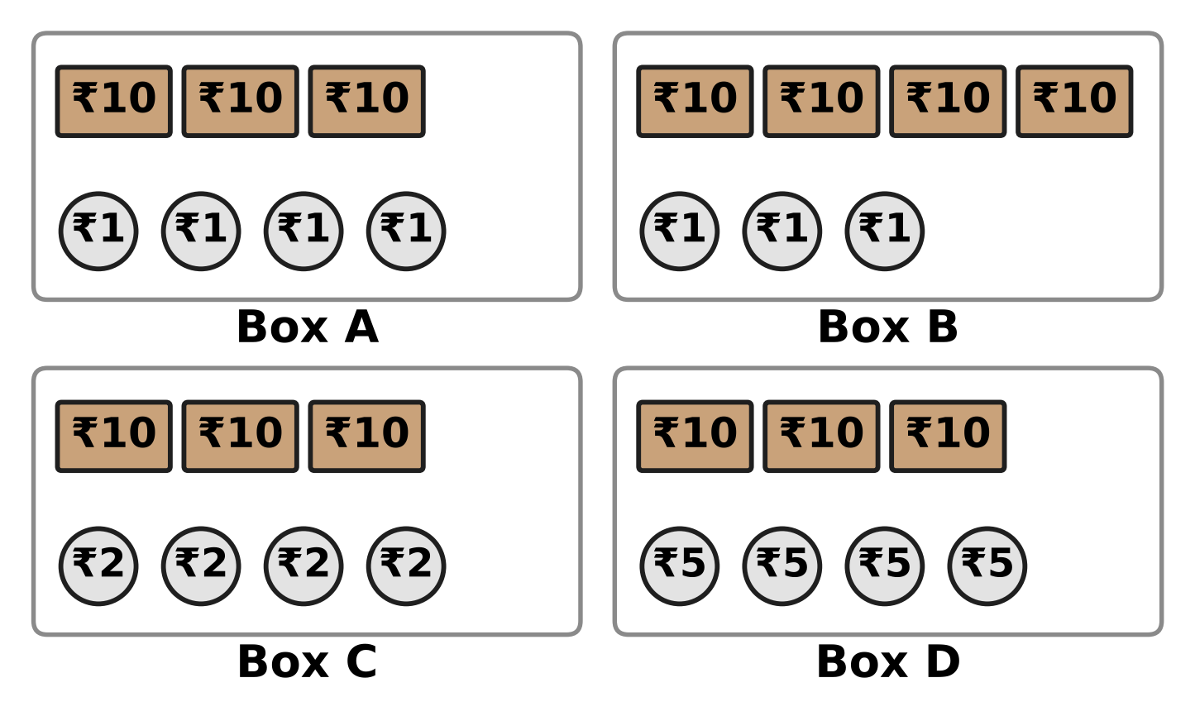
Q44. A story book costs thirty-four rupees. Each box has some notes and coins. Which box has exactly this much money? [4 marks]
(A) Box A | (B) Box B | (C) Box C | (D) Box D

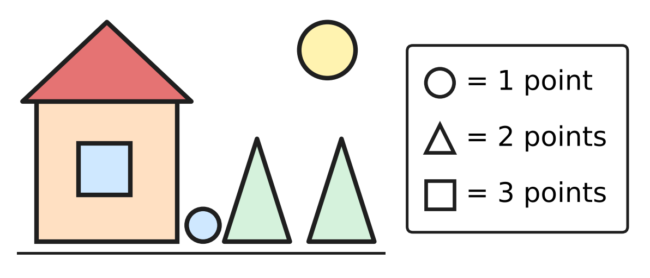
Q45. Vihaan makes this picture with circles, triangles and squares. Each shape gets the points shown in the box. How many points does his picture get? [4 marks]
(A) 7 | (B) 11 | (C) 15 | (D) 14

Answer Sheet AMO Level 1 · Class 1 · Practice Paper 4
Name: | School: | Roll No.:
Shade or tick one circle for each question.
1. Ⓐ Ⓑ Ⓒ Ⓓ | 16. Ⓐ Ⓑ Ⓒ Ⓓ | 31. Ⓐ Ⓑ Ⓒ Ⓓ
2. Ⓐ Ⓑ Ⓒ Ⓓ | 17. Ⓐ Ⓑ Ⓒ Ⓓ | 32. Ⓐ Ⓑ Ⓒ Ⓓ
3. Ⓐ Ⓑ Ⓒ Ⓓ | 18. Ⓐ Ⓑ Ⓒ Ⓓ | 33. Ⓐ Ⓑ Ⓒ Ⓓ
4. Ⓐ Ⓑ Ⓒ Ⓓ | 19. Ⓐ Ⓑ Ⓒ Ⓓ | 34. Ⓐ Ⓑ Ⓒ Ⓓ
5. Ⓐ Ⓑ Ⓒ Ⓓ | 20. Ⓐ Ⓑ Ⓒ Ⓓ | 35. Ⓐ Ⓑ Ⓒ Ⓓ
6. Ⓐ Ⓑ Ⓒ Ⓓ | 21. Ⓐ Ⓑ Ⓒ Ⓓ | 36. Ⓐ Ⓑ Ⓒ Ⓓ
7. Ⓐ Ⓑ Ⓒ Ⓓ | 22. Ⓐ Ⓑ Ⓒ Ⓓ | 37. Ⓐ Ⓑ Ⓒ Ⓓ
8. Ⓐ Ⓑ Ⓒ Ⓓ | 23. Ⓐ Ⓑ Ⓒ Ⓓ | 38. Ⓐ Ⓑ Ⓒ Ⓓ
9. Ⓐ Ⓑ Ⓒ Ⓓ | 24. Ⓐ Ⓑ Ⓒ Ⓓ | 39. Ⓐ Ⓑ Ⓒ Ⓓ
10. Ⓐ Ⓑ Ⓒ Ⓓ | 25. Ⓐ Ⓑ Ⓒ Ⓓ | 40. Ⓐ Ⓑ Ⓒ Ⓓ
11. Ⓐ Ⓑ Ⓒ Ⓓ | 26. Ⓐ Ⓑ Ⓒ Ⓓ | 41. Ⓐ Ⓑ Ⓒ Ⓓ
12. Ⓐ Ⓑ Ⓒ Ⓓ | 27. Ⓐ Ⓑ Ⓒ Ⓓ | 42. Ⓐ Ⓑ Ⓒ Ⓓ
13. Ⓐ Ⓑ Ⓒ Ⓓ | 28. Ⓐ Ⓑ Ⓒ Ⓓ | 43. Ⓐ Ⓑ Ⓒ Ⓓ
14. Ⓐ Ⓑ Ⓒ Ⓓ | 29. Ⓐ Ⓑ Ⓒ Ⓓ | 44. Ⓐ Ⓑ Ⓒ Ⓓ
15. Ⓐ Ⓑ Ⓒ Ⓓ | 30. Ⓐ Ⓑ Ⓒ Ⓓ | 45. Ⓐ Ⓑ Ⓒ Ⓓ
Q41–Q45 are Section II Star Questions (4 marks each).
For the parent or teacher
Section I correct: ______ / 40 × 2 = ______ marks Section II correct: ______ / 5 × 4 = ______ marks
Correct: ______ / 45 Score: ______ / 100
Answer Key and Solutions AMO Level 1 · Class 1 · Practice Paper 4
Quick answers
1 B | 6 B | 11 B | 16 D | 21 D | 26 B | 31 C | 36 C | 41 B
2 B | 7 B | 12 D | 17 A | 22 C | 27 D | 32 B | 37 D | 42 A
3 D | 8 D | 13 A | 18 B | 23 B | 28 C | 33 D | 38 D | 43 D
4 A | 9 C | 14 C | 19 C | 24 C | 29 A | 34 A | 39 A | 44 A
5 D | 10 A | 15 C | 20 A | 25 A | 30 C | 35 B | 40 C | 45 D
Solutions
Q | Part · level | Answer | Why?
1 | Part 1 · Ch1 · Easy | (B) 16 | There are 8 ducks in each row. 8 and 8 more make 16 ducks.
2 | Part 1 · Ch1 · Easy | (B) 10 | The numbers 1 to 9 have one digit. The next number, 10, has two digits.
3 | Part 1 · Ch1 · Easy | (D) 70 | Count in tens, one ten for each pack: 10, 20, 30, 40, 50, 60, 70.
4 | Part 1 · Ch1 · Easy | (A) 78 | Zara's number must be greater than 73. Only 78 is greater than 73.
5 | Part 1 · Ch1 · Easy | (D) 8 | Count only the teddy bears, not the trains. There are 8 teddy bears.
6 | Part 1 · Ch1 · Easy | (B) 60 | The numbers go 59, 60, 61. The number between 59 and 61 is 60.
7 | Part 1 · Ch1 · Easy | (B) 52 | The board shows 5 tens and 2 ones. That makes 52.
8 | Part 1 · Ch1 · Medium | (D) 34 | The 2 trays hold 20 eggs. Count on the 14 loose eggs from 20 to reach 34.
9 | Part 1 · Ch1 · Medium | (C) 72, 70, 27, 20 | 72 and 70 have 7 tens; 27 and 20 have only 2 tens. The row is 72, 70, 27, 20.
10 | Part 1 · Ch1 · Medium | (A) 74 | She can make 47 or 74. 74 has more tens, so it is the greatest.
11 | Part 1 · Ch1 · Medium | (B) 59 | The missing number must be less than 67. Only 59 is less than 67.
12 | Part 1 · Ch1 · Medium | (D) eighty-one | Eighty-one is 81: 8 tens and 1 one. Eighteen is 18 and twenty-eight is 28.
13 | Part 2 · Ch2 · Easy | (A) 13 | Start at 8 and count on 5 crayons: 9, 10, 11, 12, 13. So 8 + 5 = 13.
14 | Part 2 · Ch2 · Easy | (C) 2 | The first two plates have 5 bunches each. The last plate has 3 bunches. 3 and 2 more make 5, so she needs 2 more bunches.
15 | Part 2 · Ch2 · Easy | (C) Box C | Box A has 10, Box B has 8, Box C has 12 and Box D has 9 drums. Box C has 3 rows of 4, which is 12, the most.
16 | Part 2 · Ch2 · Easy | (D) 15 | The order of adding does not matter. 6 + 9 = 15 and 9 + 6 = 15.
17 | Part 2 · Ch2 · Easy | (A) 12 − 5 | Buns are eaten, so we take away: 12 − 5. That leaves 7 buns.
18 | Part 2 · Ch2 · Easy | (B) 6 | 19 − 13 = 6. So 6 cans are still in the van.
19 | Part 2 · Ch2 · Medium | (C) 14 | 12 + 7 = 19. Then 19 − 5 = 14. The shop has 14 plants.
20 | Part 2 · Ch2 · Medium | (A) 4 | 9 copies are left. 13 − 9 = 4, so 4 copies were sold.
21 | Part 2 · Ch2 · Medium | (D) 20 − 4 | 7 + 8 = 15, 9 + 5 = 14, 20 − 4 = 16 and 6 + 6 = 12. The greatest answer is 16.
22 | Part 2 · Ch2 · Medium | (C) 15 | Potatoes: 6 + 3 = 9. Tomatoes and potatoes together: 6 + 9 = 15.
23 | Part 3 · Ch5 · Easy | (B) a triangle | The front of the tent has 3 straight sides and 3 corners. It is a triangle.
24 | Part 3 · Ch5 · Easy | (C) 2 | A square has 4 sides. 2 planks are there, so 2 more planks are needed.
25 | Part 3 · Ch5 · Easy | (A) 4 | A square has 4 corners. One lamp at each corner makes 4 lamps.
26 | Part 3 · Ch5 · Easy | (B) | The two halves are the same, so the folded paper is one half. It has 3 straight sides and 3 corners, so it is still a triangle.
27 | Part 3 · Ch5 · Medium | (D) 3 | There are 2 small triangles. Together they make 1 big triangle. 2 + 1 = 3 triangles.
28 | Part 3 · Ch5 · Medium | (C) C | Fold along the dotted line. The coloured box in the bottom left corner lands on box C.
29 | Part 4 · Ch9 · Easy | (A) Wednesday | The days go Tuesday, Wednesday, Thursday. Wednesday is between Tuesday and Thursday.
30 | Part 4 · Ch9 · Easy | (C) December | December is the last month of a year. After December, the new year begins with January.
31 | Part 4 · Ch9 · Easy | (C) Picture C | Coins are round and made of metal. Notes are made of paper. Picture C shows the ₹10 note.
32 | Part 4 · Ch9 · Easy | (B) 3 | Look for the coins with the number 5 on them. There are 3 such coins.
33 | Part 4 · Ch9 · Medium | (D) Tuesday | A week has 7 days. Counting 7 days on from Tuesday brings us back to Tuesday.
34 | Part 4 · Ch9 · Medium | (A) May | January, February, March, April, May. The fifth month is May.
35 | Part 5 · Ch10 · Easy | (B) 2 | The boxes have 10, 8, 6 and 4 snails. Each box has 2 fewer than the box before. 4 − 2 = 2.
36 | Part 5 · Ch10 · Easy | (C) 54 | Each number is 10 more than the one before: 14, 24, 34, 44. Then 44 + 10 = 54.
37 | Part 5 · Ch10 · Easy | (D) Picture D | All three shapes at the top have 4 sides and 4 corners. Picture D is a rectangle, turned a little, with 4 sides and 4 corners too.
38 | Part 5 · Ch10 · Medium | (D) 64 | The cards count back in tens: 95, 85, 75, 65, 55, 45. The card with 64 should say 65, so 64 is wrong.
39 | Part 5 · Ch10 · Medium | (A) Picture A | Parrot, mango, mango becomes circle, square, square. Only Picture A repeats circle, square, square.
40 | Part 5 · Ch10 · Medium | (C) 96 | 77, 55 and 99 are each made of two same digits. 96 has two different digits, so it does not belong.
41 | Section II · Ch1 + Ch10 · Hard | (B) 56 | The middle number is 46, between 45 and 47. Going down one row adds 10, so the box below 46 is 56.
42 | Section II · Ch5 + Ch10 · Hard | (A) 4 | The row repeats triangle, circle, square. The 1st, 4th, 7th and 10th shapes are triangles. That is 4 triangles.
43 | Section II · Ch9 + Ch10 · Hard | (D) Thursday | She plays 1 day, then 2 days, then 3 days later. Next it is 4 days after Sunday: Monday, Tuesday, Wednesday, Thursday.
44 | Section II · Ch1 + Ch9 · Hard | (A) Box A | Thirty-four is 3 tens and 4 ones. Box A has three ₹10 notes and four ₹1 coins, which is ₹34.
45 | Section II · Ch2 + Ch5 · Hard | (D) 14 | There are 2 squares, 3 triangles and 2 circles. Points: 3 + 3 + 2 + 2 + 2 + 1 + 1 = 14.

