UNLOCK IQ INSTITUTE
Realize Your True Potential
Aryabhatta Maths Olympiad (AMO)
Level 1 — Practice Paper 1
CLASS 2

Questions | 45 multiple-choice questions
Marks | 100
Time | 60 minutes
Section I | 40 questions × 2 marks = 80 marks
Section II | 5 Star Questions × 4 marks = 20 marks
Negative marking | No negative marking
Calculator | Not allowed
Chapters | Number System · Operations · Geometry · Applied Mathematics · Mathematical Reasoning

Hello, friend!
• Every question has four answer choices: (A), (B), (C) and (D). Only one is correct.
• Read each question and look at its picture carefully. Then mark your answer on the answer sheet at the end.
• Section I has 40 questions of 2 marks each. Section II has 5 Star Questions of 4 marks each.
• There is no negative marking, so try every question.
• Do not use a calculator. You may do rough work on a separate sheet.
• All figures are not necessarily drawn to scale unless stated.

For parents and teachers
Print or view this paper in colour. Pictures are part of the questions.
You may read a question aloud to the child, exactly as printed. Please do not explain it or point to an answer choice.
Parts follow the AMO syllabus chapters. Chapters 3, 4, 6, 7 and 8 are not part of the Class 2 syllabus, so the chapter numbers shown in the Part headings have gaps.
The answer sheet and the answer key are at the end. Remove only the answer key before the child begins.

Name: | School: | Roll No.:

SECTION I 40 questions × 2 marks each
Part 1 — Number System (Syllabus Chapter 1)
Q1. Vanya counts back in hundreds: 900, 800, 700, and so on. Which of these numbers will she NOT say?
(A) 500 | (B) 800 | (C) 100 | (D) 450

Q2. What is the value of the digit 8 in the number 583?
(A) 83 | (B) 800 | (C) 80 | (D) 8

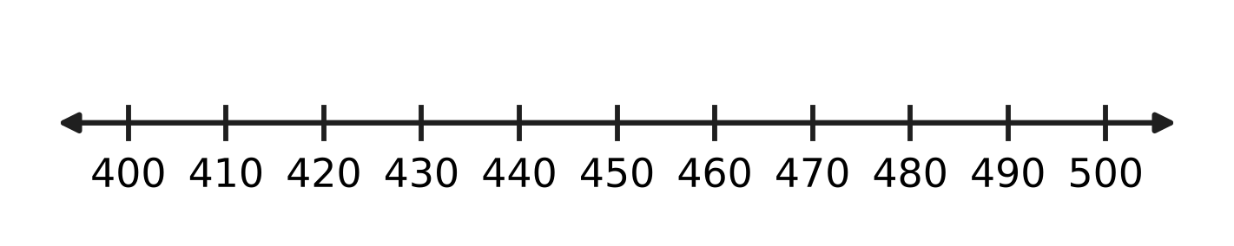
Q3. Look at the number line. The number 467 has no mark of its own. Between which two marks does 467 lie?
(A) 460 and 470 | (B) 400 and 410
(C) 470 and 480 | (D) 440 and 450

Q4. Uday puts all his marbles into 2 glass jars. Both jars get the same number, with none left over. How many marbles can he have?
(A) 135 | (B) 318 | (C) 251 | (D) 407

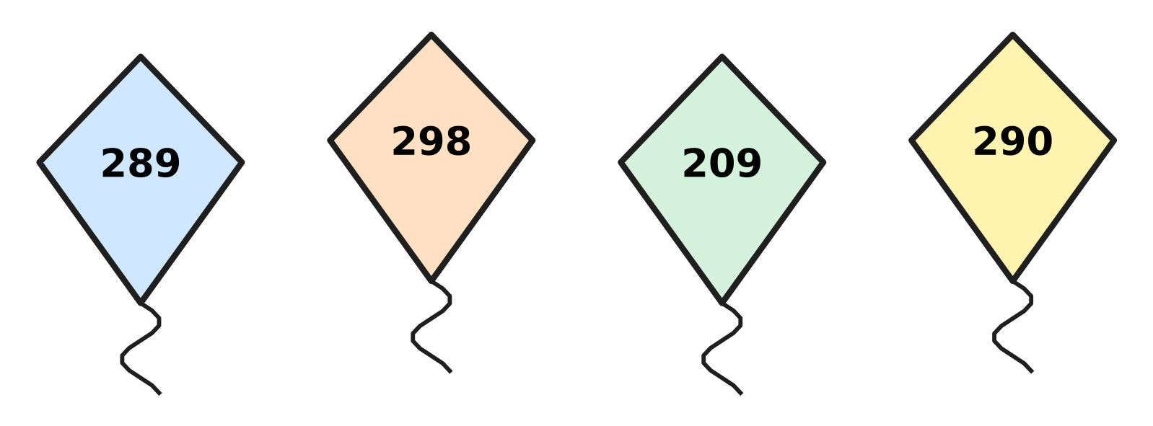
Q5. Look at the four kites. Which kite has the greatest number?
(A) 289 | (B) 290 | (C) 209 | (D) 298

Q6. Write each number name in figures. Which number has 0 in its tens place?
(A) four hundred sixty | (B) four hundred six
(C) four hundred sixteen | (D) four hundred sixty-one

Q7. A number has 5 tens. It is greater than 640 and less than 660. Which of these numbers can it be?
(A) 564 | (B) 645 | (C) 665 | (D) 654

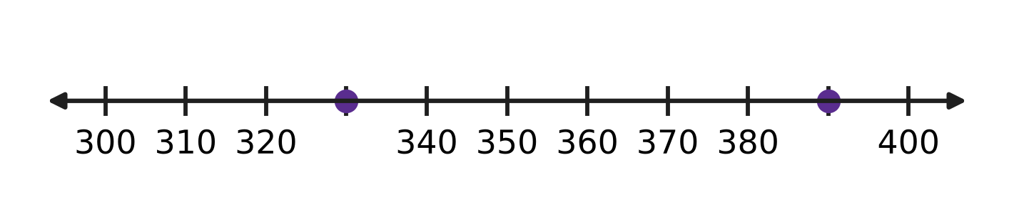
Q8. Look at the number line. The marks go up in equal steps. Which number is exactly halfway between the two dots?
(A) 360 | (B) 370 | (C) 350 | (D) 340

Q9. Which is the greatest even number that is less than 400?
(A) 390 | (B) 400 | (C) 398 | (D) 399

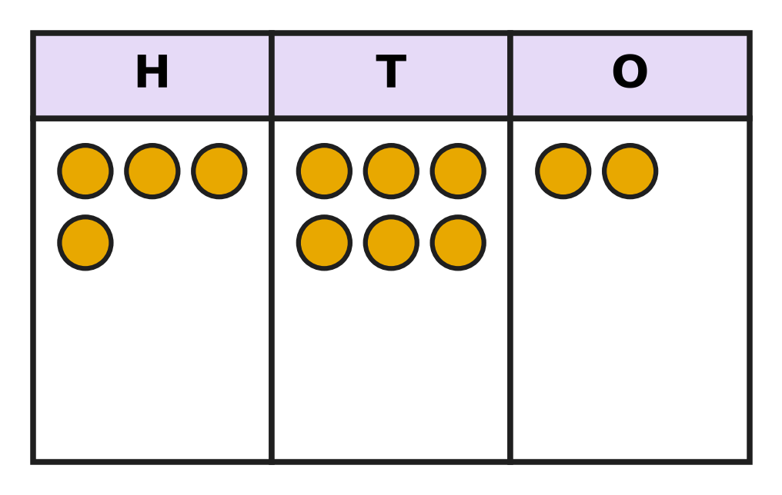
Q10. Look at the place-value chart. It shows 462. Asha puts 3 more counters in the T (tens) column. Which number does the chart show now?
(A) 465 | (B) 432 | (C) 762 | (D) 492

Part 2 — Operations & Number Properties (Syllabus Chapter 2)
Q11. What is 58 + 27?
(A) 85 | (B) 31 | (C) 75 | (D) 715

Q12. A bakery bakes 93 loaves of bread. It sells 57 loaves before noon. How many loaves are left?
(A) 150 | (B) 36 | (C) 46 | (D) 44

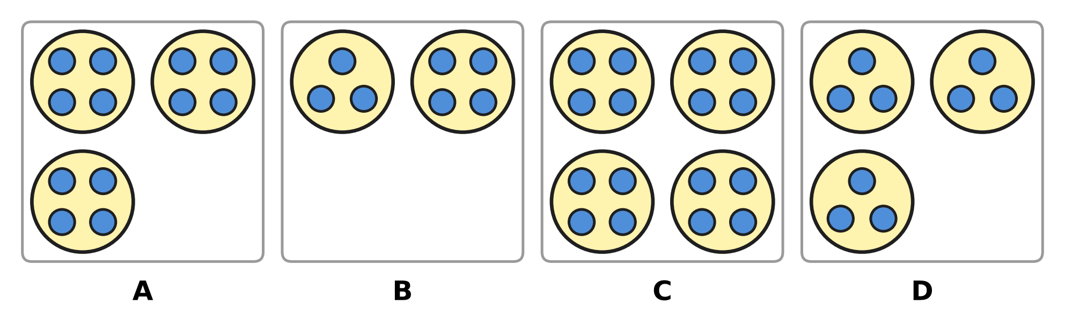
Q13. Look at the four pictures of marbles in rings. Which picture shows 3 × 4?
(A) Picture A | (B) Picture B
(C) Picture C | (D) Picture D

Q14. There are 9 children on a bicycle trip. Each child carries 2 bottles of water. How many bottles do they carry in all?
(A) 20 | (B) 16 | (C) 18 | (D) 11

Q15. A farmer has 14 cows. Half of the cows are in the field. How many cows are in the field?
(A) 7 | (B) 28 | (C) 12 | (D) 6

Q16. Workers in an orchard pick 325 red apples and 148 green apples. How many apples do they pick in all?
(A) 483 | (B) 463 | (C) 473 | (D) 177

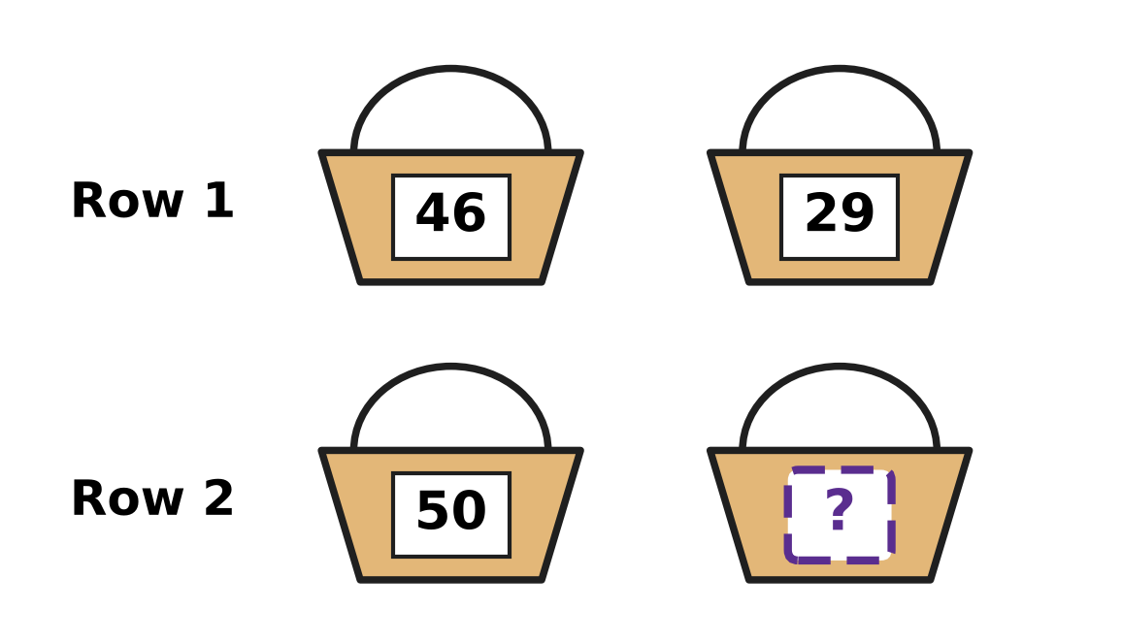
Q17. Look at the baskets. Each basket shows its number of apples. Both rows have the same number of apples in all. How many apples are in the last basket?
(A) 21 | (B) 25 | (C) 75 | (D) 15

Q18. A garden bed has 36 carrot plants in 4 equal rows. How many plants are in each row?
(A) 32 | (B) 40 | (C) 18 | (D) 9

Q19. A red album has 3 pages of 6 stamps each. A blue album has 4 pages of 4 stamps each. How many more stamps are in the red album?
(A) 18 | (B) 3 | (C) 34 | (D) 2

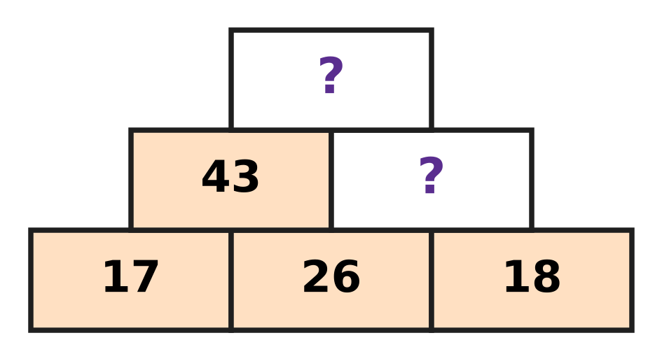
Q20. Look at Farhan's number wall. Each brick is the sum of the two bricks just under it. Which number goes in the top brick?
(A) 77 | (B) 61 | (C) 87 | (D) 44

Part 3 — Geometry (Syllabus Chapter 5)
Q21. Ruhi draws shapes with a ruler, so all her lines are straight. Which shape can she NOT draw?
(A) Square | (B) Circle
(C) Rectangle | (D) Triangle

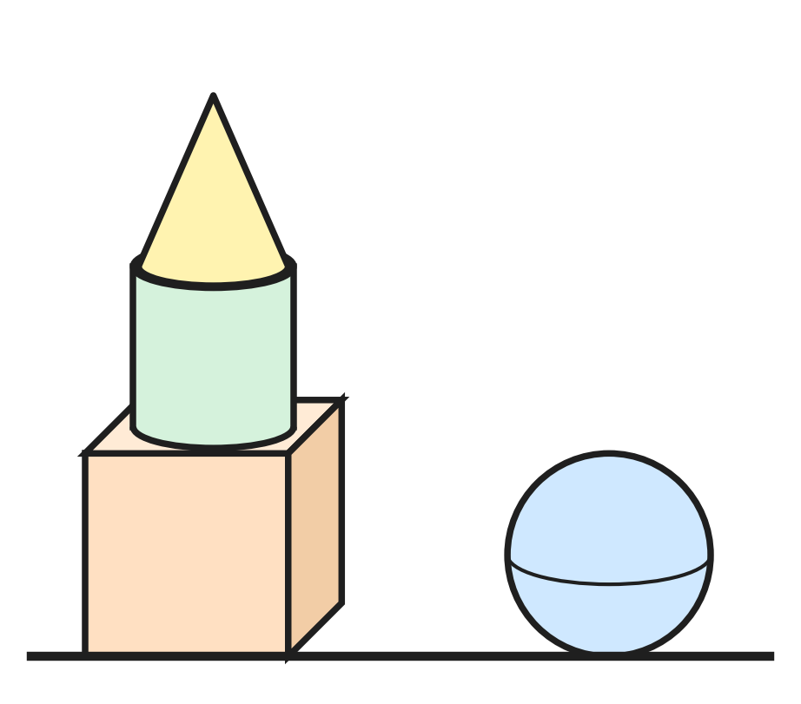
Q22. Look at Swati's solids. Where is the cylinder?
(A) In the middle of the tower | (B) On the floor next to the tower
(C) At the bottom of the tower | (D) At the top of the tower

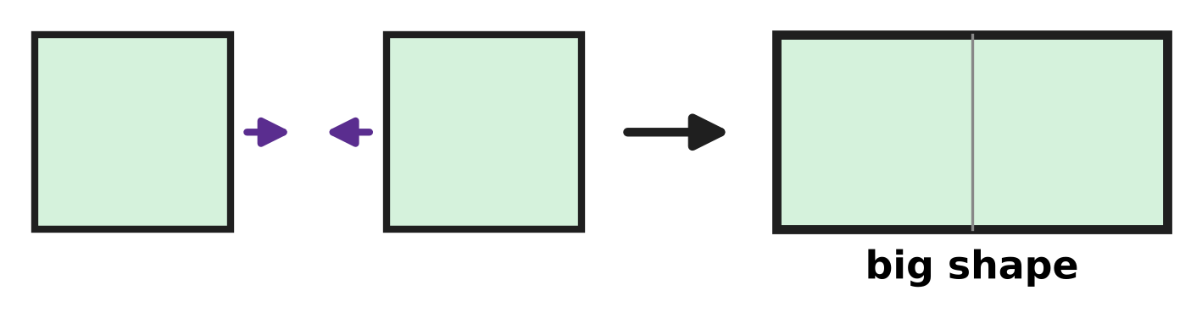
Q23. Two squares of the same size are pushed together. The picture shows the big shape they make. How many corners does the big shape have?
(A) 6 | (B) 8 | (C) 7 | (D) 4

Picture for Q24 and Q27
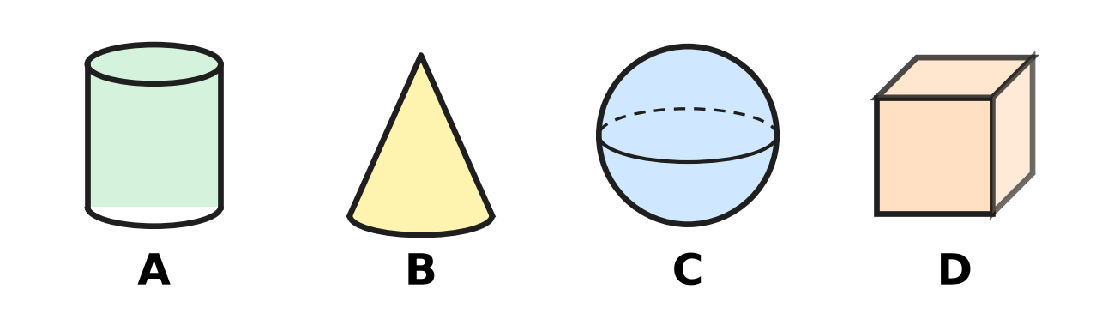
Q24. Look at the four solid shapes. Mona wants the one with no flat part at all. Which one should she pick?
(A) Picture A | (B) Picture B
(C) Picture C | (D) Picture D

Q25. Nila makes 2 triangles and 1 square with straws. Each side is one straw. The shapes do not touch. How many straws does she use?
(A) 3 | (B) 10 | (C) 7 | (D) 9

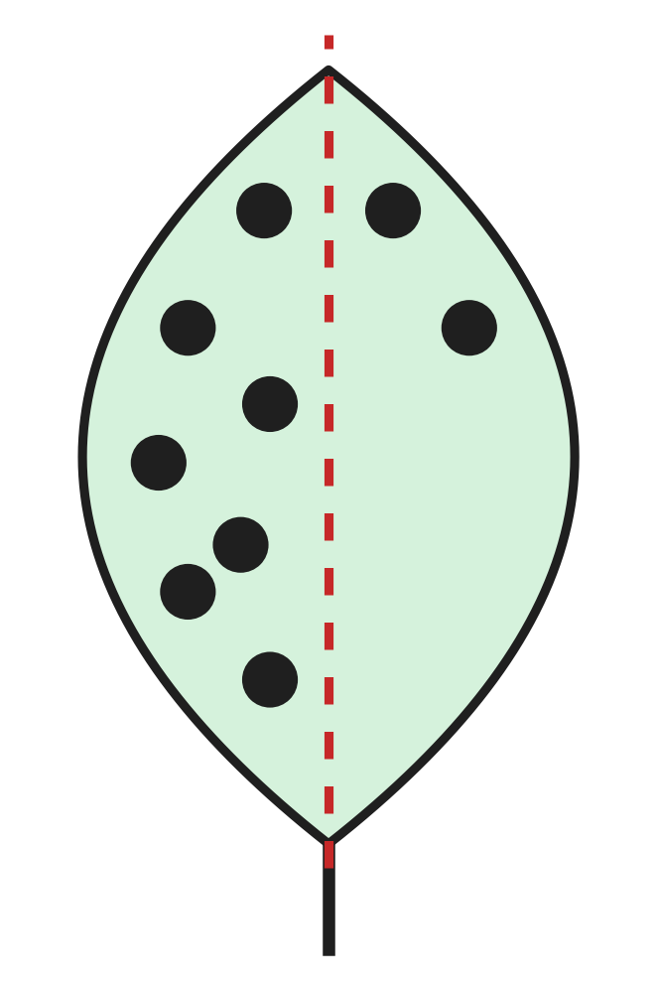
Q26. Look at the paper leaf. The two sides of the dotted line must match exactly. How many more dots must be drawn on the right side?
(A) 5 | (B) 7 | (C) 2 | (D) 9

Picture for Q24 and Q27
Q27. Look at the four solid shapes. Tanuj lays each one on its side and pushes it along the floor. Which one rolls round in a circle?
(A) Picture A | (B) Picture B
(C) Picture C | (D) Picture D

Part 4 — Applied Mathematics (Syllabus Chapter 9)
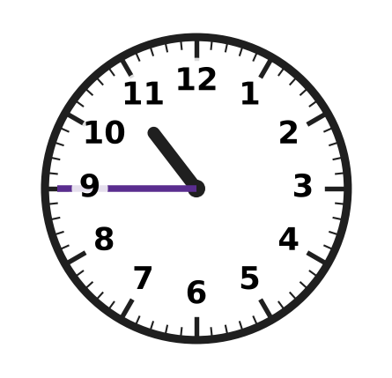
Q28. Look at the clock. What time does it show?
(A) quarter to 10 | (B) 9 o'clock
(C) quarter to 11 | (D) quarter past 11

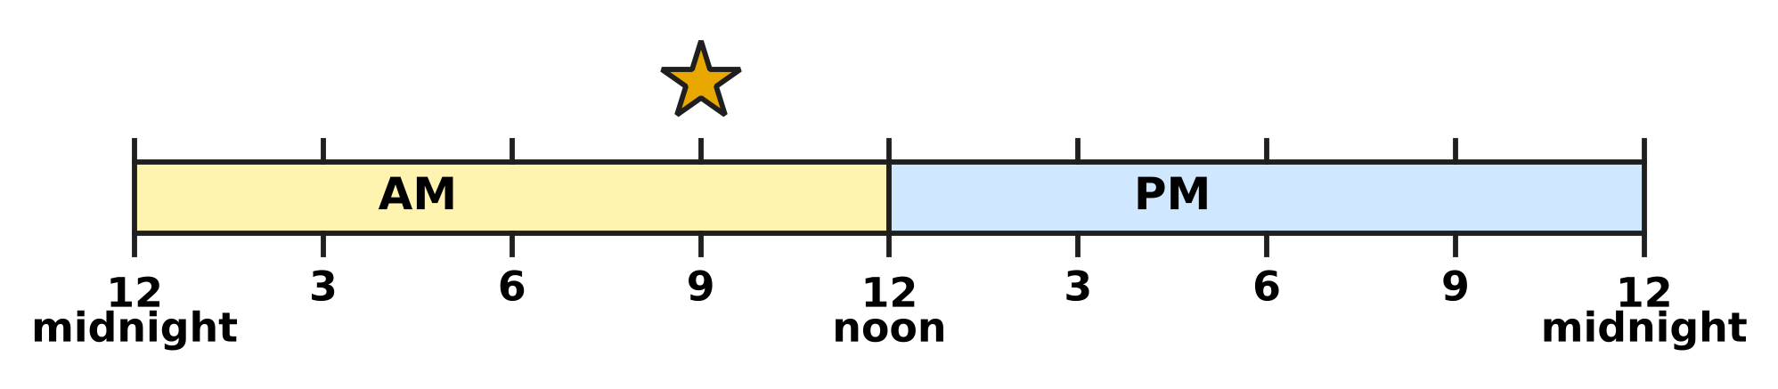
Q29. Look at the time line. It shows one whole day. What time is at the star?
(A) 3 PM | (B) 9 PM | (C) 3 AM | (D) 9 AM

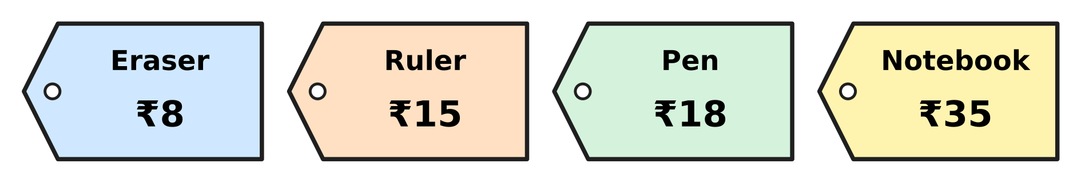
Q30. Look at the price tags in the stationery shop. How much more does the notebook cost than the pen?
(A) ₹27 | (B) ₹17 | (C) ₹23 | (D) ₹53

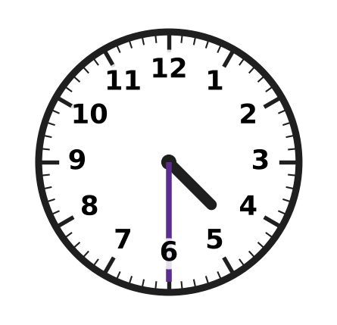
Q31. Look at the clock. It shows when the swimming pool opens in the afternoon. What time is it?
(A) 4:30 PM | (B) 5:30 PM | (C) 4:30 AM | (D) 6:30 PM

Q32. These four times are all on the same morning. Which time comes last?
(A) half past 9 | (B) quarter past 9
(C) quarter to 10 | (D) quarter to 9

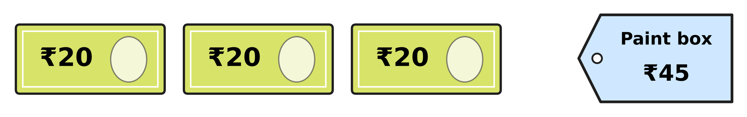
Q33. Look at the picture. Esha has these three notes. She buys the paint box. How much money does she have left?
(A) ₹45 | (B) ₹60 | (C) ₹25 | (D) ₹15

Q34. A bakery opens at 7 AM and closes at 7 PM on the same day. At which of these times is it closed?
(A) 10 PM | (B) 5 PM | (C) 8 AM | (D) 12 noon

Part 5 — Mathematical Reasoning & Problem-Solving (Syllabus Chapter 10)
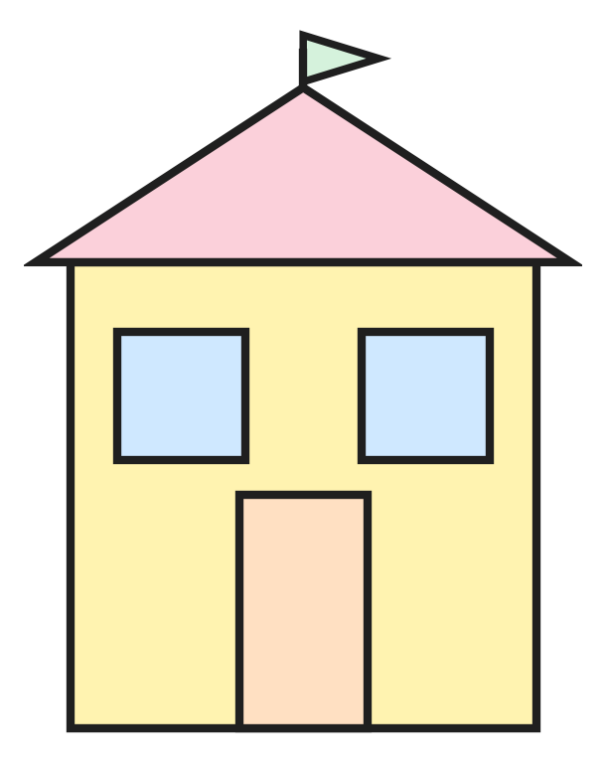
Q35. Look at the drawing of a house. It is made of flat shapes. How many squares are in it?
(A) 4 | (B) 1 | (C) 3 | (D) 2

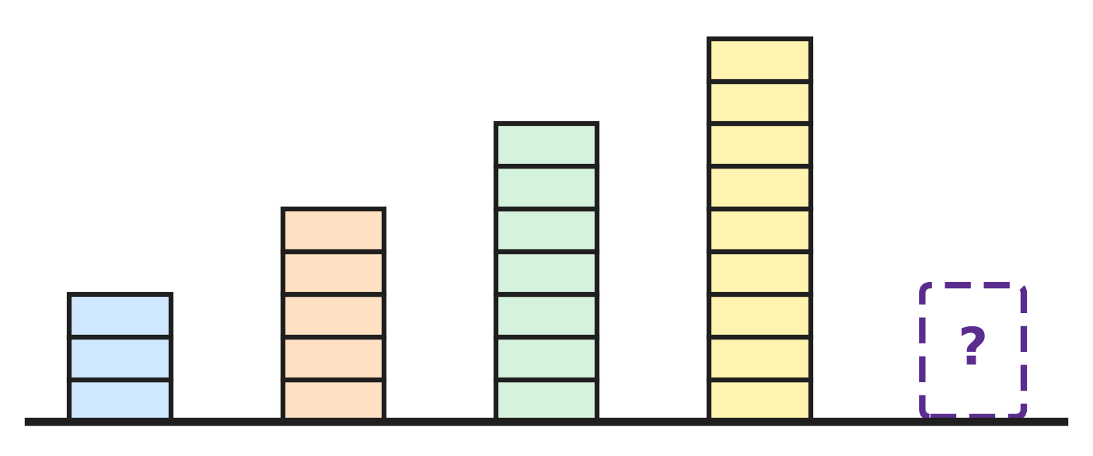
Q36. Look at Laksh's towers. They grow in the same way each time. How many blocks will the next tower have?
(A) 12 | (B) 11 | (C) 10 | (D) 9

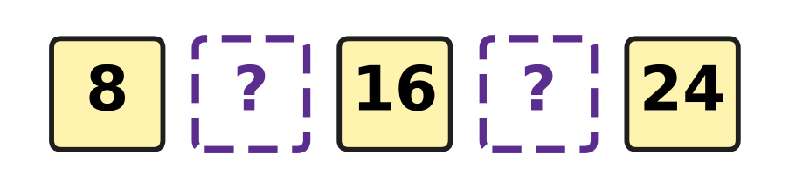
Q37. Look at the row of numbers. Every jump from one number to the next is the same. Which two numbers are missing?
(A) 12 and 18 | (B) 12 and 20
(C) 10 and 20 | (D) 9 and 17

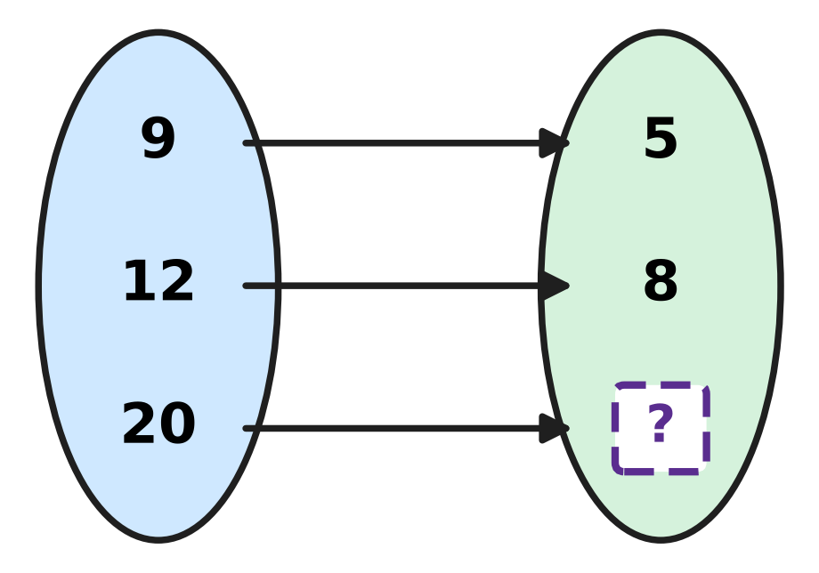
Q38. Look at the arrows. They all follow one rule. Which number is hidden?
(A) 10 | (B) 15 | (C) 24 | (D) 16

Q39. What comes next in this number pattern?
2, 3, 5, 8, 12, ___
(A) 17 | (B) 18 | (C) 20 | (D) 16

Q40. How many numbers from 10 to 30 have the digit 2 in them?
(A) 3 | (B) 12 | (C) 11 | (D) 10

SECTION II — Star Questions 5 questions × 4 marks each
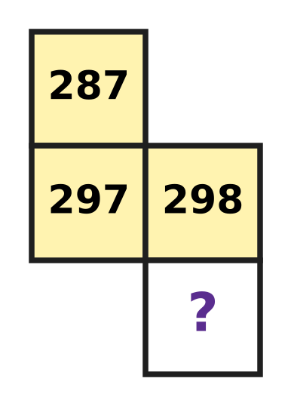
Q41. Look at the piece cut from a number chart. Each row of the chart has 10 numbers in counting order. Which number is hidden? [4 marks]
(A) 208 | (B) 308 | (C) 398 | (D) 299

Q42. One rule gives 2 → 4, 3 → 9 and 5 → 25. What does this rule give for 7? [4 marks]
(A) 49 | (B) 27 | (C) 14 | (D) 35

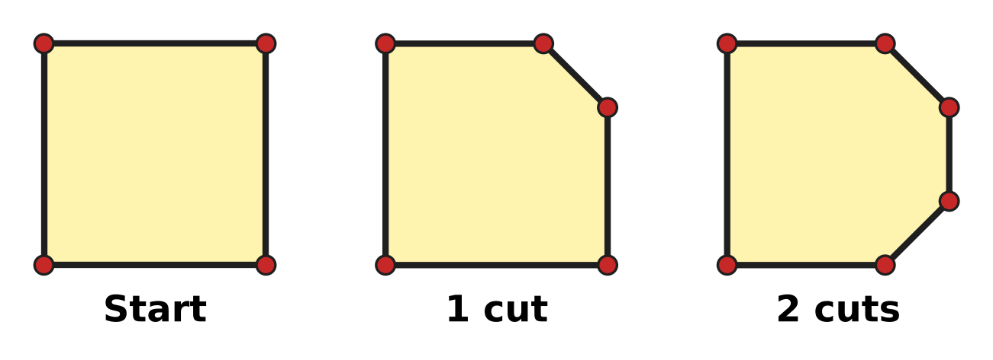
Q43. Look at the pictures. Each cut takes one corner off the paper square. How many corners will it have when all 4 corners are cut off? [4 marks]
(A) 4 | (B) 7 | (C) 0 | (D) 8

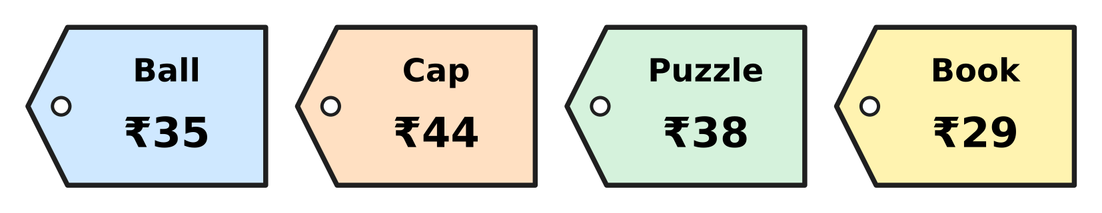
Q44. Look at the price tags. Kai has 20 coins of ₹2 and no other money. He wants to pay the exact price of one thing. Which thing can he buy? [4 marks]
(A) Cap | (B) Ball | (C) Puzzle | (D) Book

Q45. Shaan draws a triangle on the floor. He puts a ₹10 coin on each corner and a ₹2 coin in the middle of each side. He spends ₹20. How much money is left? [4 marks]
(A) ₹36 | (B) ₹12 | (C) ₹16 | (D) ₹28

Answer Sheet AMO Level 1 · Class 2 · Practice Paper 1
Name: | School: | Roll No.:
Shade or tick one circle for each question.
1. Ⓐ Ⓑ Ⓒ Ⓓ | 16. Ⓐ Ⓑ Ⓒ Ⓓ | 31. Ⓐ Ⓑ Ⓒ Ⓓ
2. Ⓐ Ⓑ Ⓒ Ⓓ | 17. Ⓐ Ⓑ Ⓒ Ⓓ | 32. Ⓐ Ⓑ Ⓒ Ⓓ
3. Ⓐ Ⓑ Ⓒ Ⓓ | 18. Ⓐ Ⓑ Ⓒ Ⓓ | 33. Ⓐ Ⓑ Ⓒ Ⓓ
4. Ⓐ Ⓑ Ⓒ Ⓓ | 19. Ⓐ Ⓑ Ⓒ Ⓓ | 34. Ⓐ Ⓑ Ⓒ Ⓓ
5. Ⓐ Ⓑ Ⓒ Ⓓ | 20. Ⓐ Ⓑ Ⓒ Ⓓ | 35. Ⓐ Ⓑ Ⓒ Ⓓ
6. Ⓐ Ⓑ Ⓒ Ⓓ | 21. Ⓐ Ⓑ Ⓒ Ⓓ | 36. Ⓐ Ⓑ Ⓒ Ⓓ
7. Ⓐ Ⓑ Ⓒ Ⓓ | 22. Ⓐ Ⓑ Ⓒ Ⓓ | 37. Ⓐ Ⓑ Ⓒ Ⓓ
8. Ⓐ Ⓑ Ⓒ Ⓓ | 23. Ⓐ Ⓑ Ⓒ Ⓓ | 38. Ⓐ Ⓑ Ⓒ Ⓓ
9. Ⓐ Ⓑ Ⓒ Ⓓ | 24. Ⓐ Ⓑ Ⓒ Ⓓ | 39. Ⓐ Ⓑ Ⓒ Ⓓ
10. Ⓐ Ⓑ Ⓒ Ⓓ | 25. Ⓐ Ⓑ Ⓒ Ⓓ | 40. Ⓐ Ⓑ Ⓒ Ⓓ
11. Ⓐ Ⓑ Ⓒ Ⓓ | 26. Ⓐ Ⓑ Ⓒ Ⓓ | 41. Ⓐ Ⓑ Ⓒ Ⓓ
12. Ⓐ Ⓑ Ⓒ Ⓓ | 27. Ⓐ Ⓑ Ⓒ Ⓓ | 42. Ⓐ Ⓑ Ⓒ Ⓓ
13. Ⓐ Ⓑ Ⓒ Ⓓ | 28. Ⓐ Ⓑ Ⓒ Ⓓ | 43. Ⓐ Ⓑ Ⓒ Ⓓ
14. Ⓐ Ⓑ Ⓒ Ⓓ | 29. Ⓐ Ⓑ Ⓒ Ⓓ | 44. Ⓐ Ⓑ Ⓒ Ⓓ
15. Ⓐ Ⓑ Ⓒ Ⓓ | 30. Ⓐ Ⓑ Ⓒ Ⓓ | 45. Ⓐ Ⓑ Ⓒ Ⓓ
Q41–Q45 are Section II Star Questions (4 marks each).
For the parent or teacher
Section I correct: ______ / 40 × 2 = ______ marks Section II correct: ______ / 5 × 4 = ______ marks
Correct: ______ / 45 Score: ______ / 100
Answer Key and Solutions AMO Level 1 · Class 2 · Practice Paper 1
Quick answers
1 D | 6 B | 11 A | 16 C | 21 B | 26 A | 31 A | 36 B | 41 B
2 C | 7 D | 12 B | 17 B | 22 A | 27 B | 32 C | 37 B | 42 A
3 A | 8 A | 13 A | 18 D | 23 D | 28 C | 33 D | 38 D | 43 D
4 B | 9 C | 14 C | 19 D | 24 C | 29 D | 34 A | 39 A | 44 C
5 D | 10 D | 15 A | 20 C | 25 B | 30 B | 35 C | 40 C | 45 C
Solutions
Q | Part · level | Answer | Why?
1 | Part 1 · Ch1 · Easy | (D) 450 | Counting back in hundreds gives 900, 800, 700, 600, 500, 400, 300, 200, 100. The number 450 is not one of them.
2 | Part 1 · Ch1 · Easy | (C) 80 | The 8 is in the tens place, so its value is 80.
3 | Part 1 · Ch1 · Easy | (A) 460 and 470 | 467 is greater than 460 and less than 470.
4 | Part 1 · Ch1 · Easy | (B) 318 | Only an even number can be shared into 2 equal groups with none left over. 318 ends in 8, so it is even. The other three are odd.
5 | Part 1 · Ch1 · Easy | (D) 298 | All have 2 hundreds. 298 and 290 have the most tens, 9. Then 8 ones is more than 0 ones, so 298 is greatest.
6 | Part 1 · Ch1 · Easy | (B) four hundred six | Four hundred six is 406: 4 hundreds, 0 tens and 6 ones. The others are 460, 416 and 461.
7 | Part 1 · Ch1 · Medium | (D) 654 | 654 has 6 hundreds, 5 tens and 4 ones, and it lies between 640 and 660. The other numbers do not have 5 tens.
8 | Part 1 · Ch1 · Medium | (A) 360 | Each step is 10. The dot after 320 is at 330 and the dot after 380 is at 390. 360 is 30 more than 330 and 30 less than 390, so 360 is halfway.
9 | Part 1 · Ch1 · Medium | (C) 398 | 399 is odd. The number before it, 398, is even.
10 | Part 1 · Ch1 · Medium | (D) 492 | 6 tens and 3 more tens make 9 tens: 492.
11 | Part 2 · Ch2 · Easy | (A) 85 | 8 + 7 = 15: write 5, carry 1. Then 5 + 2 + 1 = 8. Answer: 85.
12 | Part 2 · Ch2 · Easy | (B) 36 | Open a ten: 13 − 7 = 6. Then 8 − 5 = 3 tens. 36 are left.
13 | Part 2 · Ch2 · Easy | (A) Picture A | 3 × 4 means 3 groups of 4. Picture A has 3 rings with 4 marbles in each ring: 4 + 4 + 4 = 12.
14 | Part 2 · Ch2 · Easy | (C) 18 | 9 groups of 2: 9 × 2 = 18 bottles.
15 | Part 2 · Ch2 · Easy | (A) 7 | Half of 14 is 7, because 7 + 7 = 14. So 14 ÷ 2 = 7.
16 | Part 2 · Ch2 · Easy | (C) 473 | Ones: 5 + 8 = 13, write 3 and carry 1. Tens: 2 + 4 + 1 = 7. Hundreds: 3 + 1 = 4. They pick 473 apples.
17 | Part 2 · Ch2 · Medium | (B) 25 | Row 1 has 46 + 29 = 75 apples. Then 75 − 50 = 25.
18 | Part 2 · Ch2 · Medium | (D) 9 | Sharing into 4 equal rows is halving twice. Half of 36 is 18, and half of 18 is 9. So 36 ÷ 4 = 9.
19 | Part 2 · Ch2 · Medium | (D) 2 | 3 × 6 = 18 stamps and 4 × 4 = 16 stamps. 18 − 16 = 2.
20 | Part 2 · Ch2 · Medium | (C) 87 | Middle brick: 26 + 18 = 44. Top brick: 43 + 44 = 87.
21 | Part 3 · Ch5 · Easy | (B) Circle | A circle is round. It has no straight sides, so it cannot be drawn with straight lines only.
22 | Part 3 · Ch5 · Easy | (A) In the middle of the tower | A cylinder has a curved side and a flat circle at each end. It is in the middle of the tower, between the cube and the cone.
23 | Part 3 · Ch5 · Easy | (D) 4 | The big shape is a rectangle. A rectangle has 4 corners. The thin line in the middle only shows where the squares meet.
24 | Part 3 · Ch5 · Easy | (C) Picture C | Picture C is a sphere. It is curved all over, like a ball. The cylinder, the cone and the cube each have a flat part.
25 | Part 3 · Ch5 · Medium | (B) 10 | A triangle has 3 sides and a square has 4: 3 + 3 + 4 = 10.
26 | Part 3 · Ch5 · Medium | (A) 5 | The right side needs 7 dots too. It has 2. 7 − 2 = 5 more.
27 | Part 3 · Ch5 · Medium | (B) Picture B | Picture B is a cone. One end is a point and the other end is wide, so it rolls round in a circle.
28 | Part 4 · Ch9 · Easy | (C) quarter to 11 | The long hand is on 9, so it is quarter to. The short hand is almost at 11, so the time is quarter to 11.
29 | Part 4 · Ch9 · Easy | (D) 9 AM | The star is at the 9 before 12 noon, so it is 9 AM.
30 | Part 4 · Ch9 · Easy | (B) ₹17 | ₹35 − ₹18 = ₹17.
31 | Part 4 · Ch9 · Easy | (A) 4:30 PM | The long hand is on 6 and the short hand is between 4 and 5: half past 4. The afternoon is PM, so it is 4:30 PM.
32 | Part 4 · Ch9 · Medium | (C) quarter to 10 | In order, the times are quarter to 9, quarter past 9, half past 9 and quarter to 10. Quarter to 10 comes last.
33 | Part 4 · Ch9 · Medium | (D) ₹15 | She has ₹20 + ₹20 + ₹20 = ₹60. Then ₹60 − ₹45 = ₹15.
34 | Part 4 · Ch9 · Medium | (A) 10 PM | The bakery is open from 7 in the morning to 7 in the evening. 10 PM is at night, after 7 PM, so it is closed.
35 | Part 5 · Ch10 · Easy | (C) 3 | The big wall is a square and the two windows are squares: 3 squares. The door is a rectangle and the roof and flag are triangles.
36 | Part 5 · Ch10 · Easy | (B) 11 | The towers have 3, 5, 7, 9 blocks: 2 more each time. Next: 11.
37 | Part 5 · Ch10 · Easy | (B) 12 and 20 | Each jump is 4: 8, 12, 16, 20, 24.
38 | Part 5 · Ch10 · Easy | (D) 16 | 9 → 5 and 12 → 8: the rule is "take away 4". 20 − 4 = 16.
39 | Part 5 · Ch10 · Medium | (A) 17 | The jumps are +1, +2, +3, +4, then +5. 12 + 5 = 17.
40 | Part 5 · Ch10 · Medium | (C) 11 | The numbers are 12 and then 20, 21, 22, 23, 24, 25, 26, 27, 28, 29. That is 1 + 10 = 11 numbers.
41 | Section II · Ch1 + Ch10 · Hard | (B) 308 | Going down one row adds 10: 287 is above 297. So the hidden number is 298 + 10. 29 tens and 1 more ten make 30 tens, and 8 ones: 308.
42 | Section II · Ch2 + Ch10 · Hard | (A) 49 | Each number is multiplied by itself: 7 × 7 = 49.
43 | Section II · Ch5 + Ch10 · Hard | (D) 8 | The paper has 4 corners, then 5, then 6: one more after each cut. After 4 cuts there are 4 + 4 = 8 corners.
44 | Section II · Ch1 + Ch9 · Hard | (C) Puzzle | 20 coins of ₹2 are ₹40. ₹2 coins can make only even amounts. ₹38 is even and not more than ₹40, so he can buy the puzzle.
45 | Section II · Ch5 + Ch9 · Hard | (C) ₹16 | A triangle has 3 corners and 3 sides. 3 coins of ₹10 are ₹30 and 3 coins of ₹2 are ₹6: ₹36 in all. ₹36 − ₹20 = ₹16.

