UNLOCK IQ INSTITUTE
Realize Your True Potential
Aryabhatta Maths Olympiad (AMO)
Level 1 — Practice Paper 2
CLASS 2

Questions | 45 multiple-choice questions
Marks | 100
Time | 60 minutes
Section I | 40 questions × 2 marks = 80 marks
Section II | 5 Star Questions × 4 marks = 20 marks
Negative marking | No negative marking
Calculator | Not allowed
Chapters | Number System · Operations · Geometry · Applied Mathematics · Mathematical Reasoning

Hello, friend!
• Every question has four answer choices: (A), (B), (C) and (D). Only one is correct.
• Read each question and look at its picture carefully. Then mark your answer on the answer sheet at the end.
• Section I has 40 questions of 2 marks each. Section II has 5 Star Questions of 4 marks each.
• There is no negative marking, so try every question.
• Do not use a calculator. You may do rough work on a separate sheet.
• All figures are not necessarily drawn to scale unless stated.

For parents and teachers
Print or view this paper in colour. Pictures are part of the questions.
You may read a question aloud to the child, exactly as printed. Please do not explain it or point to an answer choice.
Parts follow the AMO syllabus chapters. Chapters 3, 4, 6, 7 and 8 are not part of the Class 2 syllabus, so the chapter numbers shown in the Part headings have gaps.
The answer sheet and the answer key are at the end. Remove only the answer key before the child begins.

Name: | School: | Roll No.:

SECTION I 40 questions × 2 marks each
Part 1 — Number System (Syllabus Chapter 1)
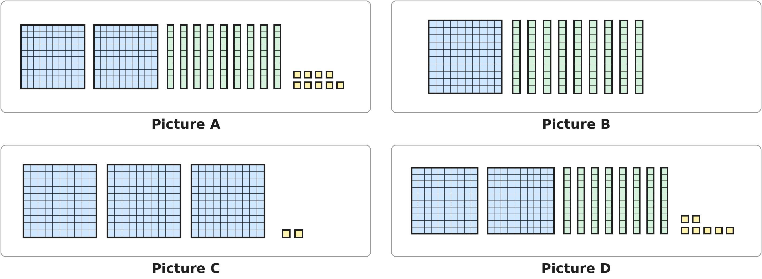
Q1. Look at the blocks. A big square is 1 hundred, a rod is 1 ten and a small square is 1 one. Which picture shows more than 300?
(A) Picture A | (B) Picture B
(C) Picture C | (D) Picture D

Q2. In which of these numbers does the digit 5 stand for 50?
(A) 125 | (B) 152 | (C) 512 | (D) 521

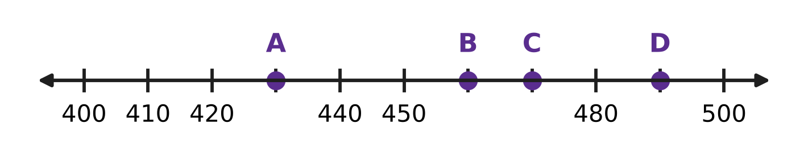
Q3. Look at the number line. The marks go up in tens. Which letter is at 470?
(A) A | (B) B | (C) C | (D) D

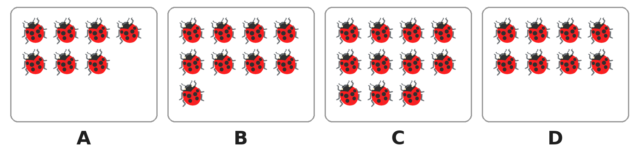
Q4. Look at the boxes of ladybirds. Which box has an even number of ladybirds?
(A) Box A | (B) Box B | (C) Box C | (D) Box D

Q5. Which of these is the number name of 340?
(A) three hundred four | (B) three hundred fourteen
(C) thirty-four | (D) three hundred forty

Q6. Which of these numbers comes between 498 and 503?
(A) 489 | (B) 497 | (C) 501 | (D) 510

Q7. In which of these numbers is the hundreds digit smaller than the tens digit?
(A) 285 | (B) 528 | (C) 825 | (D) 852

Q8. A 3-digit number begins with 47. It is even, and its ones digit is greater than 5. Which of these can be its ones digit?
(A) 4 | (B) 6 | (C) 7 | (D) 9

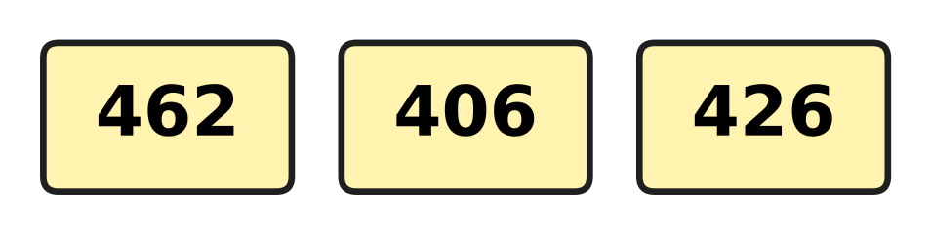
Q9. Look at the three number cards. Which of these shows the numbers from the smallest to the greatest?
(A) 462, 426, 406 | (B) 426, 406, 462
(C) 406, 462, 426 | (D) 406, 426, 462

Q10. Which of these numbers is nearest to 400?
(A) 396 | (B) 403 | (C) 408 | (D) 411

Part 2 — Operations & Number Properties (Syllabus Chapter 2)
Q11. A race on sports day is 100 steps long. Kush has run 64 steps. How many more steps must he run?
(A) 36 | (B) 44 | (C) 46 | (D) 164

Q12. A train has 245 people on it. At the next station, 38 more people get on. How many people are on the train now?
(A) 207 | (B) 273 | (C) 283 | (D) 625

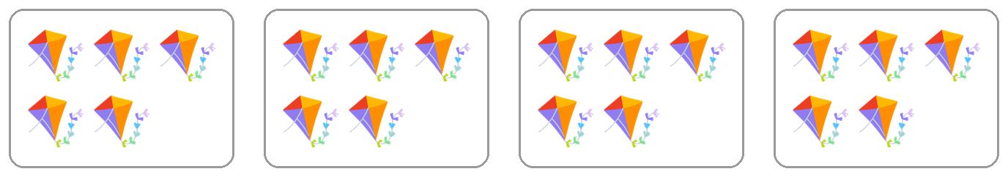
Q13. Look at the boxes of kites. Which of these tells how many kites there are?
(A) 5 × 5 | (B) 4 + 5 | (C) 4 × 4 | (D) 4 × 5

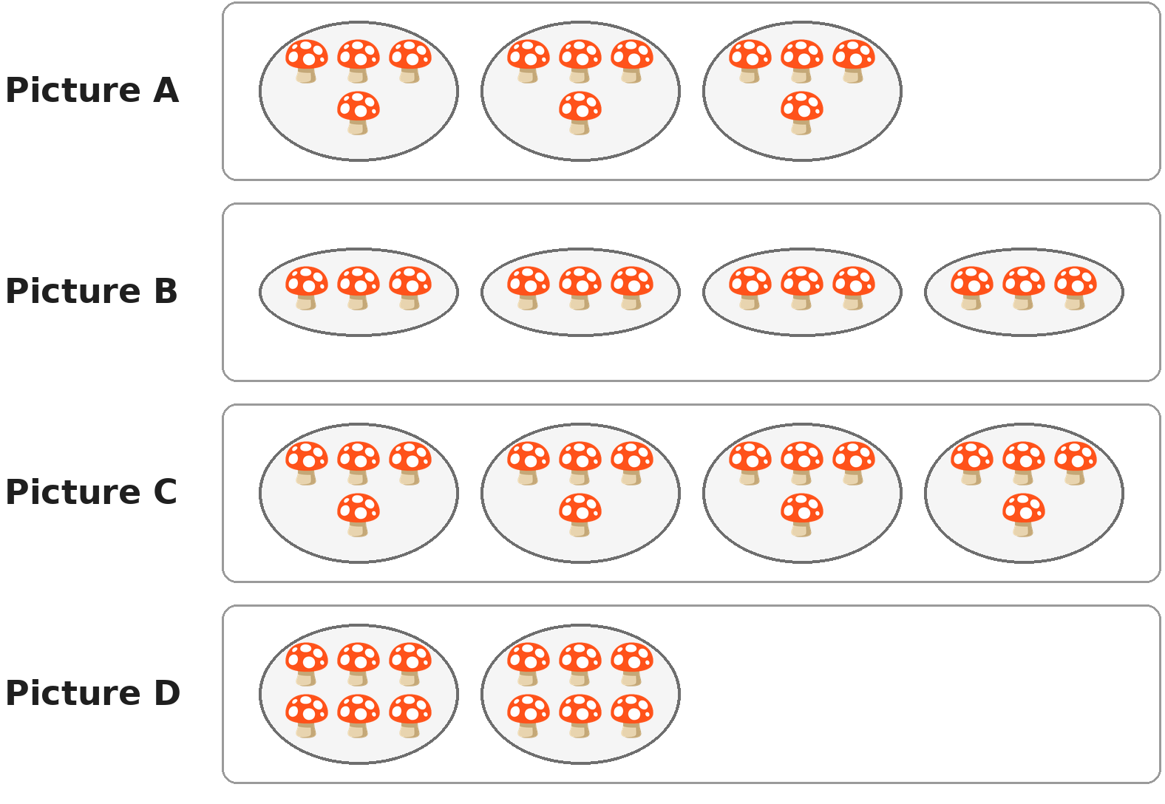
Q14. Look at the plates of mushrooms. Which picture shows 12 mushrooms shared equally among 4 plates?
(A) Picture A | (B) Picture B
(C) Picture C | (D) Picture D

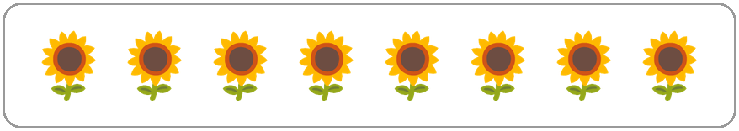
Q15. Look at the plants in a school garden. Each plant needs 3 mugs of water. How many mugs of water do they need in all?
(A) 11 | (B) 21 | (C) 24 | (D) 32

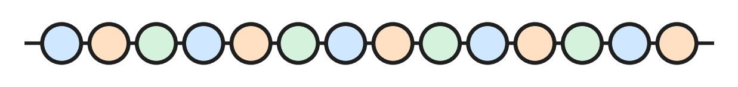
Q16. Look at the string of beads. Luke takes half of the beads off the string. How many beads stay on the string?
(A) 6 | (B) 7 | (C) 12 | (D) 14

Q17. Which of these sums makes exactly 100?
(A) 48 + 42 | (B) 55 + 55 | (C) 73 + 37 | (D) 64 + 36

Q18. Lena has 20 ribbons. She gives 3 ribbons to each of her 4 friends. How many ribbons does she have left?
(A) 8 | (B) 12 | (C) 13 | (D) 17

Q19. Which of these is the same as a quarter of 20?
(A) Half of 20 | (B) Half of 40
(C) A quarter of 16 | (D) Half of 10

Q20. In which of these do you have to open a ten before you can take away the ones?
(A) 63 − 28 | (B) 68 − 23 | (C) 86 − 32 | (D) 38 − 26

Part 3 — Geometry (Syllabus Chapter 5)
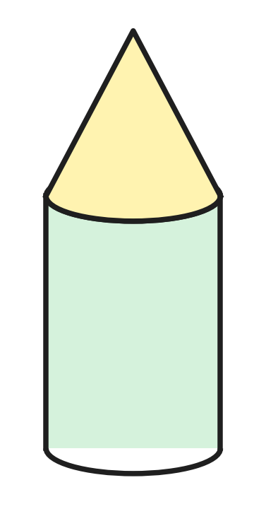
Q21. Look at the toy rocket in a toy shop. It is made of two solids, one on top of the other. Which two solids are they?
(A) A cylinder and a cone | (B) A cylinder and a sphere
(C) A cube and a cone | (D) A cube and a sphere

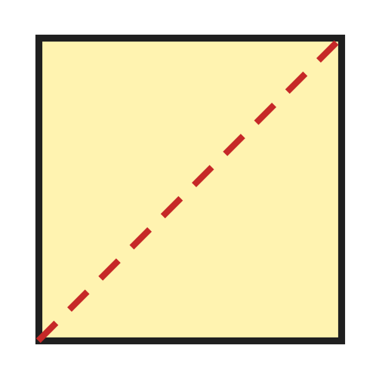
Q22. Look at the square paper. Jaya folds it along the dotted line, so that one half lies on the other. How many corners does the folded shape have?
(A) 2 | (B) 3 | (C) 4 | (D) 6

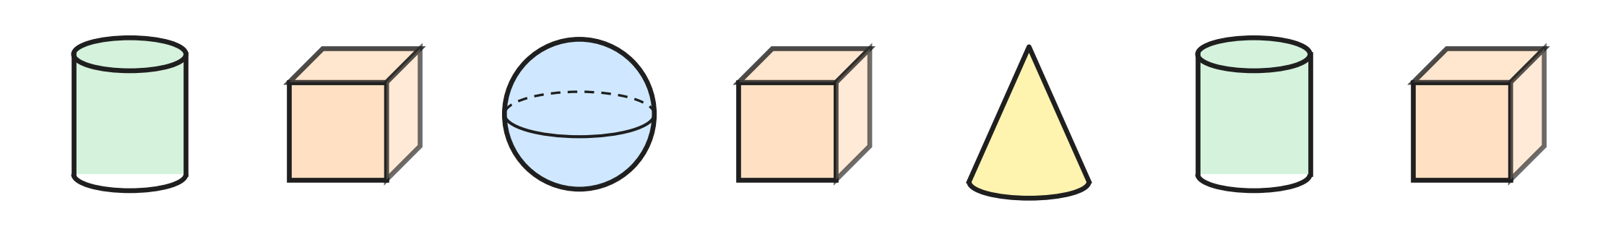
Q23. Look at the solids in a row. How many of them have no curved part at all?
(A) 1 | (B) 3 | (C) 4 | (D) 6

Q24. Ahana puts paint on one flat part of a solid. She presses it on paper. The print is a square. Which solid did she use?
(A) Sphere | (B) Cylinder
(C) Cone | (D) Cube

Q25. I am a flat shape. I have more corners than a circle, but not as many corners as a square. Which shape am I?
(A) Rectangle | (B) Square
(C) Circle | (D) Triangle

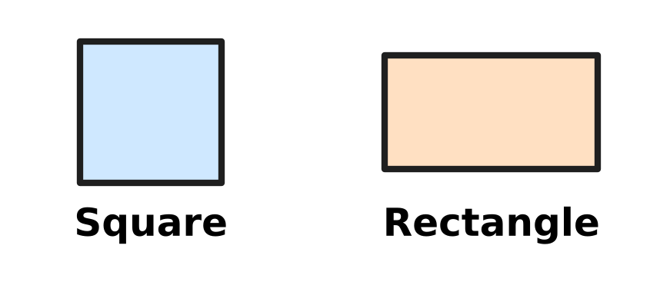
Q26. Look at the square and the rectangle. Which of these is true for the square but NOT for this rectangle?
(A) All 4 sides are equal. | (B) It has 4 corners.
(C) It is a flat shape. | (D) It has 4 straight sides.

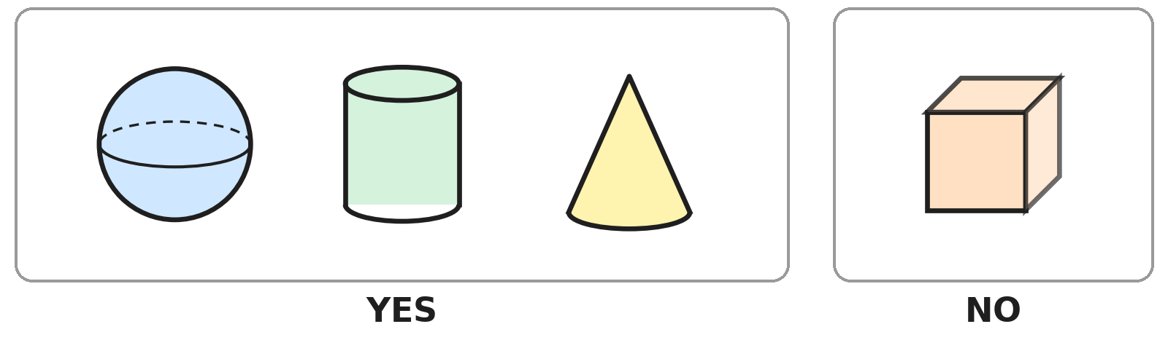
Q27. Look at the two groups of solids. Lokesh sorts them by asking one question. The answer is written under each group. Which question does he ask?
(A) Can it roll?
(B) Does it have a point at the top?
(C) Can it slide?
(D) Is it a solid shape?

Part 4 — Applied Mathematics (Syllabus Chapter 9)
Q28. Simran is sleeping in the middle of the night. Which of these can the time be?
(A) 10 AM | (B) 12 noon | (C) 2 PM | (D) 2 AM

Picture for Q29 and Q33
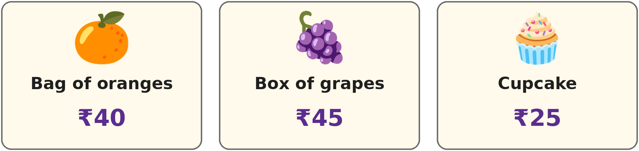
Q29. Look at the price tags at a food stall. Jai buys 2 cupcakes. How much does he pay?
(A) ₹25 | (B) ₹27 | (C) ₹50 | (D) ₹65

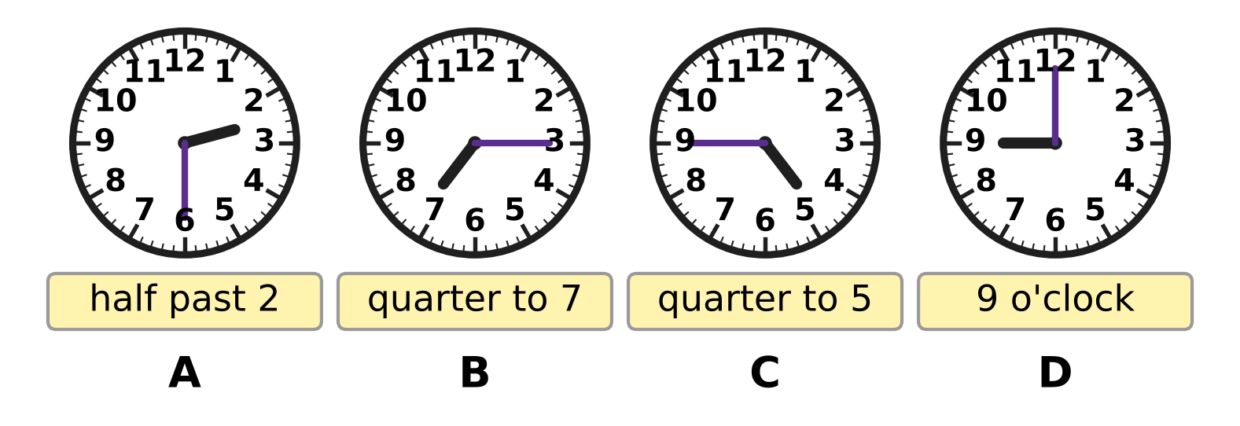
Q30. Look at the clocks. Eric has written a time under each clock. Under which clock has he written the wrong time?
(A) Clock A | (B) Clock B | (C) Clock C | (D) Clock D

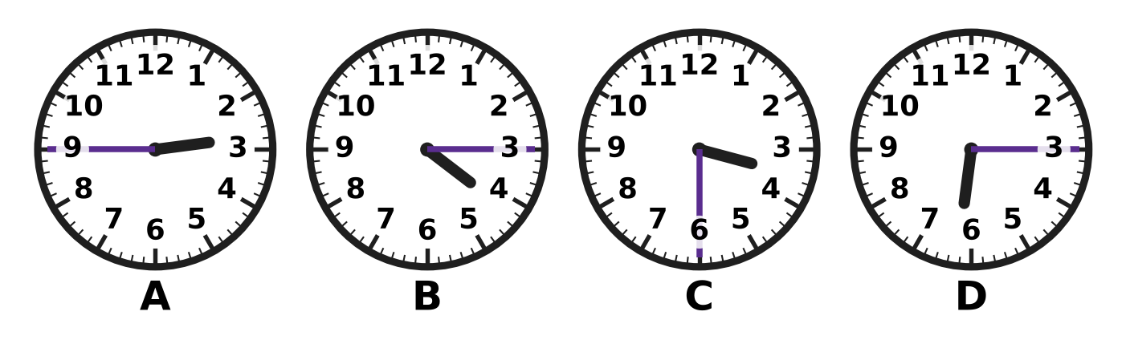
Q31. Look at the four clocks. Which clock shows a time after 3 o'clock but before 4 o'clock?
(A) Clock A | (B) Clock B | (C) Clock C | (D) Clock D

Q32. Which of these is another way to write quarter to 6?
(A) 6:45 | (B) 6:15 | (C) 5:45 | (D) 5:15

Picture for Q29 and Q33
Q33. Look at the price tags. Lucy buys a bag of oranges and a box of grapes. She pays with one note. Which is the smallest note that is enough?
(A) ₹50 note | (B) ₹100 note
(C) ₹200 note | (D) ₹500 note

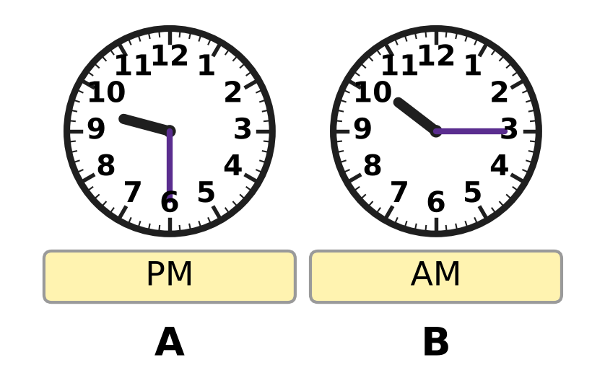
Q34. Look at the two clocks. They show two times on the same day. Which of these times comes first in the day?
(A) half past 9 PM | (B) quarter past 10 PM
(C) half past 9 AM | (D) quarter past 10 AM

Part 5 — Mathematical Reasoning & Problem-Solving (Syllabus Chapter 10)
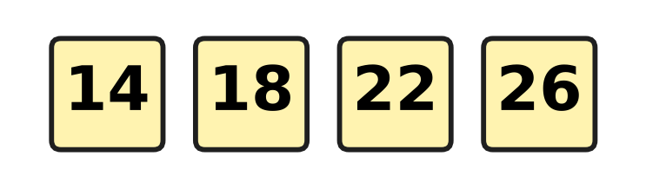
Q35. Look at the number pattern. What is the rule of the pattern?
(A) Add 4 | (B) Take away 4
(C) Add 2 | (D) Add 8

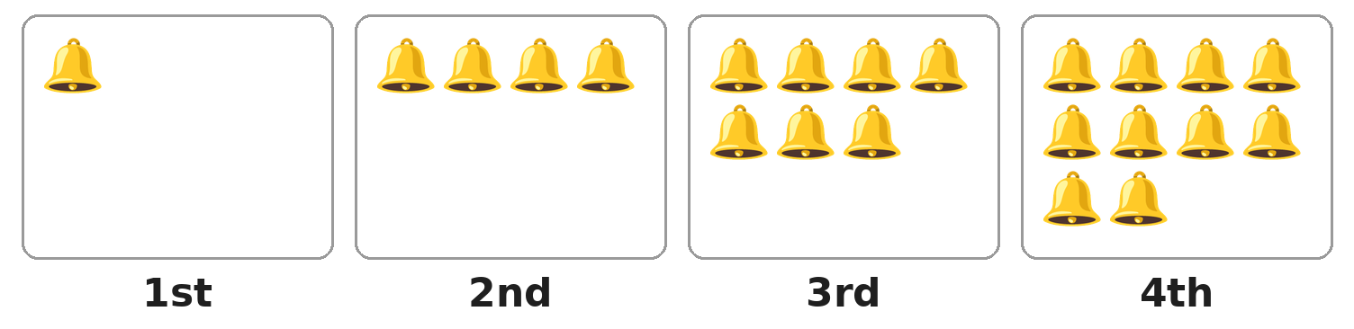
Q36. Look at the boxes of bells. The number of bells grows in the same way each time. Which box will have 16 bells?
(A) 5th box | (B) 6th box | (C) 7th box | (D) 8th box

Q37. A rule changes 3 into 8 and 6 into 11. Which of these follows the same rule?
(A) 5 → 11 | (B) 4 → 8 | (C) 9 → 14 | (D) 8 → 3

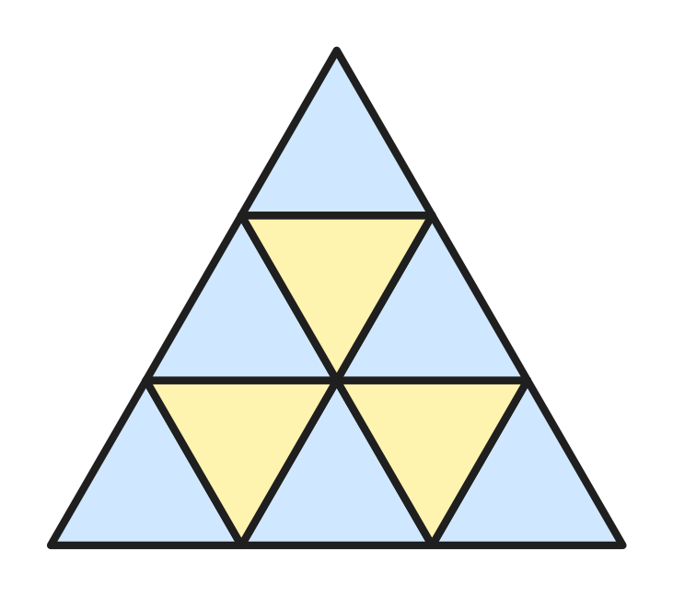
Q38. Look at the big triangle. It is made of small triangles of the same size. How many small triangles are there?
(A) 3 | (B) 6 | (C) 9 | (D) 10

Q39. A fence has 7 posts in a straight row. One board joins each post to the next post. How many boards does the fence have?
(A) 6 | (B) 7 | (C) 8 | (D) 14

Q40. In which of these patterns is every number double the number before it?
(A) 3, 6, 12, 24 | (B) 5, 10, 15, 20
(C) 1, 3, 5, 7 | (D) 2, 4, 6, 8

SECTION II — Star Questions 5 questions × 4 marks each
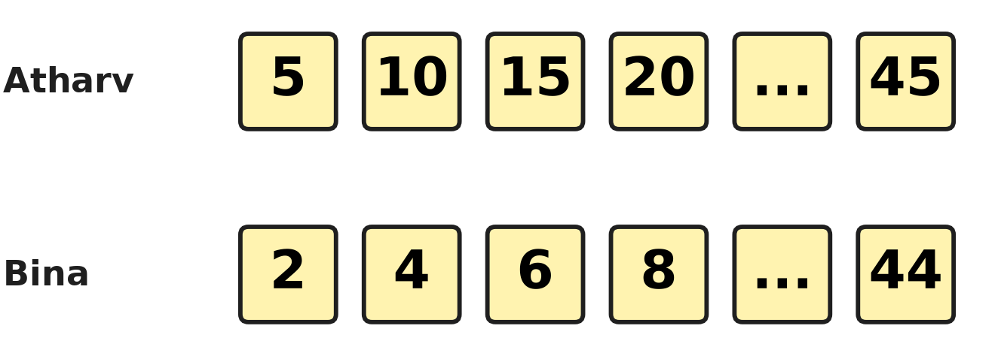
Q41. Look at the picture. Atharv counts in fives from 5 to 45. Bina counts in twos from 2 to 44. How many numbers do Atharv and Bina both say? [4 marks]
(A) 3 | (B) 4 | (C) 5 | (D) 9

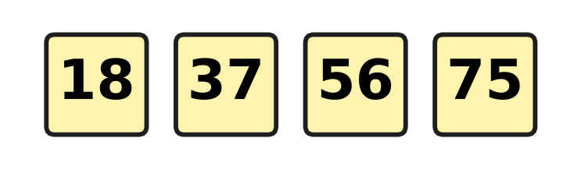
Q42. Look at the number tiles. The jump from each tile to the next is always the same, and the pattern goes on. Which of these numbers will be on the next tile? [4 marks]
(A) 85 | (B) 93 | (C) 94 | (D) 95

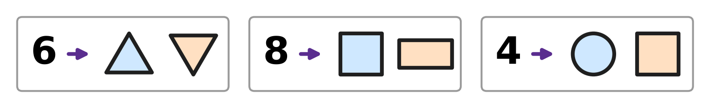
Q43. Look at the three cards. Each number and its two shapes follow the same rule about corners. Which two shapes go with the number 7? [4 marks]
(A) A circle and a triangle | (B) Two triangles
(C) A square and a rectangle | (D) A triangle and a rectangle

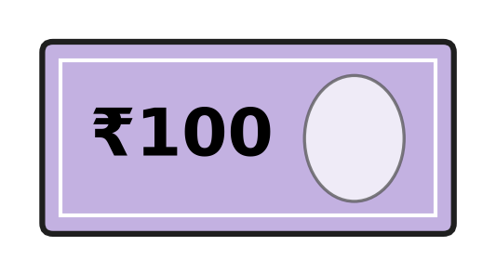
Q44. Mishti has only notes like the one in the picture. She buys a doll for ₹430. She pays with as few notes as she can. How much change does she get? [4 marks]
(A) ₹30 | (B) ₹70 | (C) ₹100 | (D) ₹170

Q45. Look at the clock. It has solids in place of 12, 3, 6 and 9. The long hand points to one solid at quarter past 8 and to another at quarter to 9. Which is true for BOTH solids? [4 marks] | 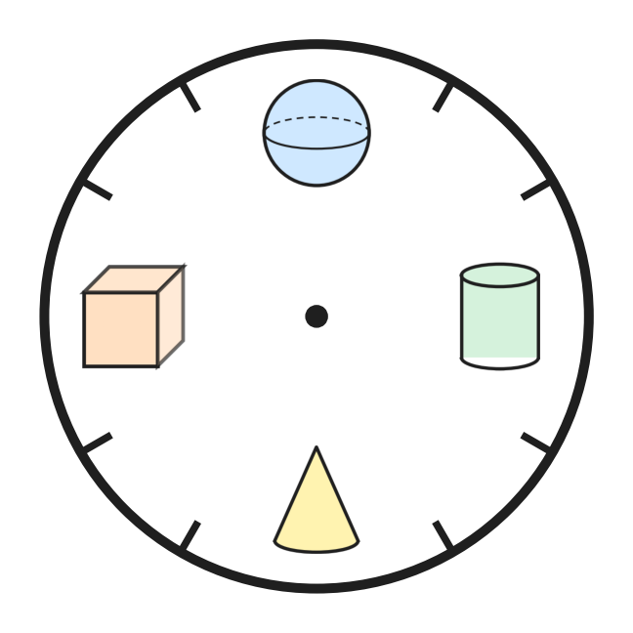
  (A) It has a flat part. | (B) It can roll.
  (C) It has a pointed top. | (D) It has no flat part.
Answer Sheet AMO Level 1 · Class 2 · Practice Paper 2
Name: | School: | Roll No.:
Shade or tick one circle for each question.
1. Ⓐ Ⓑ Ⓒ Ⓓ | 16. Ⓐ Ⓑ Ⓒ Ⓓ | 31. Ⓐ Ⓑ Ⓒ Ⓓ
2. Ⓐ Ⓑ Ⓒ Ⓓ | 17. Ⓐ Ⓑ Ⓒ Ⓓ | 32. Ⓐ Ⓑ Ⓒ Ⓓ
3. Ⓐ Ⓑ Ⓒ Ⓓ | 18. Ⓐ Ⓑ Ⓒ Ⓓ | 33. Ⓐ Ⓑ Ⓒ Ⓓ
4. Ⓐ Ⓑ Ⓒ Ⓓ | 19. Ⓐ Ⓑ Ⓒ Ⓓ | 34. Ⓐ Ⓑ Ⓒ Ⓓ
5. Ⓐ Ⓑ Ⓒ Ⓓ | 20. Ⓐ Ⓑ Ⓒ Ⓓ | 35. Ⓐ Ⓑ Ⓒ Ⓓ
6. Ⓐ Ⓑ Ⓒ Ⓓ | 21. Ⓐ Ⓑ Ⓒ Ⓓ | 36. Ⓐ Ⓑ Ⓒ Ⓓ
7. Ⓐ Ⓑ Ⓒ Ⓓ | 22. Ⓐ Ⓑ Ⓒ Ⓓ | 37. Ⓐ Ⓑ Ⓒ Ⓓ
8. Ⓐ Ⓑ Ⓒ Ⓓ | 23. Ⓐ Ⓑ Ⓒ Ⓓ | 38. Ⓐ Ⓑ Ⓒ Ⓓ
9. Ⓐ Ⓑ Ⓒ Ⓓ | 24. Ⓐ Ⓑ Ⓒ Ⓓ | 39. Ⓐ Ⓑ Ⓒ Ⓓ
10. Ⓐ Ⓑ Ⓒ Ⓓ | 25. Ⓐ Ⓑ Ⓒ Ⓓ | 40. Ⓐ Ⓑ Ⓒ Ⓓ
11. Ⓐ Ⓑ Ⓒ Ⓓ | 26. Ⓐ Ⓑ Ⓒ Ⓓ | 41. Ⓐ Ⓑ Ⓒ Ⓓ
12. Ⓐ Ⓑ Ⓒ Ⓓ | 27. Ⓐ Ⓑ Ⓒ Ⓓ | 42. Ⓐ Ⓑ Ⓒ Ⓓ
13. Ⓐ Ⓑ Ⓒ Ⓓ | 28. Ⓐ Ⓑ Ⓒ Ⓓ | 43. Ⓐ Ⓑ Ⓒ Ⓓ
14. Ⓐ Ⓑ Ⓒ Ⓓ | 29. Ⓐ Ⓑ Ⓒ Ⓓ | 44. Ⓐ Ⓑ Ⓒ Ⓓ
15. Ⓐ Ⓑ Ⓒ Ⓓ | 30. Ⓐ Ⓑ Ⓒ Ⓓ | 45. Ⓐ Ⓑ Ⓒ Ⓓ
Q41–Q45 are Section II Star Questions (4 marks each).
For the parent or teacher
Section I correct: ______ / 40 × 2 = ______ marks Section II correct: ______ / 5 × 4 = ______ marks
Correct: ______ / 45 Score: ______ / 100
Answer Key and Solutions AMO Level 1 · Class 2 · Practice Paper 2
Quick answers
1 C | 6 C | 11 A | 16 B | 21 A | 26 A | 31 C | 36 B | 41 B
2 B | 7 A | 12 C | 17 D | 22 B | 27 A | 32 C | 37 C | 42 C
3 C | 8 B | 13 D | 18 A | 23 B | 28 D | 33 B | 38 C | 43 D
4 D | 9 D | 14 B | 19 D | 24 D | 29 C | 34 D | 39 A | 44 B
5 D | 10 B | 15 C | 20 A | 25 D | 30 B | 35 A | 40 A | 45 A
Solutions
Q | Part · level | Answer | Why?
1 | Part 1 · Ch1 · Easy | (C) Picture C | Picture C has 3 hundreds and 2 ones, which is 302. The others have fewer than 3 hundreds: 299, 190 and 287.
2 | Part 1 · Ch1 · Easy | (B) 152 | In 152 the digit 5 is in the tens place, and 5 tens make 50.
3 | Part 1 · Ch1 · Easy | (C) C | Count on in tens from 450: 460, then 470. The second mark after 450 has the letter C.
4 | Part 1 · Ch1 · Easy | (D) Box D | Box D has 8 ladybirds. They make 4 pairs with none left over, so 8 is even. The numbers 7, 9 and 11 are odd.
5 | Part 1 · Ch1 · Easy | (D) three hundred forty | The number 340 has 3 hundreds and 4 tens, and 4 tens are forty. So the name is three hundred forty.
6 | Part 1 · Ch1 · Easy | (C) 501 | After 498 come 499, 500, 501, 502 and then 503. Only 501 lies between them.
7 | Part 1 · Ch1 · Medium | (A) 285 | In 285 the hundreds digit is 2 and the tens digit is 8, and 2 is smaller than 8. In 528, 825 and 852 the hundreds digit is the bigger one.
8 | Part 1 · Ch1 · Medium | (B) 6 | An even number ends in 0, 2, 4, 6 or 8. Of the answer choices, only 6 is such a digit and greater than 5. The number is 476.
9 | Part 1 · Ch1 · Medium | (D) 406, 426, 462 | All three have 4 hundreds, so compare the tens: 0 tens, 2 tens, 6 tens. The order is 406, 426, 462.
10 | Part 1 · Ch1 · Medium | (B) 403 | From 400, 396 is 4 away, 403 is 3 away, 408 is 8 away and 411 is 11 away. The nearest is 403.
11 | Part 2 · Ch2 · Easy | (A) 36 | Count up from 64: 6 more make 70, and 30 more make 100. So he must run 6 + 30 = 36 more steps.
12 | Part 2 · Ch2 · Easy | (C) 283 | Ones: 5 + 8 = 13, write 3 and carry 1. Tens: 4 + 3 + 1 = 8. Hundreds: 2. So 245 + 38 = 283.
13 | Part 2 · Ch2 · Easy | (D) 4 × 5 | There are 4 boxes, and each box has 5 kites. That is 4 groups of 5, written 4 × 5.
14 | Part 2 · Ch2 · Easy | (B) Picture B | Picture B has 4 plates with 3 mushrooms on each. 4 groups of 3 make 12, so 12 ÷ 4 = 3.
15 | Part 2 · Ch2 · Easy | (C) 24 | There are 8 plants, and 8 groups of 3 make 8 × 3 = 24 mugs.
16 | Part 2 · Ch2 · Easy | (B) 7 | There are 14 beads. Half of 14 is 14 ÷ 2 = 7. So 7 beads come off and 7 stay.
17 | Part 2 · Ch2 · Medium | (D) 64 + 36 | In 64 + 36, the ones 4 + 6 make 10, so carry 1 ten. Tens: 6 + 3 + 1 = 10 tens, which is 100. The other sums make 90, 110 and 110.
18 | Part 2 · Ch2 · Medium | (A) 8 | She gives away 4 × 3 = 12 ribbons. So 20 − 12 = 8 ribbons are left.
19 | Part 2 · Ch2 · Medium | (D) Half of 10 | A quarter of 20 is 20 ÷ 4 = 5. Half of 10 is also 5. The others are 10, 20 and 4.
20 | Part 2 · Ch2 · Medium | (A) 63 − 28 | In 63 − 28 there are only 3 ones, and 8 ones cannot be taken from 3. So one ten is opened to make 13 ones. In the others the top ones digit is big enough.
21 | Part 3 · Ch5 · Easy | (A) A cylinder and a cone | The bottom part has a curved part and flat round ends, so it is a cylinder. The top part has a point, so it is a cone.
22 | Part 3 · Ch5 · Easy | (B) 3 | The dotted line goes from corner to corner. The folded paper is a triangle, and a triangle has 3 corners.
23 | Part 3 · Ch5 · Easy | (B) 3 | Only a cube has no curved part; it has flat parts only. There are 3 cubes in the row, so the answer is 3.
24 | Part 3 · Ch5 · Easy | (D) Cube | Every flat part of a cube is a square, so it prints a square. The flat parts of a cylinder and a cone are circles, and a sphere has no flat part.
25 | Part 3 · Ch5 · Medium | (D) Triangle | A square has 4 corners and a circle has 0. A triangle has 3 corners, which is fewer than 4 and more than 0.
26 | Part 3 · Ch5 · Medium | (A) All 4 sides are equal. | Both shapes are flat and have 4 straight sides and 4 corners. Only the square has all 4 sides equal. The rectangle has 2 long and 2 short sides.
27 | Part 3 · Ch5 · Medium | (A) Can it roll? | The sphere, the cylinder and the cone each have a curved part and can roll. The cube has only flat parts and cannot roll. The question is "Can it roll?".
28 | Part 4 · Ch9 · Easy | (D) 2 AM | AM runs from midnight to noon, so 2 AM is two hours after midnight, in the night. 2 PM, 12 noon and 10 AM are in the daytime.
29 | Part 4 · Ch9 · Easy | (C) ₹50 | One cupcake costs ₹25. Two cupcakes cost ₹25 + ₹25 = ₹50.
30 | Part 4 · Ch9 · Easy | (B) Clock B | Clock B has the long hand on 3 and the short hand just after 7. That is quarter past 7, not quarter to 7. The other three times are right.
31 | Part 4 · Ch9 · Easy | (C) Clock C | Clock C shows half past 3, which is after 3 o'clock and before 4 o'clock. The other clocks show quarter to 3, quarter past 4 and quarter past 6.
32 | Part 4 · Ch9 · Medium | (C) 5:45 | Quarter to 6 comes a quarter of an hour before 6. The hour is still 5, so it is written 5:45.
33 | Part 4 · Ch9 · Medium | (B) ₹100 note | The two things cost ₹40 + ₹45 = ₹85. A ₹50 note is too little. A ₹100 note is enough, and it is the smallest such note.
34 | Part 4 · Ch9 · Medium | (D) quarter past 10 AM | Clock A shows half past 9 PM, at night. Clock B shows quarter past 10 AM, in the morning. Morning comes first, so quarter past 10 AM is earlier.
35 | Part 5 · Ch10 · Easy | (A) Add 4 | The jumps are 18 − 14 = 4, 22 − 18 = 4 and 26 − 22 = 4. Each number is 4 more than the one before, so the rule is add 4.
36 | Part 5 · Ch10 · Easy | (B) 6th box | Each box has 3 more bells than the one before. The 5th box has 10 + 3 = 13 bells and the 6th box has 13 + 3 = 16 bells.
37 | Part 5 · Ch10 · Easy | (C) 9 → 14 | The rule is add 5, because 3 + 5 = 8 and 6 + 5 = 11. Only 9 → 14 follows it, because 9 + 5 = 14.
38 | Part 5 · Ch10 · Easy | (C) 9 | From the top, the rows have 1, 3 and 5 small triangles. So there are 1 + 3 + 5 = 9.
39 | Part 5 · Ch10 · Medium | (A) 6 | The boards are in the gaps between the posts. A row of 7 posts has 6 gaps, so there are 6 boards.
40 | Part 5 · Ch10 · Medium | (A) 3, 6, 12, 24 | In (A), 3 doubled is 6, 6 doubled is 12 and 12 doubled is 24. The other patterns add 5, 2 and 2 each time.
41 | Section II · Ch1 + Ch10 · Hard | (B) 4 | Bina says only even numbers. The even numbers Atharv says are the ones ending in 0: 10, 20, 30 and 40. So both say 4 numbers.
42 | Section II · Ch2 + Ch10 · Hard | (C) 94 | Each jump is 19, because 37 − 18 = 19. The next tile is 75 + 19 = 94. Ones: 5 + 9 = 14, write 4 and carry 1; tens: 7 + 1 + 1 = 9.
43 | Section II · Ch5 + Ch10 · Hard | (D) A triangle and a rectangle | Two triangles have 3 + 3 = 6 corners, a square and a rectangle have 4 + 4 = 8, and a circle and a square have 0 + 4 = 4. So each number is the corners in all. A triangle and a rectangle have 3 + 4 = 7.
44 | Section II · Ch1 + Ch9 · Hard | (B) ₹70 | With 4 notes she has only ₹400, which is less than ₹430. So she pays with 5 notes, which is ₹500. The change is ₹500 − ₹430 = ₹70.
45 | Section II · Ch5 + Ch9 · Hard | (A) It has a flat part. | At quarter past, the long hand points to 3, where the cylinder is. At quarter to, it points to 9, where the cube is. Both have a flat part, but only the cylinder can roll.

