UNLOCK IQ INSTITUTE
Realize Your True Potential
Aryabhatta Maths Olympiad (AMO)
Level 1 — Practice Paper 3
CLASS 2

Questions | 45 multiple-choice questions
Marks | 100
Time | 60 minutes
Section I | 40 questions × 2 marks = 80 marks
Section II | 5 Star Questions × 4 marks = 20 marks
Negative marking | No negative marking
Calculator | Not allowed
Chapters | Number System · Operations · Geometry · Applied Mathematics · Mathematical Reasoning

Hello, friend!
• Every question has four answer choices: (A), (B), (C) and (D). Only one is correct.
• Read each question and look at its picture carefully. Then mark your answer on the answer sheet at the end.
• Section I has 40 questions of 2 marks each. Section II has 5 Star Questions of 4 marks each.
• There is no negative marking, so try every question.
• Do not use a calculator. You may do rough work on a separate sheet.
• All figures are not necessarily drawn to scale unless stated.

For parents and teachers
Print or view this paper in colour. Pictures are part of the questions.
You may read a question aloud to the child, exactly as printed. Please do not explain it or point to an answer choice.
Parts follow the AMO syllabus chapters. Chapters 3, 4, 6, 7 and 8 are not part of the Class 2 syllabus, so the chapter numbers shown in the Part headings have gaps.
The answer sheet and the answer key are at the end. Remove only the answer key before the child begins.

Name: | School: | Roll No.:

SECTION I 40 questions × 2 marks each
Part 1 — Number System (Syllabus Chapter 1)
Q1. Which number fills the blank?
600 + ___ + 3 = 643
(A) 4 | (B) 40 | (C) 43 | (D) 400

Q2. Which word fills the blank?
714 = seven hundred ___
(A) fourteen | (B) four
(C) forty | (D) forty-one

Q3. Which number is 100 less than 624?
(A) 623 | (B) 614 | (C) 724 | (D) 524

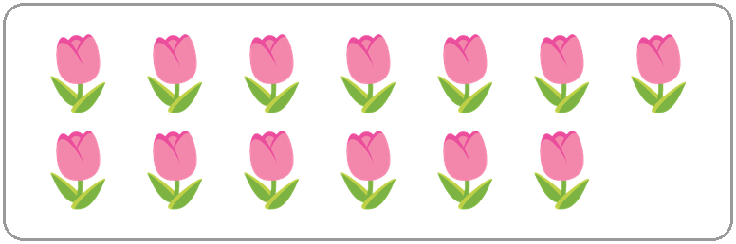
Q4. Count the tulips in the picture. Which of these is true?
(A) There are 13 tulips, and 13 is an odd number.
(B) There are 13 tulips, and 13 is an even number.
(C) There are 12 tulips, and 12 is an even number.
(D) There are 14 tulips, and 14 is an even number.

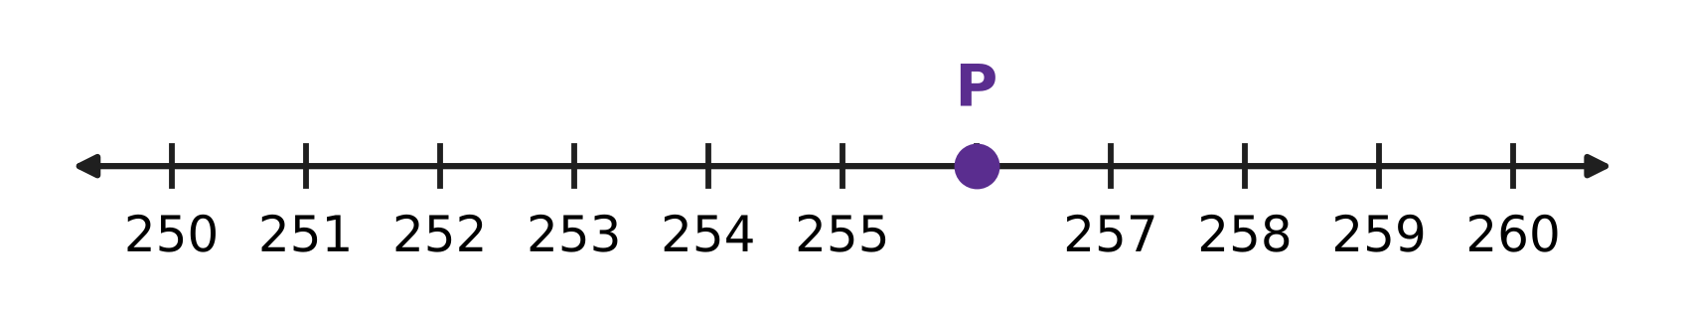
Q5. Look at the number line. The marks go up in ones. Which number is at point P?
(A) 254 | (B) 255 | (C) 256 | (D) 257

Q6. Which of these is true?
(A) 507 > 570 | (B) 507 < 570
(C) 507 = 570 | (D) 570 < 507

Q7. A number has 7 ones, 2 hundreds and 5 tens. Which number is it?
(A) 257 | (B) 275 | (C) 725 | (D) 752

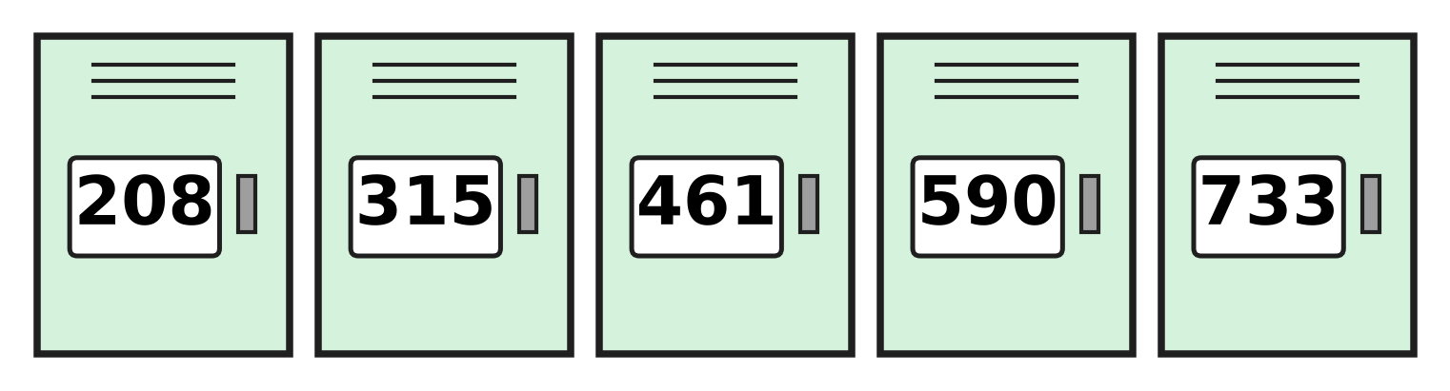
Q8. Look at the five school lockers. How many of them have an odd number?
(A) 1 | (B) 2 | (C) 3 | (D) 5

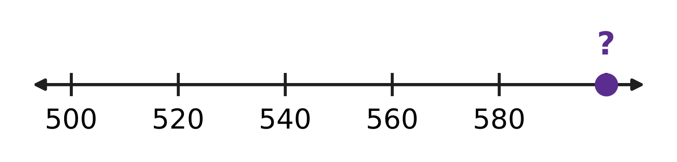
Q9. Look at the number line. The marks go up in equal steps. Which number belongs at the dot with the question mark?
(A) 581 | (B) 590 | (C) 600 | (D) 620

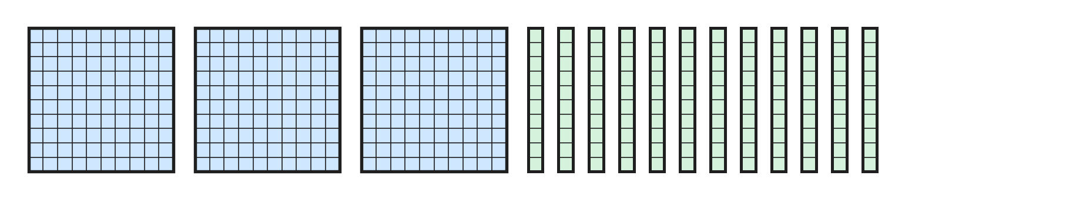
Q10. Mayank has 3 hundred-blocks and 12 ten-rods, as in the picture. Which number do they make?
(A) 312 | (B) 320 | (C) 402 | (D) 420

Part 2 — Operations & Number Properties (Syllabus Chapter 2)
Q11. A beekeeper fills 128 jars of honey in May and 47 jars in June. How many jars does she fill in all?
(A) 81 | (B) 165 | (C) 175 | (D) 598

Q12. A mango tree had 83 mangoes. Some were picked, and now 46 mangoes are left. How many mangoes were picked?
(A) 129 | (B) 43 | (C) 47 | (D) 37

Q13. Which number fills the blank?
6 + 6 + 6 = 3 × ___
(A) 6 | (B) 9 | (C) 3 | (D) 18

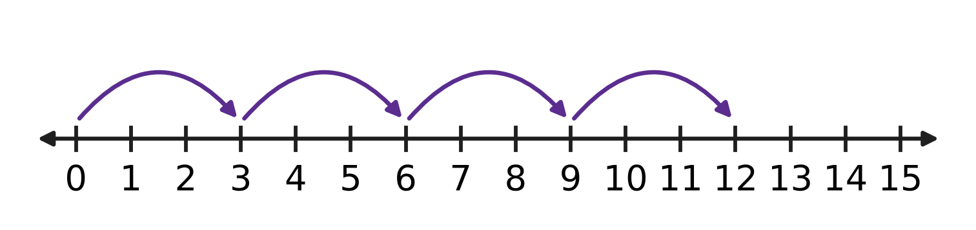
Q14. The hops on the number line start at 0 and are all the same size. Which multiplication fact do the hops show?
(A) 4 × 3 = 12 | (B) 3 × 5 = 15
(C) 4 × 4 = 16 | (D) 3 × 3 = 9

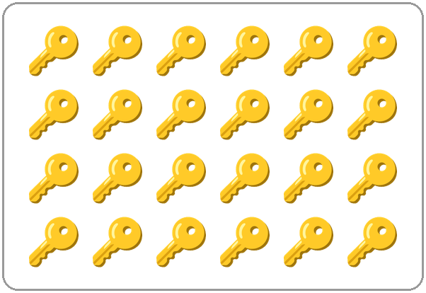
Q15. The picture shows 24 keys. Half of 24 is 12. Which number fills the blank?
A quarter of 24 is ___.
(A) 3 | (B) 4 | (C) 6 | (D) 8

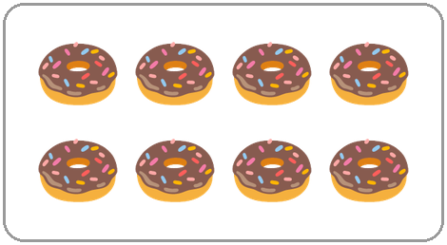
Q16. The picture shows half of the doughnuts that Juhi made. How many doughnuts did she make in all?
(A) 4 | (B) 8 | (C) 10 | (D) 16

Q17. To work out 52 − 37, Lalit first changes 52 into 4 tens and ___ ones. Which number fills the blank?
(A) 2 | (B) 3 | (C) 10 | (D) 12

Q18. In a school canteen, 8 children sit at each of the 3 tables. Another 7 children stand in a line. How many children are there in all?
(A) 31 | (B) 18 | (C) 17 | (D) 24

Q19. Which number fills the blank?
47 + ___ = 80
(A) 23 | (B) 33 | (C) 43 | (D) 127

Q20. A grain store has 457 sacks of rice and 268 sacks of wheat. How many sacks does it have in all?
(A) 615 | (B) 625 | (C) 715 | (D) 725

Part 3 — Geometry (Syllabus Chapter 5)
Q21. Which number fills the blank?
A closed flat shape with 3 straight sides has ___ corners.
(A) 0 | (B) 3 | (C) 4 | (D) 6

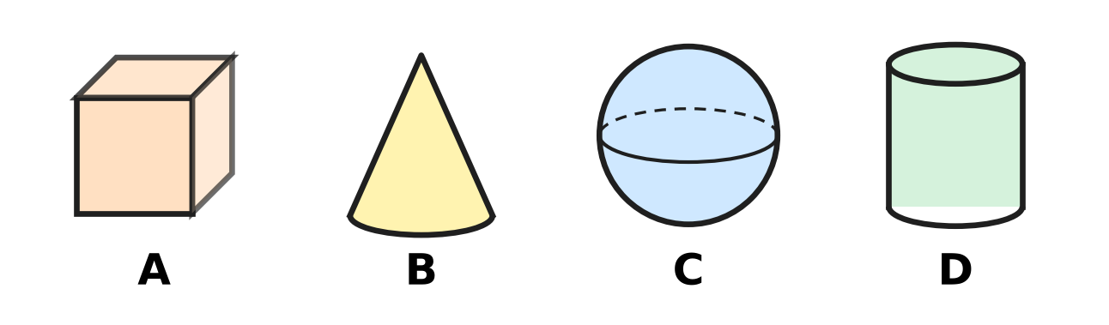
Q22. Which picture shows a solid with a pointed top?
(A) Picture A | (B) Picture B
(C) Picture C | (D) Picture D

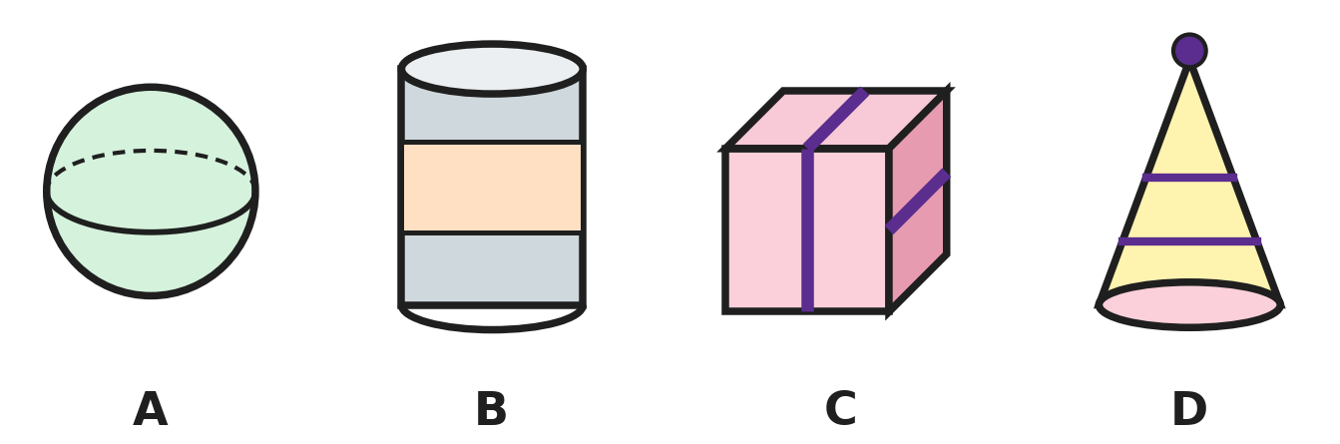
Q23. Which picture shows a thing shaped like a cube?
(A) Picture A | (B) Picture B
(C) Picture C | (D) Picture D

Q24. Which list puts the shapes in order of their corners, from the smallest number of corners to the biggest?
(A) square, triangle, circle | (B) circle, square, triangle
(C) triangle, circle, square | (D) circle, triangle, square

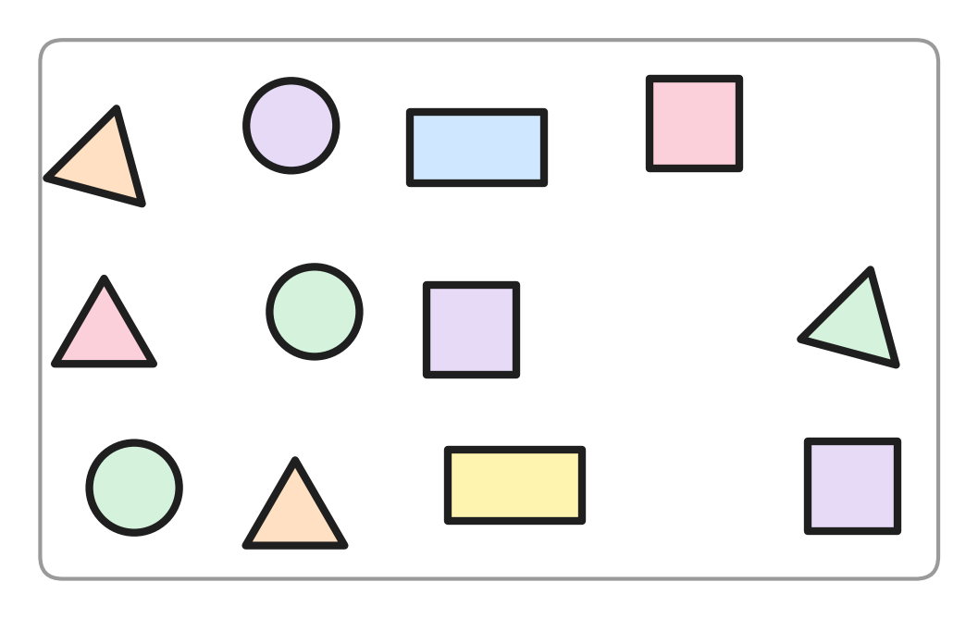
Q25. Hemant has the paper shapes in the picture. He keeps only the shapes that have exactly 4 corners. How many shapes does he keep?
(A) 3 | (B) 4 | (C) 5 | (D) 9

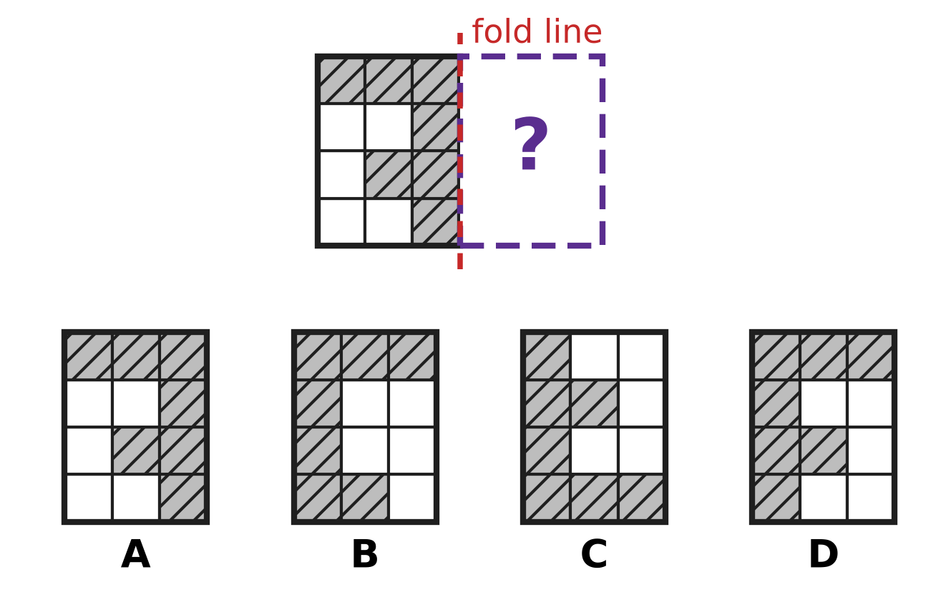
Q26. The design must be the same on both sides of the fold line. Which picture shows the missing right half?
(A) Picture A | (B) Picture B
(C) Picture C | (D) Picture D

Q27. Payal's piggy bank is a cylinder. She stands it up on one flat end and pushes it gently, without tipping it over. What does it do?
(A) It slides. | (B) It rolls straight ahead.
(C) It rolls round in a circle. | (D) It cannot move at all.

Part 4 — Applied Mathematics (Syllabus Chapter 9)
Q28. Vidya eats breakfast at 8 ___ and goes to bed at 9 ___. Which pair fills the two blanks, in order?
(A) PM, AM | (B) PM, PM | (C) AM, AM | (D) AM, PM

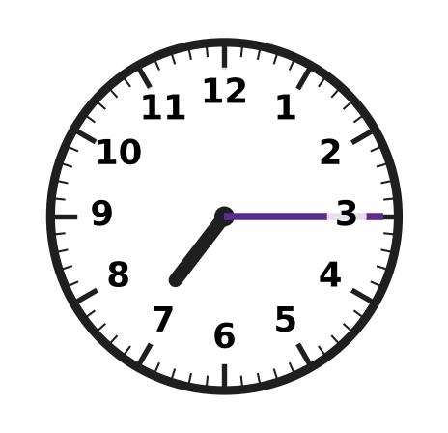
Q29. Look at the clock. Which number fills the blank?
The clock shows quarter past ___.
(A) 3 | (B) 7 | (C) 8 | (D) 15

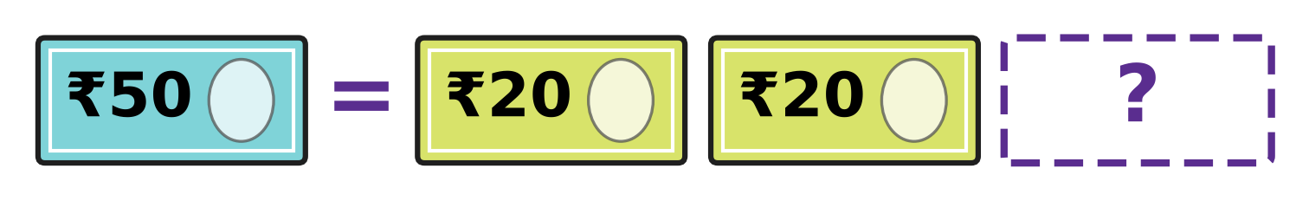
Q30. One ₹50 note has the same value as the three notes on the right in the picture. Which note is hidden?
(A) ₹10 | (B) ₹20 | (C) ₹50 | (D) ₹100

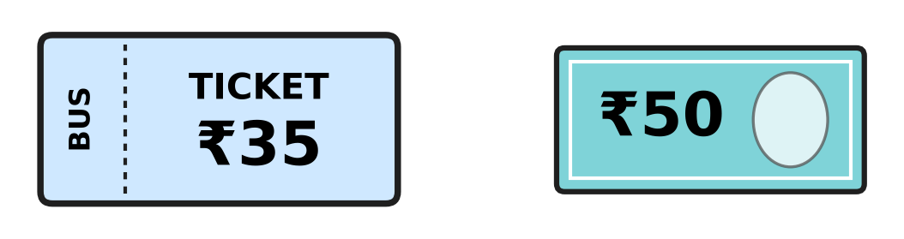
Q31. Ankit buys the bus ticket in the picture. He pays with the ₹50 note. How much change does he get?
(A) ₹5 | (B) ₹15 | (C) ₹25 | (D) ₹85

School canteen price list
Thing | Price
Sandwich | ₹30
Soup | ₹20
Juice | ₹15
Banana | ₹5

Q32. Use the table. How much more do a sandwich and a soup cost together than a juice and a banana together?
(A) ₹20 | (B) ₹30 | (C) ₹50 | (D) ₹70

Q33. A post office letter box is emptied at 7 AM, 11 AM, ___ and 6 PM, in this order, on one day. Which time fills the blank?
(A) 10 AM | (B) 3 AM | (C) 3 PM | (D) 8 PM

Q34. The last bus from the museum leaves at 6:45. Where are the hands of a clock at that time?
(A) Long hand on 9, short hand nearly at 6
(B) Long hand on 7, short hand on 9
(C) Long hand on 9, short hand nearly at 7
(D) Long hand on 3, short hand just after 6

Part 5 — Mathematical Reasoning & Problem-Solving (Syllabus Chapter 10)
Q35. A number pattern starts at 40. Each number is 4 less than the one before. What is the 4th number in the pattern?
(A) 24 | (B) 28 | (C) 32 | (D) 52

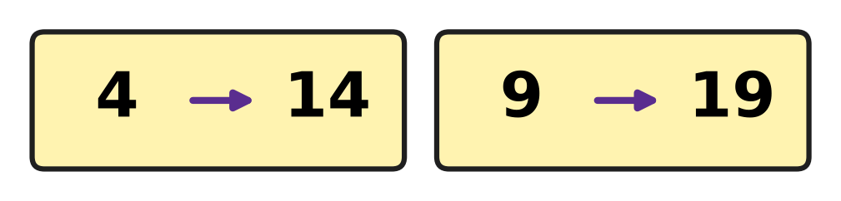
Q36. Both cards in the picture follow one rule. What does the rule do to a number?
(A) doubles the number | (B) adds 1
(C) adds 5 | (D) adds 10

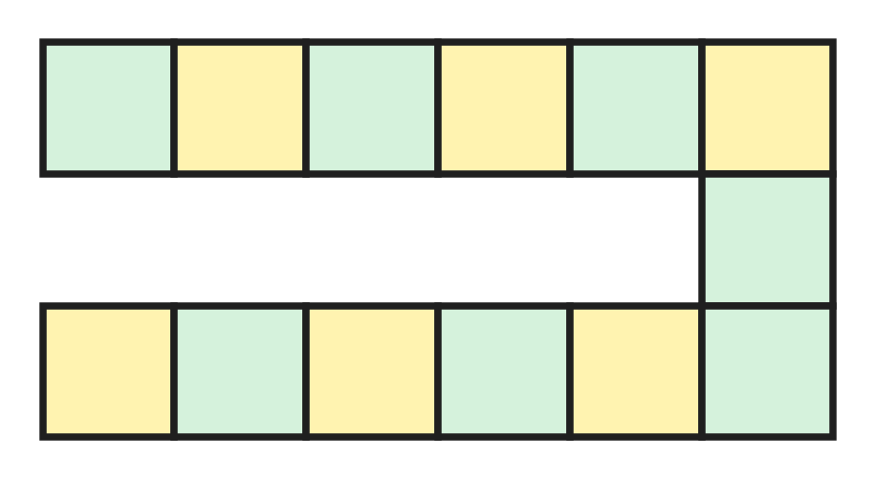
Q37. The picture shows the track of a board game. How many squares does the track have?
(A) 12 | (B) 13 | (C) 14 | (D) 18

Q38. Sakshi starts at 150 and counts on in jumps of 50. How many jumps does she need to reach 400?
(A) 3 | (B) 5 | (C) 6 | (D) 8

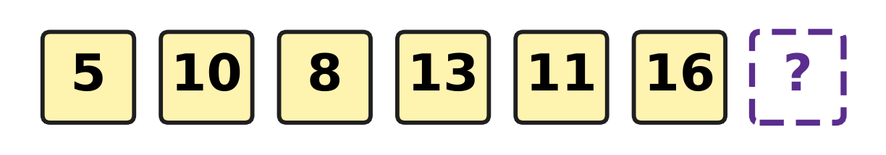
Q39. The numbers go up, then down, then up, then down. Every up jump is the same, and every down jump is the same. Which number goes in the box?
(A) 14 | (B) 18 | (C) 19 | (D) 21

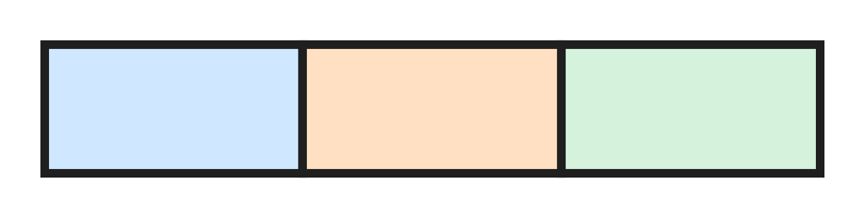
Q40. A long rectangle is divided into 3 boxes by 2 lines, as in the picture. How many rectangles can you find in all? Count big and small ones.
(A) 3 | (B) 4 | (C) 5 | (D) 6

SECTION II — Star Questions 5 questions × 4 marks each
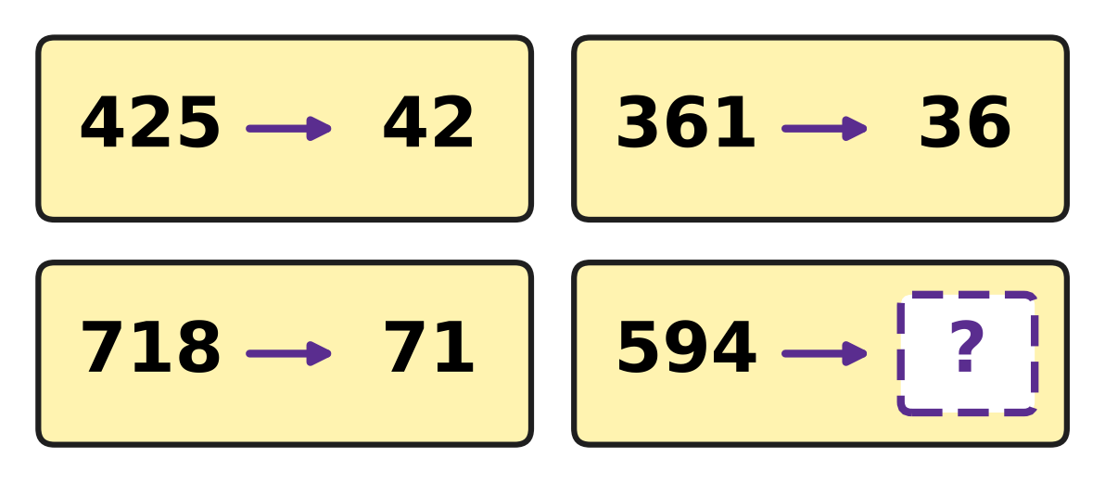
Q41. A rule about hundreds, tens and ones is used on every card in the picture. Which number goes in the box? [4 marks]
(A) 59 | (B) 60 | (C) 90 | (D) 94

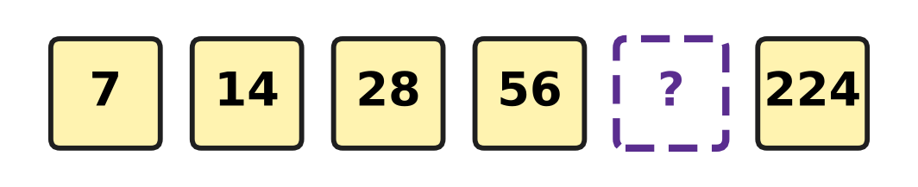
Q42. Every number in the picture is made from the number before it by the same rule. Which number is hidden? [4 marks]
(A) 63 | (B) 84 | (C) 112 | (D) 140

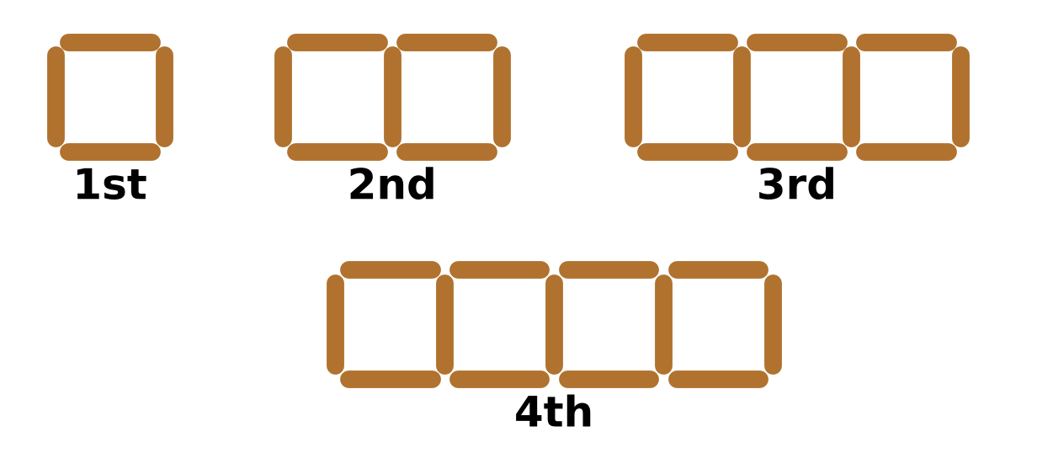
Q43. Daksh makes rows of squares with sticks, as in the picture. Squares side by side share a stick. How many sticks does the 6th shape need? [4 marks]
(A) 16 | (B) 18 | (C) 19 | (D) 24

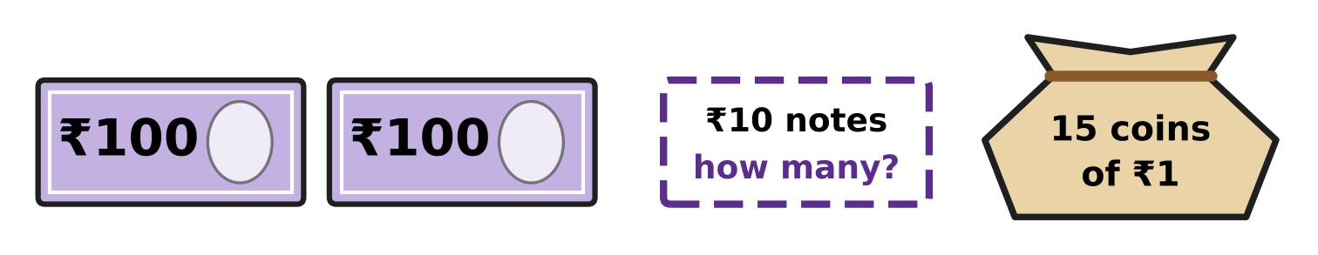
Q44. Vikram has ₹275 in his piggy bank: 2 notes of ₹100, 15 coins of ₹1, and the rest in ₹10 notes. How many ₹10 notes does he have? [4 marks]
(A) 5 | (B) 6 | (C) 7 | (D) 60

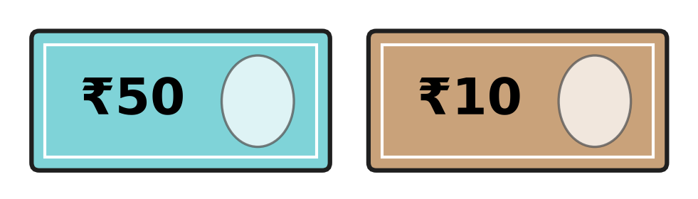
Q45. Ella has only ₹50 and ₹10 notes, like those in the picture. Her notes have 20 corners in all, and together they make ₹130. How many ₹50 notes does she have? [4 marks]
(A) 1 | (B) 2 | (C) 3 | (D) 5

Answer Sheet AMO Level 1 · Class 2 · Practice Paper 3
Name: | School: | Roll No.:
Shade or tick one circle for each question.
1. Ⓐ Ⓑ Ⓒ Ⓓ | 16. Ⓐ Ⓑ Ⓒ Ⓓ | 31. Ⓐ Ⓑ Ⓒ Ⓓ
2. Ⓐ Ⓑ Ⓒ Ⓓ | 17. Ⓐ Ⓑ Ⓒ Ⓓ | 32. Ⓐ Ⓑ Ⓒ Ⓓ
3. Ⓐ Ⓑ Ⓒ Ⓓ | 18. Ⓐ Ⓑ Ⓒ Ⓓ | 33. Ⓐ Ⓑ Ⓒ Ⓓ
4. Ⓐ Ⓑ Ⓒ Ⓓ | 19. Ⓐ Ⓑ Ⓒ Ⓓ | 34. Ⓐ Ⓑ Ⓒ Ⓓ
5. Ⓐ Ⓑ Ⓒ Ⓓ | 20. Ⓐ Ⓑ Ⓒ Ⓓ | 35. Ⓐ Ⓑ Ⓒ Ⓓ
6. Ⓐ Ⓑ Ⓒ Ⓓ | 21. Ⓐ Ⓑ Ⓒ Ⓓ | 36. Ⓐ Ⓑ Ⓒ Ⓓ
7. Ⓐ Ⓑ Ⓒ Ⓓ | 22. Ⓐ Ⓑ Ⓒ Ⓓ | 37. Ⓐ Ⓑ Ⓒ Ⓓ
8. Ⓐ Ⓑ Ⓒ Ⓓ | 23. Ⓐ Ⓑ Ⓒ Ⓓ | 38. Ⓐ Ⓑ Ⓒ Ⓓ
9. Ⓐ Ⓑ Ⓒ Ⓓ | 24. Ⓐ Ⓑ Ⓒ Ⓓ | 39. Ⓐ Ⓑ Ⓒ Ⓓ
10. Ⓐ Ⓑ Ⓒ Ⓓ | 25. Ⓐ Ⓑ Ⓒ Ⓓ | 40. Ⓐ Ⓑ Ⓒ Ⓓ
11. Ⓐ Ⓑ Ⓒ Ⓓ | 26. Ⓐ Ⓑ Ⓒ Ⓓ | 41. Ⓐ Ⓑ Ⓒ Ⓓ
12. Ⓐ Ⓑ Ⓒ Ⓓ | 27. Ⓐ Ⓑ Ⓒ Ⓓ | 42. Ⓐ Ⓑ Ⓒ Ⓓ
13. Ⓐ Ⓑ Ⓒ Ⓓ | 28. Ⓐ Ⓑ Ⓒ Ⓓ | 43. Ⓐ Ⓑ Ⓒ Ⓓ
14. Ⓐ Ⓑ Ⓒ Ⓓ | 29. Ⓐ Ⓑ Ⓒ Ⓓ | 44. Ⓐ Ⓑ Ⓒ Ⓓ
15. Ⓐ Ⓑ Ⓒ Ⓓ | 30. Ⓐ Ⓑ Ⓒ Ⓓ | 45. Ⓐ Ⓑ Ⓒ Ⓓ
Q41–Q45 are Section II Star Questions (4 marks each).
For the parent or teacher
Section I correct: ______ / 40 × 2 = ______ marks Section II correct: ______ / 5 × 4 = ______ marks
Correct: ______ / 45 Score: ______ / 100
Answer Key and Solutions AMO Level 1 · Class 2 · Practice Paper 3
Quick answers
1 B | 6 B | 11 C | 16 D | 21 B | 26 D | 31 B | 36 D | 41 A
2 A | 7 A | 12 D | 17 D | 22 B | 27 A | 32 B | 37 B | 42 C
3 D | 8 C | 13 A | 18 A | 23 C | 28 D | 33 C | 38 B | 43 C
4 A | 9 C | 14 A | 19 B | 24 D | 29 B | 34 C | 39 A | 44 B
5 C | 10 D | 15 C | 20 D | 25 C | 30 A | 35 B | 40 D | 45 B
Solutions
Q | Part · level | Answer | Why?
1 | Part 1 · Ch1 · Easy | (B) 40 | The number 643 is 6 hundreds, 4 tens and 3 ones. The 4 tens stand for 40, so 600 + 40 + 3 = 643.
2 | Part 1 · Ch1 · Easy | (A) fourteen | The number 714 is 7 hundreds and 14 more. We say 14 as fourteen, so 714 is seven hundred fourteen.
3 | Part 1 · Ch1 · Easy | (D) 524 | Taking away 100 makes the hundreds digit 1 less. 624 has 6 hundreds, so the answer has 5 hundreds: 524.
4 | Part 1 · Ch1 · Easy | (A) | There are 13 tulips. Put them in twos: 6 twos and 1 left over, so 13 is odd.
5 | Part 1 · Ch1 · Easy | (C) 256 | The mark before P is 255 and the mark after P is 257. The number between them is 256, so point P is at 256.
6 | Part 1 · Ch1 · Easy | (B) 507 < 570 | Both numbers have 5 hundreds. But 507 has 0 tens and 570 has 7 tens, so 507 is smaller: 507 < 570.
7 | Part 1 · Ch1 · Medium | (A) 257 | Hundreds come first, then tens, then ones: 2 hundreds, 5 tens, 7 ones make 257.
8 | Part 1 · Ch1 · Medium | (C) 3 | A number is odd when its ones digit is 1, 3, 5, 7 or 9. The odd numbers are 315, 461 and 733, so there are 3.
9 | Part 1 · Ch1 · Medium | (C) 600 | Each mark is 20 more than the one before: 500, 520, 540, 560, 580. One more step after 580 is 600.
10 | Part 1 · Ch1 · Medium | (D) 420 | The first 10 ten-rods make 1 more hundred, so there are 4 hundreds and 2 tens. That is 420.
11 | Part 2 · Ch2 · Easy | (C) 175 | Ones: 8 + 7 = 15, write 5 and carry 1. Tens: 2 + 4 + 1 = 7. Hundreds: 1. The total is 175.
12 | Part 2 · Ch2 · Easy | (D) 37 | The picked mangoes are 83 − 46. Change 83 into 7 tens and 13 ones. Ones: 13 − 6 = 7. Tens: 7 − 4 = 3. So 37 mangoes were picked.
13 | Part 2 · Ch2 · Easy | (A) 6 | The number 6 is added 3 times, so the sum is 3 groups of 6: 3 × 6. The blank is 6.
14 | Part 2 · Ch2 · Easy | (A) 4 × 3 = 12 | There are 4 hops, each 3 steps long, and the last hop lands on 12. So the multiplication fact is 4 × 3 = 12.
15 | Part 2 · Ch2 · Easy | (C) 6 | A quarter is half of a half. Half of 24 is 12, and half of 12 is 6.
16 | Part 2 · Ch2 · Easy | (D) 16 | Two equal halves make the whole, and 8 + 8 = 16. So she made 16 doughnuts.
17 | Part 2 · Ch2 · Medium | (D) 12 | One ten is changed into 10 ones. Then 10 ones and 2 ones make 12 ones, so 52 is 4 tens and 12 ones.
18 | Part 2 · Ch2 · Medium | (A) 31 | There are 3 tables of 8, so 3 × 8 = 24 children sit. With 7 more, there are 24 + 7 = 31.
19 | Part 2 · Ch2 · Medium | (B) 33 | Count up from 47: 3 more makes 50, and 30 more makes 80. So the blank is 3 + 30 = 33.
20 | Part 2 · Ch2 · Medium | (D) 725 | Ones: 7 + 8 = 15, write 5 and carry 1. Tens: 5 + 6 + 1 = 12, write 2 and carry 1. Hundreds: 4 + 2 + 1 = 7. The total is 725.
21 | Part 3 · Ch5 · Easy | (B) 3 | A closed shape with 3 straight sides is a triangle. Each pair of sides meets at a corner, so it has 3 corners.
22 | Part 3 · Ch5 · Easy | (B) Picture B | Picture B is a cone. It has a flat circle at the bottom, a curved side and a point at the top.
23 | Part 3 · Ch5 · Easy | (C) Picture C | A cube is a box shape with flat square faces, like a die. The gift box in Picture C is shaped like a cube.
24 | Part 3 · Ch5 · Easy | (D) | A circle has 0 corners, a triangle has 3 and a square has 4. So the order is circle, triangle, square.
25 | Part 3 · Ch5 · Medium | (C) 5 | Squares and rectangles have 4 corners. There are 3 squares and 2 rectangles, so he keeps 3 + 2 = 5 shapes.
26 | Part 3 · Ch5 · Medium | (D) Picture D | Each shaded box on the left must have a partner the same distance from the fold line, in the same row. Only Picture D matches row by row.
27 | Part 3 · Ch5 · Medium | (A) It slides. | Standing on a flat end, the piggy bank rests on a flat part, so it slides. It rolls only when it lies on its curved side.
28 | Part 4 · Ch9 · Easy | (D) AM, PM | Breakfast is in the morning, before noon, so it is 8 AM. Bedtime is at night, after noon, so it is 9 PM.
29 | Part 4 · Ch9 · Easy | (B) 7 | The long hand on 3 means quarter past. The short hand has just passed 7, so the time is quarter past 7.
30 | Part 4 · Ch9 · Easy | (A) ₹10 | ₹20 + ₹20 = ₹40. From ₹40 to ₹50 is ₹10, so the hidden note is a ₹10 note.
31 | Part 4 · Ch9 · Easy | (B) ₹15 | Count up from ₹35: ₹5 more makes ₹40 and ₹10 more makes ₹50. The change is ₹15.
32 | Part 4 · Ch9 · Medium | (B) ₹30 | A sandwich and a soup cost ₹30 + ₹20 = ₹50. A juice and a banana cost ₹15 + ₹5 = ₹20. So they cost ₹50 − ₹20 = ₹30 more.
33 | Part 4 · Ch9 · Medium | (C) 3 PM | The blank must come after 11 AM and before 6 PM. Only 3 PM is after 11 AM and before 6 PM.
34 | Part 4 · Ch9 · Medium | (C) | The time 6:45 is 45 minutes past 6, which is quarter to 7. The long hand points at 9 and the short hand is nearly at 7.
35 | Part 5 · Ch10 · Easy | (B) 28 | The pattern is 40, 36, 32, 28. The 4th number is 28.
36 | Part 5 · Ch10 · Easy | (D) adds 10 | On the cards, 4 + 10 = 14 and 9 + 10 = 19. The rule adds 10 each time.
37 | Part 5 · Ch10 · Easy | (B) 13 | The top row has 6 squares, the bottom row has 6 squares, and 1 square joins them. So there are 6 + 6 + 1 = 13.
38 | Part 5 · Ch10 · Easy | (B) 5 | Count on from 150: 200, 250, 300, 350, 400. That is 5 jumps.
39 | Part 5 · Ch10 · Medium | (A) 14 | The jumps are up 5, down 2, up 5, down 2, up 5. The next jump is down 2, and 16 − 2 = 14.
40 | Part 5 · Ch10 · Medium | (D) 6 | There are 3 small boxes, 2 rectangles made of 2 boxes side by side, and 1 big rectangle made of all 3. So there are 3 + 2 + 1 = 6.
41 | Section II · Ch1 + Ch10 · Hard | (A) 59 | Each card drops the ones digit: 425 gives 42, 361 gives 36 and 718 gives 71 (the number of tens in all). So 594 gives 59, because 594 is 59 tens and 4 ones.
42 | Section II · Ch2 + Ch10 · Hard | (C) 112 | Each number is double the one before: 7 + 7 = 14, 14 + 14 = 28 and 28 + 28 = 56. So the hidden number is 56 + 56 = 112, and 112 + 112 = 224 fits.
43 | Section II · Ch5 + Ch10 · Hard | (C) 19 | The shapes need 4, 7, 10 and 13 sticks. Each new square needs only 3 more sticks, because it shares one side. So the 5th needs 16 and the 6th needs 19.
44 | Section II · Ch1 + Ch9 · Hard | (B) 6 | The ₹100 notes make ₹200 and the coins make ₹15, which is ₹215. That leaves ₹275 − ₹215 = ₹60, and ₹60 is 6 notes of ₹10.
45 | Section II · Ch5 + Ch9 · Hard | (B) 2 | Each note has 4 corners, so 20 corners means 5 notes. Then 2 notes of ₹50 and 3 notes of ₹10 are 5 notes and make ₹100 + ₹30 = ₹130.

