UNLOCK IQ INSTITUTE
Realize Your True Potential
Aryabhatta Maths Olympiad (AMO)
Level 1 — Practice Paper 4
CLASS 2

Questions | 45 multiple-choice questions
Marks | 100
Time | 60 minutes
Section I | 40 questions × 2 marks = 80 marks
Section II | 5 Star Questions × 4 marks = 20 marks
Negative marking | No negative marking
Calculator | Not allowed
Chapters | Number System · Operations · Geometry · Applied Mathematics · Mathematical Reasoning

Hello, friend!
• Every question has four answer choices: (A), (B), (C) and (D). Only one is correct.
• Read each question and look at its picture carefully. Then mark your answer on the answer sheet at the end.
• Section I has 40 questions of 2 marks each. Section II has 5 Star Questions of 4 marks each.
• There is no negative marking, so try every question.
• Do not use a calculator. You may do rough work on a separate sheet.
• All figures are not necessarily drawn to scale unless stated.

For parents and teachers
Print or view this paper in colour. Pictures are part of the questions.
You may read a question aloud to the child, exactly as printed. Please do not explain it or point to an answer choice.
Parts follow the AMO syllabus chapters. Chapters 3, 4, 6, 7 and 8 are not part of the Class 2 syllabus, so the chapter numbers shown in the Part headings have gaps.
The answer sheet and the answer key are at the end. Remove only the answer key before the child begins.

Name: | School: | Roll No.:

SECTION I 40 questions × 2 marks each
Part 1 — Number System (Syllabus Chapter 1)
Q1. Which number is the same as 600 + 4?
(A) 610 | (B) 604 | (C) 64 | (D) 640

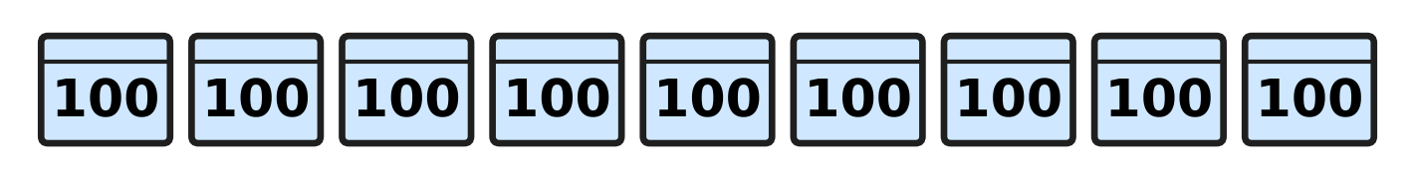
Q2. Look at the picture. Each crate holds 100 bottles. A dairy van takes away 4 full crates. How many bottles are left?
(A) 500 | (B) 600 | (C) 400 | (D) 896

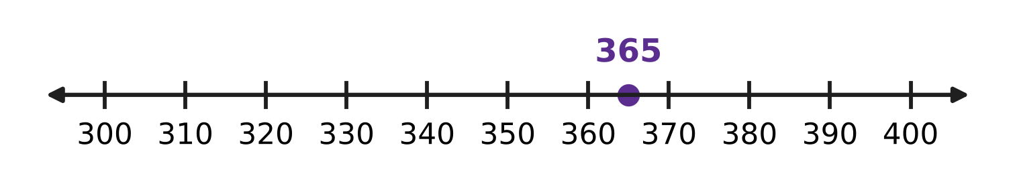
Q3. Look at the number line. The dot shows 365. Which of these numbers is to the left of the dot?
(A) 399 | (B) 356 | (C) 370 | (D) 563

Q4. Which of these numbers is odd and also between 430 and 440?
(A) 433 | (B) 436 | (C) 429 | (D) 443

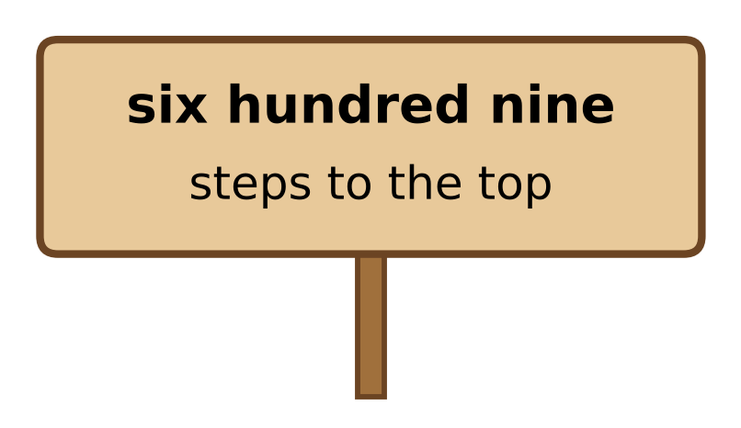
Q5. Look at the sign on a mountain path. Which number shows how many steps are left to the top?
(A) 69 | (B) 609 | (C) 690 | (D) 960

Q6. One bookshop sells 415 books in a week. A second bookshop sells more than that, but fewer than 430. How many books could the second bookshop sell?
(A) 409 | (B) 431 | (C) 427 | (D) 415

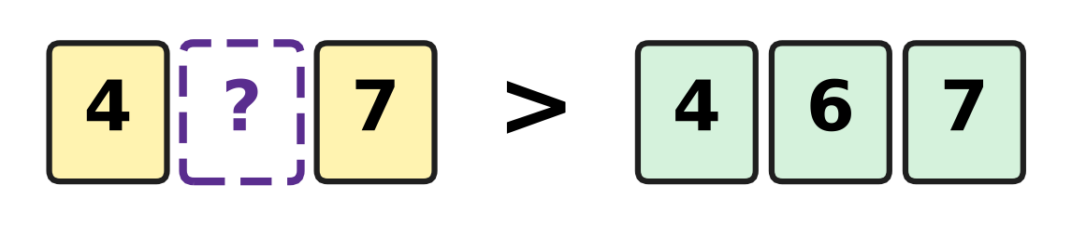
Q7. Look at the number cards. Which digit can go on the blank card to make this true?
(A) 6 | (B) 7 | (C) 3 | (D) 5

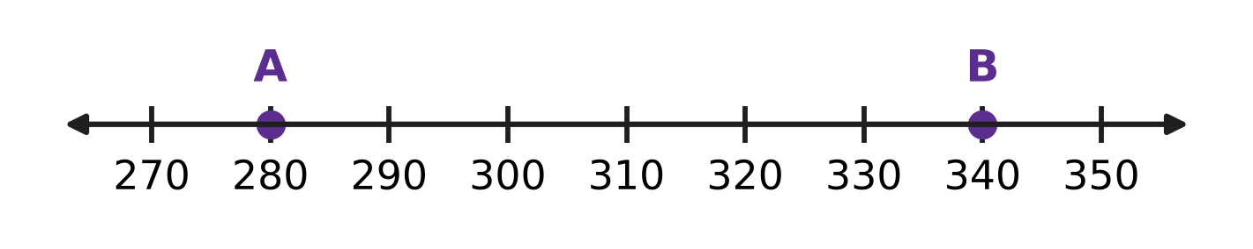
Q8. Look at the number line. How many jumps of 10 are needed to go from A to B?
(A) 6 | (B) 60 | (C) 7 | (D) 5

Q9. A shop has 370 eggs. Each tray holds 10 eggs. How many full trays of 10 eggs can the shop make?
(A) 7 | (B) 30 | (C) 37 | (D) 3

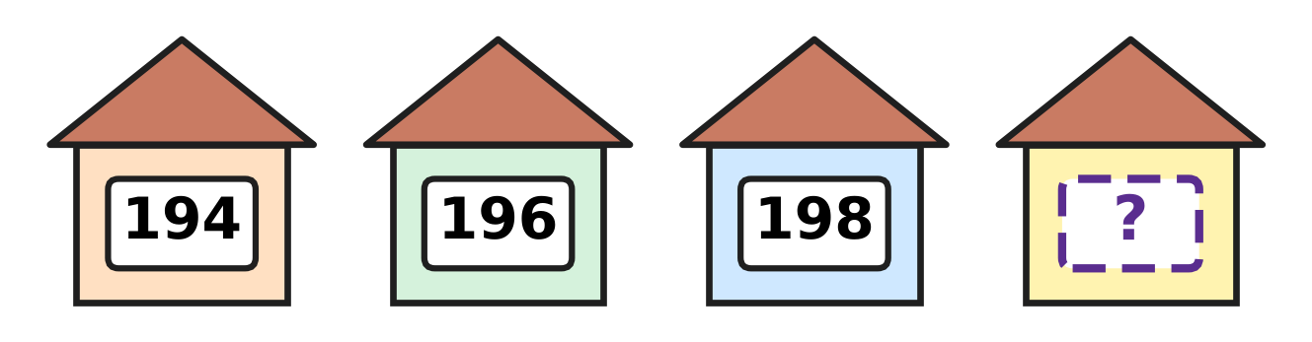
Q10. Look at the houses on one side of a street. Their numbers are even numbers in order. Which number is on the last house?
(A) 202 | (B) 199 | (C) 208 | (D) 200

Part 2 — Operations & Number Properties (Syllabus Chapter 2)
Q11. A zoo had 237 visitors in the morning and 145 visitors in the afternoon. How many visitors came in all?
(A) 372 | (B) 92 | (C) 382 | (D) 482

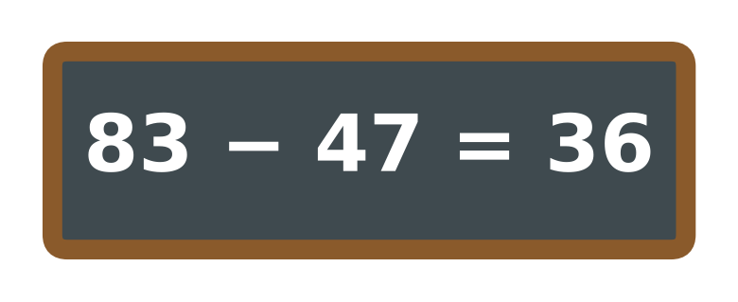
Q12. Look at the slate. Rima wants to check her answer by adding. Which sum should give 83 if she is right?
(A) 83 + 47 | (B) 36 + 47 | (C) 83 + 36 | (D) 47 + 47

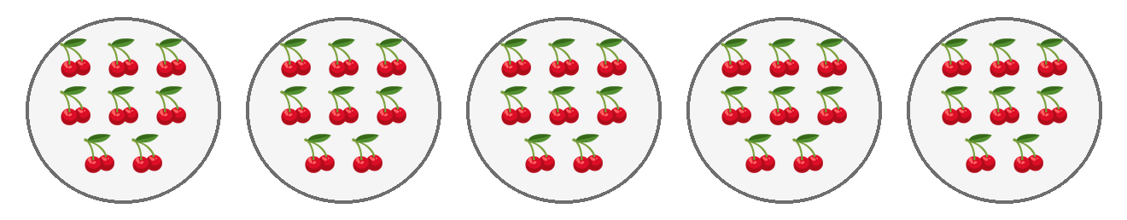
Q13. Look at the picture. Each plate has 8 bunches of cherries. There are 40 bunches in all. One more plate of 8 bunches is added. How many bunches are there now?
(A) 48 | (B) 41 | (C) 46 | (D) 56

Q14. Each umbrella stand holds 7 umbrellas. How many umbrellas do 5 full stands hold?
(A) 12 | (B) 30 | (C) 42 | (D) 35

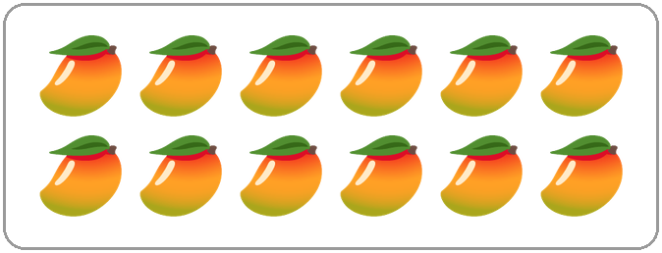
Q15. Look at the mangoes. Sonal shares them equally among 4 friends. Which of these tells how many mangoes each friend gets?
(A) 12 ÷ 4 | (B) 12 × 4 | (C) 12 − 4 | (D) 12 + 4

Q16. A recipe for 2 people needs 16 spoons of flour. How many spoons of flour are needed for 1 person?
(A) 4 | (B) 32 | (C) 8 | (D) 14

Q17. An assembly hall has 125 children. Then 48 children go back to class. After that, 36 other children come in. How many children are in the hall now?
(A) 77 | (B) 41 | (C) 161 | (D) 113

Q18. Sanjay thinks of a number. He adds 135 to it and gets 412. What is his number?
(A) 287 | (B) 277 | (C) 323 | (D) 547

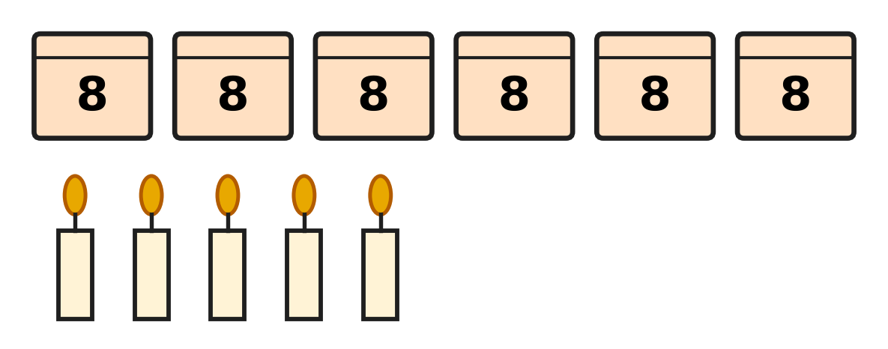
Q19. Look at the picture. Each closed box holds 8 candles. There are also some loose candles. How many candles are there in all?
(A) 13 | (B) 48 | (C) 53 | (D) 19

Q20. Kiara has 48 sweets. She keeps half of them. She shares the other half equally among 4 friends. How many sweets does each friend get?
(A) 24 | (B) 6 | (C) 20 | (D) 12

Part 3 — Geometry (Syllabus Chapter 5)
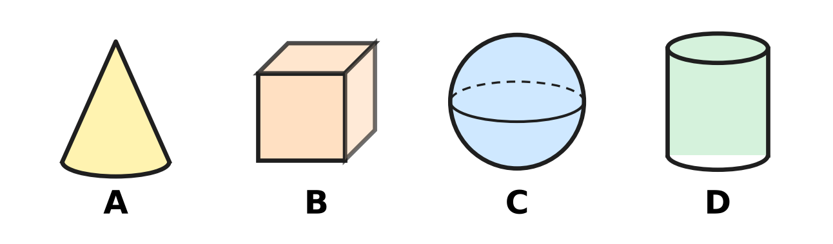
Q21. In a kitchen, dough is rolled flat with a rolling pin. Look at the four solids. Which solid has the same shape as a rolling pin?
(A) Picture A | (B) Picture B
(C) Picture C | (D) Picture D

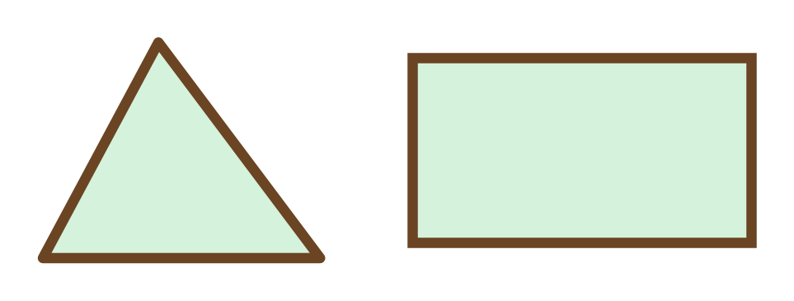
Q22. Look at the two flower beds. How many more corners does the rectangle bed have than the triangle bed?
(A) 1 | (B) 3 | (C) 4 | (D) 7

Q23. Manu joins straight sticks end to end to make a closed flat shape. What is the smallest number of sticks he needs?
(A) 4 | (B) 1 | (C) 2 | (D) 3

Q24. A cube can slide, but it cannot roll. What is the reason?
(A) It is round all over. | (B) It has only flat parts.
(C) It has a point at the top. | (D) It has a curved part.

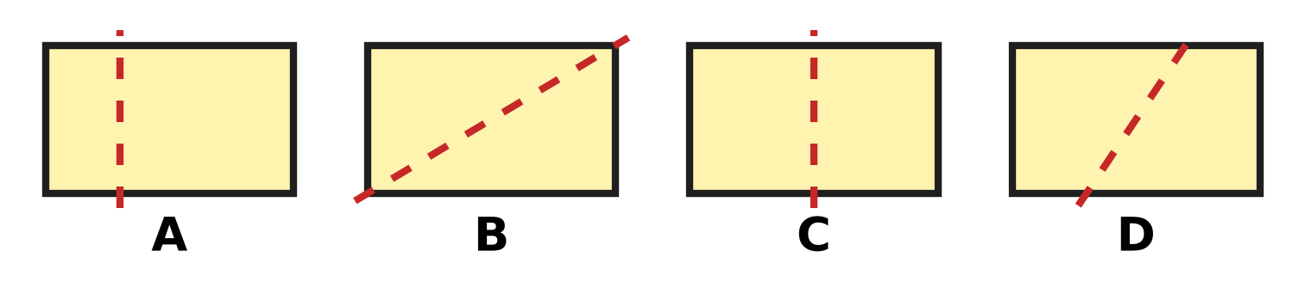
Q25. The same rectangle card is drawn four times. Along which dotted line can it be folded so that the two parts match exactly?
(A) Picture A | (B) Picture B
(C) Picture C | (D) Picture D

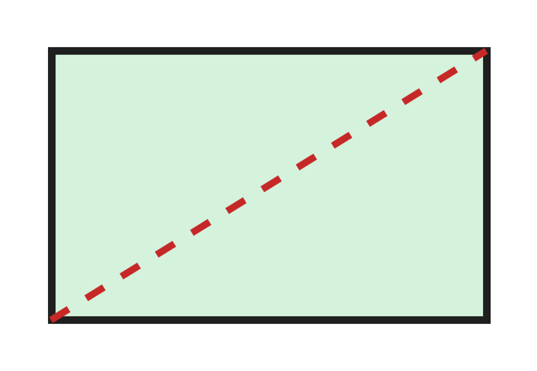
Q26. Look at the rectangle card. Ojas cuts it along the dotted line into two pieces. Which shapes are the two pieces?
(A) two triangles | (B) two squares
(C) two rectangles | (D) a triangle and a rectangle

Solid | Can it roll? | Can it slide?
Cube | No | Yes
Sphere | Yes | No
Cylinder | Yes | Yes
Cone | No | Yes

Q27. Use the table. Vinay tests four solids and writes down what he finds. One row has a mistake. Which row is it?
(A) the cylinder row | (B) the cube row
(C) the cone row | (D) the sphere row

Part 4 — Applied Mathematics (Syllabus Chapter 9)
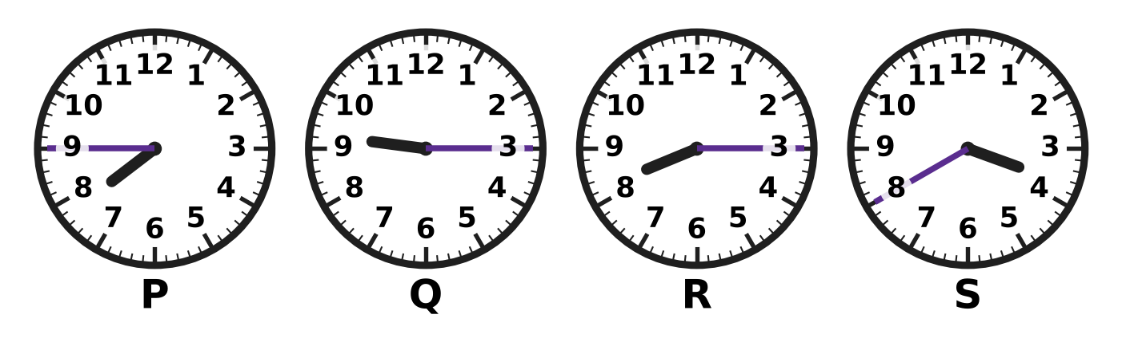
Q28. Look at the four clocks. Which clock shows 8:15?
(A) Clock P | (B) Clock Q | (C) Clock R | (D) Clock S

Q29. A night lamp is switched on at 9 PM. It is switched off at 5 AM. During which part of the day is the lamp on?
(A) the whole day | (B) the afternoon
(C) the morning | (D) the night

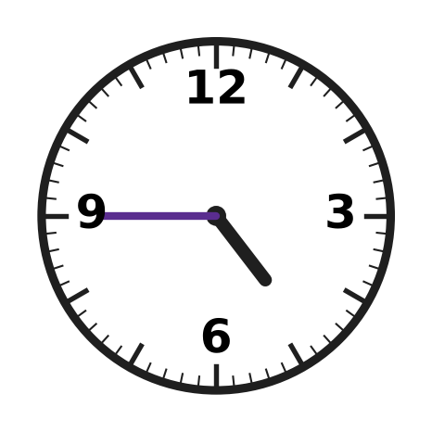
Q30. The clock on the badminton court wall shows only the numbers 12, 3, 6 and 9. Look at the clock. What time does it show?
(A) quarter to 4 | (B) quarter past 9
(C) quarter to 5 | (D) quarter past 4

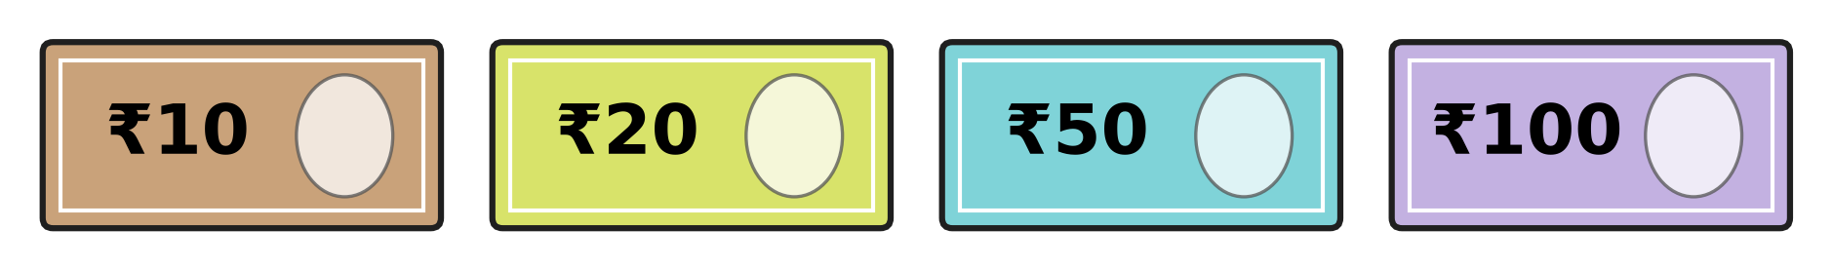
Q31. Look at the four notes. Kriti pays exactly ₹70 with two of them. Which two notes does she use?
(A) ₹50 and ₹10 | (B) ₹20 and ₹10
(C) ₹100 and ₹20 | (D) ₹50 and ₹20

Q32. Zara saves ₹5 every day for 6 days. Then she buys a paint brush for ₹24. How much money does she have left?
(A) ₹30 | (B) ₹6 | (C) ₹11 | (D) ₹19

Q33. A river ferry ticket costs ₹45 for a grown-up and ₹28 for a child. Indu buys one of each with a ₹100 note. What change does she get?
(A) ₹27 | (B) ₹55 | (C) ₹73 | (D) ₹72

Q34. Eggs cost ₹62 and milk costs ₹26. Neel has ₹80. How much more money does he need to buy both?
(A) ₹54 | (B) ₹88 | (C) ₹8 | (D) ₹18

Part 5 — Mathematical Reasoning & Problem-Solving (Syllabus Chapter 10)
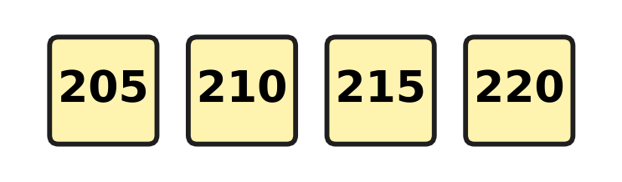
Q35. The stones on a mountain path are numbered in the pattern shown. The pattern goes on. Which of these numbers will also be on a stone?
(A) 242 | (B) 228 | (C) 251 | (D) 235

Day | 1 | 2 | 3 | 4 | 5
Plants sold | 5 | 10 | 20 | 40 | ?

Q36. Use the table. The number of plants sold follows a pattern. How many plants are sold on Day 5?
(A) 60 | (B) 80 | (C) 45 | (D) 50

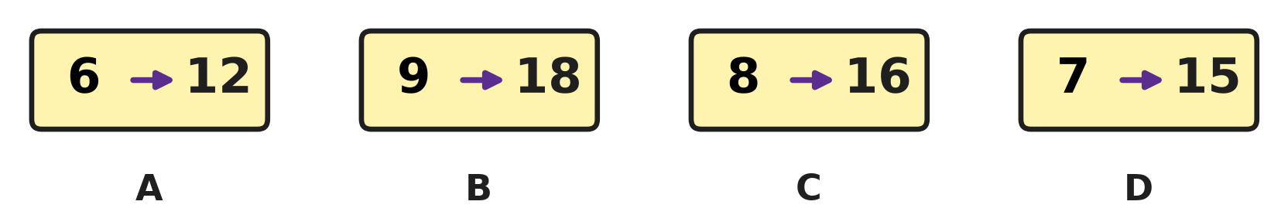
Q37. Look at the picture. On three cards, the second number is made from the first in the same way. Which card does not follow this rule?
(A) Card A | (B) Card B | (C) Card C | (D) Card D

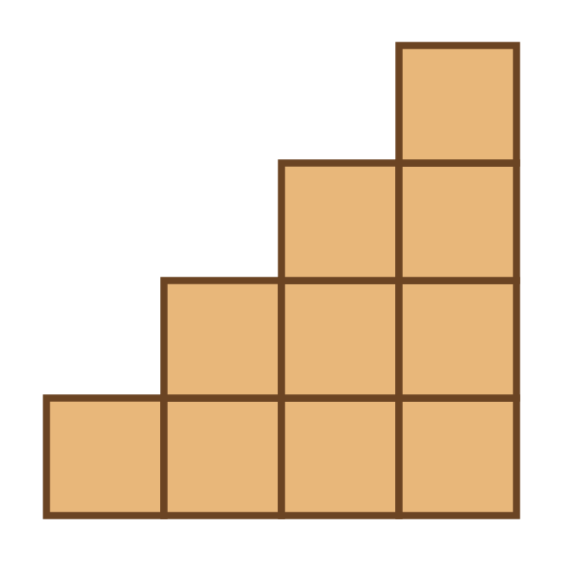
Q38. Ayaan builds stairs with wooden blocks, as in the picture. How many blocks does he use?
(A) 10 | (B) 7 | (C) 4 | (D) 16

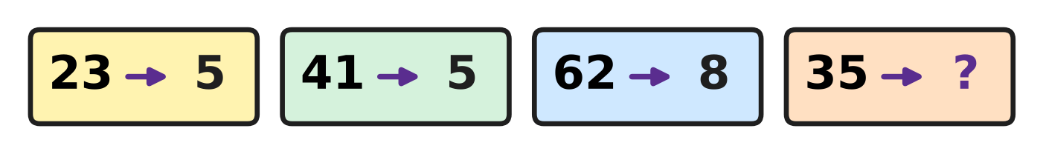
Q39. Look at the cards. One rule turns each number into a smaller number. Which number goes in place of the question mark?
(A) 15 | (B) 2 | (C) 8 | (D) 5

Q40. Four friends meet. Each friend shakes hands with every other friend once. How many handshakes are there in all?
(A) 6 | (B) 8 | (C) 4 | (D) 12

SECTION II — Star Questions 5 questions × 4 marks each
Q41. A rule changes numbers like this: 126 → 621 and 352 → 253. Which of these numbers stays the same when the rule is used? [4 marks]
(A) 544 | (B) 445 | (C) 455 | (D) 454

Q42. Five cows and some ducks have 32 legs in all. A cow has 4 legs and a duck has 2 legs. How many ducks are there? [4 marks]
(A) 3 | (B) 6 | (C) 12 | (D) 27

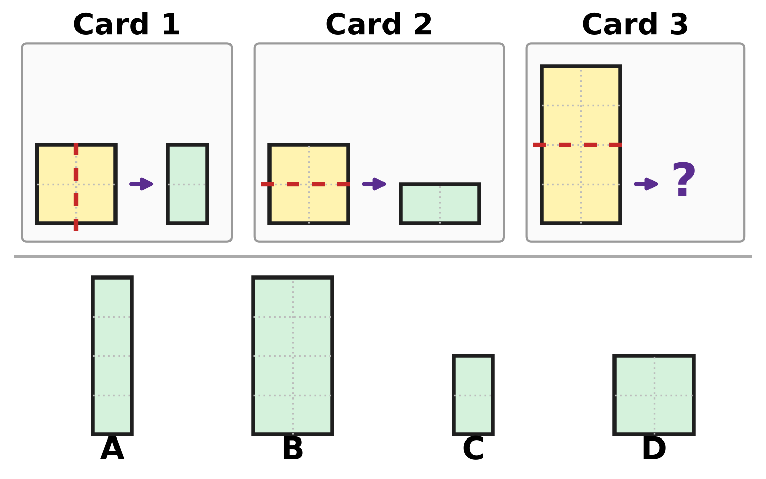
Q43. On Cards 1 and 2, one rule turns the paper on the left into the shape on the right. What does the rule make on Card 3? [4 marks]
(A) Picture A | (B) Picture B
(C) Picture C | (D) Picture D

Cash box | ₹100 notes | ₹10 notes | ₹1 coins
Box A | 3 | 12 | 0
Box B | 4 | 1 | 9
Box C | 2 | 21 | 0
Box D | 4 | 0 | 15

Q44. Use the table. It shows the notes and coins in four cash boxes at a bookshop sale. Which box has the most money? [4 marks]
(A) Box A | (B) Box B | (C) Box C | (D) Box D

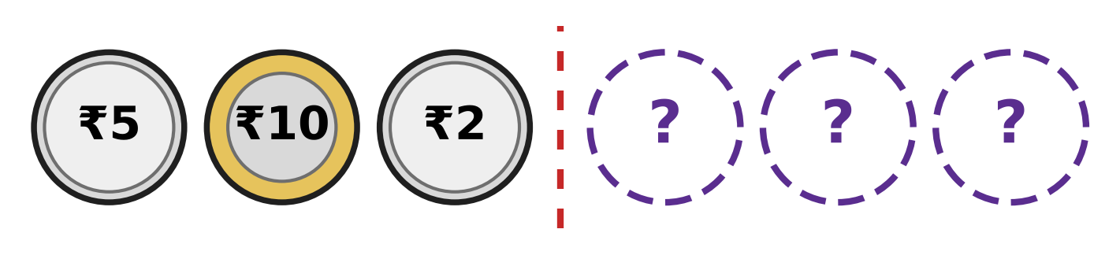
Q45. The row of coins is the same on both sides of the dotted line. Three coins are hidden. How much is the whole row worth? [4 marks]
(A) ₹17 | (B) ₹24 | (C) ₹34 | (D) ₹27

Answer Sheet AMO Level 1 · Class 2 · Practice Paper 4
Name: | School: | Roll No.:
Shade or tick one circle for each question.
1. Ⓐ Ⓑ Ⓒ Ⓓ | 16. Ⓐ Ⓑ Ⓒ Ⓓ | 31. Ⓐ Ⓑ Ⓒ Ⓓ
2. Ⓐ Ⓑ Ⓒ Ⓓ | 17. Ⓐ Ⓑ Ⓒ Ⓓ | 32. Ⓐ Ⓑ Ⓒ Ⓓ
3. Ⓐ Ⓑ Ⓒ Ⓓ | 18. Ⓐ Ⓑ Ⓒ Ⓓ | 33. Ⓐ Ⓑ Ⓒ Ⓓ
4. Ⓐ Ⓑ Ⓒ Ⓓ | 19. Ⓐ Ⓑ Ⓒ Ⓓ | 34. Ⓐ Ⓑ Ⓒ Ⓓ
5. Ⓐ Ⓑ Ⓒ Ⓓ | 20. Ⓐ Ⓑ Ⓒ Ⓓ | 35. Ⓐ Ⓑ Ⓒ Ⓓ
6. Ⓐ Ⓑ Ⓒ Ⓓ | 21. Ⓐ Ⓑ Ⓒ Ⓓ | 36. Ⓐ Ⓑ Ⓒ Ⓓ
7. Ⓐ Ⓑ Ⓒ Ⓓ | 22. Ⓐ Ⓑ Ⓒ Ⓓ | 37. Ⓐ Ⓑ Ⓒ Ⓓ
8. Ⓐ Ⓑ Ⓒ Ⓓ | 23. Ⓐ Ⓑ Ⓒ Ⓓ | 38. Ⓐ Ⓑ Ⓒ Ⓓ
9. Ⓐ Ⓑ Ⓒ Ⓓ | 24. Ⓐ Ⓑ Ⓒ Ⓓ | 39. Ⓐ Ⓑ Ⓒ Ⓓ
10. Ⓐ Ⓑ Ⓒ Ⓓ | 25. Ⓐ Ⓑ Ⓒ Ⓓ | 40. Ⓐ Ⓑ Ⓒ Ⓓ
11. Ⓐ Ⓑ Ⓒ Ⓓ | 26. Ⓐ Ⓑ Ⓒ Ⓓ | 41. Ⓐ Ⓑ Ⓒ Ⓓ
12. Ⓐ Ⓑ Ⓒ Ⓓ | 27. Ⓐ Ⓑ Ⓒ Ⓓ | 42. Ⓐ Ⓑ Ⓒ Ⓓ
13. Ⓐ Ⓑ Ⓒ Ⓓ | 28. Ⓐ Ⓑ Ⓒ Ⓓ | 43. Ⓐ Ⓑ Ⓒ Ⓓ
14. Ⓐ Ⓑ Ⓒ Ⓓ | 29. Ⓐ Ⓑ Ⓒ Ⓓ | 44. Ⓐ Ⓑ Ⓒ Ⓓ
15. Ⓐ Ⓑ Ⓒ Ⓓ | 30. Ⓐ Ⓑ Ⓒ Ⓓ | 45. Ⓐ Ⓑ Ⓒ Ⓓ
Q41–Q45 are Section II Star Questions (4 marks each).
For the parent or teacher
Section I correct: ______ / 40 × 2 = ______ marks Section II correct: ______ / 5 × 4 = ______ marks
Correct: ______ / 45 Score: ______ / 100
Answer Key and Solutions AMO Level 1 · Class 2 · Practice Paper 4
Quick answers
1 B | 6 C | 11 C | 16 C | 21 D | 26 A | 31 D | 36 B | 41 D
2 A | 7 B | 12 B | 17 D | 22 A | 27 C | 32 B | 37 D | 42 B
3 B | 8 A | 13 A | 18 B | 23 D | 28 C | 33 A | 38 A | 43 D
4 A | 9 C | 14 D | 19 C | 24 B | 29 D | 34 C | 39 C | 44 A
5 B | 10 D | 15 A | 20 B | 25 C | 30 C | 35 D | 40 A | 45 C
Solutions
Q | Part · level | Answer | Why?
1 | Part 1 · Ch1 · Easy | (B) 604 | 600 is 6 hundreds and 4 is 4 ones. There are no tens, so the number is 604.
2 | Part 1 · Ch1 · Easy | (A) 500 | There are 9 hundreds. Count back 4 hundreds: 800, 700, 600, 500. So 500 bottles are left.
3 | Part 1 · Ch1 · Easy | (B) 356 | On a number line, smaller numbers are to the left. Only 356 is smaller than 365.
4 | Part 1 · Ch1 · Easy | (A) 433 | 433 ends in 3, so it is odd, and it lies between 430 and 440. The others are even or outside the range.
5 | Part 1 · Ch1 · Easy | (B) 609 | Six hundred nine is 6 hundreds, 0 tens and 9 ones. In figures it is 609.
6 | Part 1 · Ch1 · Easy | (C) 427 | The number must be greater than 415 and less than 430. Only 427 is.
7 | Part 1 · Ch1 · Medium | (B) 7 | Both numbers have 4 hundreds and 7 ones. The tens digit must be more than 6. With 7 the number is 477, and 477 > 467.
8 | Part 1 · Ch1 · Medium | (A) 6 | From A at 280, the jumps land on 290, 300, 310, 320, 330 and 340. That is 6 jumps of 10.
9 | Part 1 · Ch1 · Medium | (C) 37 | 370 is 3 hundreds and 7 tens. 3 hundreds are 30 tens. 30 tens and 7 tens make 37 tens. So there are 37 full trays.
10 | Part 1 · Ch1 · Medium | (D) 200 | Even numbers go up in twos: 194, 196, 198. Two more than 198 is 200.
11 | Part 2 · Ch2 · Easy | (C) 382 | Ones: 7 + 5 = 12, write 2 and carry 1. Tens: 3 + 4 + 1 = 8. Hundreds: 2 + 1 = 3. The total is 382.
12 | Part 2 · Ch2 · Easy | (B) 36 + 47 | Adding back what was taken away gives the starting number. 36 + 47 = 83, so her answer is right.
13 | Part 2 · Ch2 · Easy | (A) 48 | One more plate adds 8 more bunches. 40 + 8 = 48. This is 6 × 8.
14 | Part 2 · Ch2 · Easy | (D) 35 | 5 groups of 7 are 5 × 7 = 35.
15 | Part 2 · Ch2 · Easy | (A) 12 ÷ 4 | Sharing equally is division. 12 mangoes shared among 4 friends is 12 ÷ 4, which is 3 each.
16 | Part 2 · Ch2 · Easy | (C) 8 | One person needs half as much. Half of 16 is 8.
17 | Part 2 · Ch2 · Medium | (D) 113 | 125 − 48 = 77. Then 77 + 36 = 113.
18 | Part 2 · Ch2 · Medium | (B) 277 | Undo the adding: 412 − 135 = 277. Check: 277 + 135 = 412.
19 | Part 2 · Ch2 · Medium | (C) 53 | 6 boxes hold 6 × 8 = 48 candles. With 5 loose candles there are 48 + 5 = 53.
20 | Part 2 · Ch2 · Medium | (B) 6 | Half of 48 is 24. Then 24 ÷ 4 = 6, so each friend gets 6 sweets.
21 | Part 3 · Ch5 · Easy | (D) Picture D | A rolling pin has a long curved side and a flat round end on each side. It is shaped like a cylinder, which is Picture D.
22 | Part 3 · Ch5 · Easy | (A) 1 | A rectangle has 4 corners and a triangle has 3 corners. 4 − 3 = 1 more corner.
23 | Part 3 · Ch5 · Easy | (D) 3 | The closed shape with the smallest number of straight sides is a triangle. It needs 3 sticks.
24 | Part 3 · Ch5 · Easy | (B) It has only flat parts. | A solid rolls on a curved part. A cube has no curved part: all its parts are flat. So it slides but does not roll.
25 | Part 3 · Ch5 · Medium | (C) Picture C | In Picture C the line is in the middle, so the left part lands exactly on the right part. In the other pictures the folded parts do not cover each other.
26 | Part 3 · Ch5 · Medium | (A) two triangles | The cut goes from one corner to the opposite corner. Each piece has 3 straight sides and 3 corners, so both pieces are triangles.
27 | Part 3 · Ch5 · Medium | (C) the cone row | A cone has a curved side, so it can roll on its side. The table says No for rolling, so the cone row is wrong.
28 | Part 4 · Ch9 · Easy | (C) Clock R | 8:15 is quarter past 8: the long hand is on 3 and the short hand is just after 8. Clock R shows this.
29 | Part 4 · Ch9 · Easy | (D) the night | 9 PM is at night and 5 AM is very early the next morning. The lamp is on through the night.
30 | Part 4 · Ch9 · Easy | (C) quarter to 5 | The long hand is on 9 and the short hand is nearly at 5. The time is quarter to 5.
31 | Part 4 · Ch9 · Easy | (D) ₹50 and ₹20 | ₹50 + ₹20 = ₹70. No other two of these notes make ₹70.
32 | Part 4 · Ch9 · Medium | (B) ₹6 | She saves 6 × ₹5 = ₹30. After buying the brush she has ₹30 − ₹24 = ₹6.
33 | Part 4 · Ch9 · Medium | (A) ₹27 | The two tickets cost ₹45 + ₹28 = ₹73. Change: ₹100 − ₹73 = ₹27.
34 | Part 4 · Ch9 · Medium | (C) ₹8 | Total cost: ₹62 + ₹26 = ₹88. He has ₹80, so he needs ₹88 − ₹80 = ₹8 more.
35 | Part 5 · Ch10 · Easy | (D) 235 | The numbers go up in fives: 205, 210, 215, 220, 225, 230, 235. So 235 is on a marker.
36 | Part 5 · Ch10 · Easy | (B) 80 | Each day the number is double the day before: 5, 10, 20, 40. Double 40 is 80.
37 | Part 5 · Ch10 · Easy | (D) Card D | On three cards the second number is double the first: 6 → 12, 9 → 18 and 8 → 16. Double 7 is 14, not 15, so the card 7 → 15 does not follow the rule.
38 | Part 5 · Ch10 · Easy | (A) 10 | The columns have 1, 2, 3 and 4 blocks. 1 + 2 + 3 + 4 = 10 blocks.
39 | Part 5 · Ch10 · Medium | (C) 8 | 2 + 3 = 5, 4 + 1 = 5 and 6 + 2 = 8, so the rule is add the two digits. For 35 the answer is 3 + 5 = 8.
40 | Part 5 · Ch10 · Medium | (A) 6 | Call the friends 1, 2, 3 and 4. The handshakes are 1-2, 1-3, 1-4, 2-3, 2-4 and 3-4. That is 6 handshakes.
41 | Section II · Ch1 + Ch10 · Hard | (D) 454 | The rule swaps the hundreds digit and the ones digit. A number stays the same only if these two digits are equal. 454 becomes 454.
42 | Section II · Ch2 + Ch10 · Hard | (B) 6 | The cows have 5 × 4 = 20 legs. That leaves 32 − 20 = 12 legs for the ducks. 12 ÷ 2 = 6 ducks.
43 | Section II · Ch5 + Ch10 · Hard | (D) Picture D | The rule is: fold the paper along the dotted line. On Card 3 the line goes across the middle, so the paper becomes half as tall: 2 boxes wide and 2 boxes tall, a square.
44 | Section II · Ch1 + Ch9 · Hard | (A) Box A | 12 tens are 1 hundred and 2 tens, so Box A has ₹420. Box B has ₹419, Box C has ₹410 and Box D has ₹415. ₹420 is the most.
45 | Section II · Ch5 + Ch9 · Hard | (C) ₹34 | The hidden coins match the coins on the left: ₹2, ₹10 and ₹5. Each side is worth ₹17. ₹17 + ₹17 = ₹34.

