UNLOCK IQ INSTITUTE
Realize Your True Potential
Aryabhatta Maths Olympiad (AMO)
Level 1 — Practice Paper 5
CLASS 2

Questions | 45 multiple-choice questions
Marks | 100
Time | 60 minutes
Section I | 40 questions × 2 marks = 80 marks
Section II | 5 Star Questions × 4 marks = 20 marks
Negative marking | No negative marking
Calculator | Not allowed
Chapters | Number System · Operations · Geometry · Applied Mathematics · Mathematical Reasoning

Hello, friend!
• Every question has four answer choices: (A), (B), (C) and (D). Only one is correct.
• Read each question and look at its picture carefully. Then mark your answer on the answer sheet at the end.
• Section I has 40 questions of 2 marks each. Section II has 5 Star Questions of 4 marks each.
• There is no negative marking, so try every question.
• Do not use a calculator. You may do rough work on a separate sheet.
• All figures are not necessarily drawn to scale unless stated.

For parents and teachers
Print or view this paper in colour. Pictures are part of the questions.
You may read a question aloud to the child, exactly as printed. Please do not explain it or point to an answer choice.
Parts follow the AMO syllabus chapters. Chapters 3, 4, 6, 7 and 8 are not part of the Class 2 syllabus, so the chapter numbers shown in the Part headings have gaps.
The answer sheet and the answer key are at the end. Remove only the answer key before the child begins.

Name: | School: | Roll No.:

SECTION I 40 questions × 2 marks each
Part 1 — Number System (Syllabus Chapter 1)
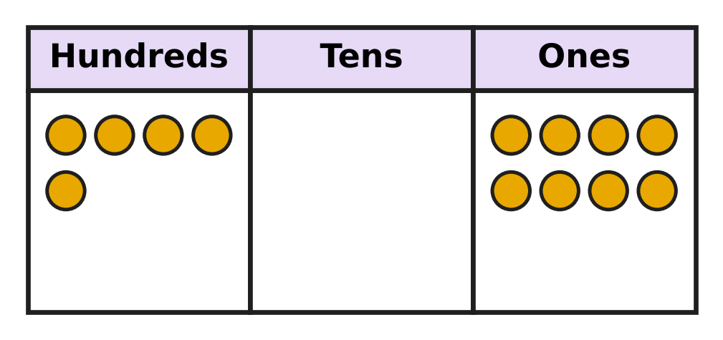
Q1. Look at the place-value chart. Deepa says the number is 58. She is wrong. Which number is it?
(A) 13 | (B) 805 | (C) 580 | (D) 508

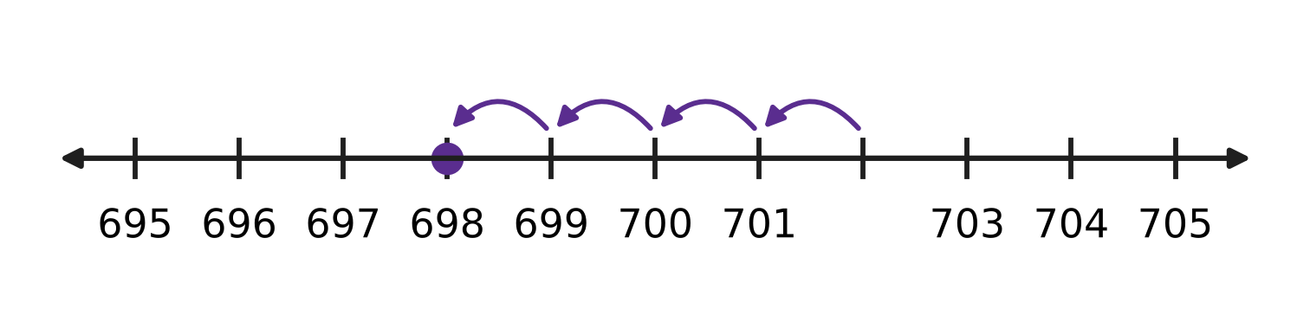
Q2. Look at the number line. Tarun makes 4 hops back and lands on 698. From which number did he start?
(A) 694 | (B) 701 | (C) 702 | (D) 703

Q3. Nakul uses the digits 3, 4 and 7 to make the four numbers below. Which of his numbers is even?
(A) 743 | (B) 437 | (C) 347 | (D) 374

Q4. Isha writes the number nine hundred fifteen in figures. Which digit does she write in the tens place?
(A) 0 | (B) 1 | (C) 5 | (D) 9

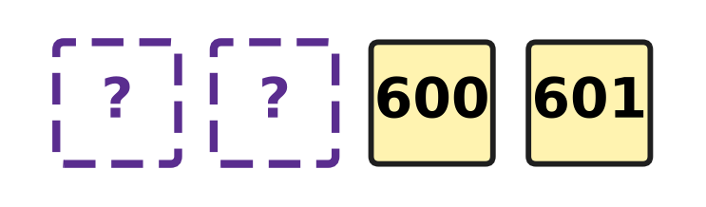
Q5. Look at the number tiles. They are numbered in order. Which two numbers are hidden?
(A) 598 and 599 | (B) 599 and 600
(C) 602 and 603 | (D) 590 and 599

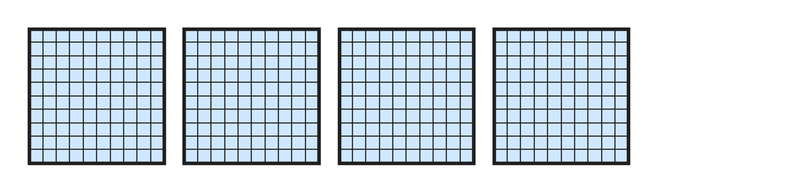
Q6. Look at the hundred-blocks. Each block is 100. How many more hundred-blocks are needed to make 700?
(A) 3 | (B) 4 | (C) 7 | (D) 300

Q7. I am a number. When you add 10 to me, you get 405. Which number am I?
(A) 415 | (B) 404 | (C) 305 | (D) 395

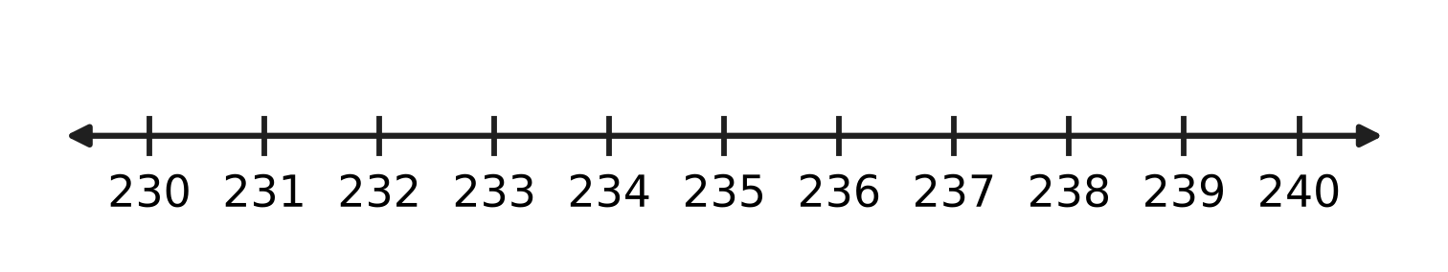
Q8. Look at the number line. How many odd numbers are greater than 230 and less than 240?
(A) 4 | (B) 5 | (C) 6 | (D) 9

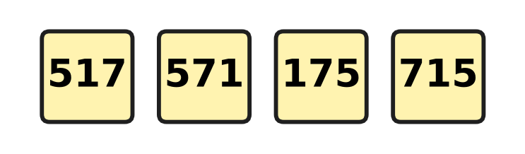
Q9. Four planes have the numbers on these cards. They take off in order, from the smallest number to the greatest. Which plane takes off third?
(A) 571 | (B) 715 | (C) 517 | (D) 175

Q10. Ivan changes just one digit of 417. His new number is 50 more than 417. What is his new number?
(A) 422 | (B) 457 | (C) 467 | (D) 917

Part 2 — Operations & Number Properties (Syllabus Chapter 2)
Q11. A tea stall starts the day with 84 paper cups. At night 37 cups are left. How many cups were used?
(A) 121 | (B) 57 | (C) 53 | (D) 47

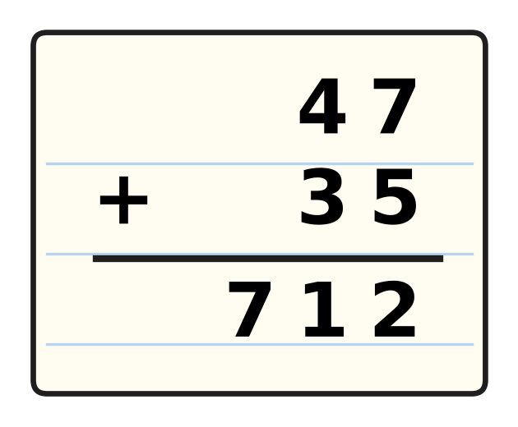
Q12. Look at the sum in the notebook. Tanmay wrote 712, which is wrong. What is the correct answer?
(A) 72 | (B) 92 | (C) 12 | (D) 82

Q13. Which of these is NOT equal to 12?
(A) 3 × 4 | (B) 6 + 6
(C) 3 + 4 | (D) 4 + 4 + 4

Q14. A car park has 96 spaces. Of these, 38 spaces are empty. How do you find the number of spaces that have a car in them?
(A) take 38 away from 96 | (B) add 38 and 38
(C) take 96 away from 38 | (D) add 96 and 38

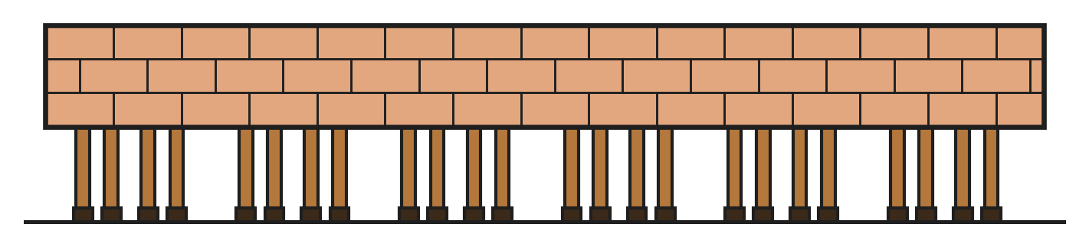
Q15. Look at the picture. Horses stand behind a wall. Only their legs can be seen. Each horse has 4 legs. How many horses are there?
(A) 4 | (B) 6 | (C) 12 | (D) 24

Q16. Three fishing nets hold 26, 18 and 35 fish. How many fish are there in all?
(A) 79 | (B) 89 | (C) 44 | (D) 69

Q17. The school sells 126 tickets for its play. There are 238 tickets left. How many tickets were there at first?
(A) 374 | (B) 112 | (C) 354 | (D) 364

Q18. There are 9 girls and 7 boys on the playground. All of them make 2 equal teams. How many children are in each team?
(A) 7 | (B) 16 | (C) 8 | (D) 4

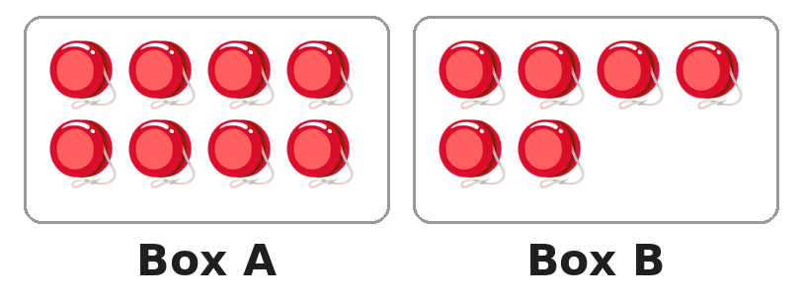
Q19. Look at the two boxes of yo-yos. How many yo-yos must go from Box A to Box B so that both boxes have the same number?
(A) 1 | (B) 2 | (C) 7 | (D) 14

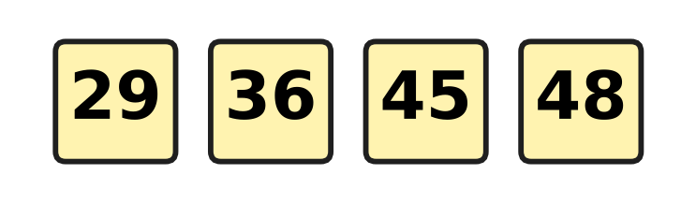
Q20. Look at the four number cards. Which two cards add up to 74?
(A) 36 and 48 | (B) 36 and 45
(C) 29 and 45 | (D) 29 and 48

Part 3 — Geometry (Syllabus Chapter 5)
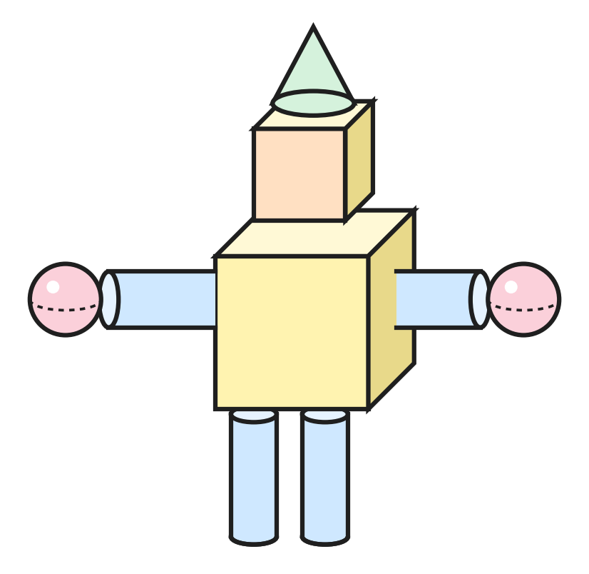
Q21. Look at the toy robot at the science exhibition. It is made of solids. How many cylinders are in it?
(A) 2 | (B) 4 | (C) 6 | (D) 9

Q22. Three of these things have the same solid shape. Which one has a different shape?
(A) a drum | (B) an orange
(C) a ball | (D) a marble

Q23. A flat shape can be drawn on paper. A solid shape can be held in your hand. Which one of these is a flat shape?
(A) cone | (B) sphere | (C) cube | (D) circle

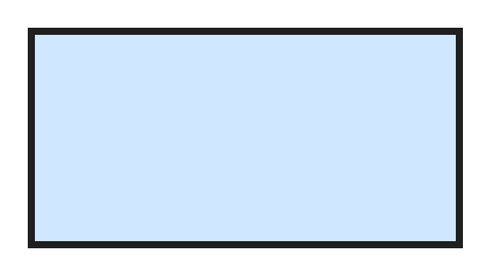
Q24. Look at the flat shape. Which shape is it?
(A) rectangle | (B) triangle
(C) square | (D) circle

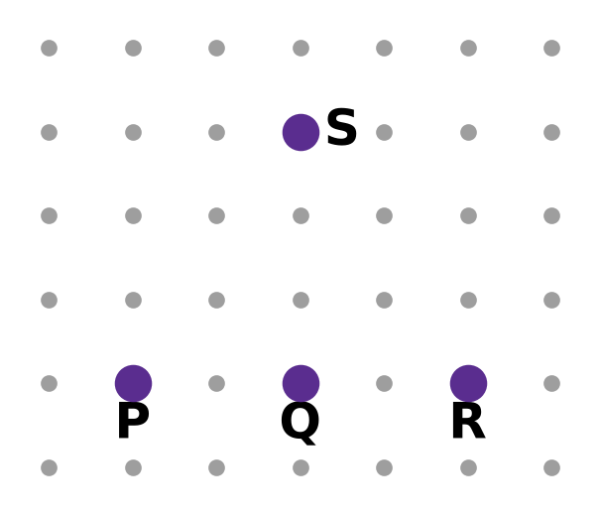
Q25. On the dot paper, Heena joins P to Q to R to S and back to P with straight lines. How many corners does her shape have?
(A) 2 | (B) 3 | (C) 4 | (D) 5

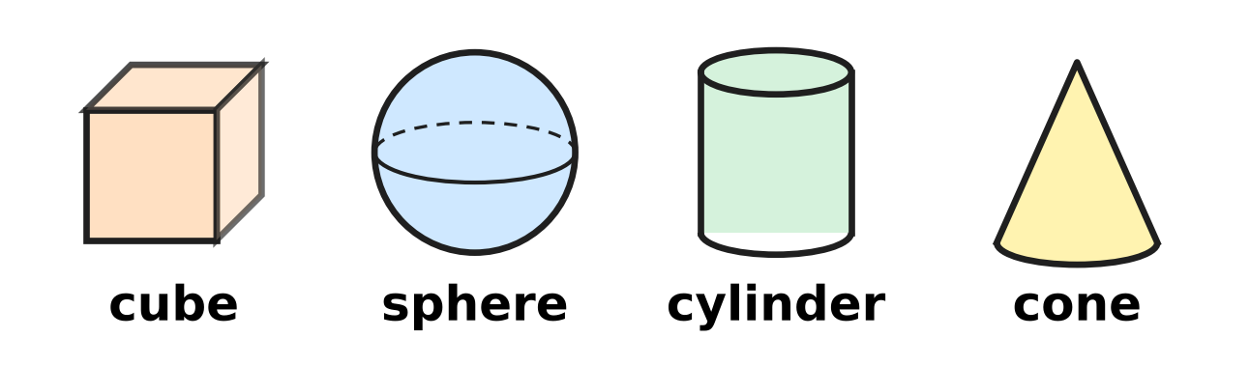
Q26. Look at the four solids. Parth keeps only the solids that have both a flat part and a curved part. Which solids does he keep?
(A) cube and sphere | (B) cube and cylinder
(C) cylinder and cone | (D) sphere and cone

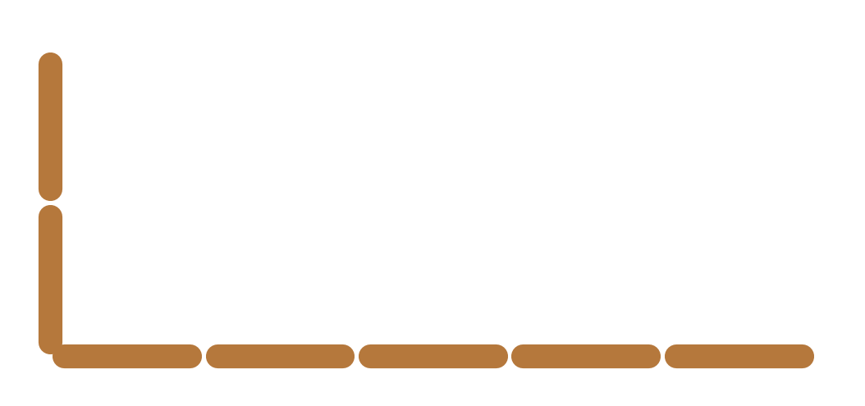
Q27. Lata is making a rectangle with sticks. Look at the picture. She has made one long side and one short side. How many more sticks does she need?
(A) 2 | (B) 5 | (C) 7 | (D) 14

Part 4 — Applied Mathematics (Syllabus Chapter 9)
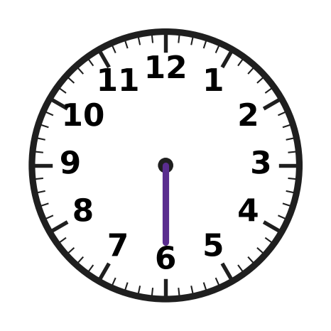
Q28. Look at the clock. Lavina wants it to show half past 9. She has drawn the long hand. Where must she draw the short hand?
(A) exactly on 9 | (B) between 8 and 9
(C) exactly on 6 | (D) between 9 and 10

Q29. Music class starts at 4 o'clock in the afternoon. How do we write this time?
(A) 4 PM | (B) 8 PM | (C) 8 AM | (D) 4 AM

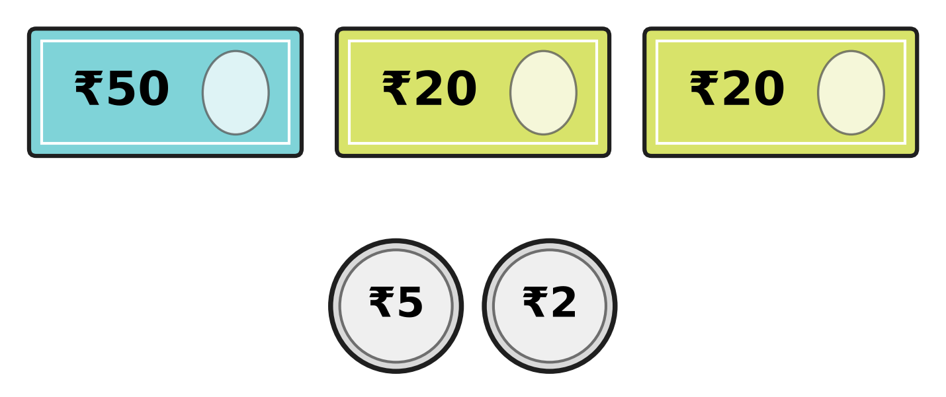
Q30. Look at the notes and coins. How much money is there in all?
(A) ₹77 | (B) ₹92 | (C) ₹95 | (D) ₹97

Q31. Kian pays for an ice-cream with a ₹50 note. He gets ₹12 back. How much does the ice-cream cost?
(A) ₹62 | (B) ₹48 | (C) ₹42 | (D) ₹38

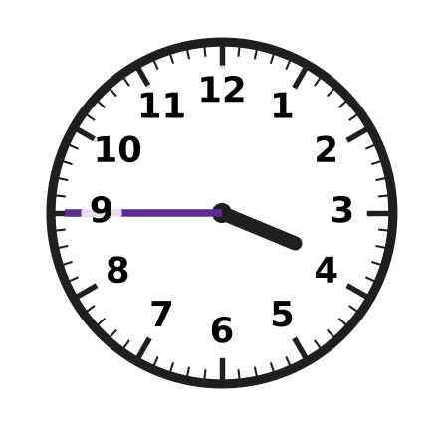
Q32. Look at the clock. Ryan reads it as quarter to 3. He is wrong. What time does the clock show?
(A) quarter past 4 | (B) half past 3
(C) quarter to 4 | (D) quarter past 3

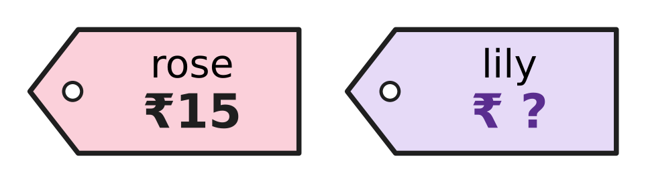
Q33. Look at the price tags. Anjali buys one rose and one lily. She pays ₹50 and gets ₹10 back. How much does the lily cost?
(A) ₹25 | (B) ₹35 | (C) ₹40 | (D) ₹45

Q34. Riya writes four times of the same day: 11 AM, 1 PM, 9 AM and 12 noon. Which of these times comes last in the day?
(A) 9 AM | (B) 11 AM | (C) 12 noon | (D) 1 PM

Part 5 — Mathematical Reasoning & Problem-Solving (Syllabus Chapter 10)
Q35. A lift goes down. It stops at floors 42, 39, 36 and 33. It keeps the same pattern. At which floor does it stop next?
(A) 23 | (B) 29 | (C) 30 | (D) 31

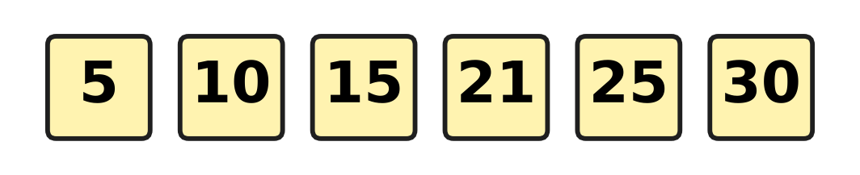
Q36. Look at the number pattern. Every jump should be the same, but one number is wrong. Which number is wrong?
(A) 15 | (B) 21 | (C) 25 | (D) 30

Q37. Jatin sees 3 → 6 and 5 → 10. He says the rule is add 3. He is wrong. Which rule fits both?
(A) double the number | (B) take away 3
(C) halve the number | (D) add 5

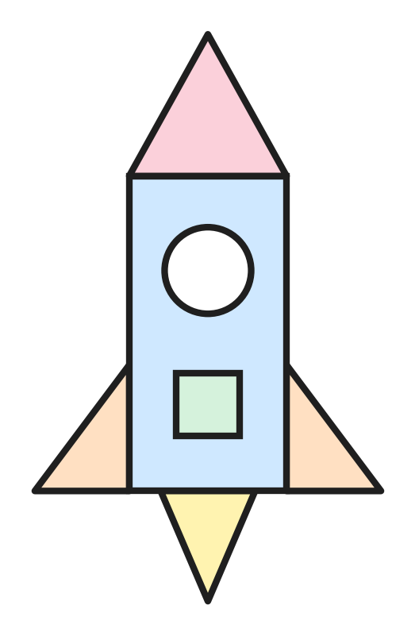
Q38. Look at the rocket. It is made of flat shapes. How many triangles are used?
(A) 3 | (B) 4 | (C) 5 | (D) 7

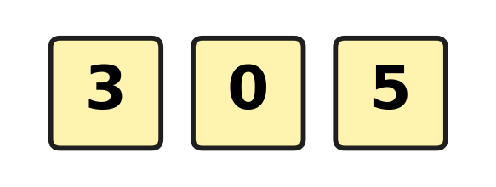
Q39. Look at the three number cards. Myra makes 2-digit numbers with two different cards. A number cannot start with 0. How many different numbers can she make?
(A) 2 | (B) 3 | (C) 4 | (D) 6

Q40. At a science exhibition, the tables are numbered 12, 13, 14 and so on up to 20. How many tables are there?
(A) 8 | (B) 9 | (C) 10 | (D) 20

SECTION II — Star Questions 5 questions × 4 marks each
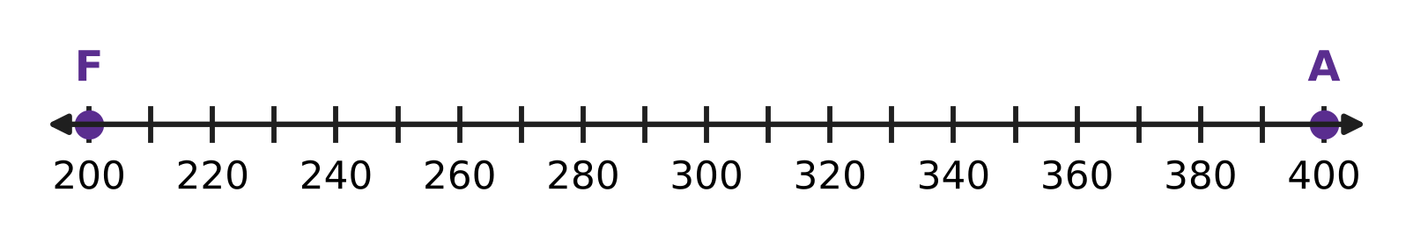
Q41. Look at the number line. A frog starts at F and hops forward 20 at a time. An ant starts at A and hops back 30 at a time. They hop at the same time. On which number do they meet? [4 marks]
(A) 260 | (B) 280 | (C) 300 | (D) 310

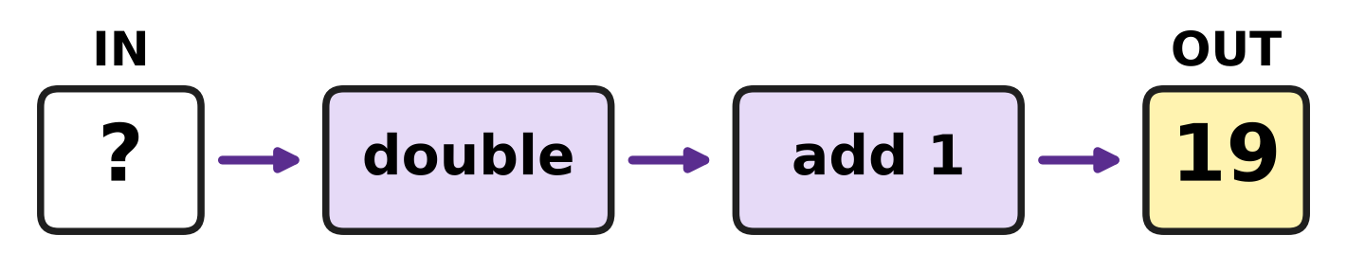
Q42. Look at the number machine. It doubles a number and then adds 1. Sarika puts in a number and 19 comes out. Which number did she put in? [4 marks]
(A) 9 | (B) 10 | (C) 18 | (D) 39

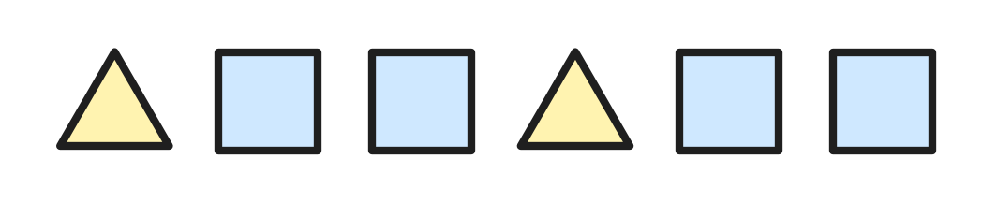
Q43. Look at the shape pattern. It goes on in the same way. Usha counts the corners, shape by shape, from the left. How many shapes has she counted when she reaches 25 corners? [4 marks]
(A) 6 | (B) 7 | (C) 8 | (D) 9

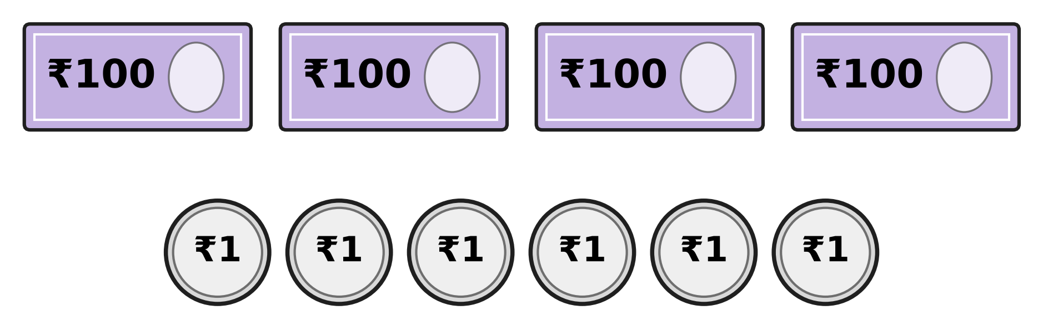
Q44. Look at the money Clara has. She changes one ₹100 note for ₹10 notes. How many notes and coins does she have now in all? [4 marks]
(A) 10 | (B) 13 | (C) 19 | (D) 20

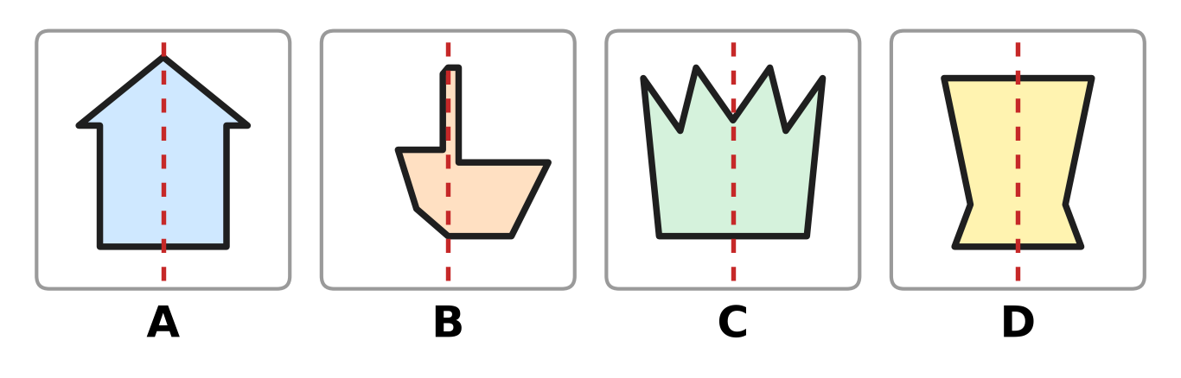
Q45. Look at the four cards. A card that is the same on both sides of the dotted line costs ₹15. Any other card costs ₹10. Zubin buys all four and pays ₹100. How much change does he get? [4 marks]
(A) ₹40 | (B) ₹45 | (C) ₹50 | (D) ₹55

Answer Sheet AMO Level 1 · Class 2 · Practice Paper 5
Name: | School: | Roll No.:
Shade or tick one circle for each question.
1. Ⓐ Ⓑ Ⓒ Ⓓ | 16. Ⓐ Ⓑ Ⓒ Ⓓ | 31. Ⓐ Ⓑ Ⓒ Ⓓ
2. Ⓐ Ⓑ Ⓒ Ⓓ | 17. Ⓐ Ⓑ Ⓒ Ⓓ | 32. Ⓐ Ⓑ Ⓒ Ⓓ
3. Ⓐ Ⓑ Ⓒ Ⓓ | 18. Ⓐ Ⓑ Ⓒ Ⓓ | 33. Ⓐ Ⓑ Ⓒ Ⓓ
4. Ⓐ Ⓑ Ⓒ Ⓓ | 19. Ⓐ Ⓑ Ⓒ Ⓓ | 34. Ⓐ Ⓑ Ⓒ Ⓓ
5. Ⓐ Ⓑ Ⓒ Ⓓ | 20. Ⓐ Ⓑ Ⓒ Ⓓ | 35. Ⓐ Ⓑ Ⓒ Ⓓ
6. Ⓐ Ⓑ Ⓒ Ⓓ | 21. Ⓐ Ⓑ Ⓒ Ⓓ | 36. Ⓐ Ⓑ Ⓒ Ⓓ
7. Ⓐ Ⓑ Ⓒ Ⓓ | 22. Ⓐ Ⓑ Ⓒ Ⓓ | 37. Ⓐ Ⓑ Ⓒ Ⓓ
8. Ⓐ Ⓑ Ⓒ Ⓓ | 23. Ⓐ Ⓑ Ⓒ Ⓓ | 38. Ⓐ Ⓑ Ⓒ Ⓓ
9. Ⓐ Ⓑ Ⓒ Ⓓ | 24. Ⓐ Ⓑ Ⓒ Ⓓ | 39. Ⓐ Ⓑ Ⓒ Ⓓ
10. Ⓐ Ⓑ Ⓒ Ⓓ | 25. Ⓐ Ⓑ Ⓒ Ⓓ | 40. Ⓐ Ⓑ Ⓒ Ⓓ
11. Ⓐ Ⓑ Ⓒ Ⓓ | 26. Ⓐ Ⓑ Ⓒ Ⓓ | 41. Ⓐ Ⓑ Ⓒ Ⓓ
12. Ⓐ Ⓑ Ⓒ Ⓓ | 27. Ⓐ Ⓑ Ⓒ Ⓓ | 42. Ⓐ Ⓑ Ⓒ Ⓓ
13. Ⓐ Ⓑ Ⓒ Ⓓ | 28. Ⓐ Ⓑ Ⓒ Ⓓ | 43. Ⓐ Ⓑ Ⓒ Ⓓ
14. Ⓐ Ⓑ Ⓒ Ⓓ | 29. Ⓐ Ⓑ Ⓒ Ⓓ | 44. Ⓐ Ⓑ Ⓒ Ⓓ
15. Ⓐ Ⓑ Ⓒ Ⓓ | 30. Ⓐ Ⓑ Ⓒ Ⓓ | 45. Ⓐ Ⓑ Ⓒ Ⓓ
Q41–Q45 are Section II Star Questions (4 marks each).
For the parent or teacher
Section I correct: ______ / 40 × 2 = ______ marks Section II correct: ______ / 5 × 4 = ______ marks
Correct: ______ / 45 Score: ______ / 100
Answer Key and Solutions AMO Level 1 · Class 2 · Practice Paper 5
Quick answers
1 D | 6 A | 11 D | 16 A | 21 B | 26 C | 31 D | 36 B | 41 B
2 C | 7 D | 12 D | 17 D | 22 A | 27 C | 32 C | 37 A | 42 A
3 D | 8 B | 13 C | 18 C | 23 D | 28 D | 33 A | 38 B | 43 B
4 B | 9 A | 14 A | 19 A | 24 A | 29 A | 34 D | 39 C | 44 C
5 A | 10 C | 15 B | 20 C | 25 B | 30 D | 35 C | 40 B | 45 B
Solutions
Q | Part · level | Answer | Why?
1 | Part 1 · Ch1 · Easy | (D) 508 | There are 5 hundreds, no tens and 8 ones. The empty tens place needs a zero, so the number is 508.
2 | Part 1 · Ch1 · Easy | (C) 702 | Go forward 4 steps from 698: 699, 700, 701, 702. He started from 702.
3 | Part 1 · Ch1 · Easy | (D) 374 | A number is even when its ones digit is 0, 2, 4, 6 or 8. Only 374 ends in 4.
4 | Part 1 · Ch1 · Easy | (B) 1 | Nine hundred fifteen is 915: 9 hundreds, 1 ten and 5 ones. The tens digit is 1.
5 | Part 1 · Ch1 · Easy | (A) 598 and 599 | Just before 600 comes 599, and just before 599 comes 598. The hidden numbers are 598 and 599.
6 | Part 1 · Ch1 · Easy | (A) 3 | The picture shows 4 hundreds, which is 400. Count on: 500, 600, 700. That is 3 more blocks.
7 | Part 1 · Ch1 · Medium | (D) 395 | 10 less than 405 is 395. Check: 395 and 10 more is 405.
8 | Part 1 · Ch1 · Medium | (B) 5 | The odd numbers are 231, 233, 235, 237 and 239. That is 5 numbers.
9 | Part 1 · Ch1 · Medium | (A) 571 | In order the numbers are 175, 517, 571, 715. The third number is 571.
10 | Part 1 · Ch1 · Medium | (C) 467 | 50 is 5 tens. The tens digit of 417 is 1, and 1 + 5 = 6. So the new number is 467, and 467 − 417 = 50.
11 | Part 2 · Ch2 · Easy | (D) 47 | 84 − 37: regroup 84 as 7 tens and 14 ones. 14 − 7 = 7 and 7 tens − 3 tens = 4 tens. 47 cups were used.
12 | Part 2 · Ch2 · Easy | (D) 82 | 7 + 5 = 12. Write 2 and carry 1 ten. Then 4 + 3 + 1 = 8 tens. The answer is 82.
13 | Part 2 · Ch2 · Easy | (C) 3 + 4 | 3 × 4 means 3 groups of 4, which is 4 + 4 + 4 = 12. 6 + 6 is also 12. But 3 + 4 is only 7.
14 | Part 2 · Ch2 · Easy | (A) take 38 away from 96 | The spaces with cars are what is left when the empty spaces are taken away: 96 − 38.
15 | Part 2 · Ch2 · Easy | (B) 6 | Count the legs in fours: 4, 8, 12, 16, 20, 24. That is 6 fours, so there are 6 horses.
16 | Part 2 · Ch2 · Easy | (A) 79 | Ones: 6 + 8 + 5 = 19, so write 9 and carry 1 ten. Tens: 2 + 1 + 3 + 1 = 7. The total is 79.
17 | Part 2 · Ch2 · Medium | (D) 364 | Put the sold tickets back: 126 + 238 = 364.
18 | Part 2 · Ch2 · Medium | (C) 8 | 9 + 7 = 16 children. 16 shared into 2 equal teams is 8 in each team.
19 | Part 2 · Ch2 · Medium | (A) 1 | There are 8 + 6 = 14 yo-yos, so each box needs 7. Moving 1 yo-yo makes 7 and 7.
20 | Part 2 · Ch2 · Medium | (C) 29 and 45 | 29 + 45: 9 + 5 = 14, write 4 and carry 1 ten. 2 + 4 + 1 = 7 tens. The total is 74.
21 | Part 3 · Ch5 · Easy | (B) 4 | The two legs and the two arms are cylinders. There are 4 cylinders.
22 | Part 3 · Ch5 · Easy | (A) a drum | A ball, an orange and a marble are spheres. A drum is a cylinder, so it is the different one.
23 | Part 3 · Ch5 · Easy | (D) circle | A circle is flat. A cube, a cone and a sphere are solids.
24 | Part 3 · Ch5 · Easy | (A) rectangle | The shape has 4 corners, 2 long sides and 2 short sides. It is a rectangle.
25 | Part 3 · Ch5 · Medium | (B) 3 | P, Q and R lie on one straight line, so Q is not a corner. The corners are P, R and S: 3 corners, so the shape is a triangle.
26 | Part 3 · Ch5 · Medium | (C) cylinder and cone | A cube is flat all over and a sphere is curved all over. The cylinder and the cone have flat circles and a curved side.
27 | Part 3 · Ch5 · Medium | (C) 7 | A rectangle has 2 long sides and 2 short sides. She still needs one long side of 5 sticks and one short side of 2 sticks: 5 + 2 = 7.
28 | Part 4 · Ch9 · Easy | (D) between 9 and 10 | At half past 9 the short hand has moved halfway from 9 towards 10.
29 | Part 4 · Ch9 · Easy | (A) 4 PM | The afternoon comes after 12 noon, so the time is 4 PM.
30 | Part 4 · Ch9 · Easy | (D) ₹97 | 50 + 20 + 20 = 90, and 5 + 2 = 7. In all there is ₹97.
31 | Part 4 · Ch9 · Easy | (D) ₹38 | ₹50 − ₹12 = ₹38. Check: ₹38 + ₹12 = ₹50.
32 | Part 4 · Ch9 · Medium | (C) quarter to 4 | The long hand is on 9, so it is quarter to the next hour. The short hand has passed 3 and is close to 4. The time is quarter to 4.
33 | Part 4 · Ch9 · Medium | (A) ₹25 | She spent ₹50 − ₹10 = ₹40 on both flowers. The lily costs ₹40 − ₹15 = ₹25.
34 | Part 4 · Ch9 · Medium | (D) 1 PM | AM times come before noon and PM times come after noon. 1 PM is the only time after noon, so it is the last.
35 | Part 5 · Ch10 · Easy | (C) 30 | Each stop is 3 floors lower than the one before. 33 − 3 = 30.
36 | Part 5 · Ch10 · Easy | (B) 21 | The numbers go up in fives: 5, 10, 15, 20, 25, 30. So 21 is wrong; it should be 20.
37 | Part 5 · Ch10 · Easy | (A) double the number | 3 + 3 = 6, but 5 + 3 is 8, not 10. Double 3 is 6 and double 5 is 10, so the rule is double the number.
38 | Part 5 · Ch10 · Easy | (B) 4 | There is 1 triangle at the top, 1 on each side and 1 at the bottom. That is 4 triangles.
39 | Part 5 · Ch10 · Medium | (C) 4 | She can make 30, 35, 50 and 53. That is 4 numbers.
40 | Part 5 · Ch10 · Medium | (B) 9 | Count them: 12, 13, 14, 15, 16, 17, 18, 19, 20. That is 9 tables.
41 | Section II · Ch1 + Ch10 · Hard | (B) 280 | Frog: 200, 220, 240, 260, 280. Ant: 400, 370, 340, 310, 280. After 4 hops each, both are on 280.
42 | Section II · Ch2 + Ch10 · Hard | (A) 9 | Work backwards. Take away the 1: 19 − 1 = 18. Then halve: 18 ÷ 2 = 9. Check: double 9 is 18, and 18 + 1 = 19.
43 | Section II · Ch5 + Ch10 · Hard | (B) 7 | The corners add up like this: 3, 7, 11, 14, 18, 22. The 7th shape is a triangle again, and 22 + 3 = 25. So she has counted 7 shapes.
44 | Section II · Ch1 + Ch9 · Hard | (C) 19 | One ₹100 note is the same as ten ₹10 notes. Then she has 3 notes of ₹100, 10 notes of ₹10 and 6 coins: 3 + 10 + 6 = 19.
45 | Section II · Ch5 + Ch9 · Hard | (B) ₹45 | Cards A, C and D are the same on both sides: 3 × ₹15 = ₹45. Card B costs ₹10. The total is ₹55, so the change is ₹100 − ₹55 = ₹45.

