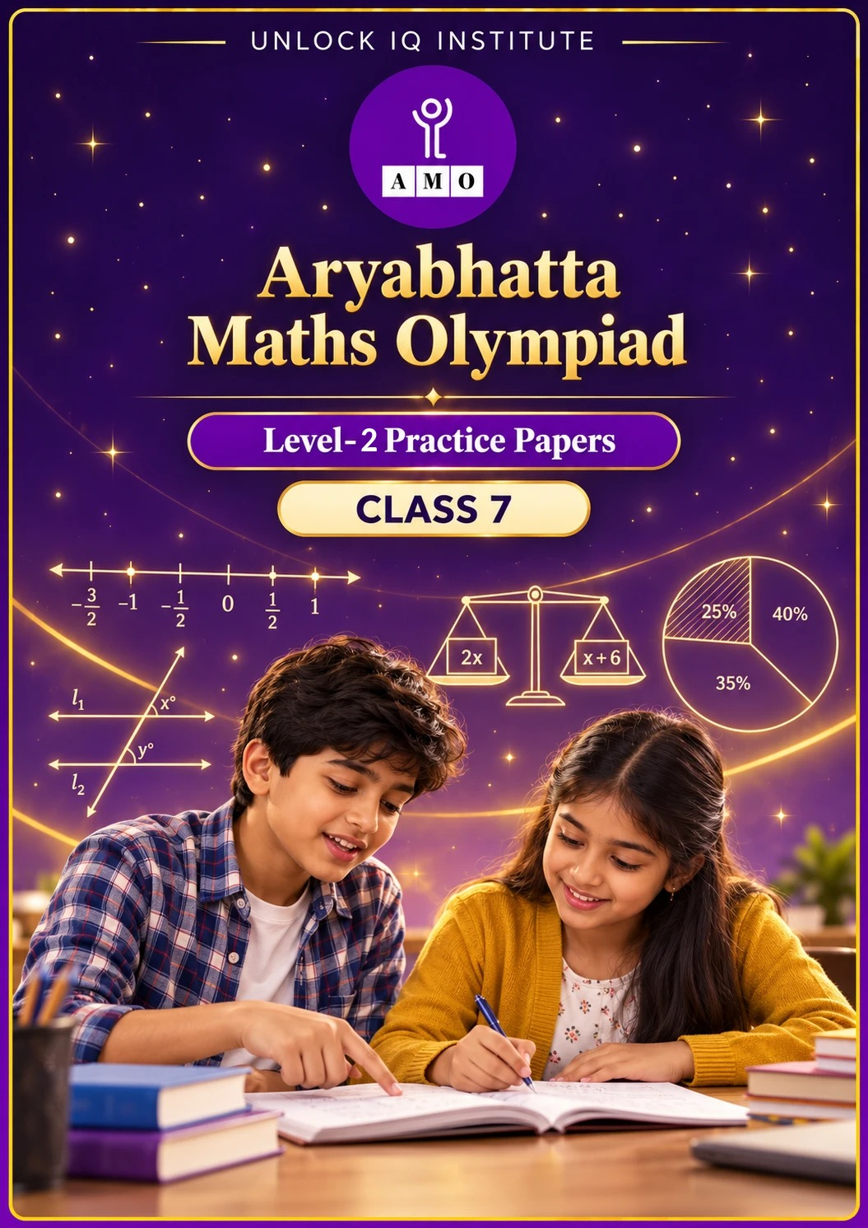
Set 1 · Practice Papers 1–5 · with answer keys & detailed solutions
Name: ____________________ | Class & Section: ________________
Roll No.: ________________ | School: ____________________
City: ____________________ | Date: ____________________

Published by Unlock IQ Institute Pvt. Ltd.
Register for Olympiads: www.aryabhattamathsolympiad.com/student-registration

ARYABHATTA MATHS OLYMPIAD
Level 2
PRACTICE PAPER-1
CLASS 7
Total Questions | 30 multiple-choice questions
Level | Level-2 (final round): every question is Hard
Time | 45 minutes
Arrangement | Parts by chapter; the last Part has mixed problems joining two chapters
Negative Marking | No negative marking
Calculator | Not allowed
Chapters | Number System · Operations · Fractions, Decimals & Percentages · Algebra · Geometry · Mensuration · Data Handling, Statistics & Probability · Applied Mathematics · Mathematical Reasoning

Instructions
• Each question has four options, (A) to (D), with exactly one correct answer.
• The questions are grouped in Parts by chapter. The last Part has mixed problems, each joining two chapters.
• Every question is at Level-2 (Hard) standard: expect several steps or a key insight.
• There is no negative marking. Calculators are not allowed; use a separate sheet for rough work.
• Figures are not necessarily drawn to scale unless stated.

For teachers
• Figures are part of the questions and work when printed in black and white.
• Parts follow the AMO syllabus chapters. Chapter 7 is not part of the Class 7 syllabus, so the chapter numbers shown in the Part headings have gaps.
• The answer sheet and the answer key are at the end. Remove the answer key before the paper is attempted.

Part 1 — Number System (Syllabus Chapter 1)
Q1. Meera marks −2/3 and 5/6 on a number line. Which rational number lies exactly halfway between them?
(A) 1/6 | (B) 1/4 | (C) −1/12 | (D) 1/12

Q2. Arjun arranges −3/4, 5/−8, −7/12 and −2/3 from smallest to largest. Which number is second in his list?
(A) 5/−8 | (B) −2/3 | (C) −7/12 | (D) −3/4

Q3. What is the value of (−5/6) ÷ (10/−9) × (−4/3)?
(A) 1 | (B) −25/36 | (C) −1 | (D) 4/9

Part 2 — Operations (Syllabus Chapter 2)
Q4. Kavya finds a whole number n such that 3ⁿ × 9² = 3 × 9⁴. What is n?
(A) 5 | (B) 4 | (C) 3 | (D) 7

Q5. The Moon is about 3.84 × 10⁵ km from the Earth. A spacecraft travels at about 1.6 × 10⁴ km per hour. About how long does a round trip take, not counting any stop?
(A) 24 hours | (B) 48 hours | (C) 2.4 hours | (D) 480 hours

Part 3 — Fractions, Decimals & Percentages (Syllabus Chapter 3)
Q6. A shopkeeper marks a lamp 40% above its cost price. He then gives a discount of 25% on the marked price. What is his profit or loss percent?
(A) 15% profit | (B) 5% profit | (C) 5% loss | (D) 10% profit

Q7. Rohan sells two fans for ₹1,200 each. On one he gains 20% and on the other he loses 20%. What is his overall result?
(A) No profit or loss | (B) Profit of ₹100
(C) Loss of ₹100 | (D) Loss of ₹48

Q8. The price of sugar rises by 25%. By what percent must a family reduce its sugar use so that its spending on sugar stays the same?
(A) 20% | (B) 25% | (C) 15% | (D) 80%

Part 4 — Algebra (Syllabus Chapter 4)
Q9. Solve (2x + 3)/5 − (x − 1)/3 = 2. What is x?
(A) 14 | (B) 6 | (C) 26 | (D) 16

Q10. The sum of three consecutive odd numbers is 147. What is the product of the smallest and the largest of them?
(A) 2,397 | (B) 2,499 | (C) 2,451 | (D) 2,303

Q11. Yash adds a² + ab and 2a² − 3ab + 4b². From this sum he subtracts 3a² − 2ab + b². What does he get?
(A) 6a² − 4ab + 5b² | (B) 3b²
(C) −3b² | (D) 4ab + 3b²

Part 5 — Geometry (Syllabus Chapter 5)
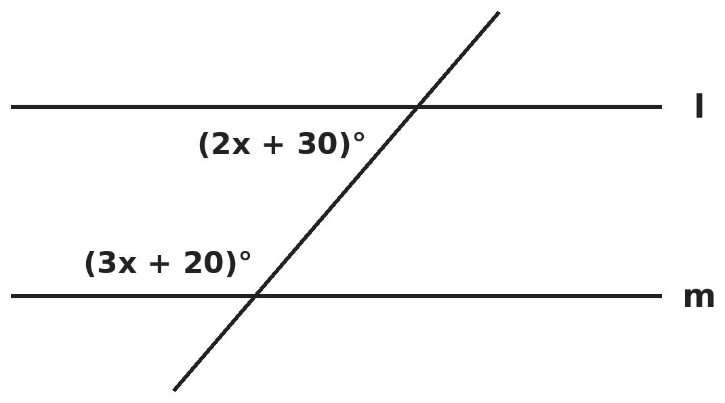
Q12. Lines l and m are parallel. The two marked angles lie between the lines on the same side of the transversal. What is the larger of the two angles?
(A) 82° | (B) 26° | (C) 110° | (D) 98°

Q13. An exterior angle of a triangle is 120°. The two interior angles opposite to it are in the ratio 3 : 5. What is the smallest angle of the triangle?
(A) 45° | (B) 60° | (C) 75° | (D) 40°

Q14. In quadrilateral ABCD, angle A equals angle C, angle B is 30° more than angle A, and angle D is twice angle A. What is angle D?
(A) 66° | (B) 132° | (C) 96° | (D) 120°

Part 6 — Mensuration (Syllabus Chapter 6)
Q15. A full tank is a cuboid 2 m × 1.5 m × 1 m. Its water is poured into drums shaped like cylinders, each of radius 35 cm and height 1 m. How many drums can be filled completely? (π = 22/7)
(A) 8 | (B) 6 | (C) 7 | (D) 9

Q16. A wooden cuboid 12 cm × 8 cm × 6 cm is cut into cubes of edge 2 cm. By how much is the total surface area of all the cubes more than that of the cuboid?
(A) 1,728 cm² | (B) 432 cm² | (C) 1,296 cm² | (D) 864 cm²

Q17. Kiran makes 6 closed tins, each a cylinder of radius 7 cm and height 10 cm, from a metal sheet 1 m long and 50 cm wide. How much sheet is left over? (π = 22/7)
(A) 2,360 cm² | (B) 512 cm² | (C) 1,436 cm² | (D) 3,152 cm²

Part 7 — Data Handling, Statistics & Probability (Syllabus Chapter 8)
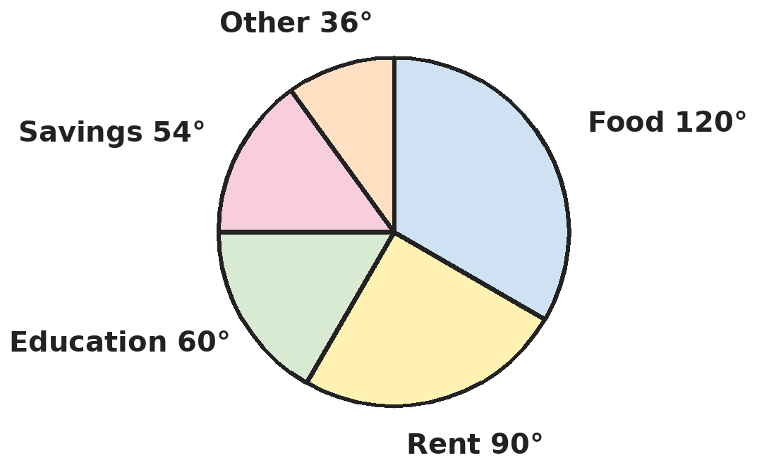
Q18. The pie chart shows how a family spends its monthly income of ₹36,000. How much more is spent on food than is saved?
(A) ₹5,400 | (B) ₹12,000 | (C) ₹66 | (D) ₹6,600

Q19. The mean of five numbers is 18. When one number is removed, the mean of the other four is 16. The removed number is then replaced by 31. What is the new mean of the five numbers?
(A) 19 | (B) 18 | (C) 20 | (D) 17

Part 8 — Applied Mathematics (Syllabus Chapter 9)
Q20. 12 workers dig a trench 60 m long in 5 days. Working at the same rate, how many workers are needed to dig a trench 96 m long in 4 days?
(A) 19 | (B) 15 | (C) 24 | (D) 30

Q21. ₹7,000 is shared among Asha, Raj and Om so that Asha : Raj = 2 : 3 and Raj : Om = 4 : 5. How much does Om get?
(A) ₹2,800 | (B) ₹2,400 | (C) ₹3,000 | (D) ₹1,600

Q22. A journey takes 4 hours at 60 km/h. Asha drives the first 2 hours at 60 km/h. At what speed must she drive the rest of the way to finish the whole journey in 3 hours?
(A) 120 km/h | (B) 80 km/h | (C) 90 km/h | (D) 100 km/h

Part 9 — Mathematical Reasoning (Syllabus Chapter 10)
Q23. In the sum AB + BA = 121, A and B are digits and AB is a 2-digit number. A is 3 more than B. What is the number AB?
(A) 47 | (B) 83 | (C) 65 | (D) 74

Q24. How many 3-digit numbers have digits that add up to 5?
(A) 15 | (B) 21 | (C) 10 | (D) 14

Q25. What is the units digit of 7⁴ × 3⁵ × 2³?
(A) 2 | (B) 6 | (C) 8 | (D) 4

Part 10 — Mixed Problems (each joins two chapters)
Q26. Kunal makes a pattern of figures with sticks. The 1st figure uses 5 sticks, the 2nd uses 8 and the 3rd uses 11, and so on. Which figure uses exactly 101 sticks?
(A) 34th | (B) 33rd | (C) 32nd | (D) 35th

Q27. The price of a bicycle is raised by 10% and then lowered by 10%. The same two changes are then made once more. What is the overall change in price?
(A) No change | (B) A decrease of 2%
(C) A decrease of 1% | (D) A decrease of 1.99%

Q28. The ages of Priya and her brother Dev are in the ratio 5 : 7. After 8 years the ratio will be 7 : 9. What is the sum of their present ages?
(A) 48 years | (B) 40 years | (C) 56 years | (D) 36 years

Q29. A cylinder just fits inside a cube of edge 14 cm: it touches all six faces of the cube. What volume inside the cube is not taken up by the cylinder? (π = 22/7)
(A) 2,156 cm³ | (B) 196 cm³ | (C) 588 cm³ | (D) 616 cm³

Q30. What is the value of (3x + 1)/(x − 1) when x = −2/3?
(A) −3/5 | (B) 5/3 | (C) 3/5 | (D) 1/5

Answer Sheet AMO Level 2 · Class 7 · Practice Paper 1
Name: | School: | Roll No.:
Shade or tick one circle for each question.
1. | Ⓐ Ⓑ Ⓒ Ⓓ | 11. | Ⓐ Ⓑ Ⓒ Ⓓ | 21. | Ⓐ Ⓑ Ⓒ Ⓓ
2. | Ⓐ Ⓑ Ⓒ Ⓓ | 12. | Ⓐ Ⓑ Ⓒ Ⓓ | 22. | Ⓐ Ⓑ Ⓒ Ⓓ
3. | Ⓐ Ⓑ Ⓒ Ⓓ | 13. | Ⓐ Ⓑ Ⓒ Ⓓ | 23. | Ⓐ Ⓑ Ⓒ Ⓓ
4. | Ⓐ Ⓑ Ⓒ Ⓓ | 14. | Ⓐ Ⓑ Ⓒ Ⓓ | 24. | Ⓐ Ⓑ Ⓒ Ⓓ
5. | Ⓐ Ⓑ Ⓒ Ⓓ | 15. | Ⓐ Ⓑ Ⓒ Ⓓ | 25. | Ⓐ Ⓑ Ⓒ Ⓓ
6. | Ⓐ Ⓑ Ⓒ Ⓓ | 16. | Ⓐ Ⓑ Ⓒ Ⓓ | 26. | Ⓐ Ⓑ Ⓒ Ⓓ
7. | Ⓐ Ⓑ Ⓒ Ⓓ | 17. | Ⓐ Ⓑ Ⓒ Ⓓ | 27. | Ⓐ Ⓑ Ⓒ Ⓓ
8. | Ⓐ Ⓑ Ⓒ Ⓓ | 18. | Ⓐ Ⓑ Ⓒ Ⓓ | 28. | Ⓐ Ⓑ Ⓒ Ⓓ
9. | Ⓐ Ⓑ Ⓒ Ⓓ | 19. | Ⓐ Ⓑ Ⓒ Ⓓ | 29. | Ⓐ Ⓑ Ⓒ Ⓓ
10. | Ⓐ Ⓑ Ⓒ Ⓓ | 20. | Ⓐ Ⓑ Ⓒ Ⓓ | 30. | Ⓐ Ⓑ Ⓒ Ⓓ

For the parent or teacher
Correct: ______ / 30
Answer Key and Solutions AMO Level 2 · Class 7 · Practice Paper 1
Quick answers
1 D | 6 B | 11 B | 16 C | 21 C | 26 B
2 B | 7 C | 12 D | 17 B | 22 A | 27 D
3 C | 8 A | 13 A | 18 D | 23 D | 28 A
4 A | 9 D | 14 B | 19 A | 24 A | 29 C
5 B | 10 A | 15 C | 20 C | 25 D | 30 C
Solutions
Q | Part · level | Answer | Why?
1 | Part 1 · Ch1 · Hard | (D) 1/12 | Hint: Halfway between two numbers is half of their sum.  Sum: −2/3 + 5/6 = −4/6 + 5/6 = 1/6. Half of 1/6 is 1/12. (1/6 is the sum, not the midpoint.)
2 | Part 1 · Ch1 · Hard | (B) −2/3 | Hint: Write all four with the denominator 24.  −3/4 = −18/24, 5/−8 = −15/24, −7/12 = −14/24, −2/3 = −16/24. From smallest: −18, −16, −15, −14 (over 24). The second is −16/24 = −2/3.
3 | Part 1 · Ch1 · Hard | (C) −1 | Hint: Dividing by 10/−9 is the same as multiplying by −9/10. Count the minus signs.  (−5/6) × (−9/10) = 45/60 = 3/4. Then 3/4 × (−4/3) = −1. There are three negative factors, so the answer is negative.
4 | Part 2 · Ch2 · Hard | (A) 5 | Hint: Write 9² and 9⁴ as powers of 3.  9² = 3⁴, so the left side is 3ⁿ × 9². Divide both sides by 9²: 3ⁿ = 3 × 9² = 3 × 81 = 243 = 3⁵. So n = 5.
5 | Part 2 · Ch2 · Hard | (B) 48 hours | Hint: Time = distance ÷ speed. Divide the numbers and the powers of 10 separately, then double.  One way: (3.84 ÷ 1.6) × 10⁵ ÷ 10⁴ = 2.4 × 10 = 24 hours. There and back: 2 × 24 = 48 hours. (24 hours is only one way.)
6 | Part 3 · Ch3 · Hard | (B) 5% profit | Hint: Take the cost price as ₹100.  Cost ₹100. Marked price ₹140. A 25% discount is ₹35, so he sells for ₹105. Profit ₹5 on ₹100 = 5%. (15% wrongly subtracts 25 from 40.)
7 | Part 3 · Ch3 · Hard | (C) Loss of ₹100 | Hint: Find the cost price of each fan separately.  Fan 1: 1.2 × cost = 1,200, so cost = ₹1,000. Fan 2: 0.8 × cost = 1,200, so cost = ₹1,500. Total cost ₹2,500, total selling price ₹2,400: a loss of ₹100.
8 | Part 3 · Ch3 · Hard | (A) 20% | Hint: If ₹100 bought 100 units before, how many units does ₹100 buy now?  Old price ₹1 per unit, new price ₹1.25. ₹100 now buys 100 ÷ 1.25 = 80 units instead of 100. The use must fall by 20 out of 100 = 20%.
9 | Part 4 · Ch4 · Hard | (D) 16 | Hint: Multiply every term by 15 first. Take care with the minus sign before the second fraction.  15 × each term: 3(2x + 3) − 5(x − 1) = 30. So 6x + 9 − 5x + 5 = 30, giving x + 14 = 30 and x = 16. (14 forgets that −5 × −1 = +5.)
10 | Part 4 · Ch4 · Hard | (A) 2,397 | Hint: Write the numbers as x, x + 2 and x + 4.  x + (x + 2) + (x + 4) = 3x + 6 = 147, so 3x = 141 and x = 47. The numbers are 47, 49 and 51. 47 × 51 = 2,397.
11 | Part 4 · Ch4 · Hard | (B) 3b² | Hint: Add like terms first; when subtracting, change every sign of the expression taken away.  Sum: 3a² − 2ab + 4b². Subtract: (3a² − 2ab + 4b²) − (3a² − 2ab + b²) = 0a² + 0ab + 3b² = 3b².
12 | Part 5 · Ch5 · Hard | (D) 98° | Hint: Interior angles on the same side of a transversal (co-interior angles) add up to 180°.  (3x + 20) + (2x + 30) = 180, so 5x + 50 = 180 and x = 26. The angles are 98° and 82°; the larger is 98°.
13 | Part 5 · Ch5 · Hard | (A) 45° | Hint: The exterior angle equals the sum of the two opposite interior angles.  The two opposite angles add to 120°: 3/8 × 120 = 45° and 5/8 × 120 = 75°. The third angle is 180° − 120° = 60°. The smallest is 45°.
14 | Part 5 · Ch5 · Hard | (B) 132° | Hint: The angles of a quadrilateral add up to 360°.  A + (A + 30) + A + 2A = 5A + 30 = 360, so A = 66°. Then D = 2 × 66° = 132°.
15 | Part 6 · Ch6 · Hard | (C) 7 | Hint: Work in cm³: 1 m³ = 10,00,000 cm³.  Tank: 3 m³ = 30,00,000 cm³. Drum: 22/7 × 35 × 35 × 100 = 3,85,000 cm³. 30,00,000 ÷ 3,85,000 ≈ 7.8, so 7 drums fill completely.
16 | Part 6 · Ch6 · Hard | (C) 1,296 cm² | Hint: Count the cubes: how many fit along each edge?  Cubes: 6 × 4 × 3 = 72, each with surface area 6 × 4 = 24 cm²: total 1,728 cm². Cuboid: 2(96 + 72 + 48) = 432 cm². Increase: 1,728 − 432 = 1,296 cm².
17 | Part 6 · Ch6 · Hard | (B) 512 cm² | Hint: One tin needs its curved surface and two circles. 1 m = 100 cm.  Curved surface: 2 × 22/7 × 7 × 10 = 440 cm². Each circle: 22/7 × 7 × 7 = 154 cm². One tin: 440 + 308 = 748 cm². Six tins: 4,488 cm². Sheet: 100 × 50 = 5,000 cm². Left: 512 cm². (2,360 forgets the circles.)
18 | Part 7 · Ch8 · Hard | (D) ₹6,600 | Hint: Each degree stands for 36,000 ÷ 360 rupees.  1° stands for ₹100. Food minus savings = 120° − 54° = 66°, which is 66 × ₹100 = ₹6,600.
19 | Part 7 · Ch8 · Hard | (A) 19 | Hint: Work with totals, not means.  Total of five: 5 × 18 = 90. Total of four: 4 × 16 = 64, so the removed number was 26. New total: 64 + 31 = 95. New mean: 95 ÷ 5 = 19.
20 | Part 8 · Ch9 · Hard | (C) 24 | Hint: More length needs more workers; fewer days also needs more workers.  Workers = 12 × (96/60) × (5/4) = 12 × 1.6 × 1.25 = 24.
21 | Part 8 · Ch9 · Hard | (C) ₹3,000 | Hint: Make Raj's share the same number in both ratios.  Asha : Raj = 8 : 12 and Raj : Om = 12 : 15, so the ratio is 8 : 12 : 15 (35 parts). Om gets 15/35 × 7,000 = ₹3,000.
22 | Part 8 · Ch9 · Hard | (A) 120 km/h | Hint: First find the length of the journey and how much is left.  Journey: 60 × 4 = 240 km. In 2 hours she covers 120 km, leaving 120 km. She has 3 − 2 = 1 hour left, so she needs 120 km/h. (80 km/h is the speed for the whole trip in 3 hours.)
23 | Part 9 · Ch10 · Hard | (D) 74 | Hint: AB + BA = (10A + B) + (10B + A) = 11(A + B).  11(A + B) = 121, so A + B = 11. With A − B = 3: A = 7, B = 4. AB = 74. Check: 74 + 47 = 121.
24 | Part 9 · Ch10 · Hard | (A) 15 | Hint: Fix the hundreds digit (1 to 5) and count how the other two digits can share the rest.  Hundreds digit 1: the other two add to 4 in 5 ways (04, 13, 22, 31, 40). Digit 2: 4 ways. 3: 3 ways. 4: 2 ways. 5: 1 way. Total 5 + 4 + 3 + 2 + 1 = 15.
25 | Part 9 · Ch10 · Hard | (D) 4 | Hint: Only the units digits matter. Find the units digit of each power first.  7⁴ = 2,401 ends in 1. 3⁵ = 243 ends in 3. 2³ = 8. Units digit of 1 × 3 × 8 = 24 is 4.
26 | Part 10 · Mixed · Ch4 + Ch10 · Hard | (B) 33rd | Hint: Write the number of sticks in the nth figure as an expression.  Each figure adds 3 sticks, so the nth figure uses 3n + 2 sticks. 3n + 2 = 101 gives 3n = 99 and n = 33.
27 | Part 10 · Mixed · Ch3 + Ch10 · Hard | (D) A decrease of 1.99% | Hint: Each pair of changes multiplies the price by 1.1 × 0.9.  One pair: 1.1 × 0.9 = 0.99. Two pairs: 0.99 × 0.99 = 0.9801. The price falls by 1 − 0.9801 = 0.0199, that is 1.99%.
28 | Part 10 · Mixed · Ch4 + Ch9 · Hard | (A) 48 years | Hint: Let the ages be 5x and 7x.  (5x + 8)/(7x + 8) = 7/9, so 45x + 72 = 49x + 56, giving 4x = 16 and x = 4. Ages 20 and 28; sum 48 years.
29 | Part 10 · Mixed · Ch5 + Ch6 · Hard | (C) 588 cm³ | Hint: The cylinder has diameter 14 cm and height 14 cm.  Cube: 14 × 14 × 14 = 2,744 cm³. Cylinder: 22/7 × 7 × 7 × 14 = 2,156 cm³. Space left: 2,744 − 2,156 = 588 cm³.
30 | Part 10 · Mixed · Ch1 + Ch4 · Hard | (C) 3/5 | Hint: Work out the top and the bottom separately.  Top: 3 × (−2/3) + 1 = −2 + 1 = −1. Bottom: −2/3 − 1 = −5/3. (−1) ÷ (−5/3) = 3/5.

ARYABHATTA MATHS OLYMPIAD
Level 2
PRACTICE PAPER-2
CLASS 7
Total Questions | 30 multiple-choice questions
Level | Level-2 (final round): every question is Hard
Time | 45 minutes
Arrangement | Parts by chapter; the last Part has mixed problems joining two chapters
Negative Marking | No negative marking
Calculator | Not allowed
Chapters | Number System · Operations · Fractions, Decimals & Percentages · Algebra · Geometry · Mensuration · Data Handling, Statistics & Probability · Applied Mathematics · Mathematical Reasoning

Instructions
• Each question has four options, (A) to (D), with exactly one correct answer.
• The questions are grouped in Parts by chapter. The last Part has mixed problems, each joining two chapters.
• Every question is at Level-2 (Hard) standard: expect several steps or a key insight.
• There is no negative marking. Calculators are not allowed; use a separate sheet for rough work.
• Figures are not necessarily drawn to scale unless stated.

For teachers
• Figures are part of the questions and work when printed in black and white.
• Parts follow the AMO syllabus chapters. Chapter 7 is not part of the Class 7 syllabus, so the chapter numbers shown in the Part headings have gaps.
• The answer sheet and the answer key are at the end. Remove the answer key before the paper is attempted.

Part 1 — Number System (Syllabus Chapter 1)
Q1. Kabir works out −3/8 + 5/12 − 1/6. What must he add to his answer to get 1?
(A) 7/8 | (B) −9/8 | (C) 1/8 | (D) 9/8

Q2. How many fractions of the form p/15, where p is an integer, lie strictly between −2/5 and 1/3?
(A) 11 | (B) 9 | (C) 12 | (D) 10

Q3. The product of two rational numbers is −14/15. One of them is 7/−10. What is the other?
(A) −4/3 | (B) 49/75 | (C) 4/3 | (D) 3/4

Part 2 — Operations (Syllabus Chapter 2)
Q4. What is the value of (3⁴ × 5³ × 2⁵) ÷ (3³ × 5³ × 6²)?
(A) 8/3 | (B) 3/8 | (C) 24 | (D) 8/9

Q5. Which is the largest: 2⁵ × 3², 4⁴ + 6³, 5⁴ − 3⁵ or 9³ ÷ 3?
(A) 2⁵ × 3² | (B) 5⁴ − 3⁵ | (C) 4⁴ + 6³ | (D) 9³ ÷ 3

Part 3 — Fractions, Decimals & Percentages (Syllabus Chapter 3)
Q6. A jacket is marked ₹2,400. Tanvi gets a discount of 10% and then a further 5% on the reduced price. How much does she pay?
(A) ₹2,052 | (B) ₹2,040 | (C) ₹2,160 | (D) ₹2,280

Q7. By selling a watch for ₹1,140, Raj loses 5%. For how much should he sell it to gain 10%?
(A) ₹1,254 | (B) ₹1,296 | (C) ₹1,200 | (D) ₹1,320

Q8. In a test, 72% of the students passed in Maths and 64% passed in Science. 8% failed in both. What percent passed in both?
(A) 36% | (B) 44% | (C) 28% | (D) 56%

Part 4 — Algebra (Syllabus Chapter 4)
Q9. A number is 12 more than five-eighths of itself. What is the number?
(A) 32 | (B) 20 | (C) 96 | (D) 24

Q10. The perimeter of a rectangle is 68 cm. Its length is 4 cm more than twice its width. What is its area?
(A) 240 cm² | (B) 224 cm² | (C) 300 cm² | (D) 204 cm²

Q11. What is the value of 2a²b − 3ab² + ab when a = −2 and b = 3?
(A) −36 | (B) 72 | (C) 60 | (D) −72

Part 5 — Geometry (Syllabus Chapter 5)
Q12. In triangle ABC, angle A = 50°. The bisectors of angles B and C meet at O. What is angle BOC?
(A) 130° | (B) 115° | (C) 65° | (D) 105°

Q13. In triangle PQR, angle Q = 60°. The exterior angle at R is 4 times angle P. What is angle P?
(A) 15° | (B) 30° | (C) 20° | (D) 40°

Q14. In triangles PQR and XYZ, PQ = XY = 5 cm, QR = YZ = 7 cm and angle P = angle X = 40°. What can you conclude?
(A) They are congruent by SAS | (B) They are congruent by SSS
(C) The triangles need not be congruent | (D) They are congruent by ASA

Part 6 — Mensuration (Syllabus Chapter 6)
Q15. A cylindrical pillar has diameter 70 cm and height 4 m. Its curved surface is painted at ₹15 per m². What is the cost? (π = 22/7)
(A) ₹264 | (B) ₹132 | (C) ₹66 | (D) ₹115.50

Q16. A cuboid has volume 1,440 cm³, length 15 cm and breadth 12 cm. What is its total surface area?
(A) 396 cm² | (B) 1,440 cm² | (C) 684 cm² | (D) 792 cm²

Q17. How many bricks of size 25 cm × 12.5 cm × 7.5 cm are needed for a wall 10 m long, 30 cm thick and 2 m high? Ignore the mortar.
(A) 2,400 | (B) 2,650 | (C) 2,560 | (D) 25,600

Part 7 — Data Handling, Statistics & Probability (Syllabus Chapter 8)
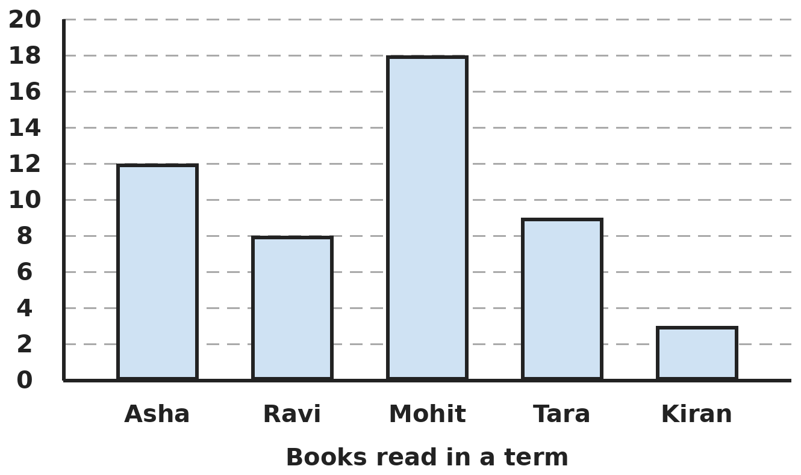
Q18. The bar graph shows the number of books five students read in a term. By how much does the mean number of books exceed the median?
(A) 0 | (B) 2 | (C) 9 | (D) 1

Q19. The data 3, 5, 5, 7, 8, 8, 8, x has mode 8 and median 7. What is x?
(A) 7 | (B) 6 | (C) 8 | (D) 5

Part 8 — Applied Mathematics (Syllabus Chapter 9)
Q20. 15 identical pumps can empty a tank in 8 hours. After 2 hours, 5 of the pumps break down. How long does it take to empty the tank in all?
(A) 12 hours | (B) 9 hours | (C) 11 hours | (D) 10 hours

Q21. On a map of scale 1 : 25,000, a rectangular park measures 8 cm by 6 cm. What is the real perimeter of the park?
(A) 70 km | (B) 0.7 km | (C) 3.5 km | (D) 7 km

Q22. 15 m of cloth costs ₹1,260. Shalini buys 22.5 m of the same cloth and is given 1/10 of the price off. How much does she pay?
(A) ₹1,701 | (B) ₹1,890 | (C) ₹1,764 | (D) ₹1,680

Part 9 — Mathematical Reasoning (Syllabus Chapter 10)
Q23. In the sum ABC + ABC + ABC = BBB, each letter stands for a different digit and ABC is a 3-digit number. What is A + B + C?
(A) 12 | (B) 13 | (C) 14 | (D) 15

Q24. Gauri pays exactly ₹50 using only ₹2 and ₹5 coins, with at least one coin of each kind. In how many different ways can she do it?
(A) 5 | (B) 4 | (C) 6 | (D) 3

Q25. 1 × 9 + 2 = 11, 12 × 9 + 3 = 111, 123 × 9 + 4 = 1,111. Following the pattern, what is 12,345 × 9 + 6?
(A) 11,111 | (B) 1,11,110 | (C) 11,11,111 | (D) 1,11,111

Part 10 — Mixed Problems (each joins two chapters)
Q26. The sum of five consecutive multiples of 7 is 455. What is the largest of them?
(A) 98 | (B) 105 | (C) 112 | (D) 91

Q27. Sana increases a number by 20%, then decreases the result by 20%, then increases that result by 20%. What is the overall change?
(A) An increase of 20% | (B) A decrease of 4%
(C) No change | (D) An increase of 15.2%

Q28. Lalit has 36 notes, all ₹10 or ₹50, worth ₹1,000 in all. How many ₹10 notes does he have?
(A) 16 | (B) 24 | (C) 20 | (D) 18

Q29. An open can (with no lid) is a cylinder of radius 7 cm and height 20 cm. How much tin is needed to make it? (π = 22/7)
(A) 1,034 cm² | (B) 1,188 cm² | (C) 880 cm² | (D) 3,080 cm²

Q30. Solve (2x − 1)/3 − (x + 2)/4 = −1/2. What is x?
(A) −4/5 | (B) 4/5 | (C) 8/5 | (D) 2/5

Answer Sheet AMO Level 2 · Class 7 · Practice Paper 2
Name: | School: | Roll No.:
Shade or tick one circle for each question.
1. | Ⓐ Ⓑ Ⓒ Ⓓ | 11. | Ⓐ Ⓑ Ⓒ Ⓓ | 21. | Ⓐ Ⓑ Ⓒ Ⓓ
2. | Ⓐ Ⓑ Ⓒ Ⓓ | 12. | Ⓐ Ⓑ Ⓒ Ⓓ | 22. | Ⓐ Ⓑ Ⓒ Ⓓ
3. | Ⓐ Ⓑ Ⓒ Ⓓ | 13. | Ⓐ Ⓑ Ⓒ Ⓓ | 23. | Ⓐ Ⓑ Ⓒ Ⓓ
4. | Ⓐ Ⓑ Ⓒ Ⓓ | 14. | Ⓐ Ⓑ Ⓒ Ⓓ | 24. | Ⓐ Ⓑ Ⓒ Ⓓ
5. | Ⓐ Ⓑ Ⓒ Ⓓ | 15. | Ⓐ Ⓑ Ⓒ Ⓓ | 25. | Ⓐ Ⓑ Ⓒ Ⓓ
6. | Ⓐ Ⓑ Ⓒ Ⓓ | 16. | Ⓐ Ⓑ Ⓒ Ⓓ | 26. | Ⓐ Ⓑ Ⓒ Ⓓ
7. | Ⓐ Ⓑ Ⓒ Ⓓ | 17. | Ⓐ Ⓑ Ⓒ Ⓓ | 27. | Ⓐ Ⓑ Ⓒ Ⓓ
8. | Ⓐ Ⓑ Ⓒ Ⓓ | 18. | Ⓐ Ⓑ Ⓒ Ⓓ | 28. | Ⓐ Ⓑ Ⓒ Ⓓ
9. | Ⓐ Ⓑ Ⓒ Ⓓ | 19. | Ⓐ Ⓑ Ⓒ Ⓓ | 29. | Ⓐ Ⓑ Ⓒ Ⓓ
10. | Ⓐ Ⓑ Ⓒ Ⓓ | 20. | Ⓐ Ⓑ Ⓒ Ⓓ | 30. | Ⓐ Ⓑ Ⓒ Ⓓ

For the parent or teacher
Correct: ______ / 30
Answer Key and Solutions AMO Level 2 · Class 7 · Practice Paper 2
Quick answers
1 D | 6 A | 11 B | 16 D | 21 D | 26 B
2 D | 7 D | 12 B | 17 C | 22 A | 27 D
3 C | 8 B | 13 C | 18 D | 23 B | 28 C
4 A | 9 A | 14 C | 19 A | 24 B | 29 A
5 C | 10 A | 15 B | 20 C | 25 D | 30 B
Solutions
Q | Part · level | Answer | Why?
1 | Part 1 · Ch1 · Hard | (D) 9/8 | Hint: Use the common denominator 24.  −3/8 + 5/12 − 1/6 = −9/24 + 10/24 − 4/24 = −3/24 = −1/8. To reach 1 he must add 1 + 1/8 = 9/8. (7/8 forgets that the sum is negative.)
2 | Part 1 · Ch1 · Hard | (D) 10 | Hint: Write −2/5 and 1/3 with denominator 15.  −2/5 = −6/15 and 1/3 = 5/15. Strictly between them p can be −5, −4, …, 3, 4. That is 10 values (remember to count 0).
3 | Part 1 · Ch1 · Hard | (C) 4/3 | Hint: Divide the product by the known number.  (−14/15) ÷ (−7/10) = (−14/15) × (−10/7) = 140/105 = 4/3. A negative divided by a negative is positive.
4 | Part 2 · Ch2 · Hard | (A) 8/3 | Hint: Break 6² into powers of 2 and 3, then cancel.  6² = 2² × 3², so the bottom is 2² × 3⁵ × 5³. Cancel 5³, and 2² from 2⁵, leaving 2³ on top. 3⁴ over 3⁵ leaves 1/3. The value is 2³ ÷ 3 = 8/3.
5 | Part 2 · Ch2 · Hard | (C) 4⁴ + 6³ | Hint: Work out each power, then do the operation.  2⁵ × 3² = 32 × 9 = 288. 4⁴ + 6³ = 256 + 216 = 472. 5⁴ − 3⁵ = 625 − 243 = 382. 9³ ÷ 3 = 729 ÷ 3 = 243. The largest is 4⁴ + 6³.
6 | Part 3 · Ch3 · Hard | (A) ₹2,052 | Hint: Take the second discount on the new price, not on ₹2,400.  After 10%: 2,400 − 240 = ₹2,160. After 5% of 2,160 (₹108): ₹2,052. (₹2,040 wrongly takes 15% of ₹2,400.)
7 | Part 3 · Ch3 · Hard | (D) ₹1,320 | Hint: First find the cost price: ₹1,140 is 95% of it.  Cost = 1,140 ÷ 0.95 = ₹1,200. For a 10% gain he must sell at 1,200 × 1.1 = ₹1,320. (₹1,254 adds 10% to ₹1,140.)
8 | Part 3 · Ch3 · Hard | (B) 44% | Hint: 92% passed in at least one subject.  Passed in at least one: 100 − 8 = 92%. Maths + Science = 72 + 64 = 136%, which counts the "both" group twice. Both = 136 − 92 = 44%.
9 | Part 4 · Ch4 · Hard | (A) 32 | Hint: x = 5x/8 + 12.  x − 5x/8 = 12, so 3x/8 = 12 and x = 32. Check: 5/8 of 32 is 20, and 20 + 12 = 32.
10 | Part 4 · Ch4 · Hard | (A) 240 cm² | Hint: Let the width be w. Then the length is 2w + 4.  2(w + 2w + 4) = 68, so 3w + 4 = 34 and w = 10. Length 24 cm. Area 24 × 10 = 240 cm².
11 | Part 4 · Ch4 · Hard | (B) 72 | Hint: Work out each term separately and watch the signs.  2a²b = 2 × 4 × 3 = 24. −3ab² = −3 × (−2) × 9 = 54. ab = −6. Total: 24 + 54 − 6 = 72.
12 | Part 5 · Ch5 · Hard | (B) 115° | Hint: Angles B and C add up to 130°. What do their halves add up to?  B + C = 180° − 50° = 130°, so B/2 + C/2 = 65°. In triangle BOC, angle BOC = 180° − 65° = 115°.
13 | Part 5 · Ch5 · Hard | (C) 20° | Hint: An exterior angle equals the sum of the two interior opposite angles.  The exterior angle at R = P + Q = P + 60°. So 4P = P + 60°, 3P = 60° and P = 20°. (Check: angle R = 180° − 80° = 100°, exterior 80° = 4 × 20°.)
14 | Part 5 · Ch5 · Hard | (C) The triangles need not be congruent | Hint: Is the equal angle between the two equal sides?  The 40° angle is at P, which is not between PQ and QR. Two sides with a non-included angle is not a congruence rule, so the triangles need not be congruent. SAS needs the angle between the two sides.
15 | Part 6 · Ch6 · Hard | (B) ₹132 | Hint: Change the radius to metres first: 35 cm = 0.35 m.  Curved surface = 2 × 22/7 × 0.35 × 4 = 8.8 m². Cost = 8.8 × 15 = ₹132. (₹264 uses the diameter as the radius.)
16 | Part 6 · Ch6 · Hard | (D) 792 cm² | Hint: First find the height.  Height = 1,440 ÷ (15 × 12) = 8 cm. Surface area = 2(15 × 12 + 12 × 8 + 15 × 8) = 2(180 + 96 + 120) = 792 cm².
17 | Part 6 · Ch6 · Hard | (C) 2,560 | Hint: Work in cm³ for both the wall and one brick.  Wall: 1,000 × 30 × 200 = 60,00,000 cm³. Brick: 25 × 12.5 × 7.5 = 2,343.75 cm³. Bricks: 60,00,000 ÷ 2,343.75 = 2,560.
18 | Part 7 · Ch8 · Hard | (D) 1 | Hint: Order the five values to find the median.  Values 12, 8, 18, 9, 3. Mean = 50 ÷ 5 = 10. In order: 3, 8, 9, 12, 18, so the median is 9. 10 − 9 = 1.
19 | Part 7 · Ch8 · Hard | (A) 7 | Hint: With 8 values, the median is the mean of the 4th and 5th values.  If x = 7: 3, 5, 5, 7, 7, 8, 8, 8, median (7 + 7)/2 = 7 and mode 8. If x = 6 the median is 6.5; if x = 8 or more it is 7.5; if x = 5 the mode is not only 8. So x = 7.
20 | Part 8 · Ch9 · Hard | (C) 11 hours | Hint: Count pump-hours: the whole job is 15 × 8 = 120 pump-hours.  First 2 hours: 15 × 2 = 30 pump-hours. Left: 90 pump-hours, done by 10 pumps in 9 hours. Total 2 + 9 = 11 hours.
21 | Part 8 · Ch9 · Hard | (D) 7 km | Hint: Find the perimeter on the map, then scale it. 1 km = 1,00,000 cm.  Map perimeter: 2 × (8 + 6) = 28 cm. Real perimeter: 28 × 25,000 = 7,00,000 cm = 7 km. (3.5 km uses only half the perimeter.)
22 | Part 8 · Ch9 · Hard | (A) ₹1,701 | Hint: Find the full price of 22.5 m first.  1 m costs 1,260 ÷ 15 = ₹84. 22.5 m cost 22.5 × 84 = ₹1,890. 1/10 off is ₹189, so she pays 1,890 − 189 = ₹1,701.
23 | Part 9 · Ch10 · Hard | (B) 13 | Hint: 3 × ABC = BBB = B × 111 = B × 3 × 37, so ABC = 37 × B.  ABC = 37B and its middle digit must be B. B = 4 gives 148, whose middle digit is 4. (37 × 3 = 111, 37 × 5 = 185, 37 × 6 = 222, … all fail.) 148 + 148 + 148 = 444. A + B + C = 1 + 4 + 8 = 13.
24 | Part 9 · Ch10 · Hard | (B) 4 | Hint: The number of ₹5 coins must be even. Why?  The ₹5 coins must make an even amount, so their number is even: 2, 4, 6 or 8 (10 would leave no ₹2 coins). These give 20, 15, 10 and 5 coins of ₹2. That is 4 ways.
25 | Part 9 · Ch10 · Hard | (D) 1,11,111 | Hint: Count how many 1s each answer has.  A number made of n digits 1, 2, …, n gives an answer of n + 1 ones. 12,345 has 5 digits, so the answer has six 1s: 1,11,111.
26 | Part 10 · Mixed · Ch4 + Ch10 · Hard | (B) 105 | Hint: The middle multiple is the average of the five.  The middle multiple is 455 ÷ 5 = 91. The five are 77, 84, 91, 98, 105. The largest is 105.
27 | Part 10 · Mixed · Ch3 + Ch10 · Hard | (D) An increase of 15.2% | Hint: Multiply by 1.2, then 0.8, then 1.2.  1.2 × 0.8 × 1.2 = 1.152, so the number goes up by 15.2%. (A rise and fall of 20% are not equal changes.)
28 | Part 10 · Mixed · Ch4 + Ch9 · Hard | (C) 20 | Hint: Let the number of ₹50 notes be x. Then there are 36 − x notes of ₹10.  50x + 10(36 − x) = 1,000, so 40x + 360 = 1,000 and x = 16. He has 16 notes of ₹50 and 20 notes of ₹10.
29 | Part 10 · Mixed · Ch5 + Ch6 · Hard | (A) 1,034 cm² | Hint: Only one circle is needed: the base.  Curved surface: 2 × 22/7 × 7 × 20 = 880 cm². Base: 22/7 × 7 × 7 = 154 cm². Total 880 + 154 = 1,034 cm². (1,188 includes a lid.)
30 | Part 10 · Mixed · Ch1 + Ch4 · Hard | (B) 4/5 | Hint: Multiply every term by 12.  4(2x − 1) − 3(x + 2) = −6, so 8x − 4 − 3x − 6 = −6, giving 5x = 4 and x = 4/5.

ARYABHATTA MATHS OLYMPIAD
Level 2
PRACTICE PAPER-3
CLASS 7
Total Questions | 30 multiple-choice questions
Level | Level-2 (final round): every question is Hard
Time | 45 minutes
Arrangement | Parts by chapter; the last Part has mixed problems joining two chapters
Negative Marking | No negative marking
Calculator | Not allowed
Chapters | Number System · Operations · Fractions, Decimals & Percentages · Algebra · Geometry · Mensuration · Data Handling, Statistics & Probability · Applied Mathematics · Mathematical Reasoning

Instructions
• Each question has four options, (A) to (D), with exactly one correct answer.
• The questions are grouped in Parts by chapter. The last Part has mixed problems, each joining two chapters.
• Every question is at Level-2 (Hard) standard: expect several steps or a key insight.
• There is no negative marking. Calculators are not allowed; use a separate sheet for rough work.
• Figures are not necessarily drawn to scale unless stated.

For teachers
• Figures are part of the questions and work when printed in black and white.
• Parts follow the AMO syllabus chapters. Chapter 7 is not part of the Class 7 syllabus, so the chapter numbers shown in the Part headings have gaps.
• The answer sheet and the answer key are at the end. Remove the answer key before the paper is attempted.

Part 1 — Number System (Syllabus Chapter 1)
Q1. Which is greater, −5/7 or −7/9, and by how much?
(A) −7/9, by 4/63 | (B) −5/7, by 4/63
(C) −5/7, by 2/63 | (D) They are equal

Q2. Nikhil takes the reciprocal of −3/8, then the additive inverse of that, and finally adds 1. What does he get?
(A) −5/3 | (B) 5/3 | (C) −11/3 | (D) 11/3

Q3. Ramesh cuts 3/8 of a 24 m rope. Then he cuts 2/5 of the rope that is left. How much rope remains?
(A) 6 m | (B) 5.4 m | (C) 9 m | (D) 15 m

Part 2 — Operations (Syllabus Chapter 2)
Q4. Without multiplying out, find the value of (9² × 8 × 5³) ÷ (6³ × 3 × 10²).
(A) 4/5 | (B) 5/4 | (C) 5/2 | (D) 1

Q5. A town has 4 × 10³ families. Each family uses 1.5 × 10² litres of water a day. A tank holds 2 × 10⁵ litres. How many full tanks does the town use in a day?
(A) 3 | (B) 30 | (C) 0.3 | (D) 6

Part 3 — Fractions, Decimals & Percentages (Syllabus Chapter 3)
Q6. The cost price of 12 pens equals the selling price of 10 pens. What is the profit percent?
(A) 16 2/3% | (B) 2% | (C) 25% | (D) 20%

Q7. A shop offers "Buy 4, get 1 free" on notebooks, and then a further 5% off the bill. What single discount on 5 notebooks does this equal?
(A) 24% | (B) 25% | (C) 20% | (D) 15%

Q8. A town of 50,000 people grows by 10% in one year and then falls by 10% the next year. What is the population after two years?
(A) 50,000 | (B) 49,500 | (C) 49,000 | (D) 50,500

Part 4 — Algebra (Syllabus Chapter 4)
Q9. A father is three times as old as his son. In 12 years he will be twice as old as his son. How old is the father now?
(A) 36 years | (B) 12 years | (C) 24 years | (D) 48 years

Q10. Simplify 5(2x − 3y) − 3(3x − 4y) + 2(x + y) and find its value when x = 4 and y = −5.
(A) 7 | (B) −17 | (C) 17 | (D) 22

Q11. The denominator of a fraction is 8 more than its numerator. If 17 is added to the numerator and 1 to the denominator, the fraction becomes 3/2. What is the fraction?
(A) 5/13 | (B) 9/17 | (C) 3/11 | (D) 7/15

Part 5 — Geometry (Syllabus Chapter 5)
Q12. In a parallelogram, one angle is 24° less than twice the angle next to it. What is the smaller angle of the parallelogram?
(A) 68° | (B) 112° | (C) 56° | (D) 78°

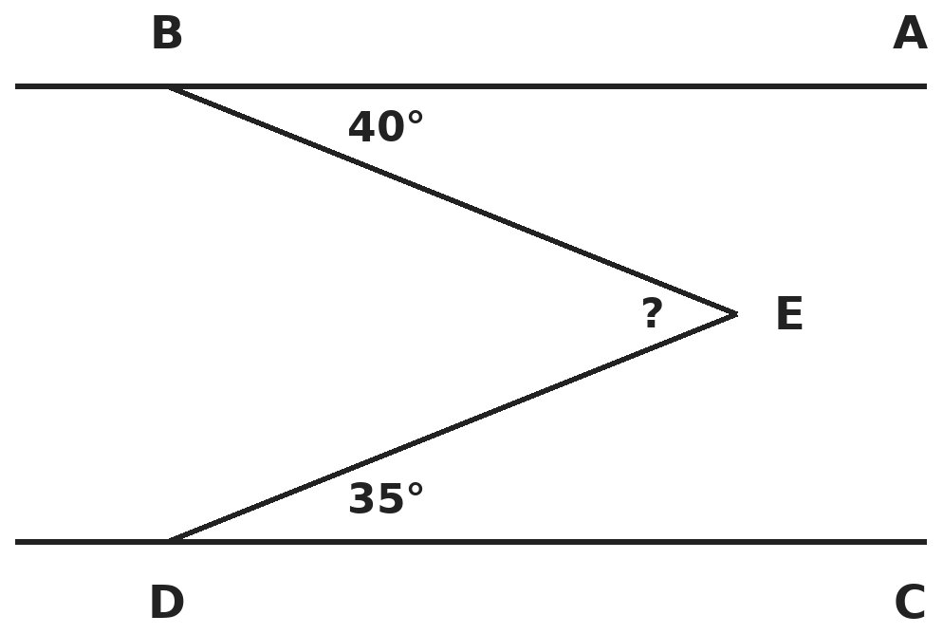
Q13. AB ∥ CD. Angle ABE = 40° and angle CDE = 35°, as marked. What is angle BED?
(A) 105° | (B) 5° | (C) 75° | (D) 140°

Q14. The angles of triangle ABC are A = x, B = 2x and C = 3x. The bisector of angle C meets AB at D. What is angle ADC?
(A) 75° | (B) 135° | (C) 45° | (D) 105°

Part 6 — Mensuration (Syllabus Chapter 6)
Q15. A cylindrical jar of radius 7 cm and height 12 cm is full of water. The water is poured into an empty tank with a rectangular base 22 cm × 14 cm. How high does the water rise? (π = 22/7)
(A) 12 cm | (B) 8.4 cm | (C) 6 cm | (D) 4 cm

Q16. A cube of edge 4 cm is painted on all faces and then cut into 1 cm cubes. How many small cubes have exactly one painted face?
(A) 8 | (B) 24 | (C) 32 | (D) 16

Q17. A room is 6 m long, 5 m wide and 3 m high. Its four walls and ceiling are painted at ₹20 per m², leaving out a door 2 m × 1 m and a window 1.5 m × 1 m. What is the cost?
(A) ₹1,920 | (B) ₹1,320 | (C) ₹1,850 | (D) ₹2,520

Part 7 — Data Handling, Statistics & Probability (Syllabus Chapter 8)
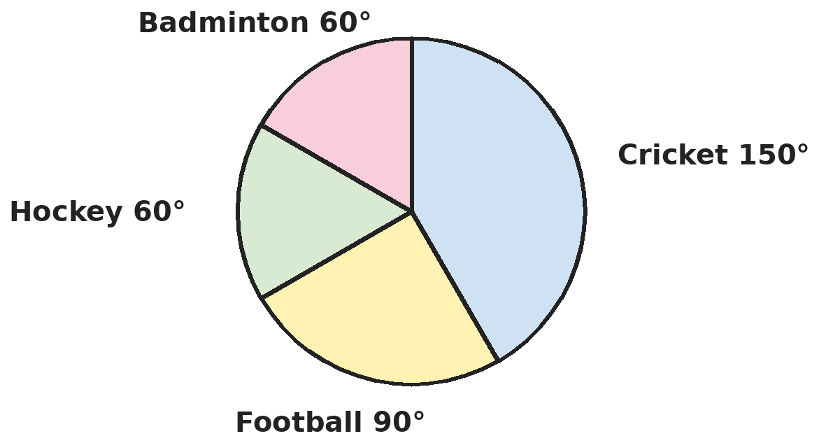
Q18. The pie chart shows the favourite sports of 720 students. 1/3 of the cricket fans are girls, and all the other girls chose badminton. There are 200 girls in all. How many badminton fans are boys?
(A) 40 | (B) 100 | (C) 120 | (D) 20

Q19. The mean of 10 numbers was found to be 25. Later it was found that 34 had been read as 43. What is the correct mean?
(A) 24.1 | (B) 25.9 | (C) 24.9 | (D) 24

Part 8 — Applied Mathematics (Syllabus Chapter 9)
Q20. ₹5,200 is shared among Anil, Bhavna and Chetan in the ratio 1/2 : 1/3 : 1/4. How much does Bhavna get?
(A) ₹1,733 | (B) ₹2,400 | (C) ₹1,600 | (D) ₹1,200

Q21. A camp has food for 200 soldiers for 30 days. After 6 days, 40 more soldiers join. How many more days will the food last?
(A) 20 | (B) 24 | (C) 16 | (D) 25

Q22. A train 360 m long passes a pole in 18 seconds. How long does it take to cross a platform 240 m long?
(A) 12 s | (B) 18 s | (C) 48 s | (D) 30 s

Part 9 — Mathematical Reasoning (Syllabus Chapter 10)
Q23. In AB × AB = CAB, the letters stand for different digits, AB is a 2-digit number and CAB is a 3-digit number. What digit is C?
(A) 5 | (B) 6 | (C) 2 | (D) 1

Q24. How many 2-digit numbers have digits whose product is 12?
(A) 6 | (B) 2 | (C) 4 | (D) 5

Q25. What is the remainder when 3⁵ + 4⁵ is divided by 7?
(A) 1 | (B) 0 | (C) 2 | (D) 4

Part 10 — Mixed Problems (each joins two chapters)
Q26. For how many whole numbers n from 1 to 50 is 3n + 2 a multiple of 7?
(A) 8 | (B) 7 | (C) 6 | (D) 5

Q27. A machine worth ₹10,000 loses 10% of its value every year. At the end of which year is its value first below ₹7,000?
(A) 4th year | (B) 3rd year | (C) 5th year | (D) 7th year

Q28. A 60 L mixture has milk and water in the ratio 7 : 3. How much water must be added to make the ratio 3 : 2?
(A) 8 L | (B) 12 L | (C) 6 L | (D) 10 L

Q29. A rectangular sheet 66 cm by 10 cm is rolled along its 66 cm side, so the edges just meet, to make a hollow cylinder 10 cm tall. What volume does the cylinder hold? (π = 22/7)
(A) 3,465 cm³ | (B) 13,860 cm³ | (C) 6,930 cm³ | (D) 660 cm³

Q30. What is the value of (x + y) ÷ (x − y) when x = −3/4 and y = 2/3?
(A) −1/17 | (B) 1/17 | (C) 17 | (D) −17

Answer Sheet AMO Level 2 · Class 7 · Practice Paper 3
Name: | School: | Roll No.:
Shade or tick one circle for each question.
1. | Ⓐ Ⓑ Ⓒ Ⓓ | 11. | Ⓐ Ⓑ Ⓒ Ⓓ | 21. | Ⓐ Ⓑ Ⓒ Ⓓ
2. | Ⓐ Ⓑ Ⓒ Ⓓ | 12. | Ⓐ Ⓑ Ⓒ Ⓓ | 22. | Ⓐ Ⓑ Ⓒ Ⓓ
3. | Ⓐ Ⓑ Ⓒ Ⓓ | 13. | Ⓐ Ⓑ Ⓒ Ⓓ | 23. | Ⓐ Ⓑ Ⓒ Ⓓ
4. | Ⓐ Ⓑ Ⓒ Ⓓ | 14. | Ⓐ Ⓑ Ⓒ Ⓓ | 24. | Ⓐ Ⓑ Ⓒ Ⓓ
5. | Ⓐ Ⓑ Ⓒ Ⓓ | 15. | Ⓐ Ⓑ Ⓒ Ⓓ | 25. | Ⓐ Ⓑ Ⓒ Ⓓ
6. | Ⓐ Ⓑ Ⓒ Ⓓ | 16. | Ⓐ Ⓑ Ⓒ Ⓓ | 26. | Ⓐ Ⓑ Ⓒ Ⓓ
7. | Ⓐ Ⓑ Ⓒ Ⓓ | 17. | Ⓐ Ⓑ Ⓒ Ⓓ | 27. | Ⓐ Ⓑ Ⓒ Ⓓ
8. | Ⓐ Ⓑ Ⓒ Ⓓ | 18. | Ⓐ Ⓑ Ⓒ Ⓓ | 28. | Ⓐ Ⓑ Ⓒ Ⓓ
9. | Ⓐ Ⓑ Ⓒ Ⓓ | 19. | Ⓐ Ⓑ Ⓒ Ⓓ | 29. | Ⓐ Ⓑ Ⓒ Ⓓ
10. | Ⓐ Ⓑ Ⓒ Ⓓ | 20. | Ⓐ Ⓑ Ⓒ Ⓓ | 30. | Ⓐ Ⓑ Ⓒ Ⓓ

For the parent or teacher
Correct: ______ / 30
Answer Key and Solutions AMO Level 2 · Class 7 · Practice Paper 3
Quick answers
1 B | 6 D | 11 D | 16 B | 21 A | 26 B
2 D | 7 A | 12 A | 17 C | 22 D | 27 A
3 C | 8 B | 13 C | 18 D | 23 B | 28 D
4 B | 9 A | 14 D | 19 A | 24 C | 29 A
5 A | 10 C | 15 C | 20 C | 25 B | 30 B
Solutions
Q | Part · level | Answer | Why?
1 | Part 1 · Ch1 · Hard | (B) −5/7, by 4/63 | Hint: Write both with denominator 63.  −5/7 = −45/63 and −7/9 = −49/63. −45 is greater than −49, so −5/7 is greater, by 4/63.
2 | Part 1 · Ch1 · Hard | (D) 11/3 | Hint: The reciprocal keeps the sign; the additive inverse changes it.  Reciprocal of −3/8 is −8/3. Its additive inverse is 8/3. 8/3 + 1 = 11/3.
3 | Part 1 · Ch1 · Hard | (C) 9 m | Hint: The second cut is 2/5 of what is left, not of 24 m.  After the first cut: 5/8 × 24 = 15 m. The second cut takes 2/5 × 15 = 6 m, leaving 9 m.
4 | Part 2 · Ch2 · Hard | (B) 5/4 | Hint: Write every number as a product of powers of 2, 3 and 5.  Top: 3⁴ × 2³ × 5³. Bottom: 6³ × 3 × 10² = 2³ × 3³ × 3 × 2² × 5² = 2⁵ × 3⁴ × 5². Cancel 3⁴, 2³ and 5²: what is left is 5 ÷ 2² = 5/4.
5 | Part 2 · Ch2 · Hard | (A) 3 | Hint: Find the total water used in standard form first.  Water used: 4 × 1.5 = 6 and 10³ × 10² = 10⁵, so 6 × 10⁵ litres. Tanks: (6 × 10⁵) ÷ (2 × 10⁵) = 3.
6 | Part 3 · Ch3 · Hard | (D) 20% | Hint: Let each pen cost ₹1.  If each pen costs ₹1, then 10 pens sell for ₹12, so each sells for ₹1.20. Profit 20 paise on ₹1 = 20%. (16 2/3% divides by 12 instead of 10.)
7 | Part 3 · Ch3 · Hard | (A) 24% | Hint: Let each notebook cost ₹100. What do you pay for 5?  5 notebooks are worth ₹500. You pay for 4: ₹400, then 5% off: ₹380. Saving ₹120 on ₹500 = 24%.
8 | Part 3 · Ch3 · Hard | (B) 49,500 | Hint: The 10% fall is of the larger number.  After year 1: 55,000. After year 2: 55,000 − 5,500 = 49,500.
9 | Part 4 · Ch4 · Hard | (A) 36 years | Hint: Let the son be x years old.  3x + 12 = 2(x + 12), so 3x + 12 = 2x + 24 and x = 12. The father is 36.
10 | Part 4 · Ch4 · Hard | (C) 17 | Hint: Simplify first: collect the x terms and the y terms.  10x − 15y − 9x + 12y + 2x + 2y = 3x − y. At x = 4, y = −5: 12 + 5 = 17.
11 | Part 4 · Ch4 · Hard | (D) 7/15 | Hint: Let the fraction be x/(x + 8).  (x + 17)/(x + 9) = 3/2, so 2x + 34 = 3x + 27 and x = 7. The fraction is 7/15. Check: 24/16 = 3/2.
12 | Part 5 · Ch5 · Hard | (A) 68° | Hint: Adjacent angles of a parallelogram add up to 180°.  x + (2x − 24) = 180, so 3x = 204 and x = 68°. The other angle is 112°. The smaller is 68°.
13 | Part 5 · Ch5 · Hard | (C) 75° | Hint: Draw a line through E parallel to AB and use alternate angles.  A line through E parallel to AB splits angle BED into two parts: 40° (alternate to angle ABE) and 35° (alternate to angle CDE). So angle BED = 40° + 35° = 75°.
14 | Part 5 · Ch5 · Hard | (D) 105° | Hint: Find x first, then look at triangle ADC.  x + 2x + 3x = 180°, so x = 30°: A = 30°, B = 60°, C = 90°. The bisector makes angle ACD = 45°. In triangle ADC: angle ADC = 180° − 30° − 45° = 105°.
15 | Part 6 · Ch6 · Hard | (C) 6 cm | Hint: The volume of water stays the same.  Volume = 22/7 × 7 × 7 × 12 = 1,848 cm³. Height in the tank = 1,848 ÷ (22 × 14) = 1,848 ÷ 308 = 6 cm.
16 | Part 6 · Ch6 · Hard | (B) 24 | Hint: Look at one face: which of its 16 small squares are not on an edge?  On each face, the inner 2 × 2 = 4 cubes have only that face painted. 6 faces × 4 = 24. (The 8 corner cubes have three painted faces.)
17 | Part 6 · Ch6 · Hard | (C) ₹1,850 | Hint: Walls: 2 × (length + width) × height.  Walls: 2 × 11 × 3 = 66 m². Ceiling: 30 m². Less door and window: 2 + 1.5 = 3.5 m². Area: 92.5 m². Cost: 92.5 × 20 = ₹1,850.
18 | Part 7 · Ch8 · Hard | (D) 20 | Hint: Each degree stands for 720 ÷ 360 students.  Each degree is 2 students. Cricket: 150° = 300 students, so 100 girls. The other 100 girls all chose badminton. Badminton: 60° = 120 students, so 120 − 100 = 20 are boys.
19 | Part 7 · Ch8 · Hard | (A) 24.1 | Hint: Find the wrong total first.  Wrong total: 250. Correct total: 250 − 43 + 34 = 241. Correct mean: 24.1.
20 | Part 8 · Ch9 · Hard | (C) ₹1,600 | Hint: Multiply the ratio by 12 to clear the fractions.  1/2 : 1/3 : 1/4 = 6 : 4 : 3 (13 parts). One part = 5,200 ÷ 13 = ₹400. Bhavna gets 4 × 400 = ₹1,600.
21 | Part 8 · Ch9 · Hard | (A) 20 | Hint: Food left after 6 days feeds 200 soldiers for 24 days.  Food left: 200 × 24 = 4,800 soldier-days. Now 240 soldiers: 4,800 ÷ 240 = 20 days.
22 | Part 8 · Ch9 · Hard | (D) 30 s | Hint: To cross the platform the train must cover its own length plus the platform.  Speed = 360 ÷ 18 = 20 m/s. Distance = 360 + 240 = 600 m. Time = 600 ÷ 20 = 30 s.
23 | Part 9 · Ch10 · Hard | (B) 6 | Hint: The square of AB must end in the digits of AB itself.  AB × AB ends in AB. A square ending in its own last two digits is 25 or 76 (or 00, 01). 76 × 76 = 5,776 has 4 digits, so AB = 25 and 25 × 25 = 625. So C = 6.
24 | Part 9 · Ch10 · Hard | (C) 4 | Hint: Write 12 as a product of two single digits.  12 = 2 × 6 = 3 × 4. The numbers are 26, 62, 34 and 43. (1 × 12 is not allowed because 12 is not a digit.) That is 4.
25 | Part 9 · Ch10 · Hard | (B) 0 | Hint: Work out the powers, or notice that 3 + 4 = 7.  3⁵ + 4⁵ = 243 + 1,024 = 1,267 = 7 × 181, so the remainder is 0. (For odd powers, aⁿ + bⁿ is always divisible by a + b.)
26 | Part 10 · Mixed · Ch4 + Ch10 · Hard | (B) 7 | Hint: Find the first n that works, then see how often it repeats.  n = 4 gives 14, the first multiple of 7. Adding 7 to n adds 21 to 3n + 2, which keeps it a multiple of 7. So n = 4, 11, 18, 25, 32, 39, 46: 7 numbers.
27 | Part 10 · Mixed · Ch3 + Ch10 · Hard | (A) 4th year | Hint: Each year the value is multiplied by 0.9.  Year 1: 9,000. Year 2: 8,100. Year 3: 7,290. Year 4: 6,561, which is the first value below ₹7,000.
28 | Part 10 · Mixed · Ch4 + Ch9 · Hard | (D) 10 L | Hint: The milk does not change. Find it first.  Milk: 7/10 × 60 = 42 L. Water: 18 L. For 3 : 2, the water must be 42 × 2/3 = 28 L. Add 28 − 18 = 10 L.
29 | Part 10 · Mixed · Ch5 + Ch6 · Hard | (A) 3,465 cm³ | Hint: The 66 cm side becomes the circumference of the base.  2 × 22/7 × r = 66, so r = 10.5 cm. Volume = 22/7 × 10.5 × 10.5 × 10 = 3,465 cm³. (660 is just 66 × 10.)
30 | Part 10 · Mixed · Ch1 + Ch4 · Hard | (B) 1/17 | Hint: Use the denominator 12.  x + y = −9/12 + 8/12 = −1/12. x − y = −9/12 − 8/12 = −17/12. (−1/12) ÷ (−17/12) = 1/17.

ARYABHATTA MATHS OLYMPIAD
Level 2
PRACTICE PAPER-4
CLASS 7
Total Questions | 30 multiple-choice questions
Level | Level-2 (final round): every question is Hard
Time | 45 minutes
Arrangement | Parts by chapter; the last Part has mixed problems joining two chapters
Negative Marking | No negative marking
Calculator | Not allowed
Chapters | Number System · Operations · Fractions, Decimals & Percentages · Algebra · Geometry · Mensuration · Data Handling, Statistics & Probability · Applied Mathematics · Mathematical Reasoning

Instructions
• Each question has four options, (A) to (D), with exactly one correct answer.
• The questions are grouped in Parts by chapter. The last Part has mixed problems, each joining two chapters.
• Every question is at Level-2 (Hard) standard: expect several steps or a key insight.
• There is no negative marking. Calculators are not allowed; use a separate sheet for rough work.
• Figures are not necessarily drawn to scale unless stated.

For teachers
• Figures are part of the questions and work when printed in black and white.
• Parts follow the AMO syllabus chapters. Chapter 7 is not part of the Class 7 syllabus, so the chapter numbers shown in the Part headings have gaps.
• The answer sheet and the answer key are at the end. Remove the answer key before the paper is attempted.

Part 1 — Number System (Syllabus Chapter 1)
Q1. How many fractions of the form p/60, where p is an integer, lie strictly between 1/4 and 1/3?
(A) 5 | (B) 3 | (C) 4 | (D) 6

Q2. What is the value of (−2/3) × (3/5) + 5/2 − (3/5) × (1/6)?
(A) 2 | (B) −2 | (C) 12/5 | (D) 8/5

Q3. A rational number added to its reciprocal gives 13/6. Which of these could the number be?
(A) 5/6 | (B) 2 | (C) 3/2 | (D) 6/13

Part 2 — Operations (Syllabus Chapter 2)
Q4. What is (2⁵ + 2⁵ + 2⁵ + 2⁵) ÷ 4³?
(A) 1/2 | (B) 2 | (C) 4 | (D) 8

Q5. How many zeros are at the end of the number 2⁵ × 5³ × 10²?
(A) 5 | (B) 7 | (C) 3 | (D) 10

Part 3 — Fractions, Decimals & Percentages (Syllabus Chapter 3)
Q6. A shopkeeper sells a fan at a 20% profit. If he had bought it for 10% less and sold it for ₹18 less, his profit would have been 30%. What is the cost price?
(A) ₹540 | (B) ₹600 | (C) ₹720 | (D) ₹500

Q7. Riya scored 72 out of 90 in Maths and 68 out of 80 in Science. English is out of 50. What must she score in English for her overall percentage in the three subjects to be 85%?
(A) 47 | (B) 45 | (C) 42 | (D) 50

Q8. Each shirt costs ₹600. Shop P offers "Buy 3, get 1 free". Shop Q offers 25% off. Kunal needs exactly 4 shirts. Which is cheaper?
(A) Shop P is cheaper | (B) Both cost the same
(C) Shop Q is cheaper | (D) Shop P, by ₹150

Part 4 — Algebra (Syllabus Chapter 4)
Q9. The digits of a 2-digit number add up to 9. When the digits are reversed, the number increases by 27. What is the number?
(A) 63 | (B) 36 | (C) 45 | (D) 27

Q10. Simplify (3x² − 5x + 2) − (x² − 2x − 4) + (−x² + x) and find its value when x = −2.
(A) 6 | (B) −2 | (C) 14 | (D) 10

Q11. A box has ₹1, ₹2 and ₹5 coins in the ratio 5 : 3 : 2 by number. Together they are worth ₹189. How many ₹2 coins are there?
(A) 18 | (B) 45 | (C) 27 | (D) 9

Part 5 — Geometry (Syllabus Chapter 5)
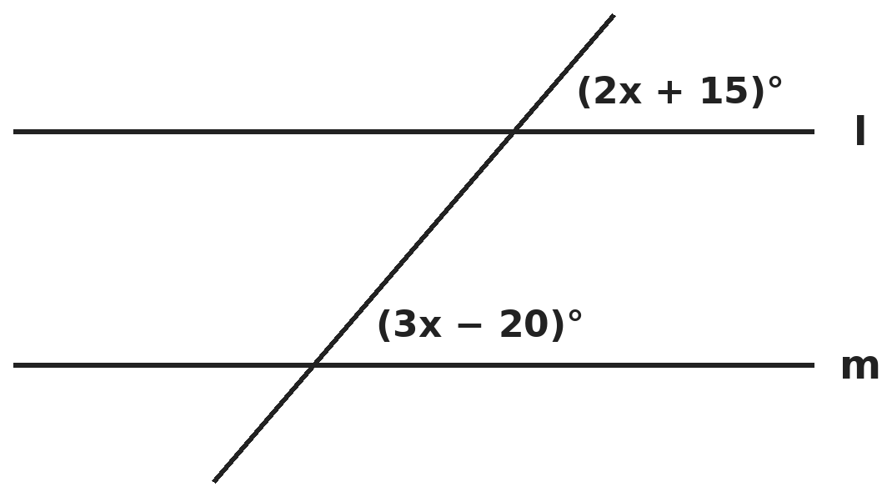
Q12. Lines l and m are parallel and the two marked angles are corresponding angles. What is the size of the angle that is co-interior with the angle marked (3x − 20)°?
(A) 85° | (B) 95° | (C) 35° | (D) 105°

Q13. In quadrilateral ABCD, side AB is parallel to side DC. Angle A = 65° and angle B = 75°. What is angle C?
(A) 115° | (B) 75° | (C) 65° | (D) 105°

Q14. In an isosceles triangle the vertex angle is twice each base angle. What is the exterior angle at one end of the base?
(A) 90° | (B) 45° | (C) 120° | (D) 135°

Part 6 — Mensuration (Syllabus Chapter 6)
Q15. A cuboid box has volume 4,500 cm³. Its length is 25 cm and its breadth is 12 cm. What is its total surface area?
(A) 855 cm² | (B) 4,500 cm² | (C) 1,710 cm² | (D) 1,350 cm²

Q16. The heights of two cylinders are in the ratio 1 : 2 and their radii are in the ratio 2 : 1. What is the ratio of their volumes?
(A) 1 : 2 | (B) 4 : 1 | (C) 1 : 1 | (D) 2 : 1

Q17. During a storm, 2 cm of rain falls on a flat roof 44 m × 35 m. All of it flows into an empty cylindrical tank of radius 1.4 m. How high does the water rise in the tank? (π = 22/7)
(A) 5 m | (B) 2.5 m | (C) 10 m | (D) 4 m

Part 7 — Data Handling, Statistics & Probability (Syllabus Chapter 8)
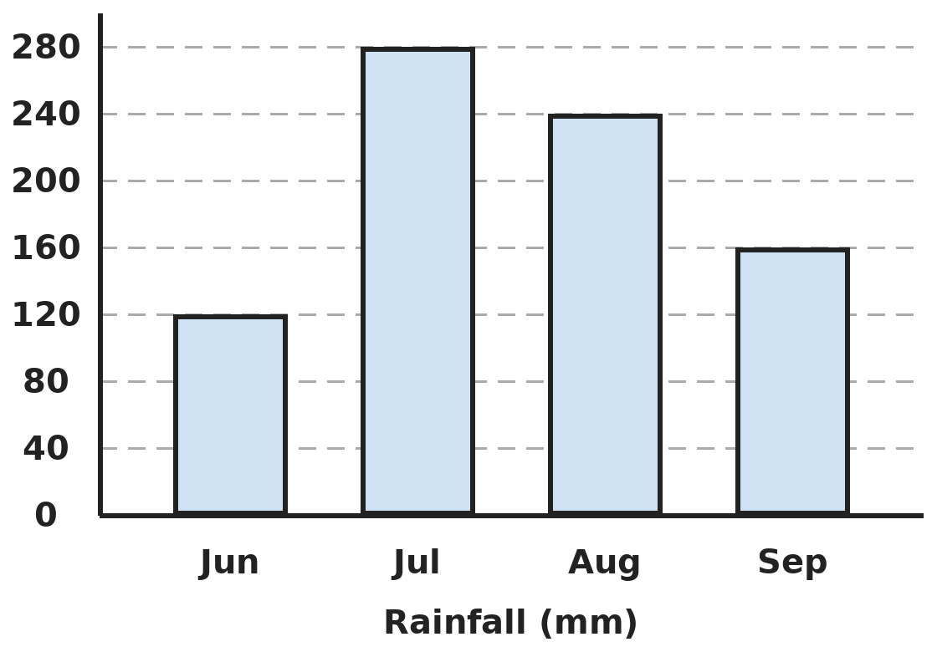
Q18. The bar graph shows the rainfall in four monsoon months. In how many of these months was the rainfall more than the mean rainfall of the four months?
(A) 2 | (B) 1 | (C) 3 | (D) 4

Q19. What is the difference between the mean and the median of the first ten prime numbers?
(A) 1 | (B) 0.1 | (C) 0.9 | (D) 1.9

Part 8 — Applied Mathematics (Syllabus Chapter 9)
Q20. 6 identical taps fill a tank in 4 hours. Leela opens 8 taps, and after 1 hour she closes 2 of them. How long does it take to fill the tank in all?
(A) 4 h | (B) 3 h | (C) 4 h 20 min | (D) 3 h 40 min

Q21. ₹1,800 is shared between Sita and Gita in the ratio 4 : 5. Then Sita gives ₹100 to Gita. What is the new ratio of their money?
(A) 4 : 5 | (B) 7 : 11 | (C) 3 : 4 | (D) 8 : 11

Q22. Walking at 5 km/h, Kabir reaches school 10 minutes late. Walking at 6 km/h, he reaches 5 minutes early. How far is the school?
(A) 6 km | (B) 7.5 km | (C) 5 km | (D) 9 km

Part 9 — Mathematical Reasoning (Syllabus Chapter 10)
Q23. A and B are digits and AB is a 2-digit number. AB × 9 = A0B, a 3-digit number with 0 in the middle. What is A + B?
(A) 9 | (B) 8 | (C) 10 | (D) 7

Q24. How many whole numbers from 1 to 100 are divisible by 3 or by 5 (or both)?
(A) 53 | (B) 46 | (C) 47 | (D) 40

Q25. What is 1/(1 × 2) + 1/(2 × 3) + 1/(3 × 4) + … + 1/(9 × 10)?
(A) 1 | (B) 10/11 | (C) 9/10 | (D) 1/10

Part 10 — Mixed Problems (each joins two chapters)
Q26. Om thinks of a number. He multiplies it by 4, adds 6, divides by 2 and then subtracts twice the number he first thought of. What is his final answer?
(A) 6 | (B) 2
(C) It depends on the number | (D) 3

Q27. What percent of the whole numbers from 1 to 100 are perfect squares or perfect cubes (or both)?
(A) 14% | (B) 10% | (C) 13% | (D) 12%

Q28. Two classes have students in the ratio 5 : 8. When 12 students leave each class, the ratio becomes 2 : 5. How many students were there in the two classes at first?
(A) 39 | (B) 52 | (C) 65 | (D) 40

Q29. A park 60 m × 40 m has two roads, each 5 m wide, crossing at right angles through the middle, parallel to the sides. What is the total area of the roads?
(A) 475 m² | (B) 500 m² | (C) 450 m² | (D) 525 m²

Q30. Solve (x − 1/2) ÷ (x + 1/3) = 1/2. What is x?
(A) −4/3 | (B) 2/3 | (C) 5/6 | (D) 4/3

Answer Sheet AMO Level 2 · Class 7 · Practice Paper 4
Name: | School: | Roll No.:
Shade or tick one circle for each question.
1. | Ⓐ Ⓑ Ⓒ Ⓓ | 11. | Ⓐ Ⓑ Ⓒ Ⓓ | 21. | Ⓐ Ⓑ Ⓒ Ⓓ
2. | Ⓐ Ⓑ Ⓒ Ⓓ | 12. | Ⓐ Ⓑ Ⓒ Ⓓ | 22. | Ⓐ Ⓑ Ⓒ Ⓓ
3. | Ⓐ Ⓑ Ⓒ Ⓓ | 13. | Ⓐ Ⓑ Ⓒ Ⓓ | 23. | Ⓐ Ⓑ Ⓒ Ⓓ
4. | Ⓐ Ⓑ Ⓒ Ⓓ | 14. | Ⓐ Ⓑ Ⓒ Ⓓ | 24. | Ⓐ Ⓑ Ⓒ Ⓓ
5. | Ⓐ Ⓑ Ⓒ Ⓓ | 15. | Ⓐ Ⓑ Ⓒ Ⓓ | 25. | Ⓐ Ⓑ Ⓒ Ⓓ
6. | Ⓐ Ⓑ Ⓒ Ⓓ | 16. | Ⓐ Ⓑ Ⓒ Ⓓ | 26. | Ⓐ Ⓑ Ⓒ Ⓓ
7. | Ⓐ Ⓑ Ⓒ Ⓓ | 17. | Ⓐ Ⓑ Ⓒ Ⓓ | 27. | Ⓐ Ⓑ Ⓒ Ⓓ
8. | Ⓐ Ⓑ Ⓒ Ⓓ | 18. | Ⓐ Ⓑ Ⓒ Ⓓ | 28. | Ⓐ Ⓑ Ⓒ Ⓓ
9. | Ⓐ Ⓑ Ⓒ Ⓓ | 19. | Ⓐ Ⓑ Ⓒ Ⓓ | 29. | Ⓐ Ⓑ Ⓒ Ⓓ
10. | Ⓐ Ⓑ Ⓒ Ⓓ | 20. | Ⓐ Ⓑ Ⓒ Ⓓ | 30. | Ⓐ Ⓑ Ⓒ Ⓓ

For the parent or teacher
Correct: ______ / 30
Answer Key and Solutions AMO Level 2 · Class 7 · Practice Paper 4
Quick answers
1 C | 6 B | 11 C | 16 D | 21 B | 26 D
2 A | 7 A | 12 B | 17 A | 22 B | 27 D
3 C | 8 B | 13 D | 18 A | 23 A | 28 B
4 B | 9 B | 14 D | 19 C | 24 C | 29 A
5 A | 10 C | 15 C | 20 D | 25 C | 30 D
Solutions
Q | Part · level | Answer | Why?
1 | Part 1 · Ch1 · Hard | (C) 4 | Hint: Write 1/4 and 1/3 with denominator 60.  1/4 = 15/60 and 1/3 = 20/60. Strictly between them p = 16, 17, 18, 19. That is 4 fractions.
2 | Part 1 · Ch1 · Hard | (A) 2 | Hint: Do the two products first, then add using the denominator 10.  (−2/3)(3/5) = −2/5 and (3/5)(1/6) = 1/10. So −4/10 + 25/10 − 1/10 = 20/10 = 2.
3 | Part 1 · Ch1 · Hard | (C) 3/2 | Hint: Test each option: add the number and its reciprocal.  3/2 + 2/3 = 9/6 + 4/6 = 13/6. (5/6 + 6/5 = 61/30, 2 + 1/2 = 5/2, 6/13 + 13/6 is far larger.) So 3/2.
4 | Part 2 · Ch2 · Hard | (B) 2 | Hint: Adding four equal terms is the same as multiplying by 4 = 2².  2⁵ + 2⁵ + 2⁵ + 2⁵ = 4 × 2⁵ = 2⁷. 4³ = 2⁶. 2⁷ ÷ 2⁶ = 2. (Adding powers does not add the exponents.)
5 | Part 2 · Ch2 · Hard | (A) 5 | Hint: Each zero needs one 2 and one 5.  2⁵ × 5³ × 10² = 2⁷ × 5⁵. There are five 5s, so five pairs 2 × 5 and 5 zeros: the number is 2² × 10⁵ = 4,00,000.
6 | Part 3 · Ch3 · Hard | (B) ₹600 | Hint: Let the cost be x. Write the second selling price in two ways.  First selling price: 1.2x. New cost 0.9x, new selling price 1.3 × 0.9x = 1.17x. So 1.2x − 18 = 1.17x, giving 0.03x = 18 and x = ₹600.
7 | Part 3 · Ch3 · Hard | (A) 47 | Hint: Find the total marks needed, not the average of the percentages.  Total maximum: 90 + 80 + 50 = 220. 85% of 220 = 187. She has 72 + 68 = 140, so she needs 187 − 140 = 47.
8 | Part 3 · Ch3 · Hard | (B) Both cost the same | Hint: Work out the bill at each shop.  Shop P: pay for 3 shirts = ₹1,800. Shop Q: 4 × 600 = 2,400, less 25% = ₹1,800. Both cost ₹1,800.
9 | Part 4 · Ch4 · Hard | (B) 36 | Hint: Let the tens digit be a; the units digit is 9 − a.  Number 10a + (9 − a) = 9a + 9. Reversed: 10(9 − a) + a = 90 − 9a. So 90 − 9a − (9a + 9) = 27, giving 81 − 18a = 27 and a = 3. The number is 36 (63 − 36 = 27).
10 | Part 4 · Ch4 · Hard | (C) 14 | Hint: When removing the brackets after a minus sign, change every sign inside.  3x² − 5x + 2 − x² + 2x + 4 − x² + x = x² − 2x + 6. At x = −2: 4 + 4 + 6 = 14.
11 | Part 4 · Ch4 · Hard | (C) 27 | Hint: Let the numbers be 5x, 3x and 2x. Find the value of each kind.  Value: 5x × 1 + 3x × 2 + 2x × 5 = 21x = 189, so x = 9. ₹2 coins: 3 × 9 = 27.
12 | Part 5 · Ch5 · Hard | (B) 95° | Hint: Corresponding angles are equal. Co-interior angles add up to 180°.  2x + 15 = 3x − 20, so x = 35 and each marked angle is 85°. The co-interior angle is 180° − 85° = 95°.
13 | Part 5 · Ch5 · Hard | (D) 105° | Hint: AB ∥ DC, so angles B and C are co-interior.  B and C lie between the parallel sides AB and DC on the same side of BC, so B + C = 180° and C = 105°. (Angle D = 115°.)
14 | Part 5 · Ch5 · Hard | (D) 135° | Hint: Let each base angle be x.  x + x + 2x = 180, so x = 45°. The exterior angle at a base vertex is 180° − 45° = 135°.
15 | Part 6 · Ch6 · Hard | (C) 1,710 cm² | Hint: Find the height first.  Height = 4,500 ÷ 300 = 15 cm. Surface area = 2(25 × 12 + 12 × 15 + 25 × 15) = 2(300 + 180 + 375) = 1,710 cm².
16 | Part 6 · Ch6 · Hard | (D) 2 : 1 | Hint: Volume depends on radius × radius × height.  Volume ratio = (2 × 2 × 1) : (1 × 1 × 2) = 4 : 2 = 2 : 1.
17 | Part 6 · Ch6 · Hard | (A) 5 m | Hint: Rain volume = roof area × 0.02 m.  Rain: 44 × 35 × 0.02 = 30.8 m³. Tank base: 22/7 × 1.4 × 1.4 = 6.16 m². Height = 30.8 ÷ 6.16 = 5 m.
18 | Part 7 · Ch8 · Hard | (A) 2 | Hint: Find the mean first.  Mean = (120 + 280 + 240 + 160) ÷ 4 = 800 ÷ 4 = 200 mm. July (280) and August (240) are above 200. That is 2 months.
19 | Part 7 · Ch8 · Hard | (C) 0.9 | Hint: List the first ten primes. Remember that 2 is prime.  2, 3, 5, 7, 11, 13, 17, 19, 23, 29. Sum 129, so the mean is 12.9. The median is the mean of the 5th and 6th: (11 + 13) ÷ 2 = 12. Difference: 0.9.
20 | Part 8 · Ch9 · Hard | (D) 3 h 40 min | Hint: The tank needs 6 × 4 = 24 tap-hours.  First hour: 8 tap-hours. Left: 16 tap-hours with 6 taps = 16/6 h = 2 h 40 min. Total 3 h 40 min.
21 | Part 8 · Ch9 · Hard | (B) 7 : 11 | Hint: Find each share first.  Sita ₹800, Gita ₹1,000. After the gift: ₹700 and ₹1,100, a ratio of 7 : 11.
22 | Part 8 · Ch9 · Hard | (B) 7.5 km | Hint: The two walking times differ by 15 minutes = 1/4 hour.  d/5 − d/6 = 1/4, so d/30 = 1/4 and d = 7.5 km.
23 | Part 9 · Ch10 · Hard | (A) 9 | Hint: Write the equation as (10A + B) × 9 = 100A + B.  90A + 9B = 100A + B, so 8B = 10A, that is 4B = 5A. With digits, A = 4 and B = 5: 45 × 9 = 405. A + B = 9.
24 | Part 9 · Ch10 · Hard | (C) 47 | Hint: Count multiples of 3, add multiples of 5, then take away those counted twice.  Multiples of 3: 33. Multiples of 5: 20. Multiples of 15 (counted twice): 6. 33 + 20 − 6 = 47.
25 | Part 9 · Ch10 · Hard | (C) 9/10 | Hint: 1/(1 × 2) = 1 − 1/2 and 1/(2 × 3) = 1/2 − 1/3.  Each term 1/(n(n + 1)) = 1/n − 1/(n + 1). Adding, the middle terms cancel: 1 − 1/10 = 9/10.
26 | Part 10 · Mixed · Ch4 + Ch10 · Hard | (D) 3 | Hint: Let the number be x and follow the steps.  4x → 4x + 6 → (4x + 6)/2 = 2x + 3 → 2x + 3 − 2x = 3. The answer is always 3.
27 | Part 10 · Mixed · Ch3 + Ch10 · Hard | (D) 12% | Hint: List them; some numbers are both.  Squares: 1, 4, 9, …, 100 (10 numbers). Cubes: 1, 8, 27, 64 (4 numbers). 1 and 64 are both. Total 10 + 4 − 2 = 12, which is 12% of 100.
28 | Part 10 · Mixed · Ch4 + Ch9 · Hard | (B) 52 | Hint: Let the classes have 5k and 8k students.  (5k − 12) : (8k − 12) = 2 : 5, so 5(5k − 12) = 2(8k − 12). 25k − 60 = 16k − 24, so 9k = 36 and k = 4. The classes had 20 and 32 students: 52 in all.
29 | Part 10 · Mixed · Ch5 + Ch6 · Hard | (A) 475 m² | Hint: The square where the roads cross must not be counted twice.  Road along the length: 60 × 5 = 300 m². Road along the width: 40 × 5 = 200 m². The crossing square 5 × 5 = 25 m² is counted twice. Total 475 m².
30 | Part 10 · Mixed · Ch1 + Ch4 · Hard | (D) 4/3 | Hint: Cross-multiply first.  2(x − 1/2) = x + 1/3, so 2x − 1 = x + 1/3 and x = 4/3. Check: (4/3 − 1/2) ÷ (4/3 + 1/3) = (5/6) ÷ (5/3) = 1/2.

ARYABHATTA MATHS OLYMPIAD
Level 2
PRACTICE PAPER-5
CLASS 7
Total Questions | 30 multiple-choice questions
Level | Level-2 (final round): every question is Hard
Time | 45 minutes
Arrangement | Parts by chapter; the last Part has mixed problems joining two chapters
Negative Marking | No negative marking
Calculator | Not allowed
Chapters | Number System · Operations · Fractions, Decimals & Percentages · Algebra · Geometry · Mensuration · Data Handling, Statistics & Probability · Applied Mathematics · Mathematical Reasoning

Instructions
• Each question has four options, (A) to (D), with exactly one correct answer.
• The questions are grouped in Parts by chapter. The last Part has mixed problems, each joining two chapters.
• Every question is at Level-2 (Hard) standard: expect several steps or a key insight.
• There is no negative marking. Calculators are not allowed; use a separate sheet for rough work.
• Figures are not necessarily drawn to scale unless stated.

For teachers
• Figures are part of the questions and work when printed in black and white.
• Parts follow the AMO syllabus chapters. Chapter 7 is not part of the Class 7 syllabus, so the chapter numbers shown in the Part headings have gaps.
• The answer sheet and the answer key are at the end. Remove the answer key before the paper is attempted.

Part 1 — Number System (Syllabus Chapter 1)
Q1. On a number line, A is at −7/4 and B is at 5/2. Point C lies between them so that AC is one third of AB. Where is C?
(A) 1/3 | (B) −5/12 | (C) −1/3 | (D) 1/12

Q2. Which of these is NOT equal to −3/5?
(A) −15/−25 | (B) 6/−10 | (C) −9/15 | (D) 3/−5

Q3. What is the value of (1 − 1/2) × (1 − 1/3) × (1 − 1/4) × … × (1 − 1/20)?
(A) 19/20 | (B) 1/2 | (C) 1/20 | (D) 1/19

Part 2 — Operations (Syllabus Chapter 2)
Q4. If 2ᵃ = 32 and 3ᵇ = 81, what is aᵇ − bᵃ?
(A) 399 | (B) 1 | (C) −399 | (D) −1

Q5. Write 3.6 × 10⁴ + 4.5 × 10³ in standard form.
(A) 8.1 × 10⁴ | (B) 4.05 × 10⁴ | (C) 8.1 × 10³ | (D) 4.05 × 10³

Part 3 — Fractions, Decimals & Percentages (Syllabus Chapter 3)
Q6. 15% of a number A is equal to 20% of a number B, and A is 200 more than B. What is A + B?
(A) 1,050 | (B) 1,400 | (C) 1,200 | (D) 1,600

Q7. A grocer buys 50 kg of rice at ₹40 per kg. He sells 30 kg at ₹48 per kg and the rest at ₹38 per kg. What is his profit percent?
(A) 12% | (B) 8% | (C) 9% | (D) 10%

Q8. A shop marks goods 50% above cost price and then gives a 20% discount. A lamp is sold for ₹960. What was its marked price?
(A) ₹1,440 | (B) ₹1,152 | (C) ₹1,200 | (D) ₹1,000

Part 4 — Algebra (Syllabus Chapter 4)
Q9. Three-quarters of a number is 5 more than two-thirds of the same number. What is 40% of the number?
(A) 16 | (B) 20 | (C) 30 | (D) 24

Q10. If a + b = 7 and ab = 10, what is the value of 3a²b + 3ab² − 2ab?
(A) 210 | (B) 190 | (C) 170 | (D) 230

Q11. Which is the simplified form of 7x²y − 3xy² + 5yx² − xy + 2y²x?
(A) 12x²y − 5xy² − xy | (B) 10x²y + xy
(C) 12x²y − xy² − xy | (D) 7x²y − xy² − xy

Part 5 — Geometry (Syllabus Chapter 5)
Q12. An exterior angle of a triangle is 110°. The two interior angles opposite to it differ by 30°. What kind of triangle is it?
(A) Obtuse-angled and scalene | (B) Right-angled and isosceles
(C) Acute-angled and scalene | (D) Acute-angled and isosceles

Q13. In quadrilateral ABCD, angle C = 100° and angle D = 60°. The bisectors of angles A and B meet at P. What is angle APB?
(A) 100° | (B) 160° | (C) 60° | (D) 80°

Q14. In triangles ABC and DEF, AB = DE, angle A = angle D and angle C = angle F. Which statement is correct?
(A) There is not enough information | (B) They are congruent: angle B = angle E, then use ASA
(C) They are congruent by SAS | (D) They are congruent by SSS

Part 6 — Mensuration (Syllabus Chapter 6)
Q15. The curved surface area of a closed cylinder is 440 cm² and its height is 10 cm. What is its volume? (π = 22/7)
(A) 3,080 cm³ | (B) 1,540 cm³ | (C) 770 cm³ | (D) 2,200 cm³

Q16. Cubes of edge 2.5 cm exactly fill a box 10 cm × 7.5 cm × 5 cm. All the cubes are then stacked one on top of another. How tall is the tower?
(A) 60 cm | (B) 24 cm | (C) 40 cm | (D) 75 cm

Q17. A box without a lid is 20 cm long, 15 cm wide and 10 cm high. What is the total area of its five faces?
(A) 1,000 cm² | (B) 1,300 cm² | (C) 700 cm² | (D) 3,000 cm²

Part 7 — Data Handling, Statistics & Probability (Syllabus Chapter 8)
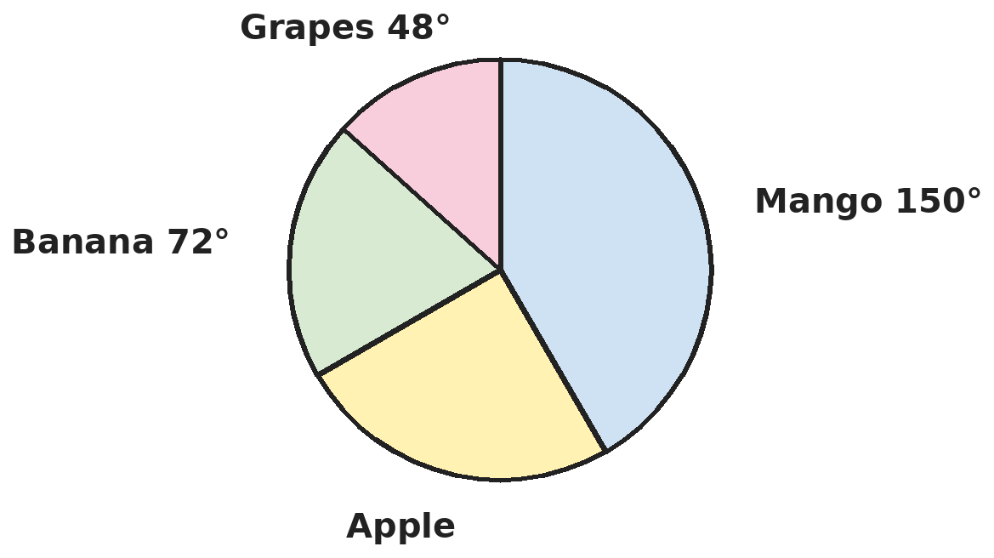
Q18. The pie chart shows the favourite fruit of 600 people. The angle for apple is not marked. How many people chose apple?
(A) 90 | (B) 250 | (C) 120 | (D) 150

Q19. The mean of six numbers is 20. The mean of the first four is 18. The last two numbers differ by 4. What is the larger of the last two?
(A) 24 | (B) 26 | (C) 22 | (D) 28

Part 8 — Applied Mathematics (Syllabus Chapter 9)
Q20. Money is shared among Aditi, Bharat and Charvi so that Aditi : Bharat = 3 : 4 and Bharat : Charvi = 6 : 7. Charvi gets ₹500 more than Aditi. How much does Bharat get?
(A) ₹1,200 | (B) ₹900 | (C) ₹1,400 | (D) ₹1,000

Q21. Gear A has 40 teeth and turns 60 times a minute. It drives gear B, which has 24 teeth. Gear B drives gear C, which has 30 teeth. How many turns does gear C make in 5 minutes?
(A) 500 | (B) 300 | (C) 80 | (D) 400

Q22. Varun drives from home to his aunt's house at 40 km/h and comes back by the same road at 60 km/h. What is his average speed for the whole trip?
(A) 50 km/h | (B) 45 km/h | (C) 48 km/h | (D) 52 km/h

Part 9 — Mathematical Reasoning (Syllabus Chapter 10)
Q23. In the sum A3 + 4B = 82, A and B are digits (A3 and 4B are 2-digit numbers). What is A × B?
(A) 27 | (B) 24 | (C) 36 | (D) 18

Q24. How many different triangles have whole-number side lengths (in cm) and a perimeter of 12 cm?
(A) 3 | (B) 4 | (C) 2 | (D) 5

Q25. What is 1 + 3 + 5 + … + 49, the sum of all odd numbers from 1 to 49?
(A) 600 | (B) 650 | (C) 625 | (D) 576

Part 10 — Mixed Problems (each joins two chapters)
Q26. x is an odd whole number. When 7 is taken away from 3 times x, the answer is more than 20 but less than 30. What is x?
(A) 9 | (B) 11 | (C) 13 | (D) 10

Q27. For how many whole numbers n from 1 to 200 are both 12% of n and 15% of n whole numbers?
(A) 4 | (B) 10 | (C) 18 | (D) 2

Q28. A bus travels 15 km/h faster than a cyclist. In the same time, the bus covers 150 km and the cyclist covers 60 km. What is the cyclist's speed?
(A) 10 km/h | (B) 25 km/h | (C) 15 km/h | (D) 12 km/h

Q29. The curved surface of a cylinder of height 6 cm is cut and opened out into a rectangle with perimeter 100 cm. What is the volume of the cylinder? (π = 22/7)
(A) 1,848 cm³ | (B) 264 cm³ | (C) 924 cm³ | (D) 462 cm³

Q30. What is the value of a³b − ab³ when a = −1/2 and b = 2/3?
(A) −7/108 | (B) 7/108 | (C) 25/108 | (D) −25/108

Answer Sheet AMO Level 2 · Class 7 · Practice Paper 5
Name: | School: | Roll No.:
Shade or tick one circle for each question.
1. | Ⓐ Ⓑ Ⓒ Ⓓ | 11. | Ⓐ Ⓑ Ⓒ Ⓓ | 21. | Ⓐ Ⓑ Ⓒ Ⓓ
2. | Ⓐ Ⓑ Ⓒ Ⓓ | 12. | Ⓐ Ⓑ Ⓒ Ⓓ | 22. | Ⓐ Ⓑ Ⓒ Ⓓ
3. | Ⓐ Ⓑ Ⓒ Ⓓ | 13. | Ⓐ Ⓑ Ⓒ Ⓓ | 23. | Ⓐ Ⓑ Ⓒ Ⓓ
4. | Ⓐ Ⓑ Ⓒ Ⓓ | 14. | Ⓐ Ⓑ Ⓒ Ⓓ | 24. | Ⓐ Ⓑ Ⓒ Ⓓ
5. | Ⓐ Ⓑ Ⓒ Ⓓ | 15. | Ⓐ Ⓑ Ⓒ Ⓓ | 25. | Ⓐ Ⓑ Ⓒ Ⓓ
6. | Ⓐ Ⓑ Ⓒ Ⓓ | 16. | Ⓐ Ⓑ Ⓒ Ⓓ | 26. | Ⓐ Ⓑ Ⓒ Ⓓ
7. | Ⓐ Ⓑ Ⓒ Ⓓ | 17. | Ⓐ Ⓑ Ⓒ Ⓓ | 27. | Ⓐ Ⓑ Ⓒ Ⓓ
8. | Ⓐ Ⓑ Ⓒ Ⓓ | 18. | Ⓐ Ⓑ Ⓒ Ⓓ | 28. | Ⓐ Ⓑ Ⓒ Ⓓ
9. | Ⓐ Ⓑ Ⓒ Ⓓ | 19. | Ⓐ Ⓑ Ⓒ Ⓓ | 29. | Ⓐ Ⓑ Ⓒ Ⓓ
10. | Ⓐ Ⓑ Ⓒ Ⓓ | 20. | Ⓐ Ⓑ Ⓒ Ⓓ | 30. | Ⓐ Ⓑ Ⓒ Ⓓ

For the parent or teacher
Correct: ______ / 30
Answer Key and Solutions AMO Level 2 · Class 7 · Practice Paper 5
Quick answers
1 C | 6 B | 11 C | 16 A | 21 D | 26 B
2 A | 7 D | 12 D | 17 A | 22 C | 27 D
3 C | 8 C | 13 D | 18 D | 23 A | 28 A
4 C | 9 D | 14 B | 19 B | 24 A | 29 C
5 B | 10 B | 15 B | 20 A | 25 C | 30 B
Solutions
Q | Part · level | Answer | Why?
1 | Part 1 · Ch1 · Hard | (C) −1/3 | Hint: First find the length AB = 5/2 − (−7/4).  AB = 5/2 + 7/4 = 17/4. One third of it is 17/12. C = −7/4 + 17/12 = −21/12 + 17/12 = −4/12 = −1/3.
2 | Part 1 · Ch1 · Hard | (A) −15/−25 | Hint: Count the minus signs in each fraction.  6/−10, −9/15 and 3/−5 all have one minus sign and reduce to −3/5. −15/−25 has two minus signs, so it equals +3/5.
3 | Part 1 · Ch1 · Hard | (C) 1/20 | Hint: Write each bracket as a single fraction: 1/2, 2/3, 3/4, …  The product is 1/2 × 2/3 × 3/4 × … × 19/20. Every numerator cancels the denominator before it, leaving 1/20.
4 | Part 2 · Ch2 · Hard | (C) −399 | Hint: Find a and b first.  2⁵ = 32, so a = 5. 3⁴ = 81, so b = 4. aᵇ − bᵃ = 5⁴ − 4⁵ = 625 − 1,024 = −399.
5 | Part 2 · Ch2 · Hard | (B) 4.05 × 10⁴ | Hint: Change both numbers to ordinary form, or to the same power of 10, before adding.  3.6 × 10⁴ = 36,000 and 4.5 × 10³ = 4,500. Sum = 40,500 = 4.05 × 10⁴. (8.1 × 10⁴ adds 3.6 and 4.5 without matching the powers.)
6 | Part 3 · Ch3 · Hard | (B) 1,400 | Hint: 15% of A = 20% of B means 3A = 4B.  From 15A = 20B, A = 4B/3, so A − B = B/3 = 200 and B = 600. A = 800. A + B = 1,400.
7 | Part 3 · Ch3 · Hard | (D) 10% | Hint: Find the total cost and the total selling price.  Cost: 50 × 40 = ₹2,000. Selling: 30 × 48 + 20 × 38 = 1,440 + 760 = ₹2,200. Profit ₹200 on ₹2,000 = 10%.
8 | Part 3 · Ch3 · Hard | (C) ₹1,200 | Hint: The selling price is 80% of the marked price.  ₹960 is 80% of the marked price, so the marked price is 960 ÷ 0.8 = ₹1,200. (The cost price is ₹800.)
9 | Part 4 · Ch4 · Hard | (D) 24 | Hint: First find the number: 3x/4 − 2x/3 = 5.  3x/4 − 2x/3 = 9x/12 − 8x/12 = x/12 = 5, so x = 60. 40% of 60 = 24.
10 | Part 4 · Ch4 · Hard | (B) 190 | Hint: Take out the common factor from the first two terms.  3a²b + 3ab² = 3ab(a + b) = 3 × 10 × 7 = 210. Then 210 − 2ab = 210 − 20 = 190.
11 | Part 4 · Ch4 · Hard | (C) 12x²y − xy² − xy | Hint: 5yx² is a like term of 7x²y, and 2y²x is a like term of −3xy².  7x²y + 5x²y = 12x²y. −3xy² + 2xy² = −xy². −xy has no like term. Answer: 12x²y − xy² − xy.
12 | Part 5 · Ch5 · Hard | (D) Acute-angled and isosceles | Hint: Find all three angles.  The opposite angles add to 110° and differ by 30°: they are 70° and 40°. The third angle is 180° − 110° = 70°. Angles 70°, 70°, 40°: all acute, two equal, so acute-angled and isosceles.
13 | Part 5 · Ch5 · Hard | (D) 80° | Hint: A + B = 360° − C − D. In triangle APB, the two base angles are A/2 and B/2.  A + B = 360° − 160° = 200°, so A/2 + B/2 = 100°. Angle APB = 180° − 100° = 80°.
14 | Part 5 · Ch5 · Hard | (B) They are congruent: angle B = angle E, then use ASA | Hint: Two equal pairs of angles make the third pair equal.  A + C = D + F, so angle B = angle E by the angle sum. Now AB = DE lies between angles A and B, and between D and E, so the triangles are congruent by ASA.
15 | Part 6 · Ch6 · Hard | (B) 1,540 cm³ | Hint: Use the curved surface area to find the radius first.  2 × 22/7 × r × 10 = 440, so r = 440 × 7 ÷ 440 = 7 cm. Volume = 22/7 × 7 × 7 × 10 = 1,540 cm³. (3,080 uses the diameter 14 in place of one radius.)
16 | Part 6 · Ch6 · Hard | (A) 60 cm | Hint: Count how many cubes fit along each edge of the box.  Along the edges: 10 ÷ 2.5 = 4, 7.5 ÷ 2.5 = 3 and 5 ÷ 2.5 = 2, so 4 × 3 × 2 = 24 cubes. Tower: 24 × 2.5 = 60 cm. (24 is the number of cubes.)
17 | Part 6 · Ch6 · Hard | (A) 1,000 cm² | Hint: Base + four walls; there is no top.  Base: 20 × 15 = 300 cm². Walls: 2(20 × 10) + 2(15 × 10) = 700 cm². Total 1,000 cm². (1,300 includes a lid; 3,000 is the volume.)
18 | Part 7 · Ch8 · Hard | (D) 150 | Hint: The angles of a pie chart add up to 360°.  Apple: 360° − 150° − 72° − 48° = 90°. People: 90/360 × 600 = 150.
19 | Part 7 · Ch8 · Hard | (B) 26 | Hint: Find the total of the last two numbers.  Total of six: 120. Total of first four: 72. The last two add to 48 and differ by 4, so they are 26 and 22. The larger is 26.
20 | Part 8 · Ch9 · Hard | (A) ₹1,200 | Hint: Combine the ratios so that Bharat's number is the same.  Aditi : Bharat : Charvi = 9 : 12 : 14. Charvi − Aditi = 5 parts = ₹500, so 1 part = ₹100. Bharat gets 12 × 100 = ₹1,200.
21 | Part 8 · Ch9 · Hard | (D) 400 | Hint: Teeth × turns is the same for gears that mesh: fewer teeth means more turns.  Teeth passing each minute: 40 × 60 = 2,400. Gear C turns 2,400 ÷ 30 = 80 times a minute (gear B in between does not change this). In 5 minutes: 400.
22 | Part 8 · Ch9 · Hard | (C) 48 km/h | Hint: Average speed = total distance ÷ total time. Try a distance of 120 km.  Take 120 km each way. Going: 3 h. Returning: 2 h. Average = 240 ÷ 5 = 48 km/h. (50 is the average of the two speeds, which is wrong.)
23 | Part 9 · Ch10 · Hard | (A) 27 | Hint: Look at the units column: 3 + B must end in 2.  3 + B ends in 2, so B = 9 with a carry of 1. Tens: A + 4 + 1 = 8, so A = 3. Check: 33 + 49 = 82. A × B = 27.
24 | Part 9 · Ch10 · Hard | (A) 3 | Hint: The longest side must be less than half the perimeter.  The longest side must be less than 6, so it is 4 or 5. With 5: (2, 5, 5) and (3, 4, 5). With 4: (4, 4, 4). That is 3 triangles.
25 | Part 9 · Ch10 · Hard | (C) 625 | Hint: 1 = 1, 1 + 3 = 4, 1 + 3 + 5 = 9. How many odd numbers are there?  There are 25 odd numbers from 1 to 49. The sum of the first n odd numbers is n × n, so the sum is 25 × 25 = 625.
26 | Part 10 · Mixed · Ch4 + Ch10 · Hard | (B) 11 | Hint: Try whole numbers for x and check 3x − 7.  x = 9 gives 20, not more than 20. x = 10 gives 23, x = 11 gives 26, x = 12 gives 29, and x = 13 gives 32, too big. So x is 10, 11 or 12, and the odd one is 11.
27 | Part 10 · Mixed · Ch3 + Ch10 · Hard | (D) 2 | Hint: 12% = 3/25 and 15% = 3/20. What must n be a multiple of?  12% of n = 3n/25 is whole only when n is a multiple of 25. 15% of n = 3n/20 is whole only when n is a multiple of 20. So n must be a multiple of 100: 100 and 200. That is 2 numbers. (18 adds the 8 multiples of 25 and the 10 multiples of 20.)
28 | Part 10 · Mixed · Ch4 + Ch9 · Hard | (A) 10 km/h | Hint: Let the cyclist's speed be x. Equal times: 150/(x + 15) = 60/x.  150x = 60(x + 15), so 90x = 900 and x = 10 km/h. The bus goes at 25 km/h; both take 6 hours.
29 | Part 10 · Mixed · Ch5 + Ch6 · Hard | (C) 924 cm³ | Hint: The rectangle's length is the circumference of the base.  2(length + 6) = 100, so the length (circumference) is 44 cm and r = 7 cm. Volume = 22/7 × 7 × 7 × 6 = 924 cm³.
30 | Part 10 · Mixed · Ch1 + Ch4 · Hard | (B) 7/108 | Hint: Work out a³b and ab³ separately.  a³b = (−1/8) × (2/3) = −1/12. ab³ = (−1/2) × (8/27) = −4/27. a³b − ab³ = −1/12 + 4/27 = −9/108 + 16/108 = 7/108.

