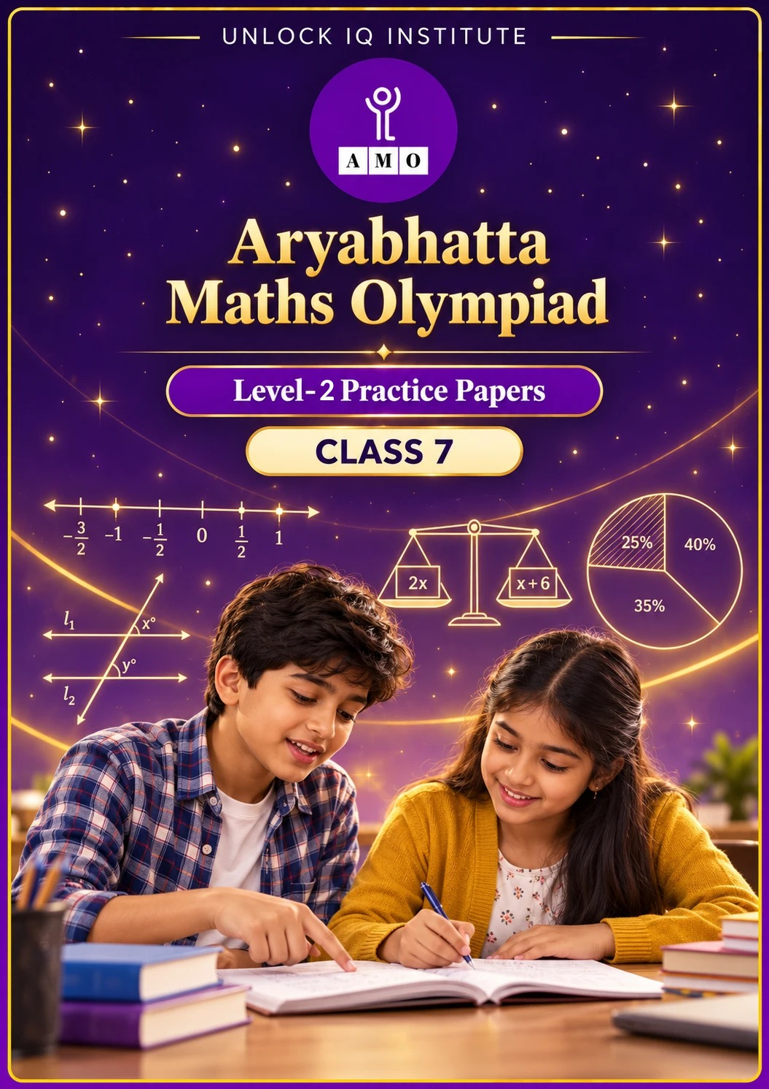
Set 2 · Practice Papers 6–10 · with answer keys & detailed solutions
Name: ____________________ | Class & Section: ________________
Roll No.: ________________ | School: ____________________
City: ____________________ | Date: ____________________

Published by Unlock IQ Institute Pvt. Ltd.
Register for Olympiads: www.aryabhattamathsolympiad.com/student-registration

ARYABHATTA MATHS OLYMPIAD
Level 2
PRACTICE PAPER-6
CLASS 7
Total Questions | 30 multiple-choice questions
Level | Level-2 (final round): every question is Hard
Time | 45 minutes
Arrangement | Parts by chapter; the last Part has mixed problems joining two chapters
Negative Marking | No negative marking
Calculator | Not allowed
Chapters | Number System · Operations · Fractions, Decimals & Percentages · Algebra · Geometry · Mensuration · Data Handling, Statistics & Probability · Applied Mathematics · Mathematical Reasoning

Instructions
• Each question has four options, (A) to (D), with exactly one correct answer.
• The questions are grouped in Parts by chapter. The last Part has mixed problems, each joining two chapters.
• Every question is at Level-2 (Hard) standard: expect several steps or a key insight.
• There is no negative marking. Calculators are not allowed; use a separate sheet for rough work.
• Figures are not necessarily drawn to scale unless stated.

For teachers
• Figures are part of the questions and work when printed in black and white.
• Parts follow the AMO syllabus chapters. Chapter 7 is not part of the Class 7 syllabus, so the chapter numbers shown in the Part headings have gaps.
• The answer sheet and the answer key are at the end. Remove the answer key before the paper is attempted.

Part 1 — Number System (Syllabus Chapter 1)
Q1. Ananya finds the mean (average) of 2/3, −5/6 and 3/4. What does she get?
(A) 7/12 | (B) −7/36 | (C) 7/36 | (D) 1/4

Q2. If x = 5/−8 and y = −3/4, what is (x − y) ÷ (x + y)?
(A) 1/11 | (B) −11 | (C) 11 | (D) −1/11

Q3. How many fractions of the form p/9, where p is an integer, lie strictly between −4/3 and −2/3?
(A) 6 | (B) 4 | (C) 5 | (D) 3

Part 2 — Operations (Syllabus Chapter 2)
Q4. Find n if [(5³ × 5⁴) ÷ (5²)³] × 3ⁿ = 45 × 9.
(A) 4 | (B) 3 | (C) 5 | (D) 2

Q5. Write 2⁵ × 5³ × 4² in standard form.
(A) 6.4 × 10³ | (B) 3.2 × 10⁴ | (C) 6.4 × 10⁴ | (D) 1.6 × 10⁴

Part 3 — Fractions, Decimals & Percentages (Syllabus Chapter 3)
Q6. A dealer sells a chair at a 10% loss. If he had sold it for ₹90 more, he would have made a 5% profit. What did the chair cost him?
(A) ₹600 | (B) ₹900 | (C) ₹540 | (D) ₹1,800

Q7. On a ₹5,000 television, Shop X gives 20% off and then a further 10% off. Shop Y gives a single 30% off. How much more does Shop X charge?
(A) ₹0 | (B) ₹50 | (C) ₹100 | (D) ₹200

Q8. 20 litres of salt water contain 10% salt. How much water must evaporate so that the salt becomes 25% of the solution?
(A) 8 L | (B) 15 L | (C) 5 L | (D) 12 L

Part 4 — Algebra (Syllabus Chapter 4)
Q9. Solve (x + 3)/4 − (x − 2)/3 = 1. What is x?
(A) −5 | (B) 7 | (C) 5 | (D) 17

Q10. Half of a number is 12 less than three-quarters of the same number. What do you get if the number is increased by 25%?
(A) 60 | (B) 48 | (C) 36 | (D) 64

Q11. If p = 2q − 3 and q = −4, what is p² − pq + q²?
(A) 93 | (B) 49 | (C) 137 | (D) −93

Part 5 — Geometry (Syllabus Chapter 5)
Q12. In triangle ABC, the exterior angle at C is 130°. Angle A = (x + 20)° and angle B = (2x + 5)°. What is the smallest angle of the triangle?
(A) 55° | (B) 75° | (C) 50° | (D) 35°

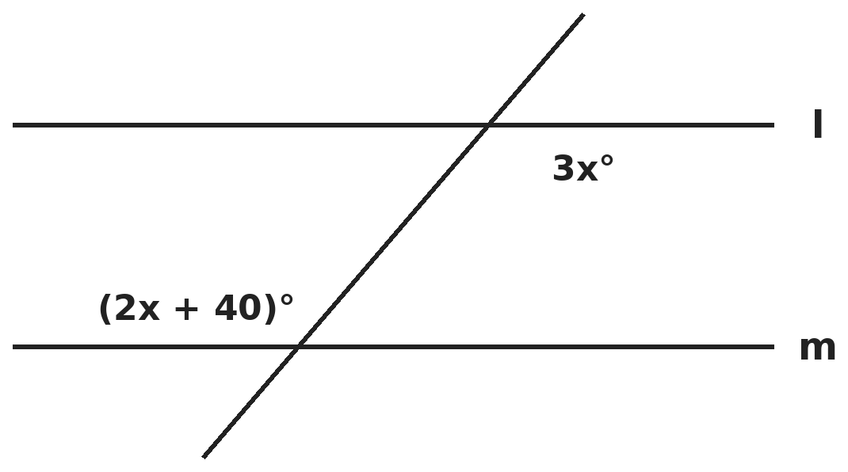
Q13. Lines l and m are parallel, and the two marked angles are alternate interior angles. What is the other angle below line l at the same crossing as the angle 3x°?
(A) 120° | (B) 40° | (C) 60° | (D) 80°

Q14. One angle of a rhombus is 64°. What angle does the longer diagonal make with a side of the rhombus?
(A) 32° | (B) 58° | (C) 64° | (D) 116°

Part 6 — Mensuration (Syllabus Chapter 6)
Q15. A cylinder has radius 7 cm and curved surface area 880 cm². What is its volume? (π = 22/7)
(A) 6,160 cm³ | (B) 3,080 cm³ | (C) 4,400 cm³ | (D) 2,200 cm³

Q16. A cube of edge 5 cm is painted on all its faces and cut into 1 cm cubes. How many of the small cubes have paint on exactly two faces?
(A) 27 | (B) 24 | (C) 54 | (D) 36

Q17. A rectangular pond is 20 m long, 15 m wide and 2 m deep, and full of water. A pump removes 500 litres every minute. How long does it take to empty the pond?
(A) 20 hours | (B) 12 hours | (C) 10 hours | (D) 2 hours

Part 7 — Data Handling, Statistics & Probability (Syllabus Chapter 8)
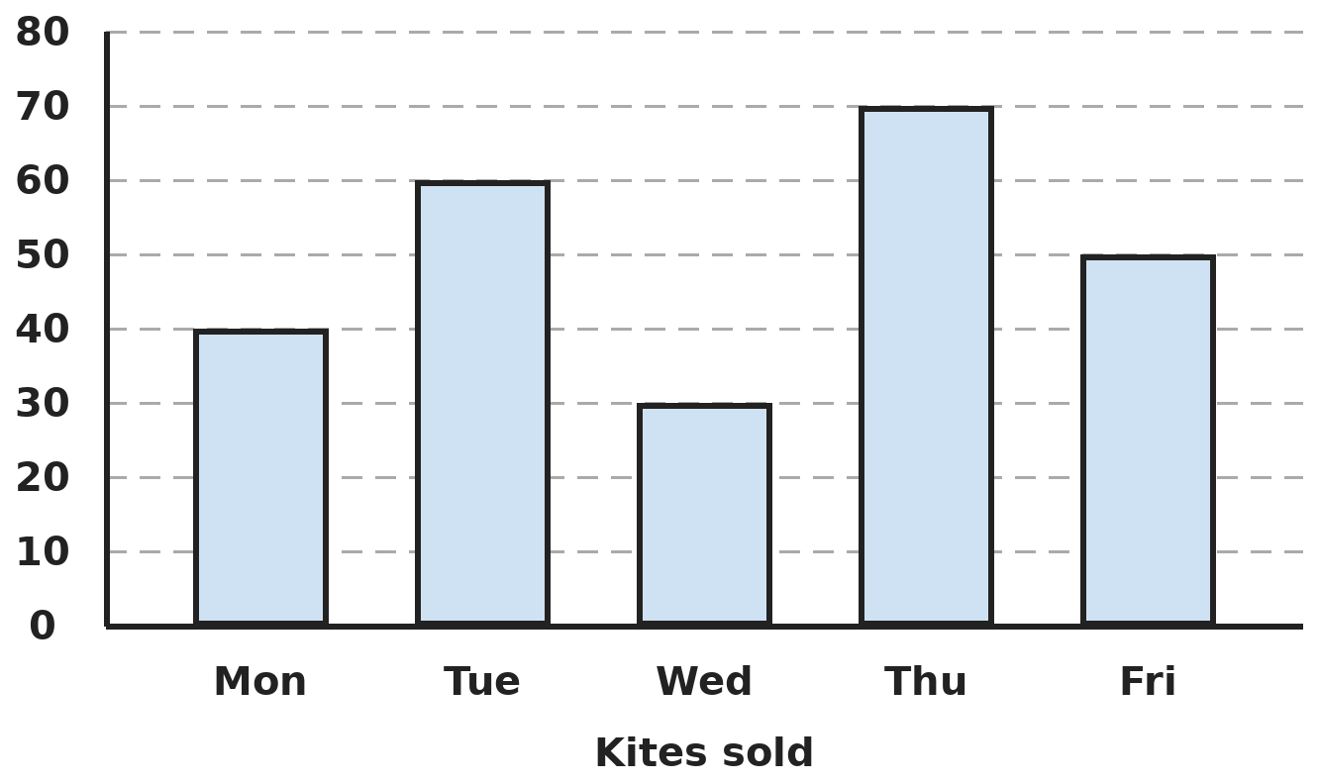
Q18. The bar graph shows the number of kites a shop sold each day. By what percent were Thursday's sales more than Wednesday's?
(A) 40% | (B) 133 1/3% | (C) 57 1/7% | (D) 233 1/3%

Q19. The median of seven numbers is 15. Two more numbers, 20 and 5, are added to the list. What is the median of the nine numbers?
(A) 12.5 | (B) 20 | (C) 17.5 | (D) 15

Part 8 — Applied Mathematics (Syllabus Chapter 9)
Q20. If x : 12 = 15 : 20 and 12 : y = 9 : 15, what is x + y?
(A) 35 | (B) 29 | (C) 27 | (D) 24

Q21. 25 workers can finish a job in 36 days. After 12 days, 5 workers leave. How many days does the whole job take?
(A) 45 | (B) 42 | (C) 30 | (D) 48

Q22. Harsh starts walking at 4 km/h. One hour later, Divya starts cycling from the same place along the same road at 12 km/h. How far from the start does she catch up with him?
(A) 4 km | (B) 8 km | (C) 12 km | (D) 6 km

Part 9 — Mathematical Reasoning (Syllabus Chapter 10)
Q23. ABC and CBA are 3-digit numbers. ABC − CBA = 297, the middle digit B is 5, and A + B + C = 14. What is ABC?
(A) 356 | (B) 653 | (C) 563 | (D) 635

Q24. A rectangle is divided into a grid of 3 squares across and 2 squares down. How many rectangles of all sizes (squares included) are in the grid?
(A) 12 | (B) 18 | (C) 15 | (D) 24

Q25. What is the smallest number that leaves remainder 2 when divided by 3, 4, 5 or 6, and is exactly divisible by 7?
(A) 62 | (B) 122 | (C) 242 | (D) 182

Part 10 — Mixed Problems (each joins two chapters)
Q26. On a calendar page, Mohit picks a 2 × 2 square of four dates. They add up to 80. What is the largest of the four dates?
(A) 23 | (B) 24 | (C) 20 | (D) 17

Q27. Neha scored 40 out of 50 in the first test. The second test is out of 75. She wants 84% of the total marks of the two tests. What must she score in the second test?
(A) 63 | (B) 65 | (C) 67 | (D) 60

Q28. The present ages of Tara and her cousin Om are in the ratio 4 : 5. Six years ago the ratio was 3 : 4. What is the sum of their present ages?
(A) 45 years | (B) 63 years | (C) 48 years | (D) 54 years

Q29. ABCD is a rectangle with AB = 24 m and BC = 10 m. M is the midpoint of BC and N is the midpoint of CD. What is the area of triangle AMN?
(A) 120 m² | (B) 60 m² | (C) 90 m² | (D) 80 m²

Q30. Solve (2/3)x − (1/4)(x − 5) = 5/2. What is x?
(A) 3 | (B) −3 | (C) 9/5 | (D) 5

Answer Sheet AMO Level 2 · Class 7 · Practice Paper 6
Name: | School: | Roll No.:
Shade or tick one circle for each question.
1. | Ⓐ Ⓑ Ⓒ Ⓓ | 11. | Ⓐ Ⓑ Ⓒ Ⓓ | 21. | Ⓐ Ⓑ Ⓒ Ⓓ
2. | Ⓐ Ⓑ Ⓒ Ⓓ | 12. | Ⓐ Ⓑ Ⓒ Ⓓ | 22. | Ⓐ Ⓑ Ⓒ Ⓓ
3. | Ⓐ Ⓑ Ⓒ Ⓓ | 13. | Ⓐ Ⓑ Ⓒ Ⓓ | 23. | Ⓐ Ⓑ Ⓒ Ⓓ
4. | Ⓐ Ⓑ Ⓒ Ⓓ | 14. | Ⓐ Ⓑ Ⓒ Ⓓ | 24. | Ⓐ Ⓑ Ⓒ Ⓓ
5. | Ⓐ Ⓑ Ⓒ Ⓓ | 15. | Ⓐ Ⓑ Ⓒ Ⓓ | 25. | Ⓐ Ⓑ Ⓒ Ⓓ
6. | Ⓐ Ⓑ Ⓒ Ⓓ | 16. | Ⓐ Ⓑ Ⓒ Ⓓ | 26. | Ⓐ Ⓑ Ⓒ Ⓓ
7. | Ⓐ Ⓑ Ⓒ Ⓓ | 17. | Ⓐ Ⓑ Ⓒ Ⓓ | 27. | Ⓐ Ⓑ Ⓒ Ⓓ
8. | Ⓐ Ⓑ Ⓒ Ⓓ | 18. | Ⓐ Ⓑ Ⓒ Ⓓ | 28. | Ⓐ Ⓑ Ⓒ Ⓓ
9. | Ⓐ Ⓑ Ⓒ Ⓓ | 19. | Ⓐ Ⓑ Ⓒ Ⓓ | 29. | Ⓐ Ⓑ Ⓒ Ⓓ
10. | Ⓐ Ⓑ Ⓒ Ⓓ | 20. | Ⓐ Ⓑ Ⓒ Ⓓ | 30. | Ⓐ Ⓑ Ⓒ Ⓓ

For the parent or teacher
Correct: ______ / 30
Answer Key and Solutions AMO Level 2 · Class 7 · Practice Paper 6
Quick answers
1 C | 6 A | 11 A | 16 D | 21 B | 26 B
2 D | 7 C | 12 C | 17 A | 22 D | 27 B
3 C | 8 D | 13 C | 18 B | 23 B | 28 D
4 A | 9 C | 14 A | 19 D | 24 B | 29 C
5 C | 10 A | 15 B | 20 B | 25 D | 30 A
Solutions
Q | Part · level | Answer | Why?
1 | Part 1 · Ch1 · Hard | (C) 7/36 | Hint: Add the three numbers using the denominator 12, then divide by 3.  2/3 − 5/6 + 3/4 = 8/12 − 10/12 + 9/12 = 7/12. Mean = 7/12 ÷ 3 = 7/36. (7/12 is the sum.)
2 | Part 1 · Ch1 · Hard | (D) −1/11 | Hint: Use the denominator 8 for both.  x = −5/8, y = −6/8. x − y = 1/8 and x + y = −11/8. (1/8) ÷ (−11/8) = −1/11.
3 | Part 1 · Ch1 · Hard | (C) 5 | Hint: Write −4/3 and −2/3 with denominator 9.  −4/3 = −12/9 and −2/3 = −6/9. Strictly between them p = −11, −10, −9, −8, −7. That is 5 fractions.
4 | Part 2 · Ch2 · Hard | (A) 4 | Hint: Simplify the powers of 5 first.  (5²)³ = 5² × 5² × 5², so (5³ × 5⁴) ÷ (5²)³ = (5³ ÷ 5²) × (5⁴ ÷ 5⁴) = 5. Then 5 × 3ⁿ = 405, so 3ⁿ = 81 = 3⁴ and n = 4.
5 | Part 2 · Ch2 · Hard | (C) 6.4 × 10⁴ | Hint: Pair each 5 with a 2 to make 10s.  2³ × 5³ = 10³. What is left is 2² × 4² = 4 × 16 = 64. So the number is 64 × 10³ = 64,000 = 6.4 × 10⁴.
6 | Part 3 · Ch3 · Hard | (A) ₹600 | Hint: The ₹90 covers the gap from −10% to +5% of the cost.  The difference between 90% and 105% of the cost is 15% of the cost = ₹90. So the cost is 90 ÷ 0.15 = ₹600.
7 | Part 3 · Ch3 · Hard | (C) ₹100 | Hint: The second discount at Shop X is 10% of a smaller amount.  Shop X: 5,000 → 4,000 → 3,600. Shop Y: 5,000 − 1,500 = 3,500. Shop X charges ₹100 more.
8 | Part 3 · Ch3 · Hard | (D) 12 L | Hint: The amount of salt does not change.  Salt: 10% of 20 = 2 L. For 2 L to be 25%, the solution must be 8 L. So 20 − 8 = 12 L of water must evaporate.
9 | Part 4 · Ch4 · Hard | (C) 5 | Hint: Multiply every term by 12. Take care with the minus sign.  3(x + 3) − 4(x − 2) = 12, so 3x + 9 − 4x + 8 = 12, giving −x + 17 = 12 and x = 5.
10 | Part 4 · Ch4 · Hard | (A) 60 | Hint: First find the number: x/2 = 3x/4 − 12.  3x/4 − x/2 = x/4 = 12, so x = 48. Increased by 25%: 48 + 12 = 60.
11 | Part 4 · Ch4 · Hard | (A) 93 | Hint: Find p first.  p = 2(−4) − 3 = −11. p² = 121, pq = 44, q² = 16. p² − pq + q² = 121 − 44 + 16 = 93.
12 | Part 5 · Ch5 · Hard | (C) 50° | Hint: The exterior angle at C equals A + B.  (x + 20) + (2x + 5) = 130, so 3x = 105 and x = 35. A = 55°, B = 75°, C = 180° − 130° = 50°. The smallest is 50°.
13 | Part 5 · Ch5 · Hard | (C) 60° | Hint: Alternate angles are equal. Angles on a straight line add up to 180°.  3x = 2x + 40, so x = 40 and each marked angle is 120°. The other angle below line l at that crossing is on a straight line with it: 180° − 120° = 60°.
14 | Part 5 · Ch5 · Hard | (A) 32° | Hint: The diagonals of a rhombus bisect its angles. Which angles does the longer diagonal join?  The angles are 64° and 116°. The longer diagonal joins the two 64° corners and bisects them, so it makes 32° with each side. (The shorter diagonal makes 58°.)
15 | Part 6 · Ch6 · Hard | (B) 3,080 cm³ | Hint: Use the curved surface to find the height first.  2 × 22/7 × 7 × h = 880, so 44h = 880 and h = 20 cm. Volume = 22/7 × 7 × 7 × 20 = 3,080 cm³.
16 | Part 6 · Ch6 · Hard | (D) 36 | Hint: Cubes with two painted faces lie along the edges, but not at the corners.  Each of the 12 edges has 5 cubes, of which 2 are corners (3 faces painted). So each edge has 3 cubes with exactly two painted faces: 12 × 3 = 36. (27 is the number with no paint.)
17 | Part 6 · Ch6 · Hard | (A) 20 hours | Hint: 1 m³ = 1,000 litres.  Volume: 20 × 15 × 2 = 600 m³ = 6,00,000 L. Time: 6,00,000 ÷ 500 = 1,200 minutes = 20 hours.
18 | Part 7 · Ch8 · Hard | (B) 133 1/3% | Hint: Percent increase = increase ÷ smaller value × 100.  Thursday 70, Wednesday 30. Increase 40. 40/30 × 100 = 133 1/3%. (57 1/7% divides by 70.)
19 | Part 7 · Ch8 · Hard | (D) 15 | Hint: One new number is above 15 and one is below.  Before, 3 numbers were at or below the middle and 3 above. Adding one number below 15 and one above keeps 15 in the middle: it is now the 5th of 9. The median stays 15.
20 | Part 8 · Ch9 · Hard | (B) 29 | Hint: In a proportion, the product of the extremes equals the product of the means.  x × 20 = 12 × 15, so x = 9. 12 × 15 = 9 × y, so y = 20. x + y = 29.
21 | Part 8 · Ch9 · Hard | (B) 42 | Hint: The job is 25 × 36 = 900 worker-days.  First 12 days: 300 worker-days. Left: 600 worker-days for 20 workers = 30 days. Total 12 + 30 = 42 days.
22 | Part 8 · Ch9 · Hard | (D) 6 km | Hint: Harsh is 4 km ahead when Divya starts. She gains 8 km every hour.  Gap 4 km, closing at 12 − 4 = 8 km/h, so she catches him after 1/2 hour. She has cycled 12 × 1/2 = 6 km.
23 | Part 9 · Ch10 · Hard | (B) 653 | Hint: ABC − CBA = 99 × (A − C).  99(A − C) = 297, so A − C = 3. A + C = 14 − 5 = 9. So A = 6 and C = 3: ABC = 653. Check: 653 − 356 = 297.
24 | Part 9 · Ch10 · Hard | (B) 18 | Hint: A rectangle is fixed by choosing 2 of the 4 vertical lines and 2 of the 3 horizontal lines.  Pairs of vertical lines: 6. Pairs of horizontal lines: 3. Rectangles: 6 × 3 = 18.
25 | Part 9 · Ch10 · Hard | (D) 182 | Hint: Such numbers are 2 more than a multiple of 60.  Numbers leaving remainder 2: 62, 122, 182, 242, … Test for 7: 62 no, 122 no, 182 = 7 × 26 yes. The answer is 182.
26 | Part 10 · Mixed · Ch4 + Ch10 · Hard | (B) 24 | Hint: If the top-left date is x, the others are x + 1, x + 7 and x + 8.  x + (x + 1) + (x + 7) + (x + 8) = 4x + 16 = 80, so x = 16. The dates are 16, 17, 23 and 24; the largest is 24.
27 | Part 10 · Mixed · Ch3 + Ch10 · Hard | (B) 65 | Hint: Find the total marks she needs out of 125.  Total maximum: 50 + 75 = 125. 84% of 125 = 105. She has 40, so she needs 105 − 40 = 65 out of 75.
28 | Part 10 · Mixed · Ch4 + Ch9 · Hard | (D) 54 years | Hint: Let the ages be 4x and 5x.  (4x − 6)/(5x − 6) = 3/4, so 16x − 24 = 15x − 18 and x = 6. Ages 24 and 30; the sum is 54 years.
29 | Part 10 · Mixed · Ch5 + Ch6 · Hard | (C) 90 m² | Hint: Take away the three right-angled triangles at the corners from the rectangle.  Rectangle: 240 m². Triangle ABM: 1/2 × 24 × 5 = 60. Triangle ADN: 1/2 × 10 × 12 = 60. Triangle MCN: 1/2 × 5 × 12 = 30. AMN = 240 − 150 = 90 m².
30 | Part 10 · Mixed · Ch1 + Ch4 · Hard | (A) 3 | Hint: Multiply every term by 12.  8x − 3(x − 5) = 30, so 8x − 3x + 15 = 30, giving 5x = 15 and x = 3.

ARYABHATTA MATHS OLYMPIAD
Level 2
PRACTICE PAPER-7
CLASS 7
Total Questions | 30 multiple-choice questions
Level | Level-2 (final round): every question is Hard
Time | 45 minutes
Arrangement | Parts by chapter; the last Part has mixed problems joining two chapters
Negative Marking | No negative marking
Calculator | Not allowed
Chapters | Number System · Operations · Fractions, Decimals & Percentages · Algebra · Geometry · Mensuration · Data Handling, Statistics & Probability · Applied Mathematics · Mathematical Reasoning

Instructions
• Each question has four options, (A) to (D), with exactly one correct answer.
• The questions are grouped in Parts by chapter. The last Part has mixed problems, each joining two chapters.
• Every question is at Level-2 (Hard) standard: expect several steps or a key insight.
• There is no negative marking. Calculators are not allowed; use a separate sheet for rough work.
• Figures are not necessarily drawn to scale unless stated.

For teachers
• Figures are part of the questions and work when printed in black and white.
• Parts follow the AMO syllabus chapters. Chapter 7 is not part of the Class 7 syllabus, so the chapter numbers shown in the Part headings have gaps.
• The answer sheet and the answer key are at the end. Remove the answer key before the paper is attempted.

Part 1 — Number System (Syllabus Chapter 1)
Q1. A water tank is 3/5 full. After 24 litres are used, it is 1/3 full. How many litres does the full tank hold?
(A) 90 L | (B) 72 L | (C) 60 L | (D) 120 L

Q2. Which is the smallest of −11/12, −7/8, −5/6 and −13/16?
(A) −13/16 | (B) −5/6 | (C) −11/12 | (D) −7/8

Q3. What is (−2/5) ÷ (4/15) − (3/8) × (−4/9)?
(A) 4/3 | (B) −5/3 | (C) −7/6 | (D) −4/3

Part 2 — Operations (Syllabus Chapter 2)
Q4. Find x if (−2)³ × (−2)ˣ = 64.
(A) 2 | (B) 3 | (C) −3 | (D) 6

Q5. Which is greater, 2⁵ × 3² or 3⁴ × 2², and by how much?
(A) 2⁵ × 3², by 36 | (B) They are equal
(C) 3⁴ × 2², by 36 | (D) 3⁴ × 2², by 18

Part 3 — Fractions, Decimals & Percentages (Syllabus Chapter 3)
Q6. Shalini sells two lamps for ₹990 each. On one she gains 10% and on the other she loses 10%. What is her overall result?
(A) No profit or loss | (B) A profit of ₹20
(C) A loss of ₹99 | (D) A loss of ₹20

Q7. A bag marked ₹1,500 is sold for ₹1,215 after two successive discounts. The first discount is 10%. What is the second discount?
(A) 9% | (B) 12% | (C) 19% | (D) 10%

Q8. Ravi spends 75% of his income and saves the rest. His income rises by 20% and his spending rises by 10%. By what percent do his savings rise?
(A) 30% | (B) 50% | (C) 10% | (D) 25%

Part 4 — Algebra (Syllabus Chapter 4)
Q9. The sides of a triangle are x cm, (x + 5) cm and (2x − 2) cm. Its perimeter is 55 cm. How long is its longest side?
(A) 18 cm | (B) 13 cm | (C) 26 cm | (D) 24 cm

Q10. A rectangle has length (3x − 1) cm and width 9 cm. Its perimeter is 58 cm. What is its area?
(A) 180 cm² | (B) 160 cm² | (C) 58 cm² | (D) 200 cm²

Q11. When a number, one-third of it and one-quarter of it are added, the total is 57. What is the number?
(A) 36 | (B) 24 | (C) 48 | (D) 12

Part 5 — Geometry (Syllabus Chapter 5)
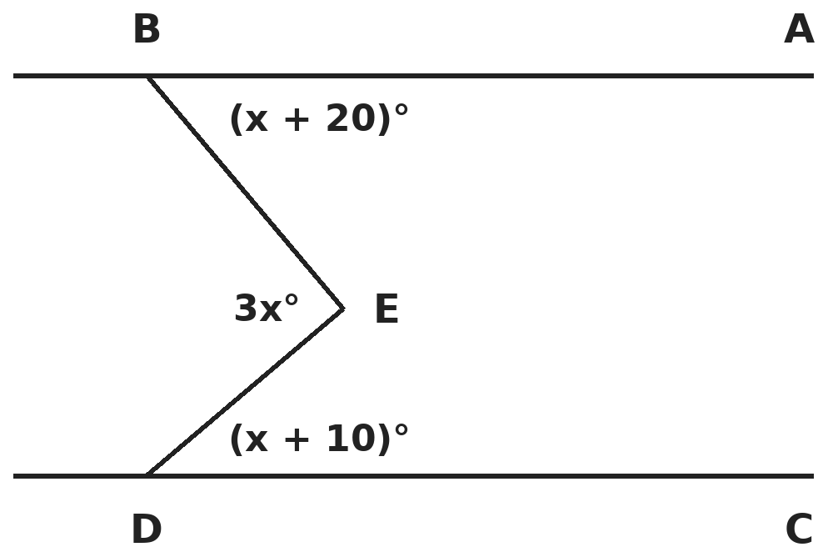
Q12. AB ∥ CD. The angles at B, D and E are marked. What is the size of angle BED?
(A) 30° | (B) 60° | (C) 90° | (D) 120°

Q13. In triangle PQR, angle Q = 70° and angle R = 50°. The bisector of angle P meets QR at S. What is angle PSR?
(A) 100° | (B) 80° | (C) 110° | (D) 70°

Q14. In parallelogram ABCD, the bisectors of angles A and B meet at P. What is angle APB?
(A) 60° | (B) 120°
(C) It depends on angle A | (D) 90°

Part 6 — Mensuration (Syllabus Chapter 6)
Q15. A hollow metal pipe is 10 cm long. Its outer radius is 14 cm and its inner radius is 7 cm. What volume of metal is in the pipe? (π = 22/7)
(A) 4,620 cm³ | (B) 6,160 cm³ | (C) 1,540 cm³ | (D) 3,080 cm³

Q16. A cuboid is 8 cm × 6 cm × 4 cm. Its length is doubled and its width is halved; the height stays 4 cm. What happens to its total surface area?
(A) It stays the same | (B) It increases by 40 cm²
(C) It increases by 64 cm² | (D) It decreases by 40 cm²

Q17. How many coins, each of radius 0.7 cm and thickness 0.5 cm, can be made by melting a metal cuboid 5.5 cm × 10 cm × 3.5 cm? (π = 22/7)
(A) 125 | (B) 500 | (C) 275 | (D) 250

Part 7 — Data Handling, Statistics & Probability (Syllabus Chapter 8)
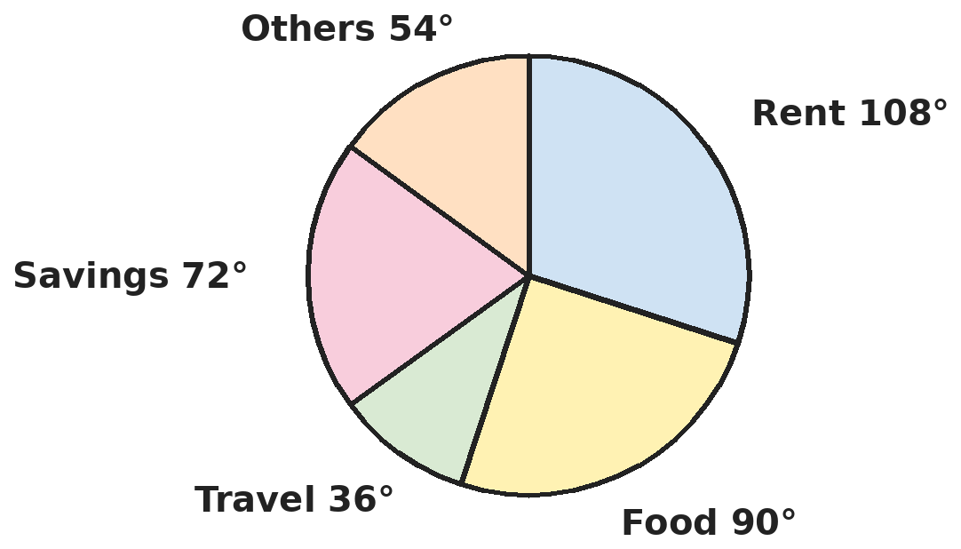
Q18. The pie chart shows how Nandini's family uses its monthly income. The family saves ₹4,800 a month. How much does it spend on food?
(A) ₹4,800 | (B) ₹7,200 | (C) ₹24,000 | (D) ₹6,000

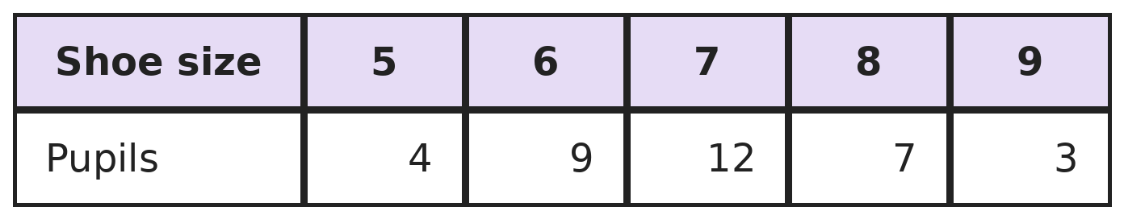
Q19. The table shows the shoe sizes of the pupils in a class. How many pupils wear a size larger than the median size?
(A) 22 | (B) 10 | (C) 7 | (D) 13

Part 8 — Applied Mathematics (Syllabus Chapter 9)
Q20. In a class the ratio of boys to girls is 7 : 5. Then 8 boys leave and 4 girls join, and the numbers become equal. How many students were there at first?
(A) 72 | (B) 60 | (C) 84 | (D) 48

Q21. A scooter uses 6 litres of petrol to go 84 km. Petrol costs ₹104 a litre. How much does Ravi spend on petrol for a 315 km ride?
(A) ₹2,184 | (B) ₹2,496 | (C) ₹2,340 | (D) ₹2,250

Q22. Pipe A fills a tank in 12 hours and pipe B fills it in 15 hours. Pipe C empties the full tank in 20 hours. If all three are opened together, how long does it take to fill the empty tank?
(A) 15 hours | (B) 10 hours | (C) 8 hours | (D) 12 hours

Part 9 — Mathematical Reasoning (Syllabus Chapter 10)
Q23. A and B are digits and AB is a 2-digit number. AB × 6 = BBB. What is A − B?
(A) 4 | (B) 2 | (C) 3 | (D) 5

Q24. How many 3-digit numbers can be made using only the digits 1 to 5, with the digits strictly increasing from left to right (like 135)?
(A) 15 | (B) 10 | (C) 20 | (D) 60

Q25. In AB + AB + AB = CAB, the letters stand for different digits, AB is a 2-digit number and CAB is a 3-digit number. What is A + B + C?
(A) 5 | (B) 7 | (C) 6 | (D) 15

Part 10 — Mixed Problems (each joins two chapters)
Q26. Four consecutive even numbers add up to 108. What is the product of the smallest and the largest?
(A) 728 | (B) 672 | (C) 720 | (D) 780

Q27. The price of a cycle is ₹1,000 now and rises by 10% every year. What will it cost after 3 years?
(A) ₹1,300 | (B) ₹1,210 | (C) ₹1,464 | (D) ₹1,331

Q28. Two numbers are in the ratio 5 : 7 and their difference is 18. What number must be added to each of them to make the ratio 6 : 7?
(A) 63 | (B) 45 | (C) 18 | (D) 54

Q29. A cylindrical log of radius 14 cm and length 2 m is cut in half along its length, through the centre. What is the total surface area of one half? (π = 22/7)
(A) 9,416 cm² | (B) 15,016 cm² | (C) 14,400 cm² | (D) 17,600 cm²

Q30. Solve 3/(x − 1) = −5/2. What is x?
(A) 1/5 | (B) −11/5 | (C) −1/5 | (D) 7/5

Answer Sheet AMO Level 2 · Class 7 · Practice Paper 7
Name: | School: | Roll No.:
Shade or tick one circle for each question.
1. | Ⓐ Ⓑ Ⓒ Ⓓ | 11. | Ⓐ Ⓑ Ⓒ Ⓓ | 21. | Ⓐ Ⓑ Ⓒ Ⓓ
2. | Ⓐ Ⓑ Ⓒ Ⓓ | 12. | Ⓐ Ⓑ Ⓒ Ⓓ | 22. | Ⓐ Ⓑ Ⓒ Ⓓ
3. | Ⓐ Ⓑ Ⓒ Ⓓ | 13. | Ⓐ Ⓑ Ⓒ Ⓓ | 23. | Ⓐ Ⓑ Ⓒ Ⓓ
4. | Ⓐ Ⓑ Ⓒ Ⓓ | 14. | Ⓐ Ⓑ Ⓒ Ⓓ | 24. | Ⓐ Ⓑ Ⓒ Ⓓ
5. | Ⓐ Ⓑ Ⓒ Ⓓ | 15. | Ⓐ Ⓑ Ⓒ Ⓓ | 25. | Ⓐ Ⓑ Ⓒ Ⓓ
6. | Ⓐ Ⓑ Ⓒ Ⓓ | 16. | Ⓐ Ⓑ Ⓒ Ⓓ | 26. | Ⓐ Ⓑ Ⓒ Ⓓ
7. | Ⓐ Ⓑ Ⓒ Ⓓ | 17. | Ⓐ Ⓑ Ⓒ Ⓓ | 27. | Ⓐ Ⓑ Ⓒ Ⓓ
8. | Ⓐ Ⓑ Ⓒ Ⓓ | 18. | Ⓐ Ⓑ Ⓒ Ⓓ | 28. | Ⓐ Ⓑ Ⓒ Ⓓ
9. | Ⓐ Ⓑ Ⓒ Ⓓ | 19. | Ⓐ Ⓑ Ⓒ Ⓓ | 29. | Ⓐ Ⓑ Ⓒ Ⓓ
10. | Ⓐ Ⓑ Ⓒ Ⓓ | 20. | Ⓐ Ⓑ Ⓒ Ⓓ | 30. | Ⓐ Ⓑ Ⓒ Ⓓ

For the parent or teacher
Correct: ______ / 30
Answer Key and Solutions AMO Level 2 · Class 7 · Practice Paper 7
Quick answers
1 A | 6 D | 11 A | 16 B | 21 C | 26 C
2 C | 7 D | 12 C | 17 D | 22 B | 27 D
3 D | 8 B | 13 A | 18 D | 23 C | 28 A
4 B | 9 D | 14 D | 19 B | 24 B | 29 B
5 C | 10 A | 15 A | 20 A | 25 C | 30 C
Solutions
Q | Part · level | Answer | Why?
1 | Part 1 · Ch1 · Hard | (A) 90 L | Hint: The 24 litres are the difference between 3/5 and 1/3 of the tank.  3/5 − 1/3 = 9/15 − 5/15 = 4/15 of the tank is 24 L. The full tank holds 24 × 15/4 = 90 L.
2 | Part 1 · Ch1 · Hard | (C) −11/12 | Hint: For negative numbers, the one furthest from 0 is the smallest. Use the denominator 48.  In 48ths: −44, −42, −40, −39. The one furthest from 0 is −44/48 = −11/12, so it is the smallest.
3 | Part 1 · Ch1 · Hard | (D) −4/3 | Hint: Work out the division and the product separately. Subtracting a negative is adding.  (−2/5) × (15/4) = −3/2. (3/8) × (−4/9) = −1/6. −3/2 − (−1/6) = −9/6 + 1/6 = −8/6 = −4/3.
4 | Part 2 · Ch2 · Hard | (B) 3 | Hint: 64 = (−2)⁶, because an even power of a negative number is positive.  (−2)³⁺ˣ = (−2)⁶, so 3 + x = 6 and x = 3. Check: (−2)³ × (−2)³ = (−8)(−8) = 64.
5 | Part 2 · Ch2 · Hard | (C) 3⁴ × 2², by 36 | Hint: Both share the factor 2² × 3² = 36.  2⁵ × 3² = 36 × 2³ = 288. 3⁴ × 2² = 36 × 3² = 324. 324 − 288 = 36, so 3⁴ × 2² is greater by 36.
6 | Part 3 · Ch3 · Hard | (D) A loss of ₹20 | Hint: Find each cost price: 990 is 110% of one and 90% of the other.  Costs: 990 ÷ 1.1 = ₹900 and 990 ÷ 0.9 = ₹1,100. Total cost ₹2,000, total selling ₹1,980: a loss of ₹20.
7 | Part 3 · Ch3 · Hard | (D) 10% | Hint: Find the price after the first discount.  After 10% off: ₹1,350. From 1,350 to 1,215 is a cut of ₹135, which is 135/1,350 = 10%.
8 | Part 3 · Ch3 · Hard | (B) 50% | Hint: Take his income as ₹100.  Income 100: spending 75, savings 25. New income 120, new spending 82.5, new savings 37.5. Savings rise by 12.5 on 25 = 50%.
9 | Part 4 · Ch4 · Hard | (D) 24 cm | Hint: Add the three sides and solve for x.  4x + 3 = 55, so x = 13. The sides are 13, 18 and 24 cm. The longest is 24 cm.
10 | Part 4 · Ch4 · Hard | (A) 180 cm² | Hint: Perimeter = 2 × (length + width).  2(3x − 1 + 9) = 58, so 3x + 8 = 29 and x = 7. Length = 20 cm. Area = 20 × 9 = 180 cm².
11 | Part 4 · Ch4 · Hard | (A) 36 | Hint: x + x/3 + x/4 = 57.  x + x/3 + x/4 = 12x/12 + 4x/12 + 3x/12 = 19x/12 = 57, so x = 36.
12 | Part 5 · Ch5 · Hard | (C) 90° | Hint: Angle BED equals the sum of the angles at B and D.  Draw a line through E parallel to AB. Then angle BED = (x + 20) + (x + 10), so 3x = 2x + 30 and x = 30. Angle BED = 90°.
13 | Part 5 · Ch5 · Hard | (A) 100° | Hint: Find angle P first, then look at triangle PSR.  Angle P = 60°, so angle SPR = 30°. In triangle PSR: angle PSR = 180° − 30° − 50° = 100°.
14 | Part 5 · Ch5 · Hard | (D) 90° | Hint: Angles A and B add up to 180°.  A + B = 180°, so A/2 + B/2 = 90°. In triangle APB, angle APB = 180° − 90° = 90°, whatever the size of A.
15 | Part 6 · Ch6 · Hard | (A) 4,620 cm³ | Hint: Metal = outer cylinder − inner cylinder.  22/7 × (14 × 14 − 7 × 7) × 10 = 22/7 × 147 × 10 = 4,620 cm³. (6,160 cm³ is the outer cylinder alone.)
16 | Part 6 · Ch6 · Hard | (B) It increases by 40 cm² | Hint: The volume stays the same, but check the surface area.  Old: 2(48 + 32 + 24) = 208 cm². New 16 × 3 × 4: 2(48 + 64 + 12) = 248 cm². It increases by 40 cm². (The volume is still 192 cm³.)
17 | Part 6 · Ch6 · Hard | (D) 250 | Hint: Number of coins = volume of cuboid ÷ volume of one coin.  Cuboid: 5.5 × 10 × 3.5 = 192.5 cm³. Coin: 22/7 × 0.7 × 0.7 × 0.5 = 0.77 cm³. Coins: 192.5 ÷ 0.77 = 250.
18 | Part 7 · Ch8 · Hard | (D) ₹6,000 | Hint: Savings are 72° out of 360°. Find the whole income first.  72° is 1/5 of 360°, so the income is 5 × 4,800 = ₹24,000. Food is 90°, a quarter: ₹6,000.
19 | Part 7 · Ch8 · Hard | (B) 10 | Hint: There are 35 pupils, so the median is the 18th pupil's size.  Total 35. Counting up: size 5 covers pupils 1–4, size 6 covers 5–13, size 7 covers 14–25. The 18th pupil wears size 7. Larger sizes: 7 + 3 = 10 pupils.
20 | Part 8 · Ch9 · Hard | (A) 72 | Hint: Let there be 7x boys and 5x girls.  7x − 8 = 5x + 4, so x = 6. At first: 42 boys and 30 girls, 72 students.
21 | Part 8 · Ch9 · Hard | (C) ₹2,340 | Hint: Find how far the scooter goes on 1 litre.  1 litre lasts 84 ÷ 6 = 14 km. For 315 km: 315 ÷ 14 = 22.5 L. Cost: 22.5 × 104 = ₹2,340.
22 | Part 8 · Ch9 · Hard | (B) 10 hours | Hint: In 1 hour A fills 1/12, B fills 1/15 and C empties 1/20.  1/12 + 1/15 − 1/20 = 5/60 + 4/60 − 3/60 = 6/60 = 1/10 of the tank per hour. It fills in 10 hours.
23 | Part 9 · Ch10 · Hard | (C) 3 | Hint: Write the equation as (10A + B) × 6 = 111 × B.  60A + 6B = 111B, so 60A = 105B, that is 4A = 7B. With digits: A = 7, B = 4. Check: 74 × 6 = 444. A − B = 3.
24 | Part 9 · Ch10 · Hard | (B) 10 | Hint: Once you choose three different digits, there is only one way to arrange them in increasing order.  Choose 3 of the 5 digits: 123, 124, 125, 134, 135, 145, 234, 235, 245, 345. That is 10.
25 | Part 9 · Ch10 · Hard | (C) 6 | Hint: Taking AB away from both sides leaves AB + AB = C00.  AB + AB = CAB − AB = 100 × C. So 2 × AB is a multiple of 100, and AB = 50 with C = 1. Check: 50 + 50 + 50 = 150. A + B + C = 5 + 0 + 1 = 6.
26 | Part 10 · Mixed · Ch4 + Ch10 · Hard | (C) 720 | Hint: Let the numbers be x, x + 2, x + 4 and x + 6.  4x + 12 = 108, so x = 24. The numbers are 24, 26, 28, 30. 24 × 30 = 720.
27 | Part 10 · Mixed · Ch3 + Ch10 · Hard | (D) ₹1,331 | Hint: Each year multiply by 1.1, not add ₹100.  1,000 → 1,100 → 1,210 → 1,331. After 3 years it costs ₹1,331. (₹1,300 adds ₹100 each year.)
28 | Part 10 · Mixed · Ch4 + Ch9 · Hard | (A) 63 | Hint: Find the two numbers first; the difference is 2 parts.  2 parts = 18, so the numbers are 45 and 63. (45 + k)/(63 + k) = 6/7 gives 315 + 7k = 378 + 6k, so k = 63. Check: 108 : 126 = 6 : 7.
29 | Part 10 · Mixed · Ch5 + Ch6 · Hard | (B) 15,016 cm² | Hint: One half has half the curved surface, two half-circles and a flat rectangle 28 cm × 200 cm.  Half curved surface: 22/7 × 14 × 200 = 8,800. Two half-circles: 22/7 × 14 × 14 = 616. Rectangle: 28 × 200 = 5,600. Total 15,016 cm².
30 | Part 10 · Mixed · Ch1 + Ch4 · Hard | (C) −1/5 | Hint: Cross-multiply: 3 × 2 = −5 × (x − 1).  6 = −5(x − 1), so x − 1 = −6/5 and x = −1/5.

ARYABHATTA MATHS OLYMPIAD
Level 2
PRACTICE PAPER-8
CLASS 7
Total Questions | 30 multiple-choice questions
Level | Level-2 (final round): every question is Hard
Time | 45 minutes
Arrangement | Parts by chapter; the last Part has mixed problems joining two chapters
Negative Marking | No negative marking
Calculator | Not allowed
Chapters | Number System · Operations · Fractions, Decimals & Percentages · Algebra · Geometry · Mensuration · Data Handling, Statistics & Probability · Applied Mathematics · Mathematical Reasoning

Instructions
• Each question has four options, (A) to (D), with exactly one correct answer.
• The questions are grouped in Parts by chapter. The last Part has mixed problems, each joining two chapters.
• Every question is at Level-2 (Hard) standard: expect several steps or a key insight.
• There is no negative marking. Calculators are not allowed; use a separate sheet for rough work.
• Figures are not necessarily drawn to scale unless stated.

For teachers
• Figures are part of the questions and work when printed in black and white.
• Parts follow the AMO syllabus chapters. Chapter 7 is not part of the Class 7 syllabus, so the chapter numbers shown in the Part headings have gaps.
• The answer sheet and the answer key are at the end. Remove the answer key before the paper is attempted.

Part 1 — Number System (Syllabus Chapter 1)
Q1. Suresh travels 2/3 of a journey by car, 1/4 of it by bus and walks the last 5 km. How long is the whole journey?
(A) 45 km | (B) 30 km | (C) 72 km | (D) 60 km

Q2. Which of these rational numbers lies between −1/2 and −1/3?
(A) −7/12 | (B) −1/4 | (C) −7/24 | (D) −5/12

Q3. What is (1/2 − 1/3) + (1/3 − 1/4) + (1/4 − 1/5) + … + (1/10 − 1/11)?
(A) 1/2 | (B) 9/22 | (C) 10/11 | (D) 9/11

Part 2 — Operations (Syllabus Chapter 2)
Q4. What is (6⁴ × 9² × 5⁴) ÷ (3⁵ × 10⁴)?
(A) 9 | (B) 27 | (C) 81 | (D) 3

Q5. A library has 3.2 × 10⁵ pages of notes to print as books of 8 × 10² pages each. The books are packed 2.5 × 10 to a box. How many boxes are needed?
(A) 16 | (B) 160 | (C) 40 | (D) 1,600

Part 3 — Fractions, Decimals & Percentages (Syllabus Chapter 3)
Q6. The cost price and the selling price of a radio are in the ratio 5 : 6, and the profit is ₹140. If the radio had been sold for ₹70 less, what would the profit or loss have been?
(A) 10% profit | (B) 20% profit | (C) 10% loss | (D) 5% profit

Q7. A shopkeeper sells two fans for ₹1,200 each. On one he gains 20%; on the other he loses 20%. What is his overall result?
(A) No profit or loss | (B) 4% gain
(C) 2% loss | (D) 4% loss

Q8. In an election with two candidates, the winner got 58% of the valid votes and won by 2,400 votes. How many valid votes were cast?
(A) 4,138 | (B) 24,000 | (C) 15,000 | (D) 14,400

Part 4 — Algebra (Syllabus Chapter 4)
Q9. If 7(x − 3) − 4(2x − 5) = x − 9, what is the value of x² − 2x?
(A) 8 | (B) 16 | (C) 4 | (D) 24

Q10. Two sides of a triangle are (2a + b) and (a − 2b + 3). Which expression must be added to their sum to get 4a + 3?
(A) a − b | (B) a + b | (C) 7a − b + 6 | (D) −a + b

Q11. Meena's age is 2/5 of her mother's age. In 8 years, Meena's age will be half of her mother's. How old is Meena now?
(A) 16 years | (B) 40 years | (C) 24 years | (D) 20 years

Part 5 — Geometry (Syllabus Chapter 5)
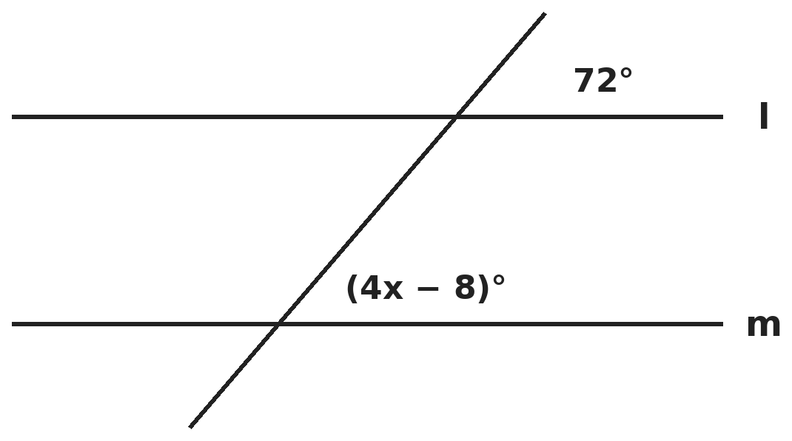
Q12. Lines l and m are parallel, and the two marked angles are corresponding angles. What is the value of x?
(A) 16 | (B) 20 | (C) 27 | (D) 18

Q13. The angles of a triangle are in the ratio 2 : 3 : 4. What is the difference between its largest and smallest exterior angles?
(A) 20° | (B) 60° | (C) 40° | (D) 80°

Q14. The diagonals of rectangle ABCD meet at O, and angle AOB = 110°. What is angle OCB + angle AOD?
(A) 145° | (B) 125° | (C) 90° | (D) 165°

Part 6 — Mensuration (Syllabus Chapter 6)
Q15. Two cylinders have the same volume. Their radii are in the ratio 2 : 3. What is the ratio of their heights?
(A) 3 : 2 | (B) 9 : 4 | (C) 4 : 9 | (D) 2 : 3

Q16. A tank with a rectangular base 3 m × 2 m has water 1.5 m deep. 4,500 litres are drawn out. How deep is the water now?
(A) 1.25 m | (B) 0.5 m | (C) 0.75 m | (D) 1 m

Q17. A cube of edge 6 cm is cut into cubes of edge 2 cm. How many times the original surface area is the total surface area of the small cubes?
(A) 3 times | (B) 9 times | (C) 27 times | (D) 2 times

Part 7 — Data Handling, Statistics & Probability (Syllabus Chapter 8)
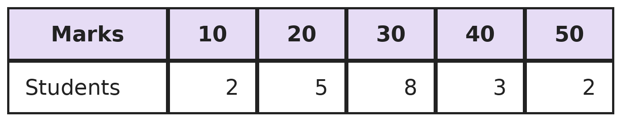
Q18. The table shows the marks scored by 20 students in a quiz. What is the mean mark?
(A) 30 | (B) 28 | (C) 31 | (D) 29

Q19. In a class of 120 students, 45 like cricket best. Of the rest, one-third like football best. In a pie chart of this data, what is the angle for football?
(A) 25° | (B) 120° | (C) 75° | (D) 90°

Part 8 — Applied Mathematics (Syllabus Chapter 9)
Q20. ₹4,500 is shared among Kavya, Yash and Om. Kavya gets twice as much as Yash, and Yash gets three times as much as Om. Kavya then gives ₹450 to Om. What is the ratio of Kavya's money to Om's now?
(A) 5 : 2 | (B) 6 : 1 | (C) 3 : 1 | (D) 2 : 5

Q21. A fort has food for 300 soldiers for 40 days. After 10 days, 100 soldiers leave. For how many more days does the food last?
(A) 30 | (B) 40 | (C) 45 | (D) 20

Q22. Two towns are 210 km apart. Two cars start at the same time from the towns, driving towards each other at 40 km/h and 30 km/h. How far from the faster car's town do they meet?
(A) 90 km | (B) 105 km | (C) 120 km | (D) 140 km

Part 9 — Mathematical Reasoning (Syllabus Chapter 10)
Q23. A, B and C are digits and AB, BC, CA are 2-digit numbers. AB + BC + CA = ABC, a 3-digit number. What is A + B + C?
(A) 19 | (B) 17 | (C) 16 | (D) 18

Q24. Gita climbs a staircase of 6 steps. Each move she climbs either 1 step or 2 steps. In how many different ways can she reach the top?
(A) 8 | (B) 21 | (C) 12 | (D) 13

Q25. How many numbers from 100 to 200 are divisible by both 4 and 6?
(A) 9 | (B) 8 | (C) 16 | (D) 25

Part 10 — Mixed Problems (each joins two chapters)
Q26. A number machine doubles a number and then subtracts 3. Pari puts a number in, and puts the result through the machine again. The final output is 29. What number did she start with?
(A) 8 | (B) 16 | (C) 9.5 | (D) 11

Q27. In a school, 60% of the students are girls. 25% of the girls and 50% of the boys play chess. What percent of all students play chess?
(A) 35% | (B) 37.5% | (C) 75% | (D) 30%

Q28. Aarav cycles from P to Q at 30 km/h and returns along the same road at 20 km/h. The round trip takes 5 hours. How far is P from Q?
(A) 50 km | (B) 75 km | (C) 100 km | (D) 60 km

Q29. The largest possible cylinder is carved from a wooden block 14 cm × 14 cm × 20 cm, with its height along the 20 cm edge. How much wood is wasted? (π = 22/7)
(A) 3,080 cm³ | (B) 3,920 cm³ | (C) 1,260 cm³ | (D) 840 cm³

Q30. Solve (x + 2)/(x − 1) = 4/3. What is x?
(A) −10 | (B) 10 | (C) 2 | (D) −2

Answer Sheet AMO Level 2 · Class 7 · Practice Paper 8
Name: | School: | Roll No.:
Shade or tick one circle for each question.
1. | Ⓐ Ⓑ Ⓒ Ⓓ | 11. | Ⓐ Ⓑ Ⓒ Ⓓ | 21. | Ⓐ Ⓑ Ⓒ Ⓓ
2. | Ⓐ Ⓑ Ⓒ Ⓓ | 12. | Ⓐ Ⓑ Ⓒ Ⓓ | 22. | Ⓐ Ⓑ Ⓒ Ⓓ
3. | Ⓐ Ⓑ Ⓒ Ⓓ | 13. | Ⓐ Ⓑ Ⓒ Ⓓ | 23. | Ⓐ Ⓑ Ⓒ Ⓓ
4. | Ⓐ Ⓑ Ⓒ Ⓓ | 14. | Ⓐ Ⓑ Ⓒ Ⓓ | 24. | Ⓐ Ⓑ Ⓒ Ⓓ
5. | Ⓐ Ⓑ Ⓒ Ⓓ | 15. | Ⓐ Ⓑ Ⓒ Ⓓ | 25. | Ⓐ Ⓑ Ⓒ Ⓓ
6. | Ⓐ Ⓑ Ⓒ Ⓓ | 16. | Ⓐ Ⓑ Ⓒ Ⓓ | 26. | Ⓐ Ⓑ Ⓒ Ⓓ
7. | Ⓐ Ⓑ Ⓒ Ⓓ | 17. | Ⓐ Ⓑ Ⓒ Ⓓ | 27. | Ⓐ Ⓑ Ⓒ Ⓓ
8. | Ⓐ Ⓑ Ⓒ Ⓓ | 18. | Ⓐ Ⓑ Ⓒ Ⓓ | 28. | Ⓐ Ⓑ Ⓒ Ⓓ
9. | Ⓐ Ⓑ Ⓒ Ⓓ | 19. | Ⓐ Ⓑ Ⓒ Ⓓ | 29. | Ⓐ Ⓑ Ⓒ Ⓓ
10. | Ⓐ Ⓑ Ⓒ Ⓓ | 20. | Ⓐ Ⓑ Ⓒ Ⓓ | 30. | Ⓐ Ⓑ Ⓒ Ⓓ

For the parent or teacher
Correct: ______ / 30
Answer Key and Solutions AMO Level 2 · Class 7 · Practice Paper 8
Quick answers
1 D | 6 A | 11 A | 16 C | 21 C | 26 C
2 D | 7 D | 12 B | 17 A | 22 C | 27 A
3 B | 8 C | 13 C | 18 D | 23 D | 28 D
4 B | 9 A | 14 B | 19 C | 24 D | 29 D
5 A | 10 B | 15 B | 20 A | 25 B | 30 B
Solutions
Q | Part · level | Answer | Why?
1 | Part 1 · Ch1 · Hard | (D) 60 km | Hint: What fraction of the journey is walked?  Car and bus: 2/3 + 1/4 = 11/12. Walked: 1/12 of the journey = 5 km. Whole journey: 60 km.
2 | Part 1 · Ch1 · Hard | (D) −5/12 | Hint: Write everything with the denominator 24: −1/2 = −12/24 and −1/3 = −8/24.  −5/12 = −10/24 lies between −12/24 and −8/24. −7/12 = −14/24 is below −1/2. −1/4 = −6/24 and −7/24 are above −1/3.
3 | Part 1 · Ch1 · Hard | (B) 9/22 | Hint: Look at what cancels.  Every middle term cancels: −1/3 with +1/3, −1/4 with +1/4, and so on. Only 1/2 − 1/11 = 11/22 − 2/22 = 9/22 is left.
4 | Part 2 · Ch2 · Hard | (B) 27 | Hint: Write every number as powers of 2, 3 and 5.  Top: 2⁴ × 3⁴ × 3⁴ × 5⁴. Bottom: 3⁵ × 2⁴ × 5⁴ = 3⁴ × 3 × 2⁴ × 5⁴. Cancel 2⁴, 5⁴ and one 3⁴: what is left is 3⁴ ÷ 3 = 3³ = 27.
5 | Part 2 · Ch2 · Hard | (A) 16 | Hint: Find the number of books first.  Books: (3.2 × 10⁵) ÷ (8 × 10²) = 0.4 × 10³ = 400. Boxes: 400 ÷ 25 = 16.
6 | Part 3 · Ch3 · Hard | (A) 10% profit | Hint: The profit is 1 part of the ratio.  1 part = ₹140, so the cost price is 5 × 140 = ₹700 and the selling price ₹840. Selling for ₹770 gives a profit of ₹70, which is 70/700 = 10% profit.
7 | Part 3 · Ch3 · Hard | (D) 4% loss | Hint: Find the cost price of each fan first.  Fan 1: 1,200 is 120% of cost, so cost = ₹1,000. Fan 2: 1,200 is 80% of cost, so cost = ₹1,500. Total cost ₹2,500, total sale ₹2,400. Loss ₹100, which is 100/2,500 = 4%.
8 | Part 3 · Ch3 · Hard | (C) 15,000 | Hint: The loser got 42%. What percent is the winning margin?  Margin = 58% − 42% = 16% of the votes = 2,400. Total = 2,400 ÷ 0.16 = 15,000.
9 | Part 4 · Ch4 · Hard | (A) 8 | Hint: Expand carefully: −4 × −5 = +20.  7x − 21 − 8x + 20 = x − 9, so −x − 1 = x − 9, giving 2x = 8 and x = 4. Then x² − 2x = 16 − 8 = 8.
10 | Part 4 · Ch4 · Hard | (B) a + b | Hint: Find the sum of the two sides, then subtract it from 4a + 3.  Sum: (2a + b) + (a − 2b + 3) = 3a − b + 3. Needed: (4a + 3) − (3a − b + 3) = a + b.
11 | Part 4 · Ch4 · Hard | (A) 16 years | Hint: Let the mother's age be m.  2m/5 + 8 = (m + 8)/2. Multiply by 10: 4m + 80 = 5m + 40, so m = 40. Meena is 2/5 × 40 = 16.
12 | Part 5 · Ch5 · Hard | (B) 20 | Hint: Corresponding angles are equal when the lines are parallel.  4x − 8 = 72, so 4x = 80 and x = 20. (27 comes from using 4x − 8 + 72 = 180, which is for co-interior angles.)
13 | Part 5 · Ch5 · Hard | (C) 40° | Hint: Find the interior angles first. The smallest interior angle gives the largest exterior angle.  Interior angles: 40°, 60°, 80°. Exterior angles: 140°, 120°, 100°. Difference: 140° − 100° = 40°.
14 | Part 5 · Ch5 · Hard | (B) 125° | Hint: The diagonals of a rectangle are equal and bisect each other, so OA = OB = OC = OD.  Angle AOD = 180° − 110° = 70° (angles on a line). Angle BOC = 70° too, and OB = OC, so angle OCB = (180° − 70°) ÷ 2 = 55°. Sum: 55° + 70° = 125°.
15 | Part 6 · Ch6 · Hard | (B) 9 : 4 | Hint: Volume depends on radius × radius × height.  2 × 2 × h₁ = 3 × 3 × h₂, so h₁ : h₂ = 9 : 4. The narrower cylinder must be taller.
16 | Part 6 · Ch6 · Hard | (C) 0.75 m | Hint: 4,500 L = 4.5 m³.  Fall in level = 4.5 ÷ (3 × 2) = 0.75 m. New depth = 1.5 − 0.75 = 0.75 m.
17 | Part 6 · Ch6 · Hard | (A) 3 times | Hint: Count the small cubes and compare surface areas.  Small cubes: 3 × 3 × 3 = 27, each with surface 24 cm²: 648 cm². Original: 6 × 36 = 216 cm². 648 ÷ 216 = 3.
18 | Part 7 · Ch8 · Hard | (D) 29 | Hint: Multiply each mark by its number of students and add.  10 × 2 + 20 × 5 + 30 × 8 + 40 × 3 + 50 × 2 = 20 + 100 + 240 + 120 + 100 = 580. Mean = 580 ÷ 20 = 29. (30 is the median and mode.)
19 | Part 7 · Ch8 · Hard | (C) 75° | Hint: Find the number who like football first.  Not cricket: 75 students. Football: 75 ÷ 3 = 25. Angle = 25/120 × 360° = 75°.
20 | Part 8 · Ch9 · Hard | (A) 5 : 2 | Hint: Let Om get x. Then Yash gets 3x and Kavya 6x.  10x = 4,500, so x = 450: Kavya ₹2,700, Om ₹450. After the gift: Kavya ₹2,250 and Om ₹900. 2,250 : 900 = 5 : 2.
21 | Part 8 · Ch9 · Hard | (C) 45 | Hint: Count the food in soldier-days.  Food: 300 × 40 = 12,000 soldier-days. After 10 days, 12,000 − 3,000 = 9,000 are left for 200 soldiers: 9,000 ÷ 200 = 45 more days.
22 | Part 8 · Ch9 · Hard | (C) 120 km | Hint: They close the gap at 40 + 30 km/h.  They meet after 210 ÷ 70 = 3 hours. The faster car has gone 40 × 3 = 120 km.
23 | Part 9 · Ch10 · Hard | (D) 18 | Hint: AB + BC + CA = 11 × (A + B + C). So ABC is 11 times its own digit sum.  Try the 3-digit multiples of 11: only 198 = 11 × 18 has digit sum 18. So A + B + C = 18. Check: 19 + 98 + 81 = 198.
24 | Part 9 · Ch10 · Hard | (D) 13 | Hint: The ways to reach step n = ways to reach step n − 1 + ways to reach step n − 2.  Steps 1 to 6: 1, 2, 3, 5, 8, 13 ways. She can reach the top in 13 ways.
25 | Part 9 · Ch10 · Hard | (B) 8 | Hint: Divisible by both 4 and 6 means divisible by 12, not 24.  Multiples of 12 from 100 to 200: 108, 120, 132, 144, 156, 168, 180, 192. That is 8.
26 | Part 10 · Mixed · Ch4 + Ch10 · Hard | (C) 9.5 | Hint: Work backwards: undo "subtract 3", then undo "double".  Second time: 29 + 3 = 32, halved = 16. First time: 16 + 3 = 19, halved = 9.5. Check: 9.5 → 16 → 29.
27 | Part 10 · Mixed · Ch3 + Ch10 · Hard | (A) 35% | Hint: Take 100 students.  60 girls: 15 play. 40 boys: 20 play. 35 out of 100 = 35%. (37.5% just averages 25% and 50%.)
28 | Part 10 · Mixed · Ch4 + Ch9 · Hard | (D) 60 km | Hint: Time = distance ÷ speed. d/30 + d/20 = 5.  d/30 + d/20 = 2d/60 + 3d/60 = d/12 = 5, so d = 60 km.
29 | Part 10 · Mixed · Ch5 + Ch6 · Hard | (D) 840 cm³ | Hint: The cylinder has radius 7 cm and height 20 cm.  Block: 14 × 14 × 20 = 3,920 cm³. Cylinder: 22/7 × 7 × 7 × 20 = 3,080 cm³. Wasted: 840 cm³.
30 | Part 10 · Mixed · Ch1 + Ch4 · Hard | (B) 10 | Hint: Cross-multiply.  3(x + 2) = 4(x − 1), so 3x + 6 = 4x − 4 and x = 10. Check: 12/9 = 4/3.

ARYABHATTA MATHS OLYMPIAD
Level 2
PRACTICE PAPER-9
CLASS 7
Total Questions | 30 multiple-choice questions
Level | Level-2 (final round): every question is Hard
Time | 45 minutes
Arrangement | Parts by chapter; the last Part has mixed problems joining two chapters
Negative Marking | No negative marking
Calculator | Not allowed
Chapters | Number System · Operations · Fractions, Decimals & Percentages · Algebra · Geometry · Mensuration · Data Handling, Statistics & Probability · Applied Mathematics · Mathematical Reasoning

Instructions
• Each question has four options, (A) to (D), with exactly one correct answer.
• The questions are grouped in Parts by chapter. The last Part has mixed problems, each joining two chapters.
• Every question is at Level-2 (Hard) standard: expect several steps or a key insight.
• There is no negative marking. Calculators are not allowed; use a separate sheet for rough work.
• Figures are not necessarily drawn to scale unless stated.

For teachers
• Figures are part of the questions and work when printed in black and white.
• Parts follow the AMO syllabus chapters. Chapter 7 is not part of the Class 7 syllabus, so the chapter numbers shown in the Part headings have gaps.
• The answer sheet and the answer key are at the end. Remove the answer key before the paper is attempted.

Part 1 — Number System (Syllabus Chapter 1)
Q1. Rani uses 1/3 of a ribbon, and then 3/8 of what is left. Now 15 m of ribbon remain. How long was the ribbon at first?
(A) 40 m | (B) 24 m | (C) 45 m | (D) 36 m

Q2. What is (−3/4) × (8/−9) × (−5/6) × (−9/10)?
(A) 1/2 | (B) −1/2 | (C) 2 | (D) −2

Q3. p and q are integers with p/q = −2/3 and q − p = 25. What is p?
(A) 10 | (B) −15 | (C) −10 | (D) 15

Part 2 — Operations (Syllabus Chapter 2)
Q4. x and y are whole numbers with 2ˣ × 3ʸ = 72. What is xʸ + yˣ?
(A) 13 | (B) 12 | (C) 17 | (D) 25

Q5. How many zeros are there at the end of 5⁵ × 4⁴ × 2²?
(A) 5 | (B) 10 | (C) 4 | (D) 8

Part 3 — Fractions, Decimals & Percentages (Syllabus Chapter 3)
Q6. Ojas buys oranges at 6 for ₹10 and sells them at 4 for ₹10. What is his profit percent?
(A) 33 1/3% | (B) 25% | (C) 40% | (D) 50%

Q7. A shopkeeper marks a cycle at ₹2,800 and gives a 15% discount. He still makes a 19% profit. What did the cycle cost him?
(A) ₹2,380 | (B) ₹1,904 | (C) ₹2,000 | (D) ₹2,240

Q8. In a fruit basket, 30% of the fruits are mangoes and 40% of the remaining fruits are apples. The other 84 fruits are bananas. How many fruits are in the basket?
(A) 120 | (B) 280 | (C) 140 | (D) 200

Part 4 — Algebra (Syllabus Chapter 4)
Q9. A father's age is 4 more than three times his son's age. Four years ago, it was 6 more than four times the son's age then. How old is the father now?
(A) 30 years | (B) 38 years | (C) 10 years | (D) 34 years

Q10. Simplify 2(3x − 4) − 3(x − 2) + 4(x + 1) and find its value when x = −3.
(A) 23 | (B) −23 | (C) −19 | (D) 19

Q11. Five consecutive integers add up to −15. What is the product of the smallest and the largest?
(A) −5 | (B) 5 | (C) 15 | (D) −15

Part 5 — Geometry (Syllabus Chapter 5)
Q12. Lines l and m are parallel. P is on l; Q and R are on m. Line PQ makes 55° with l on one side of P, and PR makes 60° with l on the other side. What is angle QPR?
(A) 65° | (B) 115° | (C) 55° | (D) 60°

Q13. In a triangle, each angle is less than the sum of the other two angles. What kind of triangle must it be?
(A) Right-angled | (B) Acute-angled | (C) Obtuse-angled | (D) Equilateral

Q14. Triangle ABC is congruent to triangle QRP, with the vertices in that order. AB = 6 cm, BC = 8 cm, QP = 7 cm and angle B = 70°. What are the perimeter of triangle QRP and angle R?
(A) 21 cm and 40° | (B) 20 cm and 70° | (C) 22 cm and 70° | (D) 21 cm and 70°

Part 6 — Mensuration (Syllabus Chapter 6)
Q15. Water flows at 7 m per second through a pipe of inner radius 1 cm into an empty 66-litre tank. How long does it take to fill the tank? (π = 22/7)
(A) 3 s | (B) 300 s | (C) 30 s | (D) 60 s

Q16. A cuboid 12 cm × 9 cm × 6 cm is cut into cubes of edge 3 cm. What is the total surface area of all the cubes?
(A) 648 cm² | (B) 1,296 cm² | (C) 468 cm² | (D) 216 cm²

Q17. A room is 8 m long, 6 m wide and 4 m high. Tiles of 1.5 m × 1 m are used to cover its floor and four walls. What is the least number of tiles needed? (Tiles may be cut and the pieces used.)
(A) 106 | (B) 107 | (C) 160 | (D) 75

Part 7 — Data Handling, Statistics & Probability (Syllabus Chapter 8)
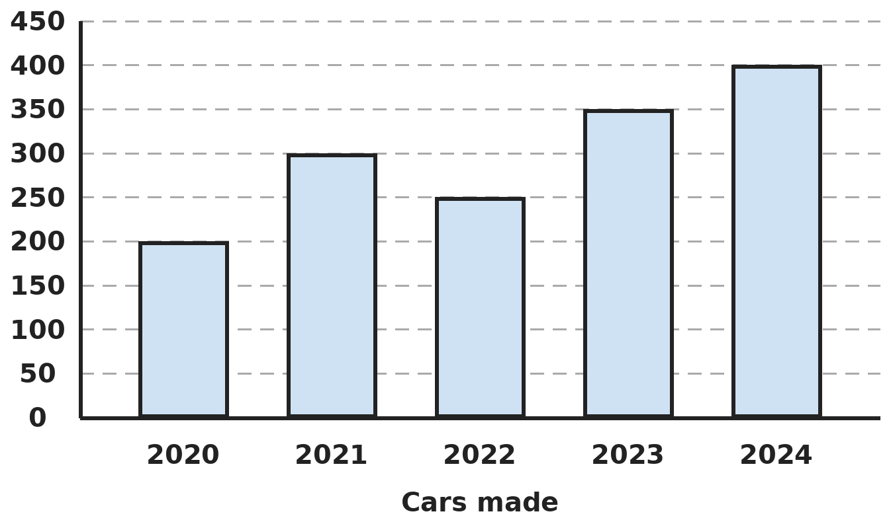
Q18. The bar graph shows the number of cars a factory made each year. In which year was the percentage increase over the year before the greatest?
(A) 2021 | (B) 2023 | (C) 2024 | (D) 2022

Q19. The numbers 6, 8, 8, x, 10 and 12 have a mean of 9. What is their median?
(A) 8 | (B) 10 | (C) 8.5 | (D) 9

Part 8 — Applied Mathematics (Syllabus Chapter 9)
Q20. Two numbers are in the ratio 3 : 4. When 6 is subtracted from each, the ratio becomes 1 : 2. What is the larger number?
(A) 9 | (B) 12 | (C) 18 | (D) 24

Q21. A bus usually takes 8 hours for a journey at 45 km/h. Today it must arrive 2 hours sooner, and it also stops for 1 hour on the way. At what speed must it travel?
(A) 60 km/h | (B) 80 km/h | (C) 65 km/h | (D) 72 km/h

Q22. One machine makes 120 bottles in 8 minutes. Two such machines start together, and a third joins them after 10 minutes. How long after the start are 1,200 bottles made in all?
(A) 30 minutes | (B) 27 minutes | (C) 40 minutes | (D) 20 minutes

Part 9 — Mathematical Reasoning (Syllabus Chapter 10)
Q23. In ABCD × 4 = DCBA, each letter is a digit and both are 4-digit numbers. What is A + B + C + D?
(A) 18 | (B) 16 | (C) 20 | (D) 22

Q24. How many 4-digit numbers use only the digits 1, 2 and 3 (repeats allowed) and contain at least one digit 1?
(A) 16 | (B) 65 | (C) 81 | (D) 54

Q25. Each number in the list 2, 5, 10, 17, 26, … is 1 more than a whole number multiplied by itself. How many numbers in the list are less than 200?
(A) 13 | (B) 15 | (C) 199 | (D) 14

Part 10 — Mixed Problems (each joins two chapters)
Q26. What is the value of 50 × 50 − 49 × 51 + 30 × 30 − 29 × 31?
(A) 0 | (B) 2 | (C) 1 | (D) 100

Q27. Starting from 200, Riya increases the number by 50% and then decreases the result by 50%. She repeats both steps once more. What number does she end with?
(A) 200 | (B) 150 | (C) 112.5 | (D) 100

Q28. Neel has ₹500 in ₹5 and ₹10 coins. He has 40 more ₹5 coins than ₹10 coins. How many ₹5 coins does he have?
(A) 20 | (B) 60 | (C) 40 | (D) 80

Q29. A cylindrical well of radius 3.5 m is dug 10 m deep. The earth taken out is spread evenly over a field 55 m × 14 m. By how much does the level of the field rise? (π = 22/7)
(A) 1 m | (B) 0.25 m | (C) 0.5 m | (D) 5 m

Q30. What is the value of x² − y² + xy when x = −1/2 and y = 1/3?
(A) −1/36 | (B) 11/36 | (C) 1/36 | (D) −11/36

Answer Sheet AMO Level 2 · Class 7 · Practice Paper 9
Name: | School: | Roll No.:
Shade or tick one circle for each question.
1. | Ⓐ Ⓑ Ⓒ Ⓓ | 11. | Ⓐ Ⓑ Ⓒ Ⓓ | 21. | Ⓐ Ⓑ Ⓒ Ⓓ
2. | Ⓐ Ⓑ Ⓒ Ⓓ | 12. | Ⓐ Ⓑ Ⓒ Ⓓ | 22. | Ⓐ Ⓑ Ⓒ Ⓓ
3. | Ⓐ Ⓑ Ⓒ Ⓓ | 13. | Ⓐ Ⓑ Ⓒ Ⓓ | 23. | Ⓐ Ⓑ Ⓒ Ⓓ
4. | Ⓐ Ⓑ Ⓒ Ⓓ | 14. | Ⓐ Ⓑ Ⓒ Ⓓ | 24. | Ⓐ Ⓑ Ⓒ Ⓓ
5. | Ⓐ Ⓑ Ⓒ Ⓓ | 15. | Ⓐ Ⓑ Ⓒ Ⓓ | 25. | Ⓐ Ⓑ Ⓒ Ⓓ
6. | Ⓐ Ⓑ Ⓒ Ⓓ | 16. | Ⓐ Ⓑ Ⓒ Ⓓ | 26. | Ⓐ Ⓑ Ⓒ Ⓓ
7. | Ⓐ Ⓑ Ⓒ Ⓓ | 17. | Ⓐ Ⓑ Ⓒ Ⓓ | 27. | Ⓐ Ⓑ Ⓒ Ⓓ
8. | Ⓐ Ⓑ Ⓒ Ⓓ | 18. | Ⓐ Ⓑ Ⓒ Ⓓ | 28. | Ⓐ Ⓑ Ⓒ Ⓓ
9. | Ⓐ Ⓑ Ⓒ Ⓓ | 19. | Ⓐ Ⓑ Ⓒ Ⓓ | 29. | Ⓐ Ⓑ Ⓒ Ⓓ
10. | Ⓐ Ⓑ Ⓒ Ⓓ | 20. | Ⓐ Ⓑ Ⓒ Ⓓ | 30. | Ⓐ Ⓑ Ⓒ Ⓓ

For the parent or teacher
Correct: ______ / 30
Answer Key and Solutions AMO Level 2 · Class 7 · Practice Paper 9
Quick answers
1 D | 6 D | 11 B | 16 B | 21 D | 26 B
2 A | 7 C | 12 A | 17 B | 22 A | 27 C
3 C | 8 D | 13 B | 18 A | 23 A | 28 B
4 C | 9 D | 14 D | 19 D | 24 B | 29 C
5 A | 10 C | 15 C | 20 B | 25 D | 30 A
Solutions
Q | Part · level | Answer | Why?
1 | Part 1 · Ch1 · Hard | (D) 36 m | Hint: What fraction of the whole ribbon is left at the end?  After the first cut 2/3 is left. She then keeps 5/8 of that: 5/8 × 2/3 = 5/12 of the ribbon = 15 m. The ribbon was 15 × 12/5 = 36 m.
2 | Part 1 · Ch1 · Hard | (A) 1/2 | Hint: First count the negative signs to decide the sign of the answer.  There are four negative signs, so the product is positive. Size: (3 × 8 × 5 × 9) ÷ (4 × 9 × 6 × 10) = 1,080 ÷ 2,160 = 1/2.
3 | Part 1 · Ch1 · Hard | (C) −10 | Hint: Write p = −2k and q = 3k for some integer k.  q − p = 3k + 2k = 5k = 25, so k = 5. p = −10 and q = 15. (Taking p = 2k, q = −3k gives k = −5 and the same p = −10.)
4 | Part 2 · Ch2 · Hard | (C) 17 | Hint: Write 72 as a product of prime factors.  72 = 8 × 9 = 2³ × 3², so x = 3 and y = 2. xʸ + yˣ = 3² + 2³ = 9 + 8 = 17.
5 | Part 2 · Ch2 · Hard | (A) 5 | Hint: Each zero needs one 2 and one 5.  Each 4 gives two 2s, so 4⁴ × 2² has 4 × 2 + 2 = 10 factors of 2, but there are only five 5s. Pair five 2s with the five 5s: the number is 2⁵ × 10⁵ = 32 × 10⁵, which ends in 5 zeros.
6 | Part 3 · Ch3 · Hard | (D) 50% | Hint: Find the cost and selling price of 12 oranges.  12 oranges cost ₹20 and sell for ₹30. Profit ₹10 on ₹20 = 50%. (33 1/3% divides by the selling price.)
7 | Part 3 · Ch3 · Hard | (C) ₹2,000 | Hint: First find the selling price.  Selling price = 85% of 2,800 = ₹2,380. This is 119% of the cost, so the cost = 2,380 ÷ 1.19 = ₹2,000.
8 | Part 3 · Ch3 · Hard | (D) 200 | Hint: Bananas are 60% of the 70% that are not mangoes.  Not mangoes: 70%. Bananas: 60% of 70% = 42% of all fruits = 84. Total = 84 ÷ 0.42 = 200.
9 | Part 4 · Ch4 · Hard | (D) 34 years | Hint: Let the son be s years old; the father is 3s + 4.  Four years ago: 3s + 4 − 4 = 4(s − 4) + 6, so 3s = 4s − 10 and s = 10. The father is 3 × 10 + 4 = 34.
10 | Part 4 · Ch4 · Hard | (C) −19 | Hint: Expand each bracket carefully: −3 × (−2) = +6.  6x − 8 − 3x + 6 + 4x + 4 = 7x + 2. At x = −3: 7 × (−3) + 2 = −19.
11 | Part 4 · Ch4 · Hard | (B) 5 | Hint: The middle integer is the average.  The middle integer is −15 ÷ 5 = −3, so the integers are −5, −4, −3, −2, −1. (−5) × (−1) = 5.
12 | Part 5 · Ch5 · Hard | (A) 65° | Hint: The three angles at P along line l make a straight angle.  The angles at P on one side of line l are 55°, angle QPR and 60°, which add up to 180°. Angle QPR = 180° − 55° − 60° = 65°. (They are also the angles of triangle PQR, by alternate angles.)
13 | Part 5 · Ch5 · Hard | (B) Acute-angled | Hint: If an angle is less than the sum of the other two, it is less than half of 180°.  Each angle A < B + C = 180° − A, so A < 90°. All three angles are acute. (It need not be equilateral.)
14 | Part 5 · Ch5 · Hard | (D) 21 cm and 70° | Hint: Match the vertices in order: A with Q, B with R, C with P.  QR = AB = 6 cm, RP = BC = 8 cm and QP = 7 cm, so the perimeter is 21 cm. R matches B, so angle R = 70°.
15 | Part 6 · Ch6 · Hard | (C) 30 s | Hint: Each second a cylinder of water 700 cm long comes out.  Per second: 22/7 × 1 × 1 × 700 = 2,200 cm³. 66 L = 66,000 cm³. Time = 66,000 ÷ 2,200 = 30 s.
16 | Part 6 · Ch6 · Hard | (B) 1,296 cm² | Hint: Count how many cubes fit along each edge.  Cubes: 4 × 3 × 2 = 24, each with surface 6 × 9 = 54 cm². Total 24 × 54 = 1,296 cm². (468 cm² is the surface of the cuboid.)
17 | Part 6 · Ch6 · Hard | (B) 107 | Hint: Area to cover = floor + four walls.  Floor: 48 m². Walls: 2 × (8 + 6) × 4 = 112 m². Total 160 m². Each tile is 1.5 m², and 160 ÷ 1.5 = 106.7, so at least 107 tiles.
18 | Part 7 · Ch8 · Hard | (A) 2021 | Hint: Percentage increase = increase ÷ previous year × 100.  2021: 100/200 = 50%. 2022: a fall. 2023: 100/250 = 40%. 2024: 50/350 ≈ 14%. The greatest is in 2021.
19 | Part 7 · Ch8 · Hard | (D) 9 | Hint: Find x first, then put the numbers in order.  Total = 6 × 9 = 54, so x = 54 − 44 = 10. In order: 6, 8, 8, 10, 10, 12. Median = (8 + 10) ÷ 2 = 9.
20 | Part 8 · Ch9 · Hard | (B) 12 | Hint: Let the numbers be 3x and 4x.  (3x − 6)/(4x − 6) = 1/2, so 6x − 12 = 4x − 6 and x = 3. The numbers are 9 and 12; the larger is 12.
21 | Part 8 · Ch9 · Hard | (D) 72 km/h | Hint: The distance stays the same; find the time left for moving.  Distance: 45 × 8 = 360 km. Time today: 8 − 2 = 6 hours, of which 1 hour is the stop, leaving 5 hours. Speed: 360 ÷ 5 = 72 km/h. (60 km/h forgets the stop.)
22 | Part 8 · Ch9 · Hard | (A) 30 minutes | Hint: One machine makes 15 bottles a minute.  Each machine makes 120 ÷ 8 = 15 a minute. First 10 minutes: 2 × 15 × 10 = 300. Left: 900 at 45 a minute = 20 minutes. Total: 10 + 20 = 30 minutes.
23 | Part 9 · Ch10 · Hard | (A) 18 | Hint: A × 4 must still be a single digit, and DCBA is even.  DCBA = 4 × ABCD is even, so its last digit A is even, and 4 × A must be a single digit, so A = 2. Then D ≥ 8 and 4 × D ends in 2, so D = 8. Working through the middle digits gives 2178 × 4 = 8712. A + B + C + D = 2 + 1 + 7 + 8 = 18.
24 | Part 9 · Ch10 · Hard | (B) 65 | Hint: Count all such numbers, then take away those with no 1 at all.  All: 3 × 3 × 3 × 3 = 81. With no 1 (only 2s and 3s): 2 × 2 × 2 × 2 = 16. At least one 1: 81 − 16 = 65.
25 | Part 9 · Ch10 · Hard | (D) 14 | Hint: The nth number is n × n + 1.  14 × 14 + 1 = 197 is less than 200, but 15 × 15 + 1 = 226 is not. So the numbers for n = 1 to 14 are less than 200: 14 numbers.
26 | Part 10 · Mixed · Ch4 + Ch10 · Hard | (B) 2 | Hint: Try smaller cases first, such as 5 × 5 − 4 × 6.  49 × 51 = (50 − 1) × 51 = 2,550 − 51 = 2,499, so 50 × 50 − 49 × 51 = 2,500 − 2,499 = 1. In the same way 29 × 31 = 899, and 900 − 899 = 1. Total: 1 + 1 = 2.
27 | Part 10 · Mixed · Ch3 + Ch10 · Hard | (C) 112.5 | Hint: One round multiplies by 1.5 × 0.5.  One round: 1.5 × 0.5 = 0.75. Two rounds: 200 × 0.75 × 0.75 = 112.5.
28 | Part 10 · Mixed · Ch4 + Ch9 · Hard | (B) 60 | Hint: Let the number of ₹10 coins be x.  10x + 5(x + 40) = 500, so 15x + 200 = 500 and x = 20. He has 20 coins of ₹10 and 60 coins of ₹5.
29 | Part 10 · Mixed · Ch5 + Ch6 · Hard | (C) 0.5 m | Hint: Volume of earth = volume of the well.  Earth: 22/7 × 3.5 × 3.5 × 10 = 385 m³. Field: 55 × 14 = 770 m². Rise = 385 ÷ 770 = 0.5 m.
30 | Part 10 · Mixed · Ch1 + Ch4 · Hard | (A) −1/36 | Hint: Work out each term with the denominator 36.  x² = 1/4 = 9/36, y² = 1/9 = 4/36, xy = −1/6 = −6/36. 9/36 − 4/36 − 6/36 = −1/36.

ARYABHATTA MATHS OLYMPIAD
Level 2
PRACTICE PAPER-10
CLASS 7
Total Questions | 30 multiple-choice questions
Level | Level-2 (final round): every question is Hard
Time | 45 minutes
Arrangement | Parts by chapter; the last Part has mixed problems joining two chapters
Negative Marking | No negative marking
Calculator | Not allowed
Chapters | Number System · Operations · Fractions, Decimals & Percentages · Algebra · Geometry · Mensuration · Data Handling, Statistics & Probability · Applied Mathematics · Mathematical Reasoning

Instructions
• Each question has four options, (A) to (D), with exactly one correct answer.
• The questions are grouped in Parts by chapter. The last Part has mixed problems, each joining two chapters.
• Every question is at Level-2 (Hard) standard: expect several steps or a key insight.
• There is no negative marking. Calculators are not allowed; use a separate sheet for rough work.
• Figures are not necessarily drawn to scale unless stated.

For teachers
• Figures are part of the questions and work when printed in black and white.
• Parts follow the AMO syllabus chapters. Chapter 7 is not part of the Class 7 syllabus, so the chapter numbers shown in the Part headings have gaps.
• The answer sheet and the answer key are at the end. Remove the answer key before the paper is attempted.

Part 1 — Number System (Syllabus Chapter 1)
Q1. Of the students in a school, 2/5 walk and 1/3 cycle. Of the rest, 3/4 come by bus and the remaining 12 come by car. How many students are there?
(A) 180 | (B) 240 | (C) 120 | (D) 150

Q2. When 5/12 is subtracted from a rational number, the result is 7/18 more than −1/4. What is the number?
(A) −5/9 | (B) 1/9 | (C) 7/9 | (D) 5/9

Q3. What is the value of 1 ÷ (−2/3) + 1 ÷ (5/4) − 1 ÷ (−1/6)?
(A) −53/10 | (B) 7/10 | (C) 53/10 | (D) 13/2

Part 2 — Operations (Syllabus Chapter 2)
Q4. What is (2⁵ × 3⁴) ÷ (6³ × 2²) + 4³ ÷ 2⁵?
(A) 3 | (B) 5 | (C) 6 | (D) 7

Q5. A heart beats about 72 times a minute. About how many times does it beat in one day? Give the answer in standard form.
(A) 1.0368 × 10⁵ | (B) 1.0368 × 10⁴ | (C) 4.32 × 10³ | (D) 1.728 × 10³

Part 3 — Fractions, Decimals & Percentages (Syllabus Chapter 3)
Q6. The cost price of 20 pens equals the selling price of x pens. The profit is 25%. What is x?
(A) 15 | (B) 16 | (C) 25 | (D) 18

Q7. A shopkeeper buys a bag for ₹800. He marks it 20% above his cost and then gives a 10% discount on the marked price. What is his profit percent?
(A) 10% | (B) 12% | (C) 8% | (D) 2%

Q8. The length of a rectangle is increased by 20% and its breadth is decreased by 20%. Then its new length is decreased by 10%. By what percent has the area changed overall?
(A) 10% decrease | (B) 14% decrease
(C) 4% decrease | (D) 13.6% decrease

Part 4 — Algebra (Syllabus Chapter 4)
Q9. 84 is split into two parts so that one-third of the first part is 7 more than one-quarter of the second part. What is the first part?
(A) 36 | (B) 42 | (C) 48 | (D) 54

Q10. If A = 3x² − 2x + 1 and B = x² + 4x − 3, what is 2A − 3B?
(A) 3x² + 8x − 7 | (B) 3x² − 16x − 7
(C) 9x² − 16x + 11 | (D) 3x² − 16x + 11

Q11. A train has 20 coaches with the same number of seats. If 4 coaches are removed and each remaining coach gets 12 more seats, the total number of seats is unchanged. How many seats does the train have?
(A) 768 | (B) 1,200 | (C) 960 | (D) 1,152

Part 5 — Geometry (Syllabus Chapter 5)
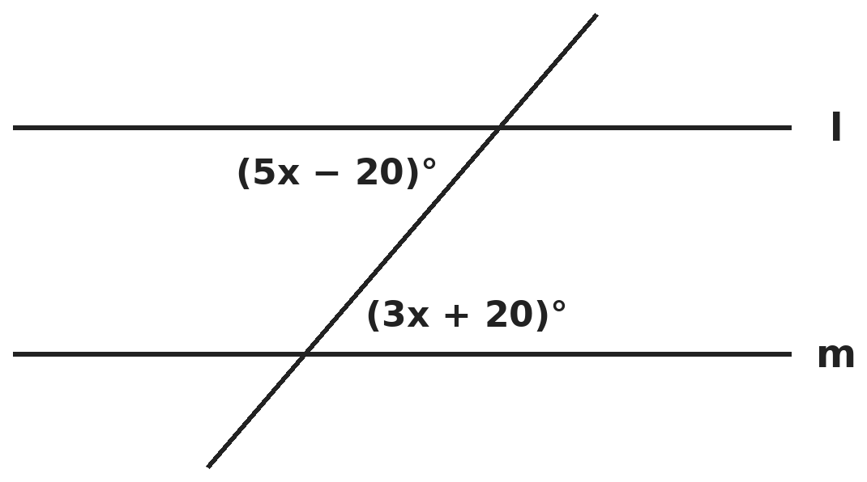
Q12. Lines l and m are parallel, and the two marked angles are alternate interior angles. What is the obtuse angle formed where the transversal crosses line l?
(A) 100° | (B) 80° | (C) 20° | (D) 120°

Q13. In triangle ABC, AB = AC. Side BA is extended beyond A, and the exterior angle formed at A is 100°. What is angle B?
(A) 50° | (B) 80° | (C) 40° | (D) 100°

Q14. The angles of a quadrilateral are x, x + 10°, x + 20° and x + 30°. What is its largest angle?
(A) 95° | (B) 105° | (C) 90° | (D) 120°

Part 6 — Mensuration (Syllabus Chapter 6)
Q15. A cylinder of radius 7 cm and height 15 cm is full of water. The water is poured into a cuboid tank with a base 22 cm × 15 cm. How deep is the water in the tank? (π = 22/7)
(A) 10 cm | (B) 14 cm | (C) 7 cm | (D) 3.5 cm

Q16. Matchboxes measure 4 cm × 2.5 cm × 1.5 cm. How many fit exactly into a carton 60 cm × 50 cm × 30 cm, all placed the same way?
(A) 600 | (B) 6,000 | (C) 4,500 | (D) 7,500

Q17. Three cubes of edge 4 cm are joined end to end to make a cuboid. What is the surface area of the cuboid?
(A) 288 cm² | (B) 192 cm² | (C) 256 cm² | (D) 224 cm²

Part 7 — Data Handling, Statistics & Probability (Syllabus Chapter 8)
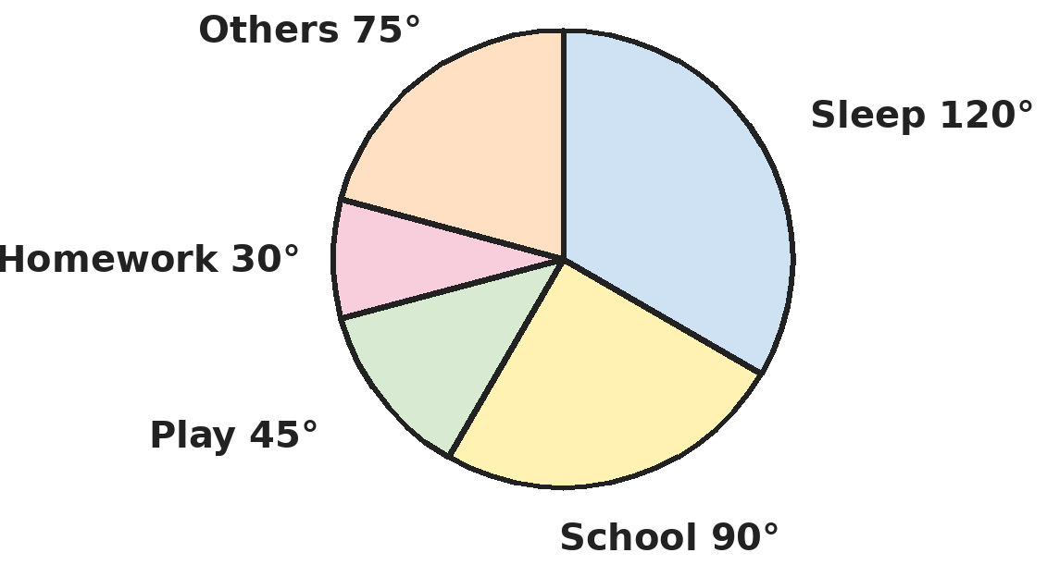
Q18. The pie chart shows how Ishaan spends a 24-hour day. How many more hours does he sleep than he spends on play and homework together?
(A) 5 hours | (B) 6 hours | (C) 2 hours | (D) 3 hours

Q19. The mean of 12 numbers is 15. Each number is multiplied by 3, and then 2 is subtracted from each result. One of the new numbers, 54, is then removed. What is the mean of the 11 numbers left?
(A) 42 | (B) 43 | (C) 41 | (D) 40.5

Part 8 — Applied Mathematics (Syllabus Chapter 9)
Q20. If a : b = 2 : 3 and b : c = 4 : 5, and a + c = 92, what is c?
(A) 32 | (B) 46 | (C) 60 | (D) 69

Q21. 12 taps together fill a tank in 7 hours. After 3 hours, 4 of the taps are closed. How long does it take to fill the tank in all?
(A) 10 hours | (B) 9 hours | (C) 8 hours | (D) 6 hours

Q22. At the same time of day, a 6 m pole casts a 4.8 m shadow and a tree casts a 12 m shadow. How tall is the tree?
(A) 15 m | (B) 9.6 m | (C) 14.4 m | (D) 10 m

Part 9 — Mathematical Reasoning (Syllabus Chapter 10)
Q23. A and B are different digits, and AB and BA are 2-digit numbers. AB + B = BA. What is A × B?
(A) 63 | (B) 56 | (C) 72 | (D) 81

Q24. Two different numbers are chosen from 1 to 10. In how many ways can they be chosen so that their sum is even?
(A) 25 | (B) 45 | (C) 10 | (D) 20

Q25. What is the units digit of 2⁵ × 3⁵ × 7⁵?
(A) 4 | (B) 2 | (C) 6 | (D) 8

Part 10 — Mixed Problems (each joins two chapters)
Q26. Lata puts the numbers 1 to 9 in a 3 × 3 grid so that every row, column and diagonal has the same sum. Which number must be in the centre?
(A) 9 | (B) 15 | (C) 1 | (D) 5

Q27. Which is the largest: 30% of 50% of 400, 50% of 30% of 420, 20% of 75% of 380, or 75% of 20% of 410?
(A) 50% of 30% of 420 | (B) 30% of 50% of 400
(C) 75% of 20% of 410 | (D) 20% of 75% of 380

Q28. Mukesh is 4 times as old as his son. In 20 years he will be twice as old as his son. How old is Mukesh now?
(A) 10 | (B) 50 | (C) 40 | (D) 30

Q29. A rectangular field has its length and breadth in the ratio 5 : 3 and a perimeter of 320 m. A path 2 m wide runs inside the field along all four edges. What is the area of the path?
(A) 624 m² | (B) 640 m² | (C) 608 m² | (D) 320 m²

Q30. Solve x/(−3) + 1/4 = 5/6 − x/2. What is x?
(A) −7/2 | (B) 7/2 | (C) 2/7 | (D) 13/2

Answer Sheet AMO Level 2 · Class 7 · Practice Paper 10
Name: | School: | Roll No.:
Shade or tick one circle for each question.
1. | Ⓐ Ⓑ Ⓒ Ⓓ | 11. | Ⓐ Ⓑ Ⓒ Ⓓ | 21. | Ⓐ Ⓑ Ⓒ Ⓓ
2. | Ⓐ Ⓑ Ⓒ Ⓓ | 12. | Ⓐ Ⓑ Ⓒ Ⓓ | 22. | Ⓐ Ⓑ Ⓒ Ⓓ
3. | Ⓐ Ⓑ Ⓒ Ⓓ | 13. | Ⓐ Ⓑ Ⓒ Ⓓ | 23. | Ⓐ Ⓑ Ⓒ Ⓓ
4. | Ⓐ Ⓑ Ⓒ Ⓓ | 14. | Ⓐ Ⓑ Ⓒ Ⓓ | 24. | Ⓐ Ⓑ Ⓒ Ⓓ
5. | Ⓐ Ⓑ Ⓒ Ⓓ | 15. | Ⓐ Ⓑ Ⓒ Ⓓ | 25. | Ⓐ Ⓑ Ⓒ Ⓓ
6. | Ⓐ Ⓑ Ⓒ Ⓓ | 16. | Ⓐ Ⓑ Ⓒ Ⓓ | 26. | Ⓐ Ⓑ Ⓒ Ⓓ
7. | Ⓐ Ⓑ Ⓒ Ⓓ | 17. | Ⓐ Ⓑ Ⓒ Ⓓ | 27. | Ⓐ Ⓑ Ⓒ Ⓓ
8. | Ⓐ Ⓑ Ⓒ Ⓓ | 18. | Ⓐ Ⓑ Ⓒ Ⓓ | 28. | Ⓐ Ⓑ Ⓒ Ⓓ
9. | Ⓐ Ⓑ Ⓒ Ⓓ | 19. | Ⓐ Ⓑ Ⓒ Ⓓ | 29. | Ⓐ Ⓑ Ⓒ Ⓓ
10. | Ⓐ Ⓑ Ⓒ Ⓓ | 20. | Ⓐ Ⓑ Ⓒ Ⓓ | 30. | Ⓐ Ⓑ Ⓒ Ⓓ

For the parent or teacher
Correct: ______ / 30
Answer Key and Solutions AMO Level 2 · Class 7 · Practice Paper 10
Quick answers
1 A | 6 B | 11 C | 16 B | 21 B | 26 D
2 D | 7 C | 12 A | 17 D | 22 A | 27 A
3 C | 8 D | 13 A | 18 D | 23 C | 28 C
4 B | 9 C | 14 B | 19 A | 24 D | 29 A
5 A | 10 D | 15 C | 20 C | 25 B | 30 B
Solutions
Q | Part · level | Answer | Why?
1 | Part 1 · Ch1 · Hard | (A) 180 | Hint: Find the fraction of all students who come by car.  Walk or cycle: 2/5 + 1/3 = 11/15. Rest: 4/15. By car: 1/4 of 4/15 = 1/15 of all students = 12. Total 180.
2 | Part 1 · Ch1 · Hard | (D) 5/9 | Hint: Write x − 5/12 = −1/4 + 7/18 and use the denominator 36.  −1/4 + 7/18 = −9/36 + 14/36 = 5/36. x = 5/36 + 5/12 = 5/36 + 15/36 = 20/36 = 5/9.
3 | Part 1 · Ch1 · Hard | (C) 53/10 | Hint: Dividing 1 by a fraction gives its reciprocal.  −3/2 + 4/5 − (−6) = −15/10 + 8/10 + 60/10 = 53/10.
4 | Part 2 · Ch2 · Hard | (B) 5 | Hint: 6³ = 2³ × 3³ and 4³ = 64.  Bottom: 2³ × 3³ × 2² = 2⁵ × 3³. The 2⁵ cancels, and 3⁴ ÷ 3³ = 3. Also 4³ ÷ 2⁵ = 64 ÷ 32 = 2. Total: 3 + 2 = 5.
5 | Part 2 · Ch2 · Hard | (A) 1.0368 × 10⁵ | Hint: Beats = 72 × 60 × 24.  72 × 60 = 4,320 beats an hour (4.32 × 10³). × 24 = 1,03,680 beats a day = 1.0368 × 10⁵. (1.728 × 10³ is 72 × 24, which forgets the minutes.)
6 | Part 3 · Ch3 · Hard | (B) 16 | Hint: Each pen sells for 1.25 times its cost.  If each pen costs ₹1, it sells for ₹1.25. 20 pens cost ₹20, and 20 ÷ 1.25 = 16 pens sell for ₹20. So x = 16.
7 | Part 3 · Ch3 · Hard | (C) 8% | Hint: The discount is 10% of the marked price, not of the cost.  Marked price: 800 + 160 = ₹960. Discount: 96, so he sells for ₹864. Profit: 64, which is 64/800 = 8%. (10% wrongly subtracts the percentages.)
8 | Part 3 · Ch3 · Hard | (D) 13.6% decrease | Hint: Multiply the factors: 1.2, 0.8 and 0.9.  1.2 × 0.8 × 0.9 = 0.864, so the new area is 86.4% of the old: a decrease of 13.6%.
9 | Part 4 · Ch4 · Hard | (C) 48 | Hint: Let the first part be x; the second is 84 − x.  x/3 = (84 − x)/4 + 7. Multiply by 12: 4x = 252 − 3x + 84, so 7x = 336 and x = 48. Check: 48/3 = 16 and 36/4 + 7 = 16.
10 | Part 4 · Ch4 · Hard | (D) 3x² − 16x + 11 | Hint: Multiply out 2A and 3B, then subtract every term of 3B.  2A = 6x² − 4x + 2. 3B = 3x² + 12x − 9. 2A − 3B = 3x² − 16x + 11.
11 | Part 4 · Ch4 · Hard | (C) 960 | Hint: Let each coach have x seats.  20x = 16(x + 12), so 4x = 192 and x = 48. Total seats: 20 × 48 = 960.
12 | Part 5 · Ch5 · Hard | (A) 100° | Hint: Alternate angles are equal.  5x − 20 = 3x + 20, so x = 20 and each marked angle is 80°. The obtuse angle at that crossing is 180° − 80° = 100°.
13 | Part 5 · Ch5 · Hard | (A) 50° | Hint: The exterior angle equals the sum of the two opposite interior angles, which are equal.  Exterior angle at A = B + C = 100°. Since AB = AC, B = C = 50°.
14 | Part 5 · Ch5 · Hard | (B) 105° | Hint: The angles add up to 360°.  4x + 60 = 360, so x = 75°. The angles are 75°, 85°, 95° and 105°. The largest is 105°.
15 | Part 6 · Ch6 · Hard | (C) 7 cm | Hint: The volume of water stays the same.  Volume = 22/7 × 7 × 7 × 15 = 2,310 cm³. Depth = 2,310 ÷ (22 × 15) = 2,310 ÷ 330 = 7 cm.
16 | Part 6 · Ch6 · Hard | (B) 6,000 | Hint: Check how many fit along each edge: 60 ÷ 4, 50 ÷ 2.5, 30 ÷ 1.5.  Along the edges: 15, 20 and 20 boxes. Total 15 × 20 × 20 = 6,000. (Volume check: 90,000 ÷ 15 = 6,000.)
17 | Part 6 · Ch6 · Hard | (D) 224 cm² | Hint: The cuboid is 12 cm × 4 cm × 4 cm. Joining hides some faces.  Cuboid 12 × 4 × 4: 2(48 + 48 + 16) = 224 cm². (288 is three separate cubes; joining hides 4 faces of 16 cm².)
18 | Part 7 · Ch8 · Hard | (D) 3 hours | Hint: 360° stands for 24 hours, so 15° stands for 1 hour.  Sleep: 120 ÷ 15 = 8 h. Play: 3 h. Homework: 2 h. 8 − (3 + 2) = 3 hours.
19 | Part 7 · Ch8 · Hard | (A) 42 | Hint: The mean changes in the same way as each number. Then work with the total.  New mean: 15 × 3 − 2 = 43, so the 12 new numbers total 12 × 43 = 516. Removing 54 leaves 462. Mean of 11: 462 ÷ 11 = 42.
20 | Part 8 · Ch9 · Hard | (C) 60 | Hint: Make b the same in both ratios.  a : b : c = 8 : 12 : 15, so a : c = 8 : 15. 23 parts = 92, so 1 part = 4 and c = 60.
21 | Part 8 · Ch9 · Hard | (B) 9 hours | Hint: Count the work in tap-hours: 12 × 7 = 84.  First 3 hours: 12 × 3 = 36 tap-hours. Left: 48 tap-hours for 8 taps = 6 hours. Total: 3 + 6 = 9 hours.
22 | Part 8 · Ch9 · Hard | (A) 15 m | Hint: Height and shadow length are in the same ratio for both.  Height ÷ shadow = 6 ÷ 4.8 = 1.25. Tree = 12 × 1.25 = 15 m.
23 | Part 9 · Ch10 · Hard | (C) 72 | Hint: Write it as 10A + B + B = 10B + A.  10A + 2B = 10B + A, so 9A = 8B. With digits: A = 8, B = 9. Check: 89 + 9 = 98. A × B = 72.
24 | Part 9 · Ch10 · Hard | (D) 20 | Hint: An even sum needs two odd numbers or two even numbers.  Pairs of odd numbers from 1, 3, 5, 7, 9: 10. Pairs of even numbers from 2, 4, 6, 8, 10: 10. Total 20.
25 | Part 9 · Ch10 · Hard | (B) 2 | Hint: 2⁵ × 3⁵ × 7⁵ = 42⁵. Only the units digit matters.  42⁵ has the same units digit as 2⁵ = 32, which is 2.
26 | Part 10 · Mixed · Ch4 + Ch10 · Hard | (D) 5 | Hint: The magic sum is 45 ÷ 3 = 15. Four lines pass through the centre.  The four lines through the centre (middle row, middle column, two diagonals) add to 4 × 15 = 60. They cover all 9 numbers once plus the centre 3 more times: 45 + 3c = 60, so c = 5.
27 | Part 10 · Mixed · Ch3 + Ch10 · Hard | (A) 50% of 30% of 420 | Hint: Each one is the same percentage of a different number.  30% of 50%, 50% of 30%, 20% of 75% and 75% of 20% all equal 15%. So the largest is the one with the largest number, 420: 15% of 420 = 63 (the others are 60, 61.5 and 57).
28 | Part 10 · Mixed · Ch4 + Ch9 · Hard | (C) 40 | Hint: Let the son be x years old. Write both ages in 20 years.  In 20 years: 4x + 20 = 2(x + 20) = 2x + 40, so 2x = 20 and x = 10. Mukesh is 4 × 10 = 40.
29 | Part 10 · Mixed · Ch5 + Ch6 · Hard | (A) 624 m² | Hint: Find the length and breadth first. The inner rectangle is 4 m shorter each way.  Length + breadth = 160 m, so the field is 100 m by 60 m (area 6,000 m²). Inside the path: 96 m by 56 m = 5,376 m². Path area: 6,000 − 5,376 = 624 m². (640 m² wrongly takes 2 × 320.)
30 | Part 10 · Mixed · Ch1 + Ch4 · Hard | (B) 7/2 | Hint: Multiply every term by 12.  −4x + 3 = 10 − 6x, so 2x = 7 and x = 7/2.

