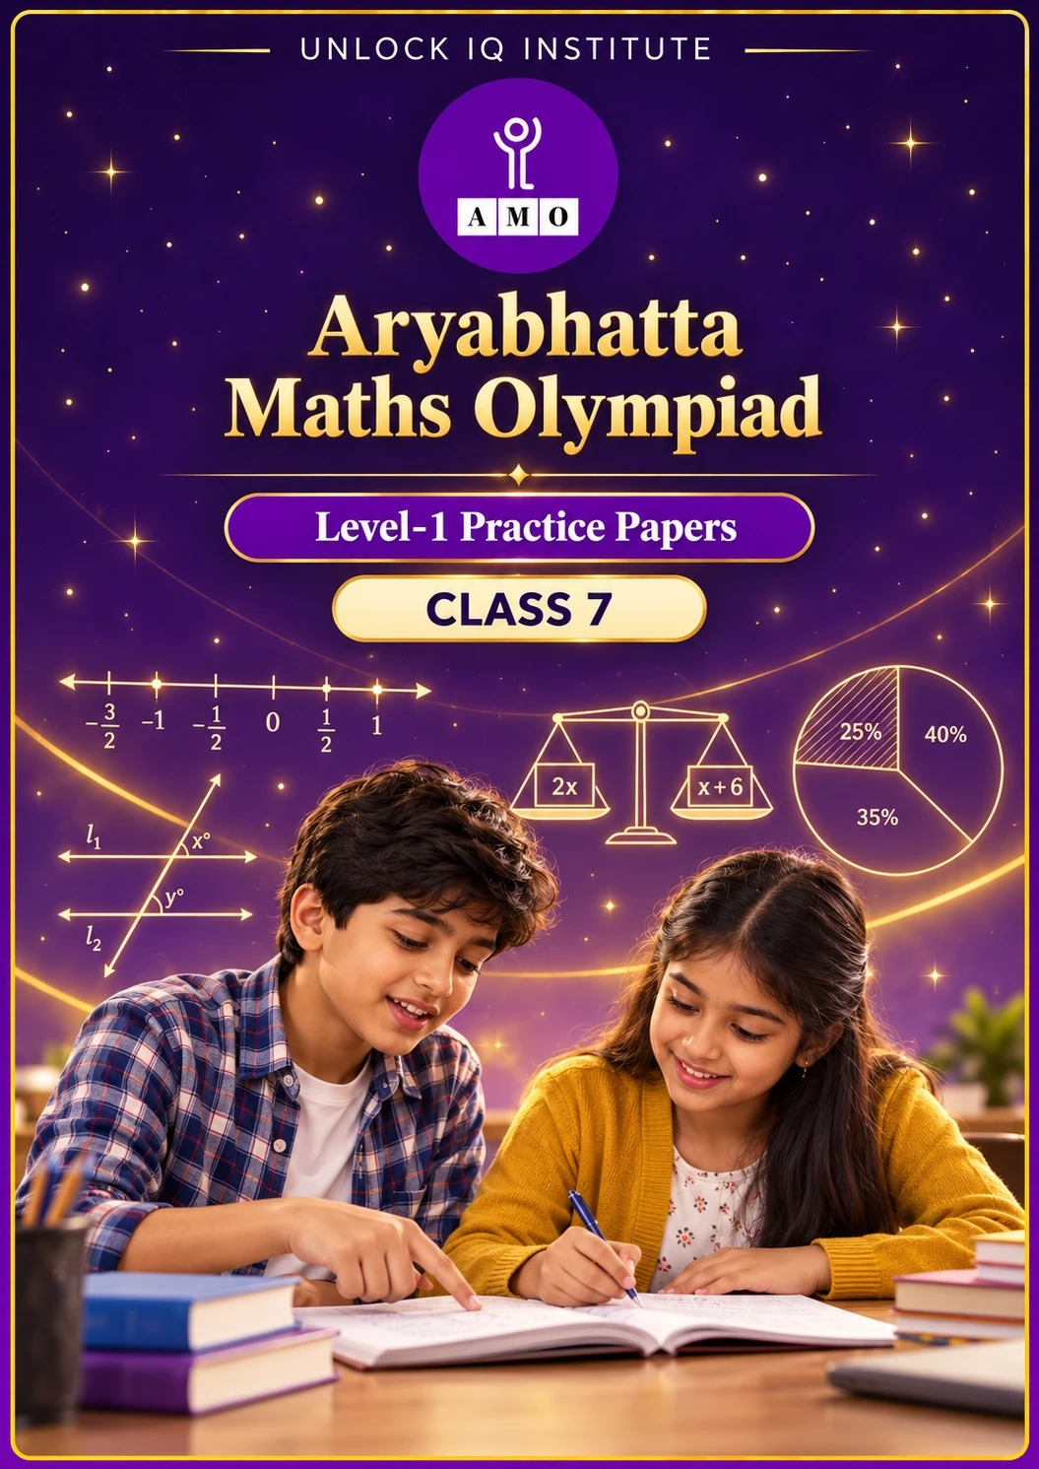
Five full practice papers · with answer keys & detailed solutions
Name: ____________________ | Class & Section: ________________
Roll No.: ________________ | School: ____________________
City: ____________________ | Date: ____________________

Published by Unlock IQ Institute Pvt. Ltd.
Register for Olympiads: www.aryabhattamathsolympiad.com/student-registration

ARYABHATTA MATHS OLYMPIAD
Level 1
PRACTICE PAPER-1
CLASS 7
Total Questions | 45 multiple-choice questions
Total Marks | 100
Time | 60 minutes
Section I | 40 questions × 2 marks = 80 marks
Section II | 5 Star Questions × 4 marks = 20 marks
Negative Marking | No negative marking
Calculator | Not allowed
Chapters | Number System · Operations · Fractions, Decimals & Percentages · Algebra · Geometry · Mensuration · Data Handling · Applied Mathematics · Mathematical Reasoning

Instructions to candidates
• This paper has 45 multiple-choice questions. Each question has four answer choices, of which exactly one is correct.
• Section I (Q1–Q40) carries 2 marks per question. Section II (Q41–Q45) carries 4 marks per question.
• There is no negative marking. Unanswered questions score zero.
• Calculators are not permitted. Rough work may be done on a separate sheet.
• Mark your answers on the answer sheet at the end of the paper.
• All figures are not necessarily drawn to scale unless stated.

For parents and teachers
• Print or view this paper in colour. Pictures are part of the questions.
• Parts follow the AMO syllabus chapters. Chapter 7 is not part of the Class 7 syllabus, so the chapter numbers shown in the Part headings have gaps.
• The answer sheet and the answer key are at the end. Remove only the answer key before the student begins.

SECTION I 40 questions × 2 marks each
Part 1 — Number System (Syllabus Chapter 1)
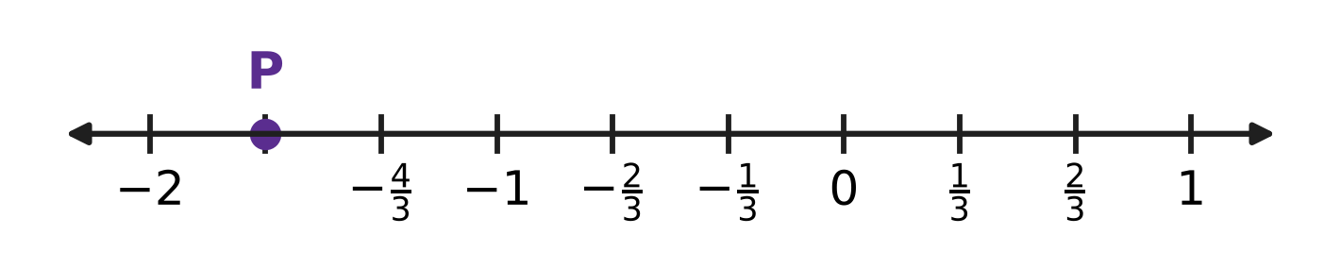
Q1. Look at the number line. Each unit from one whole number to the next is divided into equal parts. Which rational number does the point P show?
(A) $−\frac{5}{3}$ | (B) $−\frac{3}{2}$ | (C) $−\frac{1}{3}$ | (D) $−\frac{7}{3}$

Q2. A rational number is in standard form when its denominator is positive and its numerator and denominator have no common factor other than 1. Which of these is in standard form?
(A) $\frac{12}{−18}$ | (B) $\frac{−10}{15}$ | (C) $\frac{4}{−7}$ | (D) $\frac{−9}{14}$

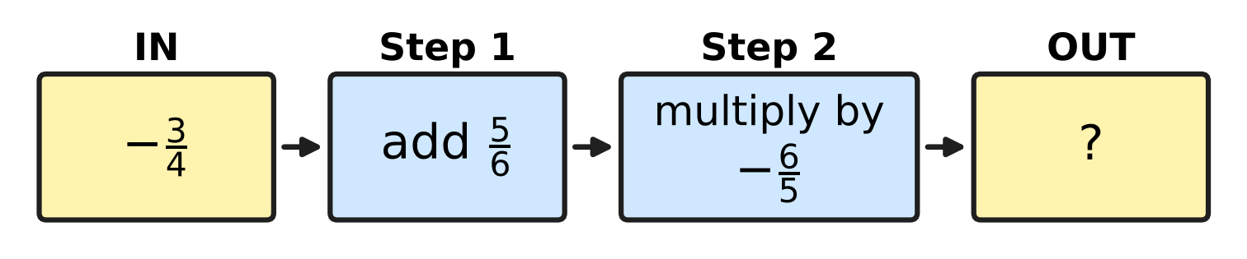
Q3. Look at the number machine. The number that goes IN passes through Step 1 and then Step 2. What number comes OUT?
(A) $\frac{26}{15}$ | (B) $−\frac{6}{25}$ | (C) $\frac{1}{10}$ | (D) $−\frac{1}{10}$

Q4. Let x = $−\frac{3}{4}$ and y = $\frac{2}{5}$. Which of these has the greatest value?
(A) x + y | (B) x − y | (C) x × y | (D) x ÷ y

Part 2 — Operations & Number Properties (Syllabus Chapter 2)
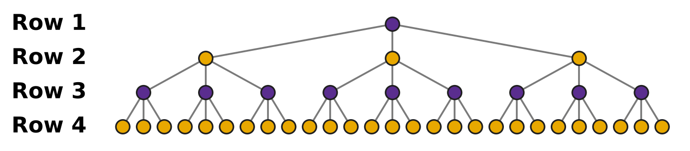
Q5. In the picture, every dot splits into 3 new dots in the next row. The pattern goes on in the same way. How many dots will there be in Row 6?
(A) 3⁵ | (B) 3⁶ | (C) 3 × 6 | (D) 6³

Q6. Which of these is NOT equal to 64?
(A) 8² | (B) 2⁵ × 2 | (C) 2³ + 2³ | (D) 4³

Q7. The number 7.05 × 10⁵ is written in the usual form, without a power of 10. How many zeros does the number have?
(A) 6 | (B) 3 | (C) 5 | (D) 4

Part 3 — Fractions, Decimals & Percentages (Syllabus Chapter 3)
Q8. A stationery shop puts the tag shown in the picture on a school bag. How much money does a buyer save because of the discount? | 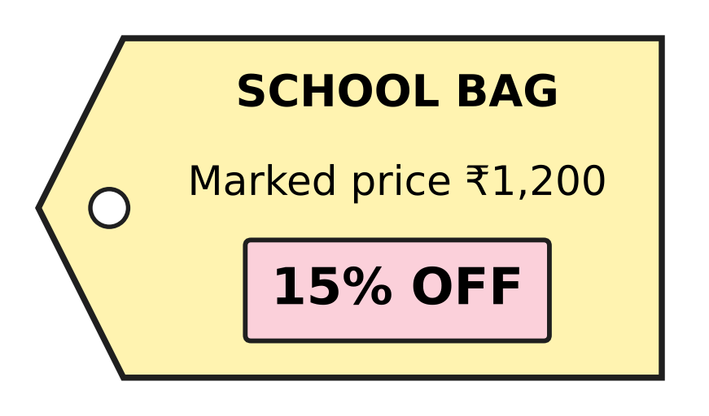
  (A) ₹180 | (B) ₹18 | (C) ₹80 | (D) ₹1,020

Q9. A school stores rainwater in the tank shown in the picture. The scale on its side shows how full the tank is, as a percentage of its capacity. How many litres of water are in the tank now? | 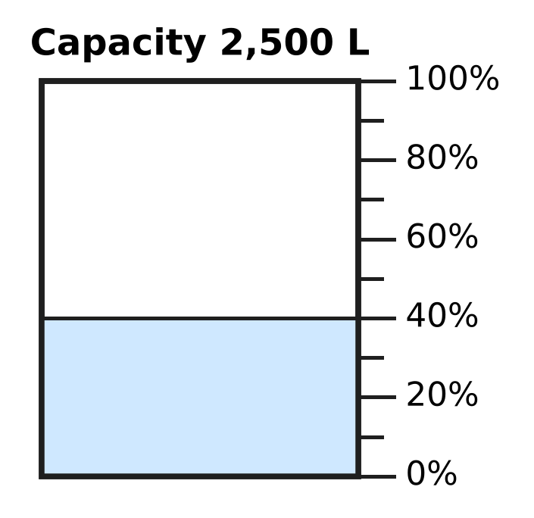
  (A) 1,500 L | (B) 1,000 L | (C) 625 L | (D) 400 L

Q10. A shopkeeper sold a chair and made a loss of ₹144. This loss was 18% of the cost price. What was the cost price of the chair?
(A) ₹2,592 | (B) ₹800 | (C) ₹656 | (D) ₹944

Cost and selling prices of four items
Item | Cost price (₹) | Selling price (₹)
K | 200 | 250
L | 400 | 480
M | 150 | 195
N | 500 | 640

Q11. A trader sold the four items in the table. On which item did the trader make the greatest profit percent?
(A) Item K | (B) Item L | (C) Item M | (D) Item N

Q12. In a school library, 45% of the books are story books and $\frac{1}{5}$ of the books are science books. The remaining 1,400 books are on other subjects. How many books does the library have in all?
(A) 1,800 | (B) 2,800 | (C) 490 | (D) 4,000

Part 4 — Algebra (Syllabus Chapter 4)
Q13. Which expression is equal to 3(2k − 5) − 4k?
(A) 10k − 15 | (B) 2k − 5 | (C) 2k − 15 | (D) 6k − 19

Q14. How many of these terms are like terms of 3pq?
−pq, 3p, 7qp, pq², −2qp, 5p²q
(A) 3 | (B) 4 | (C) 2 | (D) 1

Q15. For which equation is x = 3 the solution?
(A) 5x − 9 = x + 4 | (B) 4x − 5 = 2x + 1
(C) 2(x − 1) = x + 2 | (D) 3x + 2 = 5x − 2

Q16. Shreya has 4 times as many stamps as Kartik. If Shreya gives 15 stamps to Kartik, they will have the same number of stamps. How many stamps does Shreya have now?
(A) 10 | (B) 25 | (C) 40 | (D) 20

Q17. In the figure, the perimeter of the triangle is (9x + 4) cm. What length should replace the "?" | 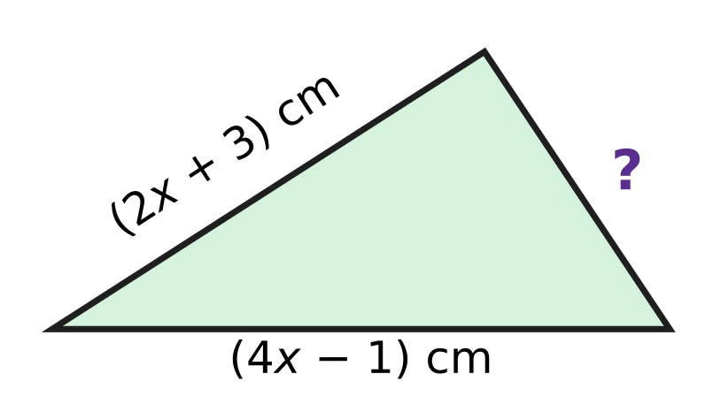
  (A) (3x + 2) cm | (B) 3x cm
  (C) (15x + 6) cm | (D) (3x + 8) cm

Part 5 — Geometry (Syllabus Chapter 5)
Q18. In the figure, line l is parallel to line m. What is the value of x? | 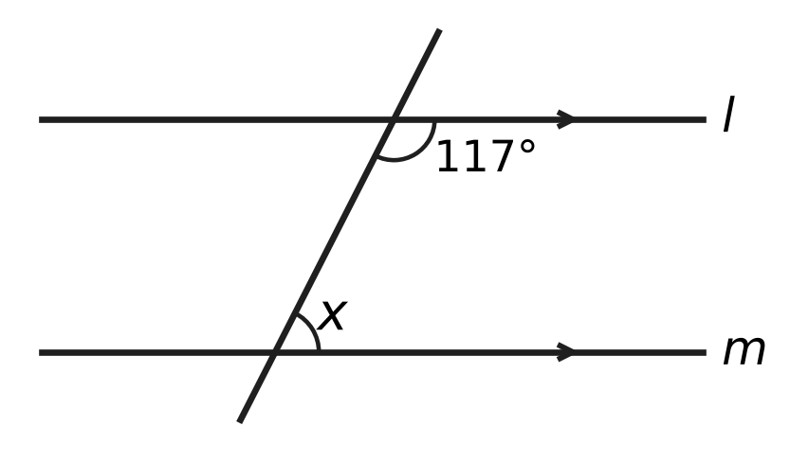
  (A) 27° | (B) 243° | (C) 117° | (D) 63°

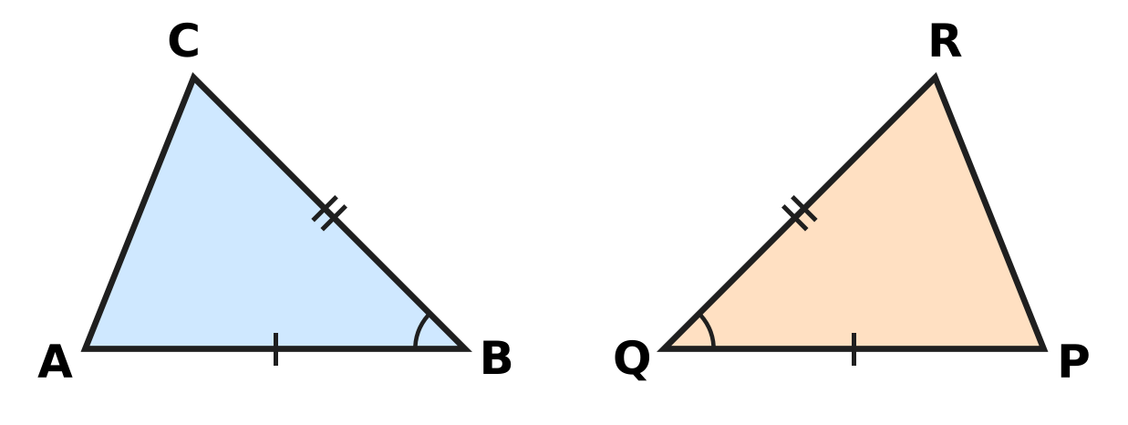
Q19. In the figure, sides with the same marks are equal, and the two marked angles are equal. By which rule is △ABC congruent to △PQR?
(A) SSS | (B) SAS | (C) ASA | (D) AAA

Q20. In the figure, side BC of △ABC is extended to D. Here is a proof that ∠4 = ∠1 + ∠2.  Step 1: ∠3 + ∠4 = 180°.  Step 2: ∠1 + ∠2 + ∠3 = 180° (angle sum of a triangle).  Step 3: So ∠4 = ∠1 + ∠2.  Which reason supports Step 1? | 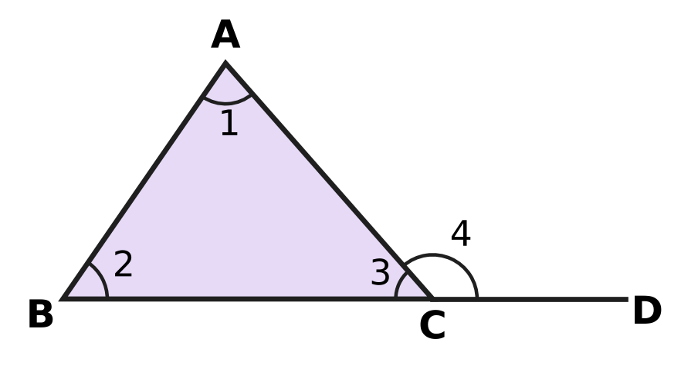
  (A) Vertically opposite angles are equal.
  (B) Alternate angles are equal.
  (C) Angles on a straight line add up to 180°.
  (D) The angles of a triangle add up to 180°.

Q21. In the figure, AB = AC in △ABC and ∠A = 44°. D is on AB and E is on AC, and DE is parallel to BC. What is the value of x (that is, ∠BDE)? | 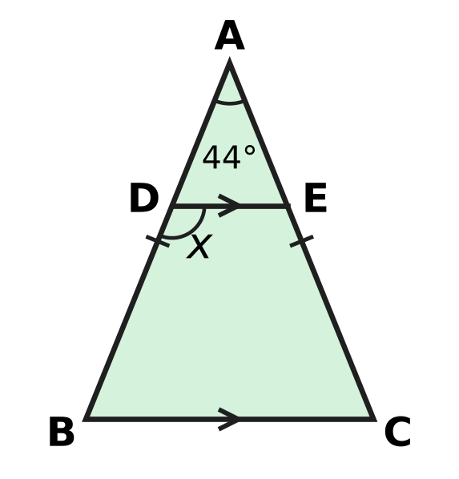
  (A) 136° | (B) 22° | (C) 68° | (D) 112°

Q22. In the figure, line l is parallel to line m. A is on l, B is on m, and O lies between the two lines. What is the value of x? | 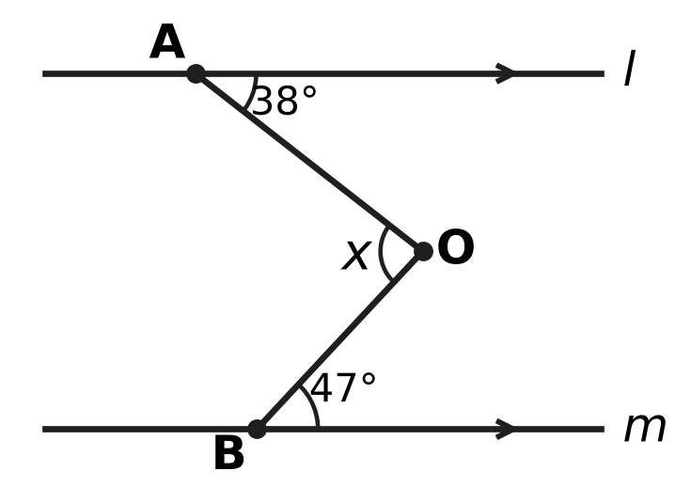
  (A) 85° | (B) 95° | (C) 9° | (D) 47°

Part 6 — Mensuration (Syllabus Chapter 6)
Q23. The picture shows the net of a closed cuboid box that is 7 cm long, 4 cm wide and 2 cm high. What is the total surface area of the box? | 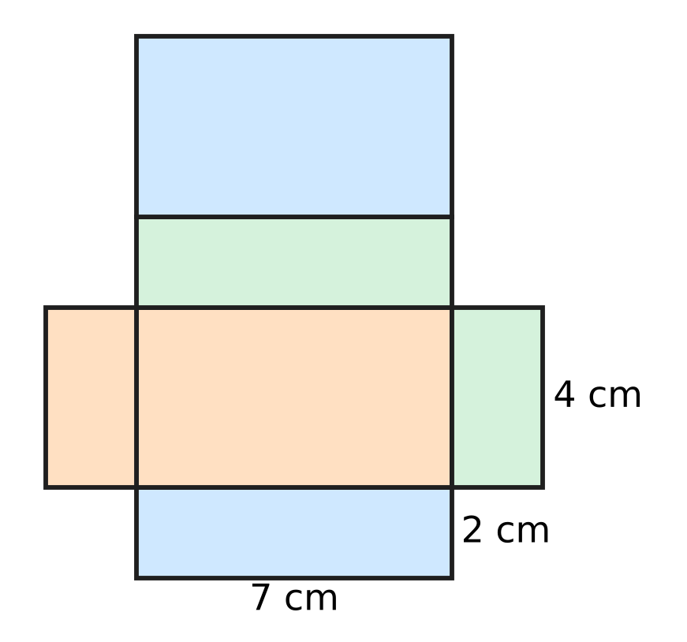
  (A) 128 cm² | (B) 100 cm² | (C) 92 cm² | (D) 50 cm²

Q24. The cylindrical jar in the figure has a radius of 7 cm. It holds 1,386 cm³ when full. How tall is the jar? Use π = $\frac{22}{7}$. | 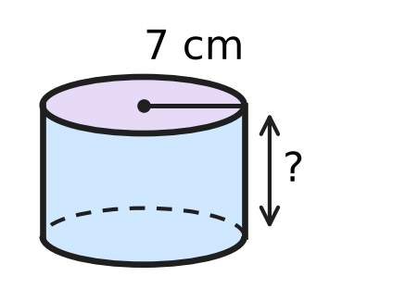
  (A) 9 cm | (B) 31.5 cm | (C) 63 cm | (D) 2.25 cm

Q25. A tape is wrapped once round the curved side of the cylindrical tin in the figure. The tape measures 50 cm. The tin is 12 cm tall. What is the area of the curved surface of the tin? | 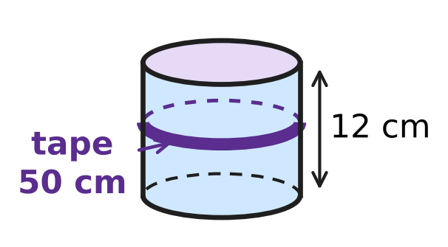
  (A) 1,200 cm² | (B) 600 cm²
  (C) 300 cm² | (D) 62 cm²

Q26. The swimming pool in the figure is a cuboid 20 m long, 8 m wide and 2 m deep, open at the top. Its floor and its four walls are covered with tiles on the inside. What area is tiled? | 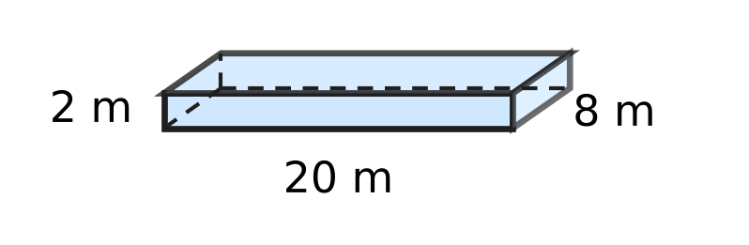
  (A) 432 m² | (B) 240 m² | (C) 112 m² | (D) 272 m²

Q27. Two cubes, each of edge 4 cm, are joined face to face to make a cuboid, as shown. What is the total surface area of the cuboid? | 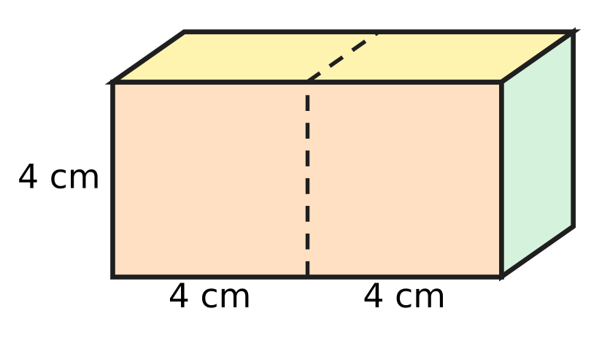
  (A) 176 cm² | (B) 192 cm² | (C) 160 cm² | (D) 96 cm²

Part 7 — Data Handling, Statistics & Probability (Syllabus Chapter 8)
Q28. The pie chart shows the trees in an orchard. There are 300 trees in all. How many pear trees are there? | 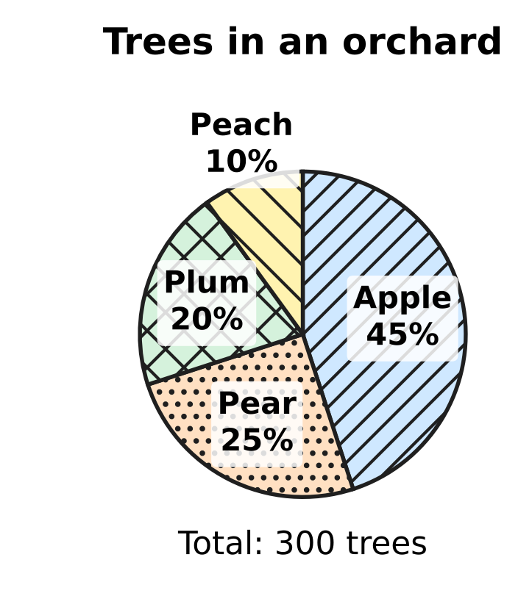
  (A) 75 | (B) 90 | (C) 25 | (D) 225

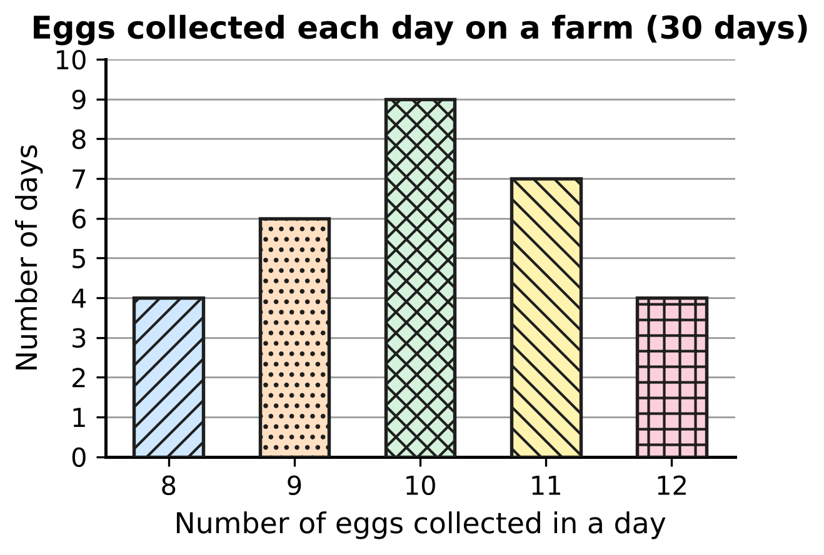
Q29. A farmer collects the eggs laid by her hens every day for 30 days. The bar graph shows on how many days each number of eggs was collected. What is the mode of the number of eggs collected in a day?
(A) 12 eggs | (B) 9 eggs | (C) 11 eggs | (D) 10 eggs

Q30. Arnav got these marks in five tests: 12, 20, 9, 16 and m. The mean of the five marks is 14. What is the median of the five marks?
(A) 14 | (B) 12 | (C) 13 | (D) 9

Part 8 — Applied Mathematics (Syllabus Chapter 9)
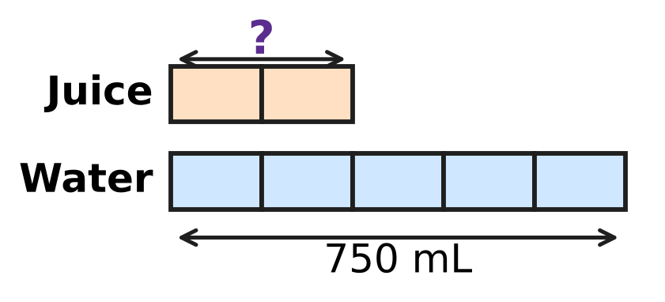
Q31. Juice and water are mixed in the ratio 2 : 5. The bar model shows the mix. All the boxes are of equal size. If 750 mL of water is used, how much juice is needed?
(A) 1,050 mL | (B) 300 mL | (C) 1,875 mL | (D) 150 mL

Seedlings in a vegetable garden (same number in every row)
Number of rows | 3 | 5 | 8
Number of seedlings | 54 | 90 | ?

Q32. In a vegetable garden, every row has the same number of seedlings. What number should replace the "?" in the table?
(A) 144 | (B) 126 | (C) 108 | (D) 162

Q33. Esha has a roll of string. It is just enough to fly 12 kites if each kite gets 30 m of string. On a windy day she gives each kite 40 m of string instead. How many kites can she fly with the same roll?
(A) 16 | (B) 9 | (C) 6 | (D) 12

Q34. On a bicycle trip, Viraj rides at a steady speed. He covers 15 km in 50 minutes. How far does he ride in 2 hours at the same speed?
(A) 45 km | (B) 30 km | (C) 18 km | (D) 36 km

Q35. Mei shares her marbles among three glass jars in the ratio 2 : 3 : 5. The third jar has 36 more marbles than the first jar. How many marbles does Mei have in all?
(A) 60 | (B) 360 | (C) 120 | (D) 180

Part 9 — Mathematical Reasoning & Problem-Solving (Syllabus Chapter 10)
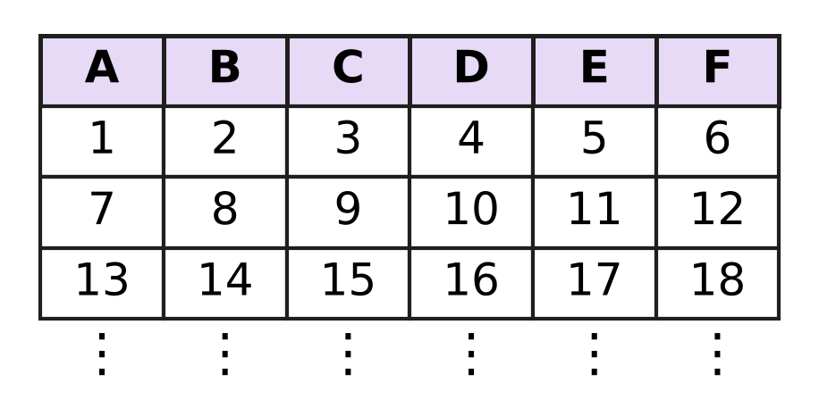
Q36. The counting numbers are written in rows of six under the columns A to F, as shown. The pattern goes on in the same way. In which column will 100 be written?
(A) Column C | (B) Column D | (C) Column E | (D) Column F

Q37. In the multiplication shown, A, B and C stand for three different digits, and A and C are not 0. What is the two-digit number AB? | 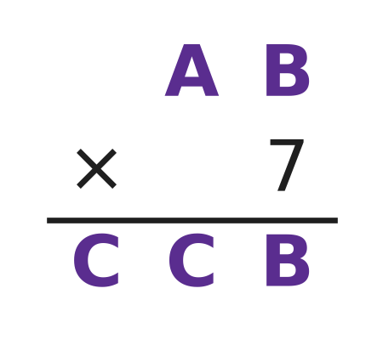
  (A) 75 | (B) 95 | (C) 85 | (D) 65

Q38. Look at these lines.
2² − 1² = 3
3² − 2² = 5
4² − 3² = 7
5² − 4² = 9
The lines go on in the same way. What is the answer in the 20th line?
(A) 400 | (B) 39 | (C) 40 | (D) 41

Q39. How many three-digit numbers have digits whose product is 12? (For example, 162 is one such number, because 1 × 6 × 2 = 12.)
(A) 18 | (B) 12 | (C) 15 | (D) 3

Q40. A whole number n leaves a remainder of 3 when it is divided by 7. What is the remainder when 2n + 5 is divided by 7?
(A) 4 | (B) 6 | (C) 3 | (D) 1

SECTION II — Star Questions 5 questions × 4 marks each
Q41. AB is a two-digit number. Writing the digit 6 at its right end gives the three-digit number AB6. Writing 6 at its left end gives the three-digit number 6AB. AB6 is 189 more than 6AB. What is the number AB? [4 marks]
(A) 21 | (B) 27 | (C) 45 | (D) 87

Q42. Ruhi baked some buns in her bakery. In the morning she sold 20% of them. At noon she sold 25% of the buns that were left. In the evening she sold 30 more buns. She then had 36 buns left. How many buns did she bake? [4 marks]
(A) 60 | (B) 120 | (C) 110 | (D) 99

Q43. On a school bus, the ratio of boys to girls is 3 : 2. At a stop, 4 boys get off and 8 girls get on. Now the ratio of boys to girls is 5 : 6. How many children were on the bus before the stop? [4 marks]
(A) 44 | (B) 40 | (C) 36 | (D) 24

Q44. The figure shows a rectangular sheet of paper PQRS with PQ = 44 cm. Its diagonal PR makes an angle of 45° with PQ. The sheet is rolled so that PQ goes once round the circular base, with no overlap, to make a hollow cylinder of height QR. What is the volume of the cylinder? Use π = $\frac{22}{7}$. [4 marks] | 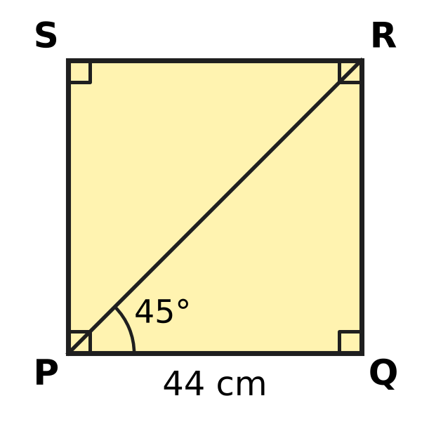
  (A) 6,776 cm³ | (B) 968 cm³
  (C) 13,552 cm³ | (D) 27,104 cm³

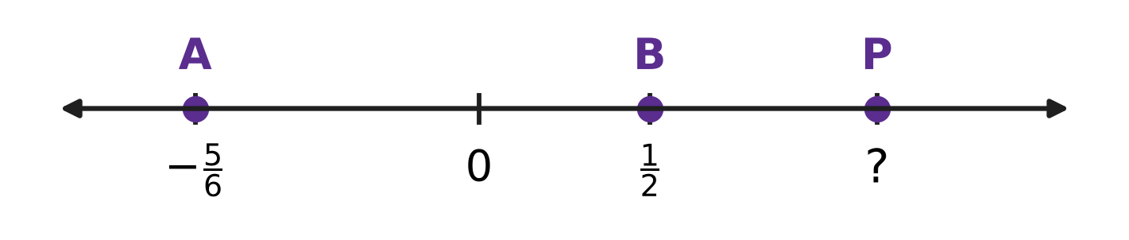
Q45. Ishan marks A at $−\frac{5}{6}$ and B at $\frac{1}{2}$ on a number line. He then marks a point P to the right of B so that the distance from A to P is 3 times the distance from B to P. Which number does P show? [4 marks]
(A) $\frac{17}{18}$ | (B) $\frac{7}{6}$ | (C) $\frac{2}{3}$ | (D) $\frac{11}{6}$

Answer Sheet AMO Level 1 · Class 7 · Practice Paper 1
Name: | School: | Roll No.:
Shade or tick one circle for each question.
1. Ⓐ Ⓑ Ⓒ Ⓓ | 16. Ⓐ Ⓑ Ⓒ Ⓓ | 31. Ⓐ Ⓑ Ⓒ Ⓓ
2. Ⓐ Ⓑ Ⓒ Ⓓ | 17. Ⓐ Ⓑ Ⓒ Ⓓ | 32. Ⓐ Ⓑ Ⓒ Ⓓ
3. Ⓐ Ⓑ Ⓒ Ⓓ | 18. Ⓐ Ⓑ Ⓒ Ⓓ | 33. Ⓐ Ⓑ Ⓒ Ⓓ
4. Ⓐ Ⓑ Ⓒ Ⓓ | 19. Ⓐ Ⓑ Ⓒ Ⓓ | 34. Ⓐ Ⓑ Ⓒ Ⓓ
5. Ⓐ Ⓑ Ⓒ Ⓓ | 20. Ⓐ Ⓑ Ⓒ Ⓓ | 35. Ⓐ Ⓑ Ⓒ Ⓓ
6. Ⓐ Ⓑ Ⓒ Ⓓ | 21. Ⓐ Ⓑ Ⓒ Ⓓ | 36. Ⓐ Ⓑ Ⓒ Ⓓ
7. Ⓐ Ⓑ Ⓒ Ⓓ | 22. Ⓐ Ⓑ Ⓒ Ⓓ | 37. Ⓐ Ⓑ Ⓒ Ⓓ
8. Ⓐ Ⓑ Ⓒ Ⓓ | 23. Ⓐ Ⓑ Ⓒ Ⓓ | 38. Ⓐ Ⓑ Ⓒ Ⓓ
9. Ⓐ Ⓑ Ⓒ Ⓓ | 24. Ⓐ Ⓑ Ⓒ Ⓓ | 39. Ⓐ Ⓑ Ⓒ Ⓓ
10. Ⓐ Ⓑ Ⓒ Ⓓ | 25. Ⓐ Ⓑ Ⓒ Ⓓ | 40. Ⓐ Ⓑ Ⓒ Ⓓ
11. Ⓐ Ⓑ Ⓒ Ⓓ | 26. Ⓐ Ⓑ Ⓒ Ⓓ | 41. Ⓐ Ⓑ Ⓒ Ⓓ
12. Ⓐ Ⓑ Ⓒ Ⓓ | 27. Ⓐ Ⓑ Ⓒ Ⓓ | 42. Ⓐ Ⓑ Ⓒ Ⓓ
13. Ⓐ Ⓑ Ⓒ Ⓓ | 28. Ⓐ Ⓑ Ⓒ Ⓓ | 43. Ⓐ Ⓑ Ⓒ Ⓓ
14. Ⓐ Ⓑ Ⓒ Ⓓ | 29. Ⓐ Ⓑ Ⓒ Ⓓ | 44. Ⓐ Ⓑ Ⓒ Ⓓ
15. Ⓐ Ⓑ Ⓒ Ⓓ | 30. Ⓐ Ⓑ Ⓒ Ⓓ | 45. Ⓐ Ⓑ Ⓒ Ⓓ
Q41–Q45 are Section II Star Questions (4 marks each).
For the parent or teacher
Section I correct: ______ / 40 × 2 = ______ marks Section II correct: ______ / 5 × 4 = ______ marks
Correct: ______ / 45 Score: ______ / 100
Answer Key and Solutions AMO Level 1 · Class 7 · Practice Paper 1
Quick answers
1 A | 6 C | 11 C | 16 C | 21 D | 26 D | 31 B | 36 B | 41 D
2 D | 7 D | 12 D | 17 A | 22 A | 27 C | 32 A | 37 B | 42 C
3 D | 8 A | 13 C | 18 D | 23 B | 28 A | 33 B | 38 D | 43 B
4 C | 9 B | 14 A | 19 B | 24 A | 29 D | 34 D | 39 C | 44 A
5 A | 10 B | 15 B | 20 C | 25 B | 30 C | 35 C | 40 A | 45 B
Solutions
Q | Part · level | Answer | Why?
1 | Part 1 · Ch1 · Easy | (A) $−\frac{5}{3}$ | Each unit is cut into 3 equal parts, so each part is 1/3. P is one part to the right of −2, so P = −2 + 1/3 = −5/3.
2 | Part 1 · Ch1 · Easy | (D) $\frac{−9}{14}$ | In −9/14, the denominator is positive and 9 and 14 have no common factor. But 4/−7 has a negative denominator, 10 and 15 share 5, and 12/−18 fails both tests.
3 | Part 1 · Ch1 · Medium | (D) $−\frac{1}{10}$ | Step 1: −3/4 + 5/6 = −9/12 + 10/12 = 1/12. Step 2: 1/12 × (−6/5) = −6/60 = −1/10.
4 | Part 1 · Ch1 · Medium | (C) x × y | x + y = −7/20, x − y = −23/20, x × y = −3/10 and x ÷ y = −15/8. All four are negative; the one closest to 0 is −3/10 (−6/20 > −7/20), so x × y is the greatest.
5 | Part 2 · Ch2 · Easy | (A) 3⁵ | Row 1 has 1 dot, Row 2 has 3, Row 3 has 3², Row 4 has 3³. Each row multiplies by 3 once more, so Row 6 has 3⁵ = 243 dots.
6 | Part 2 · Ch2 · Easy | (C) 2³ + 2³ | Here 4³ = 64, 8² = 64 and 2⁵ × 2 = 2⁶ = 64. But 2³ + 2³ = 8 + 8 = 16; the product law works only for multiplication.
7 | Part 2 · Ch2 · Medium | (D) 4 | Moving the decimal point 5 places to the right gives 705,000. Its digits are 7, 0, 5, 0, 0, 0, so it has 4 zeros.
8 | Part 3 · Ch3 · Easy | (A) ₹180 | Saving = 15% of ₹1,200 = 15/100 × 1,200 = ₹180.
9 | Part 3 · Ch3 · Easy | (B) 1,000 L | The water is at the 40% mark, and 40% of 2,500 L = 40/100 × 2,500 = 1,000 L.
10 | Part 3 · Ch3 · Easy | (B) ₹800 | The loss, 18% of the cost price, is ₹144, so 1% is ₹8 and 100% is ₹800.
11 | Part 3 · Ch3 · Medium | (C) Item M | Profit percents: K 50/200 = 25%, L 80/400 = 20%, M 45/150 = 30%, N 140/500 = 28%. The greatest is 30%, on Item M.
12 | Part 3 · Ch3 · Medium | (D) 4,000 | Science books are 1/5 = 20%. The other books are 100% − 45% − 20% = 35%. So 35% is 1,400, 1% is 40 and 100% is 4,000.
13 | Part 4 · Ch4 · Easy | (C) 2k − 15 | First, 3(2k − 5) = 6k − 15. Then 6k − 15 − 4k = 2k − 15.
14 | Part 4 · Ch4 · Easy | (A) 3 | Like terms have exactly the same letters with the same powers. −pq, 7qp and −2qp are like 3pq; 3p, pq² and 5p²q are not. So there are 3.
15 | Part 4 · Ch4 · Easy | (B) 4x − 5 = 2x + 1 | Put x = 3: 4 × 3 − 5 = 7 and 2 × 3 + 1 = 7, so both sides are equal. In each other equation the two sides are different.
16 | Part 4 · Ch4 · Medium | (C) 40 | Let Kartik have k stamps. Then 4k − 15 = k + 15, so 3k = 30 and k = 10. Shreya has 4 × 10 = 40 stamps.
17 | Part 4 · Ch4 · Medium | (A) (3x + 2) cm | Third side = (9x + 4) − (2x + 3) − (4x − 1) = 9x + 4 − 2x − 3 − 4x + 1 = 3x + 2.
18 | Part 5 · Ch5 · Easy | (D) 63° | The two angles are co-interior angles between the parallel lines, so they add to 180°. x = 180° − 117° = 63°.
19 | Part 5 · Ch5 · Easy | (B) SAS | AB = PQ and BC = QR, and the marked angles B and Q lie between these sides. Two sides and the included angle are equal, so the rule is SAS.
20 | Part 5 · Ch5 · Easy | (C) Angles on a straight line add up to 180°. | ∠3 and ∠4 lie together on the straight line BD, so they add up to 180°. That is the reason for Step 1.
21 | Part 5 · Ch5 · Medium | (D) 112° | The base angles are (180° − 44°) ÷ 2 = 68°. ∠BDE and ∠B are co-interior angles between DE and BC, so x = 180° − 68° = 112°.
22 | Part 5 · Ch5 · Medium | (A) 85° | Draw a line through O parallel to l and m. It splits x into two parts equal to 38° and 47° (alternate angles). So x = 38° + 47° = 85°.
23 | Part 6 · Ch6 · Easy | (B) 100 cm² | TSA = 2(7 × 4 + 4 × 2 + 2 × 7) = 2(28 + 8 + 14) = 2 × 50 = 100 cm².
24 | Part 6 · Ch6 · Easy | (A) 9 cm | Volume = πr²h, so 1,386 = 22/7 × 7 × 7 × h = 154 × h. h = 1,386 ÷ 154 = 9 cm.
25 | Part 6 · Ch6 · Easy | (B) 600 cm² | Opened out, the curved surface is a rectangle 50 cm long (the distance round) and 12 cm wide (the height). Area = 50 × 12 = 600 cm².
26 | Part 6 · Ch6 · Medium | (D) 272 m² | Floor = 20 × 8 = 160 m². Walls = 2 × 2 × (20 + 8) = 112 m². Tiled area = 160 + 112 = 272 m².
27 | Part 6 · Ch6 · Medium | (C) 160 cm² | The cuboid is 8 cm × 4 cm × 4 cm. TSA = 2(8 × 4 + 4 × 4 + 4 × 8) = 2 × 80 = 160 cm². (Each cube shows 5 faces: 10 × 16 = 160.)
28 | Part 7 · Ch8 · Easy | (A) 75 | Pear trees are 25% of 300 = 25/100 × 300 = 75.
29 | Part 7 · Ch8 · Easy | (D) 10 eggs | The mode is the value that occurs most often. The tallest bar (9 days) is at 10 eggs, so the mode is 10 eggs.
30 | Part 7 · Ch8 · Medium | (C) 13 | Total = 5 × 14 = 70, so m = 70 − 57 = 13. In order: 9, 12, 13, 16, 20. The middle mark is 13.
31 | Part 8 · Ch9 · Easy | (B) 300 mL | Water is 5 boxes = 750 mL, so 1 box = 150 mL. Juice is 2 boxes = 300 mL.
32 | Part 8 · Ch9 · Easy | (A) 144 | There are 54 seedlings in 3 rows, so 1 row has 18. Then 8 rows have 8 × 18 = 144 seedlings.
33 | Part 8 · Ch9 · Easy | (B) 9 | The roll is 12 × 30 = 360 m long. With 40 m for each kite, she can fly 360 ÷ 40 = 9 kites.
34 | Part 8 · Ch9 · Medium | (D) 36 km | In 1 minute he covers 15/50 = 0.3 km. In 2 hours, or 120 minutes, he covers 120 × 0.3 = 36 km.
35 | Part 8 · Ch9 · Medium | (C) 120 | The difference between the third and the first jar is 5 − 2 = 3 parts = 36, so 1 part = 12. In all: 10 parts = 120 marbles.
36 | Part 9 · Ch10 · Easy | (B) Column D | Column F holds the multiples of 6. Since 100 = 6 × 16 + 4, the number 100 comes 4 places after 96, so it is in column D.
37 | Part 9 · Ch10 · Easy | (B) 95 | 7 × B ends in B only for B = 0 or 5; B = 0 makes the first two digits of the product differ, so B = 5. Trying A5 × 7, only 95 × 7 = 665 has its first two digits equal. So AB = 95.
38 | Part 9 · Ch10 · Easy | (D) 41 | The answer in each line is the sum of its two numbers: 2 + 1 = 3, 3 + 2 = 5, and so on. The 20th line is 21² − 20² = 21 + 20 = 41.
39 | Part 9 · Ch10 · Medium | (C) 15 | The digit sets are 1, 2, 6 (6 orders), 1, 3, 4 (6 orders) and 2, 2, 3 (3 orders). Total = 6 + 6 + 3 = 15.
40 | Part 9 · Ch10 · Medium | (A) 4 | Write n = 7q + 3. Then 2n + 5 = 14q + 6 + 5 = 14q + 11 = 7(2q + 1) + 4. So the remainder is 4.
41 | Section II · Ch4 + Ch10 · Hard | (D) 87 | Let AB = n. Then AB6 = 10n + 6 and 6AB = 600 + n. So (10n + 6) − (600 + n) = 189, which gives 9n − 594 = 189, 9n = 783 and n = 87. Check: 876 − 687 = 189.
42 | Section II · Ch3 + Ch10 · Hard | (C) 110 | Before the evening she had 36 + 30 = 66 buns. These were 75% of the buns left after the morning, so that number was 66 ÷ 0.75 = 88. These 88 buns are 80% of the buns baked, so she baked 88 ÷ 0.8 = 110 buns.
43 | Section II · Ch4 + Ch9 · Hard | (B) 40 | Let there be 3k boys and 2k girls. Then (3k − 4) : (2k + 8) = 5 : 6, so 6(3k − 4) = 5(2k + 8), 18k − 24 = 10k + 40 and k = 8. Before the stop there were 5k = 40 children.
44 | Section II · Ch5 + Ch6 · Hard | (A) 6,776 cm³ | In △PQR, ∠Q = 90° and ∠QPR = 45°, so ∠PRQ = 45°. Equal angles face equal sides, so QR = PQ = 44 cm. The base circumference is 44 cm, so 2 × 22/7 × r = 44 and r = 7 cm. Volume = 22/7 × 7 × 7 × 44 = 6,776 cm³.
45 | Section II · Ch1 + Ch4 · Hard | (B) $\frac{7}{6}$ | Let P be x. The distance from A to P is x − (−5/6) = x + 5/6, and from B to P it is x − 1/2. So x + 5/6 = 3(x − 1/2) = 3x − 3/2, which gives 2x = 5/6 + 3/2 = 7/3 and x = 7/6.

ARYABHATTA MATHS OLYMPIAD
Level 1
PRACTICE PAPER-2
CLASS 7
Total Questions | 45 multiple-choice questions
Total Marks | 100
Time | 60 minutes
Section I | 40 questions × 2 marks = 80 marks
Section II | 5 Star Questions × 4 marks = 20 marks
Negative Marking | No negative marking
Calculator | Not allowed
Chapters | Number System · Operations · Fractions, Decimals & Percentages · Algebra · Geometry · Mensuration · Data Handling · Applied Mathematics · Mathematical Reasoning

Instructions to candidates
• This paper has 45 multiple-choice questions. Each question has four answer choices, of which exactly one is correct.
• Section I (Q1–Q40) carries 2 marks per question. Section II (Q41–Q45) carries 4 marks per question.
• There is no negative marking. Unanswered questions score zero.
• Calculators are not permitted. Rough work may be done on a separate sheet.
• Mark your answers on the answer sheet at the end of the paper.
• All figures are not necessarily drawn to scale unless stated.

For parents and teachers
• Print or view this paper in colour. Pictures are part of the questions.
• Parts follow the AMO syllabus chapters. Chapter 7 is not part of the Class 7 syllabus, so the chapter numbers shown in the Part headings have gaps.
• The answer sheet and the answer key are at the end. Remove only the answer key before the student begins.

SECTION I 40 questions × 2 marks each
Part 1 — Number System (Syllabus Chapter 1)
Q1. Which of these rational numbers lies between $−\frac{1}{2}$ and $−\frac{1}{3}$?
(A) $−\frac{1}{6}$ | (B) $−\frac{5}{6}$ | (C) $−\frac{7}{12}$ | (D) $−\frac{5}{12}$

Q2. Which of these has a positive value?
(A) $(−\frac{3}{8})×(−\frac{2}{5})$
(B) $(−\frac{1}{2})×(−\frac{3}{5})×(−\frac{4}{7})$
(C) $(−\frac{5}{6})÷\frac{2}{3}$
(D) $(−\frac{2}{3})×\frac{5}{4}$

Q3. At 6 a.m. the temperature on a hill was $−2\frac{1}{4}$ °C. By noon it had risen by $3\frac{1}{2}$ °C. By evening it had fallen by $1\frac{3}{4}$ °C from the noon value. What was the temperature in the evening?
(A) $3$ °C | (B) $\frac{1}{2}$ °C | (C) $−\frac{1}{2}$ °C | (D) $−7\frac{1}{2}$ °C

Q4. Which rational number lies exactly halfway between $−\frac{3}{4}$ and $\frac{1}{6}$ on the number line?
(A) $−\frac{7}{12}$ | (B) $\frac{7}{24}$ | (C) $−\frac{7}{24}$ | (D) $\frac{11}{24}$

Part 2 — Operations & Number Properties (Syllabus Chapter 2)
Q5. Which of these is a negative number?
(A) (−1)⁵ × (−4)³ | (B) (−7)³
(C) (−2)⁴ | (D) (−5)⁰

Q6. A city supplies 2,750,000 litres of water every day. How is this number written in standard form?
(A) 2.75 × 10⁶ | (B) 2.75 × 10⁴
(C) 2.75 × 10⁷ | (D) 2.75 × 10⁵

Q7. It is given that 2ˣ = 32 and 3ʸ = 81. What is the value of xʸ?
(A) 20 | (B) 1,024 | (C) 9 | (D) 625

Part 3 — Fractions, Decimals & Percentages (Syllabus Chapter 3)
Q8. Which of these is the greatest?
(A) 58% of 50 | (B) 45% of 60
(C) 12% of 250 | (D) 35% of 80

Q9. The picture shows the seating plan of a classroom. Each rectangle is a desk, and a dot marks a desk with a student at it. What percentage of the desks are empty? | 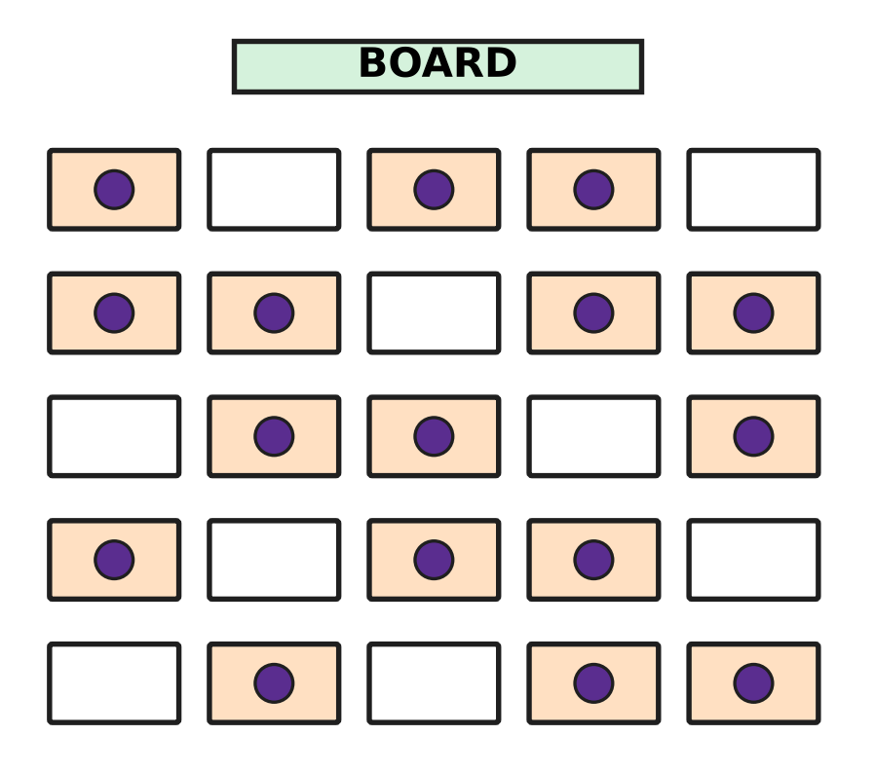
  (A) 36% | (B) 64% | (C) 9% | (D) 45%

Q10. Mira wants a toy train set marked ₹800 in a toy shop. The shop could give one of these four offers. Which offer gives her the biggest discount?
(A) ₹150 off the price | (B) Pay 85% of the price
(C) 20% off the price | (D) Price cut to ₹620

Q11. Irfan buys 50 kg of oranges at the fruit market for ₹40 per kg. He pays ₹500 to bring them to his shop. He sells all the oranges at ₹60 per kg. What is his profit percent?
(A) 25% | (B) 20% | (C) 120% | (D) 50%

Q12. A bead necklace is marked ₹750. The seller gives a discount of 12% on it and still makes a profit of 10%. What did the necklace cost the seller?
(A) ₹726 | (B) ₹594 | (C) ₹675 | (D) ₹600

Part 4 — Algebra (Syllabus Chapter 4)
Q13. Which of these expressions has exactly three terms after it is simplified?
(A) 7pq − 2qp + p | (B) 3p + 2q − p + 6
(C) 2p² + 5p − p² − 5p | (D) 4p + 3q − 4p + 2

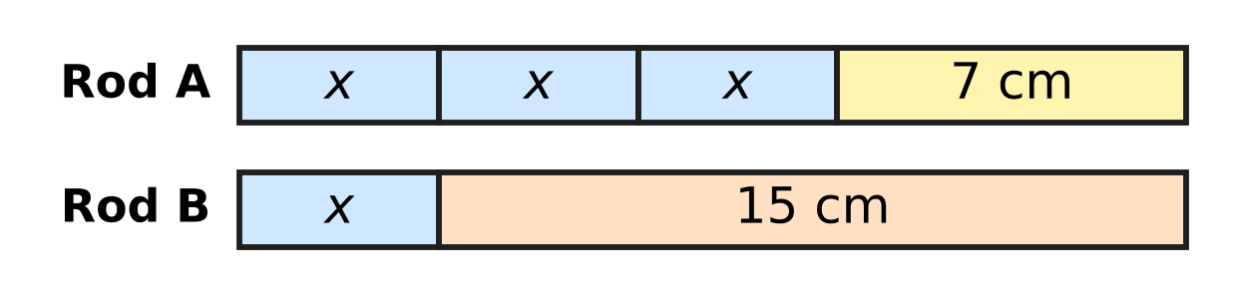
Q14. Rod A and Rod B in the picture have the same length. Each part marked x has the same length. What is the length of each part marked x?
(A) 2 cm | (B) 11 cm | (C) 4 cm | (D) 8 cm

Q15. What must be added to 4a − 3b to get 7a + 2b?
(A) 3a + 5b | (B) 11a − b | (C) 3a − b | (D) −3a − 5b

Q16. Some birds come to rest on the branches of a tree. If 6 birds sit on each branch, 4 birds find no place. If 7 birds sit on each branch, 2 branches stay empty. How many birds are there?
(A) 18 | (B) 126 | (C) 108 | (D) 112

Q17. On a train journey, Anya travels the first one-third of the distance through plains and then half of the whole distance through hills. The remaining 18 km runs along the coast. How long is the whole journey?
(A) 54 km | (B) 108 km | (C) 30 km | (D) 36 km

Part 5 — Geometry (Syllabus Chapter 5)
Q18. In the figure, line l is parallel to line m, and t crosses both lines. Which of these angles must be equal to ∠c? | 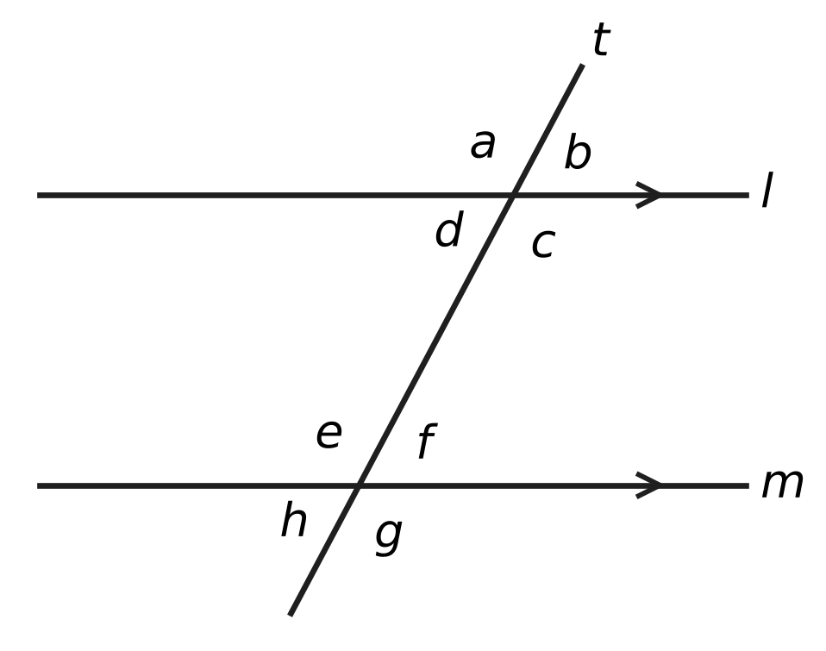
  (A) ∠e | (B) ∠d | (C) ∠f | (D) ∠h

Q19. The four angles of a quadrilateral are listed in order as you go round it. Which of these lists could be the angles of a parallelogram?
(A) 65°, 115°, 75°, 105° | (B) 75°, 75°, 105°, 105°
(C) 75°, 105°, 75°, 105° | (D) 70°, 110°, 70°, 100°

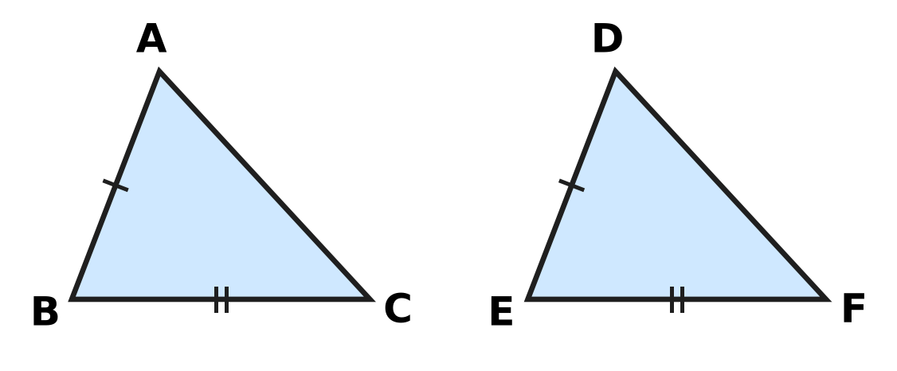
Q20. In the figure, sides with the same marks are equal: AB = DE and BC = EF. Which ONE more fact would make △ABC ≅ △DEF by the SAS rule?
(A) ∠C = ∠F | (B) AC = DF | (C) ∠B = ∠E | (D) ∠A = ∠D

Q21. In the figure, ABCD is a parallelogram with ∠ADC = 110°. The line AE cuts ∠DAB into two equal parts and meets DC at E. What is the size of ∠AED, marked "?" | 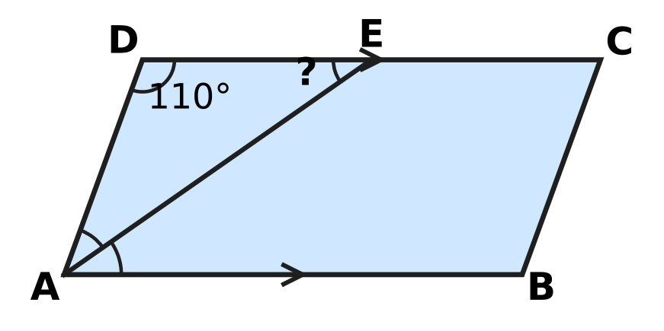
  (A) 145° | (B) 35° | (C) 70° | (D) 55°

Q22. In the figure, three straight lines meet at the point O. What is the value of x? | 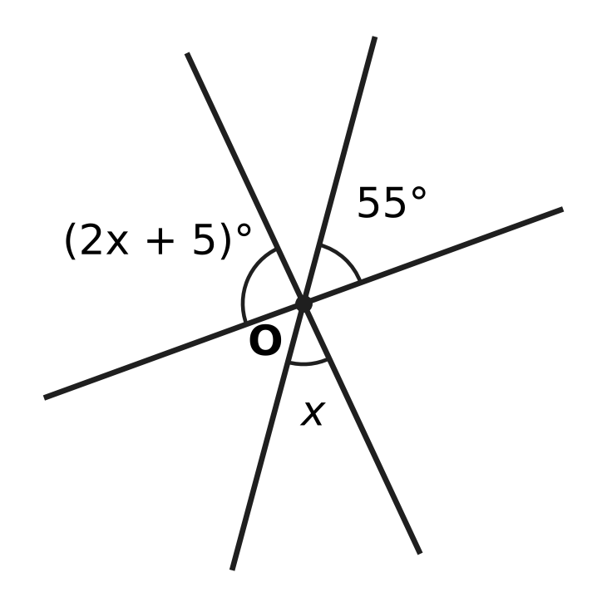
  (A) 40 | (B) 85 | (C) 100 | (D) 25

Part 6 — Mensuration (Syllabus Chapter 6)
Shoe box | Length (cm) | Breadth (cm) | Height (cm)
Box W | 30 | 18 | 10
Box X | 32 | 16 | 11
Box Y | 28 | 20 | 10
Box Z | 35 | 15 | 10

Q23. Tejas has four cuboid shoe boxes on his shoe rack. Their inside measurements are given in the table. Which box has the greatest volume?
(A) Box W | (B) Box X | (C) Box Y | (D) Box Z

Q24. The juice can in the figure is a cylinder of radius 3.5 cm and height 10 cm. How much juice can it hold when full? Use π = $\frac{22}{7}$. | 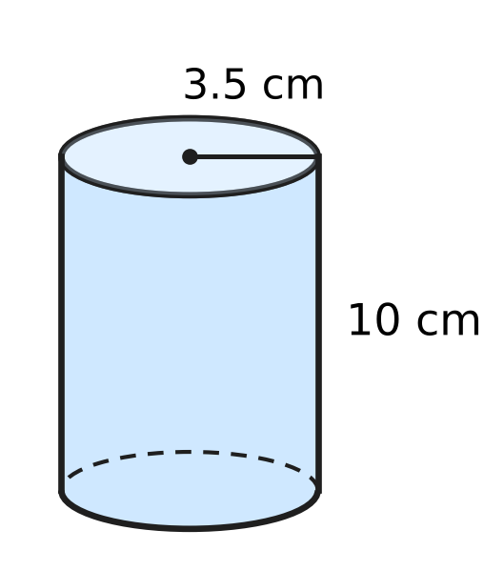
  (A) 110 cm³ | (B) 1,540 cm³
  (C) 220 cm³ | (D) 385 cm³

Q25. A gate pillar is a cuboid with a base 40 cm long and 30 cm wide, as in the figure. Only its four side faces are painted, and the painted area is 28,000 cm². How tall is the pillar, marked "?" | 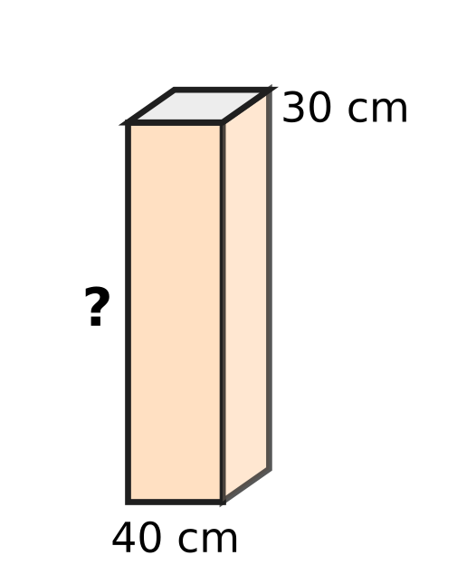
  (A) 350 cm | (B) 400 cm | (C) 700 cm | (D) 200 cm

Q26. Pihu's aquarium in the figure is a cuboid 60 cm long, 25 cm wide and 40 cm tall. She fills it with water to a depth of 30 cm. How many litres of water are in it? (1 litre = 1,000 cm³) | 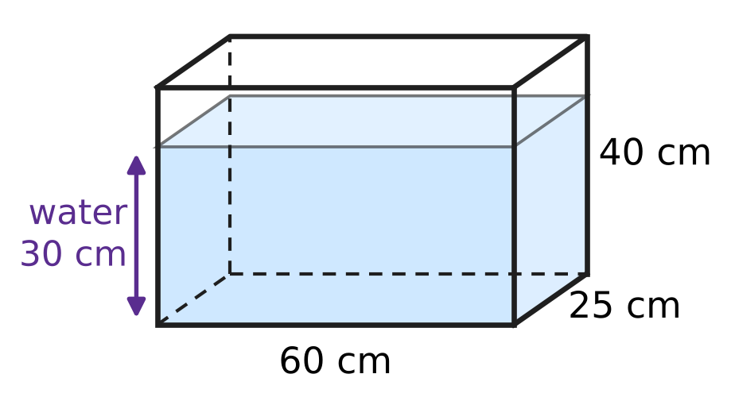
  (A) 4.5 litres | (B) 450 litres
  (C) 45 litres | (D) 60 litres

Q27. A playground roller is a cylinder of radius 35 cm and length 1.2 m, as in the figure. It rolls 25 full turns in a straight line. What area of ground does it level? Use π = $\frac{22}{7}$. | 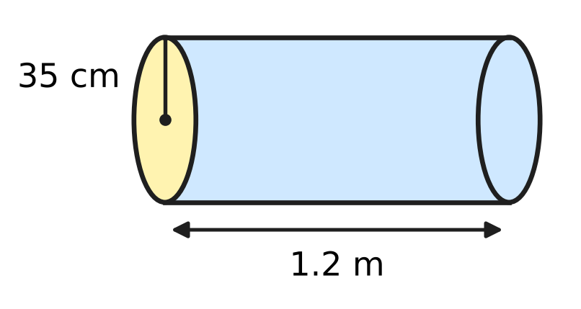
  (A) 2.64 m² | (B) 66 m² | (C) 132 m² | (D) 33 m²

Part 7 — Data Handling, Statistics & Probability (Syllabus Chapter 8)
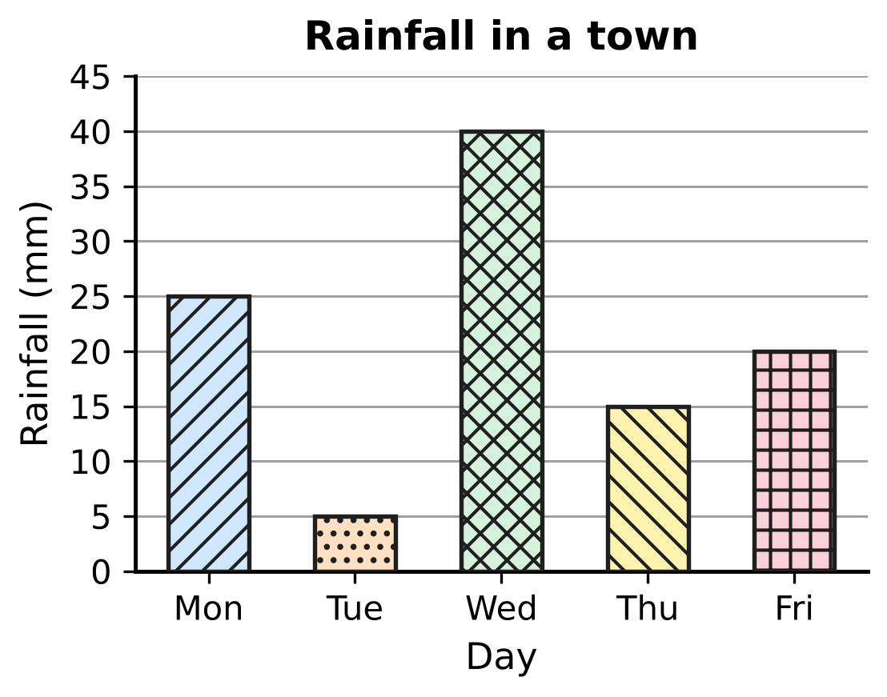
Q28. The bar graph shows the rainfall in a town on five days. What is the median rainfall of the five days?
(A) 20 mm | (B) 21 mm | (C) 40 mm | (D) 25 mm

Q29. Which of these sets of numbers has a mean of 12?
(A) 8, 12, 12, 18 | (B) 6, 13, 14, 19
(C) 9, 11, 16 | (D) 10, 12, 15

Q30. On sports day, each student chose one event. The pie chart shows the percentage of students who chose each event. 36 students chose Shot put. How many students chose Running? | 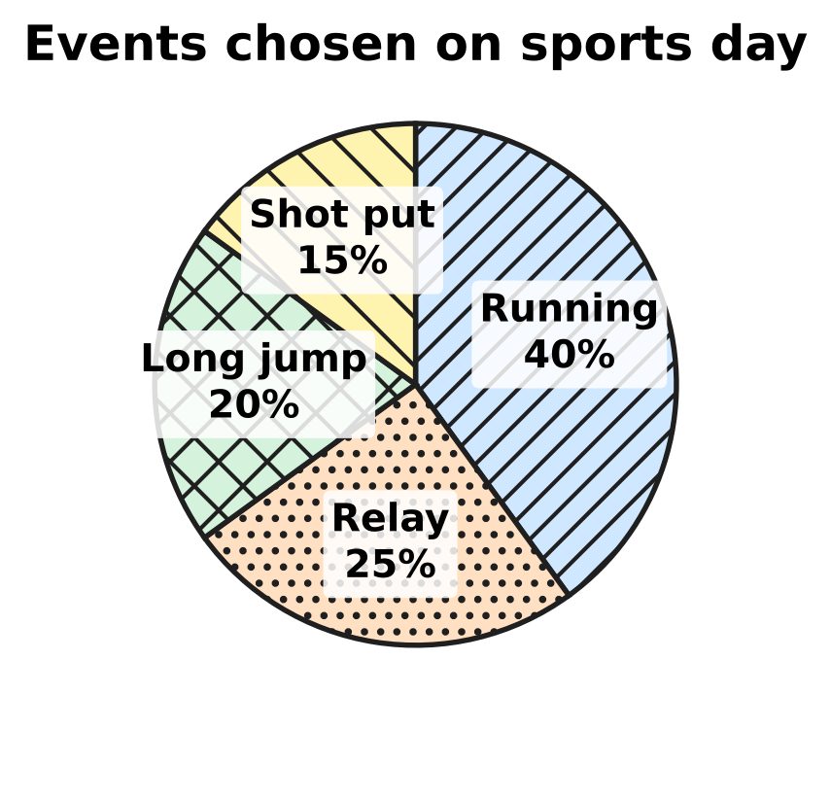
  (A) 144 | (B) 96 | (C) 61 | (D) 240

Part 8 — Applied Mathematics (Syllabus Chapter 9)
Q31. Which of these sets of four numbers, taken in the order given, are in proportion?
(A) 5, 8, 10, 15 | (B) 6, 9, 15, 21
(C) 4, 6, 10, 12 | (D) 3, 5, 12, 20

Q32. Gita has a red ribbon 75 cm long and a blue ribbon 2 m long. What is the ratio of the length of the red ribbon to the length of the blue ribbon, in its simplest form?
(A) 3 : 8 | (B) 75 : 2 | (C) 8 : 3 | (D) 3 : 80

Q33. In the school garden, 6 children fill 15 flower pots with soil in one hour. Each child works at the same rate. How many pots can 10 children fill in one hour?
(A) 9 | (B) 25 | (C) 19 | (D) 150

Q34. Each set below gives three pairs of values (x, y). In which set does y vary inversely as x?
(A) (2, 15), (3, 10), (6, 4) | (B) (2, 12), (3, 18), (5, 30)
(C) (2, 30), (3, 25), (5, 15) | (D) (2, 30), (3, 20), (5, 12)

Q35. In a school band, two-thirds of the boys is the same number as three-quarters of the girls. What is the ratio of the number of boys to the number of girls?
(A) 4 : 3 | (B) 2 : 3 | (C) 9 : 8 | (D) 8 : 9

Part 9 — Mathematical Reasoning & Problem-Solving (Syllabus Chapter 10)
Q36. In the addition shown, A and B stand for two different digits. What is the value of A + B? | 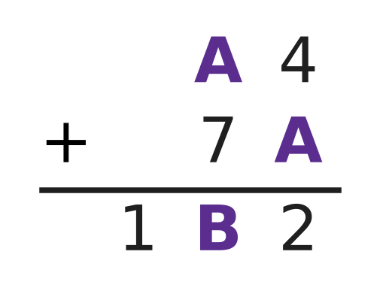
  (A) 14 | (B) 15 | (C) 10 | (D) 13

Q37. Which of these numbers leaves a remainder of 1 when it is divided by 2, when it is divided by 3 and when it is divided by 4?
(A) 29 | (B) 31 | (C) 37 | (D) 33

Q38. For a picnic in a park, Kush makes sandwiches. Each sandwich has one kind of bread and one kind of filling. He has 4 kinds of bread and 6 kinds of filling. How many different sandwiches can he make?
(A) 10 | (B) 24 | (C) 6 | (D) 48

Q39. The number 9 has exactly three factors: 1, 3 and 9. How many whole numbers from 1 to 100 have exactly three factors?
(A) 4 | (B) 10 | (C) 25 | (D) 3

Q40. The sum of 25 consecutive odd numbers is 1,875. What is the smallest of these numbers?
(A) 27 | (B) 75 | (C) 63 | (D) 51

SECTION II — Star Questions 5 questions × 4 marks each
Q41. In the sum ABC + AB + A = 300, the letters A, B and C stand for three different digits, and A is a non-zero digit. Here ABC is read as a three-digit number and AB as a two-digit number. Which three-digit number is ABC? [4 marks]
(A) 172 | (B) 263 | (C) 280 | (D) 271

Q42. A school chess club has fewer than 60 members. Exactly 45% of the members are girls. Exactly $\frac{3}{8}$ of the members wear glasses. How many members of the club are boys? [4 marks]
(A) 22 | (B) 11 | (C) 33 | (D) 18

Q43. A team of 9 workers can lay the floor tiles of a school hall in 16 days. They start the work. After some days, 3 more workers join them, and the whole floor is finished 14 days after the start. All workers work at the same rate. After how many days did the 3 workers join? [4 marks]
(A) 12 days | (B) 8 days | (C) 2 days | (D) 6 days

Q44. A cake is a cylinder of radius 14 cm and height 9 cm. The figure shows its top. Two straight vertical cuts through the centre O make four pieces. A piece is the same fraction of the cake as its angle at O is of 360°. Two of the angles at O are (4x)° and (5x)°. What is the volume of one of the two larger pieces? Use π = $\frac{22}{7}$. [4 marks] | 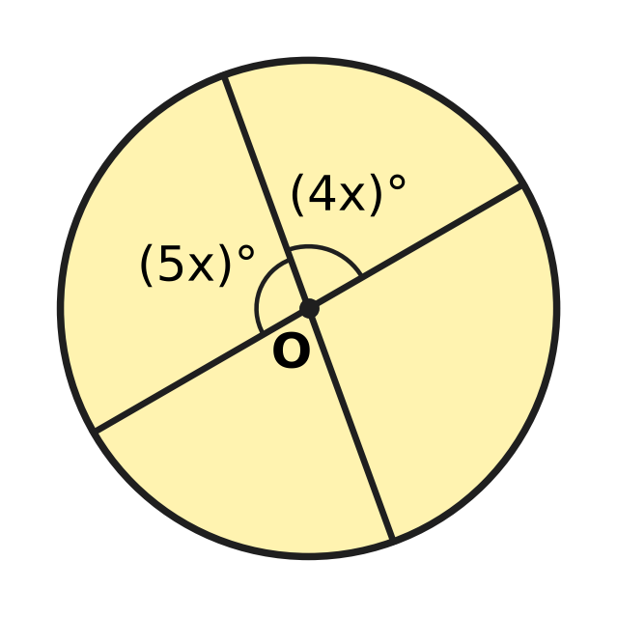
  (A) 2,772 cm³ | (B) 1,386 cm³
  (C) 1,540 cm³ | (D) 1,232 cm³

Q45. Depths below the sea surface are written as negative numbers. Lena is at $−13\frac{1}{2}$ m and rises $1\frac{1}{4}$ m every minute. At the same moment Dan is at $−2\frac{1}{4}$ m and goes down 1 m every minute. At what depth are they at the same level? [4 marks]
(A) $−8\frac{1}{2}$ m | (B) $−7\frac{1}{4}$ m | (C) $−7\frac{7}{8}$ m | (D) $−6\frac{1}{4}$ m

Answer Sheet AMO Level 1 · Class 7 · Practice Paper 2
Name: | School: | Roll No.:
Shade or tick one circle for each question.
1. Ⓐ Ⓑ Ⓒ Ⓓ | 16. Ⓐ Ⓑ Ⓒ Ⓓ | 31. Ⓐ Ⓑ Ⓒ Ⓓ
2. Ⓐ Ⓑ Ⓒ Ⓓ | 17. Ⓐ Ⓑ Ⓒ Ⓓ | 32. Ⓐ Ⓑ Ⓒ Ⓓ
3. Ⓐ Ⓑ Ⓒ Ⓓ | 18. Ⓐ Ⓑ Ⓒ Ⓓ | 33. Ⓐ Ⓑ Ⓒ Ⓓ
4. Ⓐ Ⓑ Ⓒ Ⓓ | 19. Ⓐ Ⓑ Ⓒ Ⓓ | 34. Ⓐ Ⓑ Ⓒ Ⓓ
5. Ⓐ Ⓑ Ⓒ Ⓓ | 20. Ⓐ Ⓑ Ⓒ Ⓓ | 35. Ⓐ Ⓑ Ⓒ Ⓓ
6. Ⓐ Ⓑ Ⓒ Ⓓ | 21. Ⓐ Ⓑ Ⓒ Ⓓ | 36. Ⓐ Ⓑ Ⓒ Ⓓ
7. Ⓐ Ⓑ Ⓒ Ⓓ | 22. Ⓐ Ⓑ Ⓒ Ⓓ | 37. Ⓐ Ⓑ Ⓒ Ⓓ
8. Ⓐ Ⓑ Ⓒ Ⓓ | 23. Ⓐ Ⓑ Ⓒ Ⓓ | 38. Ⓐ Ⓑ Ⓒ Ⓓ
9. Ⓐ Ⓑ Ⓒ Ⓓ | 24. Ⓐ Ⓑ Ⓒ Ⓓ | 39. Ⓐ Ⓑ Ⓒ Ⓓ
10. Ⓐ Ⓑ Ⓒ Ⓓ | 25. Ⓐ Ⓑ Ⓒ Ⓓ | 40. Ⓐ Ⓑ Ⓒ Ⓓ
11. Ⓐ Ⓑ Ⓒ Ⓓ | 26. Ⓐ Ⓑ Ⓒ Ⓓ | 41. Ⓐ Ⓑ Ⓒ Ⓓ
12. Ⓐ Ⓑ Ⓒ Ⓓ | 27. Ⓐ Ⓑ Ⓒ Ⓓ | 42. Ⓐ Ⓑ Ⓒ Ⓓ
13. Ⓐ Ⓑ Ⓒ Ⓓ | 28. Ⓐ Ⓑ Ⓒ Ⓓ | 43. Ⓐ Ⓑ Ⓒ Ⓓ
14. Ⓐ Ⓑ Ⓒ Ⓓ | 29. Ⓐ Ⓑ Ⓒ Ⓓ | 44. Ⓐ Ⓑ Ⓒ Ⓓ
15. Ⓐ Ⓑ Ⓒ Ⓓ | 30. Ⓐ Ⓑ Ⓒ Ⓓ | 45. Ⓐ Ⓑ Ⓒ Ⓓ
Q41–Q45 are Section II Star Questions (4 marks each).
For the parent or teacher
Section I correct: ______ / 40 × 2 = ______ marks Section II correct: ______ / 5 × 4 = ______ marks
Correct: ______ / 45 Score: ______ / 100
Answer Key and Solutions AMO Level 1 · Class 7 · Practice Paper 2
Quick answers
1 D | 6 A | 11 B | 16 D | 21 B | 26 C | 31 D | 36 A | 41 D
2 A | 7 D | 12 D | 17 B | 22 A | 27 B | 32 A | 37 C | 42 A
3 C | 8 C | 13 B | 18 A | 23 B | 28 A | 33 B | 38 B | 43 B
4 C | 9 A | 14 C | 19 C | 24 D | 29 C | 34 D | 39 A | 44 C
5 B | 10 D | 15 A | 20 C | 25 D | 30 B | 35 C | 40 D | 45 B
Solutions
Q | Part · level | Answer | Why?
1 | Part 1 · Ch1 · Easy | (D) $−\frac{5}{12}$ | With denominator 12, −1/2 = −6/12 and −1/3 = −4/12. Only −5/12 lies between them; −7/12 and −10/12 are less than −6/12, and −1/6 = −2/12 is greater than −4/12.
2 | Part 1 · Ch1 · Easy | (A) (−3/8) × (−2/5) | Two negative factors give a positive product: (−3/8) × (−2/5) = 6/40 = 3/20. Three negative factors, or one negative and one positive, give a negative result.
3 | Part 1 · Ch1 · Medium | (C) $−\frac{1}{2}$ °C | In quarters: −9/4 + 14/4 = 5/4 at noon; 5/4 − 7/4 = −2/4 = −1/2 °C in the evening.
4 | Part 1 · Ch1 · Medium | (C) $−\frac{7}{24}$ | The halfway point is (−3/4 + 1/6) ÷ 2 = (−9/12 + 2/12) ÷ 2 = (−7/12) ÷ 2 = −7/24.
5 | Part 2 · Ch2 · Easy | (B) (−7)³ | (−7)³ = −343 is negative. (−2)⁴ = 16, (−1)⁵ × (−4)³ = (−1) × (−64) = 64 and (−5)⁰ = 1 are all positive.
6 | Part 2 · Ch2 · Easy | (A) 2.75 × 10⁶ | Put the point after the first digit: 2.75. The point moves 6 places, so 2,750,000 = 2.75 × 10⁶.
7 | Part 2 · Ch2 · Medium | (D) 625 | Since 32 = 2⁵, x = 5, and since 81 = 3⁴, y = 4. Then xʸ = 5⁴ = 625.
8 | Part 3 · Ch3 · Easy | (C) 12% of 250 | Here 12% of 250 = 30, 58% of 50 = 29, 35% of 80 = 28 and 45% of 60 = 27. The greatest is 12% of 250.
9 | Part 3 · Ch3 · Easy | (A) 36% | There are 25 desks and 9 of them are empty. 9/25 = 36/100 = 36%.
10 | Part 3 · Ch3 · Easy | (D) Price cut to ₹620 | The discounts are ₹150, 20% of 800 = ₹160, 800 − 620 = ₹180 and 15% of 800 = ₹120. The biggest discount is the price cut to ₹620.
11 | Part 3 · Ch3 · Medium | (B) 20% | Cost price = 50 × 40 + 500 = ₹2,500. Selling price = 50 × 60 = ₹3,000. Profit = ₹500, and 500/2,500 × 100 = 20%.
12 | Part 3 · Ch3 · Medium | (D) ₹600 | Selling price = 88% of ₹750 = ₹660. This is 110% of the cost price, so the cost price = 660 × 100/110 = ₹600.
13 | Part 4 · Ch4 · Easy | (B) 3p + 2q − p + 6 | Simplified, 3p + 2q − p + 6 = 2p + 2q + 6, which has three terms. The others become 3q + 2, p² and 5pq + p.
14 | Part 4 · Ch4 · Easy | (C) 4 cm | From the rods, 3x + 7 = x + 15, so 2x = 8 and x = 4 cm. Both rods are then 19 cm long.
15 | Part 4 · Ch4 · Easy | (A) 3a + 5b | (7a + 2b) − (4a − 3b) = 7a + 2b − 4a + 3b = 3a + 5b.
16 | Part 4 · Ch4 · Medium | (D) 112 | Let there be b branches. Then 6b + 4 = 7(b − 2), so 6b + 4 = 7b − 14 and b = 18. There are 6 × 18 + 4 = 112 birds.
17 | Part 4 · Ch4 · Medium | (B) 108 km | Let the journey be x km. Then x/3 + x/2 + 18 = x, so x − 5x/6 = 18, x/6 = 18 and x = 108 km.
18 | Part 5 · Ch5 · Easy | (A) ∠e | ∠c and ∠e lie between the two parallel lines on opposite sides of t, so they are alternate angles and are equal.
19 | Part 5 · Ch5 · Easy | (C) 75°, 105°, 75°, 105° | In a parallelogram opposite angles are equal and neighbouring angles add up to 180°. Only 75°, 105°, 75°, 105° does both.
20 | Part 5 · Ch5 · Easy | (C) ∠B = ∠E | SAS needs the angle between the two equal sides. The angle between AB and BC is ∠B, and between DE and EF it is ∠E, so ∠B = ∠E is needed.
21 | Part 5 · Ch5 · Medium | (B) 35° | Neighbouring angles of a parallelogram add up to 180°, so ∠DAB = 70° and ∠DAE = 35°. In △ADE, ∠AED = 180° − 110° − 35° = 35°.
22 | Part 5 · Ch5 · Medium | (A) 40 | The angle vertically opposite x is also x, and it sits between 55° and (2x + 5)° on a straight line. So 55 + x + 2x + 5 = 180, 3x = 120 and x = 40.
23 | Part 6 · Ch6 · Easy | (B) Box X | Volumes: W = 5,400 cm³, X = 32 × 16 × 11 = 5,632 cm³, Y = 5,600 cm³ and Z = 5,250 cm³. Box X has the greatest volume.
24 | Part 6 · Ch6 · Easy | (D) 385 cm³ | Volume = πr²h = 22/7 × 3.5 × 3.5 × 10 = 11 × 3.5 × 10 = 385 cm³.
25 | Part 6 · Ch6 · Easy | (D) 200 cm | Area of the four side faces = 2h(l + b) = 2 × h × (40 + 30) = 140h. So 140h = 28,000 and h = 200 cm.
26 | Part 6 · Ch6 · Medium | (C) 45 litres | Volume of water = 60 × 25 × 30 = 45,000 cm³. Since 1,000 cm³ = 1 litre, this is 45 litres.
27 | Part 6 · Ch6 · Medium | (B) 66 m² | In one turn the roller levels an area equal to its curved surface: 2πrh = 2 × 22/7 × 0.35 × 1.2 = 2.64 m². In 25 turns: 2.64 × 25 = 66 m².
28 | Part 7 · Ch8 · Easy | (A) 20 mm | In order the rainfall values are 5, 15, 20, 25, 40 mm. The middle (third) value is 20 mm.
29 | Part 7 · Ch8 · Easy | (C) 9, 11, 16 | For C, 9 + 11 + 16 = 36 and 36 ÷ 3 = 12. The other means are 50 ÷ 4 = 12.5, 37 ÷ 3 and 52 ÷ 4 = 13.
30 | Part 7 · Ch8 · Medium | (B) 96 | Shot put is 15%, so 1% stands for 36 ÷ 15 = 2.4 students and the total is 240. Running is 40% of 240 = 96 students.
31 | Part 8 · Ch9 · Easy | (D) 3, 5, 12, 20 | Here 3 : 5 = 12 : 20 because 3 × 20 = 60 = 5 × 12. In the other sets the product of the outer numbers is not equal to the product of the middle numbers.
32 | Part 8 · Ch9 · Easy | (A) 3 : 8 | First, 2 m = 200 cm. Then 75 : 200 = 3 : 8 (dividing both by 25).
33 | Part 8 · Ch9 · Easy | (B) 25 | One child fills 15 ÷ 6 = 2.5 pots in an hour, so 10 children fill 2.5 × 10 = 25 pots.
34 | Part 8 · Ch9 · Medium | (D) (2, 30), (3, 20), (5, 12) | For inverse variation x × y must stay the same. Only 2 × 30 = 3 × 20 = 5 × 12 = 60.
35 | Part 8 · Ch9 · Medium | (C) 9 : 8 | (2/3) × boys = (3/4) × girls, so boys ÷ girls = (3/4) ÷ (2/3) = 9/8. The ratio is 9 : 8.
36 | Part 9 · Ch10 · Easy | (A) 14 | Units: 4 + A ends in 2, so A = 8 with a carry of 1. Tens: 8 + 7 + 1 = 16, so B = 6. Check: 84 + 78 = 162. A + B = 14.
37 | Part 9 · Ch10 · Easy | (C) 37 | Such a number is 1 more than a common multiple of 2, 3 and 4, that is 1 more than a multiple of 12. So 37 = 36 + 1 works; 31, 33 and 29 each fail one test.
38 | Part 9 · Ch10 · Easy | (B) 24 | Each of the 4 kinds of bread can go with each of the 6 fillings. So there are 4 × 6 = 24 different sandwiches.
39 | Part 9 · Ch10 · Medium | (A) 4 | A number has exactly three factors only when it is the square of a prime: 4, 9, 25 and 49. So there are 4 such numbers.
40 | Part 9 · Ch10 · Medium | (D) 51 | The middle (13th) number equals the mean: 1,875 ÷ 25 = 75. There are 12 odd numbers below it, so the smallest is 75 − 24 = 51.
41 | Section II · Ch4 + Ch10 · Hard | (D) 271 | ABC + AB + A = 111A + 11B + C = 300. A = 1 would need 11B + C = 189, which is impossible, so A = 2 and 11B + C = 78. B = 7 and C = 1 is the only choice, so ABC = 271.
42 | Section II · Ch3 + Ch10 · Hard | (A) 22 | Here 45% of n is whole only if n is a multiple of 20, and 3/8 of n is whole only if n is a multiple of 8. The only common multiple below 60 is 40. Girls = 18, so boys = 40 − 18 = 22.
43 | Section II · Ch4 + Ch9 · Hard | (B) 8 days | The work is 9 × 16 = 144 worker-days. If the 3 joined after d days, 9d + 12(14 − d) = 144, so 168 − 3d = 144 and d = 8.
44 | Section II · Ch5 + Ch6 · Hard | (C) 1,540 cm³ | The two marked angles make a straight line, so 9x = 180 and x = 20; the larger angle is 100°. Cake volume = 22/7 × 14 × 14 × 9 = 5,544 cm³, and 100/360 of it is 1,540 cm³.
45 | Section II · Ch1 + Ch4 · Hard | (B) $−7\frac{1}{4}$ m | After t minutes Lena is at −27/2 + 5t/4 and Dan at −9/4 − t. Setting them equal: 9t/4 = 45/4, so t = 5. The depth is −9/4 − 5 = −29/4 = −7 1/4 m.

ARYABHATTA MATHS OLYMPIAD
Level 1
PRACTICE PAPER-3
CLASS 7
Total Questions | 45 multiple-choice questions
Total Marks | 100
Time | 60 minutes
Section I | 40 questions × 2 marks = 80 marks
Section II | 5 Star Questions × 4 marks = 20 marks
Negative Marking | No negative marking
Calculator | Not allowed
Chapters | Number System · Operations · Fractions, Decimals & Percentages · Algebra · Geometry · Mensuration · Data Handling · Applied Mathematics · Mathematical Reasoning

Instructions to candidates
• This paper has 45 multiple-choice questions. Each question has four answer choices, of which exactly one is correct.
• Section I (Q1–Q40) carries 2 marks per question. Section II (Q41–Q45) carries 4 marks per question.
• There is no negative marking. Unanswered questions score zero.
• Calculators are not permitted. Rough work may be done on a separate sheet.
• Mark your answers on the answer sheet at the end of the paper.
• All figures are not necessarily drawn to scale unless stated.

For parents and teachers
• Print or view this paper in colour. Pictures are part of the questions.
• Parts follow the AMO syllabus chapters. Chapter 7 is not part of the Class 7 syllabus, so the chapter numbers shown in the Part headings have gaps.
• The answer sheet and the answer key are at the end. Remove only the answer key before the student begins.

SECTION I 40 questions × 2 marks each
Part 1 — Number System (Syllabus Chapter 1)
Q1. What number should go in the box □ to make this statement true?
$(−\frac{5}{6})$ × □ = 1
(A) $\frac{11}{6}$ | (B) $\frac{5}{6}$ | (C) $\frac{6}{5}$ | (D) $−\frac{6}{5}$

Q2. Which of these is NOT equal to $−\frac{5}{6}$?
(A) $\frac{−10}{−12}$ | (B) $\frac{−20}{24}$ | (C) $\frac{15}{−18}$ | (D) $\frac{−35}{42}$

Q3. What number should go in the box □?
$−\frac{2}{3}$ + $\frac{5}{6}$ − □ = $−\frac{1}{4}$
(A) $−\frac{1}{12}$ | (B) $\frac{5}{12}$ | (C) $−\frac{5}{12}$ | (D) $\frac{1}{12}$

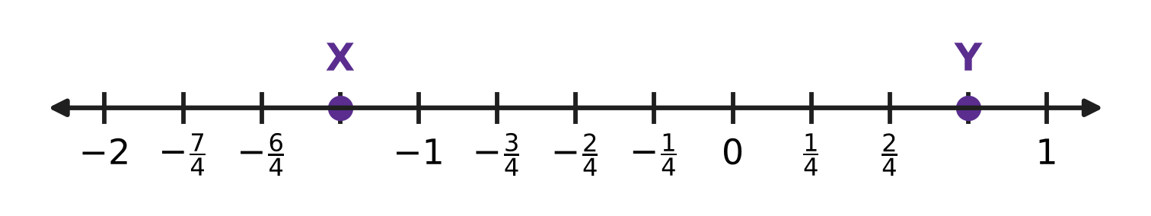
Q4. X and Y are marked on the number line. The gap between two whole numbers next to each other is split into quarters. Work out X ÷ Y.
(A) $−\frac{5}{3}$ | (B) $\frac{5}{3}$ | (C) $−\frac{3}{5}$ | (D) $−\frac{15}{16}$

Part 2 — Operations & Number Properties (Syllabus Chapter 2)
Q5. In the statement 7⁴ × 7^{n} ÷ 7³ = 7⁶, the letter n stands for a missing whole number. What is n?
(A) 9 | (B) 2 | (C) 5 | (D) 13

Q6. What is the value of (−2)³ × 3⁰ + (−1)⁵?
(A) 7 | (B) −7 | (C) −1 | (D) −9

Q7. A large sorting centre of the post office handles 6 × 10⁴ letters every day. How many letters does it handle in 30 days? Give the answer in standard form.
(A) 1.8 × 10⁴ letters | (B) 1.8 × 10⁵ letters
(C) 1.8 × 10⁶ letters | (D) 1.8 × 10⁷ letters

Part 3 — Fractions, Decimals & Percentages (Syllabus Chapter 3)
Q8. The bus fare from a village to the town went up by 20%. The new fare is ₹42. What was the fare before the rise?
(A) ₹22 | (B) ₹35 | (C) ₹33.60 | (D) ₹50.40

Q9. What number should go in the box?
$□\%$ of 80 = 30% of 120
(A) 20 | (B) 45 | (C) 30 | (D) 36

Q10. Hema makes clay pots. One pot costs her ₹160 to make. She sells it at a profit of 25%. What is the selling price of the pot?
(A) ₹185 | (B) ₹40 | (C) ₹120 | (D) ₹200

Q11. The school canteen sells a cup of milk for ₹20. Its offer is: "Buy 4 cups, get 1 cup free." Charu takes 5 cups under this offer. What percentage discount does she get on the marked price of the 5 cups?
(A) 20% | (B) 25% | (C) 5% | (D) 80%

Q12. A maths quiz has 60 questions. To win a badge, Juhi must get at least 70% of all the questions right. She has done the first 40 questions and got 29 of them right. What is the least number of the remaining 20 questions she must get right to win the badge?
(A) 11 questions | (B) 2 questions
(C) 13 questions | (D) 14 questions

Part 4 — Algebra (Syllabus Chapter 4)
Q13. What is the value of a²b − 2ab² when a = −2 and b = 3?
(A) 48 | (B) 24 | (C) −48 | (D) −24

Q14. The expression 6ab − 3a²b + 2ba − a²b + 7 is simplified. What is the coefficient of a²b in the simplified expression?
(A) −3 | (B) −2 | (C) −4 | (D) 8

Q15. The equation 4x − □ = 2x + 9 has the solution x = 7. What number is in the box □?
(A) 23 | (B) 5 | (C) 19 | (D) −5

Q16. Vikram's piggy bank has only ₹5 coins and ₹10 coins. There are 40 coins, and together they are worth ₹290. How many ₹10 coins are in the piggy bank?
(A) 58 | (B) 22 | (C) 29 | (D) 18

Q17. In the brick pyramid shown, the expression in each brick is the sum of the expressions in the two bricks just below it. The two middle bricks are left empty. The top brick is 31. What is the value of x? | 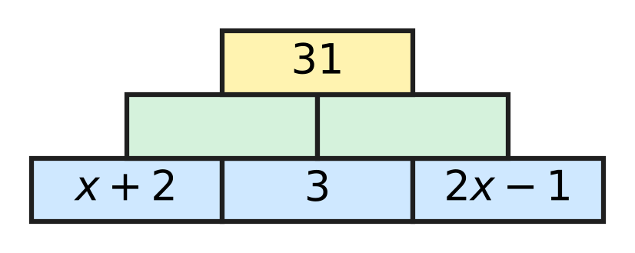
  (A) 9 | (B) 8 | (C) 24 | (D) 10

Part 5 — Geometry (Syllabus Chapter 5)
Q18. In the figure, side BC of △ABC is extended to D. ∠BAC = x°, ∠ABC = 70° and the exterior angle ∠ACD = (2x − 10)°. What is the value of x? | 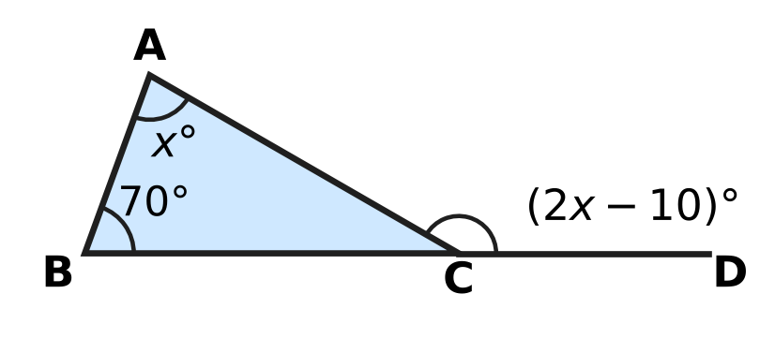
  (A) 40 | (B) 60 | (C) 80 | (D) 70

Q19. In the figure, the line t crosses the lines l and m. The two marked angles lie between l and m, on opposite sides of t. For which value of x will l be parallel to m? | 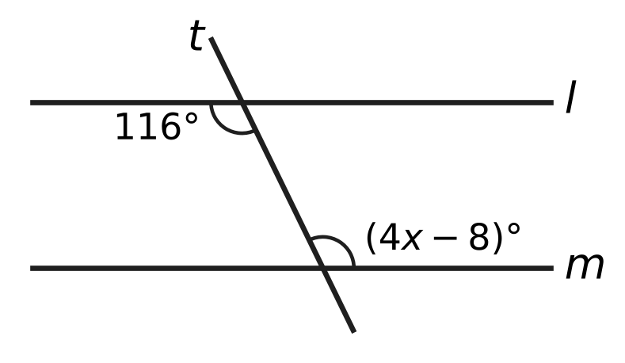
  (A) 29 | (B) 18 | (C) 27 | (D) 31

Q20. Lalit proves that the angles of the quadrilateral ABCD add up to 360°. The diagonal AC is drawn, and the angles 1, 2, 3, 4 are marked.  Step 1: AC divides ABCD into △ABC and △ACD.  Step 2: ∠1 + ∠B + ∠3 = 180° and ∠2 + ∠D + ∠4 = 180°.  Step 3: Adding, ∠1 + ∠2 + ∠B + ∠3 + ∠4 + ∠D = 360°.  Step 4: ∠1 + ∠2 = ∠A and ∠3 + ∠4 = ∠C, so ∠A + ∠B + ∠C + ∠D = 360°.  Which of these facts does the proof NOT use? | 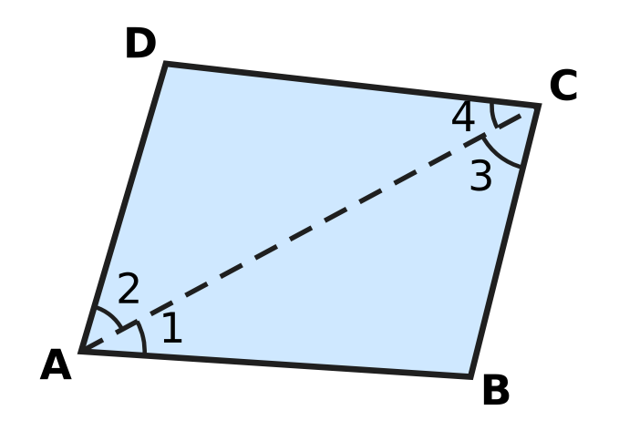
  (A) Angles on a straight line add up to 180°.
  (B) The angles of a triangle add up to 180°.
  (C) A diagonal splits a quadrilateral into two triangles.
  (D) An angle split into two parts equals the sum of the parts.

Q21. It is given that △PQR ≅ △LMN. In △PQR, ∠Q = 64°. In △LMN, ∠N = 51°. What is the size of ∠L?
(A) 51° | (B) 65° | (C) 115° | (D) 64°

Q22. In the quadrilateral ABCD shown, ∠A = 98° and ∠B = 84°. Side BC is extended beyond C, and the angle between this extension and CD is 116°. What is the size of ∠D? | 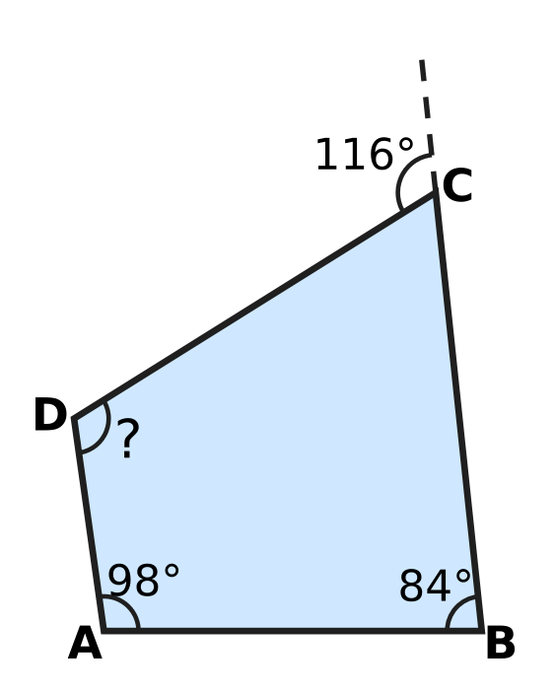
  (A) 114° | (B) 62° | (C) 178° | (D) 66°

Part 6 — Mensuration (Syllabus Chapter 6)
Q23. The wooden block shown is a cuboid. Its volume is 840 cm³. It is 14 cm long and 6 cm wide. What is its height, marked "?" | 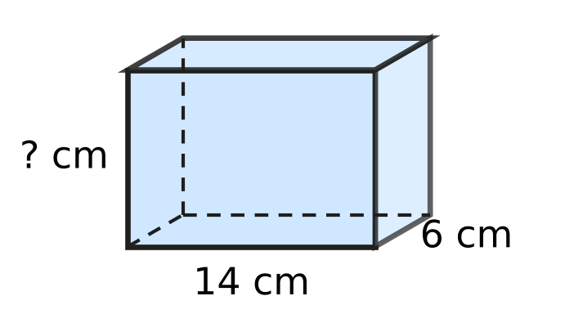
  (A) 140 cm | (B) 42 cm | (C) 60 cm | (D) 10 cm

Q24. A closed tin is a cylinder of radius 3.5 cm and height 6.5 cm, as shown. How much metal sheet is needed to make it, including the top and the bottom? Use π = $\frac{22}{7}$. | 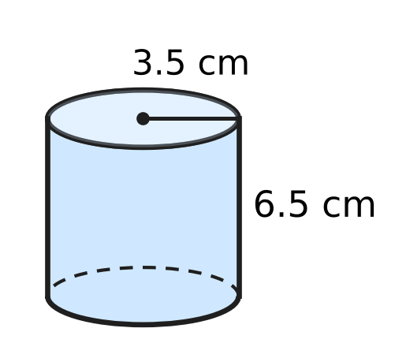
  (A) 181.5 cm² | (B) 594 cm²
  (C) 220 cm² | (D) 143 cm²

Q25. A wooden cube of edge 16 cm is cut into small cubes, each of edge 4 cm. No wood is wasted. How many small cubes are made?
(A) 16 | (B) 64 | (C) 4 | (D) 1,024

Q26. Sahil cuts a wire of length 96 cm into 12 equal pieces and uses them as the 12 edges of a cube. He then covers all six faces of the cube with paper. What area of paper does he use?
(A) 384 cm² | (B) 1,536 cm²
(C) 864 cm² | (D) 256 cm²

Q27. The curved surface area of the cylindrical container shown is 1,320 cm². Its height is 15 cm. What is its volume? Use π = $\frac{22}{7}$. | 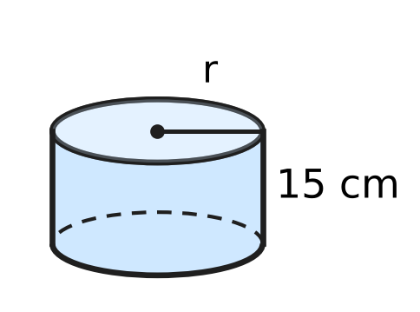
  (A) 18,480 cm³ | (B) 2,310 cm³
  (C) 9,240 cm³ | (D) 36,960 cm³

Part 7 — Data Handling, Statistics & Probability (Syllabus Chapter 8)
Q28. The pie chart shows how 240 students voted for their favourite board game. Each student voted once. What is the angle of the sector for Carrom? | 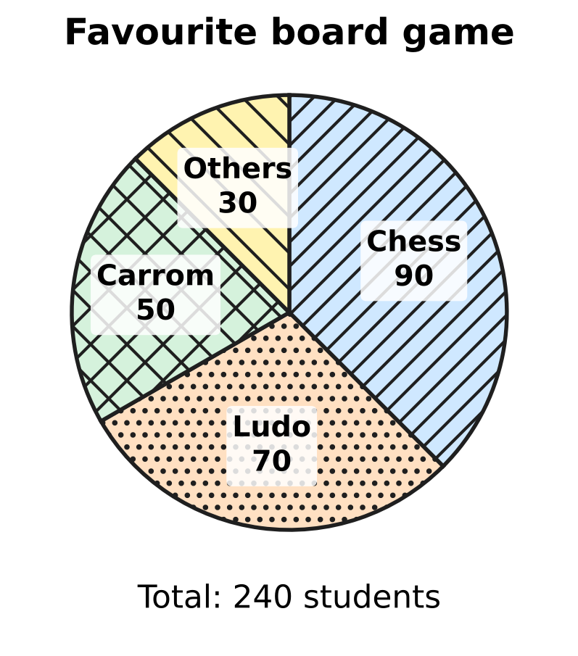
  (A) 37.5° | (B) 105° | (C) 50° | (D) 75°

Q29. Sneha ran six laps of the school running track. Her lap times, in seconds, were 58, 64, 61, 55, 67 and 60. What is the median lap time?
(A) 60.5 seconds | (B) 58 seconds
(C) 60 seconds | (D) 61 seconds

Q30. Avni counted the honey bees that visited each of five flower beds in one hour. The pictograph shows her counts. Half a symbol stands for 5 bees. What is the mean number of bees per flower bed? | 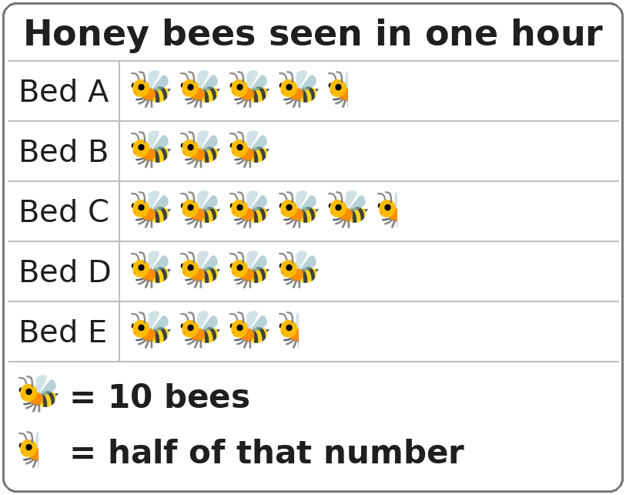
  (A) 55 bees | (B) 41 bees | (C) 40 bees | (D) 205 bees

Part 8 — Applied Mathematics (Syllabus Chapter 9)
Q31. On Rhea's map, 2 cm stands for 15 km. Two towns are 7 cm apart on the map. What is the actual distance between them?
(A) 30 km | (B) 22 km | (C) 105 km | (D) 52.5 km

Q32. A pile of 15 identical textbooks weighs 9 kg. What do 25 of these textbooks weigh?
(A) 225 kg | (B) 5.4 kg | (C) 15 kg | (D) 19 kg

Q33. In a harbour, $\frac{3}{8}$ of the boats are fishing boats. All the other boats are sailing boats. What is the ratio of fishing boats to sailing boats?
(A) 3 : 5 | (B) 5 : 3 | (C) 3 : 8 | (D) 3 : 11

Q34. Ken repairs clocks in a clock shop. Inside one clock, a gear with 40 teeth turns a smaller gear with 24 teeth. The teeth of the two gears fit together, so the same number of teeth pass the meeting point on each gear. When the large gear makes 15 full turns, how many full turns does the small gear make?
(A) 600 | (B) 9 | (C) 25 | (D) 31

Folding 60 paper planes
Number of children | 4 | 5 | ___
Planes folded by each child | 15 | ___ | 6

Q35. Some children share the work of folding 60 paper planes equally. The table shows the number of planes each child folds for different numbers of children. Which numbers fill the two blanks? (Give the blank in the first row first.)
(A) 12 and 10 | (B) 10 and 14
(C) 13 and 14 | (D) 10 and 12

Part 9 — Mathematical Reasoning & Problem-Solving (Syllabus Chapter 10)
Q36. The factors of 6 other than 6 itself are 1, 2 and 3, and 1 + 2 + 3 = 6. Which of these numbers is also equal to the sum of its factors other than itself?
(A) 20 | (B) 28 | (C) 24 | (D) 12

Q37. Daksh has three number cards: 0, 4 and 7. He puts all three cards in a row to make a three-digit number. A three-digit number cannot start with 0. How many different three-digit numbers can he make?
(A) 4 | (B) 18 | (C) 6 | (D) 27

Q38. The five-digit number $4□152$ is divisible by 9. Which digit is in the box?
(A) 7 | (B) 1 | (C) 3 | (D) 6

Q39. Which of these numbers has 1 as its units digit?
(A) 9³⁵ | (B) 7⁴⁴ | (C) 2⁴⁰ | (D) 3⁴²

Q40. The counting numbers from 1 onwards are added in order, and the sum is exactly 210. What is the last number added?
1 + 2 + 3 + … + □ = 210
(A) 14 | (B) 21 | (C) 20 | (D) 105

SECTION II — Star Questions 5 questions × 4 marks each
Q41. Some two-digit numbers are equal to the product of their two digits added to the sum of their two digits. For example, 25 does not have this property, because 2 × 5 + 2 + 5 = 17. How many two-digit numbers have this property? [4 marks]
(A) 1 | (B) 10 | (C) 9 | (D) 0

Q42. Nirav grows mangoes. It costs him ₹AB to grow 1 kg of mangoes, and he sells 1 kg at a profit of 20% for ₹BA. Here AB and BA are two-digit numbers made from two different non-zero digits A and B. What is the selling price of 1 kg? [4 marks]
(A) ₹9 | (B) ₹45 | (C) ₹63 | (D) ₹54

Q43. On one day, a museum sold 160 tickets. Adult tickets and child tickets were sold in the ratio 3 : 5. An adult ticket costs ₹20 more than a child ticket. The museum collected ₹6,000 from these tickets. What is the price of an adult ticket? [4 marks]
(A) ₹50 | (B) ₹30 | (C) ₹45 | (D) ₹25

Q44. A cuboid has a volume of 72 cm³. Its length, breadth and height are three different whole numbers of centimetres. A triangle can be made whose three sides have the same lengths as these three edges. What is the total surface area of the cuboid? [4 marks]
(A) 124 cm² | (B) 108 cm² | (C) 178 cm² | (D) 120 cm²

Q45. The sum of two rational numbers is $−\frac{1}{6}$. One of them is $\frac{3}{4}$ more than twice the other. What is the larger of the two numbers? [4 marks]
(A) $\frac{5}{36}$ | (B) $\frac{41}{36}$ | (C) $−\frac{11}{36}$ | (D) $\frac{7}{36}$

Answer Sheet AMO Level 1 · Class 7 · Practice Paper 3
Name: | School: | Roll No.:
Shade or tick one circle for each question.
1. Ⓐ Ⓑ Ⓒ Ⓓ | 16. Ⓐ Ⓑ Ⓒ Ⓓ | 31. Ⓐ Ⓑ Ⓒ Ⓓ
2. Ⓐ Ⓑ Ⓒ Ⓓ | 17. Ⓐ Ⓑ Ⓒ Ⓓ | 32. Ⓐ Ⓑ Ⓒ Ⓓ
3. Ⓐ Ⓑ Ⓒ Ⓓ | 18. Ⓐ Ⓑ Ⓒ Ⓓ | 33. Ⓐ Ⓑ Ⓒ Ⓓ
4. Ⓐ Ⓑ Ⓒ Ⓓ | 19. Ⓐ Ⓑ Ⓒ Ⓓ | 34. Ⓐ Ⓑ Ⓒ Ⓓ
5. Ⓐ Ⓑ Ⓒ Ⓓ | 20. Ⓐ Ⓑ Ⓒ Ⓓ | 35. Ⓐ Ⓑ Ⓒ Ⓓ
6. Ⓐ Ⓑ Ⓒ Ⓓ | 21. Ⓐ Ⓑ Ⓒ Ⓓ | 36. Ⓐ Ⓑ Ⓒ Ⓓ
7. Ⓐ Ⓑ Ⓒ Ⓓ | 22. Ⓐ Ⓑ Ⓒ Ⓓ | 37. Ⓐ Ⓑ Ⓒ Ⓓ
8. Ⓐ Ⓑ Ⓒ Ⓓ | 23. Ⓐ Ⓑ Ⓒ Ⓓ | 38. Ⓐ Ⓑ Ⓒ Ⓓ
9. Ⓐ Ⓑ Ⓒ Ⓓ | 24. Ⓐ Ⓑ Ⓒ Ⓓ | 39. Ⓐ Ⓑ Ⓒ Ⓓ
10. Ⓐ Ⓑ Ⓒ Ⓓ | 25. Ⓐ Ⓑ Ⓒ Ⓓ | 40. Ⓐ Ⓑ Ⓒ Ⓓ
11. Ⓐ Ⓑ Ⓒ Ⓓ | 26. Ⓐ Ⓑ Ⓒ Ⓓ | 41. Ⓐ Ⓑ Ⓒ Ⓓ
12. Ⓐ Ⓑ Ⓒ Ⓓ | 27. Ⓐ Ⓑ Ⓒ Ⓓ | 42. Ⓐ Ⓑ Ⓒ Ⓓ
13. Ⓐ Ⓑ Ⓒ Ⓓ | 28. Ⓐ Ⓑ Ⓒ Ⓓ | 43. Ⓐ Ⓑ Ⓒ Ⓓ
14. Ⓐ Ⓑ Ⓒ Ⓓ | 29. Ⓐ Ⓑ Ⓒ Ⓓ | 44. Ⓐ Ⓑ Ⓒ Ⓓ
15. Ⓐ Ⓑ Ⓒ Ⓓ | 30. Ⓐ Ⓑ Ⓒ Ⓓ | 45. Ⓐ Ⓑ Ⓒ Ⓓ
Q41–Q45 are Section II Star Questions (4 marks each).
For the parent or teacher
Section I correct: ______ / 40 × 2 = ______ marks Section II correct: ______ / 5 × 4 = ______ marks
Correct: ______ / 45 Score: ______ / 100
Answer Key and Solutions AMO Level 1 · Class 7 · Practice Paper 3
Quick answers
1 D | 6 D | 11 A | 16 D | 21 B | 26 A | 31 D | 36 B | 41 C
2 A | 7 C | 12 C | 17 B | 22 A | 27 C | 32 C | 37 A | 42 D
3 B | 8 B | 13 A | 18 C | 23 D | 28 D | 33 A | 38 D | 43 A
4 A | 9 B | 14 C | 19 D | 24 C | 29 A | 34 C | 39 B | 44 B
5 C | 10 D | 15 B | 20 A | 25 B | 30 B | 35 D | 40 C | 45 A
Solutions
Q | Part · level | Answer | Why?
1 | Part 1 · Ch1 · Easy | (D) $−\frac{6}{5}$ | A number times its reciprocal is 1. The reciprocal of −5/6 is −6/5, since (−5/6) × (−6/5) = 30/30 = 1.
2 | Part 1 · Ch1 · Easy | (A) $\frac{−10}{−12}$ | −10/−12 = 10/12 = 5/6, which is positive. The other three all simplify to −5/6.
3 | Part 1 · Ch1 · Medium | (B) $\frac{5}{12}$ | −2/3 + 5/6 = −4/6 + 5/6 = 1/6. Then 1/6 − □ = −1/4, so □ = 1/6 + 1/4 = 2/12 + 3/12 = 5/12.
4 | Part 1 · Ch1 · Medium | (A) $−\frac{5}{3}$ | X is 5 quarter-steps left of 0, so X = −5/4. Y = 3/4. X ÷ Y = (−5/4) × (4/3) = −5/3.
5 | Part 2 · Ch2 · Easy | (C) 5 | The left side is 7 to the power 4 + n − 3 = n + 1. So n + 1 = 6 and n = 5.
6 | Part 2 · Ch2 · Easy | (D) −9 | (−2)³ = −8 and 3⁰ = 1, so the product is −8. (−1)⁵ = −1. The value is −8 − 1 = −9.
7 | Part 2 · Ch2 · Medium | (C) 1.8 × 10⁶ letters | 6 × 10⁴ × 30 = 180 × 10⁴ = 1.8 × 10² × 10⁴ = 1.8 × 10⁶ letters (1,800,000).
8 | Part 3 · Ch3 · Easy | (B) ₹35 | The new fare is 120% of the old fare. So the old fare = 42 × 100 ÷ 120 = ₹35. Check: 20% of ₹35 is ₹7, and ₹35 + ₹7 = ₹42.
9 | Part 3 · Ch3 · Easy | (B) 45 | 30% of 120 = 36. 36 is 36/80 × 100 = 45% of 80.
10 | Part 3 · Ch3 · Easy | (D) ₹200 | Profit = 25% of ₹160 = ₹40. Selling price = ₹160 + ₹40 = ₹200.
11 | Part 3 · Ch3 · Medium | (A) 20% | Marked price of 5 cups = ₹100. She pays for 4 cups = ₹80. Discount = ₹20 on ₹100 = 20%.
12 | Part 3 · Ch3 · Medium | (C) 13 questions | 70% of 60 = 42 right answers are needed. She already has 29, so she needs at least 42 − 29 = 13 of the remaining 20.
13 | Part 4 · Ch4 · Easy | (A) 48 | a²b = 4 × 3 = 12. 2ab² = 2 × (−2) × 9 = −36, so −2ab² = +36. The value is 12 + 36 = 48.
14 | Part 4 · Ch4 · Easy | (C) −4 | The like terms in a²b are −3a²b and −a²b. Together they make −4a²b, so the coefficient is −4.
15 | Part 4 · Ch4 · Easy | (B) 5 | Put x = 7: the left side is 28 − □ and the right side is 14 + 9 = 23. So □ = 28 − 23 = 5.
16 | Part 4 · Ch4 · Medium | (D) 18 | Let the ₹10 coins be t. Then 10t + 5(40 − t) = 290, so 5t + 200 = 290 and t = 18.
17 | Part 4 · Ch4 · Medium | (B) 8 | Middle bricks: (x + 2) + 3 = x + 5 and 3 + (2x − 1) = 2x + 2. Top: 3x + 7 = 31, so 3x = 24 and x = 8.
18 | Part 5 · Ch5 · Easy | (C) 80 | The exterior angle equals the sum of the two interior opposite angles: 2x − 10 = x + 70, so x = 80. Check: ∠ACD = 150° = 80° + 70°.
19 | Part 5 · Ch5 · Easy | (D) 31 | Between the lines and on opposite sides of t, the angles are alternate angles. The lines are parallel when they are equal: 4x − 8 = 116, so 4x = 124 and x = 31.
20 | Part 5 · Ch5 · Easy | (A) Angles on a straight line add up to 180°. | Steps 1, 2 and 4 use the diagonal, the angle sum of a triangle and the parts of an angle. No straight-line angles appear anywhere in the proof.
21 | Part 5 · Ch5 · Medium | (B) 65° | The order of the letters gives P ↔ L, Q ↔ M, R ↔ N, so ∠R = ∠N = 51°. ∠P = 180° − 64° − 51° = 65°, and ∠L = ∠P = 65°.
22 | Part 5 · Ch5 · Medium | (A) 114° | Inside angle at C = 180° − 116° = 64°. The angles of a quadrilateral add up to 360°, so ∠D = 360° − 98° − 84° − 64° = 114°.
23 | Part 6 · Ch6 · Easy | (D) 10 cm | Height = volume ÷ (length × breadth) = 840 ÷ 84 = 10 cm.
24 | Part 6 · Ch6 · Easy | (C) 220 cm² | Total surface area = 2πr(r + h) = 2 × 22/7 × 3.5 × (3.5 + 6.5) = 22 × 10 = 220 cm².
25 | Part 6 · Ch6 · Easy | (B) 64 | Volume of the big cube = 16 × 16 × 16 = 4,096 cm³. Volume of a small cube = 4 × 4 × 4 = 64 cm³. So 4,096 ÷ 64 = 64 small cubes.
26 | Part 6 · Ch6 · Medium | (A) 384 cm² | Each edge = 96 ÷ 12 = 8 cm. Each face = 64 cm², and six faces = 384 cm².
27 | Part 6 · Ch6 · Medium | (C) 9,240 cm³ | 2πrh = 1,320 gives 2 × 22/7 × r × 15 = 1,320, so r = 14 cm. Volume = 22/7 × 14 × 14 × 15 = 9,240 cm³.
28 | Part 7 · Ch8 · Easy | (D) 75° | Angle = 50/240 × 360° = 75°.
29 | Part 7 · Ch8 · Easy | (A) 60.5 seconds | In order: 55, 58, 60, 61, 64, 67. The two middle values are 60 and 61, so the median is (60 + 61) ÷ 2 = 60.5 seconds.
30 | Part 7 · Ch8 · Medium | (B) 41 bees | The counts are 45, 30, 55, 40 and 35. Their total is 205, and 205 ÷ 5 = 41 bees.
31 | Part 8 · Ch9 · Easy | (D) 52.5 km | 1 cm stands for 15 ÷ 2 = 7.5 km. So 7 cm stands for 7 × 7.5 = 52.5 km.
32 | Part 8 · Ch9 · Easy | (C) 15 kg | One textbook weighs 9 ÷ 15 = 0.6 kg. So 25 textbooks weigh 25 × 0.6 = 15 kg.
33 | Part 8 · Ch9 · Easy | (A) 3 : 5 | If there are 8 parts in all, 3 parts are fishing boats and 5 parts are sailing boats. So the ratio is 3 : 5.
34 | Part 8 · Ch9 · Medium | (C) 25 | Teeth × turns is the same for both gears: 40 × 15 = 600 = 24 × turns. So the small gear makes 600 ÷ 24 = 25 turns.
35 | Part 8 · Ch9 · Medium | (D) 10 and 12 | The number of children × planes per child is always 4 × 15 = 60. So 60 ÷ 6 = 10 children, and 60 ÷ 5 = 12 planes each.
36 | Part 9 · Ch10 · Easy | (B) 28 | For 28: 1 + 2 + 4 + 7 + 14 = 28. For 12 the sum is 16, for 20 it is 22 and for 24 it is 36.
37 | Part 9 · Ch10 · Easy | (A) 4 | With 4 first: 407, 470. With 7 first: 704, 740. So there are 4 numbers.
38 | Part 9 · Ch10 · Easy | (D) 6 | 4 + 1 + 5 + 2 = 12. The digit sum must be a multiple of 9, so 12 + □ = 18 and □ = 6.
39 | Part 9 · Ch10 · Medium | (B) 7⁴⁴ | Units digits of powers of 7 repeat 7, 9, 3, 1. 44 is a multiple of 4, so 7⁴⁴ ends in 1. 3⁴² ends in 9, 9³⁵ ends in 9 and 2⁴⁰ ends in 6.
40 | Part 9 · Ch10 · Medium | (C) 20 | 1 + 2 + … + n = n × (n + 1) ÷ 2. We need n × (n + 1) = 420 = 20 × 21, so the last number is 20.
41 | Section II · Ch4 + Ch10 · Hard | (C) 9 | Write the number as 10a + b. Then 10a + b = ab + a + b gives 9a = ab, so b = 9 (a is not 0). The numbers are 19, 29, …, 99: there are 9.
42 | Section II · Ch3 + Ch10 · Hard | (D) ₹54 | 120% of AB = BA, so 120(10A + B) = 100(10B + A). This gives 1,100A = 880B, that is 5A = 4B. With single digits, A = 4 and B = 5. Cost ₹45, selling price ₹54 (20% of ₹45 is ₹9).
43 | Section II · Ch4 + Ch9 · Hard | (A) ₹50 | Adult tickets = 3/8 of 160 = 60 and child tickets = 100. With child price c: 60(c + 20) + 100c = 6,000, so 160c = 4,800 and c = 30. Adult price = ₹50.
44 | Section II · Ch5 + Ch6 · Hard | (B) 108 cm² | Three different whole numbers with product 72: (1, 2, 36), (1, 3, 24), (1, 4, 18), (1, 6, 12), (1, 8, 9), (2, 3, 12), (2, 4, 9), (3, 4, 6). Only 3, 4, 6 make a triangle (3 + 4 > 6). TSA = 2(12 + 24 + 18) = 108 cm².
45 | Section II · Ch1 + Ch4 · Hard | (A) $\frac{5}{36}$ | Let the other number be x. Then x + (2x + 3/4) = −1/6, so 3x = −1/6 − 3/4 = −11/12 and x = −11/36. The first is −22/36 + 27/36 = 5/36, which is the larger.

ARYABHATTA MATHS OLYMPIAD
Level 1
PRACTICE PAPER-4
CLASS 7
Total Questions | 45 multiple-choice questions
Total Marks | 100
Time | 60 minutes
Section I | 40 questions × 2 marks = 80 marks
Section II | 5 Star Questions × 4 marks = 20 marks
Negative Marking | No negative marking
Calculator | Not allowed
Chapters | Number System · Operations · Fractions, Decimals & Percentages · Algebra · Geometry · Mensuration · Data Handling · Applied Mathematics · Mathematical Reasoning

Instructions to candidates
• This paper has 45 multiple-choice questions. Each question has four answer choices, of which exactly one is correct.
• Section I (Q1–Q40) carries 2 marks per question. Section II (Q41–Q45) carries 4 marks per question.
• There is no negative marking. Unanswered questions score zero.
• Calculators are not permitted. Rough work may be done on a separate sheet.
• Mark your answers on the answer sheet at the end of the paper.
• All figures are not necessarily drawn to scale unless stated.

For parents and teachers
• Print or view this paper in colour. Pictures are part of the questions.
• Parts follow the AMO syllabus chapters. Chapter 7 is not part of the Class 7 syllabus, so the chapter numbers shown in the Part headings have gaps.
• The answer sheet and the answer key are at the end. Remove only the answer key before the student begins.

SECTION I 40 questions × 2 marks each
Part 1 — Number System (Syllabus Chapter 1)
Q1. On a number line, the point $−\frac{5}{8}$ is marked. Which of these points is to the left of it?
(A) $−\frac{5}{6}$ | (B) $−\frac{1}{2}$ | (C) $−\frac{3}{8}$ | (D) $−\frac{2}{5}$

Q2. Two points on a number line show $−\frac{5}{6}$ and $\frac{3}{8}$. How far apart are the two points?
(A) $\frac{29}{24}$ | (B) $\frac{4}{7}$ | (C) $\frac{11}{24}$ | (D) $−\frac{29}{24}$

Q3. At a ferry jetty, a marked pole shows the water level of the river. During a dry spell, the level changes by $−\frac{3}{8}$ m every day. After how many days will the total change in the level be $−2\frac{1}{4}$ m?
(A) 12 days | (B) 3 days | (C) 6 days | (D) 18 days

Q4. How many numbers of the form $\frac{p}{10}$, where p is an integer, are greater than $−\frac{2}{5}$ and less than $\frac{3}{10}$?
(A) 5 | (B) 6 | (C) 7 | (D) 8

Part 2 — Operations & Number Properties (Syllabus Chapter 2)
Q5. Which of these numbers is the greatest?
(A) 2.5 × 10⁶ | (B) 9.8 × 10⁵
(C) 1.9 × 10⁶ | (D) 6.4 × 10⁵

Q6. The number 3⁵ is how many times the number 3²?
(A) 3 | (B) 9 | (C) 234 | (D) 27

Q7. What is (3.5 × 10⁴) + (2.5 × 10³), written in standard form?
(A) 2.85 × 10³ | (B) 3.75 × 10⁴
(C) 6 × 10⁴ | (D) 6 × 10⁷

Part 3 — Fractions, Decimals & Percentages (Syllabus Chapter 3)
Q8. A shop receives 450 eggs packed in egg trays. On the way, 6% of the eggs crack. How many eggs do NOT crack?
(A) 444 eggs | (B) 27 eggs | (C) 423 eggs | (D) 405 eggs

Q9. A shopkeeper bought an umbrella stand for ₹1,250. He sold it for ₹1,000. What was his loss percent?
(A) 2.5% | (B) 80% | (C) 20% | (D) 25%

Q10. In a bookshop sale, every book is sold at 20% off its marked price. Komal buys two books marked ₹250 and ₹350. How much does she pay in all?
(A) ₹480 | (B) ₹550 | (C) ₹580 | (D) ₹120

Q11. There were two candidates in a school council election. Every student voted for exactly one of them. The winner got 58% of the votes and won by 112 votes. How many students voted?
(A) 294 | (B) 700 | (C) 1,400 | (D) 406

Q12. Imran's savings are 25% more than Zara's savings. By what percentage are Zara's savings less than Imran's savings?
(A) 75% | (B) 25% | (C) 80% | (D) 20%

Part 4 — Algebra (Syllabus Chapter 4)
Q13. In an art class, Ojas has n crayons. Rima has 5 fewer than three times as many crayons as Ojas. How many crayons do they have together?
(A) 4n − 15 | (B) 4n + 5 | (C) 3n − 5 | (D) 4n − 5

Q14. A wooden plank is (5x + 3) cm long. Two pieces, each (x − 1) cm long, are cut from it to make a shelf. What length of the plank is left?
(A) (3x + 5) cm | (B) (3x + 1) cm
(C) (7x + 1) cm | (D) (4x + 4) cm

Q15. Vivek solved the equation 4x − 7 = 2x + 9 as shown.
Step 1: 4x − 2x − 7 = 9
Step 2: 2x − 7 = 9
Step 3: 2x = 9 − 7
Step 4: x = 1
In which step did he make his first mistake?
(A) Step 1 | (B) Step 2 | (C) Step 3 | (D) Step 4

Q16. Three classes collected 102 kg of old paper for recycling. Class 7B collected 6 kg more than Class 7A. Class 7C collected twice as much as Class 7A. How much paper did Class 7C collect?
(A) 54 kg | (B) 48 kg | (C) 30 kg | (D) 24 kg

Q17. Vihaan thinks of a number. He multiplies it by 5 and then subtracts 12. Chitra takes the same number, multiplies it by 3 and then adds 10. They both get the same answer. What is the number?
(A) −1 | (B) 43 | (C) 11 | (D) 22

Part 5 — Geometry (Syllabus Chapter 5)
Q18. The sides of a triangle are 7 cm, 12 cm and x cm, where x is a whole number. What is the smallest possible value of x?
(A) 18 | (B) 19 | (C) 6 | (D) 5

Q19. In the figure, ABCD is a parallelogram. Its diagonals AC and BD meet at O. AC = 16 cm, BD = 12 cm and AB = 9 cm. What is the perimeter of △AOB? | 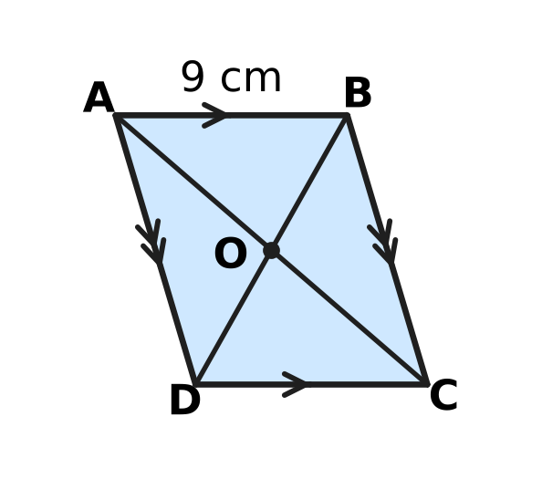
  (A) 14 cm | (B) 23 cm | (C) 29 cm | (D) 37 cm

Q20. In the figure, ABCD is a square and BCE is an equilateral triangle drawn outside the square on the side BC. What is the size of ∠ABE (marked "?")? | 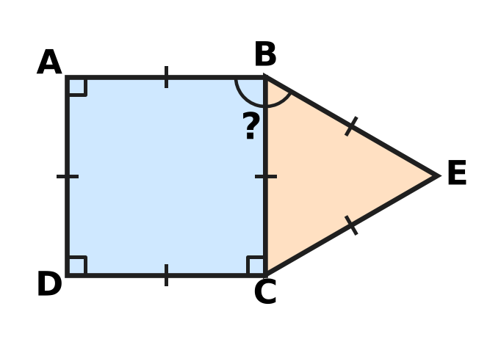
  (A) 150° | (B) 120° | (C) 135° | (D) 30°

Q21. In the figure, line l is parallel to line m. A is on l, and B, C and D are on m. AB makes an angle of 48° with l, and ∠ACD = 115°. What is the value of x? | 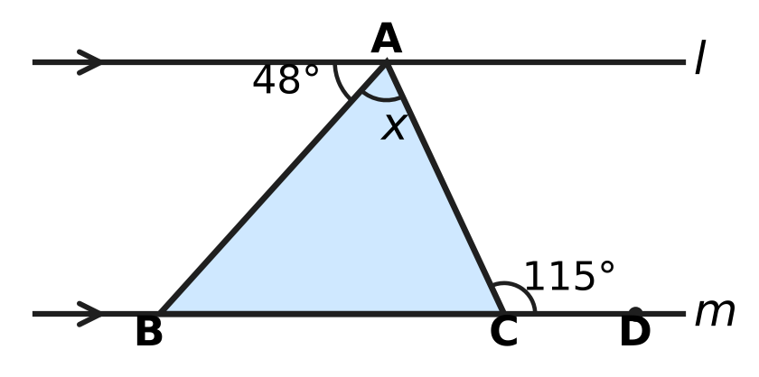
  (A) 65° | (B) 132° | (C) 17° | (D) 67°

Q22. In the quadrilateral ABCD shown, AB = AD and CB = CD, as marked. ∠BAD = 64° and ∠BCD = 52°. What is the value of x, the size of ∠ABC? | 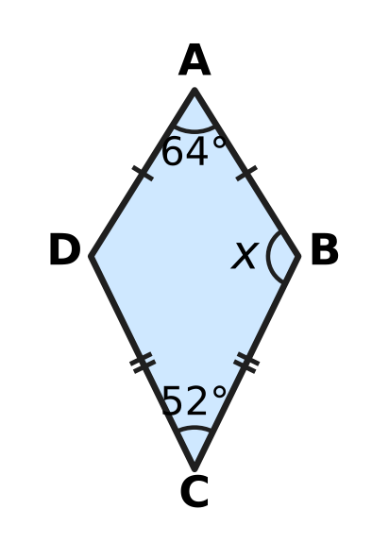
  (A) 122° | (B) 32° | (C) 116° | (D) 244°

Part 6 — Mensuration (Syllabus Chapter 6)
Q23. A cuboid of modelling clay measures 16 cm × 4 cm × 1 cm. All of it is reshaped into one cube, with no clay left over. What is the length of an edge of the cube?
(A) 8 cm | (B) 7 cm | (C) 4 cm | (D) 16 cm

Container | Radius of base (cm) | Height (cm)
Cylinder A | 3 | 8
Cylinder B | 5 | 3
Cylinder C | 2 | 16
Cylinder D | 4 | 5

Q24. The table gives the radius and height of four cylindrical containers. Which container holds the most water when full?
(A) Cylinder A | (B) Cylinder B
(C) Cylinder C | (D) Cylinder D

Q25. A cuboid tank has a base 20 cm long and 15 cm wide, and holds some water. A stone is put in the tank. It sinks fully and the water level rises by 2 cm, as shown. No water spills out. What is the volume of the stone? | 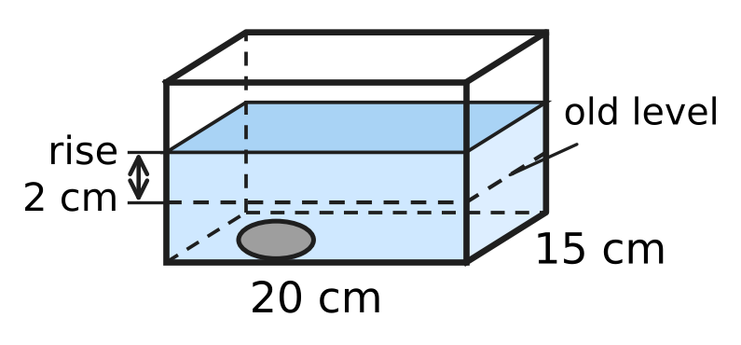
  (A) 300 cm³ | (B) 600 cm³ | (C) 40 cm³ | (D) 30 cm³

Q26. A sheet of card is 30 cm long and 20 cm wide. A square of side 5 cm is cut from each corner, as shown. The sides are folded up along the dashed lines to make an open box. What is the volume of the box? | 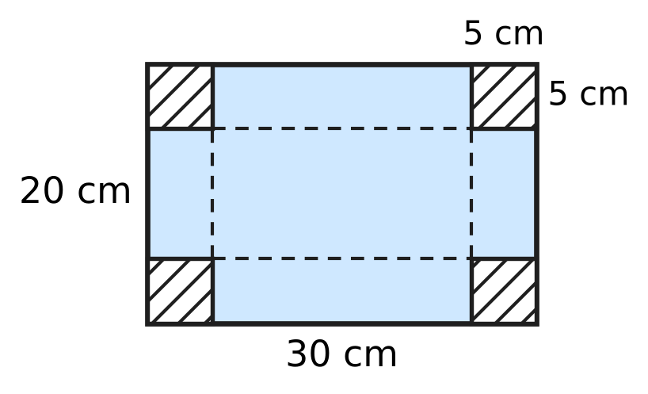
  (A) 1,500 cm³ | (B) 1,875 cm³
  (C) 3,000 cm³ | (D) 1,000 cm³

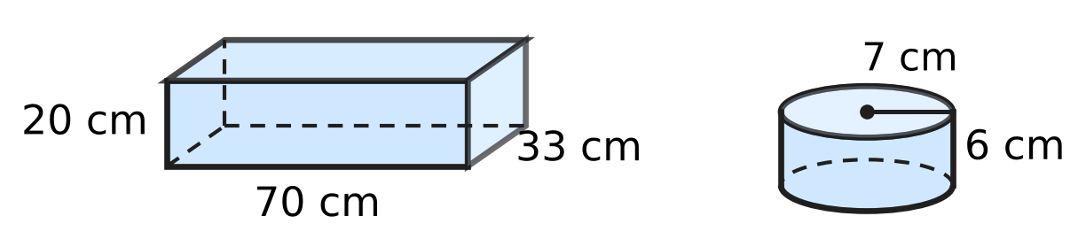
Q27. At a milk dairy, the cuboid container shown, 70 cm long, 33 cm wide and 20 cm high, is full of milk. All the milk is poured into cylindrical tubs like the one shown, of radius 7 cm and height 6 cm. How many tubs can be filled completely? Use π = $\frac{22}{7}$.
(A) 200 | (B) 300 | (C) 175 | (D) 50

Part 7 — Data Handling, Statistics & Probability (Syllabus Chapter 8)
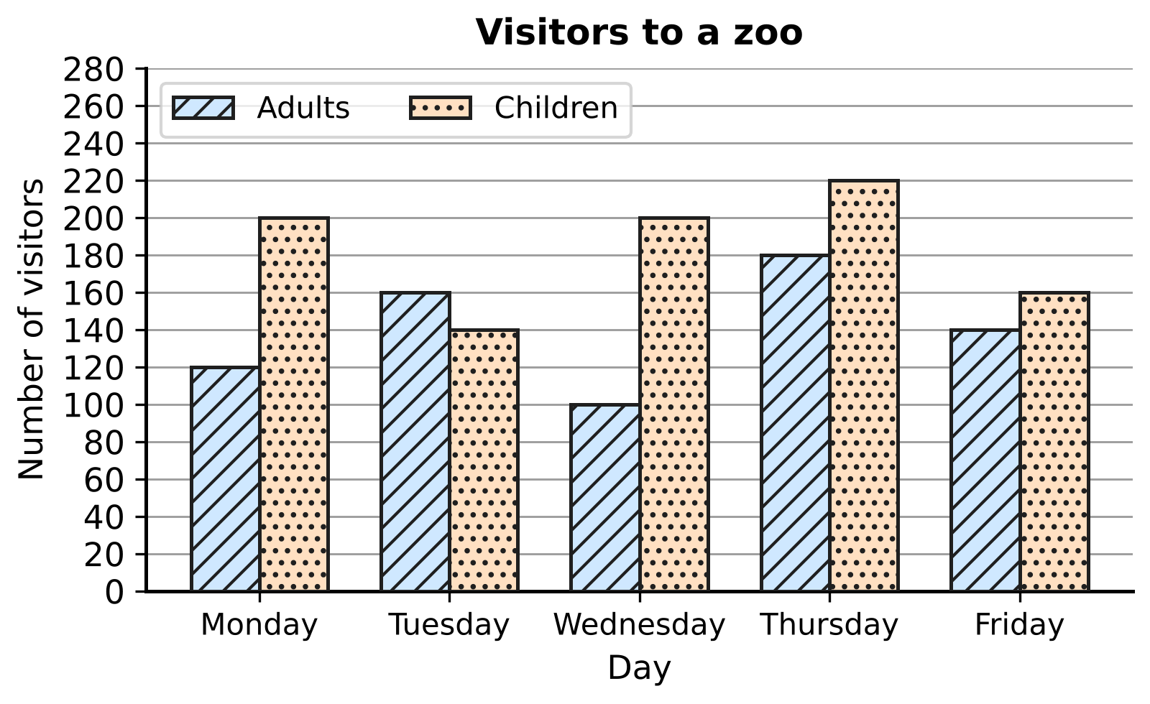
Q28. The double bar graph shows the number of adults and children who visited a zoo on five days. On which day was the difference between the number of children and the number of adults the greatest?
(A) Monday | (B) Wednesday
(C) Thursday | (D) Friday

Number of pets | 0 | 1 | 2 | 3 | 4
Number of students | 9 | 14 | 10 | 5 | 2

Q29. Each of the 40 students of a class wrote down how many pets they have. The table shows the results. What is the mode of the number of pets?
(A) 2 | (B) 4 | (C) 1 | (D) 14

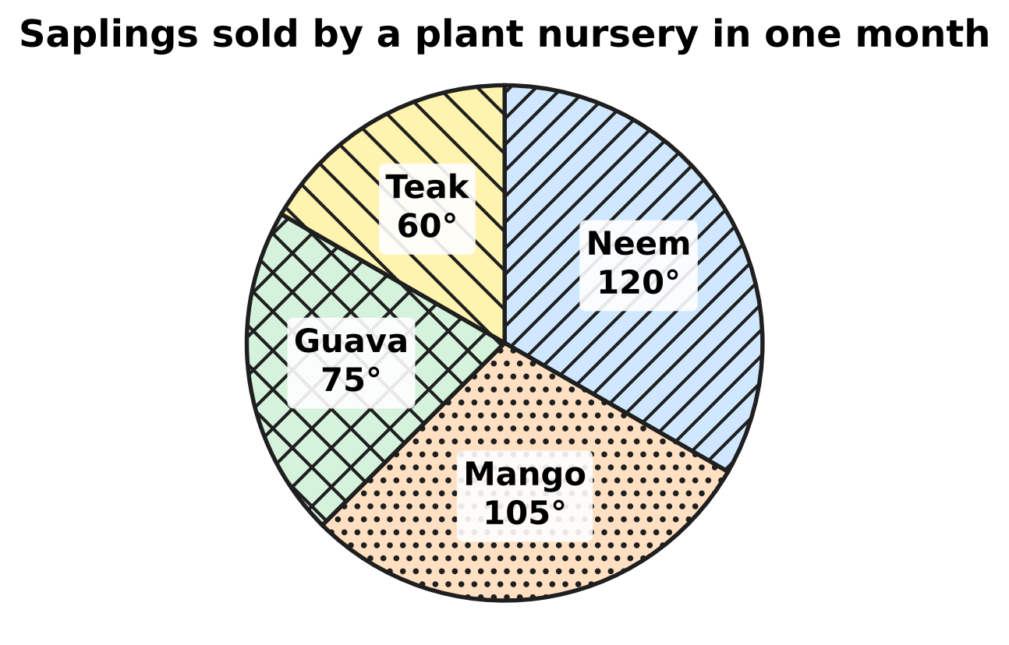
Q30. The pie chart shows the saplings sold by a plant nursery in one month. The angle of each sector is marked. The nursery sold 40 more mango saplings than guava saplings. How many saplings did it sell in all?
(A) 480 | (B) 270 | (C) 140 | (D) 360

Part 8 — Applied Mathematics (Syllabus Chapter 9)
Q31. Kriti's recipe for a rice dish uses 450 g of rice for 6 people. How much rice does she need to make the same dish for 10 people?
(A) 75 g | (B) 750 g | (C) 4,500 g | (D) 270 g

Q32. At a school assembly, the students stand in 36 rows with 20 students in each row. The next day the same students stand in rows of 30. How many rows are there now?
(A) 26 | (B) 54 | (C) 30 | (D) 24

Pack | Mass | Price
Pack P | 500 g | ₹60
Pack Q | 750 g | ₹84
Pack R | 1 kg | ₹110
Pack S | 2 kg | ₹210

Q33. The table shows four packs of the same washing powder. Which pack has the lowest price for each kilogram?
(A) Pack P | (B) Pack Q | (C) Pack R | (D) Pack S

Q34. On a mountain hike, 12 hikers need 18 kg of food for 5 days. Every hiker eats the same amount each day. How much food do 8 hikers need for 6 days?
(A) 32.4 kg | (B) 14.4 kg | (C) 10 kg | (D) 12 kg

Q35. For a school picnic, a teacher buys apples at ₹150 per kg and pears at ₹120 per kg. The masses of apples and pears are in the ratio 4 : 3. She pays ₹2,880 in all. What mass of pears does she buy?
(A) 12 kg | (B) 21 kg | (C) 9 kg | (D) 3 kg

Part 9 — Mathematical Reasoning & Problem-Solving (Syllabus Chapter 10)
Q36. Look at this pattern.
1 × 8 + 1 = 9
12 × 8 + 2 = 98
123 × 8 + 3 = 987
1,234 × 8 + 4 = 9,876
The pattern goes on in the same way. What is 123,456 × 8 + 6?
(A) 987,654 | (B) 987,648
(C) 9,876,543 | (D) 98,765

Q37. A palindrome is a number that reads the same from left to right and from right to left, such as 363. How many three-digit palindromes are divisible by 5?
(A) 10 | (B) 9 | (C) 20 | (D) 90

Q38. Look at this list of numbers: 2, 5, 10, 17, 26, … The pattern goes on in the same way. Which term of the list is 101?
(A) 11th term | (B) 10th term
(C) 9th term | (D) 50th term

Q39. The figure shows the straight paths in a park. Tia walks along the paths from A to B. At every step she goes either to the right or up, never left or down. How many different routes can she take? | 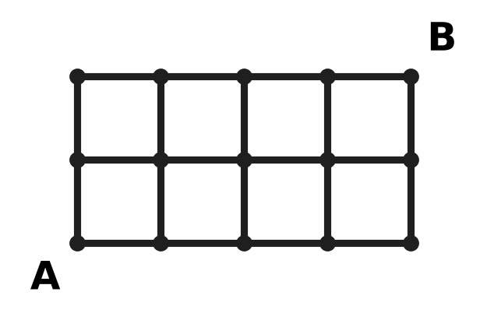
  (A) 10 | (B) 6 | (C) 15 | (D) 8

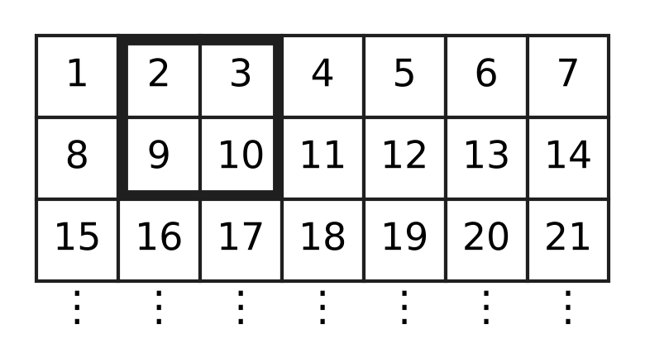
Q40. The counting numbers are written in rows of 7, as shown. The grid goes on in the same way. The four numbers inside a 2 × 2 square are added, for example 2 + 3 + 9 + 10 = 24. For another 2 × 2 square, the total is 116. What is the smallest number in that square?
(A) 33 | (B) 29 | (C) 26 | (D) 25

SECTION II — Star Questions 5 questions × 4 marks each
Q41. A bag holds only red counters and blue counters. The number of red counters is 5 more than twice the number of blue counters. There are more than 30 and fewer than 40 counters in the bag. All the counters can be shared equally among 4 children, with none left over. How many red counters are in the bag? [4 marks]
(A) 9 | (B) 23 | (C) 25 | (D) 27

Q42. A wall clock is marked ₹250. The shop may give a discount of a whole-number percentage that is greater than 10% and less than 30%. For how many of these discounts is the sale price a whole number of rupees? [4 marks]
(A) 19 | (B) 3 | (C) 9 | (D) 10

Q43. Garima makes big candles and small candles from the same wax. The mass of 3 big candles is the same as the mass of 5 small candles. A small candle has a mass of 60 g. She packs a box with big and small candles. The box has twice as many small candles as big candles. Together they have a mass of 2,640 g. How many candles are in the box? [4 marks]
(A) 24 | (B) 44 | (C) 12 | (D) 36

Q44. The figure shows the side view of a folding stool. The legs AC and BD are straight and cross at O. Equal marks show OA = OC and OB = OD. The lower ends C and D of the legs are 35 cm apart. The seat is a cylinder 6 cm thick, and AB is a diameter of the seat. What is the volume of the seat? Use π = $\frac{22}{7}$. [4 marks] | 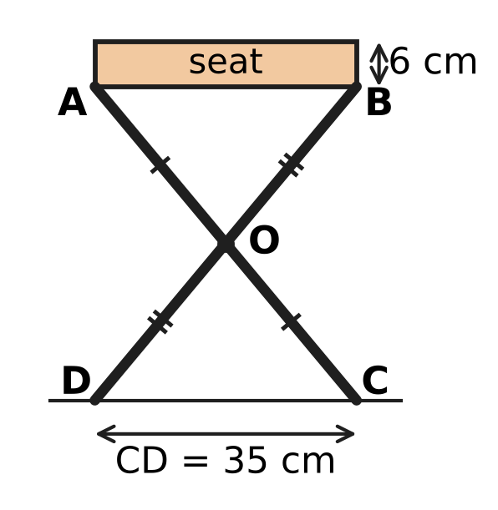
  (A) 5,775 cm³ | (B) 660 cm³
  (C) 11,550 cm³ | (D) 23,100 cm³

Q45. A rational number x is greater than $−\frac{2}{3}$ and less than $−\frac{1}{3}$. On the number line, x and $4x+\frac{5}{2}$ are at the same distance from 0. What is the value of x? [4 marks]
(A) $−\frac{2}{5}$ | (B) $−\frac{5}{8}$ | (C) $−\frac{5}{6}$ | (D) $−\frac{1}{2}$

Answer Sheet AMO Level 1 · Class 7 · Practice Paper 4
Name: | School: | Roll No.:
Shade or tick one circle for each question.
1. Ⓐ Ⓑ Ⓒ Ⓓ | 16. Ⓐ Ⓑ Ⓒ Ⓓ | 31. Ⓐ Ⓑ Ⓒ Ⓓ
2. Ⓐ Ⓑ Ⓒ Ⓓ | 17. Ⓐ Ⓑ Ⓒ Ⓓ | 32. Ⓐ Ⓑ Ⓒ Ⓓ
3. Ⓐ Ⓑ Ⓒ Ⓓ | 18. Ⓐ Ⓑ Ⓒ Ⓓ | 33. Ⓐ Ⓑ Ⓒ Ⓓ
4. Ⓐ Ⓑ Ⓒ Ⓓ | 19. Ⓐ Ⓑ Ⓒ Ⓓ | 34. Ⓐ Ⓑ Ⓒ Ⓓ
5. Ⓐ Ⓑ Ⓒ Ⓓ | 20. Ⓐ Ⓑ Ⓒ Ⓓ | 35. Ⓐ Ⓑ Ⓒ Ⓓ
6. Ⓐ Ⓑ Ⓒ Ⓓ | 21. Ⓐ Ⓑ Ⓒ Ⓓ | 36. Ⓐ Ⓑ Ⓒ Ⓓ
7. Ⓐ Ⓑ Ⓒ Ⓓ | 22. Ⓐ Ⓑ Ⓒ Ⓓ | 37. Ⓐ Ⓑ Ⓒ Ⓓ
8. Ⓐ Ⓑ Ⓒ Ⓓ | 23. Ⓐ Ⓑ Ⓒ Ⓓ | 38. Ⓐ Ⓑ Ⓒ Ⓓ
9. Ⓐ Ⓑ Ⓒ Ⓓ | 24. Ⓐ Ⓑ Ⓒ Ⓓ | 39. Ⓐ Ⓑ Ⓒ Ⓓ
10. Ⓐ Ⓑ Ⓒ Ⓓ | 25. Ⓐ Ⓑ Ⓒ Ⓓ | 40. Ⓐ Ⓑ Ⓒ Ⓓ
11. Ⓐ Ⓑ Ⓒ Ⓓ | 26. Ⓐ Ⓑ Ⓒ Ⓓ | 41. Ⓐ Ⓑ Ⓒ Ⓓ
12. Ⓐ Ⓑ Ⓒ Ⓓ | 27. Ⓐ Ⓑ Ⓒ Ⓓ | 42. Ⓐ Ⓑ Ⓒ Ⓓ
13. Ⓐ Ⓑ Ⓒ Ⓓ | 28. Ⓐ Ⓑ Ⓒ Ⓓ | 43. Ⓐ Ⓑ Ⓒ Ⓓ
14. Ⓐ Ⓑ Ⓒ Ⓓ | 29. Ⓐ Ⓑ Ⓒ Ⓓ | 44. Ⓐ Ⓑ Ⓒ Ⓓ
15. Ⓐ Ⓑ Ⓒ Ⓓ | 30. Ⓐ Ⓑ Ⓒ Ⓓ | 45. Ⓐ Ⓑ Ⓒ Ⓓ
Q41–Q45 are Section II Star Questions (4 marks each).
For the parent or teacher
Section I correct: ______ / 40 × 2 = ______ marks Section II correct: ______ / 5 × 4 = ______ marks
Correct: ______ / 45 Score: ______ / 100
Answer Key and Solutions AMO Level 1 · Class 7 · Practice Paper 4
Quick answers
1 A | 6 D | 11 B | 16 B | 21 D | 26 D | 31 B | 36 A | 41 B
2 A | 7 B | 12 D | 17 C | 22 A | 27 D | 32 D | 37 A | 42 C
3 C | 8 C | 13 D | 18 C | 23 C | 28 B | 33 D | 38 B | 43 D
4 B | 9 C | 14 A | 19 B | 24 D | 29 C | 34 B | 39 C | 44 A
5 A | 10 A | 15 C | 20 A | 25 B | 30 A | 35 C | 40 D | 45 D
Solutions
Q | Part · level | Answer | Why?
1 | Part 1 · Ch1 · Easy | (A) $−\frac{5}{6}$ | Points to the left are smaller. −3/8, −1/2 and −2/5 all lie between −5/8 and 0. −5/6 is less than −5/8 (the same 5 parts, but sixths are bigger than eighths), so only −5/6 is to the left.
2 | Part 1 · Ch1 · Easy | (A) $\frac{29}{24}$ | Distance = 3/8 − (−5/6) = 3/8 + 5/6 = 9/24 + 20/24 = 29/24.
3 | Part 1 · Ch1 · Medium | (C) 6 days | Number of days = (−9/4) ÷ (−3/8) = (−9/4) × (−8/3) = 72/12 = 6.
4 | Part 1 · Ch1 · Medium | (B) 6 | −2/5 = −4/10. The numbers p/10 with −4 < p < 3 have p = −3, −2, −1, 0, 1, 2. That is 6 numbers.
5 | Part 2 · Ch2 · Easy | (A) 2.5 × 10⁶ | Numbers with 10⁶ are greater than numbers with 10⁵. Of 2.5 × 10⁶ and 1.9 × 10⁶, the greater is 2.5 × 10⁶ (2,500,000).
6 | Part 2 · Ch2 · Easy | (D) 27 | We need 3⁵ ÷ 3² = 3⁵⁻² = 3³ = 27. Check: 243 ÷ 9 = 27.
7 | Part 2 · Ch2 · Medium | (B) 3.75 × 10⁴ | Write 2.5 × 10³ as 0.25 × 10⁴. So the sum is (3.5 + 0.25) × 10⁴ = 3.75 × 10⁴ (that is, 35,000 + 2,500 = 37,500).
8 | Part 3 · Ch3 · Easy | (C) 423 eggs | The cracked eggs are 6% of 450 = 450 × 6/100 = 27. So 450 − 27 = 423 eggs do not crack.
9 | Part 3 · Ch3 · Easy | (C) 20% | Loss = 1,250 − 1,000 = ₹250. Loss percent = 250/1,250 × 100 = 20%.
10 | Part 3 · Ch3 · Easy | (A) ₹480 | Total marked price = 250 + 350 = ₹600. Discount = 20% of 600 = ₹120. She pays 600 − 120 = ₹480.
11 | Part 3 · Ch3 · Medium | (B) 700 | The other candidate got 42%. The winning margin is 58% − 42% = 16% of the votes = 112. So 1% is 7 votes and the total is 700.
12 | Part 3 · Ch3 · Medium | (D) 20% | If Zara has ₹100, Imran has ₹125. Zara has ₹25 less, and 25/125 × 100 = 20%.
13 | Part 4 · Ch4 · Easy | (D) 4n − 5 | Rima has 3n − 5 crayons. Together they have n + (3n − 5) = 4n − 5.
14 | Part 4 · Ch4 · Easy | (A) (3x + 5) cm | Left = (5x + 3) − 2(x − 1) = 5x + 3 − 2x + 2 = (3x + 5) cm.
15 | Part 4 · Ch4 · Easy | (C) Step 3 | From 2x − 7 = 9, adding 7 to both sides gives 2x = 16, not 9 − 7. So Step 3 is wrong; the correct answer is x = 8.
16 | Part 4 · Ch4 · Medium | (B) 48 kg | Let Class 7A collect x kg. Then x + (x + 6) + 2x = 102, so 4x = 96 and x = 24. Class 7C collected 2 × 24 = 48 kg.
17 | Part 4 · Ch4 · Medium | (C) 11 | Let the number be n. Then 5n − 12 = 3n + 10, so 2n = 22 and n = 11. Check: 55 − 12 = 43 and 33 + 10 = 43.
18 | Part 5 · Ch5 · Easy | (C) 6 | The sum 7 + x must be greater than 12, so x is greater than 5. The smallest whole number greater than 5 is 6 (and 6, 7, 12 do make a triangle).
19 | Part 5 · Ch5 · Easy | (B) 23 cm | The diagonals of a parallelogram bisect each other, so AO = 8 cm and BO = 6 cm. Perimeter = 8 + 6 + 9 = 23 cm.
20 | Part 5 · Ch5 · Easy | (A) 150° | ∠ABC = 90° (angle of a square) and ∠CBE = 60° (angle of an equilateral triangle). ∠ABE = 90° + 60° = 150°.
21 | Part 5 · Ch5 · Medium | (D) 67° | ∠ABC = 48° (alternate angles, l ∥ m). The exterior angle ∠ACD equals ∠ABC + x, so x = 115° − 48° = 67°.
22 | Part 5 · Ch5 · Medium | (A) 122° | △ABC ≅ △ADC by SSS (AB = AD, CB = CD, AC common), so ∠ABC = ∠ADC. These two add up to 360° − 64° − 52° = 244°, so x = 122°.
23 | Part 6 · Ch6 · Easy | (C) 4 cm | Volume = 16 × 4 × 1 = 64 cm³. The cube has the same volume, and 4 × 4 × 4 = 64, so its edge is 4 cm.
24 | Part 6 · Ch6 · Easy | (D) Cylinder D | Volume = πr²h, so compare r × r × h: A 72, B 75, C 64, D 80 (each times π). Cylinder D holds the most.
25 | Part 6 · Ch6 · Easy | (B) 600 cm³ | The stone pushes up a layer of water 20 cm × 15 cm × 2 cm. Its volume = 20 × 15 × 2 = 600 cm³.
26 | Part 6 · Ch6 · Medium | (D) 1,000 cm³ | The base of the box is (30 − 10) cm by (20 − 10) cm = 20 cm by 10 cm, and the height is 5 cm. Volume = 20 × 10 × 5 = 1,000 cm³.
27 | Part 6 · Ch6 · Medium | (D) 50 | Milk = 70 × 33 × 20 = 46,200 cm³. One tub holds 22/7 × 7 × 7 × 6 = 924 cm³. Number of tubs = 46,200 ÷ 924 = 50.
28 | Part 7 · Ch8 · Easy | (B) Wednesday | Differences: Monday 80, Tuesday 20, Wednesday 100, Thursday 40, Friday 20. The greatest is on Wednesday.
29 | Part 7 · Ch8 · Easy | (C) 1 | The mode is the value that occurs most often. There are 14 students with 1 pet, more than for any other value, so the mode is 1.
30 | Part 7 · Ch8 · Medium | (A) 480 | The difference between the sectors is 105° − 75° = 30°, which stands for 40 saplings. So 360° stands for 40 × 12 = 480 saplings.
31 | Part 8 · Ch9 · Easy | (B) 750 g | Rice for 1 person = 450 ÷ 6 = 75 g. For 10 people: 75 × 10 = 750 g.
32 | Part 8 · Ch9 · Easy | (D) 24 | Number of students = 36 × 20 = 720. In rows of 30: 720 ÷ 30 = 24 rows.
33 | Part 8 · Ch9 · Easy | (D) Pack S | Price per kg: P ₹120, Q ₹112, R ₹110, S ₹105. Pack S is the cheapest for each kilogram.
34 | Part 8 · Ch9 · Medium | (B) 14.4 kg | Food for 1 hiker for 1 day = 18 ÷ (12 × 5) = 0.3 kg. For 8 hikers for 6 days: 0.3 × 8 × 6 = 14.4 kg.
35 | Part 8 · Ch9 · Medium | (C) 9 kg | Then 4 kg of apples and 3 kg of pears cost 4 × 150 + 3 × 120 = ₹960. Since ₹2,880 ÷ ₹960 = 3, she buys 3 × 3 = 9 kg of pears (and 12 kg of apples).
36 | Part 9 · Ch10 · Easy | (A) 987,654 | In each line the answer counts down from 9, with as many digits as the first number has. The number 123,456 has six digits, so the answer is 987,654.
37 | Part 9 · Ch10 · Easy | (A) 10 | A number divisible by 5 ends in 0 or 5. A palindrome ending in 0 would start with 0, so it must be 5_5. The middle digit can be 0 to 9: 10 palindromes.
38 | Part 9 · Ch10 · Easy | (B) 10th term | Each term is one more than a square: 1² + 1, 2² + 1, 3² + 1, … Since 101 = 10² + 1, it is the 10th term.
39 | Part 9 · Ch10 · Medium | (C) 15 | Write at each corner the number of ways to reach it: it is the sum of the numbers just to the left and just below. The bottom row and left column are all 1; the top row becomes 1, 3, 6, 10, 15. So there are 15 routes.
40 | Part 9 · Ch10 · Medium | (D) 25 | If the smallest number is n, the square holds n, n + 1, n + 7 and n + 8, with total 4n + 16. So 4n + 16 = 116 and n = 25 (square 25, 26, 32, 33).
41 | Section II · Ch4 + Ch10 · Hard | (B) 23 | With b blue counters there are 2b + 5 red ones, so 3b + 5 in all. Between 30 and 40 this gives b = 9, 10 or 11 (totals 32, 35, 38). Only 32 is divisible by 4, so b = 9 and there are 23 red counters.
42 | Section II · Ch3 + Ch10 · Hard | (C) 9 | A discount of d% of ₹250 is 250 × d/100 = 5d/2 rupees. This is a whole number only when d is even. The even values greater than 10 and less than 30 are 12, 14, …, 28: 9 discounts.
43 | Section II · Ch4 + Ch9 · Hard | (D) 36 | A big candle has mass 5 × 60 ÷ 3 = 100 g. With x big and 2x small candles: 100x + 120x = 2,640, so 220x = 2,640 and x = 12. The box has 12 + 24 = 36 candles.
44 | Section II · Ch5 + Ch6 · Hard | (A) 5,775 cm³ | ∠AOB = ∠COD (vertically opposite), OA = OC and OB = OD, so △AOB ≅ △COD (SAS) and AB = CD = 35 cm. The radius is 17.5 cm. Volume = 22/7 × 17.5 × 17.5 × 6 = 5,775 cm³.
45 | Section II · Ch1 + Ch4 · Hard | (D) $−\frac{1}{2}$ | Numbers at the same distance from 0 are equal or opposite. If 4x + 5/2 = x, then x = −5/6, which is less than −2/3, so it does not fit. If 4x + 5/2 = −x, then 5x = −5/2, so x = −1/2, which is between −2/3 and −1/3.

ARYABHATTA MATHS OLYMPIAD
Level 1
PRACTICE PAPER-5
CLASS 7
Total Questions | 45 multiple-choice questions
Total Marks | 100
Time | 60 minutes
Section I | 40 questions × 2 marks = 80 marks
Section II | 5 Star Questions × 4 marks = 20 marks
Negative Marking | No negative marking
Calculator | Not allowed
Chapters | Number System · Operations · Fractions, Decimals & Percentages · Algebra · Geometry · Mensuration · Data Handling · Applied Mathematics · Mathematical Reasoning

Instructions to candidates
• This paper has 45 multiple-choice questions. Each question has four answer choices, of which exactly one is correct.
• Section I (Q1–Q40) carries 2 marks per question. Section II (Q41–Q45) carries 4 marks per question.
• There is no negative marking. Unanswered questions score zero.
• Calculators are not permitted. Rough work may be done on a separate sheet.
• Mark your answers on the answer sheet at the end of the paper.
• All figures are not necessarily drawn to scale unless stated.

For parents and teachers
• Print or view this paper in colour. Pictures are part of the questions.
• Parts follow the AMO syllabus chapters. Chapter 7 is not part of the Class 7 syllabus, so the chapter numbers shown in the Part headings have gaps.
• The answer sheet and the answer key are at the end. Remove only the answer key before the student begins.

SECTION I 40 questions × 2 marks each
Part 1 — Number System (Syllabus Chapter 1)
Q1. The rational number $\frac{21}{−56}$ is written in standard form as $\frac{p}{q}$, where q is positive. What is the value of p + q?
(A) 11 | (B) −5 | (C) 5 | (D) 77

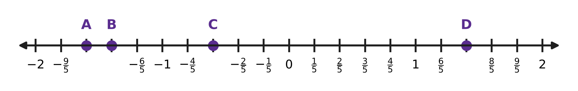
Q2. On the number line, each unit is divided into 5 equal parts. Which point shows the rational number $−\frac{7}{5}$?
(A) Point A | (B) Point B | (C) Point C | (D) Point D

Q3. A number is added to $−\frac{2}{3}$. The result is greater than 0 and less than $\frac{1}{4}$. Which of these could the number be?
(A) 1 | (B) $\frac{1}{2}$ | (C) $\frac{11}{12}$ | (D) $\frac{3}{4}$

Q4. What is the value of $(\frac{1}{2}−1)×(\frac{1}{3}−1)×(\frac{1}{4}−1)×…×(\frac{1}{11}−1)$?
(A) $\frac{1}{11}$ | (B) $−\frac{1}{11}$ | (C) $\frac{1}{10}$ | (D) $\frac{10}{11}$

Part 2 — Operations & Number Properties (Syllabus Chapter 2)
Q5. How many digits does the number 2⁴ × 5⁴ × 7 have?
(A) 5 | (B) 4 | (C) 8 | (D) 6

Q6. What is the value of (−1)¹ + (−1)² + (−1)³ + … + (−1)⁹?
(A) 0 | (B) −9 | (C) −1 | (D) 1

Q7. What number must 2³ × 3² be multiplied by to give 6⁴?
(A) 6 | (B) 2 | (C) 9 | (D) 18

Part 3 — Fractions, Decimals & Percentages (Syllabus Chapter 3)
Q8. An ice-cream stall sells a cone for ₹60. The stall makes a profit of ₹12 on each cone. What is the profit percent?
(A) 12% | (B) 80% | (C) 20% | (D) 25%

Q9. A cook uses 300 g of rice from a 2 kg bag. What percentage of the bag of rice does she use?
(A) 0.15% | (B) 150% | (C) 15% | (D) 30%

Q10. In a music class, 40% of the students play the flute. One quarter of the flute players also play the guitar. What percentage of the whole class plays both the flute and the guitar?
(A) 10% | (B) 25% | (C) 15% | (D) 65%

Q11. Deepak sold a study lamp for ₹760 and made a loss of 20%. At what price should he have sold it to make a profit of 10%?
(A) ₹950 | (B) ₹836 | (C) ₹1,045 | (D) ₹988

Q12. A company runs hot-air balloon rides. It raises the price of each ride by 20%. After that, the number of rides it sells in a month falls by 10%. By what percentage does the money it collects in a month change?
(A) It goes up by 8%. | (B) It goes up by 108%.
(C) It goes up by 10%. | (D) It goes up by 2%.

Part 4 — Algebra (Syllabus Chapter 4)
Q13. Solve the equation 7 − 3y = 2y + 22.
(A) y = 15 | (B) y = −3 | (C) y = −15 | (D) y = 3

Q14. Ana simplified 7a − (3a − 5) and wrote 4a − 5. Her answer is wrong. What is the correct simplified expression?
(A) 10a + 5 | (B) 10a − 5 | (C) −4a + 5 | (D) 4a + 5

Q15. The figure shows the plan of a playground. Its sides meet at right angles, and the length of each side is marked. What is the perimeter of the playground? | 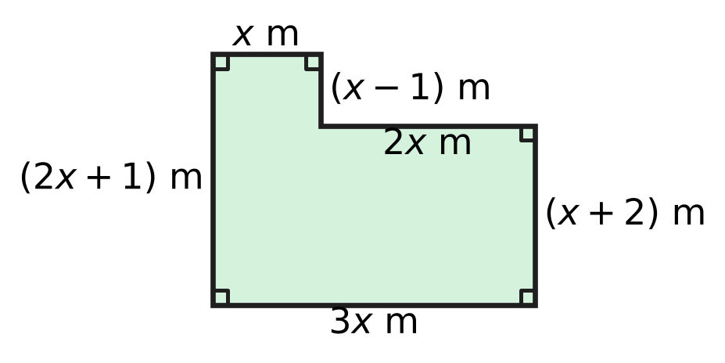
  (A) (8x + 3) m | (B) (10x + 4) m
  (C) (10x + 2) m | (D) 10x m

Q16. Parth gets into a lift and goes up 7 floors. The floor number where he gets out is 3 more than twice the floor number where he got in. On which floor does he get out?
(A) Floor 14 | (B) Floor 17 | (C) Floor 4 | (D) Floor 11

Q17. Two-thirds of a number is 12 more than two-fifths of the same number. What is the number?
(A) 18 | (B) 45 | (C) 90 | (D) 30

Part 5 — Geometry (Syllabus Chapter 5)
Q18. In △ABC and △PQR, three pairs of parts are known to be equal. Which of these sets of equal parts does NOT guarantee that △ABC ≅ △PQR?
(A) AB = PQ, BC = QR, ∠A = ∠P | (B) AB = PQ, BC = QR, CA = RP
(C) AB = PQ, ∠B = ∠Q, BC = QR | (D) ∠A = ∠P, AB = PQ, ∠B = ∠Q

Q19. Three angles of a quadrilateral are equal. The fourth angle is 105°. What is the size of each of the three equal angles?
(A) 255° | (B) 85° | (C) 75° | (D) 25°

Q20. In the figure, the line t crosses the three straight lines l, m and n. Three of the angles are marked. Which two lines are parallel? | 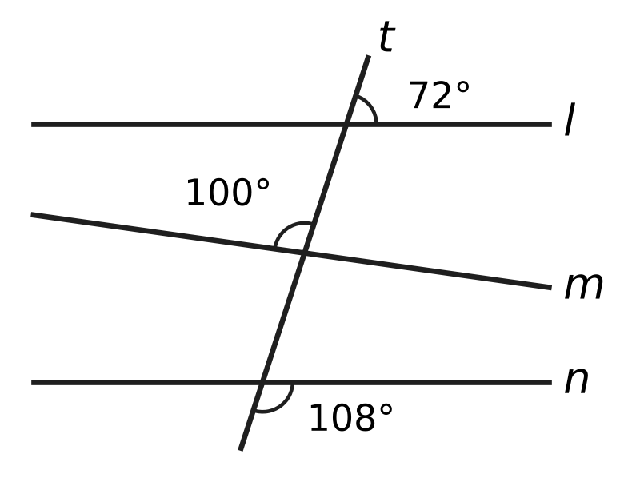
  (A) l and m | (B) l and n
  (C) m and n | (D) all three lines

Q21. In the figure, ∠BAC = 70°. The line BI cuts ∠ABC into two equal parts, and the line CI cuts ∠ACB into two equal parts. What is the value of x, the size of ∠BIC? | 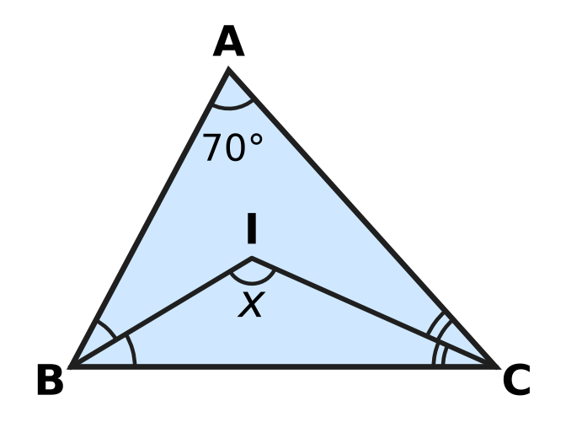
  (A) 125° | (B) 145° | (C) 110° | (D) 55°

Q22. In △PQR, ∠P = ∠Q + ∠R and ∠Q = 2 × ∠R. What is the size of ∠Q?
(A) 45° | (B) 90° | (C) 30° | (D) 60°

Part 6 — Mensuration (Syllabus Chapter 6)
Q23. The total surface area of a small cube is 54 cm². The total surface area of a large cube is 864 cm². The edge of the large cube is how many times the edge of the small cube?
(A) 8 times | (B) 64 times | (C) 4 times | (D) 16 times

Q24. The closed drum in the figure is a cylinder of radius 21 cm and height 40 cm. Only its two circular ends are painted. What area is painted? Use π = $\frac{22}{7}$. | 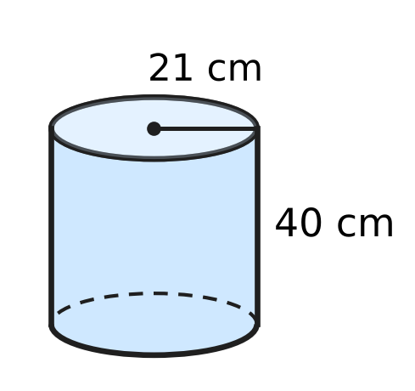
  (A) 1,386 cm² | (B) 2,772 cm²
  (C) 8,052 cm² | (D) 5,280 cm²

Q25. A cube has edges of 6 cm. Which of these cuboids has the same volume as the cube?
(A) 12 cm × 6 cm × 3 cm | (B) 9 cm × 4 cm × 5 cm
(C) 8 cm × 6 cm × 4 cm | (D) 12 cm × 3 cm × 4 cm

Q26. The edges of the cuboid in the figure are whole numbers of centimetres. The areas of three of its faces are 20 cm², 15 cm² and 12 cm², as marked. What is the volume of the cuboid? | 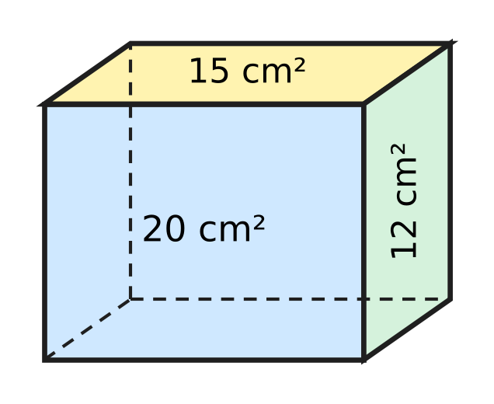
  (A) 94 cm³ | (B) 3,600 cm³
  (C) 47 cm³ | (D) 60 cm³

Q27. During a shower, 2 cm of rain falls on a flat roof that is 10 m long and 6 m wide. All of this water flows into a tank. How many litres of water reach the tank? (1 m³ = 1,000 litres)
(A) 12,000 litres | (B) 120 litres
(C) 1,200 litres | (D) 120,000 litres

Part 7 — Data Handling, Statistics & Probability (Syllabus Chapter 8)
Q28. Yash counted the cars in a car park at noon on five days: 42, 38, 51, 45 and 44. Later he found that the count 38 should have been 58. By how much does the mean number of cars increase?
(A) 20 | (B) 48 | (C) 44 | (D) 4

Q29. Six numbers are written in increasing order: 4, 7, x, 12, 15, 20. Their median is 10. What is the value of x?
(A) 13 | (B) 8 | (C) 2 | (D) 10

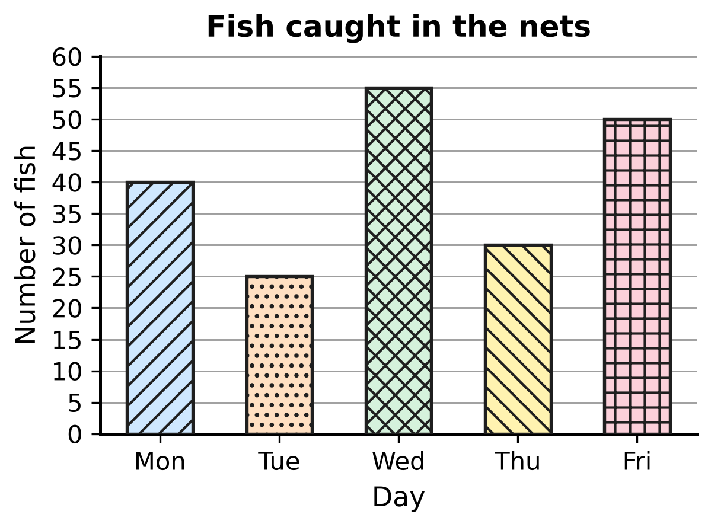
Q30. A fishing boat drops its nets once a day. The bar graph shows the number of fish caught on five days. On how many of these days was the catch MORE than the mean catch of the five days?
(A) 2 | (B) 4 | (C) 3 | (D) 1

Part 8 — Applied Mathematics (Syllabus Chapter 9)
Q31. A plane flies between two airports at a steady speed of 600 km per hour, and the trip takes 2 hours. On a new timetable the same trip must take 1 hour 30 minutes. At what steady speed must the plane fly?
(A) 1,200 km per hour | (B) 450 km per hour
(C) 800 km per hour | (D) 750 km per hour

Q32. Which of these ratios is the greatest?
(A) 7 : 12 | (B) 2 : 3 | (C) 3 : 5 | (D) 5 : 8

Q33. A necklace has only red, blue and green beads. The numbers of red, blue and green beads are in the ratio 5 : 4 : 2. Which of these could be the total number of beads?
(A) 77 | (B) 80 | (C) 75 | (D) 60

Q34. Kian and Zoya share ₹900 in the ratio 4 : 5. Then Zoya gives ₹50 of her share to Kian. What is the ratio of Kian's money to Zoya's money now?
(A) 7 : 11 | (B) 4 : 5 | (C) 1 : 1 | (D) 9 : 10

Q35. The quantity y varies directly as x. When x increases by 8, y increases by 12. What is the value of y when x = 18?
(A) 22 | (B) 12 | (C) 216 | (D) 27

Part 9 — Mathematical Reasoning & Problem-Solving (Syllabus Chapter 10)
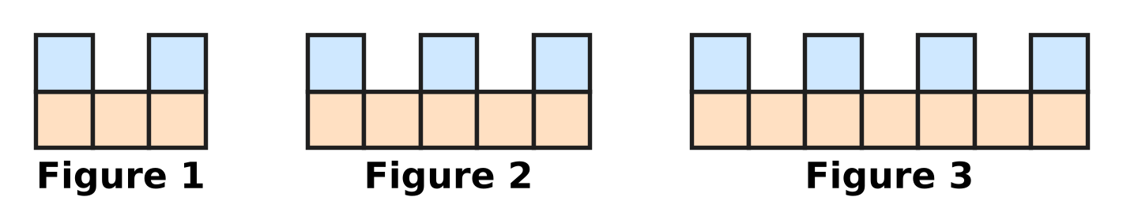
Q36. Square floor tiles are laid to make the figures shown. The pattern goes on in the same way. Which figure uses exactly 92 tiles?
(A) Figure 46 | (B) Figure 30
(C) Figure 31 | (D) Figure 29

Q37. I am a two-digit number. I am a multiple of 7. My two digits add up to 10. My tens digit is smaller than my units digit. Who am I?
(A) 37 | (B) 35 | (C) 28 | (D) 91

Q38. In how many different ways can 30 be written as the sum of two prime numbers? The order does not matter, so 7 + 23 and 23 + 7 are the same way.
(A) 4 | (B) 6 | (C) 2 | (D) 3

Q39. A staircase has 6 steps. Usha climbs it by going up either 1 step or 2 steps at a time. For example, 2 + 1 + 1 + 2 and 1 + 1 + 2 + 2 are two different ways. In how many different ways can she climb from the bottom to the top?
(A) 13 | (B) 11 | (C) 64 | (D) 4

Q40. The list 1 × 2, 2 × 3, 3 × 4, 4 × 5, … goes on in the same way. How many of the first 20 numbers in this list are multiples of 3?
(A) 6 | (B) 7 | (C) 13 | (D) 14

SECTION II — Star Questions 5 questions × 4 marks each
Q41. At a science exhibition, Isha's three stalls have numbers that are consecutive multiples of 6, such as 30, 36 and 42. The three stall numbers add up to a three-digit number whose three digits are all the same. What is the largest of Isha's three stall numbers? [4 marks]
(A) 216 | (B) 234 | (C) 222 | (D) 228

Bouquet | P | Q | R | S
Cost price (₹) | 120 | 180 | 280 | 320

Q42. Heena's flower shop made the four bouquets in the table. She sold some of them at a profit of 25% and all the others at a loss of 20%. Taking all four together, she made neither a profit nor a loss. Which bouquets did she sell at a loss? [4 marks]
(A) P and R | (B) Q and S
(C) R and S | (D) P, Q and R

Q43. Tarun's tea stall has a can with 60 litres of milk and water, mixed in the ratio 2 : 1. He takes out some of the mixture and puts in the same amount of water. Now the ratio of milk to water is 1 : 1. How many litres of the mixture did he take out? [4 marks]
(A) 20 litres | (B) 15 litres
(C) 30 litres | (D) 10 litres

Q44. The figure shows a cylindrical storage bin from the side. ABCD is the rectangle through its centre: AB is a diameter of the base and AD is the height. The base radius is 21 cm. Two straight sticks AE and ED rest inside, with E on BC. ∠EAB = 15°, ∠DEC = 30° and ED = 84 cm. What is the volume of the bin? Use π = $\frac{22}{7}$. [4 marks] | 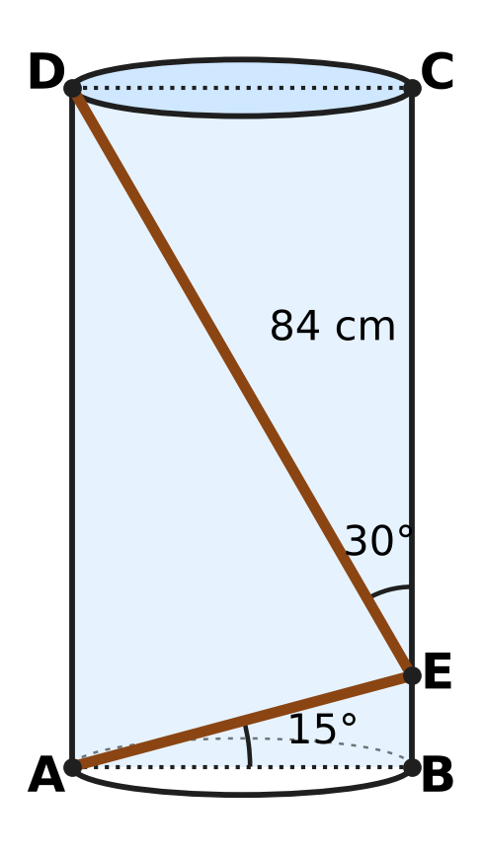
  (A) 116,424 cm³ | (B) 58,212 cm³
  (C) 465,696 cm³ | (D) 232,848 cm³

Q45. x is a negative rational number. When $(3x−\frac{1}{2})$ is multiplied by itself, the result is $\frac{49}{16}$. What is the value of x? [4 marks]
(A) $−\frac{3}{4}$ | (B) $−\frac{5}{4}$ | (C) $−\frac{5}{12}$ | (D) $−\frac{1}{12}$

Answer Sheet AMO Level 1 · Class 7 · Practice Paper 5
Name: | School: | Roll No.:
Shade or tick one circle for each question.
1. Ⓐ Ⓑ Ⓒ Ⓓ | 16. Ⓐ Ⓑ Ⓒ Ⓓ | 31. Ⓐ Ⓑ Ⓒ Ⓓ
2. Ⓐ Ⓑ Ⓒ Ⓓ | 17. Ⓐ Ⓑ Ⓒ Ⓓ | 32. Ⓐ Ⓑ Ⓒ Ⓓ
3. Ⓐ Ⓑ Ⓒ Ⓓ | 18. Ⓐ Ⓑ Ⓒ Ⓓ | 33. Ⓐ Ⓑ Ⓒ Ⓓ
4. Ⓐ Ⓑ Ⓒ Ⓓ | 19. Ⓐ Ⓑ Ⓒ Ⓓ | 34. Ⓐ Ⓑ Ⓒ Ⓓ
5. Ⓐ Ⓑ Ⓒ Ⓓ | 20. Ⓐ Ⓑ Ⓒ Ⓓ | 35. Ⓐ Ⓑ Ⓒ Ⓓ
6. Ⓐ Ⓑ Ⓒ Ⓓ | 21. Ⓐ Ⓑ Ⓒ Ⓓ | 36. Ⓐ Ⓑ Ⓒ Ⓓ
7. Ⓐ Ⓑ Ⓒ Ⓓ | 22. Ⓐ Ⓑ Ⓒ Ⓓ | 37. Ⓐ Ⓑ Ⓒ Ⓓ
8. Ⓐ Ⓑ Ⓒ Ⓓ | 23. Ⓐ Ⓑ Ⓒ Ⓓ | 38. Ⓐ Ⓑ Ⓒ Ⓓ
9. Ⓐ Ⓑ Ⓒ Ⓓ | 24. Ⓐ Ⓑ Ⓒ Ⓓ | 39. Ⓐ Ⓑ Ⓒ Ⓓ
10. Ⓐ Ⓑ Ⓒ Ⓓ | 25. Ⓐ Ⓑ Ⓒ Ⓓ | 40. Ⓐ Ⓑ Ⓒ Ⓓ
11. Ⓐ Ⓑ Ⓒ Ⓓ | 26. Ⓐ Ⓑ Ⓒ Ⓓ | 41. Ⓐ Ⓑ Ⓒ Ⓓ
12. Ⓐ Ⓑ Ⓒ Ⓓ | 27. Ⓐ Ⓑ Ⓒ Ⓓ | 42. Ⓐ Ⓑ Ⓒ Ⓓ
13. Ⓐ Ⓑ Ⓒ Ⓓ | 28. Ⓐ Ⓑ Ⓒ Ⓓ | 43. Ⓐ Ⓑ Ⓒ Ⓓ
14. Ⓐ Ⓑ Ⓒ Ⓓ | 29. Ⓐ Ⓑ Ⓒ Ⓓ | 44. Ⓐ Ⓑ Ⓒ Ⓓ
15. Ⓐ Ⓑ Ⓒ Ⓓ | 30. Ⓐ Ⓑ Ⓒ Ⓓ | 45. Ⓐ Ⓑ Ⓒ Ⓓ
Q41–Q45 are Section II Star Questions (4 marks each).
For the parent or teacher
Section I correct: ______ / 40 × 2 = ______ marks Section II correct: ______ / 5 × 4 = ______ marks
Correct: ______ / 45 Score: ______ / 100
Answer Key and Solutions AMO Level 1 · Class 7 · Practice Paper 5
Quick answers
1 C | 6 C | 11 C | 16 D | 21 A | 26 D | 31 C | 36 B | 41 D
2 B | 7 D | 12 A | 17 B | 22 D | 27 C | 32 B | 37 C | 42 B
3 D | 8 D | 13 B | 18 A | 23 C | 28 D | 33 A | 38 D | 43 B
4 A | 9 C | 14 D | 19 B | 24 B | 29 B | 34 C | 39 A | 44 A
5 A | 10 A | 15 C | 20 B | 25 A | 30 A | 35 D | 40 C | 45 C
Solutions
Q | Part · level | Answer | Why?
1 | Part 1 · Ch1 · Easy | (C) 5 | HCF(21, 56) = 7, so 21/−56 = −3/8 in standard form (denominator positive). p + q = −3 + 8 = 5.
2 | Part 1 · Ch1 · Easy | (B) Point B | −7/5 = −1 2/5, so it is 2 parts to the LEFT of −1, that is 7 parts to the left of 0. That is point B.
3 | Part 1 · Ch1 · Medium | (D) $\frac{3}{4}$ | Add each to −2/3 = −8/12: 3/4 gives 1/12, which is between 0 and 3/12. 1/2 gives −1/6, 11/12 gives exactly 1/4 and 1 gives 1/3.
4 | Part 1 · Ch1 · Medium | (A) $\frac{1}{11}$ | The brackets are −1/2, −2/3, −3/4, …, −10/11. Each numerator cancels the denominator before it, leaving 1/11. There are 10 negative factors, an even number, so the product is +1/11.
5 | Part 2 · Ch2 · Easy | (A) 5 | Here 2⁴ × 5⁴ = (2 × 5)⁴ = 10⁴, so the number is 7 × 10⁴ = 70,000. It has 5 digits.
6 | Part 2 · Ch2 · Easy | (C) −1 | Odd powers of −1 are −1 and even powers are +1. The terms pair off as (−1 + 1) four times, leaving (−1)⁹ = −1.
7 | Part 2 · Ch2 · Medium | (D) 18 | Write 6⁴ = 2⁴ × 3⁴. Dividing by 2³ × 3² leaves 2¹ × 3² = 2 × 9 = 18.
8 | Part 3 · Ch3 · Easy | (D) 25% | Cost price = 60 − 12 = ₹48. Profit % = 12 ÷ 48 × 100 = 25%.
9 | Part 3 · Ch3 · Easy | (C) 15% | There are 2,000 g in 2 kg. So she uses 300 ÷ 2,000 × 100 = 15%.
10 | Part 3 · Ch3 · Easy | (A) 10% | One quarter of 40% is 40 ÷ 4 = 10% of the class.
11 | Part 3 · Ch3 · Medium | (C) ₹1,045 | 80% of the cost price is ₹760, so the cost price is 760 × 100 ÷ 80 = ₹950. A 10% profit gives 950 + 95 = ₹1,045.
12 | Part 3 · Ch3 · Medium | (A) It goes up by 8%. | For every ₹100 collected before, the price becomes 120% and the rides 90%: 1.2 × 0.9 = 1.08, so ₹108 is collected now. That is an increase of 8%.
13 | Part 4 · Ch4 · Easy | (B) y = −3 | Move the y terms to one side and the numbers to the other: −3y − 2y = 22 − 7, so −5y = 15 and y = −3. Check: 7 + 9 = 16 = −6 + 22.
14 | Part 4 · Ch4 · Easy | (D) 4a + 5 | A minus sign before a bracket changes every sign inside it: 7a − 3a + 5 = 4a + 5.
15 | Part 4 · Ch4 · Easy | (C) (10x + 2) m | Add all six sides: 3x + (x + 2) + 2x + (x − 1) + x + (2x + 1) = 10x + 2 metres.
16 | Part 4 · Ch4 · Medium | (D) Floor 11 | Say he gets in on floor f. Then f + 7 = 2f + 3, so f = 4. He gets out on floor 4 + 7 = 11 (check: 2 × 4 + 3 = 11).
17 | Part 4 · Ch4 · Medium | (B) 45 | (2/3)n − (2/5)n = 12, so (10/15 − 6/15)n = 12, (4/15)n = 12 and n = 45. Check: 30 is 12 more than 18.
18 | Part 5 · Ch5 · Easy | (A) AB = PQ, BC = QR, ∠A = ∠P | The first three sets are SSS, SAS and ASA. In "AB, BC and ∠A" the angle is not between the two sides (SSA), so congruence is not guaranteed.
19 | Part 5 · Ch5 · Easy | (B) 85° | The angles of a quadrilateral add up to 360°. The three equal angles add up to 360° − 105° = 255°, and 255° ÷ 3 = 85°.
20 | Part 5 · Ch5 · Easy | (B) l and n | Compare the angle above each line, to the right of t: at l it is 72°, at m it is 180° − 100° = 80°, at n it is 180° − 108° = 72°. Corresponding angles are equal only for l and n.
21 | Part 5 · Ch5 · Medium | (A) 125° | ∠ABC + ∠ACB = 180° − 70° = 110°, so their halves add up to 55°. In △BIC, x = 180° − 55° = 125°.
22 | Part 5 · Ch5 · Medium | (D) 60° | ∠P + (∠Q + ∠R) = 180° and ∠P = ∠Q + ∠R, so ∠P = 90° and ∠Q + ∠R = 90°. With ∠Q = 2∠R, ∠R = 30° and ∠Q = 60°.
23 | Part 6 · Ch6 · Easy | (C) 4 times | One face of the small cube is 54 ÷ 6 = 9 cm², so its edge is 3 cm. One face of the large cube is 864 ÷ 6 = 144 cm², so its edge is 12 cm. So the answer is 12 ÷ 3 = 4.
24 | Part 6 · Ch6 · Easy | (B) 2,772 cm² | Area of one end = 22/7 × 21 × 21 = 1,386 cm². Two ends = 2 × 1,386 = 2,772 cm².
25 | Part 6 · Ch6 · Easy | (A) 12 cm × 6 cm × 3 cm | The cube holds 6 × 6 × 6 = 216 cm³. 12 × 6 × 3 = 216 cm³; the others give 180, 192 and 144 cm³.
26 | Part 6 · Ch6 · Medium | (D) 60 cm³ | The edges must be 5 cm, 4 cm and 3 cm (5 × 4 = 20, 5 × 3 = 15, 3 × 4 = 12). Volume = 5 × 3 × 4 = 60 cm³.
27 | Part 6 · Ch6 · Medium | (C) 1,200 litres | First, 2 cm = 0.02 m. Volume = 10 × 6 × 0.02 = 1.2 m³ = 1.2 × 1,000 = 1,200 litres.
28 | Part 7 · Ch8 · Easy | (D) 4 | The total goes up by 58 − 38 = 20, so the mean goes up by 20 ÷ 5 = 4 (from 44 to 48).
29 | Part 7 · Ch8 · Easy | (B) 8 | With six numbers, the median is the mean of the 3rd and 4th: (x + 12) ÷ 2 = 10, so x + 12 = 20 and x = 8.
30 | Part 7 · Ch8 · Medium | (A) 2 | Total = 40 + 25 + 55 + 30 + 50 = 200, so the mean is 40 fish. Only Wednesday (55) and Friday (50) are more than 40.
31 | Part 8 · Ch9 · Easy | (C) 800 km per hour | The distance is 600 × 2 = 1,200 km. Less time needs more speed: 1,200 ÷ 1.5 = 800 km per hour.
32 | Part 8 · Ch9 · Easy | (B) 2 : 3 | Write each as a fraction with denominator 120: 2/3 = 80/120, 5/8 = 75/120, 3/5 = 72/120, 7/12 = 70/120. The greatest is 2 : 3.
33 | Part 8 · Ch9 · Easy | (A) 77 | There are 5 + 4 + 2 = 11 parts, so the total must be a multiple of 11. Only 77 is: 35 red, 28 blue, 14 green.
34 | Part 8 · Ch9 · Medium | (C) 1 : 1 | Kian gets 4/9 × 900 = ₹400 and Zoya ₹500. After the gift, Kian has ₹450 and Zoya ₹450, so the ratio is 1 : 1.
35 | Part 8 · Ch9 · Medium | (D) 27 | y = kx, so a change of 8 in x gives a change of 8k in y. 8k = 12, so k = 3/2 and y = 3/2 × 18 = 27.
36 | Part 9 · Ch10 · Easy | (B) Figure 30 | The figures use 5, 8, 11, … tiles: 3 more each time, so Figure n uses 3n + 2 tiles. Then 3n + 2 = 92 gives n = 30.
37 | Part 9 · Ch10 · Easy | (C) 28 | Multiples of 7 with digit sum 10 are 28 and 91. Only in 28 is the tens digit smaller than the units digit.
38 | Part 9 · Ch10 · Easy | (D) 3 | List the smaller prime: 7 + 23, 11 + 19 and 13 + 17 work, while 2, 3 and 5 give 28, 27 and 25, which are not prime. So there are 3 ways.
39 | Part 9 · Ch10 · Medium | (A) 13 | Sort by the number of 2-step moves. None: 1 way. One: 5 moves, the 2 can be in 5 places. Two: 4 moves, 6 ways to place the two 2s. Three: 1 way. Total 1 + 5 + 6 + 1 = 13.
40 | Part 9 · Ch10 · Medium | (C) 13 | n × (n + 1) is a multiple of 3 when n or n + 1 is. Among n = 1 to 20, n is a multiple of 3 six times and n + 1 is a multiple of 3 seven times, so 13 terms.
41 | Section II · Ch4 + Ch10 · Hard | (D) 228 | If the smallest is 6k, the sum is 6k + 6(k + 1) + 6(k + 2) = 18k + 18, a multiple of 18. A number like 111, 222, …, 999 is 111 × d = 3 × 37 × d, and it is a multiple of 18 only when d = 6. So 18k + 18 = 666, k = 36, and the numbers are 216, 222 and 228.
42 | Section II · Ch3 + Ch10 · Hard | (B) Q and S | The 25% profit must equal the 20% loss, so (cost of loss bouquets) = 25/20 × (cost of profit bouquets). The total is ₹900, so the profit group costs ₹400 and the loss group ₹500. Only Q + S = 180 + 320 = 500 (and P + R = 400) works.
43 | Section II · Ch4 + Ch9 · Hard | (B) 15 litres | At first: 40 L milk, 20 L water. Taking out m litres removes 2m/3 L of milk. At the end milk = water = 30 L, so 40 − 2m/3 = 30, giving m = 15.
44 | Section II · Ch5 + Ch6 · Hard | (A) 116,424 cm³ | In △ABE, ∠AEB = 90° − 15° = 75°, so ∠AED = 180° − 75° − 30° = 75°. Also ∠DAE = 90° − 15° = 75°. So △ADE has two equal angles and AD = ED = 84 cm, the height. Volume = 22/7 × 21 × 21 × 84 = 116,424 cm³.
45 | Section II · Ch1 + Ch4 · Hard | (C) $−\frac{5}{12}$ | Both 7/4 × 7/4 and (−7/4) × (−7/4) equal 49/16. If 3x − 1/2 = 7/4, then x = 3/4, which is not negative. So 3x − 1/2 = −7/4, 3x = −5/4 and x = −5/12.

