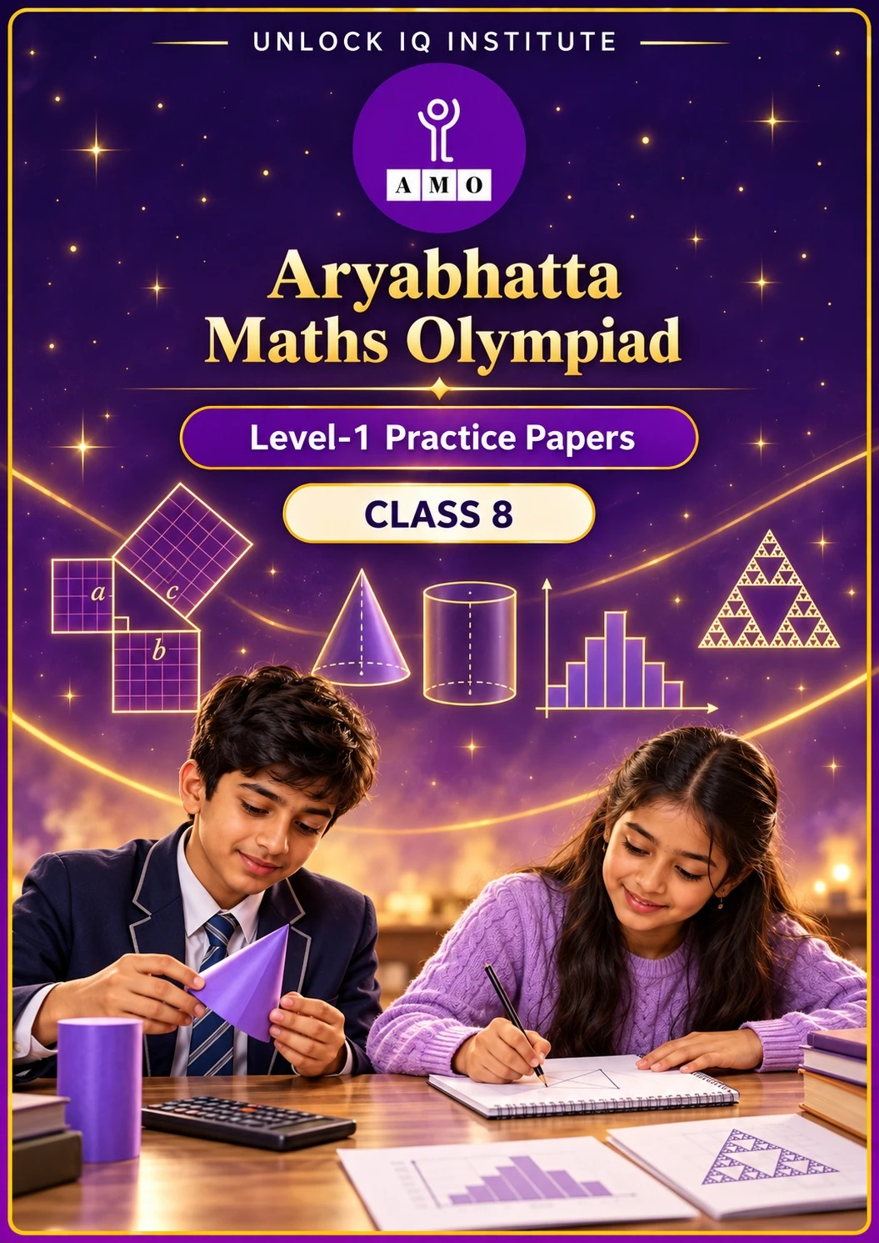
Five full practice papers · with answer keys & detailed solutions
Name: ____________________ | Class & Section: ________________
Roll No.: ________________ | School: ____________________
City: ____________________ | Date: ____________________

Published by Unlock IQ Institute Pvt. Ltd.
Register for Olympiads: www.aryabhattamathsolympiad.com/student-registration

ARYABHATTA MATHS OLYMPIAD
Level 1
PRACTICE PAPER-1
CLASS 8
Total Questions | 45 multiple-choice questions
Total Marks | 100
Time | 60 minutes
Section I | 40 questions × 2 marks = 80 marks
Section II | 5 Star Questions × 4 marks = 20 marks
Negative Marking | No negative marking
Calculator | Not allowed
Chapters | Number System · Operations · Fractions, Decimals & Percentages · Algebra · Geometry · Mensuration · Data Handling · Applied Mathematics · Mathematical Reasoning

Instructions to candidates
• This paper has 45 multiple-choice questions. Each question has four answer choices, of which exactly one is correct.
• Section I (Q1–Q40) carries 2 marks per question. Section II (Q41–Q45) carries 4 marks per question.
• There is no negative marking. Unanswered questions score zero.
• Calculators are not permitted. Rough work may be done on a separate sheet.
• Mark your answers on the answer sheet at the end of the paper.
• All figures are not necessarily drawn to scale unless stated.

For parents and teachers
• Print or view this paper in colour. Pictures are part of the questions.
• Parts follow the AMO syllabus chapters. Chapter 7 is not part of the Class 8 syllabus, so the chapter numbers shown in the Part headings have gaps.
• The answer sheet and the answer key are at the end. Remove only the answer key before the student begins.

SECTION I 40 questions × 2 marks each
Part 1 — Number System (Syllabus Chapter 1)
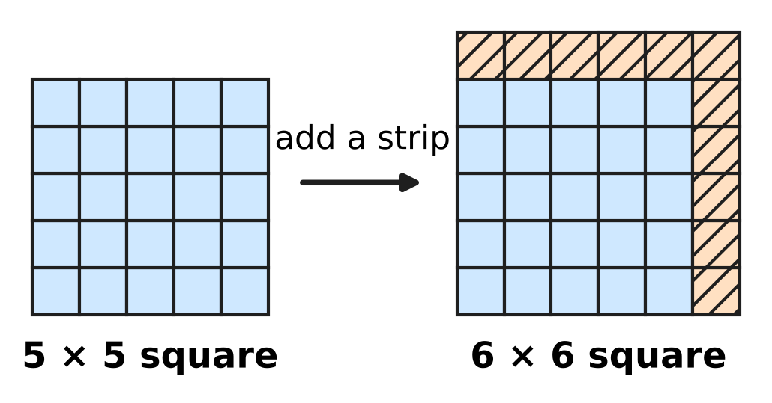
Q1. The picture shows a 5 × 5 square of tiles made into a 6 × 6 square by adding a strip of shaded tiles along two sides. In the same way, a 24 × 24 square of tiles is made into a 25 × 25 square. How many tiles are added?
(A) 48 | (B) 49 | (C) 50 | (D) 625

Q2. Which of these numbers lies between √3 and √5?
(A) 1.7 | (B) 1.9 | (C) 2.3 | (D) 4

Q3. Arun has many wooden blocks like the one in the picture, each 4 cm × 2 cm × 2 cm. He wants to put some of them together, without gaps or cutting, to make one solid cube. What is the least number of blocks he needs? | 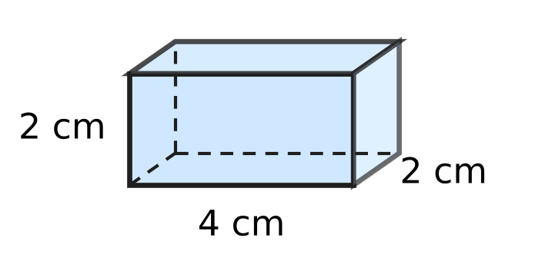
  (A) 2 | (B) 4 | (C) 16 | (D) 32

Part 2 — Operations & Number Properties (Syllabus Chapter 2)
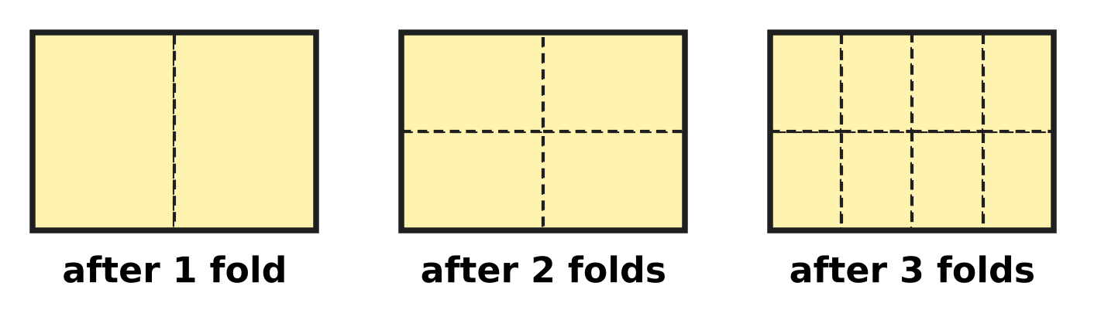
Q4. A sheet of paper is folded in half again and again. The picture shows the sheet opened out after 1, 2 and 3 folds; the dashed lines are the creases. The sheet is folded in half 6 times and opened out. What fraction of the whole sheet is each small part?
(A) 2⁶ | (B) 6⁻² | (C) 12⁻¹ | (D) 2⁻⁶

Q5. A fine grain of sand is 0.000075 m wide. How is this width written in standard form?
(A) 7.5 × 10⁻⁵ m | (B) 7.5 × 10⁻⁶ m
(C) 7.5 × 10⁻⁴ m | (D) 7.5 × 10⁵ m

Q6. How many of these six numbers are equal to $\frac{1}{16}$?
2⁻⁴, 4⁻², (−4)⁻², 8⁻², ${(\frac{1}{4})}^{−2}$, (−2)⁻⁴
(A) 2 | (B) 3 | (C) 4 | (D) 5

Part 3 — Fractions, Decimals & Percentages (Syllabus Chapter 3)
Q7. At a stationery shop, Asha sees the price tag in the picture. The price was cut twice, and each crossed-out price was the price before the next cut. The first cut was a 20% discount. What percentage was the second discount? | 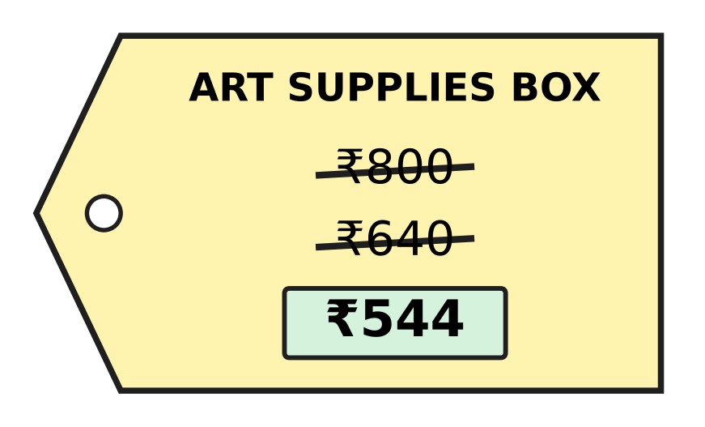
  (A) 32% | (B) 85% | (C) 12% | (D) 15%

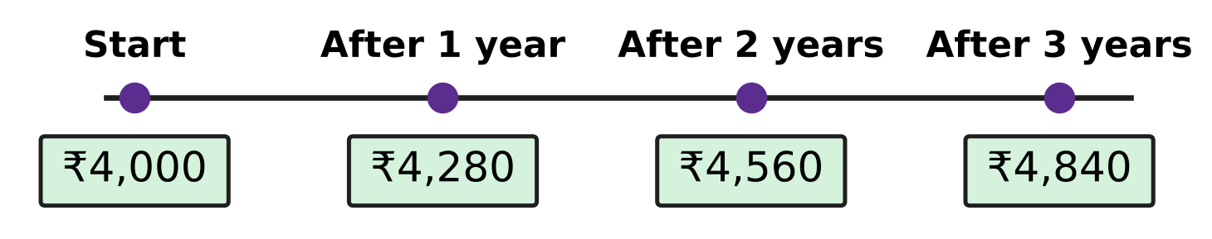
Q8. Navya puts some money in a savings scheme that pays simple interest. The picture shows the amount she has at the start and after each year. What is the rate of interest per year?
(A) 7% | (B) 14% | (C) 21% | (D) 28%

Q9. In the school vegetable garden, Ishan measures a bean plant. It is 50 cm tall. In the next week its height increases by 10%. In the week after that, its new height increases by 20%. How tall is the plant now?
(A) 55 cm | (B) 60 cm | (C) 65 cm | (D) 66 cm

Q10. At simple interest, a sum of money becomes $\frac{7}{4}$ of itself in 10 years. What is the rate of interest per year?
(A) 7.5% | (B) $13\frac{1}{3}$% | (C) 17.5% | (D) 75%

Q11. The number of books in a school library went up by 40% in one year. In the next year, old books were removed and the new number went down by 15%. The library now has 4,760 books. How many books did it have at the start?
(A) 4,000 | (B) 3,808 | (C) 5,600 | (D) 3,360

Part 4 — Algebra (Syllabus Chapter 4)
Q12. A rectangle is cut into four parts as shown in the picture. Its length is (x + 7) and its width is (x + 4). Which expression gives the area of the whole rectangle? | 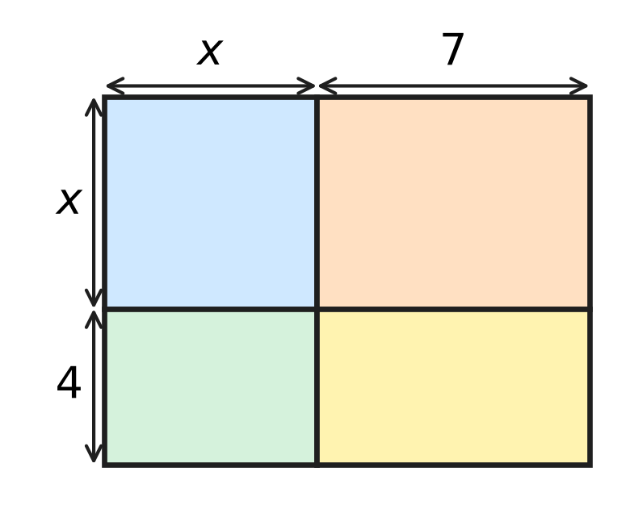
  (A) $x^{2}+28$ | (B) $2x+11$
  (C) $x^{2}+28x+11$ | (D) $x^{2}+11x+28$

Q13. Three consecutive multiples of 8 add up to 264. What is the largest of the three?
(A) 80 | (B) 88 | (C) 96 | (D) 104

Q14. Which of these is a factor of $x^{2}−x−30$?
(A) $x−6$ | (B) $x+6$ | (C) $x−10$ | (D) $x−5$

Q15. Four identical rectangular tiles are placed round a square hole to make a big square, as in the picture. The big square has area 196 cm². Each tile has area 45 cm². What is the side of the square hole? | 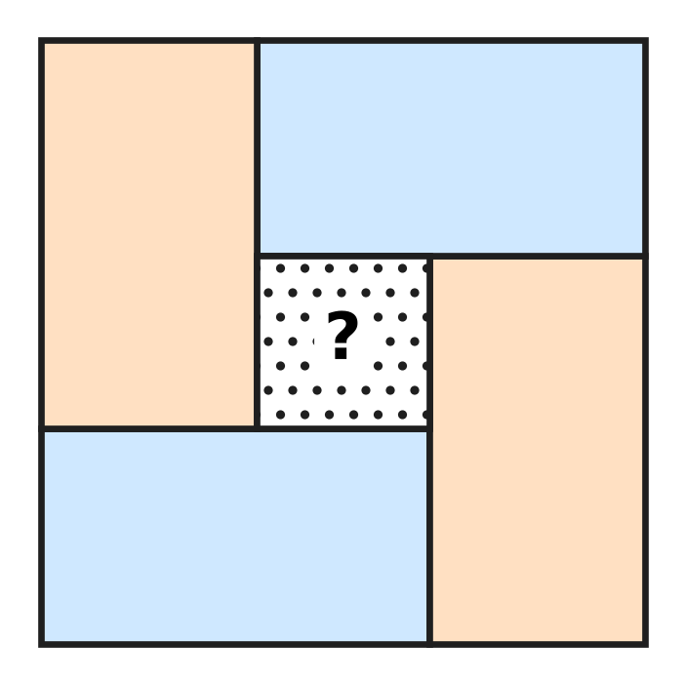
  (A) 9 cm | (B) 5 cm | (C) 16 cm | (D) 4 cm

Q16. For a school bus outing, the fare for each child is ₹30 less than the fare for each adult. A group of 4 adults and 8 children pays ₹1,320 in all. What is the fare for one child?
(A) ₹100 | (B) ₹130 | (C) ₹110 | (D) ₹120

Part 5 — Geometry (Syllabus Chapter 5)
Q17. On a windy day, Uday ties his kite string to a peg in flat ground. The string is 50 m long and stretched straight. The kite is directly above a point 30 m from the peg, as in the picture. How high is the kite above the ground? | 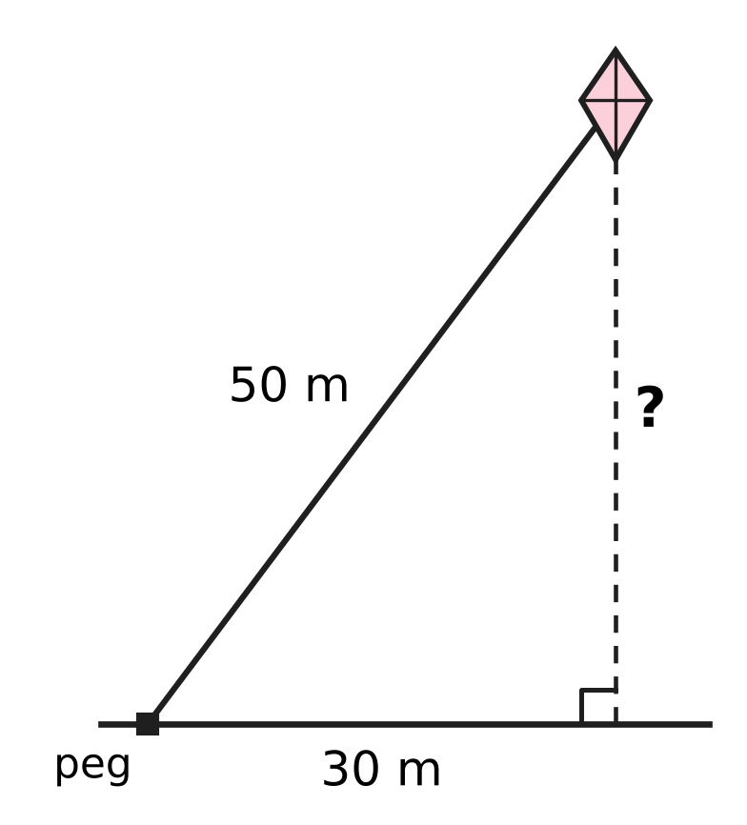
  (A) 25 m | (B) 20 m | (C) 80 m | (D) 40 m

Q18. ABCD is a rectangle. Its diagonals AC and BD meet at O. ∠OAB = 32°, as in the picture. What is ∠AOB? | 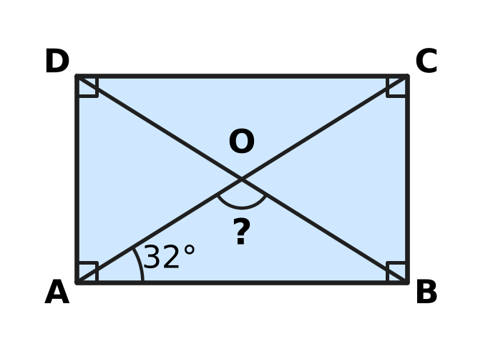
  (A) 148° | (B) 64° | (C) 58° | (D) 116°

Q19. The picture shows a net made of one regular pentagon and five identical triangles. It is folded to make a closed solid. How many edges does the solid have? | 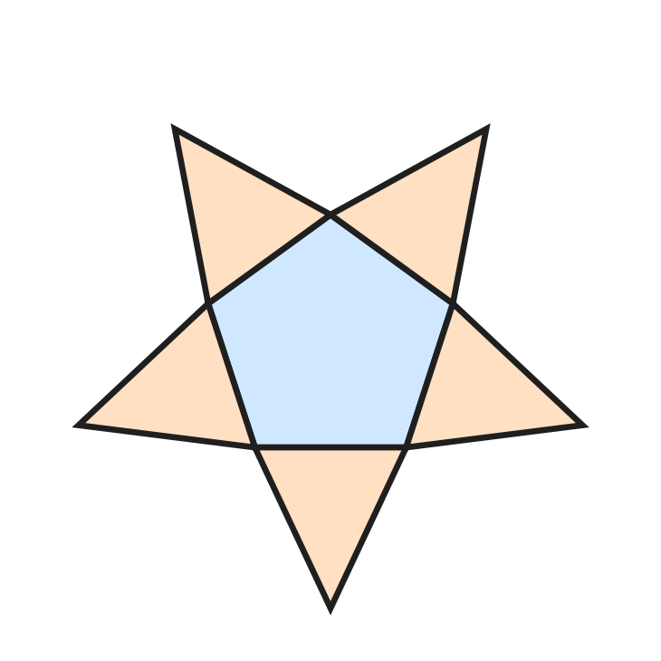
  (A) 6 | (B) 10 | (C) 15 | (D) 20

Q20. In △ABC, D is on AB and E is on AC, with DE ∥ BC. AD = 4 cm, DB = 6 cm and DE = 6 cm, as in the picture. What is the length of BC? | 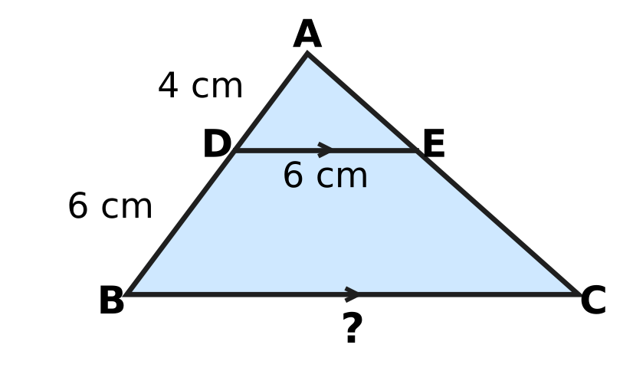
  (A) 15 cm | (B) 9 cm | (C) 12 cm | (D) 10 cm

Q21. ABCD is a trapezium with DC ∥ AB, as in the picture. DC = 8 cm, AB = 26 cm, and the slanting sides AD and BC are both 15 cm. DM is perpendicular to AB. What is the height h = DM? | 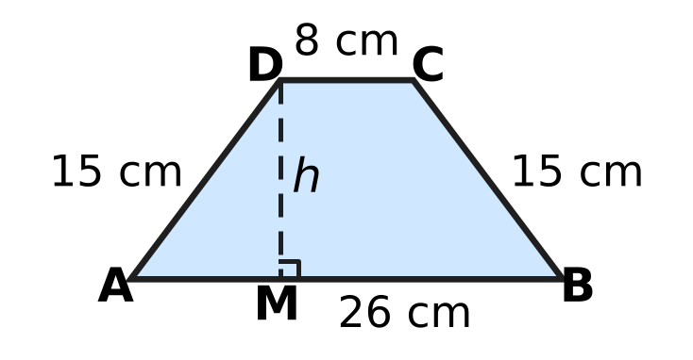
  (A) 9 cm | (B) 6 cm | (C) 12 cm | (D) √306 cm

Part 6 — Mensuration (Syllabus Chapter 6)
Q22. Bela makes a cone-shaped paper cup, open at the top. Its top has radius 3.5 cm and its slant height is 8 cm, as in the picture. How much paper is needed for the cup? (Use π = $\frac{22}{7}$.) | 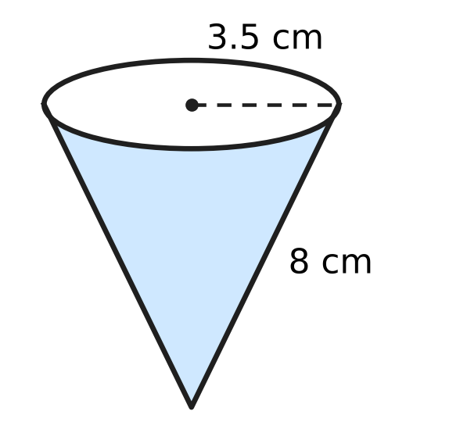
  (A) 88 cm² | (B) 126.5 cm²
  (C) 176 cm² | (D) 308 cm²

Q23. A classroom notice board is a rectangle 1.5 m long and 0.8 m wide. What is its area in square centimetres?
(A) 120 cm² | (B) 1,200 cm²
(C) 12,000 cm² | (D) 120,000 cm²

Q24. A solid wooden cylinder has volume 840 cm³. A cone with the same base and the same height as the cylinder is carved out of it, as shown by the dashed lines in the picture. What is the volume of the wood that is left? | 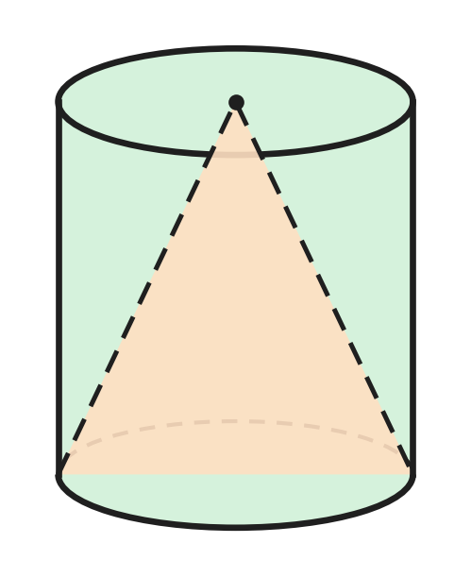
  (A) 280 cm³ | (B) 420 cm³ | (C) 560 cm³ | (D) 630 cm³

Q25. A rainwater tank is a cylinder with radius 1.4 m. Some water is taken out and the water level falls by 15 cm, as in the picture. How many litres of water were taken out? (Use π = $\frac{22}{7}$; 1 m³ = 1,000 litres.) | 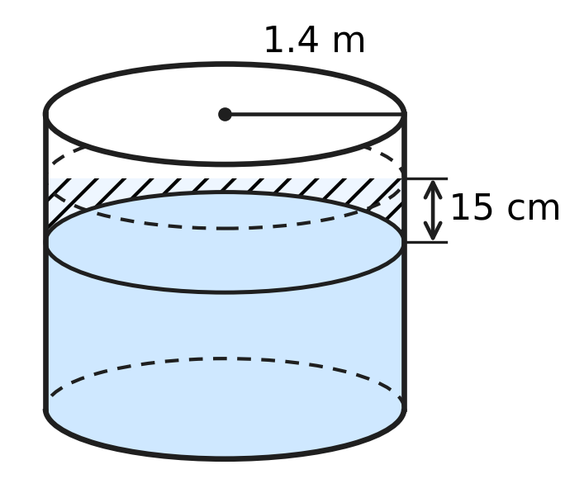
  (A) 92.4 litres | (B) 3,696 litres
  (C) 9,240 litres | (D) 924 litres

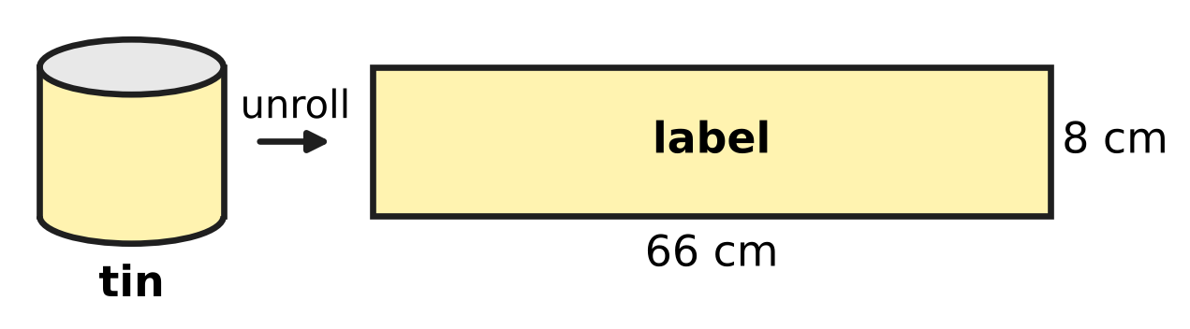
Q26. A paper label covers the whole curved surface of a closed cylindrical tin, with no overlap. When the label is taken off and laid flat, it is a rectangle 66 cm long and 8 cm wide, as in the picture. What is the volume of the tin? (Use π = $\frac{22}{7}$.)
(A) 2,772 cm³ | (B) 264 cm³
(C) 528 cm³ | (D) 11,088 cm³

Part 7 — Data Handling, Statistics & Probability (Syllabus Chapter 8)
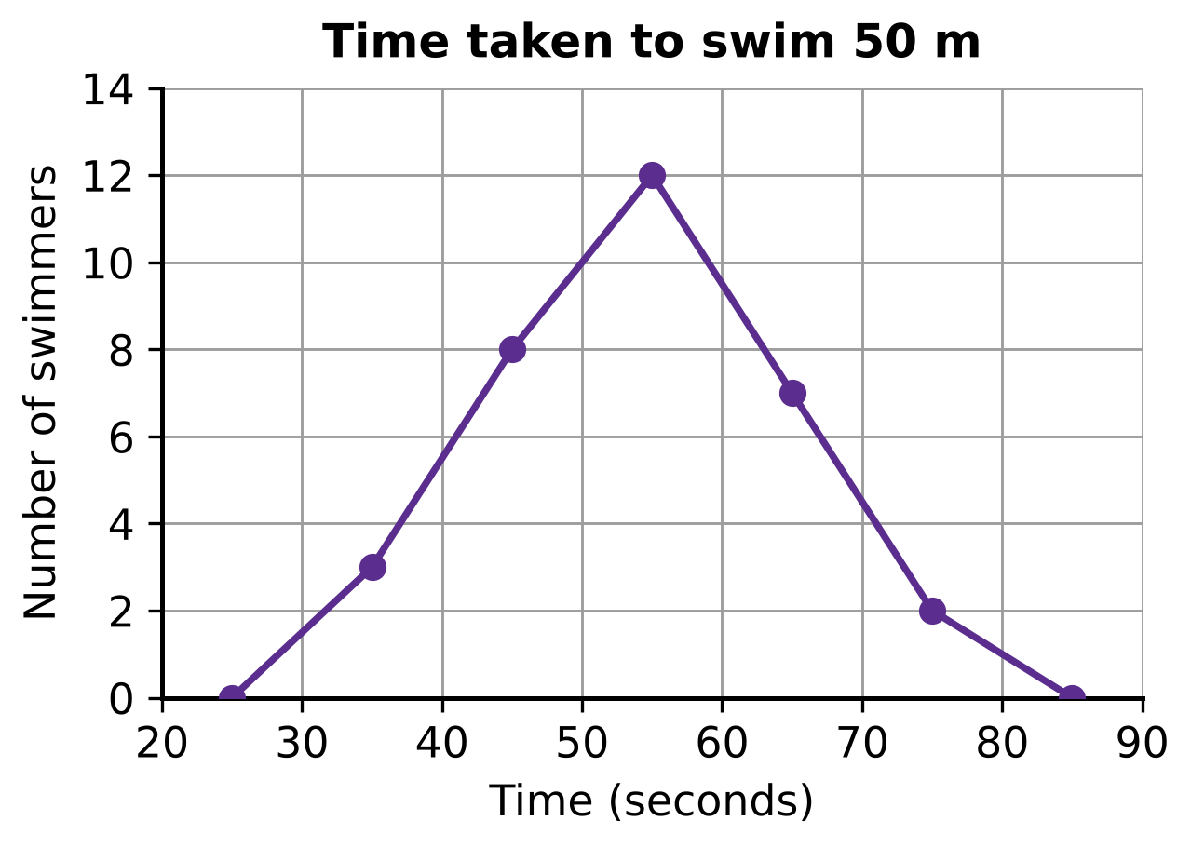
Q27. The swimmers at a swimming pool were timed over 50 m. Their times were grouped in classes 30–40, 40–50, 50–60, 60–70 and 70–80 seconds, where 30–40 means 30 or more but less than 40. The frequency polygon in the picture shows the number of swimmers in each class, plotted at the middle of the class. How many swimmers took 60 seconds or more?
(A) 7 | (B) 9 | (C) 12 | (D) 21

Q28. The pie chart shows how the 540 students of a school come to school. The angle of each sector is marked. How many more students walk to school than come by bicycle? | 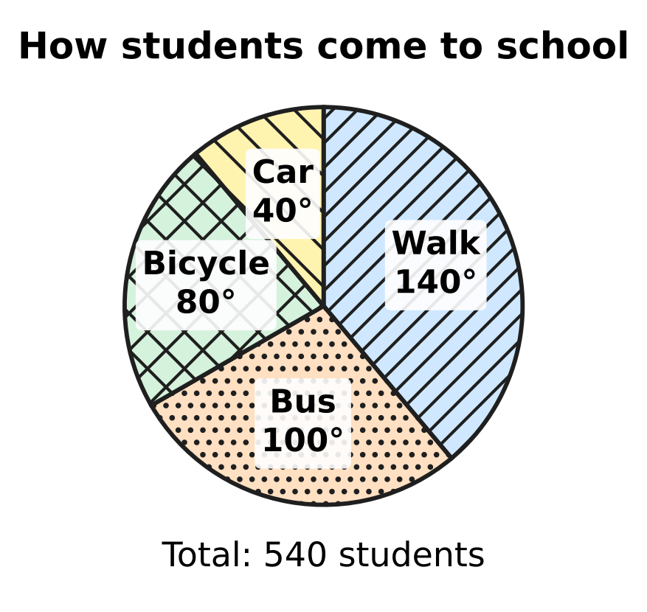
  (A) 60 | (B) 90 | (C) 120 | (D) 210

Goals scored by a school team in 25 matches
Goals in a match | 0 | 1 | 2 | 3 | 4 | 5
Number of matches | 4 | 7 | 6 | 4 | 3 | 1

Q29. The table shows how many goals a school team scored in each of its 25 matches. What is the median number of goals scored in a match?
(A) 1 | (B) 2 | (C) 2.5 | (D) 4

Part 8 — Applied Mathematics (Syllabus Chapter 9)
Q30. Kartik buys a used bicycle for ₹2,400 and spends ₹600 on repairs. He then sells it for ₹3,600. What is his profit percent?
(A) 25% | (B) $16\frac{2}{3}$% | (C) 20% | (D) 50%

Q31. A sum of money earns ₹540 as simple interest in 3 years. How much simple interest will the same sum earn in 5 years at the same rate?
(A) ₹720 | (B) ₹900 | (C) ₹1,080 | (D) ₹2,700

Q32. Leela sells a glass jar full of marbles for ₹780 and makes a profit of 20%. What did the jar of marbles cost her?
(A) ₹624 | (B) ₹936 | (C) ₹130 | (D) ₹650

Q33. Farhan buys 50 kg of apples from an orchard at ₹80 per kg. Of these, 10% rot and are thrown away. He sells the rest at ₹100 per kg. What is his profit percent?
(A) 10% | (B) 12.5% | (C) 15% | (D) 25%

Q34. For her stamp collection club, Swati buys 50 stamps at ₹12 each and 50 stamps at ₹18 each. She sells the cheaper stamps at a profit of 25% and the costlier stamps at a loss of 10%. What is her overall profit or loss percent?
(A) 4% profit | (B) 4% loss
(C) 7.5% profit | (D) 15% profit

Part 9 — Mathematical Reasoning & Problem-Solving (Syllabus Chapter 10)
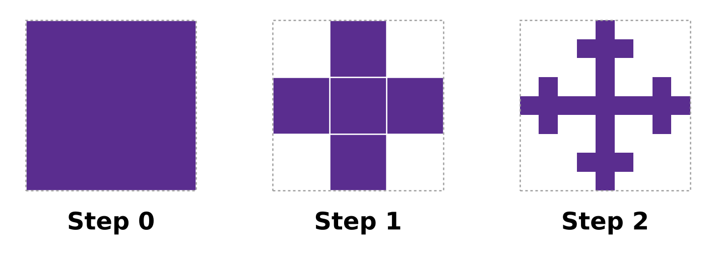
Q35. The picture shows the first steps of a fractal. At each step, every filled square is cut into 9 equal small squares, and only the middle one and the four touching its sides are kept. How many filled squares will there be at Step 3?
(A) 25 | (B) 45 | (C) 125 | (D) 625

Q36. In the number 74,3d6, the letter d stands for one digit. Which of these values of d makes the number divisible by 8?
(A) 1 | (B) 5 | (C) 7 | (D) 9

Q37. A 4-digit palindrome reads the same from left to right and from right to left, like 2,662. Which number divides EVERY 4-digit palindrome?
(A) 7 | (B) 11 | (C) 13 | (D) 101

Q38. In the multiplication shown in the picture, each letter stands for a digit. Different letters stand for different digits, and no number starts with 0. What is the two-digit number AB? | 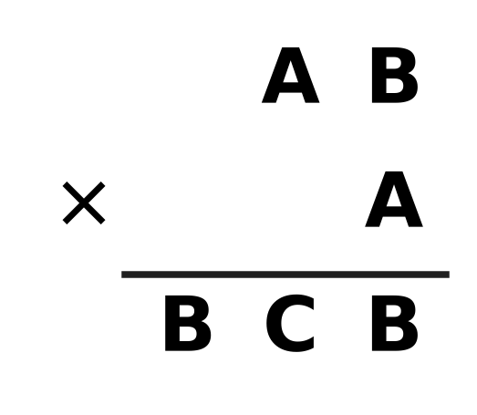
  (A) 95 | (B) 57 | (C) 75 | (D) 35

Q39. In the picture, three lines are drawn from the top corner of a big triangle to its base, and one more line is drawn across it from side to side. How many triangles of all sizes are there in the picture? | 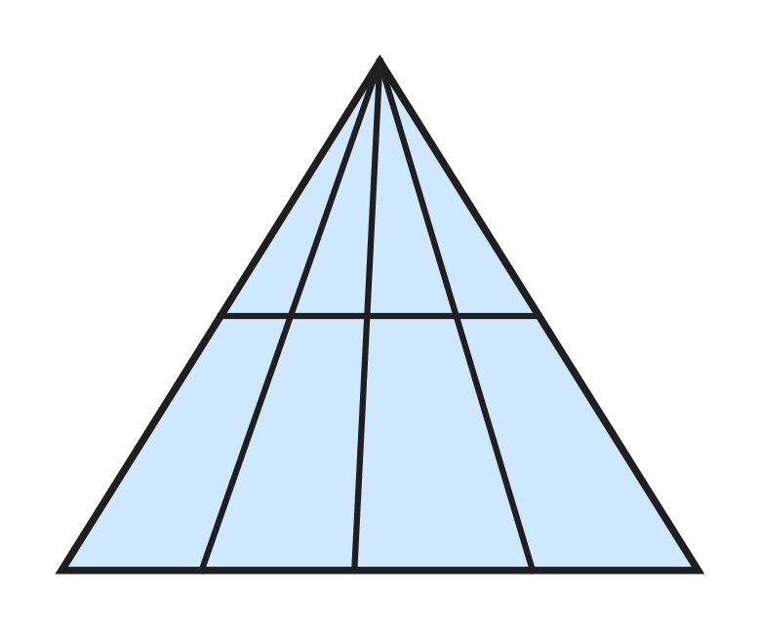
  (A) 8 | (B) 10 | (C) 14 | (D) 20

Q40. Advait's farm has some cows and some hens, at least one of each. Together they have 35 heads. Which of these could be the total number of their legs?
(A) 64 | (B) 67 | (C) 98 | (D) 142

SECTION II — Star Questions 5 questions × 4 marks each
Q41. A square floor is made of n × n square tiles. A smaller square of m × m tiles is removed from one corner, as in the picture, where m is at least 1. Exactly 96 tiles are left. How many different pairs of whole numbers (n, m) are possible? [4 marks] | 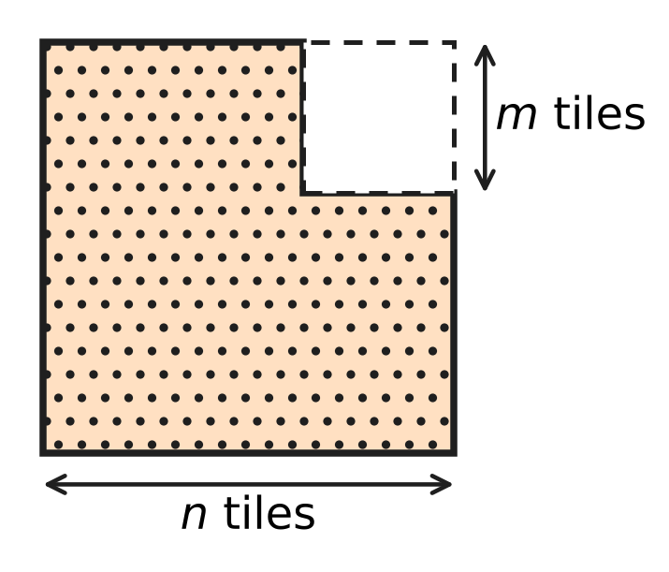
  (A) 4 | (B) 6 | (C) 8 | (D) 12

Q42. A solid has flat faces and no holes, so F + V − E = 2 for its faces F, vertices V and edges E. Every face is a triangle or a square. Every edge joins two vertices and is shared by exactly two faces. The solid has 24 vertices, and exactly 4 edges meet at every vertex. How many of its faces are squares? [4 marks]
(A) 8 | (B) 13 | (C) 18 | (D) 24

Q43. PQRS is a rhombus with perimeter 100 cm. Its diagonals PR and QS, shown in the picture, differ in length by 34 cm. What is the area of the rhombus? [4 marks] | 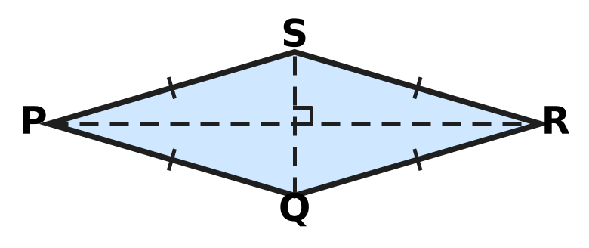
  (A) 168 cm² | (B) 336 cm² | (C) 625 cm² | (D) 672 cm²

Q44. Samar borrows ₹20,000 at 9% per year simple interest and uses it all to buy school bags. He marks the bags 25% above his cost and sells all of them at a discount of 8% on the marked price. After 8 months he repays the loan with its interest. What is his profit as a percentage of ₹20,000? [4 marks]
(A) 6% | (B) 9% | (C) 11% | (D) 15%

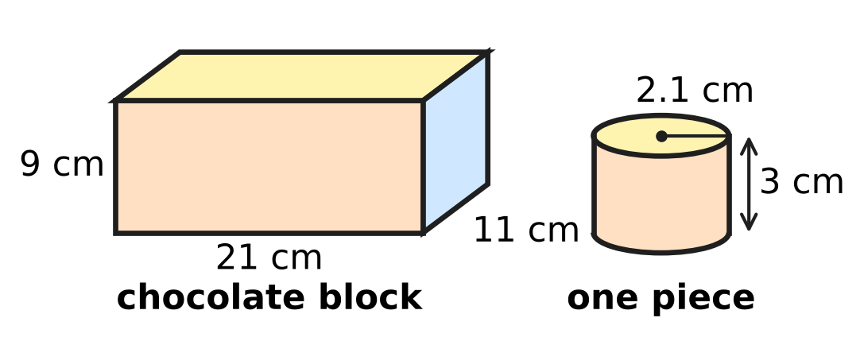
Q45. At a bakery, Reena melts a cuboid block of chocolate and pours all of it into cylindrical moulds. Each mould makes one piece, and no chocolate is lost. The sizes are shown in the picture. The block costs ₹1,600 and each piece is wrapped in a paper that costs ₹4. She wants a profit of 25% on her total cost. At what price should she sell each wrapped piece? (Use π = $\frac{22}{7}$.) [4 marks]
(A) ₹36 | (B) ₹40 | (C) ₹44 | (D) ₹45

Answer Sheet AMO Level 1 · Class 8 · Practice Paper 1
Name: | School: | Roll No.:
Shade or tick one circle for each question.
1. Ⓐ Ⓑ Ⓒ Ⓓ | 16. Ⓐ Ⓑ Ⓒ Ⓓ | 31. Ⓐ Ⓑ Ⓒ Ⓓ
2. Ⓐ Ⓑ Ⓒ Ⓓ | 17. Ⓐ Ⓑ Ⓒ Ⓓ | 32. Ⓐ Ⓑ Ⓒ Ⓓ
3. Ⓐ Ⓑ Ⓒ Ⓓ | 18. Ⓐ Ⓑ Ⓒ Ⓓ | 33. Ⓐ Ⓑ Ⓒ Ⓓ
4. Ⓐ Ⓑ Ⓒ Ⓓ | 19. Ⓐ Ⓑ Ⓒ Ⓓ | 34. Ⓐ Ⓑ Ⓒ Ⓓ
5. Ⓐ Ⓑ Ⓒ Ⓓ | 20. Ⓐ Ⓑ Ⓒ Ⓓ | 35. Ⓐ Ⓑ Ⓒ Ⓓ
6. Ⓐ Ⓑ Ⓒ Ⓓ | 21. Ⓐ Ⓑ Ⓒ Ⓓ | 36. Ⓐ Ⓑ Ⓒ Ⓓ
7. Ⓐ Ⓑ Ⓒ Ⓓ | 22. Ⓐ Ⓑ Ⓒ Ⓓ | 37. Ⓐ Ⓑ Ⓒ Ⓓ
8. Ⓐ Ⓑ Ⓒ Ⓓ | 23. Ⓐ Ⓑ Ⓒ Ⓓ | 38. Ⓐ Ⓑ Ⓒ Ⓓ
9. Ⓐ Ⓑ Ⓒ Ⓓ | 24. Ⓐ Ⓑ Ⓒ Ⓓ | 39. Ⓐ Ⓑ Ⓒ Ⓓ
10. Ⓐ Ⓑ Ⓒ Ⓓ | 25. Ⓐ Ⓑ Ⓒ Ⓓ | 40. Ⓐ Ⓑ Ⓒ Ⓓ
11. Ⓐ Ⓑ Ⓒ Ⓓ | 26. Ⓐ Ⓑ Ⓒ Ⓓ | 41. Ⓐ Ⓑ Ⓒ Ⓓ
12. Ⓐ Ⓑ Ⓒ Ⓓ | 27. Ⓐ Ⓑ Ⓒ Ⓓ | 42. Ⓐ Ⓑ Ⓒ Ⓓ
13. Ⓐ Ⓑ Ⓒ Ⓓ | 28. Ⓐ Ⓑ Ⓒ Ⓓ | 43. Ⓐ Ⓑ Ⓒ Ⓓ
14. Ⓐ Ⓑ Ⓒ Ⓓ | 29. Ⓐ Ⓑ Ⓒ Ⓓ | 44. Ⓐ Ⓑ Ⓒ Ⓓ
15. Ⓐ Ⓑ Ⓒ Ⓓ | 30. Ⓐ Ⓑ Ⓒ Ⓓ | 45. Ⓐ Ⓑ Ⓒ Ⓓ
Q41–Q45 are Section II Star Questions (4 marks each).
For the parent or teacher
Section I correct: ______ / 40 × 2 = ______ marks Section II correct: ______ / 5 × 4 = ______ marks
Correct: ______ / 45 Score: ______ / 100
Answer Key and Solutions AMO Level 1 · Class 8 · Practice Paper 1
Quick answers
1 B | 6 C | 11 A | 16 A | 21 C | 26 A | 31 B | 36 C | 41 A
2 B | 7 D | 12 D | 17 D | 22 A | 27 B | 32 D | 37 B | 42 C
3 B | 8 A | 13 C | 18 D | 23 C | 28 B | 33 B | 38 C | 43 B
4 D | 9 D | 14 A | 19 B | 24 C | 29 B | 34 A | 39 D | 44 B
5 A | 10 A | 15 D | 20 A | 25 D | 30 C | 35 C | 40 C | 45 D
Solutions
Q | Part · level | Answer | Why?
1 | Part 1 · Ch1 · Easy | (B) 49 | Tiles added = 25² − 24² = 625 − 576 = 49 (that is, 24 + 24 + 1 for the corner).
2 | Part 1 · Ch1 · Easy | (B) 1.9 | Square each number: 1.9² = 3.61 lies between 3 and 5, so √3 < 1.9 < √5. But 1.7² = 2.89, 2.3² = 5.29 and 4² = 16 do not.
3 | Part 1 · Ch1 · Medium | (B) 4 | Volume of a block = 16 cm³. The smallest cube whose volume is a multiple of 16 and whose edge can hold a 4 cm length is 4 cm × 4 cm × 4 cm = 64 cm³, and 64 ÷ 16 = 4 blocks.
4 | Part 2 · Ch2 · Easy | (D) 2⁻⁶ | Each fold doubles the number of parts: 2, 4, 8, … so 6 folds give 2⁶ = 64 parts. One part is 1/2⁶ = 2⁻⁶ of the sheet.
5 | Part 2 · Ch2 · Easy | (A) 7.5 × 10⁻⁵ m | Move the decimal point 5 places to the right to get 7.5, so 0.000075 = 7.5 × 10⁻⁵ m.
6 | Part 2 · Ch2 · Medium | (C) 4 | Here 2⁻⁴ = 1/16, 4⁻² = 1/16, (−4)⁻² = 1/16 and (−2)⁻⁴ = 1/16. But 8⁻² = 1/64 and (1/4)⁻² = 16. So 4 of them equal 1/16.
7 | Part 3 · Ch3 · Easy | (D) 15% | The second cut is 640 − 544 = ₹96 on a price of ₹640. As a percentage, 96/640 × 100 = 15%.
8 | Part 3 · Ch3 · Easy | (A) 7% | The amount grows by ₹280 every year, so the interest is ₹280 per year on ₹4,000. Rate = 280/4,000 × 100 = 7% per year.
9 | Part 3 · Ch3 · Easy | (D) 66 cm | After week 1: 50 × 1.1 = 55 cm. After week 2: 55 × 1.2 = 66 cm.
10 | Part 3 · Ch3 · Medium | (A) 7.5% | Interest = 7/4 − 1 = 3/4 of the sum in 10 years, so 3/40 of the sum each year. Rate = 3/40 × 100 = 7.5% per year.
11 | Part 3 · Ch3 · Medium | (A) 4,000 | A rise of 40% then a fall of 15% multiply the number by 1.4 × 0.85 = 1.19. So the start = 4,760 ÷ 1.19 = 4,000 books.
12 | Part 4 · Ch4 · Easy | (D) $x^{2}+11x+28$ | The four parts are x², 7x, 4x and 4 × 7 = 28. Together: x² + 11x + 28.
13 | Part 4 · Ch4 · Easy | (C) 96 | Let them be 8k − 8, 8k and 8k + 8. Their sum is 24k = 264, so k = 11. The numbers are 80, 88 and 96; the largest is 96.
14 | Part 4 · Ch4 · Easy | (A) $x−6$ | Two numbers with product −30 and sum −1 are −6 and 5. So x² − x − 30 = (x − 6)(x + 5), and x − 6 is a factor.
15 | Part 4 · Ch4 · Medium | (D) 4 cm | If a tile is a by b, the big square has side a + b and the hole has side a − b. (a − b)² = (a + b)² − 4ab = 196 − 4 × 45 = 16, so the side is 4 cm.
16 | Part 4 · Ch4 · Medium | (A) ₹100 | Let a child pay ₹c, so an adult pays ₹(c + 30). Then 4(c + 30) + 8c = 1,320, so 12c = 1,200 and c = 100.
17 | Part 5 · Ch5 · Easy | (D) 40 m | The string is the hypotenuse: height² = 50² − 30² = 2,500 − 900 = 1,600, so the height is 40 m.
18 | Part 5 · Ch5 · Easy | (D) 116° | The diagonals of a rectangle are equal and bisect each other, so OA = OB and ∠OBA = ∠OAB = 32°. Then ∠AOB = 180° − 32° − 32° = 116°.
19 | Part 5 · Ch5 · Easy | (B) 10 | The net folds into a pentagonal pyramid: 5 edges round the base and 5 edges up to the top, so 10 edges. (Check: F + V − E = 6 + 6 − 10 = 2.)
20 | Part 5 · Ch5 · Medium | (A) 15 cm | DE ∥ BC gives equal corresponding angles, so △ADE ∼ △ABC. AB = 4 + 6 = 10 cm, so BC/DE = AB/AD = 10/4 and BC = 6 × 10/4 = 15 cm.
21 | Part 5 · Ch5 · Medium | (C) 12 cm | The two slanting sides are equal, so AM = (26 − 8) ÷ 2 = 9 cm. In right △AMD, h² = 15² − 9² = 225 − 81 = 144, so h = 12 cm.
22 | Part 6 · Ch6 · Easy | (A) 88 cm² | Paper = curved surface = πrl = 22/7 × 3.5 × 8 = 88 cm².
23 | Part 6 · Ch6 · Easy | (C) 12,000 cm² | Area = 1.5 × 0.8 = 1.2 m². Since 1 m² = 100 cm × 100 cm = 10,000 cm², the area is 12,000 cm².
24 | Part 6 · Ch6 · Easy | (C) 560 cm³ | A cone with the same base and height has 1/3 of the cylinder's volume: 840 ÷ 3 = 280 cm³. Wood left = 840 − 280 = 560 cm³.
25 | Part 6 · Ch6 · Medium | (D) 924 litres | Water taken out = πr²h = 22/7 × 1.4 × 1.4 × 0.15 = 0.924 m³ = 924 litres.
26 | Part 6 · Ch6 · Medium | (A) 2,772 cm³ | The 66 cm side goes round the tin, so 2πr = 66 and r = 10.5 cm. The height is 8 cm. Volume = 22/7 × 10.5 × 10.5 × 8 = 2,772 cm³.
27 | Part 7 · Ch8 · Easy | (B) 9 | Taking 60 seconds or more means the classes 60–70 and 70–80. Their points (at 65 and 75) are at 7 and 2, so 7 + 2 = 9 swimmers.
28 | Part 7 · Ch8 · Easy | (B) 90 | The difference in angle is 140° − 80° = 60°. That is 60/360 of 540 students = 90 students.
29 | Part 7 · Ch8 · Medium | (B) 2 | With 25 matches, the median is the 13th value in order. The first 4 values are 0 and the next 7 are 1 (11 values so far); the 12th to 17th values are 2. So the median is 2.
30 | Part 8 · Ch9 · Easy | (C) 20% | Cost price = 2,400 + 600 = ₹3,000. Profit = 3,600 − 3,000 = ₹600. Profit percent = 600/3,000 × 100 = 20%.
31 | Part 8 · Ch9 · Easy | (B) ₹900 | Simple interest is the same every year: ₹540 ÷ 3 = ₹180 per year. For 5 years: 180 × 5 = ₹900.
32 | Part 8 · Ch9 · Easy | (D) ₹650 | Selling price = 120% of the cost price. So the cost price = 780 × 100/120 = ₹650.
33 | Part 8 · Ch9 · Medium | (B) 12.5% | Cost = 50 × 80 = ₹4,000. He sells 45 kg for 45 × 100 = ₹4,500. Profit = ₹500, which is 500/4,000 × 100 = 12.5%.
34 | Part 8 · Ch9 · Medium | (A) 4% profit | Cost = 600 + 900 = ₹1,500. Selling price = 600 × 1.25 + 900 × 0.9 = 750 + 810 = ₹1,560. Profit = ₹60, which is 60/1,500 × 100 = 4%.
35 | Part 9 · Ch10 · Easy | (C) 125 | Each filled square becomes 5 filled squares, so the number is multiplied by 5 at every step: 1, 5, 25, 125. At Step 3 there are 5³ = 125 squares.
36 | Part 9 · Ch10 · Easy | (C) 7 | A number is divisible by 8 when the number made by its last three digits is. Of the options, only 376 = 8 × 47 works; 316, 356 and 396 are not multiples of 8. So d = 7.
37 | Part 9 · Ch10 · Easy | (B) 11 | The example 2,662 = 2 × 11 × 11 × 11 is not a multiple of 7, 13 or 101, so only 11 can work. It always does: abba = 1,001a + 110b = 11 × (91a + 10b).
38 | Part 9 · Ch10 · Medium | (C) 75 | B × A must end in B. A = 1 gives a two-digit product, so either A = 6 with B even, or B = 5 with A odd. A = 6 gives 62 × 6 = 372, 64 × 6 = 384, 68 × 6 = 408: none fits. B = 5 gives 35 × 3 = 105, 75 × 7 = 525, 95 × 9 = 855; only 525 has the form BCB, so AB = 75.
39 | Part 9 · Ch10 · Medium | (D) 20 | Every triangle has the top corner and two of the 5 lines from it, with its base on the cross line or on the bottom line. Choosing 2 of the 5 lines gives 10 ways, and there are 2 bases: 2 × 10 = 20.
40 | Part 9 · Ch10 · Medium | (C) 98 | Each animal has 2 or 4 legs, so the total is even. The fewest legs come from 1 cow and 34 hens: 4 + 68 = 72. The most come from 34 cows and 1 hen: 136 + 2 = 138. The total 98 works: 14 cows and 21 hens have 56 + 42 = 98 legs.
41 | Section II · Ch4 + Ch10 · Hard | (A) 4 | n² − m² = (n − m)(n + m) = 96. The two factors differ by 2m, so both are even: 2 × 48, 4 × 24, 6 × 16, 8 × 12. These give (n, m) = (25, 23), (14, 10), (11, 5), (10, 2): 4 pairs.
42 | Section II · Ch5 + Ch10 · Hard | (C) 18 | Counting edge ends at the vertices, E = 24 × 4 ÷ 2 = 48, so F = 2 − 24 + 48 = 26. Counting edges round the faces, 3 × (triangles) + 4 × (squares) = 2 × 48 = 96; with 26 faces this gives 8 triangles and 18 squares. (Such a solid really exists: the rhombicuboctahedron has exactly these faces.)
43 | Section II · Ch4 + Ch5 · Hard | (B) 336 cm² | Side = 25 cm. The diagonals bisect at right angles; let the half-diagonals be a and b, so a² + b² = 625 and a − b = 17. Then 2ab = 625 − 17² = 336. The area is 4 × ½ab = 2ab = 336 cm².
44 | Section II · Ch3 + Ch9 · Hard | (B) 9% | Selling price = 20,000 × 1.25 × 0.92 = ₹23,000. Interest = 20,000 × 9/100 × 8/12 = ₹1,200. Profit = 23,000 − 20,000 − 1,200 = ₹1,800, which is 9% of ₹20,000.
45 | Section II · Ch6 + Ch9 · Hard | (D) ₹45 | Block = 21 × 11 × 9 = 2,079 cm³. One piece = 22/7 × 2.1 × 2.1 × 3 = 41.58 cm³, so 2,079 ÷ 41.58 = 50 pieces. Total cost = 1,600 + 50 × 4 = ₹1,800. With 25% profit she needs ₹2,250, that is ₹45 per piece.

ARYABHATTA MATHS OLYMPIAD
Level 1
PRACTICE PAPER-2
CLASS 8
Total Questions | 45 multiple-choice questions
Total Marks | 100
Time | 60 minutes
Section I | 40 questions × 2 marks = 80 marks
Section II | 5 Star Questions × 4 marks = 20 marks
Negative Marking | No negative marking
Calculator | Not allowed
Chapters | Number System · Operations · Fractions, Decimals & Percentages · Algebra · Geometry · Mensuration · Data Handling · Applied Mathematics · Mathematical Reasoning

Instructions to candidates
• This paper has 45 multiple-choice questions. Each question has four answer choices, of which exactly one is correct.
• Section I (Q1–Q40) carries 2 marks per question. Section II (Q41–Q45) carries 4 marks per question.
• There is no negative marking. Unanswered questions score zero.
• Calculators are not permitted. Rough work may be done on a separate sheet.
• Mark your answers on the answer sheet at the end of the paper.
• All figures are not necessarily drawn to scale unless stated.

For parents and teachers
• Print or view this paper in colour. Pictures are part of the questions.
• Parts follow the AMO syllabus chapters. Chapter 7 is not part of the Class 8 syllabus, so the chapter numbers shown in the Part headings have gaps.
• The answer sheet and the answer key are at the end. Remove only the answer key before the student begins.

SECTION I 40 questions × 2 marks each
Part 1 — Number System (Syllabus Chapter 1)
Q1. Which of these numbers is rational?
(A) √2 + √2 | (B) √0.9 | (C) (√5)³ | (D) √3 × √12

Q2. Simran spreads a square mat for a picnic in the park. The mat has an area of 2.89 m². How long is each side of the mat?
(A) 0.7225 m | (B) 0.17 m | (C) 17 m | (D) 1.7 m

Q3. Which of these has the greatest value?
(A) 0.9² | (B) √0.64 | (C) ∛0.729 | (D) ∛0.343

Part 2 — Operations & Number Properties (Syllabus Chapter 2)
Q4. Which of these numbers is negative?
(A) (−3)⁻² | (B) (−2)⁻³ | (C) 2⁻³ | (D) (−1)⁻⁴

Q5. $8^{−2}=2^{x}$. What is the value of x?
(A) −6 | (B) −4 | (C) 6 | (D) 1

Q6. A drop of water has a volume of 5 × 10⁻² mL. A water bottle holds 1.5 × 10³ mL. How many such drops are needed to fill the bottle?
(A) 75 | (B) 30,000 | (C) 300,000 | (D) 3,000

Part 3 — Fractions, Decimals & Percentages (Syllabus Chapter 3)
Q7. Which of these deposits earns exactly ₹600 as simple interest?
(A) ₹1,000 at 10% a year for 6 months | (B) ₹4,000 at 6% a year for 2 years
(C) ₹2,000 at 7.5% a year for 4 years | (D) ₹3,000 at 4% a year for 4 years

Q8. Jaya puts ₹8,000 in a bank that pays simple interest. After 9 months she gets ₹480 as interest. What is the rate of interest per year?
(A) 6% | (B) 4.5% | (C) 12% | (D) 8%

Q9. On sports day, 60% of the 400 students of a school run in races. Of the students who run, 25% win a medal. How many students win a medal?
(A) 60 | (B) 140 | (C) 100 | (D) 240

Q10. An item is marked ₹2,000. A shop can give two successive discounts in one of the four ways below. The second discount is on the reduced price. Which way makes the final price the lowest?
(A) 25% and then 15% | (B) 35% and then 5%
(C) 20% and then 20% | (D) 30% and then 10%

Q11. The length of a rectangle is increased by 20% and its width is decreased by 10%. What happens to its area?
(A) It increases by 8%. | (B) It increases by 2%.
(C) It decreases by 12%. | (D) It increases by 10%.

Part 4 — Algebra (Syllabus Chapter 4)
Q12. Which of these expressions is NOT a perfect square?
(A) $9x^{2}+24x+16$ | (B) $x^{2}+10x+25$
(C) $4x^{2}−12x+9$ | (D) $x^{2}+6x+36$

Q13. For two numbers x and y, $x^{2}−y^{2}=45$ and x + y = 9. What is the value of x − y?
(A) 36 | (B) 3 | (C) 5 | (D) 405

Q14. Mira cuts a ribbon 250 cm long into two pieces. One piece is 40 cm longer than twice the other piece. How long is the longer piece?
(A) 180 cm | (B) 145 cm | (C) 105 cm | (D) 70 cm

Q15. The expression $x^{2}+kx+24$ can be written as (x + a)(x + b), where a and b are positive whole numbers. Which of these can NOT be the value of k?
(A) 14 | (B) 12 | (C) 11 | (D) 10

Q16. On a train journey, a coach had some passengers. At one station, $\frac{3}{5}$ of them got off and 12 new passengers got on. The coach then had 44 passengers. How many passengers were in the coach before the station?
(A) 110 | (B) 32 | (C) 80 | (D) 140

Part 5 — Geometry (Syllabus Chapter 5)
Q17. In the picture, △ABC has AB = AC = 17 cm and BC = 16 cm. AD is perpendicular to BC, so D is the midpoint of BC. What is the height h = AD? | 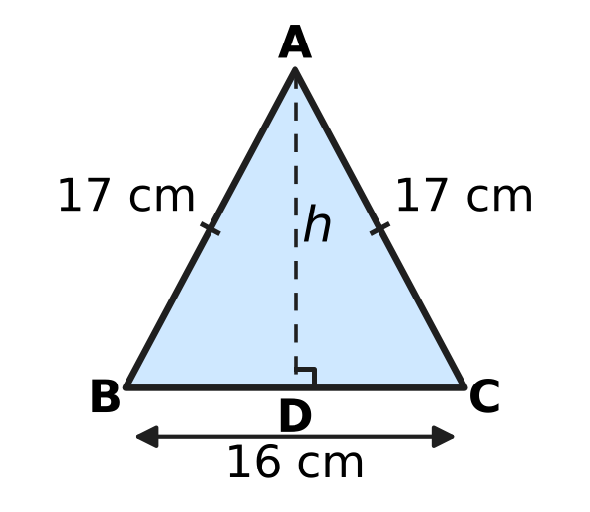
  (A) 25 cm | (B) 8 cm | (C) 9 cm | (D) 15 cm

Q18. ABCD is a parallelogram. Which of these facts is enough to prove that ABCD is a rectangle?
(A) One of its angles is 90°. | (B) Its opposite angles are equal.
(C) Two of its adjacent sides are equal. | (D) Its diagonals are perpendicular.

Q19. Which of these solids has exactly 30 edges?
(A) a prism whose base has 8 sides | (B) a prism whose base has 10 sides
(C) a pyramid whose base has 10 sides | (D) a prism whose base has 15 sides

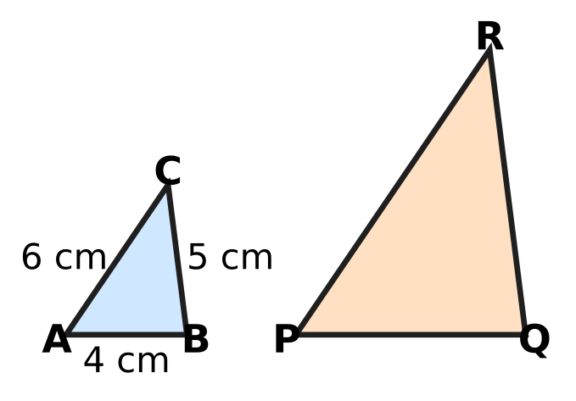
Q20. In the picture, △ABC ∼ △PQR, with AB = 4 cm, BC = 5 cm and CA = 6 cm. The perimeter of △PQR is 45 cm. What is the length of the longest side of △PQR?
(A) 36 cm | (B) 15 cm | (C) 12 cm | (D) 18 cm

Q21. Two upright poles stand on level ground 12 m apart. They are 4 m and 9 m tall, as in the picture. A bird flies in a straight line from the top of the shorter pole to its nest on top of the taller pole. How far does it fly? | 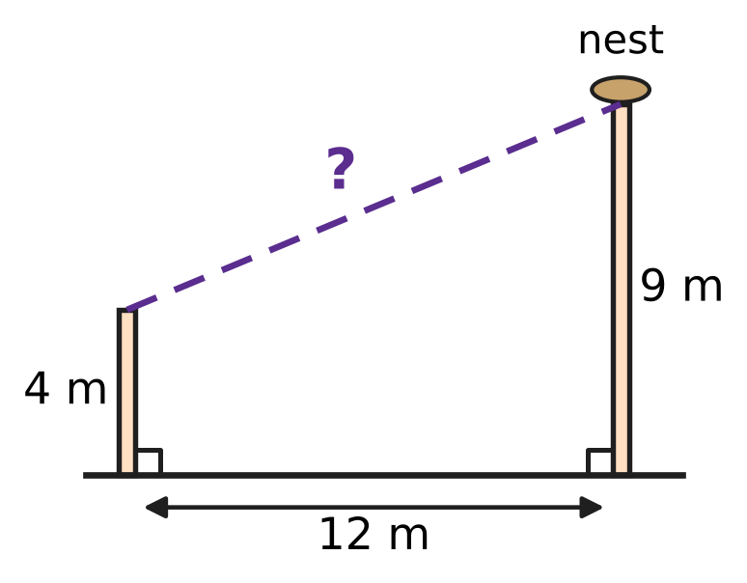
  (A) 17 m | (B) 15 m | (C) 13 m | (D) 5 m

Part 6 — Mensuration (Syllabus Chapter 6)
Cone | K | L | M | N
Radius (cm) | 6 | 5 | 2 | 3
Height (cm) | 2 | 3 | 15 | 8

Q22. The table gives the radius and the height of four solid cones. Which cone has the greatest volume?
(A) Cone K | (B) Cone L | (C) Cone M | (D) Cone N

Q23. Cylinder A has radius r and height h. Cylinder B has radius 2r and height h ÷ 2, as in the picture. The volume of B is how many times the volume of A? | 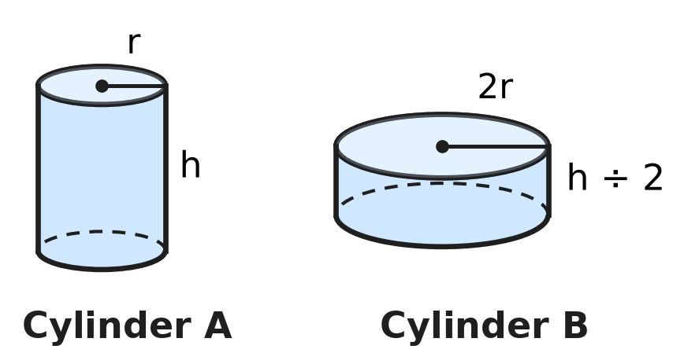
  (A) 4 | (B) 8 | (C) 2 | (D) 1

Q24. A solid cone of candle wax, shown in the picture, has a base diameter of 4.2 cm and a height of 50 mm. What is its volume? (Use π = $\frac{22}{7}$.) | 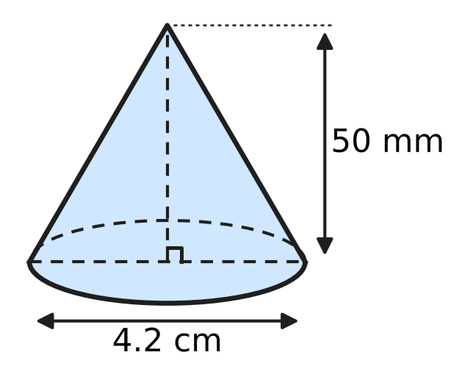
  (A) 231 cm³ | (B) 23.1 cm³ | (C) 69.3 cm³ | (D) 11 cm³

Q25. Lena fills an empty aquarium tank, a cuboid 60 cm × 40 cm × 40 cm as in the picture, using a jug that holds 1.2 litres. How many full jugs of water does she need to fill the tank? (1 litre = 1,000 cm³.) | 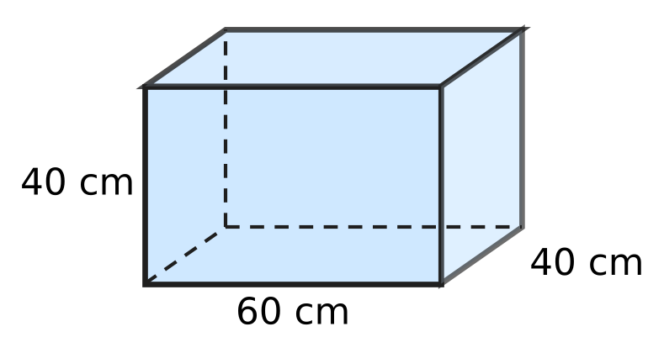
  (A) 80 | (B) 800 | (C) 8 | (D) 96

Q26. Anya buys a solid wooden toy rocket from a toy shop. It is a cylinder with a cone of the same radius on top, as in the picture. The radius is 3.5 cm and the cylinder is 10 cm tall. The whole rocket has a volume of 500.5 cm³. How tall is the cone, h? (Use π = $\frac{22}{7}$.) | 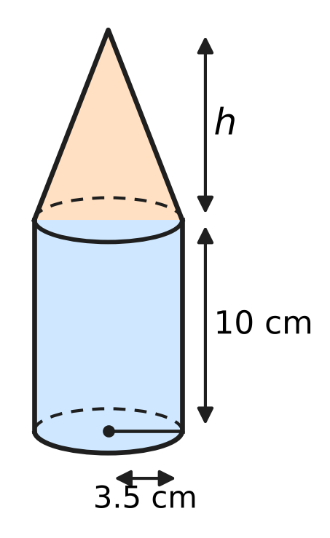
  (A) 19 cm | (B) 39 cm | (C) 3 cm | (D) 9 cm

Part 7 — Data Handling, Statistics & Probability (Syllabus Chapter 8)
Favourite subject | Maths | Science | English | Art
Number of students | 120 | 160 | 90 | 110

Q27. The table shows the favourite subjects of 480 students. The data is to be shown in a pie chart. Which subject will have a sector of 90°?
(A) Maths | (B) Science | (C) English | (D) Art

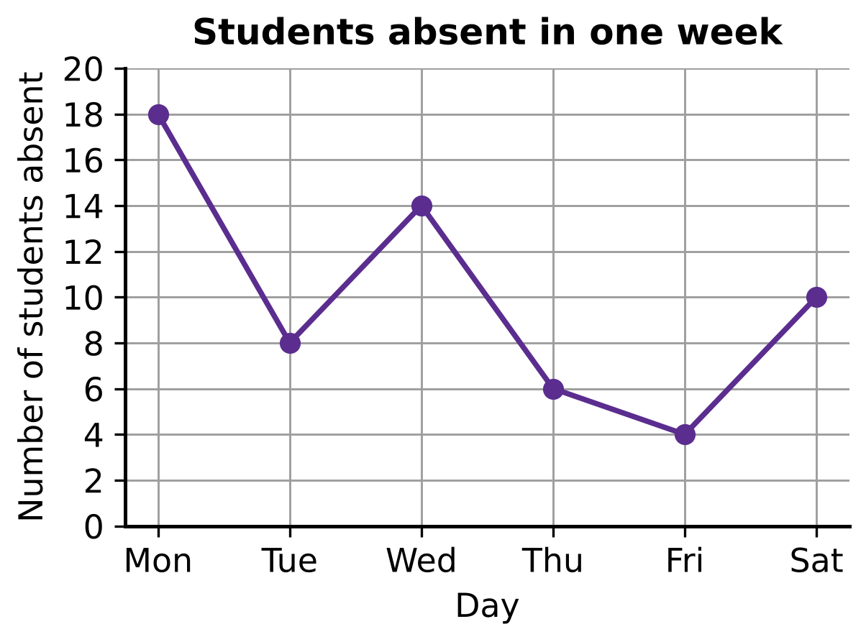
Q28. The line graph shows the number of students absent from a school on each day of one week, Monday to Saturday. What is the mean number of students absent per day?
(A) 11 | (B) 10 | (C) 9 | (D) 12

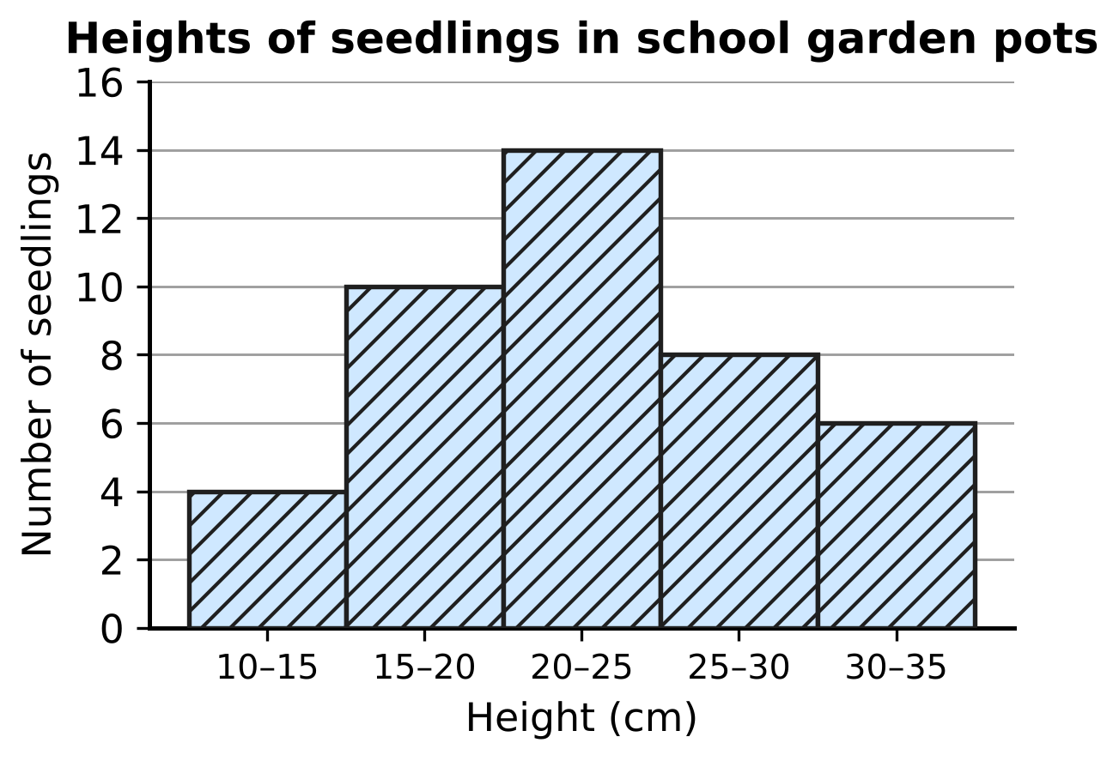
Q29. The histogram shows the heights of the seedlings in the school garden pots. The class 10–15 means 10 cm or more but less than 15 cm. A frequency polygon is drawn for this histogram. Which of these points (height in cm, number of seedlings) lies on the frequency polygon?
(A) (15, 10) | (B) (17.5, 14)
(C) (17.5, 10) | (D) (20, 10)

Part 8 — Applied Mathematics (Syllabus Chapter 9)
Item | A | B | C | D
Cost price (₹) | 80 | 150 | 50 | 200
Selling price (₹) | 100 | 180 | 65 | 236

Q30. The table shows the cost price and the selling price of four items. Which item gives the greatest profit percent?
(A) Item A | (B) Item B | (C) Item C | (D) Item D

Q31. Ashok borrows ₹36,000 at 8% per year simple interest. How much interest does he pay for each month?
(A) ₹240 | (B) ₹288 | (C) ₹3,000 | (D) ₹2,880

Q32. Rekha sells a table and makes a profit of ₹180. This profit is 15% of her cost price. What is her selling price?
(A) ₹1,020 | (B) ₹1,200 | (C) ₹2,700 | (D) ₹1,380

Q33. At the fruit market, Irfan buys 30 kg of oranges at ₹60 per kg and 20 kg of bigger oranges at ₹90 per kg. He mixes them and sells all 50 kg at ₹81 per kg. What is his profit percent?
(A) 35% | (B) 12.5% | (C) 9% | (D) 8%

Q34. Pavan sells a wall clock. His profit is one-fifth of the selling price. What is his profit percent on the cost price?
(A) 125% | (B) 80% | (C) 20% | (D) 25%

Part 9 — Mathematical Reasoning & Problem-Solving (Syllabus Chapter 10)
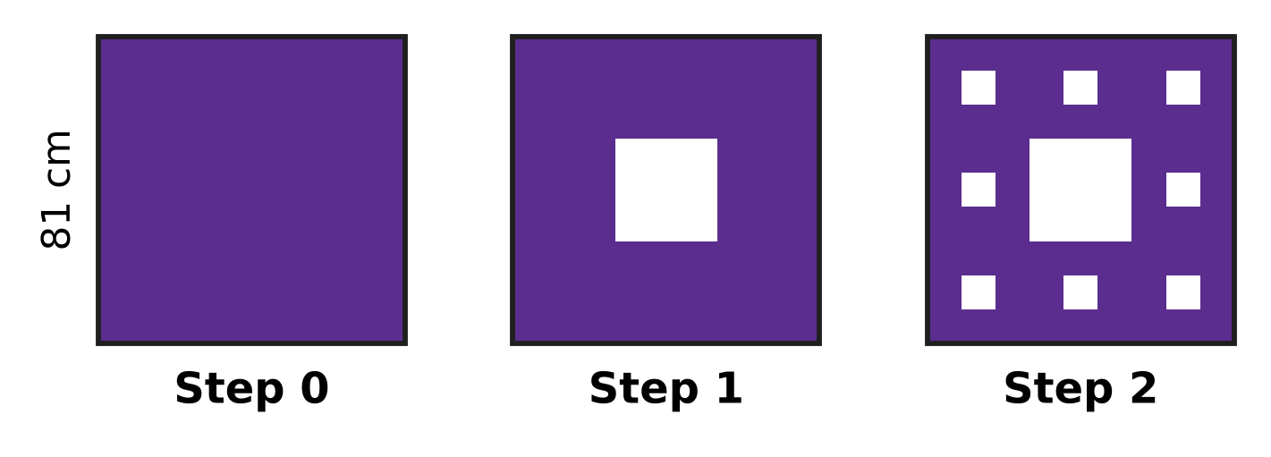
Q35. The picture shows the first steps of the Sierpiński carpet. It starts at Step 0 with a filled square of side 81 cm. At each step, every filled square is cut into 9 equal squares and the middle one is removed. What is the side of each smallest filled square at Step 3?
(A) 3 cm | (B) 1 cm | (C) 9 cm | (D) 27 cm

Q36. How many two-digit numbers have digits that differ by 7?
(A) 4 | (B) 6 | (C) 5 | (D) 3

Q37. Beads are threaded on a closed necklace in the colours red, blue, green, yellow, red, blue, green, yellow, … all the way round. The pattern never breaks, even where the last bead meets the first. Which of these could be the number of beads?
(A) 42 | (B) 50 | (C) 54 | (D) 48

Q38. In the multiplication ABCD × 4 = DCBA, each letter stands for a digit. Different letters stand for different digits, and neither A nor D is 0. What is the four-digit number ABCD?
(A) 1,089 | (B) 2,178 | (C) 2,198 | (D) 2,187

Q39. Tejas puts 10 pairs of shoes on a shoe rack with a top, a middle and a bottom shelf. Each shelf gets at least 1 pair and at most 5 pairs. In how many ways can he choose how many pairs go on each shelf?
(A) 18 | (B) 21 | (C) 36 | (D) 4

Q40. Which of these numbers is divisible by 36?
(A) 6,354 | (B) 5,736 | (C) 5,832 | (D) 5,382

SECTION II — Star Questions 5 questions × 4 marks each
Q41. Take a two-digit number. Add its two digits, multiply its two digits, and add these two results and 12. For some numbers the answer is the number itself. For example, 23 works, because (2 + 3) + (2 × 3) + 12 = 23. How many two-digit numbers work, 23 included? [4 marks]
(A) 6 | (B) 3 | (C) 9 | (D) 4

Q42. The picture shows 25 dots in a 5 × 5 square pattern, 1 cm apart. A square is drawn with all four corners on dots; its sides need not be along the rows of dots. How many different squares of area exactly 5 cm² can be drawn? [4 marks] | 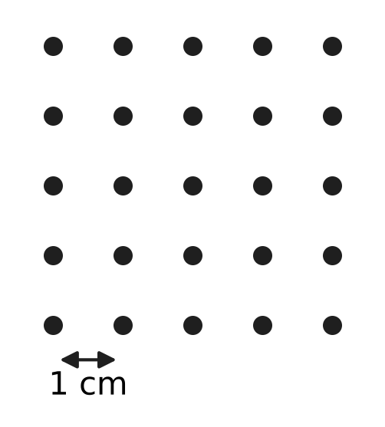
  (A) 16 | (B) 0 | (C) 8 | (D) 4

Q43. In the picture, △LMN has a right angle at M, LM = 12 cm and MN = 6 cm. A rectangle MDEF is drawn with D on LM, F on MN and E on LN. The area of the rectangle is 16 cm², and its sides MD and MF have different lengths. What is the perimeter of the rectangle? [4 marks] | 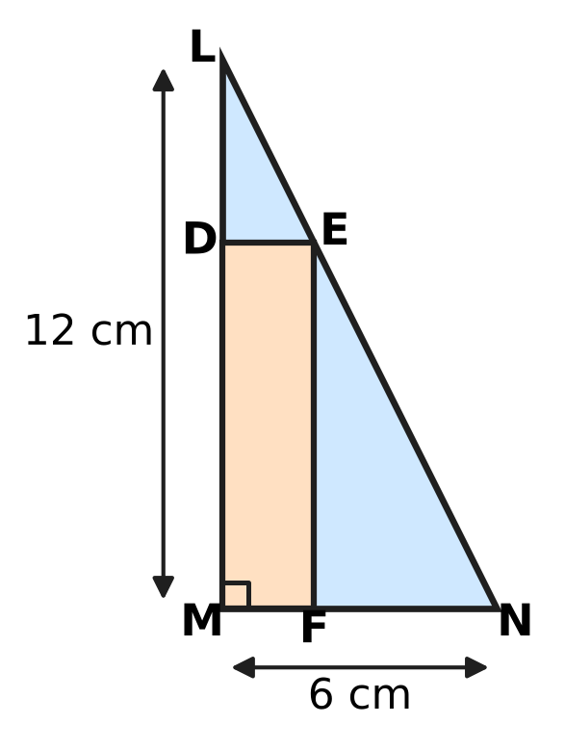
  (A) 20 cm | (B) 16 cm | (C) 24 cm | (D) 10 cm

Q44. The list price of a classroom desk is ₹3,000. Vijay, a dealer, buys desks from the maker at successive discounts of 25% and 20% on the list price. He sells them to a school at 10% off the list price, and gives 1 desk free with every 4 desks the school pays for. What is Vijay's profit percent? [4 marks]
(A) $16\frac{2}{3}$% | (B) 20% | (C) $33\frac{1}{3}$% | (D) 50%

Q45. Gaurav paints the curved surfaces of 25 cylindrical fence posts. Each post has radius 7 cm and height 1.6 m, as in the picture. The owner pays him ₹50 for every square metre painted. The paint costs Gaurav ₹704 in all. What is his profit percent on the cost of the paint? (Use π = $\frac{22}{7}$.) [4 marks] | 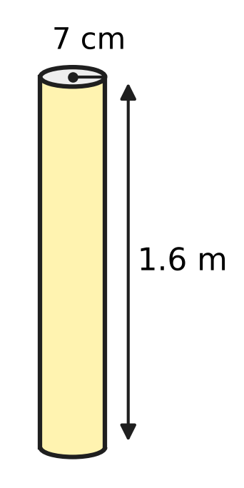
  (A) 80% | (B) 20% | (C) 25% | (D) 150%
Answer Sheet AMO Level 1 · Class 8 · Practice Paper 2
Name: | School: | Roll No.:
Shade or tick one circle for each question.
1. Ⓐ Ⓑ Ⓒ Ⓓ | 16. Ⓐ Ⓑ Ⓒ Ⓓ | 31. Ⓐ Ⓑ Ⓒ Ⓓ
2. Ⓐ Ⓑ Ⓒ Ⓓ | 17. Ⓐ Ⓑ Ⓒ Ⓓ | 32. Ⓐ Ⓑ Ⓒ Ⓓ
3. Ⓐ Ⓑ Ⓒ Ⓓ | 18. Ⓐ Ⓑ Ⓒ Ⓓ | 33. Ⓐ Ⓑ Ⓒ Ⓓ
4. Ⓐ Ⓑ Ⓒ Ⓓ | 19. Ⓐ Ⓑ Ⓒ Ⓓ | 34. Ⓐ Ⓑ Ⓒ Ⓓ
5. Ⓐ Ⓑ Ⓒ Ⓓ | 20. Ⓐ Ⓑ Ⓒ Ⓓ | 35. Ⓐ Ⓑ Ⓒ Ⓓ
6. Ⓐ Ⓑ Ⓒ Ⓓ | 21. Ⓐ Ⓑ Ⓒ Ⓓ | 36. Ⓐ Ⓑ Ⓒ Ⓓ
7. Ⓐ Ⓑ Ⓒ Ⓓ | 22. Ⓐ Ⓑ Ⓒ Ⓓ | 37. Ⓐ Ⓑ Ⓒ Ⓓ
8. Ⓐ Ⓑ Ⓒ Ⓓ | 23. Ⓐ Ⓑ Ⓒ Ⓓ | 38. Ⓐ Ⓑ Ⓒ Ⓓ
9. Ⓐ Ⓑ Ⓒ Ⓓ | 24. Ⓐ Ⓑ Ⓒ Ⓓ | 39. Ⓐ Ⓑ Ⓒ Ⓓ
10. Ⓐ Ⓑ Ⓒ Ⓓ | 25. Ⓐ Ⓑ Ⓒ Ⓓ | 40. Ⓐ Ⓑ Ⓒ Ⓓ
11. Ⓐ Ⓑ Ⓒ Ⓓ | 26. Ⓐ Ⓑ Ⓒ Ⓓ | 41. Ⓐ Ⓑ Ⓒ Ⓓ
12. Ⓐ Ⓑ Ⓒ Ⓓ | 27. Ⓐ Ⓑ Ⓒ Ⓓ | 42. Ⓐ Ⓑ Ⓒ Ⓓ
13. Ⓐ Ⓑ Ⓒ Ⓓ | 28. Ⓐ Ⓑ Ⓒ Ⓓ | 43. Ⓐ Ⓑ Ⓒ Ⓓ
14. Ⓐ Ⓑ Ⓒ Ⓓ | 29. Ⓐ Ⓑ Ⓒ Ⓓ | 44. Ⓐ Ⓑ Ⓒ Ⓓ
15. Ⓐ Ⓑ Ⓒ Ⓓ | 30. Ⓐ Ⓑ Ⓒ Ⓓ | 45. Ⓐ Ⓑ Ⓒ Ⓓ
Q41–Q45 are Section II Star Questions (4 marks each).
For the parent or teacher
Section I correct: ______ / 40 × 2 = ______ marks Section II correct: ______ / 5 × 4 = ______ marks
Correct: ______ / 45 Score: ______ / 100
Answer Key and Solutions AMO Level 1 · Class 8 · Practice Paper 2
Quick answers
1 D | 6 B | 11 A | 16 C | 21 C | 26 D | 31 A | 36 C | 41 D
2 D | 7 C | 12 D | 17 D | 22 B | 27 A | 32 D | 37 D | 42 C
3 C | 8 D | 13 C | 18 A | 23 C | 28 B | 33 B | 38 B | 43 A
4 B | 9 A | 14 A | 19 B | 24 B | 29 C | 34 D | 39 A | 44 B
5 A | 10 B | 15 B | 20 D | 25 A | 30 C | 35 A | 40 C | 45 C
Solutions
Q | Part · level | Answer | Why?
1 | Part 1 · Ch1 · Easy | (D) √3 × √12 | √3 × √12 = √36 = 6, which is rational. The others are 2√2, √0.9 and 5√5, which are irrational.
2 | Part 1 · Ch1 · Easy | (D) 1.7 m | Side = √2.89 = 1.7 m, because 1.7 × 1.7 = 2.89.
3 | Part 1 · Ch1 · Medium | (C) ∛0.729 | √0.64 = 0.8, ∛0.729 = 0.9, 0.9² = 0.81 and ∛0.343 = 0.7. The greatest is ∛0.729 = 0.9.
4 | Part 2 · Ch2 · Easy | (B) (−2)⁻³ | (−2)⁻³ = 1/(−2)³ = 1/(−8) = −1/8, which is negative. The others are 1/8, 1/9 and 1.
5 | Part 2 · Ch2 · Easy | (A) −6 | Since 8 = 2³, 8⁻² = (2³)⁻² = 2⁻⁶, because 3 × (−2) = −6. Check: 8⁻² = 1/64 = 2⁻⁶.
6 | Part 2 · Ch2 · Medium | (B) 30,000 | Number of drops = (1.5 × 10³) ÷ (5 × 10⁻²) = 0.3 × 10⁵ = 3 × 10⁴ = 30,000.
7 | Part 3 · Ch3 · Easy | (C) ₹2,000 at 7.5% a year for 4 years | SI = P × R × T ÷ 100: 2,000 × 7.5 × 4 ÷ 100 = ₹600. The others earn ₹50, ₹480 and ₹480.
8 | Part 3 · Ch3 · Easy | (D) 8% | Time = 9/12 = 3/4 year. R = 100 × 480 ÷ (8,000 × 3/4) = 48,000 ÷ 6,000 = 8% per year.
9 | Part 3 · Ch3 · Easy | (A) 60 | Students who run = 60% of 400 = 240. Medal winners = 25% of 240 = 60.
10 | Part 3 · Ch3 · Medium | (B) 35% and then 5% | Final prices: 2,000 × 0.7 × 0.9 = ₹1,260; 2,000 × 0.8 × 0.8 = ₹1,280; 2,000 × 0.75 × 0.85 = ₹1,275; 2,000 × 0.65 × 0.95 = ₹1,235. The lowest is with 35% and then 5%.
11 | Part 3 · Ch3 · Medium | (A) It increases by 8%. | New area = 1.2 × 0.9 = 1.08 times the old area, so the area increases by 8%.
12 | Part 4 · Ch4 · Easy | (D) $x^{2}+6x+36$ | (x + 6)² = x² + 12x + 36, not x² + 6x + 36. The others are (x + 5)², (2x − 3)² and (3x + 4)².
13 | Part 4 · Ch4 · Easy | (C) 5 | x² − y² = (x + y)(x − y), so 45 = 9 × (x − y) and x − y = 5.
14 | Part 4 · Ch4 · Easy | (A) 180 cm | Let the shorter piece be x cm. Then x + (2x + 40) = 250, so 3x = 210 and x = 70. The longer piece is 2 × 70 + 40 = 180 cm.
15 | Part 4 · Ch4 · Medium | (B) 12 | k = a + b where a × b = 24: the pairs 1 × 24, 2 × 12, 3 × 8, 4 × 6 give k = 25, 14, 11, 10. So k cannot be 12.
16 | Part 4 · Ch4 · Medium | (C) 80 | Let there be x passengers. Then $\frac{2}{5}$x + 12 = 44, so $\frac{2}{5}$x = 32 and x = 80.
17 | Part 5 · Ch5 · Easy | (D) 15 cm | BD = 8 cm. By the Baudhāyana–Pythagoras theorem, h² = 17² − 8² = 289 − 64 = 225, so h = 15 cm.
18 | Part 5 · Ch5 · Easy | (A) One of its angles is 90°. | Adjacent angles of a parallelogram add up to 180°, so if one angle is 90°, all four are 90° and ABCD is a rectangle.
19 | Part 5 · Ch5 · Easy | (B) a prism whose base has 10 sides | A prism with an n-sided base has n + n + n = 3n edges, so 3 × 10 = 30. The others have 24, 20 and 45 edges.
20 | Part 5 · Ch5 · Medium | (D) 18 cm | Perimeter of △ABC = 4 + 5 + 6 = 15 cm, so the scale factor is 45 ÷ 15 = 3. The longest side RP = 3 × 6 = 18 cm.
21 | Part 5 · Ch5 · Medium | (C) 13 m | The difference in heights is 9 − 4 = 5 m and the gap is 12 m. Distance = √(12² + 5²) = √169 = 13 m.
22 | Part 6 · Ch6 · Easy | (B) Cone L | Volume = ⅓πr²h, so compare r² × h: K 36 × 2 = 72, L 25 × 3 = 75, M 4 × 15 = 60, N 9 × 8 = 72. Cone L has the greatest volume.
23 | Part 6 · Ch6 · Easy | (C) 2 | Volume of B = π × (2r)² × (h ÷ 2) = π × 4r² × h ÷ 2 = 2πr²h, which is 2 times the volume of A (πr²h).
24 | Part 6 · Ch6 · Easy | (B) 23.1 cm³ | Radius = 4.2 ÷ 2 = 2.1 cm and height = 50 mm = 5 cm. Volume = ⅓ × 22/7 × 2.1 × 2.1 × 5 = 23.1 cm³.
25 | Part 6 · Ch6 · Medium | (A) 80 | Volume = 60 × 40 × 40 = 96,000 cm³ = 96 litres. Number of jugs = 96 ÷ 1.2 = 80.
26 | Part 6 · Ch6 · Medium | (D) 9 cm | Cylinder = 22/7 × 3.5 × 3.5 × 10 = 385 cm³, so the cone is 500.5 − 385 = 115.5 cm³. Then ⅓ × 38.5 × h = 115.5, so h = 9 cm.
27 | Part 7 · Ch8 · Easy | (A) Maths | An angle of 90° is one quarter of 360°, so the subject must have one quarter of 480 = 120 students: Maths (120/480 × 360° = 90°).
28 | Part 7 · Ch8 · Easy | (B) 10 | Total = 18 + 8 + 14 + 6 + 4 + 10 = 60 over 6 days. Mean = 60 ÷ 6 = 10.
29 | Part 7 · Ch8 · Medium | (C) (17.5, 10) | The frequency polygon joins the mid-points of the tops of the bars. The class 15–20 has mid-point 17.5 and frequency 10, so (17.5, 10) lies on it.
30 | Part 8 · Ch9 · Easy | (C) Item C | Profit percents: A 20/80 = 25%, B 30/150 = 20%, C 15/50 = 30%, D 36/200 = 18%. Item C gives the greatest profit percent.
31 | Part 8 · Ch9 · Easy | (A) ₹240 | Interest for a year = 36,000 × 8 ÷ 100 = ₹2,880. For each month = 2,880 ÷ 12 = ₹240.
32 | Part 8 · Ch9 · Easy | (D) ₹1,380 | 15% of cost = ₹180, so cost = 180 × 100 ÷ 15 = ₹1,200. Selling price = 1,200 + 180 = ₹1,380.
33 | Part 8 · Ch9 · Medium | (B) 12.5% | Cost = 30 × 60 + 20 × 90 = ₹3,600. Sale = 50 × 81 = ₹4,050. Profit = ₹450, and 450/3,600 × 100 = 12.5%.
34 | Part 8 · Ch9 · Medium | (D) 25% | If the selling price is 5 parts, the profit is 1 part and the cost is 4 parts. Profit percent = 1/4 × 100 = 25%.
35 | Part 9 · Ch10 · Easy | (A) 3 cm | Each step divides the side by 3: 81 → 27 → 9 → 3. At Step 3 each smallest square has side 3 cm.
36 | Part 9 · Ch10 · Easy | (C) 5 | The digit pairs are 1 and 8, 2 and 9, 0 and 7. They give 18, 81, 29, 92 and 70 (07 is not two-digit): 5 numbers.
37 | Part 9 · Ch10 · Easy | (D) 48 | The 4 colours repeat in full blocks all the way round, so the number of beads must be a multiple of 4. Only 48 = 4 × 12 is.
38 | Part 9 · Ch10 · Medium | (B) 2,178 | Four times the number still has 4 digits, so A is 1 or 2. A is the last digit of an even product, so A = 2. Then 4 × D ends in 2 and D ≥ 8, so D = 8. Checking gives 2,178 × 4 = 8,712.
39 | Part 9 · Ch10 · Medium | (A) 18 | Top shelf 1 → (4, 5), (5, 4): 2 ways; top 2 → 3 ways; top 3 → 4 ways; top 4 → 5 ways; top 5 → 4 ways. Total = 2 + 3 + 4 + 5 + 4 = 18.
40 | Part 9 · Ch10 · Medium | (C) 5,832 | Here 36 = 4 × 9, and 4 and 9 have no common factor. For 5,832, the last two digits 32 are divisible by 4, and 5 + 8 + 3 + 2 = 18 is divisible by 9. Each of the others fails one test.
41 | Section II · Ch4 + Ch10 · Hard | (D) 4 | Let the number be 10a + b. Then 10a + b = a + b + ab + 12 gives a(9 − b) = 12. As 9 − b ≤ 9, a × (9 − b) can be 2 × 6, 3 × 4, 4 × 3 or 6 × 2, giving 23, 35, 46 and 67 — 4 numbers.
42 | Section II · Ch5 + Ch10 · Hard | (C) 8 | Area 5 cm² needs a side √5 cm, which joins dots 1 across and 2 up (1² + 2² = 5). Such a square fills a 3 cm × 3 cm block; there are 4 such blocks, and each holds 2 tilted squares: 4 × 2 = 8.
43 | Section II · Ch4 + Ch5 · Hard | (A) 20 cm | Let MF = x and MD = y. △LDE ∼ △LMN gives (12 − y)/12 = x/6, so y = 12 − 2x. Then x(12 − 2x) = 16 gives x² − 6x + 8 = 0, that is (x − 2)(x − 4) = 0. x = 4 makes a square, so x = 2, y = 8 and the perimeter is 2 × (2 + 8) = 20 cm.
44 | Section II · Ch3 + Ch9 · Hard | (B) 20% | Cost of a desk = 3,000 × 0.75 × 0.8 = ₹1,800. Price to the school = ₹2,700. For 5 desks he spends 5 × 1,800 = ₹9,000 and receives 4 × 2,700 = ₹10,800. Profit = ₹1,800 = 20% of ₹9,000.
45 | Section II · Ch6 + Ch9 · Hard | (C) 25% | Curved surface of one post = 2 × 22/7 × 7 × 160 = 7,040 cm². For 25 posts: 176,000 cm² = 17.6 m². Payment = 17.6 × 50 = ₹880. Profit = 880 − 704 = ₹176, and 176/704 × 100 = 25%.

ARYABHATTA MATHS OLYMPIAD
Level 1
PRACTICE PAPER-3
CLASS 8
Total Questions | 45 multiple-choice questions
Total Marks | 100
Time | 60 minutes
Section I | 40 questions × 2 marks = 80 marks
Section II | 5 Star Questions × 4 marks = 20 marks
Negative Marking | No negative marking
Calculator | Not allowed
Chapters | Number System · Operations · Fractions, Decimals & Percentages · Algebra · Geometry · Mensuration · Data Handling · Applied Mathematics · Mathematical Reasoning

Instructions to candidates
• This paper has 45 multiple-choice questions. Each question has four answer choices, of which exactly one is correct.
• Section I (Q1–Q40) carries 2 marks per question. Section II (Q41–Q45) carries 4 marks per question.
• There is no negative marking. Unanswered questions score zero.
• Calculators are not permitted. Rough work may be done on a separate sheet.
• Mark your answers on the answer sheet at the end of the paper.
• All figures are not necessarily drawn to scale unless stated.

For parents and teachers
• Print or view this paper in colour. Pictures are part of the questions.
• Parts follow the AMO syllabus chapters. Chapter 7 is not part of the Class 8 syllabus, so the chapter numbers shown in the Part headings have gaps.
• The answer sheet and the answer key are at the end. Remove only the answer key before the student begins.

SECTION I 40 questions × 2 marks each
Part 1 — Number System (Syllabus Chapter 1)
Q1. Complete the statement: √190 is closest to the whole number ___.
(A) 13 | (B) 14 | (C) 12 | (D) 15

Q2. Real numbers obey the distributive law. Fill the box so that the statement is true:
√2 × (3 + √2) = 3√2 + $□$
(A) 2√2 | (B) 4 | (C) 2 | (D) √2

Q3. The cube 5³ can be written as the sum of five consecutive odd numbers: 5³ = 21 + 23 + 25 + 27 + 29. In the same way, 6³ is the sum of six consecutive odd numbers. What is the first of these six numbers?
(A) 33 | (B) 35 | (C) 41 | (D) 31

Part 2 — Operations & Number Properties (Syllabus Chapter 2)
Q4. A sack holds about 1.5 × 10⁶ grains of wheat. Each grain has a mass of about 4 × 10⁻² g. Complete the statement: the wheat in the sack has a mass of about ___.
(A) 6 × 10⁴ g | (B) 6 × 10⁻¹² g
(C) 6 × 10³ g | (D) 6 × 10⁸ g

Q5. Find the missing number:
($□$)⁻³ = $\frac{125}{8}$
(A) $\frac{5}{2}$ | (B) $\frac{2}{5}$ | (C) $−\frac{2}{5}$ | (D) $\frac{8}{125}$

Q6. If 9ˣ × 27 = $\frac{1}{3}$, what is the value of x?
(A) 2 | (B) −1 | (C) −2 | (D) −4

Part 3 — Fractions, Decimals & Percentages (Syllabus Chapter 3)
Q7. Rhea takes ₹4,000 out of her piggy bank and puts it in a savings scheme that pays 7% per year simple interest. How much interest does she earn in the fourth year alone?
(A) ₹840 | (B) ₹4,280 | (C) ₹1,120 | (D) ₹280

Q8. Manav borrows ₹15,000 for 2 years at simple interest to repair his fishing boat in the harbour. The bank raises the rate from 8% to 9% per year before he signs. How much more interest will he pay over the 2 years?
(A) ₹300 | (B) ₹150 | (C) ₹2,400 | (D) ₹2,700

Q9. A clay pot is sold with a 10% discount followed by a further 25% discount on the reduced price. Which of these always gives the same final price?
(A) a 25% discount followed by a further 10% discount
(B) a single discount of 37.5%
(C) a 17.5% discount followed by a further 17.5% discount
(D) a single discount of 35%

Q10. The number of honey bees on a bee farm went up by the same percentage in each of two years, from 25,000 to 36,000. By what percentage did the number go up each year?
(A) 22% | (B) 44% | (C) 120% | (D) 20%

Q11. At a museum gift shop, Saira buys a book priced ₹1,000. She can use a ₹100-off coupon and a 10% member discount, one after the other, in either order. How much more does she pay if she uses the coupon first?
(A) ₹100 | (B) ₹0 | (C) ₹10 | (D) ₹90

Part 4 — Algebra (Syllabus Chapter 4)
Q12. The identity below has one term missing. Which term completes it?
(5p − $□$)² = 25p² − 30pq + 9q²
(A) 9q | (B) 3q | (C) 6q | (D) −3q

Q13. A square tile has an area of (9x² + 30x + 25) cm². What is its perimeter?
(A) (12x + 5) cm | (B) (6x + 10) cm
(C) (12x + 20) cm | (D) (3x + 5) cm

Q14. The school canteen sold some sandwiches on Monday. On Tuesday it sold 8 more than on Monday. On Wednesday it sold twice as many as on Monday. It sold 68 sandwiches in the three days. How many did it sell on Monday?
(A) 17 | (B) 23 | (C) 30 | (D) 15

Q15. Both x² − 25 and x² + 2x − 15 can be divided exactly by the same expression (x + k). Complete the statement: k = ___.
(A) −3 | (B) 5 | (C) 3 | (D) −5

Q16. On a classroom shelf, $\frac{1}{3}$ of the books are storybooks and $\frac{1}{4}$ are science books. The remaining 30 books are maths books. How many storybooks are there?
(A) 24 | (B) 18 | (C) 72 | (D) 20

Part 5 — Geometry (Syllabus Chapter 5)
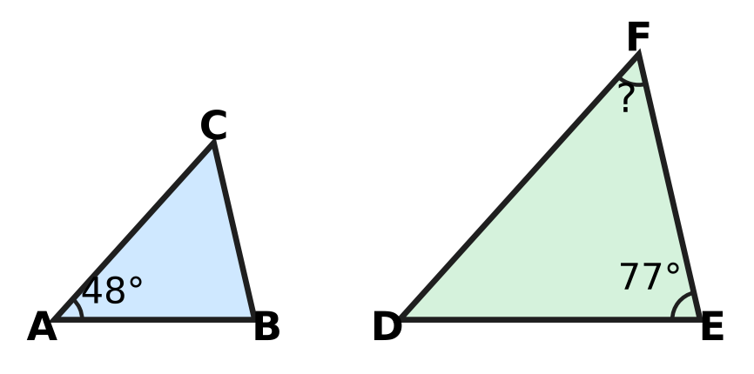
Q17. In the picture, △ABC ∼ △DEF, with the vertices in this order. ∠A = 48° and ∠E = 77°. Complete the statement: ∠F = ___.
(A) 77° | (B) 125° | (C) 48° | (D) 55°

Q18. PQRS is a rhombus, so all four of its sides are equal, as marked in the picture. The diagonal PR is drawn and ∠PQR = 116°. What is the angle x = ∠QPR? | 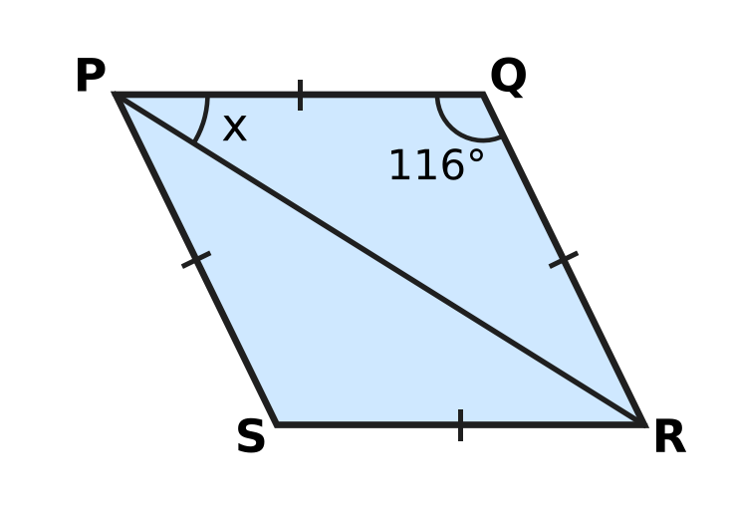
  (A) 64° | (B) 32° | (C) 36° | (D) 58°

Q19. In the picture, a square is drawn on each side of a right-angled triangle. The squares on the two shorter sides have areas 81 cm² and 144 cm². What is the area of the square marked "?" | 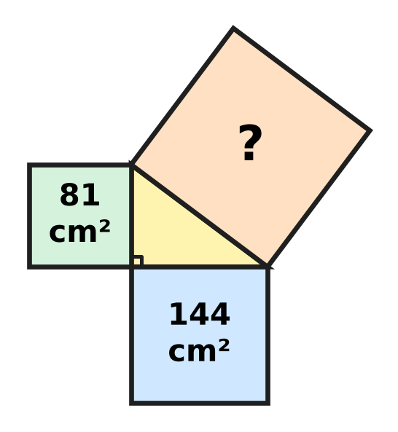
  (A) 225 cm² | (B) 21 cm² | (C) 63 cm² | (D) 15 cm²

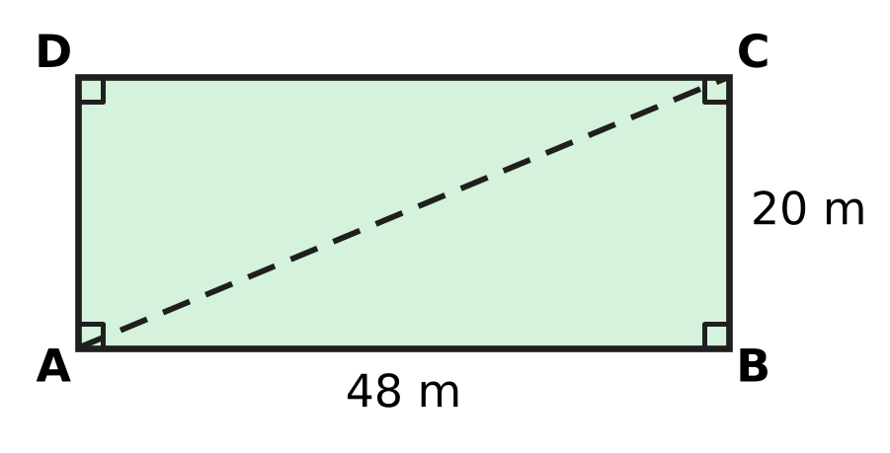
Q20. The picture shows a rectangular playground ABCD, 48 m long and 20 m wide. Nina usually walks from A to B and then to C. Today she walks straight from A to C along the dashed line. How much shorter is her walk today?
(A) 52 m | (B) 68 m | (C) 16 m | (D) 28 m

Q21. Sahil builds a solid from equal cubes on a 3 × 3 square base. The picture is the top view; each number tells how many cubes are stacked in that square. He then draws the view from the FRONT, as shown by the arrow. How many squares does the front view have? | 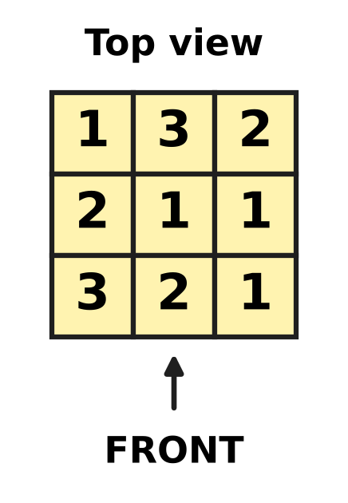
  (A) 6 | (B) 9 | (C) 8 | (D) 16

Part 6 — Mensuration (Syllabus Chapter 6)
Q22. A field of area 1.2 hectares is divided into equal square plots of side 20 m, with nothing left over. How many plots are there? (Use 1 hectare = 10,000 m².)
(A) 300 | (B) 30 | (C) 3 | (D) 600

Q23. A cylindrical pillar in the school hall is 3 m tall, as in the picture. Its curved surface has an area of 13.2 m². What is the diameter of the pillar? (Use π = $\frac{22}{7}$.) | 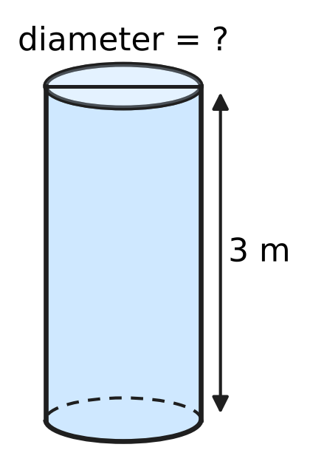
  (A) 0.7 m | (B) 2.8 m | (C) 4.4 m | (D) 1.4 m

Q24. A conical roof covers a round platform. The base of the roof has a diameter of 16 m and its slant height is 10 m, as in the picture. How high is the top of the roof above the base (h)? | 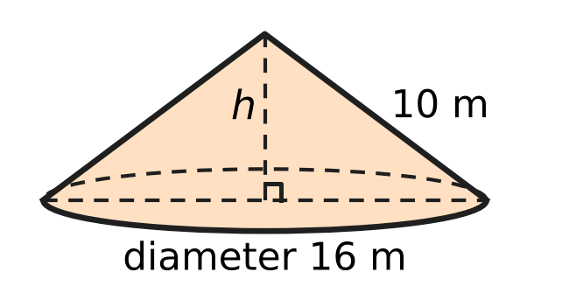
  (A) 6 m | (B) 18 m | (C) 2 m | (D) 8 m

Q25. A solid stand is made of two cylinders, one on top of the other, with their centres in a line. The bottom one has radius 14 cm and the top one has radius 7 cm; each is 10 cm tall, as in the picture. All of it is painted except the face it stands on. What area is painted? (Use π = $\frac{22}{7}$.) | 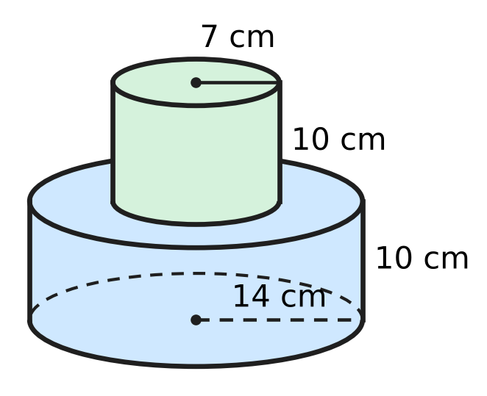
  (A) 2,552 cm² | (B) 1,936 cm²
  (C) 2,090 cm² | (D) 1,474 cm²

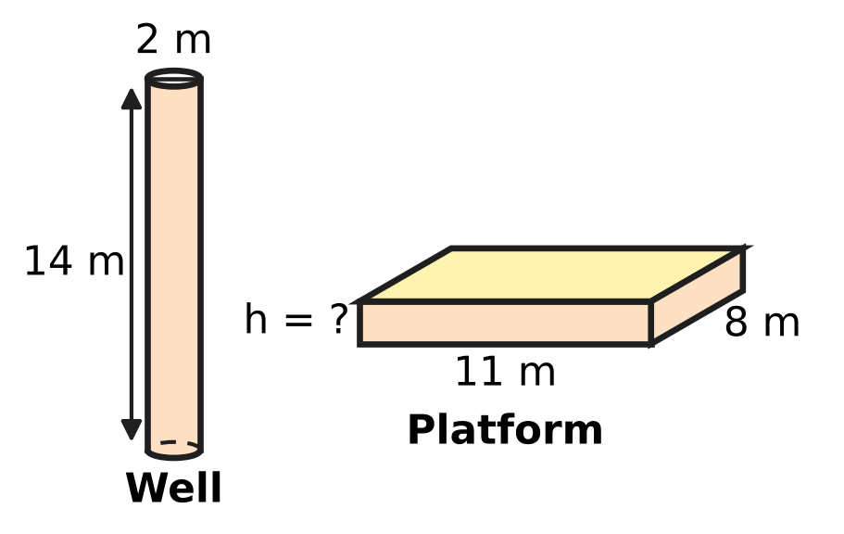
Q26. A well is dug in the shape of a cylinder, 2 m in diameter and 14 m deep. All the earth taken out is spread evenly to make a platform 11 m long and 8 m wide, as in the picture. Assume the earth keeps the same volume. How high is the platform, in centimetres? (Use π = $\frac{22}{7}$.)
(A) 200 cm | (B) 100 cm | (C) 5 cm | (D) 50 cm

Part 7 — Data Handling, Statistics & Probability (Syllabus Chapter 8)
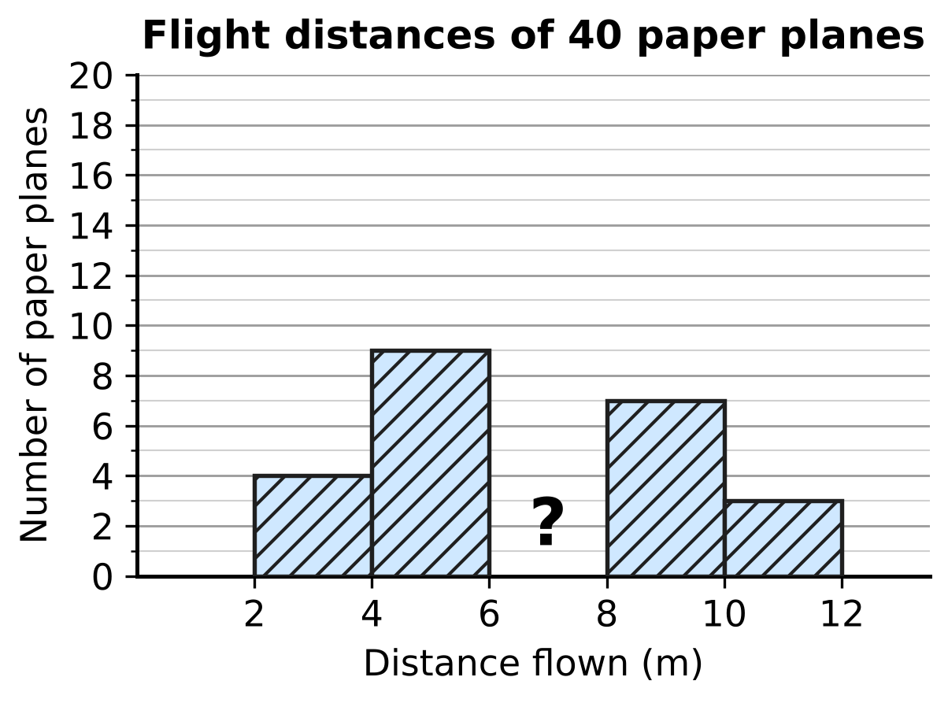
Q27. Students flew 40 paper planes and grouped the distances in classes 2–4, 4–6, 6–8, 8–10 and 10–12 m, where 6–8 means 6 m or more but less than 8 m. In the histogram, the bar for the class 6–8 m is missing (marked ?). Complete the statement: the bar for 6–8 m should show ___ planes.
(A) 17 | (B) 23 | (C) 9 | (D) 40

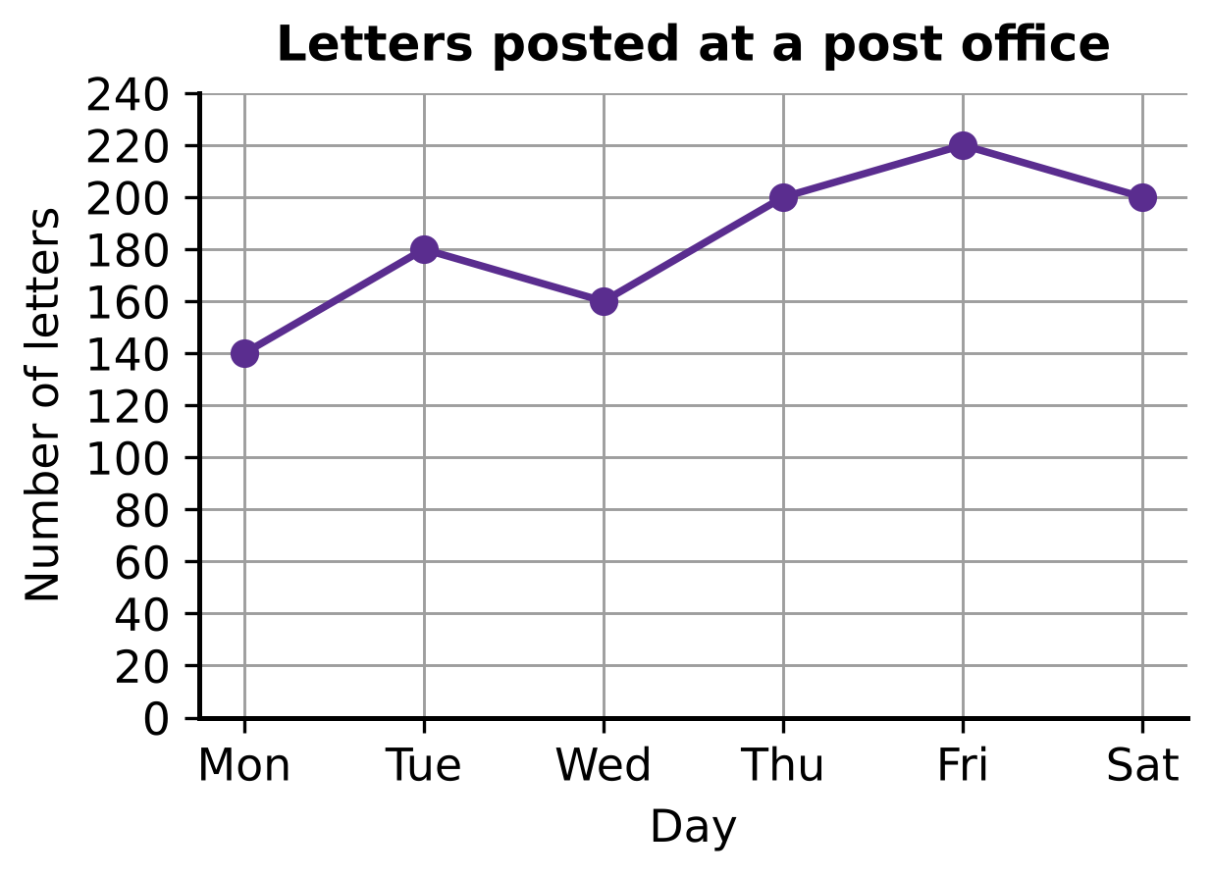
Q28. The line graph shows the number of letters posted at a post office on each day from Monday to Saturday. On how many of these days were more letters posted than on the day before?
(A) 5 | (B) 4 | (C) 3 | (D) 2

Q29. In a maths quiz, the 30 students of Section A have a mean score of 14. The 20 students of Section B have a mean score of 19. What is the mean score of all 50 students?
(A) 16.5 | (B) 17 | (C) 16 | (D) 15

Part 8 — Applied Mathematics (Syllabus Chapter 9)
Q30. Lalit pays ₹5,900 for a board game. This price includes a tax (GST) of 18% on the price before tax. What was the price before tax?
(A) ₹5,000 | (B) ₹4,838 | (C) ₹5,882 | (D) ₹6,962

Q31. In a clearance sale, Ken buys a bicycle marked ₹6,000 at a discount of 25%. Soon after, he sells it to a friend for ₹6,000. What is his profit percent?
(A) $133\frac{1}{3}$% | (B) $33\frac{1}{3}$% | (C) 75% | (D) 25%

Q32. Vinita borrows ₹12,000 for 1 year at 10% per year simple interest to buy a sewing machine. She repays the loan and the interest together in 12 equal monthly payments. How much is each payment?
(A) ₹1,000 | (B) ₹1,200 | (C) ₹100 | (D) ₹1,100

Q33. Kavin sells school bags at a profit of 20%. Then his supplier lowers the cost price of each bag by 20%, but Kavin keeps his selling price unchanged. What is his new profit percent?
(A) 20% | (B) 50% | (C) 40% | (D) 44%

Q34. Payal puts ₹2,000 in a savings scheme at the start of a year. At the start of the next year she puts in another ₹2,000. The scheme pays 10% per year simple interest. How much does she have at the end of the second year?
(A) ₹4,600 | (B) ₹4,400 | (C) ₹4,620 | (D) ₹4,800

Part 9 — Mathematical Reasoning & Problem-Solving (Syllabus Chapter 10)
Q35. Tushar marks five dots on a sheet, as in the picture. Three of the dots lie on one straight line (shown dashed), and no other three dots lie on a straight line. How many different triangles can he draw with all three corners at these dots? | 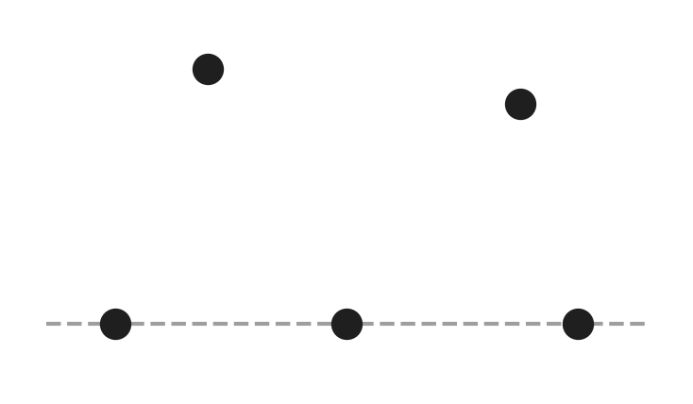
  (A) 10 | (B) 3 | (C) 9 | (D) 6

Q36. Fifteen whole numbers add up to an even number. At least how many of the fifteen numbers must be even?
(A) 8 | (B) 2 | (C) 0 | (D) 1

Q37. Ella claims: "Every number that is divisible by both 6 and 9 is also divisible by 54." Which of these numbers shows that her claim is false?
(A) 18 | (B) 24 | (C) 27 | (D) 108

Q38. In the sum AA + BB + CC = ABC, each letter stands for a digit. Different letters stand for different digits, and none of A, B, C is 0. (AA is a two-digit number with both digits A, and ABC is a three-digit number.) What is the number ABC?
(A) 189 | (B) 297 | (C) 891 | (D) 198

Q39. A spinner has three equal parts marked 1, 3 and 7. Harsh spins it three times and adds the three numbers he gets. How many different totals are possible?
(A) 21 | (B) 27 | (C) 9 | (D) 10

Q40. A number is made by writing the block 48 again and again: 48, 4848, 484848, … (the block is written k times). Complete the statement: the least value of k for which the number is divisible by 9 is ___.
(A) 6 | (B) 3 | (C) 9 | (D) 12

SECTION II — Star Questions 5 questions × 4 marks each
Q41. On a bus, a long-route ticket costs ₹12 and a short-route ticket costs ₹7. On one day, the conductor, Bhavna, collected exactly ₹200 from ticket sales. She sold at least one ticket of each kind, and she sold more long-route tickets than short-route tickets. How many tickets did she sell in all? [4 marks]
(A) 25 | (B) 16 | (C) 20 | (D) 12

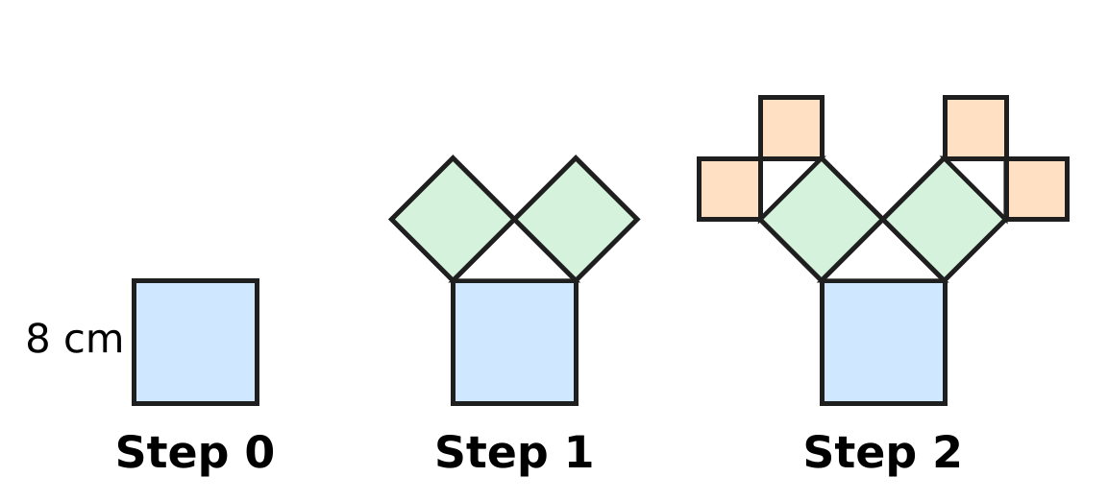
Q42. The picture shows a fractal "tree of squares". Step 0 is a square of side 8 cm. At each step, on the outer side of every square drawn in the step before (the top side in Step 0), a right-angled isosceles triangle is drawn with that side as its longest side. Then a new square is drawn outward on each of the two shorter sides of the triangle. What is the total area of all the squares drawn in Steps 0 to 4, counting each square separately? [4 marks]
(A) 124 cm² | (B) 320 cm² | (C) 64 cm² | (D) 256 cm²

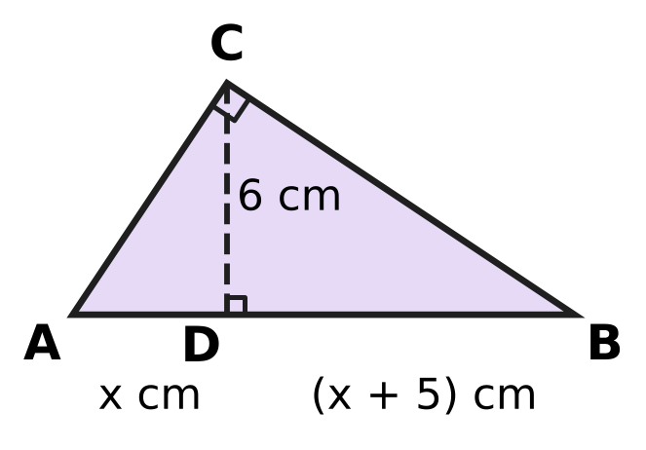
Q43. In the picture, triangle ABC has a right angle at C. CD is perpendicular to AB. AD = x cm, DB = (x + 5) cm and CD = 6 cm. What is the area of triangle ABC? [4 marks]
(A) 39 cm² | (B) 27 cm² | (C) 78 cm² | (D) 36 cm²

Q44. Vikram grows mangoes and sells them at ₹50 per kg, making a profit of 25% on his cost. Next season his cost per kg goes up by 20%, and he raises his selling price by 8%. What is his new profit percent? [4 marks]
(A) $11\frac{1}{9}$% | (B) 13% | (C) 20% | (D) 12.5%

Q45. A running track is the ring between two circles with the same centre O and radii 35 m and 42 m, as in the picture. A contractor resurfaces the whole track. He charges ₹500 per m² but gives a discount of 20% on the total bill. His own cost is ₹300 per m². What is his profit? (Use π = $\frac{22}{7}$.) [4 marks] | 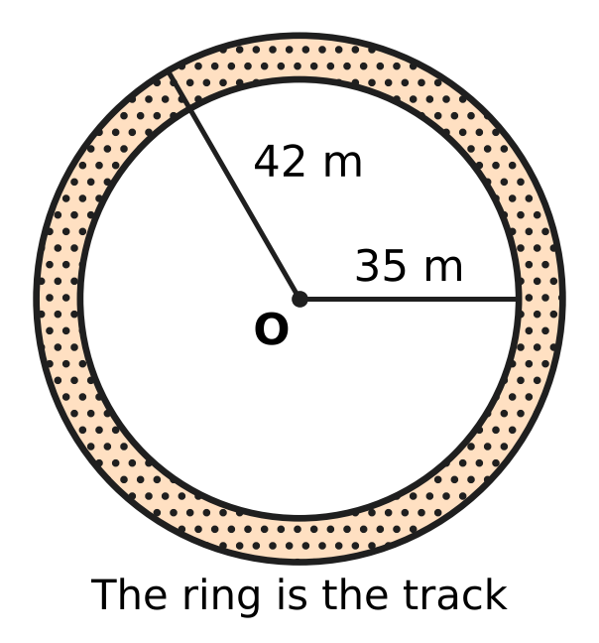
  (A) ₹15,400 | (B) ₹338,800 | (C) ₹169,400 | (D) ₹554,400
Answer Sheet AMO Level 1 · Class 8 · Practice Paper 3
Name: | School: | Roll No.:
Shade or tick one circle for each question.
1. Ⓐ Ⓑ Ⓒ Ⓓ | 16. Ⓐ Ⓑ Ⓒ Ⓓ | 31. Ⓐ Ⓑ Ⓒ Ⓓ
2. Ⓐ Ⓑ Ⓒ Ⓓ | 17. Ⓐ Ⓑ Ⓒ Ⓓ | 32. Ⓐ Ⓑ Ⓒ Ⓓ
3. Ⓐ Ⓑ Ⓒ Ⓓ | 18. Ⓐ Ⓑ Ⓒ Ⓓ | 33. Ⓐ Ⓑ Ⓒ Ⓓ
4. Ⓐ Ⓑ Ⓒ Ⓓ | 19. Ⓐ Ⓑ Ⓒ Ⓓ | 34. Ⓐ Ⓑ Ⓒ Ⓓ
5. Ⓐ Ⓑ Ⓒ Ⓓ | 20. Ⓐ Ⓑ Ⓒ Ⓓ | 35. Ⓐ Ⓑ Ⓒ Ⓓ
6. Ⓐ Ⓑ Ⓒ Ⓓ | 21. Ⓐ Ⓑ Ⓒ Ⓓ | 36. Ⓐ Ⓑ Ⓒ Ⓓ
7. Ⓐ Ⓑ Ⓒ Ⓓ | 22. Ⓐ Ⓑ Ⓒ Ⓓ | 37. Ⓐ Ⓑ Ⓒ Ⓓ
8. Ⓐ Ⓑ Ⓒ Ⓓ | 23. Ⓐ Ⓑ Ⓒ Ⓓ | 38. Ⓐ Ⓑ Ⓒ Ⓓ
9. Ⓐ Ⓑ Ⓒ Ⓓ | 24. Ⓐ Ⓑ Ⓒ Ⓓ | 39. Ⓐ Ⓑ Ⓒ Ⓓ
10. Ⓐ Ⓑ Ⓒ Ⓓ | 25. Ⓐ Ⓑ Ⓒ Ⓓ | 40. Ⓐ Ⓑ Ⓒ Ⓓ
11. Ⓐ Ⓑ Ⓒ Ⓓ | 26. Ⓐ Ⓑ Ⓒ Ⓓ | 41. Ⓐ Ⓑ Ⓒ Ⓓ
12. Ⓐ Ⓑ Ⓒ Ⓓ | 27. Ⓐ Ⓑ Ⓒ Ⓓ | 42. Ⓐ Ⓑ Ⓒ Ⓓ
13. Ⓐ Ⓑ Ⓒ Ⓓ | 28. Ⓐ Ⓑ Ⓒ Ⓓ | 43. Ⓐ Ⓑ Ⓒ Ⓓ
14. Ⓐ Ⓑ Ⓒ Ⓓ | 29. Ⓐ Ⓑ Ⓒ Ⓓ | 44. Ⓐ Ⓑ Ⓒ Ⓓ
15. Ⓐ Ⓑ Ⓒ Ⓓ | 30. Ⓐ Ⓑ Ⓒ Ⓓ | 45. Ⓐ Ⓑ Ⓒ Ⓓ
Q41–Q45 are Section II Star Questions (4 marks each).
For the parent or teacher
Section I correct: ______ / 40 × 2 = ______ marks Section II correct: ______ / 5 × 4 = ______ marks
Correct: ______ / 45 Score: ______ / 100
Answer Key and Solutions AMO Level 1 · Class 8 · Practice Paper 3
Quick answers
1 B | 6 C | 11 C | 16 A | 21 C | 26 D | 31 B | 36 D | 41 C
2 C | 7 D | 12 B | 17 D | 22 B | 27 A | 32 D | 37 A | 42 B
3 D | 8 A | 13 C | 18 B | 23 D | 28 C | 33 B | 38 D | 43 A
4 A | 9 A | 14 D | 19 A | 24 A | 29 C | 34 A | 39 C | 44 D
5 B | 10 D | 15 B | 20 C | 25 B | 30 A | 35 C | 40 B | 45 C
Solutions
Q | Part · level | Answer | Why?
1 | Part 1 · Ch1 · Easy | (B) 14 | Here 13² = 169 and 14² = 196. The number 190 is 21 more than 169 but only 6 less than 196, so √190 is closest to 14.
2 | Part 1 · Ch1 · Easy | (C) 2 | √2 × (3 + √2) = √2 × 3 + √2 × √2 = 3√2 + 2, because √2 × √2 = 2.
3 | Part 1 · Ch1 · Medium | (D) 31 | Here 6³ = 216. Six consecutive odd numbers with sum 216 have an average of 216 ÷ 6 = 36, so they are 31, 33, 35, 37, 39 and 41. The first is 31.
4 | Part 2 · Ch2 · Easy | (A) 6 × 10⁴ g | (1.5 × 4) × 10⁶ × 10⁻² = 6 × 10⁶⁻² = 6 × 10⁴ g, which is 60 kg.
5 | Part 2 · Ch2 · Easy | (B) $\frac{2}{5}$ | (2/5)⁻³ = (5/2)³ = 125/8. So the box holds 2/5.
6 | Part 2 · Ch2 · Medium | (C) −2 | Write everything with base 3: 3²ˣ × 3³ = 3⁻¹, so 2x + 3 = −1, 2x = −4 and x = −2.
7 | Part 3 · Ch3 · Easy | (D) ₹280 | Simple interest is the same every year: 4,000 × 7 ÷ 100 = ₹280. So the fourth year alone earns ₹280.
8 | Part 3 · Ch3 · Easy | (A) ₹300 | The rate goes up by 1% a year. Extra interest = 15,000 × 1 × 2 ÷ 100 = ₹300.
9 | Part 3 · Ch3 · Easy | (A) a 25% discount followed by a further 10% discount | Taking 10% off and then 25% off leaves 0.9 × 0.75 = 0.675 of the price. Taking 25% off and then 10% off leaves 0.75 × 0.9 = 0.675 too, because the order of multiplying does not matter. (A single 35% leaves 0.65, and 17.5% twice leaves about 0.68.)
10 | Part 3 · Ch3 · Medium | (D) 20% | Here 36,000 ÷ 25,000 = 1.44 = 1.2 × 1.2. Each year the number was multiplied by 1.2, which is an increase of 20%.
11 | Part 3 · Ch3 · Medium | (C) ₹10 | Coupon first: ₹1,000 − ₹100 = ₹900, then 10% off gives ₹810. Discount first: ₹900, then ₹100 off gives ₹800. She pays ₹10 more.
12 | Part 4 · Ch4 · Easy | (B) 3q | (a − b)² = a² − 2ab + b². Here a = 5p and 2 × 5p × b = 30pq, so b = 3q. Check: (3q)² = 9q².
13 | Part 4 · Ch4 · Easy | (C) (12x + 20) cm | Here 9x² + 30x + 25 = (3x + 5)², so each side is (3x + 5) cm. Perimeter = 4(3x + 5) = (12x + 20) cm.
14 | Part 4 · Ch4 · Easy | (D) 15 | Let Monday = x. Then x + (x + 8) + 2x = 68, so 4x = 60 and x = 15.
15 | Part 4 · Ch4 · Medium | (B) 5 | x² − 25 = (x − 5)(x + 5) and x² + 2x − 15 = (x + 5)(x − 3). The common factor is x + 5, so k = 5.
16 | Part 4 · Ch4 · Medium | (A) 24 | Let the total be n. The maths books are 1 − 1/3 − 1/4 = 5/12 of n, so 5n/12 = 30 and n = 72. Storybooks = 72 ÷ 3 = 24.
17 | Part 5 · Ch5 · Easy | (D) 55° | Similar triangles have equal corresponding angles: ∠D = ∠A = 48°. So ∠F = 180° − 48° − 77° = 55°.
18 | Part 5 · Ch5 · Easy | (B) 32° | PQ = QR, so △PQR is isosceles and ∠QPR = ∠QRP. So x = (180° − 116°) ÷ 2 = 32°.
19 | Part 5 · Ch5 · Easy | (A) 225 cm² | By the Baudhāyana–Pythagoras theorem, the square on the hypotenuse equals the sum of the other two squares: 81 + 144 = 225 cm².
20 | Part 5 · Ch5 · Medium | (C) 16 m | AC = √(48² + 20²) = √2,704 = 52 m. The usual walk is 48 + 20 = 68 m, so today is 68 − 52 = 16 m shorter.
21 | Part 5 · Ch5 · Medium | (C) 8 | From the front, each column shows its tallest stack: left column 3, middle column 3, right column 2. The front view has 3 + 3 + 2 = 8 squares.
22 | Part 6 · Ch6 · Easy | (B) 30 | The field is 1.2 hectares = 12,000 m². Each plot has area 20 × 20 = 400 m². Number of plots = 12,000 ÷ 400 = 30.
23 | Part 6 · Ch6 · Easy | (D) 1.4 m | Curved surface area = 2πrh = 13.2, so 2 × 22/7 × r × 3 = 13.2, giving r = 13.2 × 7 ÷ 132 = 0.7 m. The diameter is 2 × 0.7 = 1.4 m.
24 | Part 6 · Ch6 · Easy | (A) 6 m | Radius = 16 ÷ 2 = 8 m. Height, radius and slant height form a right triangle: h = √(10² − 8²) = √36 = 6 m.
25 | Part 6 · Ch6 · Medium | (B) 1,936 cm² | Curved surfaces: 2 × 22/7 × 14 × 10 = 880 and 2 × 22/7 × 7 × 10 = 440. The ring and the small top together make one circle of radius 14: 22/7 × 196 = 616. Total = 1,936 cm².
26 | Part 6 · Ch6 · Medium | (D) 50 cm | Volume of earth = 22/7 × 1 × 1 × 14 = 44 m³. Height = 44 ÷ (11 × 8) = 0.5 m = 50 cm.
27 | Part 7 · Ch8 · Easy | (A) 17 | The four bars shown add up to 4 + 9 + 7 + 3 = 23. The missing bar is 40 − 23 = 17.
28 | Part 7 · Ch8 · Easy | (C) 3 | The line goes up from Monday to Tuesday, from Wednesday to Thursday and from Thursday to Friday. That is 3 days.
29 | Part 7 · Ch8 · Medium | (C) 16 | Total of scores = 30 × 14 + 20 × 19 = 420 + 380 = 800. Mean = 800 ÷ 50 = 16.
30 | Part 8 · Ch9 · Easy | (A) ₹5,000 | Price before tax × 1.18 = 5,900, so the price before tax = 5,900 ÷ 1.18 = ₹5,000. Check: 18% of 5,000 = 900 and 5,000 + 900 = 5,900.
31 | Part 8 · Ch9 · Easy | (B) $33\frac{1}{3}$% | Cost price = 75% of ₹6,000 = ₹4,500. Profit = ₹1,500 on ₹4,500 = 1/3 = 33⅓%.
32 | Part 8 · Ch9 · Easy | (D) ₹1,100 | Interest = 12,000 × 10 ÷ 100 = ₹1,200. Total to repay = ₹13,200. Each payment = 13,200 ÷ 12 = ₹1,100.
33 | Part 8 · Ch9 · Medium | (B) 50% | Let the old cost be ₹100. The selling price is ₹120. The new cost is ₹80, so the profit is ₹40 on ₹80, which is 50%.
34 | Part 8 · Ch9 · Medium | (A) ₹4,600 | The first ₹2,000 earns interest for 2 years: ₹400. The second earns for 1 year: ₹200. Total = 4,000 + 400 + 200 = ₹4,600.
35 | Part 9 · Ch10 · Easy | (C) 9 | Five dots give 10 groups of three dots. The three dots on the line do not make a triangle, so there are 10 − 1 = 9 triangles.
36 | Part 9 · Ch10 · Easy | (D) 1 | The sum of an odd count of odd numbers is odd. So the fifteen numbers cannot all be odd; at most 14 can be odd. At least 1 must be even, and 14 odd numbers with one even number do give an even sum.
37 | Part 9 · Ch10 · Easy | (A) 18 | The number 18 is divisible by 6 and by 9, but not by 54. One such number is enough to show the claim is false.
38 | Part 9 · Ch10 · Medium | (D) 198 | AA + BB + CC = 11(A + B + C), which is at most 11 × 24 = 264, so the first digit A must be 1 or 2. Trying both cases, only 11 + 99 + 88 = 198 works: A = 1, B = 9, C = 8.
39 | Part 9 · Ch10 · Medium | (C) 9 | The groups are 1+1+1 = 3, 1+1+3 = 5, 1+3+3 = 7, 1+1+7 = 9, 3+3+3 = 9, 1+3+7 = 11, 3+3+7 = 13, 1+7+7 = 15, 3+7+7 = 17, 7+7+7 = 21. Since 9 appears twice, there are 9 different totals.
40 | Part 9 · Ch10 · Medium | (B) 3 | Each block adds 4 + 8 = 12 to the digit sum, so the digit sum is 12k. This is a multiple of 9 first when k = 3 (digit sum 36). So 484848 is the first one divisible by 9.
41 | Section II · Ch4 + Ch10 · Hard | (C) 20 | Let a long-route and c short-route tickets be sold: 12a + 7c = 200, so 200 − 12a must be a multiple of 7. Trying a = 1 to 16, this happens only for a = 5 (c = 20) and a = 12 (c = 8). Since a must be more than c, a = 12 and c = 8, so she sold 20 tickets.
42 | Section II · Ch5 + Ch10 · Hard | (B) 320 cm² | By the Baudhāyana–Pythagoras theorem, the two squares on the shorter sides together have the same area as the square on the longest side. So each step adds squares with total area 64 cm². Steps 0 to 4 give 5 × 64 = 320 cm².
43 | Section II · Ch4 + Ch5 · Hard | (A) 39 cm² | Triangles ACD and CBD are similar (each has a right angle, and ∠A = ∠BCD), so AD/CD = CD/DB, giving x(x + 5) = 36. Since 4 × 9 = 36, x = 4 and AB = 4 + 9 = 13 cm. Area = ½ × 13 × 6 = 39 cm².
44 | Section II · Ch3 + Ch9 · Hard | (D) 12.5% | Old cost = 50 ÷ 1.25 = ₹40 per kg. New cost = 40 × 1.2 = ₹48. New price = 50 × 1.08 = ₹54. Profit = ₹6 on ₹48 = 12.5%.
45 | Section II · Ch6 + Ch9 · Hard | (C) ₹169,400 | Area of ring = 22/7 × (42² − 35²) = 22/7 × 539 = 1,694 m². After the discount he charges ₹400 per m², so his profit is ₹100 per m². Profit = 1,694 × 100 = ₹169,400.

ARYABHATTA MATHS OLYMPIAD
Level 1
PRACTICE PAPER-4
CLASS 8
Total Questions | 45 multiple-choice questions
Total Marks | 100
Time | 60 minutes
Section I | 40 questions × 2 marks = 80 marks
Section II | 5 Star Questions × 4 marks = 20 marks
Negative Marking | No negative marking
Calculator | Not allowed
Chapters | Number System · Operations · Fractions, Decimals & Percentages · Algebra · Geometry · Mensuration · Data Handling · Applied Mathematics · Mathematical Reasoning

Instructions to candidates
• This paper has 45 multiple-choice questions. Each question has four answer choices, of which exactly one is correct.
• Section I (Q1–Q40) carries 2 marks per question. Section II (Q41–Q45) carries 4 marks per question.
• There is no negative marking. Unanswered questions score zero.
• Calculators are not permitted. Rough work may be done on a separate sheet.
• Mark your answers on the answer sheet at the end of the paper.
• All figures are not necessarily drawn to scale unless stated.

For parents and teachers
• Print or view this paper in colour. Pictures are part of the questions.
• Parts follow the AMO syllabus chapters. Chapter 7 is not part of the Class 8 syllabus, so the chapter numbers shown in the Part headings have gaps.
• The answer sheet and the answer key are at the end. Remove only the answer key before the student begins.

SECTION I 40 questions × 2 marks each
Part 1 — Number System (Syllabus Chapter 1)
Q1. At the school assembly, 640 students stand in a square formation, with as many rows as there are students in each row. The square is made as large as possible, and the students who do not fit stand at the side. How many students stand at the side?
(A) 25 | (B) 64 | (C) 36 | (D) 15

Q2. Which of these is ALWAYS an irrational number?
(A) the product of two different irrational numbers
(B) the quotient of two different irrational numbers
(C) the product of a non-zero rational number and an irrational number
(D) the sum of two different irrational numbers

Q3. Three solid metal cubes have edges 1 cm, 6 cm and 8 cm. They are melted and made into one solid cube, with no metal lost. What is the edge of the new cube?
(A) 9 cm | (B) 5 cm | (C) 15 cm | (D) 10 cm

Part 2 — Operations & Number Properties (Syllabus Chapter 2)
Q4. Simplify ${(a^{−2}b^{3})}^{2}×a^{5}$, where a is not 0.
(A) $a^{3}b^{6}$ | (B) $ab^{6}$
(C) $ab^{5}$ | (D) $a^{9}b^{6}$

Q5. What is the value of (−1)⁻¹ + (−1)⁻² + (−1)⁻³ + (−1)⁻⁴?
(A) 0 | (B) 4 | (C) −4 | (D) −2

Q6. A sheet of paper is 1 × 10⁻⁴ m thick. A strand of spider silk is 2.5 × 10⁻⁶ m thick. How many times as thick as the silk is the paper?
(A) 0.025 | (B) 4 | (C) 40 | (D) 400

Part 3 — Fractions, Decimals & Percentages (Syllabus Chapter 3)
Q7. In a bookshop sale, every book is sold at 15% off its marked price. Members of the book club get a further 10% off the sale price. Kiara is a member. How much does she pay for a book marked ₹800?
(A) ₹600 | (B) ₹612 | (C) ₹188 | (D) ₹680

Q8. Komal deposits a sum of money in a bank at 5% per year simple interest. After 3 years the bank pays her ₹4,600 in all, that is, the sum together with the interest. What sum did she deposit?
(A) ₹690 | (B) ₹4,370 | (C) ₹3,910 | (D) ₹4,000

Q9. The fare for a river ferry went up from ₹30 to ₹40. A year later it came back down from ₹40 to ₹30. By what percentage did the fare go down?
(A) 10% | (B) 25% | (C) $33\frac{1}{3}$% | (D) 75%

Q10. Two equal sums of money are lent at simple interest, one at 6% per year and the other at 9% per year. After 4 years, the second sum has earned ₹720 more interest than the first. How much is each sum?
(A) ₹2,000 | (B) ₹24,000 | (C) ₹3,000 | (D) ₹6,000

Q11. A zoo cut its ticket price by 10%. Because of this, more people came, and the money collected from tickets went up by 17%. By what percent did the number of visitors go up?
(A) 30% | (B) 5.3% | (C) 27% | (D) 7%

Part 4 — Algebra (Syllabus Chapter 4)
Q12. Which number must be added to 4y² − 28y to make it a perfect square of the form (a − b)²?
(A) 7 | (B) 784 | (C) 49 | (D) 196

Q13. The area of the rectangle in the picture is (x² + 9x + 20) cm², and one of its sides is (x + 4) cm. How long is its other side? | 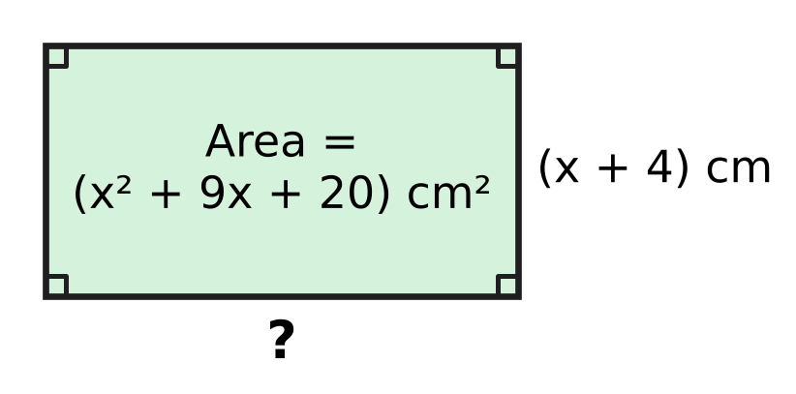
  (A) (x + 16) cm | (B) (x + 9) cm
  (C) (x + 20) cm | (D) (x + 5) cm

Q14. A badminton court is a rectangle. Its length is 7.3 m more than its width, and its perimeter is 39 m. How long is the court?
(A) 9.75 m | (B) 17.05 m | (C) 13.4 m | (D) 6.1 m

Q15. Manu packs all the eggs from his farm into trays that hold 12 eggs each, and every tray is full. If he used trays that hold 15 eggs each, he would need 5 fewer trays, and every tray would still be full. How many eggs are there?
(A) 25 | (B) 300 | (C) 375 | (D) 60

Q16. Ojas works out n² + 2n − 3 for every whole number n from 2 to 30. How many of his 29 answers are prime numbers?
(A) 1 | (B) 0 | (C) 15 | (D) 2

Part 5 — Geometry (Syllabus Chapter 5)
Q17. On a mountain hike, Trisha walks straight up a slope from A to B, as in the picture. B is 90 m higher than A, and 120 m away from A when measured level (along AC). How long is the slope AB? | 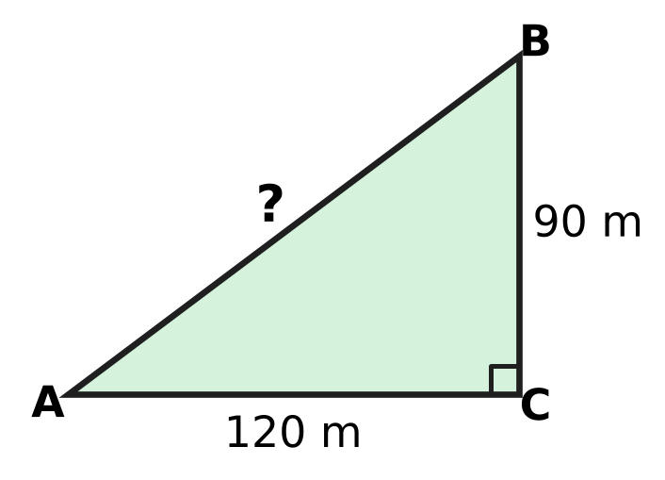
  (A) 105 m | (B) 210 m | (C) 150 m | (D) 30 m

Q18. Which of these is true for every rhombus but is NOT true for every rectangle?
(A) Its diagonals are perpendicular to each other.
(B) Its opposite sides are parallel.
(C) Its diagonals bisect each other.
(D) Its diagonals are equal in length.

Q19. The net in the picture is folded to make a cube. Which number is on the face opposite the face marked 1? | 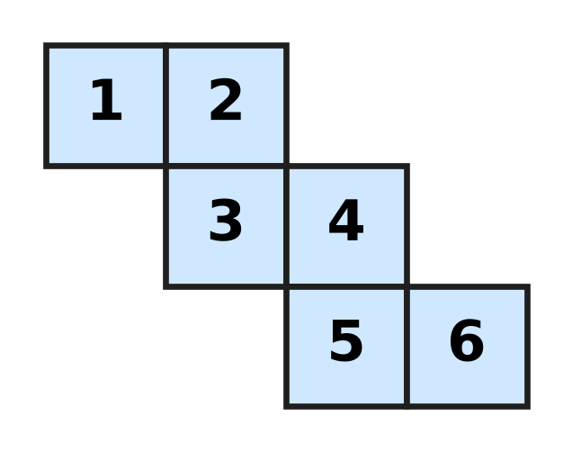
  (A) 3 | (B) 4 | (C) 2 | (D) 6

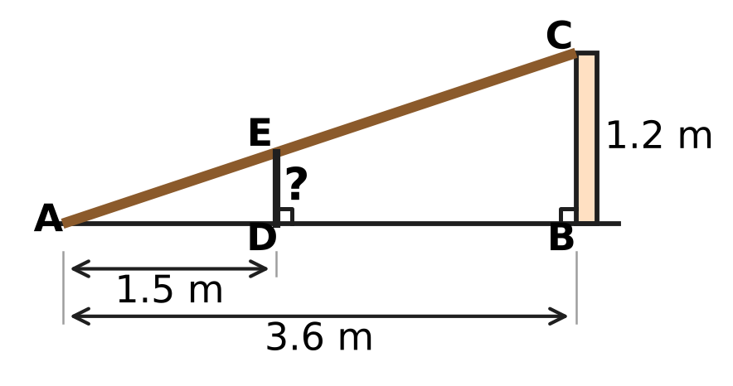
Q20. Vihaan leans a straight wooden plank AC from the ground at A to the top of a wall BC, which is 1.2 m high. A is 3.6 m from the bottom B of the wall. A vertical post DE stands 1.5 m from A and just touches the plank at E, as in the picture. How tall is the post?
(A) 4.5 m | (B) 0.6 m | (C) 0.7 m | (D) 0.5 m

Q21. KLMN is a rhombus with sides of 39 cm, as in the picture. Its diagonal KM is 72 cm long. How long is the other diagonal LN? | 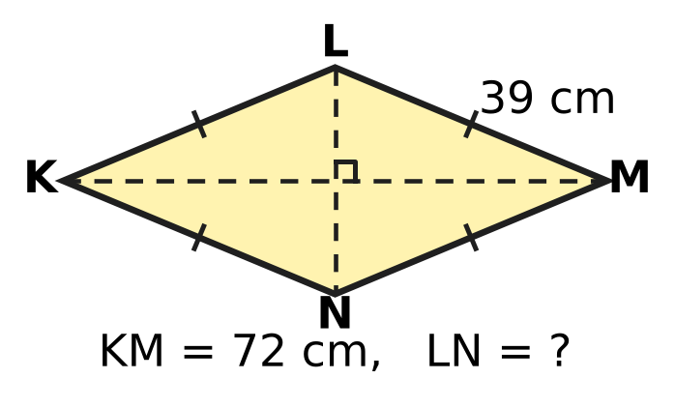
  (A) 33 cm | (B) 30 cm | (C) 15 cm | (D) 78 cm

Part 6 — Mensuration (Syllabus Chapter 6)
Q22. A tent is in the shape of a cone with base radius 3 m and height 3.5 m, as in the picture. How much air is inside the tent? (Use π = $\frac{22}{7}$.) | 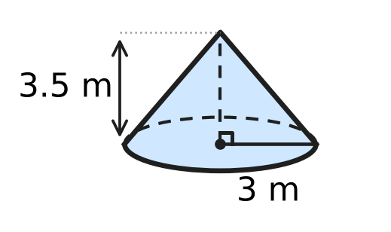
  (A) 33 m³ | (B) 99 m³ | (C) 132 m³ | (D) 11 m³

Q23. A lamp cover is the curved surface of a cone, as in the picture. Its base radius is 14 cm, and it uses 1,100 cm² of material. What is its slant height l? (Use π = $\frac{22}{7}$.) | 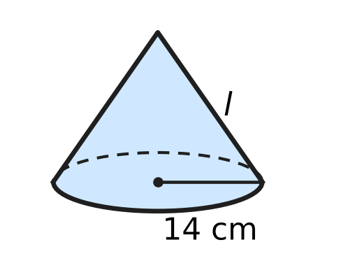
  (A) 5 cm | (B) 12.5 cm | (C) 50 cm | (D) 25 cm

Q24. A closed cylindrical can, shown in the picture, has an inside radius of 7 cm. It holds exactly 1.54 litres when full. What is its height h? (Use π = $\frac{22}{7}$; 1 litre = 1,000 cm³.) | 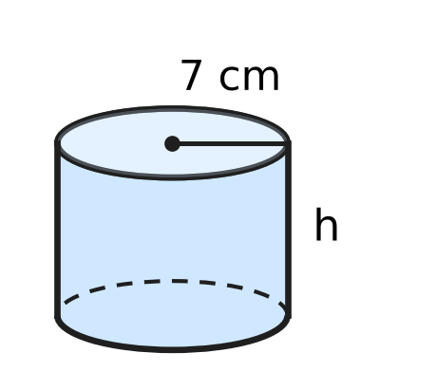
  (A) 2.5 cm | (B) 1 cm | (C) 10 cm | (D) 70 cm

Q25. An umbrella stand is a solid wooden cuboid 20 cm × 20 cm × 30 cm. A cylindrical hole of radius 7 cm and depth 25 cm is cut straight down into its top, as in the picture. What volume of wood is left? (Use π = $\frac{22}{7}$.) | 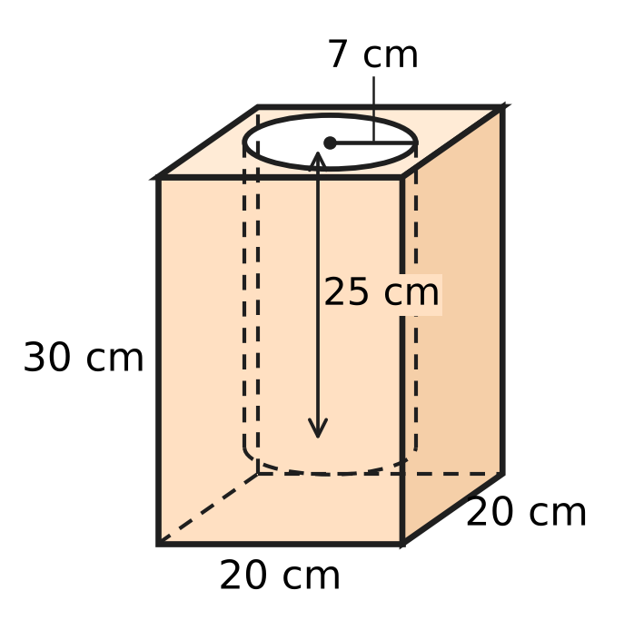
  (A) 15,850 cm³ | (B) 3,850 cm³
  (C) 10,900 cm³ | (D) 8,150 cm³

Q26. A cylindrical glass jar has an inside radius of 7 cm and is partly filled with water. Zara drops 22 identical marbles into it. All of them sink, and the water level rises by 1 cm, as in the picture. What is the volume of one marble? (Use π = $\frac{22}{7}$.) | 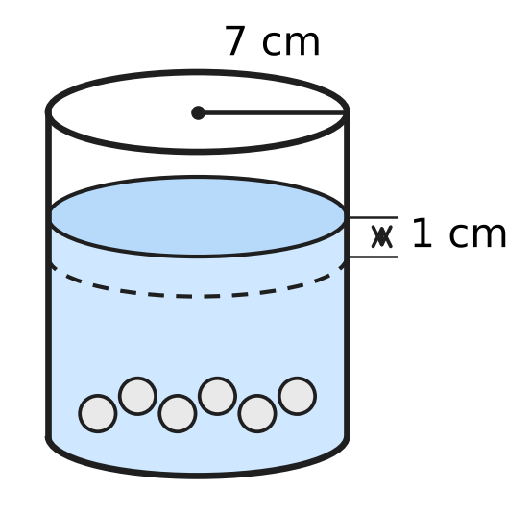
  (A) 7 cm³ | (B) 28 cm³ | (C) 154 cm³ | (D) 2 cm³

Part 7 — Data Handling, Statistics & Probability (Syllabus Chapter 8)
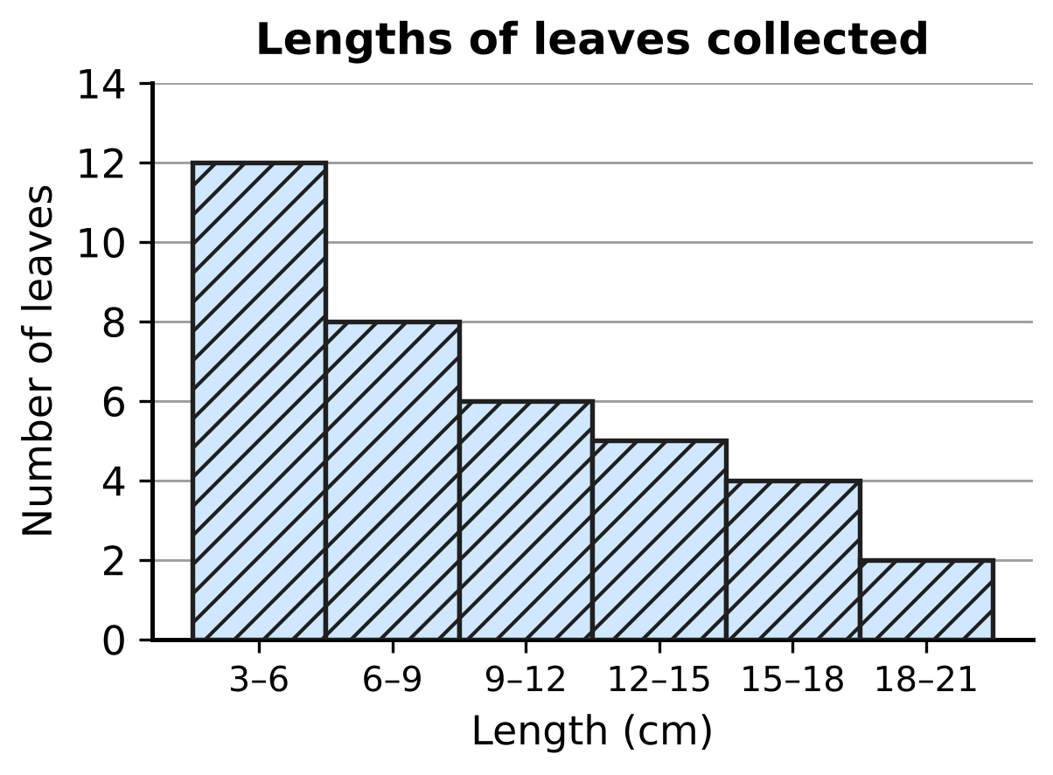
Q27. For a science project, a class measured 37 leaves. The histogram in the picture shows their lengths; the class 6–9 means 6 cm or more but less than 9 cm. The leaves are put in order from shortest to longest. In which class is the length of the middle (19th) leaf?
(A) 3–6 cm | (B) 6–9 cm | (C) 9–12 cm | (D) 12–15 cm

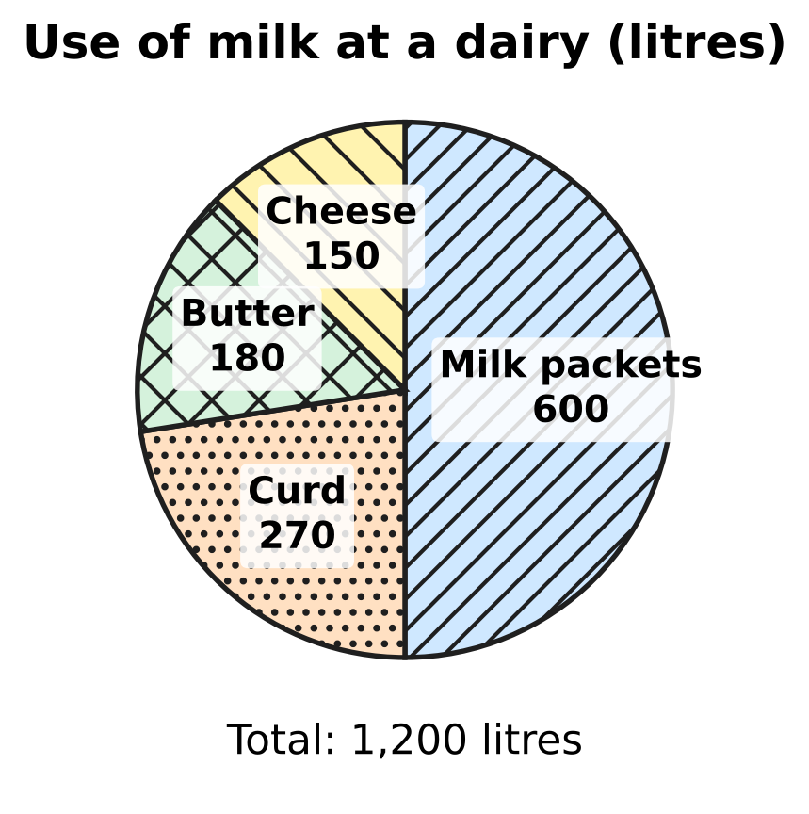
Q28. The pie chart shows how a milk dairy used the 1,200 litres of milk it collected one morning. What is the angle of the sector for butter?
(A) 45° | (B) 60° | (C) 54° | (D) 15°

Q29. The marks of six students, written in increasing order, are 5, 8, x, 14, 19 and 22. The median of the six marks is 12. What is the mean of the six marks?
(A) 12 | (B) 15.6 | (C) 13 | (D) 10

Part 8 — Applied Mathematics (Syllabus Chapter 9)
Q30. Imran borrows ₹40,000 at 6% per year simple interest. On the same day he lends all of it to a friend at 9% per year simple interest. How much does he gain in 3 years?
(A) ₹7,200 | (B) ₹3,600 | (C) ₹1,200 | (D) ₹10,800

Q31. Rupa bakes cakes at home from her own recipes. She buys an oven for ₹4,000. The ingredients for each cake cost ₹180, and she sells each cake for ₹280. How many cakes must she sell so that her profit pays back the cost of the oven?
(A) 23 | (B) 15 | (C) 9 | (D) 40

Q32. Chetan sells his old art-class easel at a loss of 20% on what he paid for it. If he had sold it for twice that price, what would his profit percent have been?
(A) 60% | (B) 20% | (C) 160% | (D) 40%

Q33. A plant nursery buys saplings, all at the same cost price. It sells $\frac{3}{4}$ of them at a profit of 20%. At what loss percent must it sell the rest so that its profit on all the saplings is 12%?
(A) 12% | (B) 3% | (C) 32% | (D) 8%

Q34. A shopkeeper wants to give a discount of 25% on the marked price and still make a profit of 20% on the cost price. By what percent above the cost price must he mark his goods?
(A) 45% | (B) $33\frac{1}{3}$% | (C) 60% | (D) 50%

Part 9 — Mathematical Reasoning & Problem-Solving (Syllabus Chapter 10)
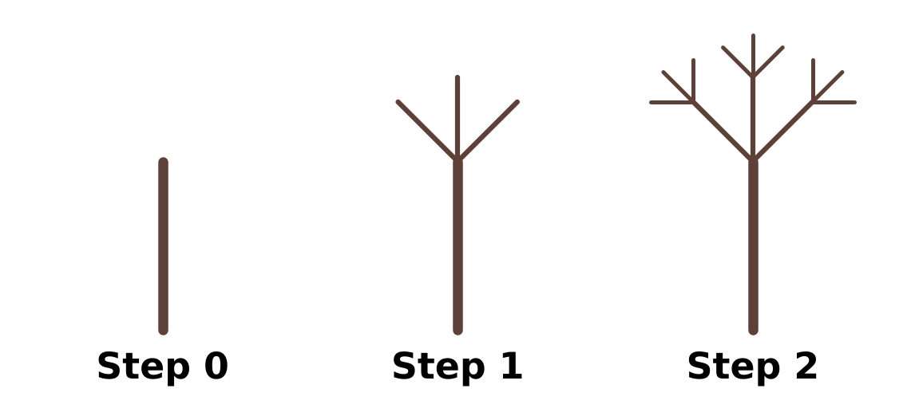
Q35. The picture shows Steps 0, 1 and 2 of a fractal tree. Step 0 is a single straight stem. At each new step, three new branches, each half as long, grow from the free end of every branch drawn in the step before. Counting the stem as a branch, how many branches does the whole tree have at Step 3?
(A) 27 | (B) 40 | (C) 39 | (D) 13

Q36. A whole number leaves a remainder of 5 when it is divided by 12. What remainder does it leave when it is divided by 4?
(A) 5 | (B) 3 | (C) 0 | (D) 1

Q37. Three-digit numbers are made using the digits 2, 4, 5, 7 and 9, with no digit used twice in a number. How many of these numbers are divisible by 5?
(A) 25 | (B) 12 | (C) 20 | (D) 60

Q38. Fifteen schools play a quiz league. They are split into 3 groups of 5. In each group, every school meets every other school of its group once. Then the 3 group winners meet each other once in a final round. How many matches are played in all?
(A) 105 | (B) 30 | (C) 63 | (D) 33

Q39. A, B and C are three different digits, and none of them is 0. Using them, the two-digit numbers AB and AC multiply to give the three-digit number CAB: AB × AC = CAB. What is the number CAB?
(A) 246 | (B) 264 | (C) 624 | (D) 625

Q40. Sonal writes the numbers 1, 2, 3, …, 10 in a row. In each of the 9 gaps between them she writes a + sign or a − sign, and then works out the total. With every sign +, the total is 55. What is the largest total less than 55 that she can get?
(A) 51 | (B) 53 | (C) 54 | (D) 45

SECTION II — Star Questions 5 questions × 4 marks each
Q41. For how many whole numbers n from 1 to 48 is n² + 5n + 6 divisible by 12? [4 marks]
(A) 32 | (B) 24 | (C) 16 | (D) 8

Q42. On squared paper, a rectangle 6 squares long and 4 squares wide is drawn, and a straight line is drawn from one corner to the opposite corner. The line passes through the inside of the 8 shaded squares in the picture. In the same way, a straight line is drawn from corner to opposite corner of a rectangle 20 squares long and 15 squares wide. Through the inside of how many squares does it pass? [4 marks] | 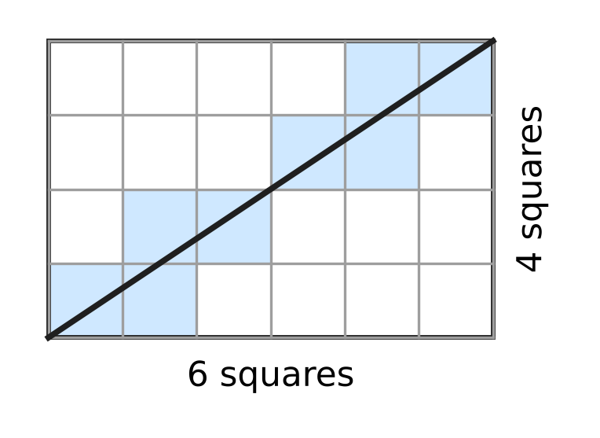
  (A) 35 | (B) 30 | (C) 31 | (D) 33

Q43. ABCD is a parallelogram. The line AE cuts ∠DAB into two equal angles and meets the side DC at E, as in the picture. AD = (x + 5) cm, DE = (2x − 3) cm and EC = (x − 1) cm. What is the perimeter of ABCD? [4 marks] | 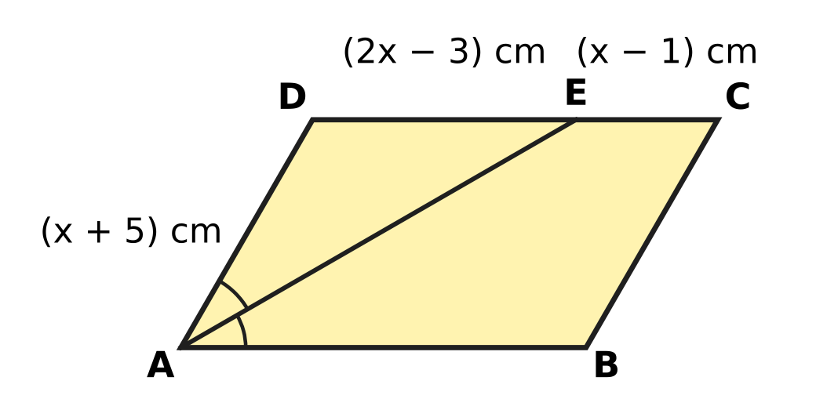
  (A) 80 cm | (B) 33 cm | (C) 52 cm | (D) 66 cm

Q44. A trader buys a cupboard for ₹2,500. He marks its price x% above his cost. Later he sells it at a discount of x% on the marked price, and so makes a loss of ₹100. What was the marked price? [4 marks]
(A) ₹3,000 | (B) ₹2,550 | (C) ₹2,600 | (D) ₹2,400

Q45. Jayesh builds an open cylindrical water tank with no lid. Inside, it has radius 3.5 m and depth 2 m, as in the picture. He lines the inside wall and the floor with tiles, which costs ₹120 for every square metre. He borrows the whole cost at 10% per year simple interest and repays the loan with interest after 2 years. How much does he repay in all? (Use π = $\frac{22}{7}$.) [4 marks] | 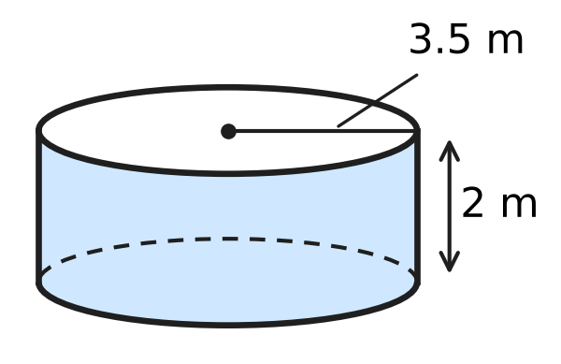
  (A) ₹9,900 | (B) ₹6,336 | (C) ₹17,424 | (D) ₹11,880
Answer Sheet AMO Level 1 · Class 8 · Practice Paper 4
Name: | School: | Roll No.:
Shade or tick one circle for each question.
1. Ⓐ Ⓑ Ⓒ Ⓓ | 16. Ⓐ Ⓑ Ⓒ Ⓓ | 31. Ⓐ Ⓑ Ⓒ Ⓓ
2. Ⓐ Ⓑ Ⓒ Ⓓ | 17. Ⓐ Ⓑ Ⓒ Ⓓ | 32. Ⓐ Ⓑ Ⓒ Ⓓ
3. Ⓐ Ⓑ Ⓒ Ⓓ | 18. Ⓐ Ⓑ Ⓒ Ⓓ | 33. Ⓐ Ⓑ Ⓒ Ⓓ
4. Ⓐ Ⓑ Ⓒ Ⓓ | 19. Ⓐ Ⓑ Ⓒ Ⓓ | 34. Ⓐ Ⓑ Ⓒ Ⓓ
5. Ⓐ Ⓑ Ⓒ Ⓓ | 20. Ⓐ Ⓑ Ⓒ Ⓓ | 35. Ⓐ Ⓑ Ⓒ Ⓓ
6. Ⓐ Ⓑ Ⓒ Ⓓ | 21. Ⓐ Ⓑ Ⓒ Ⓓ | 36. Ⓐ Ⓑ Ⓒ Ⓓ
7. Ⓐ Ⓑ Ⓒ Ⓓ | 22. Ⓐ Ⓑ Ⓒ Ⓓ | 37. Ⓐ Ⓑ Ⓒ Ⓓ
8. Ⓐ Ⓑ Ⓒ Ⓓ | 23. Ⓐ Ⓑ Ⓒ Ⓓ | 38. Ⓐ Ⓑ Ⓒ Ⓓ
9. Ⓐ Ⓑ Ⓒ Ⓓ | 24. Ⓐ Ⓑ Ⓒ Ⓓ | 39. Ⓐ Ⓑ Ⓒ Ⓓ
10. Ⓐ Ⓑ Ⓒ Ⓓ | 25. Ⓐ Ⓑ Ⓒ Ⓓ | 40. Ⓐ Ⓑ Ⓒ Ⓓ
11. Ⓐ Ⓑ Ⓒ Ⓓ | 26. Ⓐ Ⓑ Ⓒ Ⓓ | 41. Ⓐ Ⓑ Ⓒ Ⓓ
12. Ⓐ Ⓑ Ⓒ Ⓓ | 27. Ⓐ Ⓑ Ⓒ Ⓓ | 42. Ⓐ Ⓑ Ⓒ Ⓓ
13. Ⓐ Ⓑ Ⓒ Ⓓ | 28. Ⓐ Ⓑ Ⓒ Ⓓ | 43. Ⓐ Ⓑ Ⓒ Ⓓ
14. Ⓐ Ⓑ Ⓒ Ⓓ | 29. Ⓐ Ⓑ Ⓒ Ⓓ | 44. Ⓐ Ⓑ Ⓒ Ⓓ
15. Ⓐ Ⓑ Ⓒ Ⓓ | 30. Ⓐ Ⓑ Ⓒ Ⓓ | 45. Ⓐ Ⓑ Ⓒ Ⓓ
Q41–Q45 are Section II Star Questions (4 marks each).
For the parent or teacher
Section I correct: ______ / 40 × 2 = ______ marks Section II correct: ______ / 5 × 4 = ______ marks
Correct: ______ / 45 Score: ______ / 100
Answer Key and Solutions AMO Level 1 · Class 8 · Practice Paper 4
Quick answers
1 D | 6 C | 11 A | 16 A | 21 B | 26 A | 31 D | 36 D | 41 C
2 C | 7 B | 12 C | 17 C | 22 A | 27 B | 32 A | 37 B | 42 B
3 A | 8 D | 13 D | 18 A | 23 D | 28 C | 33 A | 38 D | 43 D
4 B | 9 B | 14 C | 19 B | 24 C | 29 C | 34 C | 39 C | 44 A
5 A | 10 D | 15 B | 20 D | 25 D | 30 B | 35 B | 40 A | 45 D
Solutions
Q | Part · level | Answer | Why?
1 | Part 1 · Ch1 · Easy | (D) 15 | 25² = 625 ≤ 640 < 676 = 26², so the largest square has 25 rows of 25 students. Then 640 − 625 = 15 students stand at the side.
2 | Part 1 · Ch1 · Easy | (C) the product of a non-zero rational number and an irrational number | √2 + (−√2) = 0, √2 × √8 = 4 and √8 ÷ √2 = 2 are rational. A non-zero rational times an irrational, such as 3√2, is always irrational.
3 | Part 1 · Ch1 · Medium | (A) 9 cm | Total volume = 1³ + 6³ + 8³ = 1 + 216 + 512 = 729 cm³. The new edge is ∛729 = 9 cm.
4 | Part 2 · Ch2 · Easy | (B) $ab^{6}$ | (a⁻²b³)² = a⁻⁴b⁶. Then a⁻⁴ × a⁵ = a¹, so the answer is ab⁶.
5 | Part 2 · Ch2 · Easy | (A) 0 | (−1)⁻¹ = −1, (−1)⁻² = 1, (−1)⁻³ = −1 and (−1)⁻⁴ = 1. The sum is −1 + 1 − 1 + 1 = 0.
6 | Part 2 · Ch2 · Medium | (C) 40 | (1 × 10⁻⁴) ÷ (2.5 × 10⁻⁶) = (1 ÷ 2.5) × 10⁻⁴⁺⁶ = 0.4 × 100 = 40.
7 | Part 3 · Ch3 · Easy | (B) ₹612 | Sale price = 800 × 0.85 = ₹680. Kiara pays 680 × 0.9 = ₹612.
8 | Part 3 · Ch3 · Easy | (D) ₹4,000 | In 3 years the interest is 15% of the money put in, so ₹4,600 is 115% of it. The sum is 4,600 ÷ 1.15 = ₹4,000.
9 | Part 3 · Ch3 · Easy | (B) 25% | The fall is ₹10 on the old fare of ₹40. So the fall is 10 ÷ 40 × 100 = 25%.
10 | Part 3 · Ch3 · Medium | (D) ₹6,000 | The extra interest is 3% per year for 4 years, which is 12% of the sum. 12% of the sum = ₹720, so the sum is 720 ÷ 0.12 = ₹6,000.
11 | Part 3 · Ch3 · Medium | (A) 30% | Money = price × visitors. The new price is 0.9 times the old, and the new money is 1.17 times the old, so visitors became 1.17 ÷ 0.9 = 1.3 times as many: a rise of 30%.
12 | Part 4 · Ch4 · Easy | (C) 49 | For 4y² − 28y + b² = (2y − b)² we need 2 × 2y × b = 28y, so b = 7 and b² = 49: 4y² − 28y + 49 = (2y − 7)².
13 | Part 4 · Ch4 · Easy | (D) (x + 5) cm | x² + 9x + 20 = (x + 4)(x + 5), because 4 + 5 = 9 and 4 × 5 = 20. So the other side is (x + 5) cm.
14 | Part 4 · Ch4 · Easy | (C) 13.4 m | Let the width be w m. Then 2(w + w + 7.3) = 39, so 2w + 7.3 = 19.5 and w = 6.1. The length is 6.1 + 7.3 = 13.4 m.
15 | Part 4 · Ch4 · Medium | (B) 300 | Let the number of 12-egg trays be t. Then 12t = 15(t − 5), so 3t = 75 and t = 25. There are 12 × 25 = 300 eggs.
16 | Part 4 · Ch4 · Medium | (A) 1 | n² + 2n − 3 = (n + 3)(n − 1). A product of two whole numbers is prime only if the smaller factor is 1, so n − 1 = 1 and n = 2, giving 5. Only 1 answer is prime.
17 | Part 5 · Ch5 · Easy | (C) 150 m | AB² = 90² + 120² = 8,100 + 14,400 = 22,500, so AB = 150 m.
18 | Part 5 · Ch5 · Easy | (A) Its diagonals are perpendicular to each other. | The diagonals of every rhombus cross at right angles. A rectangle that is not a square has diagonals that are not perpendicular.
19 | Part 5 · Ch5 · Easy | (B) 4 | Take face 3 as the base. Faces 2 and 4 fold up as the back and right walls, 5 folds up from 4 as the front wall, 1 folds down from 2 as the left wall and 6 is the top. So 1 (left) is opposite 4 (right).
20 | Part 5 · Ch5 · Medium | (D) 0.5 m | Triangles ADE and ABC are similar (same angle at A, right angles at D and B). So DE ÷ 1.2 = 1.5 ÷ 3.6, which gives DE = 0.5 m.
21 | Part 5 · Ch5 · Medium | (B) 30 cm | The diagonals of a rhombus bisect each other at right angles. Half of LN = √(39² − 36²) = √225 = 15 cm, so LN = 30 cm.
22 | Part 6 · Ch6 · Easy | (A) 33 m³ | V = ⅓πr²h = ⅓ × 22/7 × 9 × 3.5 = 33 m³.
23 | Part 6 · Ch6 · Easy | (D) 25 cm | Curved surface = πrl, so 22/7 × 14 × l = 1,100. That is 44 × l = 1,100, so l = 25 cm.
24 | Part 6 · Ch6 · Easy | (C) 10 cm | The volume is 1.54 litres = 1,540 cm³. πr² = 22/7 × 49 = 154 cm², so h = 1,540 ÷ 154 = 10 cm.
25 | Part 6 · Ch6 · Medium | (D) 8,150 cm³ | Cuboid = 20 × 20 × 30 = 12,000 cm³. Hole = 22/7 × 7² × 25 = 3,850 cm³. Wood left = 12,000 − 3,850 = 8,150 cm³.
26 | Part 6 · Ch6 · Medium | (A) 7 cm³ | The marbles push up a cylinder of water 1 cm high: 22/7 × 7² × 1 = 154 cm³. One marble = 154 ÷ 22 = 7 cm³.
27 | Part 7 · Ch8 · Easy | (B) 6–9 cm | Counting from the shortest: the 3–6 class holds leaves 1 to 12 and the 6–9 class holds leaves 13 to 20. So the 19th leaf is in the class 6–9 cm.
28 | Part 7 · Ch8 · Easy | (C) 54° | Angle = 180 ÷ 1,200 × 360° = 54°.
29 | Part 7 · Ch8 · Medium | (C) 13 | For six values the median is the average of the 3rd and 4th: (x + 14) ÷ 2 = 12, so x = 10. Mean = (5 + 8 + 10 + 14 + 19 + 22) ÷ 6 = 78 ÷ 6 = 13.
30 | Part 8 · Ch9 · Easy | (B) ₹3,600 | He gains 9% − 6% = 3% of ₹40,000 each year, which is ₹1,200. In 3 years he gains ₹3,600.
31 | Part 8 · Ch9 · Easy | (D) 40 | Each cake gives a profit of 280 − 180 = ₹100. To make ₹4,000 she must sell 4,000 ÷ 100 = 40 cakes.
32 | Part 8 · Ch9 · Easy | (A) 60% | Take the cost as ₹100. He sold it for ₹80, so twice that price is ₹160. The profit is ₹60 on ₹100, which is 60%.
33 | Part 8 · Ch9 · Medium | (A) 12% | Take the total cost as 100. The first part gives 75 × 20% = 15 profit; the target is 12. The other 25 must lose 3, which is 3 ÷ 25 = 12% loss.
34 | Part 8 · Ch9 · Medium | (C) 60% | Take the cost price as ₹100. The selling price must be ₹120, which is 75% of the marked price. Marked price = 120 ÷ 0.75 = ₹160, which is 60% above cost.
35 | Part 9 · Ch10 · Easy | (B) 40 | The steps add 1, 3, 9 and 27 branches, each step three times the one before. At Step 3 the tree has 1 + 3 + 9 + 27 = 40 branches.
36 | Part 9 · Ch10 · Easy | (D) 1 | The number is 12k + 5 = 4(3k + 1) + 1. So the remainder on division by 4 is 1.
37 | Part 9 · Ch10 · Easy | (B) 12 | The number must end in 5, since 0 is not available. The first digit then has 4 choices and the middle digit 3, so there are 4 × 3 = 12 numbers.
38 | Part 9 · Ch10 · Medium | (D) 33 | Each group of 5 has 5 × 4 ÷ 2 = 10 matches, so the groups have 3 × 10 = 30. The final round has 3 matches. Total 30 + 3 = 33.
39 | Part 9 · Ch10 · Medium | (C) 624 | CAB ends in B, so B × C ends in B, and A must be small to keep the product at three digits. Trying the cases, only 24 × 26 = 624 works.
40 | Part 9 · Ch10 · Medium | (A) 51 | Changing + k to − k lowers the total by 2k, and the smallest k with a sign in front of it is 2. So the largest total below 55 is 55 − 4 = 51.
41 | Section II · Ch4 + Ch10 · Hard | (C) 16 | n² + 5n + 6 = (n + 2)(n + 3), two consecutive numbers, so exactly one of them is even. It is divisible by 4 only when n + 2 or n + 3 is a multiple of 4, and by 3 only when n + 2 or n + 3 is a multiple of 3. In each block of 12 numbers both hold for 4 values of n (n = 1, 6, 9, 10), so from 1 to 48 there are 4 × 4 = 16.
42 | Section II · Ch5 + Ch10 · Hard | (B) 30 | The line enters a new square each time it crosses one of the 19 + 14 = 33 inside grid lines, except that it crosses two lines at once at a corner. By similar triangles it meets a corner (x, y) only when y : x = 15 : 20 = 3 : 4, at (4, 3), (8, 6), (12, 9) and (16, 12). So it passes through 1 + 33 − 4 = 30 squares.
43 | Section II · Ch4 + Ch5 · Hard | (D) 66 cm | AB ∥ DC, so ∠DEA = ∠EAB (alternate angles) = ∠DAE. So △ADE is isosceles with DE = AD: 2x − 3 = x + 5, x = 8. Then AD = 13 cm and DC = 13 + 7 = 20 cm, so the perimeter is 2 × (13 + 20) = 66 cm.
44 | Section II · Ch3 + Ch9 · Hard | (A) ₹3,000 | The selling price is 2,500 × (1 + x/100)(1 − x/100) = 2,400, so 1 − x²/10,000 = 0.96 and x² = 400, x = 20. Marked price = 2,500 × 1.2 = ₹3,000.
45 | Section II · Ch6 + Ch9 · Hard | (D) ₹11,880 | Wall = 2 × 22/7 × 3.5 × 2 = 44 m² and floor = 22/7 × 3.5 × 3.5 = 38.5 m², so 82.5 m² in all. Cost = 82.5 × 120 = ₹9,900. Interest = 20% of 9,900 = ₹1,980, so he repays ₹11,880.

ARYABHATTA MATHS OLYMPIAD
Level 1
PRACTICE PAPER-5
CLASS 8
Total Questions | 45 multiple-choice questions
Total Marks | 100
Time | 60 minutes
Section I | 40 questions × 2 marks = 80 marks
Section II | 5 Star Questions × 4 marks = 20 marks
Negative Marking | No negative marking
Calculator | Not allowed
Chapters | Number System · Operations · Fractions, Decimals & Percentages · Algebra · Geometry · Mensuration · Data Handling · Applied Mathematics · Mathematical Reasoning

Instructions to candidates
• This paper has 45 multiple-choice questions. Each question has four answer choices, of which exactly one is correct.
• Section I (Q1–Q40) carries 2 marks per question. Section II (Q41–Q45) carries 4 marks per question.
• There is no negative marking. Unanswered questions score zero.
• Calculators are not permitted. Rough work may be done on a separate sheet.
• Mark your answers on the answer sheet at the end of the paper.
• All figures are not necessarily drawn to scale unless stated.

For parents and teachers
• Print or view this paper in colour. Pictures are part of the questions.
• Parts follow the AMO syllabus chapters. Chapter 7 is not part of the Class 8 syllabus, so the chapter numbers shown in the Part headings have gaps.
• The answer sheet and the answer key are at the end. Remove only the answer key before the student begins.

SECTION I 40 questions × 2 marks each
Part 1 — Number System (Syllabus Chapter 1)
Q1. A gift box is a cube. Its volume is 512 cm³. What is the area of one face of the box?
(A) 8 cm² | (B) 64 cm² | (C) 384 cm² | (D) 128 cm²

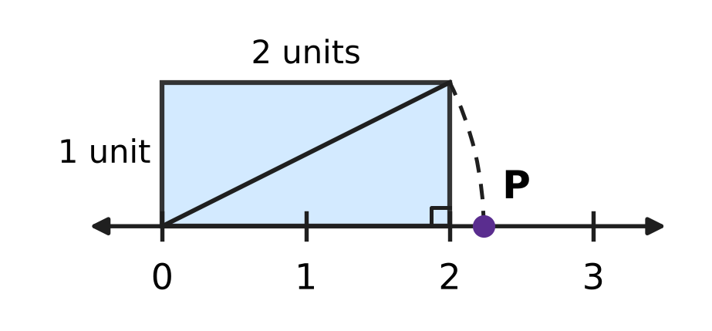
Q2. In the picture, a rectangle 2 units long and 1 unit high stands on the number line with one corner at 0. An arc with centre 0 passes through the opposite corner of the rectangle and meets the number line at P. Which number does P show?
(A) √3 | (B) 3 | (C) 5 | (D) √5

Q3. The odd numbers 1, 3, 5, 7, … are added in order, starting from 1, and the adding stops at the odd number k. The total is 324. What is k?
(A) 37 | (B) 18 | (C) 35 | (D) 33

Part 2 — Operations & Number Properties (Syllabus Chapter 2)
Q4. I am a number. When I am raised to the power −2, the answer is $\frac{1}{49}$. My cube is a negative number. Who am I?
(A) −7 | (B) $−\frac{1}{7}$ | (C) 7 | (D) $\frac{1}{7}$

Q5. Which of these is NOT equal to 0.0006?
(A) 60 × 10⁻⁵ | (B) 6 × 10⁻³
(C) 6 × 10⁻⁴ | (D) 0.6 × 10⁻³

Q6. Parth simplified (2³)⁻² × 2⁸ like this: (2³)⁻² × 2⁸ = 2³⁻²⁺⁸ = 2⁹ = 512. His answer is wrong. What is the correct value?
(A) 16,384 | (B) $\frac{1}{4}$ | (C) 4 | (D) 512

Part 3 — Fractions, Decimals & Percentages (Syllabus Chapter 3)
Q7. Lata's savings are 60% more than Zoya's savings. By what percentage are Zoya's savings less than Lata's?
(A) 62.5% | (B) 40% | (C) 60% | (D) 37.5%

Q8. Dhruv puts ₹10,000 in a bank that pays simple interest. The rate is 6% per year for the first 2 years and 8% per year for the next 3 years. How much interest does he earn in the 5 years?
(A) ₹3,600 | (B) ₹3,000 | (C) ₹4,000 | (D) ₹3,500

Q9. A plane takes off with a full fuel tank. In the first hour it uses 40% of the fuel. In the second hour it uses 30% of the fuel that is left. After two hours, 8,400 litres of fuel are left. How many litres does the full tank hold?
(A) 28,000 litres | (B) 20,000 litres
(C) 12,000 litres | (D) 14,000 litres

Q10. Last week, 40% of the ice creams sold at an ice-cream stall were mango. This week the stall sold 25% more ice creams in all, and 50% more mango ice creams than last week. What percentage of this week's ice creams were mango?
(A) 48% | (B) 50% | (C) 32% | (D) 60%

Q11. On the same day, Hana puts ₹8,000 in a bank at 5% per year simple interest, and Ivan puts ₹6,000 in another bank at 10% per year simple interest. After how many years will they have the same amount?
(A) 20 years | (B) 2 years | (C) 5 years | (D) 10 years

Part 4 — Algebra (Syllabus Chapter 4)
Q12. One factor of xy − 4x + 3y − 12 is (y − 4). What is the other factor?
(A) x − 4 | (B) y + 3 | (C) x + 3 | (D) x − 3

Q13. Hot-air balloon A is 150 m above the ground and rises 15 m every minute. At the same moment, balloon B is 690 m above the ground and comes down 12 m every minute. After how many minutes will the two balloons be at the same height?
(A) 180 minutes | (B) 45 minutes
(C) 20 minutes | (D) 36 minutes

Q14. For two numbers a and b, a − b = 4 and a² + b² = 40. What is the value of ab?
(A) 24 | (B) 18 | (C) 36 | (D) 12

Q15. In a music class, there are 4 more girls than boys. Then 6 girls move to another class and 6 new boys join. Now there are twice as many boys as girls. How many children were in the music class at the start?
(A) 24 | (B) 10 | (C) 14 | (D) 12

Q16. The product of two consecutive odd numbers is 399. What is their sum?
(A) 42 | (B) 40 | (C) 38 | (D) 20

Part 5 — Geometry (Syllabus Chapter 5)
Q17. ABCD is a kite with AB = AD and CB = CD, as marked in the picture. ∠DAB = 70° and ∠BCD = 50°. What is x, the size of ∠ABC? | 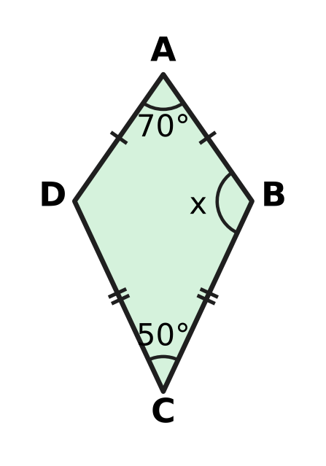
  (A) 60° | (B) 120° | (C) 110° | (D) 240°

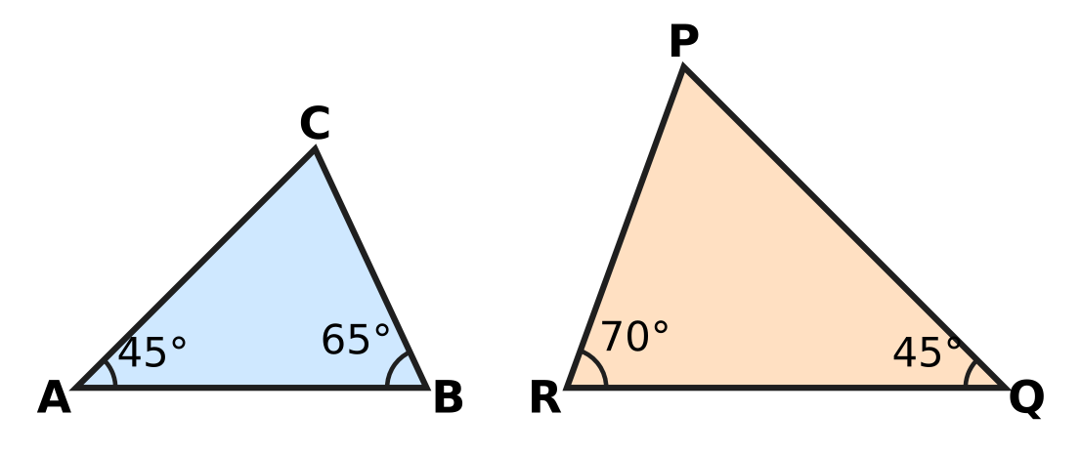
Q18. Look at the two triangles in the picture, with the angles marked. Which of these statements is correct?
(A) △ABC ∼ △QRP | (B) △ABC ∼ △PQR
(C) △ABC ∼ △QPR | (D) △ABC ∼ △RPQ

Q19. A square floor tile has a diagonal of 30 cm, as in the picture. What is the area of the tile? | 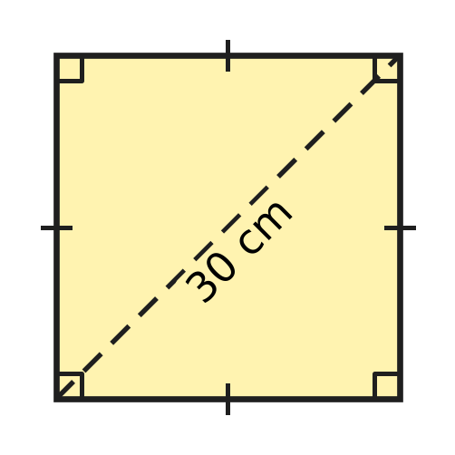
  (A) 225 cm² | (B) 441 cm² | (C) 900 cm² | (D) 450 cm²

Q20. A playground swing hangs from a bar on straight chains 2.5 m long. The seat is pulled back, with the chains kept straight, until it is 1.5 m sideways from where it hangs at rest, as in the picture. How much higher is the seat now than at rest? | 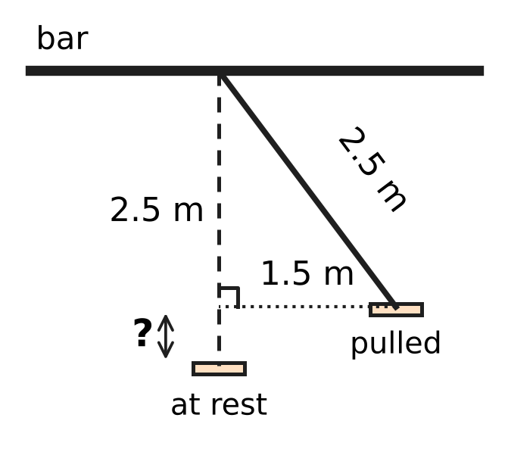
  (A) 0.5 m | (B) 1 m | (C) 2 m | (D) 1.5 m

Q21. PQRS is a rhombus. Its diagonal PR is exactly as long as each side, as marked in the picture. What is ∠QPS? | 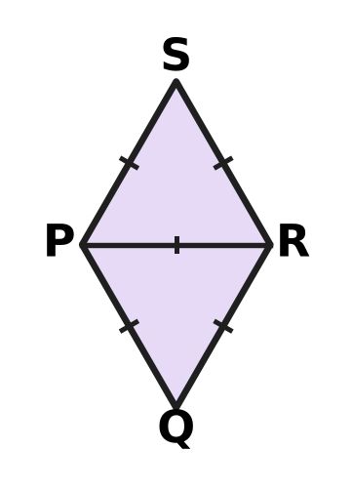
  (A) 60° | (B) 90° | (C) 120° | (D) 30°

Part 6 — Mensuration (Syllabus Chapter 6)
Q22. A steel container is a cylinder that is open at the top. Its radius is 7 cm and its height is 9 cm, as in the picture. What is the area of its outside surface (the curved surface and the base)? (Use π = $\frac{22}{7}$.) | 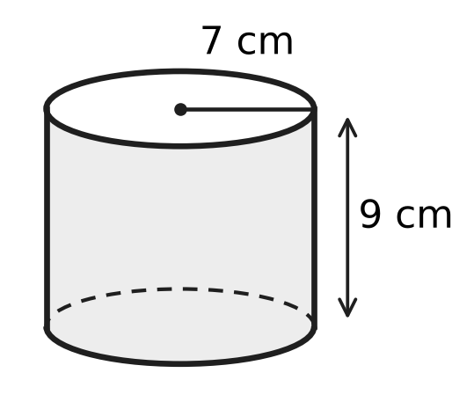
  (A) 396 cm² | (B) 550 cm²
  (C) 1,386 cm² | (D) 704 cm²

Q23. Cylinder A has radius 7 cm and height 10 cm. Cylinder B has radius 10 cm and height 7 cm, as in the picture. Their curved surfaces have the same area. How much greater is the volume of B than the volume of A? (Use π = $\frac{22}{7}$.) | 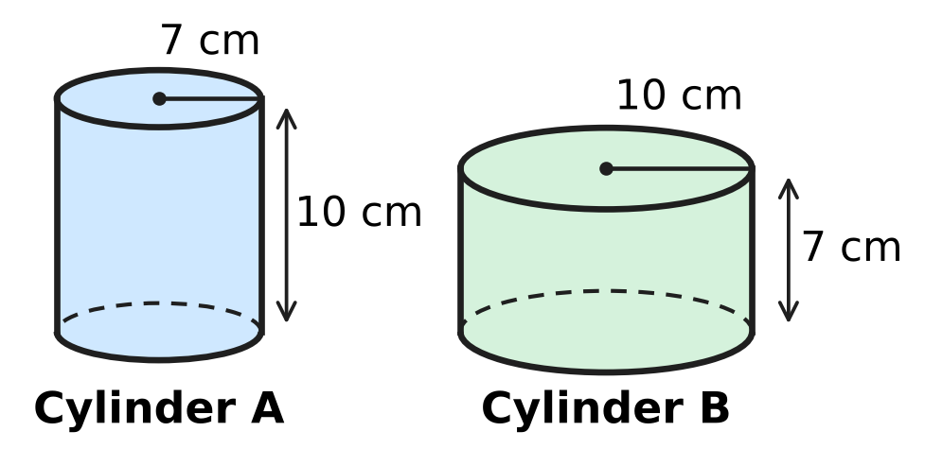
  (A) 1,540 cm³ | (B) 0 cm³
  (C) 2,200 cm³ | (D) 660 cm³

Q24. In a storm, 2 cm of rain falls on the flat roof of Deepa's house. The roof is a rectangle 15 m long and 8 m wide. All the rain that falls on the roof is collected. How many litres is this? (1 m³ = 1,000 litres.)
(A) 2,400 litres | (B) 240,000 litres
(C) 24,000 litres | (D) 240 litres

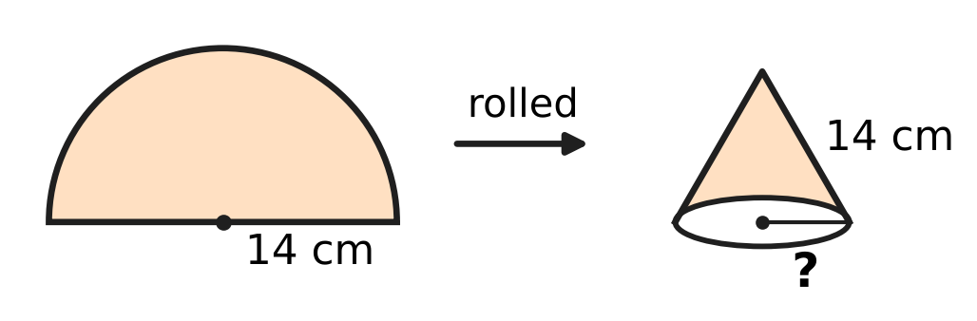
Q25. A semicircular sheet of paper has radius 14 cm. It is rolled into an open cone so that its two straight edges just meet, with no overlap, as in the picture. What is the radius of the base of the cone?
(A) 14 cm | (B) 7 cm | (C) 3.5 cm | (D) 22 cm

Q26. A closed cylinder has a curved surface area of 880 cm² and a total surface area of 1,188 cm². What is its radius? (Use π = $\frac{22}{7}$.)
(A) 49 cm | (B) 14 cm | (C) 7 cm | (D) 20 cm

Part 7 — Data Handling, Statistics & Probability (Syllabus Chapter 8)
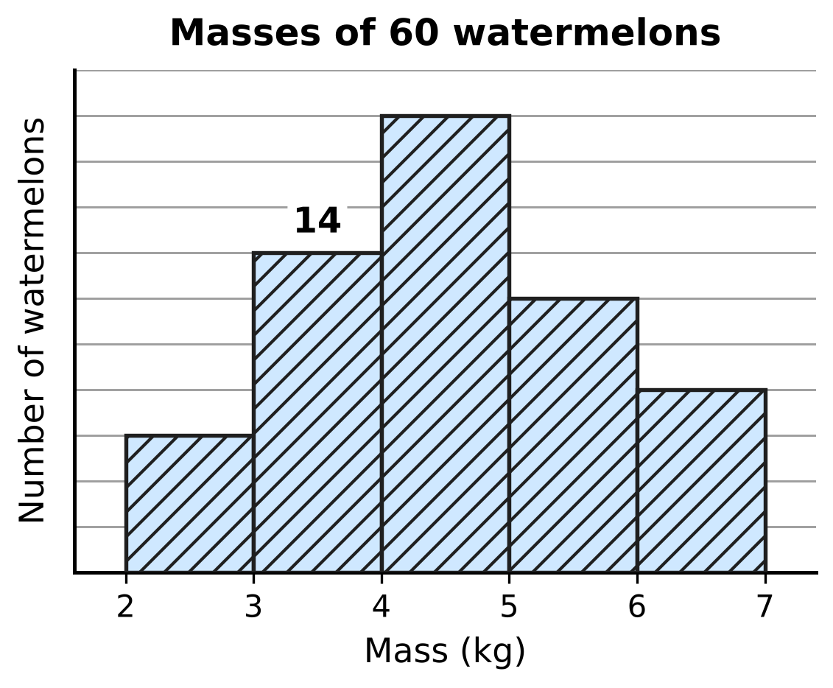
Q27. The histogram in the picture shows the masses of 60 watermelons. The class 3–4 means 3 kg or more but less than 4 kg. The numbers on the vertical scale are missing, but the bar for 3–4 kg is marked: it stands for 14 watermelons. How many watermelons have a mass of 5 kg or more but less than 6 kg?
(A) 6 | (B) 20 | (C) 8 | (D) 12

Q28. The pie chart shows the bouquets a flower shop sold in one week. The angle of each sector is marked. The shop sold 48 more bouquets of roses than bouquets of lilies. How many bouquets did it sell in all that week? | 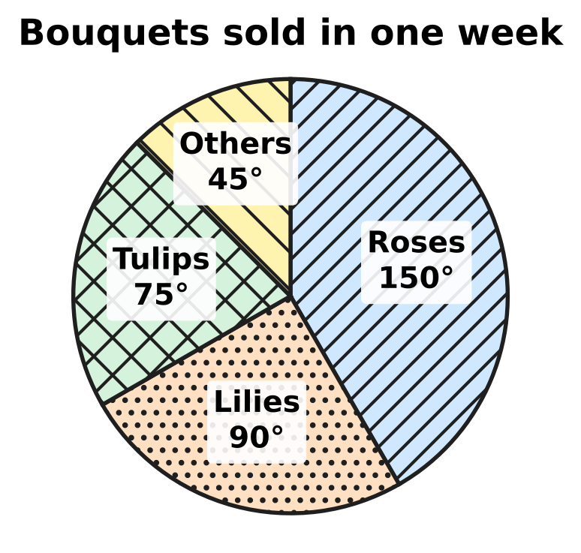
  (A) 288 | (B) 72 | (C) 80 | (D) 120

Q29. Five whole numbers have a mean of 7 and a median of 6. Their only mode is 4. What is the greatest possible value of the largest of the five numbers?
(A) 21 | (B) 14 | (C) 15 | (D) 17

Part 8 — Applied Mathematics (Syllabus Chapter 9)
Q30. If Usha sells her old study table for ₹1,140, she makes a loss. If she sells it for ₹1,260, she makes a profit equal to that loss. What did the table cost her?
(A) ₹1,200 | (B) ₹1,320 | (C) ₹1,080 | (D) ₹60

Q31. Zubin needs to borrow ₹50,000 for 3 years. Bank X charges 8% per year simple interest. Bank Y charges 7% per year simple interest and also a one-time fee of ₹1,000. How much does Zubin save by choosing the cheaper bank?
(A) ₹1,500 | (B) ₹1,000 | (C) ₹2,500 | (D) ₹500

Q32. A school spent ₹7,500 on its play. It sold 300 tickets at ₹30 each. What was its profit percent?
(A) 120% | (B) 15% | (C) 20% | (D) $16\frac{2}{3}$%

Q33. At a tea stall, each cup of tea costs ₹6 to make, and the rent for the day is ₹600. One day the stall sells 300 cups at ₹10 each. What is its profit percent for that day?
(A) $66\frac{2}{3}$% | (B) 25% | (C) 20% | (D) $33\frac{1}{3}$%

Q34. Kian sells a camera at a profit of 10%. If he had bought it for 10% less and sold it for ₹30 less, he would have made a profit of 20%. What did the camera cost him?
(A) ₹300 | (B) ₹3,000 | (C) ₹1,500 | (D) ₹750

Part 9 — Mathematical Reasoning & Problem-Solving (Syllabus Chapter 10)
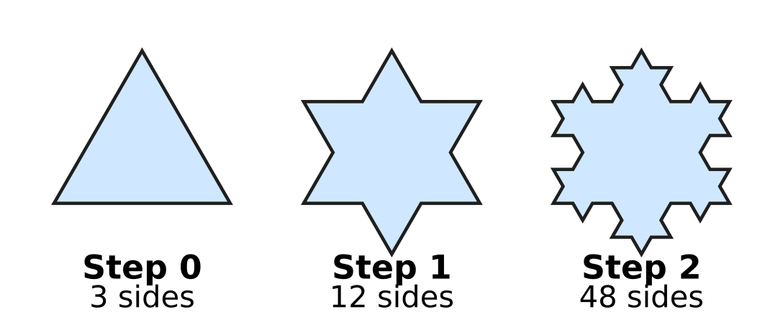
Q35. The picture shows Steps 0, 1 and 2 of the Koch snowflake. At each step, every side is replaced by 4 sides, each one-third as long. At which step does the snowflake first have more than 500 sides?
(A) Step 3 | (B) Step 8 | (C) Step 5 | (D) Step 4

Q36. A toy robot moves along the lines of the grid in the picture, from corner S to corner T. At every step it moves one side of a small square to the right or one side up, never left or down. How many different routes can it take from S to T? | 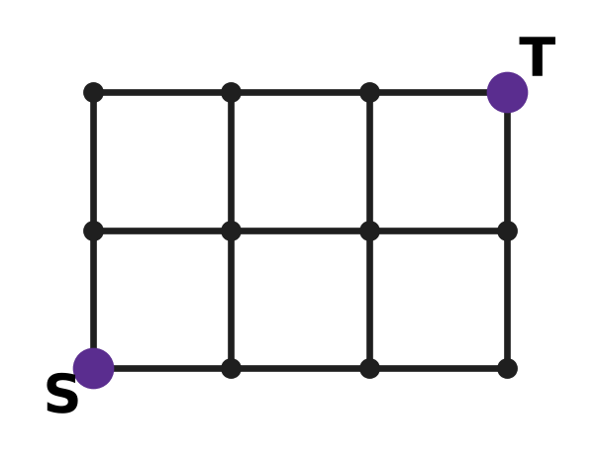
  (A) 10 | (B) 5 | (C) 6 | (D) 20

Q37. Look at this pattern: 3 × 4 × 5 × 6 + 1 = 361 = 19², 4 × 5 × 6 × 7 + 1 = 841 = 29², and 5 × 6 × 7 × 8 + 1 = 1,681 = 41². In the same way, 10 × 11 × 12 × 13 + 1 is a perfect square. What is its square root?
(A) 133 | (B) 131 | (C) 130 | (D) 143

Q38. ABB is a three-digit perfect square. A and B are different digits, and B ≠ 0. What is A + B?
(A) 5 | (B) 1 | (C) 9 | (D) 4

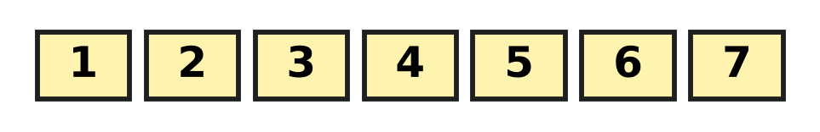
Q39. At a science exhibition, there are 7 stalls in a row, numbered 1 to 7 as in the picture. Three of the stalls are to be chosen for robot models. No two of the chosen stalls may be next to each other. In how many ways can the three stalls be chosen?
(A) 25 | (B) 15 | (C) 35 | (D) 10

Q40. A building has floors numbered 0 to 30. Its lift starts at floor 0. Each time the lift moves, it goes exactly 3 floors up or exactly 3 floors down. What is the highest floor the lift can be on after exactly 15 moves?
(A) 29 | (B) 30 | (C) 27 | (D) 45

SECTION II — Star Questions 5 questions × 4 marks each
Q41. ABCD is a four-digit number. AB and CD are the two-digit numbers made by its first two and its last two digits. Different letters stand for different digits, and neither A nor C is 0. If ABCD = (AB + CD)², what is AB + CD? [4 marks]
(A) 99 | (B) 45 | (C) 30 | (D) 55

Q42. The triangle ABC in the picture has sides 4 cm, 6 cm and 9 cm. Another triangle is similar to triangle ABC, and two of its sides are 12 cm and 18 cm long. What is the greatest possible perimeter of this triangle? [4 marks] | 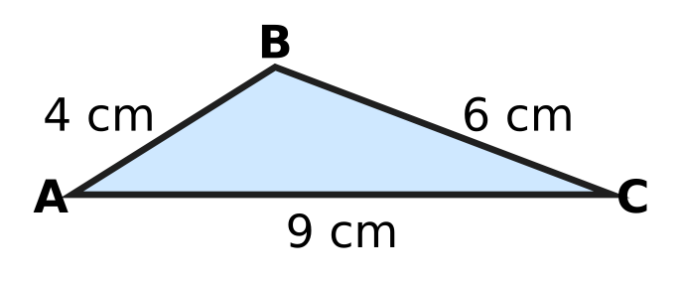
  (A) 57 cm | (B) 95 cm | (C) 85.5 cm | (D) 38 cm

Q43. In the trapezium ABCD in the picture, AB ∥ DC, AB = 10 cm and DC = 15 cm. The diagonals AC and BD meet at O. BO = (x + 1) cm and OD = (2x − 4) cm. How long is the diagonal BD? [4 marks] | 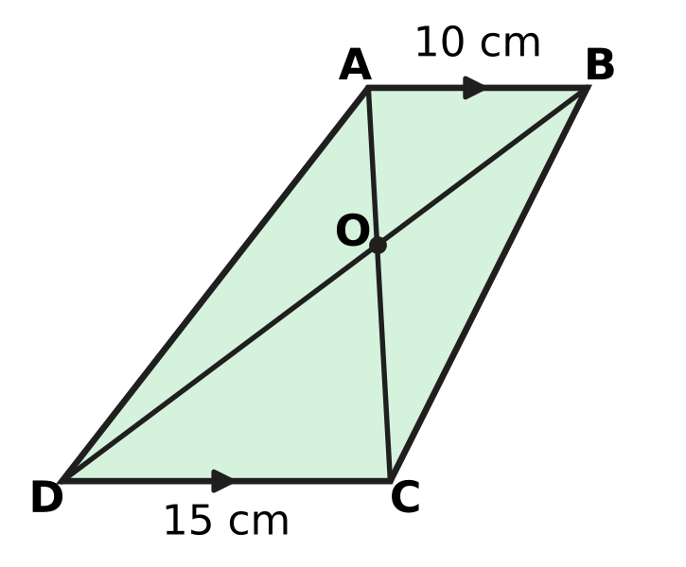
  (A) 7.5 cm | (B) 12 cm | (C) 30 cm | (D) 18 cm

Q44. Nakul has ₹60,000 and wants to buy a fishing net priced ₹60,000. The seller offers two ways to pay. Way 1: pay now and get a 5% discount. Way 2: pay the full price after one year. Any money that Nakul keeps stays in his bank for that year at 6% per year simple interest. At the end of the year, after paying for the net, which way leaves him with more money, and by how much? [4 marks]
(A) Way 1, by ₹3,000 | (B) Way 2, by ₹420
(C) Way 2, by ₹600 | (D) Way 2, by ₹3,420

Q45. Isha makes hollow plastic traffic cones for a car park. Each one is the curved surface of a cone with base radius 14 cm and height 48 cm, as in the picture. The plastic costs her ₹5 for every 100 cm², and this is her only cost. She marks each cone 50% above her cost. Then she gives the car park a discount of 20% on the marked price. What is her total profit on 150 cones? (Use π = $\frac{22}{7}$.) [4 marks] | 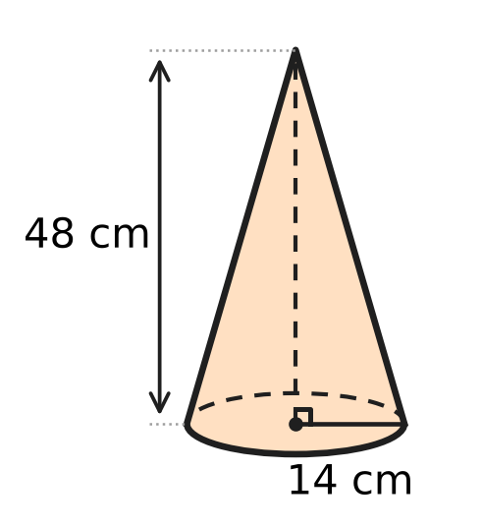
  (A) ₹3,168 | (B) ₹4,950 | (C) ₹8,250 | (D) ₹3,300
Answer Sheet AMO Level 1 · Class 8 · Practice Paper 5
Name: | School: | Roll No.:
Shade or tick one circle for each question.
1. Ⓐ Ⓑ Ⓒ Ⓓ | 16. Ⓐ Ⓑ Ⓒ Ⓓ | 31. Ⓐ Ⓑ Ⓒ Ⓓ
2. Ⓐ Ⓑ Ⓒ Ⓓ | 17. Ⓐ Ⓑ Ⓒ Ⓓ | 32. Ⓐ Ⓑ Ⓒ Ⓓ
3. Ⓐ Ⓑ Ⓒ Ⓓ | 18. Ⓐ Ⓑ Ⓒ Ⓓ | 33. Ⓐ Ⓑ Ⓒ Ⓓ
4. Ⓐ Ⓑ Ⓒ Ⓓ | 19. Ⓐ Ⓑ Ⓒ Ⓓ | 34. Ⓐ Ⓑ Ⓒ Ⓓ
5. Ⓐ Ⓑ Ⓒ Ⓓ | 20. Ⓐ Ⓑ Ⓒ Ⓓ | 35. Ⓐ Ⓑ Ⓒ Ⓓ
6. Ⓐ Ⓑ Ⓒ Ⓓ | 21. Ⓐ Ⓑ Ⓒ Ⓓ | 36. Ⓐ Ⓑ Ⓒ Ⓓ
7. Ⓐ Ⓑ Ⓒ Ⓓ | 22. Ⓐ Ⓑ Ⓒ Ⓓ | 37. Ⓐ Ⓑ Ⓒ Ⓓ
8. Ⓐ Ⓑ Ⓒ Ⓓ | 23. Ⓐ Ⓑ Ⓒ Ⓓ | 38. Ⓐ Ⓑ Ⓒ Ⓓ
9. Ⓐ Ⓑ Ⓒ Ⓓ | 24. Ⓐ Ⓑ Ⓒ Ⓓ | 39. Ⓐ Ⓑ Ⓒ Ⓓ
10. Ⓐ Ⓑ Ⓒ Ⓓ | 25. Ⓐ Ⓑ Ⓒ Ⓓ | 40. Ⓐ Ⓑ Ⓒ Ⓓ
11. Ⓐ Ⓑ Ⓒ Ⓓ | 26. Ⓐ Ⓑ Ⓒ Ⓓ | 41. Ⓐ Ⓑ Ⓒ Ⓓ
12. Ⓐ Ⓑ Ⓒ Ⓓ | 27. Ⓐ Ⓑ Ⓒ Ⓓ | 42. Ⓐ Ⓑ Ⓒ Ⓓ
13. Ⓐ Ⓑ Ⓒ Ⓓ | 28. Ⓐ Ⓑ Ⓒ Ⓓ | 43. Ⓐ Ⓑ Ⓒ Ⓓ
14. Ⓐ Ⓑ Ⓒ Ⓓ | 29. Ⓐ Ⓑ Ⓒ Ⓓ | 44. Ⓐ Ⓑ Ⓒ Ⓓ
15. Ⓐ Ⓑ Ⓒ Ⓓ | 30. Ⓐ Ⓑ Ⓒ Ⓓ | 45. Ⓐ Ⓑ Ⓒ Ⓓ
Q41–Q45 are Section II Star Questions (4 marks each).
For the parent or teacher
Section I correct: ______ / 40 × 2 = ______ marks Section II correct: ______ / 5 × 4 = ______ marks
Correct: ______ / 45 Score: ______ / 100
Answer Key and Solutions AMO Level 1 · Class 8 · Practice Paper 5
Quick answers
1 B | 6 C | 11 D | 16 B | 21 C | 26 C | 31 D | 36 A | 41 D
2 D | 7 D | 12 C | 17 B | 22 B | 27 D | 32 C | 37 B | 42 A
3 C | 8 A | 13 C | 18 C | 23 D | 28 A | 33 B | 38 A | 43 C
4 A | 9 B | 14 D | 19 D | 24 A | 29 B | 34 C | 39 D | 44 B
5 B | 10 A | 15 A | 20 A | 25 B | 30 A | 35 D | 40 C | 45 D
Solutions
Q | Part · level | Answer | Why?
1 | Part 1 · Ch1 · Easy | (B) 64 cm² | Edge = ∛512 = 8 cm, because 8 × 8 × 8 = 512. One face is a square of area 8 × 8 = 64 cm².
2 | Part 1 · Ch1 · Easy | (D) √5 | The slanting line from 0 to the far corner is √(2² + 1²) = √5 units long. The arc keeps this length, so P shows √5.
3 | Part 1 · Ch1 · Medium | (C) 35 | The sum of the first n odd numbers is n². n² = 324 gives n = 18, and the 18th odd number is 2 × 18 − 1 = 35.
4 | Part 2 · Ch2 · Easy | (A) −7 | Here (−7)⁻² = 1 ÷ (−7)² = 1/49, and (−7)³ = −343 is negative. The number 7 also gives 1/49 but its cube is positive.
5 | Part 2 · Ch2 · Easy | (B) 6 × 10⁻³ | The numbers 6 × 10⁻⁴, 60 × 10⁻⁵ and 0.6 × 10⁻³ all equal 0.0006. But 6 × 10⁻³ = 0.006, which is ten times as large.
6 | Part 2 · Ch2 · Easy | (C) 4 | A power of a power multiplies the indices: (2³)⁻² = 2⁻⁶. Then 2⁻⁶ × 2⁸ = 2⁻⁶⁺⁸ = 2² = 4.
7 | Part 3 · Ch3 · Easy | (D) 37.5% | If Zoya has 100, Lata has 160. Zoya has 60 less, and 60 ÷ 160 × 100 = 37.5%.
8 | Part 3 · Ch3 · Easy | (A) ₹3,600 | First 2 years: 10,000 × 6% × 2 = ₹1,200. Next 3 years: 10,000 × 8% × 3 = ₹2,400. Total = ₹3,600.
9 | Part 3 · Ch3 · Medium | (B) 20,000 litres | After two hours 70% of 60% = 42% of the tank is left. So 42% of the tank is 8,400 litres, and the full tank is 8,400 ÷ 0.42 = 20,000 litres.
10 | Part 3 · Ch3 · Medium | (A) 48% | Say 100 were sold last week, 40 of them mango. This week 125 were sold and 40 × 1.5 = 60 were mango. So the answer is 60 ÷ 125 × 100 = 48%.
11 | Part 3 · Ch3 · Medium | (D) 10 years | Hana gets ₹400 a year and Ivan ₹600, so Ivan closes the gap of ₹2,000 by ₹200 each year. It takes 2,000 ÷ 200 = 10 years (both then have ₹12,000).
12 | Part 4 · Ch4 · Easy | (C) x + 3 | Group the terms: x(y − 4) + 3(y − 4) = (y − 4)(x + 3). The other factor is x + 3.
13 | Part 4 · Ch4 · Easy | (C) 20 minutes | After t minutes: 150 + 15t = 690 − 12t, so 27t = 540 and t = 20. Both are then 450 m high.
14 | Part 4 · Ch4 · Easy | (D) 12 | (a − b)² = a² + b² − 2ab, so 16 = 40 − 2ab. Then 2ab = 24 and ab = 12.
15 | Part 4 · Ch4 · Medium | (A) 24 | Let there be b boys and b + 4 girls. Then b + 6 = 2(b + 4 − 6), so b + 6 = 2b − 4 and b = 10. There were 10 + 14 = 24 children.
16 | Part 4 · Ch4 · Medium | (B) 40 | Call the numbers n − 1 and n + 1. Then (n − 1)(n + 1) = n² − 1 = 399, so n² = 400 and n = 20. The numbers are 19 and 21, and their sum is 40.
17 | Part 5 · Ch5 · Easy | (B) 120° | △ABC ≅ △ADC (SSS: AB = AD, CB = CD, AC common), so ∠B = ∠D. The angles of ABCD add to 360°, so 2x = 360° − 70° − 50° = 240° and x = 120°.
18 | Part 5 · Ch5 · Easy | (C) △ABC ∼ △QPR | ∠C = 180° − 45° − 65° = 70° and ∠P = 180° − 45° − 70° = 65°. So A ↔ Q (45°), B ↔ P (65°) and C ↔ R (70°): △ABC ∼ △QPR.
19 | Part 5 · Ch5 · Easy | (D) 450 cm² | If the side is s, then s² + s² = 30² = 900 (Baudhāyana–Pythagoras). So 2s² = 900 and the area s² = 450 cm².
20 | Part 5 · Ch5 · Medium | (A) 0.5 m | The pulled seat is √(2.5² − 1.5²) = √4 = 2 m below the bar. At rest it is 2.5 m below the bar, so it is now 2.5 − 2 = 0.5 m higher.
21 | Part 5 · Ch5 · Medium | (C) 120° | PQ = QR = PR, so △PQR is equilateral and ∠QPR = 60°. In the same way △PSR is equilateral and ∠RPS = 60°. So ∠QPS = 60° + 60° = 120°.
22 | Part 6 · Ch6 · Easy | (B) 550 cm² | Curved surface = 2 × 22/7 × 7 × 9 = 396 cm². Base = 22/7 × 7 × 7 = 154 cm². Total = 550 cm².
23 | Part 6 · Ch6 · Easy | (D) 660 cm³ | Volume of A = 22/7 × 7 × 7 × 10 = 1,540 cm³. Volume of B = 22/7 × 10 × 10 × 7 = 2,200 cm³. The difference is 660 cm³.
24 | Part 6 · Ch6 · Easy | (A) 2,400 litres | Here 2 cm = 0.02 m. Volume = 15 × 8 × 0.02 = 2.4 m³ = 2.4 × 1,000 = 2,400 litres.
25 | Part 6 · Ch6 · Medium | (B) 7 cm | The curved edge of the semicircle, π × 14, becomes the rim of the base, 2πr. So 2πr = 14π and r = 7 cm.
26 | Part 6 · Ch6 · Medium | (C) 7 cm | The two circular ends make up 1,188 − 880 = 308 cm². So 2 × 22/7 × r² = 308, r² = 49 and r = 7 cm.
27 | Part 7 · Ch8 · Easy | (D) 12 | The 3–4 kg bar is 7 squares tall and stands for 14 watermelons, so each square is 2 watermelons. The 5–6 kg bar is 6 squares tall: 6 × 2 = 12.
28 | Part 7 · Ch8 · Easy | (A) 288 | Roses minus lilies is 150° − 90° = 60°, and 60° stands for 48 bouquets. The full 360° is 6 times 60°, so the total is 6 × 48 = 288.
29 | Part 7 · Ch8 · Medium | (B) 14 | The total is 5 × 7 = 35. The middle number is 6, and 4 must appear twice, below it: 4, 4, 6, d, e with d + e = 21. d cannot be 6 (6 would also be a mode), so the least d is 7 and e = 14.
30 | Part 8 · Ch9 · Easy | (A) ₹1,200 | The cost price is exactly halfway between the two prices: (1,140 + 1,260) ÷ 2 = ₹1,200. The loss and the profit are both ₹60.
31 | Part 8 · Ch9 · Easy | (D) ₹500 | Bank X: 50,000 × 8% × 3 = ₹12,000. Bank Y: 50,000 × 7% × 3 + 1,000 = ₹11,500. Bank Y is cheaper by ₹500.
32 | Part 8 · Ch9 · Easy | (C) 20% | Ticket money = 300 × 30 = ₹9,000. Profit = 9,000 − 7,500 = ₹1,500. Profit percent = 1,500 ÷ 7,500 × 100 = 20%.
33 | Part 8 · Ch9 · Medium | (B) 25% | Cost = 300 × 6 + 600 = ₹2,400. Money taken = 300 × 10 = ₹3,000. Profit = ₹600, and 600 ÷ 2,400 × 100 = 25%.
34 | Part 8 · Ch9 · Medium | (C) ₹1,500 | Let the cost be C. Then 1.1C − 30 = 1.2 × 0.9C = 1.08C, so 0.02C = 30 and C = ₹1,500. Check: 1,650 − 30 = 1,620 = 1.2 × 1,350.
35 | Part 9 · Ch10 · Easy | (D) Step 4 | The numbers of sides are 3, 12, 48, 192, 768, … (×4 each step). Step 3 has 192 and Step 4 has 768, so Step 4 is the first above 500.
36 | Part 9 · Ch10 · Easy | (A) 10 | Every route has 3 moves right and 2 moves up, 5 moves in all. By where the first up move comes: 4 + 3 + 2 + 1 = 10 routes.
37 | Part 9 · Ch10 · Easy | (B) 131 | In the pattern, 19 = 3 × 6 + 1, 29 = 4 × 7 + 1 and 41 = 5 × 8 + 1: first × last + 1. So the root is 10 × 13 + 1 = 131. Check: 131² = 17,161 = 17,160 + 1.
38 | Part 9 · Ch10 · Medium | (A) 5 | The three-digit squares ending in two equal digits are 100, 144, 400 and 900. Only 144 = 12² has B ≠ 0, so A + B = 1 + 4 = 5.
39 | Part 9 · Ch10 · Medium | (D) 10 | First stall 1: the other two from 3 to 7 with a gap: 6 ways. First stall 2: 3 ways. First stall 3: 1 way (3, 5, 7). Total 6 + 3 + 1 = 10.
40 | Part 9 · Ch10 · Medium | (C) 27 | The floor is 3 × (ups − downs), and ups + downs = 15 is odd, so ups − downs is odd. The highest such floor up to 30 is 3 × 9 = 27 (12 ups and 3 downs).
41 | Section II · Ch4 + Ch10 · Hard | (D) 55 | Let s = AB + CD. Then 100 × AB + CD = s², so s² − s = 99 × AB and s(s − 1) is a multiple of 9 and of 11. With s from 32 to 99 this gives s = 45, 55 or 99, i.e. 2025, 3025, 9801. Only 3025 = (30 + 25)² follows the rules, so AB + CD = 55.
42 | Section II · Ch5 + Ch10 · Hard | (A) 57 cm | Case 1: 12 and 18 match 4 and 6 (scale 3): sides 12, 18, 27, perimeter 57 cm. Case 2: 12 and 18 match 6 and 9 (scale 2): sides 8, 12, 18, perimeter 38 cm. No other pair works. The greatest perimeter is 57 cm.
43 | Section II · Ch4 + Ch5 · Hard | (C) 30 cm | ∠OAB = ∠OCD and ∠OBA = ∠ODC (alternate angles), so △OAB ∼ △OCD and BO ÷ OD = AB ÷ DC = 10 ÷ 15. So 3(x + 1) = 2(2x − 4), giving x = 11. Then BO = 12 cm, OD = 18 cm and BD = 30 cm.
44 | Section II · Ch3 + Ch9 · Hard | (B) Way 2, by ₹420 | Way 1: he pays ₹57,000 and the ₹3,000 left grows to 3,000 × 1.06 = ₹3,180. Way 2: ₹60,000 grows to ₹63,600; after paying he has ₹3,600. Way 2 is better by ₹420.
45 | Section II · Ch6 + Ch9 · Hard | (D) ₹3,300 | Slant height = √(14² + 48²) = 50 cm. Curved surface = 22/7 × 14 × 50 = 2,200 cm², so each cone costs ₹110. Marked price = ₹165 and selling price = 80% of 165 = ₹132. Profit = 150 × (132 − 110) = ₹3,300.

