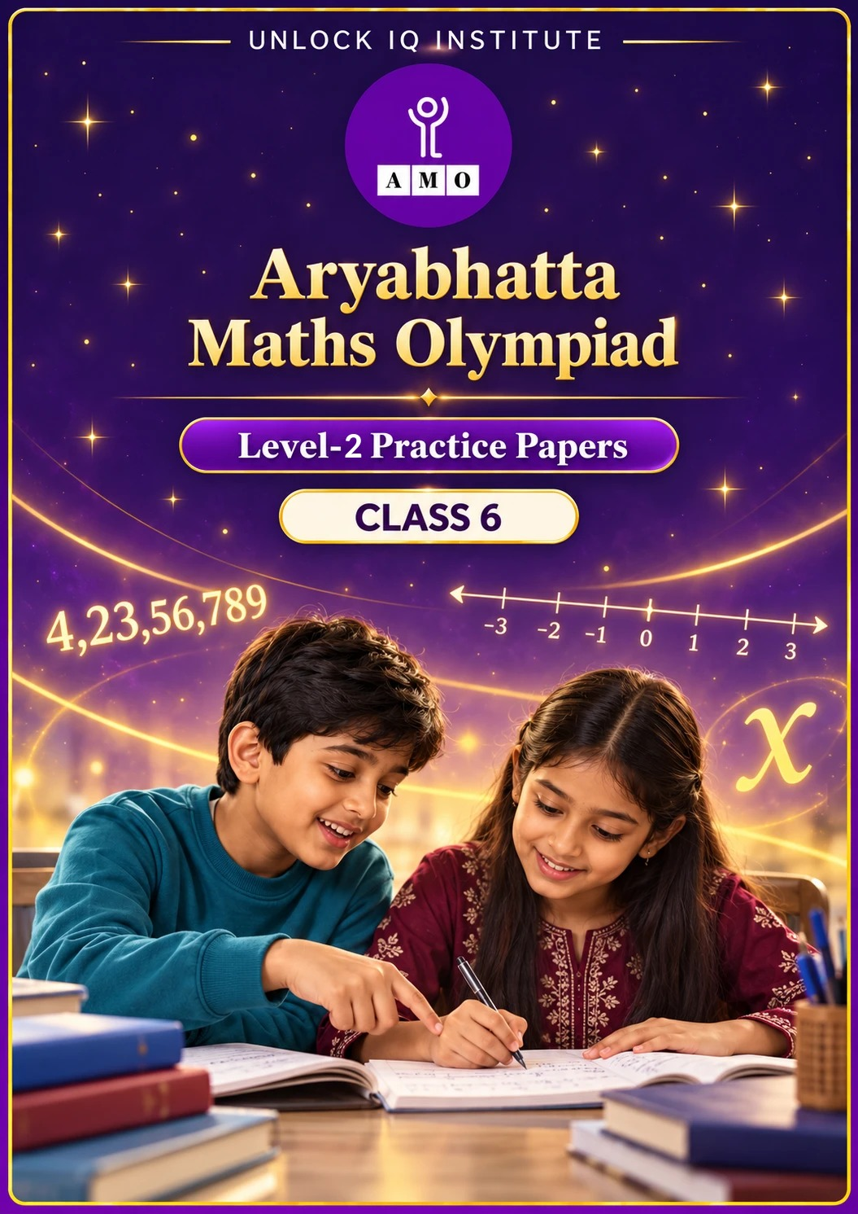
Set 1 · Practice Papers 1–5 · with answer keys & detailed solutions
Name: ____________________ | Class & Section: ________________
Roll No.: ________________ | School: ____________________
City: ____________________ | Date: ____________________

Published by Unlock IQ Institute Pvt. Ltd.
Register for Olympiads: www.aryabhattamathsolympiad.com/student-registration

ARYABHATTA MATHS OLYMPIAD
Level 2
PRACTICE PAPER-1
CLASS 6
Total Questions | 30 multiple-choice questions
Level | Level-2 (final round): every question is Hard
Time | 45 minutes
Arrangement | Parts by chapter; the last Part has mixed problems joining two chapters
Negative Marking | No negative marking
Calculator | Not allowed
Chapters | Number System · Operations · Fractions, Decimals & Percentages · Algebra · Geometry · Mensuration · Data Handling, Statistics & Probability · Applied Mathematics · Mathematical Reasoning

Instructions
• Each question has four options, (A) to (D), with exactly one correct answer.
• The questions are grouped in Parts by chapter. The last Part has mixed problems, each joining two chapters.
• Every question is at Level-2 (Hard) standard: expect several steps or a key insight.
• There is no negative marking. Calculators are not allowed; use a separate sheet for rough work.
• Figures are not necessarily drawn to scale unless stated.

For teachers
• Figures are part of the questions and work when printed in black and white.
• Parts follow the AMO syllabus chapters. Chapter 7 is not part of the Class 6 syllabus, so the chapter numbers shown in the Part headings have gaps.
• The answer sheet and the answer key are at the end. Remove the answer key before the paper is attempted.

Part 1 — Number System (Syllabus Chapter 1)
Q1. Three consecutive whole numbers multiply to give 2,730. What is the largest of the three numbers?
(A) 15 | (B) 14 | (C) 13 | (D) 16

Q2. At 6 AM the temperature in Leh was −8°C. It rose by 3°C every hour until noon, then fell by 2°C every hour until 5 PM. What was the temperature at 5 PM?
(A) 2°C | (B) 0°C | (C) −2°C | (D) 10°C

Q3. Three temple bells ring every 12, 15 and 20 minutes. They ring together at 8:00 AM. How many times do they ring together from 8:00 AM to 6:00 PM, counting both?
(A) 11 | (B) 10 | (C) 12 | (D) 6

Part 2 — Operations (Syllabus Chapter 2)
Q4. What is the value of 120 − [48 ÷ {16 − (3 × 4)} + 5 × 6]?
(A) 62 | (B) 78 | (C) 138 | (D) 90

Q5. What is the sum of all the integers from −25 to 30, including both?
(A) 30 | (B) 140 | (C) 155 | (D) 0

Q6. Arun works out 98 × 47 + 2 × 47. Jaya works out 125 × 37 × 8. Both use number properties instead of long multiplication. How much larger is Jaya's answer?
(A) 4,700 | (B) 37,000 | (C) 31,300 | (D) 32,300

Part 3 — Fractions, Decimals & Percentages (Syllabus Chapter 3)
Q7. Which is the 2nd smallest of these: 3/8, 0.36, 37%, 7/20?
(A) 0.36 | (B) 7/20 | (C) 37% | (D) 3/8

Q8. A school has 1,250 students and 48% of them are girls. 25% of the girls and 20% of the boys wear spectacles. How many students wear spectacles?
(A) 281 | (B) 250 | (C) 300 | (D) 280

Q9. A bicycle costs ₹800. Its price is raised by 25%. Later the new price is reduced by 20%. What is the final price?
(A) ₹840 | (B) ₹760 | (C) ₹820 | (D) ₹800

Part 4 — Algebra (Syllabus Chapter 4)
Q10. Squares are made in a row with matchsticks: 1 square uses 4 sticks, 2 squares use 7, 3 squares use 10. How many sticks do 25 squares use?
(A) 76 | (B) 100 | (C) 75 | (D) 79

Q11. If a = −2, b = 3 and c = −4, what is the value of ab − bc + ca?
(A) −10 | (B) 2 | (C) 14 | (D) −14

Part 5 — Geometry (Syllabus Chapter 5)
Q12. At exactly 7 o'clock, the hands of a clock make two angles. What is the size of the reflex angle?
(A) 210° | (B) 150° | (C) 230° | (D) 240°

Q13. In a triangle, one angle is twice the smallest angle and the third angle is 20° more than the smallest. What type of triangle is it, and what is its largest angle?
(A) Obtuse, 100° | (B) Right, 90° | (C) Acute, 60° | (D) Acute, 80°

Q14. How many diagonals does a regular octagon have?
(A) 16 | (B) 20 | (C) 28 | (D) 40

Part 6 — Mensuration (Syllabus Chapter 6)
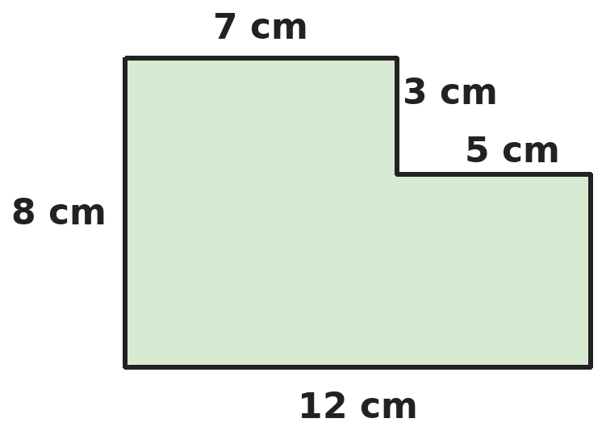
Q15. A 12 cm by 8 cm card has a 5 cm by 3 cm rectangle cut from one corner, as shown. What are the perimeter and the area of the card that is left?
(A) 34 cm, 81 cm² | (B) 40 cm, 96 cm² | (C) 40 cm, 81 cm² | (D) 46 cm, 81 cm²

Q16. A box with no lid is 20 cm long, 15 cm wide and 10 cm high. How much paper is needed to cover its outside exactly?
(A) 1,300 cm² | (B) 700 cm² | (C) 1,000 cm² | (D) 3,000 cm²

Q17. How many cubes of edge 4 cm can be packed into a box 20 cm long, 12 cm wide and 10 cm high?
(A) 37 | (B) 30 | (C) 40 | (D) 36

Part 7 — Data Handling, Statistics & Probability (Syllabus Chapter 8)
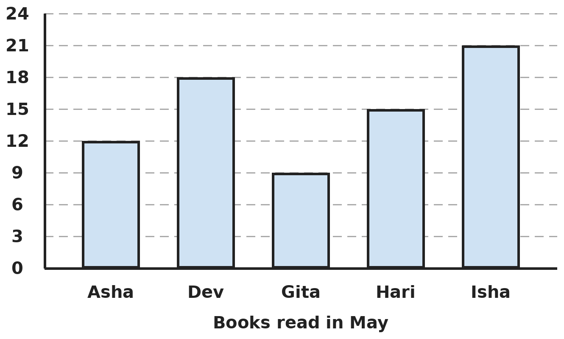
Q18. The bar graph shows the books read by five friends. How many more books did the top two readers read than the bottom two readers together?
(A) 12 | (B) 21 | (C) 18 | (D) 15

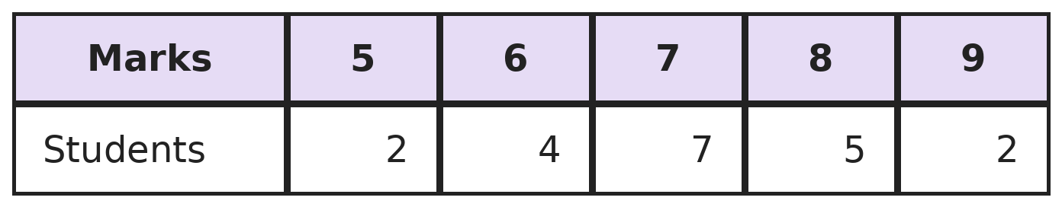
Q19. The table shows the marks of a class in a quiz. What percentage of the class scored at least 8 marks?
(A) 25% | (B) 35% | (C) 45% | (D) 70%

Part 8 — Applied Mathematics (Syllabus Chapter 9)
Q20. A train 300 m long runs at 72 km/h. How long does it take to cross a bridge 700 m long completely?
(A) 50 s | (B) 35 s | (C) 15 s | (D) 14 s

Q21. Asha, Bina and Chetan share ₹4,500 in the ratio 2 : 3 : 4. Chetan then gives half of his share to Asha. How much does Asha have now?
(A) ₹1,000 | (B) ₹1,500 | (C) ₹2,500 | (D) ₹2,000

Q22. 12 workers can build a wall in 10 days. They work for 4 days, and then 6 more workers join them at the same rate. How many days does the whole wall take?
(A) 10 | (B) 8 | (C) 6 | (D) 9

Part 9 — Mathematical Reasoning (Syllabus Chapter 10)
Q23. It is 9 AM on a Monday. What day and time will it be exactly 100 hours later?
(A) Friday, 1 PM | (B) Thursday, 1 PM
(C) Friday, 11 AM | (D) Saturday, 1 PM

Q24. Kavya adds seven odd numbers. Which of these could be her total?
(A) 50 | (B) 64 | (C) 38 | (D) 45

Q25. Tara spent half her money and ₹10 more at one shop. At a second shop she spent half of what was left and ₹10 more. She had ₹20 left. How much did she start with?
(A) ₹120 | (B) ₹100 | (C) ₹140 | (D) ₹160

Part 10 — Mixed Problems (each joins two chapters)

Q26. In a number pattern the 1st term is 5, the 2nd is 9 and the 3rd is 13. Which term is exactly 101?
(A) 24th | (B) 26th | (C) 20th | (D) 25th

Q27. How many numbers from 1 to 1,000 are divisible by 6 but not by 9?
(A) 166 | (B) 110 | (C) 111 | (D) 55

Q28. Two tanks each hold 1,000 L of water. From Tank A, 20% of the water is used and then 50 L more. From Tank B, 50 L is used and then 20% of what is left. Which tank has more water left, and by how much?
(A) Tank A, by 10 L | (B) Both have the same
(C) Tank B, by 10 L | (D) Tank B, by 40 L

Q29. A rectangle is 12 cm long and 8 cm wide. A straight cut goes from one corner to the middle of the opposite long side, cutting off a right-angled triangle. What is the area of the larger piece?
(A) 48 cm² | (B) 84 cm² | (C) 24 cm² | (D) 72 cm²

Q30. A cab charges ₹50 to start plus ₹12 for every km. Riya pays ₹386 for her ride. How many km did she travel?
(A) 32 | (B) 27 | (C) 28 | (D) 23

Answer Sheet AMO Level 2 · Class 6 · Practice Paper 1
Name: | School: | Roll No.:
Shade or tick one circle for each question.
1. | Ⓐ Ⓑ Ⓒ Ⓓ | 11. | Ⓐ Ⓑ Ⓒ Ⓓ | 21. | Ⓐ Ⓑ Ⓒ Ⓓ
2. | Ⓐ Ⓑ Ⓒ Ⓓ | 12. | Ⓐ Ⓑ Ⓒ Ⓓ | 22. | Ⓐ Ⓑ Ⓒ Ⓓ
3. | Ⓐ Ⓑ Ⓒ Ⓓ | 13. | Ⓐ Ⓑ Ⓒ Ⓓ | 23. | Ⓐ Ⓑ Ⓒ Ⓓ
4. | Ⓐ Ⓑ Ⓒ Ⓓ | 14. | Ⓐ Ⓑ Ⓒ Ⓓ | 24. | Ⓐ Ⓑ Ⓒ Ⓓ
5. | Ⓐ Ⓑ Ⓒ Ⓓ | 15. | Ⓐ Ⓑ Ⓒ Ⓓ | 25. | Ⓐ Ⓑ Ⓒ Ⓓ
6. | Ⓐ Ⓑ Ⓒ Ⓓ | 16. | Ⓐ Ⓑ Ⓒ Ⓓ | 26. | Ⓐ Ⓑ Ⓒ Ⓓ
7. | Ⓐ Ⓑ Ⓒ Ⓓ | 17. | Ⓐ Ⓑ Ⓒ Ⓓ | 27. | Ⓐ Ⓑ Ⓒ Ⓓ
8. | Ⓐ Ⓑ Ⓒ Ⓓ | 18. | Ⓐ Ⓑ Ⓒ Ⓓ | 28. | Ⓐ Ⓑ Ⓒ Ⓓ
9. | Ⓐ Ⓑ Ⓒ Ⓓ | 19. | Ⓐ Ⓑ Ⓒ Ⓓ | 29. | Ⓐ Ⓑ Ⓒ Ⓓ
10. | Ⓐ Ⓑ Ⓒ Ⓓ | 20. | Ⓐ Ⓑ Ⓒ Ⓓ | 30. | Ⓐ Ⓑ Ⓒ Ⓓ

For the parent or teacher
Correct: ______ / 30
Answer Key and Solutions AMO Level 2 · Class 6 · Practice Paper 1
Quick answers
1 A | 6 D | 11 C | 16 C | 21 D | 26 D
2 B | 7 A | 12 A | 17 B | 22 B | 27 C
3 A | 8 D | 13 D | 18 C | 23 A | 28 C
4 B | 9 D | 14 B | 19 B | 24 D | 29 D
5 B | 10 A | 15 C | 20 A | 25 C | 30 C
Solutions
Q | Part · level | Answer | Why?
1 | Part 1 · Ch1 · Hard | (A) 15 | Hint: Write 2,730 as a product of primes and regroup the primes.  2,730 = 2 × 3 × 5 × 7 × 13. Regroup: 13 × (2 × 7) × (3 × 5) = 13 × 14 × 15. The largest is 15.
2 | Part 1 · Ch1 · Hard | (B) 0°C | Hint: Count the hours of rising and the hours of falling separately.  6 AM to noon is 6 hours: −8 + 6 × 3 = −8 + 18 = 10°C. Noon to 5 PM is 5 hours: 10 − 5 × 2 = 0°C.
3 | Part 1 · Ch1 · Hard | (A) 11 | Hint: Find the LCM of 12, 15 and 20.  LCM of 12, 15 and 20 is 60 minutes, so they ring together every hour: 8, 9, …, 18 o'clock. That is 11 times.
4 | Part 2 · Ch2 · Hard | (B) 78 | Hint: Work from the innermost bracket outwards.  (3 × 4) = 12. {16 − 12} = 4. 48 ÷ 4 = 12. 12 + 5 × 6 = 12 + 30 = 42. 120 − 42 = 78.
5 | Part 2 · Ch2 · Hard | (B) 140 | Hint: Pair each negative integer with its positive partner.  −25 + 25 = 0, −24 + 24 = 0, …, and 0 adds nothing. The integers from −25 to 25 add up to 0. What is left is 26 + 27 + 28 + 29 + 30 = 140.
6 | Part 2 · Ch2 · Hard | (D) 32,300 | Hint: Use the distributive property for Arun and regroup 125 × 8 for Jaya.  Arun: 47 × (98 + 2) = 47 × 100 = 4,700. Jaya: (125 × 8) × 37 = 1,000 × 37 = 37,000. Difference: 37,000 − 4,700 = 32,300.
7 | Part 3 · Ch3 · Hard | (A) 0.36 | Hint: Change all four into decimals.  3/8 = 0.375, 0.36, 37% = 0.37 and 7/20 = 0.35. In order: 0.35, 0.36, 0.37, 0.375. The 2nd smallest is 0.36.
8 | Part 3 · Ch3 · Hard | (D) 280 | Hint: Find the number of girls and boys first.  Girls: 48% of 1,250 = 600, so boys = 650. Girls with spectacles: 25% of 600 = 150. Boys: 20% of 650 = 130. Total 150 + 130 = 280.
9 | Part 3 · Ch3 · Hard | (D) ₹800 | Hint: The 20% is taken from the new, higher price.  After the rise: 800 + 25% of 800 = 800 + 200 = ₹1,000. After the cut: 1,000 − 20% of 1,000 = 1,000 − 200 = ₹800. (₹840 wrongly takes the net change as +5%.)
10 | Part 4 · Ch4 · Hard | (A) 76 | Hint: Each new square adds 3 sticks. Write an expression for n squares.  The first square uses 4 sticks and each new square adds 3, so n squares use 3n + 1 sticks. For n = 25: 3 × 25 + 1 = 76.
11 | Part 4 · Ch4 · Hard | (C) 14 | Hint: Work out each product carefully with its sign.  ab = −2 × 3 = −6. bc = 3 × (−4) = −12. ca = −4 × (−2) = 8. ab − bc + ca = −6 − (−12) + 8 = −6 + 12 + 8 = 14.
12 | Part 5 · Ch5 · Hard | (A) 210° | Hint: Each hour mark is 30° apart. The reflex angle is more than 180°.  At 7 o'clock the hands are 5 hour-marks apart the short way: 5 × 30° = 150°. The reflex angle is the other way round: 360° − 150° = 210°.
13 | Part 5 · Ch5 · Hard | (D) Acute, 80° | Hint: The three angles add up to 180°.  Smallest + 2 × smallest + (smallest + 20°) = 180°, so 4 × smallest = 160° and the smallest is 40°. The angles are 40°, 80° and 60°. All are less than 90°, so it is acute, and the largest is 80°.
14 | Part 5 · Ch5 · Hard | (B) 20 | Hint: From each corner, you cannot draw a diagonal to itself or to its two neighbours.  From each of the 8 corners there are 8 − 3 = 5 diagonals. 8 × 5 = 40 counts every diagonal twice (once from each end). So there are 40 ÷ 2 = 20.
15 | Part 6 · Ch6 · Hard | (C) 40 cm, 81 cm² | Hint: Cutting a corner rectangle does not change the perimeter. Why?  The two new edges (5 cm and 3 cm) replace the two edges that were cut away, so the perimeter stays 2 × (12 + 8) = 40 cm. Area: 12 × 8 − 5 × 3 = 96 − 15 = 81 cm².
16 | Part 6 · Ch6 · Hard | (C) 1,000 cm² | Hint: There are only 5 faces to cover.  Base: 20 × 15 = 300 cm². Two long sides: 2 × 20 × 10 = 400 cm². Two short sides: 2 × 15 × 10 = 300 cm². Total 300 + 400 + 300 = 1,000 cm². (1,300 includes the lid.)
17 | Part 6 · Ch6 · Hard | (B) 30 | Hint: Count how many cubes fit along each edge. Parts of a cube do not count.  Along 20 cm: 5 cubes. Along 12 cm: 3 cubes. Along 10 cm: only 2 cubes (2 cm is wasted). 5 × 3 × 2 = 30. (Dividing volumes, 2,400 ÷ 64 = 37.5, ignores the wasted space.)
18 | Part 7 · Ch8 · Hard | (C) 18 | Hint: Read each bar against the gridlines.  Top two: Isha 21 + Dev 18 = 39. Bottom two: Gita 9 + Asha 12 = 21. 39 − 21 = 18.
19 | Part 7 · Ch8 · Hard | (B) 35% | Hint: Find the total number of students first.  Total: 2 + 4 + 7 + 5 + 2 = 20 students. At least 8 marks: 5 + 2 = 7 students. 7 out of 20 = 35/100 = 35%.
20 | Part 8 · Ch9 · Hard | (A) 50 s | Hint: The train must cover the bridge plus its own length. 72 km/h = 20 m every second.  Distance = 700 + 300 = 1,000 m. 72 km/h = 72,000 m in 3,600 s = 20 m/s. Time = 1,000 ÷ 20 = 50 s. (35 s forgets the train's length.)
21 | Part 8 · Ch9 · Hard | (D) ₹2,000 | Hint: There are 2 + 3 + 4 = 9 equal parts.  One part = 4,500 ÷ 9 = ₹500. Asha ₹1,000, Bina ₹1,500, Chetan ₹2,000. Half of Chetan's share is ₹1,000, so Asha has 1,000 + 1,000 = ₹2,000.
22 | Part 8 · Ch9 · Hard | (B) 8 | Hint: Count the work in worker-days.  The wall needs 12 × 10 = 120 worker-days. In 4 days, 12 workers do 48 worker-days, leaving 72. Now 18 workers work: 72 ÷ 18 = 4 more days. Total 4 + 4 = 8 days.
23 | Part 9 · Ch10 · Hard | (A) Friday, 1 PM | Hint: 100 hours = some whole days and some hours.  100 = 4 × 24 + 4, so 100 hours is 4 days and 4 hours. 4 days after Monday 9 AM is Friday 9 AM. 4 hours later is Friday, 1 PM.
24 | Part 9 · Ch10 · Hard | (D) 45 | Hint: Odd + odd is even. What happens with seven odd numbers?  Pairs of odd numbers add to even numbers. Seven odd numbers make three pairs and one extra odd number, so the total is even + odd = odd. Only 45 is odd. (For example 1 + 3 + 5 + 7 + 9 + 11 + 9 = 45.)
25 | Part 9 · Ch10 · Hard | (C) ₹140 | Hint: Work backwards from ₹20, undoing each step.  Before the last ₹10 she had 20 + 10 = ₹30, which was half, so she had ₹60 after the first shop. Before the first ₹10: 60 + 10 = ₹70, which was half, so she started with ₹140.
26 | Part 10 · Mixed · Ch4 + Ch10 · Hard | (D) 25th | Hint: Write the nth term as an expression, then work backwards from 101.  Each term adds 4, so the nth term is 4n + 1. Taking away the 1 from 101 leaves 100, and 100 = 4 × 25. So 101 is the 25th term.
27 | Part 10 · Mixed · Ch1 + Ch10 · Hard | (C) 111 | Hint: A number divisible by both 6 and 9 is divisible by their LCM.  Multiples of 6 up to 1,000: 1,000 ÷ 6 = 166 (remainder 4). Multiples of both 6 and 9 are multiples of 18: 1,000 ÷ 18 = 55 (remainder 10). 166 − 55 = 111.
28 | Part 10 · Mixed · Ch3 + Ch9 · Hard | (C) Tank B, by 10 L | Hint: Work out what is left in each tank, one step at a time.  Tank A: 1,000 − 200 = 800 L, then 800 − 50 = 750 L. Tank B: 1,000 − 50 = 950 L, then 950 − 20% of 950 = 950 − 190 = 760 L. Tank B has 10 L more.
29 | Part 10 · Mixed · Ch5 + Ch6 · Hard | (D) 72 cm² | Hint: The triangle has the 8 cm side and half of the 12 cm side as its two shorter sides.  The triangle's shorter sides are 8 cm and 6 cm, so its area is 8 × 6 ÷ 2 = 24 cm². The rectangle is 96 cm². The larger piece (a four-sided shape) is 96 − 24 = 72 cm².
30 | Part 10 · Mixed · Ch4 + Ch9 · Hard | (C) 28 | Hint: Write the fare for n km, then work backwards.  Fare = 50 + 12n. 386 − 50 = 336 is the distance part. 336 ÷ 12 = 28 km.

ARYABHATTA MATHS OLYMPIAD
Level 2
PRACTICE PAPER-2
CLASS 6
Total Questions | 30 multiple-choice questions
Level | Level-2 (final round): every question is Hard
Time | 45 minutes
Arrangement | Parts by chapter; the last Part has mixed problems joining two chapters
Negative Marking | No negative marking
Calculator | Not allowed
Chapters | Number System · Operations · Fractions, Decimals & Percentages · Algebra · Geometry · Mensuration · Data Handling, Statistics & Probability · Applied Mathematics · Mathematical Reasoning

Instructions
• Each question has four options, (A) to (D), with exactly one correct answer.
• The questions are grouped in Parts by chapter. The last Part has mixed problems, each joining two chapters.
• Every question is at Level-2 (Hard) standard: expect several steps or a key insight.
• There is no negative marking. Calculators are not allowed; use a separate sheet for rough work.
• Figures are not necessarily drawn to scale unless stated.

For teachers
• Figures are part of the questions and work when printed in black and white.
• Parts follow the AMO syllabus chapters. Chapter 7 is not part of the Class 6 syllabus, so the chapter numbers shown in the Part headings have gaps.
• The answer sheet and the answer key are at the end. Remove the answer key before the paper is attempted.

Part 1 — Number System (Syllabus Chapter 1)
Q1. What is the sum of the place values of all the 5s in 5,25,50,000?
(A) 15 | (B) 5,55,00,000 | (C) 5,05,50,000 | (D) 5,50,50,000

Q2. What is the smallest number that leaves remainder 1 when divided by 2, 3, 4, 5 or 6, but is exactly divisible by 7?
(A) 61 | (B) 421 | (C) 361 | (D) 301

Q3. A submarine is at −120 m (below sea level). It rises 45 m, dives 80 m and then rises 30 m. A helicopter hovers 75 m above sea level. How far apart are they now?
(A) 50 m | (B) 125 m | (C) 200 m | (D) 195 m

Part 2 — Operations (Syllabus Chapter 2)
Q4. Here are four ways of writing 8 + 4 × 6 − 2, with or without brackets. Which of these gives the largest value?
(A) (8 + 4) × (6 − 2) | (B) 8 + 4 × (6 − 2)
(C) 8 + 4 × 6 − 2 | (D) (8 + 4) × 6 − 2

Q5. What is the value of (−1) × (−2) × (−3) × (−4) × (−5) ÷ (−6)?
(A) 20 | (B) −20 | (C) 120 | (D) −120

Q6. The sum of two integers is −7 and their product is −60. What is the larger integer?
(A) 12 | (B) −5 | (C) 5 | (D) −12

Part 3 — Fractions, Decimals & Percentages (Syllabus Chapter 3)
Q7. Three of these are equal. Which one is different: 0.125, 1/8, 12.5%, 3/25?
(A) 0.125 | (B) 3/25 | (C) 1/8 | (D) 12.5%

Q8. A water tank is 40% full. After 54 litres are added, it is 85% full. What is the full capacity of the tank?
(A) 135 L | (B) 120 L | (C) 108 L | (D) 90 L

Q9. Pooja scored 72 out of 90 in a test. Kiran scored 84 out of 105 in another test. Compare their percentages.
(A) Pooja did better, with 80% | (B) Kiran did better, with 84%
(C) Both scored 80% | (D) Pooja did better, with 72%

Part 4 — Algebra (Syllabus Chapter 4)
Q10. A rectangle has length (2x + 3) cm and breadth (x − 1) cm. Write its perimeter as an expression and find it when x = 7.
(A) 3x + 2; 23 cm | (B) 6x + 4; 46 cm | (C) 6x + 4; 34 cm | (D) 6x + 8; 50 cm

Q11. One table seats 6 people. Two tables pushed together seat 10, and three seat 14. How many tables in a row are needed to seat exactly 70 people?
(A) 18 | (B) 12 | (C) 17 | (D) 16

Part 5 — Geometry (Syllabus Chapter 5)
Q12. Two straight lines cross each other. One of the angles formed is 4 times the angle next to it. What is the size of the larger of these two angles?
(A) 144° | (B) 36° | (C) 135° | (D) 150°

Q13. A triangle has two sides of 7 cm with an angle of 60° between them. Which type of triangle is it?
(A) Equilateral | (B) Isosceles but not equilateral
(C) Scalene | (D) Right-angled

Q14. A polygon has 3 times as many diagonals as sides. How many sides does it have?
(A) 6 | (B) 12 | (C) 9 | (D) 8

Part 6 — Mensuration (Syllabus Chapter 6)
Q15. A wire is bent into a rectangle 18 cm by 14 cm. It is then straightened and bent into a square. What is the area of the square?
(A) 256 cm² | (B) 252 cm² | (C) 64 cm² | (D) 196 cm²

Q16. Three cubes of edge 4 cm are joined end to end to make a cuboid. What is the surface area of the cuboid?
(A) 288 cm² | (B) 224 cm² | (C) 192 cm² | (D) 256 cm²

Q17. A tank is 2 m long, 1.5 m wide and 1 m deep. How many 15-litre buckets of water are needed to fill it? (1 m³ = 1,000 L)
(A) 20 | (B) 2,000 | (C) 200 | (D) 300

Part 7 — Data Handling, Statistics & Probability (Syllabus Chapter 8)
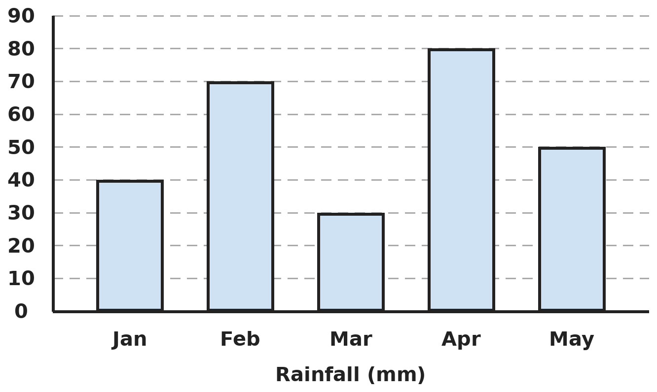
Q18. The bar graph shows the rainfall in a town. What fraction of the total rainfall fell in the months that had less than 60 mm each?
(A) 5/9 | (B) 4/9 | (C) 3/5 | (D) 2/5

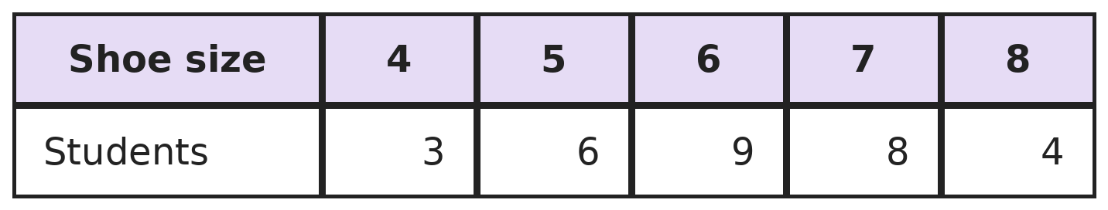
Q19. The table shows the shoe sizes of the students in a class. How many more students wear size 7 or above than size 5 or below?
(A) 1 | (B) 12 | (C) 3 | (D) 9

Part 8 — Applied Mathematics (Syllabus Chapter 9)
Q20. Ravi cycles to school. At 12 km/h he reaches 5 minutes late. At 15 km/h he reaches 5 minutes early. How far is the school?
(A) 12 km | (B) 10 km | (C) 6 km | (D) 15 km

Q21. In a club, the ratio of boys to girls is 5 : 4. After 10 more girls join, the numbers of boys and girls are equal. How many boys are there?
(A) 40 | (B) 45 | (C) 60 | (D) 50

Q22. 8 pens cost ₹96 and 5 notebooks cost ₹175. How much do 6 pens and 3 notebooks cost?
(A) ₹171 | (B) ₹183 | (C) ₹167 | (D) ₹177

Part 9 — Mathematical Reasoning (Syllabus Chapter 10)
Q23. A clock is set right at noon on Sunday. It gains 3 minutes every hour. What time does it show at the real noon on Monday?
(A) 12:48 PM | (B) 1:12 PM | (C) 1:24 PM | (D) 1:00 PM

Q24. The numbers 1 to 10 are written on a board. Mihir rubs out any two numbers and writes their difference. He repeats this until one number is left. What can you say about the last number?
(A) It must be even | (B) It must be 0
(C) It must be 10 | (D) It must be odd

Q25. Neha thinks of a number. She multiplies it by 3, subtracts 7 and then halves the result. She gets 25. What was her number?
(A) 21 | (B) 19 | (C) 17 | (D) 11

Part 10 — Mixed Problems (each joins two chapters)

Q26. In this pattern, the nth number is n × (n + 1). Which term of the pattern is 210?
(A) 15th | (B) 13th | (C) 21st | (D) 14th

Q27. What is the smallest 4-digit number that is exactly divisible by 12, by 18 and by 30?
(A) 1,080 | (B) 1,000 | (C) 1,260 | (D) 1,800

Q28. Simran increases her driving speed by 25% on the same route. By what percentage does her journey time go down?
(A) 20% | (B) 25% | (C) 75% | (D) 80%

Q29. Squares of side 5 cm are cut from the four corners of a 20 cm square sheet. The sides are folded up to make an open box. What is the volume of the box?
(A) 1,500 cm³ | (B) 2,000 cm³ | (C) 1,000 cm³ | (D) 500 cm³

Q30. Plan A costs ₹199 plus ₹2 per minute. Plan B costs ₹99 plus ₹4 per minute. For how many minutes in a month do the two plans cost the same?
(A) 50 | (B) 25 | (C) 100 | (D) 49

Answer Sheet AMO Level 2 · Class 6 · Practice Paper 2
Name: | School: | Roll No.:
Shade or tick one circle for each question.
1. | Ⓐ Ⓑ Ⓒ Ⓓ | 11. | Ⓐ Ⓑ Ⓒ Ⓓ | 21. | Ⓐ Ⓑ Ⓒ Ⓓ
2. | Ⓐ Ⓑ Ⓒ Ⓓ | 12. | Ⓐ Ⓑ Ⓒ Ⓓ | 22. | Ⓐ Ⓑ Ⓒ Ⓓ
3. | Ⓐ Ⓑ Ⓒ Ⓓ | 13. | Ⓐ Ⓑ Ⓒ Ⓓ | 23. | Ⓐ Ⓑ Ⓒ Ⓓ
4. | Ⓐ Ⓑ Ⓒ Ⓓ | 14. | Ⓐ Ⓑ Ⓒ Ⓓ | 24. | Ⓐ Ⓑ Ⓒ Ⓓ
5. | Ⓐ Ⓑ Ⓒ Ⓓ | 15. | Ⓐ Ⓑ Ⓒ Ⓓ | 25. | Ⓐ Ⓑ Ⓒ Ⓓ
6. | Ⓐ Ⓑ Ⓒ Ⓓ | 16. | Ⓐ Ⓑ Ⓒ Ⓓ | 26. | Ⓐ Ⓑ Ⓒ Ⓓ
7. | Ⓐ Ⓑ Ⓒ Ⓓ | 17. | Ⓐ Ⓑ Ⓒ Ⓓ | 27. | Ⓐ Ⓑ Ⓒ Ⓓ
8. | Ⓐ Ⓑ Ⓒ Ⓓ | 18. | Ⓐ Ⓑ Ⓒ Ⓓ | 28. | Ⓐ Ⓑ Ⓒ Ⓓ
9. | Ⓐ Ⓑ Ⓒ Ⓓ | 19. | Ⓐ Ⓑ Ⓒ Ⓓ | 29. | Ⓐ Ⓑ Ⓒ Ⓓ
10. | Ⓐ Ⓑ Ⓒ Ⓓ | 20. | Ⓐ Ⓑ Ⓒ Ⓓ | 30. | Ⓐ Ⓑ Ⓒ Ⓓ

For the parent or teacher
Correct: ______ / 30
Answer Key and Solutions AMO Level 2 · Class 6 · Practice Paper 2
Quick answers
1 C | 6 C | 11 C | 16 B | 21 D | 26 D
2 D | 7 B | 12 A | 17 C | 22 D | 27 A
3 C | 8 B | 13 A | 18 B | 23 B | 28 A
4 D | 9 C | 14 C | 19 C | 24 D | 29 D
5 A | 10 B | 15 A | 20 B | 25 B | 30 A
Solutions
Q | Part · level | Answer | Why?
1 | Part 1 · Ch1 · Hard | (C) 5,05,50,000 | Hint: Name the place of each 5: crores, lakhs, ten thousands.  In 5,25,50,000 the 5s stand for 5 crores (5,00,00,000), 5 lakhs (5,00,000) and 5 ten-thousands (50,000). Sum: 5,00,00,000 + 5,00,000 + 50,000 = 5,05,50,000. (15 adds the face values.)
2 | Part 1 · Ch1 · Hard | (D) 301 | Hint: The number is 1 more than a multiple of the LCM of 2, 3, 4, 5 and 6.  LCM of 2, 3, 4, 5, 6 is 60, so the number is 61, 121, 181, 241, 301, … Test each for 7: 301 = 7 × 43 is the first one divisible by 7.
3 | Part 1 · Ch1 · Hard | (C) 200 m | Hint: Find the submarine's final position as an integer first.  −120 + 45 − 80 + 30 = −125 m. The helicopter is at +75 m. Distance = 75 − (−125) = 200 m.
4 | Part 2 · Ch2 · Hard | (D) (8 + 4) × 6 − 2 | Hint: Work out each one, brackets first.  (8 + 4) × 6 − 2 = 72 − 2 = 70. (8 + 4) × (6 − 2) = 12 × 4 = 48. 8 + 4 × (6 − 2) = 8 + 16 = 24. 8 + 4 × 6 − 2 = 8 + 24 − 2 = 30. The largest is 70.
5 | Part 2 · Ch2 · Hard | (A) 20 | Hint: Count the negative signs first.  Five negatives multiplied give a negative: 1 × 2 × 3 × 4 × 5 = 120, so the product is −120. Then −120 ÷ (−6) = 20 (negative ÷ negative is positive).
6 | Part 2 · Ch2 · Hard | (C) 5 | Hint: The product is negative, so one integer is positive and one is negative.  Pairs with product −60 and one negative: try 5 and −12. Sum 5 + (−12) = −7. The larger integer is 5.
7 | Part 3 · Ch3 · Hard | (B) 3/25 | Hint: Change each into a decimal.  1/8 = 0.125 and 12.5% = 0.125. 3/25 = 12/100 = 0.12, so 3/25 is different.
8 | Part 3 · Ch3 · Hard | (B) 120 L | Hint: The 54 litres fill 85% − 40% of the tank.  54 L is 45% of the tank. 1% is 54 ÷ 45 = 1.2 L, so 100% is 120 L.
9 | Part 3 · Ch3 · Hard | (C) Both scored 80% | Hint: Change each score to a percentage.  Pooja: 72/90 = 8/10 = 80%. Kiran: 84/105 = 4/5 = 80%. Both scored 80%.
10 | Part 4 · Ch4 · Hard | (B) 6x + 4; 46 cm | Hint: Perimeter = 2 × (length + breadth).  Length + breadth = 2x + 3 + x − 1 = 3x + 2. Perimeter = 2(3x + 2) = 6x + 4. At x = 7: 42 + 4 = 46 cm.
11 | Part 4 · Ch4 · Hard | (C) 17 | Hint: Each extra table adds 4 seats. Write the seats for n tables.  n tables seat 4n + 2 people. 4n + 2 = 70 gives 4n = 68, so n = 17.
12 | Part 5 · Ch5 · Hard | (A) 144° | Hint: Two angles next to each other on a straight line add up to 180°.  The two angles make 5 equal parts of 180°, so one part is 36°. The larger angle is 4 × 36° = 144°.
13 | Part 5 · Ch5 · Hard | (A) Equilateral | Hint: Equal sides have equal angles opposite them.  The two angles opposite the equal sides are equal, and together they make 180° − 60° = 120°. So each is 60°. All three angles are 60°, so the triangle is equilateral.
14 | Part 5 · Ch5 · Hard | (C) 9 | Hint: A polygon with n sides has n × (n − 3) ÷ 2 diagonals.  n × (n − 3) ÷ 2 = 3n means (n − 3) ÷ 2 = 3, so n − 3 = 6 and n = 9. Check: a 9-sided polygon has 9 × 6 ÷ 2 = 27 = 3 × 9 diagonals.
15 | Part 6 · Ch6 · Hard | (A) 256 cm² | Hint: The perimeter stays the same.  Wire length = 2 × (18 + 14) = 64 cm. Square side = 64 ÷ 4 = 16 cm. Area = 16 × 16 = 256 cm².
16 | Part 6 · Ch6 · Hard | (B) 224 cm² | Hint: The cuboid is 12 cm × 4 cm × 4 cm.  Surface area = 2 × (12 × 4 + 12 × 4 + 4 × 4) = 2 × (48 + 48 + 16) = 224 cm². (288 adds the three cubes' areas, counting the 4 hidden faces.)
17 | Part 6 · Ch6 · Hard | (C) 200 | Hint: Find the volume in m³, then in litres.  Volume = 2 × 1.5 × 1 = 3 m³ = 3,000 L. Buckets: 3,000 ÷ 15 = 200.
18 | Part 7 · Ch8 · Hard | (B) 4/9 | Hint: Add all five bars, then the bars below 60 mm.  Total: 40 + 70 + 30 + 80 + 50 = 270 mm. Months under 60 mm: 40 + 30 + 50 = 120 mm. 120/270 = 4/9.
19 | Part 7 · Ch8 · Hard | (C) 3 | Hint: "Or above" and "or below" include the size itself.  Size 7 or above: 8 + 4 = 12. Size 5 or below: 3 + 6 = 9. 12 − 9 = 3.
20 | Part 8 · Ch9 · Hard | (B) 10 km | Hint: The two journey times differ by 10 minutes. Try the options.  At 12 km/h, 10 km takes 50 minutes. At 15 km/h it takes 40 minutes. The difference is 10 minutes, which matches 5 late and 5 early. So the school is 10 km away.
21 | Part 8 · Ch9 · Hard | (D) 50 | Hint: The difference between boys and girls was 1 part.  Boys are 5 parts and girls 4 parts, so the girls are 1 part short. 10 girls fill that gap, so 1 part = 10. Boys = 5 × 10 = 50.
22 | Part 8 · Ch9 · Hard | (D) ₹177 | Hint: Use the unitary method for each item.  One pen = 96 ÷ 8 = ₹12, so 6 pens = ₹72. One notebook = 175 ÷ 5 = ₹35, so 3 notebooks = ₹105. Total ₹177.
23 | Part 9 · Ch10 · Hard | (B) 1:12 PM | Hint: How many hours pass from Sunday noon to Monday noon?  24 hours pass, so the clock gains 24 × 3 = 72 minutes = 1 hour 12 minutes. It shows 1:12 PM.
24 | Part 9 · Ch10 · Hard | (D) It must be odd | Hint: Look at whether the total of all the numbers is odd or even, and how it changes.  The total 1 + 2 + … + 10 = 55 is odd. Replacing a and b by a − b changes the total by 2b, an even number, so the total stays odd. The last number is the total at the end, so it must be odd.
25 | Part 9 · Ch10 · Hard | (B) 19 | Hint: Undo the steps in reverse order.  Undo the halving: 25 × 2 = 50. Undo the subtraction: 50 + 7 = 57. Undo the multiplication: 57 ÷ 3 = 19.
26 | Part 10 · Mixed · Ch4 + Ch10 · Hard | (D) 14th | Hint: Find two numbers next to each other whose product is 210.  210 = 14 × 15, so n = 14. The 14th term is 210.
27 | Part 10 · Mixed · Ch1 + Ch10 · Hard | (A) 1,080 | Hint: Find the LCM of 12, 18 and 30 first.  12 = 2 × 2 × 3, 18 = 2 × 3 × 3, 30 = 2 × 3 × 5. LCM = 2 × 2 × 3 × 3 × 5 = 180. 180 × 5 = 900 is 3-digit, 180 × 6 = 1,080 is the smallest 4-digit multiple.
28 | Part 10 · Mixed · Ch3 + Ch9 · Hard | (A) 20% | Hint: Try a speed of 40 km/h and a distance of 200 km.  At 40 km/h, 200 km takes 5 hours. At 25% more, 50 km/h, it takes 4 hours. The time falls by 1 hour out of 5, which is 20%.
29 | Part 10 · Mixed · Ch5 + Ch6 · Hard | (D) 500 cm³ | Hint: The base of the box is what is left in the middle.  The base is 20 − 5 − 5 = 10 cm on each side and the height is 5 cm. Volume = 10 × 10 × 5 = 500 cm³.
30 | Part 10 · Mixed · Ch4 + Ch9 · Hard | (A) 50 | Hint: Plan B starts ₹100 cheaper but costs ₹2 more every minute.  Plan B starts ₹100 cheaper. Each minute it catches up by ₹2. After 100 ÷ 2 = 50 minutes they are equal: 199 + 100 = 299 and 99 + 200 = 299.

ARYABHATTA MATHS OLYMPIAD
Level 2
PRACTICE PAPER-3
CLASS 6
Total Questions | 30 multiple-choice questions
Level | Level-2 (final round): every question is Hard
Time | 45 minutes
Arrangement | Parts by chapter; the last Part has mixed problems joining two chapters
Negative Marking | No negative marking
Calculator | Not allowed
Chapters | Number System · Operations · Fractions, Decimals & Percentages · Algebra · Geometry · Mensuration · Data Handling, Statistics & Probability · Applied Mathematics · Mathematical Reasoning

Instructions
• Each question has four options, (A) to (D), with exactly one correct answer.
• The questions are grouped in Parts by chapter. The last Part has mixed problems, each joining two chapters.
• Every question is at Level-2 (Hard) standard: expect several steps or a key insight.
• There is no negative marking. Calculators are not allowed; use a separate sheet for rough work.
• Figures are not necessarily drawn to scale unless stated.

For teachers
• Figures are part of the questions and work when printed in black and white.
• Parts follow the AMO syllabus chapters. Chapter 7 is not part of the Class 6 syllabus, so the chapter numbers shown in the Part headings have gaps.
• The answer sheet and the answer key are at the end. Remove the answer key before the paper is attempted.

Part 1 — Number System (Syllabus Chapter 1)
Q1. Ishani writes "seven crore seven lakh seven thousand seven" in digits. How many zeros does she write?
(A) 4 | (B) 5 | (C) 6 | (D) 3

Q2. How many different prime factors does 2,310 have, and which is the largest?
(A) 4 primes, largest 11 | (B) 5 primes, largest 7
(C) 5 primes, largest 11 | (D) 6 primes, largest 13

Q3. Three iron rods are 84 cm, 120 cm and 156 cm long. They are cut into pieces of equal length, as long as possible, with nothing wasted. How many pieces are there in all?
(A) 30 | (B) 12 | (C) 36 | (D) 25

Part 2 — Operations (Syllabus Chapter 2)
Q4. What is the value of 18 − [−3 − {12 ÷ (−4) + 2 × (−5)}]?
(A) 28 | (B) 2 | (C) −8 | (D) 8

Q5. What is the value of (−36) ÷ [(−4) × 3 − (−3) × 2]?
(A) −6 | (B) −2 | (C) 2 | (D) 6

Q6. Kunal adds ten consecutive integers, starting from −6. What total does he get?
(A) −15 | (B) −6 | (C) 15 | (D) −3

Part 3 — Fractions, Decimals & Percentages (Syllabus Chapter 3)
Q7. Which is the largest of these: 2/3, 0.67, 66%, 0.666?
(A) 2/3 | (B) 0.67 | (C) 66% | (D) 0.666

Q8. A village has 8,000 people. The population rises by 10% in one year and falls by 10% the next year. What is the population after two years?
(A) 8,000 | (B) 8,080 | (C) 7,920 | (D) 7,200

Q9. In a class, 60% of the students like cricket, 45% like football and 20% like both. What percentage of the class likes neither game?
(A) 15% | (B) 5% | (C) 25% | (D) 35%

Part 4 — Algebra (Syllabus Chapter 4)
Q10. Raju is x years old. His father's age is 4 years more than 3 times Raju's age. Write the sum of their ages 5 years from now, and find it when x = 12.
(A) 4x + 9; 57 | (B) 4x + 4; 52 | (C) 3x + 14; 50 | (D) 4x + 14; 62

Q11. Simplify 3(2p − q) − 2(p − 3q) and find its value when p = −1 and q = 2.
(A) −10 | (B) 14 | (C) 2 | (D) −2

Part 5 — Geometry (Syllabus Chapter 5)
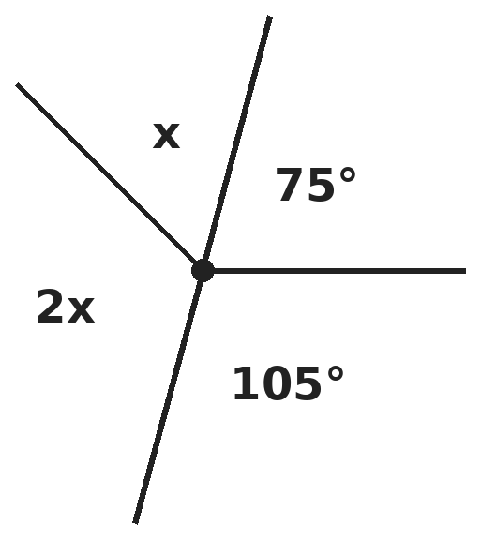
Q12. Four angles meet at a point: 75°, x, 2x and 105°, as shown. What is the largest of the four angles?
(A) 105° | (B) 120° | (C) 60° | (D) 90°

Q13. In a triangle, the middle angle is twice the smallest, and the largest is three times the smallest. What type of triangle is it?
(A) Acute-angled | (B) Obtuse-angled | (C) Equiangular | (D) Right-angled

Q14. All the diagonals are drawn from one corner of a polygon, and they cut it into 8 triangles. How many diagonals does the polygon have in all, from every corner?
(A) 7 | (B) 35 | (C) 70 | (D) 45

Part 6 — Mensuration (Syllabus Chapter 6)
Q15. A field is 60 m by 40 m. Two paths, each 3 m wide, cross through the middle, one parallel to each side. What is the total area of the paths?
(A) 291 m² | (B) 300 m² | (C) 309 m² | (D) 282 m²

Q16. A cube of edge 6 cm is cut into 27 equal small cubes. By how much does the total surface area increase?
(A) 432 cm² | (B) 648 cm² | (C) 216 cm² | (D) 324 cm²

Q17. A wooden cube of edge 12 cm is cut into small cubes of edge 3 cm. What is the total surface area of all the small cubes?
(A) 864 cm² | (B) 1,728 cm² | (C) 3,456 cm² | (D) 2,592 cm²

Part 7 — Data Handling, Statistics & Probability (Syllabus Chapter 8)
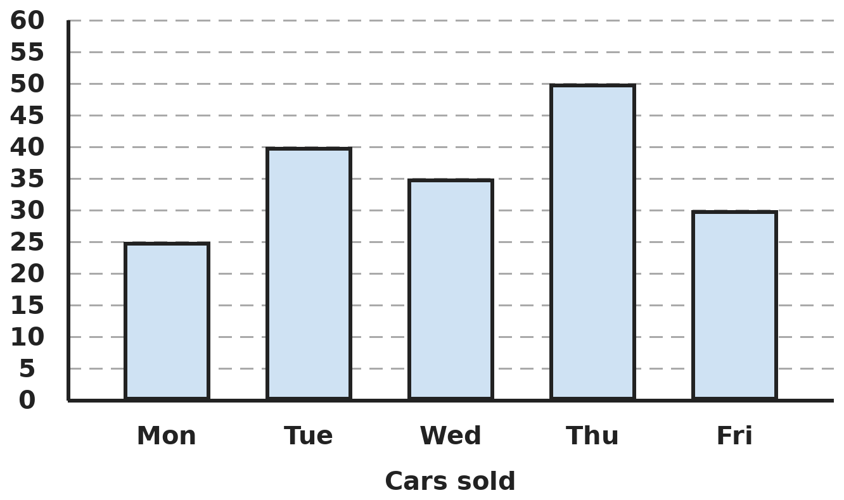
Q18. The bar graph shows the cars sold by a showroom. On how many days were more cars sold than on the day before, and what was the biggest rise?
(A) 3 days; 15 cars | (B) 2 days; 20 cars
(C) 2 days; 25 cars | (D) 2 days; 15 cars

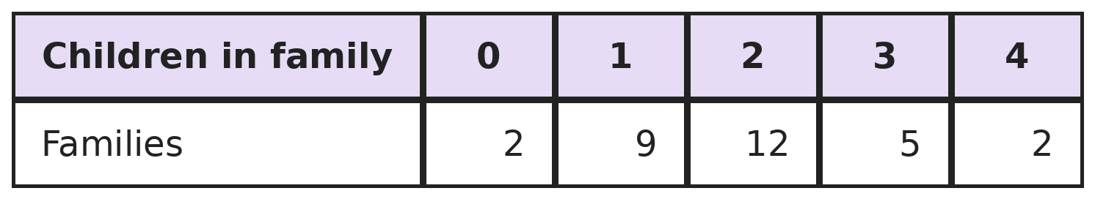
Q19. The table shows how many children there are in each of 30 families. How many children are there altogether?
(A) 56 | (B) 30 | (C) 10 | (D) 60

Part 8 — Applied Mathematics (Syllabus Chapter 9)
Q20. Two trains are 450 km apart. At 9 AM they start towards each other at 70 km/h and 80 km/h. At what time do they meet?
(A) 12:00 noon | (B) 11:00 AM | (C) 1:00 PM | (D) 3:00 PM

Q21. The ages of a mother and her daughter are in the ratio 7 : 2. The mother is 30 years older. How old is the mother?
(A) 35 | (B) 42 | (C) 12 | (D) 49

Q22. A car runs 270 km on 18 litres of petrol. How much petrol does it need for 405 km?
(A) 24 L | (B) 27 L | (C) 30 L | (D) 21 L

Part 9 — Mathematical Reasoning (Syllabus Chapter 10)
Q23. A 12-hour clock shows 8 o'clock. What will it show exactly 1,000 hours later?
(A) 8 o'clock | (B) 4 o'clock | (C) 10 o'clock | (D) 12 o'clock

Q24. A frog jumps forward 3 cm or 5 cm at each jump. Which of these distances can it cover in exactly 10 jumps?
(A) 37 cm | (B) 40 cm | (C) 45 cm | (D) 53 cm

Q25. A patch of water lilies doubles its area every day. It covers the whole pond on day 20. On which day did it cover half the pond?
(A) Day 10 | (B) Day 18 | (C) Day 19 | (D) Day 15

Part 10 — Mixed Problems (each joins two chapters)
Q26. 1 = 1, 1 + 3 = 4, 1 + 3 + 5 = 9. Following the pattern, what is the sum of the first 25 odd numbers?
(A) 600 | (B) 650 | (C) 625 | (D) 49

Q27. What is the value of 1 − 2 + 3 − 4 + 5 − 6 + … + 99 − 100?
(A) 50 | (B) −50 | (C) −100 | (D) 0

Q28. Kajal has 10 litres of juice that is 30% mango pulp. How many litres of pure pulp must she add to make the juice 50% pulp?
(A) 2 L | (B) 5 L | (C) 20 L | (D) 4 L

Q29. A square has the same perimeter as an equilateral triangle of side 12 cm. What is the area of the square?
(A) 144 cm² | (B) 36 cm² | (C) 72 cm² | (D) 81 cm²

Q30. Om buys 20 items, some pens at ₹15 each and the rest pencils at ₹5 each. He pays ₹200. How many pens does he buy?
(A) 12 | (B) 8 | (C) 10 | (D) 5

Answer Sheet AMO Level 2 · Class 6 · Practice Paper 3
Name: | School: | Roll No.:
Shade or tick one circle for each question.
1. | Ⓐ Ⓑ Ⓒ Ⓓ | 11. | Ⓐ Ⓑ Ⓒ Ⓓ | 21. | Ⓐ Ⓑ Ⓒ Ⓓ
2. | Ⓐ Ⓑ Ⓒ Ⓓ | 12. | Ⓐ Ⓑ Ⓒ Ⓓ | 22. | Ⓐ Ⓑ Ⓒ Ⓓ
3. | Ⓐ Ⓑ Ⓒ Ⓓ | 13. | Ⓐ Ⓑ Ⓒ Ⓓ | 23. | Ⓐ Ⓑ Ⓒ Ⓓ
4. | Ⓐ Ⓑ Ⓒ Ⓓ | 14. | Ⓐ Ⓑ Ⓒ Ⓓ | 24. | Ⓐ Ⓑ Ⓒ Ⓓ
5. | Ⓐ Ⓑ Ⓒ Ⓓ | 15. | Ⓐ Ⓑ Ⓒ Ⓓ | 25. | Ⓐ Ⓑ Ⓒ Ⓓ
6. | Ⓐ Ⓑ Ⓒ Ⓓ | 16. | Ⓐ Ⓑ Ⓒ Ⓓ | 26. | Ⓐ Ⓑ Ⓒ Ⓓ
7. | Ⓐ Ⓑ Ⓒ Ⓓ | 17. | Ⓐ Ⓑ Ⓒ Ⓓ | 27. | Ⓐ Ⓑ Ⓒ Ⓓ
8. | Ⓐ Ⓑ Ⓒ Ⓓ | 18. | Ⓐ Ⓑ Ⓒ Ⓓ | 28. | Ⓐ Ⓑ Ⓒ Ⓓ
9. | Ⓐ Ⓑ Ⓒ Ⓓ | 19. | Ⓐ Ⓑ Ⓒ Ⓓ | 29. | Ⓐ Ⓑ Ⓒ Ⓓ
10. | Ⓐ Ⓑ Ⓒ Ⓓ | 20. | Ⓐ Ⓑ Ⓒ Ⓓ | 30. | Ⓐ Ⓑ Ⓒ Ⓓ

For the parent or teacher
Correct: ______ / 30
Answer Key and Solutions AMO Level 2 · Class 6 · Practice Paper 3
Quick answers
1 A | 6 A | 11 C | 16 A | 21 B | 26 C
2 C | 7 B | 12 B | 17 C | 22 B | 27 B
3 A | 8 C | 13 D | 18 D | 23 D | 28 D
4 D | 9 A | 14 B | 19 A | 24 B | 29 D
5 D | 10 D | 15 A | 20 A | 25 C | 30 C
Solutions
Q | Part · level | Answer | Why?
1 | Part 1 · Ch1 · Hard | (A) 4 | Hint: Write the number with Indian commas: crores, lakhs, thousands, ones.  The number is 7,07,07,007. Its digits are 7 0 7 0 7 0 0 7, which has 4 zeros.
2 | Part 1 · Ch1 · Hard | (C) 5 primes, largest 11 | Hint: Divide by 2, 3, 5, 7, … in turn.  2,310 = 2 × 1,155 = 2 × 3 × 385 = 2 × 3 × 5 × 77 = 2 × 3 × 5 × 7 × 11. That is 5 different primes and the largest is 11.
3 | Part 1 · Ch1 · Hard | (A) 30 | Hint: The longest possible piece is the HCF of the three lengths.  84 = 12 × 7, 120 = 12 × 10 and 156 = 12 × 13, and 7, 10, 13 share no factor, so the HCF is 12 cm. Pieces: 7 + 10 + 13 = 30.
4 | Part 2 · Ch2 · Hard | (D) 8 | Hint: Inside the curly bracket, divide and multiply before adding.  12 ÷ (−4) = −3 and 2 × (−5) = −10, so the curly bracket is −13. Then −3 − (−13) = 10. Finally 18 − 10 = 8.
5 | Part 2 · Ch2 · Hard | (D) 6 | Hint: Work out the bracket carefully: two products, then subtract.  (−4) × 3 = −12 and (−3) × 2 = −6. The bracket is −12 − (−6) = −6. (−36) ÷ (−6) = 6.
6 | Part 2 · Ch2 · Hard | (A) −15 | Hint: Write the ten integers and cancel the opposite pairs.  The integers are −6, −5, −4, −3, −2, −1, 0, 1, 2, 3. The pairs −3 and 3, −2 and 2, −1 and 1 cancel. What is left is −6 − 5 − 4 = −15.
7 | Part 3 · Ch3 · Hard | (B) 0.67 | Hint: 2/3 = 0.6666… goes on for ever.  2/3 = 0.6666…, 66% = 0.66, and 0.666 stops after three digits. Compare: 0.670 > 0.6666… > 0.666 > 0.660. The largest is 0.67.
8 | Part 3 · Ch3 · Hard | (C) 7,920 | Hint: The fall is 10% of the new, larger number.  After the rise: 8,000 + 800 = 8,800. After the fall: 8,800 − 880 = 7,920.
9 | Part 3 · Ch3 · Hard | (A) 15% | Hint: The 20% who like both are counted in the 60% and in the 45%.  Students who like at least one game: 60% + 45% − 20% = 85%. Neither: 100% − 85% = 15%.
10 | Part 4 · Ch4 · Hard | (D) 4x + 14; 62 | Hint: Add 5 to each age before adding the two ages.  In 5 years Raju is x + 5 and his father is 3x + 4 + 5 = 3x + 9. Sum = 4x + 14. At x = 12: 48 + 14 = 62.
11 | Part 4 · Ch4 · Hard | (C) 2 | Hint: Open both brackets carefully; the second bracket is multiplied by −2.  3(2p − q) = 6p − 3q and −2(p − 3q) = −2p + 6q. Together: 4p + 3q. At p = −1, q = 2: −4 + 6 = 2.
12 | Part 5 · Ch5 · Hard | (B) 120° | Hint: Angles around a point add up to 360°.  75° + 105° + x + 2x = 360°, so 3x = 180° and x = 60°. The angles are 75°, 60°, 120° and 105°. The largest is 120°.
13 | Part 5 · Ch5 · Hard | (D) Right-angled | Hint: The three angles make 1 + 2 + 3 = 6 equal parts of 180°.  One part = 180° ÷ 6 = 30°. The angles are 30°, 60° and 90°, so it is right-angled.
14 | Part 5 · Ch5 · Hard | (B) 35 | Hint: Diagonals from one corner make (number of sides − 2) triangles.  8 triangles means the polygon has 8 + 2 = 10 sides. From each corner there are 10 − 3 = 7 diagonals. 10 × 7 = 70 counts every diagonal twice (once from each end), so there are 35. (A pentagon checks: 5 × 2 ÷ 2 = 5.)
15 | Part 6 · Ch6 · Hard | (A) 291 m² | Hint: The square where the paths cross is counted twice if you just add them.  Path along the length: 60 × 3 = 180 m². Path along the width: 40 × 3 = 120 m². The crossing square, 3 × 3 = 9 m², is in both. Total 180 + 120 − 9 = 291 m².
16 | Part 6 · Ch6 · Hard | (A) 432 cm² | Hint: Find the edge of a small cube first.  Big cube: 6 × 6 × 6 = 216 cm². Each small cube has edge 2 cm and surface area 6 × 4 = 24 cm². 27 small cubes: 27 × 24 = 648 cm². Increase: 648 − 216 = 432 cm².
17 | Part 6 · Ch6 · Hard | (C) 3,456 cm² | Hint: Count the small cubes: 4 along each edge.  There are 4 × 4 × 4 = 64 small cubes. Each has 6 × 3 × 3 = 54 cm². Total 64 × 54 = 3,456 cm². (864 cm² is the big cube's surface only.)
18 | Part 7 · Ch8 · Hard | (D) 2 days; 15 cars | Hint: Compare each day with the day before it. Monday has no day before.  Tue (40) > Mon (25): rise 15. Wed (35) < Tue. Thu (50) > Wed (35): rise 15. Fri (30) < Thu. So 2 days, and the biggest rise is 15 cars.
19 | Part 7 · Ch8 · Hard | (A) 56 | Hint: Multiply each number of children by the number of families.  0 × 2 + 1 × 9 + 2 × 12 + 3 × 5 + 4 × 2 = 0 + 9 + 24 + 15 + 8 = 56.
20 | Part 8 · Ch9 · Hard | (A) 12:00 noon | Hint: Together they close the gap by 70 + 80 km every hour.  The gap closes by 150 km each hour. 450 ÷ 150 = 3 hours. 9 AM + 3 hours = 12 noon.
21 | Part 8 · Ch9 · Hard | (B) 42 | Hint: The difference of 30 years is 7 − 2 = 5 parts.  5 parts = 30 years, so 1 part = 6 years. Mother = 7 × 6 = 42 years (daughter 12).
22 | Part 8 · Ch9 · Hard | (B) 27 L | Hint: Find the distance for 1 litre first.  1 litre gives 270 ÷ 18 = 15 km. 405 ÷ 15 = 27 litres.
23 | Part 9 · Ch10 · Hard | (D) 12 o'clock | Hint: Every 12 hours the clock shows the same time again.  1,000 = 12 × 83 + 4, so the clock moves on by 4 hours: 8 + 4 = 12 o'clock.
24 | Part 9 · Ch10 · Hard | (B) 40 cm | Hint: Each jump is an odd number. What about the total of 10 odd numbers?  Ten odd jumps make an even total, between 30 cm (all 3s) and 50 cm (all 5s). 37 and 45 are odd and 53 is too big. 40 cm works: five 3s and five 5s.
25 | Part 9 · Ch10 · Hard | (C) Day 19 | Hint: Work backwards one day from day 20.  The area doubles each day, so one day before the pond was full it was half full: day 19. (Day 10 wrongly halves the number of days.)
26 | Part 10 · Mixed · Ch4 + Ch10 · Hard | (C) 625 | Hint: The sum of the first n odd numbers is n × n.  The sums 1, 4, 9 are 1 × 1, 2 × 2, 3 × 3. So the first n odd numbers add to n × n. For n = 25: 25 × 25 = 625. (49 is the 25th odd number.)
27 | Part 10 · Mixed · Ch1 + Ch10 · Hard | (B) −50 | Hint: Group the terms in pairs.  (1 − 2) + (3 − 4) + … + (99 − 100) has 50 pairs, each equal to −1. Total −50.
28 | Part 10 · Mixed · Ch3 + Ch9 · Hard | (D) 4 L | Hint: The water part does not change.  The juice has 3 L pulp and 7 L water. For 50% pulp, the pulp must equal the water: 7 L. She must add 7 − 3 = 4 L of pulp. Check: 7 out of 14 is 50%.
29 | Part 10 · Mixed · Ch5 + Ch6 · Hard | (D) 81 cm² | Hint: All three sides of an equilateral triangle are equal.  Triangle perimeter = 3 × 12 = 36 cm. Square side = 36 ÷ 4 = 9 cm. Area = 9 × 9 = 81 cm².
30 | Part 10 · Mixed · Ch4 + Ch9 · Hard | (C) 10 | Hint: If all 20 were pencils, the cost would be ₹100.  20 pencils would cost ₹100. Changing one pencil into a pen adds ₹10. He needs ₹100 more, so 100 ÷ 10 = 10 pens. Check: 10 × 15 + 10 × 5 = 150 + 50 = ₹200.

ARYABHATTA MATHS OLYMPIAD
Level 2
PRACTICE PAPER-4
CLASS 6
Total Questions | 30 multiple-choice questions
Level | Level-2 (final round): every question is Hard
Time | 45 minutes
Arrangement | Parts by chapter; the last Part has mixed problems joining two chapters
Negative Marking | No negative marking
Calculator | Not allowed
Chapters | Number System · Operations · Fractions, Decimals & Percentages · Algebra · Geometry · Mensuration · Data Handling, Statistics & Probability · Applied Mathematics · Mathematical Reasoning

Instructions
• Each question has four options, (A) to (D), with exactly one correct answer.
• The questions are grouped in Parts by chapter. The last Part has mixed problems, each joining two chapters.
• Every question is at Level-2 (Hard) standard: expect several steps or a key insight.
• There is no negative marking. Calculators are not allowed; use a separate sheet for rough work.
• Figures are not necessarily drawn to scale unless stated.

For teachers
• Figures are part of the questions and work when printed in black and white.
• Parts follow the AMO syllabus chapters. Chapter 7 is not part of the Class 6 syllabus, so the chapter numbers shown in the Part headings have gaps.
• The answer sheet and the answer key are at the end. Remove the answer key before the paper is attempted.

Part 1 — Number System (Syllabus Chapter 1)
Q1. What is the difference between the largest and the smallest 8-digit numbers that have all their digits different?
(A) 8,86,30,865 | (B) 8,75,30,865 | (C) 8,85,31,865 | (D) 8,85,30,865

Q2. A number is 2 × 2 × 3 × 5 × 7. How many of its factors are odd?
(A) 4 | (B) 8 | (C) 24 | (D) 12

Q3. On a number line, A is at −14 and B is at 22. Point C is one quarter of the way from A to B. Which integer is at C?
(A) −5 | (B) −9 | (C) 9 | (D) 4

Part 2 — Operations (Syllabus Chapter 2)
Q4. What is the value of {6 + 18 ÷ (3 × 2)} × [4 − (−2)]?
(A) 54 | (B) 90 | (C) 48 | (D) −54

Q5. How many of these are true for ALL integers a, b, c (with no division by 0)? (i) a + b = b + a. (ii) a − b = b − a. (iii) a × (b + c) = a × b + a × c. (iv) (a ÷ b) ÷ c = a ÷ (b ÷ c).
(A) 3 | (B) 1 | (C) 4 | (D) 2

Q6. Three integers add up to 2 and multiply to give −60. One of them is −5. What is the largest of the three?
(A) 3 | (B) 4 | (C) 12 | (D) 7

Part 3 — Fractions, Decimals & Percentages (Syllabus Chapter 3)
Q7. Which of these numbers lies between 3/8 and 2/5?
(A) 0.39 | (B) 37% | (C) 0.41 | (D) 3/7

Q8. Aman spends 40% of his salary on rent and 25% of what is left on food. He saves the remaining ₹13,500. What is his salary?
(A) ₹27,000 | (B) ₹40,500 | (C) ₹22,500 | (D) ₹30,000

Q9. What percentage of 2 hours is 18 minutes?
(A) 9% | (B) 18% | (C) 30% | (D) 15%

Part 4 — Algebra (Syllabus Chapter 4)
Q10. Which of these values of x makes 20 − 2x greater than 5x − 4, and also makes 4x greater than 10?
(A) 2 | (B) 3 | (C) 4 | (D) 5

Q11. Hexagons are made in a row with matchsticks, each pair sharing one side. 1 hexagon uses 6 sticks and 2 hexagons use 11. How many sticks do 12 hexagons use?
(A) 72 | (B) 60 | (C) 66 | (D) 61

Part 5 — Geometry (Syllabus Chapter 5)
Q12. Two angles together make a straight angle. One of them is 30° more than half of the other. What is the larger angle?
(A) 80° | (B) 120° | (C) 110° | (D) 100°

Q13. An isosceles triangle has one angle of 70°. How many different sets of angles can the triangle have?
(A) 2 | (B) 1 | (C) 3 | (D) 0

Q14. A polygon has 14 diagonals. How many sides does it have?
(A) 8 | (B) 14 | (C) 7 | (D) 6

Part 6 — Mensuration (Syllabus Chapter 6)
Q15. A room is 6 m long, 4 m wide and 3 m high. Its four walls and ceiling are painted, but not a window of 2 m² or a door of 3 m². What area is painted?
(A) 84 m² | (B) 79 m² | (C) 103 m² | (D) 55 m²

Q16. The length of a rectangle is increased by 20% and its breadth is decreased by 20%. What happens to its area?
(A) It stays the same | (B) It increases by 4%
(C) It decreases by 4% | (D) It decreases by 20%

Q17. A cuboid has volume 480 cm³, length 12 cm and breadth 8 cm. What is its total surface area?
(A) 480 cm² | (B) 196 cm² | (C) 392 cm² | (D) 412 cm²

Part 7 — Data Handling, Statistics & Probability (Syllabus Chapter 8)
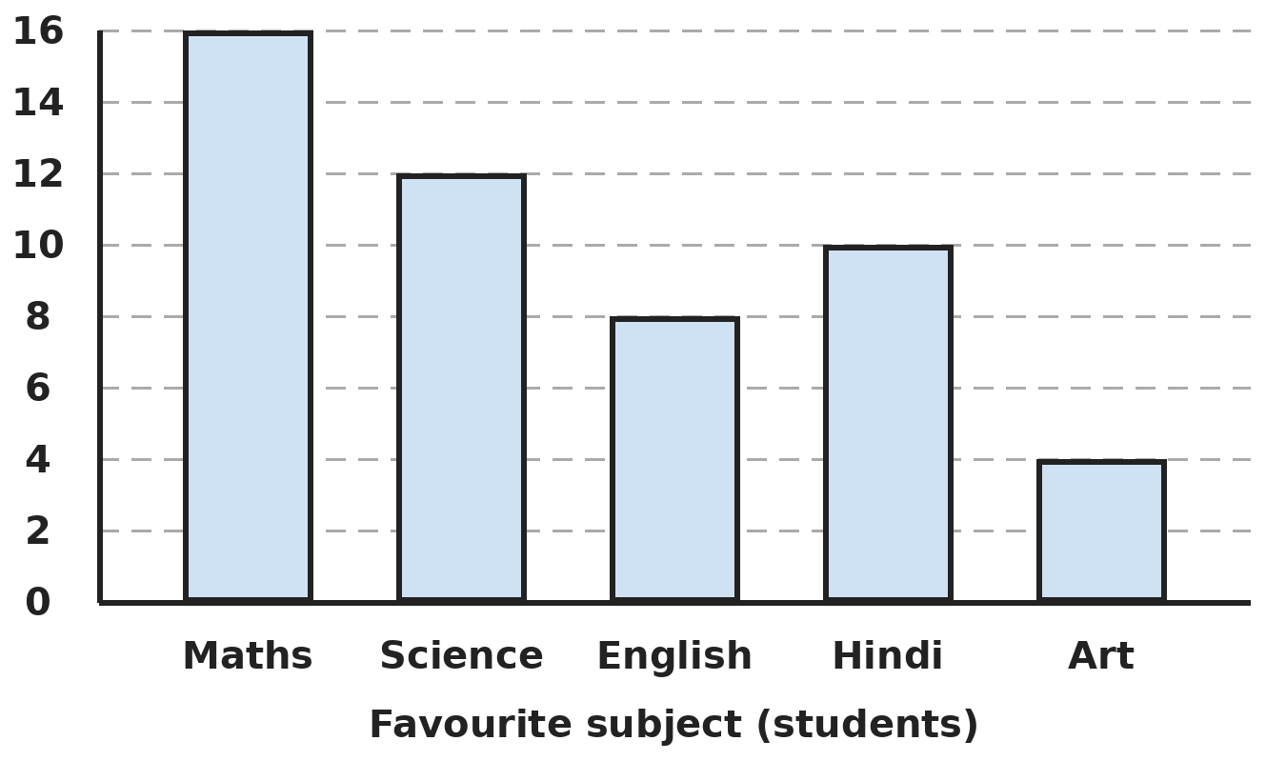
Q18. The bar graph shows the favourite subjects of a group of students. What percentage of the students chose one of the two most popular subjects?
(A) 56% | (B) 28% | (C) 32% | (D) 50%

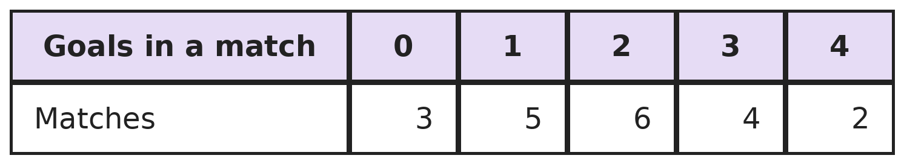
Q19. The table shows the goals scored in each match of a school football league. In how many matches were at least 2 goals scored, and how many goals were scored in those matches?
(A) 12 matches, 20 goals | (B) 6 matches, 12 goals
(C) 12 matches, 32 goals | (D) 14 matches, 32 goals

Part 8 — Applied Mathematics (Syllabus Chapter 9)
Q20. A bus travels 60 km at 40 km/h and then another 60 km at 60 km/h. What is its average speed for the whole trip?
(A) 50 km/h | (B) 48 km/h | (C) 45 km/h | (D) 52 km/h

Q21. The money with Arnav, Bhavna and Chirag is in the ratios Arnav : Bhavna = 2 : 3 and Bhavna : Chirag = 4 : 5. What is Arnav : Chirag?
(A) 2 : 5 | (B) 8 : 12 | (C) 10 : 12 | (D) 8 : 15

Q22. 15 men can dig a trench in 12 days. How many MORE men are needed to dig it in 9 days?
(A) 20 | (B) 3 | (C) 5 | (D) 8

Part 9 — Mathematical Reasoning (Syllabus Chapter 10)
Q23. A clock strikes once at 1 o'clock, twice at 2 o'clock, and so on up to 12 times at 12 o'clock. How many times does it strike in a full day of 24 hours?
(A) 78 | (B) 156 | (C) 300 | (D) 144

Q24. Two opposite corner squares are cut from an 8 × 8 chessboard, leaving 62 squares. Can 31 dominoes, each covering two neighbouring squares, cover it exactly?
(A) No, because the two removed squares are the same colour | (B) Yes, in exactly one way
(C) No, because 62 is not a multiple of 4 | (D) Yes, in many ways

Q25. Ram took half the mangoes in a basket and 1 more. Shyam took half of what was left and 1 more. Hari took half of the rest and 1 more. No mangoes were left. How many were there at first?
(A) 12 | (B) 16 | (C) 10 | (D) 14

Part 10 — Mixed Problems (each joins two chapters)

Q26. The nth number in this pattern is n × (n + 1) ÷ 2. What is the first number in the pattern that is greater than 100?
(A) 91 | (B) 120 | (C) 105 | (D) 100

Q27. How many integers from −50 to 50 (including both) are multiples of 3 or of 5?
(A) 47 | (B) 54 | (C) 40 | (D) 46

Q28. Kiran drives 240 km. She drives the first half at 60 km/h and then increases her speed by 20% for the second half. How long does the whole trip take?
(A) 4 h | (B) 3 h 20 min | (C) 3 h 40 min | (D) 3 h 36 min

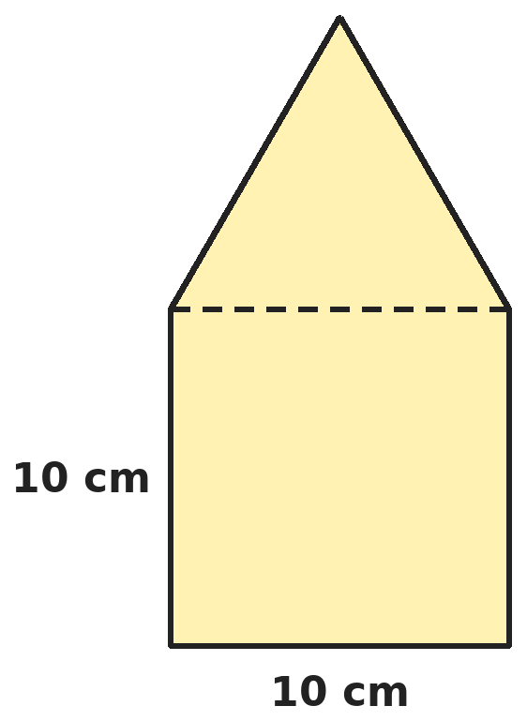
Q29. An equilateral triangle of side 10 cm sits exactly on top of a square of side 10 cm to make a house shape. What is the perimeter of the house shape, and the size of its largest angle?
(A) 60 cm; 150° | (B) 50 cm; 150° | (C) 50 cm; 120° | (D) 70 cm; 90°

Q30. A taxi charges ₹x per km for the first 10 km and ₹(x − 4) per km after that. A 25 km ride costs ₹315. What is x?
(A) 12 | (B) 15 | (C) 18 | (D) 13

Answer Sheet AMO Level 2 · Class 6 · Practice Paper 4
Name: | School: | Roll No.:
Shade or tick one circle for each question.
1. | Ⓐ Ⓑ Ⓒ Ⓓ | 11. | Ⓐ Ⓑ Ⓒ Ⓓ | 21. | Ⓐ Ⓑ Ⓒ Ⓓ
2. | Ⓐ Ⓑ Ⓒ Ⓓ | 12. | Ⓐ Ⓑ Ⓒ Ⓓ | 22. | Ⓐ Ⓑ Ⓒ Ⓓ
3. | Ⓐ Ⓑ Ⓒ Ⓓ | 13. | Ⓐ Ⓑ Ⓒ Ⓓ | 23. | Ⓐ Ⓑ Ⓒ Ⓓ
4. | Ⓐ Ⓑ Ⓒ Ⓓ | 14. | Ⓐ Ⓑ Ⓒ Ⓓ | 24. | Ⓐ Ⓑ Ⓒ Ⓓ
5. | Ⓐ Ⓑ Ⓒ Ⓓ | 15. | Ⓐ Ⓑ Ⓒ Ⓓ | 25. | Ⓐ Ⓑ Ⓒ Ⓓ
6. | Ⓐ Ⓑ Ⓒ Ⓓ | 16. | Ⓐ Ⓑ Ⓒ Ⓓ | 26. | Ⓐ Ⓑ Ⓒ Ⓓ
7. | Ⓐ Ⓑ Ⓒ Ⓓ | 17. | Ⓐ Ⓑ Ⓒ Ⓓ | 27. | Ⓐ Ⓑ Ⓒ Ⓓ
8. | Ⓐ Ⓑ Ⓒ Ⓓ | 18. | Ⓐ Ⓑ Ⓒ Ⓓ | 28. | Ⓐ Ⓑ Ⓒ Ⓓ
9. | Ⓐ Ⓑ Ⓒ Ⓓ | 19. | Ⓐ Ⓑ Ⓒ Ⓓ | 29. | Ⓐ Ⓑ Ⓒ Ⓓ
10. | Ⓐ Ⓑ Ⓒ Ⓓ | 20. | Ⓐ Ⓑ Ⓒ Ⓓ | 30. | Ⓐ Ⓑ Ⓒ Ⓓ

For the parent or teacher
Correct: ______ / 30
Answer Key and Solutions AMO Level 2 · Class 6 · Practice Paper 4
Quick answers
1 D | 6 B | 11 D | 16 C | 21 D | 26 C
2 B | 7 A | 12 D | 17 C | 22 C | 27 A
3 A | 8 D | 13 A | 18 A | 23 B | 28 C
4 A | 9 D | 14 C | 19 C | 24 A | 29 B
5 D | 10 B | 15 B | 20 B | 25 D | 30 B
Solutions
Q | Part · level | Answer | Why?
1 | Part 1 · Ch1 · Hard | (D) 8,85,30,865 | Hint: The smallest cannot start with 0: it is 1,02,34,567.  Largest: 9,87,65,432. Smallest: 1,02,34,567. Difference: 9,87,65,432 − 1,02,34,567 = 8,85,30,865.
2 | Part 1 · Ch1 · Hard | (B) 8 | Hint: An odd factor cannot use any 2.  Odd factors are made only from 3, 5 and 7, each used or not: 1, 3, 5, 7, 15, 21, 35, 105. That is 8.
3 | Part 1 · Ch1 · Hard | (A) −5 | Hint: Find the distance from A to B first.  AB = 22 − (−14) = 36. A quarter of 36 is 9. C = −14 + 9 = −5.
4 | Part 2 · Ch2 · Hard | (A) 54 | Hint: Inside the curly bracket, the round bracket comes first.  (3 × 2) = 6, so 18 ÷ 6 = 3 and the curly bracket is 6 + 3 = 9. The square bracket is 4 + 2 = 6. 9 × 6 = 54. (90 comes from working 18 ÷ 3 × 2 as 12.)
5 | Part 2 · Ch2 · Hard | (D) 2 | Hint: Test (ii) and (iv) with small numbers like 8, 4 and 2.  (i) is the commutative property and (iii) is the distributive property: both always true. (ii) fails: 8 − 4 ≠ 4 − 8. (iv) fails: (8 ÷ 4) ÷ 2 = 1 but 8 ÷ (4 ÷ 2) = 4. So 2.
6 | Part 2 · Ch2 · Hard | (B) 4 | Hint: The other two add up to 7 and multiply to 12.  The other two add to 2 − (−5) = 7 and multiply to −60 ÷ (−5) = 12. They are 3 and 4. The largest is 4.
7 | Part 3 · Ch3 · Hard | (A) 0.39 | Hint: Change everything into decimals.  3/8 = 0.375 and 2/5 = 0.4. 0.39 lies between them. 37% = 0.37 is too small, 0.41 is too big, and 3/7 = 0.428… is too big.
8 | Part 3 · Ch3 · Hard | (D) ₹30,000 | Hint: The 25% is of the remaining 60%, not of the whole salary.  After rent, 60% is left. Food takes 25% of that, which is 15% of the salary. Savings = 60% − 15% = 45% of the salary = ₹13,500. 1% = ₹300, so the salary is ₹30,000.
9 | Part 3 · Ch3 · Hard | (D) 15% | Hint: Change 2 hours into minutes first.  2 hours = 120 minutes. 18/120 = 3/20 = 15/100 = 15%. (9% wrongly uses 200 minutes.)
10 | Part 4 · Ch4 · Hard | (B) 3 | Hint: Substitute each value into all three expressions.  x = 2: 16 > 6, but 4x = 8 is not greater than 10. x = 3: 14 > 11 and 12 > 10, so both are true. x = 4: 12 is not greater than 16. x = 5: 10 is not greater than 21. Only x = 3 works.
11 | Part 4 · Ch4 · Hard | (D) 61 | Hint: Each new hexagon adds 5 sticks.  n hexagons use 5n + 1 sticks (6, 11, 16, …). For n = 12: 60 + 1 = 61. (72 forgets the shared sides.)
12 | Part 5 · Ch5 · Hard | (D) 100° | Hint: Try the options: check that the two angles add up to 180°.  If the larger is 100°, the other is 180° − 100° = 80°, and 80° = half of 100° + 30° = 50° + 30°. So the larger angle is 100°.
13 | Part 5 · Ch5 · Hard | (A) 2 | Hint: The 70° angle could be one of the two equal angles, or the odd one.  If 70° is one of the equal angles: 70°, 70°, 40°. If 70° is the odd angle: the other two share 110°, giving 55°, 55°, 70°. That is 2 sets.
14 | Part 5 · Ch5 · Hard | (C) 7 | Hint: An n-sided polygon has n × (n − 3) ÷ 2 diagonals. Try the options.  n = 7: 7 × 4 ÷ 2 = 14. ✓ (n = 8 gives 20 and n = 6 gives 9.)
15 | Part 6 · Ch6 · Hard | (B) 79 m² | Hint: The four walls together are a long strip of length 2 × (6 + 4).  Walls: 2 × (6 + 4) × 3 = 60 m². Ceiling: 6 × 4 = 24 m². Total 84 m². Minus window and door: 84 − 5 = 79 m².
16 | Part 6 · Ch6 · Hard | (C) It decreases by 4% | Hint: Try a 10 cm by 10 cm square.  A 10 × 10 square (100 cm²) becomes 12 × 8 = 96 cm². The area falls by 4 cm² out of 100, which is 4%.
17 | Part 6 · Ch6 · Hard | (C) 392 cm² | Hint: Find the height first.  Height = 480 ÷ (12 × 8) = 5 cm. Surface area = 2 × (12 × 8 + 12 × 5 + 8 × 5) = 2 × (96 + 60 + 40) = 392 cm².
18 | Part 7 · Ch8 · Hard | (A) 56% | Hint: Find the total number of students first.  Total: 16 + 12 + 8 + 10 + 4 = 50. Top two: Maths 16 + Science 12 = 28. 28 out of 50 = 56%. (28% is the count, not the percentage.)
19 | Part 7 · Ch8 · Hard | (C) 12 matches, 32 goals | Hint: "At least 2" means 2, 3 or 4 goals.  Matches: 6 + 4 + 2 = 12. Goals in them: 2 × 6 + 3 × 4 + 4 × 2 = 12 + 12 + 8 = 32.
20 | Part 8 · Ch9 · Hard | (B) 48 km/h | Hint: Average speed = total distance ÷ total time.  Time: 60 ÷ 40 = 1.5 h and 60 ÷ 60 = 1 h, so 2.5 h in all. Average speed = 120 ÷ 2.5 = 48 km/h. (50 km/h wrongly averages the two speeds.)
21 | Part 8 · Ch9 · Hard | (D) 8 : 15 | Hint: Make Bhavna's share the same number in both ratios.  Arnav : Bhavna = 8 : 12 and Bhavna : Chirag = 12 : 15. So Arnav : Chirag = 8 : 15.
22 | Part 8 · Ch9 · Hard | (C) 5 | Hint: Find the number of man-days of work first.  Work = 15 × 12 = 180 man-days. In 9 days: 180 ÷ 9 = 20 men. Extra men: 20 − 15 = 5.
23 | Part 9 · Ch10 · Hard | (B) 156 | Hint: The clock goes round twice in a day.  One round: 1 + 2 + … + 12 = 78 strikes. Two rounds in 24 hours: 156.
24 | Part 9 · Ch10 · Hard | (A) No, because the two removed squares are the same colour | Hint: Every domino covers one black and one white square.  Opposite corners have the same colour, so 30 squares of one colour and 32 of the other are left. 31 dominoes would cover 31 of each colour. So it is impossible.
25 | Part 9 · Ch10 · Hard | (D) 14 | Hint: Work backwards. Before Hari, what number has half + 1 equal to the whole?  Before Hari there were 2 (he took 1 + 1). Before Shyam: half of it and 1 more left 2, so half was 3 and there were 6. Before Ram: half of it and 1 more left 6, so half was 7 and there were 14.
26 | Part 10 · Mixed · Ch4 + Ch10 · Hard | (C) 105 | Hint: Try n = 13 and n = 14.  n = 13: 13 × 14 ÷ 2 = 91. n = 14: 14 × 15 ÷ 2 = 105. So 105 is the first above 100. (100 is not in the pattern.)
27 | Part 10 · Mixed · Ch1 + Ch10 · Hard | (A) 47 | Hint: Count multiples of 3, of 5, and take away multiples of 15 once. Do not forget 0.  Multiples of 3: −48 to 48, which is 16 + 1 + 16 = 33. Multiples of 5: −50 to 50, which is 10 + 1 + 10 = 21. Multiples of 15: −45 to 45, which is 3 + 1 + 3 = 7. Total 33 + 21 − 7 = 47.
28 | Part 10 · Mixed · Ch3 + Ch9 · Hard | (C) 3 h 40 min | Hint: 20% more than 60 km/h is 72 km/h.  First 120 km at 60 km/h: 2 h. Second 120 km at 72 km/h: 120 ÷ 72 = 1 2/3 h = 1 h 40 min. Total 3 h 40 min.
29 | Part 10 · Mixed · Ch5 + Ch6 · Hard | (B) 50 cm; 150° | Hint: The shared side is inside the shape, not on its edge.  The outline has 5 sides of 10 cm: 50 cm. Where the roof meets a wall, the square's 90° and the triangle's 60° join: 150°. The other angles are 60° and 90°, so the largest is 150°.
30 | Part 10 · Mixed · Ch4 + Ch9 · Hard | (B) 15 | Hint: Imagine every km cost ₹x. How much more would the ride cost?  If all 25 km cost ₹x, the fare would be ₹4 more for each of the last 15 km: 315 + 15 × 4 = ₹375. So 25 km at ₹x cost ₹375, and x = 375 ÷ 25 = 15. Check: 10 × 15 + 15 × 11 = 150 + 165 = 315.

ARYABHATTA MATHS OLYMPIAD
Level 2
PRACTICE PAPER-5
CLASS 6
Total Questions | 30 multiple-choice questions
Level | Level-2 (final round): every question is Hard
Time | 45 minutes
Arrangement | Parts by chapter; the last Part has mixed problems joining two chapters
Negative Marking | No negative marking
Calculator | Not allowed
Chapters | Number System · Operations · Fractions, Decimals & Percentages · Algebra · Geometry · Mensuration · Data Handling, Statistics & Probability · Applied Mathematics · Mathematical Reasoning

Instructions
• Each question has four options, (A) to (D), with exactly one correct answer.
• The questions are grouped in Parts by chapter. The last Part has mixed problems, each joining two chapters.
• Every question is at Level-2 (Hard) standard: expect several steps or a key insight.
• There is no negative marking. Calculators are not allowed; use a separate sheet for rough work.
• Figures are not necessarily drawn to scale unless stated.

For teachers
• Figures are part of the questions and work when printed in black and white.
• Parts follow the AMO syllabus chapters. Chapter 7 is not part of the Class 6 syllabus, so the chapter numbers shown in the Part headings have gaps.
• The answer sheet and the answer key are at the end. Remove the answer key before the paper is attempted.

Part 1 — Number System (Syllabus Chapter 1)
Q1. A city has 1 crore 20 lakh people. How many millions is that in the international system?
(A) 120 | (B) 1.2 | (C) 1,200 | (D) 12

Q2. What is the smallest whole number by which 252 must be multiplied so that the product is a multiple of 360?
(A) 10 | (B) 5 | (C) 2 | (D) 30

Q3. Add all the negative integers greater than −15 and all the positive integers less than 12. What is the total?
(A) −105 | (B) 39 | (C) −39 | (D) −171

Part 2 — Operations (Syllabus Chapter 2)
Q4. What is the value of [{(−2) × (−3)} − {(−8) ÷ 2}] × (−1)?
(A) 10 | (B) −2 | (C) 2 | (D) −10

Q5. Use number properties to work out 125 × 37 × 8 + 63 × 1,000.
(A) 37,063 | (B) 1,00,000 | (C) 63,037 | (D) 1,10,000

Q6. At 6 PM the temperature in a hill town is 18°C. It falls by 4°C every hour. At what time does it reach −10°C?
(A) 1 AM | (B) 12 midnight | (C) 2 AM | (D) 11 PM

Part 3 — Fractions, Decimals & Percentages (Syllabus Chapter 3)
Q7. Write these in order from largest to smallest: 4/5, 0.83, 79%, 41/50. Which is third?
(A) 41/50 | (B) 79% | (C) 4/5 | (D) 0.83

Q8. When a number is increased by 20%, the result is 90. What is 20% LESS than the original number?
(A) 72 | (B) 60 | (C) 70 | (D) 54

Q9. 20% of Arjun's marks is equal to 25% of Bela's marks. Bela scored 64. What did Arjun score?
(A) 51.2 | (B) 80 | (C) 60 | (D) 70

Part 4 — Algebra (Syllabus Chapter 4)
Q10. Notebooks cost ₹(y + 5) each and pens cost ₹y each. Divya buys x notebooks and 3 pens. Write her total cost and find it when x = 4 and y = 15.
(A) x(y + 5) + 3y; ₹105 | (B) xy + 5 + 3y; ₹110
(C) (x + 3)(y + 5); ₹140 | (D) x(y + 5) + 3y; ₹125

Q11. Three consecutive even numbers are 2n, 2n + 2 and 2n + 4. Their sum is 78. What is n?
(A) 13 | (B) 12 | (C) 24 | (D) 26

Part 5 — Geometry (Syllabus Chapter 5)
Q12. Riya faces north. She turns 135° clockwise and then 270° anticlockwise. In which direction does she face now?
(A) North-east | (B) South-east | (C) South-west | (D) North-west

Q13. Five angles meet at a point. They measure x°, 2x°, 3x°, 4x° and 5x°. What type of angle is the largest one?
(A) Acute | (B) Reflex | (C) Right | (D) Obtuse

Q14. A regular hexagon is cut along its three longest diagonals, which all pass through its centre. What pieces does this make?
(A) 6 equilateral triangles | (B) 6 right-angled triangles
(C) 3 equilateral triangles | (D) 6 scalene triangles

Part 6 — Mensuration (Syllabus Chapter 6)
Q15. A square park has side 50 m. A path 5 m wide runs all round the outside of it. What is the area of the path?
(A) 1,000 m² | (B) 500 m² | (C) 1,100 m² | (D) 1,200 m²

Q16. A cube of edge 5 cm is cut into two cuboids by one straight cut parallel to a face. By how much does the total surface area increase?
(A) 25 cm² | (B) 50 cm² | (C) 0 cm² | (D) 150 cm²

Q17. How many bricks of 20 cm × 10 cm × 5 cm are needed for a wall 10 m long, 30 cm thick and 2 m high? (Ignore cement.)
(A) 6,000 | (B) 600 | (C) 60,000 | (D) 3,000

Part 7 — Data Handling, Statistics & Probability (Syllabus Chapter 8)
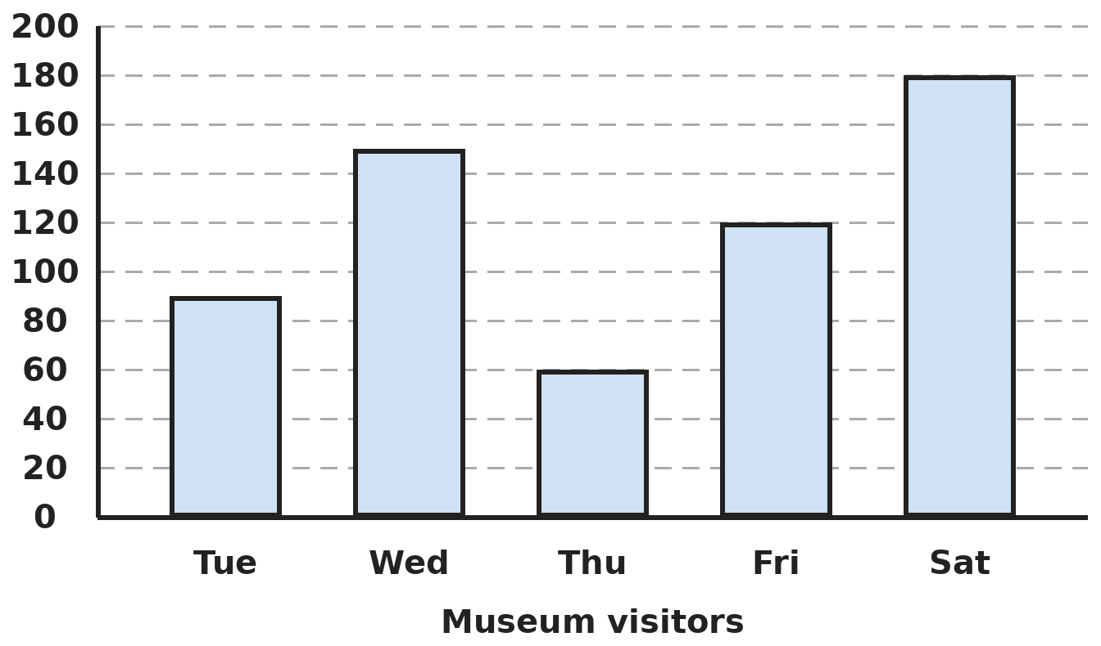
Q18. The bar graph shows the visitors to a museum. Saturday's visitors were how many times Thursday's, and how many more than Wednesday's?
(A) 2 times; 30 more | (B) 3 times; 60 more
(C) 4 times; 30 more | (D) 3 times; 30 more

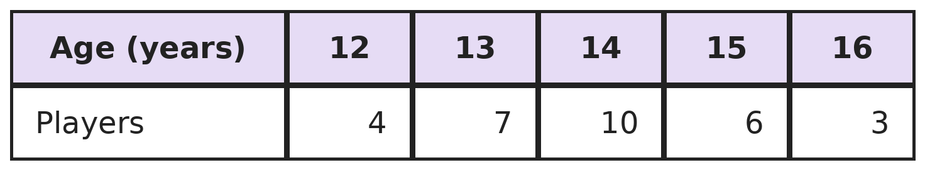
Q19. The table shows the ages of the players in a sports camp. What fraction of the players are older than 13 but younger than 16?
(A) 8/15 | (B) 19/30 | (C) 1/3 | (D) 2/5

Part 8 — Applied Mathematics (Syllabus Chapter 9)
Q20. Vivek covers 25 km in 3 hours, partly walking at 5 km/h and partly running at 10 km/h. How far does he walk?
(A) 10 km | (B) 15 km | (C) 20 km | (D) 5 km

Q21. ₹6,300 is shared between Ira and Om so that Ira gets ₹900 more than Om. What is the ratio of Ira's share to Om's?
(A) 3 : 2 | (B) 7 : 6 | (C) 4 : 3 | (D) 5 : 4

Q22. A recipe mixes rice and dal in the ratio 3 : 2. For 6 people it uses 450 g of rice. How much dal is needed for 14 people?
(A) 700 g | (B) 1,050 g | (C) 300 g | (D) 750 g

Part 9 — Mathematical Reasoning (Syllabus Chapter 10)
Q23. Today is Wednesday. Which day of the week will it be 100 days from today?
(A) Friday | (B) Thursday | (C) Saturday | (D) Wednesday

Q24. Sameer chooses 4 different numbers from 1, 3, 5, …, 19. Which of these could be their sum?
(A) 41 | (B) 40 | (C) 35 | (D) 81

Q25. Lata thinks of a number. She adds 5, multiplies by 4, subtracts 8 and divides by 6. The answer is 10. What was her number?
(A) 12 | (B) 17 | (C) 8 | (D) 15

Part 10 — Mixed Problems (each joins two chapters)
Q26. Look at the pattern 3, 8, 15, 24, 35, … Which term of the pattern is 168?
(A) 13th | (B) 11th | (C) 12th | (D) 14th

Q27. What is the smallest number that leaves remainder 4 when divided by 6, remainder 6 when divided by 8, and remainder 8 when divided by 10?
(A) 122 | (B) 118 | (C) 238 | (D) 120

Q28. A train usually runs at 80 km/h. Because of repairs it runs at 60 km/h. By what percentage does the time for a 240 km journey increase?
(A) 25% | (B) 20% | (C) 33 1/3% | (D) 40%

Q29. A 6 cm wooden cube is painted on all faces and cut into 1 cm cubes. How many small cubes have paint on exactly one face?
(A) 144 | (B) 96 | (C) 64 | (D) 56

Q30. Rahul is r years old and his sister is 4 years younger. In 6 years their ages will add up to 48. What is r?
(A) 18 | (B) 22 | (C) 24 | (D) 20

Answer Sheet AMO Level 2 · Class 6 · Practice Paper 5
Name: | School: | Roll No.:
Shade or tick one circle for each question.
1. | Ⓐ Ⓑ Ⓒ Ⓓ | 11. | Ⓐ Ⓑ Ⓒ Ⓓ | 21. | Ⓐ Ⓑ Ⓒ Ⓓ
2. | Ⓐ Ⓑ Ⓒ Ⓓ | 12. | Ⓐ Ⓑ Ⓒ Ⓓ | 22. | Ⓐ Ⓑ Ⓒ Ⓓ
3. | Ⓐ Ⓑ Ⓒ Ⓓ | 13. | Ⓐ Ⓑ Ⓒ Ⓓ | 23. | Ⓐ Ⓑ Ⓒ Ⓓ
4. | Ⓐ Ⓑ Ⓒ Ⓓ | 14. | Ⓐ Ⓑ Ⓒ Ⓓ | 24. | Ⓐ Ⓑ Ⓒ Ⓓ
5. | Ⓐ Ⓑ Ⓒ Ⓓ | 15. | Ⓐ Ⓑ Ⓒ Ⓓ | 25. | Ⓐ Ⓑ Ⓒ Ⓓ
6. | Ⓐ Ⓑ Ⓒ Ⓓ | 16. | Ⓐ Ⓑ Ⓒ Ⓓ | 26. | Ⓐ Ⓑ Ⓒ Ⓓ
7. | Ⓐ Ⓑ Ⓒ Ⓓ | 17. | Ⓐ Ⓑ Ⓒ Ⓓ | 27. | Ⓐ Ⓑ Ⓒ Ⓓ
8. | Ⓐ Ⓑ Ⓒ Ⓓ | 18. | Ⓐ Ⓑ Ⓒ Ⓓ | 28. | Ⓐ Ⓑ Ⓒ Ⓓ
9. | Ⓐ Ⓑ Ⓒ Ⓓ | 19. | Ⓐ Ⓑ Ⓒ Ⓓ | 29. | Ⓐ Ⓑ Ⓒ Ⓓ
10. | Ⓐ Ⓑ Ⓒ Ⓓ | 20. | Ⓐ Ⓑ Ⓒ Ⓓ | 30. | Ⓐ Ⓑ Ⓒ Ⓓ

For the parent or teacher
Correct: ______ / 30
Answer Key and Solutions AMO Level 2 · Class 6 · Practice Paper 5
Quick answers
1 D | 6 A | 11 B | 16 B | 21 C | 26 C
2 A | 7 C | 12 C | 17 A | 22 A | 27 B
3 C | 8 B | 13 D | 18 D | 23 A | 28 C
4 D | 9 B | 14 A | 19 A | 24 B | 29 B
5 B | 10 D | 15 C | 20 D | 25 A | 30 D
Solutions
Q | Part · level | Answer | Why?
1 | Part 1 · Ch1 · Hard | (D) 12 | Hint: 1 million = 10 lakh.  1 crore 20 lakh = 1,20,00,000 = 12,000,000. That is 12 million, since 1 million = 10,00,000 (10 lakh).
2 | Part 1 · Ch1 · Hard | (A) 10 | Hint: Compare the prime factorisations of 252 and 360.  252 = 2 × 2 × 3 × 3 × 7 and 360 = 2 × 2 × 2 × 3 × 3 × 5. 252 is missing one 2 and one 5, so multiply by 2 × 5 = 10. Check: 2,520 = 360 × 7.
3 | Part 1 · Ch1 · Hard | (C) −39 | Hint: The negatives are −14 to −1 and the positives are 1 to 11.  −1 − 2 − … − 14 = −105. 1 + 2 + … + 11 = 66. Total −105 + 66 = −39.
4 | Part 2 · Ch2 · Hard | (D) −10 | Hint: Watch the sign when you subtract a negative number.  (−2) × (−3) = 6 and (−8) ÷ 2 = −4. 6 − (−4) = 10. 10 × (−1) = −10.
5 | Part 2 · Ch2 · Hard | (B) 1,00,000 | Hint: Multiply 125 and 8 first.  125 × 37 × 8 = (125 × 8) × 37 = 1,000 × 37 = 37,000. Then 37,000 + 63,000 = 1,00,000, because 37 + 63 = 100 thousands.
6 | Part 2 · Ch2 · Hard | (A) 1 AM | Hint: Find the total fall from 18°C to −10°C.  The fall is 18 − (−10) = 28°C. 28 ÷ 4 = 7 hours. 6 PM + 7 hours = 1 AM.
7 | Part 3 · Ch3 · Hard | (C) 4/5 | Hint: Change everything into hundredths.  4/5 = 0.80, 0.83, 79% = 0.79 and 41/50 = 0.82. Largest first: 0.83, 0.82, 0.80, 0.79. The third is 4/5.
8 | Part 3 · Ch3 · Hard | (B) 60 | Hint: 120% of the number is 90.  120% of the number = 90, so 1% = 0.75 and the number is 75. 20% less than 75 is 75 − 15 = 60. (72 wrongly takes 20% off 90.)
9 | Part 3 · Ch3 · Hard | (B) 80 | Hint: Find 25% of 64 first.  25% of 64 = 16. So 20% of Arjun's marks is 16, and 1% is 0.8. Arjun scored 80.
10 | Part 4 · Ch4 · Hard | (D) x(y + 5) + 3y; ₹125 | Hint: Each notebook costs (y + 5), so x notebooks cost x(y + 5).  Total = x(y + 5) + 3y. At x = 4, y = 15: 4 × 20 + 3 × 15 = 80 + 45 = ₹125.
11 | Part 4 · Ch4 · Hard | (B) 12 | Hint: The middle number of three equally spaced numbers is their sum ÷ 3.  The three numbers are equally spaced, so the middle one is 78 ÷ 3 = 26. The numbers are 24, 26 and 28. The smallest is 2n = 24, so n = 12. (24 is the smallest number, not n.)
12 | Part 5 · Ch5 · Hard | (C) South-west | Hint: Combine the two turns into one turn.  135° clockwise then 270° anticlockwise is the same as 135° anticlockwise. From north, 90° anticlockwise is west and 45° more is south-west.
13 | Part 5 · Ch5 · Hard | (D) Obtuse | Hint: Angles at a point add up to 360°. How many x's are there in all?  There are 1 + 2 + 3 + 4 + 5 = 15 lots of x, so 15x = 360° and x = 24°. The largest angle is 5 × 24° = 120°, which is obtuse.
14 | Part 5 · Ch5 · Hard | (A) 6 equilateral triangles | Hint: Each angle at the centre is 360° ÷ 6.  The three diagonals make 6 triangles meeting at the centre, each with a 60° angle there. Each triangle has two equal sides (centre to corner), so its other two angles are (180° − 60°) ÷ 2 = 60°. All 6 are equilateral.
15 | Part 6 · Ch6 · Hard | (C) 1,100 m² | Hint: The outer square has side 50 + 5 + 5.  Outer square: 60 × 60 = 3,600 m². Park: 50 × 50 = 2,500 m². Path: 3,600 − 2,500 = 1,100 m². (1,000 forgets the four corner squares.)
16 | Part 6 · Ch6 · Hard | (B) 50 cm² | Hint: The cut makes new faces. How many, and how big?  The cut creates two new faces, each 5 × 5 = 25 cm². The surface area increases by 50 cm², wherever the cut is made.
17 | Part 6 · Ch6 · Hard | (A) 6,000 | Hint: Change the wall's measurements into centimetres.  Wall: 1,000 × 30 × 200 = 60,00,000 cm³. Brick: 20 × 10 × 5 = 1,000 cm³. Bricks: 60,00,000 ÷ 1,000 = 6,000.
18 | Part 7 · Ch8 · Hard | (D) 3 times; 30 more | Hint: Read Thursday, Wednesday and Saturday carefully against the gridlines.  Saturday 180, Thursday 60, Wednesday 150. 180 ÷ 60 = 3 times. 180 − 150 = 30 more.
19 | Part 7 · Ch8 · Hard | (A) 8/15 | Hint: Only ages 14 and 15 count.  Total players: 4 + 7 + 10 + 6 + 3 = 30. Ages 14 and 15: 10 + 6 = 16. 16/30 = 8/15.
20 | Part 8 · Ch9 · Hard | (D) 5 km | Hint: If he ran all the way, 25 km would take 2.5 hours.  Running all 25 km takes 2.5 h, half an hour short. Each km walked instead of run adds 1/5 − 1/10 = 1/10 h. He needs 1/2 h more, so he walks 5 km. Check: 5 km takes 1 h and 20 km run takes 2 h.
21 | Part 8 · Ch9 · Hard | (C) 4 : 3 | Hint: Take away the extra ₹900 first and share the rest equally.  6,300 − 900 = 5,400, shared equally gives ₹2,700 each. Ira has 2,700 + 900 = ₹3,600 and Om ₹2,700. 3,600 : 2,700 = 4 : 3.
22 | Part 8 · Ch9 · Hard | (A) 700 g | Hint: Find the rice for one person first, then use the ratio.  Rice for one person: 450 ÷ 6 = 75 g. For 14 people: 14 × 75 = 1,050 g of rice. Dal is 2/3 of the rice: 1,050 ÷ 3 × 2 = 700 g.
23 | Part 9 · Ch10 · Hard | (A) Friday | Hint: Every 7 days the day of the week repeats.  100 = 7 × 14 + 2. After 14 full weeks it is Wednesday again; 2 more days gives Friday.
24 | Part 9 · Ch10 · Hard | (B) 40 | Hint: Is the sum of four odd numbers odd or even? How big can it be?  Four odd numbers add to an even number, so 41 and 35 are impossible. The largest sum is 13 + 15 + 17 + 19 = 64, so 81 is impossible. 40 works: 1 + 5 + 15 + 19 = 40.
25 | Part 9 · Ch10 · Hard | (A) 12 | Hint: Undo each step, starting from the last.  10 × 6 = 60. 60 + 8 = 68. 68 ÷ 4 = 17. 17 − 5 = 12.
26 | Part 10 · Mixed · Ch4 + Ch10 · Hard | (C) 12th | Hint: 3 = 1 × 3, 8 = 2 × 4, 15 = 3 × 5. Write the nth term.  The nth term is n × (n + 2). We need two numbers 2 apart that multiply to 168: 12 × 14 = 168. So n = 12, the 12th term. (11 × 13 = 143 and 13 × 15 = 195.)
27 | Part 10 · Mixed · Ch1 + Ch10 · Hard | (B) 118 | Hint: In each case the remainder is 2 less than the divisor.  Adding 2 to the number makes it divisible by 6, 8 and 10. LCM of 6, 8 and 10 is 120, so the number is 120 − 2 = 118. Check: 118 = 6 × 19 + 4 = 8 × 14 + 6 = 10 × 11 + 8.
28 | Part 10 · Mixed · Ch3 + Ch9 · Hard | (C) 33 1/3% | Hint: Find the two journey times.  At 80 km/h: 3 hours. At 60 km/h: 4 hours. The time increases by 1 hour out of 3, which is 33 1/3%. (25% is the fall in speed.)
29 | Part 10 · Mixed · Ch5 + Ch6 · Hard | (B) 96 | Hint: On each face, the cubes along the edges have more than one painted face.  On each face, the inner 4 × 4 = 16 cubes have only that face painted. 6 faces × 16 = 96.
30 | Part 10 · Mixed · Ch4 + Ch9 · Hard | (D) 20 | Hint: Work backwards to their total age today.  In 6 years each is 6 years older, so today their ages add up to 48 − 12 = 36. If the sister were 4 years older, the two ages would be equal and add to 40, so Rahul is 40 ÷ 2 = 20. Check: 20 and 16 now; 26 + 22 = 48.

