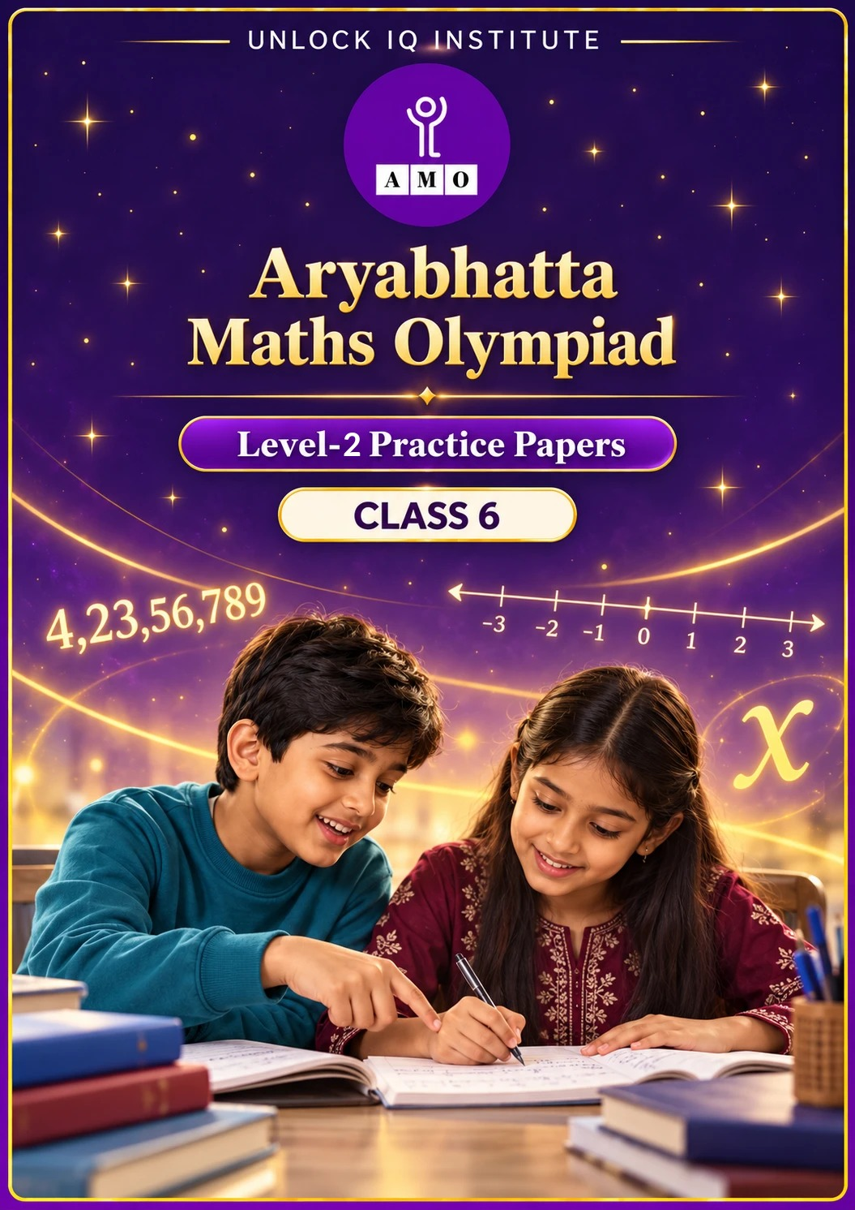
Set 2 · Practice Papers 6–10 · with answer keys & detailed solutions
Name: ____________________ | Class & Section: ________________
Roll No.: ________________ | School: ____________________
City: ____________________ | Date: ____________________

Published by Unlock IQ Institute Pvt. Ltd.
Register for Olympiads: www.aryabhattamathsolympiad.com/student-registration

ARYABHATTA MATHS OLYMPIAD
Level 2
PRACTICE PAPER-6
CLASS 6
Total Questions | 30 multiple-choice questions
Level | Level-2 (final round): every question is Hard
Time | 45 minutes
Arrangement | Parts by chapter; the last Part has mixed problems joining two chapters
Negative Marking | No negative marking
Calculator | Not allowed
Chapters | Number System · Operations · Fractions, Decimals & Percentages · Algebra · Geometry · Mensuration · Data Handling, Statistics & Probability · Applied Mathematics · Mathematical Reasoning

Instructions
• Each question has four options, (A) to (D), with exactly one correct answer.
• The questions are grouped in Parts by chapter. The last Part has mixed problems, each joining two chapters.
• Every question is at Level-2 (Hard) standard: expect several steps or a key insight.
• There is no negative marking. Calculators are not allowed; use a separate sheet for rough work.
• Figures are not necessarily drawn to scale unless stated.

For teachers
• Figures are part of the questions and work when printed in black and white.
• Parts follow the AMO syllabus chapters. Chapter 7 is not part of the Class 6 syllabus, so the chapter numbers shown in the Part headings have gaps.
• The answer sheet and the answer key are at the end. Remove the answer key before the paper is attempted.

Part 1 — Number System (Syllabus Chapter 1)
Q1. How many 7-digit numbers are there in all?
(A) 99,99,999 | (B) 89,99,999 | (C) 9,99,999 | (D) 90,00,000

Q2. Two two-digit numbers have HCF 6 and LCM 180, and they differ by 6. What is their sum?
(A) 66 | (B) 78 | (C) 102 | (D) 72

Q3. In a building, the ground floor is floor 0 and floors below it are −1, −2, and so on. A lift starts at floor 12, goes down 15 floors, up 7 floors and then down 9 floors. Where is it now?
(A) Floor 3 | (B) Floor 5 | (C) Floor −3 | (D) Floor −5

Part 2 — Operations (Syllabus Chapter 2)
Q4. What is the value of 64 ÷ [16 − {4 × (5 − 3)}] − 3 × (−2)?
(A) 2 | (B) −2 | (C) 14 | (D) 26

Q5. Two integers a and b have product −24 and sum 5, with a > b. What is a − b?
(A) 11 | (B) 5 | (C) −11 | (D) 2

Q6. Use number properties to find 37 × 25 × 4 × 2 + 63 × 200.
(A) 19,800 | (B) 20,000 | (C) 12,600 | (D) 7,400

Part 3 — Fractions, Decimals & Percentages (Syllabus Chapter 3)
Q7. Arrange these from largest to smallest: 0.08 of 525, 7% of 650, 1/12 of 492, 3/8 of 104. Which is third?
(A) 0.08 of 525 | (B) 7% of 650 | (C) 3/8 of 104 | (D) 1/12 of 492

Q8. In a school election between two candidates, the winner got 58% of the votes and won by 1,920 votes. How many votes were cast? (No vote was invalid.)
(A) 11,000 | (B) 3,310 | (C) 12,000 | (D) 16,000

Q9. A shop sold 40% of its stock of school bags on Monday and half of the remaining bags on Tuesday. 90 bags were left. How many bags were there at first?
(A) 225 | (B) 180 | (C) 300 | (D) 450

Part 4 — Algebra (Syllabus Chapter 4)
Q10. 3 apples cost ₹a and 5 bananas cost ₹b. Write the cost of 12 apples and 10 bananas, and find it when a = 60 and b = 40.
(A) 4a + 2b; ₹320 | (B) 12a + 10b; ₹1,120
(C) 4a + 2b; ₹280 | (D) 3a + 5b; ₹380

Q11. What is the value of 5 − 2(x − 3) + x × x when x = −1?
(A) 12 | (B) −2 | (C) 16 | (D) 14

Part 5 — Geometry (Syllabus Chapter 5)
Q12. Kartik faces east and turns clockwise until he faces north. Through what angle does he turn, and what type of angle is it?
(A) 270°, reflex | (B) 90°, right
(C) 180°, straight | (D) 225°, reflex

Q13. In triangle PQR, angle P = angle Q and angle R = 2 × angle P. Which describes the triangle?
(A) Right-angled and isosceles | (B) Acute-angled and isosceles
(C) Right-angled and scalene | (D) Equilateral

Q14. A regular polygon has perimeter 96 cm and each side is 8 cm. How many diagonals does it have?
(A) 12 | (B) 54 | (C) 108 | (D) 48

Part 6 — Mensuration (Syllabus Chapter 6)
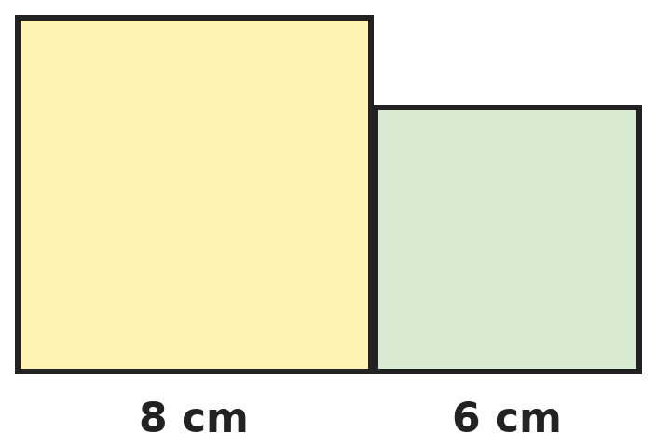
Q15. Squares of side 8 cm and 6 cm are placed side by side with their bottoms in line, as shown. What is the perimeter of the combined shape?
(A) 56 cm | (B) 44 cm | (C) 50 cm | (D) 40 cm

Q16. A tank with a base of 50 cm by 40 cm has water 30 cm deep. Three identical stones are dropped in and the water rises to 33 cm. One stone is then taken out. How deep is the water now?
(A) 31 cm | (B) 32.5 cm | (C) 32 cm | (D) 30 cm

Q17. A floor 5 m long and 4 m wide has a border 1 m wide all round. The border is covered with square tiles of side 25 cm, and the inside with square tiles of side 50 cm. How many tiles are used in all?
(A) 320 | (B) 224 | (C) 272 | (D) 248

Part 7 — Data Handling, Statistics & Probability (Syllabus Chapter 8)
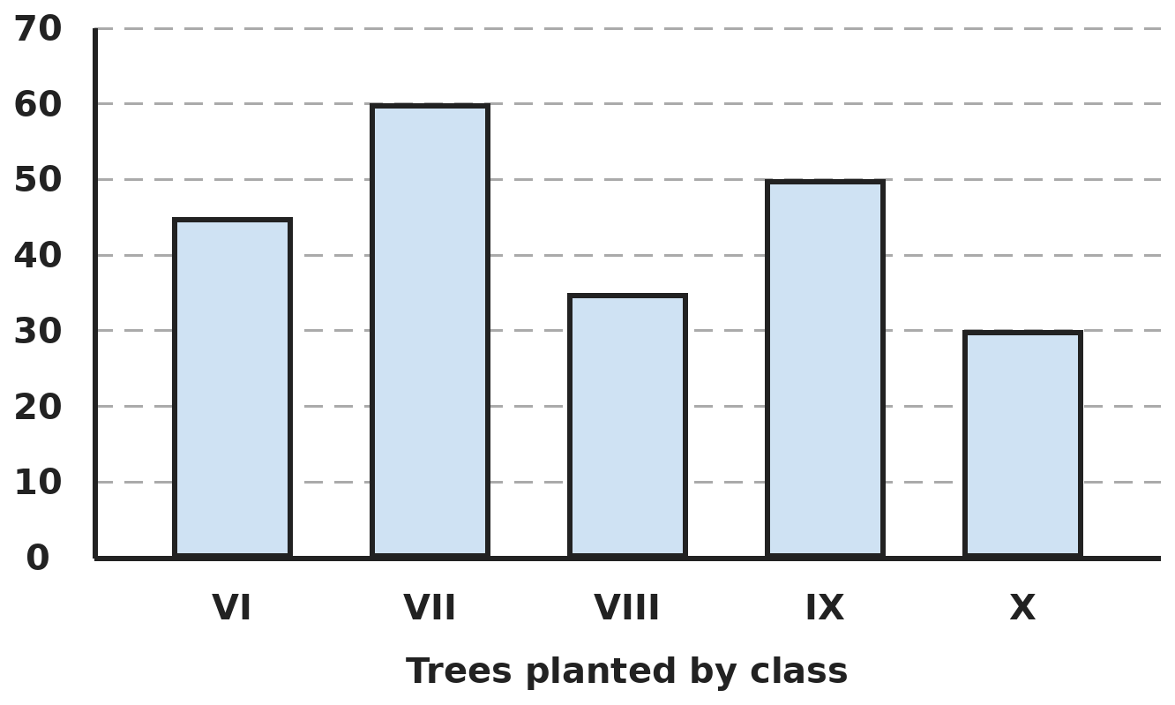
Q18. The bar graph shows the trees planted by five classes. The school's target was 250 trees. How many more trees were needed, and which class planted the most?
(A) 20; Class VII | (B) 30; Class IX | (C) 30; Class VII | (D) 50; Class VII

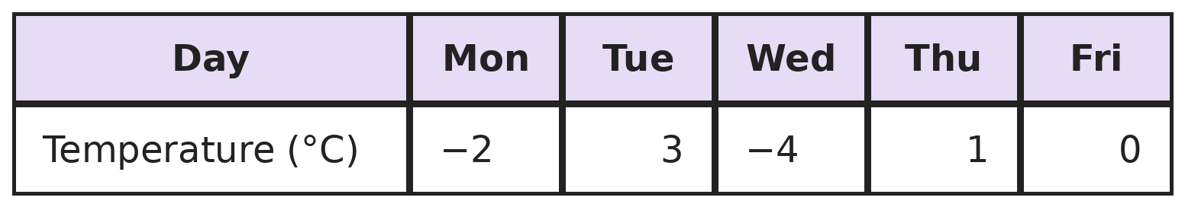
Q19. The table shows the lowest temperature in Shimla on five days. What is the difference between the warmest and the coldest of these, and on how many days was it below 0°C?
(A) 7°C; 2 days | (B) 1°C; 2 days | (C) 7°C; 3 days | (D) 6°C; 2 days

Part 8 — Applied Mathematics (Syllabus Chapter 9)
Q20. A car leaves at 8 AM at 50 km/h. A second car leaves from the same place at 10 AM at 75 km/h along the same road. At what time does it catch up?
(A) 12 noon | (B) 1 PM | (C) 2 PM | (D) 4 PM

Q21. The length and breadth of a rectangle are in the ratio 5 : 3, and its perimeter is 64 cm. What is its area?
(A) 60 cm² | (B) 240 cm² | (C) 256 cm² | (D) 192 cm²

Q22. A tap fills 3/5 of a tank in 9 minutes. How long will it take to fill the rest of the tank?
(A) 15 min | (B) 6 min | (C) 9 min | (D) 5 min

Part 9 — Mathematical Reasoning (Syllabus Chapter 10)
Q23. It is 10 PM now. What time will it be exactly 75 hours later?
(A) 1 PM | (B) 10 PM | (C) 3 AM | (D) 1 AM

Q24. Seven coins lie heads up. In each move, Pallavi turns over exactly two coins. Can she ever make all seven coins show tails?
(A) Yes, in 4 moves | (B) Yes, in 7 moves
(C) No, the number of heads always stays odd | (D) No, because 7 is a prime number

Q25. Meera spent 1/3 of her money on books and 1/4 of what was left on lunch. She had ₹150 left. How much did she have at first?
(A) ₹250 | (B) ₹300 | (C) ₹450 | (D) ₹360

Part 10 — Mixed Problems (each joins two chapters)

Q26. The nth number of this pattern is 5n + 2. Which of these numbers is in the pattern: 247, 250, 256, 261?
(A) 250 | (B) 247 | (C) 256 | (D) 261

Q27. How many 3-digit numbers have digits that multiply to give 12?
(A) 15 | (B) 12 | (C) 18 | (D) 9

Q28. Ashwin cycles 40% of a 30 km route at 12 km/h and the rest at 18 km/h. How long does the whole ride take?
(A) 2 h 30 min | (B) 1 h 40 min | (C) 2 h | (D) 2 h 15 min

Q29. A cube of edge 3 cm is glued on top of a cube of edge 5 cm, at its centre. The bottom of the large cube rests on a table. What is the total area of the faces exposed to the air (not touching the table or the other cube)?
(A) 170 cm² | (B) 152 cm² | (C) 125 cm² | (D) 161 cm²

Q30. Chhaya earns ₹x each day, but ₹(x + 50) on Sundays. In a 30-day month with 4 Sundays she earns ₹15,200. What is x?
(A) 500 | (B) 506 | (C) 480 | (D) 520

Answer Sheet AMO Level 2 · Class 6 · Practice Paper 6
Name: | School: | Roll No.:
Shade or tick one circle for each question.
1. | Ⓐ Ⓑ Ⓒ Ⓓ | 11. | Ⓐ Ⓑ Ⓒ Ⓓ | 21. | Ⓐ Ⓑ Ⓒ Ⓓ
2. | Ⓐ Ⓑ Ⓒ Ⓓ | 12. | Ⓐ Ⓑ Ⓒ Ⓓ | 22. | Ⓐ Ⓑ Ⓒ Ⓓ
3. | Ⓐ Ⓑ Ⓒ Ⓓ | 13. | Ⓐ Ⓑ Ⓒ Ⓓ | 23. | Ⓐ Ⓑ Ⓒ Ⓓ
4. | Ⓐ Ⓑ Ⓒ Ⓓ | 14. | Ⓐ Ⓑ Ⓒ Ⓓ | 24. | Ⓐ Ⓑ Ⓒ Ⓓ
5. | Ⓐ Ⓑ Ⓒ Ⓓ | 15. | Ⓐ Ⓑ Ⓒ Ⓓ | 25. | Ⓐ Ⓑ Ⓒ Ⓓ
6. | Ⓐ Ⓑ Ⓒ Ⓓ | 16. | Ⓐ Ⓑ Ⓒ Ⓓ | 26. | Ⓐ Ⓑ Ⓒ Ⓓ
7. | Ⓐ Ⓑ Ⓒ Ⓓ | 17. | Ⓐ Ⓑ Ⓒ Ⓓ | 27. | Ⓐ Ⓑ Ⓒ Ⓓ
8. | Ⓐ Ⓑ Ⓒ Ⓓ | 18. | Ⓐ Ⓑ Ⓒ Ⓓ | 28. | Ⓐ Ⓑ Ⓒ Ⓓ
9. | Ⓐ Ⓑ Ⓒ Ⓓ | 19. | Ⓐ Ⓑ Ⓒ Ⓓ | 29. | Ⓐ Ⓑ Ⓒ Ⓓ
10. | Ⓐ Ⓑ Ⓒ Ⓓ | 20. | Ⓐ Ⓑ Ⓒ Ⓓ | 30. | Ⓐ Ⓑ Ⓒ Ⓓ

For the parent or teacher
Correct: ______ / 30
Answer Key and Solutions AMO Level 2 · Class 6 · Practice Paper 6
Quick answers
1 D | 6 B | 11 D | 16 C | 21 B | 26 B
2 A | 7 D | 12 A | 17 D | 22 B | 27 A
3 D | 8 C | 13 A | 18 C | 23 D | 28 C
4 C | 9 C | 14 B | 19 A | 24 C | 29 D
5 A | 10 A | 15 B | 20 C | 25 B | 30 A
Solutions
Q | Part · level | Answer | Why?
1 | Part 1 · Ch1 · Hard | (D) 90,00,000 | Hint: Count from the smallest 7-digit number to the largest, including both.  The smallest is 10,00,000 and the largest is 99,99,999. Count = 99,99,999 − 10,00,000 + 1 = 90,00,000.
2 | Part 1 · Ch1 · Hard | (A) 66 | Hint: Write the numbers as 6 × a and 6 × b, where a and b share no factor.  HCF × LCM = 6 × 180 = 1,080 = (6a)(6b), so a × b = 30 with a and b sharing no factor: 1 and 30, 2 and 15, 3 and 10, or 5 and 6. The pairs are 6 and 180, 12 and 90, 18 and 60, 30 and 36. Only 30 and 36 are two-digit and differ by 6. Sum: 66.
3 | Part 1 · Ch1 · Hard | (D) Floor −5 | Hint: Add the moves as integers: down is negative.  12 − 15 + 7 − 9 = −5. The lift is at floor −5, the fifth floor below ground.
4 | Part 2 · Ch2 · Hard | (C) 14 | Hint: Clear the brackets from the inside, then divide and multiply before subtracting.  (5 − 3) = 2, 4 × 2 = 8, 16 − 8 = 8. 64 ÷ 8 = 8. 3 × (−2) = −6. 8 − (−6) = 14.
5 | Part 2 · Ch2 · Hard | (A) 11 | Hint: One is positive and one is negative. List the pairs with product −24.  Pairs with product −24: 8 and −3 add to 5. ✓ So a = 8, b = −3 and a − b = 8 − (−3) = 11.
6 | Part 2 · Ch2 · Hard | (B) 20,000 | Hint: 25 × 4 × 2 = 200.  37 × 25 × 4 × 2 = 37 × 200. Then 37 × 200 + 63 × 200 = (37 + 63) × 200 = 100 × 200 = 20,000.
7 | Part 3 · Ch3 · Hard | (D) 1/12 of 492 | Hint: Work out each one as a number.  0.08 × 525 = 42. 7% of 650 = 45.5. 492 ÷ 12 = 41. 3/8 of 104 = 39. In order: 45.5, 42, 41, 39. The third is 1/12 of 492.
8 | Part 3 · Ch3 · Hard | (C) 12,000 | Hint: The loser got 42%. The winning margin is the difference in percentages.  Margin = 58% − 42% = 16% of the votes = 1,920. 1% = 120 votes, so 100% = 12,000.
9 | Part 3 · Ch3 · Hard | (C) 300 | Hint: After Monday 60% is left. Tuesday takes half of that.  After Monday: 60% left. After Tuesday: half of 60% = 30% left = 90 bags. 1% = 3 bags, so the stock was 300.
10 | Part 4 · Ch4 · Hard | (A) 4a + 2b; ₹320 | Hint: 12 apples are 4 lots of 3 apples.  12 apples = 4 × ₹a and 10 bananas = 2 × ₹b. Cost = 4a + 2b. At a = 60, b = 40: 240 + 80 = ₹320.
11 | Part 4 · Ch4 · Hard | (D) 14 | Hint: (x − 3) is −4 when x = −1.  x − 3 = −4, so −2(x − 3) = 8. x × x = (−1) × (−1) = 1. Total 5 + 8 + 1 = 14.
12 | Part 5 · Ch5 · Hard | (A) 270°, reflex | Hint: Clockwise from east goes to south first.  East → south is 90°, south → west is 90°, west → north is 90°. Total 270°. It is more than 180°, so it is a reflex angle.
13 | Part 5 · Ch5 · Hard | (A) Right-angled and isosceles | Hint: The angles are P, P and 2P.  P + P + 2P = 4P = 180°, so P = 45°. The angles are 45°, 45° and 90°: right-angled, and the two equal angles make it isosceles.
14 | Part 5 · Ch5 · Hard | (B) 54 | Hint: Find the number of sides first.  Sides: 96 ÷ 8 = 12. Diagonals: 12 × (12 − 3) ÷ 2 = 12 × 9 ÷ 2 = 54.
15 | Part 6 · Ch6 · Hard | (B) 44 cm | Hint: Part of the touching edge is inside the shape.  The two perimeters add to 32 + 24 = 56 cm. The 6 cm of touching edge is counted twice (once in each square) but is inside the shape, so subtract 2 × 6. Perimeter = 56 − 12 = 44 cm.
16 | Part 6 · Ch6 · Hard | (C) 32 cm | Hint: Find the volume of one stone first.  The three stones raise the water 3 cm: 50 × 40 × 3 = 6,000 cm³, so one stone is 2,000 cm³. Taking one out lowers the water by 2,000 ÷ (50 × 40) = 1 cm. New depth: 33 − 1 = 32 cm.
17 | Part 6 · Ch6 · Hard | (D) 248 | Hint: The inside part is 3 m by 2 m.  Inside: 3 m × 2 m. 50 cm tiles: 6 along, 4 across, so 24 tiles. Border area: 20 − 6 = 14 m². One 25 cm tile covers 1/16 m², so the border takes 14 × 16 = 224 tiles. Total 24 + 224 = 248.
18 | Part 7 · Ch8 · Hard | (C) 30; Class VII | Hint: Add all five bars.  Total: 45 + 60 + 35 + 50 + 30 = 220. More needed: 250 − 220 = 30. Class VII planted the most (60).
19 | Part 7 · Ch8 · Hard | (A) 7°C; 2 days | Hint: 0°C is not below 0°C.  Warmest 3°C, coldest −4°C: difference 3 − (−4) = 7°C. Below 0°C: Monday and Wednesday, 2 days.
20 | Part 8 · Ch9 · Hard | (C) 2 PM | Hint: By 10 AM the first car is 100 km ahead.  At 10 AM the gap is 2 × 50 = 100 km. The gap closes by 75 − 50 = 25 km each hour, so it takes 100 ÷ 25 = 4 hours. 10 AM + 4 h = 2 PM.
21 | Part 8 · Ch9 · Hard | (B) 240 cm² | Hint: Length + breadth = half the perimeter.  Length + breadth = 32 cm = 8 parts, so 1 part = 4 cm. Length 20 cm, breadth 12 cm. Area 240 cm².
22 | Part 8 · Ch9 · Hard | (B) 6 min | Hint: Find the time for 1/5 of the tank.  3/5 takes 9 minutes, so 1/5 takes 3 minutes. The rest is 2/5, which takes 6 minutes.
23 | Part 9 · Ch10 · Hard | (D) 1 AM | Hint: 75 hours = 3 days and some hours.  75 = 3 × 24 + 3. After 3 days it is 10 PM again; 3 more hours gives 1 AM.
24 | Part 9 · Ch10 · Hard | (C) No, the number of heads always stays odd | Hint: How can one move change the number of heads?  A move changes the number of heads by −2, 0 or +2, so it stays odd. It starts at 7 (odd) and can never reach 0 (even). So it is impossible.
25 | Part 9 · Ch10 · Hard | (B) ₹300 | Hint: The ₹150 is 3/4 of what was left after the books.  ₹150 is 3/4 of the money after books, so that money was ₹200. ₹200 is 2/3 of the start, so she started with ₹300.
26 | Part 10 · Mixed · Ch4 + Ch10 · Hard | (B) 247 | Hint: A number in the pattern is 2 more than a multiple of 5.  247 − 2 = 245 = 5 × 49, so 247 is the 49th number. 250 − 2 = 248, 256 − 2 = 254 and 261 − 2 = 259 are not multiples of 5.
27 | Part 10 · Mixed · Ch1 + Ch10 · Hard | (A) 15 | Hint: Find the sets of three digits with product 12, then count their orders.  Digit sets: {1, 2, 6} and {1, 3, 4}, each in 6 orders, and {2, 2, 3} in 3 orders. 6 + 6 + 3 = 15.
28 | Part 10 · Mixed · Ch3 + Ch9 · Hard | (C) 2 h | Hint: Find the two distances first.  40% of 30 km = 12 km, taking 12 ÷ 12 = 1 h. The rest, 18 km, takes 18 ÷ 18 = 1 h. Total 2 h.
29 | Part 10 · Mixed · Ch5 + Ch6 · Hard | (D) 161 cm² | Hint: Leave out the table face and the 3 × 3 patch where the cubes meet.  Large cube: 4 sides × 25 = 100, plus its top 25 − 9 = 16. Small cube: 4 sides × 9 = 36, plus its top 9. Total 100 + 16 + 36 + 9 = 161 cm².
30 | Part 10 · Mixed · Ch4 + Ch9 · Hard | (A) 500 | Hint: Take away the Sunday extras first.  The 4 Sundays pay 4 × ₹50 = ₹200 extra. Without the extras she would earn 15,200 − 200 = ₹15,000 in 30 days, so x = 15,000 ÷ 30 = 500.

ARYABHATTA MATHS OLYMPIAD
Level 2
PRACTICE PAPER-7
CLASS 6
Total Questions | 30 multiple-choice questions
Level | Level-2 (final round): every question is Hard
Time | 45 minutes
Arrangement | Parts by chapter; the last Part has mixed problems joining two chapters
Negative Marking | No negative marking
Calculator | Not allowed
Chapters | Number System · Operations · Fractions, Decimals & Percentages · Algebra · Geometry · Mensuration · Data Handling, Statistics & Probability · Applied Mathematics · Mathematical Reasoning

Instructions
• Each question has four options, (A) to (D), with exactly one correct answer.
• The questions are grouped in Parts by chapter. The last Part has mixed problems, each joining two chapters.
• Every question is at Level-2 (Hard) standard: expect several steps or a key insight.
• There is no negative marking. Calculators are not allowed; use a separate sheet for rough work.
• Figures are not necessarily drawn to scale unless stated.

For teachers
• Figures are part of the questions and work when printed in black and white.
• Parts follow the AMO syllabus chapters. Chapter 7 is not part of the Class 6 syllabus, so the chapter numbers shown in the Part headings have gaps.
• The answer sheet and the answer key are at the end. Remove the answer key before the paper is attempted.

Part 1 — Number System (Syllabus Chapter 1)
Q1. Kriti rounds 4,56,78,912 to the nearest lakh and also to the nearest crore. What is the difference between her two answers?
(A) 44,00,000 | (B) 43,00,000 | (C) 3,00,000 | (D) 43,21,088

Q2. How many factors does 48 have, and how many of them are even?
(A) 10 factors, 5 even | (B) 8 factors, 6 even
(C) 10 factors, 8 even | (D) 12 factors, 8 even

Q3. What is the product of all the integers from −5 to 5, leaving out 0?
(A) 14,400 | (B) 0 | (C) −120 | (D) −14,400

Part 2 — Operations (Syllabus Chapter 2)
Q4. Which of these has the value −4?
(A) 12 − 4 × (2 + 6 ÷ 3) | (B) (12 − 4) × 2 + 6 ÷ 3
(C) 12 − 4 × 2 + 6 ÷ 3 | (D) 12 − (4 × 2 + 6) ÷ 2

Q5. What is the value of (−3) × [(−2) + 5] − [(−12) ÷ (−4)] × (−1)?
(A) −12 | (B) 6 | (C) 0 | (D) −6

Q6. Use number properties to find (4 × 17 × 25) − (17 × 99).
(A) 17 | (B) 1 | (C) 117 | (D) −17

Part 3 — Fractions, Decimals & Percentages (Syllabus Chapter 3)
Q7. How many of these are greater than 1/3: 0.33, 34%, 2/7, 0.334, 5/16?
(A) 3 | (B) 1 | (C) 2 | (D) 4

Q8. A 20 kg watermelon is 90% water. After lying in the sun, it is 80% water. What does it weigh now?
(A) 18 kg | (B) 10 kg | (C) 16 kg | (D) 12 kg

Q9. A batter scores 120 runs. 40% of the runs come from fours and 15% from sixes. How many boundaries (fours and sixes) does she hit?
(A) 15 | (B) 66 | (C) 12 | (D) 18

Part 4 — Algebra (Syllabus Chapter 4)
Q10. Simplify (3x + 2y) − (x − 4y) + 2(x − y).
(A) 4x − 4y | (B) 4x + 4y | (C) 2x + 4y | (D) 4x + 2y

Q11. Shirts cost ₹s each and trousers ₹t each. Raghav buys 3 shirts and 2 trousers and gets ₹100 off the bill. Write his bill and find it when s = 450 and t = 800.
(A) 3s + 2t − 100; ₹2,950 | (B) 5(s + t) − 100; ₹6,150
(C) 3s + 2t − 100; ₹2,850 | (D) 3s + 2t + 100; ₹3,050

Part 5 — Geometry (Syllabus Chapter 5)
Q12. Three angles on a straight line are a, 2a and 3a. What is the largest of them, and what type of angle is it?
(A) 60°, acute | (B) 120°, obtuse | (C) 90°, right | (D) 90°, straight

Q13. One angle of a triangle is 100°. The other two angles differ by 20°. Which describes the triangle?
(A) Obtuse-angled and isosceles | (B) Acute-angled and scalene
(C) Right-angled and scalene | (D) Obtuse-angled and scalene

Q14. Which polygon has exactly as many diagonals as sides?
(A) Hexagon | (B) Pentagon | (C) Square | (D) Heptagon

Part 6 — Mensuration (Syllabus Chapter 6)
Q15. A rectangle has perimeter 46 cm and area 120 cm². What is its length (the longer side)?
(A) 12 cm | (B) 20 cm | (C) 23 cm | (D) 15 cm

Q16. The outside of a closed box 30 cm × 20 cm × 10 cm is painted. Paint costs ₹2 for every 100 cm². What is the cost?
(A) ₹120 | (B) ₹22 | (C) ₹88 | (D) ₹44

Q17. A cuboid 6 cm × 5 cm × 4 cm is built from 1 cm cubes. How many of the cubes are completely hidden inside (not on any face)?
(A) 60 | (B) 24 | (C) 96 | (D) 120

Part 7 — Data Handling, Statistics & Probability (Syllabus Chapter 8)
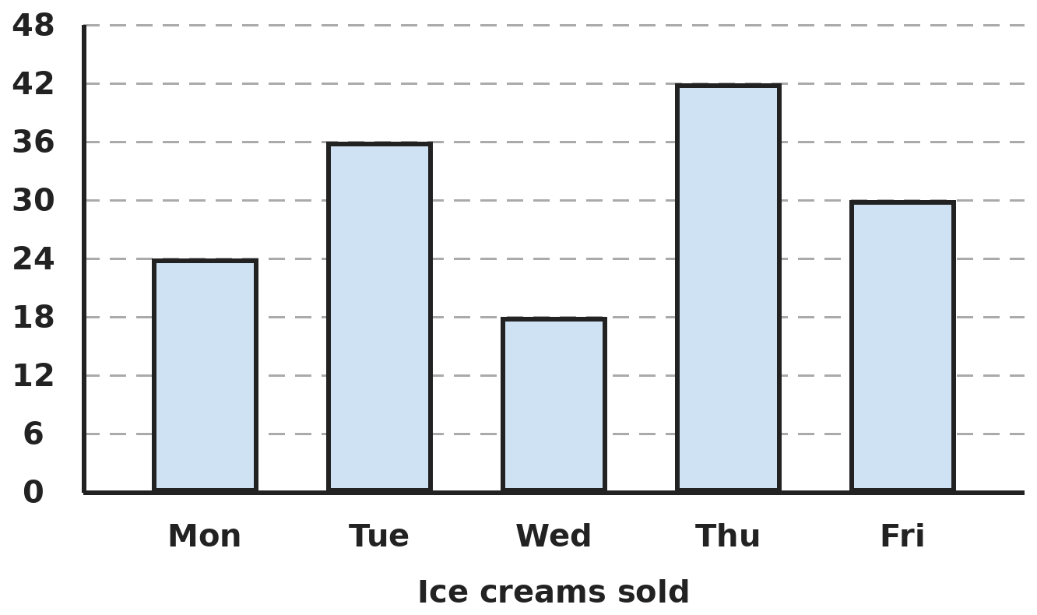
Q18. The bar graph shows ice creams sold at a stall. What fraction of the week's sales came from the two days with the lowest sales?
(A) 7/25 | (B) 2/5 | (C) 1/5 | (D) 3/10

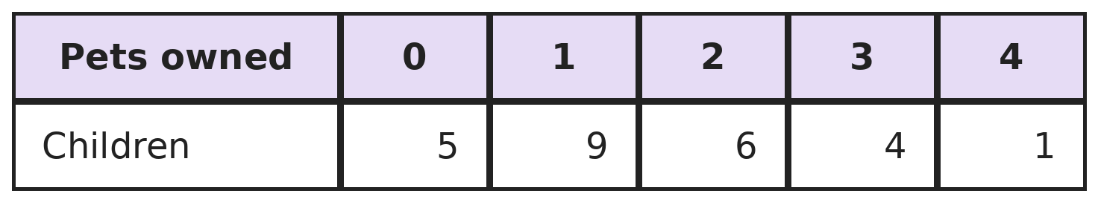
Q19. The table shows how many pets each of 25 children owns. How many pets are there in all, and how many children own at least 2 pets?
(A) 37 pets; 6 children | (B) 37 pets; 11 children
(C) 25 pets; 11 children | (D) 40 pets; 11 children

Part 8 — Applied Mathematics (Syllabus Chapter 9)
Q20. A runner (5 m/s) and a cyclist (13 m/s) start together from the same point on a 400 m circular track, going the same way. After how long does the cyclist first pass the runner?
(A) 22 s | (B) 80 s | (C) 31 s | (D) 50 s

Q21. A 60-litre mixture has milk and water in the ratio 3 : 1. How much water must be added to make the ratio 3 : 2?
(A) 20 L | (B) 10 L | (C) 15 L | (D) 30 L

Q22. 6 machines make 720 bottles in 4 hours. How many bottles do 9 such machines make in 5 hours?
(A) 1,080 | (B) 900 | (C) 1,620 | (D) 1,350

Part 9 — Mathematical Reasoning (Syllabus Chapter 10)
Q23. A clock loses 10 minutes every hour. It is set right at 6 AM. Later it shows 6 PM. What is the real time?
(A) 8:00 PM | (B) 8:24 PM | (C) 4:00 PM | (D) 7:12 PM

Q24. Can a chess knight return to its starting square in exactly 7 moves?
(A) No, each move changes the colour of its square | (B) Yes, from any square
(C) Yes, but only from a corner | (D) No, it always needs at least 8 moves

Q25. Each hour, half the water in a tank leaks out and then 10 litres are poured in. After 3 hours the tank has 30 litres. How much did it have at the start?
(A) 80 L | (B) 120 L | (C) 100 L | (D) 60 L

Part 10 — Mixed Problems (each joins two chapters)

Q26. In this sequence, each number is 3 × (the number before) − 2. What is the 6th number?
(A) 244 | (B) 82 | (C) 226 | (D) 246

Q27. How many integers lie strictly between −30 and 30 that are divisible by neither 2 nor 3?
(A) 21 | (B) 19 | (C) 20 | (D) 40

Q28. A tank holds 400 L of water. On Monday 25% of it is used. On Tuesday 10% of what is left is used. What percentage of the full tank has been used?
(A) 32.5% | (B) 35% | (C) 30% | (D) 33%

Q29. A square is cut along both its diagonals into 4 triangles. Each triangle has area 9 cm². What is the perimeter of the square?
(A) 36 cm | (B) 12 cm | (C) 18 cm | (D) 24 cm

Q30. A plumber charges ₹200 for a visit plus ₹150 an hour. An electrician charges ₹350 for a visit plus ₹100 an hour. For how many hours of work do they charge the same, and how much?
(A) 3 hours; ₹600 | (B) 2 hours; ₹500 | (C) 3 hours; ₹650 | (D) 4 hours; ₹750

Answer Sheet AMO Level 2 · Class 6 · Practice Paper 7
Name: | School: | Roll No.:
Shade or tick one circle for each question.
1. | Ⓐ Ⓑ Ⓒ Ⓓ | 11. | Ⓐ Ⓑ Ⓒ Ⓓ | 21. | Ⓐ Ⓑ Ⓒ Ⓓ
2. | Ⓐ Ⓑ Ⓒ Ⓓ | 12. | Ⓐ Ⓑ Ⓒ Ⓓ | 22. | Ⓐ Ⓑ Ⓒ Ⓓ
3. | Ⓐ Ⓑ Ⓒ Ⓓ | 13. | Ⓐ Ⓑ Ⓒ Ⓓ | 23. | Ⓐ Ⓑ Ⓒ Ⓓ
4. | Ⓐ Ⓑ Ⓒ Ⓓ | 14. | Ⓐ Ⓑ Ⓒ Ⓓ | 24. | Ⓐ Ⓑ Ⓒ Ⓓ
5. | Ⓐ Ⓑ Ⓒ Ⓓ | 15. | Ⓐ Ⓑ Ⓒ Ⓓ | 25. | Ⓐ Ⓑ Ⓒ Ⓓ
6. | Ⓐ Ⓑ Ⓒ Ⓓ | 16. | Ⓐ Ⓑ Ⓒ Ⓓ | 26. | Ⓐ Ⓑ Ⓒ Ⓓ
7. | Ⓐ Ⓑ Ⓒ Ⓓ | 17. | Ⓐ Ⓑ Ⓒ Ⓓ | 27. | Ⓐ Ⓑ Ⓒ Ⓓ
8. | Ⓐ Ⓑ Ⓒ Ⓓ | 18. | Ⓐ Ⓑ Ⓒ Ⓓ | 28. | Ⓐ Ⓑ Ⓒ Ⓓ
9. | Ⓐ Ⓑ Ⓒ Ⓓ | 19. | Ⓐ Ⓑ Ⓒ Ⓓ | 29. | Ⓐ Ⓑ Ⓒ Ⓓ
10. | Ⓐ Ⓑ Ⓒ Ⓓ | 20. | Ⓐ Ⓑ Ⓒ Ⓓ | 30. | Ⓐ Ⓑ Ⓒ Ⓓ

For the parent or teacher
Correct: ______ / 30
Answer Key and Solutions AMO Level 2 · Class 6 · Practice Paper 7
Quick answers
1 B | 6 A | 11 C | 16 D | 21 C | 26 A
2 C | 7 C | 12 C | 17 B | 22 D | 27 C
3 D | 8 B | 13 D | 18 A | 23 B | 28 A
4 A | 9 A | 14 B | 19 B | 24 A | 29 D
5 D | 10 B | 15 D | 20 D | 25 C | 30 C
Solutions
Q | Part · level | Answer | Why?
1 | Part 1 · Ch1 · Hard | (B) 43,00,000 | Hint: Look at the digits just after the lakhs place and just after the crores place.  Nearest lakh: the thousands part 78,912 is more than 50,000, so round up to 4,57,00,000. Nearest crore: 56 lakh is more than 50 lakh, so round up to 5,00,00,000. Difference: 43,00,000.
2 | Part 1 · Ch1 · Hard | (C) 10 factors, 8 even | Hint: List the factors in pairs: 1 × 48, 2 × 24, …  Factor pairs: 1 × 48, 2 × 24, 3 × 16, 4 × 12, 6 × 8. That is 10 factors. Only 1 and 3 are odd, so 8 are even.
3 | Part 1 · Ch1 · Hard | (D) −14,400 | Hint: There are five negative numbers in the product.  (−1)(−2)(−3)(−4)(−5) = −120, since five negatives give a negative. 1 × 2 × 3 × 4 × 5 = 120. Product = −120 × 120 = −14,400.
4 | Part 2 · Ch2 · Hard | (A) 12 − 4 × (2 + 6 ÷ 3) | Hint: Work out each one, brackets first, then × and ÷, then + and −.  12 − 4 × (2 + 2) = 12 − 16 = −4. ✓ (12 − 4) × 2 + 2 = 18. 12 − 8 + 2 = 6. 12 − 14 ÷ 2 = 5.
5 | Part 2 · Ch2 · Hard | (D) −6 | Hint: Work out both square brackets first.  (−2) + 5 = 3 and (−12) ÷ (−4) = 3. So the expression is (−3) × 3 − 3 × (−1) = −9 + 3 = −6.
6 | Part 2 · Ch2 · Hard | (A) 17 | Hint: 4 × 25 = 100.  4 × 17 × 25 = 17 × 100. Then 17 × 100 − 17 × 99 = 17 × (100 − 99) = 17.
7 | Part 3 · Ch3 · Hard | (C) 2 | Hint: 1/3 = 0.3333… Change each number into a decimal.  0.33 < 0.333…; 34% = 0.34 > 0.333…; 2/7 = 0.2857…; 0.334 > 0.3333…; 5/16 = 0.3125. Only 34% and 0.334: 2 numbers.
8 | Part 3 · Ch3 · Hard | (B) 10 kg | Hint: Only the water dries. The non-water part stays the same.  Non-water part: 10% of 20 kg = 2 kg. Afterwards this 2 kg is 20% of the melon, so the melon weighs 2 × 5 = 10 kg.
9 | Part 3 · Ch3 · Hard | (A) 15 | Hint: Find the runs from fours and from sixes first.  Runs from fours: 40% of 120 = 48, which is 12 fours. Runs from sixes: 15% of 120 = 18, which is 3 sixes. Boundaries: 12 + 3 = 15.
10 | Part 4 · Ch4 · Hard | (B) 4x + 4y | Hint: The minus sign in front of (x − 4y) changes both signs inside.  3x + 2y − x + 4y + 2x − 2y = (3x − x + 2x) + (2y + 4y − 2y) = 4x + 4y.
11 | Part 4 · Ch4 · Hard | (C) 3s + 2t − 100; ₹2,850 | Hint: Add the costs, then take off ₹100.  Bill = 3s + 2t − 100. At s = 450, t = 800: 1,350 + 1,600 − 100 = ₹2,850.
12 | Part 5 · Ch5 · Hard | (C) 90°, right | Hint: Angles on a straight line add up to 180°.  a + 2a + 3a = 6a = 180°, so a = 30°. The largest is 3a = 90°, a right angle.
13 | Part 5 · Ch5 · Hard | (D) Obtuse-angled and scalene | Hint: The other two angles add up to 180° − 100°.  The other two angles add up to 80° and differ by 20°, so they are 50° and 30°. With a 100° angle the triangle is obtuse-angled. All three angles are different, so all three sides are different: scalene.
14 | Part 5 · Ch5 · Hard | (B) Pentagon | Hint: Count diagonals with n × (n − 3) ÷ 2.  Pentagon: 5 × 2 ÷ 2 = 5 diagonals and 5 sides. ✓ Square: 2 diagonals. Hexagon: 9. Heptagon: 14.
15 | Part 6 · Ch6 · Hard | (D) 15 cm | Hint: Length + breadth = 23. Which two numbers add to 23 and multiply to 120?  Length + breadth = 46 ÷ 2 = 23 and length × breadth = 120. 15 + 8 = 23 and 15 × 8 = 120, so the length is 15 cm.
16 | Part 6 · Ch6 · Hard | (D) ₹44 | Hint: Find the total surface area first.  Surface area = 2 × (30 × 20 + 30 × 10 + 20 × 10) = 2 × (600 + 300 + 200) = 2,200 cm². Cost = 22 × ₹2 = ₹44.
17 | Part 6 · Ch6 · Hard | (B) 24 | Hint: Remove one layer from every face.  Taking one layer off every face leaves an inner block of (6 − 2) × (5 − 2) × (4 − 2) = 4 × 3 × 2 = 24 cubes.
18 | Part 7 · Ch8 · Hard | (A) 7/25 | Hint: Find the total first, then the two smallest bars.  Total: 24 + 36 + 18 + 42 + 30 = 150. Two lowest: Wed 18 + Mon 24 = 42. 42/150 = 7/25.
19 | Part 7 · Ch8 · Hard | (B) 37 pets; 11 children | Hint: Multiply each number of pets by its number of children.  Pets: 0 + 9 + 12 + 12 + 4 = 37. At least 2 pets: 6 + 4 + 1 = 11 children.
20 | Part 8 · Ch9 · Hard | (D) 50 s | Hint: The cyclist must gain one full lap of 400 m.  The cyclist gains 13 − 5 = 8 m every second. To gain 400 m takes 400 ÷ 8 = 50 s.
21 | Part 8 · Ch9 · Hard | (C) 15 L | Hint: The milk stays the same.  Milk = 45 L and water = 15 L. For 3 : 2, water must be 2/3 of the milk = 30 L. Add 30 − 15 = 15 L.
22 | Part 8 · Ch9 · Hard | (D) 1,350 | Hint: Find the bottles one machine makes in one hour.  One machine makes 720 ÷ (6 × 4) = 30 bottles an hour. 9 machines for 5 hours: 9 × 5 × 30 = 1,350.
23 | Part 9 · Ch10 · Hard | (B) 8:24 PM | Hint: In each real hour, the clock moves only 50 minutes.  The clock has moved 12 hours = 720 minutes. It moves 50 minutes per real hour, so 720 ÷ 50 = 14.4 real hours = 14 h 24 min. 6 AM + 14 h 24 min = 8:24 PM.
24 | Part 9 · Ch10 · Hard | (A) No, each move changes the colour of its square | Hint: What colour is the square after 1 move, 2 moves, …?  Every knight move goes to a square of the other colour. After an odd number of moves, like 7, it is on the opposite colour, so it cannot be back on its start square. (It can return in 2, 4, … moves, so the last option is false.)
25 | Part 9 · Ch10 · Hard | (C) 100 L | Hint: Undo each hour: take away 10, then double.  Hour 3: (30 − 10) × 2 = 40. Hour 2: (40 − 10) × 2 = 60. Hour 1: (60 − 10) × 2 = 100 L.
26 | Part 10 · Mixed · Ch4 + Ch10 · Hard | (A) 244 | Hint: Keep applying the rule: next = 3 × now − 2.  2, 4, 10, 28, then 3 × 28 − 2 = 82, then 3 × 82 − 2 = 244. The 6th number is 244.
27 | Part 10 · Mixed · Ch1 + Ch10 · Hard | (C) 20 | Hint: Count the positive ones from 1 to 29 and double; 0 is divisible by 2.  From 1 to 29: the numbers not divisible by 2 or 3 are 1, 5, 7, 11, 13, 17, 19, 23, 25, 29, which is 10. The negative ones match them: 10 more. 0 is divisible by 2. Total 20.
28 | Part 10 · Mixed · Ch3 + Ch9 · Hard | (A) 32.5% | Hint: Find what is left after Monday first.  Monday: 25% of 400 = 100 L used, 300 L left. Tuesday: 10% of 300 = 30 L used. Total used 130 L out of 400 L = 32.5%. (35% wrongly adds the two percentages.)
29 | Part 10 · Mixed · Ch5 + Ch6 · Hard | (D) 24 cm | Hint: Find the area of the square first.  The square's area is 4 × 9 = 36 cm², so its side is 6 cm (6 × 6 = 36). Perimeter = 4 × 6 = 24 cm.
30 | Part 10 · Mixed · Ch4 + Ch9 · Hard | (C) 3 hours; ₹650 | Hint: The electrician starts ₹150 dearer but costs ₹50 less each hour.  The difference of ₹150 closes by ₹50 an hour, so after 3 hours they are equal. Plumber: 200 + 450 = ₹650. Electrician: 350 + 300 = ₹650.

ARYABHATTA MATHS OLYMPIAD
Level 2
PRACTICE PAPER-8
CLASS 6
Total Questions | 30 multiple-choice questions
Level | Level-2 (final round): every question is Hard
Time | 45 minutes
Arrangement | Parts by chapter; the last Part has mixed problems joining two chapters
Negative Marking | No negative marking
Calculator | Not allowed
Chapters | Number System · Operations · Fractions, Decimals & Percentages · Algebra · Geometry · Mensuration · Data Handling, Statistics & Probability · Applied Mathematics · Mathematical Reasoning

Instructions
• Each question has four options, (A) to (D), with exactly one correct answer.
• The questions are grouped in Parts by chapter. The last Part has mixed problems, each joining two chapters.
• Every question is at Level-2 (Hard) standard: expect several steps or a key insight.
• There is no negative marking. Calculators are not allowed; use a separate sheet for rough work.
• Figures are not necessarily drawn to scale unless stated.

For teachers
• Figures are part of the questions and work when printed in black and white.
• Parts follow the AMO syllabus chapters. Chapter 7 is not part of the Class 6 syllabus, so the chapter numbers shown in the Part headings have gaps.
• The answer sheet and the answer key are at the end. Remove the answer key before the paper is attempted.

Part 1 — Number System (Syllabus Chapter 1)
Q1. The smallest 8-digit number is taken away from the smallest 10-digit number. How many lakhs is the answer?
(A) 990 | (B) 99,000 | (C) 9,900 | (D) 9,000

Q2. A number is 2 × 3 × 3 × 5 × 11. Which of these is NOT a factor of it?
(A) 30 | (B) 44 | (C) 45 | (D) 66

Q3. A floor 4.8 m by 3.6 m is to be covered with the largest possible square tiles, without cutting any. How many tiles are needed?
(A) 48 | (B) 24 | (C) 6 | (D) 12

Part 2 — Operations (Syllabus Chapter 2)
Q4. What is the value of −[−{−(−5) − 3} − 2]?
(A) −4 | (B) 0 | (C) 10 | (D) 4

Q5. Three integers add up to −10. The largest is 7 and the middle one is −3. What is the product of all three?
(A) −294 | (B) −210 | (C) 294 | (D) 210

Q6. Use number properties to find 125 × (−8) × 17 × (−5) × 2.
(A) −1,70,000 | (B) 17,000 | (C) 85,000 | (D) 1,70,000

Part 3 — Fractions, Decimals & Percentages (Syllabus Chapter 3)
Q7. Which is the smallest of these: 1/40, 0.03, 2.4%, 0.0245?
(A) 2.4% | (B) 0.0245 | (C) 1/40 | (D) 0.03

Q8. Rohit's rent is ₹8,000 a month. After one year it goes up by 10%. A year later it goes up by 5% of the new rent. What is the monthly rent then?
(A) ₹9,240 | (B) ₹9,200 | (C) ₹9,600 | (D) ₹9,680

Q9. In a class, 40% of the students are girls. Three quarters of the girls and half of the boys passed a test. What percentage of the class passed?
(A) 62.5% | (B) 60% | (C) 50% | (D) 65%

Part 4 — Algebra (Syllabus Chapter 4)
Q10. If p = 2q and q = −3, what is the value of p × q − (p + q)?
(A) 9 | (B) 27 | (C) −27 | (D) 15

Q11. A group of n friends shares a restaurant bill of ₹(60n + 90) equally. Each friend pays ₹75. How many friends are there?
(A) 5 | (B) 9 | (C) 8 | (D) 6

Part 5 — Geometry (Syllabus Chapter 5)
Q12. Two angles together make a complete turn. The reflex angle is 4 times the other angle. What is the reflex angle?
(A) 270° | (B) 300° | (C) 288° | (D) 252°

Q13. In triangle ABC, AB = AC and angle B is twice angle A. What is angle A?
(A) 36° | (B) 72° | (C) 45° | (D) 60°

Q14. Rani adds up the lines of symmetry of an equilateral triangle, a square, a rectangle that is not a square, a regular hexagon and a rhombus that is not a square. What total does she get?
(A) 21 | (B) 15 | (C) 19 | (D) 17

Part 6 — Mensuration (Syllabus Chapter 6)
Q15. A rectangular lawn is 20 m by 12 m. A path 1 m wide runs all round the outside. Paving costs ₹50 per m². What does paving the path cost?
(A) ₹3,400 | (B) ₹3,200 | (C) ₹1,600 | (D) ₹3,600

Q16. A cuboid 10 cm × 8 cm × 6 cm is cut into cubes of edge 2 cm. What is the total surface area of all the cubes?
(A) 376 cm² | (B) 480 cm² | (C) 1,440 cm² | (D) 2,880 cm²

Q17. A swimming pool is 25 m long and 10 m wide and is filled to a depth of 1.5 m. How many litres of water does it hold? (1 m³ = 1,000 L)
(A) 3,75,000 L | (B) 37,500 L | (C) 375 L | (D) 37,50,000 L

Part 7 — Data Handling, Statistics & Probability (Syllabus Chapter 8)
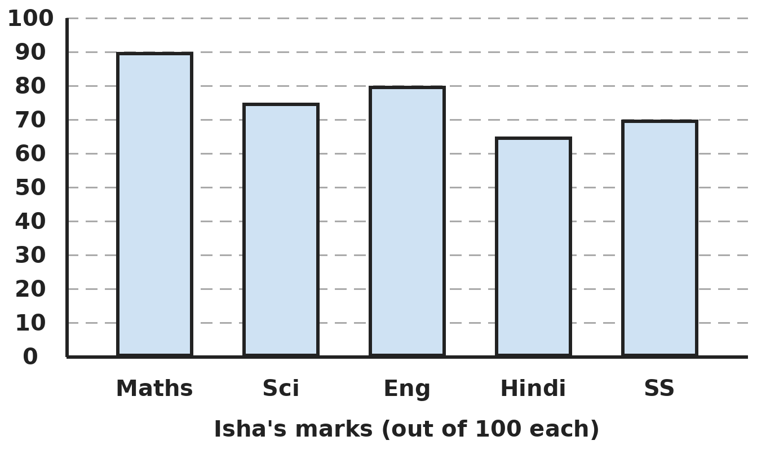
Q18. The bar graph shows Isha's marks out of 100 in five subjects. What is her overall percentage?
(A) 80% | (B) 76% | (C) 75% | (D) 78%

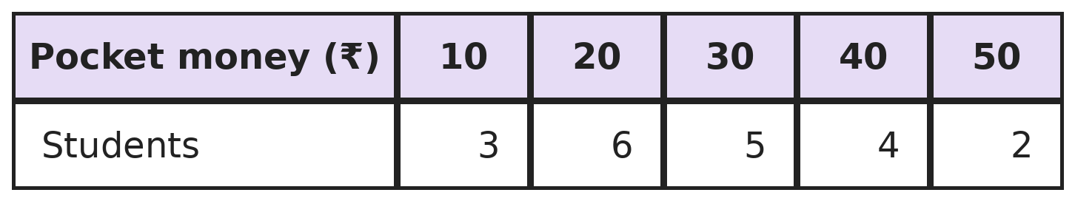
Q19. The table shows the daily pocket money of 20 students. How much do they get in all each day, and how many get more than ₹25?
(A) ₹560; 6 students | (B) ₹150; 11 students
(C) ₹600; 11 students | (D) ₹560; 11 students

Part 8 — Applied Mathematics (Syllabus Chapter 9)
Q20. Arun stands between two cliffs and shouts. He hears the first echo after 2 seconds and the second echo after 3 seconds. Sound travels at 340 m/s. How far apart are the cliffs?
(A) 1,700 m | (B) 850 m | (C) 425 m | (D) 510 m

Q21. ₹2,600 is shared among Anil, Bhoomi and Chetan in the ratio 1/2 : 1/3 : 1/4. How much does Chetan get?
(A) ₹650 | (B) ₹800 | (C) ₹600 | (D) ₹1,200

Q22. 4 kg of apples and 3 kg of grapes cost ₹760. One kg of grapes costs ₹20 more than one kg of apples. What is the price of one kg of apples?
(A) ₹120 | (B) ₹100 | (C) ₹108 | (D) ₹95

Part 9 — Mathematical Reasoning (Syllabus Chapter 10)
Q23. A train leaves at 22:45 (24-hour time) and the journey takes 7 hours 50 minutes. When does it arrive, in 12-hour time?
(A) 6:35 AM | (B) 5:35 AM | (C) 6:35 PM | (D) 7:35 AM

Q24. Which of these could be the sum of 10 consecutive integers?
(A) 150 | (B) 144 | (C) 145 | (D) 140

Q25. Kajal travels half the way home by bus, one third of the remaining distance by auto, and walks the last 2 km. How far is her home?
(A) 12 km | (B) 6 km | (C) 9 km | (D) 4 km

Part 10 — Mixed Problems (each joins two chapters)
Q26. An n × n square of dots has 4n − 4 dots on its border. Which square has exactly 96 dots on its border?
(A) 24 × 24 | (B) 26 × 26 | (C) 25 × 25 | (D) 12 × 12

Q27. What is the last digit of 7 × 7 × 7 × … × 7, with 2,025 sevens?
(A) 9 | (B) 3 | (C) 1 | (D) 7

Q28. Bharat drives for 3 hours. For 40% of the time he drives at 60 km/h and for the rest at 90 km/h. How far does he travel?
(A) 225 km | (B) 234 km | (C) 216 km | (D) 252 km

Q29. An equilateral triangle has the same perimeter as a square of side 9 cm. What is the side of the triangle, and what is the total of all the angles of both shapes?
(A) 12 cm; 540° | (B) 12 cm; 450° | (C) 9 cm; 540° | (D) 12 cm; 360°

Q30. Tank A has 500 L and loses 15 L every hour. Tank B has 200 L and gains 25 L every hour. After how long do they hold the same amount?
(A) 12 hours | (B) 7 hours | (C) 7.5 hours | (D) 8 hours

Answer Sheet AMO Level 2 · Class 6 · Practice Paper 8
Name: | School: | Roll No.:
Shade or tick one circle for each question.
1. | Ⓐ Ⓑ Ⓒ Ⓓ | 11. | Ⓐ Ⓑ Ⓒ Ⓓ | 21. | Ⓐ Ⓑ Ⓒ Ⓓ
2. | Ⓐ Ⓑ Ⓒ Ⓓ | 12. | Ⓐ Ⓑ Ⓒ Ⓓ | 22. | Ⓐ Ⓑ Ⓒ Ⓓ
3. | Ⓐ Ⓑ Ⓒ Ⓓ | 13. | Ⓐ Ⓑ Ⓒ Ⓓ | 23. | Ⓐ Ⓑ Ⓒ Ⓓ
4. | Ⓐ Ⓑ Ⓒ Ⓓ | 14. | Ⓐ Ⓑ Ⓒ Ⓓ | 24. | Ⓐ Ⓑ Ⓒ Ⓓ
5. | Ⓐ Ⓑ Ⓒ Ⓓ | 15. | Ⓐ Ⓑ Ⓒ Ⓓ | 25. | Ⓐ Ⓑ Ⓒ Ⓓ
6. | Ⓐ Ⓑ Ⓒ Ⓓ | 16. | Ⓐ Ⓑ Ⓒ Ⓓ | 26. | Ⓐ Ⓑ Ⓒ Ⓓ
7. | Ⓐ Ⓑ Ⓒ Ⓓ | 17. | Ⓐ Ⓑ Ⓒ Ⓓ | 27. | Ⓐ Ⓑ Ⓒ Ⓓ
8. | Ⓐ Ⓑ Ⓒ Ⓓ | 18. | Ⓐ Ⓑ Ⓒ Ⓓ | 28. | Ⓐ Ⓑ Ⓒ Ⓓ
9. | Ⓐ Ⓑ Ⓒ Ⓓ | 19. | Ⓐ Ⓑ Ⓒ Ⓓ | 29. | Ⓐ Ⓑ Ⓒ Ⓓ
10. | Ⓐ Ⓑ Ⓒ Ⓓ | 20. | Ⓐ Ⓑ Ⓒ Ⓓ | 30. | Ⓐ Ⓑ Ⓒ Ⓓ

For the parent or teacher
Correct: ______ / 30
Answer Key and Solutions AMO Level 2 · Class 6 · Practice Paper 8
Quick answers
1 C | 6 D | 11 D | 16 C | 21 C | 26 C
2 B | 7 A | 12 C | 17 A | 22 B | 27 D
3 D | 8 A | 13 A | 18 B | 23 A | 28 B
4 D | 9 B | 14 D | 19 D | 24 C | 29 A
5 C | 10 B | 15 A | 20 B | 25 B | 30 C
Solutions
Q | Part · level | Answer | Why?
1 | Part 1 · Ch1 · Hard | (C) 9,900 | Hint: Write both numbers with Indian commas.  Smallest 10-digit: 1,00,00,00,000 (100 crore). Smallest 8-digit: 1,00,00,000 (1 crore). The difference is 99 crore = 99,00,00,000. One crore is 100 lakh, so 99 crore = 9,900 lakh.
2 | Part 1 · Ch1 · Hard | (B) 44 | Hint: Write each option as a product of primes.  30 = 2 × 3 × 5, 45 = 3 × 3 × 5 and 66 = 2 × 3 × 11 all use primes that are there. 44 = 2 × 2 × 11 needs two 2s, but the number has only one. So 44 is not a factor.
3 | Part 1 · Ch1 · Hard | (D) 12 | Hint: Work in centimetres and find the HCF of 480 and 360.  HCF of 480 and 360 is 120, so each tile is 120 cm. Tiles: (480 ÷ 120) × (360 ÷ 120) = 4 × 3 = 12.
4 | Part 2 · Ch2 · Hard | (D) 4 | Hint: Start inside: −(−5) = 5.  −(−5) = 5. {5 − 3} = 2, so −{…} = −2. [−2 − 2] = −4. −[−4] = 4.
5 | Part 2 · Ch2 · Hard | (C) 294 | Hint: Find the smallest integer first.  Smallest = −10 − 7 − (−3) = −14. Product = 7 × (−3) × (−14) = 7 × 42 = 294 (two negatives make a positive).
6 | Part 2 · Ch2 · Hard | (D) 1,70,000 | Hint: Group 125 with 8, and 5 with 2.  There are two negative numbers, so the answer is positive. (125 × 8) × (5 × 2) × 17 = 1,000 × 10 × 17 = 1,70,000.
7 | Part 3 · Ch3 · Hard | (A) 2.4% | Hint: Write each as a decimal with four decimal places.  1/40 = 0.0250, 0.03 = 0.0300, 2.4% = 0.0240 and 0.0245. The smallest is 0.0240, which is 2.4%.
8 | Part 3 · Ch3 · Hard | (A) ₹9,240 | Hint: The second rise is 5% of the new rent, not of ₹8,000.  After the first rise: 8,000 + 800 = ₹8,800. The second rise is 5% of 8,800 = ₹440, giving ₹9,240. (₹9,200 takes 5% of ₹8,000 instead.)
9 | Part 3 · Ch3 · Hard | (B) 60% | Hint: Imagine a class of 100 students.  Out of 100: 40 girls, of whom 30 passed; 60 boys, of whom 30 passed. 60 passed out of 100 = 60%.
10 | Part 4 · Ch4 · Hard | (B) 27 | Hint: Find p first.  p = 2 × (−3) = −6. p × q = (−6) × (−3) = 18. p + q = −9. 18 − (−9) = 27.
11 | Part 4 · Ch4 · Hard | (D) 6 | Hint: Compare what each friend pays with the ₹60 per person in the bill.  The bill is ₹60 for each friend plus ₹90 extra. Each friend pays ₹75, which is ₹15 more than ₹60, and these extra ₹15s cover the ₹90: 90 ÷ 15 = 6 friends. Check: 60 × 6 + 90 = 450 = 6 × 75.
12 | Part 5 · Ch5 · Hard | (C) 288° | Hint: A complete turn is 360°.  The two angles make 1 + 4 = 5 parts of 360°, so 1 part is 72°. The reflex angle is 4 × 72° = 288°.
13 | Part 5 · Ch5 · Hard | (A) 36° | Hint: Angles B and C are equal.  Angle C = angle B = 2 × angle A. So A + 2A + 2A = 5A = 180°, and A = 36°.
14 | Part 5 · Ch5 · Hard | (D) 17 | Hint: A rectangle and a rhombus each have fewer lines than a square. Do not count a rectangle's diagonals.  Equilateral triangle 3, square 4, rectangle 2 (the two middle lines), regular hexagon 6, rhombus 2 (its two diagonals). Total 3 + 4 + 2 + 6 + 2 = 17. (21 gives the rectangle and the rhombus 4 each.)
15 | Part 6 · Ch6 · Hard | (A) ₹3,400 | Hint: The outer rectangle is 22 m by 14 m.  Path area = 22 × 14 − 20 × 12 = 308 − 240 = 68 m². Cost = 68 × 50 = ₹3,400.
16 | Part 6 · Ch6 · Hard | (C) 1,440 cm² | Hint: Count the cubes first: how many fit along each edge?  Cubes: 5 × 4 × 3 = 60. Each has 6 × 2 × 2 = 24 cm². Total 60 × 24 = 1,440 cm². (376 cm² is the cuboid's own surface.)
17 | Part 6 · Ch6 · Hard | (A) 3,75,000 L | Hint: Find the volume in m³ first.  Volume = 25 × 10 × 1.5 = 375 m³ = 375 × 1,000 = 3,75,000 L.
18 | Part 7 · Ch8 · Hard | (B) 76% | Hint: Add all five marks and compare with 500.  Total: 90 + 75 + 80 + 65 + 70 = 380 out of 500. 380/500 = 76/100 = 76%.
19 | Part 7 · Ch8 · Hard | (D) ₹560; 11 students | Hint: Multiply each amount by its number of students.  Total: 10 × 3 + 20 × 6 + 30 × 5 + 40 × 4 + 50 × 2 = 30 + 120 + 150 + 160 + 100 = ₹560. More than ₹25: 5 + 4 + 2 = 11 students.
20 | Part 8 · Ch9 · Hard | (B) 850 m | Hint: Each echo goes to a cliff and comes back.  Nearer cliff: sound travels 340 × 2 = 680 m there and back, so it is 340 m away. Farther cliff: 340 × 3 = 1,020 m there and back, so 510 m away. The cliffs are on opposite sides: 340 + 510 = 850 m apart.
21 | Part 8 · Ch9 · Hard | (C) ₹600 | Hint: Multiply each fraction by 12 to get whole numbers.  1/2 : 1/3 : 1/4 = 6 : 4 : 3 (multiplying by 12). 13 parts = ₹2,600, so 1 part = ₹200. Chetan gets 3 × 200 = ₹600.
22 | Part 8 · Ch9 · Hard | (B) ₹100 | Hint: If the grapes were ₹20 cheaper, it would be like buying 7 kg of apples.  Taking ₹20 off each kg of grapes takes ₹60 off: 7 kg of apples would cost 760 − 60 = ₹700. One kg of apples = ₹100 (grapes ₹120).
23 | Part 9 · Ch10 · Hard | (A) 6:35 AM | Hint: 22:45 is 10:45 PM.  10:45 PM + 7 h = 5:45 AM. 5:45 AM + 50 min = 6:35 AM the next day.
24 | Part 9 · Ch10 · Hard | (C) 145 | Hint: If the first integer is a, the sum is 10a + 45.  The sum is a + (a + 1) + … + (a + 9) = 10a + 45, so it always ends in 5. Only 145 does: a = 10, giving 10 + 11 + … + 19 = 145.
25 | Part 9 · Ch10 · Hard | (B) 6 km | Hint: After the bus, half is left. The walk is two thirds of that half.  After the bus, 1/2 is left. The auto takes 1/3 of that, leaving 2/3 of 1/2 = 1/3 of the whole. So 1/3 of the way is 2 km and the whole way is 6 km.
26 | Part 10 · Mixed · Ch4 + Ch10 · Hard | (C) 25 × 25 | Hint: Why is it 4n − 4 and not 4n? Put the corners back.  Each side has n dots, but the 4 corners are counted twice, so the border has 4n − 4 dots. Adding the 4 corners back gives 96 + 4 = 100 = 4 × 25, so n = 25.
27 | Part 10 · Mixed · Ch1 + Ch10 · Hard | (D) 7 | Hint: Look at the last digits of 7, 7 × 7, 7 × 7 × 7, …  Last digits go 7, 9, 3, 1, 7, 9, 3, 1, … repeating every 4. 2,025 = 4 × 506 + 1, so the last digit is the 1st in the cycle: 7.
28 | Part 10 · Mixed · Ch3 + Ch9 · Hard | (B) 234 km | Hint: 40% of 3 hours is 1.2 hours.  1.2 h at 60 km/h = 72 km. The other 1.8 h at 90 km/h = 162 km. Total 234 km. (225 km wrongly uses the average of the two speeds.)
29 | Part 10 · Mixed · Ch5 + Ch6 · Hard | (A) 12 cm; 540° | Hint: The angles of a triangle add to 180° and those of a square to 4 × 90°.  Perimeter = 36 cm, so the triangle's side is 12 cm. Angles: 180° + 360° = 540°.
30 | Part 10 · Mixed · Ch4 + Ch9 · Hard | (C) 7.5 hours | Hint: The gap of 300 L closes by 15 + 25 L each hour.  The gap closes by 40 L per hour. 300 ÷ 40 = 7.5 hours. Check: A has 500 − 112.5 = 387.5 L and B has 200 + 187.5 = 387.5 L.

ARYABHATTA MATHS OLYMPIAD
Level 2
PRACTICE PAPER-9
CLASS 6
Total Questions | 30 multiple-choice questions
Level | Level-2 (final round): every question is Hard
Time | 45 minutes
Arrangement | Parts by chapter; the last Part has mixed problems joining two chapters
Negative Marking | No negative marking
Calculator | Not allowed
Chapters | Number System · Operations · Fractions, Decimals & Percentages · Algebra · Geometry · Mensuration · Data Handling, Statistics & Probability · Applied Mathematics · Mathematical Reasoning

Instructions
• Each question has four options, (A) to (D), with exactly one correct answer.
• The questions are grouped in Parts by chapter. The last Part has mixed problems, each joining two chapters.
• Every question is at Level-2 (Hard) standard: expect several steps or a key insight.
• There is no negative marking. Calculators are not allowed; use a separate sheet for rough work.
• Figures are not necessarily drawn to scale unless stated.

For teachers
• Figures are part of the questions and work when printed in black and white.
• Parts follow the AMO syllabus chapters. Chapter 7 is not part of the Class 6 syllabus, so the chapter numbers shown in the Part headings have gaps.
• The answer sheet and the answer key are at the end. Remove the answer key before the paper is attempted.

Part 1 — Number System (Syllabus Chapter 1)
Q1. In 3,62,45,108, the place value of 6 is divided by the face value of 4. What is the answer?
(A) 60,00,000 | (B) 15,00,000 | (C) 1,50,000 | (D) 15,000

Q2. What is the HCF of 1,001 and 1,155?
(A) 7 | (B) 77 | (C) 11 | (D) 143

Q3. The top of Everest is at 8,849 m and the shore of the Dead Sea is at −430 m. Kanchenjunga is 263 m lower than Everest. How far is the top of Kanchenjunga above the Dead Sea shore?
(A) 8,156 m | (B) 9,542 m | (C) 8,586 m | (D) 9,016 m

Part 2 — Operations (Syllabus Chapter 2)
Q4. What is the value of 7 + [6 × {5 − (4 − 3 × 2)}]?
(A) 25 | (B) 13 | (C) 49 | (D) 91

Q5. What is the next number in the pattern −81, 27, −9, 3, …?
(A) 1 | (B) −1 | (C) −3 | (D) 0

Q6. Ravi subtracts −7 from the sum of −12 and 5, and then multiplies the result by −3. What does he get?
(A) 42 | (B) 0 | (C) −42 | (D) −6

Part 3 — Fractions, Decimals & Percentages (Syllabus Chapter 3)
Q7. 0.4 of a number is 36. What is 45% of the same number?
(A) 16.2 | (B) 45 | (C) 40.5 | (D) 36.45

Q8. A plant is 480 mm tall. In a month it grows 25% taller. Then 10% of its new height is trimmed off. How tall is it now?
(A) 540 mm | (B) 552 mm | (C) 528 mm | (D) 600 mm

Q9. In a class, 3/5 of the students are boys. 25% of the boys and 30% of the girls play chess. What percentage of the class plays chess?
(A) 55% | (B) 28% | (C) 26% | (D) 27%

Part 4 — Algebra (Syllabus Chapter 4)
Q10. An isosceles triangle has two equal sides of (2a + 1) cm and a base of (a + 4) cm. For which value of a is it equilateral, and what is its perimeter then?
(A) a = 3, 21 cm | (B) a = 3, 14 cm | (C) a = 5, 31 cm | (D) a = 4, 27 cm

Q11. In a hall, the 1st row has 10 chairs and each row has 2 more than the row in front. Write the number of chairs in the nth row, and find it for the 15th row.
(A) 2n + 10; 40 | (B) 10n; 150 | (C) 2n + 8; 38 | (D) 2n + 8; 36

Part 5 — Geometry (Syllabus Chapter 5)
Q12. Dev faces south-east. He turns 225° anticlockwise. Which direction does he face now?
(A) West | (B) North | (C) East | (D) North-west

Q13. How many different isosceles triangles have whole-number sides (in cm) and a perimeter of 20 cm?
(A) 5 | (B) 3 | (C) 9 | (D) 4

Q14. Each corner of a regular hexagon is cut off to make a regular 12-sided polygon. How many more diagonals does the new shape have than the hexagon?
(A) 45 | (B) 54 | (C) 36 | (D) 27

Part 6 — Mensuration (Syllabus Chapter 6)
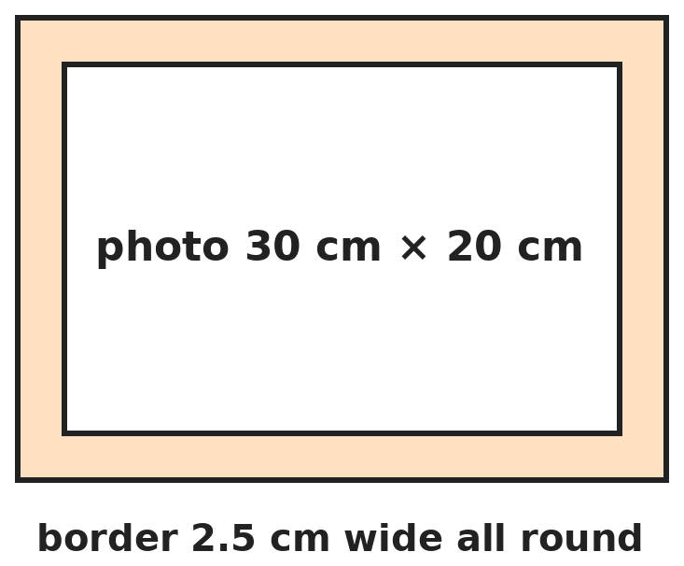
Q15. A photo 30 cm by 20 cm has a frame 2.5 cm wide all round it. What is the area of the frame alone?
(A) 250 cm² | (B) 262.5 cm² | (C) 275 cm² | (D) 300 cm²

Q16. A cube-shaped tank has inner edge 30 cm and is two thirds full of water. How many litres are needed to fill it? (1,000 cm³ = 1 L)
(A) 18 L | (B) 9 L | (C) 27 L | (D) 10 L

Q17. A cuboid is 12 cm long and 8 cm wide. Its total surface area is 592 cm². What is its height?
(A) 12 cm | (B) 8 cm | (C) 15 cm | (D) 10 cm

Part 7 — Data Handling, Statistics & Probability (Syllabus Chapter 8)
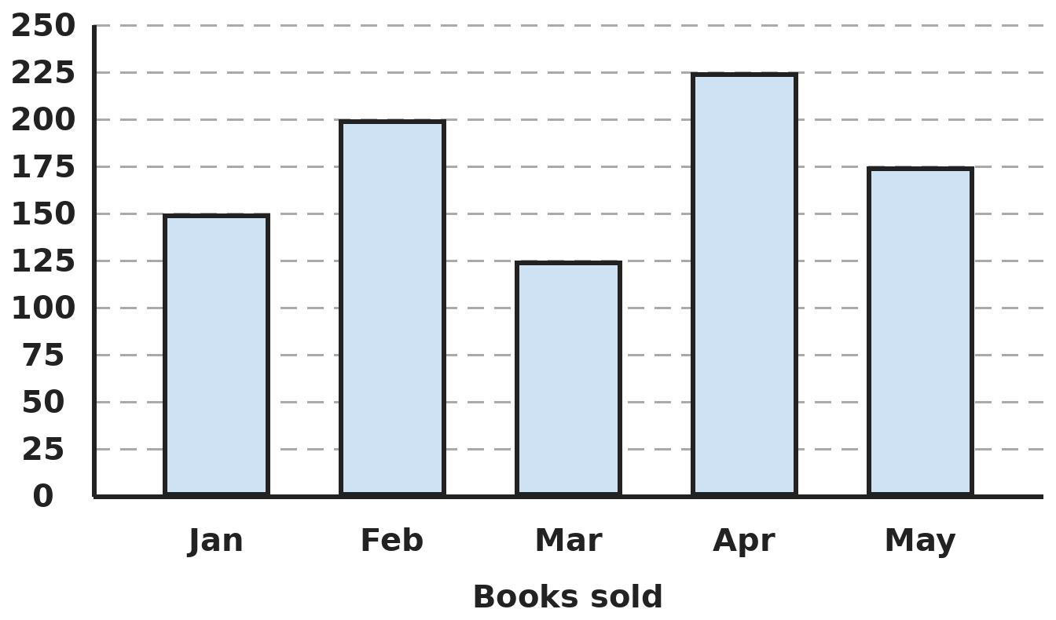
Q18. The bar graph shows books sold by a shop. In which month were sales exactly 3/4 of February's, and how many more books were sold in May than in March?
(A) March; 50 | (B) January; 75 | (C) January; 50 | (D) May; 50

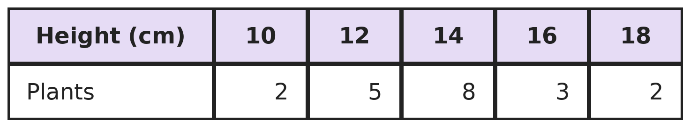
Q19. The table shows the heights of 20 plants. What fraction of the plants are taller than 12 cm but not taller than 16 cm?
(A) 13/20 | (B) 2/5 | (C) 11/20 | (D) 3/5

Part 8 — Applied Mathematics (Syllabus Chapter 9)
Q20. A train 120 m long passes a pole in 8 seconds and a platform in 20 seconds. How long is the platform?
(A) 300 m | (B) 180 m | (C) 150 m | (D) 120 m

Q21. In a garden, roses : lilies = 4 : 7 and lilies : tulips = 3 : 5. There are 35 tulips. How many roses are there?
(A) 12 | (B) 20 | (C) 21 | (D) 15

Q22. A car uses 8 litres of petrol for every 100 km. Petrol costs ₹105 a litre. What does the petrol for a 450 km trip cost?
(A) ₹3,360 | (B) ₹4,725 | (C) ₹3,840 | (D) ₹3,780

Part 9 — Mathematical Reasoning (Syllabus Chapter 10)
Q23. A 12-hour clock shows 9 o'clock. What will it show 57 hours later?
(A) 6 o'clock | (B) 9 o'clock | (C) 3 o'clock | (D) 5 o'clock

Q24. Kiran writes 15 numbers, each either 1 or −1. Which of these could be their sum?
(A) 0 | (B) 4 | (C) −16 | (D) −3

Q25. In a game, a player's points are doubled and then 5 is taken away each round. After 3 rounds Ravi has 37 points. How many did he start with?
(A) 9 | (B) 11 | (C) 7 | (D) 16

Part 10 — Mixed Problems (each joins two chapters)

Q26. The nth number of this pattern is n × n − n. Which term is 110?
(A) 10th | (B) 12th | (C) 11th | (D) 110th

Q27. How many 2-digit numbers have exactly 3 factors?
(A) 4 | (B) 3 | (C) 5 | (D) 2

Q28. Neha walks at 80% of Tanya's speed. Tanya takes 24 minutes for a walk. How long does Neha take for the same walk?
(A) 28.8 min | (B) 19.2 min | (C) 30 min | (D) 32 min

Q29. Two identical right-angled triangles with shorter sides 6 cm and 8 cm are joined along their 8 cm sides to make one triangle. What type of triangle is it, and what is its area?
(A) Isosceles; 24 cm² | (B) Isosceles; 48 cm²
(C) Equilateral; 48 cm² | (D) Scalene; 96 cm²

Q30. A hall costs ₹(2,000 + 150p) for p people. The cost is shared equally. How many people must come so that each person pays exactly ₹175?
(A) 40 | (B) 100 | (C) 60 | (D) 80

Answer Sheet AMO Level 2 · Class 6 · Practice Paper 9
Name: | School: | Roll No.:
Shade or tick one circle for each question.
1. | Ⓐ Ⓑ Ⓒ Ⓓ | 11. | Ⓐ Ⓑ Ⓒ Ⓓ | 21. | Ⓐ Ⓑ Ⓒ Ⓓ
2. | Ⓐ Ⓑ Ⓒ Ⓓ | 12. | Ⓐ Ⓑ Ⓒ Ⓓ | 22. | Ⓐ Ⓑ Ⓒ Ⓓ
3. | Ⓐ Ⓑ Ⓒ Ⓓ | 13. | Ⓐ Ⓑ Ⓒ Ⓓ | 23. | Ⓐ Ⓑ Ⓒ Ⓓ
4. | Ⓐ Ⓑ Ⓒ Ⓓ | 14. | Ⓐ Ⓑ Ⓒ Ⓓ | 24. | Ⓐ Ⓑ Ⓒ Ⓓ
5. | Ⓐ Ⓑ Ⓒ Ⓓ | 15. | Ⓐ Ⓑ Ⓒ Ⓓ | 25. | Ⓐ Ⓑ Ⓒ Ⓓ
6. | Ⓐ Ⓑ Ⓒ Ⓓ | 16. | Ⓐ Ⓑ Ⓒ Ⓓ | 26. | Ⓐ Ⓑ Ⓒ Ⓓ
7. | Ⓐ Ⓑ Ⓒ Ⓓ | 17. | Ⓐ Ⓑ Ⓒ Ⓓ | 27. | Ⓐ Ⓑ Ⓒ Ⓓ
8. | Ⓐ Ⓑ Ⓒ Ⓓ | 18. | Ⓐ Ⓑ Ⓒ Ⓓ | 28. | Ⓐ Ⓑ Ⓒ Ⓓ
9. | Ⓐ Ⓑ Ⓒ Ⓓ | 19. | Ⓐ Ⓑ Ⓒ Ⓓ | 29. | Ⓐ Ⓑ Ⓒ Ⓓ
10. | Ⓐ Ⓑ Ⓒ Ⓓ | 20. | Ⓐ Ⓑ Ⓒ Ⓓ | 30. | Ⓐ Ⓑ Ⓒ Ⓓ

For the parent or teacher
Correct: ______ / 30
Answer Key and Solutions AMO Level 2 · Class 6 · Practice Paper 9
Quick answers
1 B | 6 B | 11 C | 16 B | 21 A | 26 C
2 B | 7 C | 12 A | 17 D | 22 D | 27 D
3 D | 8 A | 13 D | 18 C | 23 A | 28 C
4 C | 9 D | 14 A | 19 C | 24 D | 29 B
5 B | 10 A | 15 C | 20 B | 25 A | 30 D
Solutions
Q | Part · level | Answer | Why?
1 | Part 1 · Ch1 · Hard | (B) 15,00,000 | Hint: The face value of a digit is the digit itself.  6 is in the ten-lakhs place, so its place value is 60,00,000. The face value of 4 is 4. 60,00,000 ÷ 4 = 15,00,000.
2 | Part 1 · Ch1 · Hard | (B) 77 | Hint: Write both numbers as products of primes.  1,001 = 7 × 11 × 13 and 1,155 = 3 × 5 × 7 × 11. Common primes: 7 and 11. HCF = 77.
3 | Part 1 · Ch1 · Hard | (D) 9,016 m | Hint: Find the height of Kanchenjunga, then subtract a negative number.  Kanchenjunga: 8,849 − 263 = 8,586 m. Difference: 8,586 − (−430) = 8,586 + 430 = 9,016 m.
4 | Part 2 · Ch2 · Hard | (C) 49 | Hint: Inside the round bracket, multiply first.  3 × 2 = 6, so (4 − 6) = −2. {5 − (−2)} = 7. 6 × 7 = 42. 7 + 42 = 49.
5 | Part 2 · Ch2 · Hard | (B) −1 | Hint: What do you divide by each time?  Each number is the one before divided by −3: −81 ÷ (−3) = 27, 27 ÷ (−3) = −9, −9 ÷ (−3) = 3. Next: 3 ÷ (−3) = −1.
6 | Part 2 · Ch2 · Hard | (B) 0 | Hint: Subtracting −7 is the same as adding 7.  −12 + 5 = −7. Then −7 − (−7) = 0. 0 × (−3) = 0.
7 | Part 3 · Ch3 · Hard | (C) 40.5 | Hint: Find the number first.  0.4 × number = 36, so the number is 90. 45% of 90 = 40.5.
8 | Part 3 · Ch3 · Hard | (A) 540 mm | Hint: The 10% is taken off the new height, not the old one.  After growing: 480 + 25% of 480 = 480 + 120 = 600 mm. After trimming 10%: 600 − 60 = 540 mm.
9 | Part 3 · Ch3 · Hard | (D) 27% | Hint: Imagine a class of 100: 60 boys and 40 girls.  Out of 100: 25% of 60 = 15 boys and 30% of 40 = 12 girls. 27 out of 100 = 27%. (55% wrongly adds the two percentages.)
10 | Part 4 · Ch4 · Hard | (A) a = 3, 21 cm | Hint: Equilateral means the base equals the other two sides. Test each value of a.  a = 3: 2a + 1 = 7 and a + 4 = 7, so all sides are 7 cm and the perimeter is 21 cm. a = 4 gives 9 and 8; a = 5 gives 11 and 9, so those are not equilateral. (14 cm is only two sides.)
11 | Part 4 · Ch4 · Hard | (C) 2n + 8; 38 | Hint: Check your expression for n = 1 and n = 2.  Row n has 10 + 2(n − 1) = 2n + 8 chairs. Check: n = 1 gives 10, n = 2 gives 12. For n = 15: 30 + 8 = 38.
12 | Part 5 · Ch5 · Hard | (A) West | Hint: Turn 180° first, then 45° more.  180° anticlockwise from south-east is north-west. 45° more anticlockwise is west.
13 | Part 5 · Ch5 · Hard | (D) 4 | Hint: Sides a, a, b with 2a + b = 20. The two equal sides together must be longer than b.  b = 20 − 2a must be positive and less than 2a. a = 6: (6, 6, 8). a = 7: (7, 7, 6). a = 8: (8, 8, 4). a = 9: (9, 9, 2). a = 5 gives (5, 5, 10), which is flat. So 4 triangles.
14 | Part 5 · Ch5 · Hard | (A) 45 | Hint: A polygon with n sides has n × (n − 3) ÷ 2 diagonals.  Hexagon: 6 × 3 ÷ 2 = 9. 12-sided polygon: 12 × 9 ÷ 2 = 54. Difference: 54 − 9 = 45.
15 | Part 6 · Ch6 · Hard | (C) 275 cm² | Hint: The outer rectangle is 35 cm by 25 cm.  Outer: 35 × 25 = 875 cm². Photo: 30 × 20 = 600 cm². Frame = 875 − 600 = 275 cm².
16 | Part 6 · Ch6 · Hard | (B) 9 L | Hint: Find the full volume in litres first.  Volume = 30 × 30 × 30 = 27,000 cm³ = 27 L. One third is empty: 27 ÷ 3 = 9 L.
17 | Part 6 · Ch6 · Hard | (D) 10 cm | Hint: Half the surface area is one of each pair of faces.  Half the surface area is 296 cm²: the top (12 × 8 = 96) plus one long side and one short side. The two sides together are 296 − 96 = 200 cm², and they make a strip 12 + 8 = 20 cm long and h tall. So h = 200 ÷ 20 = 10 cm.
18 | Part 7 · Ch8 · Hard | (C) January; 50 | Hint: Find 3/4 of February's sales first.  February: 200. 3/4 of 200 = 150, which is January. May 175 − March 125 = 50.
19 | Part 7 · Ch8 · Hard | (C) 11/20 | Hint: Only the 14 cm and 16 cm plants count.  Plants of 14 cm and 16 cm: 8 + 3 = 11 out of 20, which is 11/20.
20 | Part 8 · Ch9 · Hard | (B) 180 m | Hint: Find the speed from the pole first.  Speed = 120 ÷ 8 = 15 m/s. In 20 s the train covers 300 m, which is its own length plus the platform. Platform = 300 − 120 = 180 m.
21 | Part 8 · Ch9 · Hard | (A) 12 | Hint: Find the lilies from the tulips first.  Lilies : tulips = 3 : 5, so 35 tulips means 21 lilies. Roses : lilies = 4 : 7, so 21 lilies means 12 roses.
22 | Part 8 · Ch9 · Hard | (D) ₹3,780 | Hint: Find the litres needed for 450 km first.  Litres = 8 × 4.5 = 36 L. Cost = 36 × 105 = ₹3,780.
23 | Part 9 · Ch10 · Hard | (A) 6 o'clock | Hint: Every 12 hours the clock shows the same time.  57 = 12 × 4 + 9. After 48 hours it shows 9 o'clock again; 9 more hours gives 6 o'clock.
24 | Part 9 · Ch10 · Hard | (D) −3 | Hint: Is the sum of 15 odd numbers odd or even? How big can it be?  Each number is odd, and 15 odd numbers add to an odd number, so 0 and 4 are impossible. The sum is between −15 and 15, so −16 is impossible. −3 works: six 1s and nine −1s.
25 | Part 9 · Ch10 · Hard | (A) 9 | Hint: Undo each round: add 5, then halve.  (37 + 5) ÷ 2 = 21. (21 + 5) ÷ 2 = 13. (13 + 5) ÷ 2 = 9. Check: 9 → 13 → 21 → 37.
26 | Part 10 · Mixed · Ch4 + Ch10 · Hard | (C) 11th | Hint: n × n − n = n × (n − 1). Which two numbers next to each other multiply to 110?  n × (n − 1) = 110 = 11 × 10, so n = 11. Check: 11 × 11 − 11 = 110.
27 | Part 10 · Mixed · Ch1 + Ch10 · Hard | (D) 2 | Hint: Try a few: 4 has factors 1, 2, 4. 9 has 1, 3, 9. What kind of numbers are these?  A number with exactly 3 factors is a prime times itself: 1, p and p × p. Two-digit ones: 5 × 5 = 25 and 7 × 7 = 49. (11 × 11 = 121 is too big.) So 2.
28 | Part 10 · Mixed · Ch3 + Ch9 · Hard | (C) 30 min | Hint: Pick a length for the walk that works with 24 minutes.  Say the walk is 1,200 m. Tanya walks 1,200 ÷ 24 = 50 m a minute. Neha walks 80% of that, 40 m a minute, so she takes 1,200 ÷ 40 = 30 minutes. (28.8 wrongly adds 20% to the time.)
29 | Part 10 · Mixed · Ch5 + Ch6 · Hard | (B) Isosceles; 48 cm² | Hint: The two long sides of the new triangle are the same length.  The new triangle has two equal sides (the long sides of the two pieces), so it is isosceles. Each piece is half of a 6 cm × 8 cm rectangle, so its area is 48 ÷ 2 = 24 cm², and the total is 48 cm².
30 | Part 10 · Mixed · Ch4 + Ch9 · Hard | (D) 80 | Hint: Each person pays ₹150 for themselves plus a share of the ₹2,000.  Each person pays 150 + 2,000 ÷ p = 175, so 2,000 ÷ p = 25 and p = 80. Check: 2,000 + 12,000 = 14,000 = 80 × 175.

ARYABHATTA MATHS OLYMPIAD
Level 2
PRACTICE PAPER-10
CLASS 6
Total Questions | 30 multiple-choice questions
Level | Level-2 (final round): every question is Hard
Time | 45 minutes
Arrangement | Parts by chapter; the last Part has mixed problems joining two chapters
Negative Marking | No negative marking
Calculator | Not allowed
Chapters | Number System · Operations · Fractions, Decimals & Percentages · Algebra · Geometry · Mensuration · Data Handling, Statistics & Probability · Applied Mathematics · Mathematical Reasoning

Instructions
• Each question has four options, (A) to (D), with exactly one correct answer.
• The questions are grouped in Parts by chapter. The last Part has mixed problems, each joining two chapters.
• Every question is at Level-2 (Hard) standard: expect several steps or a key insight.
• There is no negative marking. Calculators are not allowed; use a separate sheet for rough work.
• Figures are not necessarily drawn to scale unless stated.

For teachers
• Figures are part of the questions and work when printed in black and white.
• Parts follow the AMO syllabus chapters. Chapter 7 is not part of the Class 6 syllabus, so the chapter numbers shown in the Part headings have gaps.
• The answer sheet and the answer key are at the end. Remove the answer key before the paper is attempted.

Part 1 — Number System (Syllabus Chapter 1)
Q1. What is the smallest 8-digit number whose digits add up to 9?
(A) 1,00,00,008 | (B) 1,00,00,080 | (C) 1,00,00,009 | (D) 8,00,00,001

Q2. Two numbers, both less than 72, have LCM 72 and HCF 12. What is their sum?
(A) 84 | (B) 48 | (C) 60 | (D) 72

Q3. In a quiz, each correct answer gets +4, each wrong answer −2 and each skipped question 0. Isha attempts 20 of the 25 questions and scores 50. How many did she get wrong?
(A) 15 | (B) 10 | (C) 3 | (D) 5

Part 2 — Operations (Syllabus Chapter 2)
Q4. What is the value of (−48) ÷ {(−2) × [3 − (−1)]} + 5?
(A) −1 | (B) 11 | (C) 1 | (D) 17

Q5. Compare P = (−7) × (−8) − (−6) × 9 and Q = (−100) ÷ (−4) × 5. Which is true?
(A) P is larger, by 15 | (B) P and Q are equal
(C) Q is larger, by 235 | (D) Q is larger, by 15

Q6. Three integers A, B and C have A ÷ B = −4 and B ÷ C = −3. What is A ÷ C?
(A) −12 | (B) 12 | (C) −7 | (D) 7

Part 3 — Fractions, Decimals & Percentages (Syllabus Chapter 3)
Q7. How many of these are equal to 7/8: 0.875, 87.5%, 35/40, 21/24, 0.78?
(A) 3 | (B) 5 | (C) 4 | (D) 2

Q8. A batter's score rises from 40 to 50 in one match and falls from 50 to 40 in the next. The rise is a% and the fall is b%. What is a − b?
(A) 0 | (B) 5 | (C) 10 | (D) 20

Q9. A 15-litre solution is 20% salt. 5 litres of water are added. What percentage of the new solution is salt?
(A) 20% | (B) 15% | (C) 25% | (D) 12%

Part 4 — Algebra (Syllabus Chapter 4)
Q10. A farm has h hens and c cows. The total number of legs is 2h + 4c. There are 30 heads and 74 legs. How many cows are there?
(A) 7 | (B) 23 | (C) 14 | (D) 8

Q11. What is the value of m × m × m − 3 × m × n + n × n when m = −1 and n = 2?
(A) 9 | (B) −3 | (C) 3 | (D) −9

Part 5 — Geometry (Syllabus Chapter 5)
Q12. Three angles on a straight line are (x + 20)°, (2x − 10)° and (x + 10)°. What is the smallest of the three angles?
(A) 40° | (B) 60° | (C) 70° | (D) 50°

Q13. An isosceles triangle has one angle three times another of its angles. Which of these could be its angles?
(A) 45°, 45°, 90° | (B) 30°, 30°, 120°
(C) 36°, 36°, 108° | (D) 60°, 60°, 60°

Q14. A regular polygon has 20 diagonals and a perimeter of 64 cm. How long is each side?
(A) 10 cm | (B) 6.4 cm | (C) 8 cm | (D) 16 cm

Part 6 — Mensuration (Syllabus Chapter 6)
Q15. A square of side 3 cm is cut from each corner of a 15 cm by 10 cm card. What are the area and the perimeter of the card that is left?
(A) 114 cm²; 38 cm | (B) 141 cm²; 50 cm
(C) 114 cm²; 62 cm | (D) 114 cm²; 50 cm

Q16. A box is 40 cm × 30 cm × 20 cm. Books 20 cm × 15 cm × 5 cm are packed flat in it, all the same way up. How many books fit?
(A) 32 | (B) 8 | (C) 16 | (D) 24

Q17. All 12 edges of a cuboid add up to 72 cm. Its length is 8 cm and its breadth is 6 cm. What is its volume?
(A) 192 cm³ | (B) 288 cm³ | (C) 336 cm³ | (D) 144 cm³

Part 7 — Data Handling, Statistics & Probability (Syllabus Chapter 8)
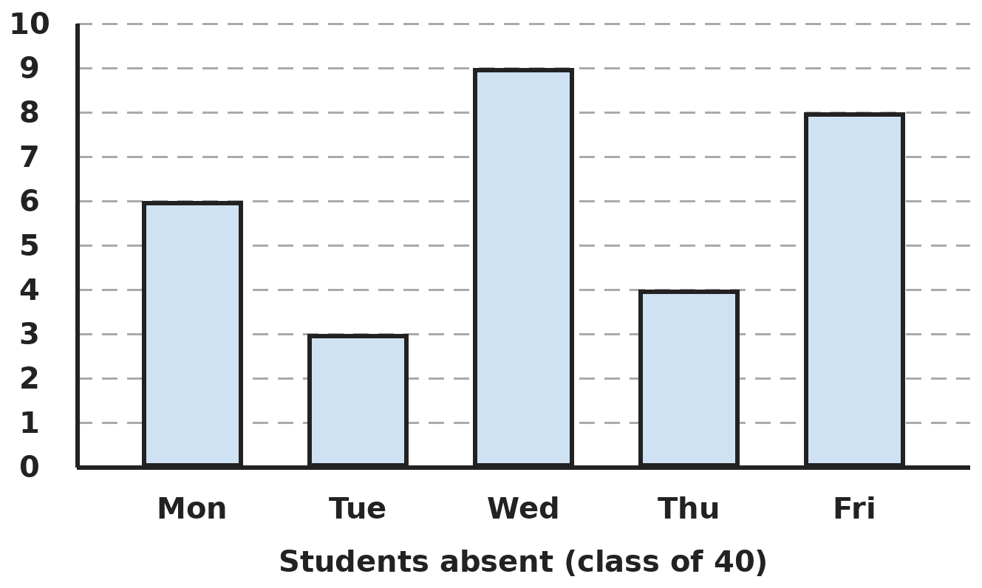
Q18. The bar graph shows how many students of a class of 40 were absent each day. On how many days was the attendance above 85%?
(A) 3 | (B) 1 | (C) 2 | (D) 4

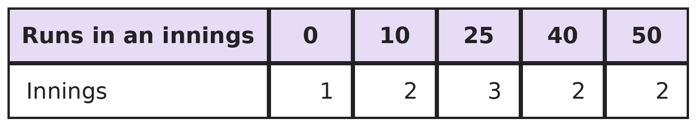
Q19. The table shows the runs Kunal scored in his 10 innings. How many runs did he score in all, and in how many innings did he score 40 or more?
(A) 275; 2 innings | (B) 125; 4 innings
(C) 275; 4 innings | (D) 300; 4 innings

Part 8 — Applied Mathematics (Syllabus Chapter 9)
Q20. Two friends 18 km apart walk towards each other at 4 km/h and 5 km/h. A dog runs back and forth between them at 12 km/h until they meet. How far does the dog run?
(A) 18 km | (B) 12 km | (C) 36 km | (D) 24 km

Q21. The salaries of Ankita and Bhuvan are in the ratio 4 : 5. Each gets a rise of ₹2,000 and the ratio becomes 5 : 6. What was Ankita's salary before the rise?
(A) ₹10,000 | (B) ₹8,000 | (C) ₹4,000 | (D) ₹12,000

Q22. A typist types 1,200 words in 25 minutes. After typing for 1 hour at this speed, she slows down to 2/3 of it. How many words does she type in 1 hour 30 minutes?
(A) 4,320 | (B) 3,840 | (C) 3,360 | (D) 2,880

Part 9 — Mathematical Reasoning (Syllabus Chapter 10)
Q23. What time is it exactly 1,000 minutes after 9:20 AM?
(A) 2:00 AM | (B) 1:00 AM | (C) 2:00 PM | (D) 1:40 AM

Q24. Can each of 9 people shake hands with exactly 3 of the others?
(A) Yes, in many ways | (B) No, because 9 × 3 is odd
(C) Yes, but in only one way | (D) No, because 9 is a multiple of 3

Q25. Meena gives away a quarter of her stickers, then 6 more, then half of what is left. She has 15 left. How many did she have at first?
(A) 40 | (B) 52 | (C) 48 | (D) 60

Part 10 — Mixed Problems (each joins two chapters)
Q26. The sum 1 + 2 + 3 + … + n equals n × (n + 1) ÷ 2. What is the smallest n for which the sum is more than 200?
(A) 20 | (B) 19 | (C) 21 | (D) 14

Q27. How many numbers from 1 to 200 are divisible by 4 or by 6, but not by both?
(A) 51 | (B) 67 | (C) 83 | (D) 34

Q28. A shop had 160 customers on Friday. Saturday had 25% more customers than Friday, and Sunday had 20% fewer than Saturday. How many customers came on Sunday?
(A) 168 | (B) 152 | (C) 200 | (D) 160

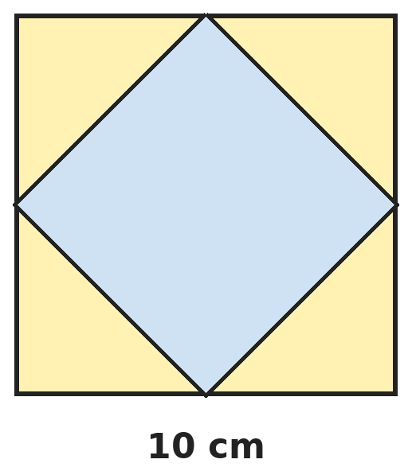
Q29. A square is drawn by joining the midpoints of the sides of a square of side 10 cm, as shown. What is the area of the inner square?
(A) 25 cm² | (B) 50 cm² | (C) 75 cm² | (D) 40 cm²

Q30. Plant A is 12 cm tall and grows 3 cm a week. Plant B is 30 cm tall and grows 1.5 cm a week. After how many weeks are they the same height?
(A) 6 weeks | (B) 8 weeks | (C) 18 weeks | (D) 12 weeks

Answer Sheet AMO Level 2 · Class 6 · Practice Paper 10
Name: | School: | Roll No.:
Shade or tick one circle for each question.
1. | Ⓐ Ⓑ Ⓒ Ⓓ | 11. | Ⓐ Ⓑ Ⓒ Ⓓ | 21. | Ⓐ Ⓑ Ⓒ Ⓓ
2. | Ⓐ Ⓑ Ⓒ Ⓓ | 12. | Ⓐ Ⓑ Ⓒ Ⓓ | 22. | Ⓐ Ⓑ Ⓒ Ⓓ
3. | Ⓐ Ⓑ Ⓒ Ⓓ | 13. | Ⓐ Ⓑ Ⓒ Ⓓ | 23. | Ⓐ Ⓑ Ⓒ Ⓓ
4. | Ⓐ Ⓑ Ⓒ Ⓓ | 14. | Ⓐ Ⓑ Ⓒ Ⓓ | 24. | Ⓐ Ⓑ Ⓒ Ⓓ
5. | Ⓐ Ⓑ Ⓒ Ⓓ | 15. | Ⓐ Ⓑ Ⓒ Ⓓ | 25. | Ⓐ Ⓑ Ⓒ Ⓓ
6. | Ⓐ Ⓑ Ⓒ Ⓓ | 16. | Ⓐ Ⓑ Ⓒ Ⓓ | 26. | Ⓐ Ⓑ Ⓒ Ⓓ
7. | Ⓐ Ⓑ Ⓒ Ⓓ | 17. | Ⓐ Ⓑ Ⓒ Ⓓ | 27. | Ⓐ Ⓑ Ⓒ Ⓓ
8. | Ⓐ Ⓑ Ⓒ Ⓓ | 18. | Ⓐ Ⓑ Ⓒ Ⓓ | 28. | Ⓐ Ⓑ Ⓒ Ⓓ
9. | Ⓐ Ⓑ Ⓒ Ⓓ | 19. | Ⓐ Ⓑ Ⓒ Ⓓ | 29. | Ⓐ Ⓑ Ⓒ Ⓓ
10. | Ⓐ Ⓑ Ⓒ Ⓓ | 20. | Ⓐ Ⓑ Ⓒ Ⓓ | 30. | Ⓐ Ⓑ Ⓒ Ⓓ

For the parent or teacher
Correct: ______ / 30
Answer Key and Solutions AMO Level 2 · Class 6 · Practice Paper 10
Quick answers
1 A | 6 B | 11 A | 16 C | 21 B | 26 A
2 C | 7 C | 12 D | 17 A | 22 B | 27 A
3 D | 8 B | 13 C | 18 C | 23 A | 28 D
4 B | 9 B | 14 C | 19 C | 24 B | 29 B
5 D | 10 A | 15 D | 20 D | 25 C | 30 D
Solutions
Q | Part · level | Answer | Why?
1 | Part 1 · Ch1 · Hard | (A) 1,00,00,008 | Hint: The first digit must be at least 1. Put the rest of the total as far right as possible.  The first digit is 1, leaving 8 for the other digits. To keep the number small, put the 8 in the ones place: 1,00,00,008. (1,00,00,009 has digit sum 10.)
2 | Part 1 · Ch1 · Hard | (C) 60 | Hint: Both numbers are multiples of 12, and their product is 12 × 72.  Write them as 12a and 12b with a and b sharing no factor, so a × b = 72 ÷ 12 = 6. The choices are 1 and 6 (12 and 72, but 72 is not less than 72) or 2 and 3 (24 and 36). Sum 24 + 36 = 60.
3 | Part 1 · Ch1 · Hard | (D) 5 | Hint: If all 20 were correct she would score 80. Each wrong answer instead loses 6.  All 20 correct would give 80. Each wrong answer changes +4 into −2, a loss of 6. 80 − 50 = 30 lost, so 30 ÷ 6 = 5 wrong. Check: 15 × 4 − 5 × 2 = 50.
4 | Part 2 · Ch2 · Hard | (B) 11 | Hint: Work out the square bracket, then the curly bracket.  [3 − (−1)] = 4. {(−2) × 4} = −8. (−48) ÷ (−8) = 6. 6 + 5 = 11.
5 | Part 2 · Ch2 · Hard | (D) Q is larger, by 15 | Hint: In Q, divide first and then multiply, working left to right.  P = 56 − (−54) = 56 + 54 = 110. Q = 25 × 5 = 125. Q is larger by 15.
6 | Part 2 · Ch2 · Hard | (B) 12 | Hint: A = −4 × B and B = −3 × C.  A = −4 × B = −4 × (−3 × C) = 12 × C. So A ÷ C = 12. Example: C = 1, B = −3, A = 12.
7 | Part 3 · Ch3 · Hard | (C) 4 | Hint: 7/8 = 0.875.  0.875 ✓. 87.5% = 0.875 ✓. 35/40 = 7/8 ✓. 21/24 = 7/8 ✓. 0.78 is not. So 4.
8 | Part 3 · Ch3 · Hard | (B) 5 | Hint: Each percentage is worked out from the starting score of that change.  Rise: 10 out of 40 = 25%. Fall: 10 out of 50 = 20%. a − b = 25 − 20 = 5.
9 | Part 3 · Ch3 · Hard | (B) 15% | Hint: The amount of salt does not change.  Salt = 20% of 15 = 3 L. New total = 20 L. 3/20 = 15/100 = 15%.
10 | Part 4 · Ch4 · Hard | (A) 7 | Hint: If all 30 animals were hens, there would be 60 legs.  30 hens would have 60 legs. Each cow adds 2 more legs. 74 − 60 = 14 extra legs, so 14 ÷ 2 = 7 cows (and 23 hens).
11 | Part 4 · Ch4 · Hard | (A) 9 | Hint: Work out each part with its sign: m × m × m is negative here.  m × m × m = (−1)(−1)(−1) = −1. 3 × m × n = 3 × (−1) × 2 = −6. n × n = 4. Total: −1 − (−6) + 4 = 9.
12 | Part 5 · Ch5 · Hard | (D) 50° | Hint: The three angles add up to 180°.  The three angles add up to 180°. Together they are 4 lots of x plus 20 − 10 + 10 = 20, so 4x is 180 − 20 = 160 and x = 40. The angles are 60°, 70° and 50°. The smallest is 50°. (40° is x, not an angle.)
13 | Part 5 · Ch5 · Hard | (C) 36°, 36°, 108° | Hint: Check two things for each set: the sum is 180° and one angle is three times another.  36° + 36° + 108° = 180° and 108° = 3 × 36°. ✓ In 45, 45, 90 the ratio is 2; in 30, 30, 120 it is 4; in 60, 60, 60 it is 1.
14 | Part 5 · Ch5 · Hard | (C) 8 cm | Hint: Find the number of sides from n × (n − 3) ÷ 2 = 20.  n = 8: 8 × 5 ÷ 2 = 20 diagonals. ✓ So it is an octagon, and each side is 64 ÷ 8 = 8 cm.
15 | Part 6 · Ch6 · Hard | (D) 114 cm²; 50 cm | Hint: Does cutting a square from a corner change the perimeter?  Area: 150 − 4 × 9 = 114 cm². At each corner, two 3 cm edges are removed and two new 3 cm edges appear, so the perimeter stays 2 × (15 + 10) = 50 cm.
16 | Part 6 · Ch6 · Hard | (C) 16 | Hint: Count how many fit along each edge.  Along 40: 2 books. Along 30: 2 books. Up 20 cm: 4 books of 5 cm. 2 × 2 × 4 = 16. (The volumes give 24,000 ÷ 1,500 = 16 too.)
17 | Part 6 · Ch6 · Hard | (A) 192 cm³ | Hint: A cuboid has 4 edges of each length.  4 × (8 + 6 + h) = 72, so 8 + 6 + h = 18 and h = 4 cm. Volume = 8 × 6 × 4 = 192 cm³.
18 | Part 7 · Ch8 · Hard | (C) 2 | Hint: Above 85% present means fewer than how many absent?  85% of 40 = 34, so attendance above 85% means more than 34 present, that is fewer than 6 absent. Tuesday (3) and Thursday (4): 2 days. Monday has exactly 6 absent, which is exactly 85%.
19 | Part 7 · Ch8 · Hard | (C) 275; 4 innings | Hint: Multiply each score by its number of innings.  Total: 0 + 20 + 75 + 80 + 100 = 275. Innings with 40 or more: 2 + 2 = 4.
20 | Part 8 · Ch9 · Hard | (D) 24 km | Hint: Do not follow the dog's trips. Find how long it runs.  The friends close the gap at 9 km/h, so they meet after 18 ÷ 9 = 2 hours. The dog runs for 2 hours at 12 km/h: 24 km.
21 | Part 8 · Ch9 · Hard | (B) ₹8,000 | Hint: Try the options: check both ratios.  Ankita ₹8,000 and Bhuvan ₹10,000 are in the ratio 4 : 5. After the rise: 10,000 : 12,000 = 5 : 6. ✓
22 | Part 8 · Ch9 · Hard | (B) 3,840 | Hint: Find her speed in words per minute first.  Speed: 1,200 ÷ 25 = 48 words a minute. First 60 minutes: 60 × 48 = 2,880 words. Then 2/3 of 48 = 32 words a minute for 30 minutes: 960 words. Total 2,880 + 960 = 3,840.
23 | Part 9 · Ch10 · Hard | (A) 2:00 AM | Hint: 1,000 minutes = how many hours and minutes?  1,000 = 16 × 60 + 40, so 16 h 40 min. 9:20 AM + 16 h = 1:20 AM next day. 40 min more: 2:00 AM.
24 | Part 9 · Ch10 · Hard | (B) No, because 9 × 3 is odd | Hint: Each handshake involves two people.  Counting handshakes person by person gives 9 × 3 = 27, and this counts every handshake twice, so it must be even. 27 is odd, so it is impossible.
25 | Part 9 · Ch10 · Hard | (C) 48 | Hint: Work backwards: double, add 6, and then find the whole from three quarters.  Before the last step: 15 × 2 = 30. Before giving 6: 36. That is 3/4 of the start, so she had 36 ÷ 3 × 4 = 48.
26 | Part 10 · Mixed · Ch4 + Ch10 · Hard | (A) 20 | Hint: Try n = 19 and n = 20.  n = 19: 19 × 20 ÷ 2 = 190, not enough. n = 20: 20 × 21 ÷ 2 = 210 > 200. So n = 20.
27 | Part 10 · Mixed · Ch1 + Ch10 · Hard | (A) 51 | Hint: Numbers divisible by both are multiples of 12.  Multiples of 4: 50. Multiples of 6: 33. Multiples of 12 (both): 16. Only 4: 50 − 16 = 34. Only 6: 33 − 16 = 17. Total 34 + 17 = 51.
28 | Part 10 · Mixed · Ch3 + Ch9 · Hard | (D) 160 | Hint: Work out Saturday first.  Saturday: 160 + 25% of 160 = 200. Sunday: 200 − 20% of 200 = 160. (168 wrongly treats it as a 5% rise.)
29 | Part 10 · Mixed · Ch5 + Ch6 · Hard | (B) 50 cm² | Hint: The four corner pieces are right-angled triangles with shorter sides of 5 cm.  Each corner triangle is half of a 5 cm × 5 cm square, so its area is 25 ÷ 2 = 12.5 cm². Four of them make 50 cm². Inner square = 100 − 50 = 50 cm². (Folding the four corners in covers the inner square exactly.)
30 | Part 10 · Mixed · Ch4 + Ch9 · Hard | (D) 12 weeks | Hint: Plant A catches up by 1.5 cm each week.  The gap is 18 cm and closes by 3 − 1.5 = 1.5 cm a week. 18 ÷ 1.5 = 12 weeks. Both are then 48 cm.

