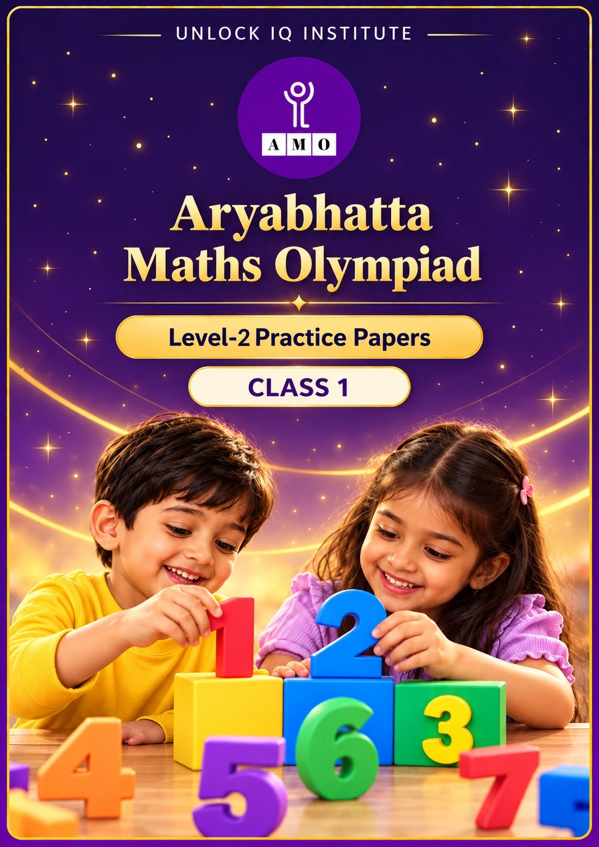
Set 1 · Practice Papers 1–5 · with answer keys & detailed solutions
Name: ____________________ | Class & Section: ________________
Roll No.: ________________ | School: ____________________
City: ____________________ | Date: ____________________

Published by Unlock IQ Institute Pvt. Ltd.
Register for Olympiads: www.aryabhattamathsolympiad.com/student-registration

ARYABHATTA MATHS OLYMPIAD
Level 2
PRACTICE PAPER-1
CLASS 1
Total Questions | 30 multiple-choice questions
Level | Level-2 (final round): every question is Hard
Time | 45 minutes
Section I | 25 questions, each from one chapter
Section II | 5 Star Questions, each joining two chapters
Negative Marking | No negative marking
Calculator | Not allowed
Chapters | Number System · Operations · Geometry · Applied Mathematics · Mathematical Reasoning

👋 Hello, friend! How to do this paper:
⭐ Every question has four answer choices: (A), (B), (C) and (D). Only one is correct.
⭐ Read each question and look at its picture carefully. Then mark your answer on the answer sheet at the end.
⭐ This is a Level-2 paper. Every question needs careful thinking, so take your time and check each step.
⭐ Section I has 25 questions. Section II has 5 Star Questions.
⭐ There is no negative marking, so try every question.
⭐ Do not use a calculator. You may do rough work on a separate sheet.
⭐ All figures are not necessarily drawn to scale unless stated.

For parents and teachers
• Pictures are part of the questions. Every picture also works when printed in black and white.
• You may read a question aloud to the child, exactly as printed. Please do not explain it or point to an answer choice.
• Parts follow the AMO syllabus chapters. Chapters 3, 4, 6, 7 and 8 are not part of the Class 1 syllabus, so the chapter numbers shown in the Part headings have gaps.
• The answer sheet and the answer key are at the end. Remove only the answer key before the child begins.

SECTION I 25 questions · every question is Hard
Part 1 — Number System (Syllabus Chapter 1)
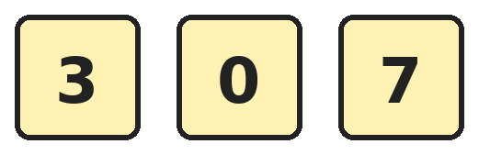
Q1. Anita has these three digit cards. She uses two different cards to make the smallest 2-digit number she can. Which number does she make?
(A) 30 | (B) 3 | (C) 37 | (D) 70

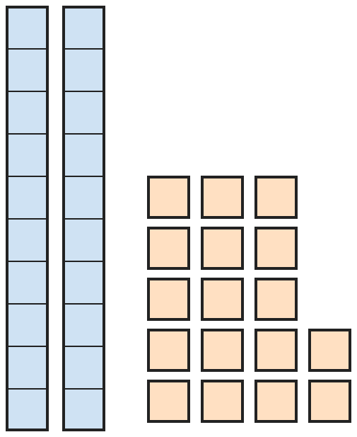
Q2. Rohan shows a number with tens rods and ones cubes. Which number does he show?
(A) 217 | (B) 27 | (C) 37 | (D) 19

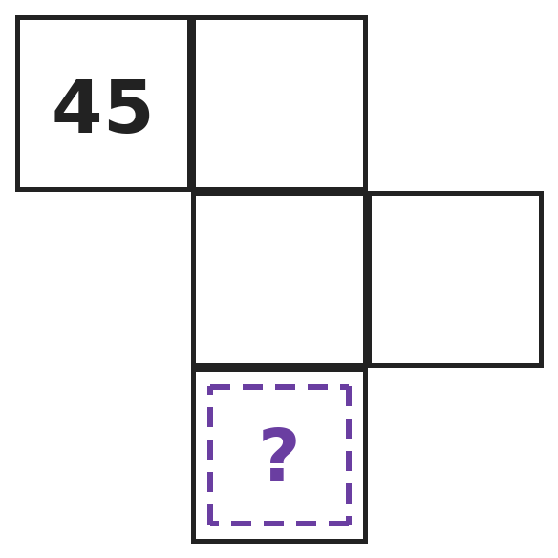
Q3. This piece is cut from a number chart of 1 to 100. Which number goes in the box with the question mark?
(A) 57 | (B) 56 | (C) 66 | (D) 65

Q4. Houses on a street are numbered 38, 39, 40 and so on. Meera lives at number 38 and Kabir lives at number 52. How many houses are between their houses?
(A) 14 | (B) 15 | (C) 12 | (D) 13

Q5. I am a number between 30 and 50. My ones digit is 2 more than my tens digit. My two digits add up to 10. Which number am I?
(A) 35 | (B) 46 | (C) 64 | (D) 37

Q6. Lockers in a school are numbered from 40 to 60. Isha puts one sticker on every locker whose number has the digit 5 in it. How many stickers does she use?
(A) 11 | (B) 10 | (C) 12 | (D) 2

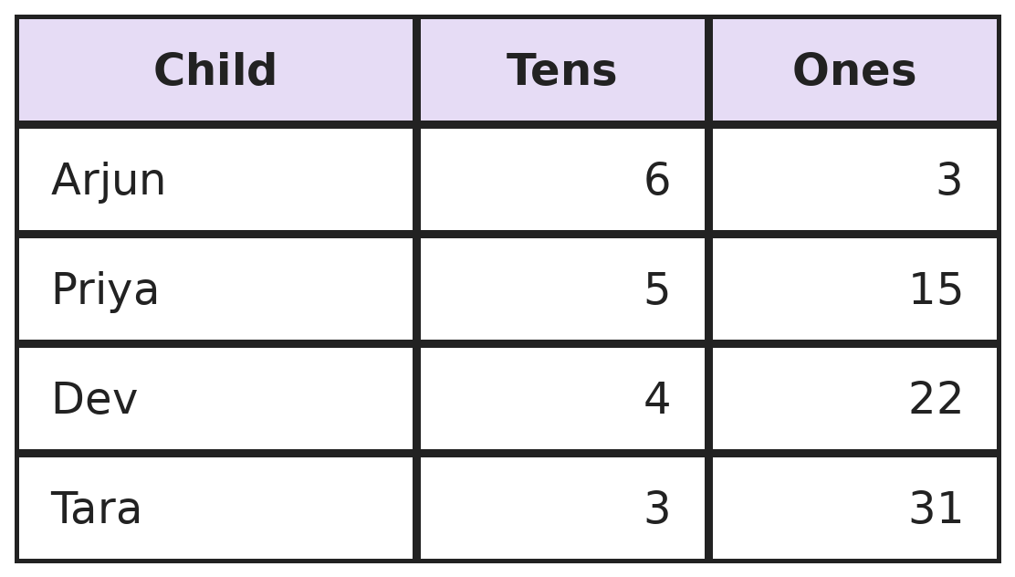
Q7. The table shows the tens and ones each child uses to make a number. Whose number is the largest?
(A) Priya | (B) Arjun | (C) Dev | (D) Tara

Part 2 — Operations (Syllabus Chapter 2)
Q8. Kavya had some sweets. She gave 4 sweets to Ravi and 3 sweets to Neel. Now she has 6 sweets left. How many sweets did she have at first?
(A) 10 | (B) 13 | (C) 7 | (D) 9

Q9. A bus has 12 people. At the first stop, 5 people get off and 7 people get on. At the second stop, 4 people get off. How many people are on the bus now?
(A) 14 | (B) 6 | (C) 10 | (D) 9

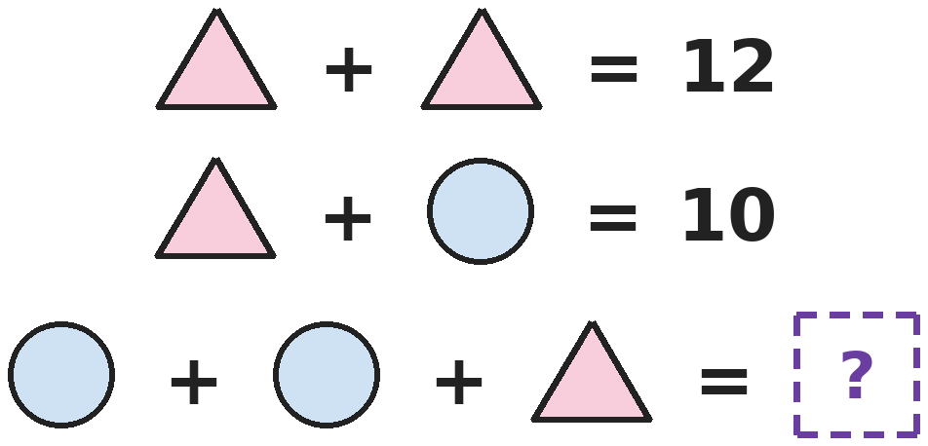
Q10. Each shape stands for a number. Shapes that look the same stand for the same number. Which number goes in the box with the question mark?
(A) 16 | (B) 12 | (C) 14 | (D) 10

Q11. Asha and Om pick 15 mangoes in all. Asha picks 3 more mangoes than Om. How many mangoes does Asha pick?
(A) 6 | (B) 9 | (C) 12 | (D) 18

Q12. Siya puts 10 marbles into two bags. Each bag gets at least 1 marble. Putting 3 and 7 is the same as putting 7 and 3. In how many ways can she do it?
(A) 4 | (B) 9 | (C) 10 | (D) 5

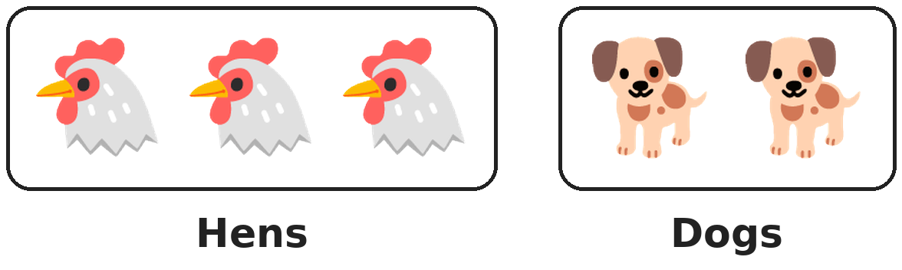
Q13. These animals are in a farmyard. Then two hens walk out and two more dogs walk in. How many legs are in the farmyard now?
(A) 14 | (B) 18 | (C) 16 | (D) 10

Part 3 — Geometry (Syllabus Chapter 5)
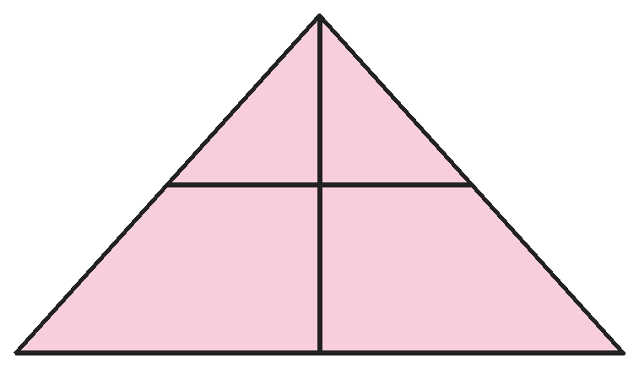
Q14. Priya draws a big triangle and two straight lines inside it. How many triangles of all sizes can you find in her drawing?
(A) 4 | (B) 6 | (C) 3 | (D) 5

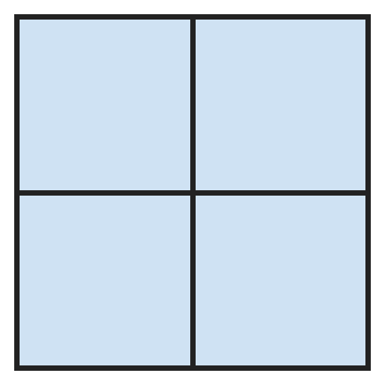
Q15. Gauri draws this window. How many squares can you find in it?
(A) 4 | (B) 6 | (C) 8 | (D) 5

Q16. Neha folds a square sheet of paper in half. Then she folds it in half again. She punches one hole through all the layers. How many holes are there when she opens it?
(A) 4 | (B) 2 | (C) 1 | (D) 3

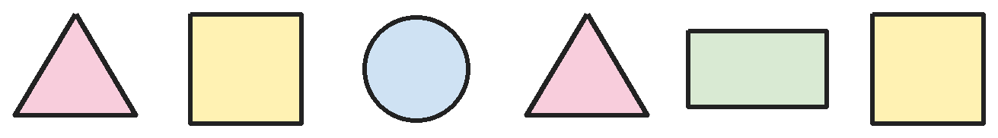
Q17. Kunal draws these shapes. How many corners do all the shapes have altogether?
(A) 19 | (B) 16 | (C) 22 | (D) 18

Part 4 — Applied Mathematics (Syllabus Chapter 9)
Q18. The day before yesterday was Monday. Which day will it be on the day after tomorrow?
(A) Thursday | (B) Wednesday | (C) Saturday | (D) Friday

Q19. Which month comes 4 months after the month just before June?
(A) September | (B) October | (C) August | (D) January

Q20. Riya must pay exactly ₹13 using only ₹1, ₹2, ₹5 and ₹10 coins. What is the smallest number of coins she can use?
(A) 4 | (B) 2 | (C) 5 | (D) 3

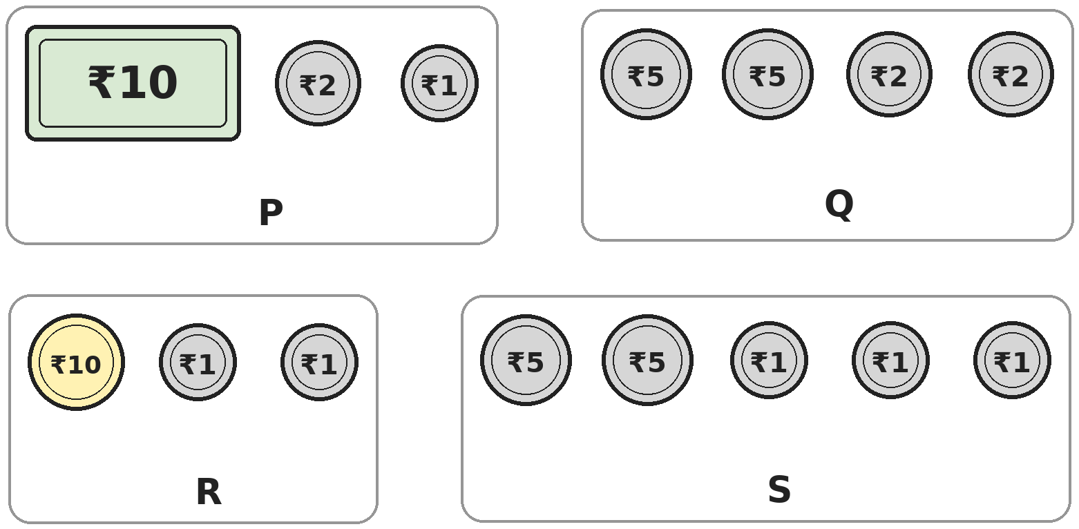
Q21. Look at the money in purses P, Q, R and S. Which purse has the most money?
(A) Purse P | (B) Purse Q | (C) Purse R | (D) Purse S

Part 5 — Mathematical Reasoning (Syllabus Chapter 10)

Q22. Look at the number pattern. Which number comes next?
(A) 15 | (B) 17 | (C) 14 | (D) 16


Q23. The shapes repeat in the same order again and again. Which shape will be 15th in the row?
(A) Circle | (B) Square | (C) Rectangle | (D) Triangle

Q24. Four buses have the numbers 52, 14, 41 and 23. Three of the bus numbers belong together. Which bus number is the odd one out?
(A) 14 | (B) 52 | (C) 41 | (D) 23


Q25. Vivaan makes squares in a row with sticks. One square needs 4 sticks, two squares need 7 sticks and three squares need 10 sticks. How many sticks does he need for five squares?
(A) 16 | (B) 20 | (C) 13 | (D) 15

SECTION II — Star Questions 5 questions · each joins two chapters

Q26. Look at how the tens digit and the ones digit change in this pattern. Which number comes next? [Star]
(A) 54 | (B) 46 | (C) 55 | (D) 44


Q27. The shapes follow a pattern. Ankit adds up the sides of the first 5 shapes in the pattern. What total does he get? [Star]
(A) 18 | (B) 20 | (C) 17 | (D) 14

Q28. Anaya's dance class is held every 3 days. Her first class is on a Monday, and her second class is on Thursday. On which day is her 4th class? [Star]
(A) Wednesday | (B) Thursday | (C) Sunday | (D) Tuesday

Q29. Diya has 3 notes of ₹10 and 14 coins of ₹1. How much money does she have? [Star]
(A) ₹17 | (B) ₹34 | (C) ₹44 | (D) ₹314

Q30. Yash has 20 sticks. He makes 2 triangles and 2 squares, using one stick for each side. No two shapes share a stick. How many sticks are left? [Star]
(A) 14 | (B) 4 | (C) 6 | (D) 8

Answer Sheet AMO Level 2 · Class 1 · Practice Paper 1
Name: | School: | Roll No.:
Shade or tick one circle for each question.
1. | Ⓐ Ⓑ Ⓒ Ⓓ | 11. | Ⓐ Ⓑ Ⓒ Ⓓ | 21. | Ⓐ Ⓑ Ⓒ Ⓓ
2. | Ⓐ Ⓑ Ⓒ Ⓓ | 12. | Ⓐ Ⓑ Ⓒ Ⓓ | 22. | Ⓐ Ⓑ Ⓒ Ⓓ
3. | Ⓐ Ⓑ Ⓒ Ⓓ | 13. | Ⓐ Ⓑ Ⓒ Ⓓ | 23. | Ⓐ Ⓑ Ⓒ Ⓓ
4. | Ⓐ Ⓑ Ⓒ Ⓓ | 14. | Ⓐ Ⓑ Ⓒ Ⓓ | 24. | Ⓐ Ⓑ Ⓒ Ⓓ
5. | Ⓐ Ⓑ Ⓒ Ⓓ | 15. | Ⓐ Ⓑ Ⓒ Ⓓ | 25. | Ⓐ Ⓑ Ⓒ Ⓓ
6. | Ⓐ Ⓑ Ⓒ Ⓓ | 16. | Ⓐ Ⓑ Ⓒ Ⓓ | 26. | Ⓐ Ⓑ Ⓒ Ⓓ
7. | Ⓐ Ⓑ Ⓒ Ⓓ | 17. | Ⓐ Ⓑ Ⓒ Ⓓ | 27. | Ⓐ Ⓑ Ⓒ Ⓓ
8. | Ⓐ Ⓑ Ⓒ Ⓓ | 18. | Ⓐ Ⓑ Ⓒ Ⓓ | 28. | Ⓐ Ⓑ Ⓒ Ⓓ
9. | Ⓐ Ⓑ Ⓒ Ⓓ | 19. | Ⓐ Ⓑ Ⓒ Ⓓ | 29. | Ⓐ Ⓑ Ⓒ Ⓓ
10. | Ⓐ Ⓑ Ⓒ Ⓓ | 20. | Ⓐ Ⓑ Ⓒ Ⓓ | 30. | Ⓐ Ⓑ Ⓒ Ⓓ
Q26–Q30 are Section II Star Questions. Each joins two chapters.
For the parent or teacher
Section I correct: ______ / 25 Section II correct: ______ / 5
Correct: ______ / 30
Answer Key and Solutions AMO Level 2 · Class 1 · Practice Paper 1
Quick answers
1 A | 6 A | 11 B | 16 A | 21 B | 26 A
2 C | 7 A | 12 D | 17 D | 22 D | 27 C
3 C | 8 B | 13 B | 18 D | 23 D | 28 A
4 D | 9 C | 14 B | 19 A | 24 B | 29 C
5 B | 10 C | 15 D | 20 D | 25 A | 30 C
Solutions
Q | Part · level | Answer | Why?
1 | Part 1 · Ch1 · Hard | (A) 30 | Hint: A 2-digit number cannot begin with 0.  The tens digit cannot be 0, so the smallest tens digit she can use is 3. Then 0 goes in the ones place: 30. Writing 03 just gives 3, which is not a 2-digit number.
2 | Part 1 · Ch1 · Hard | (C) 37 | Hint: Ten ones cubes make one ten.  There are 2 tens and 17 ones. The 17 ones are 1 ten and 7 ones. So there are 3 tens and 7 ones, which is 37.
3 | Part 1 · Ch1 · Hard | (C) 66 | Hint: On the chart, one box down adds 1 ten. One box to the right adds 1.  Going down from 45 gives 55 and then 65. One box to the right of 65 is 66.
4 | Part 1 · Ch1 · Hard | (D) 13 | Hint: Do not count Meera's house or Kabir's house.  The houses in between are 39 to 51. From 39 to 48 there are 10 houses, and 49, 50 and 51 are 3 more. So there are 13 houses.
5 | Part 1 · Ch1 · Hard | (B) 46 | Hint: Try tens digit 3, then tens digit 4.  With tens digit 3 the number is 35, and its digits add up to 3 + 5 = 8. With tens digit 4 the number is 46, and 4 + 6 = 10. So the number is 46.
6 | Part 1 · Ch1 · Hard | (A) 11 | Hint: Look at the tens digit and the ones digit of each number.  All the numbers from 50 to 59 have a 5: that is 10 lockers. The number 45 also has a 5. So she uses 11 stickers. Locker 55 has two 5s but gets only one sticker.
7 | Part 1 · Ch1 · Hard | (A) Priya | Hint: Change extra ones into tens before you compare.  Arjun's number is 63. Priya's 5 tens and 15 ones make 65. Dev's 4 tens and 22 ones make 62. Tara's 3 tens and 31 ones make 61. The largest is 65, so it is Priya's.
8 | Part 2 · Ch2 · Hard | (B) 13 | Hint: Put back the sweets she gave away.  She has 6 left. Add back the 3 for Neel and the 4 for Ravi: 6 + 3 + 4 = 13.
9 | Part 2 · Ch2 · Hard | (C) 10 | Hint: Work out the number after each stop, one at a time.  After the first stop: 12 − 5 = 7, and 7 + 7 = 14. After the second stop: 14 − 4 = 10.
10 | Part 2 · Ch2 · Hard | (C) 14 | Hint: Two triangles make 12. What is one triangle?  Triangle + triangle = 12, so one triangle is 6. Triangle + circle = 10, so the circle is 4. Circle + circle + triangle = 4 + 4 + 6 = 14.
11 | Part 2 · Ch2 · Hard | (B) 9 | Hint: Try pairs of numbers that add up to 15.  If Om picks 6, Asha picks 6 + 3 = 9, and 6 + 9 = 15. So Asha picks 9 mangoes. (12 and 3 add to 15, but 12 is 9 more than 3.)
12 | Part 2 · Ch2 · Hard | (D) 5 | Hint: Start with 1 and 9, then 2 and 8, and keep going.  The ways are 1 and 9, 2 and 8, 3 and 7, 4 and 6, and 5 and 5. That is 5 ways. After 5 and 5 the pairs only repeat.
13 | Part 2 · Ch2 · Hard | (B) 18 | Hint: First find how many hens and how many dogs are there now. A hen has 2 legs and a dog has 4.  Now there is 3 − 2 = 1 hen and 2 + 2 = 4 dogs. Hen legs: 2. Dog legs: 4 + 4 + 4 + 4 = 16. Altogether 2 + 16 = 18 legs.
14 | Part 3 · Ch5 · Hard | (B) 6 | Hint: Count the small triangles first. Then look for triangles made of more than one part.  There are 2 small triangles at the top, and together they make 1 more. Using the full height, there is the left half, the right half and the whole shape: 3 more. 2 + 1 + 3 = 6.
15 | Part 3 · Ch5 · Hard | (D) 5 | Hint: Do not forget the big square around the outside.  There are 4 small squares. All four together make 1 big square. 4 + 1 = 5.
16 | Part 3 · Ch5 · Hard | (A) 4 | Hint: Each fold doubles the number of layers.  After one fold there are 2 layers. After the second fold there are 4 layers. One punch goes through all 4 layers, so there are 4 holes.
17 | Part 3 · Ch5 · Hard | (D) 18 | Hint: A circle has no corners.  Two triangles have 3 + 3 = 6 corners. Two squares have 4 + 4 = 8 corners. The rectangle has 4. The circle has none. 6 + 8 + 4 = 18.
18 | Part 4 · Ch9 · Hard | (D) Friday | Hint: First find today.  The day before yesterday was Monday, so yesterday was Tuesday and today is Wednesday. Tomorrow is Thursday, so the day after tomorrow is Friday.
19 | Part 4 · Ch9 · Hard | (A) September | Hint: First find the month just before June.  The month just before June is May. Counting 4 months on from May: June, July, August, September.
20 | Part 4 · Ch9 · Hard | (D) 3 | Hint: Use the biggest coin you can first.  Take a ₹10 coin. Then ₹3 is left, which is a ₹2 coin and a ₹1 coin. That is 3 coins. No two of these coins add up to exactly ₹13.
21 | Part 4 · Ch9 · Hard | (B) Purse Q | Hint: Add up the money in each purse. More coins does not always mean more money.  P has ₹10 + ₹2 + ₹1 = ₹13. Q has ₹5 + ₹5 + ₹2 + ₹2 = ₹14. R has ₹10 + ₹1 + ₹1 = ₹12. S has ₹5 + ₹5 + ₹1 + ₹1 + ₹1 = ₹13. Purse Q has the most.
22 | Part 5 · Ch10 · Hard | (D) 16 | Hint: Look at how much is added each time.  The numbers go up by 1, then 2, then 3, then 4. Next we add 5: 11 + 5 = 16.
23 | Part 5 · Ch10 · Hard | (D) Triangle | Hint: Find the group of shapes that repeats and count how many are in it.  The group circle, square, triangle, triangle repeats. It has 4 shapes. Shapes 1 to 12 make 3 full groups. Shape 13 is a circle, 14 is a square and 15 is a triangle.
24 | Part 5 · Ch10 · Hard | (B) 52 | Hint: Add the two digits of each number.  For 14, 41 and 23 the digits add up to 5. For 52 the digits add up to 5 + 2 = 7. So 52 is the odd one out.
25 | Part 5 · Ch10 · Hard | (A) 16 | Hint: Each new square needs 3 more sticks.  The numbers of sticks go 4, 7, 10. Adding 3 each time gives 13 sticks for four squares and 16 sticks for five squares.
26 | Section II · Ch1 + Ch10 · Hard | (A) 54 | Hint: Look at the tens digits and the ones digits separately.  The tens digit goes up by 1 each time: 1, 2, 3, 4, so next is 5. The ones digit goes down by 1: 8, 7, 6, 5, so next is 4. The next number is 54.
27 | Section II · Ch5 + Ch10 · Hard | (C) 17 | Hint: Work out the 5th shape first.  The pattern is triangle, square, triangle, square, so the 5th shape is a triangle. Sides: 3 + 4 + 3 + 4 + 3 = 17.
28 | Section II · Ch9 + Ch10 · Hard | (A) Wednesday | Hint: Count 3 days forward from each class.  Class 1 is on Monday. Class 2 is 3 days later, on Thursday. Class 3 is 3 days after that, on Sunday. Class 4 is on Wednesday.
29 | Section II · Ch1 + Ch9 · Hard | (C) ₹44 | Hint: Each ₹10 note is one ten. Ten ₹1 coins also make one ten.  Three ₹10 notes are 3 tens, or ₹30. Fourteen ₹1 coins are 1 ten and 4 ones, or ₹14. So she has 4 tens and 4 ones: ₹44.
30 | Section II · Ch2 + Ch5 · Hard | (C) 6 | Hint: Count the sides of all four shapes first.  Two triangles use 3 + 3 = 6 sticks. Two squares use 4 + 4 = 8 sticks. That is 6 + 8 = 14 sticks. So 20 − 14 = 6 sticks are left.

ARYABHATTA MATHS OLYMPIAD
Level 2
PRACTICE PAPER-2
CLASS 1
Total Questions | 30 multiple-choice questions
Level | Level-2 (final round): every question is Hard
Time | 45 minutes
Section I | 25 questions, each from one chapter
Section II | 5 Star Questions, each joining two chapters
Negative Marking | No negative marking
Calculator | Not allowed
Chapters | Number System · Operations · Geometry · Applied Mathematics · Mathematical Reasoning

👋 Hello, friend! How to do this paper:
⭐ Every question has four answer choices: (A), (B), (C) and (D). Only one is correct.
⭐ Read each question and look at its picture carefully. Then mark your answer on the answer sheet at the end.
⭐ This is a Level-2 paper. Every question needs careful thinking, so take your time and check each step.
⭐ Section I has 25 questions. Section II has 5 Star Questions.
⭐ There is no negative marking, so try every question.
⭐ Do not use a calculator. You may do rough work on a separate sheet.
⭐ All figures are not necessarily drawn to scale unless stated.

For parents and teachers
• Pictures are part of the questions. Every picture also works when printed in black and white.
• You may read a question aloud to the child, exactly as printed. Please do not explain it or point to an answer choice.
• Parts follow the AMO syllabus chapters. Chapters 3, 4, 6, 7 and 8 are not part of the Class 1 syllabus, so the chapter numbers shown in the Part headings have gaps.
• The answer sheet and the answer key are at the end. Remove only the answer key before the child begins.

SECTION I 25 questions · every question is Hard
Part 1 — Number System (Syllabus Chapter 1)
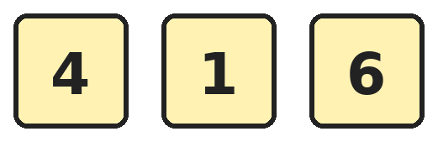
Q1. Tanvi uses two different cards from these to make 2-digit numbers. How many different numbers less than 50 can she make?
(A) 4 | (B) 6 | (C) 2 | (D) 3

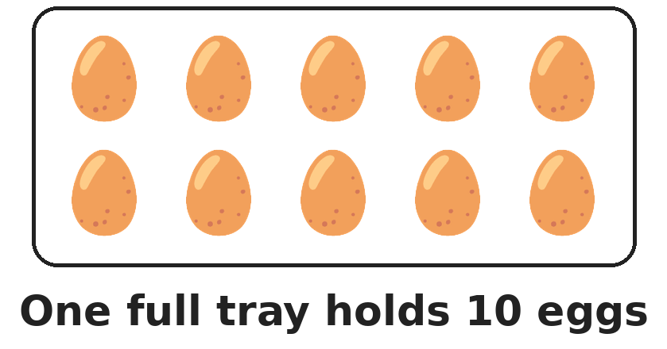
Q2. Eggs are packed in trays of 10. Pari has 34 eggs. What is the smallest number of trays she needs to hold all her eggs?
(A) 3 | (B) 34 | (C) 7 | (D) 4

Q3. Arjun starts at 26. He jumps back by 1 ten. Then he jumps forward by 3 ones. On which number does he land?
(A) 19 | (B) 39 | (C) 33 | (D) 13

Q4. Raffle tickets are numbered from 1 to 50. A ticket wins a prize if both its digits are the same, like 22. How many tickets win a prize?
(A) 5 | (B) 9 | (C) 4 | (D) 3

Q5. Mihir writes the numbers 47, 74, 44, 77 and 70 in order from smallest to largest. Which number is in the middle?
(A) 44 | (B) 70 | (C) 74 | (D) 47

Q6. Which of these is NOT the same as the number 62?
(A) 2 tens and 6 ones | (B) 6 tens and 2 ones
(C) 5 tens and 12 ones | (D) 4 tens and 22 ones

Q7. Jiya's number has 4 more tens than 27 and 2 fewer ones than 27. What is Jiya's number?
(A) 65 | (B) 25 | (C) 67 | (D) 69

Part 2 — Operations (Syllabus Chapter 2)
Q8. Sneha has 14 stickers and Dev has 6 stickers. How many stickers must Sneha give Dev so that they both have the same number?
(A) 8 | (B) 10 | (C) 2 | (D) 4

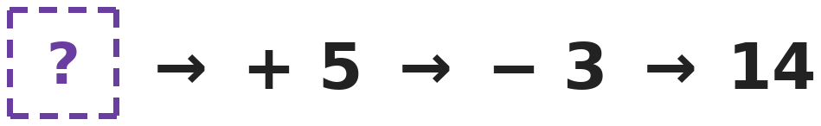
Q9. A number goes into this machine. The machine adds 5 and then takes away 3. The number that comes out is 14. Which number went in?
(A) 16 | (B) 22 | (C) 12 | (D) 6

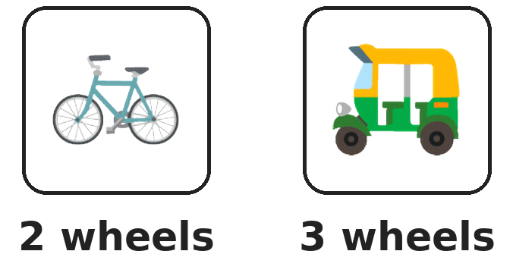
Q10. A bicycle has 2 wheels and an auto-rickshaw has 3 wheels. At a stand there are 5 such vehicles with 13 wheels in all. How many of them are auto-rickshaws?
(A) 2 | (B) 3 | (C) 4 | (D) 5

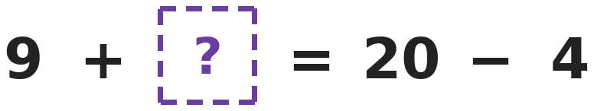
Q11. Both sides of the equals sign must have the same value. Which number goes in the box with the question mark?
(A) 11 | (B) 15 | (C) 7 | (D) 16

Q12. Rahul thinks of three numbers that come one after another, like 2, 3 and 4. His three numbers add up to 15. What is the biggest of his numbers?
(A) 5 | (B) 7 | (C) 6 | (D) 15

Q13. Ruhi reads 3 pages of a book on Monday. Each day she reads 2 more pages than the day before. How many pages has she read in all by the end of Wednesday?
(A) 7 | (B) 9 | (C) 13 | (D) 15

Part 3 — Geometry (Syllabus Chapter 5)
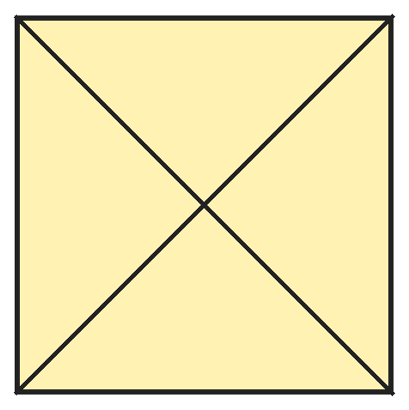
Q14. Aditi draws two lines from corner to corner on a square tile. How many triangles of all sizes can you find on the tile?
(A) 4 | (B) 6 | (C) 9 | (D) 8

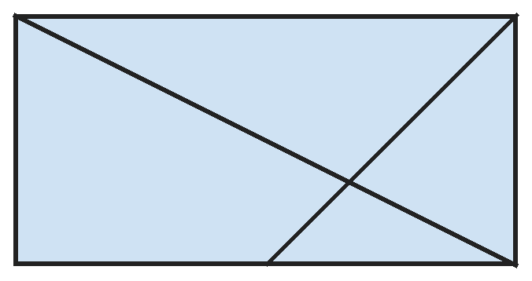
Q15. Mansi draws a rectangle, one line from corner to corner and one line from a top corner to the middle of the bottom side. How many triangles of all sizes are there?
(A) 4 | (B) 6 | (C) 5 | (D) 3

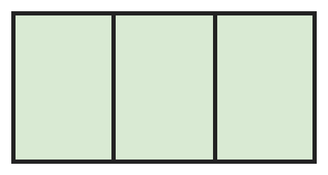
Q16. Mihir draws a strip divided into 3 boxes. How many rectangles of all sizes can you find in the strip?
(A) 6 | (B) 3 | (C) 4 | (D) 5

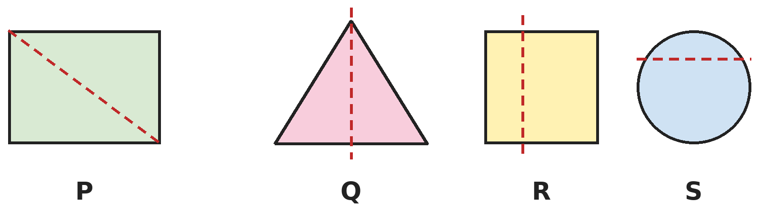
Q17. In which picture does the dotted line fold the shape into two halves that match exactly?
(A) P | (B) Q | (C) R | (D) S

Part 4 — Applied Mathematics (Syllabus Chapter 9)
Q18. Today is Saturday. Which day will it be 9 days from today?
(A) Sunday | (B) Tuesday | (C) Monday | (D) Thursday

Q19. School holidays start in the month after April. They end in the month before August. How many months do the holidays touch, counting the first and last month?
(A) 3 | (B) 4 | (C) 2 | (D) 5

Q20. Vansh pays ₹6 using only ₹1 and ₹2 coins. Using the same coins in a different order counts as the same way. In how many different ways can he pay?
(A) 3 | (B) 4 | (C) 6 | (D) 5

Q21. Navya buys a pencil box for ₹13. She pays with a ₹20 note. The shopkeeper gives her change using the fewest coins. Which coins does she get?
(A) ₹5, ₹1 and ₹1 | (B) ₹2, ₹2 and ₹2 | (C) ₹5 and ₹2 | (D) ₹5 and ₹1

Part 5 — Mathematical Reasoning (Syllabus Chapter 10)

Q22. Sakshi writes this number pattern on the board. Which number should she write next?
(A) 14 | (B) 7 | (C) 6 | (D) 8

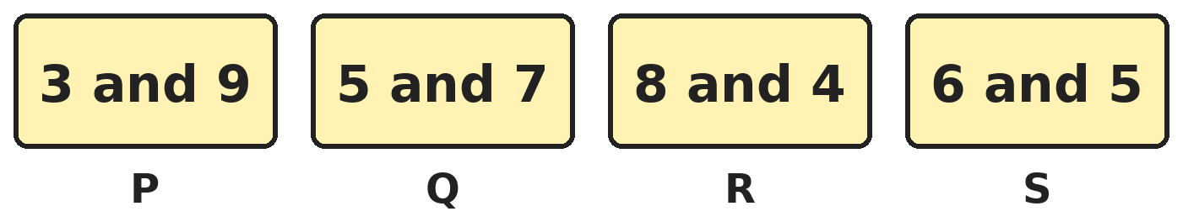
Q23. Three of these cards belong together. Which card is the odd one out?
(A) Card P | (B) Card Q | (C) Card R | (D) Card S

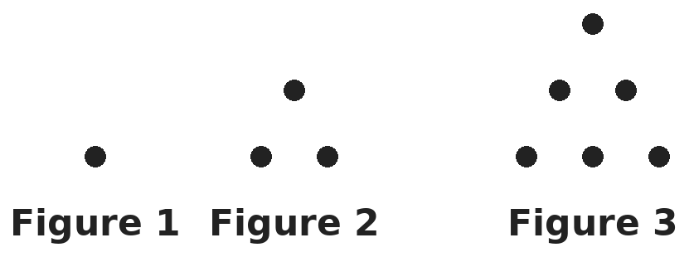
Q24. Dots are arranged in a growing pattern. How many dots will Figure 5 have?
(A) 15 | (B) 10 | (C) 12 | (D) 13

Q25. Lakshya counts in threes, starting at 2: 2, 5, 8 and so on. Which of these numbers will he say?
(A) 15 | (B) 18 | (C) 21 | (D) 20

SECTION II — Star Questions 5 questions · each joins two chapters
Q26. On a number chart, Om marks 12, 23 and 34, and keeps going in the same way. Which of these numbers will he also mark? [Star]
(A) 65 | (B) 76 | (C) 57 | (D) 67

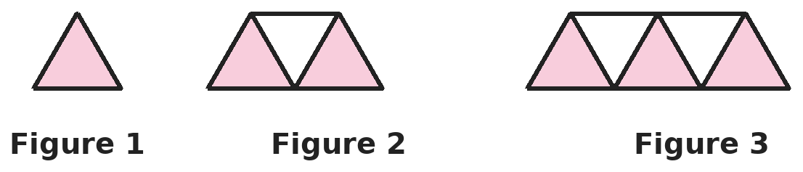
Q27. Look at how the strip of triangles grows. How many small triangles will Figure 6 have? [Star]
(A) 12 | (B) 11 | (C) 9 | (D) 13

Q28. Rani writes the months in a pattern: January, March, May, July and so on. What is the 6th month she writes? [Star]
(A) September | (B) November | (C) December | (D) October

Q29. Vikram has ₹47 in ₹10 notes and ₹1 coins. He has as many ₹10 notes as he can. How many ₹1 coins does he have? [Star]
(A) 4 | (B) 47 | (C) 7 | (D) 11

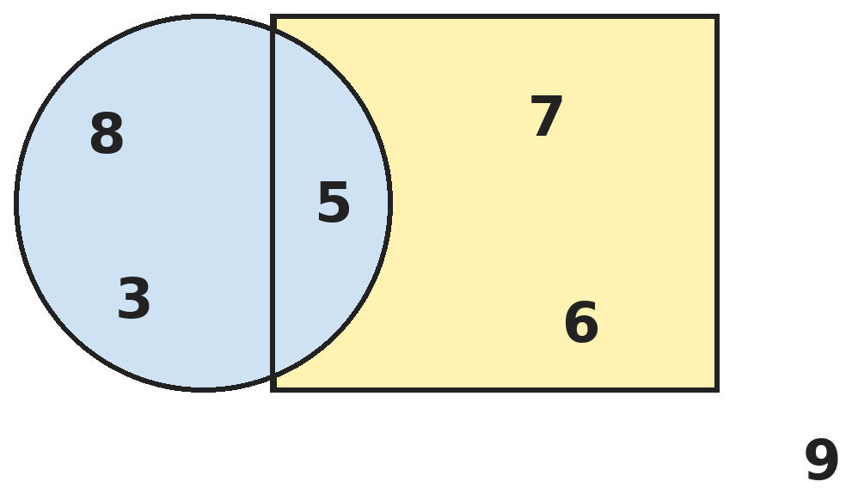
Q30. Add all the numbers that are inside the circle. What do you get? [Star]
(A) 16 | (B) 11 | (C) 18 | (D) 13

Answer Sheet AMO Level 2 · Class 1 · Practice Paper 2
Name: | School: | Roll No.:
Shade or tick one circle for each question.
1. | Ⓐ Ⓑ Ⓒ Ⓓ | 11. | Ⓐ Ⓑ Ⓒ Ⓓ | 21. | Ⓐ Ⓑ Ⓒ Ⓓ
2. | Ⓐ Ⓑ Ⓒ Ⓓ | 12. | Ⓐ Ⓑ Ⓒ Ⓓ | 22. | Ⓐ Ⓑ Ⓒ Ⓓ
3. | Ⓐ Ⓑ Ⓒ Ⓓ | 13. | Ⓐ Ⓑ Ⓒ Ⓓ | 23. | Ⓐ Ⓑ Ⓒ Ⓓ
4. | Ⓐ Ⓑ Ⓒ Ⓓ | 14. | Ⓐ Ⓑ Ⓒ Ⓓ | 24. | Ⓐ Ⓑ Ⓒ Ⓓ
5. | Ⓐ Ⓑ Ⓒ Ⓓ | 15. | Ⓐ Ⓑ Ⓒ Ⓓ | 25. | Ⓐ Ⓑ Ⓒ Ⓓ
6. | Ⓐ Ⓑ Ⓒ Ⓓ | 16. | Ⓐ Ⓑ Ⓒ Ⓓ | 26. | Ⓐ Ⓑ Ⓒ Ⓓ
7. | Ⓐ Ⓑ Ⓒ Ⓓ | 17. | Ⓐ Ⓑ Ⓒ Ⓓ | 27. | Ⓐ Ⓑ Ⓒ Ⓓ
8. | Ⓐ Ⓑ Ⓒ Ⓓ | 18. | Ⓐ Ⓑ Ⓒ Ⓓ | 28. | Ⓐ Ⓑ Ⓒ Ⓓ
9. | Ⓐ Ⓑ Ⓒ Ⓓ | 19. | Ⓐ Ⓑ Ⓒ Ⓓ | 29. | Ⓐ Ⓑ Ⓒ Ⓓ
10. | Ⓐ Ⓑ Ⓒ Ⓓ | 20. | Ⓐ Ⓑ Ⓒ Ⓓ | 30. | Ⓐ Ⓑ Ⓒ Ⓓ
Q26–Q30 are Section II Star Questions. Each joins two chapters.
For the parent or teacher
Section I correct: ______ / 25 Section II correct: ______ / 5
Correct: ______ / 30
Answer Key and Solutions AMO Level 2 · Class 1 · Practice Paper 2
Quick answers
1 A | 6 A | 11 C | 16 A | 21 C | 26 D
2 D | 7 A | 12 C | 17 B | 22 B | 27 B
3 A | 8 D | 13 D | 18 C | 23 D | 28 B
4 C | 9 C | 14 D | 19 A | 24 A | 29 C
5 B | 10 B | 15 B | 20 B | 25 D | 30 A
Solutions
Q | Part · level | Answer | Why?
1 | Part 1 · Ch1 · Hard | (A) 4 | Hint: List every number she can make first.  She can make 14, 16, 41, 46, 61 and 64. Of these, 14, 16, 41 and 46 are less than 50. That is 4 numbers.
2 | Part 1 · Ch1 · Hard | (D) 4 | Hint: The eggs that are left over also need a tray.  Three trays hold 30 eggs. The other 4 eggs need one more tray. So she needs 4 trays.
3 | Part 1 · Ch1 · Hard | (A) 19 | Hint: A jump of 1 ten changes only the tens digit.  Jumping back 1 ten from 26 lands on 16. Then 3 ones forward: 17, 18, 19.
4 | Part 1 · Ch1 · Hard | (C) 4 | Hint: List them in order: 11, 22, and so on.  The winning tickets are 11, 22, 33 and 44. The next one, 55, is more than 50. So 4 tickets win.
5 | Part 1 · Ch1 · Hard | (B) 70 | Hint: Compare the tens digits first.  In order they are 44, 47, 70, 74, 77. The middle number (the 3rd) is 70.
6 | Part 1 · Ch1 · Hard | (A) 2 tens and 6 ones | Hint: Change each one into a number.  6 tens and 2 ones is 62. 5 tens and 12 ones is 50 and 12, which is 62. 4 tens and 22 ones is 40 and 22, which is 62. But 2 tens and 6 ones is only 26.
7 | Part 1 · Ch1 · Hard | (A) 65 | Hint: Change the tens digit and the ones digit separately.  27 has 2 tens and 7 ones. Four more tens gives 6 tens. Two fewer ones gives 5 ones. So the number is 65.
8 | Part 2 · Ch2 · Hard | (D) 4 | Hint: Try giving one sticker at a time and check both numbers.  If Sneha gives 4, she has 14 − 4 = 10 and Dev has 6 + 4 = 10. Giving 8 would leave Sneha with 6 and Dev with 14, which is not equal.
9 | Part 2 · Ch2 · Hard | (C) 12 | Hint: Work backwards and undo each step.  Undo the last step first: 14 + 3 = 17. Then undo adding 5: 17 − 5 = 12. Check: 12 + 5 = 17 and 17 − 3 = 14.
10 | Part 2 · Ch2 · Hard | (B) 3 | Hint: If all 5 were bicycles, how many wheels would there be? Each auto-rickshaw adds 1 more wheel.  If all 5 were bicycles there would be 2 + 2 + 2 + 2 + 2 = 10 wheels. There are 13, which is 3 more. Each auto-rickshaw has 1 wheel more than a bicycle, so there are 3 auto-rickshaws (and 2 bicycles: 9 + 4 = 13).
11 | Part 2 · Ch2 · Hard | (C) 7 | Hint: Work out 20 − 4 first.  20 − 4 = 16. So 9 + ? must be 16. Since 9 + 7 = 16, the missing number is 7.
12 | Part 2 · Ch2 · Hard | (C) 6 | Hint: Try three numbers in a row close to 5.  Try 4, 5 and 6: 4 + 5 + 6 = 15. The biggest of the three is 6.
13 | Part 2 · Ch2 · Hard | (D) 15 | Hint: Find the pages for each day first.  Monday: 3 pages. Tuesday: 3 + 2 = 5 pages. Wednesday: 5 + 2 = 7 pages. In all: 3 + 5 + 7 = 15 pages.
14 | Part 3 · Ch5 · Hard | (D) 8 | Hint: Count the small triangles. Then count triangles made of two small ones.  The two lines make 4 small triangles. Two small triangles next to each other make a big triangle (half the square), and there are 4 of these. 4 + 4 = 8.
15 | Part 3 · Ch5 · Hard | (B) 6 | Hint: Count the small triangles first, then look for big triangles made of more than one part.  There are 3 small triangles: one at the top and two on the right. The corner-to-corner line makes 2 big triangles, the top-right half and the bottom-left half. The line from the top-right corner to the bottom middle makes 1 more. 3 + 2 + 1 = 6.
16 | Part 3 · Ch5 · Hard | (A) 6 | Hint: Count rectangles made of 1 box, of 2 boxes side by side, and of all 3 boxes.  One box: 3 rectangles. Two boxes side by side: 2 rectangles. All three boxes: 1 rectangle. 3 + 2 + 1 = 6.
17 | Part 3 · Ch5 · Hard | (B) Q | Hint: Imagine folding along the dotted line. Do the two halves sit exactly on top of each other?  In R and S the dotted line is not in the middle, so one part is bigger. Folding the rectangle in P along its corner-to-corner line does not make the corners meet. Only in Q do the two halves match exactly.
18 | Part 4 · Ch9 · Hard | (C) Monday | Hint: After 7 days it is the same day of the week again.  7 days after Saturday is Saturday again. Two more days: Sunday, then Monday. So it will be Monday.
19 | Part 4 · Ch9 · Hard | (A) 3 | Hint: Name the first month and the last month.  The month after April is May. The month before August is July. May, June and July make 3 months.
20 | Part 4 · Ch9 · Hard | (B) 4 | Hint: Start with three ₹2 coins, then use one fewer ₹2 coin each time.  Three ₹2 coins. Two ₹2 coins and two ₹1 coins. One ₹2 coin and four ₹1 coins. Six ₹1 coins. That is 4 ways.
21 | Part 4 · Ch9 · Hard | (C) ₹5 and ₹2 | Hint: First find how much change she should get.  The change is ₹20 − ₹13 = ₹7. A ₹5 coin and a ₹2 coin make ₹7 with just 2 coins. ₹5, ₹1 and ₹1 also make ₹7 but use 3 coins.
22 | Part 5 · Ch10 · Hard | (B) 7 | Hint: Look at every other number.  The 1st, 3rd and 5th numbers are 1, 3, 5 (going up by 2). The 2nd, 4th and 6th are 20, 18, 16 (going down by 2). The 7th number belongs to the first list, so it is 7.
23 | Part 5 · Ch10 · Hard | (D) Card S | Hint: Add the two numbers on each card.  P: 3 + 9 = 12. Q: 5 + 7 = 12. R: 8 + 4 = 12. S: 6 + 5 = 11. Card S is the odd one out.
24 | Part 5 · Ch10 · Hard | (A) 15 | Hint: Each new figure adds one more row, with one more dot than the row before.  Figure 1 has 1 dot. Figure 2 has 1 + 2 = 3. Figure 3 has 3 + 3 = 6. Figure 4 has 6 + 4 = 10. Figure 5 has 10 + 5 = 15.
25 | Part 5 · Ch10 · Hard | (D) 20 | Hint: Keep adding 3 and write each number down.  He says 2, 5, 8, 11, 14, 17, 20, 23 and so on. Of the options, only 20 is in his list. He jumps over 15, 18 and 21.
26 | Section II · Ch1 + Ch10 · Hard | (D) 67 | Hint: Each step adds 1 ten and 1 one.  Each number has 1 more ten and 1 more one than the one before: 12, 23, 34, 45, 56, 67, 78, 89. So 67 is marked. The others are never reached.
27 | Section II · Ch5 + Ch10 · Hard | (B) 11 | Hint: Count the small triangles in each figure. How many are added each time?  Figure 1 has 1 triangle, Figure 2 has 3 and Figure 3 has 5. Each figure adds 2. So Figures 4, 5 and 6 have 7, 9 and 11.
28 | Section II · Ch9 + Ch10 · Hard | (B) November | Hint: She skips one month each time.  She skips one month each time: January, March, May, July, September, November. The 6th month is November.
29 | Section II · Ch1 + Ch9 · Hard | (C) 7 | Hint: Think of ₹47 as tens and ones.  ₹47 is 4 tens and 7 ones. Four ₹10 notes make ₹40. The rest, ₹7, is seven ₹1 coins.
30 | Section II · Ch2 + Ch5 · Hard | (A) 16 | Hint: A number in the part where the circle and the square overlap is inside both shapes.  The numbers inside the circle are 8, 3 and 5. The 5 is in the part shared with the square, so it is inside the circle too. 8 + 3 + 5 = 16.

ARYABHATTA MATHS OLYMPIAD
Level 2
PRACTICE PAPER-3
CLASS 1
Total Questions | 30 multiple-choice questions
Level | Level-2 (final round): every question is Hard
Time | 45 minutes
Section I | 25 questions, each from one chapter
Section II | 5 Star Questions, each joining two chapters
Negative Marking | No negative marking
Calculator | Not allowed
Chapters | Number System · Operations · Geometry · Applied Mathematics · Mathematical Reasoning

👋 Hello, friend! How to do this paper:
⭐ Every question has four answer choices: (A), (B), (C) and (D). Only one is correct.
⭐ Read each question and look at its picture carefully. Then mark your answer on the answer sheet at the end.
⭐ This is a Level-2 paper. Every question needs careful thinking, so take your time and check each step.
⭐ Section I has 25 questions. Section II has 5 Star Questions.
⭐ There is no negative marking, so try every question.
⭐ Do not use a calculator. You may do rough work on a separate sheet.
⭐ All figures are not necessarily drawn to scale unless stated.

For parents and teachers
• Pictures are part of the questions. Every picture also works when printed in black and white.
• You may read a question aloud to the child, exactly as printed. Please do not explain it or point to an answer choice.
• Parts follow the AMO syllabus chapters. Chapters 3, 4, 6, 7 and 8 are not part of the Class 1 syllabus, so the chapter numbers shown in the Part headings have gaps.
• The answer sheet and the answer key are at the end. Remove only the answer key before the child begins.

SECTION I 25 questions · every question is Hard
Part 1 — Number System (Syllabus Chapter 1)
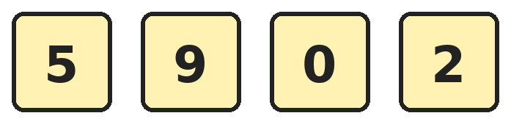
Q1. Ishaan makes 2-digit numbers using two different cards from these. What is the largest number he can make that is less than 90?
(A) 59 | (B) 95 | (C) 90 | (D) 52

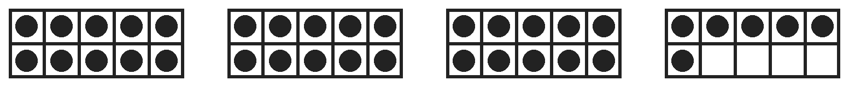
Q2. Each frame holds 10 dots. Shreya wants to fill these four frames and one more empty frame. How many more dots does she need?
(A) 4 | (B) 10 | (C) 24 | (D) 14

Q3. A box hides the ones digit of the number 5☐. The number is greater than 57. How many different digits could be in the box?
(A) 3 | (B) 1 | (C) 2 | (D) 7

Q4. Diya counts back by tens, starting at 95. She stops before she reaches a number less than 20. What is the last number she says?
(A) 15 | (B) 25 | (C) 20 | (D) 35

Q5. Ayaan swaps the two digits of a number. Which of these numbers becomes bigger after the swap?
(A) 52 | (B) 29 | (C) 55 | (D) 74

Q6. Kavya looks for numbers between 20 and 50 whose ones digit is double the tens digit. How many such numbers are there?
(A) 3 | (B) 1 | (C) 2 | (D) 4

Q7. Points A and B are marked on the number line. Which number is exactly halfway between A and B?
(A) 34 | (B) 36 | (C) 35 | (D) 33

Part 2 — Operations (Syllabus Chapter 2)
Q8. Raj is 4 years older than his sister Isha. In 3 years, Raj will be 12 years old. How old is Isha now?
(A) 9 | (B) 5 | (C) 8 | (D) 1

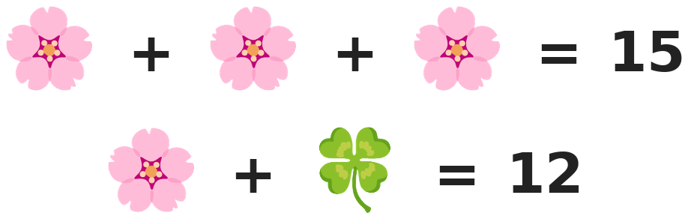
Q9. Pictures that look the same hide the same number. Which number does the leaf hide?
(A) 7 | (B) 5 | (C) 12 | (D) 3

Q10. Gauri starts on the ground. Each turn, she climbs up 3 steps and then goes down 1 step. On which step is she after 4 turns?
(A) 12 | (B) 4 | (C) 9 | (D) 8

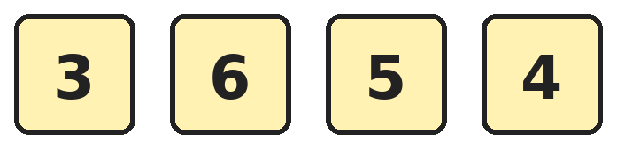
Q11. Neel removes one of these cards. The other three cards add up to 15. Which card does he remove?
(A) 6 | (B) 3 | (C) 5 | (D) 4

Q12. There are 18 children in a class. The teacher makes teams of 4 children each, with as many full teams as she can. How many children are not in a team?
(A) 4 | (B) 2 | (C) 0 | (D) 6

Q13. Neha has 8 marbles. Tarun has 5 more marbles than Neha. Leela has 3 fewer marbles than Tarun. How many marbles does Leela have?
(A) 10 | (B) 13 | (C) 16 | (D) 5

Part 3 — Geometry (Syllabus Chapter 5)
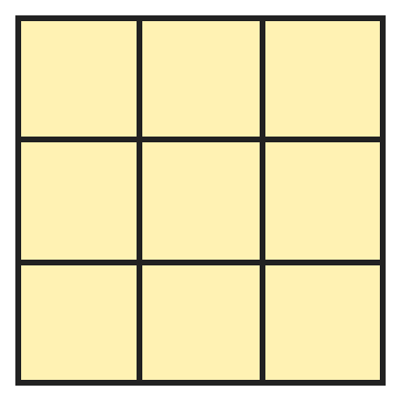
Q14. Look at this game board. How many squares of all sizes can you find on it?
(A) 14 | (B) 9 | (C) 10 | (D) 13

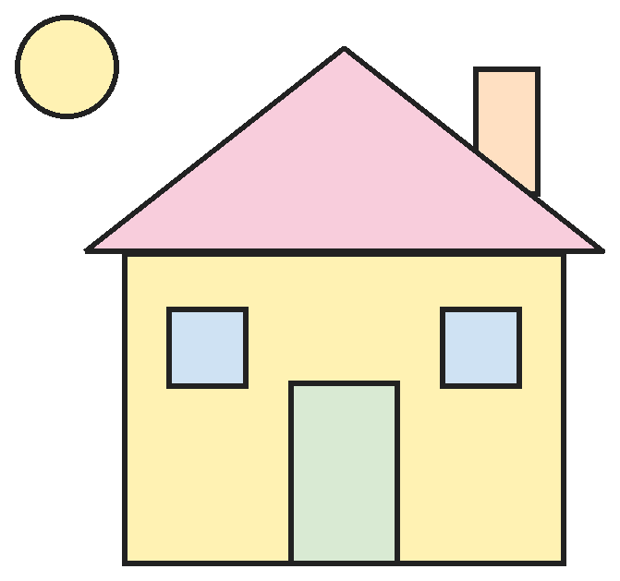
Q15. Mohit draws this house. How many shapes in his drawing have exactly 4 corners?
(A) 4 | (B) 6 | (C) 7 | (D) 5

Q16. Pallavi cuts a square paper into 4 equal small squares. Then she cuts each small square from one corner to the opposite corner. How many triangles does she get?
(A) 4 | (B) 6 | (C) 8 | (D) 16

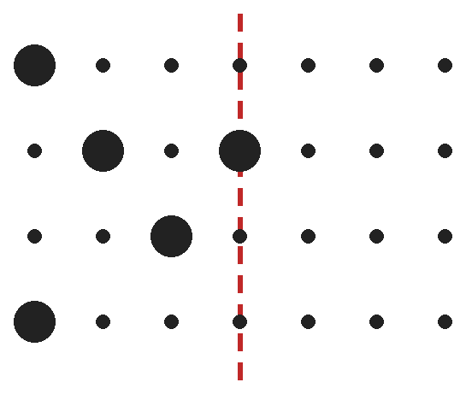
Q17. The big dots must look the same on both sides of the dotted line, like a mirror. How many big dots must be added on the right side?
(A) 5 | (B) 9 | (C) 4 | (D) 10

Part 4 — Applied Mathematics (Syllabus Chapter 9)
Q18. Isha's birthday is 3 days after the day that comes just before Friday. On which day is her birthday?
(A) Monday | (B) Saturday | (C) Wednesday | (D) Sunday

Q19. Which month is the 3rd month after the 9th month of the year?
(A) November | (B) March | (C) December | (D) October

Q20. Sahil gives a shopkeeper one ₹10 coin and one ₹2 coin. He gets back ₹2 coins of the same total value. How many ₹2 coins does he get?
(A) 5 | (B) 7 | (C) 6 | (D) 12

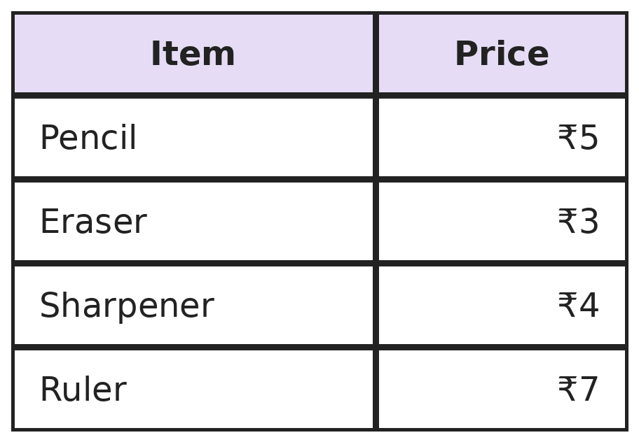
Q21. Kabir pays for two different items with a ₹10 coin. He gets ₹1 back. Which two items does he buy?
(A) Pencil and sharpener | (B) Eraser and ruler
(C) Pencil and eraser | (D) Sharpener and ruler

Part 5 — Mathematical Reasoning (Syllabus Chapter 10)

Q22. The cards show how many rabbits live in a garden in each of the first six months. If the pattern goes on, how many rabbits will there be next month?
(A) 11 | (B) 13 | (C) 12 | (D) 10

Q23. Four lockers are numbered 52, 43, 65 and 87. Three of the locker numbers belong together. Which locker number is the odd one out?
(A) 43 | (B) 65 | (C) 87 | (D) 52


Q24. The pictures repeat in the same order. How many stars are there in the first 13 pictures?
(A) 8 | (B) 9 | (C) 13 | (D) 4


Q25. A magic plant has 1, 2, 4 and then 8 leaves on four days in a row. The pattern goes on. How many leaves will it have on the next day?
(A) 12 | (B) 16 | (C) 10 | (D) 14

SECTION II — Star Questions 5 questions · each joins two chapters
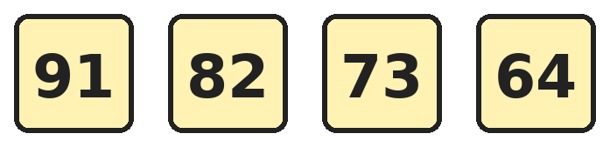
Q26. The pattern continues in the same way. Which number comes 3 places after 64? [Star]
(A) 46 | (B) 55 | (C) 34 | (D) 37

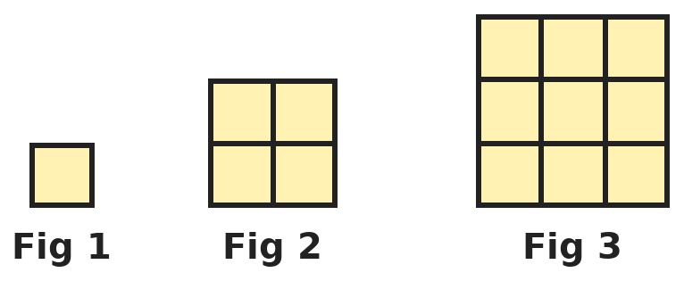
Q27. Each figure is a bigger square made of small squares. How many more small squares does Figure 4 have than Figure 3? [Star]
(A) 9 | (B) 5 | (C) 7 | (D) 4

Q28. Meera starts saving on a Monday. She saves ₹2 every day. On which day does her saving first reach ₹12? [Star]
(A) Friday | (B) Sunday | (C) Thursday | (D) Saturday

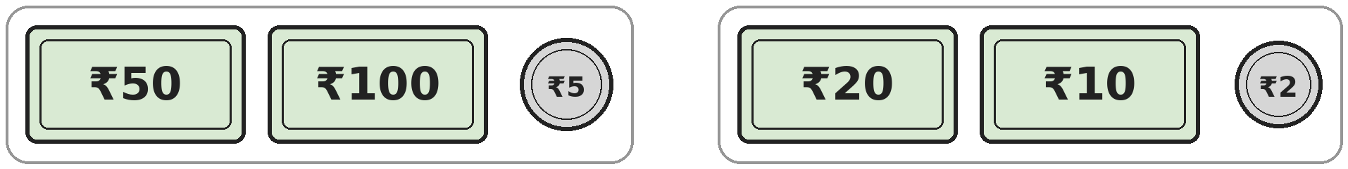
Q29. Aditi puts these notes and coins in order from the greatest value to the least value. Which one is 4th? [Star]
(A) ₹20 | (B) ₹5 | (C) ₹10 | (D) ₹50

Q30. Yuvraj draws 3 shapes. Each shape is a triangle or a square. The 3 shapes have 11 corners in all. Which shapes did he draw? [Star]
(A) 2 triangles and 1 square | (B) 3 squares
(C) 3 triangles | (D) 1 triangle and 2 squares

Answer Sheet AMO Level 2 · Class 1 · Practice Paper 3
Name: | School: | Roll No.:
Shade or tick one circle for each question.
1. | Ⓐ Ⓑ Ⓒ Ⓓ | 11. | Ⓐ Ⓑ Ⓒ Ⓓ | 21. | Ⓐ Ⓑ Ⓒ Ⓓ
2. | Ⓐ Ⓑ Ⓒ Ⓓ | 12. | Ⓐ Ⓑ Ⓒ Ⓓ | 22. | Ⓐ Ⓑ Ⓒ Ⓓ
3. | Ⓐ Ⓑ Ⓒ Ⓓ | 13. | Ⓐ Ⓑ Ⓒ Ⓓ | 23. | Ⓐ Ⓑ Ⓒ Ⓓ
4. | Ⓐ Ⓑ Ⓒ Ⓓ | 14. | Ⓐ Ⓑ Ⓒ Ⓓ | 24. | Ⓐ Ⓑ Ⓒ Ⓓ
5. | Ⓐ Ⓑ Ⓒ Ⓓ | 15. | Ⓐ Ⓑ Ⓒ Ⓓ | 25. | Ⓐ Ⓑ Ⓒ Ⓓ
6. | Ⓐ Ⓑ Ⓒ Ⓓ | 16. | Ⓐ Ⓑ Ⓒ Ⓓ | 26. | Ⓐ Ⓑ Ⓒ Ⓓ
7. | Ⓐ Ⓑ Ⓒ Ⓓ | 17. | Ⓐ Ⓑ Ⓒ Ⓓ | 27. | Ⓐ Ⓑ Ⓒ Ⓓ
8. | Ⓐ Ⓑ Ⓒ Ⓓ | 18. | Ⓐ Ⓑ Ⓒ Ⓓ | 28. | Ⓐ Ⓑ Ⓒ Ⓓ
9. | Ⓐ Ⓑ Ⓒ Ⓓ | 19. | Ⓐ Ⓑ Ⓒ Ⓓ | 29. | Ⓐ Ⓑ Ⓒ Ⓓ
10. | Ⓐ Ⓑ Ⓒ Ⓓ | 20. | Ⓐ Ⓑ Ⓒ Ⓓ | 30. | Ⓐ Ⓑ Ⓒ Ⓓ
Q26–Q30 are Section II Star Questions. Each joins two chapters.
For the parent or teacher
Section I correct: ______ / 25 Section II correct: ______ / 5
Correct: ______ / 30
Answer Key and Solutions AMO Level 2 · Class 1 · Practice Paper 3
Quick answers
1 A | 6 A | 11 B | 16 C | 21 A | 26 D
2 D | 7 C | 12 B | 17 C | 22 B | 27 C
3 C | 8 B | 13 A | 18 D | 23 D | 28 D
4 B | 9 A | 14 A | 19 C | 24 A | 29 C
5 B | 10 D | 15 D | 20 C | 25 B | 30 D
Solutions
Q | Part · level | Answer | Why?
1 | Part 1 · Ch1 · Hard | (A) 59 | Hint: Any number with tens digit 9 is too big.  Numbers with tens digit 9 (90, 92, 95) are not less than 90. The next biggest tens digit is 5, and the biggest ones digit left is 9. So the answer is 59.
2 | Part 1 · Ch1 · Hard | (D) 14 | Hint: Count the empty boxes in the frames shown, then add the new frame.  The first three frames are full. The fourth frame has 6 dots, so it needs 4 more. The new empty frame needs 10. So she needs 4 + 10 = 14 more dots.
3 | Part 1 · Ch1 · Hard | (C) 2 | Hint: Which numbers in the fifties are greater than 57?  The numbers in the fifties that are greater than 57 are 58 and 59. So the box could hide 8 or 9: that is 2 digits.
4 | Part 1 · Ch1 · Hard | (B) 25 | Hint: Counting back by tens keeps the ones digit the same.  She says 95, 85, 75, 65, 55, 45, 35, 25. The next number, 15, is less than 20, so she stops at 25.
5 | Part 1 · Ch1 · Hard | (B) 29 | Hint: Swapping makes a number bigger only if the ones digit is bigger than the tens digit.  29 becomes 92, which is bigger. 52 becomes 25 and 74 becomes 47, which are smaller. 55 stays 55.
6 | Part 1 · Ch1 · Hard | (A) 3 | Hint: The tens digit can be 2, 3 or 4.  Tens digit 2: double 2 is 4, giving 24. Tens digit 3: double 3 is 6, giving 36. Tens digit 4: double 4 is 8, giving 48. That is 3 numbers.
7 | Part 1 · Ch1 · Hard | (C) 35 | Hint: Find the numbers at A and B first.  A is 32 and B is 38. Counting in from both ends: 33 and 37, 34 and 36, then 35 is left in the middle. So the halfway number is 35.
8 | Part 2 · Ch2 · Hard | (B) 5 | Hint: First find how old Raj is now.  Raj will be 12 in 3 years, so now he is 12 − 3 = 9. Isha is 4 years younger: 9 − 4 = 5.
9 | Part 2 · Ch2 · Hard | (A) 7 | Hint: Three equal flowers make 15. What is one flower?  Three equal numbers that make 15 are 5, 5 and 5, so each flower is 5. Then 5 + leaf = 12, so the leaf is 7.
10 | Part 2 · Ch2 · Hard | (D) 8 | Hint: Work out where she is after each full turn.  Each turn takes her up 3 and down 1, so she is 2 steps higher. After 4 turns: 2, 4, 6, 8. She is on step 8.
11 | Part 2 · Ch2 · Hard | (B) 3 | Hint: Add all four cards first.  All four cards add up to 3 + 6 + 5 + 4 = 18. To leave 15, he must remove 18 − 15 = 3.
12 | Part 2 · Ch2 · Hard | (B) 2 | Hint: Count in fours: 4, 8, 12, and so on.  Counting in fours: 4, 8, 12, 16. Four teams use 16 children. The next team would need 20. So 18 − 16 = 2 children are left.
13 | Part 2 · Ch2 · Hard | (A) 10 | Hint: Find how many Tarun has first.  Tarun has 8 + 5 = 13 marbles. Leela has 3 fewer than Tarun: 13 − 3 = 10.
14 | Part 3 · Ch5 · Hard | (A) 14 | Hint: Count small squares, then squares made of 4 small squares, then the whole board.  There are 9 small squares. Squares made of 2 by 2 small squares: 4. The whole board is 1 more square. 9 + 4 + 1 = 14.
15 | Part 3 · Ch5 · Hard | (D) 5 | Hint: Squares and rectangles have 4 corners. Check every shape, even small ones.  The wall, the door, the two windows and the chimney each have 4 corners: that is 5 shapes. The roof is a triangle with 3 corners and the sun is a circle with no corners.
16 | Part 3 · Ch5 · Hard | (C) 8 | Hint: One corner-to-corner cut turns a square into 2 triangles.  Each of the 4 small squares is cut into 2 triangles. 2 + 2 + 2 + 2 = 8 triangles.
17 | Part 3 · Ch5 · Hard | (C) 4 | Hint: A dot that sits on the dotted line does not need a partner.  There are 5 big dots. One of them is on the dotted line, so it is already on both sides. The other 4 dots on the left each need a matching dot on the right. So 4 dots must be added.
18 | Part 4 · Ch9 · Hard | (D) Sunday | Hint: Find the day just before Friday first.  The day just before Friday is Thursday. Three days after Thursday: Friday, Saturday, Sunday. So her birthday is on Sunday.
19 | Part 4 · Ch9 · Hard | (C) December | Hint: First find the 9th month by counting from January.  The 9th month is September. Three months after September: October, November, December.
20 | Part 4 · Ch9 · Hard | (C) 6 | Hint: Find the total first, then count in twos.  The total is ₹10 + ₹2 = ₹12. Counting in twos: 2, 4, 6, 8, 10, 12. That is 6 coins of ₹2.
21 | Part 4 · Ch9 · Hard | (A) Pencil and sharpener | Hint: The two items together must cost ₹9.  He spends ₹10 − ₹1 = ₹9. Pencil and sharpener cost ₹5 + ₹4 = ₹9. Eraser and ruler cost ₹10, pencil and eraser cost ₹8, and sharpener and ruler cost ₹11.
22 | Part 5 · Ch10 · Hard | (B) 13 | Hint: Look at the two numbers just before each number.  Each number is the sum of the two numbers before it: 1 + 1 = 2, 1 + 2 = 3, 2 + 3 = 5, 3 + 5 = 8. Next is 5 + 8 = 13.
23 | Part 5 · Ch10 · Hard | (D) 52 | Hint: Compare the tens digit with the ones digit in each number.  In 43, 65 and 87 the tens digit is 1 more than the ones digit. In 52 the tens digit is 3 more than the ones digit. So 52 is the odd one out.
24 | Part 5 · Ch10 · Hard | (A) 8 | Hint: Each group of 3 pictures has 2 stars.  The group moon, star, star repeats. 12 pictures make 4 groups, with 2 stars each: 2 + 2 + 2 + 2 = 8 stars. The 13th picture starts a new group, so it is a moon. So there are 8 stars.
25 | Part 5 · Ch10 · Hard | (B) 16 | Hint: Compare each number with the one before it.  Each number is double the one before: 1 + 1 = 2, 2 + 2 = 4, 4 + 4 = 8. Next is 8 + 8 = 16.
26 | Section II · Ch1 + Ch10 · Hard | (D) 37 | Hint: The tens digit goes down by 1 and the ones digit goes up by 1.  Each time the tens digit goes down by 1 and the ones digit goes up by 1. After 64 come 55, 46 and 37. So 3 places after 64 is 37.
27 | Section II · Ch5 + Ch10 · Hard | (C) 7 | Hint: Count the small squares in Figures 1, 2 and 3. How much do they grow by?  Figure 1 has 1 small square, Figure 2 has 4 and Figure 3 has 9. The jumps are 3 and then 5, so the next jump is 7. Figure 4 is 4 rows of 4, which is 16, and 16 − 9 = 7.
28 | Section II · Ch9 + Ch10 · Hard | (D) Saturday | Hint: Count in twos, one day at a time.  Monday ₹2, Tuesday ₹4, Wednesday ₹6, Thursday ₹8, Friday ₹10, Saturday ₹12. So it first reaches ₹12 on Saturday.
29 | Section II · Ch1 + Ch9 · Hard | (C) ₹10 | Hint: A coin can be worth less than a note. Write the values in order.  In order from greatest: ₹100, ₹50, ₹20, ₹10, ₹5, ₹2. The 4th is the ₹10 note.
30 | Section II · Ch2 + Ch5 · Hard | (D) 1 triangle and 2 squares | Hint: A triangle has 3 corners and a square has 4.  1 triangle and 2 squares have 3 + 4 + 4 = 11 corners. 2 triangles and 1 square have 10, 3 squares have 12 and 3 triangles have 9.

ARYABHATTA MATHS OLYMPIAD
Level 2
PRACTICE PAPER-4
CLASS 1
Total Questions | 30 multiple-choice questions
Level | Level-2 (final round): every question is Hard
Time | 45 minutes
Section I | 25 questions, each from one chapter
Section II | 5 Star Questions, each joining two chapters
Negative Marking | No negative marking
Calculator | Not allowed
Chapters | Number System · Operations · Geometry · Applied Mathematics · Mathematical Reasoning

👋 Hello, friend! How to do this paper:
⭐ Every question has four answer choices: (A), (B), (C) and (D). Only one is correct.
⭐ Read each question and look at its picture carefully. Then mark your answer on the answer sheet at the end.
⭐ This is a Level-2 paper. Every question needs careful thinking, so take your time and check each step.
⭐ Section I has 25 questions. Section II has 5 Star Questions.
⭐ There is no negative marking, so try every question.
⭐ Do not use a calculator. You may do rough work on a separate sheet.
⭐ All figures are not necessarily drawn to scale unless stated.

For parents and teachers
• Pictures are part of the questions. Every picture also works when printed in black and white.
• You may read a question aloud to the child, exactly as printed. Please do not explain it or point to an answer choice.
• Parts follow the AMO syllabus chapters. Chapters 3, 4, 6, 7 and 8 are not part of the Class 1 syllabus, so the chapter numbers shown in the Part headings have gaps.
• The answer sheet and the answer key are at the end. Remove only the answer key before the child begins.

SECTION I 25 questions · every question is Hard
Part 1 — Number System (Syllabus Chapter 1)
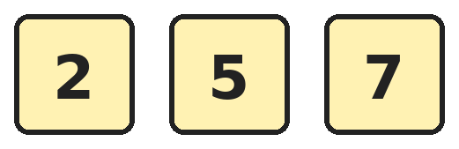
Q1. Aryan makes every 2-digit number he can using two different cards. He lists them from smallest to largest. Which number is 4th in his list?
(A) 57 | (B) 52 | (C) 72 | (D) 27

Q2. Which number name is for the number that is 1 ten less than the number 2 more than 72?
(A) seventy-three | (B) sixty-four | (C) sixty-two | (D) seventy-four

Q3. What is the smallest 2-digit number whose two digits add up to 12?
(A) 48 | (B) 66 | (C) 93 | (D) 39

Q4. Think of the largest 2-digit number whose tens digit is 4. Which number is 1 more than it?
(A) 50 | (B) 49 | (C) 41 | (D) 48

Q5. Nakul looks at the numbers from 40 to 49. In how many of them is the tens digit bigger than the ones digit?
(A) 5 | (B) 3 | (C) 4 | (D) 10

Q6. Point A is marked on the number line. Which number is 1 ten and 2 ones more than the number at A?
(A) 58 | (B) 68 | (C) 66 | (D) 78

Q7. How many numbers between 50 and 90 have the same ones digit as 38?
(A) 3 | (B) 4 | (C) 5 | (D) 9

Part 2 — Operations (Syllabus Chapter 2)
Q8. Ved knows that 7 + 9 = 16. Which of these number sentences is NOT true?
(A) 9 − 7 = 16 | (B) 16 − 9 = 7 | (C) 9 + 7 = 16 | (D) 16 − 7 = 9

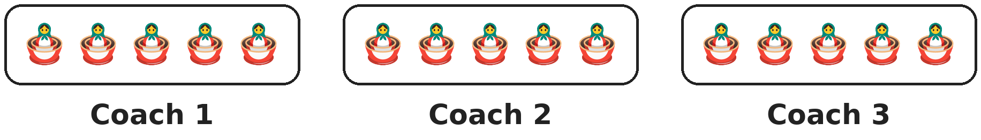
Q9. A toy train has 3 coaches with 5 dolls in each coach. At a stop, 4 dolls get off. How many dolls are on the train now?
(A) 15 | (B) 11 | (C) 19 | (D) 8

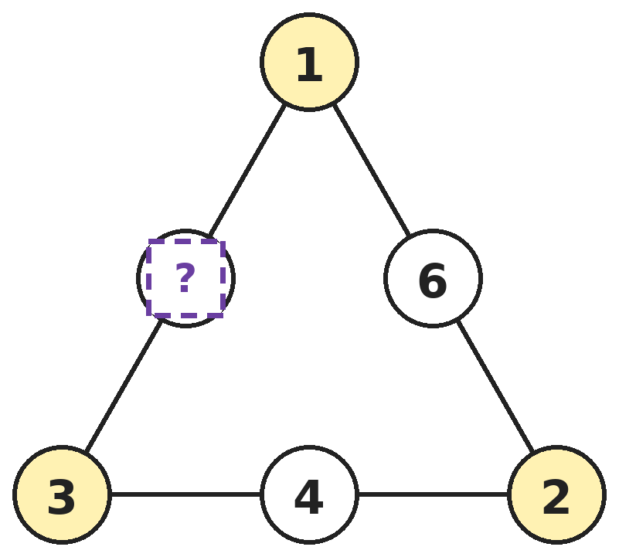
Q10. The three numbers along each side of the triangle add up to the same total. Which number goes in the box with the question mark?
(A) 5 | (B) 6 | (C) 4 | (D) 3

Q11. Riya doubles her number and then adds 3. She gets 15. What is her number?
(A) 12 | (B) 9 | (C) 6 | (D) 7

Q12. There are 17 children in a class and 9 of them are girls. How many more girls than boys are there?
(A) 8 | (B) 9 | (C) 2 | (D) 1

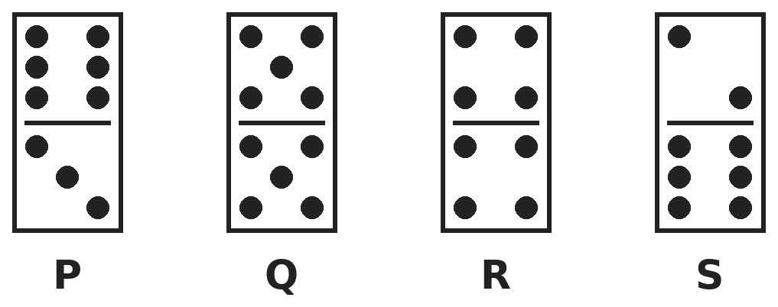
Q13. Which domino has the same total number of dots as 4 + 5?
(A) Domino P | (B) Domino Q | (C) Domino R | (D) Domino S

Part 3 — Geometry (Syllabus Chapter 5)
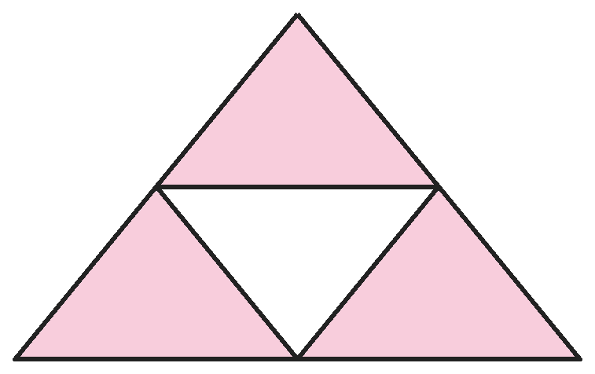
Q14. Lines join the middle points of the sides of a big triangle. How many triangles of all sizes are there in the picture?
(A) 4 | (B) 5 | (C) 3 | (D) 6

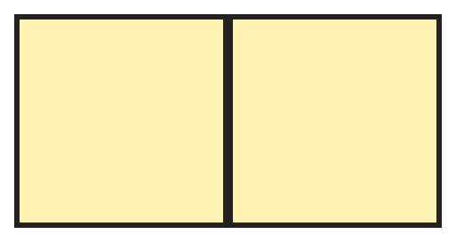
Q15. Two equal squares are pushed together side by side to make one new shape. How many corners does the new shape have?
(A) 4 | (B) 8 | (C) 6 | (D) 7

Q16. Dev cuts a rectangle into 2 squares. Then he cuts each square into 2 triangles. How many corners do all his pieces have altogether?
(A) 8 | (B) 4 | (C) 12 | (D) 16

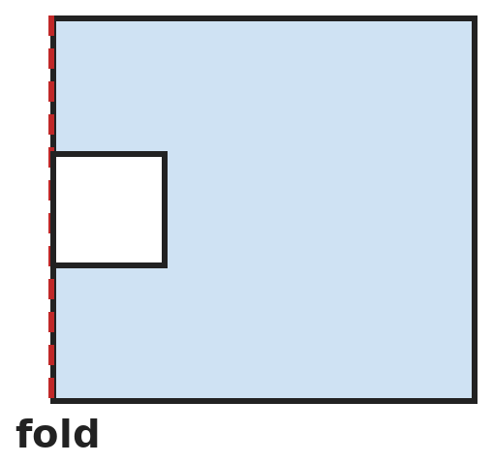
Q17. Rohan folds a paper in half. He cuts a small square out of the folded edge, as shown. He then opens the paper. What shape is the hole?
(A) Square | (B) Triangle | (C) Circle | (D) Rectangle

Part 4 — Applied Mathematics (Syllabus Chapter 9)
Q18. The 1st day of a month is a Monday. How many Sundays are there from the 1st to the 14th of that month?
(A) 1 | (B) 3 | (C) 2 | (D) 7

Q19. Ira's school year starts in June and lasts for 10 months, counting June. In which month does it end?
(A) April | (B) February | (C) March | (D) May

Q20. Shalini has three Indian notes. Each note has a different value. Together they make ₹80. Which notes does she have?
(A) ₹50, ₹20 and ₹10 | (B) ₹50, ₹20 and ₹20
(C) ₹40, ₹30 and ₹10 | (D) ₹50, ₹10 and ₹10

Q21. A piggy bank has three ₹5 coins and two ₹2 coins. Lavanya takes out one coin. Now ₹14 is left in the bank. Which coin did she take out?
(A) ₹2 | (B) ₹1 | (C) ₹5 | (D) ₹10

Part 5 — Mathematical Reasoning (Syllabus Chapter 10)

Q22. Chirag hops along a number track. He lands on the numbers shown. If he keeps hopping the same way, where does he land next?
(A) 10 | (B) 12 | (C) 13 | (D) 11

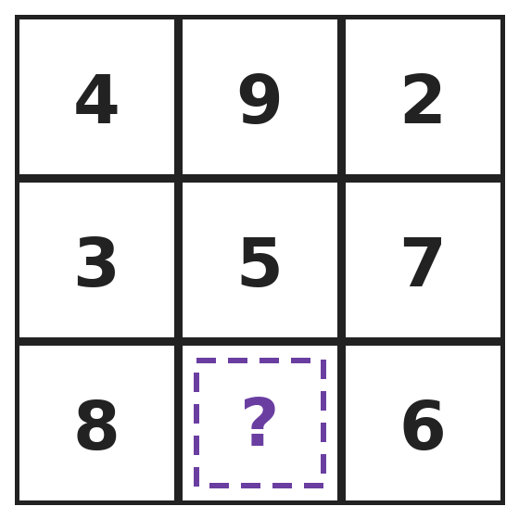
Q23. In this square, every row and every column adds up to 15. Which number is hidden by the question mark?
(A) 7 | (B) 2 | (C) 4 | (D) 1

Q24. Three of these show the same number. Which one is the odd one out?
(A) 43 | (B) 4 tens and 13 ones
(C) forty-three | (D) 3 tens and 13 ones

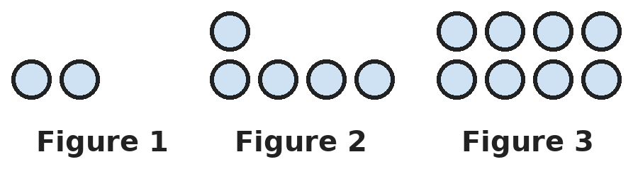
Q25. Look at how the number of circles grows from figure to figure. How many circles will Figure 5 have?
(A) 11 | (B) 13 | (C) 17 | (D) 14

SECTION II — Star Questions 5 questions · each joins two chapters
Q26. On a number chart from 1 to 100, Bhavna marks 7, 17, 27 and every number below them in the same column. How many marked numbers are less than 60? [Star]
(A) 5 | (B) 6 | (C) 7 | (D) 10

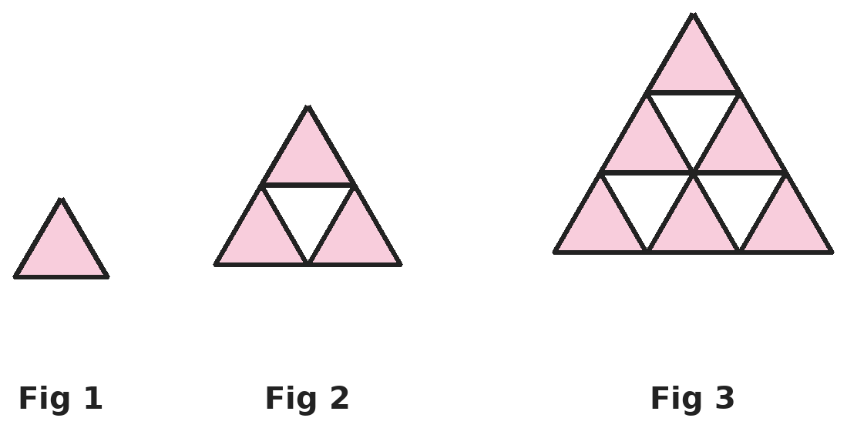
Q27. Each figure is a big triangle made of small triangles. The figures keep growing in the same way. How many small triangles will Figure 4 have? [Star]
(A) 12 | (B) 13 | (C) 16 | (D) 10

Q28. Gopal waters the plants every Monday and every Thursday. His first watering is on a Monday. On which day is his 5th watering? [Star]
(A) Thursday | (B) Tuesday | (C) Friday | (D) Monday

Q29. The months are numbered 1 to 12, starting with January as 1. Which month has a 2-digit number with both digits the same? [Star]
(A) December | (B) November | (C) October | (D) January

Q30. Arjun draws 3 triangles and 1 circle on the left of a fold line. He draws 1 more circle right on the fold line. Then he copies the left side onto the right, like a mirror. How many shapes are there in all? [Star]
(A) 10 | (B) 8 | (C) 9 | (D) 5

Answer Sheet AMO Level 2 · Class 1 · Practice Paper 4
Name: | School: | Roll No.:
Shade or tick one circle for each question.
1. | Ⓐ Ⓑ Ⓒ Ⓓ | 11. | Ⓐ Ⓑ Ⓒ Ⓓ | 21. | Ⓐ Ⓑ Ⓒ Ⓓ
2. | Ⓐ Ⓑ Ⓒ Ⓓ | 12. | Ⓐ Ⓑ Ⓒ Ⓓ | 22. | Ⓐ Ⓑ Ⓒ Ⓓ
3. | Ⓐ Ⓑ Ⓒ Ⓓ | 13. | Ⓐ Ⓑ Ⓒ Ⓓ | 23. | Ⓐ Ⓑ Ⓒ Ⓓ
4. | Ⓐ Ⓑ Ⓒ Ⓓ | 14. | Ⓐ Ⓑ Ⓒ Ⓓ | 24. | Ⓐ Ⓑ Ⓒ Ⓓ
5. | Ⓐ Ⓑ Ⓒ Ⓓ | 15. | Ⓐ Ⓑ Ⓒ Ⓓ | 25. | Ⓐ Ⓑ Ⓒ Ⓓ
6. | Ⓐ Ⓑ Ⓒ Ⓓ | 16. | Ⓐ Ⓑ Ⓒ Ⓓ | 26. | Ⓐ Ⓑ Ⓒ Ⓓ
7. | Ⓐ Ⓑ Ⓒ Ⓓ | 17. | Ⓐ Ⓑ Ⓒ Ⓓ | 27. | Ⓐ Ⓑ Ⓒ Ⓓ
8. | Ⓐ Ⓑ Ⓒ Ⓓ | 18. | Ⓐ Ⓑ Ⓒ Ⓓ | 28. | Ⓐ Ⓑ Ⓒ Ⓓ
9. | Ⓐ Ⓑ Ⓒ Ⓓ | 19. | Ⓐ Ⓑ Ⓒ Ⓓ | 29. | Ⓐ Ⓑ Ⓒ Ⓓ
10. | Ⓐ Ⓑ Ⓒ Ⓓ | 20. | Ⓐ Ⓑ Ⓒ Ⓓ | 30. | Ⓐ Ⓑ Ⓒ Ⓓ
Q26–Q30 are Section II Star Questions. Each joins two chapters.
For the parent or teacher
Section I correct: ______ / 25 Section II correct: ______ / 5
Correct: ______ / 30
Answer Key and Solutions AMO Level 2 · Class 1 · Practice Paper 4
Quick answers
1 A | 6 B | 11 C | 16 C | 21 C | 26 B
2 B | 7 B | 12 D | 17 D | 22 D | 27 C
3 D | 8 A | 13 A | 18 C | 23 D | 28 D
4 A | 9 B | 14 B | 19 C | 24 B | 29 B
5 C | 10 A | 15 A | 20 A | 25 D | 30 C
Solutions
Q | Part · level | Answer | Why?
1 | Part 1 · Ch1 · Hard | (A) 57 | Hint: There are 6 numbers. Write them all in order.  The numbers are 25, 27, 52, 57, 72 and 75. In order, the 4th number is 57.
2 | Part 1 · Ch1 · Hard | (B) sixty-four | Hint: First find the number that is 2 more than 72.  2 more than 72 is 74. One ten less than 74 is 64, because only the tens digit goes down by 1. 64 is read as sixty-four.
3 | Part 1 · Ch1 · Hard | (D) 39 | Hint: Make the tens digit as small as you can.  The ones digit can be at most 9. To make 12, the tens digit must then be at least 3, because 3 + 9 = 12. So the smallest number is 39.
4 | Part 1 · Ch1 · Hard | (A) 50 | Hint: First find the largest number with tens digit 4.  The largest number with tens digit 4 is 49. One more than 49 is 50.
5 | Part 1 · Ch1 · Hard | (C) 4 | Hint: The tens digit is always 4. Which ones digits are smaller than 4?  The tens digit is 4, so the ones digit must be 0, 1, 2 or 3. The numbers are 40, 41, 42 and 43: that is 4 numbers. In 44 the digits are equal.
6 | Part 1 · Ch1 · Hard | (B) 68 | Hint: Find A first. Then add 1 ten and 2 ones separately.  A is 56. One ten more is 66. Two ones more than 66 is 68.
7 | Part 1 · Ch1 · Hard | (B) 4 | Hint: The ones digit must be 8. List them.  The numbers between 50 and 90 that end in 8 are 58, 68, 78 and 88. That is 4 numbers.
8 | Part 2 · Ch2 · Hard | (A) 9 − 7 = 16 | Hint: Taking away from 16 must give 7 or 9.  9 + 7 = 16 is true because the order of adding does not matter. 16 − 9 = 7 and 16 − 7 = 9 are true. But 9 − 7 = 2, not 16.
9 | Part 2 · Ch2 · Hard | (B) 11 | Hint: Find how many dolls there were before the stop.  Before the stop there are 5 + 5 + 5 = 15 dolls. After 4 get off: 15 − 4 = 11 dolls.
10 | Part 2 · Ch2 · Hard | (A) 5 | Hint: Find the total of a side that is complete.  The right side is 1 + 6 + 2 = 9 and the bottom side is 2 + 4 + 3 = 9. So the left side must also make 9: 1 + ? + 3 = 9, which means ? = 5.
11 | Part 2 · Ch2 · Hard | (C) 6 | Hint: Work backwards: undo adding 3 first.  Before adding 3 she had 15 − 3 = 12. Twelve is her number doubled, and 6 + 6 = 12. So her number is 6.
12 | Part 2 · Ch2 · Hard | (D) 1 | Hint: First find the number of boys.  There are 17 − 9 = 8 boys. The girls are 9 − 8 = 1 more than the boys.
13 | Part 2 · Ch2 · Hard | (A) Domino P | Hint: Count both halves of each domino and add.  4 + 5 = 9. Domino P has 6 + 3 = 9. Q has 5 + 5 = 10, R has 4 + 4 = 8 and S has 2 + 6 = 8.
14 | Part 3 · Ch5 · Hard | (B) 5 | Hint: Do not forget the big triangle itself.  There are 4 small triangles (3 at the corners and 1 upside-down in the middle). The big triangle is 1 more. 4 + 1 = 5.
15 | Part 3 · Ch5 · Hard | (A) 4 | Hint: Look at the outline of the new shape only.  The two squares together make a rectangle. Where the squares touch, the corners are no longer corners of the shape. A rectangle has 4 corners.
16 | Part 3 · Ch5 · Hard | (C) 12 | Hint: Find how many pieces there are, and what shape they are.  2 squares cut into 2 triangles each give 4 triangles. Each triangle has 3 corners: 3 + 3 + 3 + 3 = 12 corners.
17 | Part 3 · Ch5 · Hard | (D) Rectangle | Hint: The cut goes through two layers that open out on both sides of the fold.  The square cut sits on the fold, so when the paper opens the same square appears on both sides of the fold. Two squares side by side make a rectangle that is twice as wide as it is tall.
18 | Part 4 · Ch9 · Hard | (C) 2 | Hint: Find the date of the first Sunday.  Monday is the 1st, so Sunday is the 7th. The next Sunday is 7 days later, on the 14th. So there are 2 Sundays.
19 | Part 4 · Ch9 · Hard | (C) March | Hint: June is month 1. Count on until you reach month 10.  June 1, July 2, August 3, September 4, October 5, November 6, December 7, January 8, February 9, March 10. It ends in March.
20 | Part 4 · Ch9 · Hard | (A) ₹50, ₹20 and ₹10 | Hint: Think about which notes really exist, and that all three must be different.  ₹50 + ₹20 + ₹10 = ₹80, and all three are real, different notes. The second and fourth groups repeat a note. There are no ₹40 or ₹30 notes.
21 | Part 4 · Ch9 · Hard | (C) ₹5 | Hint: First find how much money was in the bank.  At first there was ₹5 + ₹5 + ₹5 + ₹2 + ₹2 = ₹19. Now there is ₹14, so she took out ₹19 − ₹14 = ₹5. That is a ₹5 coin.
22 | Part 5 · Ch10 · Hard | (D) 11 | Hint: Look at what is added each time.  The pattern adds 1, then 2, then 1, then 2: 2, 3, 5, 6, 8, 9. Next it adds 2: 9 + 2 = 11.
23 | Part 5 · Ch10 · Hard | (D) 1 | Hint: Use the bottom row or the middle column.  Bottom row: 8 + ? + 6 = 15. Since 8 + 6 = 14, the ? must be 1. Check the middle column: 9 + 5 + 1 = 15.
24 | Part 5 · Ch10 · Hard | (B) 4 tens and 13 ones | Hint: Change extra ones into tens, then write each as a number.  43 and forty-three show 43. 3 tens and 13 ones is 4 tens and 3 ones, which is also 43. But 4 tens and 13 ones is 5 tens and 3 ones, which is 53.
25 | Part 5 · Ch10 · Hard | (D) 14 | Hint: Count the circles in each figure. How many are added each time?  The figures have 2, 5 and 8 circles, so 3 are added each time. Figure 4 has 8 + 3 = 11 and Figure 5 has 11 + 3 = 14.
26 | Section II · Ch1 + Ch10 · Hard | (B) 6 | Hint: Going down a column adds 1 ten each time.  The marked numbers are 7, 17, 27, 37, 47, 57, 67, 77, 87, 97. The ones less than 60 are 7, 17, 27, 37, 47 and 57: that is 6 numbers.
27 | Section II · Ch5 + Ch10 · Hard | (C) 16 | Hint: Count the small triangles in each figure, row by row.  Figure 1 has 1 small triangle, Figure 2 has 4 and Figure 3 has 9. The jumps are 3 and then 5, so the next jump is 7. Figure 4 has 9 + 7 = 16 small triangles.
28 | Section II · Ch9 + Ch10 · Hard | (D) Monday | Hint: List the waterings in order.  Watering 1 is Monday, 2 is Thursday, 3 is Monday, 4 is Thursday and 5 is Monday.
29 | Section II · Ch1 + Ch9 · Hard | (B) November | Hint: Which number from 1 to 12 has two equal digits?  The only number from 1 to 12 with two equal digits is 11. Counting from January, the 11th month is November.
30 | Section II · Ch2 + Ch5 · Hard | (C) 9 | Hint: The circle on the fold line is not copied again.  Left side: 3 triangles and 1 circle, which is 4 shapes. The right side copies them: 4 more shapes. The circle on the fold line is 1 shape. 4 + 4 + 1 = 9.

ARYABHATTA MATHS OLYMPIAD
Level 2
PRACTICE PAPER-5
CLASS 1
Total Questions | 30 multiple-choice questions
Level | Level-2 (final round): every question is Hard
Time | 45 minutes
Section I | 25 questions, each from one chapter
Section II | 5 Star Questions, each joining two chapters
Negative Marking | No negative marking
Calculator | Not allowed
Chapters | Number System · Operations · Geometry · Applied Mathematics · Mathematical Reasoning

👋 Hello, friend! How to do this paper:
⭐ Every question has four answer choices: (A), (B), (C) and (D). Only one is correct.
⭐ Read each question and look at its picture carefully. Then mark your answer on the answer sheet at the end.
⭐ This is a Level-2 paper. Every question needs careful thinking, so take your time and check each step.
⭐ Section I has 25 questions. Section II has 5 Star Questions.
⭐ There is no negative marking, so try every question.
⭐ Do not use a calculator. You may do rough work on a separate sheet.
⭐ All figures are not necessarily drawn to scale unless stated.

For parents and teachers
• Pictures are part of the questions. Every picture also works when printed in black and white.
• You may read a question aloud to the child, exactly as printed. Please do not explain it or point to an answer choice.
• Parts follow the AMO syllabus chapters. Chapters 3, 4, 6, 7 and 8 are not part of the Class 1 syllabus, so the chapter numbers shown in the Part headings have gaps.
• The answer sheet and the answer key are at the end. Remove only the answer key before the child begins.

SECTION I 25 questions · every question is Hard
Part 1 — Number System (Syllabus Chapter 1)
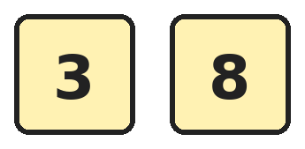
Q1. Nisha makes 2-digit numbers using only the digits on these cards. She may use a digit twice. How many different numbers can she make?
(A) 4 | (B) 2 | (C) 3 | (D) 6

Q2. What is the greatest number less than 70 whose two digits add up to 9?
(A) 63 | (B) 72 | (C) 54 | (D) 69

Q3. In Sita's number, the tens digit stands for 70 ones. The ones digit is 2 less than the tens digit. What is Sita's number?
(A) 72 | (B) 77 | (C) 75 | (D) 57

Q4. Which point on the number line shows the number that is 2 tens less than 86?
(A) Point P | (B) Point Q | (C) Point R | (D) Point S

Q5. How many numbers between 10 and 50 have 0 as their ones digit?
(A) 4 | (B) 2 | (C) 3 | (D) 6

Q6. Counting up from 34, which is the next number made of the same two digits, 3 and 4?
(A) 35 | (B) 43 | (C) 44 | (D) 53

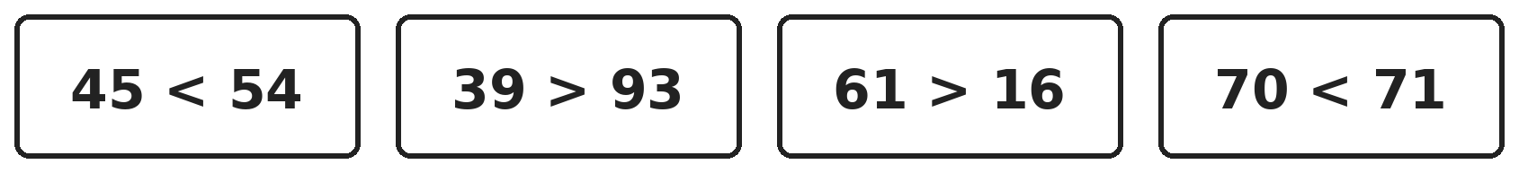
Q7. Look at the four cards. How many of them show a true statement?
(A) 2 | (B) 3 | (C) 4 | (D) 1

Part 2 — Operations (Syllabus Chapter 2)
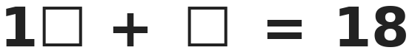
Q8. Both boxes hide the same digit. Which digit is it?
(A) 9 | (B) 8 | (C) 3 | (D) 4

Q9. There are 6 birds on a tree. Some more birds come. Then 4 birds fly away. Now there are 9 birds. How many birds came?
(A) 3 | (B) 5 | (C) 7 | (D) 13

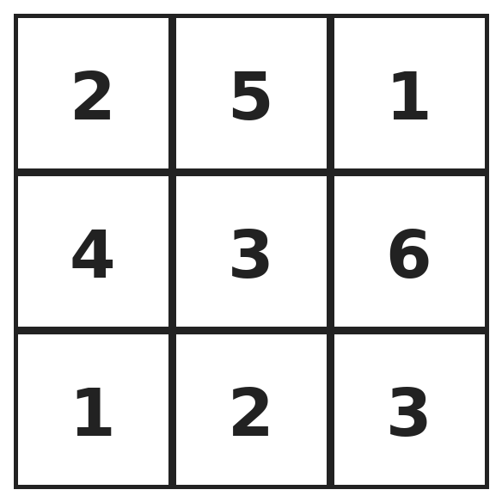
Q10. Mohan starts at the top-left box and moves only right or down to the bottom-right box. He adds every number he passes, including both ends. What is the largest total he can get?
(A) 18 | (B) 17 | (C) 19 | (D) 20

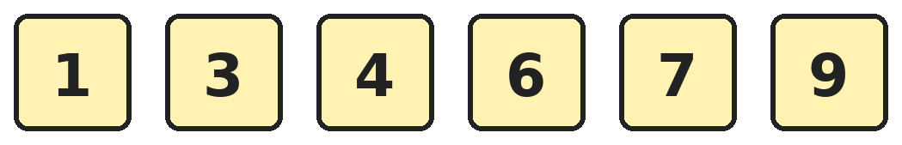
Q11. Jatin makes pairs of these cards that add up to 10. Each card can be used only once. How many pairs can he make?
(A) 2 | (B) 3 | (C) 4 | (D) 6

Q12. Prachi has 20 beads. She uses 6 beads for a bracelet. She uses twice as many beads for a necklace. How many beads are left?
(A) 8 | (B) 14 | (C) 12 | (D) 2

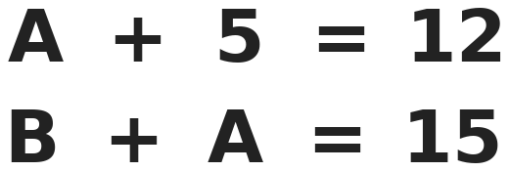
Q13. Each letter stands for a number. What number does B stand for?
(A) 8 | (B) 3 | (C) 7 | (D) 10

Part 3 — Geometry (Syllabus Chapter 5)
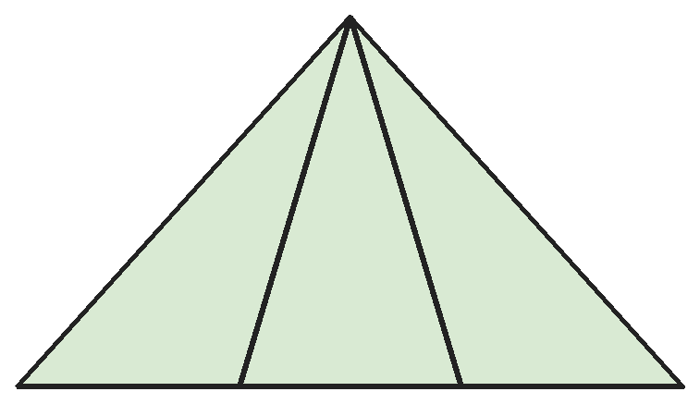
Q14. Rahul draws a triangle and two lines from its top corner to the bottom side. How many triangles of all sizes are in his drawing?
(A) 3 | (B) 5 | (C) 4 | (D) 6

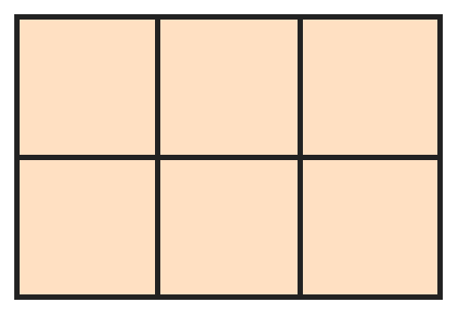
Q15. A chocolate bar has 2 rows of 3 square pieces. How many squares of all sizes can you find on the bar?
(A) 6 | (B) 8 | (C) 7 | (D) 9

Q16. Ananya folds a square paper in half to make a rectangle. Then she folds the rectangle in half so that its two short sides meet. What shape is the folded paper now?
(A) Rectangle | (B) Triangle | (C) Circle | (D) Square

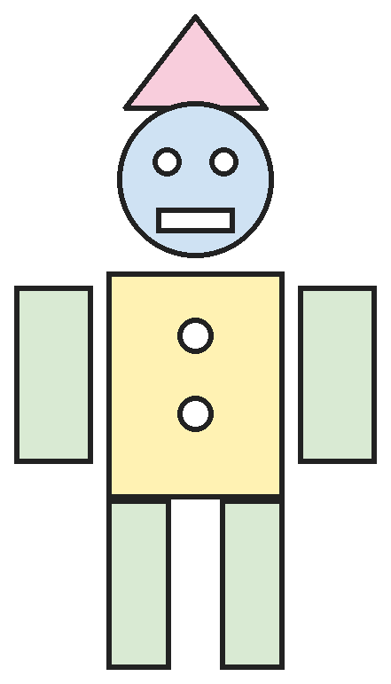
Q17. Kartik's robot is made of shapes. How many more rectangles than circles are there in the robot?
(A) 6 | (B) 5 | (C) 2 | (D) 1

Part 4 — Applied Mathematics (Syllabus Chapter 9)
Q18. Isha's grandma arrives on the 3rd day after Wednesday. She leaves on the 2nd day after she arrives. On which day does she leave?
(A) Sunday | (B) Monday | (C) Saturday | (D) Friday

Q19. How many months come between March and September?
(A) 6 | (B) 7 | (C) 4 | (D) 5

Q20. Tushar wants to make exactly ₹17 using exactly 4 coins. Which coins should he use?
(A) ₹10, ₹5, ₹1 and ₹1 | (B) ₹10, ₹2, ₹2 and ₹2
(C) ₹5, ₹5, ₹5 and ₹1 | (D) ₹10, ₹5 and ₹2

Q21. Kirti changes a ₹20 note into ₹5 coins. She gives 2 of the coins to her brother. How much money does Kirti have left?
(A) ₹10 | (B) ₹18 | (C) ₹15 | (D) ₹2

Part 5 — Mathematical Reasoning (Syllabus Chapter 10)

Q22. Ekta has 20 balloons. Every hour some burst, so she has 20, then 18, then 15, then 11. If the pattern goes on, how many will she have next?
(A) 7 | (B) 8 | (C) 5 | (D) 6

Q23. Four players wear shirts numbered 27, 35, 49 and 41. Three of the shirt numbers belong together. Which shirt number is the odd one out?
(A) 27 | (B) 41 | (C) 35 | (D) 49


Q24. Madhav writes 1, 2, 3 again and again. What is the total of the first 10 numbers he writes?
(A) 18 | (B) 20 | (C) 19 | (D) 10

Q25. The pattern keeps growing in the same way. How many circles are there between the 4th and the 5th triangles?
(A) 5 | (B) 4 | (C) 6 | (D) 14

SECTION II — Star Questions 5 questions · each joins two chapters

Q26. Look at how this number pattern works. Which number comes next? [Star]
(A) 54 | (B) 44 | (C) 45 | (D) 36

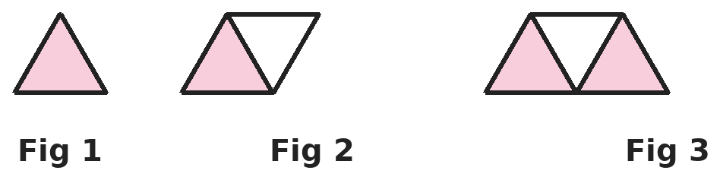
Q27. Each figure is a strip of triangles. Look only at the outside edge of each figure. How many corners will the outside edge of Figure 6 have? [Star]
(A) 8 | (B) 18 | (C) 6 | (D) 12


Q28. Coins are placed in a row in a repeating pattern: ₹1, ₹2, ₹5, ₹1, ₹2 and so on. What is the total value of the first 7 coins? [Star]
(A) ₹16 | (B) ₹18 | (C) ₹15 | (D) ₹17

Q29. Sana writes the date 13 with its digits swapped and gets 31, which is also a date. For which of these dates does swapping the digits NOT give a date in any month? [Star]
(A) 12 | (B) 21 | (C) 23 | (D) 30

Q30. Gita draws 3 triangles. She puts 2 beads on every corner of each triangle. How many beads does she use? [Star]
(A) 9 | (B) 18 | (C) 6 | (D) 12

Answer Sheet AMO Level 2 · Class 1 · Practice Paper 5
Name: | School: | Roll No.:
Shade or tick one circle for each question.
1. | Ⓐ Ⓑ Ⓒ Ⓓ | 11. | Ⓐ Ⓑ Ⓒ Ⓓ | 21. | Ⓐ Ⓑ Ⓒ Ⓓ
2. | Ⓐ Ⓑ Ⓒ Ⓓ | 12. | Ⓐ Ⓑ Ⓒ Ⓓ | 22. | Ⓐ Ⓑ Ⓒ Ⓓ
3. | Ⓐ Ⓑ Ⓒ Ⓓ | 13. | Ⓐ Ⓑ Ⓒ Ⓓ | 23. | Ⓐ Ⓑ Ⓒ Ⓓ
4. | Ⓐ Ⓑ Ⓒ Ⓓ | 14. | Ⓐ Ⓑ Ⓒ Ⓓ | 24. | Ⓐ Ⓑ Ⓒ Ⓓ
5. | Ⓐ Ⓑ Ⓒ Ⓓ | 15. | Ⓐ Ⓑ Ⓒ Ⓓ | 25. | Ⓐ Ⓑ Ⓒ Ⓓ
6. | Ⓐ Ⓑ Ⓒ Ⓓ | 16. | Ⓐ Ⓑ Ⓒ Ⓓ | 26. | Ⓐ Ⓑ Ⓒ Ⓓ
7. | Ⓐ Ⓑ Ⓒ Ⓓ | 17. | Ⓐ Ⓑ Ⓒ Ⓓ | 27. | Ⓐ Ⓑ Ⓒ Ⓓ
8. | Ⓐ Ⓑ Ⓒ Ⓓ | 18. | Ⓐ Ⓑ Ⓒ Ⓓ | 28. | Ⓐ Ⓑ Ⓒ Ⓓ
9. | Ⓐ Ⓑ Ⓒ Ⓓ | 19. | Ⓐ Ⓑ Ⓒ Ⓓ | 29. | Ⓐ Ⓑ Ⓒ Ⓓ
10. | Ⓐ Ⓑ Ⓒ Ⓓ | 20. | Ⓐ Ⓑ Ⓒ Ⓓ | 30. | Ⓐ Ⓑ Ⓒ Ⓓ
Q26–Q30 are Section II Star Questions. Each joins two chapters.
For the parent or teacher
Section I correct: ______ / 25 Section II correct: ______ / 5
Correct: ______ / 30
Answer Key and Solutions AMO Level 2 · Class 1 · Practice Paper 5
Quick answers
1 A | 6 B | 11 B | 16 D | 21 A | 26 C
2 A | 7 B | 12 D | 17 D | 22 D | 27 A
3 C | 8 D | 13 A | 18 B | 23 B | 28 D
4 B | 9 C | 14 D | 19 D | 24 C | 29 C
5 C | 10 C | 15 B | 20 A | 25 A | 30 B
Solutions
Q | Part · level | Answer | Why?
1 | Part 1 · Ch1 · Hard | (A) 4 | Hint: The tens digit can be 3 or 8, and so can the ones digit.  With tens digit 3: 33 and 38. With tens digit 8: 83 and 88. That is 4 numbers.
2 | Part 1 · Ch1 · Hard | (A) 63 | Hint: Try the biggest tens digit allowed first.  The tens digit can be at most 6, because the number is less than 70. With tens digit 6 the ones digit must be 3, since 6 + 3 = 9. So the number is 63.
3 | Part 1 · Ch1 · Hard | (C) 75 | Hint: 70 ones make 7 tens.  70 ones are 7 tens, so the tens digit is 7. The ones digit is 2 less than 7, which is 5. The number is 75.
4 | Part 1 · Ch1 · Hard | (B) Point Q | Hint: Two tens less changes only the tens digit.  Two tens less than 86 is 66, because the tens digit goes from 8 down to 6. Point Q is at 66.
5 | Part 1 · Ch1 · Hard | (C) 3 | Hint: "Between" means 10 and 50 themselves do not count.  The numbers ending in 0 are 10, 20, 30, 40, 50. Between 10 and 50 only 20, 30 and 40 count. That is 3 numbers.
6 | Part 1 · Ch1 · Hard | (B) 43 | Hint: The digits can swap places.  With digits 3 and 4 we can make 34 and 43. Counting up from 34, the next such number is 43.
7 | Part 1 · Ch1 · Hard | (B) 3 | Hint: Compare the tens digits first in each card.  45 < 54 is true. 39 > 93 is false, because 39 has fewer tens. 61 > 16 is true. 70 < 71 is true. So 3 cards are true.
8 | Part 2 · Ch2 · Hard | (D) 4 | Hint: Try a digit and check the sum.  Try 4: 14 + 4 = 18. It works. A bigger digit such as 9 is too big, because 19 is already more than 18. So the digit is 4.
9 | Part 2 · Ch2 · Hard | (C) 7 | Hint: Work backwards from 9.  Before 4 flew away there were 9 + 4 = 13 birds. At the start there were 6, so 13 − 6 = 7 birds came.
10 | Part 2 · Ch2 · Hard | (C) 19 | Hint: Try each path. There are not many.  The best path is 2, 5, 3, 6, 3 (right, down, right, down). Its total is 2 + 5 + 3 + 6 + 3 = 19. Other paths give 17, 18, 15, 14 and 12.
11 | Part 2 · Ch2 · Hard | (B) 3 | Hint: Find a partner for each card.  1 + 9 = 10, 3 + 7 = 10 and 4 + 6 = 10. That uses all 6 cards, so he makes 3 pairs.
12 | Part 2 · Ch2 · Hard | (D) 2 | Hint: Twice as many as 6 means 6 + 6.  The necklace uses 6 + 6 = 12 beads. Altogether she uses 6 + 12 = 18 beads. 20 − 18 = 2 beads are left.
13 | Part 2 · Ch2 · Hard | (A) 8 | Hint: Find A from the first sentence.  A + 5 = 12, so A = 7. Then B + 7 = 15, so B = 8.
14 | Part 3 · Ch5 · Hard | (D) 6 | Hint: Count single parts, then two parts together, then the whole.  There are 3 small triangles. Two small triangles side by side make a bigger one: there are 2 of these. The whole shape is 1 more. 3 + 2 + 1 = 6.
15 | Part 3 · Ch5 · Hard | (B) 8 | Hint: Look for squares made of 4 pieces too.  There are 6 small squares. A square of 2 by 2 pieces can sit on the left or on the right: 2 more. 6 + 2 = 8. The whole bar is not a square.
16 | Part 3 · Ch5 · Hard | (D) Square | Hint: Imagine the square is 4 boxes long on each side.  Think of a square that is 4 boxes by 4 boxes. The first fold makes a rectangle 4 boxes long and 2 boxes wide. Folding so the short sides meet halves the long side: 2 boxes by 2 boxes. That is a square.
17 | Part 3 · Ch5 · Hard | (D) 1 | Hint: Count the rectangles and the circles separately. Small shapes count too.  Rectangles: mouth, body, 2 arms and 2 legs make 6. Circles: head, 2 eyes and 2 buttons make 5. So there is 6 − 5 = 1 more rectangle.
18 | Part 4 · Ch9 · Hard | (B) Monday | Hint: Find the day she arrives first.  Three days after Wednesday: Thursday, Friday, Saturday. She arrives on Saturday. Two days after that: Sunday, Monday. She leaves on Monday.
19 | Part 4 · Ch9 · Hard | (D) 5 | Hint: Do not count March or September.  The months between them are April, May, June, July and August. That is 5 months.
20 | Part 4 · Ch9 · Hard | (A) ₹10, ₹5, ₹1 and ₹1 | Hint: Check both things: the total and the number of coins.  ₹10 + ₹5 + ₹1 + ₹1 = ₹17 with 4 coins. ₹10, ₹2, ₹2, ₹2 and ₹5, ₹5, ₹5, ₹1 make only ₹16. ₹10, ₹5 and ₹2 make ₹17 but use only 3 coins.
21 | Part 4 · Ch9 · Hard | (A) ₹10 | Hint: First find how many ₹5 coins make ₹20.  Counting in fives: 5, 10, 15, 20, so ₹20 is four ₹5 coins. She gives away 2 coins, so 2 coins are left: ₹5 + ₹5 = ₹10.
22 | Part 5 · Ch10 · Hard | (D) 6 | Hint: Look at how much is taken away each time.  The pattern takes away 2, then 3, then 4. Next it takes away 5: 11 − 5 = 6.
23 | Part 5 · Ch10 · Hard | (B) 41 | Hint: Compare the two digits of each number.  In 27, 35 and 49 the ones digit is bigger than the tens digit. In 41 the ones digit is smaller than the tens digit. So 41 is the odd one out.
24 | Part 5 · Ch10 · Hard | (C) 19 | Hint: Each group 1, 2, 3 adds up to 6.  The first 9 numbers are three groups of 1, 2, 3, so they add up to 6 + 6 + 6 = 18. The 10th number is 1. Total 18 + 1 = 19.
25 | Part 5 · Ch10 · Hard | (A) 5 | Hint: Count the circles in each gap between triangles.  The gaps have 2, then 3, then 4 circles, one more each time. The next gap, between the 4th and 5th triangles, has 5 circles.
26 | Section II · Ch1 + Ch10 · Hard | (C) 45 | Hint: Look at the numbers in pairs.  The pattern goes 12 then its swap 21, then 23 then its swap 32, then 34 then its swap 43. The next pair starts with 45.
27 | Section II · Ch5 + Ch10 · Hard | (A) 8 | Hint: Count the corners of the outline of Figures 1, 2 and 3.  Figure 1 is a triangle with 3 corners. The outline of Figure 2 has 4 corners and that of Figure 3 has 5. Each new triangle adds 1 corner to the outline. So Figure 6 has 3 + 5 = 8 corners.
28 | Section II · Ch9 + Ch10 · Hard | (D) ₹17 | Hint: Each group of three coins is worth ₹8.  The first 6 coins are two groups of ₹1, ₹2, ₹5, worth ₹8 + ₹8 = ₹16. The 7th coin is ₹1. Total ₹16 + ₹1 = ₹17.
29 | Section II · Ch1 + Ch9 · Hard | (C) 23 | Hint: The largest date in any month is 31.  12 swaps to 21 and 21 swaps to 12, which are both dates. 30 swaps to 03, which is the date 3. But 23 swaps to 32, and no month has 32 days.
30 | Section II · Ch2 + Ch5 · Hard | (B) 18 | Hint: First count all the corners.  3 triangles have 3 + 3 + 3 = 9 corners. Two beads on each corner: 9 + 9 = 18 beads.

