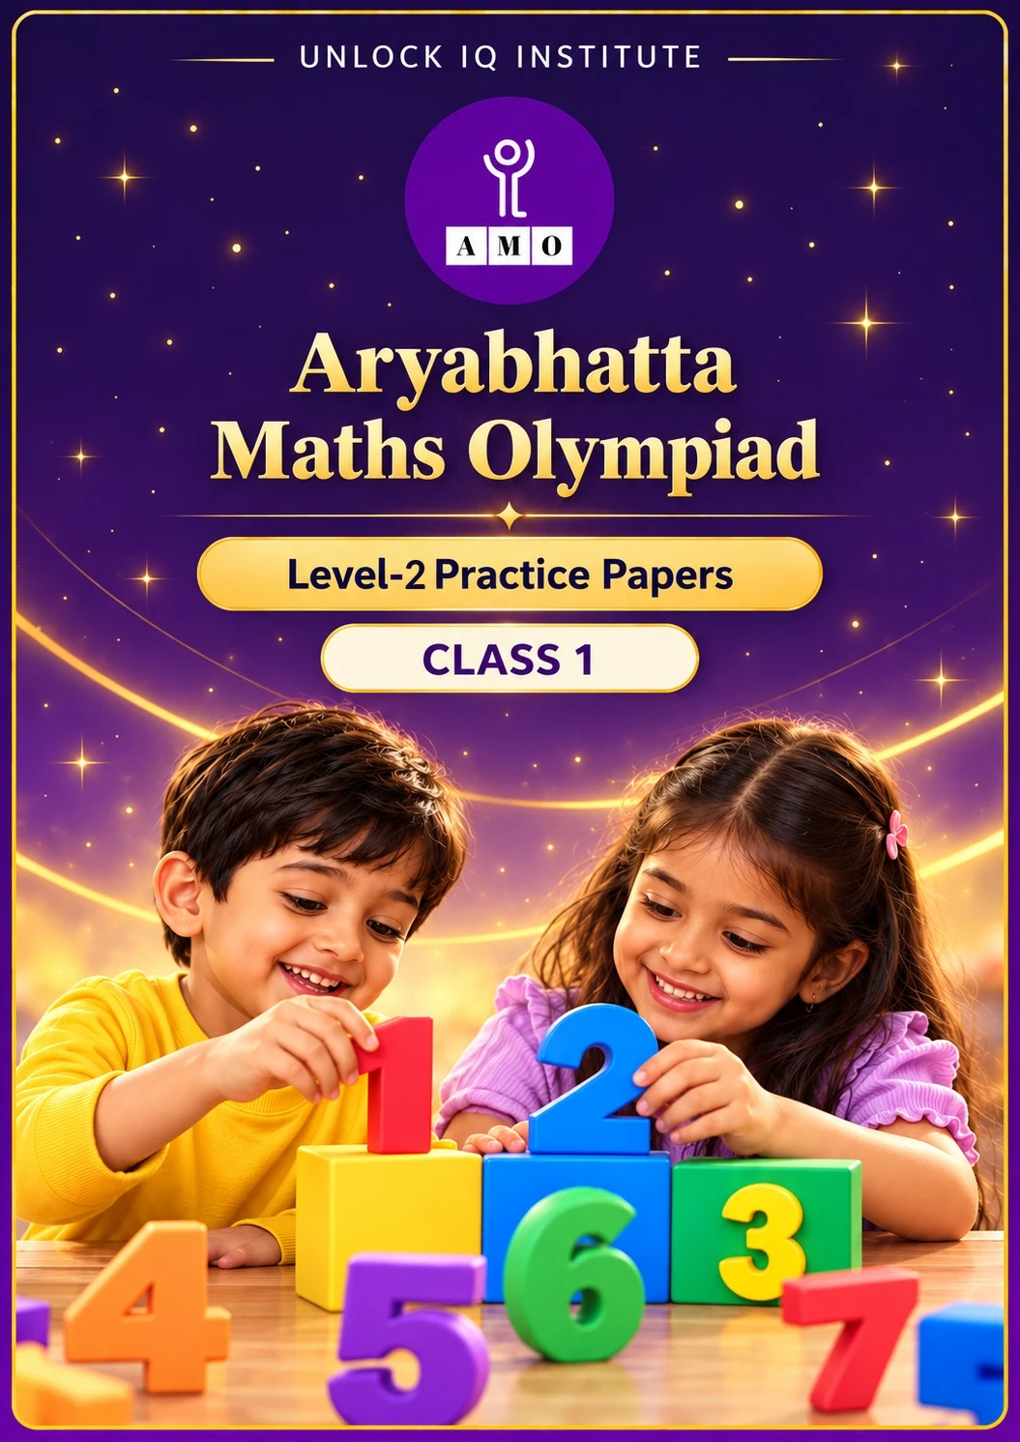
Set 2 · Practice Papers 6–10 · with answer keys & detailed solutions
Name: ____________________ | Class & Section: ________________
Roll No.: ________________ | School: ____________________
City: ____________________ | Date: ____________________

Published by Unlock IQ Institute Pvt. Ltd.
Register for Olympiads: www.aryabhattamathsolympiad.com/student-registration

ARYABHATTA MATHS OLYMPIAD
Level 2
PRACTICE PAPER-6
CLASS 1
Total Questions | 30 multiple-choice questions
Level | Level-2 (final round): every question is Hard
Time | 45 minutes
Section I | 25 questions, each from one chapter
Section II | 5 Star Questions, each joining two chapters
Negative Marking | No negative marking
Calculator | Not allowed
Chapters | Number System · Operations · Geometry · Applied Mathematics · Mathematical Reasoning

👋 Hello, friend! How to do this paper:
⭐ Every question has four answer choices: (A), (B), (C) and (D). Only one is correct.
⭐ Read each question and look at its picture carefully. Then mark your answer on the answer sheet at the end.
⭐ This is a Level-2 paper. Every question needs careful thinking, so take your time and check each step.
⭐ Section I has 25 questions. Section II has 5 Star Questions.
⭐ There is no negative marking, so try every question.
⭐ Do not use a calculator. You may do rough work on a separate sheet.
⭐ All figures are not necessarily drawn to scale unless stated.

For parents and teachers
• Pictures are part of the questions. Every picture also works when printed in black and white.
• You may read a question aloud to the child, exactly as printed. Please do not explain it or point to an answer choice.
• Parts follow the AMO syllabus chapters. Chapters 3, 4, 6, 7 and 8 are not part of the Class 1 syllabus, so the chapter numbers shown in the Part headings have gaps.
• The answer sheet and the answer key are at the end. Remove only the answer key before the child begins.

SECTION I 25 questions · every question is Hard
Part 1 — Number System (Syllabus Chapter 1)
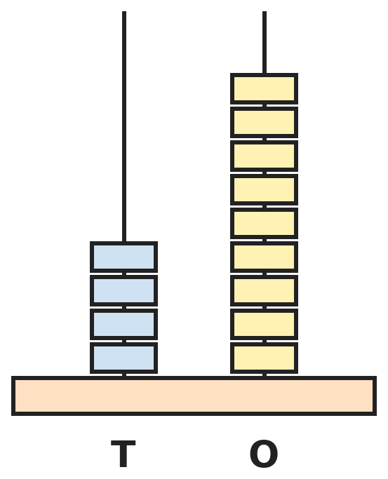
Q1. The abacus shows a number. A rod can hold at most 9 beads. What number will it show after 2 more ones are added?
(A) 411 | (B) 61 | (C) 51 | (D) 50

Q2. In a hall, Row 1 has seats 1 to 10, Row 2 has seats 11 to 20, and so on. In which row is seat 47?
(A) Row 4 | (B) Row 7 | (C) Row 6 | (D) Row 5

Q3. Kiara's book has pages numbered 1 to 50. Pages 21 to 30 are torn out. How many pages are left in the book?
(A) 41 | (B) 40 | (C) 30 | (D) 20

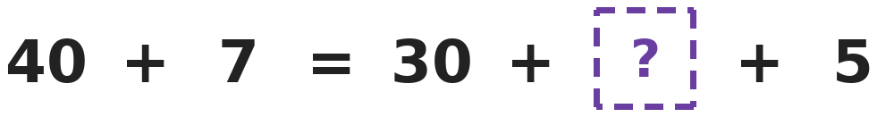
Q4. Both sides of the equals sign show the same number. Which number goes in the box with the question mark?
(A) 12 | (B) 17 | (C) 2 | (D) 7

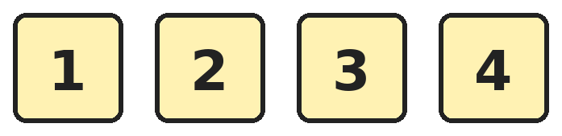
Q5. Varun makes 2-digit numbers using two different cards. In how many of his numbers is the tens digit bigger than the ones digit?
(A) 12 | (B) 4 | (C) 3 | (D) 6

Q6. Asha writes all the numbers from 1 to 12. How many digits does she write in all?
(A) 12 | (B) 14 | (C) 15 | (D) 24

Q7. Arjun thinks of the number that is 1 ten more than the number that is 1 ten less than 58. Which number is it?
(A) 68 | (B) 58 | (C) 48 | (D) 59

Part 2 — Operations (Syllabus Chapter 2)
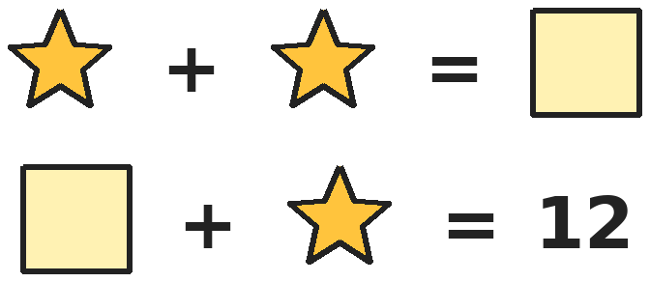
Q8. Shapes that look the same stand for the same number. What number does the square stand for?
(A) 4 | (B) 6 | (C) 8 | (D) 12

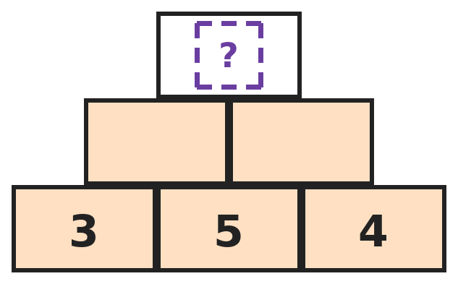
Q9. In this number wall, each brick is the sum of the two bricks just below it. Which number goes in the top brick?
(A) 17 | (B) 12 | (C) 16 | (D) 18

Q10. Rani thinks of two numbers that add up to 11. Both numbers are bigger than 3. The same two numbers in a different order count as one pair. How many pairs are possible?
(A) 2 | (B) 4 | (C) 5 | (D) 3

Q11. A small bus has 3 rows with 4 seats in each row. Two seats are empty and 1 child is standing. How many children are on the bus?
(A) 12 | (B) 9 | (C) 11 | (D) 13

Q12. Dev had 15 marbles and Yash had 4. Dev gave some marbles to Yash. Now Dev has 3 more marbles than Yash had at first. How many marbles did Dev give?
(A) 7 | (B) 8 | (C) 11 | (D) 4

Q13. Bela knows that 9 + 6 = 15. She changes the 9 to 7. What must the 6 change to so that the new total is 2 more than 15?
(A) 8 | (B) 4 | (C) 10 | (D) 6

Part 3 — Geometry (Syllabus Chapter 5)
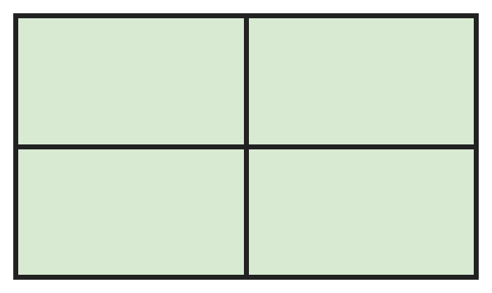
Q14. Meera's cupboard door has 4 equal panels. How many rectangles of all sizes can you find in it?
(A) 4 | (B) 5 | (C) 9 | (D) 8

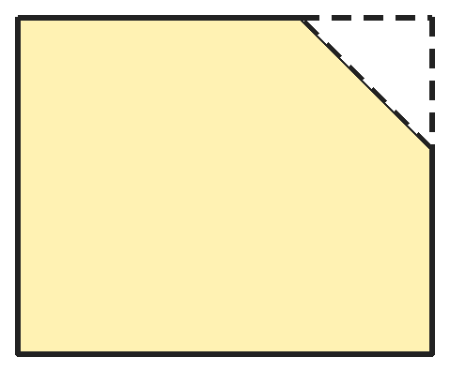
Q15. Naina cuts one corner off a square paper with one straight cut, as shown. How many corners does the big piece have now?
(A) 5 | (B) 4 | (C) 3 | (D) 6

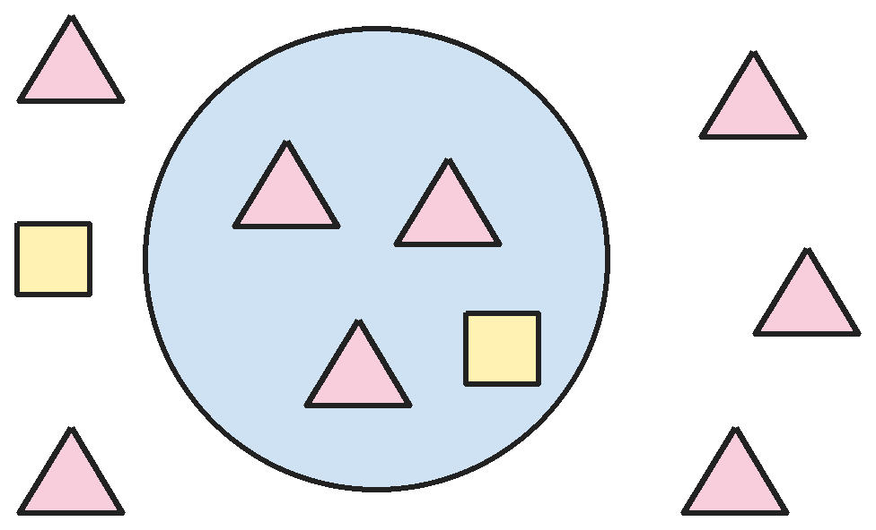
Q16. How many more triangles are outside the circle than inside it?
(A) 2 | (B) 8 | (C) 5 | (D) 3

Q17. Yash cuts a square along both of its corner-to-corner lines and gets 4 triangles. He joins two of the triangles along their longest sides. What shape does he make?
(A) A rectangle | (B) A smaller square
(C) A circle | (D) A bigger triangle

Part 4 — Applied Mathematics (Syllabus Chapter 9)
Q18. Which day comes 3 days before the day after Saturday?
(A) Wednesday | (B) Friday | (C) Tuesday | (D) Thursday

Q19. Pooja picks exactly two coins from ₹1, ₹2, ₹5 and ₹10 coins. Both coins may be of the same kind. Which amount can she NOT make?
(A) ₹7 | (B) ₹11 | (C) ₹15 | (D) ₹8

Q20. Which month is exactly in the middle of March and November, with the same number of months before it as after it?
(A) June | (B) July | (C) August | (D) September

Q21. A month has 30 days. Its 1st day is a Monday. How many Mondays are there in that month?
(A) 4 | (B) 5 | (C) 6 | (D) 3

Part 5 — Mathematical Reasoning (Syllabus Chapter 10)

Q22. Om walks on a number track and steps on these numbers in order. If he keeps going the same way, which number does he step on next?
(A) 9 | (B) 11 | (C) 4 | (D) 6

Q23. Shirt numbers should go 2, 5, 9, 14 and so on, adding one more each time. One shirt in this list is wrong: 2, 5, 9, 15, 20. Which number is wrong?
(A) 9 | (B) 15 | (C) 20 | (D) 5

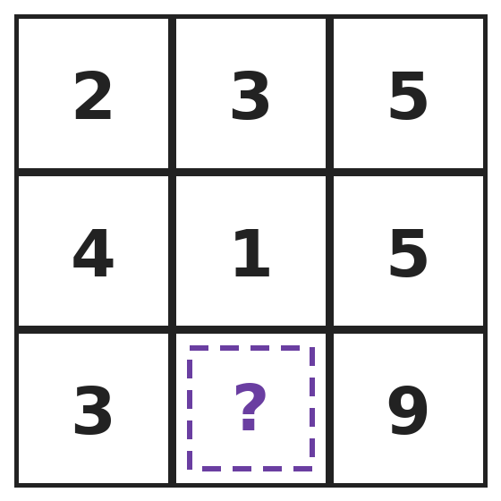
Q24. The numbers in every row of this table follow the same rule. Which number is hidden by the question mark?
(A) 6 | (B) 3 | (C) 12 | (D) 5

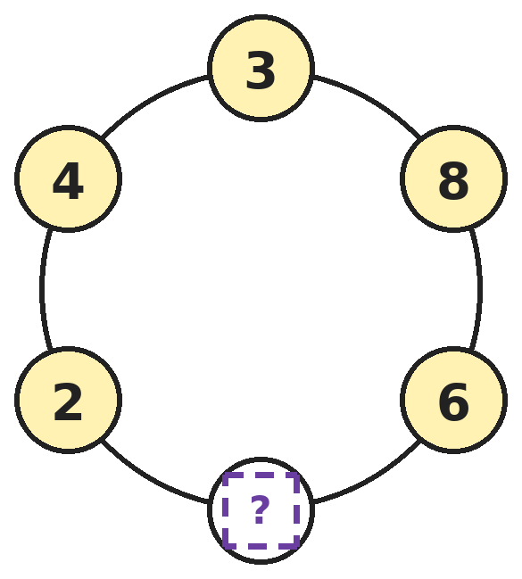
Q25. In this ring, each number and the number straight across from it add up to the same total. Which number is hidden?
(A) 1 | (B) 5 | (C) 9 | (D) 7

SECTION II — Star Questions 5 questions · each joins two chapters

Q26. Look carefully at how this pattern is built. Which number comes next? [Star]
(A) 37 | (B) 46 | (C) 45 | (D) 44

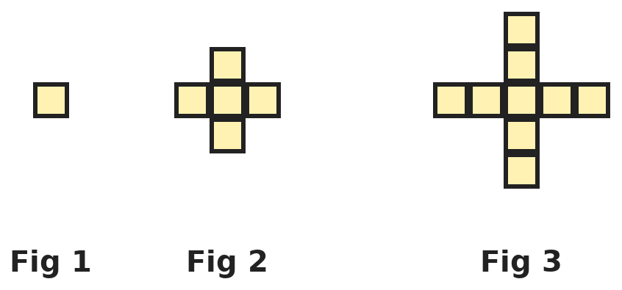
Q27. Each figure is made of small squares. The figures keep growing in the same way. How many small squares will Figure 4 have? [Star]
(A) 12 | (B) 16 | (C) 13 | (D) 17

Q28. On Monday, Kunal puts ₹1 in his piggy bank. Each day he puts in ₹1 more than the day before. How much has he put in altogether by the end of Friday? [Star]
(A) ₹15 | (B) ₹5 | (C) ₹10 | (D) ₹21

Q29. A month has dates from 1 to 31. How many of these dates have the digit 2 in them? [Star]
(A) 11 | (B) 12 | (C) 10 | (D) 13

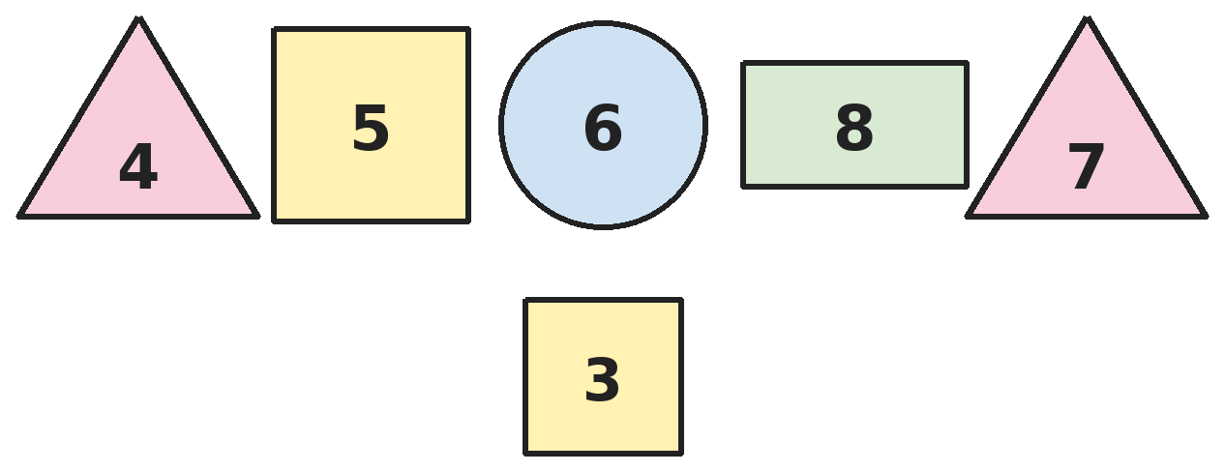
Q30. Each shape has a number inside it. What is the total of the numbers inside all the shapes that have exactly 4 corners? [Star]
(A) 22 | (B) 11 | (C) 33 | (D) 16

Answer Sheet AMO Level 2 · Class 1 · Practice Paper 6
Name: | School: | Roll No.:
Shade or tick one circle for each question.
1. | Ⓐ Ⓑ Ⓒ Ⓓ | 11. | Ⓐ Ⓑ Ⓒ Ⓓ | 21. | Ⓐ Ⓑ Ⓒ Ⓓ
2. | Ⓐ Ⓑ Ⓒ Ⓓ | 12. | Ⓐ Ⓑ Ⓒ Ⓓ | 22. | Ⓐ Ⓑ Ⓒ Ⓓ
3. | Ⓐ Ⓑ Ⓒ Ⓓ | 13. | Ⓐ Ⓑ Ⓒ Ⓓ | 23. | Ⓐ Ⓑ Ⓒ Ⓓ
4. | Ⓐ Ⓑ Ⓒ Ⓓ | 14. | Ⓐ Ⓑ Ⓒ Ⓓ | 24. | Ⓐ Ⓑ Ⓒ Ⓓ
5. | Ⓐ Ⓑ Ⓒ Ⓓ | 15. | Ⓐ Ⓑ Ⓒ Ⓓ | 25. | Ⓐ Ⓑ Ⓒ Ⓓ
6. | Ⓐ Ⓑ Ⓒ Ⓓ | 16. | Ⓐ Ⓑ Ⓒ Ⓓ | 26. | Ⓐ Ⓑ Ⓒ Ⓓ
7. | Ⓐ Ⓑ Ⓒ Ⓓ | 17. | Ⓐ Ⓑ Ⓒ Ⓓ | 27. | Ⓐ Ⓑ Ⓒ Ⓓ
8. | Ⓐ Ⓑ Ⓒ Ⓓ | 18. | Ⓐ Ⓑ Ⓒ Ⓓ | 28. | Ⓐ Ⓑ Ⓒ Ⓓ
9. | Ⓐ Ⓑ Ⓒ Ⓓ | 19. | Ⓐ Ⓑ Ⓒ Ⓓ | 29. | Ⓐ Ⓑ Ⓒ Ⓓ
10. | Ⓐ Ⓑ Ⓒ Ⓓ | 20. | Ⓐ Ⓑ Ⓒ Ⓓ | 30. | Ⓐ Ⓑ Ⓒ Ⓓ
Q26–Q30 are Section II Star Questions. Each joins two chapters.
For the parent or teacher
Section I correct: ______ / 25 Section II correct: ______ / 5
Correct: ______ / 30
Answer Key and Solutions AMO Level 2 · Class 1 · Practice Paper 6
Quick answers
1 C | 6 C | 11 C | 16 A | 21 B | 26 D
2 D | 7 B | 12 B | 17 B | 22 D | 27 C
3 B | 8 C | 13 C | 18 D | 23 B | 28 A
4 A | 9 A | 14 C | 19 D | 24 A | 29 B
5 D | 10 A | 15 A | 20 B | 25 D | 30 D
Solutions
Q | Part · level | Answer | Why?
1 | Part 1 · Ch1 · Hard | (C) 51 | Hint: Ten ones beads are swapped for one tens bead.  The abacus shows 4 tens and 9 ones, which is 49. Two more ones make 11 ones, which is 1 ten and 1 one. So it shows 5 tens and 1 one: 51.
2 | Part 1 · Ch1 · Hard | (D) Row 5 | Hint: Find where each row ends.  Row 1 ends at 10, Row 2 at 20, Row 3 at 30, Row 4 at 40 and Row 5 at 50. Seat 47 comes after 40 and before 50, so it is in Row 5.
3 | Part 1 · Ch1 · Hard | (B) 40 | Hint: First count the torn pages. Count both page 21 and page 30.  The torn pages are 21, 22, … , 30. That is 10 pages, not 30 − 21 = 9. So 50 − 10 = 40 pages are left (5 tens take away 1 ten).
4 | Part 1 · Ch1 · Hard | (A) 12 | Hint: First find what 40 + 7 makes. Then see what is still missing on the right.  40 + 7 = 47, which is 4 tens and 7 ones. The right side already has 3 tens and 5 ones. It still needs 1 ten and 2 ones, which is 12.
5 | Part 1 · Ch1 · Hard | (D) 6 | Hint: Choose the tens digit first, then a smaller ones digit.  Tens digit 2: 21. Tens digit 3: 31 and 32. Tens digit 4: 41, 42 and 43. That is 1 + 2 + 3 = 6 numbers.
6 | Part 1 · Ch1 · Hard | (C) 15 | Hint: Numbers 1 to 9 have one digit. 10, 11 and 12 have two digits.  1 to 9 use 9 digits. 10, 11 and 12 use 2 + 2 + 2 = 6 digits. In all 9 + 6 = 15 digits.
7 | Part 1 · Ch1 · Hard | (B) 58 | Hint: Go one ten down, then one ten up.  1 ten less than 58 is 48. 1 ten more than 48 is 58. Going down and up by the same amount brings him back to 58.
8 | Part 2 · Ch2 · Hard | (C) 8 | Hint: Swap the square for two stars in the second line.  The square is star + star, so the second line is star + star + star = 12. Since 4 + 4 + 4 = 12, each star is 4. The square is 4 + 4 = 8.
9 | Part 2 · Ch2 · Hard | (A) 17 | Hint: Fill in the middle row first.  The middle bricks are 3 + 5 = 8 and 5 + 4 = 9. The top brick is 8 + 9 = 17.
10 | Part 2 · Ch2 · Hard | (A) 2 | Hint: List the pairs that make 11, then cross out any with a number that is 3 or less.  Pairs that make 11: 1 and 10, 2 and 9, 3 and 8, 4 and 7, 5 and 6. Only 4 and 7, and 5 and 6, have both numbers bigger than 3. That is 2 pairs.
11 | Part 2 · Ch2 · Hard | (C) 11 | Hint: First count all the seats.  There are 4 + 4 + 4 = 12 seats. Two are empty, so 12 − 2 = 10 children are sitting. With 1 child standing, there are 10 + 1 = 11 children.
12 | Part 2 · Ch2 · Hard | (B) 8 | Hint: Find how many marbles Dev has now.  Yash had 4 at first, so Dev now has 4 + 3 = 7. Dev started with 15, so he gave away 15 − 7 = 8 marbles.
13 | Part 2 · Ch2 · Hard | (C) 10 | Hint: First find the new total. Then find what goes with 7.  2 more than 15 is 17. So 7 + ? = 17. Since 7 + 10 = 17, the 6 must change to 10.
14 | Part 3 · Ch5 · Hard | (C) 9 | Hint: Count 1 panel, 2 panels and all 4 panels.  One panel: 4 rectangles. Two panels side by side: 2. Two panels one above the other: 2. All four panels: 1. Total 4 + 2 + 2 + 1 = 9.
15 | Part 3 · Ch5 · Hard | (A) 5 | Hint: The cut takes away one corner. How many new corners does it make?  The square had 4 corners. The cut takes away 1 corner but makes 2 new corners, one at each end of the cut. 4 − 1 + 2 = 5 corners.
16 | Part 3 · Ch5 · Hard | (A) 2 | Hint: Count the triangles inside and outside separately. Ignore the squares.  Inside the circle there are 3 triangles. Outside there are 5 triangles. 5 − 3 = 2 more outside.
17 | Part 3 · Ch5 · Hard | (B) A smaller square | Hint: Each triangle has a square corner. Imagine putting two long sides together.  Each of the 4 triangles has one square corner and two equal short sides. Joining two of them along the long side puts their square corners opposite each other. The shape has 4 equal sides and 4 square corners, so it is a smaller square.
18 | Part 4 · Ch9 · Hard | (D) Thursday | Hint: First find the day after Saturday.  The day after Saturday is Sunday. Three days before Sunday: Saturday, Friday, Thursday. The answer is Thursday.
19 | Part 4 · Ch9 · Hard | (D) ₹8 | Hint: List what two coins can make.  Two of these coins can make ₹2, ₹3, ₹4, ₹6, ₹7, ₹10, ₹11, ₹12, ₹15 or ₹20. For example ₹7 is ₹5 + ₹2, ₹11 is ₹10 + ₹1 and ₹15 is ₹10 + ₹5. ₹8 is not in the list, so it cannot be made.
20 | Part 4 · Ch9 · Hard | (B) July | Hint: Write the months from March to November in order.  The months are March, April, May, June, July, August, September, October, November. There are 9 of them. July is 5th, with 4 months before it and 4 after it.
21 | Part 4 · Ch9 · Hard | (B) 5 | Hint: Mondays come every 7 days.  The Mondays are the 1st, 8th, 15th, 22nd and 29th. The next would be the 36th, which is not in the month. So there are 5 Mondays.
22 | Part 5 · Ch10 · Hard | (D) 6 | Hint: Look at how he moves each time.  He goes up 3, then back 2, again and again: 3, 6, 4, 7, 5, 8. Next he goes back 2: 8 − 2 = 6.
23 | Part 5 · Ch10 · Hard | (B) 15 | Hint: Look at what is added each time: 3, then 4, then …  The pattern adds 3, 4, 5, 6: 2, 5, 9, 14, 20. So 15 is wrong and should be 14. Then 14 + 6 = 20 is right.
24 | Part 5 · Ch10 · Hard | (A) 6 | Hint: Look at how the first two numbers in a row make the third.  In each row the first two numbers add up to the third: 2 + 3 = 5 and 4 + 1 = 5. So 3 + ? = 9, which means ? = 6.
25 | Part 5 · Ch10 · Hard | (D) 7 | Hint: Look at a pair that is complete, like 8 and 2.  8 and 2 are across from each other and make 10. 6 and 4 also make 10. The hidden number is across from 3, so 3 + ? = 10, and ? = 7.
26 | Section II · Ch1 + Ch10 · Hard | (D) 44 | Hint: Look at the numbers in pairs.  The pairs are 11 and 13, 22 and 24, 33 and 35. Each pair starts with a number whose two digits are the same, then adds 2. The next pair starts with 44.
27 | Section II · Ch5 + Ch10 · Hard | (C) 13 | Hint: How many squares are added from one figure to the next?  Figure 1 has 1 square, Figure 2 has 5 and Figure 3 has 9. Each time 4 squares are added, one on each arm. Figure 4 has 9 + 4 = 13.
28 | Section II · Ch9 + Ch10 · Hard | (A) ₹15 | Hint: Write the amount for each day from Monday to Friday.  Monday ₹1, Tuesday ₹2, Wednesday ₹3, Thursday ₹4, Friday ₹5. Altogether 1 + 2 + 3 + 4 + 5 = ₹15.
29 | Section II · Ch1 + Ch9 · Hard | (B) 12 | Hint: Check 1 to 9, then the teens, then the twenties.  The dates are 2, 12, and all ten dates from 20 to 29. That is 1 + 1 + 10 = 12 dates. The 22nd has two 2s but is one date.
30 | Section II · Ch2 + Ch5 · Hard | (D) 16 | Hint: Squares and rectangles have 4 corners. Triangles have 3 and circles have none.  The 4-cornered shapes are the two squares and the rectangle, with 5, 3 and 8. Their total is 5 + 3 + 8 = 16.

ARYABHATTA MATHS OLYMPIAD
Level 2
PRACTICE PAPER-7
CLASS 1
Total Questions | 30 multiple-choice questions
Level | Level-2 (final round): every question is Hard
Time | 45 minutes
Section I | 25 questions, each from one chapter
Section II | 5 Star Questions, each joining two chapters
Negative Marking | No negative marking
Calculator | Not allowed
Chapters | Number System · Operations · Geometry · Applied Mathematics · Mathematical Reasoning

👋 Hello, friend! How to do this paper:
⭐ Every question has four answer choices: (A), (B), (C) and (D). Only one is correct.
⭐ Read each question and look at its picture carefully. Then mark your answer on the answer sheet at the end.
⭐ This is a Level-2 paper. Every question needs careful thinking, so take your time and check each step.
⭐ Section I has 25 questions. Section II has 5 Star Questions.
⭐ There is no negative marking, so try every question.
⭐ Do not use a calculator. You may do rough work on a separate sheet.
⭐ All figures are not necessarily drawn to scale unless stated.

For parents and teachers
• Pictures are part of the questions. Every picture also works when printed in black and white.
• You may read a question aloud to the child, exactly as printed. Please do not explain it or point to an answer choice.
• Parts follow the AMO syllabus chapters. Chapters 3, 4, 6, 7 and 8 are not part of the Class 1 syllabus, so the chapter numbers shown in the Part headings have gaps.
• The answer sheet and the answer key are at the end. Remove only the answer key before the child begins.

SECTION I 25 questions · every question is Hard
Part 1 — Number System (Syllabus Chapter 1)
Q1. Which number name is for the number made of 1 ten and 17 ones?
(A) seventeen | (B) twenty-seven | (C) eighteen | (D) thirty-seven

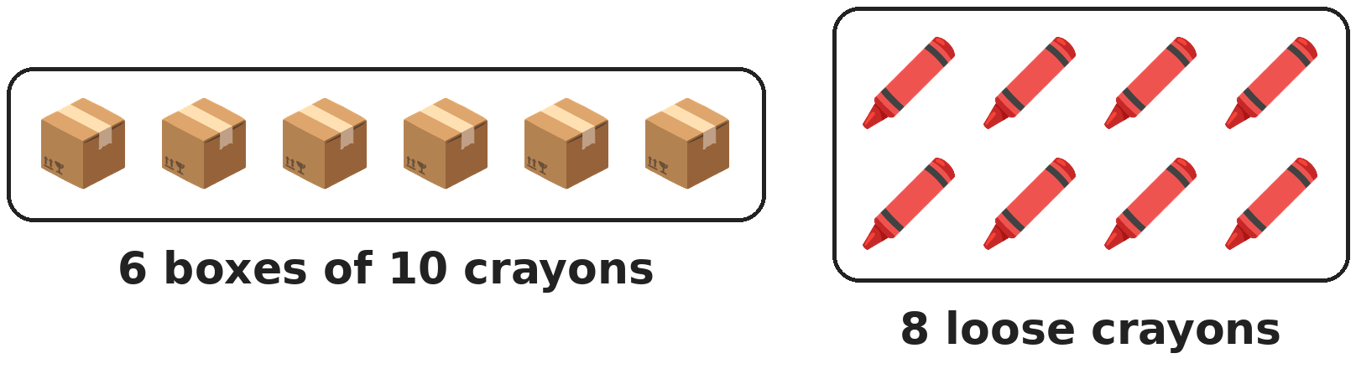
Q2. Meera has these crayons. She gives away 1 box and 3 loose crayons. How many crayons does she have left?
(A) 65 | (B) 55 | (C) 58 | (D) 45

Q3. Which digit is in the ones place of the number that is 1 ten more than the number just before 70?
(A) 9 | (B) 7 | (C) 0 | (D) 8

Q4. What is the largest 2-digit number whose two digits add up to 5?
(A) 41 | (B) 50 | (C) 32 | (D) 95

Q5. Which number is closer to 50: 46 or 53?
(A) 46 | (B) Both are equally close
(C) 53 | (D) 50

Q6. What is the smallest 2-digit number that has the digit 7 in it?
(A) 70 | (B) 7 | (C) 17 | (D) 27

Q7. How many 2-digit numbers have digits that add up to 3?
(A) 3 | (B) 2 | (C) 4 | (D) 6

Part 2 — Operations (Syllabus Chapter 2)
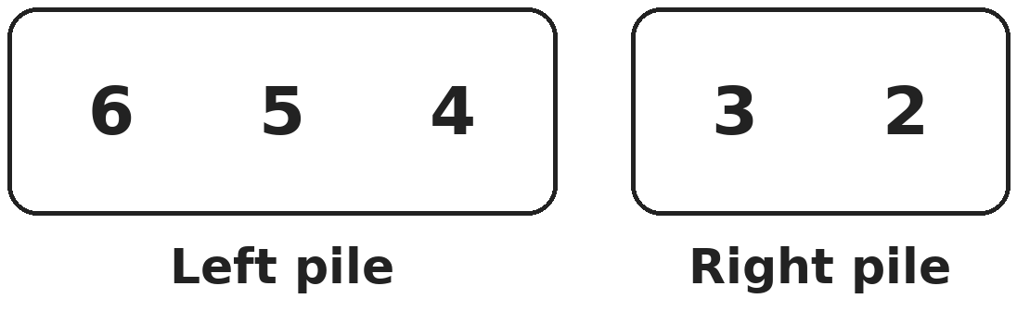
Q8. Hari moves one card from the left pile to the right pile. Now both piles add up to the same total. Which card does he move?
(A) 6 | (B) 4 | (C) 3 | (D) 5

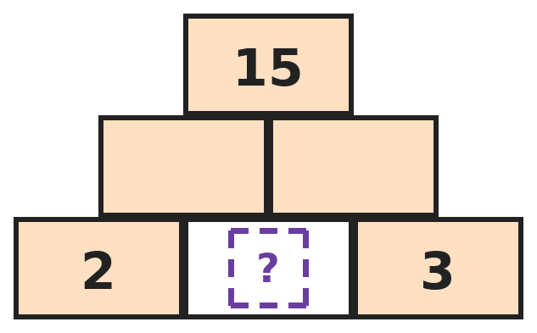
Q9. In this number wall, each brick is the sum of the two bricks just below it. Which number goes in the empty bottom brick?
(A) 10 | (B) 4 | (C) 6 | (D) 5

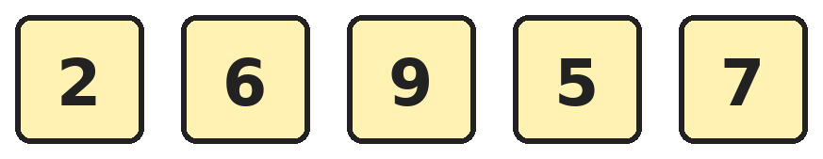
Q10. Kusum chooses three different cards that add up to exactly 20. Which three cards does she choose?
(A) 9, 5 and 7 | (B) 6, 9 and 7 | (C) 6, 9 and 5 | (D) 2, 9 and 7

Q11. Tanvi has 4 stickers. Raj has 3 more stickers than Tanvi. Mansi has 2 more stickers than Raj. How many stickers do the three children have in all?
(A) 9 | (B) 13 | (C) 16 | (D) 20

Q12. Two dice show a total of 9. One die shows 3 more than the other. Which numbers do the dice show?
(A) 4 and 5 | (B) 2 and 7 | (C) 1 and 8 | (D) 3 and 6

Q13. Anaya has 7 pairs of socks. She loses 3 single socks. How many socks does she have now?
(A) 11 | (B) 4 | (C) 14 | (D) 10

Part 3 — Geometry (Syllabus Chapter 5)
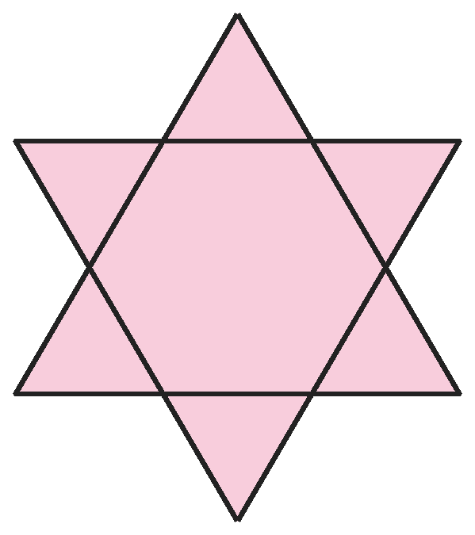
Q14. Sakshi draws one triangle pointing up and one pointing down to make a star. How many triangles of all sizes can you find?
(A) 6 | (B) 2 | (C) 7 | (D) 8

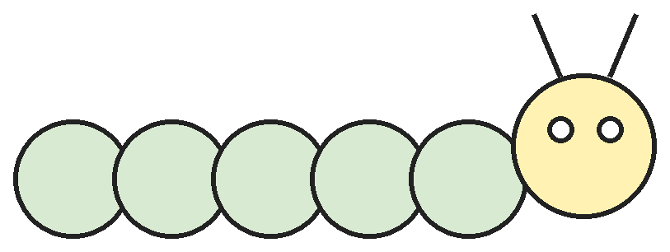
Q15. Kush draws a caterpillar using only circles and two lines. How many circles of all sizes are in his drawing?
(A) 6 | (B) 7 | (C) 5 | (D) 8

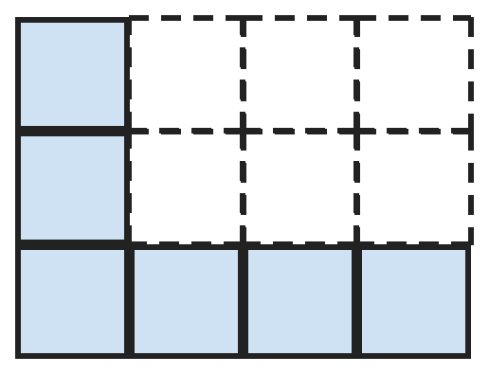
Q16. Gita has made the shaded L-shape out of small squares. How many more small squares does she need to fill the whole dotted rectangle?
(A) 12 | (B) 5 | (C) 6 | (D) 7

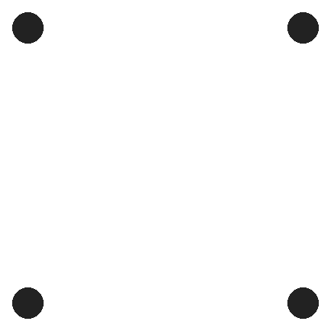
Q17. Ojas joins every pair of these four dots with a straight line. How many lines does he draw?
(A) 4 | (B) 6 | (C) 8 | (D) 5

Part 4 — Applied Mathematics (Syllabus Chapter 9)
Q18. Which month is 2 months after the month that comes right after October?
(A) January | (B) December | (C) February | (D) March

Q19. A pen costs ₹7. Rahul pays using only ₹5 coins, giving as few coins as he can. How much change does he get back?
(A) ₹2 | (B) ₹3 | (C) ₹8 | (D) ₹5

Q20. Which of these is worth the least money?
(A) Six ₹1 coins | (B) Four ₹2 coins
(C) A ₹5 coin and a ₹2 coin | (D) A ₹5 coin and three ₹1 coins

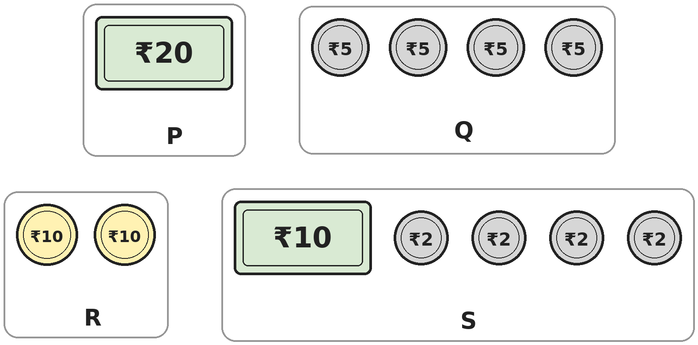
Q21. How many of the groups P, Q, R and S are worth exactly ₹20?
(A) 4 | (B) 2 | (C) 1 | (D) 3

Part 5 — Mathematical Reasoning (Syllabus Chapter 10)
Q22. Rohit counts back by 5s, starting at 50. What is the 6th number he says?
(A) 25 | (B) 20 | (C) 30 | (D) 35

Q23. Three of these cards match a number name with its tens and ones correctly. Which card is the odd one out?
(A) fifteen – 1 ten and 5 ones | (B) fourteen – 4 tens and 1 one
(C) fifty-one – 5 tens and 1 one | (D) forty – 4 tens and 0 ones

Q24. Kavya starts at 3 and jumps 4 each time: 3, 7, 11 and so on. Neel starts at 4 and jumps 3 each time: 4, 7, 10 and so on. After 7, which is the next number they both land on?
(A) 15 | (B) 16 | (C) 19 | (D) 22

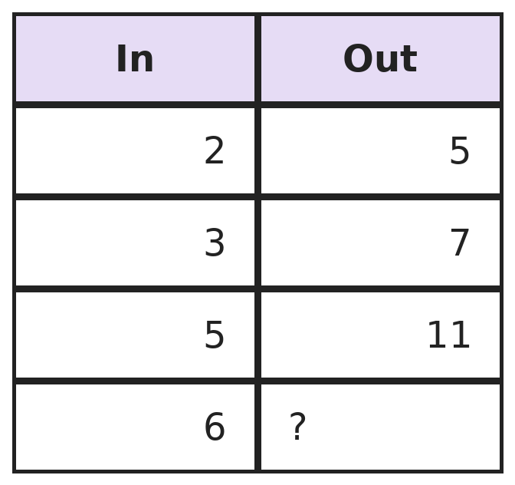
Q25. A number machine follows the same rule every time. What number comes out when 6 goes in?
(A) 13 | (B) 12 | (C) 9 | (D) 14

SECTION II — Star Questions 5 questions · each joins two chapters
Q26. Prachi counts in tens starting at 6: 6, 16, 26 and so on. Which number that she says has digits that add up to 10? [Star]
(A) 36 | (B) 46 | (C) 64 | (D) 56

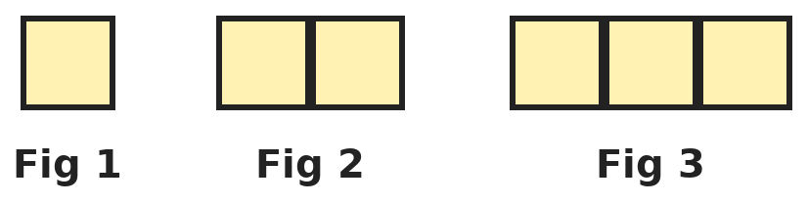
Q27. Each figure is a row of squares joined together. How many corners does the outline of Figure 10 have? [Star]
(A) 40 | (B) 20 | (C) 4 | (D) 22

Q28. The 1st of a month is a Wednesday. On which date is the third Friday of that month? [Star]
(A) 10th | (B) 15th | (C) 24th | (D) 17th

Q29. Asha has six ₹10 notes. Ravi has four ₹10 notes and thirteen ₹1 coins. How many more ₹1 coins does Ravi need to have as much money as Asha? [Star]
(A) 3 | (B) 7 | (C) 13 | (D) 17

Q30. Leena draws 4 triangles. Kabir draws 2 squares. How many more corners are there in Leena's drawing than in Kabir's? [Star]
(A) 2 | (B) 12 | (C) 4 | (D) 8

Answer Sheet AMO Level 2 · Class 1 · Practice Paper 7
Name: | School: | Roll No.:
Shade or tick one circle for each question.
1. | Ⓐ Ⓑ Ⓒ Ⓓ | 11. | Ⓐ Ⓑ Ⓒ Ⓓ | 21. | Ⓐ Ⓑ Ⓒ Ⓓ
2. | Ⓐ Ⓑ Ⓒ Ⓓ | 12. | Ⓐ Ⓑ Ⓒ Ⓓ | 22. | Ⓐ Ⓑ Ⓒ Ⓓ
3. | Ⓐ Ⓑ Ⓒ Ⓓ | 13. | Ⓐ Ⓑ Ⓒ Ⓓ | 23. | Ⓐ Ⓑ Ⓒ Ⓓ
4. | Ⓐ Ⓑ Ⓒ Ⓓ | 14. | Ⓐ Ⓑ Ⓒ Ⓓ | 24. | Ⓐ Ⓑ Ⓒ Ⓓ
5. | Ⓐ Ⓑ Ⓒ Ⓓ | 15. | Ⓐ Ⓑ Ⓒ Ⓓ | 25. | Ⓐ Ⓑ Ⓒ Ⓓ
6. | Ⓐ Ⓑ Ⓒ Ⓓ | 16. | Ⓐ Ⓑ Ⓒ Ⓓ | 26. | Ⓐ Ⓑ Ⓒ Ⓓ
7. | Ⓐ Ⓑ Ⓒ Ⓓ | 17. | Ⓐ Ⓑ Ⓒ Ⓓ | 27. | Ⓐ Ⓑ Ⓒ Ⓓ
8. | Ⓐ Ⓑ Ⓒ Ⓓ | 18. | Ⓐ Ⓑ Ⓒ Ⓓ | 28. | Ⓐ Ⓑ Ⓒ Ⓓ
9. | Ⓐ Ⓑ Ⓒ Ⓓ | 19. | Ⓐ Ⓑ Ⓒ Ⓓ | 29. | Ⓐ Ⓑ Ⓒ Ⓓ
10. | Ⓐ Ⓑ Ⓒ Ⓓ | 20. | Ⓐ Ⓑ Ⓒ Ⓓ | 30. | Ⓐ Ⓑ Ⓒ Ⓓ
Q26–Q30 are Section II Star Questions. Each joins two chapters.
For the parent or teacher
Section I correct: ______ / 25 Section II correct: ______ / 5
Correct: ______ / 30
Answer Key and Solutions AMO Level 2 · Class 1 · Practice Paper 7
Quick answers
1 B | 6 C | 11 D | 16 C | 21 D | 26 B
2 B | 7 A | 12 D | 17 B | 22 A | 27 C
3 A | 8 D | 13 A | 18 A | 23 B | 28 D
4 B | 9 D | 14 D | 19 B | 24 C | 29 B
5 C | 10 C | 15 D | 20 A | 25 A | 30 C
Solutions
Q | Part · level | Answer | Why?
1 | Part 1 · Ch1 · Hard | (B) twenty-seven | Hint: 17 ones are 1 ten and 7 ones.  17 ones are 1 ten and 7 ones. With the 1 ten we already have, that makes 2 tens and 7 ones, which is 27: twenty-seven.
2 | Part 1 · Ch1 · Hard | (B) 55 | Hint: Work with the boxes (tens) and the loose crayons (ones) separately.  She has 6 tens and 8 ones, which is 68. Giving away 1 box leaves 5 tens. Giving away 3 loose crayons leaves 5 ones. So she has 55 crayons.
3 | Part 1 · Ch1 · Hard | (A) 9 | Hint: First find the number just before 70.  The number just before 70 is 69. One ten more than 69 is 79. Its ones digit is 9.
4 | Part 1 · Ch1 · Hard | (B) 50 | Hint: Make the tens digit as big as you can.  The tens digit can be at most 5, because the digits must add up to 5. Then the ones digit is 0. So the largest number is 50.
5 | Part 1 · Ch1 · Hard | (C) 53 | Hint: Count the steps from each number to 50.  From 46 to 50 is 4 steps: 47, 48, 49, 50. From 53 to 50 is 3 steps: 52, 51, 50. So 53 is closer.
6 | Part 1 · Ch1 · Hard | (C) 17 | Hint: The 7 does not have to be the tens digit.  A 2-digit number with tens digit 1 is the smallest kind. With 7 as the ones digit we get 17. 7 is only a 1-digit number, and 27 and 70 are bigger than 17.
7 | Part 1 · Ch1 · Hard | (A) 3 | Hint: The tens digit cannot be 0.  Tens digit 1 gives 12. Tens digit 2 gives 21. Tens digit 3 gives 30. That is 3 numbers.
8 | Part 2 · Ch2 · Hard | (D) 5 | Hint: Find the total of all the cards. Each pile must get half of it.  The left pile adds to 15 and the right pile to 5, so all the cards make 20. Each pile must make 10. Moving the 5 gives left 6 + 4 = 10 and right 3 + 2 + 5 = 10.
9 | Part 2 · Ch2 · Hard | (D) 5 | Hint: Try a number and build the wall upwards.  Try 5: the middle bricks are 2 + 5 = 7 and 5 + 3 = 8, and the top is 7 + 8 = 15. It works. Trying 4 gives a top of 13, and 6 gives 17.
10 | Part 2 · Ch2 · Hard | (C) 6, 9 and 5 | Hint: Add each group carefully.  6 + 9 + 5 = 20. The other groups make 9 + 5 + 7 = 21, 6 + 9 + 7 = 22 and 2 + 9 + 7 = 18.
11 | Part 2 · Ch2 · Hard | (D) 20 | Hint: Find how many each child has, then add.  Tanvi has 4. Raj has 4 + 3 = 7. Mansi has 7 + 2 = 9. In all 4 + 7 + 9 = 20 stickers.
12 | Part 2 · Ch2 · Hard | (D) 3 and 6 | Hint: A die shows only the numbers 1 to 6.  3 and 6 make 9, and 6 is 3 more than 3. 4 and 5 make 9 but differ by only 1. 2 and 7, and 1 and 8, are not possible on dice.
13 | Part 2 · Ch2 · Hard | (A) 11 | Hint: A pair is 2 socks.  7 pairs are 2 + 2 + 2 + 2 + 2 + 2 + 2 = 14 socks. After losing 3, she has 14 − 3 = 11 socks.
14 | Part 3 · Ch5 · Hard | (D) 8 | Hint: Count the small points of the star, then the two big triangles.  Each of the 6 points of the star is a small triangle. The two big triangles she drew make 2 more. 6 + 2 = 8.
15 | Part 3 · Ch5 · Hard | (D) 8 | Hint: Count the body, the head and the small circles on the head.  The body has 5 circles and the head is 1 more circle. The two eyes are 2 small circles. 5 + 1 + 2 = 8 circles.
16 | Part 3 · Ch5 · Hard | (C) 6 | Hint: Count all the boxes in the rectangle, then the shaded ones.  The rectangle has 3 rows of 4 boxes: 4 + 4 + 4 = 12. The L-shape uses 6 boxes. She needs 12 − 6 = 6 more.
17 | Part 3 · Ch5 · Hard | (B) 6 | Hint: Do not forget the lines that go from corner to corner across the middle.  There are 4 lines round the outside, making a square. There are also 2 lines across the middle, from corner to opposite corner. 4 + 2 = 6 lines.
18 | Part 4 · Ch9 · Hard | (A) January | Hint: After December, the months start again with January.  The month right after October is November. Two months after November: December, then January.
19 | Part 4 · Ch9 · Hard | (B) ₹3 | Hint: One ₹5 coin is not enough. How many does he need?  One ₹5 coin is less than ₹7, so he gives two coins: ₹5 + ₹5 = ₹10. His change is ₹10 − ₹7 = ₹3.
20 | Part 4 · Ch9 · Hard | (A) Six ₹1 coins | Hint: Work out the value of each group. More coins does not always mean more money.  Six ₹1 coins make ₹6. Four ₹2 coins make ₹8. A ₹5 and a ₹2 coin make ₹7. A ₹5 and three ₹1 coins make ₹8. The least is six ₹1 coins.
21 | Part 4 · Ch9 · Hard | (D) 3 | Hint: Add up each group.  P is ₹20. Q is ₹5 + ₹5 + ₹5 + ₹5 = ₹20. R is ₹10 + ₹10 = ₹20. S is ₹10 + ₹2 + ₹2 + ₹2 + ₹2 = ₹18. So 3 groups are worth ₹20.
22 | Part 5 · Ch10 · Hard | (A) 25 | Hint: 50 is the 1st number he says.  He says 50, 45, 40, 35, 30, 25. The 6th number is 25.
23 | Part 5 · Ch10 · Hard | (B) fourteen – 4 tens and 1 one | Hint: Write each number name as a number first.  Fifteen is 15, fifty-one is 51 and forty is 40, and those cards are right. Fourteen is 14, which is 1 ten and 4 ones, not 4 tens and 1 one (that is 41).
24 | Part 5 · Ch10 · Hard | (C) 19 | Hint: Write both lists a little further.  Kavya lands on 3, 7, 11, 15, 19, 23. Neel lands on 4, 7, 10, 13, 16, 19. After 7, the next number in both lists is 19.
25 | Part 5 · Ch10 · Hard | (A) 13 | Hint: Adding the same number each time does not work here. Try doubling.  2 → 5, 3 → 7, 5 → 11: each number is doubled and then 1 is added (2 + 2 + 1 = 5). So 6 → 6 + 6 + 1 = 13.
26 | Section II · Ch1 + Ch10 · Hard | (B) 46 | Hint: Every number she says ends in 6.  Every number she says has ones digit 6. To make 10, the tens digit must be 4, since 4 + 6 = 10. So the number is 46. 64 has the right digits but she never says it.
27 | Section II · Ch5 + Ch10 · Hard | (C) 4 | Hint: Look only at the outside edge of each figure.  Squares joined in a row always make a rectangle. Figures 1, 2 and 3 all have an outline with 4 corners. Figure 10 is also a long rectangle, so its outline has 4 corners.
28 | Section II · Ch9 + Ch10 · Hard | (D) 17th | Hint: Find the date of the first Friday.  The 1st is Wednesday, so the first Friday is the 3rd. Fridays come every 7 days: 3rd, 10th, 17th. The third Friday is the 17th.
29 | Section II · Ch1 + Ch9 · Hard | (B) 7 | Hint: Write each amount as tens and ones.  Asha has 6 tens, which is ₹60. Ravi has 4 tens and 13 ones, which is 5 tens and 3 ones, or ₹53. From 53 to 60 is 7 more ones, so he needs 7 more ₹1 coins.
30 | Section II · Ch2 + Ch5 · Hard | (C) 4 | Hint: Find the total corners in each drawing first.  Leena's 4 triangles have 3 + 3 + 3 + 3 = 12 corners. Kabir's 2 squares have 4 + 4 = 8 corners. 12 − 8 = 4 more.

ARYABHATTA MATHS OLYMPIAD
Level 2
PRACTICE PAPER-8
CLASS 1
Total Questions | 30 multiple-choice questions
Level | Level-2 (final round): every question is Hard
Time | 45 minutes
Section I | 25 questions, each from one chapter
Section II | 5 Star Questions, each joining two chapters
Negative Marking | No negative marking
Calculator | Not allowed
Chapters | Number System · Operations · Geometry · Applied Mathematics · Mathematical Reasoning

👋 Hello, friend! How to do this paper:
⭐ Every question has four answer choices: (A), (B), (C) and (D). Only one is correct.
⭐ Read each question and look at its picture carefully. Then mark your answer on the answer sheet at the end.
⭐ This is a Level-2 paper. Every question needs careful thinking, so take your time and check each step.
⭐ Section I has 25 questions. Section II has 5 Star Questions.
⭐ There is no negative marking, so try every question.
⭐ Do not use a calculator. You may do rough work on a separate sheet.
⭐ All figures are not necessarily drawn to scale unless stated.

For parents and teachers
• Pictures are part of the questions. Every picture also works when printed in black and white.
• You may read a question aloud to the child, exactly as printed. Please do not explain it or point to an answer choice.
• Parts follow the AMO syllabus chapters. Chapters 3, 4, 6, 7 and 8 are not part of the Class 1 syllabus, so the chapter numbers shown in the Part headings have gaps.
• The answer sheet and the answer key are at the end. Remove only the answer key before the child begins.

SECTION I 25 questions · every question is Hard
Part 1 — Number System (Syllabus Chapter 1)
Q1. Ruhi puts these number names in order from smallest to largest: forty-one, fourteen, forty, fifty-four. Which name comes second?
(A) fourteen | (B) forty-one | (C) fifty-four | (D) forty

Q2. Think of the smallest 2-digit number that has both digits the same. Which number is 5 more than it?
(A) 15 | (B) 27 | (C) 16 | (D) 6

Q3. Lata has 7 tens and 12 ones. How many more ones does she need to make 100?
(A) 3 | (B) 28 | (C) 81 | (D) 18

Q4. Om shows the number 36 on an abacus that has a tens rod and a ones rod. How many beads does he use in all?
(A) 36 | (B) 6 | (C) 9 | (D) 3

Q5. Meena scores 47 points in a game. Ravi scores 1 ten more than Meena. Om scores 2 ones less than Ravi. What is Om's score?
(A) 45 | (B) 57 | (C) 55 | (D) 59

Q6. How many 2-digit numbers are less than 25?
(A) 15 | (B) 25 | (C) 24 | (D) 14

Q7. How many numbers between 75 and 85 have 8 as their tens digit?
(A) 5 | (B) 4 | (C) 6 | (D) 10

Part 2 — Operations (Syllabus Chapter 2)
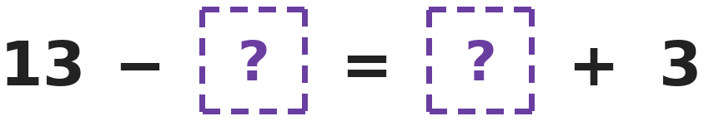
Q8. Both boxes hide the same number. Which number is it?
(A) 10 | (B) 5 | (C) 8 | (D) 4

Q9. In a board game, Siya is on square 7. She moves 6 squares forward, then 2 squares back, then 5 squares forward. On which square is she now?
(A) 16 | (B) 20 | (C) 11 | (D) 18

Q10. Asha has 9 stickers. Bela has 4 fewer stickers than double the number Asha has. How many stickers does Bela have?
(A) 5 | (B) 18 | (C) 14 | (D) 22

Q11. Which number is 8 more than the number that is 5 less than 14?
(A) 11 | (B) 17 | (C) 19 | (D) 9

Q12. Ravi's number is 6 more than 7. Om's number is 3 more than Ravi's number. What is Om's number?
(A) 16 | (B) 13 | (C) 10 | (D) 4

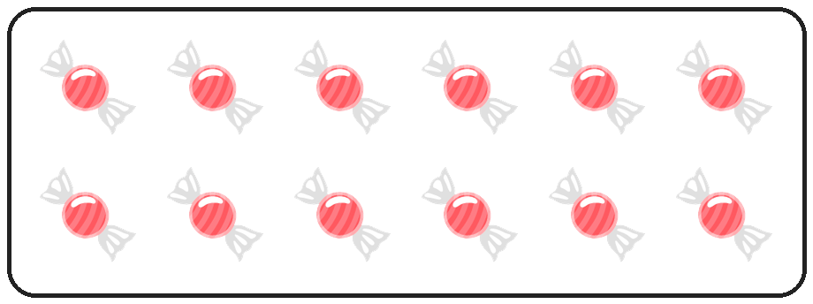
Q13. A box has 2 rows of 6 sweets. Yash eats 5 of them. How many sweets are left in the box?
(A) 7 | (B) 12 | (C) 6 | (D) 17

Part 3 — Geometry (Syllabus Chapter 5)
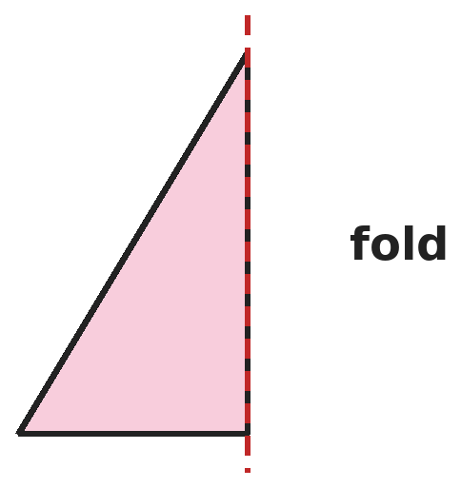
Q14. This is the left half of a shape. The dotted line is a fold line, like a mirror. What is the whole shape?
(A) Square | (B) Triangle | (C) Rectangle | (D) Circle

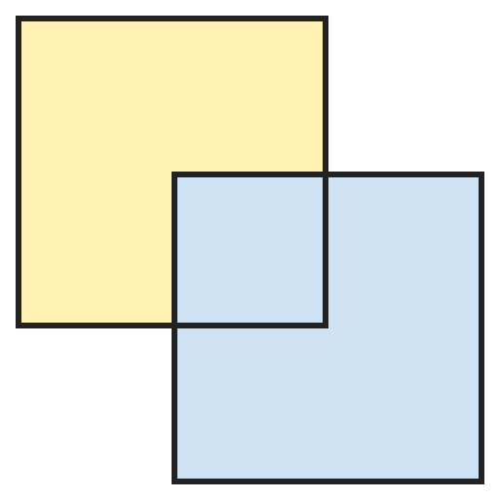
Q15. Two equal squares overlap as shown. The part where they overlap is also a square. How many squares can you find in the drawing?
(A) 3 | (B) 2 | (C) 4 | (D) 5

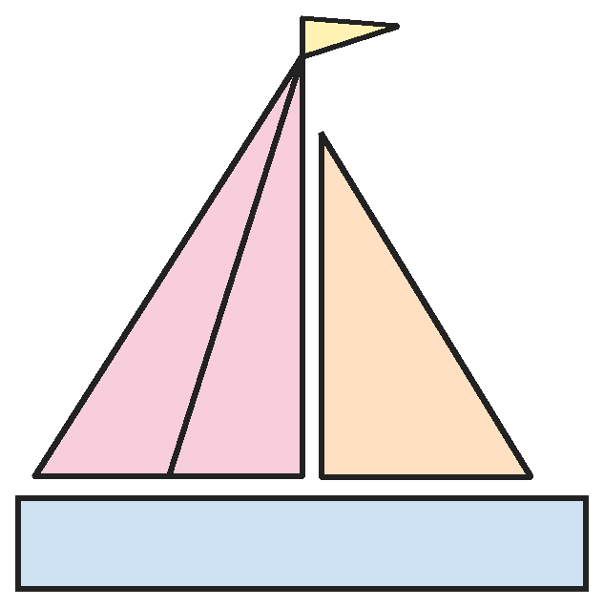
Q16. Look at the sailboat. The left sail has a line drawn on it. How many triangles of all sizes are there in the picture?
(A) 3 | (B) 4 | (C) 5 | (D) 6

Q17. Gaurav cuts a square along both of its middle lines, one across and one down. How many corners do all the pieces have altogether?
(A) 4 | (B) 8 | (C) 16 | (D) 12

Part 4 — Applied Mathematics (Syllabus Chapter 9)
Q18. In Vani's calendar, each week starts on Sunday. She counts the days starting with the first Sunday as day 1. Which day of the week is day 12?
(A) Friday | (B) Thursday | (C) Wednesday | (D) Monday

Q19. Tanya has one ₹10 note, one ₹5 coin and two ₹2 coins. She pays exactly ₹12 for a toy. How much money does she have left?
(A) ₹5 | (B) ₹9 | (C) ₹19 | (D) ₹7

Q20. Raju has one ₹1 coin, one ₹2 coin and one ₹5 coin. How many different amounts can he pay using one or more of these coins?
(A) 3 | (B) 8 | (C) 7 | (D) 6

Q21. Which month is the 4th month counting from the end of the year?
(A) October | (B) August | (C) April | (D) September

Part 5 — Mathematical Reasoning (Syllabus Chapter 10)
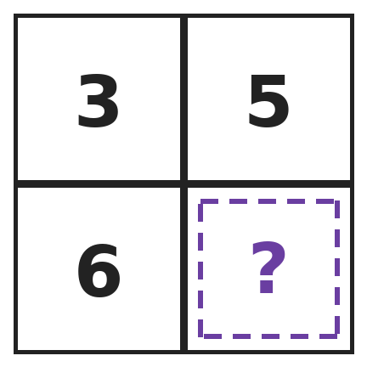
Q22. In this square, the two numbers on one corner-to-corner line add up to the same as the two numbers on the other corner-to-corner line. Which number is hidden?
(A) 14 | (B) 8 | (C) 2 | (D) 4

Q23. Mansi draws shapes in this pattern: 1 circle, then 2 squares, then 3 circles, then 4 squares, and so on. What is the 10th shape she draws?
(A) Circle | (B) Triangle | (C) Rectangle | (D) Square

Q24. Look at the pattern 95, 86, 77 and so on. What is the 6th number in the pattern?
(A) 50 | (B) 59 | (C) 41 | (D) 68

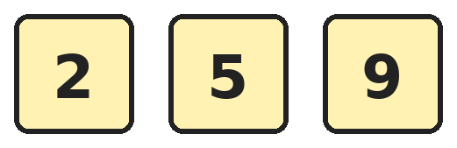
Q25. Ira adds any two different cards. Which total can she NOT get?
(A) 7 | (B) 11 | (C) 14 | (D) 12

SECTION II — Star Questions 5 questions · each joins two chapters
Q26. On a number chart, Om marks 5, 14, 23 and 32. He keeps going the same way. Which number does he mark next? [Star]
(A) 42 | (B) 41 | (C) 50 | (D) 31

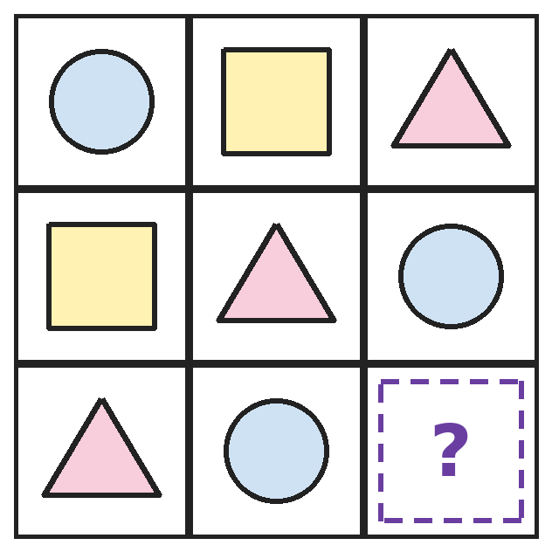
Q27. Each row and each column of this grid has one circle, one square and one triangle. Which shape goes in the box with the question mark? [Star]
(A) Circle | (B) Square | (C) Triangle | (D) Rectangle

Q28. A family checks their water tank every 4 months. The checks are in February, June and October. In which month is the next check? [Star]
(A) January | (B) December | (C) March | (D) February

Q29. How many days are there in 2 weeks and 6 days? Choose the answer written as tens and ones. [Star]
(A) 1 ten and 9 ones | (B) 2 tens and 6 ones
(C) 1 ten and 4 ones | (D) 2 tens and 0 ones

Q30. Arjun makes a square with sticks, using one stick for each side. Then he adds a triangle roof on top, using the top of the square as one side of the triangle. How many sticks does he use in all? [Star]
(A) 7 | (B) 6 | (C) 8 | (D) 5

Answer Sheet AMO Level 2 · Class 1 · Practice Paper 8
Name: | School: | Roll No.:
Shade or tick one circle for each question.
1. | Ⓐ Ⓑ Ⓒ Ⓓ | 11. | Ⓐ Ⓑ Ⓒ Ⓓ | 21. | Ⓐ Ⓑ Ⓒ Ⓓ
2. | Ⓐ Ⓑ Ⓒ Ⓓ | 12. | Ⓐ Ⓑ Ⓒ Ⓓ | 22. | Ⓐ Ⓑ Ⓒ Ⓓ
3. | Ⓐ Ⓑ Ⓒ Ⓓ | 13. | Ⓐ Ⓑ Ⓒ Ⓓ | 23. | Ⓐ Ⓑ Ⓒ Ⓓ
4. | Ⓐ Ⓑ Ⓒ Ⓓ | 14. | Ⓐ Ⓑ Ⓒ Ⓓ | 24. | Ⓐ Ⓑ Ⓒ Ⓓ
5. | Ⓐ Ⓑ Ⓒ Ⓓ | 15. | Ⓐ Ⓑ Ⓒ Ⓓ | 25. | Ⓐ Ⓑ Ⓒ Ⓓ
6. | Ⓐ Ⓑ Ⓒ Ⓓ | 16. | Ⓐ Ⓑ Ⓒ Ⓓ | 26. | Ⓐ Ⓑ Ⓒ Ⓓ
7. | Ⓐ Ⓑ Ⓒ Ⓓ | 17. | Ⓐ Ⓑ Ⓒ Ⓓ | 27. | Ⓐ Ⓑ Ⓒ Ⓓ
8. | Ⓐ Ⓑ Ⓒ Ⓓ | 18. | Ⓐ Ⓑ Ⓒ Ⓓ | 28. | Ⓐ Ⓑ Ⓒ Ⓓ
9. | Ⓐ Ⓑ Ⓒ Ⓓ | 19. | Ⓐ Ⓑ Ⓒ Ⓓ | 29. | Ⓐ Ⓑ Ⓒ Ⓓ
10. | Ⓐ Ⓑ Ⓒ Ⓓ | 20. | Ⓐ Ⓑ Ⓒ Ⓓ | 30. | Ⓐ Ⓑ Ⓒ Ⓓ
Q26–Q30 are Section II Star Questions. Each joins two chapters.
For the parent or teacher
Section I correct: ______ / 25 Section II correct: ______ / 5
Correct: ______ / 30
Answer Key and Solutions AMO Level 2 · Class 1 · Practice Paper 8
Quick answers
1 D | 6 A | 11 B | 16 C | 21 D | 26 B
2 C | 7 A | 12 A | 17 C | 22 B | 27 B
3 D | 8 B | 13 A | 18 B | 23 D | 28 D
4 C | 9 A | 14 B | 19 D | 24 A | 29 D
5 C | 10 C | 15 A | 20 C | 25 D | 30 B
Solutions
Q | Part · level | Answer | Why?
1 | Part 1 · Ch1 · Hard | (D) forty | Hint: Write each name as a number first.  The numbers are 41, 14, 40 and 54. In order: 14, 40, 41, 54. The second is 40, which is forty.
2 | Part 1 · Ch1 · Hard | (C) 16 | Hint: The smallest 2-digit number is 10, but its digits are not the same.  The smallest 2-digit number with both digits the same is 11. Five more than 11 is 16. (15 is 5 more than 10.)
3 | Part 1 · Ch1 · Hard | (D) 18 | Hint: First write 7 tens and 12 ones as a number.  7 tens and 12 ones are 8 tens and 2 ones, which is 82. From 82 to 90 is 8, and from 90 to 100 is 10. So she needs 8 + 10 = 18 more.
4 | Part 1 · Ch1 · Hard | (C) 9 | Hint: Each bead on the tens rod stands for one ten.  36 is 3 tens and 6 ones. He puts 3 beads on the tens rod and 6 beads on the ones rod. That is 3 + 6 = 9 beads.
5 | Part 1 · Ch1 · Hard | (C) 55 | Hint: Find Ravi's score first.  Ravi scores 1 ten more than 47, which is 57. Om scores 2 ones less than 57, which is 55.
6 | Part 1 · Ch1 · Hard | (A) 15 | Hint: The smallest 2-digit number is 10.  The 2-digit numbers less than 25 are 10, 11, … , 24. From 10 to 19 there are 10 numbers, and 20 to 24 are 5 more. That is 15.
7 | Part 1 · Ch1 · Hard | (A) 5 | Hint: "Between" means 75 and 85 do not count.  The numbers between 75 and 85 are 76 to 84. Of these, 80, 81, 82, 83 and 84 have tens digit 8. That is 5 numbers.
8 | Part 2 · Ch2 · Hard | (B) 5 | Hint: Try a number in both boxes and check both sides.  Try 5: 13 − 5 = 8 and 5 + 3 = 8. Both sides are 8, so the number is 5. Trying 4 gives 9 and 7, which are not equal.
9 | Part 2 · Ch2 · Hard | (A) 16 | Hint: Work out where she is after each move.  7 + 6 = 13. Then 13 − 2 = 11. Then 11 + 5 = 16. She is on square 16.
10 | Part 2 · Ch2 · Hard | (C) 14 | Hint: Double 9 means 9 + 9.  Double 9 is 9 + 9 = 18. Four fewer than 18 is 18 − 4 = 14.
11 | Part 2 · Ch2 · Hard | (B) 17 | Hint: First find the number that is 5 less than 14.  5 less than 14 is 14 − 5 = 9. Then 8 more than 9 is 9 + 8 = 17.
12 | Part 2 · Ch2 · Hard | (A) 16 | Hint: Find Ravi's number first.  Ravi's number is 7 + 6 = 13. Om's number is 3 more: 13 + 3 = 16.
13 | Part 2 · Ch2 · Hard | (A) 7 | Hint: Count the sweets in the box first.  There are 6 + 6 = 12 sweets. After Yash eats 5, there are 12 − 5 = 7 left.
14 | Part 3 · Ch5 · Hard | (B) Triangle | Hint: Imagine the same half drawn on the other side of the dotted line.  The mirror half has a slanting side going down to the right. Together the two halves have one point at the top and a straight bottom side. That makes a triangle.
15 | Part 3 · Ch5 · Hard | (A) 3 | Hint: Look at the middle part as well as the two big squares.  There are the 2 big squares, and the overlapping part in the middle is 1 small square. 2 + 1 = 3 squares.
16 | Part 3 · Ch5 · Hard | (C) 5 | Hint: The left sail with its line has more than one triangle.  The left sail is one big triangle, and its line splits it into 2 smaller triangles: 3 triangles there. The right sail is 1 more and the flag is 1 more. 3 + 1 + 1 = 5.
17 | Part 3 · Ch5 · Hard | (C) 16 | Hint: What shape are the pieces, and how many are there?  The two middle lines cut the square into 4 small squares. Each small square has 4 corners: 4 + 4 + 4 + 4 = 16.
18 | Part 4 · Ch9 · Hard | (B) Thursday | Hint: Day 8 is the next Sunday.  Days 1 to 7 are Sunday to Saturday. Day 8 is Sunday again. Then day 9 is Monday, 10 Tuesday, 11 Wednesday and 12 Thursday.
19 | Part 4 · Ch9 · Hard | (D) ₹7 | Hint: First find how much money she has in all.  She has ₹10 + ₹5 + ₹2 + ₹2 = ₹19. She can pay ₹12 with the ₹10 note and one ₹2 coin. She has ₹19 − ₹12 = ₹7 left (a ₹5 coin and a ₹2 coin).
20 | Part 4 · Ch9 · Hard | (C) 7 | Hint: Try one coin, then two coins, then all three.  One coin: ₹1, ₹2, ₹5. Two coins: ₹3, ₹6, ₹7. All three: ₹8. These are 7 different amounts.
21 | Part 4 · Ch9 · Hard | (D) September | Hint: December is the 1st month from the end.  Counting from the end: December 1st, November 2nd, October 3rd, September 4th.
22 | Part 5 · Ch10 · Hard | (B) 8 | Hint: One line has 5 and 6. The other has 3 and the hidden number.  5 + 6 = 11. So 3 + ? = 11, and the hidden number is 8.
23 | Part 5 · Ch10 · Hard | (D) Square | Hint: Write down which places the circles and squares take.  Shape 1 is a circle. Shapes 2 and 3 are squares. Shapes 4, 5 and 6 are circles. Shapes 7, 8, 9 and 10 are squares. So the 10th shape is a square.
24 | Part 5 · Ch10 · Hard | (A) 50 | Hint: The tens digit goes down by 1 and the ones digit goes up by 1.  The pattern is 95, 86, 77, 68, 59, 50. The 6th number is 50.
25 | Part 5 · Ch10 · Hard | (D) 12 | Hint: There are only three pairs of cards.  The pairs are 2 + 5 = 7, 2 + 9 = 11 and 5 + 9 = 14. She cannot get 12.
26 | Section II · Ch1 + Ch10 · Hard | (B) 41 | Hint: Look at how the tens digit and the ones digit change.  Each time the tens digit goes up by 1 and the ones digit goes down by 1. After 32 comes 41.
27 | Section II · Ch5 + Ch10 · Hard | (B) Square | Hint: Look at what the bottom row and the last column are missing.  The bottom row already has a triangle and a circle, so it needs a square. The last column has a triangle and a circle too, so it also needs a square.
28 | Section II · Ch9 + Ch10 · Hard | (D) February | Hint: Count 4 months on from October.  Four months after October: November, December, January, February. The next check is in February.
29 | Section II · Ch1 + Ch9 · Hard | (D) 2 tens and 0 ones | Hint: A week has 7 days.  2 weeks are 7 + 7 = 14 days. Then 14 + 6 = 20 days. 20 is 2 tens and 0 ones.
30 | Section II · Ch2 + Ch5 · Hard | (B) 6 | Hint: The roof needs only 2 new sticks.  The square uses 4 sticks. The triangle shares the top stick, so it needs only 2 more. 4 + 2 = 6 sticks.

ARYABHATTA MATHS OLYMPIAD
Level 2
PRACTICE PAPER-9
CLASS 1
Total Questions | 30 multiple-choice questions
Level | Level-2 (final round): every question is Hard
Time | 45 minutes
Section I | 25 questions, each from one chapter
Section II | 5 Star Questions, each joining two chapters
Negative Marking | No negative marking
Calculator | Not allowed
Chapters | Number System · Operations · Geometry · Applied Mathematics · Mathematical Reasoning

👋 Hello, friend! How to do this paper:
⭐ Every question has four answer choices: (A), (B), (C) and (D). Only one is correct.
⭐ Read each question and look at its picture carefully. Then mark your answer on the answer sheet at the end.
⭐ This is a Level-2 paper. Every question needs careful thinking, so take your time and check each step.
⭐ Section I has 25 questions. Section II has 5 Star Questions.
⭐ There is no negative marking, so try every question.
⭐ Do not use a calculator. You may do rough work on a separate sheet.
⭐ All figures are not necessarily drawn to scale unless stated.

For parents and teachers
• Pictures are part of the questions. Every picture also works when printed in black and white.
• You may read a question aloud to the child, exactly as printed. Please do not explain it or point to an answer choice.
• Parts follow the AMO syllabus chapters. Chapters 3, 4, 6, 7 and 8 are not part of the Class 1 syllabus, so the chapter numbers shown in the Part headings have gaps.
• The answer sheet and the answer key are at the end. Remove only the answer key before the child begins.

SECTION I 25 questions · every question is Hard
Part 1 — Number System (Syllabus Chapter 1)
Q1. Two dice show 4 and 6. Riya makes the biggest 2-digit number she can with these two digits. Ravi makes the smallest. How many more tens does Riya's number have?
(A) 18 | (B) 2 | (C) 6 | (D) 10

Q2. How many 2-digit numbers have 7 as the tens digit and a ones digit greater than 4?
(A) 4 | (B) 5 | (C) 10 | (D) 6

Q3. Leela shows 53 using bundles of 10 sticks and single sticks. She uses as few pieces as she can. How many pieces (bundles and single sticks together) does she use?
(A) 8 | (B) 53 | (C) 6 | (D) 15

Q4. Which number is 2 tens less than the number that is 3 ones more than 57?
(A) 60 | (B) 40 | (C) 37 | (D) 50

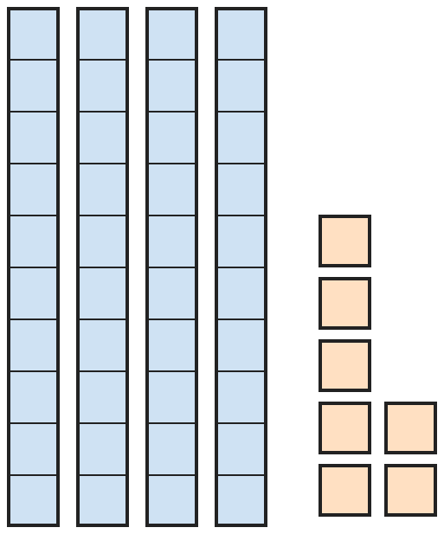
Q5. Each tall tower has 10 blocks. How many more blocks are needed to have 60 blocks in all?
(A) 3 | (B) 23 | (C) 13 | (D) 20

Q6. Raju writes the numbers from 1 to 20. How many times does he write the digit 1?
(A) 11 | (B) 12 | (C) 10 | (D) 2

Q7. How many numbers from 1 to 50 have 4 as their ones digit?
(A) 5 | (B) 4 | (C) 6 | (D) 10

Part 2 — Operations (Syllabus Chapter 2)
Q8. Which pair of subtractions gives the same answer?
(A) 17 − 8 and 13 − 4 | (B) 15 − 6 and 12 − 4
(C) 14 − 5 and 16 − 8 | (D) 18 − 9 and 11 − 3

Q9. A dart board has rings worth 3, 5 and 7 points. Rani throws 2 darts and both hit the board. Both darts may hit the same ring. Which total can she NOT get?
(A) 10 | (B) 12 | (C) 8 | (D) 11

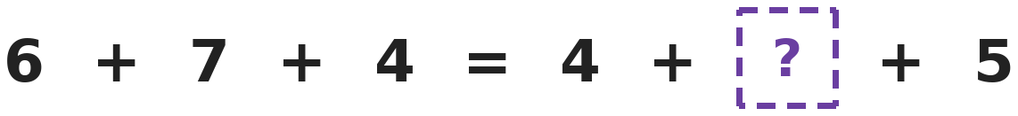
Q10. Both sides of the equals sign have the same total. Which number goes in the box?
(A) 7 | (B) 6 | (C) 17 | (D) 8

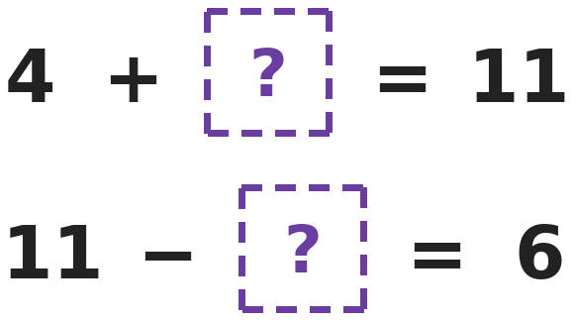
Q11. The two boxes hide different numbers. What is the total of the two hidden numbers?
(A) 2 | (B) 12 | (C) 7 | (D) 15

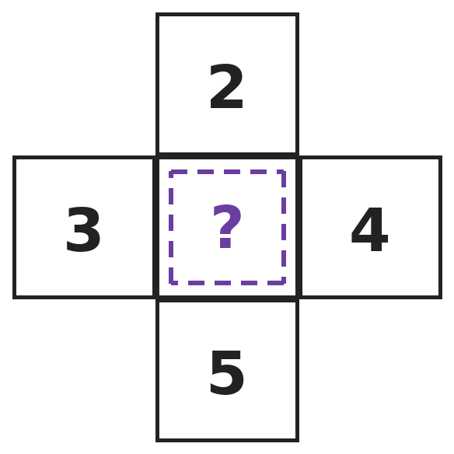
Q12. The row of three numbers and the column of three numbers each add up to 12. Which number is in the middle?
(A) 7 | (B) 4 | (C) 5 | (D) 6

Q13. Gita has 5 kites. Each kite has 3 bows on its tail. In the wind, 2 bows fall off. How many bows are left?
(A) 15 | (B) 13 | (C) 10 | (D) 8

Part 3 — Geometry (Syllabus Chapter 5)
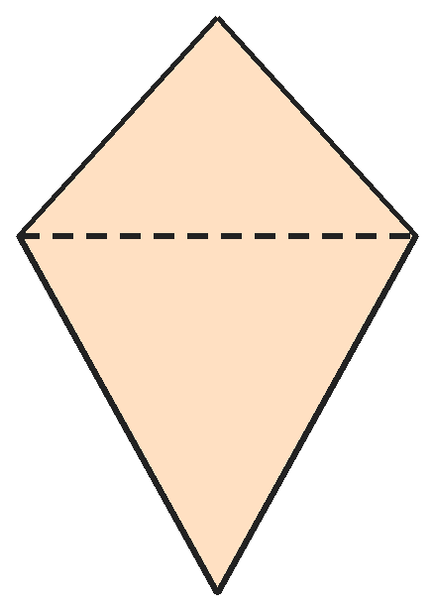
Q14. Two triangles are joined along one side to make this kite. How many sides does the outline of the kite have?
(A) 6 | (B) 5 | (C) 4 | (D) 3

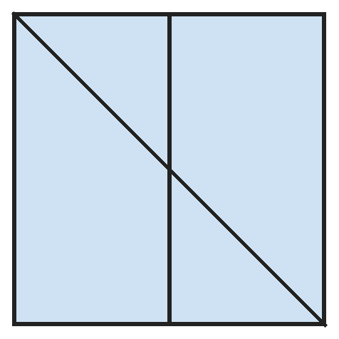
Q15. A square has one line from corner to corner and one line down the middle. How many triangles of all sizes can you find?
(A) 2 | (B) 6 | (C) 3 | (D) 4

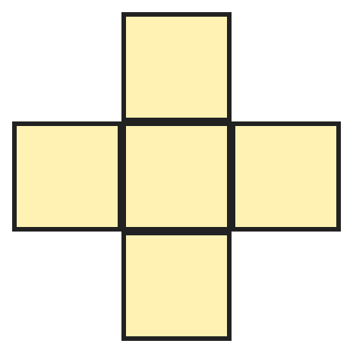
Q16. This plus shape is made of equal small squares. How many squares of all sizes can you find in it?
(A) 6 | (B) 4 | (C) 9 | (D) 5

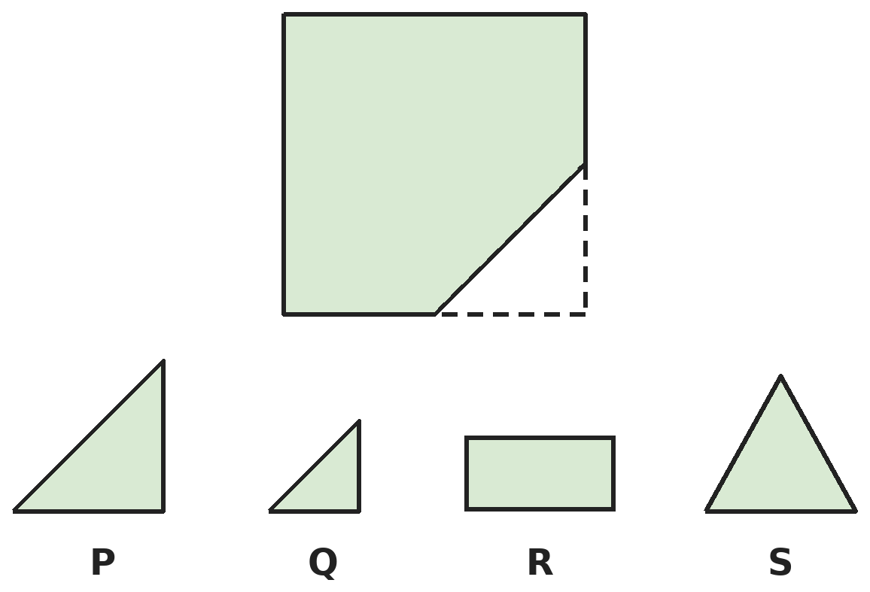
Q17. A corner piece is missing from the square tile. Which piece fits exactly into the gap?
(A) Piece P | (B) Piece Q | (C) Piece R | (D) Piece S

Part 4 — Applied Mathematics (Syllabus Chapter 9)
Q18. A library is closed on Sundays and Mondays. It is open on all the other days. On how many days is it open in 2 weeks?
(A) 5 | (B) 12 | (C) 10 | (D) 14

Q19. Which two Indian notes together make exactly ₹70?
(A) ₹40 and ₹30 | (B) ₹60 and ₹10 | (C) ₹50 and ₹20 | (D) ₹50 and ₹10

Q20. Kunal has tuition every Tuesday, Thursday and Saturday. How many days of tuition does he have in 3 weeks?
(A) 3 | (B) 6 | (C) 21 | (D) 9

Q21. How many ₹2 coins together are worth the same as one ₹20 note and one ₹10 coin?
(A) 15 | (B) 10 | (C) 12 | (D) 30

Part 5 — Mathematical Reasoning (Syllabus Chapter 10)
Q22. Three of these groups have the same number of apples. Which group is the odd one out?
(A) 3 bags of 3 apples | (B) 2 bags of 4 apples
(C) 4 bags of 2 apples | (D) 8 single apples

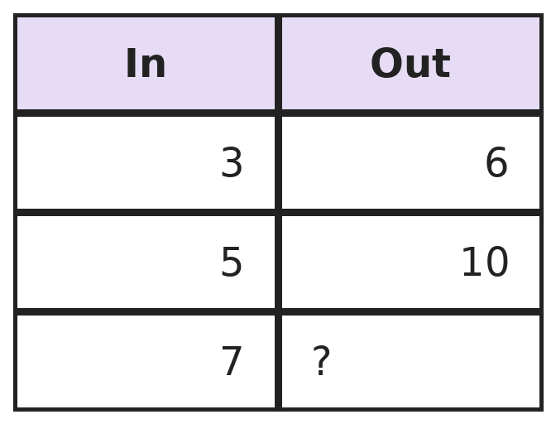
Q23. A number machine does the same thing to every number. What comes out when 7 goes in?
(A) 12 | (B) 14 | (C) 9 | (D) 10


Q24. Nandini writes the numbers in this pattern: one 1, two 2s, three 3s, four 4s, and so on. What is the 12th number she writes?
(A) 5 | (B) 4 | (C) 6 | (D) 12

Q25. Raghav counts back by 3s, starting at 20: 20, 17, 14 and so on. What is the first number he says that is less than 5?
(A) 5 | (B) 2 | (C) 3 | (D) 4

SECTION II — Star Questions 5 questions · each joins two chapters

Q26. Jiya counts on in nines: 9, 18, 27, 36 and so on. What is the first number she says whose tens digit is bigger than its ones digit? [Star]
(A) 45 | (B) 63 | (C) 36 | (D) 54

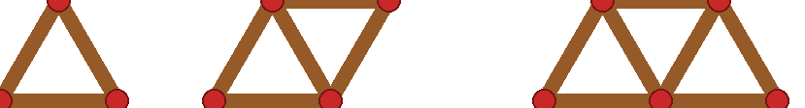
Q27. Vivek makes triangles in a row with sticks. One triangle needs 3 sticks, two need 5 and three need 7. How many triangles in a row can he make with 15 sticks? [Star]
(A) 7 | (B) 5 | (C) 6 | (D) 8

Q28. A gardener waters a hedge on the 2nd, 5th and 8th of a month, and keeps going in the same way. On which date is the 6th watering? [Star]
(A) 14th | (B) 18th | (C) 17th | (D) 20th

Q29. Sneha must pay ₹38 using ₹10 notes and ₹5, ₹2 and ₹1 coins. She uses as few notes and coins as she can. How many notes and coins does she use? [Star]
(A) 11 | (B) 5 | (C) 6 | (D) 8

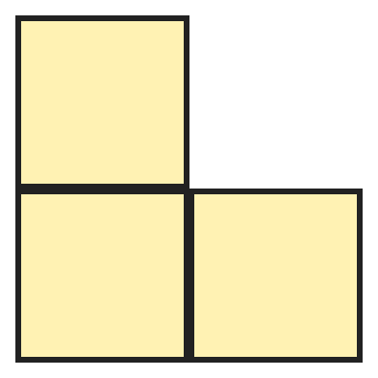
Q30. Three equal squares are joined to make this L-shape. How many sides does the outline of the L-shape have? [Star]
(A) 8 | (B) 12 | (C) 4 | (D) 6

Answer Sheet AMO Level 2 · Class 1 · Practice Paper 9
Name: | School: | Roll No.:
Shade or tick one circle for each question.
1. | Ⓐ Ⓑ Ⓒ Ⓓ | 11. | Ⓐ Ⓑ Ⓒ Ⓓ | 21. | Ⓐ Ⓑ Ⓒ Ⓓ
2. | Ⓐ Ⓑ Ⓒ Ⓓ | 12. | Ⓐ Ⓑ Ⓒ Ⓓ | 22. | Ⓐ Ⓑ Ⓒ Ⓓ
3. | Ⓐ Ⓑ Ⓒ Ⓓ | 13. | Ⓐ Ⓑ Ⓒ Ⓓ | 23. | Ⓐ Ⓑ Ⓒ Ⓓ
4. | Ⓐ Ⓑ Ⓒ Ⓓ | 14. | Ⓐ Ⓑ Ⓒ Ⓓ | 24. | Ⓐ Ⓑ Ⓒ Ⓓ
5. | Ⓐ Ⓑ Ⓒ Ⓓ | 15. | Ⓐ Ⓑ Ⓒ Ⓓ | 25. | Ⓐ Ⓑ Ⓒ Ⓓ
6. | Ⓐ Ⓑ Ⓒ Ⓓ | 16. | Ⓐ Ⓑ Ⓒ Ⓓ | 26. | Ⓐ Ⓑ Ⓒ Ⓓ
7. | Ⓐ Ⓑ Ⓒ Ⓓ | 17. | Ⓐ Ⓑ Ⓒ Ⓓ | 27. | Ⓐ Ⓑ Ⓒ Ⓓ
8. | Ⓐ Ⓑ Ⓒ Ⓓ | 18. | Ⓐ Ⓑ Ⓒ Ⓓ | 28. | Ⓐ Ⓑ Ⓒ Ⓓ
9. | Ⓐ Ⓑ Ⓒ Ⓓ | 19. | Ⓐ Ⓑ Ⓒ Ⓓ | 29. | Ⓐ Ⓑ Ⓒ Ⓓ
10. | Ⓐ Ⓑ Ⓒ Ⓓ | 20. | Ⓐ Ⓑ Ⓒ Ⓓ | 30. | Ⓐ Ⓑ Ⓒ Ⓓ
Q26–Q30 are Section II Star Questions. Each joins two chapters.
For the parent or teacher
Section I correct: ______ / 25 Section II correct: ______ / 5
Correct: ______ / 30
Answer Key and Solutions AMO Level 2 · Class 1 · Practice Paper 9
Quick answers
1 B | 6 B | 11 B | 16 D | 21 A | 26 D
2 B | 7 A | 12 C | 17 A | 22 A | 27 A
3 A | 8 A | 13 B | 18 C | 23 B | 28 C
4 B | 9 D | 14 C | 19 C | 24 A | 29 C
5 C | 10 D | 15 D | 20 D | 25 B | 30 D
Solutions
Q | Part · level | Answer | Why?
1 | Part 1 · Ch1 · Hard | (B) 2 | Hint: Write both numbers and compare their tens digits.  Riya's number is 64, which has 6 tens. Ravi's number is 46, which has 4 tens. 6 − 4 = 2 more tens.
2 | Part 1 · Ch1 · Hard | (B) 5 | Hint: The ones digit can be 5, 6, 7, 8 or 9.  The numbers are 75, 76, 77, 78 and 79. That is 5 numbers. 74 does not count, because 4 is not greater than 4.
3 | Part 1 · Ch1 · Hard | (A) 8 | Hint: Use as many bundles of 10 as you can.  53 is 5 tens and 3 ones, so she uses 5 bundles and 3 single sticks. That is 5 + 3 = 8 pieces.
4 | Part 1 · Ch1 · Hard | (B) 40 | Hint: First find 3 ones more than 57.  3 ones more than 57 is 60. Two tens less than 60 is 40.
5 | Part 1 · Ch1 · Hard | (C) 13 | Hint: Count on to the next ten, then on to 60.  There are 4 towers and 7 single blocks: 47 blocks. 3 more blocks make 50, and 10 more make 60. So 3 + 10 = 13 more blocks are needed.
6 | Part 1 · Ch1 · Hard | (B) 12 | Hint: The number 11 has two 1s.  He writes a 1 in 1, then in 10, 12, 13, 14, 15, 16, 17, 18 and 19, and twice in 11. That is 1 + 9 + 2 = 12 times.
7 | Part 1 · Ch1 · Hard | (A) 5 | Hint: Do not forget the 1-digit number 4.  The numbers are 4, 14, 24, 34 and 44. That is 5 numbers. (40 to 49 have 4 as the tens digit, not the ones digit, except 44.)
8 | Part 2 · Ch2 · Hard | (A) 17 − 8 and 13 − 4 | Hint: Work out both subtractions in each pair.  17 − 8 = 9 and 13 − 4 = 9, so this pair matches. In the other pairs: 9 and 8, 9 and 8, 9 and 8.
9 | Part 2 · Ch2 · Hard | (D) 11 | Hint: List all the totals two darts can make.  Two darts can make 3 + 3 = 6, 3 + 5 = 8, 3 + 7 = 10, 5 + 5 = 10, 5 + 7 = 12 and 7 + 7 = 14. So 11 is not possible.
10 | Part 2 · Ch2 · Hard | (D) 8 | Hint: The left side is 6 + 7 + 4. What do 4 and 5 still need?  The left side is 6 + 7 + 4 = 17. The right side has 4 + 5 = 9 so far. 17 − 9 = 8, so the box holds 8.
11 | Part 2 · Ch2 · Hard | (B) 12 | Hint: Find each hidden number first.  4 + 7 = 11, so the first box is 7. 11 − 5 = 6, so the second box is 5. Their total is 7 + 5 = 12.
12 | Part 2 · Ch2 · Hard | (C) 5 | Hint: Use the row: 3 + ? + 4 = 12.  Row: 3 + ? + 4 = 12. Since 3 + 4 = 7, the middle is 12 − 7 = 5. Check the column: 2 + 5 + 5 = 12.
13 | Part 2 · Ch2 · Hard | (B) 13 | Hint: Count the bows in threes first.  5 kites with 3 bows each: 3 + 3 + 3 + 3 + 3 = 15 bows. After 2 fall off: 15 − 2 = 13.
14 | Part 3 · Ch5 · Hard | (C) 4 | Hint: The side where the triangles are joined is inside the kite.  The two triangles have 3 + 3 = 6 sides. The shared side is inside the kite, so it is not on the outline. The outline has 4 sides.
15 | Part 3 · Ch5 · Hard | (D) 4 | Hint: The corner-to-corner line makes 2 big triangles. Does the middle line make any small ones?  The corner-to-corner line makes 2 big triangles. The middle line cuts a small triangle off each of them, one at the top and one at the bottom. 2 + 2 = 4 triangles.
16 | Part 3 · Ch5 · Hard | (D) 5 | Hint: Can 4 small squares here make a bigger square?  There are 5 small squares. No 4 of them sit together in a 2 by 2 block, so there is no bigger square. The answer is 5.
17 | Part 3 · Ch5 · Hard | (A) Piece P | Hint: The gap is a triangle with a square corner. Compare sizes too.  The gap is a triangle with a square corner and two equal short sides. Piece P has the same shape and size. Q is too small, R is a rectangle and S has no square corner.
18 | Part 4 · Ch9 · Hard | (C) 10 | Hint: Find the open days in one week first.  In one week it is open on Tuesday, Wednesday, Thursday, Friday and Saturday: 5 days. In 2 weeks it is open on 5 + 5 = 10 days.
19 | Part 4 · Ch9 · Hard | (C) ₹50 and ₹20 | Hint: Some of these notes do not exist.  ₹50 + ₹20 = ₹70, and both are real notes. There are no ₹40, ₹30 or ₹60 notes, and ₹50 + ₹10 is only ₹60.
20 | Part 4 · Ch9 · Hard | (D) 9 | Hint: Find the tuition days in one week.  Each week has 3 tuition days. In 3 weeks: 3 + 3 + 3 = 9 days.
21 | Part 4 · Ch9 · Hard | (A) 15 | Hint: Find the total first, then count in twos.  ₹20 + ₹10 = ₹30. Counting in twos to 30: 2, 4, 6, … , 30. That is 10 coins for ₹20 and 5 more for ₹10, so 15 coins.
22 | Part 5 · Ch10 · Hard | (A) 3 bags of 3 apples | Hint: Find the total number of apples in each group.  2 bags of 4 make 4 + 4 = 8. 4 bags of 2 make 2 + 2 + 2 + 2 = 8. 8 single apples make 8. But 3 bags of 3 make 3 + 3 + 3 = 9.
23 | Part 5 · Ch10 · Hard | (B) 14 | Hint: Compare each In number with its Out number.  3 → 6 and 5 → 10: each number is doubled. So 7 → 7 + 7 = 14.
24 | Part 5 · Ch10 · Hard | (A) 5 | Hint: Count how many numbers she has written after each group.  After the 1 she has written 1 number, after the 2s 3 numbers, after the 3s 6 numbers and after the 4s 10 numbers. The 11th to 15th numbers are 5s, so the 12th is 5.
25 | Part 5 · Ch10 · Hard | (B) 2 | Hint: Keep taking away 3.  He says 20, 17, 14, 11, 8, 5, 2. The number 5 is not less than 5. The first number less than 5 is 2.
26 | Section II · Ch1 + Ch10 · Hard | (D) 54 | Hint: Each time the tens digit goes up by 1 and the ones digit goes down by 1.  She says 9, 18, 27, 36, 45, 54. In 45 the tens digit is smaller than the ones digit. In 54 the tens digit 5 is bigger than 4. So the answer is 54.
27 | Section II · Ch5 + Ch10 · Hard | (A) 7 | Hint: Each new triangle needs 2 more sticks.  The sticks needed go 3, 5, 7, 9, 11, 13, 15 for 1, 2, 3, 4, 5, 6, 7 triangles. So 15 sticks make 7 triangles.
28 | Section II · Ch9 + Ch10 · Hard | (C) 17th | Hint: The waterings are 3 days apart.  The waterings are on the 2nd, 5th, 8th, 11th, 14th and 17th. The 6th watering is on the 17th.
29 | Section II · Ch1 + Ch9 · Hard | (C) 6 | Hint: ₹38 is 3 tens and 8 ones.  Three ₹10 notes make ₹30. The ₹8 left is ₹5 + ₹2 + ₹1, which is 3 coins. So she uses 3 + 3 = 6 notes and coins.
30 | Section II · Ch2 + Ch5 · Hard | (D) 6 | Hint: Trace round the outside edge and count each straight side.  Going round the outside: left side, bottom side, right side, a short top side, a short side going up, and the top of the top square. That is 6 sides.

ARYABHATTA MATHS OLYMPIAD
Level 2
PRACTICE PAPER-10
CLASS 1
Total Questions | 30 multiple-choice questions
Level | Level-2 (final round): every question is Hard
Time | 45 minutes
Section I | 25 questions, each from one chapter
Section II | 5 Star Questions, each joining two chapters
Negative Marking | No negative marking
Calculator | Not allowed
Chapters | Number System · Operations · Geometry · Applied Mathematics · Mathematical Reasoning

👋 Hello, friend! How to do this paper:
⭐ Every question has four answer choices: (A), (B), (C) and (D). Only one is correct.
⭐ Read each question and look at its picture carefully. Then mark your answer on the answer sheet at the end.
⭐ This is a Level-2 paper. Every question needs careful thinking, so take your time and check each step.
⭐ Section I has 25 questions. Section II has 5 Star Questions.
⭐ There is no negative marking, so try every question.
⭐ Do not use a calculator. You may do rough work on a separate sheet.
⭐ All figures are not necessarily drawn to scale unless stated.

For parents and teachers
• Pictures are part of the questions. Every picture also works when printed in black and white.
• You may read a question aloud to the child, exactly as printed. Please do not explain it or point to an answer choice.
• Parts follow the AMO syllabus chapters. Chapters 3, 4, 6, 7 and 8 are not part of the Class 1 syllabus, so the chapter numbers shown in the Part headings have gaps.
• The answer sheet and the answer key are at the end. Remove only the answer key before the child begins.

SECTION I 25 questions · every question is Hard
Part 1 — Number System (Syllabus Chapter 1)
Q1. Pari counts back by ones from 63. The first number she says is 62. What is the 5th number she says?
(A) 58 | (B) 59 | (C) 57 | (D) 68

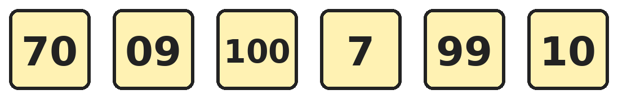
Q2. How many of the numbers on these cards are 2-digit numbers?
(A) 3 | (B) 4 | (C) 2 | (D) 5

Q3. Shreya counts in tens from 10 to 100. Ravi counts in fives from 5 to 50. How many numbers do they both say?
(A) 10 | (B) 4 | (C) 5 | (D) 6

Q4. How many numbers are greater than 58 and less than 65, and also have 6 as their tens digit?
(A) 6 | (B) 4 | (C) 7 | (D) 5

Q5. Which of these numbers is more than 4 tens and 9 ones, but less than 5 tens and 2 ones?
(A) 48 | (B) 53 | (C) 49 | (D) 51

Q6. Asha's house number is between 40 and 50, and both its digits are the same. Kunal's house number is 2 tens more than Asha's. What is Kunal's house number?
(A) 46 | (B) 64 | (C) 66 | (D) 44

Q7. How many of the numbers from 1 to 30 are written with two digits?
(A) 20 | (B) 30 | (C) 21 | (D) 9

Part 2 — Operations (Syllabus Chapter 2)
Q8. Each of 1, 2, 3 and 4 is used once in each number sentence below. Which number sentence is true?
(A) 1 + 2 = 3 + 4 | (B) 1 + 4 = 2 + 3 | (C) 1 + 3 = 2 + 4 | (D) 4 − 1 = 3 − 2

Q9. Ankit writes 13 as the sum of three different numbers. The biggest of the three numbers is 7. In how many ways can he do it?
(A) 3 | (B) 2 | (C) 1 | (D) 4

Q10. Kabir has 7 more marbles than Isha. Kabir gives Isha 2 of his marbles. Now how many more marbles does Kabir have than Isha?
(A) 5 | (B) 9 | (C) 3 | (D) 7

Q11. Mohan had 18 mangoes. He sold 7 in the morning and some more in the evening. Now he has 5 mangoes left. How many did he sell in the evening?
(A) 6 | (B) 11 | (C) 13 | (D) 12

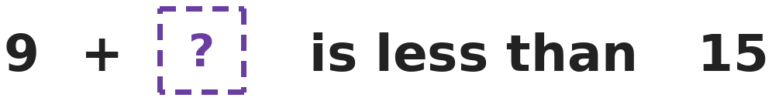
Q12. What is the largest number that can go in the box so that the sentence is true?
(A) 6 | (B) 5 | (C) 4 | (D) 14

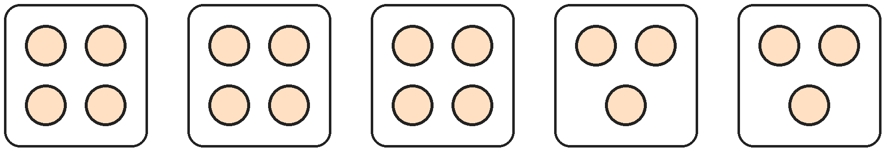
Q13. Grandma puts laddoos on five plates, as shown. Each circle is one laddoo. How many laddoos are there in all?
(A) 15 | (B) 18 | (C) 20 | (D) 5

Part 3 — Geometry (Syllabus Chapter 5)
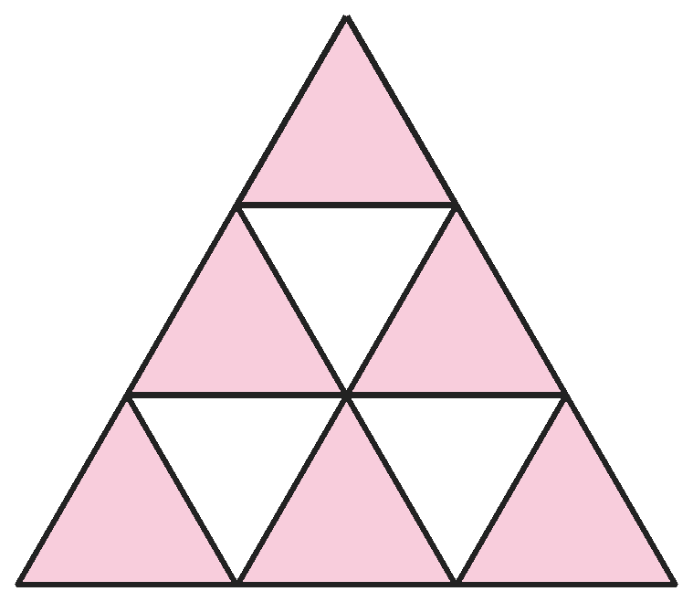
Q14. This big triangle is made of 9 small triangles. How many triangles of all sizes can you find?
(A) 9 | (B) 10 | (C) 13 | (D) 12

Q15. Isha folds a square paper in half, then in half again the other way. All the folds meet at one corner of the small folded square. She cuts off that corner. How many holes are there when she opens the paper?
(A) 4 | (B) 2 | (C) 0 | (D) 1

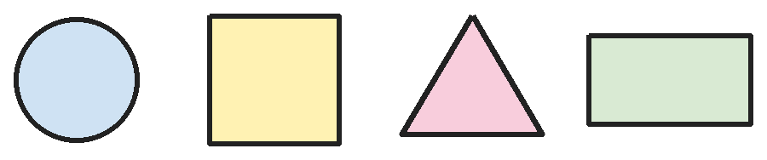
Q16. How many of these shapes can be folded along a straight line so that the two halves match exactly?
(A) 3 | (B) 2 | (C) 1 | (D) 4

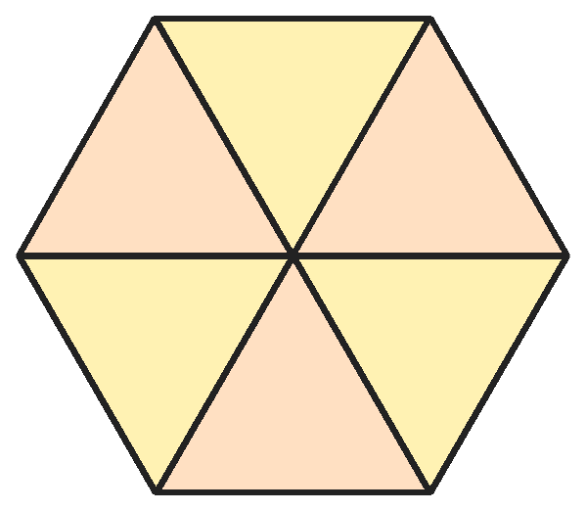
Q17. This picture is made of triangles that meet in the middle. How many triangles of all sizes can you find?
(A) 7 | (B) 6 | (C) 12 | (D) 8

Part 4 — Applied Mathematics (Syllabus Chapter 9)
Q18. Which day comes 2 days after the day that is 2 days before Tuesday?
(A) Thursday | (B) Sunday | (C) Tuesday | (D) Monday

Q19. Which month is 5 months before the month that comes right after June?
(A) February | (B) January | (C) March | (D) December

Q20. Diya gives four ₹10 notes and two ₹5 coins at a bank. She gets back one note of the same total value. Which note does she get?
(A) ₹40 | (B) ₹100 | (C) ₹50 | (D) ₹20

Q21. Today is Thursday. Which day was it 8 days ago?
(A) Wednesday | (B) Friday | (C) Thursday | (D) Tuesday

Part 5 — Mathematical Reasoning (Syllabus Chapter 10)
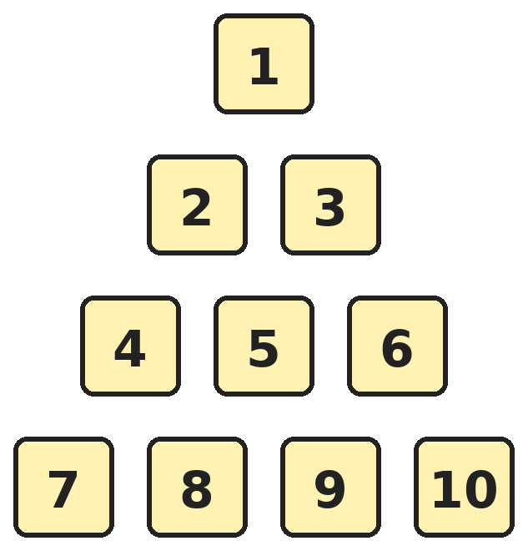
Q22. Numbers are written in rows. Each row has one more number than the row above it. What is the first number in Row 6?
(A) 15 | (B) 21 | (C) 11 | (D) 16

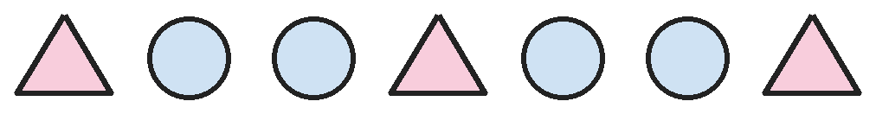
Q23. The shapes repeat in this order. In which place in the row is the 5th triangle?
(A) 15 | (B) 10 | (C) 12 | (D) 13

Q24. Look at the pattern: 1 + 9, 2 + 8, 3 + 7 and so on. Which is the 6th pair in this pattern?
(A) 5 + 5 | (B) 7 + 3 | (C) 6 + 4 | (D) 6 + 3

Q25. Hema adds the two digits of 58. Then she adds the two digits of her answer. What number does she get at the end?
(A) 4 | (B) 13 | (C) 3 | (D) 8

SECTION II — Star Questions 5 questions · each joins two chapters
Q26. Which number has a tens digit that is 3 more than its ones digit, and two digits that add up to 11? [Star]
(A) 47 | (B) 83 | (C) 65 | (D) 74

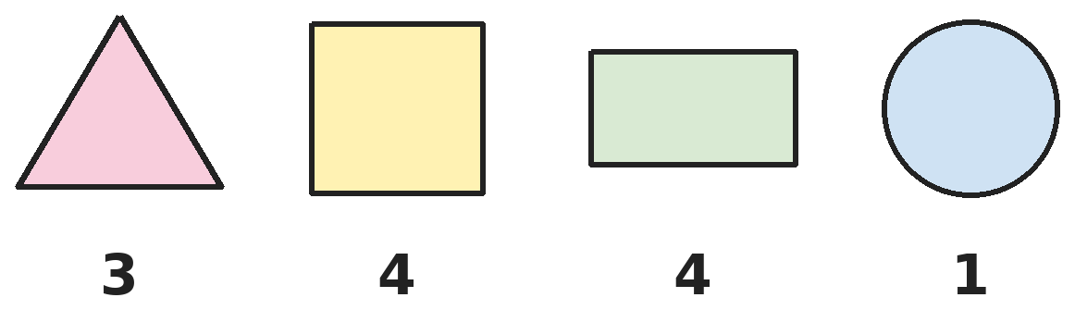
Q27. Each shape is labelled with its number of corners. Exactly one label is wrong. Which shape has the wrong label? [Star]
(A) Triangle | (B) Square | (C) Circle | (D) Rectangle

Q28. Om and Sita both practise music on a Tuesday. After that, Om practises every 2nd day and Sita every 3rd day. On which day will they next practise on the same day? [Star]
(A) Monday | (B) Thursday | (C) Friday | (D) Saturday

Q29. Dates in a month go up to 31. Diya's birthday is on the largest date that has two digits, both the same. On which date is her birthday? [Star]
(A) 11th | (B) 22nd | (C) 33rd | (D) 31st

Q30. Leela draws 2 squares and some triangles. All her shapes have 17 corners altogether. How many triangles does she draw? [Star]
(A) 3 | (B) 9 | (C) 4 | (D) 5

Answer Sheet AMO Level 2 · Class 1 · Practice Paper 10
Name: | School: | Roll No.:
Shade or tick one circle for each question.
1. | Ⓐ Ⓑ Ⓒ Ⓓ | 11. | Ⓐ Ⓑ Ⓒ Ⓓ | 21. | Ⓐ Ⓑ Ⓒ Ⓓ
2. | Ⓐ Ⓑ Ⓒ Ⓓ | 12. | Ⓐ Ⓑ Ⓒ Ⓓ | 22. | Ⓐ Ⓑ Ⓒ Ⓓ
3. | Ⓐ Ⓑ Ⓒ Ⓓ | 13. | Ⓐ Ⓑ Ⓒ Ⓓ | 23. | Ⓐ Ⓑ Ⓒ Ⓓ
4. | Ⓐ Ⓑ Ⓒ Ⓓ | 14. | Ⓐ Ⓑ Ⓒ Ⓓ | 24. | Ⓐ Ⓑ Ⓒ Ⓓ
5. | Ⓐ Ⓑ Ⓒ Ⓓ | 15. | Ⓐ Ⓑ Ⓒ Ⓓ | 25. | Ⓐ Ⓑ Ⓒ Ⓓ
6. | Ⓐ Ⓑ Ⓒ Ⓓ | 16. | Ⓐ Ⓑ Ⓒ Ⓓ | 26. | Ⓐ Ⓑ Ⓒ Ⓓ
7. | Ⓐ Ⓑ Ⓒ Ⓓ | 17. | Ⓐ Ⓑ Ⓒ Ⓓ | 27. | Ⓐ Ⓑ Ⓒ Ⓓ
8. | Ⓐ Ⓑ Ⓒ Ⓓ | 18. | Ⓐ Ⓑ Ⓒ Ⓓ | 28. | Ⓐ Ⓑ Ⓒ Ⓓ
9. | Ⓐ Ⓑ Ⓒ Ⓓ | 19. | Ⓐ Ⓑ Ⓒ Ⓓ | 29. | Ⓐ Ⓑ Ⓒ Ⓓ
10. | Ⓐ Ⓑ Ⓒ Ⓓ | 20. | Ⓐ Ⓑ Ⓒ Ⓓ | 30. | Ⓐ Ⓑ Ⓒ Ⓓ
Q26–Q30 are Section II Star Questions. Each joins two chapters.
For the parent or teacher
Section I correct: ______ / 25 Section II correct: ______ / 5
Correct: ______ / 30
Answer Key and Solutions AMO Level 2 · Class 1 · Practice Paper 10
Quick answers
1 A | 6 B | 11 A | 16 D | 21 A | 26 D
2 A | 7 C | 12 B | 17 B | 22 D | 27 C
3 C | 8 B | 13 B | 18 C | 23 D | 28 A
4 D | 9 B | 14 C | 19 A | 24 C | 29 B
5 D | 10 C | 15 D | 20 C | 25 A | 30 A
Solutions
Q | Part · level | Answer | Why?
1 | Part 1 · Ch1 · Hard | (A) 58 | Hint: Write the numbers she says, one by one.  She says 62, 61, 60, 59, 58. The 5th number is 58.
2 | Part 1 · Ch1 · Hard | (A) 3 | Hint: A 2-digit number cannot start with 0, and 100 has three digits.  70, 99 and 10 are 2-digit numbers. 09 is just 9, which has one digit. 100 has three digits and 7 has one. So 3 cards.
3 | Part 1 · Ch1 · Hard | (C) 5 | Hint: Ravi stops at 50.  Ravi says 5, 10, 15, 20, 25, 30, 35, 40, 45, 50. Of these, Shreya also says 10, 20, 30, 40 and 50. That is 5 numbers.
4 | Part 1 · Ch1 · Hard | (D) 5 | Hint: List the numbers between 58 and 65 first.  The numbers between 58 and 65 are 59, 60, 61, 62, 63 and 64. Of these, 60, 61, 62, 63 and 64 have tens digit 6. That is 5 numbers.
5 | Part 1 · Ch1 · Hard | (D) 51 | Hint: Write both as numbers first.  4 tens and 9 ones is 49, and 5 tens and 2 ones is 52. The numbers between them are 50 and 51. Of the options, only 51 fits.
6 | Part 1 · Ch1 · Hard | (B) 64 | Hint: Find Asha's house number first.  Between 40 and 50, the number with both digits the same is 44. Two tens more than 44 is 64. Only the tens digit changes.
7 | Part 1 · Ch1 · Hard | (C) 21 | Hint: First count the numbers written with one digit.  The numbers 1 to 9 have one digit. So the numbers 10 to 30 have two digits. From 10 to 19 there are 10, from 20 to 29 there are 10, and 30 is 1 more: 21.
8 | Part 2 · Ch2 · Hard | (B) 1 + 4 = 2 + 3 | Hint: Work out both sides of each sentence.  1 + 4 = 5 and 2 + 3 = 5, so 1 + 4 = 2 + 3 is true. The other sentences give 3 and 7, 4 and 6, and 3 and 1.
9 | Part 2 · Ch2 · Hard | (B) 2 | Hint: The other two numbers must add up to 6, be different, and be smaller than 7.  The other two numbers add to 13 − 7 = 6. Different pairs that make 6 are 1 and 5, and 2 and 4 (3 and 3 are not different). So the ways are 7 + 5 + 1 and 7 + 4 + 2: 2 ways.
10 | Part 2 · Ch2 · Hard | (C) 3 | Hint: Kabir loses 2 and Isha gains 2.  Kabir goes down by 2, so the gap shrinks by 2. Isha goes up by 2, so it shrinks by 2 more. 7 − 2 − 2 = 3. For example, 10 and 3 become 8 and 5.
11 | Part 2 · Ch2 · Hard | (A) 6 | Hint: Find how many he had after the morning.  After the morning he had 18 − 7 = 11. He has 5 left, so in the evening he sold 11 − 5 = 6.
12 | Part 2 · Ch2 · Hard | (B) 5 | Hint: Try 6 first, then smaller numbers.  9 + 6 = 15, which is not less than 15. 9 + 5 = 14, which is less than 15. So the largest number is 5.
13 | Part 2 · Ch2 · Hard | (B) 18 | Hint: Count the plates of 4 and the plates of 3 separately.  Three plates have 4 each: 4 + 4 + 4 = 12. Two plates have 3 each: 3 + 3 = 6. In all 12 + 6 = 18 laddoos.
14 | Part 3 · Ch5 · Hard | (C) 13 | Hint: Look for triangles made of 4 small triangles too.  There are 9 small triangles. Triangles made of 4 small ones: one at the top, one at the bottom left and one at the bottom right, so 3. The whole big triangle is 1 more. 9 + 3 + 1 = 13.
15 | Part 3 · Ch5 · Hard | (D) 1 | Hint: Where on the big square is the corner where all the folds meet?  The corner where all the folds meet is the centre of the big square. Cutting it off cuts out one piece from the middle. When the paper is opened, there is just 1 hole, in the centre.
16 | Part 3 · Ch5 · Hard | (D) 4 | Hint: Try a fold down the middle of each shape.  The circle folds through its middle. The square and the rectangle fold down the middle. This triangle folds from its top corner to the middle of its bottom side. So all 4 shapes can.
17 | Part 3 · Ch5 · Hard | (B) 6 | Hint: Do two triangles next to each other make a bigger triangle?  There are 6 small triangles. Two triangles next to each other make a 4-sided shape, not a triangle, and three make a 4-sided shape too. So there are only 6 triangles.
18 | Part 4 · Ch9 · Hard | (C) Tuesday | Hint: Going 2 days back and then 2 days forward …  2 days before Tuesday is Sunday. 2 days after Sunday is Tuesday. Going back 2 and forward 2 brings us back to Tuesday.
19 | Part 4 · Ch9 · Hard | (A) February | Hint: First find the month right after June.  The month right after June is July. Going back 5 months from July: June, May, April, March, February.
20 | Part 4 · Ch9 · Hard | (C) ₹50 | Hint: Find the total of the notes and of the coins.  Four ₹10 notes make ₹40. Two ₹5 coins make ₹10. Altogether ₹40 + ₹10 = ₹50, so she gets a ₹50 note. There is no ₹40 note.
21 | Part 4 · Ch9 · Hard | (A) Wednesday | Hint: 7 days ago was also a Thursday.  7 days ago was Thursday, because a week has 7 days. One more day back is Wednesday.
22 | Part 5 · Ch10 · Hard | (D) 16 | Hint: Row 5 has 5 numbers.  Row 4 ends with 10. Row 5 has 5 numbers: 11, 12, 13, 14, 15. So Row 6 starts with 16.
23 | Part 5 · Ch10 · Hard | (D) 13 | Hint: Write down the places of the first few triangles.  The triangles are in places 1, 4, 7, 10 and 13. Each triangle is 3 places after the one before. The 5th triangle is in place 13.
24 | Part 5 · Ch10 · Hard | (C) 6 + 4 | Hint: The first number goes up by 1 and the second goes down by 1.  The pairs are 1 + 9, 2 + 8, 3 + 7, 4 + 6, 5 + 5, 6 + 4. The 6th pair is 6 + 4. Every pair adds up to 10.
25 | Part 5 · Ch10 · Hard | (A) 4 | Hint: 5 + 8 first.  5 + 8 = 13. Then the digits of 13 add up to 1 + 3 = 4.
26 | Section II · Ch1 + Ch10 · Hard | (D) 74 | Hint: Check both rules for each number.  74: 7 is 3 more than 4, and 7 + 4 = 11. Both rules work. 47 has the digits the wrong way round. 83 adds to 11 but 8 is 5 more than 3. 65 adds to 11 but 6 is only 1 more than 5.
27 | Section II · Ch5 + Ch10 · Hard | (C) Circle | Hint: Count the corners of each shape yourself.  A triangle has 3 corners, a square has 4 and a rectangle has 4, so those labels are right. A circle has no corners, so its label should be 0, not 1.
28 | Section II · Ch9 + Ch10 · Hard | (A) Monday | Hint: List the days for each of them.  Om: Tuesday, Thursday, Saturday, Monday. Sita: Tuesday, Friday, Monday. The next day they share is Monday, 6 days after the Tuesday.
29 | Section II · Ch1 + Ch9 · Hard | (B) 22nd | Hint: Which 2-digit numbers have both digits the same?  2-digit numbers with both digits the same are 11, 22, 33 and so on. No month has a 33rd day, so the largest such date is the 22nd.
30 | Section II · Ch2 + Ch5 · Hard | (A) 3 | Hint: First find the corners of the 2 squares.  2 squares have 4 + 4 = 8 corners. That leaves 17 − 8 = 9 corners for the triangles. Each triangle has 3, and 3 + 3 + 3 = 9, so she draws 3 triangles.

