**Business Requirements Document (BRD)**

**Project Name:** Blinkit Sales Analysis Dashboard

**Date:**

**1. Project Overview**

The Blinkit Sales Analysis Dashboard is a powerful tool that helps understand and improve sales performance in different areas of Blinkit’s business. It brings together data from various sources so that everyone involved can easily track, study, and improve sales strategies.

The dashboard highlights important factors that affect sales, such as store features, product details, and what customers like. This makes it a helpful tool for making better business decisions. By showing the data in a clear and interactive way, the dashboard helps teams answer important business questions, spot trends, and make smart decisions based on data.

This project was created to fix problems in tracking sales and improving performance. It provides one place to get both a big-picture view and detailed analysis, making it easier to manage and improve sales effectively.

**2. Business Objectives**

The main goals of the Blinkit Sales Analysis Dashboard are:

1. **Better Sales Monitoring:** Show sales trends in real-time and from past data, covering things like store location, size, and type.
2. **Smarter Decisions with Data:** Help teams find the main factors driving sales and improve strategies to increase revenue.
3. **Efficient Use of Resources:** Help manage inventory by spotting items that sell well and those that don’t, so promotions and resources can be used wisely.
4. **Customer Understanding:** Learn what customers like and how they behave by analyzing product data. This helps improve customer service and offer better products.
5. **Growth Support:** Provide insights to plan for growth, whether it’s entering new markets or improving current stores.

**3. Key Questions Answered by the Dashboard**

The dashboard helps answer many important questions in a simple way, such as:

**Outlet Performance Analysis**

* How do sales change in different outlet locations, like cities or villages?
* How well do outlets of different sizes (small, medium, large) perform in terms of sales?
* Which outlets are doing the best, and which ones need improvement?

**Item-Level Insights**

* Which types of items sell the most and the least?
* Does the fat content of an item affect how much it sells?
* Is there a link between how visible an item is and how well it sells?
* Does an item’s weight impact its sales?
* Which specific items are the best and worst sellers?

**Customer Preferences and Behavior**

* Do items with higher customer ratings sell better?
* Do outlets with better ratings have higher sales compared to lower-rated ones?

**Outlet and Item Correlation Analysis**

* How do sales trends for specific types of items differ based on the location of the outlet?
* Which outlets sell particular types of items the best?
* Is there a pattern between an item’s visibility, type, and the size of the outlet that affects sales?

**Predictive and Strategic Insights**

* Can we predict future sales trends based on outlet features?
* What are the main factors driving sales, and how can they be improved?
* Are smaller outlets performing better in cities or villages?

**4. Data Sources and Transformations**

**Primary Data Source:**

* Blinkit’s Internal Sales Database Excel File: Contains detailed information about outlets, items, sales transactions, and customer feedback.

**Data Transformations**

1. **Derived Metrics:**
   * **Outlet Age:** Calculated using the outlet’s establishment year.
   * **Weight Categories:** Items are grouped into weight ranges for easier analysis (e.g., light, medium, heavy).
   * **Visibility Categories:** Items are categorized based on their visibility (e.g., low, medium, high).
2. **Aggregation:**
   * Summarizing sales data by outlet and item dimensions to create meaningful metrics.
   * Calculating trends and averages to spot patterns.
3. **Data Cleansing:**
   * **Duplicate Removal:** Eliminating repeated entries to ensure data accuracy.
   * **Invalid Data Handling:** Removing records with missing or incorrect information.
   * **Field Standardization:** Ensuring consistency in categories like outlet and item types (e.g., fixing typos or varying formats).
4. **Integration:**
   * Combining multiple columns (outlets, items, sales, feedback) into a single, unified view to provide a holistic understanding of sales performance.

**5. Insights and Findings**

The dashboard reveals important insights across different areas:

**Outlet Location Type**

* **Urban Outlets:** Generate the majority of sales, highlighting their strong customer base.
* **Rural Outlets:** Show lower sales performance, but with opportunities for growth through better outreach and tailored strategies.
* **Suburban Outlets:** Perform moderately, with room for growth by implementing targeted promotions and improving product offerings.

**Outlet Size**

* **Medium-Sized Outlets:** Consistently achieve the highest sales, making them a key driver of overall performance.
* **Large Outlets:** Perform well but lag behind medium-sized outlets, possibly due to higher operational costs or lower foot traffic.
* **Small Outlets:** Underperform compared to others, but show potential in niche or localized markets where personalized services can attract loyal customers.

**Outlet Type**

* **Supermarket Type 1:** Dominates sales contributions, significantly outperforming other outlet types.
* **Grocery Stores:** While smaller in scale, they maintain steady and reliable sales trends, making them important for specific customer segments.

**Item Types**

* **Top Categories:** Fruits and snacks are the best-performing item types, reflecting strong and consistent demand.
* **Lagging Categories:** Seafood and breakfast items have lower sales, suggesting the need for targeted promotions or better availability.
* **Steady Performers:** Frozen foods and household items maintain stable demand, showing that they are customer staples.

**Item Visibility**

* **High Visibility:** Items that are more prominently displayed tend to sell better, showing a strong correlation between visibility and performance.
* **Improvement Opportunity:** Boosting the visibility of low-performing items can significantly enhance their sales.

**Customer Ratings**

* **High Ratings:** Outlets with better customer ratings consistently achieve higher sales, showing the importance of customer satisfaction.
* **Focus Area:** Improving customer experience, service quality, and feedback handling can directly impact sales growth.

**6. Future Enhancements**

To make the Blinkit Sales Analysis Dashboard even more effective, the following enhancements are planned:

* Predictive Analytics
* Real-Time Insights
* Customer Segmentation, etc…
  1. **Security and Compliance**

This project is licensed under the MIT License - see the LICENSE file for the details in [github](https://github.com/Baishnab1708/Blinkit_Sales_Analysis) repository.

**8. Design and Layout of Dashboard**

**Page 1**

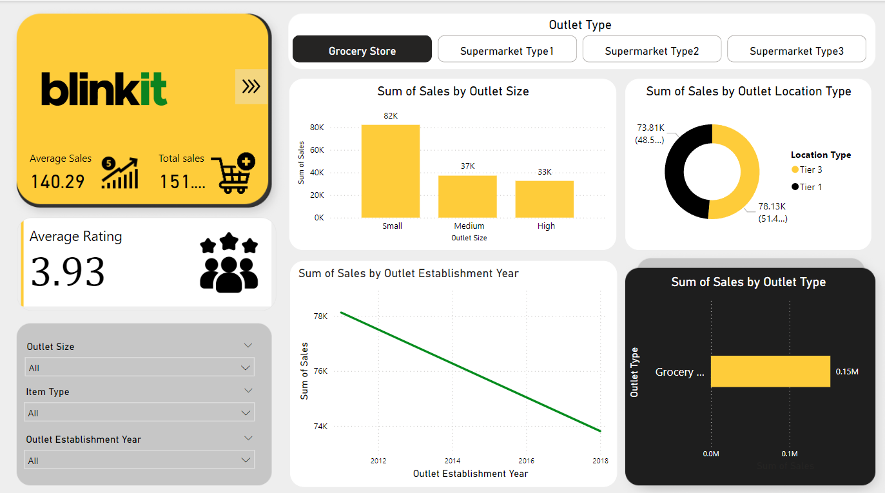

**Page 2**

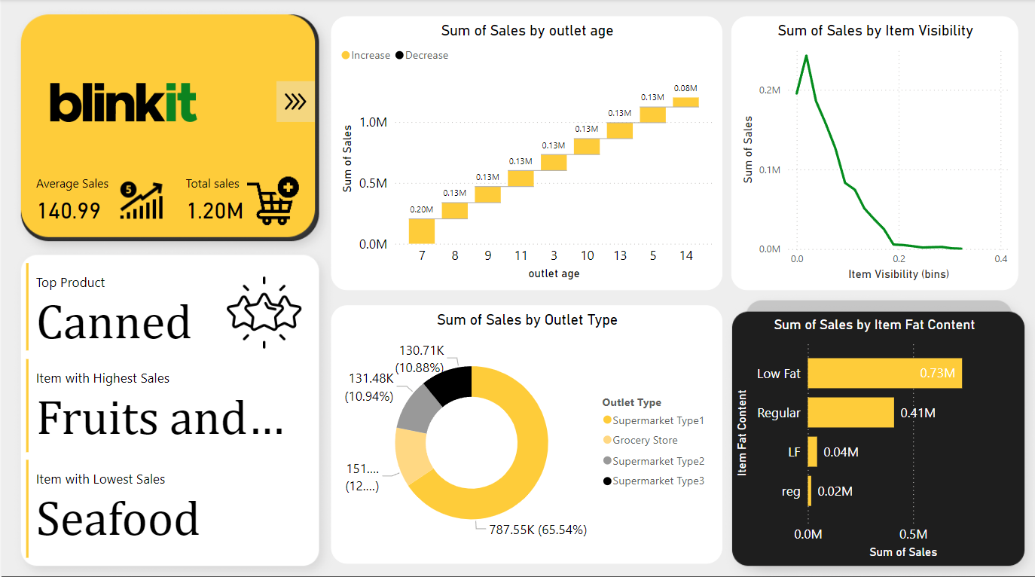

**Page 3**

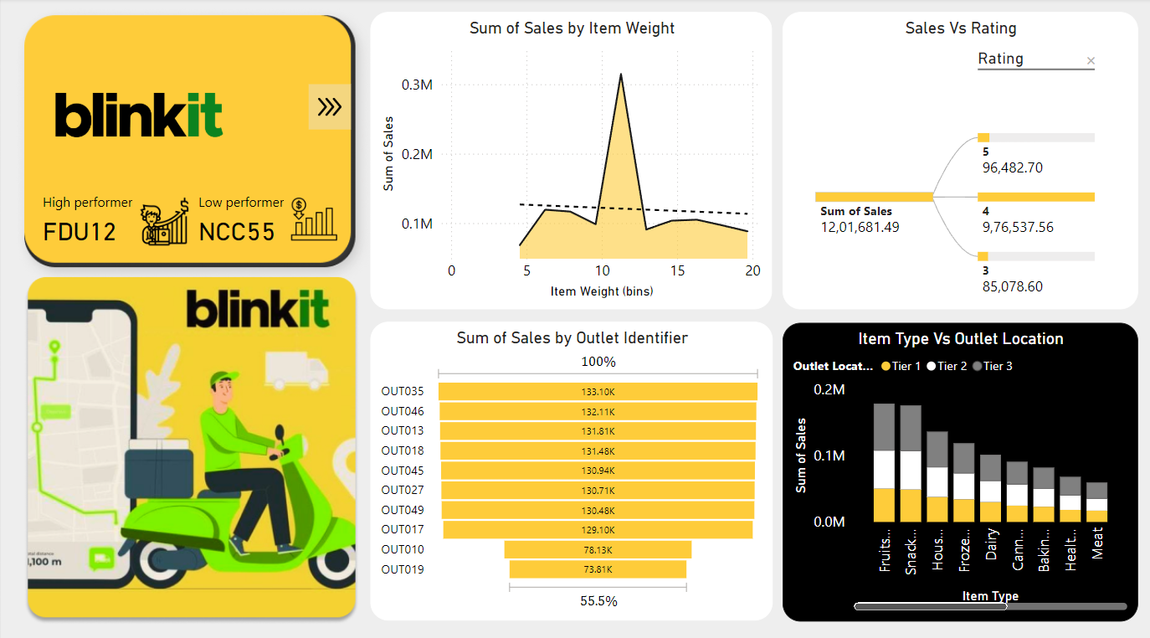

**Page 4**

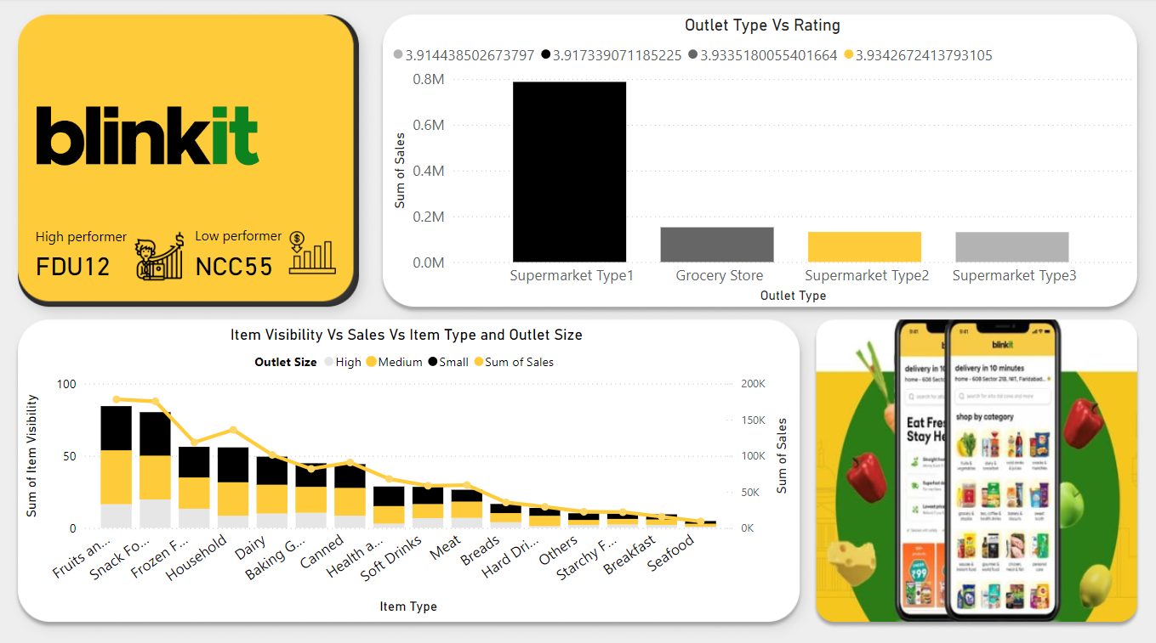

**Approval Section**

* **Prepared By:** Baishnab, Abin, Dedeepya, Sagana, Saramila, Jashwanth, Shaik
* **Reviewed By:** Ajith Kumar Sir