Test Cloud
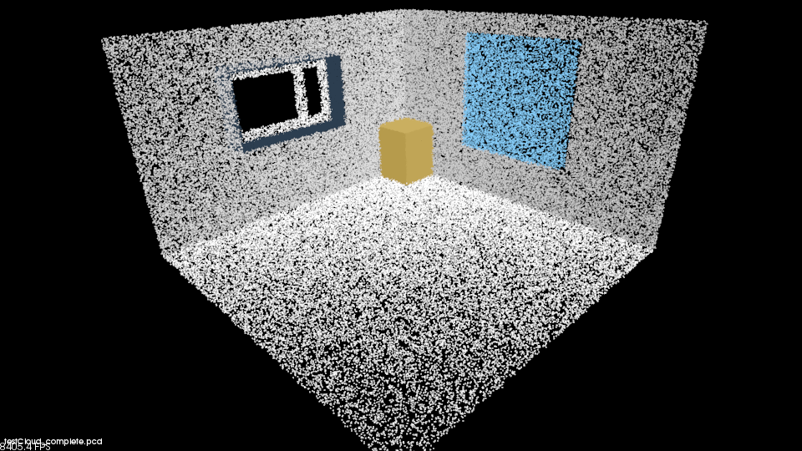
12 planes
little noise: 169672 points.
Noisy: 169650 points.

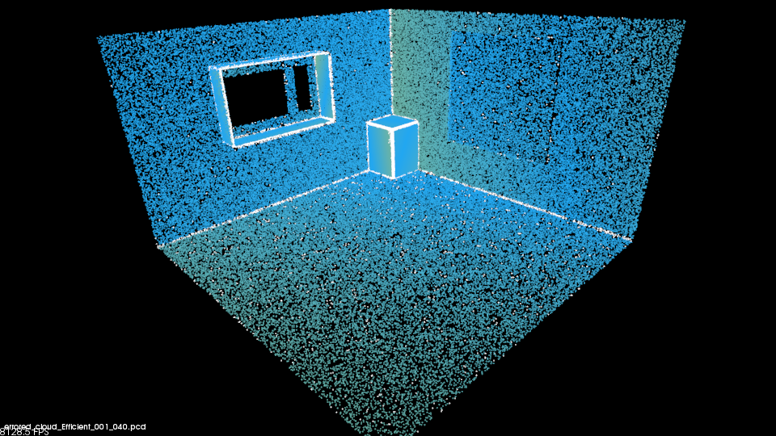
Little Noise (gaussian N(0,0.001))
Without PPR
Planar points | 158389
# planes | 12
Normal rad | 0.04
Inlier threshold | 0.02
NonPlanar | 11283
Incorrect | 15
Average dist | 0.00495

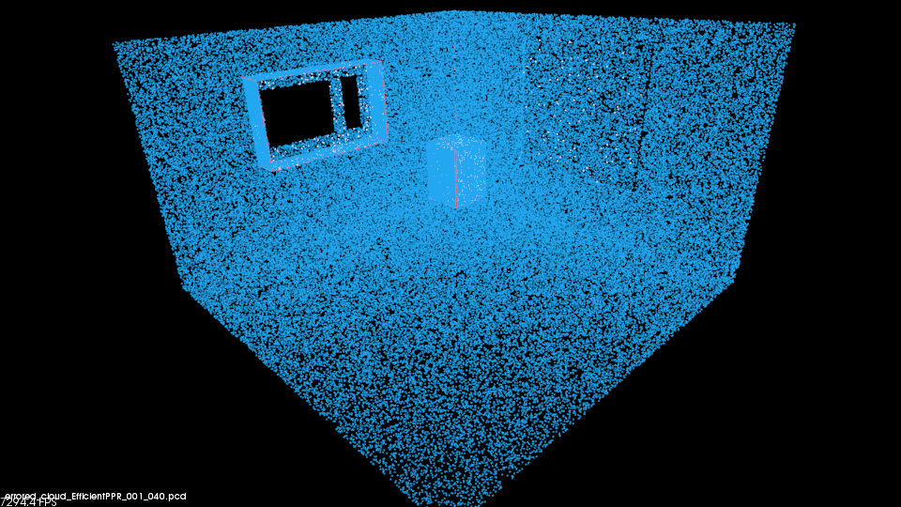
With PPR
Planar points | 168222
# planes | 15
Normal rad | 0.04
Inlier threshold | 0.02
NonPlanar | 1062
Incorrect | 637
Average dist | 5.61976e-05

With Noise ( gaussian N(0,0.02) )

Without PPR
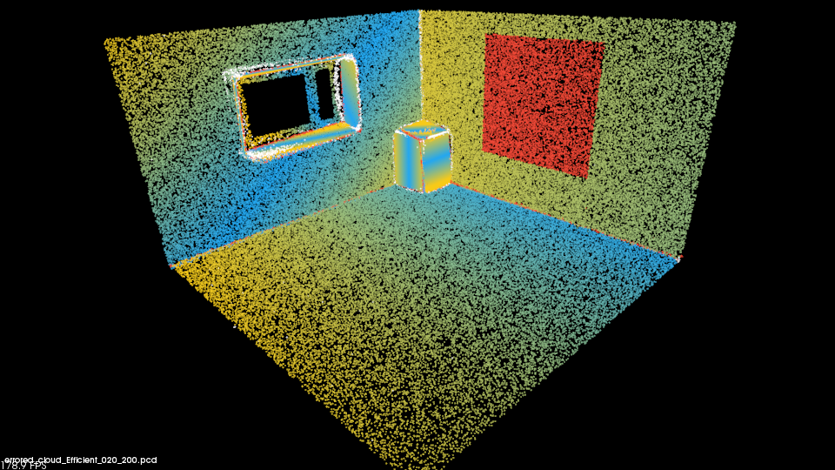
Planar points | 169495
# planes | 15
Normal rad | 0.2 m
Inlier threshold | 0.1 m
Angle Threshold | 0.6 rad
Nonplanar points | 3581
Incorrect | 11476
Average distance | 0.0265

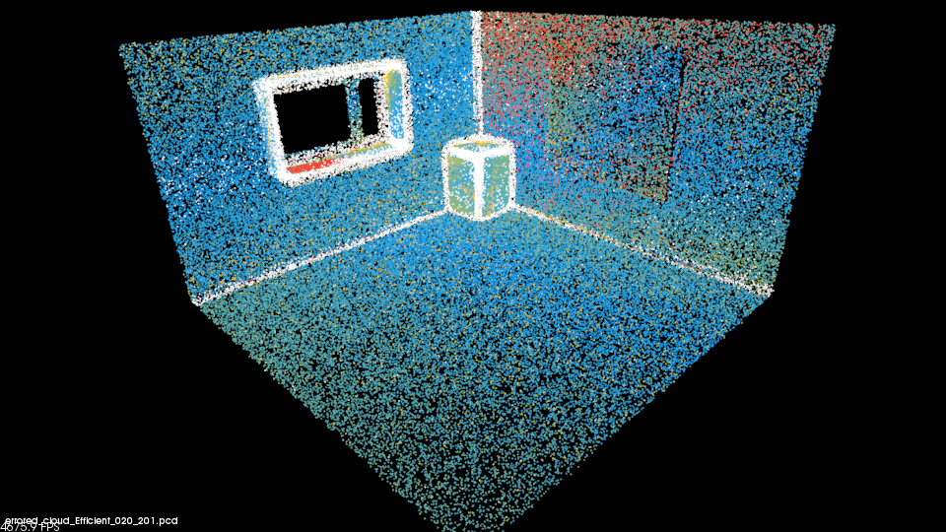
Planar points | 169495
# planes | 36
Normal rad | 0.2 m
Inlier threshold | 0.03 m
Angle Threshold | 0.3 rad
NonPlanar | 22377
Incorrect | 6751
Average distance | 0.011

With PPR
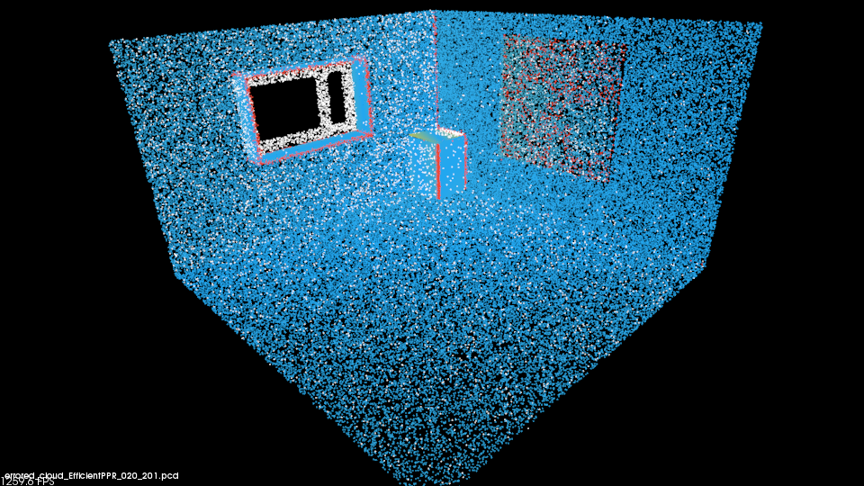
Planar points | 169495
# planes | 11
Normal rad | 0.2 m
Inlier threshold (RANSAC) | 0.03 m
Angle threshold | 0.3 rad
NonPlanar points | 9388
Incorrect | 6177
Average distance | 0.0025

QTD decimation
