**Practical 2**

**APPLICATION DEVELOPMENT FRAMEWORKS**

2CSDE86

**Mistry Unnat**

20BCE515



Department of Computer Science and Engineering

Institute of Technology

Nirma University

Ahmedabad

**Aim :** **Hands-on for understanding Django Project Structure and Application Structure. Sample Hello world webpage.**

* **Django Project Structure**

|  |  |
| --- | --- |
| **manage.py** | Command line utility lets you interact with your Django project. |
| **_init_.py** | A blank Python script whose presence indicates to the Python interpreter that the directory is a Python package. |
| **settings.py** | Contains the configuration settings for the Django project. |
| **urls.py** | Contains URL patterns for the Django project. |
| **wsgi.py** | Contains WSGI configuration properties for the Django project. |

* **Django App Structure**

|  |  |
| --- | --- |
| **admin.py** | File with admin definitions for the app - such definitions are needed to access model class instances from the Django admin. |
| **apps.py** | File with configuration parameters for the app. |
| **models.py** | File with database definitions (i.e., model classes) for the app. |
| **tests.py** | File with test definitions for the app. |
| **views.py** | File with view definitions (i.e., controller methods) for the app. |
| **migrations** | The directory that contains migrations applied to the app’s database definitions (i.e., model classes). |

* **Create a new directory hello_world**

mkdir_hello_world

cd hello_world

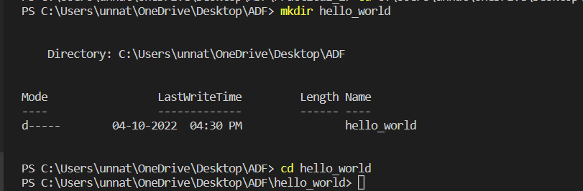

* 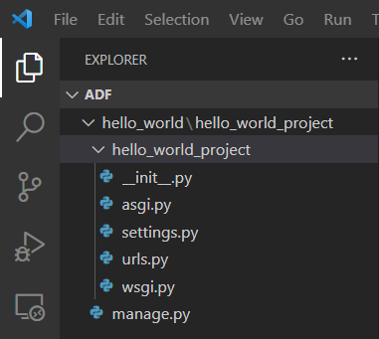**Creating Django project:**

django-admin startproject hello_world_project

This command will create following files ->

Apply migrations and test our project. Run these commands.

python manage.py migrate

python manage.py runserver

This will start the Django's built-in server now open your preferred browser and navigate to this address http://127.0.0.1:8000/ if everything went well you should see the default Django's welcome page.

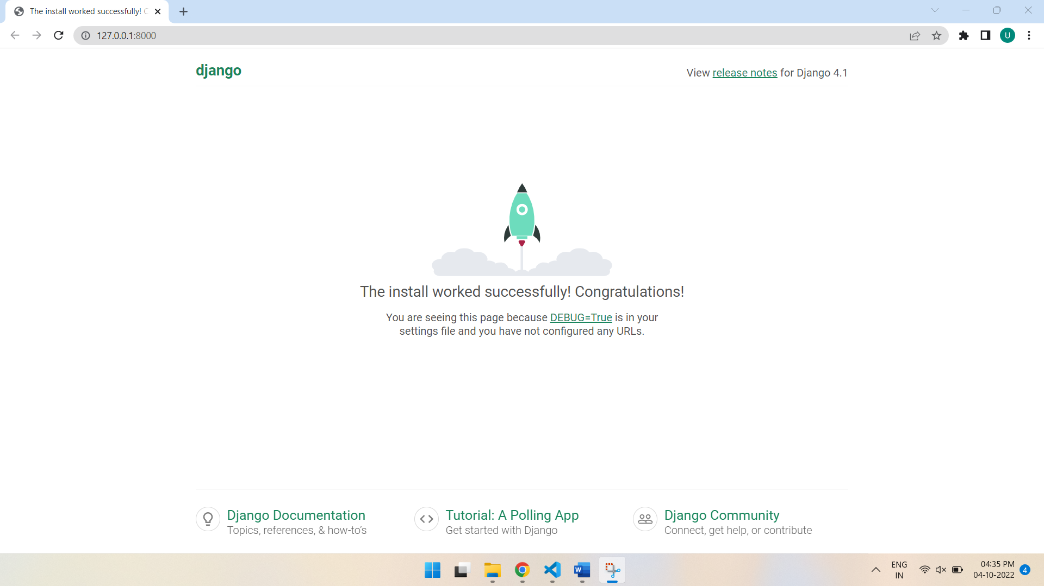

Press ctrl+c in the terminal window, to stop the server.

* 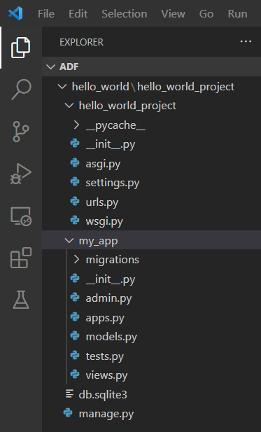**Create a Django app**

python manage.py startapp my_app

This will create another directory inside the project called my_app, now the project should look something like this

* **Add my_app in settings.py**

INSTALLED_APPS = [

    'django.contrib.admin',

    'django.contrib.auth',

    'django.contrib.contenttypes',

    'django.contrib.sessions',

    'django.contrib.messages',

    'django.contrib.staticfiles',

    'my_app'

]

* **Update my_app/views.py**

from django.shortcuts import render

from django.http import HttpResponse

def index(request):

    return HttpResponse('Hello, World!')

* **Update hello_world_project/urls.py**

from django.contrib import admin

from django.urls import path

from my_app import views

urlpatterns = [

    path('admin/', admin.site.urls),

    path('',views.index,name="homepage")

]

* **Run server**

python manage.py runserver

Now visit http://127.0.0.1:8000/ you should see Hello, World! written there.

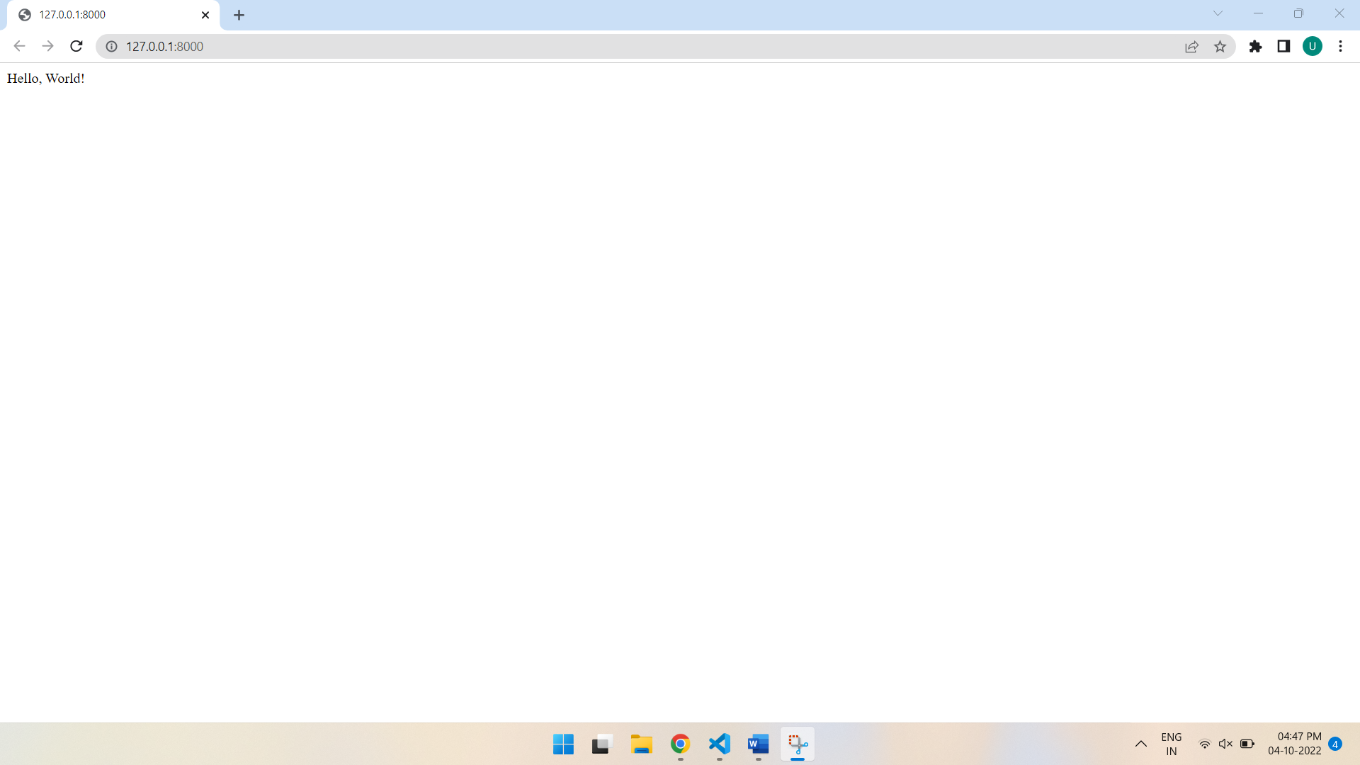

**\*\*END\*\***