**Practical 1**

**APPLICATION DEVELOPMENT FRAMEWORKS**

2CSDE86

**Mistry Unnat**

20BCE515



Department of Computer Science and Engineering

Institute of Technology

Nirma University

Ahmedabad

**Aim :**

**Task 1 :** Python installation, Anaconda, Pycharm, VSCode installation and configuration in student's personal laptop/lab system.

* **Anaconda Installation:**

**Step 1:** Download Anaconda Installer from: <https://www.anaconda.com/>

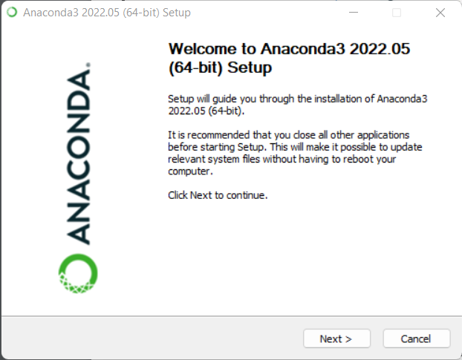

**Step-2:** Select Installation type and then click on next.

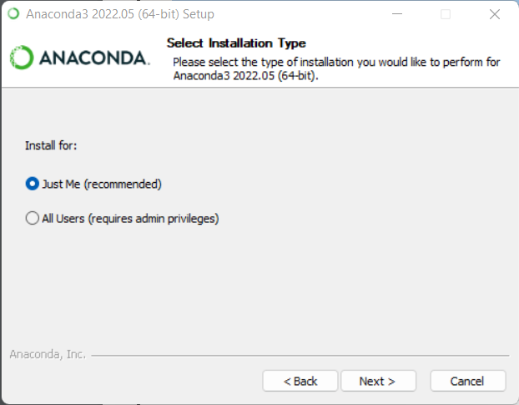

**Step-3:** Select destination folder to install anaconda and then click on next.

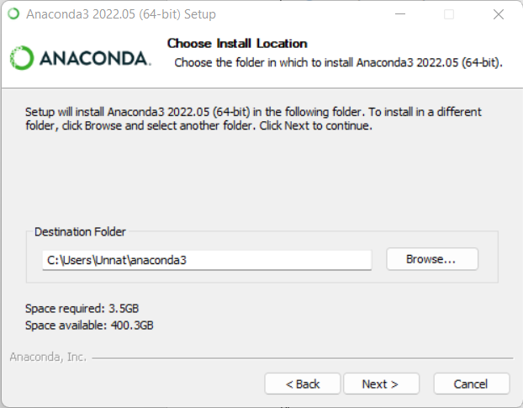

**Step-4:** Select whether to add Anaconda to your PATH environment variable or register Anaconda as your default Python.

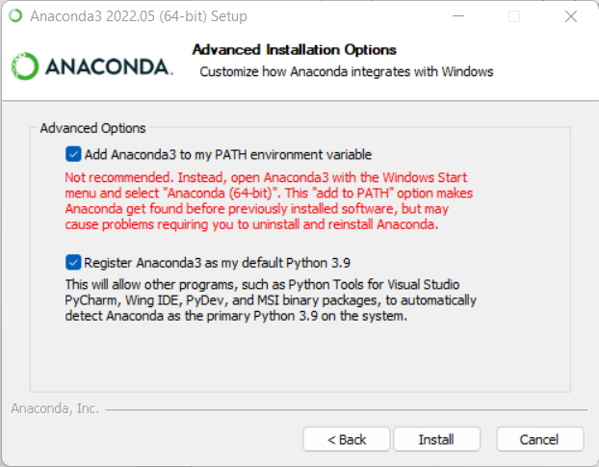

**Step-5:** After successful completion you will see the following dialog box.

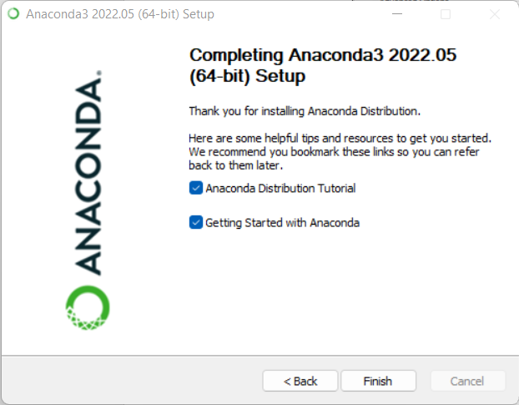

* **Pycharm Installation:**

**Step-1:** Download Pycharm From Following Link: [www.jetbrains.com/pycharm/download/](http://www.jetbrains.com/pycharm/download/)

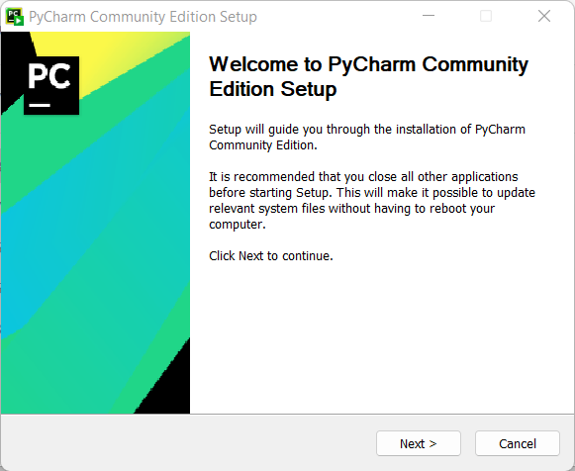

**Step-2:** Select Destination Folder for installation

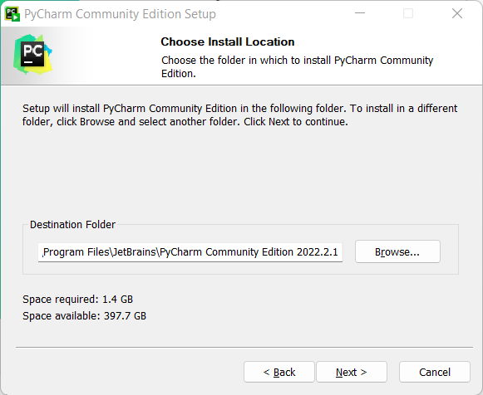

**Step-3:** Configure Path Variable and create desktop shortcut.

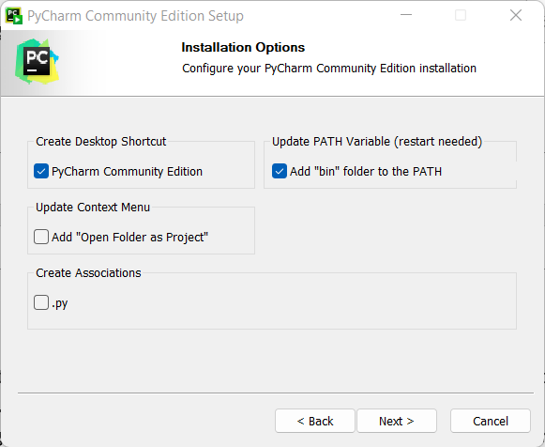

**Step-4:** After that click on next and install , and installation will get started and then reboot the pc.

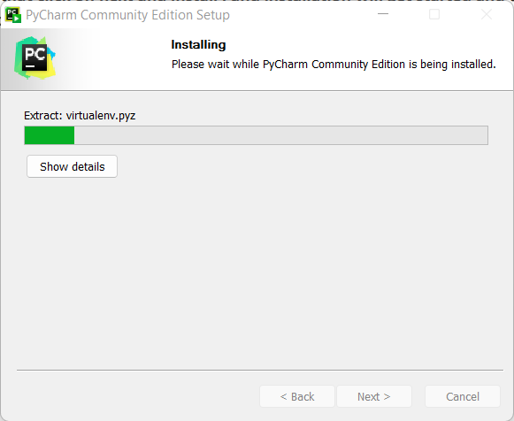

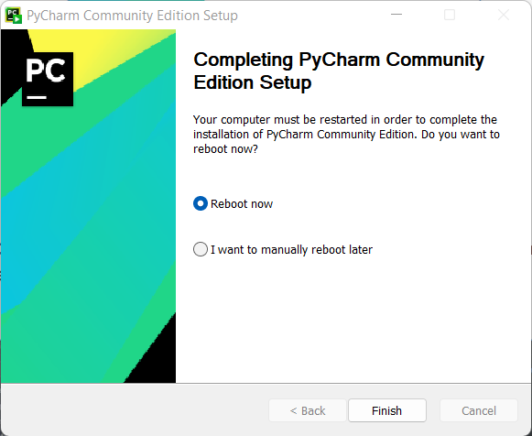

**Step-5:** Configuring conda environment in pycharm by adding a local interpreter in configure menu.

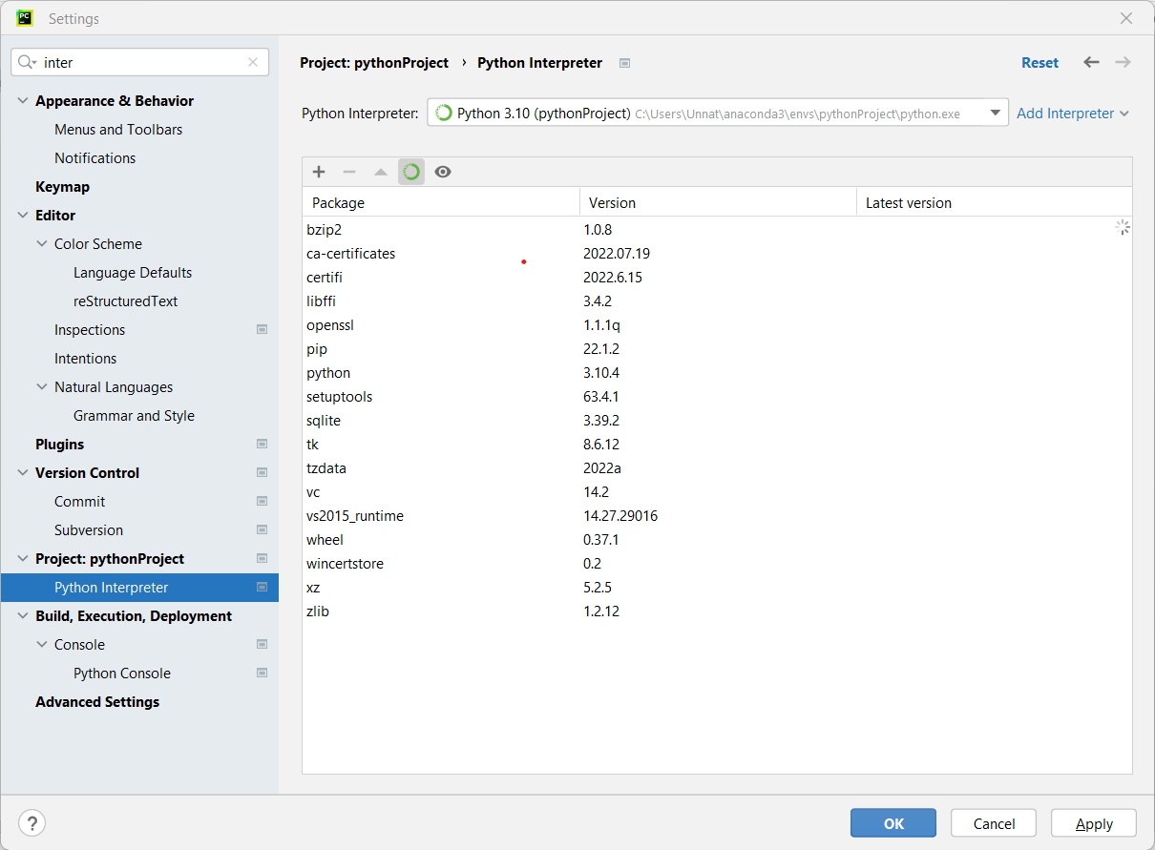

**Task-2:** Practice problems for recalling concepts of Python

(Variables, File read and write, plots etc)

**Python Code :**

import numpy as np  
import matplotlib.pyplot as plt  
  
v = 10  
p = 20  
print("a={0} and b={1}".format(v, p))  
str = 'Hello Unnat!'  
print(str)  
print(str[2:5])  
print(str * 2)  
print(str + "TEST")  
print(str[-12:])

list = ['abcd', 786, 2.23, 'Unnat', 70.2]  
tinylist = [123, '{Unnat}']  
print(list)  
print(list + tinylist)  
tuple = ('abcd', 786, 2.23, 'Unnat', 70.2)  
tinytuple = (123, 'Unnat')  
print(tuple)  
print(tuple + tinytuple)  
dict = {'name': 'Unnat', 'code': 6734, 'dept': 'coding'}  
print(dict)  
print(dict.keys())  
print(dict.values())  
*# While Loop*count = 0  
while (count < 9):  
 print('The count is:', count)  
 count = count + 1  
*# For Loop*numbers = [12, 22, 33, 55, 340, 55, 76, 37, 22, 23, 41, 13]  
for num in numbers:  
 if num % 2 == 0:  
 print("Even Number Present:", num)  
*# Line chart*x = np.arange(0, 10)  
y = x + 1

plt.title("Matplotlib ")  
plt.xlabel("x axis caption")  
plt.ylabel("y axis caption")  
plt.plot(x, y, linestyle='-', color='b')  
plt.show()  
x = np.arange(1, 11)  
y1 = x + 1  
y2 = x + 5

plt.title("Matplotlib demo")  
plt.xlabel("x axis caption")  
plt.ylabel("y axis caption")  
plt.plot(x, y1, label="student 1")  
plt.plot(x, y2, label="student 2")  
plt.legend(loc=2)  
plt.show()  
x = np.arange(0, 11)  
y = x + 1

plt.title("Matplotlib demo")  
plt.xlabel("x axis caption")  
plt.ylabel("y axis caption")  
plt.scatter(x, y, marker='v', color='g')  
plt.show()

**Output :**

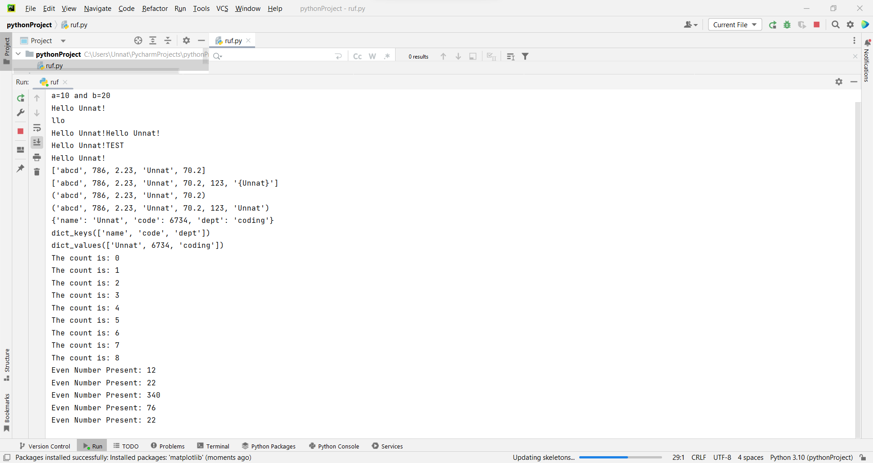

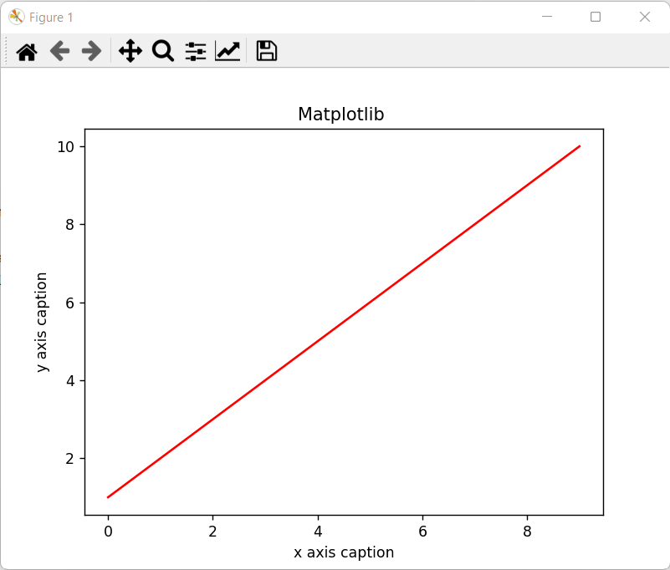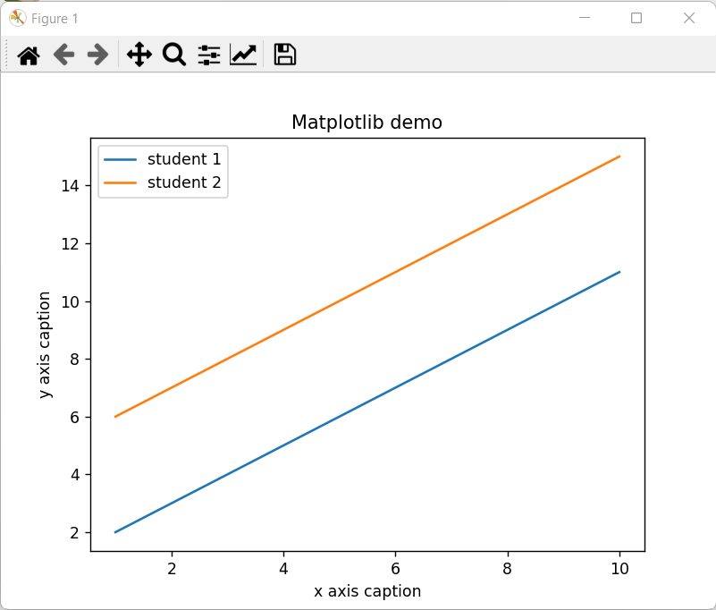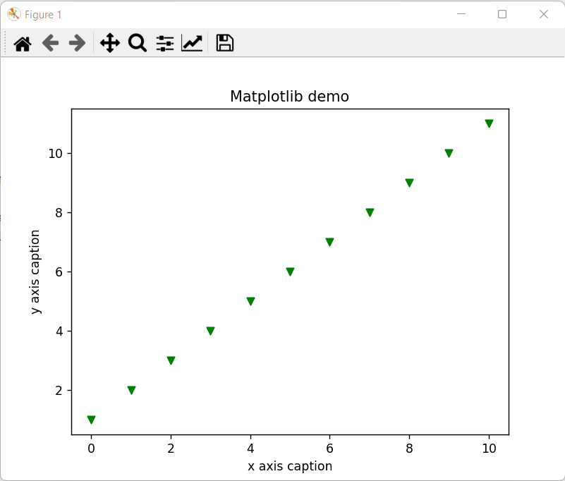

**Task-3:** Minion Game

**Python Code :**

def minion(string):  
 s = len(string)  
 kevin = 0  
 stuart = 0  
 for i in range(s):  
 if string[i] in 'AaEeIiOoUu':  
 kevin += (s - i)  
 *# print("Vowel", kevin)* else:  
 stuart += (s - i)  
 *# print("Consonant", stuart)* if kevin < stuart:  
 print('Stuart ' + str(stuart))  
 elif kevin > stuart:  
 print('Kevin ' + str(kevin))  
 else:  
 print('Draw')  
  
  
str1 = input("Enter String:")  
minion(str1)

**Output :**

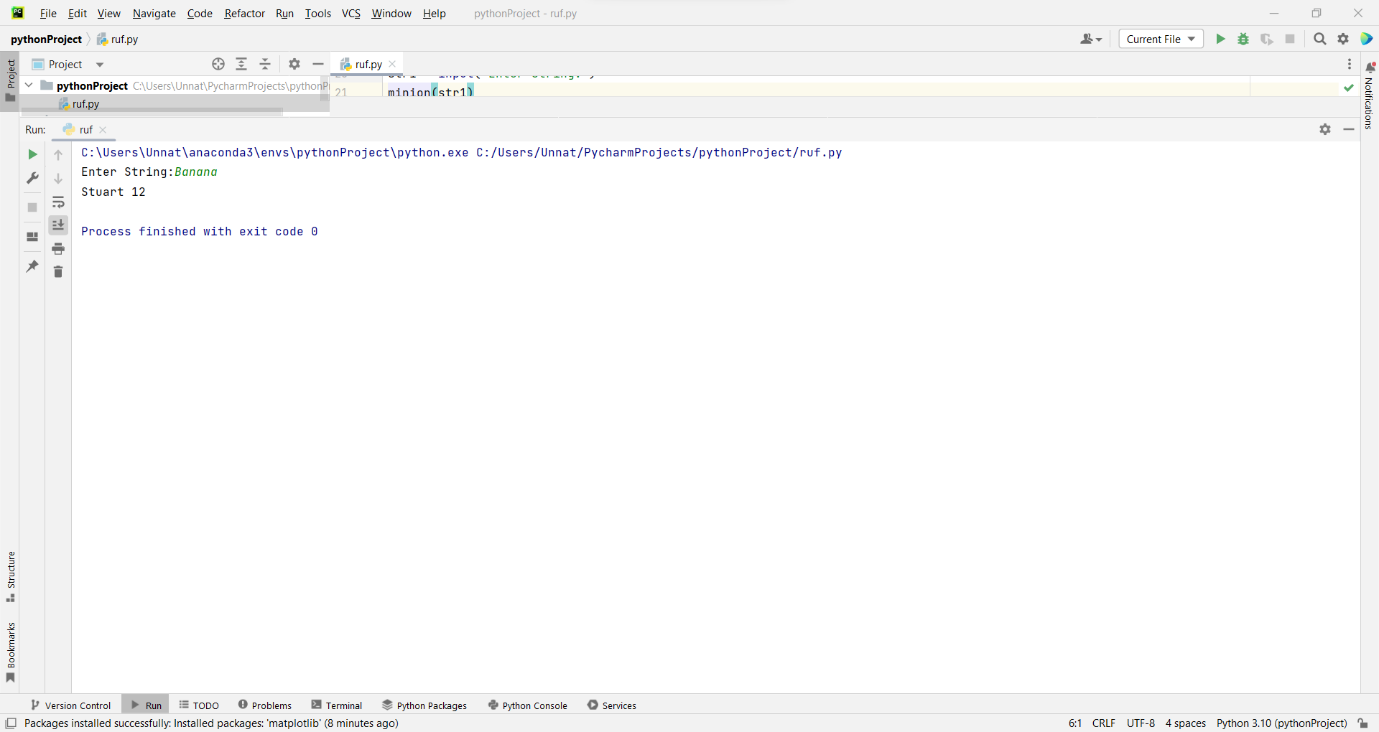

**Conclusion:**

In this practical, we installed necessary IDE and tools in our system and also we revised the concepts of python, numpy and matplotlib.