**Practical 3**

**Big Data Analytics**

2CS702

**Mistry Unnat**

20BCE515



Department of Computer Science and Engineering

Institute of Technology

Nirma University

Ahmedabad

**AIM :** Setup Single Node Hadoop Cluster and Apply HDFS Commands on single node Hadoop Cluster

**Commands :**

Starting the daemons… and checking if they are up and working

Commands used :

1. %HADOOP_HOME%/sbin/start-all.cmd
2. jps

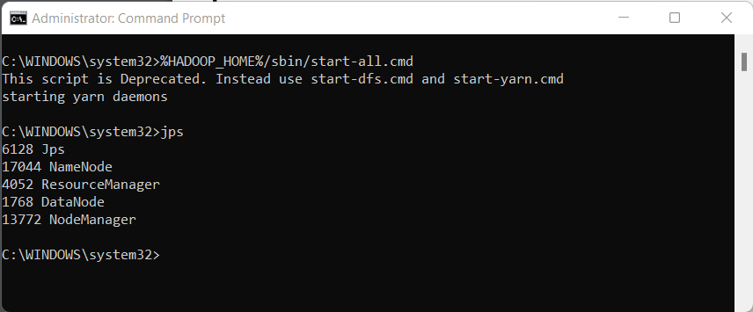

1. **mkdir :** creates directory

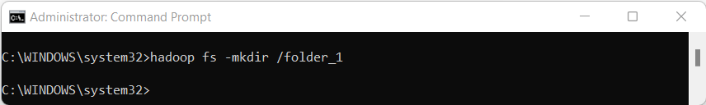

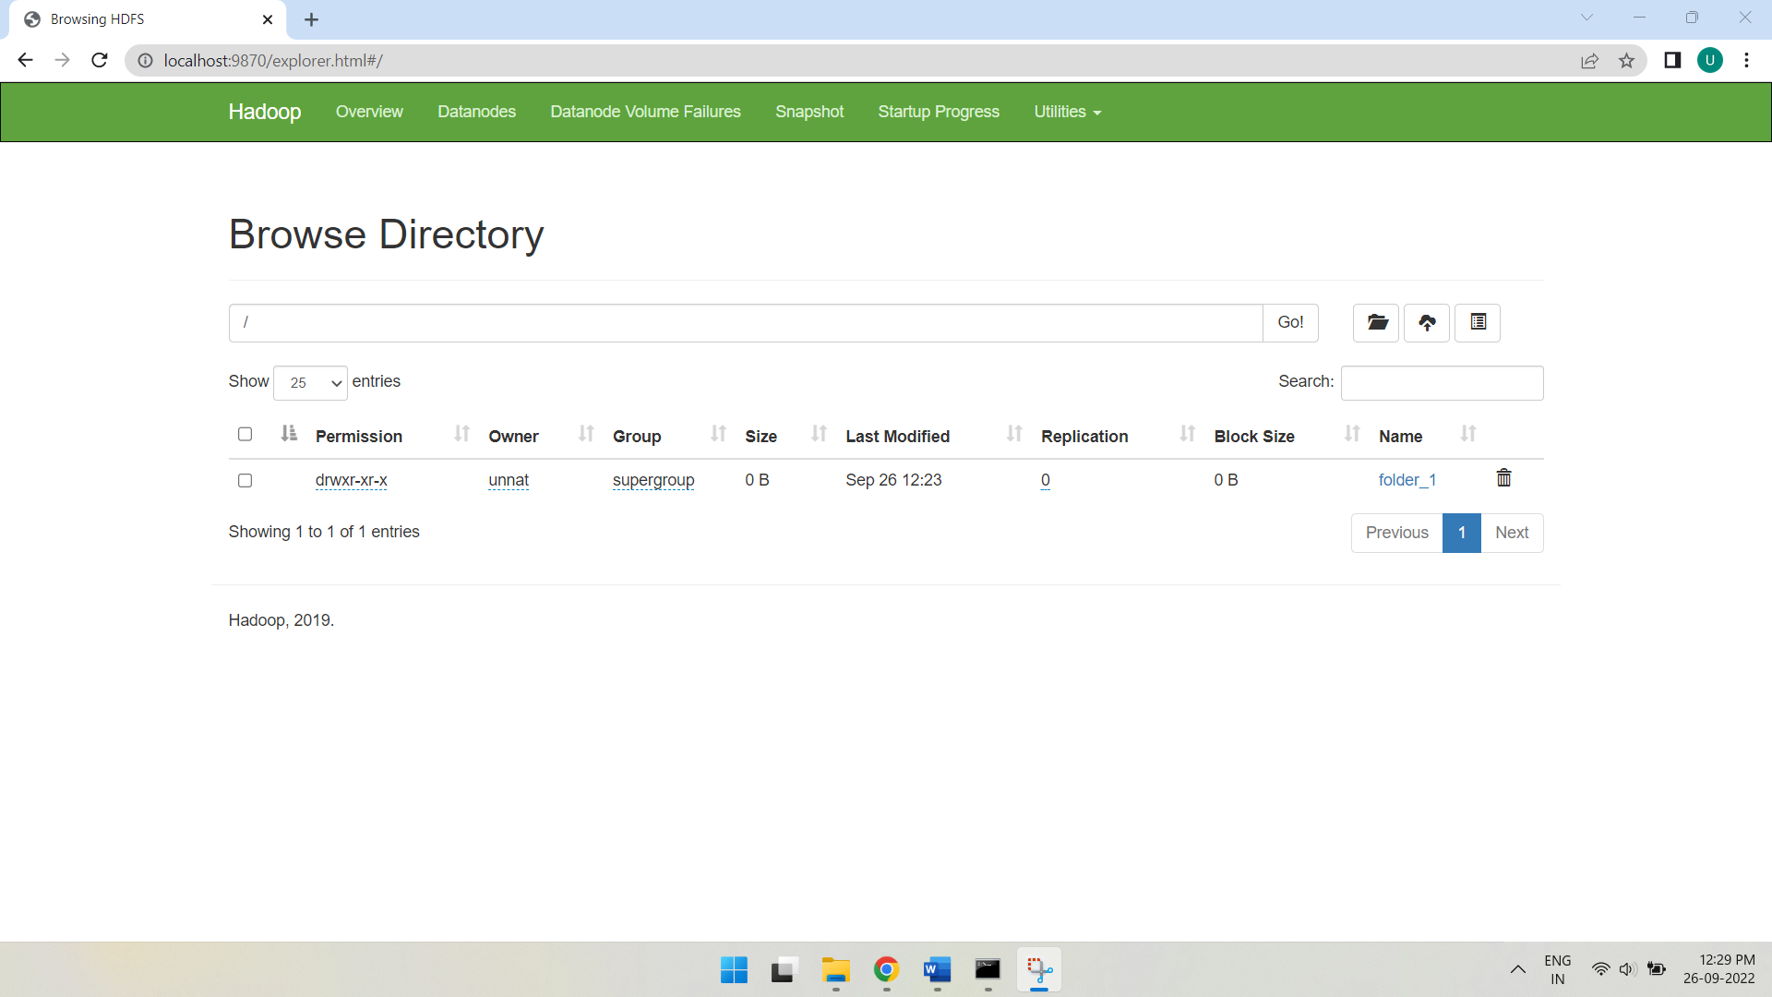

1. **ls :** lists files and folders

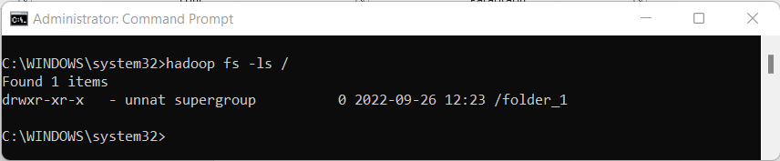

1. **chmod :** To change file and directory permissions, use the command chmod (change mode).

|  |  |  |
| --- | --- | --- |
| **Permission** | **Files** | **Directories** |
| r | can **read** the file | can **ls** the directory |
| w | can **write** the file | can **modify** the directory's contents |
| x | can **execute** the file | can **cd** to the directory |

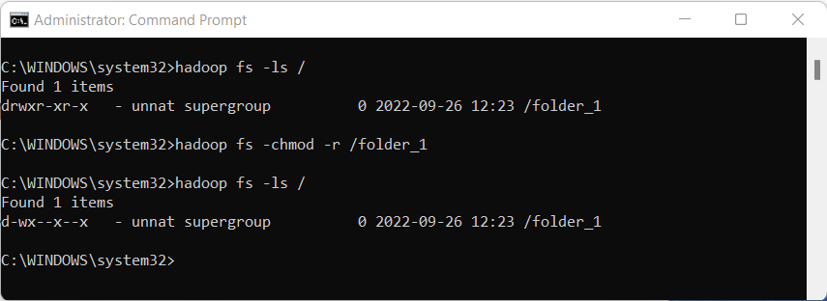

1. **count :** Hadoop HDFS count option is used to count a number of directories, number of files, number of characters in a file and file size.

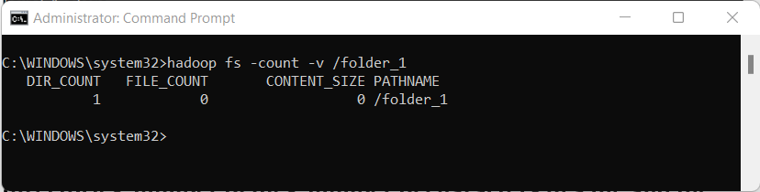

1. **copyFromLocal :** Hadoop copyFromLocal command is used to copy the file from your local file system to the HDFS(Hadoop Distributed File System).

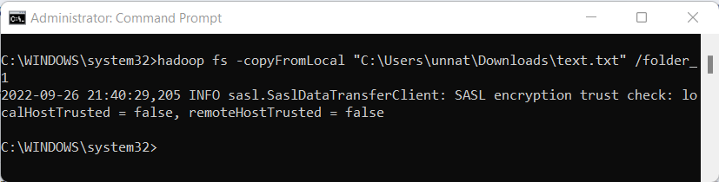

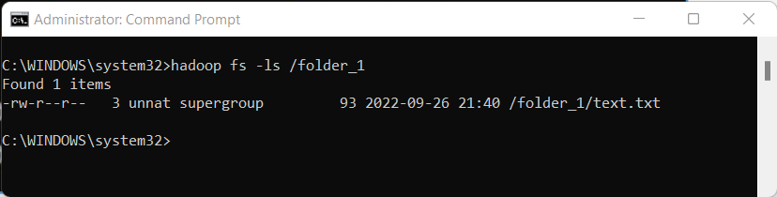

1. **stat :** Print statistics about the file/directory at <path> in the specified format.

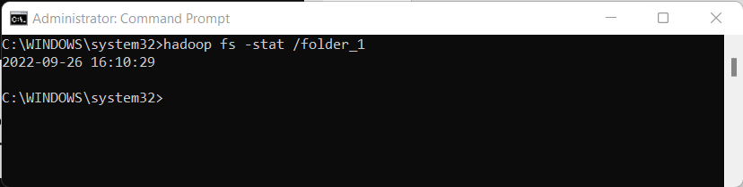

1. **tail :** The Hadoop fs shell tail command shows the last 1KB of a file on console or stdout.

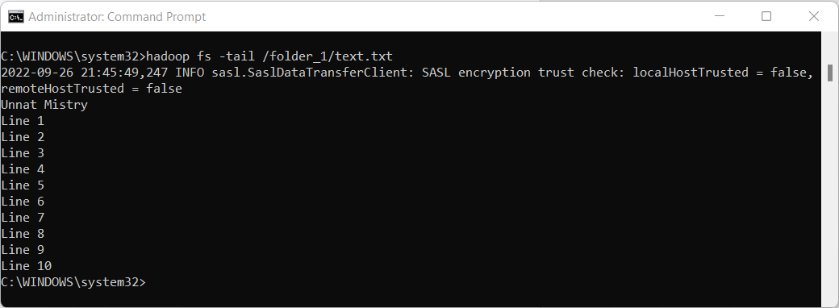

1. **touchz :** touchz command creates a file in HDFS with file size equals to 0 byte. The directory is the name of the directory where we will create the file, and filename is the name of the new file we are going to create.

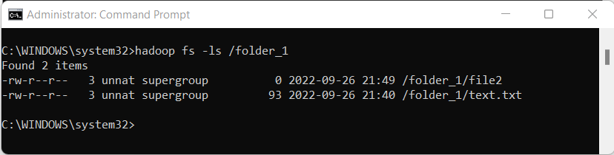

1. **rm :** This command is similar to the Linux rm command, and it is used for removing a file from the HDFS file system.

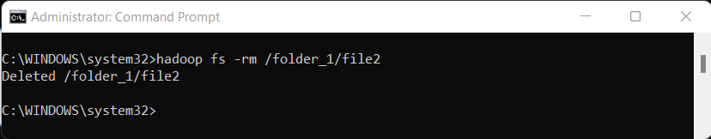

1. **cp :** The cp command copies a file from one directory to another directory within the HDFS.

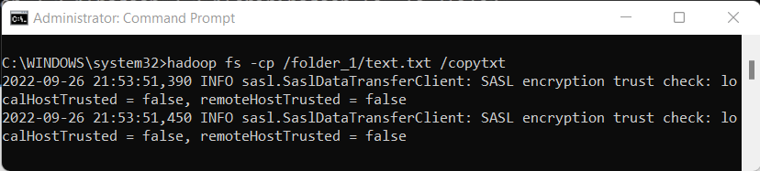

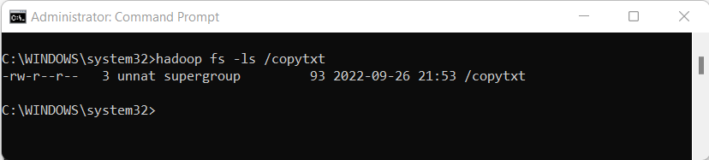

1. **mv :** moves files from source to destination.

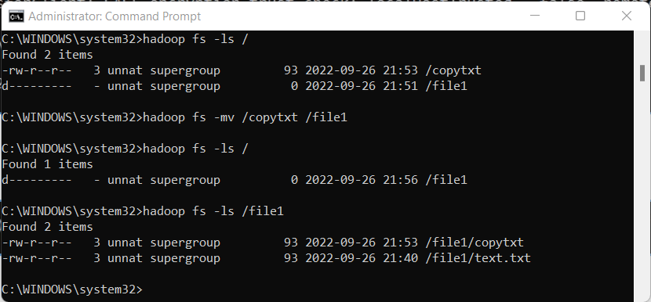

**Conclusion :**

In this practical, we setup a single node Hadoop cluster and applied HDFS commands on single node Hadoop cluster.