**Practical 3**

**Software Testing and Quality Assurance**

2CSDE80

**Mistry Unnat**

20BCE515

**September 30, 2022**



Department of Computer Science and Engineering

Institute of Technology

Nirma University

Ahmedabad

**AIM :**

To study and perform sample tests using Test Link Testing tool.

**Login to TestLink**

**Step 1 :** Open the Testlink home-page and enter the login details

Enter the userID – admin

Enter the password

Click on the login tab

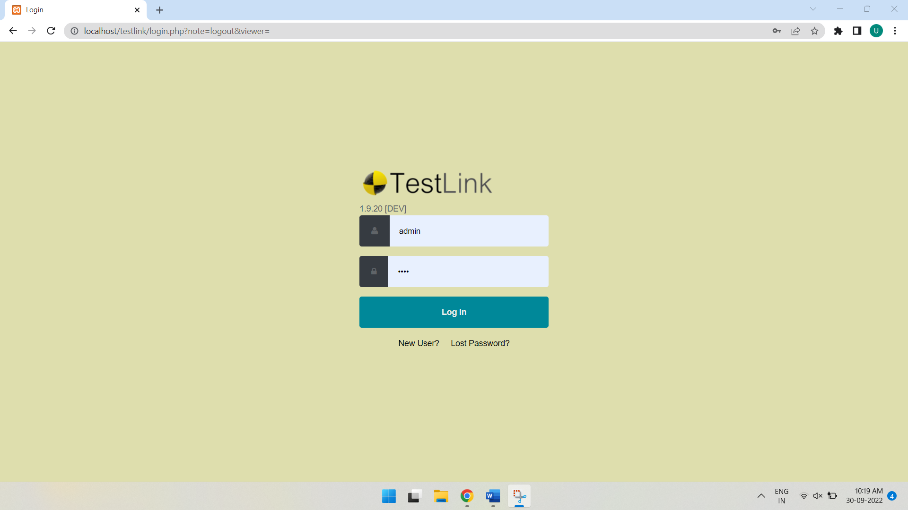

Creating a Test Project

**Step 1:** In the main window click on Test Project Management, it will open another window.

Step 2: Click on the tab “create” to create a new project.

Step 3: Enter all the required fields in the window like a category for a test project, name of the project, prefix, description, etc. After filling all necessary details, click on tab “Create” at the end of the window.

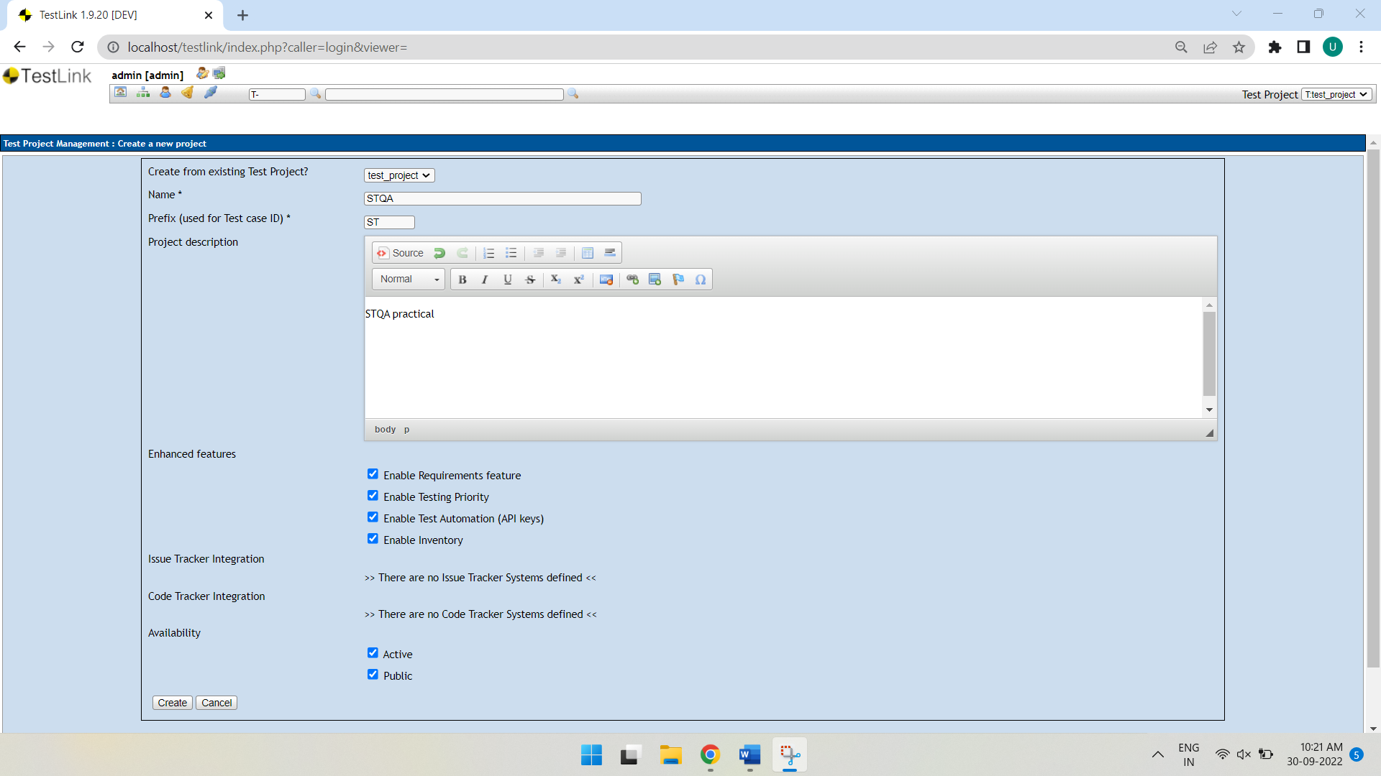

This will create your project “STQA” successfully.

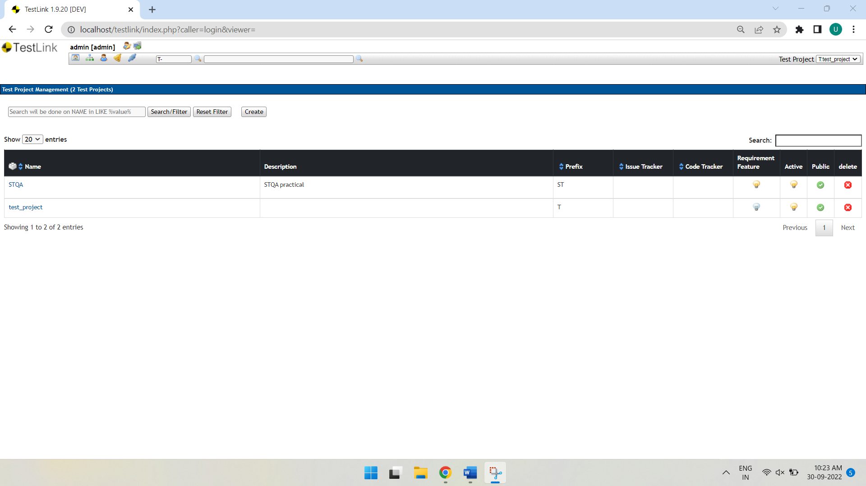

Creating a Test Plan

Test plan holds the complete information like the scope of Software testing, milestone, test suites and test cases. Once you have created a Test Project, next step is to create Test plan.

Step 1: From the home-page, click on Test Plan Management from home-page