**Practical 7**

**Compiler Construction**

2CS701

**Mistry Unnat**

20BCE515



Department of Computer Science and Engineering

Institute of Technology

Nirma University

Ahmedabad

**Aim :**

#### **To implement grammar rules for control statements, and Loop control.**

# **lab_7.y**

%{

#include<stdio.h> int yylex();

void yyerror(char *msg); void yywrap();

int count_for=0,count_if=0,count_while=0,count_switch=0,count_do_while=0; extern int line;

%}

%token FOR IF ELSE WHILE DO SWITCH CASE DEFAULT BREAK REOP DT AROP1 ID INT_CONST BOOL_CONST CHAR_CONST STR_CONST

%%

SS : SS S

| S

;

S : FOR_STMT

| IF_STMT

| WHILE_STMT

| DO_WHILE_STMT

| SWITCH_STMT

| BLOCK

| ';'

;

FOR_STMT : FOR '(' ASMT ';' COND ';' INCR ')' S {count_for++;} ; WHILE_STMT : WHILE '(' COND ')' S {count_while++;};

DO_WHILE_STMT : DO '{' S '}' WHILE '(' COND ')' ';' {count_do_while++;}; IF_STMT : IF '(' COND ')' S {count_if++;}

| IF '(' COND ')' S ELSE S {count_if++;}

;

SWITCH_STMT : SWITCH '(' ID ')' '{' CASE_STMTS DEFAULT_STMT '}' {count_switch++;}

;

CASE_STMTS : CASE_STMT CASE_STMTS

| CASE_STMT

;

CASE_STMT : CASE CONST ':' SS BREAK ';'

;

DEFAULT_STMT : DEFAULT ':' SS

;

BLOCK : '{' SS '}'

;

ASMT : DT ID '=' INT_CONST

| DT ID '=' ID

| ID '=' INT_CONST

;

COND : ID REOP ID

| ID REOP CONST

| CONST REOP ID

| CONST REOP CONST

;

INCR : ID AROP1

;

CONST : INT_CONST

| CHAR_CONST

| BOOL_CONST

| STR_CONST

;

%%

int main()

{

yyparse(); return 0;

}

void yyerror(char *msg)

{

printf("\nError Message :- %s statements are not following grammer rules at %d",msg,line);

}

void yywrap()

{

printf("\nNumber of for loop is %d",count_for); printf("\nNumber of while loop is %d",count_while); printf("\nNumber of do while loop is %d",count_do_while); printf("\nNumber of if statements is %d",count_if); printf("\nNumber of switch statements is %d",count_switch);

}

# **lab_7.l**

%{

#include "y.tab.h" int line=1;

%}

%%

"\n" {printf("");line++;}

"\t"|" " {printf("");}

"++"|"--" {return AROP1;} "int"|"float"|"double"|"char" {return DT;} "=="|"!="|"<"|">"|"<="|">=" {return REOP;}

[();{}:=] {return yytext[0];} [0-9]+ {return INT_CONST;}

['].['] {return CHAR_CONST;}

"true"|"false" {return BOOL_CONST;} ["].*["] {return STR_CONST;}

"for" {return FOR;} "if" {return IF;} "else" {return ELSE;}

"while" {return WHILE;} "do" {return DO;} "switch" {return SWITCH;} "case" {return CASE;}

"default" {return DEFAULT;} "break" {return BREAK;}

([_a-zA-Z](0-9)*)+ {return ID;}

%%

# **Screenshots**

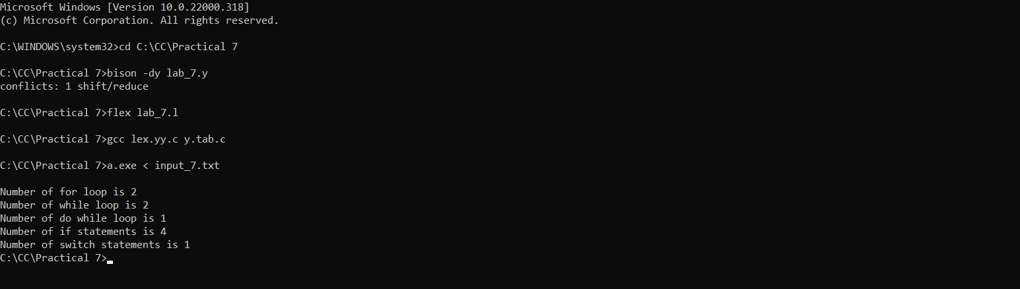

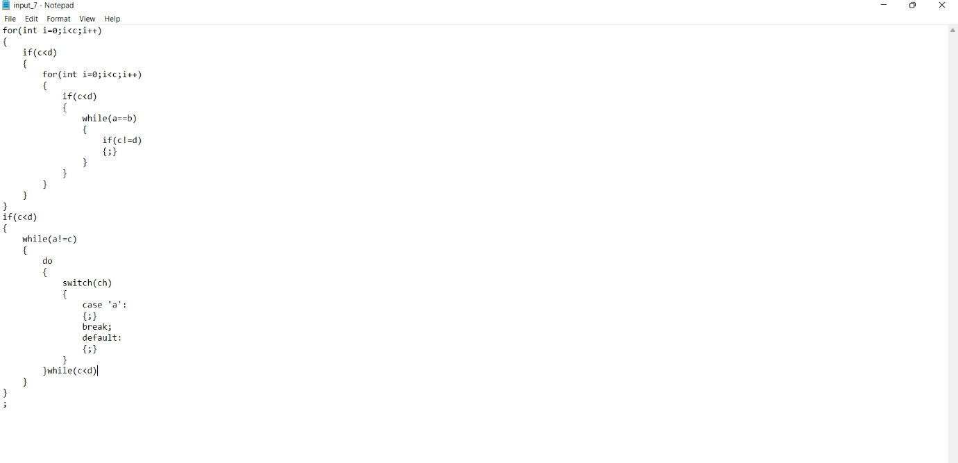



END