**Practical 8**

**Compiler Construction**

2CS701

**Mistry Unnat**

20BCE515



Department of Computer Science and Engineering

Institute of Technology

Nirma University

Ahmedabad

**Practical 8**

**Aim :**

To implement a Type Checker.

**Code :**



#include<stdlib.h>

printf("Enter the variable-type[%d](float-f,int-i):",i);

if(typ[i]=='f')

b[i]=c;



flag=1;

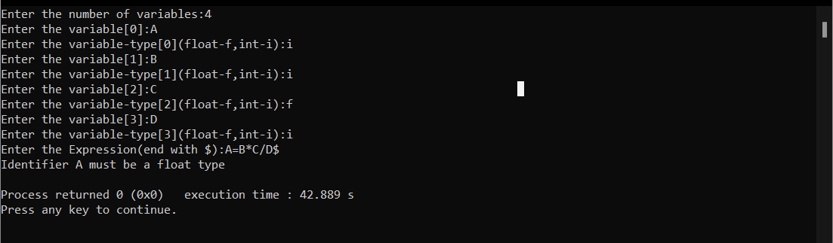**Output :**

