**Practical 10**

**Software Testing and Quality Assurance**

2CSDE80

**Mistry Unnat**

20BCE515



Department of Computer Science and Engineering

Institute of Technology

Nirma University

Ahmedabad

**AIM :** To demonstrate testing of a mobile application.

## Setting Up Selenoid

**Step-1** **:** Make a folder name Selendroid in C drive

**Step-2 :** Paste the following jar files/folder in the Selendroid folder :

* selendroid-standalone
* selendroid-client
* selenium

**Step-3 :** Open Command Prompt at the Selendroid folder.

**Step-4 :** Make an apk of an android application.

**Step-5 :** After downloading the apk file, place it in the Selendroid folder.

**Step-6 :** Execute the commands in the command prompt.

* cd Selendroid
* java –jar selendroid-standalone-0.17.0-with-dependencies_fixed.jar
* java –jar selendroid-standalone-0.17.0-with-dependencies_fixed.jar –app “ConvertMilesToKmApp.apk”

## **Output :**

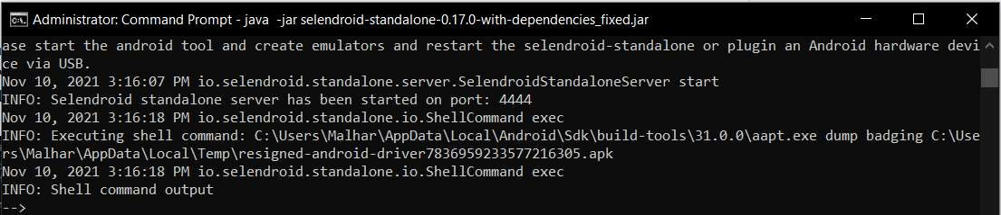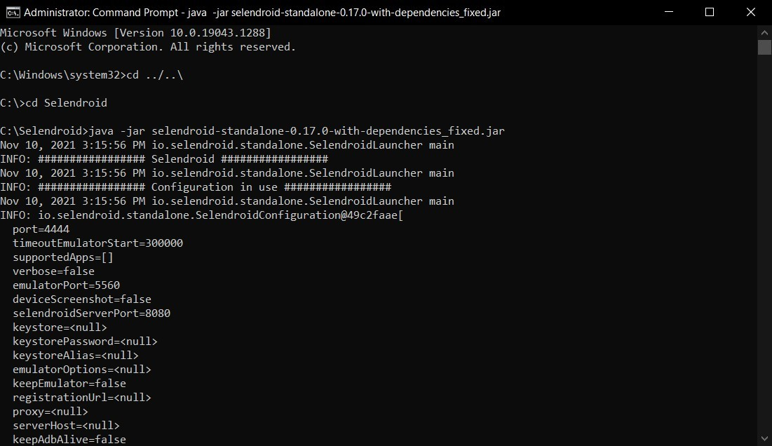



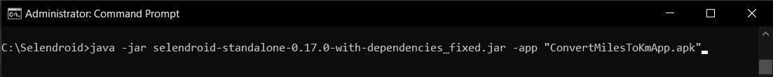

**Mobile Application Performance Testing Tools**

Performance testing in mobile applications is different from web application performance testing. While testing mobile applications we need to consider the network conditions, packet loss, latency, the type of device that we are using like a smartphone or smart device and bandwidth.

## BlazeMeter

1. Provides performance and load testing as a service
2. Can run all Jmeter Scripts
3. Cost depends on the requirements, has both free and paid plans
4. Easy to set up

## Apptim

1. Evaluates the performance of native Android and iOS mobile apps while running them on real devices
2. Integrates well with JIRA
3. Cost depends on the requirements, has both free and paid plans
4. Easy to Navigate

## Jmeter

* + 1. Used to measure the performance of the mobile application in which it will recordthe request through a proxy
    2. Platform independent and supports various server types and protocols
    3. Free
    4. Easy to set up and navigate

## Experitest

* + 1. Using SaaS provides for manual testing, performance testing, load testing, andmonitoring for mobile applications
    2. Support to all mobile OS, iOS, Android, Windows Phone, and Blackberry
    3. Cost depends on the requirements, has both free and paid plans
    4. Need a good understanding to operate

## Gatling

* + 1. Designed to be used as a load testing tool for analyzing and measuring the performance of a variety of services, with a focus on web applications, but can also be used for mobile
    2. Scala based scripting
    3. Free
    4. Need a good understanding to operate