**Practical 4**

**Software Testing and Quality Assurance**

2CSDE80

**Mistry Unnat**

20BCE515



Department of Computer Science and Engineering

Institute of Technology

Nirma University

Ahmedabad

**AIM : To study and perform sample tests using JUNIT Test Tool.**

* JUnit is a unit testing framework for the Java programming language. JUnit has been important in the development of test-driven development, and is one of a family of unit testing frameworks which is collectively known as xUnit that originated with SUnit. JUnit is linked as a JAR at compile-time.
* JUnit is an open-source testing framework for Java programmers. To perform unit testing, we need to create test cases. The unit test case is a code which ensures that the program logic works as expected.
* **Types of Unit Testing :**

There are two ways to perform unit testing: 1) Manual testing 2) Automated testing.

**1) Manual Testing** : If we execute the test cases manually without any tool support, it is known as manual testing. It is time consuming and less reliable.

**2) Automated Testing** : If we execute the test cases by tool support, it is known as automated testing. It is fast and more reliable.

* **Why we need JUnit testing :**
* It finds bugs early in the code, which makes our code more reliable.
* JUnit is useful for developers, who work in a test-driven environment.
* Unit testing forces a developer to read code more than writing.
* We develop more readable, reliable and bug-free code which builds confidence during development.
* Using JUnit we can save testing time.
* In real time, in the web application development we implement JUnit test cases in the DAO classes. DAO classes can be tested with out server.
* With JUnit we can also test Struts / Spring applications but most of the time we test only DAO classes. Even some times service classes also tested using JUnit.

**Code:**

package junit;

import static org.junit.Assert.*assertEquals*;

import java.util.StringTokenizer;

import org.junit.Test;

public class Final {

public static int findMax(int arr[]){

int max=0;

for(int i=1;i<arr.length;i++){

if(max<arr[i]) max=arr[i];

}

return max;

}

public static int findCube(int n){

return n*n*n;

}

public static String reverseOfWords(String str){

StringBuilder result=new StringBuilder();

StringTokenizer tokenizer=new StringTokenizer(str," ");

while(tokenizer.hasMoreTokens()){

StringBuilder sb=new StringBuilder();

sb.append(tokenizer.nextToken()); sb.reverse();

result.append(sb); result.append(" ");

}

return result.toString();

}

public int multiply(int a, int b) {

return a * b;

}

@Test

public void Setup()

{

*assertEquals*(4,*findMax*(new int[]{1,3,4,2}));

*assertEquals*(1,*findMax*(new int[]{-12,1,-3,-4,-2})); *assertEquals*("erahK hsuytarP ",*reverseOfWords*("Unnat Mistry")); *assertEquals*(27,*findCube*(3));

*assertEquals*(10,multiply(2,5));

}

}

**Output:**

**Test Case 1: All True**

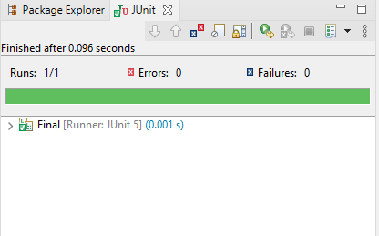

**Test Case 2: Changing value of multiply function parameters to 2, 3.**

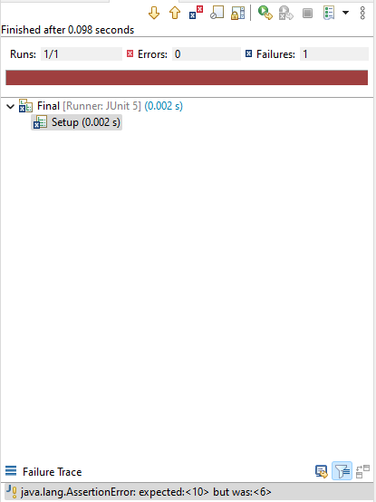

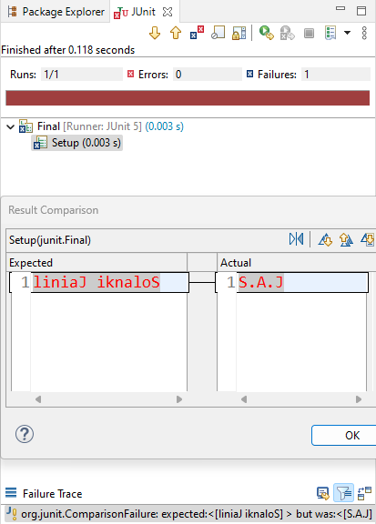**Test Case 3: Changing value of reverseOf Words function parameters to J.A.S**.

erahK hsuytarP

**Test Case 4: Changing value of findCube function parameters to 5.**

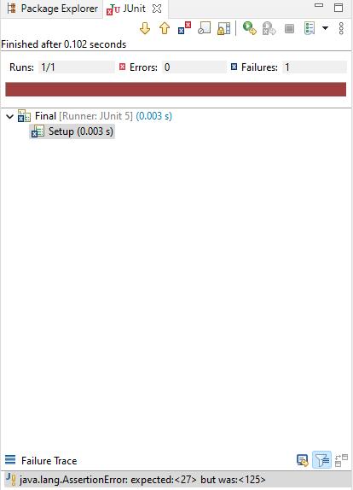

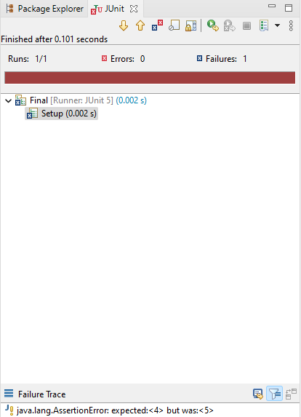**Test Case 5: Changing value of findMax function parameters to [4,3,5,2]**

END