**Practical 5**

**Software Testing and Quality Assurance**

2CSDE80

**Mistry Unnat**

20BCE515



Department of Computer Science and Engineering

Institute of Technology

Nirma University

Ahmedabad

**AIM :** To study and perform sample tests using Selenium Test Tool.

**Introduction :**

Selenium is the first thing that comes to mind when one is planning to automate the testing of web applications.

* It is a beneficial tool because it is not only open source but also a portable software testing framework for web Applications that support multiple languages like Java, C#, Ruby, Python.
* Eventually choosing the right language varies by project, organization, and individuals driving it.

Thus, writing selenium test cases using Java has multiple benefits:

* Programs written in Java are faster than other popular languages like Python.
* Java is more widely used in commercial applications as compared to other programming languages.

**Why we need Selenium testing :**

* Selenium is compatible with multiple operating systems like Windows, Linux, Solaris, Macintosh.
* It also supports multiple browsers like Chrome, Safari, IE, Edge, Firefox.
* It is used to automate functional tests.
* Also, Selenium is easy to integrate with tools like Jenkins, Maven, and Docker to achieve a continuous testing approach.
* Tools like TestNG and JUnit further help in structuring the selenium tests for easy maintainability and generating reports.

**Pre Requisite Installation of Eclipse IDE and Jar File:**

* **Installation of Selenium Testing Tool**
* **Downloading the jar file for Selenium.**

**Code For Checking Login Functionality of LMS Nirma:**

**import** org.openqa.selenium.By;

**import** org.openqa.selenium.WebDriver;

**import** org.openqa.selenium.chrome.ChromeDriver;

**public** **class** Test1 {

**public** **static** **void** main(String args[]) {

System.*setProperty*("webdriver.chrome.driver", "chromedriver.exe");

WebDriver driver = **new** ChromeDriver();

// URL of LMS Website

driver.get("https://lms.nirmauni.ac.in/login/index.php");

// Maximize window size of browser

driver.manage().window().maximize();

// Email id

driver.findElement(By.*id*("username")).sendKeys("20bce515@nirmauni.ac.in");

// Passwords

driver.findElement(By.*id*("password")).sendKeys("BlahBlahBlah");

// Logging In By Clicking Login Button

driver.findElement(By.*id*("loginbtn")).click();

}

}

* Executing the Code:

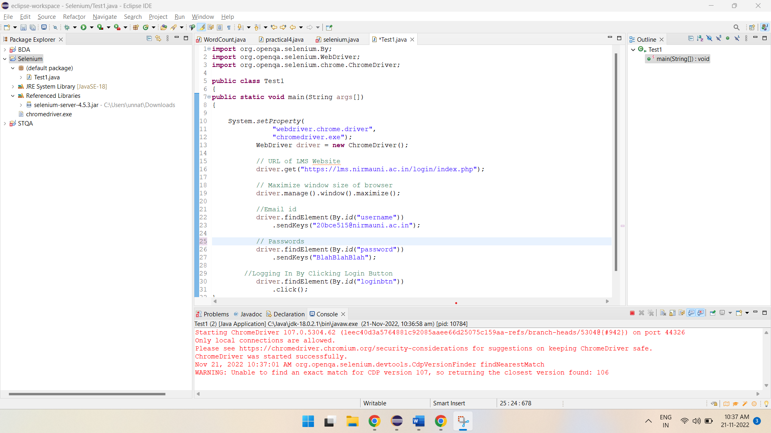

* The Website is being opened and credentials will be automatically inserted as per the code.

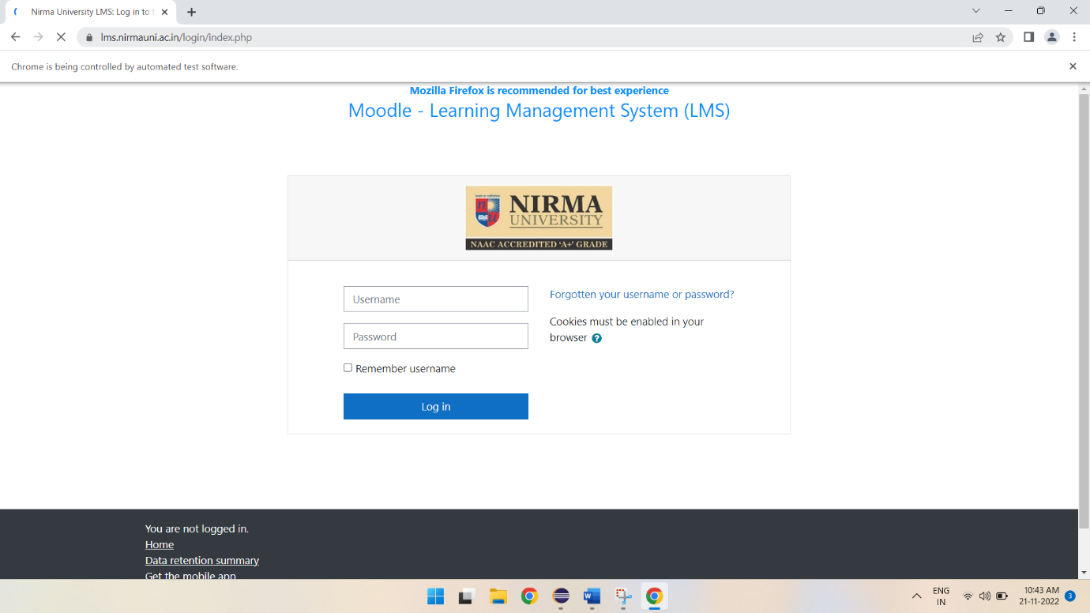

* The Website is being opened and credentials will be automatically inserted as per the code.

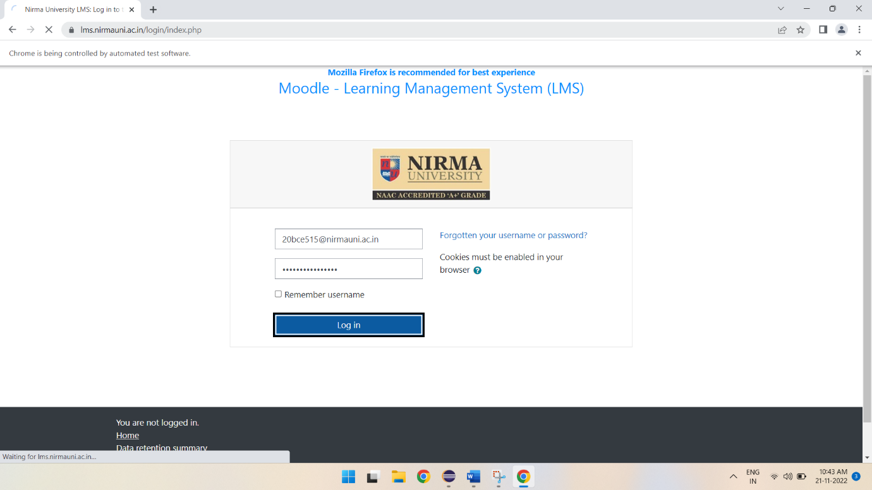

* Finally, if credentials are correct, user shall be successfully logged in.

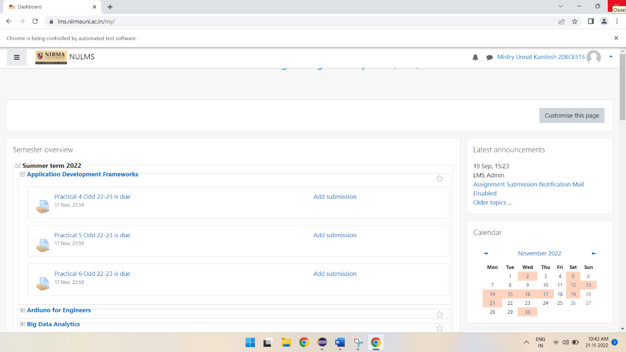

END