**Practical 6**

**Software Testing and Quality Assurance**

2CSDE80

**Mistry Unnat**

20BCE515



Department of Computer Science and Engineering

Institute of Technology

Nirma University

Ahmedabad

**AIM : To perform automated functional GUI testing using AutoIT.**

AutoIT is a scripting language designed to automate windows GUI.

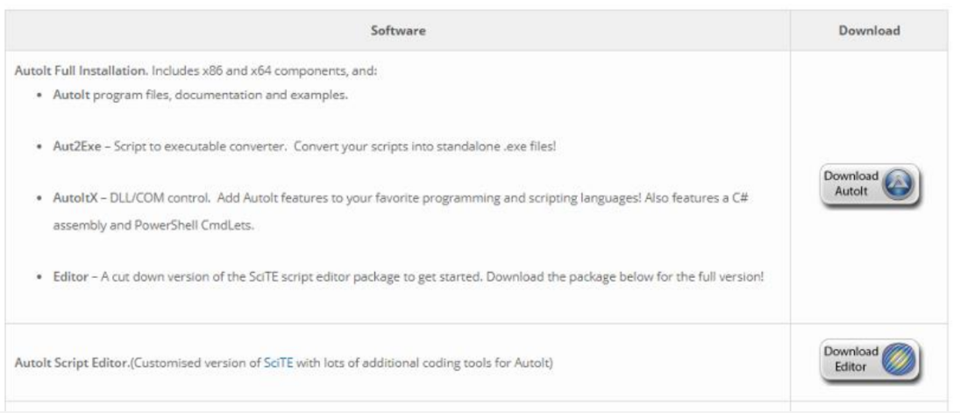

* **Download AutoIT**

Step 1: Click on 'AutoIt' > 'Downloads' option

Step 2: Click on 'Download AutoIt' button Download AutoIt editor

Step 3: Click on 'Download Editor' button

After AutoIt installation, open AutoIT Editor and click on ‘SciTE.exe’ file.

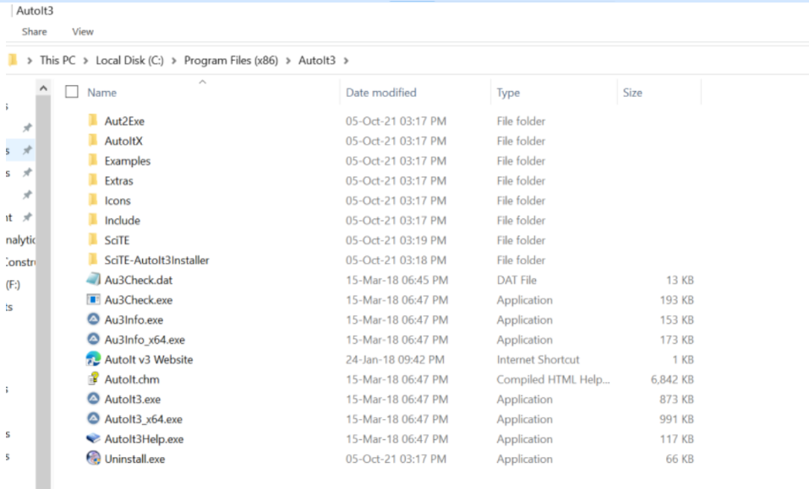

Click on ‘Au3Info.exe’ file and open element identifier.

Let’s see how to find element using element Identifier

In this section, we will see how to find elements in the file uploader window using AutoIT Element Identifier. It finds the element of window GUI and provide the attribute of element like title, class, instance etc.

We shall use it for PDF to DOC — Convert PDF to Word Online. After clicking on ‘UPLOAD FILES’ button, we need to call AutoIT script. The control immediately moved to AUTOIT after clicking ‘UPLOAD FILES’ button.

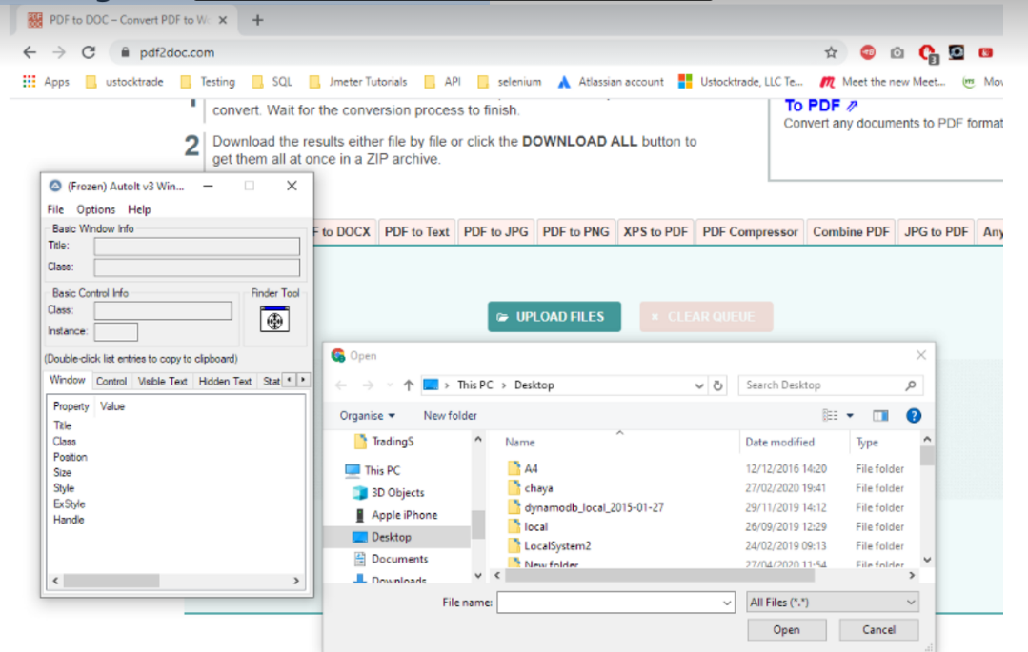

**Step** 1: Open element Identifier- Go to ‘C:\Program Files (x86)\AutoIt3’ and click on ‘Au3Info.exe’ file.

**Step** 2: Open file uploader window by clicking on ‘UPLOAD FILES’.

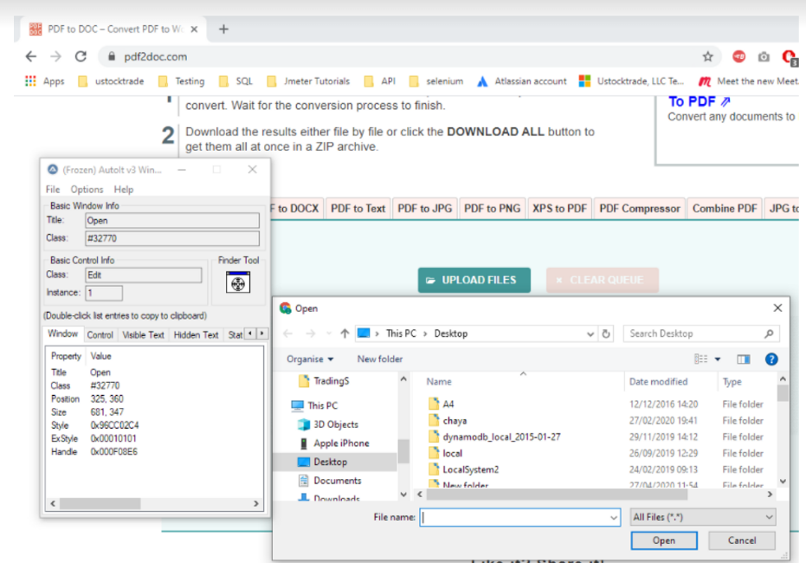

Open file uploader window

**Step 3:** Drag the ‘Finder Tool’ on the “ File name” element of file uploader to find the attributes.

Attributes are title=Open, class=Edit and instance=1.

Let’s write scripts using AutoIT editor

Methods are required for writing file upload script:

Sets input focus to a given control on a window

**ControlFocus**(“ title “,” text “,controlID )Sets text of a control

**ControlSetText**(“ title “,” text “,controlID ,” File path which need to upload “ )Sends a mouse click command to a given control

**ControlClick**(“ title “,” text “,controlID )

**ControlFocus** method: focus to the ‘file name’ text box of the file uploader

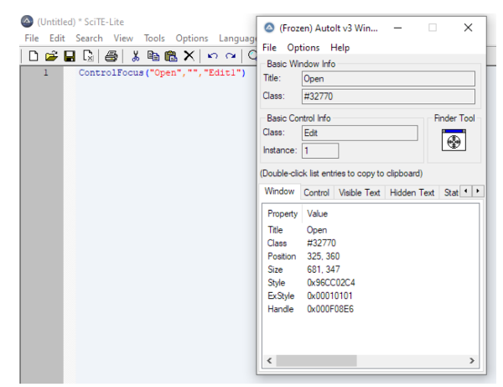

ControlFocus method

**title** — “Open”

text is not required.

**controlID** — “Edit1” (combination of class=’Edit’ and Instance=’1')

**ControlFocus**(“Open”,””,”Edit1")

**ControlSetText** method : Input file path of a control

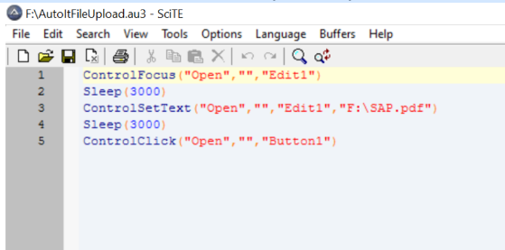

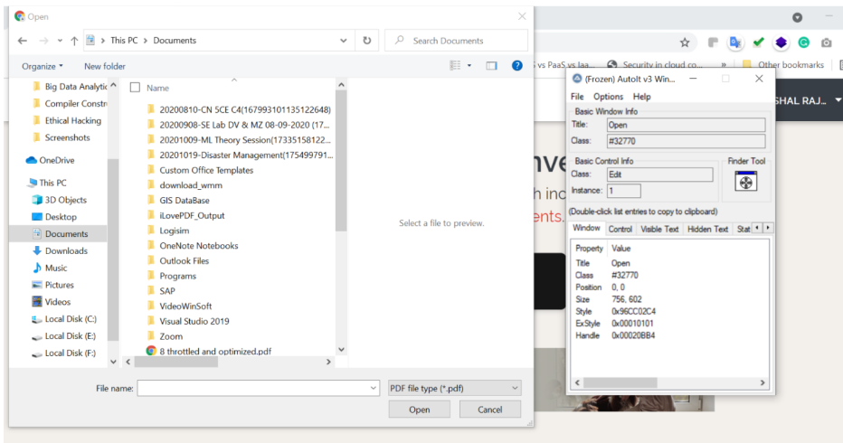

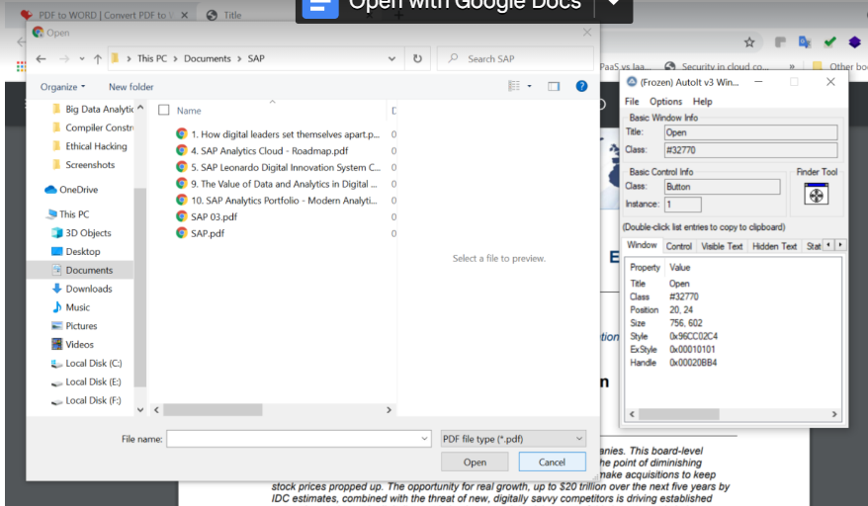

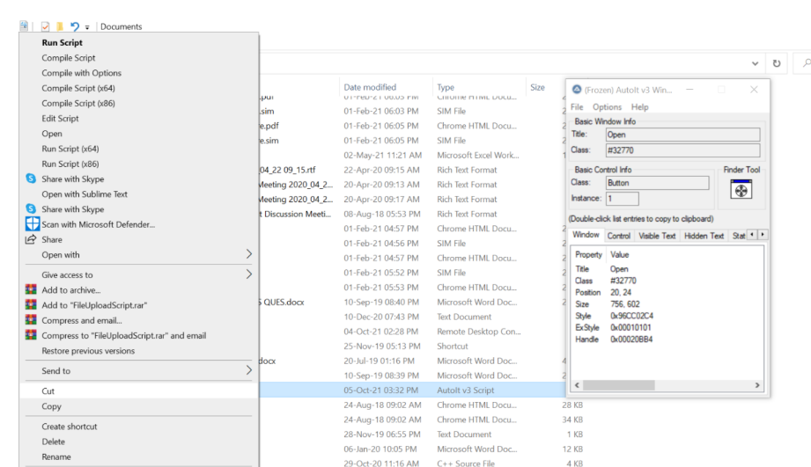

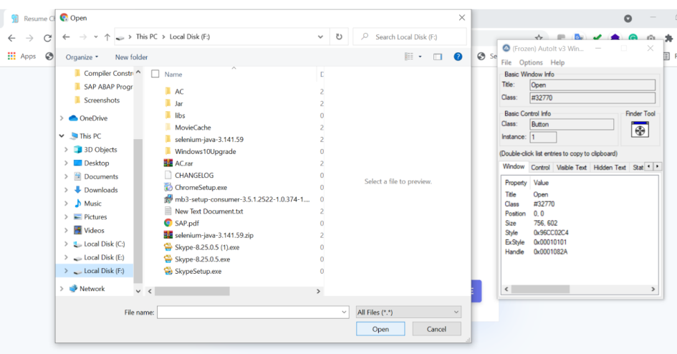

END