**Practical 7**

**Software Testing and Quality Assurance**

2CSDE80

**Mistry Unnat**

20BCE515



Department of Computer Science and Engineering

Institute of Technology

Nirma University

Ahmedabad

**AIM : To study and perform sample tests using Apache JMeter Testing Tool**

**Introduction**:

Performance Testing is crucial to determine that the web application under test will satisfy high load requirements. It can be used to analyze overall server performance under heavy load.

* JMeter testing tool offers following benefit in Performance Testing:
* JMeter can be used to test performance of both static resources such as JavaScript and HTML, as well as dynamic resources, such as JSP, Servlets, and AJAX.
* JMeter can discover maximum number of concurrent users that your website can handle
* JMeter provides a variety of graphical analyses of performance reports.

**Create a Performance Test Plan in Jmeter:**

**Step 1)**

**Add Thread Group:**

**1. Start JMeter.**

**2. Select Test Plan on the tree.**

**3. Add Thread Group.**

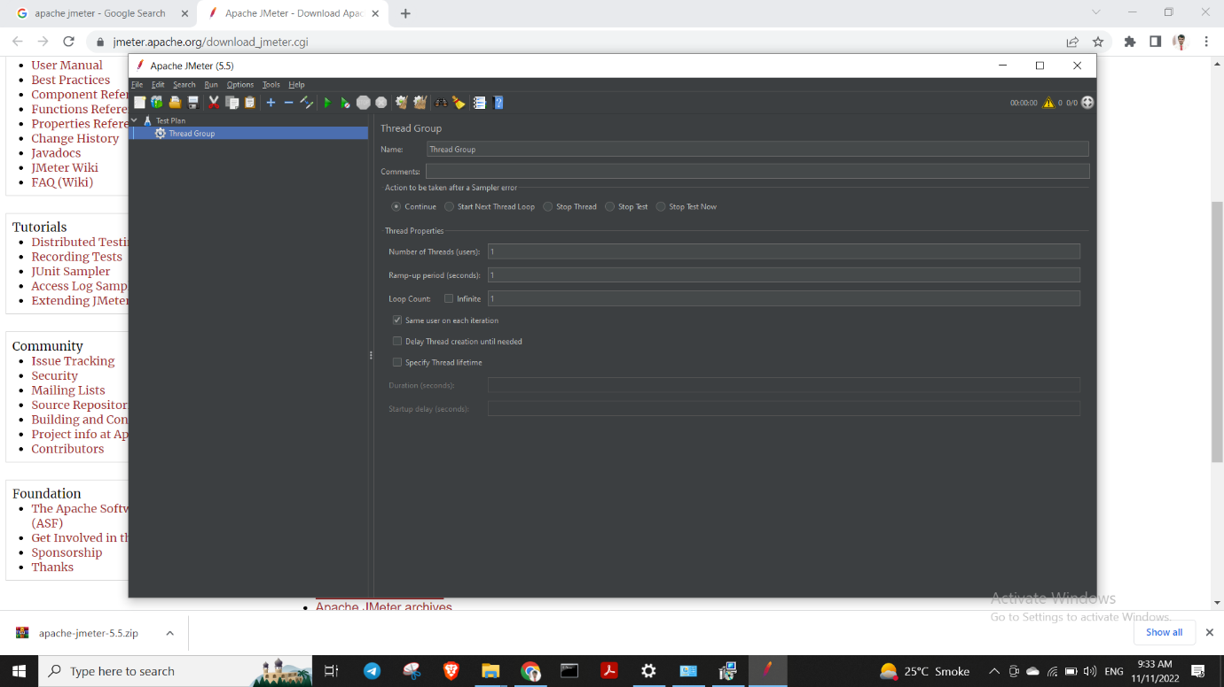

**HTTP Request**

**Right-click on Thread Group and select: Add -> Sampler -> HTTP Request.**

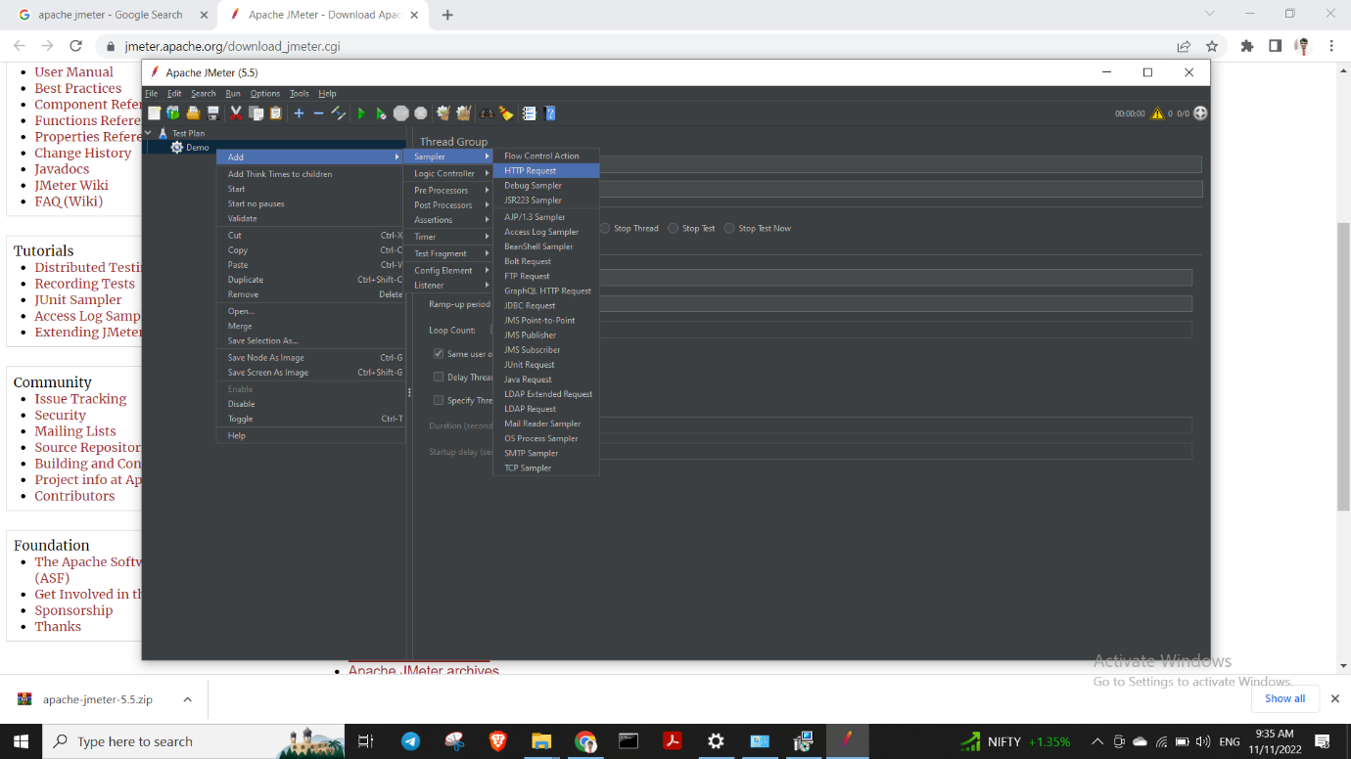

**Creating Http Request:**

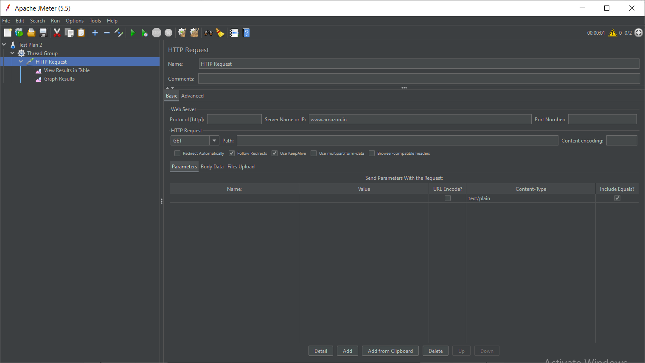

**In the below snippet, we can see two success samples for http request at** [**www.amazon.in**](http://www.amazon.in)

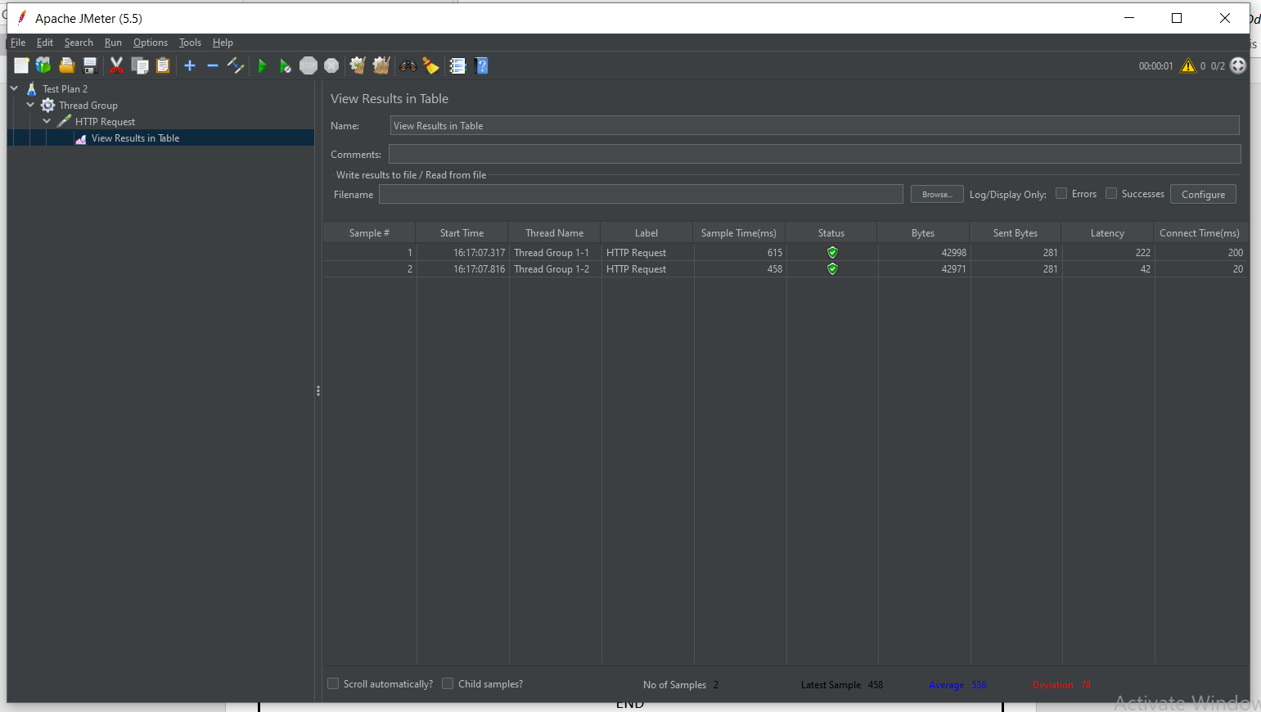

**Graph Results for the same :**

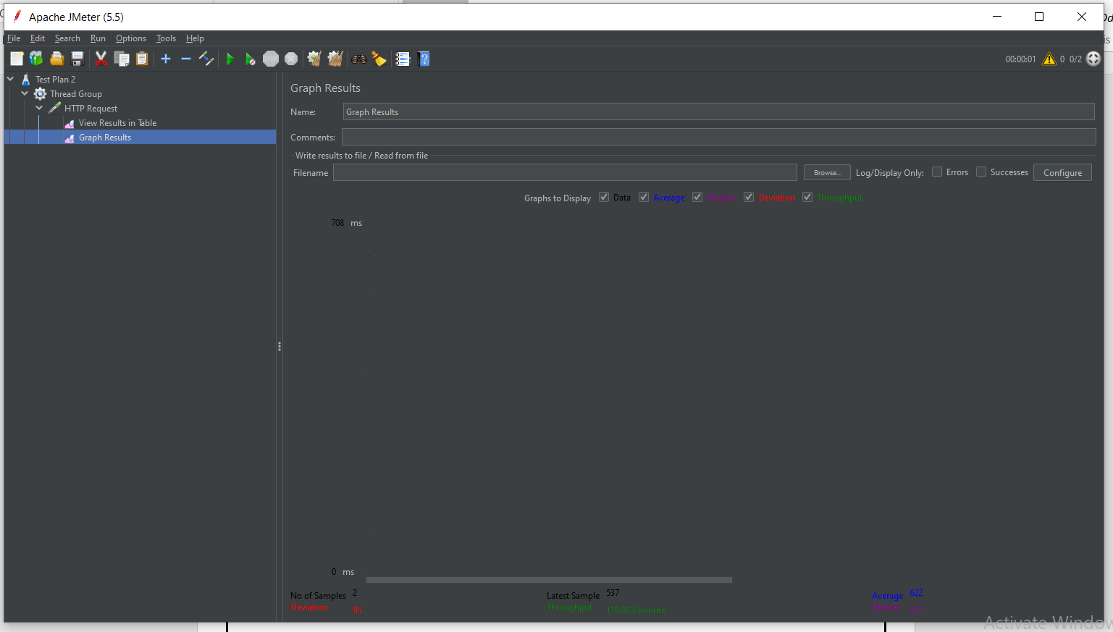

END