**Practical 8**

**Software Testing and Quality Assurance**

2CSDE80

**Mistry Unnat**

20BCE515



Department of Computer Science and Engineering

Institute of Technology

Nirma University

Ahmedabad

**AIM :** To implement load testing method.

Step-1:

Right click on Test Plan and go to Add -> Threads -> Thread Group.

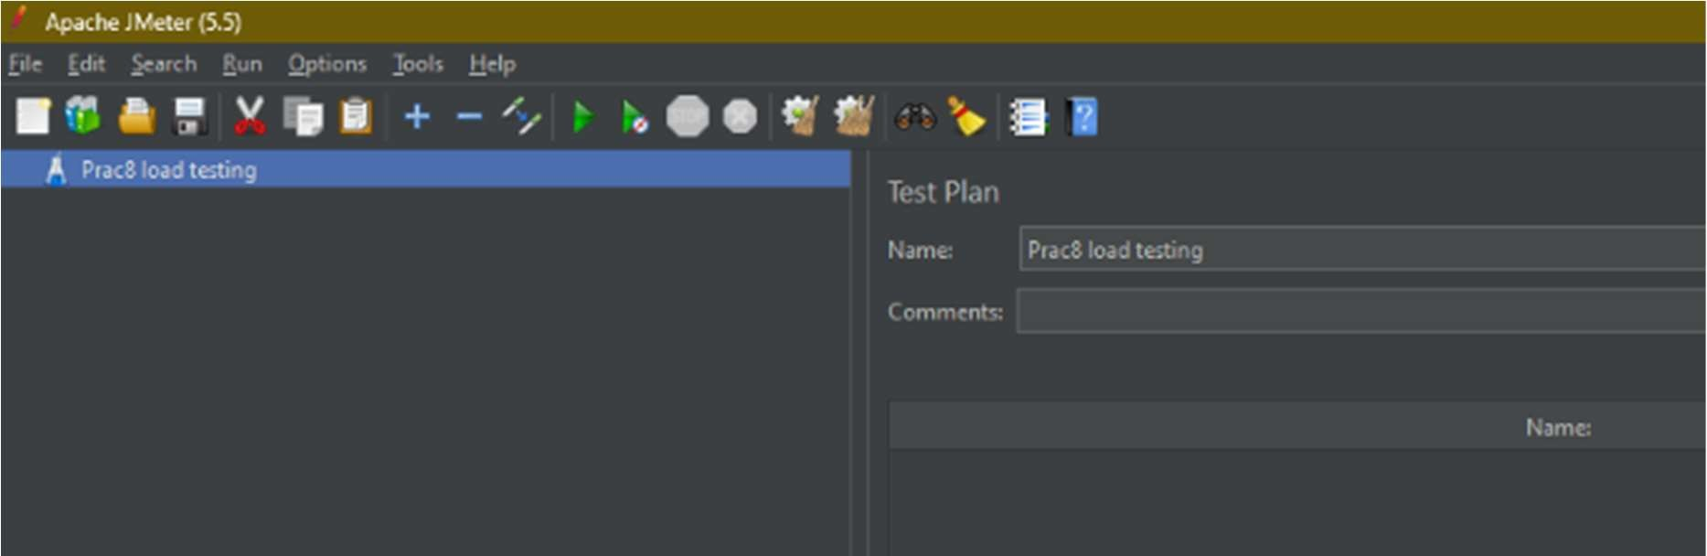

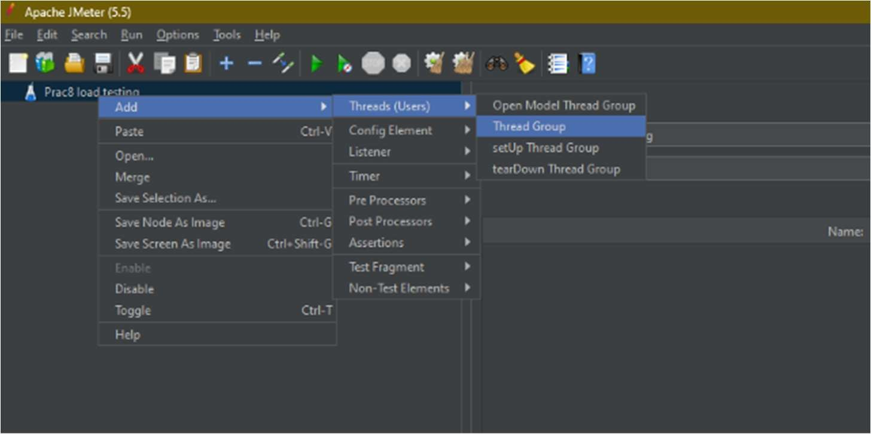

Step-2:

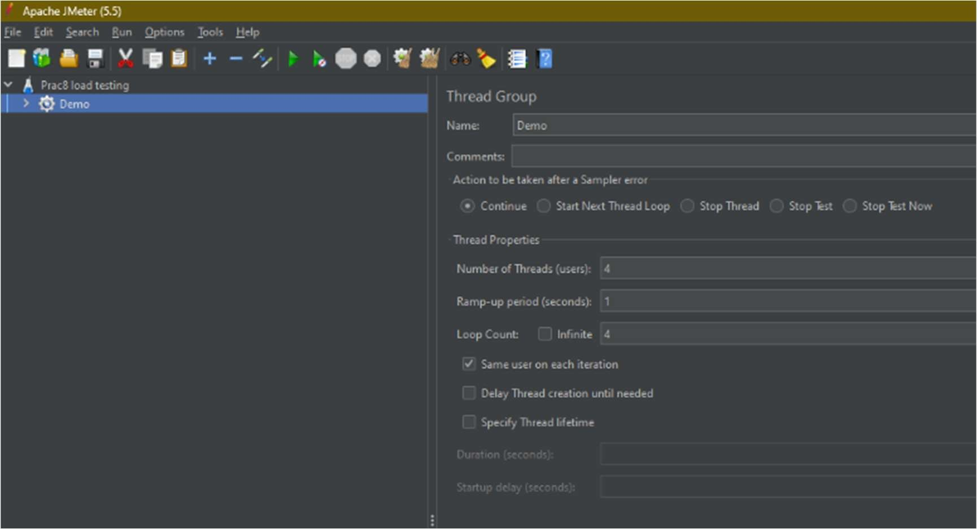Give the name of thread group and in Thread properties enter the number of users in the Number of Threads(Users) field.

Step-3:

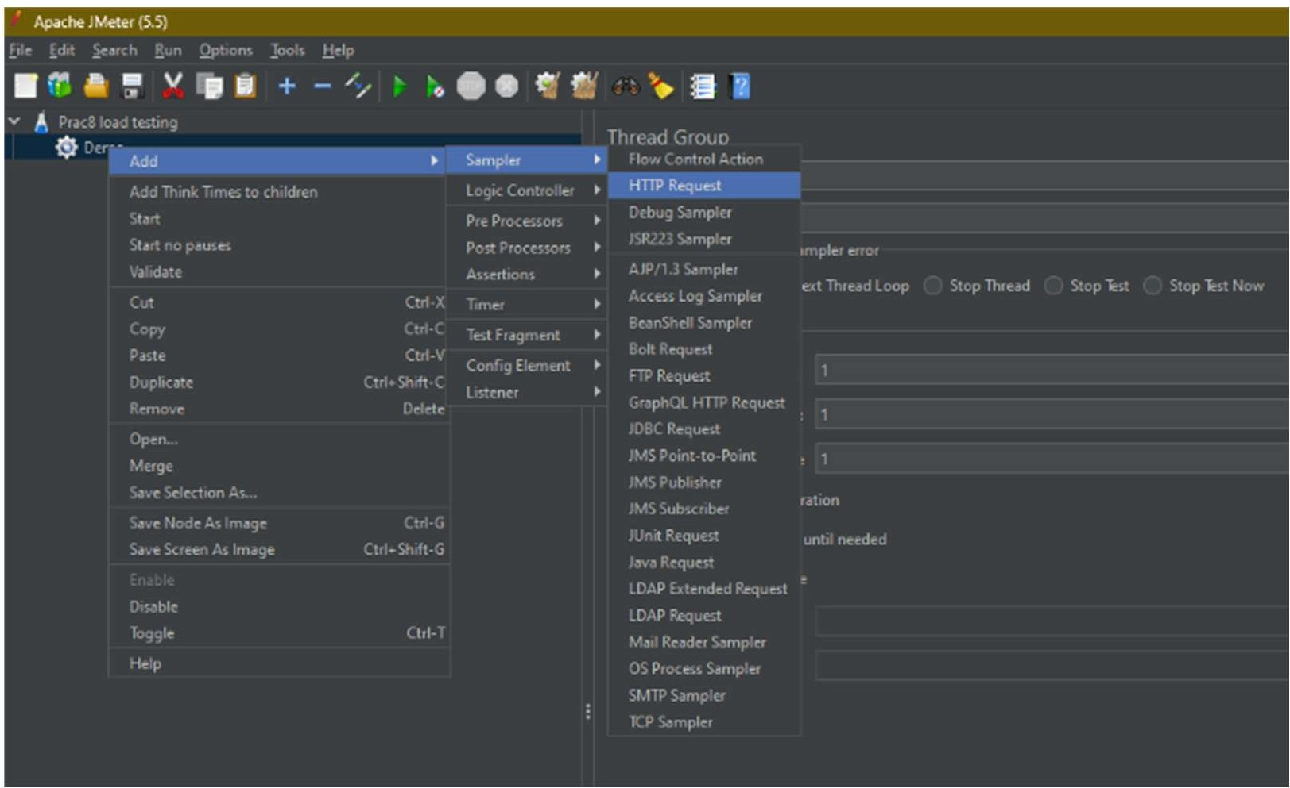Right click on the created Test Group and go to Add -> Sampler -> HTTP Request.

Step-4:

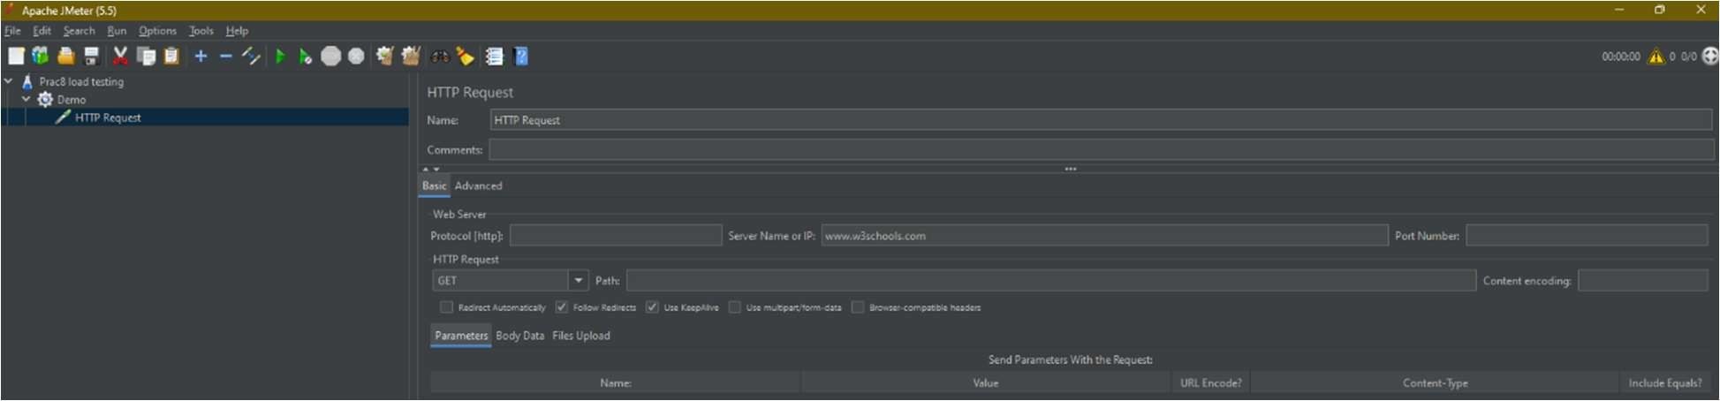Give the url of the website on the performance test is to be done in Server Name or IP and click on Add at the Bottom Pane.

Step-5:

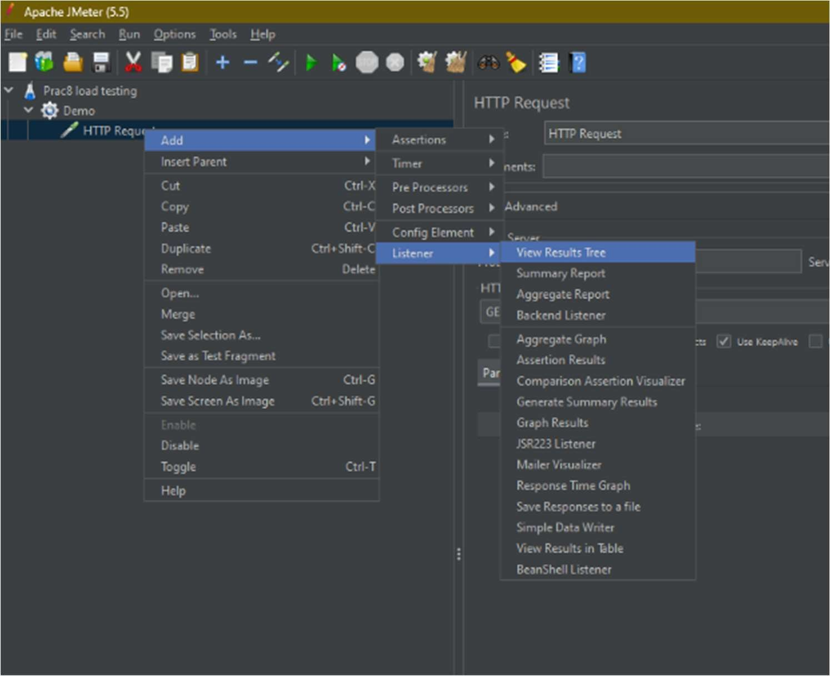Right click on HTTP Request and go to Add->Listener->View Result Tree same way add View Results in Table.

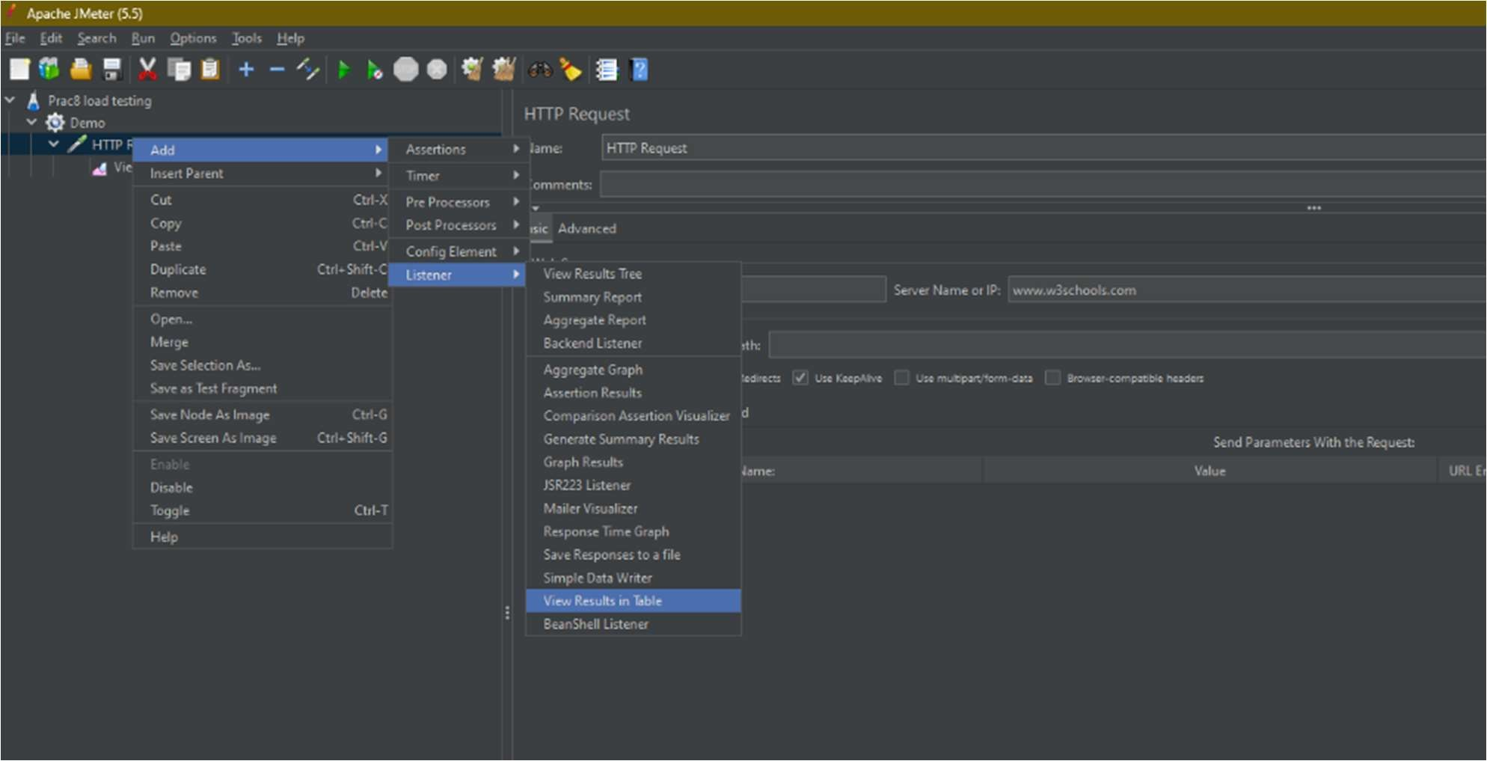

Step-6:

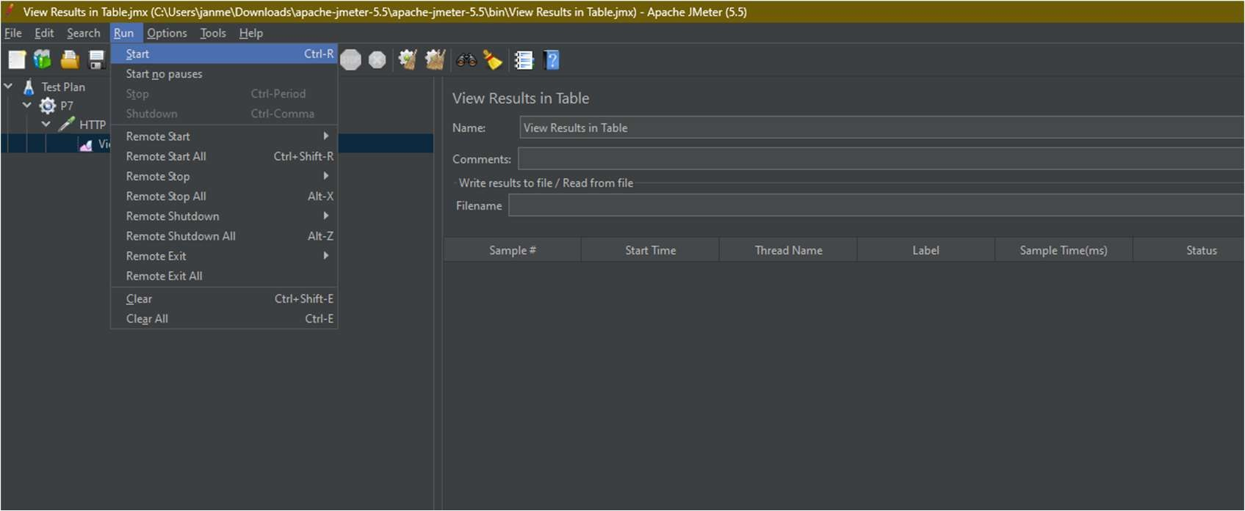In the top pane click on Run and click on Start.

Step-7:

You can see all the test cases recorded and their status.

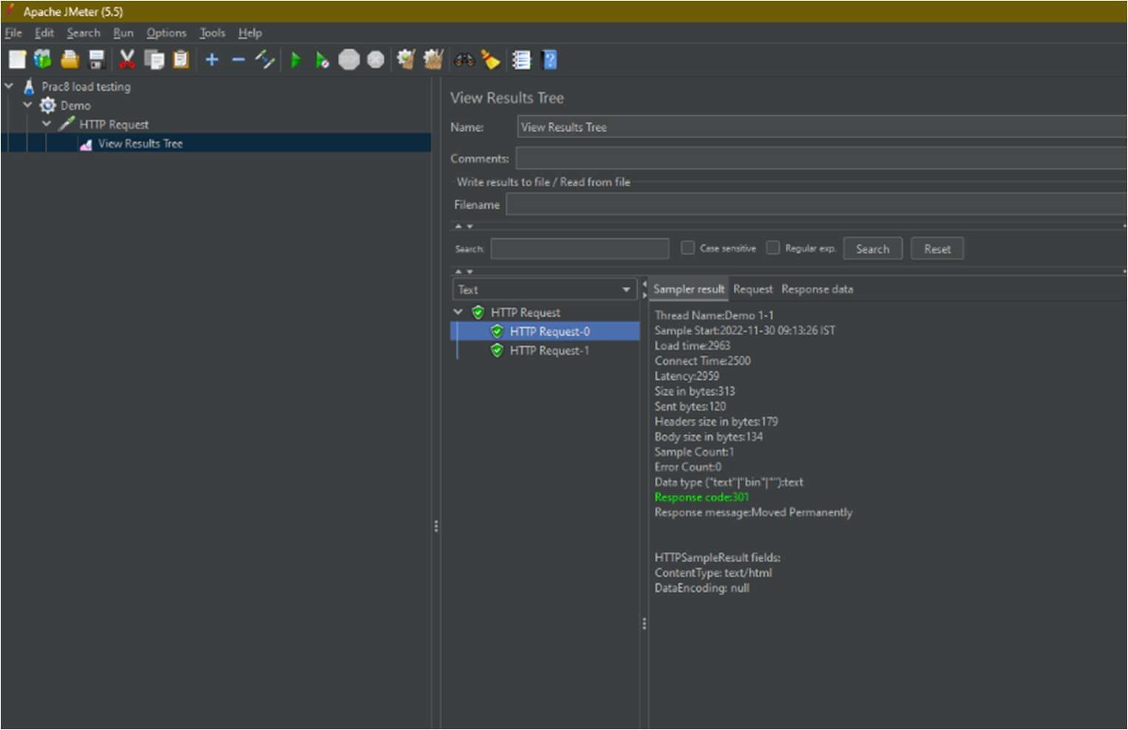

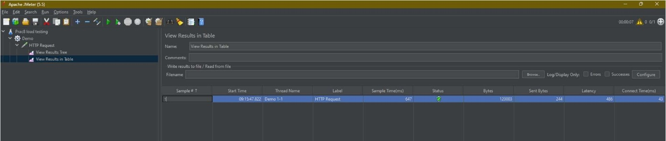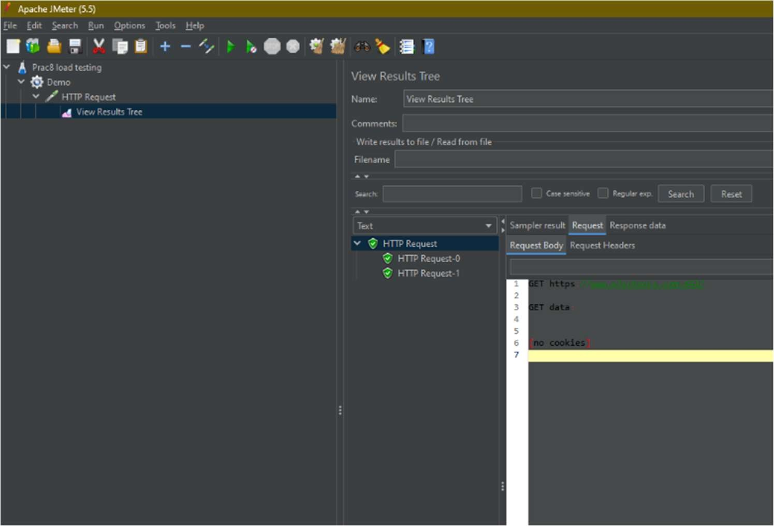

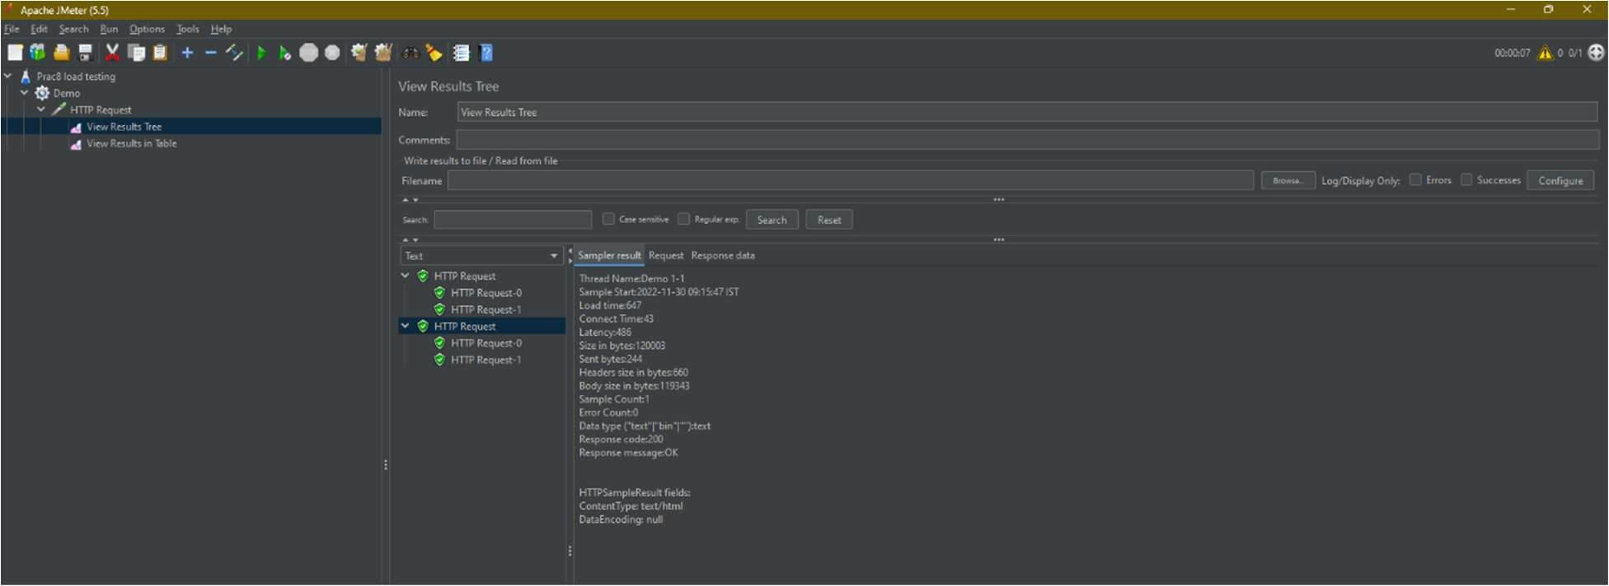

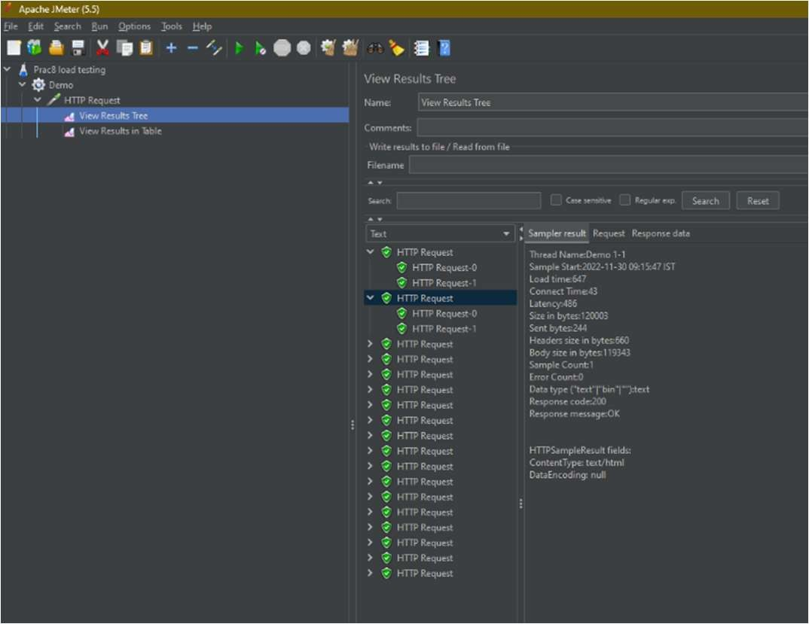

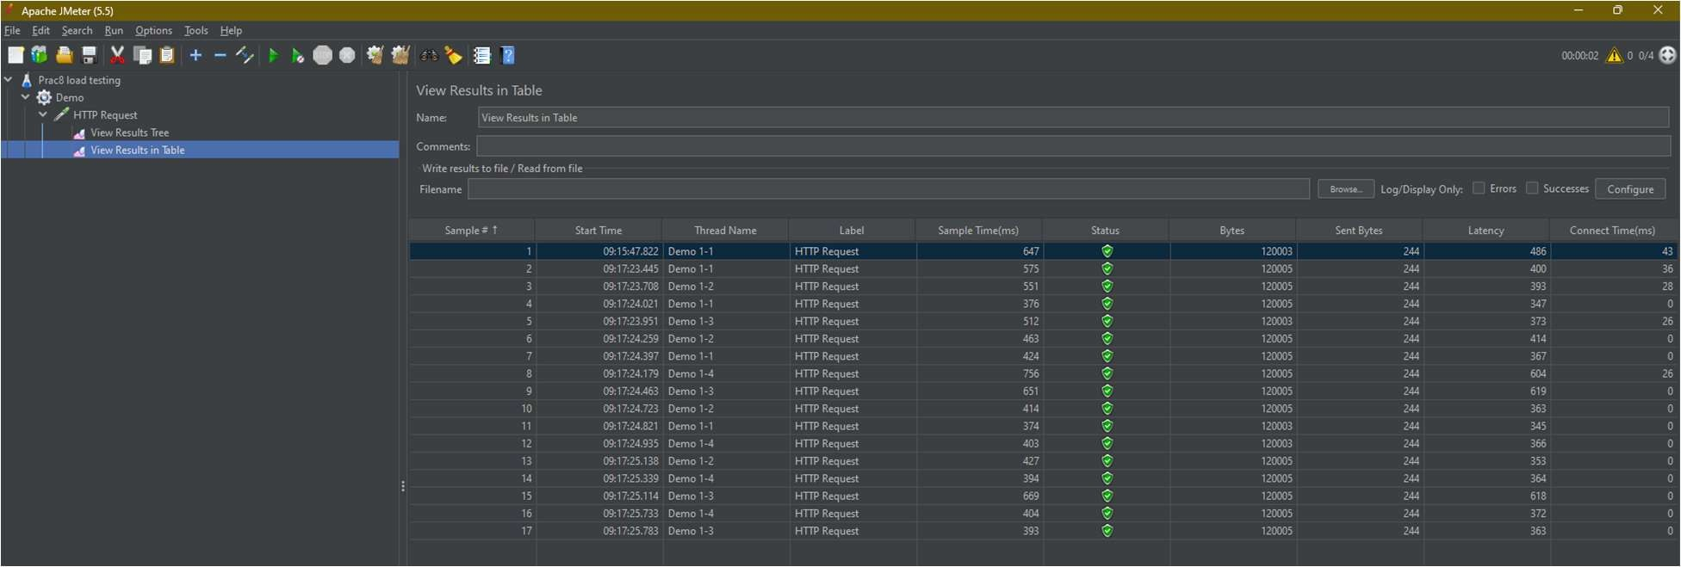

**Load Testing on WeatherApi**

Step-1:

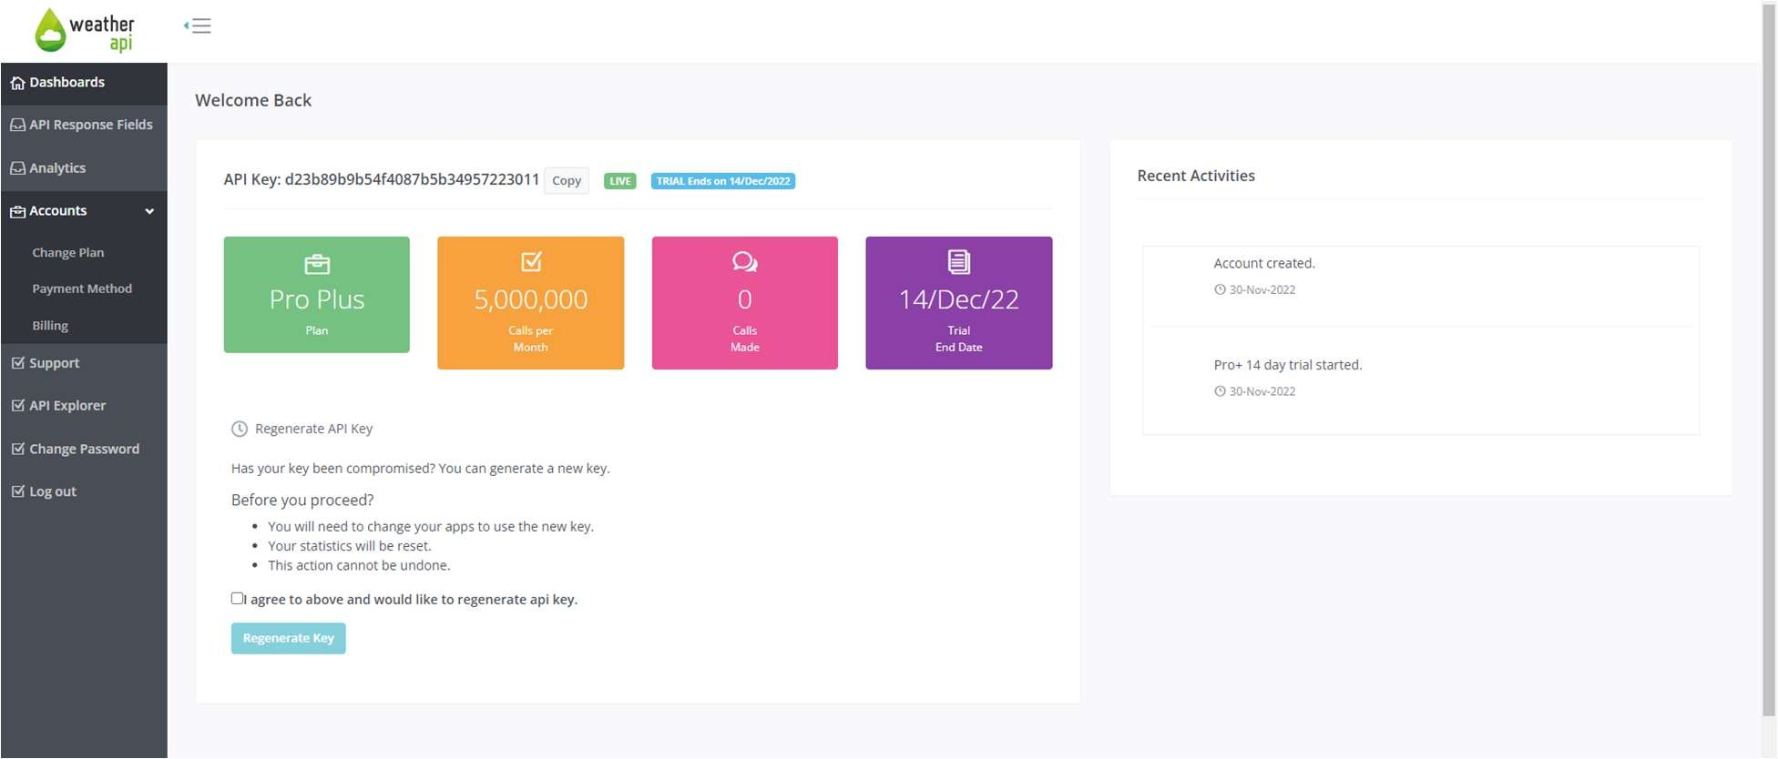Create an account in WeatherApi.com

Step-2:

**Copy the API key and Go to API Explorer.**

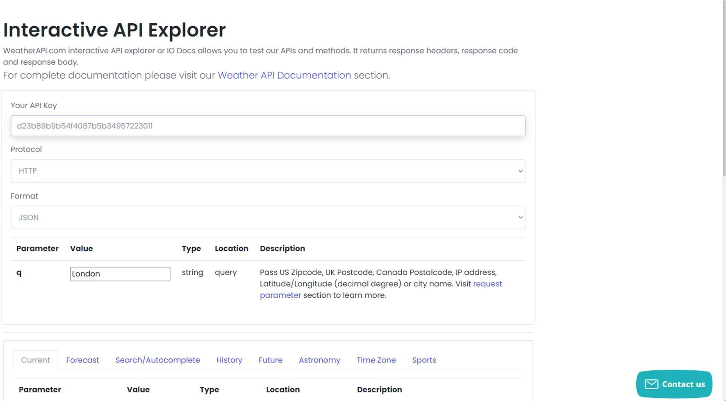

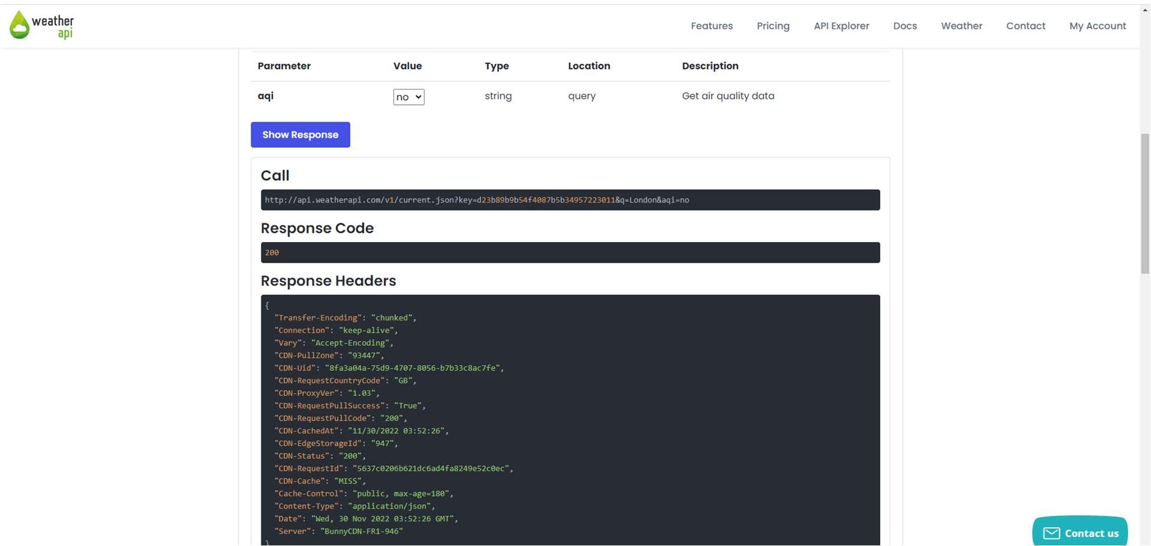Copy and paste your API key and click show response to check if the key is valid or not.

Step-3:

Configure the HTTP accordingly.

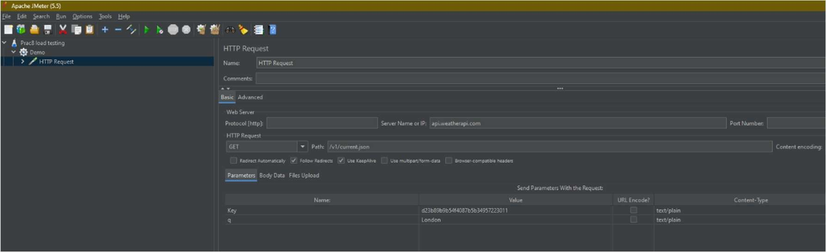 request

Step-4:

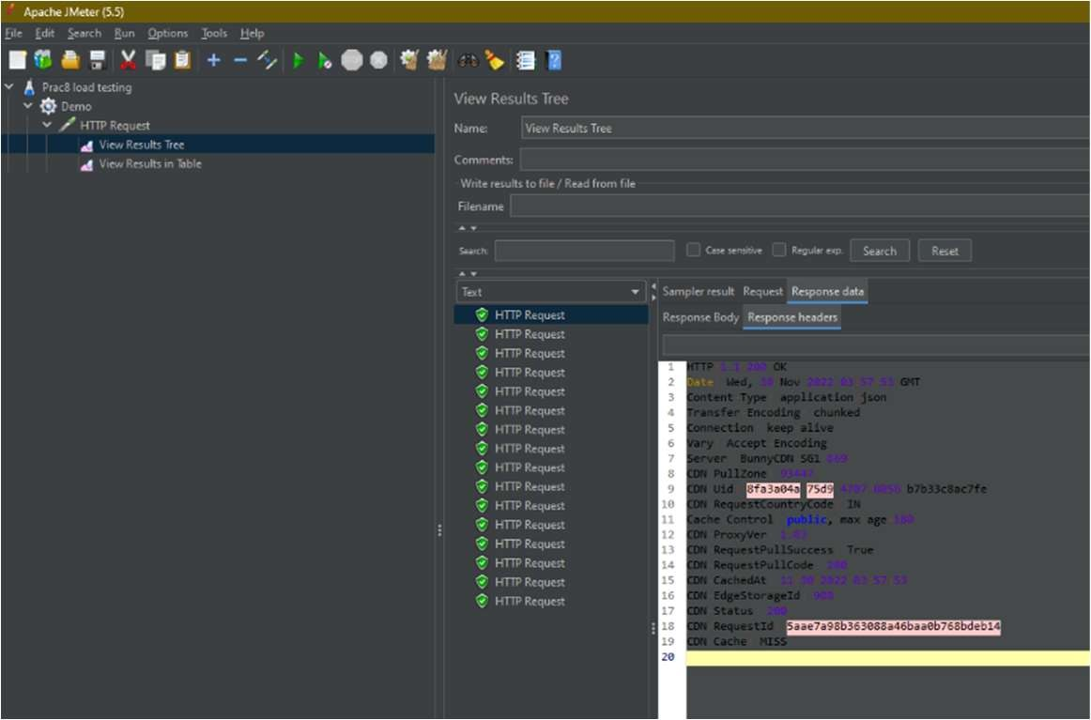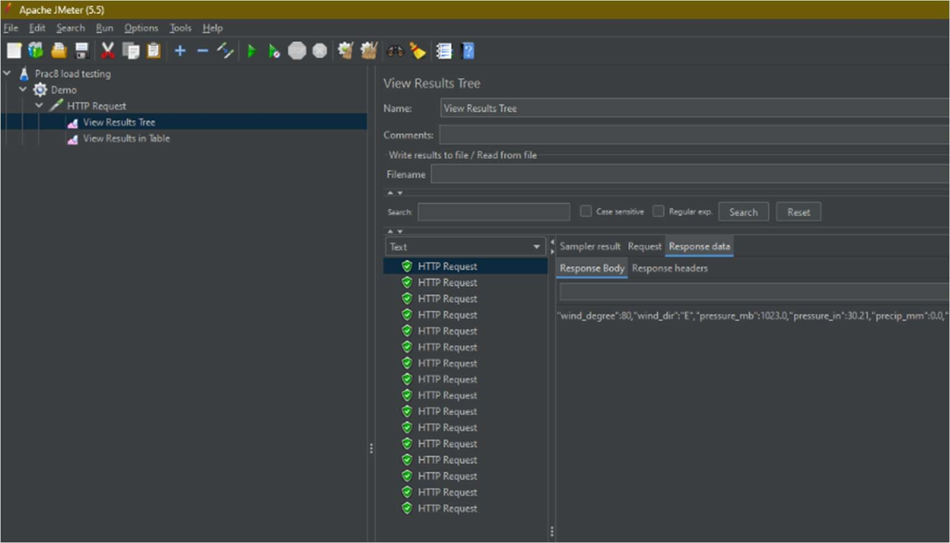In the top pane click on Run and click on Start.

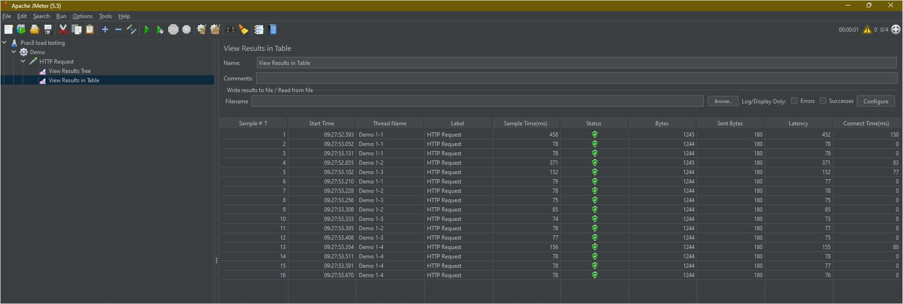

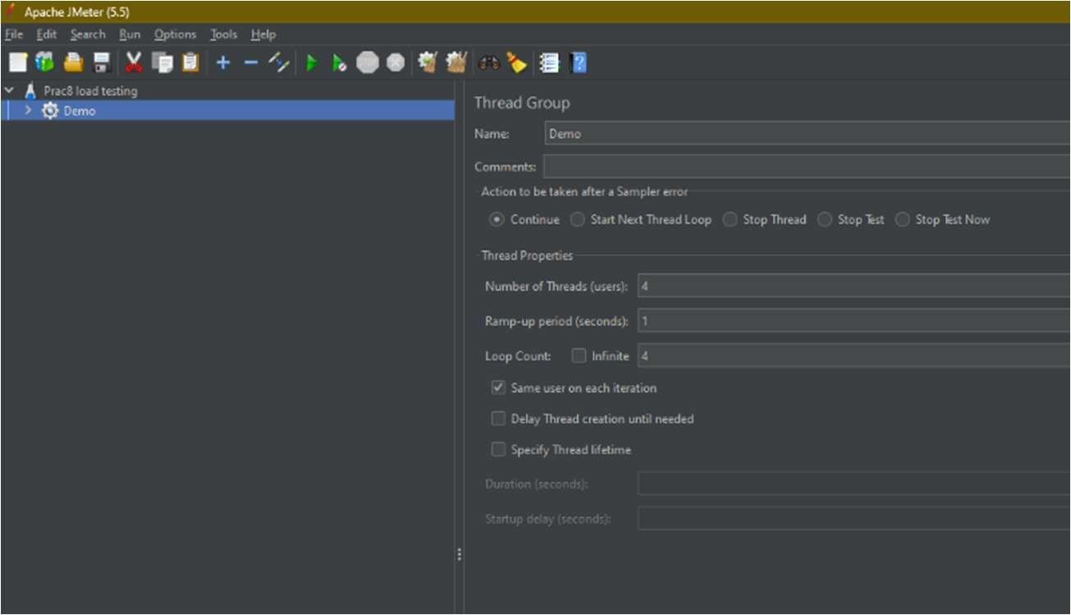

END