**Practical 9**

**Software Testing and Quality Assurance**

2CSDE80

**Mistry Unnat**

20BCE515



Department of Computer Science and Engineering

Institute of Technology

Nirma University

Ahmedabad

**AIM :** Regression Testing with Watir.

**HTML Code :**

<html>

<head>

    <title>Testing UI using Watir</title>

</head>

<body>

    <script type="text/javascript"> function wsentered() {

            console.log("inside wsentered");

            var firstname = document.getElementById("firstname"); var gender = "";

            var vehicle = ""; var vehicle1 = ""; var vehicle2 = ""; var vehicle3 = ""; var sentence = "";

            if (document.getElementById("gender_male").checked) {

                gender = "Male";

            }

            else if (document.getElementById("gender_female").checked) {

                gender = "Female";

            }

            if (document.getElementById("trans_car").checked) {

                vehicle = "Car";

            }

            if (document.getElementById("trans_bus").checked) {

                vehicle1 = "Bus";

            }

            if (document.getElementById("trans_train").checked) {

                vehicle2 = "Train";

            }

            if (document.getElementById("trans_air").checked) {

                vehicle3 = "Airplane";

            }

            if (firstname.value != "") {

                sentence = "<b>Passenger Details:</b><br><br>First Name: " + firstname.value + "

                    < br > Gender: " + gender + " < br > Means of transportation: <br>"; if(vehicle != "")

                        sentence = sentence + "<li>" + vehicle + "</li>"; if(vehicle1 != "")

                        sentence = sentence + "<li>" + vehicle1 + "</li>"; if(vehicle2 != "")

                        sentence = sentence + "<li>" + vehicle2 + "</li>"; if(vehicle3 != "")

                        sentence = sentence + "<li>" + vehicle3 + "</li>"; document.getElementById("displayfirstname").innerHTML = sentence; document.getElementById("displayfirstname").style.display = "";

}

}

    </script>

    <div id="divfirstname">

        Enter First Name : <input type="text" id="firstname" name="firstname" onchange="wsentered()" /><br><br>

        <b>Select Gender?</b><br>

        <input type="radio" name="gender" value="male" id="gender_male"> Male<br>

        <input type="radio" name="gender" value="female" id="gender_female"> Female<br><br>

        <b>How would you like to travel?</b><br>

        <input type="checkbox" name="option1" value="Car" id="trans_car"> Car<br>

        <input type="checkbox" name="option2" value="Bus" id="trans_bus"> Bus<br>

        <input type="checkbox" name="option3" value="Train" id="trans_train"> Train<br>

        <input type="checkbox" name="option4" value="Air" id="trans_air"> Airways<br><br>

    </div>

    <br>

    <br>

    <div style="display:none;" id="displayfirstname">

    </div>

</body>

</html>

**Script Code :**

require 'watir'

b = Watir::Browser.new :chrome b.goto('file:///H:/sem_7/STQA/sample.html') t2 = b.radio value: 'female'

t3 = b.checkbox value: 'Train' t4 = b.checkbox value: 'Air' t2.exists?

t3.exists? t4.exists? t2.set t3.set

t4.set

t = b.text_field id: 'firstname' t.exists?

t.set 'Prince Mehta' t.value t.fire_event('onchange')

**Output:**

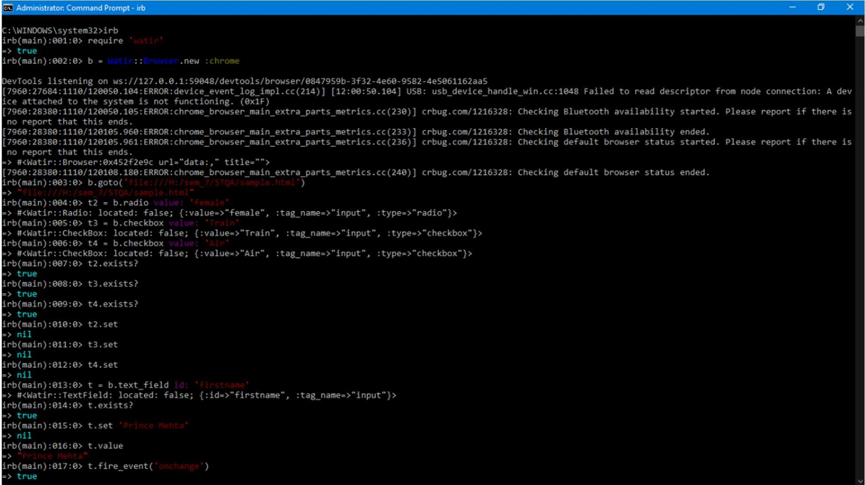

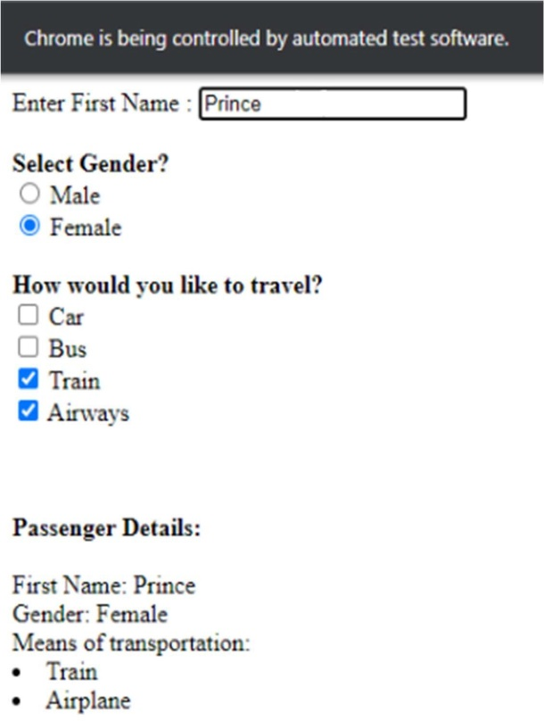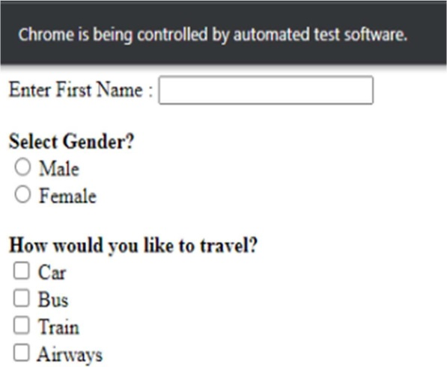

END