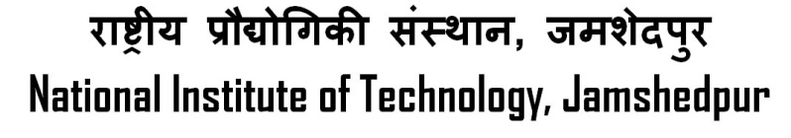

**(An Institute of National Importance, under MHRD, Govt. of India)**



# Unnati Chaurasia

B TECH. (HONS), ENGINEERING AND COMPUTATIONAL MECHANICS

**DOB:**-26 March, 2003 **Reg. ID**: - 2022UGCM010

**OBJECTIVE**

**To be a member of MES, which will give me an exposure to real-life challenges and hence test and develop my managerial and problem solving skills. Also to get an opportunity to represent, contribute and maintain the legacy of my branch.**

**EDUCATIONAL QUALIFICATION**

|  |  |  |  |  |  |
| --- | --- | --- | --- | --- | --- |
|  | **Name of Examination** | **Year of passing** | **Board/**  **University** | **Institution** | **Percentage/**  **CGPA** |
| **Graduation** | 1st Semester Examinations | 2023 | NIT Jamshedpur | NIT Jamshedpur | 8.46 CGPA |
| **Senior Secondary(XII)** | Senior School Certificate Examination | 2021 | Central Board of Secondary Education | Little Flower House | 95.60% |
| **Secondary**  **School(X)** | Senior School Certificate Examination | 2019 | Central Board of Secondary Education | St. Mary’s Convent School | 96.80% |

**POSITION OF RESPONSIBILITIES**

* Currently: Technical Secretary of Hostel-C
* Currently : MES Representative
* Head Girl (2020-21)
* Red House Captain of school.

**ACHIEVEMENTS**

* Branch Topper
* Qualified for both National and International Olympiads.
* Participated and Won Interschool competitions.
* Represented my school in several competitions, like for The Dainik Jagran.
* Among the Top 5 students throughout my school days.

**EXTRA-CURRICULAR ACTIVITIES**

* **Member, Web Development Team ,** **NIT Jamshedpur**
* **Member, Team Innoreva, NIT Jamshedpur**
* **Member, Team F.A.C.E.S. , NIT Jamshedpur**
* **Member, Anchoring Team, NIT Jamshedpur**
* **Member(Content Team),Go Green Club, NIT Jamshedpur**
* **Member, Basketball, NIT Jamshedpur**
* **Member, Team Sankalp, NIT Jamshedpur**

**HOBBIES & INTERESTS**

* Drawing
* Reading

**PERSONAL INFORMATION**

|  |  |
| --- | --- |
| **Correspondence Address** | Room No.: 3002, Hostel-C, NIT Jamshedpur,  Adityapur, Jamshedpur,  Jharkhand, PIN- 831014. |
| **Permanent Address** | **K 56/109 A**  **Near D.A.V. College, Ausanganj**  **Varanasi, Uttar Pradesh**  **PIN - 221001** |
| **Email id** | unnatichaurasia12@gmail.com |
| **Phone/Mob No** | 9670966612 |