**Shop Bridge Backend Execution Document**

**Database Table Script :**

USE [ShopBridgeDB]

GO

SET ANSI_NULLS ON

GO

SET QUOTED_IDENTIFIER ON

GO

CREATE TABLE [dbo].[Products](

[Identifier] [uniqueidentifier] NOT NULL,

[Name] [nvarchar](255) NULL,

[Description] [nvarchar](255) NULL,

[Price] [int] NULL,

[IsActive] [bit] NULL,

[CreatedBy] [nvarchar](255) NULL,

[CreatedOn] [datetime2](7) NULL,

[UpdatedBy] [nvarchar](255) NULL,

[UpdatedOn] [datetime2](7) NULL

CONSTRAINT [PK_Identifier] PRIMARY KEY CLUSTERED

(

[Identifier] ASC

)WITH (PAD_INDEX = OFF, STATISTICS_NORECOMPUTE = OFF, IGNORE_DUP_KEY = OFF, ALLOW_ROW_LOCKS = ON, ALLOW_PAGE_LOCKS = ON, OPTIMIZE_FOR_SEQUENTIAL_KEY = OFF) ON [PRIMARY],

CONSTRAINT [Name_Unique] UNIQUE NONCLUSTERED

(

[Name] ASC

)WITH (PAD_INDEX = OFF, STATISTICS_NORECOMPUTE = OFF, IGNORE_DUP_KEY = OFF, ALLOW_ROW_LOCKS = ON, ALLOW_PAGE_LOCKS = ON, OPTIMIZE_FOR_SEQUENTIAL_KEY = OFF) ON [PRIMARY]

) ON [PRIMARY]

GO

**Tracking for Efforts spent to complete the Assisgnment**

1. Data store design – 1 hr

2. API and service logic – 12 hrs

3. Unit Test Coverage – 2 hrs

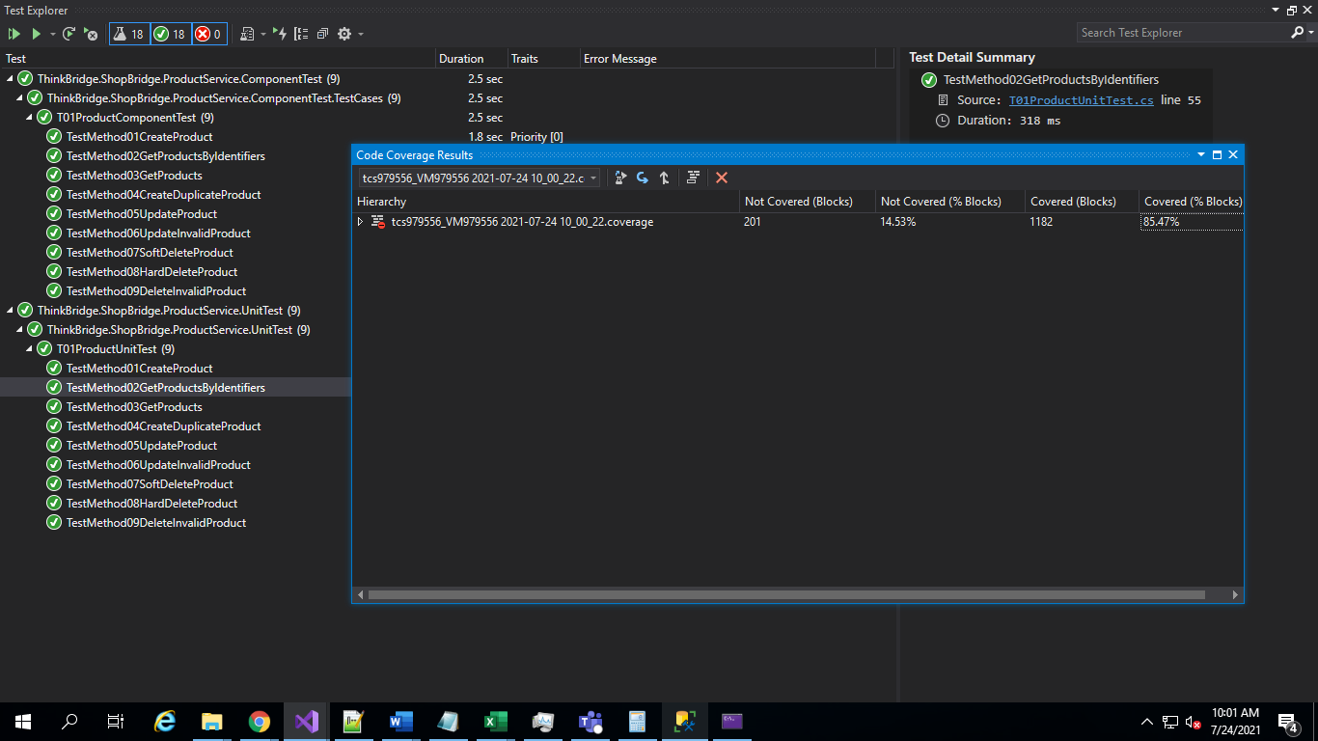

Step 1 : Run the Application and Swagger UI will be displayed with POST, GET, PUT and DELETE Operations 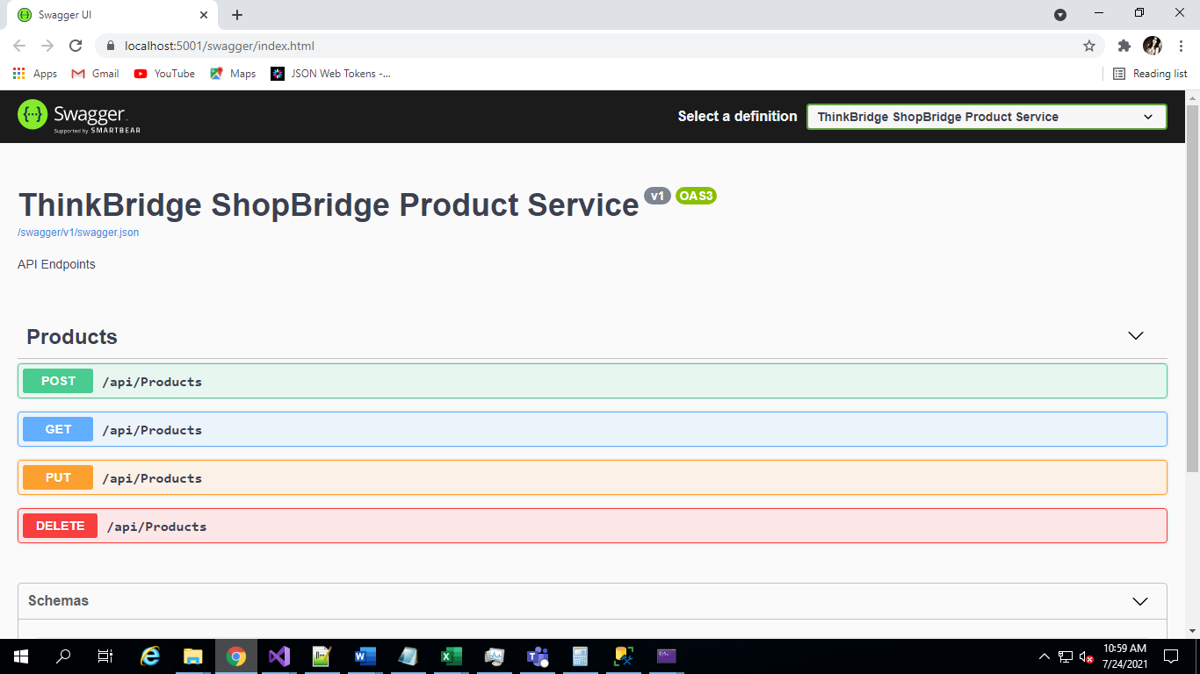

Step 2 : New Products can be created by executing the POST Method. We need to pass a Product Object in order to insert it in the Database.

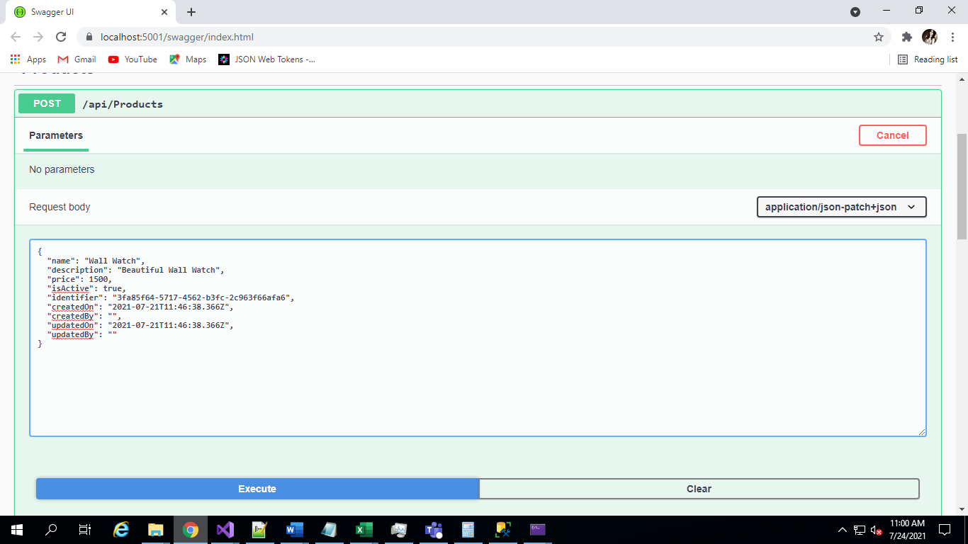

Step 3 : On Click of Execute –Details Saved successfully.

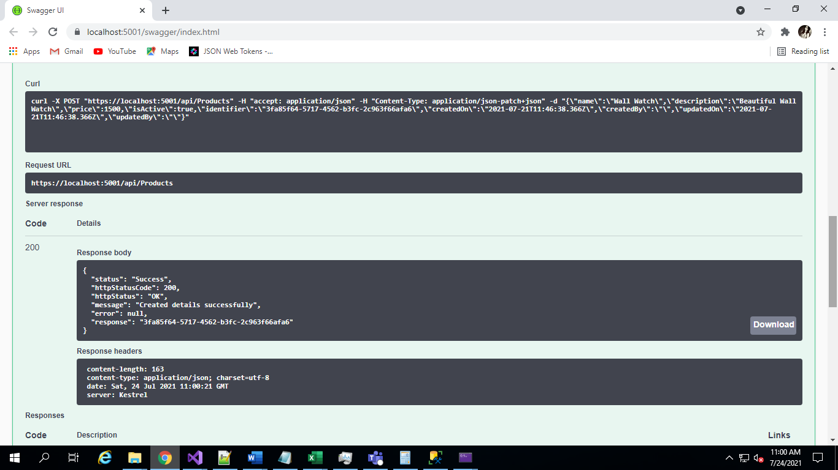

Step 4 : We can fetch the existing Product Details by executing the GET Method.

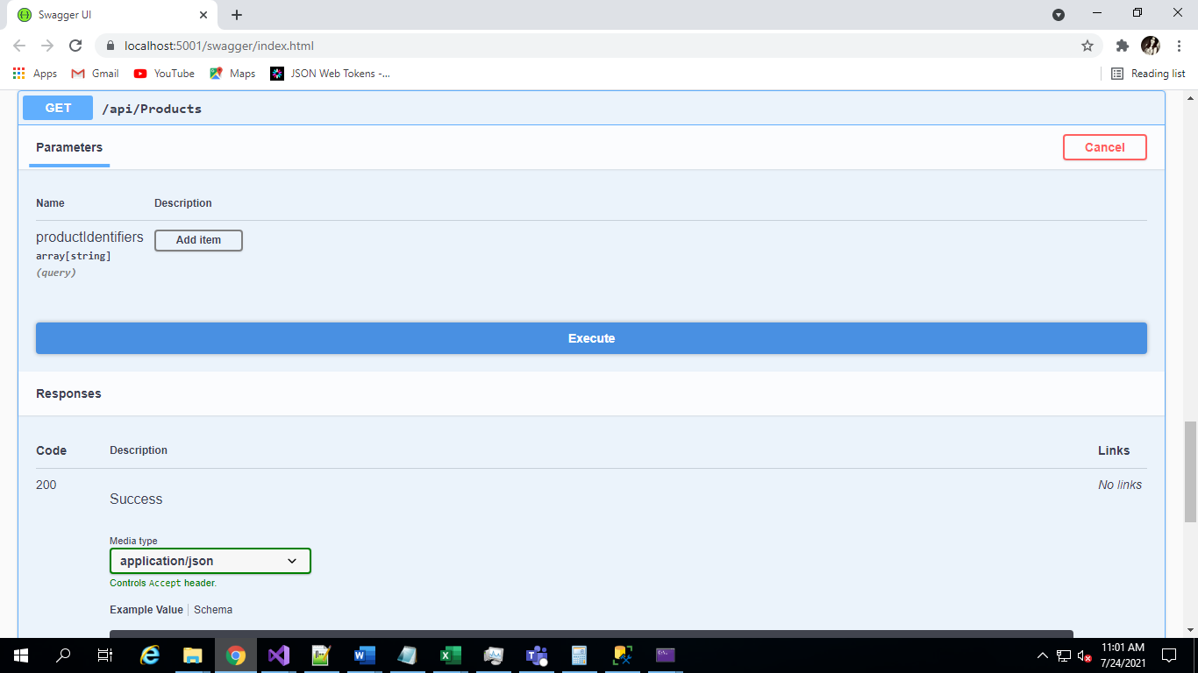

Step 5 : On Click of Execute all the Products present in Database will be returned as an output.

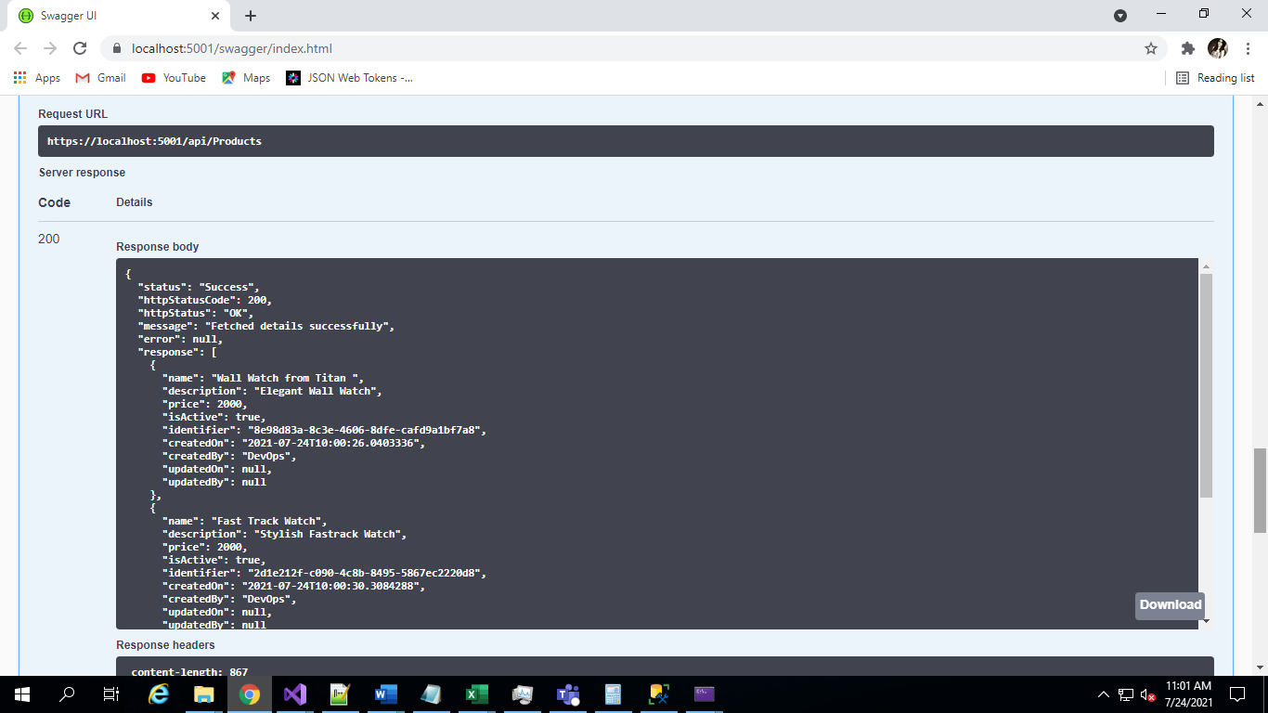

Step 6 : In order to update an existing Product we can execute the PUT method with required modifications by passing the Product object.

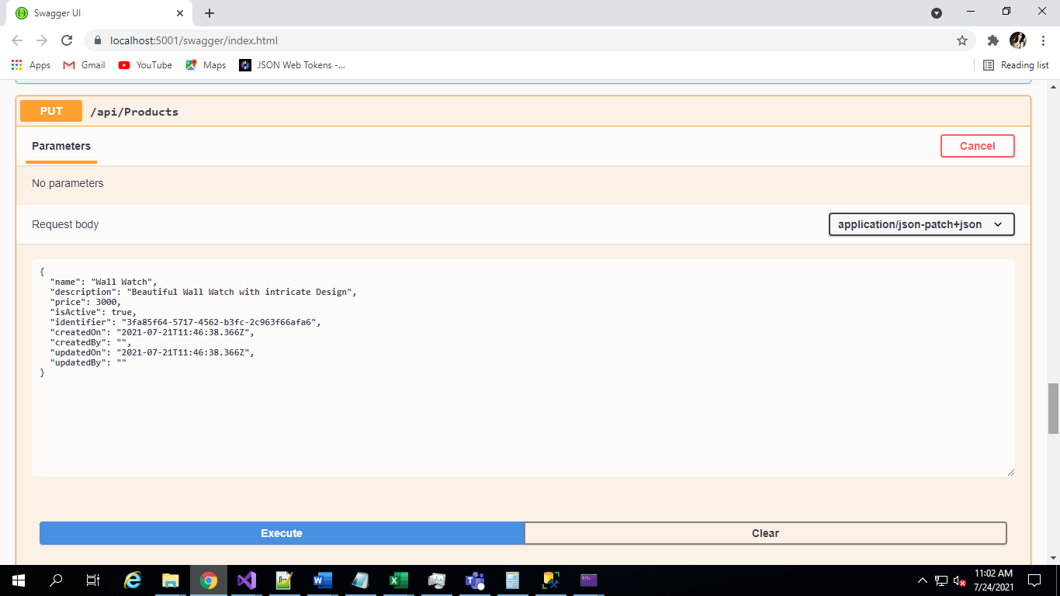

Step 7 : On click of Execute the Product detailed will be updated successfully

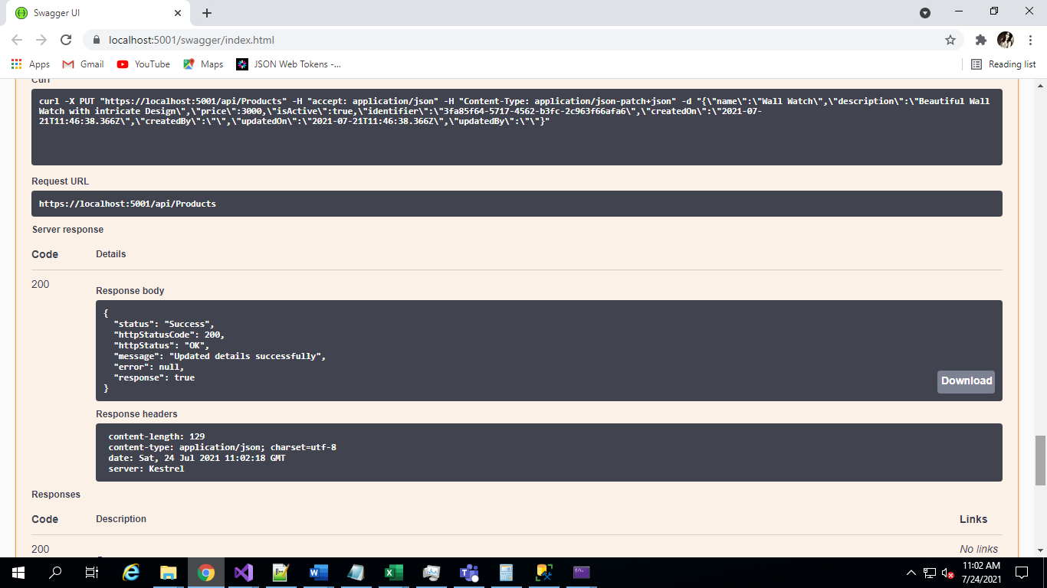

Screenshot of Local DB for reference

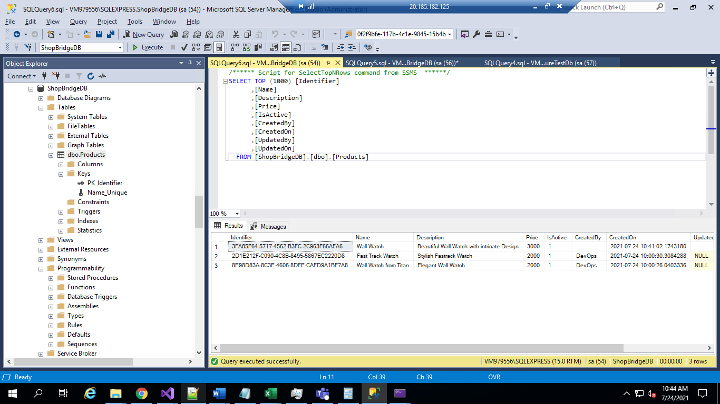

Step 8 : In order to delete the existing Product we can execute the DELETE method by passing the DeleteInfo Object

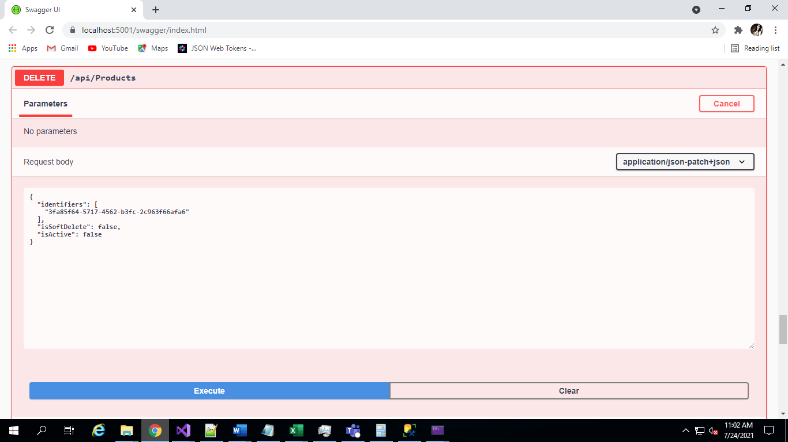

Step 8 : On Click of Execute the product details will be deleted from the Database.

