COURSE: BCSE205L
COMPUTER ARCHITECTURE AND ORGANIZATION
DA-1
NAME – UNNATI
REG. NO – 24BCE1517
Domain-Specific Architecture : Google TPU

- Motivation Behind the Architecture –
The Google Tensor Processing Unit (TPU) emerged from a clear need: the rapid increase in machine learning workloads and the shortcomings of existing hardware. Between 2013 and 2014, Google realized that standard CPUs were too slow for large-scale deep learning tasks. While GPUs were faster, they consumed more power and were mainly designed for graphics work, not for the tensor-heavy matrix operations required in machine learning. Google engineers realized that if every search or translation request ran on complex neural networks, the amount of computing needed could double every year. This would put enormous pressure on their data centres. Traditional CPUs and GPUs simply couldn’t deliver the processing power (in TOPS – Tera Operations per Second) needed, while still keeping energy use and costs under control.This led Google to create a specialized processor—a chip built specifically for neural network inference. It features:
- Fixed-function matrix multiplication units
- Lower precision arithmetic (8-bit integers instead of 32-bit floating-point)
- Close integration with on-chip memory to cut down data movement costs
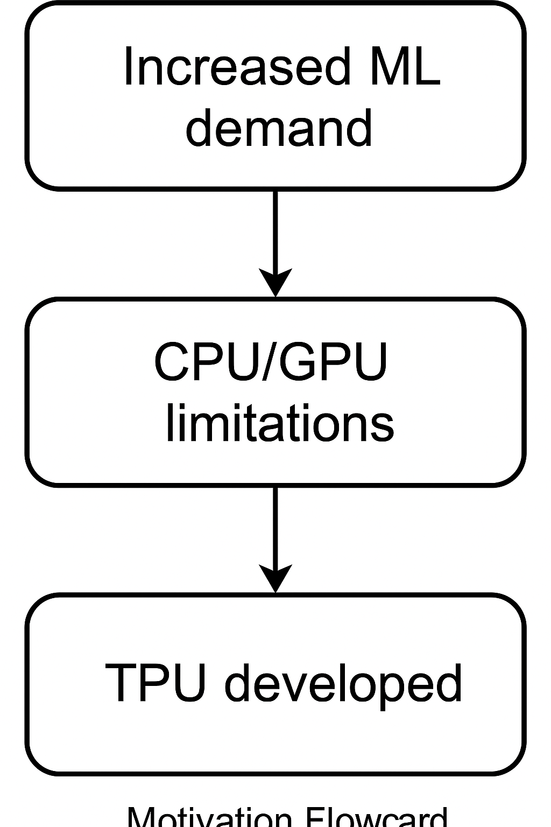
- Unique Features & Domain Fit –
The TPU is built from the ground up for deep learning, both for training models and running them (inference). Its design focuses on the specific needs of neural networks, and includes key features such as:
- Systolic Array Architecture
At the heart of the TPU lies a 256×256 matrix multiply unit, serving as the core processing engine. The systolic array’s rhythmic data flow enables pipelined execution, significantly reducing the need for large intermediary storage.
- Quantized Arithmetic
TPUs employ 8-bit integer operations instead of traditional 32-bit floating-point calculations. This approach maintains sufficient accuracy for most AI tasks while drastically reducing memory footprint and energy consumption.
- On-Chip Memory (Unified Buffer)
To minimize DRAM access latency and store frequently used data—such as weights and activations—the TPU incorporates a large Unified Buffer. This design improves performance by keeping critical data close to the processing units.
- Domain-Specific Instruction Set Architecture (ISA)
The TPU’s ISA is specifically designed to eliminate unnecessary instruction overhead and directly accelerate tensor operations, ensuring maximum efficiency in deep learning workloads.
- Integration with TensorFlow
Google has closely integrated TPU hardware with its open-source deep learning framework, TensorFlow. This integration allows developers to deploy models on TPUs without the need for hardware-specific coding, streamlining the workflow.
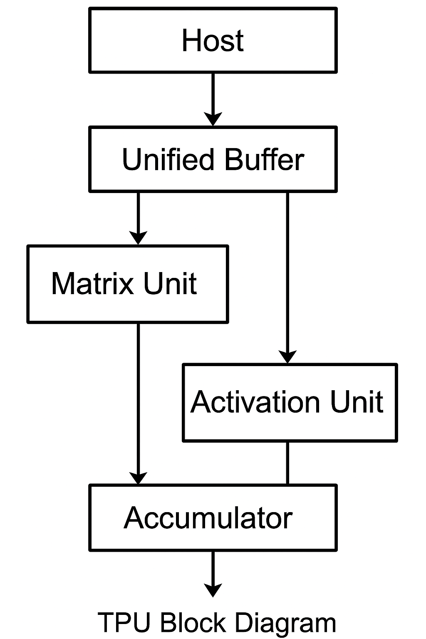
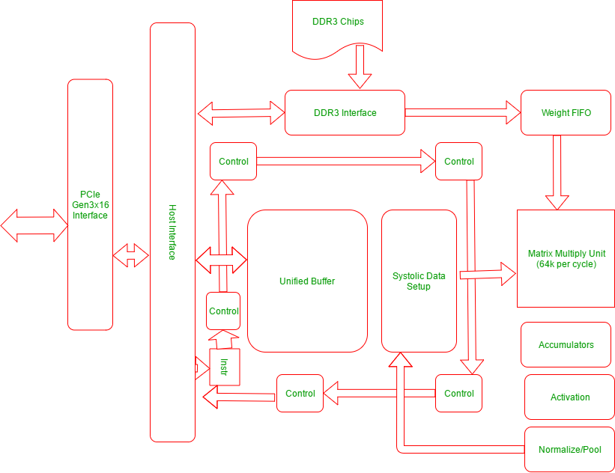
This graphic illustrates a high-level architecture of a deep-learning accelerator, where data comes into a host interface through a PCIe Gen3x16 interface which manages communication and instruction flow of the accelerator. Behind the host interface is a DDR3 memory, with its own DDR3 interface, which stores model weights and activations connected to a unified buffer supplying the weights into a systolic data structure. A Matrix Multiply Unit processes models at a rate of 64k ops per cycle and employs a weight FIFO, so the processing ring is always fresh and efficient. Outputs of the Matrix Multiply Unit must flow through accumulators, activation functions, and normalization/pooling before returning through the host interface. Data movement and module processing of all types are coordinated with control blocks.
- Comparison with General-Purpose CPUs & GPUs-
Feature | CPU | GPU | TPU
Target | General-purpose computing | Graphics & parallel workloads | Deep learning inference/training
Instruction Flexibility | High | Moderate | Low
Throughput (TOPS) | Low | High | Very High
Latency | Low | Moderate | High (but hidden by batching)
Power Efficiency | Low | Medium | High
Data Types | 32-bit/64-bit float & int | Mixed precision | INT8, bfloat16
Programming Model | C/C++, Python, etc. | CUDA, OpenCL | TensorFlow XLA
- CPUs excel in flexibility but suffer in throughput for ML workloads.
- GPUs offer great parallelism but are still general-purpose for matrix operations.
- TPUs sacrifice flexibility for massive throughput and energy efficiency in AI tasks.
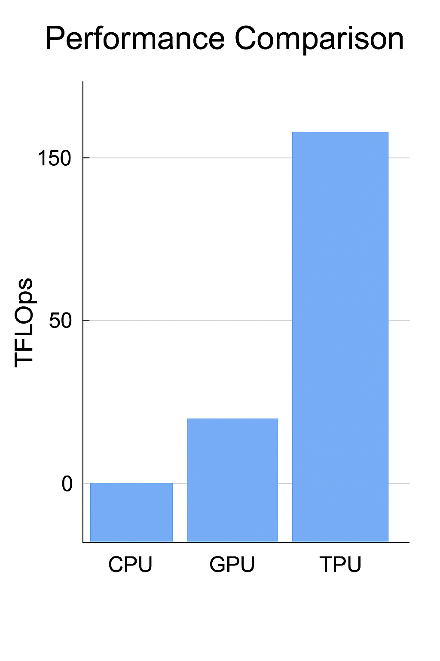
- Performance Trade-Offs –
For machine learning tasks, TPUs are incredibly fast, but they have limitations.
The Boundaries of Specialization Flexibility: Less able to manage a range of tasks than a CPU.
Workloads without machine learning will not function well.
• Batch processing is required for TPUs to function optimally, which isn't always feasible for real-time applications.
• Reduced Risks of Precision
The model's accuracy might be slightly lower when comparing INT8 or bfloat16 to full-precision training.
• High Development Cost of Developing custom ASICs comes with high non-recurring engineering costs.
For large-scale inference applications, however, these trade-offs are outweighed by the notable power savings and throughput benefits.

- Use Case: Google Translate –
For every translation request, neural machine translation (NMT) models—like the ones that drive Google Translate—perform billions of matrix multiplications. Because of their high parallelizability, these calculations are a perfect workload for Tensor Processing Units (TPUs).
Prior to TPUs
In order to maintain acceptable response times, the complexity of translation models was limited. It was difficult to translate in real time because many queries had latency in the hundreds of milliseconds. Google's ability to provide translation services on a global scale was constrained by energy and infrastructure costs.
Effects of TPUs
- Increased Model Complexity: Without compromising speed, TPUs made it possible to employ deeper, more precise NMT architectures.
- Better grammar, idiomatic translation, and contextual understanding all contribute to increased real-time accuracy.
- Significant Latency Reduction: Translation times for numerous language pairs decreased to less than 50 milliseconds.
- Reduced Energy Cost per Translation: Efficiency improvements made it possible to translate billions of words every day while saving money on operating expenses.
- Global Scalability: Even on devices with limited bandwidth, users can now obtain high-quality translations nearly instantaneously.

Why This Use Case Is Suitable for TPUs
TPUs are excellent at low-precision large-scale matrix multiplications (e.g., INT8, BF16), which is precisely what NMT models need.
For sequential matrix operations, the systolic array design maximizes throughput while reducing memory bottlenecks.
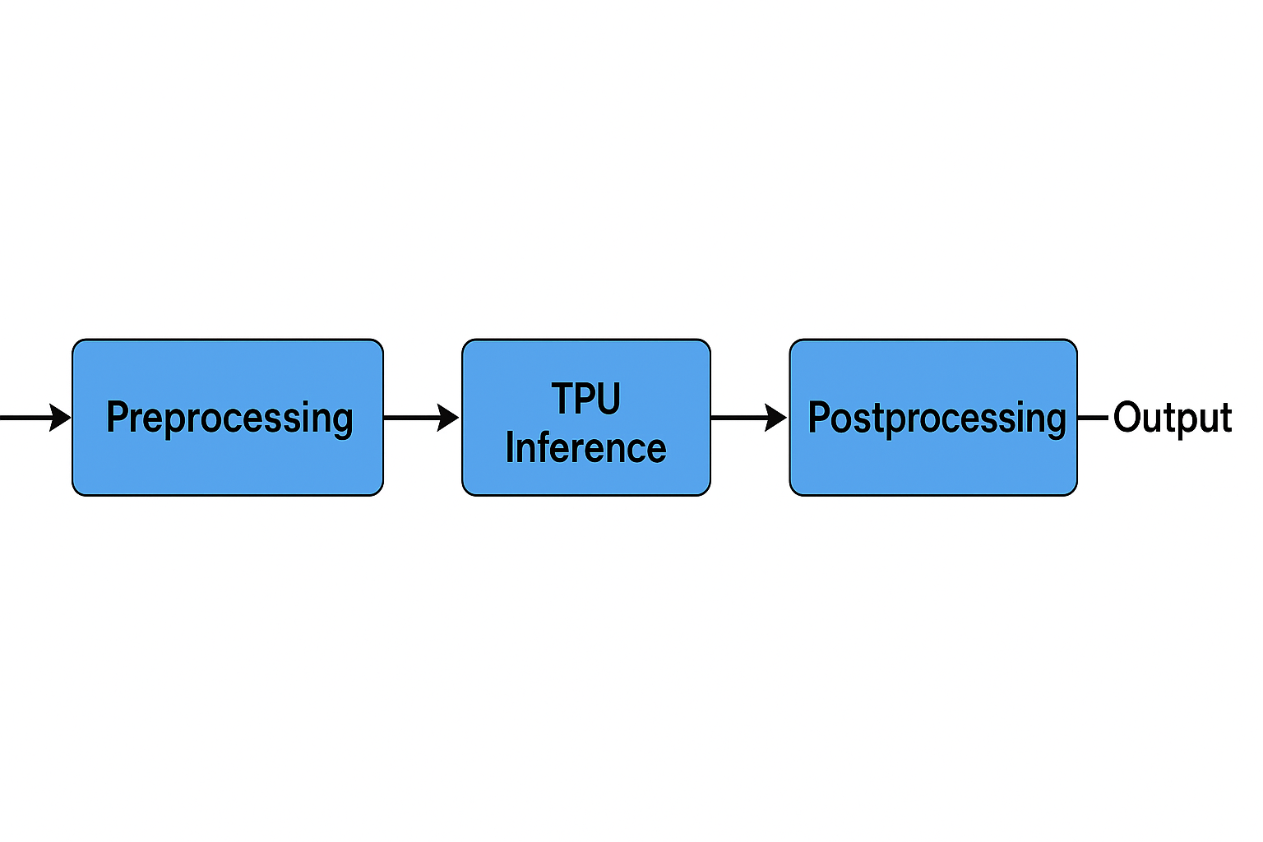

- Conclusion –
The Google TPU is an example of a paradigm shift in computing, where efficiency is achieved by shifting from general-purpose designs to domain-specific structures.
TPUs achieve orders of magnitude better performance per watt for deep learning by customizing every hardware choice, from on-chip memory to systolic arrays.
Specialized processors like TPUs, NVIDIA Tensor Cores, and Graphcore IPUs will become more and more prevalent in hardware as AI models get bigger. The TPU is a shining illustration of how domain-specific design choices may revolutionize compute efficiency on a large scale.

