BUSINESS REQUIREMENT DOCUMENT

# 1. Introduction

## 1.1 Purpose

The purpose of this document is to outline the development of a platform that facilitates the quick and reliable connection between individuals and service providers for tasks such as home repairs, cleaning, tutoring, or personal care. The platform is designed to address the challenges users face when trying to find qualified, trustworthy professionals on short notice, ensuring that the process is efficient, safe, and user-friendly.

## 1.2 Intended Audience

This document is intended for:

* **Developers and Engineers**: To understand the technical requirements and architecture of the platform.
* **Project Managers**: To oversee the progress and ensure the project meets its objectives.
* **Stakeholders and Investors**: To assess the potential value and impact of the platform.
* **Quality Assurance Team**: To ensure the platform meets the necessary quality standards before launch.

## 1.3 Intended Use

The platform is intended to be used by:

* **Homeowners**: In need of immediate repair services, such as plumbing, electrical work, or carpentry.
* **Parents and Students**: Seeking last-minute tutoring services.
* **Individuals**: Requiring urgent personal care services or house cleaning.
* **Service Providers**: Professionals offering various services who wish to connect with potential clients quickly and efficiently.

## 1.4 Product Scope

### In Scope

* Creating Services: Service providers can create and manage listings for the services they offer.
* Booking Services: Users can search for, filter, select, and book available service providers.
* Registration: Both users and service providers can register on the platform, creating profiles with necessary details.
* Navigation for Service Providers: The platform will provide navigation assistance to help service providers reach the client's location.
* Sending Payments for Orders: Users can make secure payments for services through the platform.
* Reviewing Service Providers: Users can rate, and review service providers based on their experience.
* Suggestions: Users will be given service recommendations based on their profile and previous orders.

### Not In Scope

* Advanced AI-Driven Matching: While basic matching algorithms will be used, advanced AI-driven personalization and recommendation features are not included in this version.
* Inventory Management: The platform will not include features for service providers to manage inventory or supplies.
* In-Depth Analytics: Detailed analytics and reporting features for users or service providers are beyond the scope of this initial release.
* Offline Payment Methods: The platform will only support digital payments; offline payment options (like cash on delivery) will not be available.
* Extended Support for Non-Service-Based Listings: The platform will focus solely on services and will not support product sales or non-service-related listings.

# 2. Overall Description

## 2.1 User Needs

* Immediate Access: Users need a quick and reliable way to connect with service providers who are available on short notice.
* Quality Assurance: Users require confidence in the quality and expertise of the service providers.
* Safety and Trust: Users need assurance that the service providers they hire are trustworthy and have been vetted.
* Ease of Use: The platform should be user-friendly, making it easy to find, book, and pay for services.

## 2.2 Assumptions and Dependencies

* Service Provider Availability: The platform assumes that there will be enough service providers available at any given time to meet user demands.
* Internet Connectivity: The platform's functionality is dependent on users and service providers having reliable internet access.
* Third-Party Services: The platform may rely on third-party services for payment processing and background checks.
* User Adoption: The platform's success assumes a steady growth in user base and service provider participation.

# 3. System Features and Requirements

## 3.1 Functional Requirements

**User Registration and Authentication**

* + Users and service providers can register and create profiles with personal and professional details.
  + Login options include email and password or social media accounts.

**Service Provider Listings**

* + Service providers can create and manage service listings with descriptions, pricing, and availability.
  + Listings are categorized for easy browsing (e.g., home repairs, tutoring, cleaning, personal care).

**Service Booking**

* + Users can search for service providers by category, location, and availability.
  + Search results can be filtered by ratings, distance, and price.
  + Users can view service provider details and book appointments.

**Navigation Assistance**

* + Integrated navigation assistance to help service providers reach clients.
  + Features include route optimization and real-time traffic updates.

**Payment Processing**

* + Secure payment processing through the platform.
  + Supports various payment methods, including credit/debit cards and digital wallets.

**Service Reviews and Ratings**

* + Users can rate and review service providers based on their experience.
  + Reviews and feedback comments are visible on the service provider’s profile.

**User Profile Management**

* + Users can manage profiles, view booking history, and update personal details.
  + Service providers can update service listings, view bookings, and manage their profiles.

## 3.2 External Interface Requirements

**User Interface**

* + Web-based interface accessible through modern browsers.

**Payment Gateway Integration**

* + Integration with third-party payment gateways for secure transactions.

**Navigation API**

* + Integration with a navigation API (e.g., Google Maps) for route assistance.

## 3.3 System Features

**Scalability**

* + Scalable to accommodate a growing number of users and service providers.
  + Handles increased traffic and transactions during peak times.

**Security**

* + Secure storage and protection of user and service provider data.
  + Implementation of SSL/TLS for secure data transmission and adherence to data protection best practices.

**Performance**

* + Fast response times and high availability.
  + Load balancing and caching mechanisms to ensure optimal performance.

**Usability**

* + User-friendly with intuitive navigation and a clean interface.

**Maintenance**

* + Designed for easy maintenance and updates.

## 3.4 Non-Functional Requirements

**Reliability**

* + High uptime and reliability with minimal downtime.
  + Backup and recovery processes to ensure data integrity.

**Scalability**

* + Supports vertical and horizontal scaling to handle increasing users and transactions.

**Performance**

* + Efficient handling of peak loads without performance degradation.
  + Optimized response times for key functions (e.g., search, booking).

**Security**

* + Implementation of industry-standard security measures to protect data and transactions.

**Accessibility**

* + Compliance with accessibility standards to ensure usability for individuals with disabilities.

# 3. Diagrams

## 3.1 Class Diagrams

### User Management Service

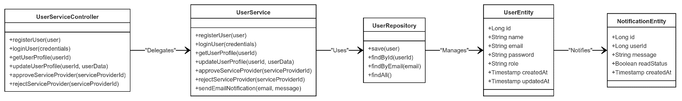

### Booking Management Service

### Service Provider Management Service

## 3.2 Use Case Diagram

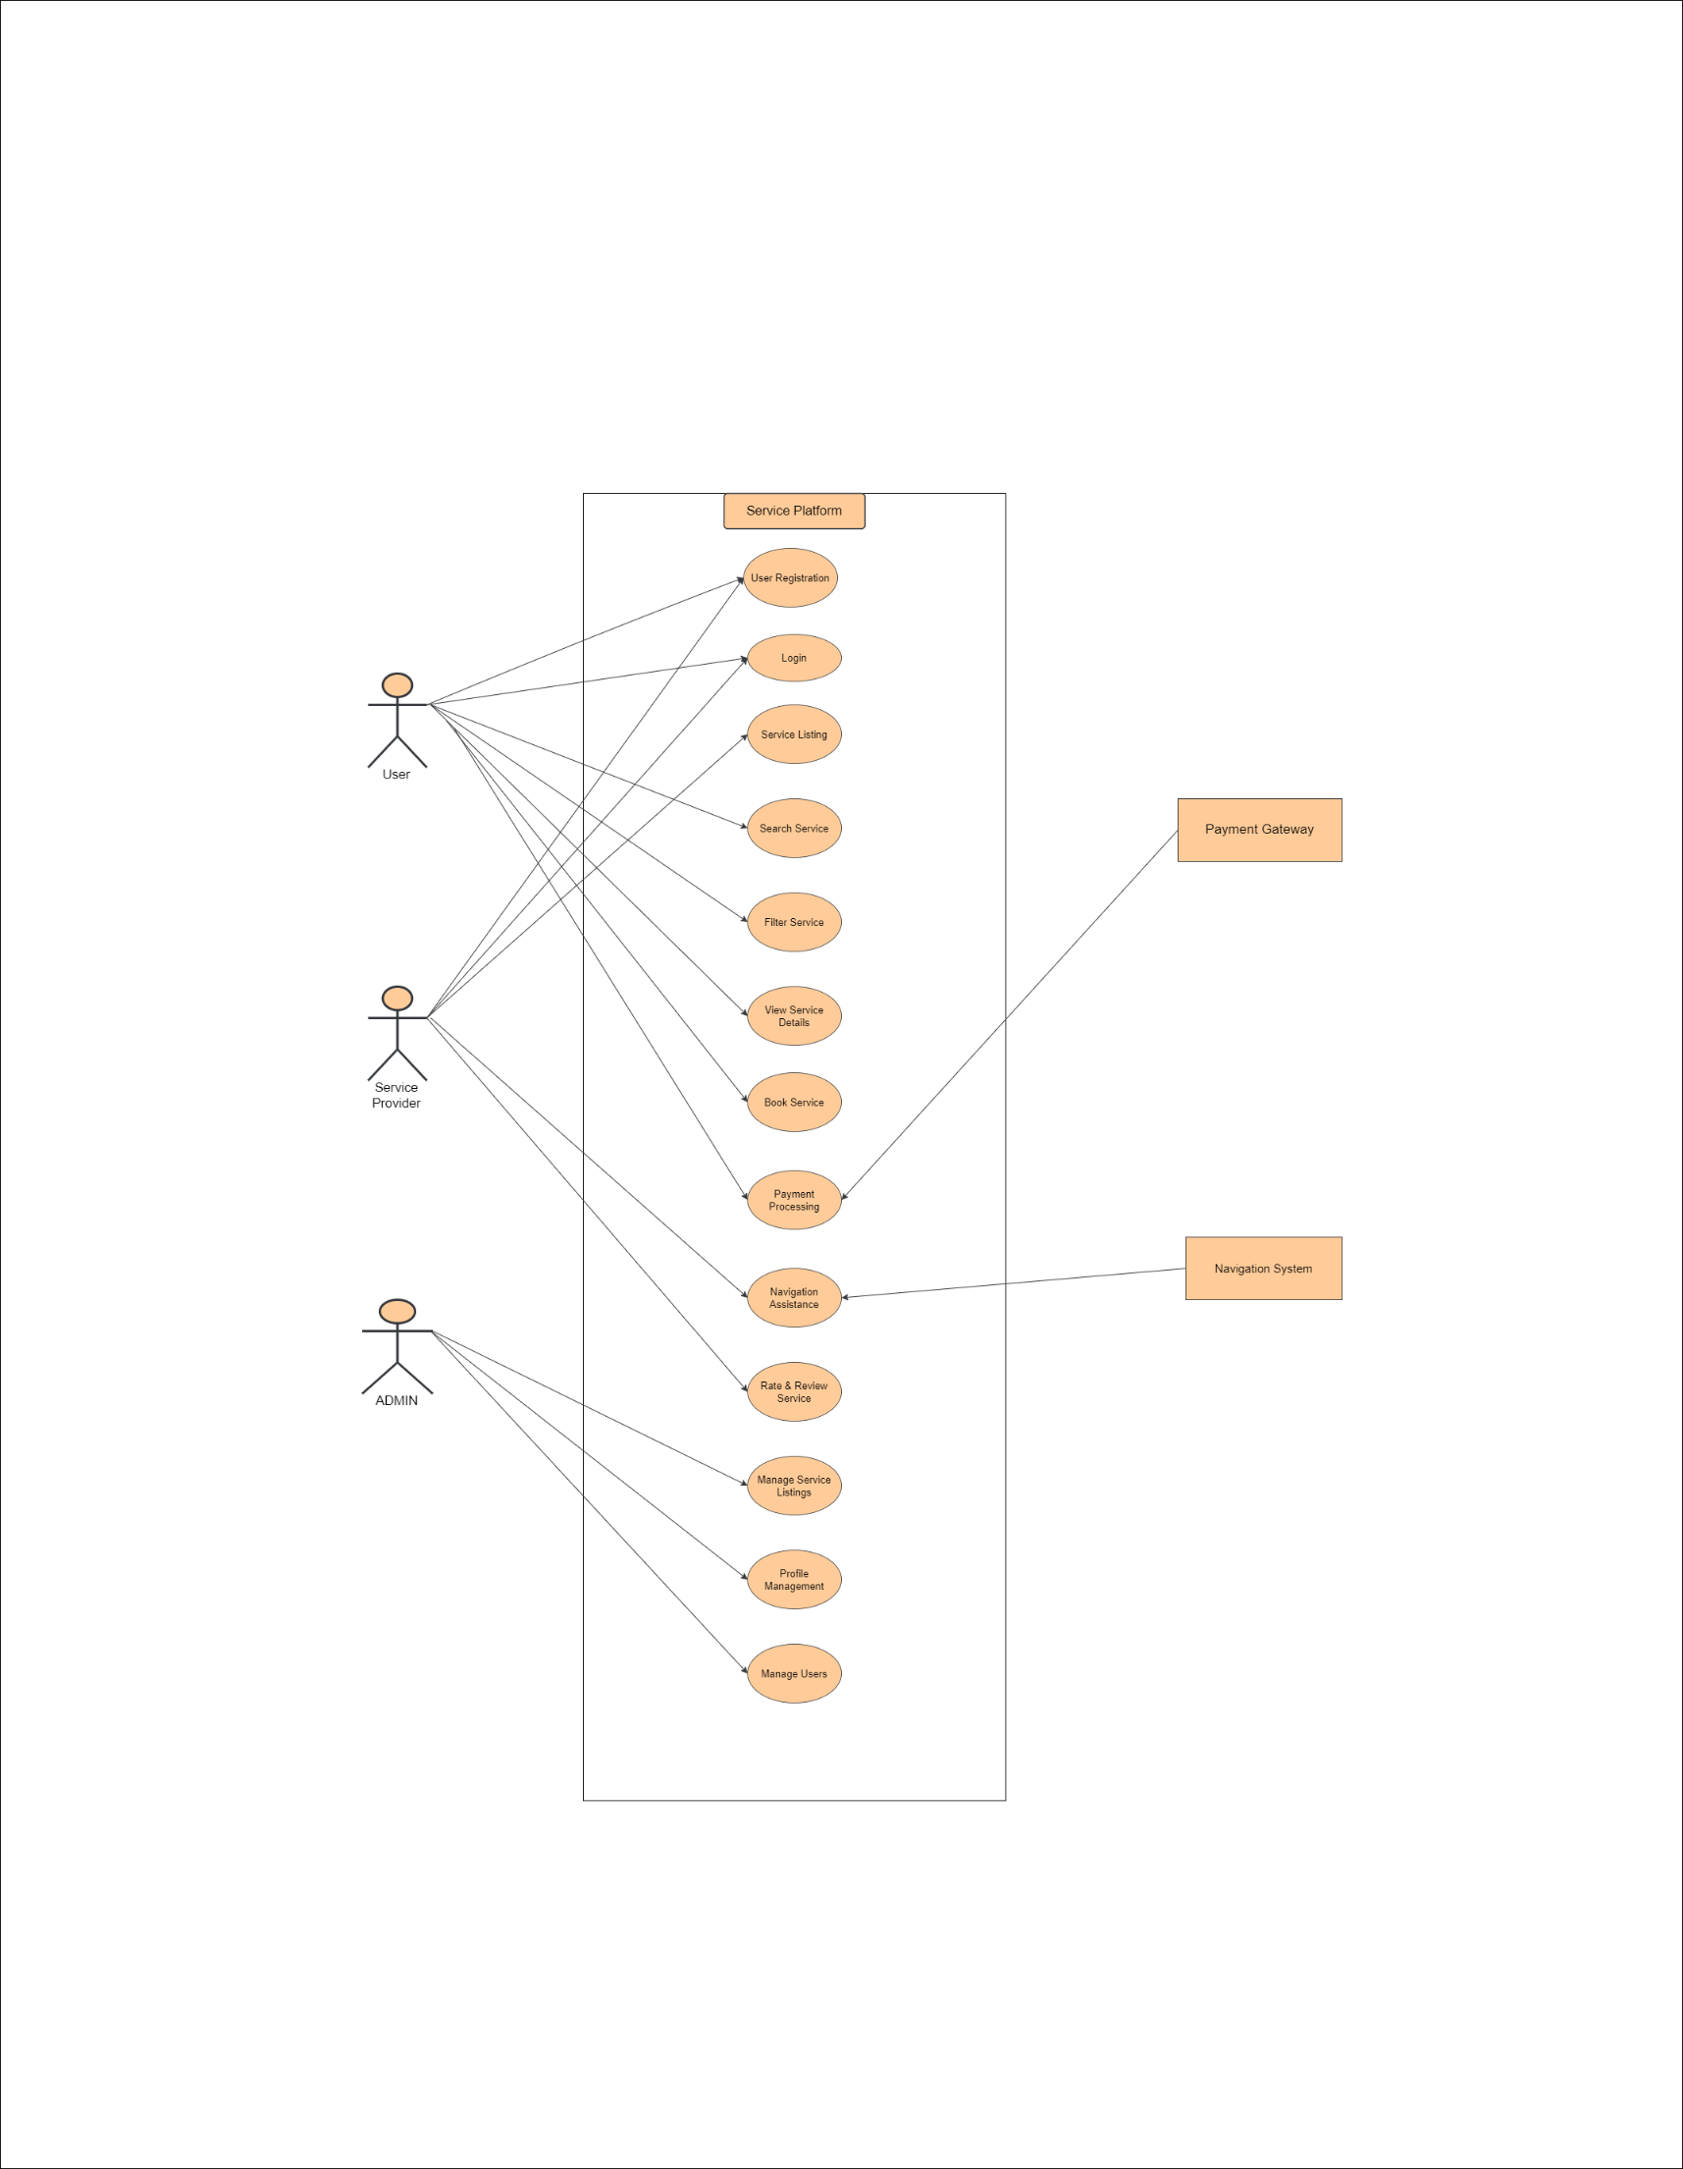

## 3.3 Entity Relationship Diagram

## 3.4 Sequence Diagram

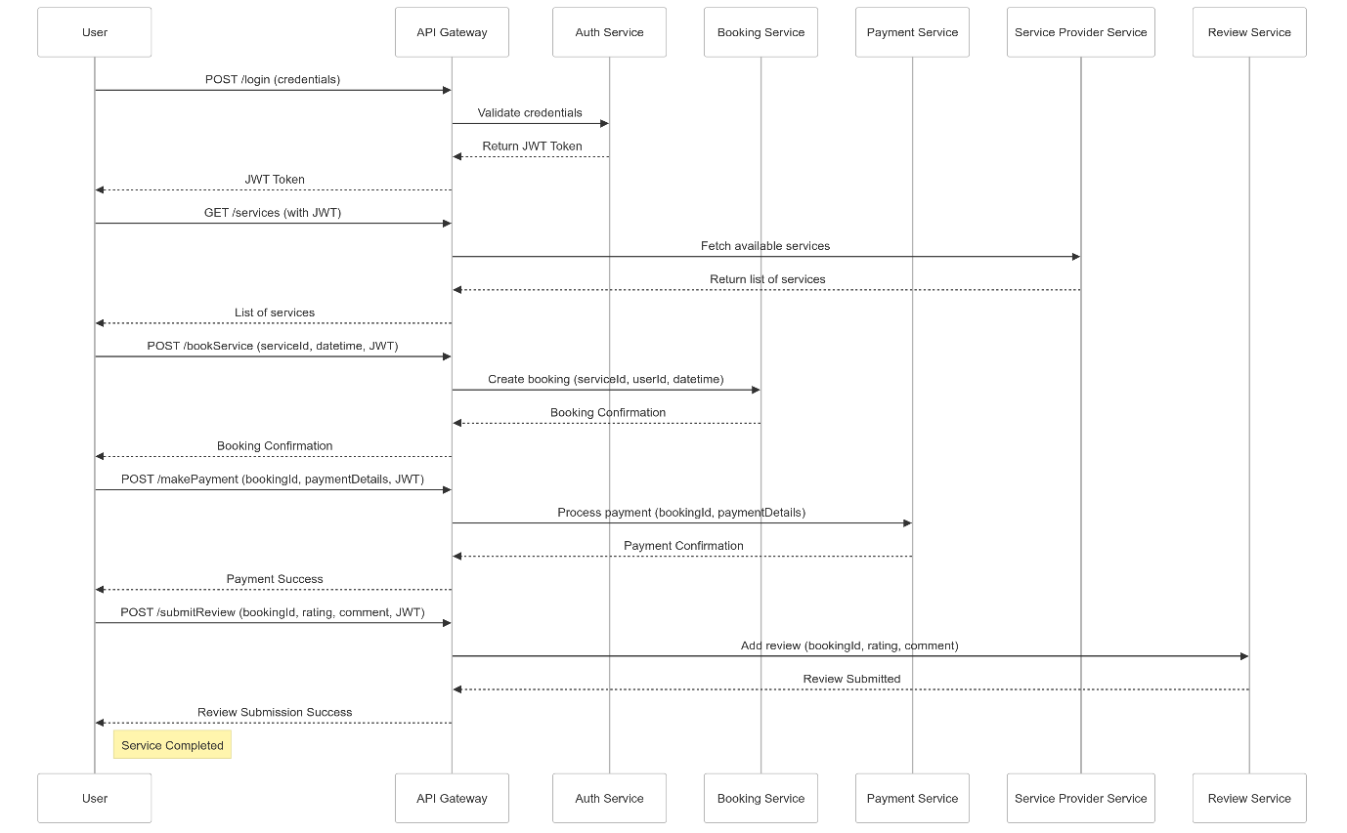Top of Form

Bottom of Form



## 3.4 Architecture Diagram

