Ip – plan

DB – 10.12.3.170
uno : Passord170
DB_URI : mongodb://10.12.3.170:27017/?directConnection=true&appName=mongosh+2.2.2
sensor1 : Passord1
sensor2 : Passord2

Frontend – 10.12.3.171
uno : Passord171
sensor1 : Passord1
sensor2 : Passord2

Backend – 10.12.3.172
uno : Passord172
sensor1 : Passord1
sensor2 : Passord2

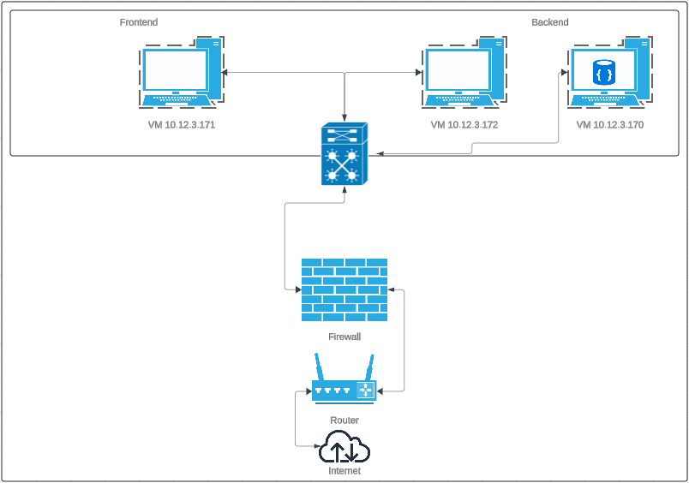
Tech:
Node, React, Pm2, Nginx, Linux, validator, nodemon, mongoose, jsonwebtoken, express, dotenv, cors, bcrypt, VM, MongoDB

