Ip – plan

DB – 10.12.3.170
uno : Passord170
DB :
superpadde : Passord1

Frontend – 10.12.3.171
uno : Passord171
superpadde : Passord1

Backend – 10.12.3.172
uno : Passord172
superpadde : Passord1

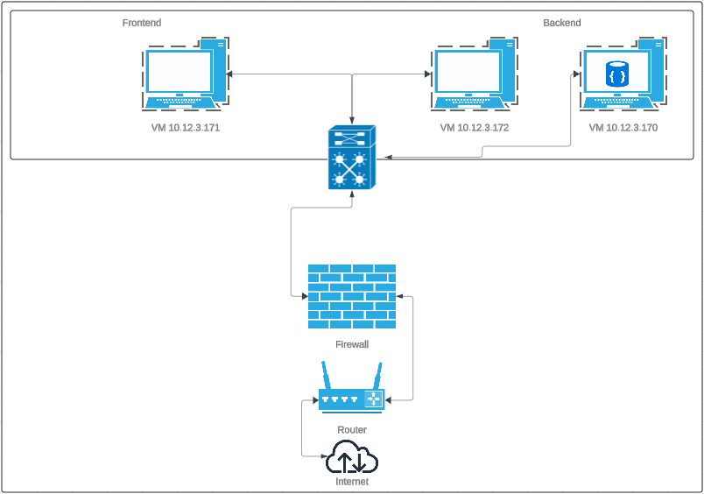
Tech:
Node, React, Pm2, Nginx, Linux, validator, nodemon, mongoose, jsonwebtoken, express, dotenv, cors, bcrypt, VM, MongoDB

